Name of Journal: World Journal of Gastroenterology
ESPS Manuscript NO.: 19878
Manuscript Type: CASE REPORT

Delayed diagnosis of alpha-1-antitrypsin deficiency following post-hepatectomy liver failure: A case report

Norton B et al. Delayed diagnosis of alpha-1-antitrypsin deficiency

Benjamin Norton, Jemimah Denson, Christopher Briggs, Matthew Bowles, David Stell, Somaiah Aroori

Benjamin Norton, Peninsula College of Medicine and Dentistry, Tamar Science Park, PL6 8BU Plymouth, United Kingdom

Jemimah Denson, Department of Histopathology, Plymouth Hospitals NHS Trust, PL6 8DH Plymouth, United Kingdom

Christopher Briggs, Matthew Bowles, David Stell, Somaiah Aroori, Peninsula HPB Unit, Derriford Hospital, PL6 8DH Plymouth, United Kingdom

Author contributions: Norton B and Aroori S wrote the paper; Denson J, Briggs C, Bowles M, Stell D, Aroori S were the doctors involved in the case, and advised with regard to the research; Aroori S provided the CT images and Denson J provided the histology images; all authors have read and approved the final manuscript.

Institutional review board statement: This case report was exempt from the Institutional Review Board standards at Peninsula School of Medicine and Dentistry.

Informed consent statement: The patient’s relative involved in this study gave there verbal informed consent authorising use and disclosure of there protected health information.

Conflict-of-interest statement: All the authors have no conflicts of interests to declare.

Open-Access: This article is an open-access article which was selected by an in-house editor and fully peer-reviewed by external reviewers. It is distributed in accordance with the Creative Commons Attribution Non Commercial (CC BY-NC 4.0) license, which permits others to distribute, remix, adapt, build upon this work non-commercially, and license their derivative works on different terms, provided the original work is properly cited and the use is non-commercial. See: http://creativecommons.org/licenses/by-nc/4.0/

Correspondence to: Somaiah Aroori, MS, MD, FRCS, EBS in HPB Surgery, Consultant HPB Surgeon, Peninsula HPB unit, Derriford Hospital, PL6 8DH Plymouth, United Kingdom. s.aroori@nhs.net
Telephone: +44-7837388342

Received: May 24, 2015
Peer-review started: May 25, 2015
First decision: July 19, 2015
Revised: September 5, 2015
Accepted: November 30, 2015
Article in press:
Published online:

Abstract
Post-hepatectomy liver failure (PHLF) is a leading cause of morbidity and mortality following major liver resection. The development of PHLF is dependent on the volume of the remaining liver tissue and hepatocyte function. Without effective pre-operative assessment, patients with undiagnosed liver disease could be at increased risk of PHLF. We report a case of a 60 year-old male patient with PHLF secondary to undiagnosed alpha-1-antitrypsin deficiency (AATD) following major liver resection. He initially presented with acute large bowel obstruction secondary to a colorectal adenocarcinoma, which had metastasized to the liver. There was no significant past medical history apart from mild chronic obstructive pulmonary disease. After colonic surgery and liver directed neo-adjuvant chemotherapy, he underwent a laparoscopic partially extended right hepatectomy and radio-frequency ablation. Post-operatively he developed PHLF. The cause of PHLF remained unknown, prompting re-analysis of the histology, which showed evidence of AATD. He subsequently developed progressive liver dysfunction, portal hypertension, and eventually an extensive parastomal bleed, which led to his death; this was ultimately due to a combination of AATD and chemotherapy. This case highlights that formal testing for AATD in all patients with a known history of chronic obstructive pulmonary disease, heavy smoking, or strong family history could help prevent the development of PHLF in patients undergoing major liver resection.

Key words: Post-hepatectomy liver failure; Hepatectomy; Alpha-1-antitrypsin deficiency; Functional liver remnant; Liver resection

© The Author(s) 2015. Published by Baishideng Publishing Group Inc. All rights reserved.

Core tip: A report of a 60-year-old male who underwent an extended right hepatectomy for metastatic colorectal adenocarcinoma. He subsequently developed post-hepatectomy liver failure secondary to a delayed diagnosis of alpha-1-antitrypsin deficiency. Clinicians should be aware of, and test for, the possibility of undiagnosed alpha-1-antitrypsin deficiency in patients with known chronic obstructive pulmonary disease or a family history, undergoing major liver resection.
Norton B, Denson J, Briggs C, Bowles M, Stell D, Aroori S. Delayed diagnosis of alpha-1-antitrypsin deficiency following post-hepatectomy liver failure: A case report. World J Gastroenterol 2015; In press

INTRODUCTION
Post-hepatectomy liver failure (PHLF) is a leading cause of death following major liver resection with an estimated mortality of 70%^{[1]}. There is no strict definition for PHLF, but it is considered a condition characterised by an inability of the liver to carry out normal excretory, detoxifying and synthetic function after post-operative day 5^{[2]}. There is usually significant biochemical and clinical evidence of liver dysfunction, with persistent hyperbilirubinaemia the most sensitive marker, and features of coagulopathy, portal hypertension and ascites^{[3]}. A similar syndrome is seen in liver transplant recipients receiving a donor liver that is too small, resulting in acute liver failure (ALF), termed ‘small-for-size syndrome’^{[4]}. In both of these scenarios the underlying pathophysiological mechanism of liver dysfunction is complex, and most likely related to liver hepatocyte volume and function. Any factor affecting the ability of the hepatic parenchyma to regenerate following liver resection could significantly affect hepatic flow to the remnant liver, leading to hyperperfusion and cellular damage^{[5]}. Therefore, pre-operative assessment is vital to establish patients with undiagnosed liver disease that are at increased risk of PHLF. We report a case of PHLF secondary to previously undiagnosed alpha-1-antitrypsin deficiency (AATD) after laparoscopic partially extended right hepatectomy and radio-frequency ablation (RFA) for colorectal liver metastases.

CASE REPORT
A previously well 60 year-old male initially presented to local hospital with acute large bowel obstruction requiring emergency Hartmann’s procedure. Intra-operatively, an obstructing tumour was noted in the sigmoid colon with solitary peritoneal deposit and bi-lobar liver metastasis. Histology confirmed a moderately differentiated adenocarcinoma (pT4 pN2) of the sigmoid colon. Subsequently, he was referred to our center for further management. There was no significant past medical history apart from mild chronic obstructive pulmonary disease (COPD), managed without inhalers. He was an ex-smoker giving up five years previously, and his alcohol consumption was minimal.

Pre-liver surgery investigations
A staging computed tomography (CT) revealed multiple liver metastases located in segments 2/3, 4/8, 5/6, and 6 (Figure 1A, 1B). He also had a positron emission tomography-computed tomography (PET-CT), which suggested evidence of peritoneal disease in the right side of the abdomen, in addition to the liver metastases. After discussion in the hepatobiliary (HPB) multi-disciplinary team (MDT) he was referred for neo-adjuvant chemotherapy. He received in total 12 cycles of Oxaliplatin and Capecitabine based chemotherapy. After twelve cycles were completed, CT imaging showed evidence of two residual lesions in the right hemi-liver, and a small lesion on the surface of the left hemi-liver with no evidence of peritoneal disease (Figure 1C, 1D). After discussion in the HPB MDT, he was seen in the clinic and informed about the role of surgery and RFA; he decided to proceed with the operation.
Pre-operative assessment included cardio-pulmonary exercise testing (CPET) (6.47 min at 20 watt per min ramp, stopping due to knee pain). Anaerobic threshold was 14.2 mL/min/kg at 769 mL/min (increased due to low BMI), VO₂ max of 21 mL/min/kg and confirmation of moderate COPD with saturations 93% on room air, FEV₁/FVC ratio 48%, and significantly elevated VE/VCO₂ at 48. He was considered high risk of post-operative respiratory complications. His pre-operative blood results were: alanine transferase (ALT) 46 (10-41 IU/L), alkaline phosphatase (ALP) 138 (30-130 U/L), bilirubin 11 (0-20 μmol/L), albumin 47 (35-50 g/L), international normalized ratio (INR) 1.1, hemoglobin (Hb) 168 (130-175 g/L), creatinine 77 (62-106 μmol/L), and urea 4.4 (2.5-7.8 mmol/L).

Intra-operative findings
At diagnostic laparoscopy, there was no evidence of any peritoneal metastasis. On intra-op ultrasound, two lesions were noted in segments 6 and 8/4a, and a solitary lesion in liver segment 2/3. He underwent a laparoscopic partially extended right hepatectomy with cholecystectomy and RFA to the left liver lesion with no intra-operative complications. The liver was transected using a CUSA and Thunderbeat (Olympus®). The total operation time was 390 min with approximately one litre of blood loss recorded and no blood transfusions given.

Post-operative course
As per our routine practice, post-operatively, he was admitted to the intensive care unit (ICU) and was discharged to the ward four days later. There were no immediate complications while he was on the ICU. On the ward, there was poor progression with reduced oral intake requiring nasogastric feeding, development of ascites with large drain output (> 2.5 L/d) and hyponatraemia. Clinical and biochemical markers were suggestive of decompensated liver function (Figure 2). A suspected diagnosis of PHLF was made given his recent major liver resection. He was managed with prophylactic antibiotics, lactulose, albumin replacement, and fluid restriction.
Three weeks after the operation he was readmitted to the ICU because of multi-system dysfunction, including PHLF, hypoxia, hyponatraemia, acute kidney injury (AKI) and suspected sepsis. He had ultrasound liver scan, magnetic resonance cholangiopancreatography (MRCP), and triple phase CT to identify a source of sepsis and problems with inflow and outflow to the remnant liver. MRCP showed no evidence of biliary obstruction and triple phase CT confirmed patent inflow and outflow with good residual liver volume. CT also showed large volume ascites and bilateral pleural effusions. As no obvious cause could be identified for the development of PHLF, his case for reviewed at the HPB MDT.

Histology
Histology of the resected liver showed four fibrotic nodules, two of which contained residual degenerate moderately differentiated intestinal adenocarcinoma, entirely consistent with colorectal liver metastases. In view of his development of PHLF due to unknown cause, the case was reviewed at the HPB MDT, and it was decided to re-analyse the histology of the liver. This showed features consistent with mild chronic inflammation with a very minor degree of interface activity. Within the liver lobules there was zone 3 hepatocyte atrophy with patchy inflammation and sinusoidal dilatation; features consistent with chemotherapy effect. Special stains highlighted prominent DPAS positive globules within hepatocytes, which were positive with alpha-1-antitrypsin (AAT) immunohistochemistry (Figure 3). There was no evidence of cirrhosis, and it was concluded that these features would be consistent with AATD. This was confirmed clinically, with blood tests revealing a low serum AAT level of 0.2 (0.9-2.0 g/L), but there was in vivo degradation of the phenotype specimen.

Outcome
After stabilization in ICU, he was again discharged back to the ward, but had a complicated course over the next month. He experienced several post-operative complications as a result of PHLF. These include severe portal hypertension causing significant ascites requiring frequent paracentesis, malnutrition, recurrent sepsis with a suspected focus either in the chest on ascitic fluid (managed with meropenem and ambisome), parastomal varices with one episode of stomal bleeding requiring a embolisation, persistent hyponatraemia, and hypotensive episodes. After several weeks of co-ordinated care between the hepatobiliary surgeons, hepatologists, microbiologists, and intensivists, he developed a second, extensive parastomal bleed, which was decided not for active management. He subsequently died ten weeks following liver resection with his death attributed to PHLF secondary to chemotherapy and previously undiagnosed AATD.

DISCUSSION
Post-hepatectomy liver failure represents a major cause of morbidity and mortality following liver resection, expected to occur in 10% of cases^{[6,7]}. The success of liver resection, especially for more extensive operations, is dependent on regeneration of hepatic tissue. Hepatic regeneration is a process whereby liver mass is replenished by existing hepatocytes. The mechanism of hepatic regeneration is thought to revolve around three major networks: cytokines, growth factors and metabolic functions. These networks are proposed to interact with one another to promote cellular replication, and provide a driving force through the cell cycle^{[8]}. After liver resection, the remaining hepatic parenchyma needs to accommodate the haemodynamic changes to allow effective regeneration^{[9]}. If the parenchyma is unable to accommodate these changes, which may be due to a severely reduced hepatic volume or poor hepatocyte function, then regeneration is prevented and the liver will become damaged^{[5]}. The decreased hepatocyte volume leads to hyperperfusion causing sinusoid dilatation, kupffer cell activation, and subsequently progressive necrosis of the remnant liver, leading to impairment in its metabolic function and development of PHLF^{[10]}.
The volume of the remaining hepatic tissue that must accommodate the haemodynamic changes following liver resection, is termed the functional liver remnant (FLR)^{[5]}. The risk of death in patients undergoing liver resection for malignancy was found to be directly related to the volume of the FLR^{[11,12]}. All patients undergoing liver resection must have a full medical assessment to check for any potential co-morbidity, which could affect regeneration of the FLR. This may include a full blood count, renal function, liver function, albumin, and coagulation studies. Patients with pre-existing liver disease, such as cirrhosis or chemotherapy-associated steatohepatitis (CASH), need to be assessed for suitability of liver resection as this can effect regeneration, putting them at higher risk of developing PHLF^{[13]}. The need to identify high risk patients pre-operatively has led to volumetric analysis using 3D CT reconstructions or magnetic resonance imaging (MRI), as it allows estimation of acceptable FLR percentages^{[14,15]}. Although many authors currently view CT/MRI volumetric analysis as essential prior to major liver resection, there is no standardization for accurately calculating FLR volumes. Imaging tends to over-estimate liver volume, and different formulae have been proposed in an attempt to account for this error^{[15,16]}. Additionally, volumetric analysis does not give any indication as to the underlying hepatic function. For example, there are many predictive patient-factors associated with an increased risk of PHLF not accounted for by imaging. These factors are predominantly related to underlying liver disease, which include: CASH, diabetes and obesity (non-alcoholic fatty liver disease), cirrhosis, hepatic B and C, hyperbilirubinaemia, and AATD^{[13]}.
In our case, pre-operative assessment did not identify any significant underlying liver disease. The CT images were reviewed at the HPB MDT, which deemed the expected FLR size to be acceptable for a partially extended right hepatectomy, although formal 3D volumetric analysis was not undertaken. Our centre will consider liver resection if we can leave a FLR of 30% in post chemotherapy livers, 40% in patients with established cirrhosis/fibrosis, and 20% in normal a liver. In this case, more formal testing for underlying liver disease, such as AATD, as part of the pre-operative assessment, could have altered our surgical management, and ultimately, helped to prevent the development of PHLF. We believe that PHLF in our patient was due to several factors; mainly undiagnosed AATD disorder, neo-adjuvant chemotherapy, and extended liver resection. However, it is currently not routine practice to check for AATD in patients requiring liver resection with no evidence of cirrhosis or family history.
AATD is an under-diagnosed condition with a suspected worldwide prevalence of 3.4 million people^{[17]}. It is an autosomal recessive disease, with co-dominant expression, caused by a mutation in the SERPINA1 gene^{[18,19]}. There are approximately 123 single nucleotide polymorphisms affecting the gene^{[19]}. The M allele accounts for over 95% of alleles in the general population, with other alleles including S and Z, accounting for 2%-3% and 1% respectively^{[18]}. The normal phenotype is denoted Pi-MM, while the most severe phenotype is Pi-ZZ, which leads to low concentrations of the AAT protein and highest risk of organ damage^{[20]}. The most significant organs affected are the lungs and liver. AAT is usually produced within hepatocytes, but defective alleles can lead to its polymerization, cellular aggregation, and subsequent liver dysfunction^{[21,22]}. AAT is normally excreted from hepatocytes where it may counteract the action of neutrophil elastase. Failed excretion can lead to pulmonary inflammation and proteolytic damage, which may manifest as COPD^{[23]}. Other associated clinical manifestations of AATD can include panniculitis and vasculitis^{[19]}.
Due the effect of AATD on hepatocyte function, left undiagnosed, it could have deleterious effects following liver resection. Using a Pi-Z mouse model, one study showed that proliferation of hepatocytes predominantly occurred in cells without abnormal AAT accumulation^{[24]}. Therefore, it is unsurprising that hepatocyte regeneration was affected in our case of undiagnosed AATD. At present, the ATS/ERS recommends testing for AATD in all patients with COPD^{[25]}. Moreover, it is suggested that living-donor liver transplantations should be screened for underlying metabolic disorders (e.g., AATD) as they could pose safety issues to both donor and recipient^{[26]}.
In a situation where AATD is detected pre-operatively, we recommend avoidance of major liver resection as it will affect liver regeneration. We would recommend pre-operative liver biopsy and liver volumetric analysis before deciding whether or not to consider a patient for major liver resection. If the FLR is less than 40% then major liver resection should be avoided and measures should be taken to increase FLR prior to surgery (e.g., portal vein embolization). In our case, we would not have considered major liver resection if we were aware of his diagnosis prior to surgery. Especially since he received several cycles of neo-adjuvant chemotherapy.
Currently, there is no recommendation for AATD testing in patients undergoing major liver resection. To help prevent the development of PHLF as seen in our case, we recommend formal testing for AAT levels and AATD phenotyping, in all patients with a known history of COPD, heavy smoking history, or those with a strong family history undergoing major liver resection. If AATD is identified, we recommend avoidance of major hepatectomy (more than 4 segments), even if patients do not receive neo-adjuvant chemotherapy.
In conclusion, this case demonstrates the need for better screening for AATD, which is an under-diagnosed condition, in susceptible patients undergoing major liver resection. Identification of patients with AATD prior to surgical intervention, would aid pre-operative assessment and surgical planning, and ultimately, help to prevent the development of post-hepatectomy liver failure.

COMMENTS
Case characteristics
A report of a 60-year-old male who underwent an extended right hepatectomy for metastatic colorectal adenocarcinoma. He subsequently developed post-hepatectomy liver failure secondary to a delayed diagnosis of alpha-1-antitrypsin deficiency.

Clinical diagnosis
Post-hepatectomy liver failure (PHLF) associated with significant ascites, malnutrition, recurrent sepsis and parastomal varices.

Differential diagnosis
Alpha-1-antitrypsin deficiency (AATD), chemotherapy-associated steatohepatitis, non-alcoholic fatty liver disease.

Laboratory diagnosis
Hyponatraemia, acute kidney injury, acute liver failure and alpha-1-antitrypsin deficiency: AAT level of 0.2 (0.9-2.0 g/L).

Imaging diagnosis
Magnetic resonance cholangiopancreatography showed no evidence of biliary obstruction and triple phase computed tomography confirmed patent inflow and outflow with good residual liver volume. No obvious cause could be identified on imaging for the development of PHLF.

Pathological diagnosis
Alpha-1-antitrypsin deficiency. Prominent DPAS positive globules within hepatocytes, which were positive with alpha-1-antitrypsin (AAT) immunohistochemistry.

Treatment
Conservative management failed and unfortunately the patient died.

Related reports
PHLF is a leading cause of death following major liver resection, which is related to failure in regeneration of the remaining hepatic tissue. This may be due to intrinsic liver disease and/or reduced volume of the functional liver remnant. To date, this is the first report of PHLF secondary to a delayed diagnosis of AATD following major liver resection.

Term explanation
AATD is an autosomal recessive disease that is under recognised. The alpha-1-antitrypsin protein is usually produced within hepatocytes, but defective alleles can lead to cellular aggregation and subsequent liver dysfunction. This causes impaired regeneration post-hepatectomy.

Experiences and lessons
This case demonstrates the need for better screening for AATD, which is an under-diagnosed condition, in susceptible patients (e.g., COPD, family history) undergoing major liver resection.

Peer-review
This is a well written and informative case report.

REFERENCES
1 Balzan S, Belghiti J, Farges O, Ogata S, Sauvanet A, Delefosse D, Durand F. The "50-50 criteria" on postoperative day 5: an accurate predictor of liver failure and death after hepatectomy. Ann Surg 2005; 242: 824-88, discussion 824-88, [PMID: 16327492 DOI: 10.1097/01.sla.0000189131.90876.9e]
2 Rahbari NN, Garden OJ, Padbury R, Brooke-Smith M, Crawford M, Adam R, Koch M, Makuuchi M, Dematteo RP, Christophi C, Banting S, Usatoff V, Nagino M, Maddern G, Hugh TJ, Vauthey JN, Greig P, Rees M, Yokoyama Y, Fan ST, Nimura Y, Figueras J, Capussotti L, Büchler MW, Weitz J. Posthepatectomy liver failure: a definition and grading by the International Study Group of Liver Surgery (ISGLS). Surgery 2011; 149: 713-724 [PMID: 21236455 DOI: 10.1016/j.surg.2010.10.001]
3 Mullen JT, Ribero D, Reddy SK, Donadon M, Zorzi D, Gautam S, Abdalla EK, Curley SA, Capussotti L, Clary BM, Vauthey JN. Hepatic insufficiency and mortality in 1,059 noncirrhotic patients undergoing major hepatectomy. J Am Coll Surg 2007; 204: 854-62; discussion 862-4 [PMID: 17481498 DOI: 10.1016/j.jamcollsurg.2006.12.032]
4 Tucker ON, Heaton N. The 'small for size' liver syndrome. Curr Opin Crit Care 2005; 11: 150-155 [PMID: 15758596]
5 Eshkenazy R, Dreznik Y, Lahat E, Zakai BB, Zendel A, Ariche A. Small for size liver remnant following resection: prevention and management. Hepatobiliary Surg Nutr 2014; 3: 303-312 [PMID: 25392842 DOI: 10.3978/j.issn.2304-3881.2014.09.08]
6 Paugam-Burtz C, Janny S, Delefosse D, Dahmani S, Dondero F, Mantz J, Belghiti J. Prospective validation of the "fifty-fifty" criteria as an early and accurate predictor of death after liver resection in intensive care unit patients. Ann Surg 2009; 249: 124-128 [PMID: 19106687 DOI: 10.1097/SLA.0b013e31819279cd]
7 Jaeck D, Bachellier P, Oussoultzoglou E, Weber JC, Wolf P. Surgical resection of hepatocellular carcinoma. Post-operative outcome and long-term results in Europe: an overview. Liver Transpl 2004; 10: S58-S63 [PMID: 14762841 DOI: 10.1002/lt.20041]
8 Fausto N, Campbell JS, Riehle KJ. Liver regeneration. Hepatology 2006; 43: S45-S53 [PMID: 16447274 DOI: 10.1002/hep.20969]
9 Asencio JM, Vaquero J, Olmedilla L, García Sabrido JL. "Small-for-flow" syndrome: shifting the "size" paradigm. Med Hypotheses 2013; 80: 573-577 [PMID: 23428310 DOI: 10.1016/j.mehy.2013.01.02]
10 Panis Y, McMullan DM, Emond JC. Progressive necrosis after hepatectomy and the pathophysiology of liver failure after massive resection. Surgery 1997; 121: 142-149 [PMID: 9037225 DOI: 10.1016/S0039-6060(97)90283-X]
11 Ferrero A, Viganò L, Polastri R, Muratore A, Eminefendic H, Regge D, Capussotti L. Postoperative liver dysfunction and future remnant liver: where is the limit? Results of a prospective study. World J Surg 2007; 31: 1643-1651 [PMID: 17551779 DOI: 10.1007/s00268-007-9123-2]
12 Kishi Y, Abdalla EK, Chun YS, Zorzi D, Madoff DC, Wallace MJ, Curley SA, Vauthey JN. Three hundred and one consecutive extended right hepatectomies: evaluation of outcome based on systematic liver volumetry. Ann Surg 2009; 250: 540-548 [PMID: 19730239 DOI: 10.1097/SLA.0b013e3181b674df]
13 Kauffmann R, Fong Y. Post-hepatectomy liver failure. Hepatobiliary Surg Nutr 2014; 3: 238-246 [PMID: 25392835 DOI: 10.3978/j.issn.2304-3881.2014.09.01]
14 Mise Y, Tani K, Aoki T, Sakamoto Y, Hasegawa K, Sugawara Y, Kokudo N. Virtual liver resection: computer-assisted operation planning using a three-dimensional liver representation. J Hepatobiliary Pancreat Sci 2013; 20: 157-164 [PMID: 23135735 DOI: 10.1007/s00534-012-0574-y]
15 D’Onofrio M, De Robertis R, Demozzi E, Crosara S, Canestrini S, Mucelli RP. Liver volumetry: Is imaging reliable? Personal experience and review of the literature. World J Radiol 2014; 6: 62-71 [PMID: 24778768 DOI: 10.4329/wjr.v6.i4.62]
16 Niehues SM, Unger JK, Malinowski M, Neymeyer J, Hamm B, Stockmann M. Liver volume measurement: reason of the difference between in vivo CT-volumetry and intraoperative ex vivo determination and how to cope it. Eur J Med Res 2010; 15: 345-350 [PMID: 20947471 DOI: 10.1186/2047-783X-15-8-345]
17 de Serres FJ. Worldwide racial and ethnic distribution of alpha1-antitrypsin deficiency: summary of an analysis of published genetic epidemiologic surveys. Chest 2002; 122: 1818-1829 [PMID: 12426287 DOI: 10.1378/chest.122.5.1818]
18 Fairbanks KD, Tavill AS. Liver disease in alpha 1-antitrypsin deficiency: a review. Am J Gastroenterol 2008; 103: 2136-241; quiz 2142 [PMID: 18796107 DOI: 10.1111/j.1572-0241.2008.01955.x]
19 Kelly E, Greene CM, Carroll TP, McElvaney NG, O'Neill SJ. Alpha-1 antitrypsin deficiency. Respir Med 2010; 104: 763-772 [PMID: 20303723 DOI: 10.1016/j.rmed.2010.01.016]
20 Larsson C. Natural history and life expectancy in severe alpha1-antitrypsin deficiency, Pi Z. Acta Med Scand 1978; 204: 345-351 [PMID: 309708]
21 Perlmutter DH, Brodsky JL, Balistreri WF, Trapnell BC. Molecular pathogenesis of alpha-1-antitrypsin deficiency-associated liver disease: a meeting review. Hepatology 2007; 45: 1313-1323 [PMID: 17464974 DOI: 10.1002/hep.21628]
22 Wu Y, Whitman I, Molmenti E, Moore K, Hippenmeyer P, Perlmutter DH. A lag in intracellular degradation of mutant alpha 1-antitrypsin correlates with the liver disease phenotype in homozygous PiZZ alpha 1-antitrypsin deficiency. Proc Natl Acad Sci U S A 1994; 91: 9014-9018 [PMID: 8090762]
23 American Thoracic Society, European Respiratory Society. American Thoracic Society/European Respiratory Society statement: standards for the diagnosis and management of individuals with alpha-1 antitrypsin deficiency. Am J Respir Crit Care Med 2003; 168: 818-900 [PMID: 14522813 DOI: 10.1164/rccm.168.7.818]
24 Llewellyn-Jones CG, Lomas DA, Carrell RW, Stockley RA. The effect of the Z mutation on the ability of alpha 1-antitrypsin to prevent neutrophil mediated tissue damage. Biochim Biophys Acta 1994; 1227: 155-160 [PMID: 7986822]
25 Teckman JH, Qu D, Perlmutter DH. Molecular pathogenesis of liver disease in alpha1-antitrypsin deficiency. Hepatology 1996; 24: 1504-1516 [PMID: 8938188 DOI: 10.1002/hep.510240635]
26 Schielke A, Conti F, Goumard C, Perdigao F, Calmus Y, Scatton O. Liver transplantation using grafts with rare metabolic disorders. Dig Liver Dis 2015; 47: 261-270 [PMID: 25498135 DOI: 10.1016/j.dld.2014.11.004]
P-Reviewer: Lykoudis PM, Sanal MG, Wu CC S-Editor: Yu J L-Editor: E-Editor:

B
D
A
C

Figure 1 Computed tomography imaging of liver. Evidence of metastatic lesions in the right hemi-liver segments VI (A) and IV (B) pre-chemotherapy. Two residual lesions in the right hemi-liver segments VI (C) and IV (D) post-chemotherapy. Red arrows indicate metastatic lesions.

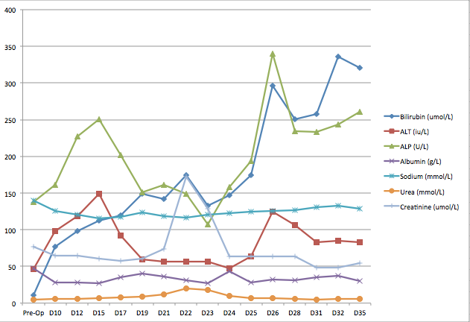
Days since operation (Day 0)
Biochemical values

Figure 2 Trend in biochemical markers following hepatectomy.

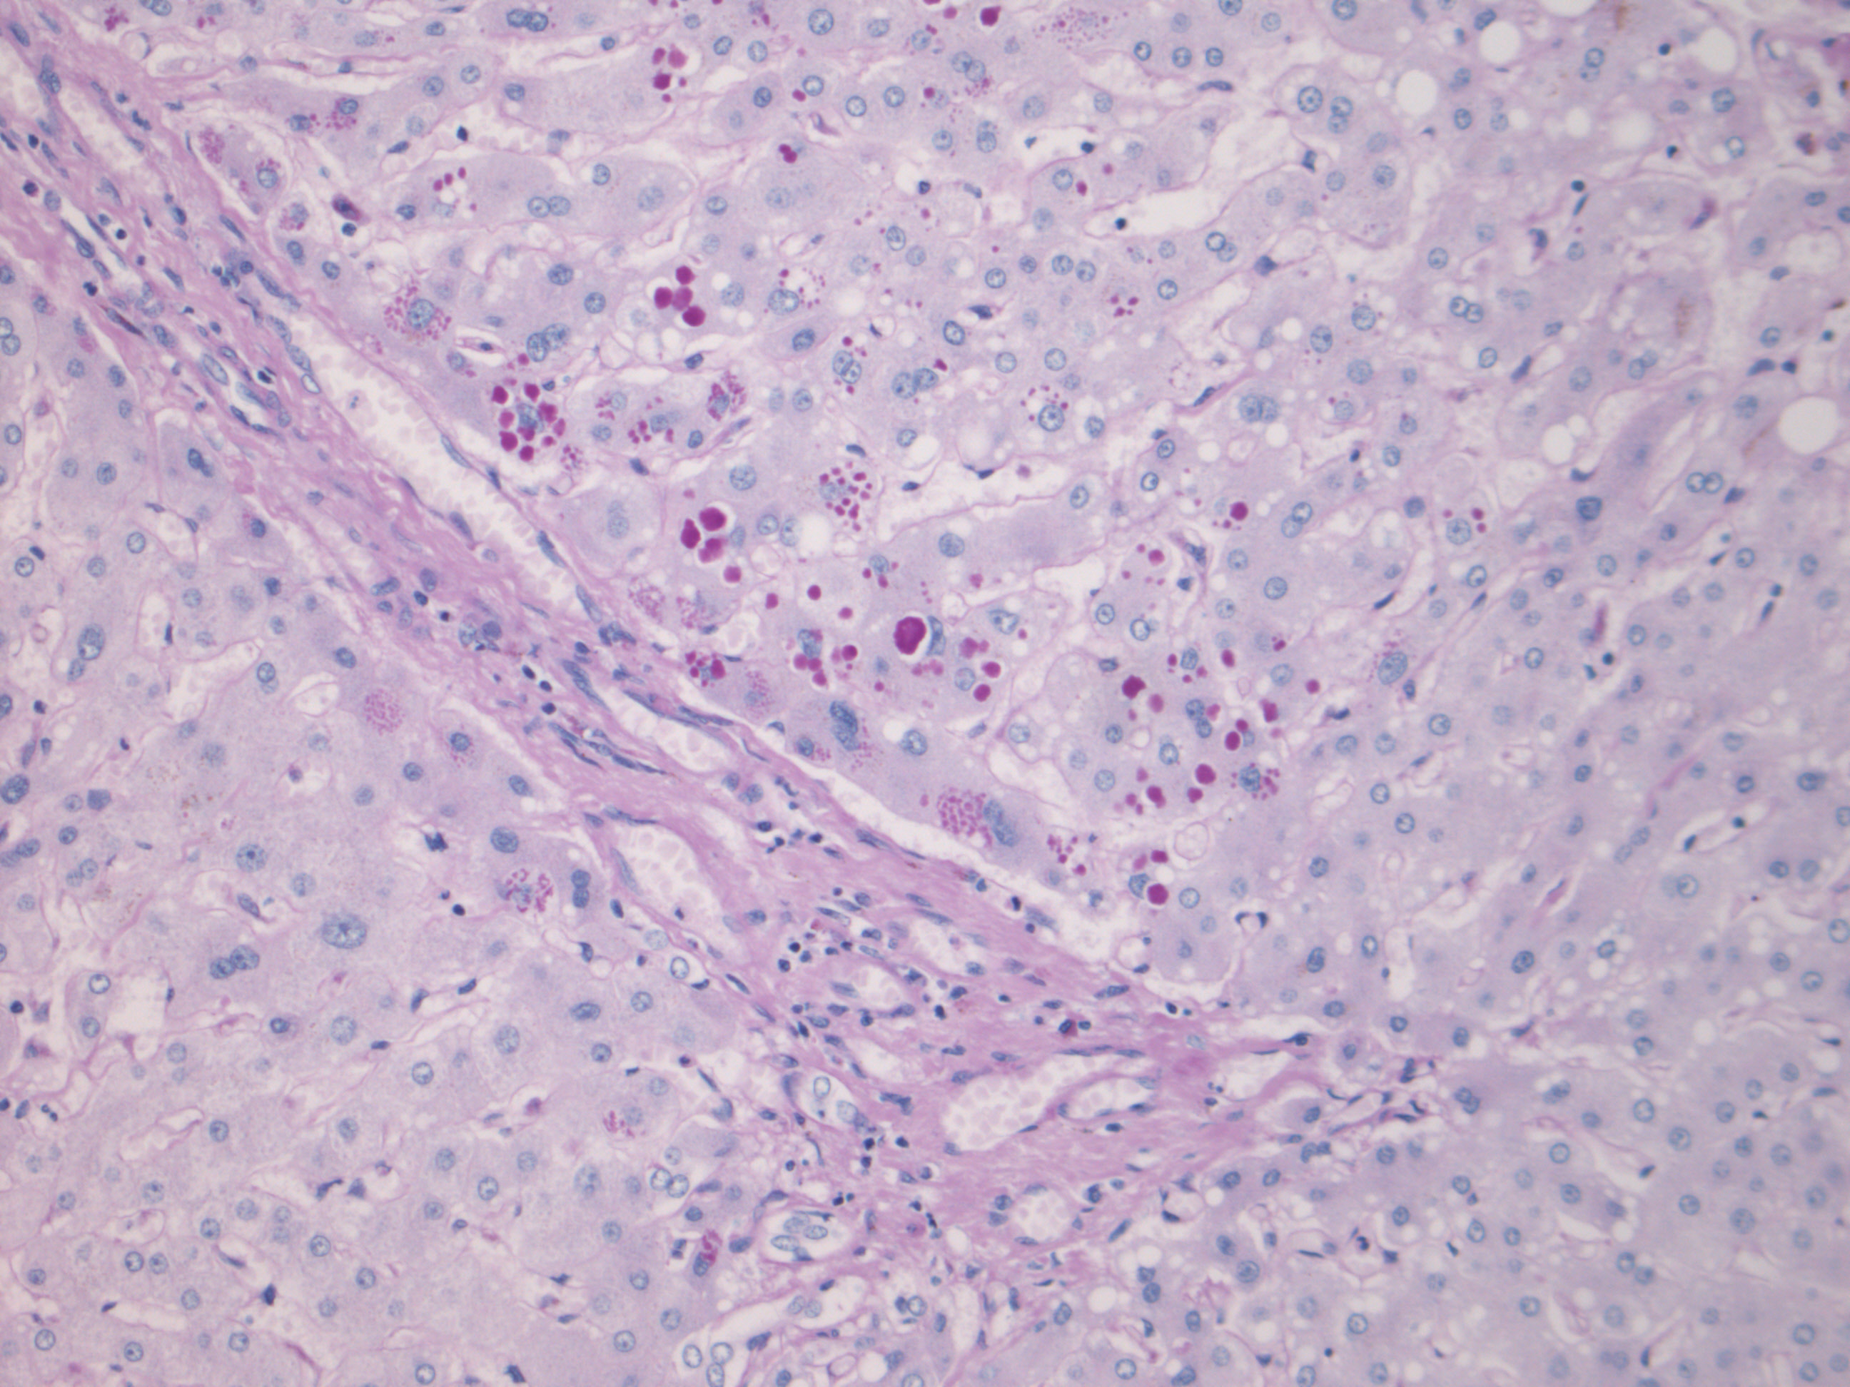

Figure 3 Histopathological findings. Alpha-1-antitrypsin globules within peri-portal hepatocytes (Diastase periodic acid schiff, magnification × 200).

