Name of Journal: World Journal of Hepatology
Manuscript NO: 57564
Manuscript Type: ORIGINAL ARTICLE

Retrospective Study
Real impact of tumor marker AFP and PIVKA-Ⅱ in detecting very small hepatocellular carcinoma (≤ 2 cm, Barcelona stage 0) - assessment with large number of cases

Tarao K et al. Impact of TM in small HCC

Kazuo Tarao, Akito Nozaki, Hirokazu Komatsu, Tatsuji Komatsu, Masataka Taguri, Katsuaki Tanaka, Makoto Chuma, Kazushi Numata, Shin Maeda

Kazuo Tarao, Department of Gastroenterology, Tarao’s Gastroenterological Clinic, Yokohama 241-0821, Japan

Akito Nozaki, Makoto Chuma, Kazushi Numata, Gastroenterological Center, Yokohama City University Medical Center, Yokohama 232-0024, Japan

Hirokazu Komatsu, Department of Gastroenterology, Yokohama Municipal Citizen’s Hospital, Yokohama 221-0855, Japan

Tatsuji Komatsu, Department of Clinical Research, National Hospital Organization Yokohama Medical Center, Yokohama 245-8575, Japan

Masataka Taguri, Department of Data Science, Yokohama City University School of Data Science, Yokohama 236-0004, Japan

Katsuaki Tanaka, Department of Gastroenterology, Hadano Red Cross Hospital, Kanagawa 221-0045, Japan

Shin Maeda, Department of Gastroenterology, Yokohama City University Graduate School of Medicine, Yokohama 236-0004, Japan

Author contributions: Tarao K summarized the data and wrote the paper; Nozaki A, Komatsu H, Komatsu T, Tanaka K, Chuma M, Numata K and Maeda S were responsible for patient follow-up; Taguri M conducted the statistical analyses.

Supported by the Kanagawa Association of Medical and Dental Practitioners.

Corresponding author: Kazuo Tarao, MD, PhD, Director, Department of Gastroenterology, Tarao’s Gastroenterological Clinic, 2-58-6, Taiyo Building Futamatagawa, Asahi-ku, Yokohama 241-0821, Japan. duoluoweih7@gmail.com

Received: June 23, 2020
Revised: August 10, 2020
Accepted: September 2, 2020
Published online:

Abstract
BACKGROUND
In hepatocellular carcinoma (HCC), detection and treatment prior to growth beyond 2 cm are relevant as a larger tumor size is more frequently associated with microvascular invasion and/or satellites.

AIM
To examine the impact of the tumor marker alpha-fetoprotein (AFP) or PIVKA-Ⅱ in detecting very small HCC nodules (≤ 2 cm in maximum diameter, Barcelona stage 0) in the large number of very small HCC. The difference in the behavior of these tumor markers in HCC development was also examined.

METHODS
A total of 933 patients with single-nodule HCC were examined. They were subdivided into 394 patients with HCC nodules ≤ 2 cm in maximum diameter and 539 patients whose nodules were > 2 cm. The rates of patients whose AFP and PIVKA-Ⅱ showed normal values were examined.

RESULTS
The positive ratio of the marker PIVKA-Ⅱ was significantly different (P < 0.0001) between patients with nodules ≤ 2 cm in diameter and those with nodules > 2 cm, but there was no significant difference in AFP (P = 0.4254). In the patients whose tumor was ≤ 2 cm, 50.5% showed normal levels in AFP and 68.8% showed normal levels in PIVKA-Ⅱ. In 36.4% of those patients, both AFP and PIVKA-Ⅱ showed normal levels. The PIVKA-Ⅱ-positive ratio was markedly increased with an increase in the tumor size. In contrast, the positivity in AFP was increased gradually and slowly.

CONCLUSION
In the surveillance of very small HCC nodules (≤ 2 cm in diameter, Barcelona clinical stage 0) the tumor markers AFP and PIVKA-Ⅱ are not so useful.

Key words: Hepatocellular carcinoma; AFP; PIVKA-Ⅱ; Barcelona clinical stage; Tumor markers

Tarao K, Nozaki A, Komatsu H, Komatsu T, Taguri M, Tanaka K, Chuma M, Numata K, Maeda S. Real impact of tumor marker AFP and PIVKA-Ⅱ in detecting very small hepatocellular carcinoma (≤ 2 cm, Barcelona stage 0) - assessment with large number of cases. World J Hepatol 2020; In press

Core tip: In hepatocellular carcinoma, detection and treatment prior to nodule growth of 2 cm (Barcelona stage 0) are relevant as a larger tumor size is more frequently associated with microvascular invasion and/or satellites. We surveyed the real impact of the tumor markers alpha-fetoprotein (AFP) or PIVKA-Ⅱ in detecting very small hepatocellular carcinoma with a large number of cases (≤ 2 cm in diameter 394 cases) and found in AFP that 50.5% and in PIVKA-Ⅱ that 68.8% showed normal levels. Moreover, 36.4% of the patients showed normal levels in both AFP and PIVKA-Ⅱ. In the surveillance of very small hepatocellular carcinoma nodules, the tumor markers are not so useful.
INTRODUCTION
For the detection of hepatocellular carcinoma (HCC) from various liver diseases, especially liver cirrhosis, surveillance with the tumor markers, alpha-fetoprotein (AFP) and PIVKA-Ⅱ, or detection with the imaging modalities, ultrasonography (US) or magnetic resonance imaging (MRI) [computed tomography (CT)], is usually performed.
Detection and treatment prior to growth beyond 2 cm are relevant as a larger tumor size is more frequently associated with microvascular invasion and/or satellites, which are major predictors of recurrence after initial effective treatment^{[1]}. The same tendency was observed by Stravitz et al^{[2]}, and they reported that the early detection of HCC improves the prognosis.
Therefore, we must identify minute HCC nodules (≤ 2 cm in diameter) in the surveillance of HCC. Previous reports concerning the tumor markers AFP and PIVKA-Ⅱ in very small HCCs included a relatively small number of cases. In this retrospective analysis, we examined the precise levels of these markers in a large number of very small HCC cases (< 2 cm in diameter, 394 cases) and whether the tumor marker AFP or PIVKA-Ⅱ is useful to find very small HCC (≤ 2 cm in maximum diameter, Barcelona clinic liver cancer staging 0)^{[3,4]}. Also, we examined the difference in the behavior of these tumor markers in relation to the tumor size of HCC nodules.

MATERIALS AND METHODS
Study population
This was a retrospective study that included 933 patients with single HCC nodules who entered the following three hospitals in Yokohama City for the first time, between January 2008 and January 2019: Gastroenterological Center, Yokohama City University Medical Center, Department of Gastroenterology, Yokohama Municipal Citizen's Hospital, Department of Clinical Research, National Hospital Organization Yokohama Medical Center. HCCs were diagnosed chiefly by dynamic CT and abdominal angiography, which showed early enhancement and early wash out. This work was performed in accordance with the Declaration of Helsinki.
Previously diagnosed HCC was excluded from the protocol. This study was performed after approval by the respective institutional review boards.
The patients were classified according to etiologies of liver diseases: 72 with hepatitis B (presence of hepatitis B surface antigen in serum), 540 with hepatitis C (presence of hepatitis C antibody in serum), 10 with primary biliary cholangitis, five with autoimmune hepatitis, 70 with alcoholic liver diseases, and others (Table 1).

Measurement of PIVKA-Ⅱ and AFP
Samples were collected before the treatment for HCC. Concentrations of PIVKA-Ⅱ and AFP in serum samples were determined by the chemiluminescent enzyme immunoassay in all three hospitals, and the cutoff values for PIVKA-Ⅱ and AFP were 40 mAU/mL and 10 ng/mL, respectively, in every hospital. For PIVKA-Ⅱ and AFP, ≤ 40 mAU/mL and ≤ 10 ng/mL were set as normal values, respectively.

HCC detection
The diagnosis of HCC was confirmed by US, MRI, CT, enhanced dynamic CT, and abdominal angiography. All patients underwent abdominal angiography to confirm the single nodules. The maximum diameter of the HCC nodules was scaled by US or MRI.
Helical dynamic CT and abdominal angiography were performed in almost all patients except the patients with hypersensitivity to iodine and with advanced kidney disease. In the helical dynamic CT, an intravenous bolus injection of contrast material and sequential scanning were performed, and intense homogenous arterial-phase (early enhancement) and early washout were thought to be characteristic of HCC^{[5-7]}. Abdominal angiography was also performed to exclude the benign nodular lesions and to exclude the HCC patients with macrovascular invasion.
The patients with macrovascular invasion or extrahepatic metastasis were excluded. In the hepatectomy performed patients, final decision of HCC was made by pathological diagnosis and cases of benign nodules were excluded.

Statistical analysis
For the comparisons of test-positive proportions between > 2 cm and ≤ 2 cm tumors, we conducted chi-squared tests for AFP and PIVKA-Ⅱ, respectively. To understand the relationships between the tumor size and test-positive proportions for AFP and PIVKA-Ⅱ, we applied logistic regression models using the tumor size as an independent variable and test results (positive or not) as the dependent variable. All reported P values correspond to two-sided tests, and P < 0.05 was considered significant. All analyses were performed with Statistics Analysis System, version 9.4 (Statistics Analysis System Institute, Cary, NC, United States).

RESULTS
The clinical characteristics of the patients are summarized in Table 1. Our study included 933 HCC patients with a single nodule. In total, 622 patients were male, and 311 patients were female. The average age was 72.0 ± 9.6 years. Concerning the tumor size at diagnosis, 394 patients had HCC nodules ≤ 2 cm in maximum diameter, and 539 patients had nodules larger than 2 cm in maximum diameter.
The positive rates of AFP and PIVKA-Ⅱ in patients whose tumor was ≤ 2 cm and those whose tumor size was more than 2 cm are shown in Table 2. The level of PIVKA-Ⅱ showed a significant difference (P < 0.0001), but there was no difference in AFP (P = 0.4254).
Table 3 shows the rates of patients whose AFP and PIVKA-Ⅱ exhibited normal values in those with a maximum tumor size of ≤ 2 cm. In AFP, 50.5% showed normal levels, and in PIVKA-Ⅱ, 68.8% showed normal levels. A more important finding was that, in 36.4% of the patients, both AFP and PIVKA-Ⅱ showed normal levels.
Table 4 shows the treatment methods of all HCC patients. In the very small HCC patients (≤ 2 cm), the radiofrequency ablation group occupied the majority. In the relatively large HCC group (> 2 cm), treatment by transcatheter arterial chemoembolization was the most frequent, followed by hepatectomy and radiofrequency ablation.
Figure 1 shows the relationship between the tumor size and PIVKA-Ⅱ and AFP positivity. The PIVKA-Ⅱ positive ratio was markedly increased with an increase in tumor size. In contrast, the positivity in AFP was increased gradually and slowly.
Figure 2 shows the correlation between the tumor size and PIVKA-Ⅱ levels. The correlation ratio was 0.5691 (P < 0.0001).
Figure 3 shows the correlation between the tumor size and AFP levels. The correlation ratio was 0.1895 (P < 0.0001).

DISCUSSION
Although the early detection of HCC with imaging modalities has been developed in recent years, tumor markers are still commonly used in HCC detection and follow-up.
We demonstrated in this study that 36.4% of the patients whose maximum diameter of HCC nodules was equal to or less than 2.0 cm (Barcelona stage 0) showed normal levels of both AFP and PIVKA-Ⅱ. In support of our results, it was reported that about 30% of HCC patients show false-negative results regarding tumor markers, especially in its early stage^{[4-10]}. Moreover, it was demonstrated that AFP has a sensitivity of about 68% in the diagnosis of HCC, but the sensitivity decreased to about 59% in its early stage^{[11,12]}.
In recent years, Huang et al^{[13]} demonstrated that PIVKA-Ⅱ combined with AFP showed a better diagnostic ability than AFP alone for HCC diagnosis. However, our study confirmed the limitation in detecting HCC in patients with very small single HCC nodules (≤ 2 cm) (Barcelona clinic liver cancer staging 0)^{[3,4]}, even in combination with AFP and PIVKA-Ⅱ.
We demonstrated that more than a third of the patients with minute HCC nodules (≥ 2 cm in diameter) were dropped from surveillance using the tumor markers AFP and PIVKA-Ⅱ alone. Based on the results, we must depend on imaging modalities such as US or MRI (CT) for the surveillance of minute HCC.
Colli et al^{[14]} conducted a systemic review on this issue and found that pooled estimates of 14 US studies were 60.5% (95% confidence interval (CI): 44-76) for sensitivity^{[13-29]}, and that nine MRI studies were 80.6% (95%CI: 70-91) for sensitivity^{[27,30-37]}. The difference in sensitivity between US and MRI may be due to the fact that MRI is less influenced by the operator’s technique and patient's body type.
More recently, Kim et al^{[38]} compared MRI and US in a cohort of 407 patients with cirrhosis who underwent 1100 surveillance examinations and found that MRI had a sensitivity of 83.7% (95%CI: 69.7%-92.2%) for early HCC detection, which was significantly higher than US (25.6%, 95%CI: 14.8%-49.4%). Thus, we must follow-up patients with liver disease, especially liver cirrhosis, at regular intervals (at least every 6 mo) with MRI to detect very small HCC (diameter ≤ 2 cm).
Furthermore, we demonstrated that the PIVKA-Ⅱ positive ratio was markedly increased with an increase in tumor size. In support of this phenomenon, previous studies established the correlation between the PIVKA-Ⅱ level and tumor size^{[16]}, and that PIVKA-Ⅱ maintains the growth of HCC^{[17]}. Moreover, Ma et al^{[18]} reported direct clinical evidence of the correlation between PIVKA-Ⅱ and cell proliferation.

conclusion
More than one third of the patients with very small HCC nodule (≤ 2 cm in diameter, Barcelona stage 0) were dropped from the surveillance using the tumor markers AFP and PIVKA-Ⅱ. So, we must survey patients with liver diseases by MRI at regular intervals to detect very small HCC nodules.

ARTICLE HIGHLIGHTS
Research background
In hepatocellular carcinoma (HCC), detection and treatment prior to growth of 2 cm are relevant as a larger tumor size is more frequently associated with microvascular invasion and/or satellites. However, we often experience cases whose tumor size was ≤ 2 cm and who showed normal values in both AFP and PIVKA-Ⅱ.

Research motivation
Previous reports concerning the tumor markers AFP or PIVKA-Ⅱ in very small HCC included relatively small number of cases, and a larger study is necessary in order to elucidate the precise levels of these markers.

Research objectives
In the present study, we surveyed the levels of AFP and PIVKA-Ⅱ in a large number of very small HCC cases (≤ 2 cm in diameter, 394 cases).

Research methods
We analyzed 933 patients with single HCC nodules and surveyed the limitation of these tumor markers in the surveillance of very small HCC (≤ 2 cm, Barcelona stage 0, 394 cases).

Research results
It was found in patients with very small HCC (≤ 2 cm in diameter) that AFP and PIVKA-Ⅱ levels were normal in 50.5% and 68.8%, respectively. Moreover, 36.4% of the patients showed normal levels of both AFP and PIVKA-Ⅱ. We examined the difference in behavior of these tumor markers in relation to the size of HCC nodules and found that PIVKA-Ⅱ positive ratio was markedly increased with an increase in tumor size, whereas the positivity in AFP was increased gradually and slowly.

Research conclusions
More than one third of the patients with very small HCC nodule (≤ 2 cm in diameter, Barcelona stage 0) were dropped from the surveillance using the tumor markers AFP and PIVKA-Ⅱ.

Research perspectives
We propose that for detecting very small HCC nodules, we must survey patients with liver diseases by imaging modalities, especially by magnetic resonance imaging.

REFERENCES
1 Forner A, Llovet JM, Bruix J. Hepatocellular carcinoma. Lancet 2012; 379: 1245-1255 [PMID: 22353262 DOI: 10.1016/S0140-6736(11)61347-0]
2 Stravitz RT, Heuman DM, Chand N, Sterling RK, Shiffman ML, Luketic VA, Sanyal AJ, Habib A, Mihas AA, Giles HC, Maluf DG, Cotterell AH, Posner MP, Fisher RA. Surveillance for hepatocellular carcinoma in patients with cirrhosis improves outcome. Am J Med2008; 121: 119-126 [PMID: 18261500 DOI: 10.1016/j.amjmed.2007.09.020]
3 Han K, Kim JH. Transarterial chemoembolization in hepatocellular carcinoma treatment: Barcelona clinic liver cancer staging system. World J Gastroenterol 2015; 21: 10327-10335 [PMID: 26420959 DOI: 10.3748/wjg.v21.i36.10327]
4 Kawano Y, Sasaki A, Kai S, Endo Y, Iwaki K, Uchida H, Shibata K, Ohta M, Kitano S. Short- and long-term outcomes after hepatic resection for hepatocellular carcinoma with concomitant esophageal varices in patients with cirrhosis. Ann Surg Oncol 2008; 15: 1670-1676 [PMID: 18368453 DOI: 10.1245/s10434-008-9880-7]
5 Hayashi M, Matsui O, Ueda K, Kawamori Y, Kadoya M, Yoshikawa J, Gabata T, Takashima T, Nonomura A, Nakanuma Y. Correlation between the blood supply and grade of malignancy of hepatocellular nodules associated with liver cirrhosis: evaluation by CT during intraarterial injection of contrast medium. AJR Am J Roentgenol 1999; 172: 969-976 [PMID: 10587130 DOI: 10.2214/ajr.172.4.10587130]
6 Ueda K, Terada T, Nakanuma Y, Matsui O. Vascular supply in adenomatous hyperplasia of the liver and hepatocellular carcinoma: a morphometric study. Hum Pathol 1992; 23: 619-626 [PMID: 1317345 DOI: 10.1016/0046-8177(92)90316-u]
7 Roncalli M, Roz E, Coggi G, Di Rocco MG, Bossi P, Minola E, Gambacorta M, Borzio M. The vascular profile of regenerative and dysplastic nodules of the cirrhotic liver: implications for diagnosis and classification. Hepatology 1999; 30: 1174-1178 [PMID: 10534338 DOI: 10.1002/hep.510300507]
8 Matsuda M, Asakawa M, Amemiya H, Fujii H. Lens culinaris agglutinin-reactive fraction of AFP is a useful prognostic biomarker for survival after repeat hepatic resection for HCC. J Gastroenterol Hepatol 2011; 26: 731-738 [PMID: 21155886 DOI: 10.1111/j.1440-1746.2010.06532.x]
9 Sherman M, Peltekian KM, Lee C. Screening for hepatocellular carcinoma in chronic carriers of hepatitis B virus: incidence and prevalence of hepatocellular carcinoma in a North American urban population. Hepatology 1995; 22: 432-438 [PMID: 7543434 DOI: 10.1002/hep.1840220210]
10 Cui R, He J, Zhang F, Wang B, Ding H, Shen H, Li Y, Chen X. Diagnostic value of protein induced by vitamin K absence (PIVKAII) and hepatoma-specific band of serum gamma-glutamyl transferase (GGTII) as hepatocellular carcinoma markers complementary to alpha-fetoprotein. Br J Cancer 2003; 88: 1878-1882 [PMID: 12799630 DOI: 10.1038/sj.bjc.6601018]
11 Choi JY, Jung SW, Kim HY, Kim M, Kim Y, Kim DG, Oh EJ. Diagnostic value of AFP-L3 and PIVKA-II in hepatocellular carcinoma according to total-AFP. World J Gastroenterol 2013; 19: 339-346 [PMID: 23372355 DOI: 10.3748/wjg.v19.i3.339]
12 Song P, Feng X, Inagaki Y, Song T, Zhang K, Wang Z, Zheng S, Ma K, Li Q, Kong D, Wu Q, Zhang T, Zhao X, Hasegawa K, Sugawara Y, Kokudo N, Tang W; Japan-China Joint Team for Medical Research and Cooperation on HCC. Clinical utility of simultaneous measurement of alpha-fetoprotein and des-γ-carboxy prothrombin for diagnosis of patients with hepatocellular carcinoma in China: A multi-center case-controlled study of 1,153 subjects. Biosci Trends 2014; 8: 266-273 [PMID: 25382443 DOI: 10.5582/bst.2014.01116]
13 Huang S, Jiang F, Wang Y, Yu Y, Ren S, Wang X, Yin P, Lou J. Diagnostic performance of tumor markers AFP and PIVKA-II in Chinese hepatocellular carcinoma patients. Tumour Biol 2017; 39: 1010428317705763 [PMID: 28621228 DOI: 10.1177/1010428317705763]
14 Colli A, Fraquelli M, Casazza G, Massironi S, Colucci A, Conte D, Duca P. Accuracy of ultrasonography, spiral CT, magnetic resonance, and alpha-fetoprotein in diagnosing hepatocellular carcinoma: a systematic review. Am J Gastroenterol 2006; 101: 513-523 [PMID: 16542288 DOI: 10.1111/j.1572-0241.2006.00467.x]
15 Poté N, Cauchy F, Albuquerque M, Voitot H, Belghiti J, Castera L, Puy H, Bedossa P, Paradis V. Performance of PIVKA-II for early hepatocellular carcinoma diagnosis and prediction of microvascular invasion. J Hepatol 2015; 62: 848-854 [PMID: 25450201 DOI: 10.1016/j.jhep.2014.11.005]
16 Shirabe K, Toshima T, Kimura K, Yamashita Y, Ikeda T, Ikegami T, Yoshizumi T, Abe K, Aishima S, Maehara Y. New scoring system for prediction of microvascular invasion in patients with hepatocellular carcinoma. Liver Int 2014; 34: 937-941 [PMID: 24393295 DOI: 10.1111/Liv.12459]
17 Cui SX, Zhang YS, Chu JH, Song ZY, Qu XJ. Des-gamma-carboxy prothrombin (DCP) antagonizes the effects of gefitinib on human hepatocellular carcinoma cells. Cell Physiol Biochem 2015; 35: 201-212 [PMID: 25591763 DOI: 10.1159/000369688]
18 Ma XL, Zhu J, Wu J, Tian L, Gao YY, Zhang CY, Zhou Y, Dai Q, Wang BL, Pan BS, Zhou J, Fan J, Yang XR, Guo W. Significance of PIVKA-II levels for predicting microvascular invasion and tumor cell proliferation in Chinese patients with hepatitis B virus-associated hepatocellular carcinoma. Oncol Lett 2018; 15: 8396-8404 [PMID: 29805574 DOI: 10.3892/ol.2018.8375]
19 Okazaki N, Yoshida T, Yoshino M, Matue H. Screening of patients with chronic liver disease for hepatocellular carcinoma by ultrasonography. Clin Oncol 1984; 10: 241-246 [PMID: 6206972]
20 Maringhini A, Cottone M, Sciarrino E, Marcenò MP, La Seta F, Rinaldi F, Pagliaro L. Ultrasonographic and radionuclide detection of hepatocellular carcinoma in cirrhotics with low alpha-fetoprotein levels. Cancer 1984; 54: 2924-2926 [PMID: 6208995 DOI: 10.1002/1097-0142(19841215)54:12<2924::aid-cncr2820541218>3.0.co;2-f]
21 Kobayashi K, Sugimoto T, Makino H, Kumagai M, Unoura M, Tanaka N, Kato Y, Hattori N. Screening methods for early detection of hepatocellular carcinoma. Hepatology 1985; 5: 1100-1105 [PMID: 2998963 DOI: 10.1002/hep.1840050607]
22 Tanaka S, Kitamura T, Ohshima A, Umeda K, Okuda S, Ohtani T, Tatsuta M, Yamamoto K. Diagnostic accuracy of ultrasonography for hepatocellular carcinoma. Cancer 1986; 58: 344-347 [PMID: 3013391 DOI: 10.1002/1097-0142(19860715)58:2<344::aid-cncr2820580224>3.0.co;2-e]
23 Dodd GD 3rd, Miller WJ, Baron RL, Skolnick ML, Campbell WL. Detection of malignant tumors in end-stage cirrhotic livers: efficacy of sonography as a screening technique. AJR Am J Roentgenol 1992; 159: 727-733 [PMID: 1326883 DOI: 10.2214/ajr.159.4.1326883]
24 Saada J, Bhattacharya S, Dhillon AP, Dick R, Burroughs AK, Rolles K, Davidson BR. Detection of small hepatocellular carcinomas in cirrhotic livers using iodised oil computed tomography. Gut 1997; 41: 404-407 [PMID: 9378400 DOI: 10.1136/gut.41.3.404]
25 Chalasani N, Horlander JC Sr, Said A, Hoen H, Kopecky KK, Stockberger SM Jr, Manam R, Kwo PY, Lumeng L. Screening for hepatocellular carcinoma in patients with advanced cirrhosis. Am J Gastroenterol 1999; 94: 2988-2993 [PMID: 10520857 DOI: 10.1111/j.1572-0241.1999.01448.x]
26 Gambarin-Gelwan M, Wolf DC, Shapiro R, Schwartz ME, Min AD. Sensitivity of commonly available screening tests in detecting hepatocellular carcinoma in cirrhotic patients undergoing liver transplantation. Am J Gastroenterol 2000; 95: 1535-1538 [PMID: 10894592 DOI: 10.1111/j.1572-0241.2000.02091.x]
27 Rode A, Bancel B, Douek P, Chevallier M, Vilgrain V, Picaud G, Henry L, Berger F, Bizollon T, Gaudin JL, Ducerf C. Small nodule detection in cirrhotic livers: evaluation with US, spiral CT, and MRI and correlation with pathologic examination of explanted liver. J Comput Assist Tomogr 2001; 25: 327-336 [PMID: 11351179 DOI: 10.1097/00004728-200105000-00001]
28 Kim CK, Lim JH, Lee WJ. Detection of hepatocellular carcinomas and dysplastic nodules in cirrhotic liver: accuracy of ultrasonography in transplant patients. J Ultrasound Med 2001; 20: 99-104 [PMID: 11211142 DOI: 10.7863/jum.2001.20.2.99]
29 Bennett GL, Krinsky GA, Abitbol RJ, Kim SY, Theise ND, Teperman LW. Sonographic detection of hepatocellular carcinoma and dysplastic nodules in cirrhosis: correlation of pretransplantation sonography and liver explant pathology in 200 patients. AJR Am J Roentgenol 2002; 179: 75-80 [PMID: 12076908 DOI: 10.2214/ajr.179.1.1790075]
30 Teefey SA, Hildeboldt CC, Dehdashti F, Siegel BA, Peters MG, Heiken JP, Brown JJ, McFarland EG, Middleton WD, Balfe DM, Ritter JH. Detection of primary hepatic malignancy in liver transplant candidates: prospective comparison of CT, MR imaging, US, and PET. Radiology 2003; 226: 533-542 [PMID: 12563151 DOI: 10.1148/radiol.2262011980]
31 Libbrecht L, Bielen D, Verslype C, Vanbeckevoort D, Pirenne J, Nevens F, Desmet V, Roskams T. Focal lesions in cirrhotic explant livers: pathological evaluation and accuracy of pretransplantation imaging examinations. Liver Transpl 2002; 8: 749-761 [PMID: 12200773 DOI: 10.1053/jlts.2002.34922]
32 Born M, Layer G, Kreft B, Schwarz N, Schild H. [MRI, CT and CT arterial portography in the diagnosis of malignant liver tumors in liver cirrhosis]. Rofo 1998; 168: 567-572 [PMID: 9687948 DOI: 10.1055/s-2007-1015282]
33 Krinsky GA, Lee VS, Theise ND, Weinreb JC, Rofsky NM, Diflo T, Teperman LW. Hepatocellular carcinoma and dysplastic nodules in patients with cirrhosis: prospective diagnosis with MR imaging and explantation correlation. Radiology 2001; 219: 445-454 [PMID: 11323471 DOI: 10.1148/radiology.219.2.r01ma40445]
34 Burrel M, Llovet JM, Ayuso C, Iglesias C, Sala M, Miquel R, Caralt T, Ayuso JR, Solé M, Sanchez M, Brú C, Bruix J; Barcelona Clínic Liver Cancer Group. MRI angiography is superior to helical CT for detection of HCC prior to liver transplantation: an explant correlation. Hepatology 2003; 38: 1034-1042 [PMID: 14512891 DOI: 10.1053/jhep.2003.50409]
35 de Lédinghen V, Laharie D, Lecesne R, Le Bail B, Winnock M, Bernard PH, Saric J, Couzigou P, Balabaud C, Bioulac-Sage P, Drouillard J. Detection of nodules in liver cirrhosis: spiral computed tomography or magnetic resonance imaging? A prospective study of 88 nodules in 34 patients. Eur J Gastroenterol Hepatol 2002; 14: 159-165 [PMID: 11981340 DOI: 10.1097/00042737-200202000-00010]
36 Bhartia B, Ward J, Guthrie JA, Robinson PJ. Hepatocellular carcinoma in cirrhotic livers: double-contrast thin-section MR imaging with pathologic correlation of explanted tissue. AJR Am J Roentgenol 2003; 180: 577-584 [PMID: 12591657 DOI: 10.2214/ajr.180.3.1800577]
37 Mori K, Scheidler J, Helmberger T, Holzknecht N, Schauer R, Schirren CA, Bittmann I, Dugas M, Reiser M. Detection of malignant hepatic lesions before orthotopic liver transplantation: accuracy of ferumoxides-enhanced MR imaging. AJR Am J Roentgenol 2002; 179: 1045-1051 [PMID: 12239063 DOI: 10.2214/ajr.179.4.1791045]
38 Kim SY, An J, Lim YS, Han S, Lee JY, Byun JH, Won HJ, Lee SJ, Lee HC, Lee YS. MRI With Liver-Specific Contrast for Surveillance of Patients With Cirrhosis at High Risk of Hepatocellular Carcinoma. JAMA Oncol 2017; 3: 456-463 [PMID: 27657493 DOI: 10.1001/jamaoncol.2016.3147]

Footnotes
Institutional review board statement: The study was reviewed and approved by the Yokohama Municipal Citizen’s Hospital Institutional Review Board (Approval No. 19-02-03).

Informed consent statement: This study is a retrospective observational study and does not require consent form.

Conflict-of-interest statement: Tanaka K has received research funding from Bristol-Myers Squibb and Abb Vie; Nozaki A has received research funding from Gilead Sciences; Tarao K, Komatsu H, Komatsu T, Taguri M, Chuma M, Numata K and Maeda S, declare that they have no conflict of interest.

Data sharing statement: The datasets used and/or analyzed during the current study are available from the corresponding author on reasonable request.

Open-Access: This article is an open-access article that was selected by an in-house editor and fully peer-reviewed by external reviewers. It is distributed in accordance with the Creative Commons Attribution NonCommercial (CC BY-NC 4.0) license, which permits others to distribute, remix, adapt, build upon this work non-commercially, and license their derivative works on different terms, provided the original work is properly cited and the use is non-commercial. See: http://creativecommons.org/Licenses/by-nc/4.0/

Manuscript source: Unsolicited manuscript

Peer-review started: June 23, 2020
First decision: July 30, 2020
Article in press:

Specialty type: Gastroenterology and hepatology
Country/Territory of origin: Japan
Peer-review report’s scientific quality classification
Grade A (Excellent): 0
Grade B (Very good): 0
Grade C (Good): C, C
Grade D (Fair): 0
Grade E (Poor): 0

P-Reviewer: Wang GY, Zhong JH S-Editor: Zhang L L-Editor: Filipodia P-Editor:

Figure Legends
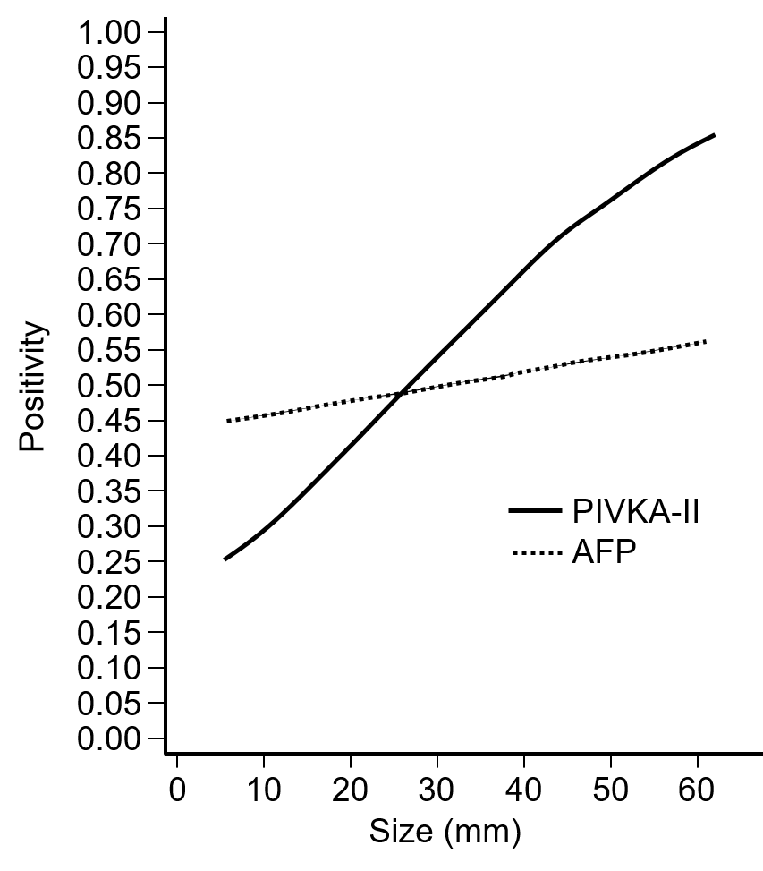
Figure 1 Relationship between tumor size and PIVKA-Ⅱ and alpha-fetoprotein positivity. AFP: Alpha-fetoprotein.
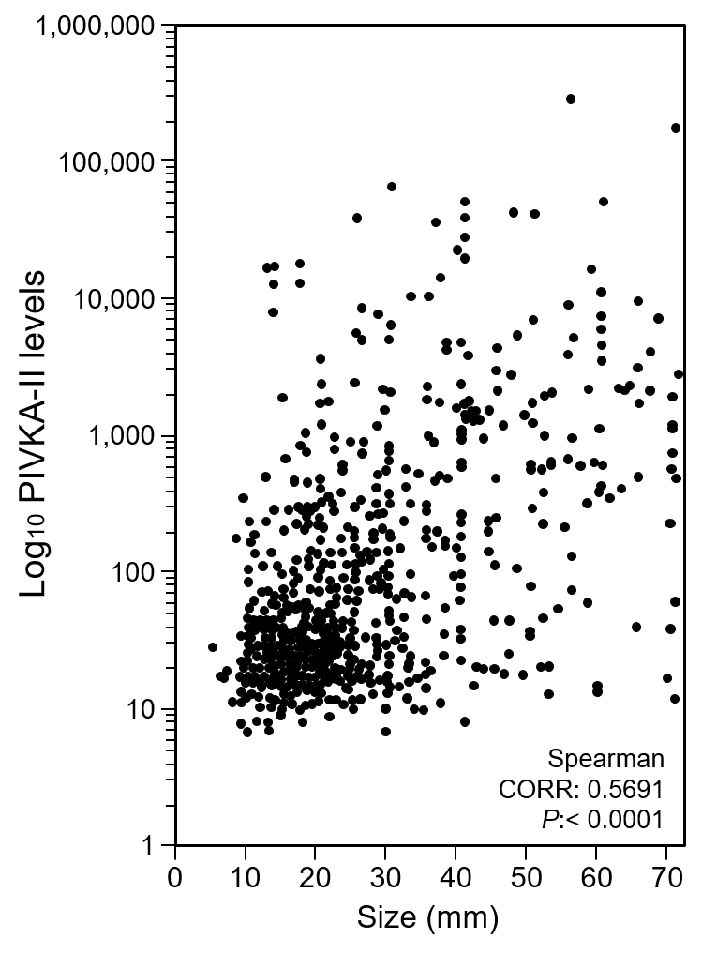
Figure 2 Correlation between tumor size and PIVKA-Ⅱ levels.
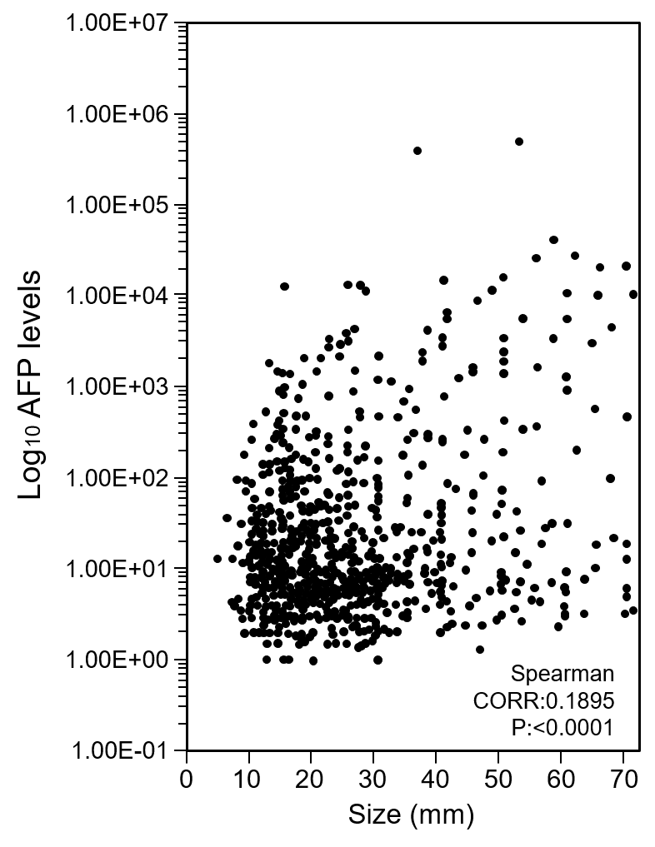
Figure 3 Correlation between tumor size and alpha-fetoprotein levels. AFP: Alpha-fetoprotein.
Table 1 Background of the hepatocellular carcinoma patients
 | Maximum diameter of nodules
 |  | ≤ 20 mm | > 20 mm
Number of patients |  | 394 | 539
Sex | Male | 230 (58.4%) | 392 (72.7%)
 | Female | 164 (41.6%) | 147 (22.3%)
Age in yr |  | 71.3 ± 8.8 | 72.5 ± 10.1
Etiology | HBV | 33 (8.4%) | 39 (7.2%)
 | HCV | 274 (69.5%) | 266 (49.4%)
 | PBC | 4 (1.0%) | 6 (1.1%)
 | Alcohol | 17 (4.3%) | 53 (9.8%)
 | NASH | 4 (1.0%) | 8 (1.5%)
 | Autoimmune hepatitis | 3 (0.8%) | 2 (0.4%)
 | Unknown | 23 (5.8%) | 62 (11.5%)
HBV: Hepatitis B virus; HCV: Hepatitis C virus; NASH: Non-alcoholic steatohepatitis; PBC: Primary biliary cirrhosis.
Table 2 Positive rates of alpha-fetoprotein and PIVKA-Ⅱ in patients whose tumor size was ≤ 2 cm and those whose tumor size was more than 2 cm
 |  | Maximum diameter of HCC nodules |  | P value¹
 |  | ≤ 2 cm, n = 394 | > 2 cm, n =539
AFP | (+) | 195 (49.5%) | 281 (52.1%) | 0.4254
 | (-) | 199 (50.5%) | 258 (47.9%)
PIVKA | (+) | 123 (31.2%) | 385 (71.4%) | < 0.0001
 | (-) | 271 (68.8%) | 154 (28.6%)
¹χ² tests. AFP: Alpha-fetoprotein; HCC: Hepatocellular carcinoma.

Table 3 The rates of patients whose alpha-fetoprotein and PIVKA-Ⅱ showed normal values in those whose maximum tumor size was ≤ 2 cm, n = 394 cases
HCC tumor marker | No. of cases (%)
AFP, normal cases | 199 (50.5)
PIVKA-Ⅱ, normal cases | 271 (68.8)
Both AFP and PIVKA-Ⅱ, normal cases | 142 (36.4)
AFP: Alpha-fetoprotein; HCC: Hepatocellular carcinoma.

Table 4 Treatment methods of hepatocellular carcinoma patients
Therapy | No of treated patients
 | Group
 | ≤ 2 cm, n = 394 | > 2 cm, n = 539
Hepatectomy | 45 | 110
RFA | 223 | 107
TACE | 56 | 136
TACE + RFA | 6 | 32
TAI | 2 | 10
Chemotherapy | 9 | 21
BSC | 10 | 60
Others | 13 | 63
BSC: Best supportive care; RFA: Radiofrequency ablation; TACE: Transcatheter arterial chemoembolization; TAI: Transcatheter arterial infusion.

