Name of Journal: World Journal of Clinical Cases
Manuscript NO: 48448
Manuscript: ORIGINAL ARTICLE

Basic Study
Reduced microRNA-451 expression in eutopic endometrium contributes to the pathogenesis of endometriosis

Gao S et al. Effect of miRNA-451 on endometriosis

Shan Gao, Shuang Liu, Zi-Ming Gao, Peng Deng, Dan-Bo Wang

Shan Gao, Shuang Liu, Department of Obstetrics and Gynecology, Shengjing Hospital of China Medical University, Shenyang 110042, Liaoning Province, China

Zi-Ming Gao, Peng Deng, Department of Surgical Oncology and General Surgery, First Affiliated Hospital of China Medical University, Shenyang 110042, Liaoning Province, China

Dan-Bo Wang, Department of Gynecology, Cancer Hospital of China Medical University, Liaoning Cancer Hospital and Institute, Shenyang 110042, Liaoning Province, China

ORCID number: Shan Gao (0000-0003-4020-6815); Shuang Liu (0000-0001-6741-2876); Zi-Ming Gao (0000-0002-8968-6015); Peng Deng (0000-0002-5036-4385); Dan-Bo Wang (0000-0002-6685-7328).

Author contributions: Gao S performed the majority of the experiments and analyzed the data; Liu S and Deng P performed the molecular investigations; Wang DB conceived and designed the experiments; Gao S and Gao ZM wrote the manuscript.

Institutional review board statement: This study was reviewed and approved by the Ethics Committee of China Medical University.

Conflict of interest statement: All authors declare no conflicts of interest.

Data sharing statement: No additional data are available.

Open-Access: This article is an open-access article which was selected by an in-house editor and fully peer-reviewed by external reviewers. It is distributed in accordance with the Creative Commons Attribution Non Commercial (CC BY-NC 4.0) license, which permits others to distribute, remix, adapt, build upon this work non-commercially, and license their derivative works on different terms, provided the original work is properly cited and the use is non-commercial. See: http://creativecommons.org/licenses/by-nc/4.0/

Manuscript source: Unsolicited manuscript

Corresponding author: Dan-Bo Wang, MD, Professor, Department of Gynecology, Cancer Hospital of China Medical University, Liaoning Cancer Hospital and Institute, No. 44, Xiaoheyan Road, Dadong District, Shenyang 110042, Liaoning Province, China. wangdb_cmu@126.com
Telephone: +86-13840265165

Received: May 13, 2019
Peer-review started: May 21, 2019
First decision: July 30, 2019
Revised: August 6, 2019
Accepted: August 20, 2019
Article in press: August 20, 2019
Published online: August 26, 2019

Abstract
BACKGROUND
Endometriosis (EMs) is a chronic and recurrent, but benign, disease in women of reproductive age, and EMs patients have a high risk of developing gynecological tumors and autoimmune disorders. The etiology of EMs is not clear. Certain genetic markers in the eutopic endometrium are key in the pathogenesis of EMs. MicroRNAs (miRNAs) are implicated in several biological processes, such as cell proliferation, differentiation, and apoptosis. MiR-451 is interesting, as it acts as a tumor suppressor and is relevant to the poor prognosis of cancers.

AIM
To evaluate the expression levels and role of miR-451 in the eutopic endometrium and predict possible targets of miR-451 and related signaling pathways.

METHODS
Quantitative real-time polymerase chain reaction was used to evaluate miR-451 expression in cultured cell lines as well as in pathologic tissues from 40 patients with EMs and 20 donors with no history of the disease (controls). Cell Counting Kit-8 and flow cytometric assays were performed to determine cell proliferation and survival rates after transfection with miR-451 mimics and siRNAs. MiR-451 targets were predicted using miRDB and miRcode target-predicting databases.

RESULTS
We observed lower miR-451 levels in eutopic endometrial tissues from patients with EMs than in control tissues, and this difference was not related to the American Society for Reproductive Medicine stage. Ectopic overexpression of miR-451 in eutopic cells induced apoptosis and inhibited cell proliferation. SiRNA-mediated miR-451 knockdown reversed these effects. Using miRDB and miRcode, we identified 12 potential miR-451 target genes. We hypothesize that the expression of YWHAZ, OSR1, TTN, and CDKN2D may be regulated by miR-451 and be involved in disease pathogenesis.

CONCLUSION
Reduced miR-451 expression in the eutopic endometrium contributes to the pathogenesis of EMs by promoting cell proliferation and reducing apoptosis. Thus, miR-451 is a novel biomarker for EMs. YWHAZ, OSR1, TTN, and CDKN2D are potential target genes of miR-451 and may have key roles in this disease.

Key words: Endometriosis; miR-451; Proliferation; Apoptosis; Pathogenesis

© The Author(s) 2019. Published by Baishideng Publishing Group Inc. All rights reserved.

Core tip: Despite the high prevalence of endometriosis (EMs), its etiology is unclear. This study focuses on the expression of miR-451 in patients diagnosed with EMs. We report miR-451 as a novel biomarker of EMs as it is downregulated in the eutopic endometrium. YWHAZ, OSR1, TTN, and CDKN2D were identified as potential target genes of miR-451 that may have important roles in disease pathogenesis. We believe that our study contributes significantly to the literature because it suggests a novel biomarker for EMs that may facilitate the early diagnosis of the disease without the need for invasive methods such as laparoscopic examination.

Citation: Gao S, Liu S, Gao ZM, Deng P, Wang DB. Reduced microRNA-451 expression in eutopic endometrium contributes to the pathogenesis of endometriosis. World J Clin Cases 2019; 7(16): 2155-2164
URL: https://www.wjgnet.com/2307-8960/full/v7/i16/2155.htm
DOI: https://dx.doi.org/10.12998/wjcc.v7.i16.2155

INTRODUCTION
Endometriosis (EMs) is a chronic and recurrent, but benign, disease in women of reproductive age, with a morbidity of approximately 10%. It is characterized by the presence of functional endometrial glands and stroma outside the uterine cavity^{[1,2]}. Typical symptoms of EMs include cyclic pelvic pain, dysmenorrhea, dyspareunia, and infertility. Previous studies have reported that EMs patients have a high risk of developing gynecological tumors and autoimmune disorders^{[3,4]}. Thus, EMs can cause severe psychological and physiological harm to those affected by it and imposes a substantial social burden^{[5,6]}.
Despite its high prevalence and incapacitating symptoms, the etiology of EMs is not clear. Evidence suggests that it is a multifactorial disease. Retrograde menstruation, immune system disorders, and genetic and environmental factors have been proposed as susceptibility factors for EMs^{[7-9]}. The susceptibility factor of retrograde menstruation proposed by Sampson is the most widely accepted^{[10]}. However, almost all women of reproductive age exhibit some degree of retrograde menstruation, and only 10% to 15% suffer from EMs^{[11,12]}. Recently, more evidence has emerged to support the theory that genetic changes in the eutopic endometrium may be the key molecular events in the pathogenesis of EMs^{[13]}.
MicroRNAs (miRNAs) are short noncoding RNA molecules that regulate genetic expression post-transcriptionally and are implicated in several biological processes, such as cell proliferation, differentiation, and apoptosis^{[14,15]}. Some miRNAs have been reported to be abnormally expressed in reproductive cancers^{[12,16,17]}, and miR-451 is of particular interest, as it acts as a tumor suppressor and is relevant to the poor prognosis of cancers. Aberrant miR-451 expression has been shown in eutopic and ectopic endometrial tissues; however, data regarding differences in miR-451 expression in the eutopic endometrium from healthy patients and those with EMs remain inconclusive^{[18,19]}.
In our study, we examined miR-451 expression in the eutopic endometrium of women with and without EMs and evaluated the role of miR-451 in cell proliferation. Finally, we predicted possible targets of miR-451 and the related signaling pathways.

MATERIALS AND METHODS
Tissue collection
Pathologic tissues were collected from patients with grade III cervical intraepithelial neoplasia, including 40 with EMs and 20 without. All 60 subjects underwent total hysterectomy at the Shengjing Hospital of China Medical University between 2009 and 2010. The EMs group included 2, 6, 20, and 12 cases at American Society for Reproductive Medicine (ASRM) stage I, II, III, and IV, respectively, of the disease. None of the patients had a history of endocrine, immune, or metabolic disorders and none had received any hormonal or antibiotic treatments within 3 mo prior to surgery.

Cell lines and culture
The ectopic and eutopic endometrial tissues were digested overnight at 37 °C with Dispase IV for 70 min and Dispase II for 50 min (Sigma, United States). After filtration through 100 and 400 mesh nylon screens, the obtained primary cells were rinsed in PBS and then cultured for 24 h in DMEM/F12 medium supplemented with 15% fetal bovine serum and antibiotics at 37 °C in an atmosphere containing 5% CO₂.

Quantitative real-time PCR (qRT-PCR)
Total RNA was isolated from the EMs tissues using the TRIzol reagent. cDNA was synthesized from miR-451 using a TaqMan® miRNA Reverse Transcription Kit and used in a 1:5 dilution ratio for qRT-PCR, which was performed, using an miRNA Assays kit and Universal Master Mix following the kit protocols (Applied Biosystems). U6 was used as the endogenous control. Conditions of reverse transcription were as follows: 16 °C for 30 min, 42 °C for 30 min, 85 °C for 5 min, and then holding at 4 °C. Conditions for qRT-PCR were as follows: enzyme activation at 95 °C for 10 min followed by 40 cycles of denaturation for 15 s at 95 °C and annealing and extension for 60 s at 60 °C. All experimental samples were run in triplicate and each qRT-PCR reaction was repeated at least two times. MiR-451 expression levels were calculated and analyzed using the 2^{−ΔΔCt} relative quantitation method.

Transfection
Using LipofectamineTM 2000 reagent, miR-451 mimics and miR-451 inhibitors were transfected into EMs cells and normal endometrial cells, respectively. The oligonucleotide sequence of the miR-451 mimic is 5′-AAACCGUUACCAUUACUGAGUU-3′, and its NC sequence is 5′-UUCUCCGAACGUGUCACGUTT-3′. The oligonucleotide sequence of the miR-451 inhibitor is 5′-AACUCAGUAAUGGUAACGGUUU-3′, and the sequence of the scrambled siRNA is 5′-CAGUACUUUUGUGUAGUACAA-3’. In addition, cells transfected with or without the empty vector were used as the control groups. All cells were incubated at 37 °C in an atmosphere containing 5% CO₂ for 24 to 96 h post transfection.

Cell proliferation analysis
Cellular proliferation analysis was performed using the Cell Counting Kit-8 (CCK-8) assay. After transfection with miR-451 mimics/inhibitors for 24h, 48h, 72h, and 96 h, 2 × 10³ cells were added to 96-well plates and incubated overnight at 37 °C in an atmosphere containing 5% CO₂. Then, 10 μL of CCK-8 was added to each well (Beyotime Biotechnology). The cells were incubated for another 4 h at 37 °C in an atmosphere containing 5% CO₂, and then cell viability was determined by measuring the optical density at 450 nm.

Flow cytometry to assess apoptosis
Annexin V-FITC/PI double-staining assays were performed for analysis of apoptosis. Cells were collected and suspended in PBS 24 h after transfection. Cells were then stained in 500 μL of binding buffer with 5 μL of each of annexin V-FITC and PI (KeyGen Biotech), incubated in the dark at room temperature for 5-15 min, and subjected to flow cytometric analysis to assess cellular apoptosis within 1 h.

Prediction of target genes and microarray data
Using miRDB (http://mirdb.org/miRDB/index.html) and miRcode (http://www.mircode.org/), we predicted the target genes of miR-451. Expression levels of the identified targeted genes were determined by analyzing the GSE7846 gene profile from the GEO database (https://www.ncbi.nlm.nih.gov/geo/). This dataset includes the expression data of endometrial cells derived from patients with EMs (ectopic group) and without EMs (normal group). We screened the differentially expressed genes with a P-value < 0.01 and an adjusted P-value < 0.01 between the EMs and control groups.

Statistical analysis
Data are expressed as the mean ± SEM. Statistical comparisons between groups were determined using the t-test and χ² test. Statistical significance was defined as p < 0.05. Analyses were performed using the R 3.4.2 and SPSS 22.0 software.

Ethics approval and informed consent
This study was approved by the China Medical University Research Ethics Committee according to the Helsinki Declaration, and written informed consent was obtained from each study participant.

RESULTS
MiR-451 expression is reduced in eutopic tissues and cell lines derived from EMs patients compared to the controls
qRT-PCR was performed to quantitatively analyze the expression levels of miR-451 in eutopic tissues from the EMs and control groups. As shown in Figure 1A, we observed a significant reduction in miR-451 expression in the EMs group compared to the control group (EMs, 0.22 ± 0.06; control, 1.12 ± 0.11, p < 0.01). Consistent with the tissue results, miR-451 expression in cells was significantly lower in the EMs group than in the control group (Figure 1B). The correlation of miR-451 expression levels with ASRM stage was then analyzed, as shown in Table 1. No significant association was found between miR-451 expression and ASRM stage (p > 0.05).

MiR-451 mimic inhibits cell proliferation and induces apoptosis in EMs eutopic cells
MiR-451 levels in eutopic cells transfected with miR-451 mimic were higher than those in the non-transfected control and scrambled mimic oligomer groups (miR-451 mimic, 1.33 ± 0.28; control, 0.25 ± 0.06; scrambled, 0.32 ± 0.09, p < 0.01) (Figure 2A). CCK-8 assay results showed that transfection with miR-451 mimic suppressed the proliferation rate of EMs cells (Figure 2B). To investigate whether the reduced cell proliferation resulted from apoptosis, we evaluated the effect of miR-451 mimic on cellular apoptosis using flow cytometry. MiR-451 mimic induced early apoptosis in a larger number of cells compared to scrambled oligonucleotides, and this difference was statistically significant (p < 0.01) (Figure 2C and 2D). Thus, overexpression of miR-451 in EMs cells induces apoptosis and inhibits cell proliferation.

Transfection of miR-451 siRNA into control eutopic cells promotes cell proliferation and inhibits cell apoptosis
As shown in Figure 3A, miR-451 expression was significantly attenuated in the siRNA-transfected group compared to the non-transfected and scrambled mimic oligomer groups (miR-451 siRNA, 0.41 ± 0.14; control, 1.23 ± 0.08; scrambled, 1.06 ± 0.06, p < 0.01). Additionally, the proliferation ability of miR-451 siRNA-transfected cells was greater than that of the other two groups (Figure 3B). We used flow cytometric assay to evaluate the effect of miR-451 siRNA transfection on apoptosis. Our results showed that the proportion of early apoptotic cells was significantly lower in the miR-451 siRNA group compared to that in the scrambled group (p < 0.01) (Figure 3C and 3D). These results indicate that, in eutopic cells, miR-451 reduces apoptosis and increases cell proliferation.

Prediction of miR-451 target genes
Using the miRDB and miRcode miRNA target prediction databases, we identified a total of 12 genes targeted by miR-451, namely, OSR1, MEX3C, CUX2, ZNF644, TBC1D9B, DCAF5, CDKN2B, TTN, YWHAZ, CDKN2D, EIF2AK3, and TBX1 (Figure 4A). As shown in Figure 4B, among the targeted genes, the expression levels of OSR1, YWHAZ, TTN, and CDKN2D were significantly different between the two groups according to GSE7846 (p < 0.05, adj. p < 0.05). The logFC values of OSR1, YWHAZ, TTN, and CDKN2D were 0.76, 0.43, 0.33, and 0.63, respectively. Furthermore, according to the pathway analysis data in the Kyoto Encyclopedia of Genes and Genomes, YWHAZ and CDKN2D may have important roles in the cell cycle in EMs (Figure 4C).

DISCUSSION
In this study, qRT-PCR analysis of eutopic endometrial tissues and cells showed that miR-451 was significantly downregulated in patients with EMs compared to normal controls (p = 0.011). Although we did not observe a significant association between miR-451 expression and the ASRM stage of EMs, ectopic overexpression of miR-451 in eutopic cells in EMs was shown to be associated with reduced cell proliferation and increased apoptosis. Conversely, siRNA-mediated knockdown of miR-451 promoted the proliferation and reduced the apoptosis of eutopic cells.
The “eutopic endometrium determinism” theory suggests that the occurrence of EMs is mainly dependent on the characteristics of eutopic endometrial lesions, and retrograde menstruation may act as a precipitating factor. Thus, genetic dysregulation in the endometrium is crucial in the pathogenesis of EMs. Identifying differentially expressed genes between patients with and without EMs would serve as a minimally invasive method to diagnose EMs and evaluate the risk of recurrence. For example, Mahdian et al^{[20]} reported that MIF, CD74, and COX-2 are essential in inflammation and endometrium reconstruction during the menstrual cycle, and increased expression of these genes is a molecular biomarker for the development and pathophysiology of EMs. In addition, Sapkota et al^{[21]} also identified five novel loci (CCDC170, FN1, SYNE1, ESR1, and FSHB) and nineteen independent single nucleotide polymorphisms that are significantly associated with the risk of EMs.
Furthermore, miRNAs regulate the expression of target genes and key cellular processes in EMs. In 2009, Burney et al^{[14]} reported the downregulation of the miR-9 and miR-34 miRNA families in eutopic cells in the setting of EMs, and this downregulation is closely related to progesterone resistance in early secretory endometrium. Laudanski et al^{[22]} showed that miR-483-5p and miR-629-3p are downregulated in EMs, and this is associated with inflammation. Moreover, miR-21 was shown to be significantly upregulated in severe EMs (stage III/IV) compared to mild EMs (stage I/II)^{[23]}. Notably, miR-451 has been established as a tumor-suppressor gene in gastric, colorectal, bladder, and non-small cell lung carcinomas^{[24]}, and it was also shown to be downregulated in ovarian cancer compared to its concurrent EMs^{[25]}. In addition, Nothnick et al^{[26]} showed that deficiency of miR-451 regulates fibrinogen alpha chain and reduces endometrial implantation in a mouse model. Similarly, we found that miR-451 was downregulated in the eutopic endometrium in EMs compared to normal controls in studies involving both tissues and cells.
Using miRNA target-predicting databases, we identified 12 potential target genes of miR-451 and analyzed their expression levels according to the GSE7846 dataset. Finally, a total of four genes, YWHAZ, OSR1, TTN, and CDKN2D, were selected for further analysis. Among these target genes of miR-451, YWHAZ has previously been shown to be overexpressed in tissues in EMs^{[19,27]}. Joshi et al reported that miR-451 regulates YWHAZ expression and promotes proliferation of eutopic cells in baboons with EMs^{[19]}. However, the roles of OSR1, TTN, and CDKN2D in EMs have not been reported until now. Published reports suggest that OSR1 inhibits proliferation and induces cellular apoptosis by acting on the WNK and NF-κB pathways, and OSR1 is dramatically downregulated in several carcinomas^{[28-30]}. In addition, CDKN2D has been shown to be involved in carcinogenesis and has been identified in gynecological cancers. This gene may be regulated by miR-451 in esophageal carcinoma cell lines^{[31]}. Thus, our study provides several novel therapeutic targets for EMs.
Notably, most studies on EMs have only focused on identifying differences between ectopic lesions and eutopic endometrium. For example, Graham et al^{[18]} reported that miR-451 is overexpressed in ectopic lesions compared to eutopic lesions and reduces cell survival by regulating MIF. In this study, we found significant differences in miR-451 expression in the eutopic endometrium of patients with and without EMs, which effectively supports the “eutopic endometrium determinism” theory. Furthermore, we identified four potential target genes of miR-451 by bioinformatics analysis and analyzed their downstream pathways.
Our study has two limitations. First, the number of included patients was relatively small. Second, the in silico-predicted targets of miR-451 need to be validated through experiments, such as 3′-UTR luciferase reporter assays. However, we believe that our results indicate a novel role of miR-451 in EMs and support several potential biomarkers in the form of miR-451 targets that may be used for future clinical diagnosis and therapy of this disease.
In conclusion, miR-451 is a novel biomarker for EMs and is downregulated in the eutopic endometrium. YWHAZ, OSR1, TTN, and CDKN2D are potential target genes of miR-451 and may have important roles in the pathogenesis of EMs.

Article Highlights
Research background
Despite the high prevalence of endometriosis (EMs), its etiology is unclear.

Research motivation
MiR-451 acts as a tumor suppressor and is relevant to the poor prognosis of cancers.

Research objectives
To evaluate the expression levels and role of miR-451 in the eutopic endometrium and predict possible targets of miR-451 and related signaling pathways.

Research methods
Quantitative real-time PCR was used to evaluate miR-451 expression. Cell Counting Kit-8 and flow cytometric assays were performed to determine cell proliferation and survival rates.

Research results
MiR-451 was downregulated in the eutopic endometrium and related with EMs cell proliferation and apoptosis. YWHAZ, OSR1, TTN, and CDKN2D were identified as potential target genes of miR-451.

Research conclusions
Reduced miR-451 expression in the eutopic endometrium contributes to the pathogenesis of EMs by promoting cell proliferation and reducing apoptosis.

Research perspectives
MiR-451 is a novel biomarker for EMs. YWHAZ, OSR1, TTN, and CDKN2D are potential target genes of miR-451 and may have key roles in this disease.

References
1 Viganò P, Parazzini F, Somigliana E, Vercellini P. Endometriosis: epidemiology and aetiological factors. Best Pract Res Clin Obstet Gynaecol 2004; 18: 177-200 [PMID: 15157637 DOI: 10.1016/j.bpobgyn.2004.01.007]
2 Zondervan KT, Becker CM, Koga K, Missmer SA, Taylor RN, Viganò P. Endometriosis. Nat Rev Dis Primers 2018; 4: 9 [PMID: 30026507 DOI: 10.1038/s41572-018-0008-5]
3 Sinaii N, Cleary SD, Ballweg ML, Nieman LK, Stratton P. High rates of autoimmune and endocrine disorders, fibromyalgia, chronic fatigue syndrome and atopic diseases among women with endometriosis: a survey analysis. Hum Reprod 2002; 17: 2715-2724 [PMID: 12351553 DOI: 10.1093/humrep/17.10.2715]
4 Somigliana E, Vigano' P, Parazzini F, Stoppelli S, Giambattista E, Vercellini P. Association between endometriosis and cancer: a comprehensive review and a critical analysis of clinical and epidemiological evidence. Gynecol Oncol 2006; 101: 331-341 [PMID: 16473398 DOI: 10.1016/j.ygyno.2005.11.033]
5 Gao X, Yeh YC, Outley J, Simon J, Botteman M, Spalding J. Health-related quality of life burden of women with endometriosis: a literature review. Curr Med Res Opin 2006; 22: 1787-1797 [PMID: 16968582 DOI: 10.1185/030079906X121084]
6 Simoens S, Dunselman G, Dirksen C, Hummelshoj L, Bokor A, Brandes I, Brodszky V, Canis M, Colombo GL, DeLeire T, Falcone T, Graham B, Halis G, Horne A, Kanj O, Kjer JJ, Kristensen J, Lebovic D, Mueller M, Vigano P, Wullschleger M, D'Hooghe T. The burden of endometriosis: costs and quality of life of women with endometriosis and treated in referral centres. Hum Reprod 2012; 27: 1292-1299 [PMID: 22422778 DOI: 10.1093/humrep/des073]
7 Pitt JA, Feng L, Abbott BD, Schmid J, Batt RE, Costich TG, Koury ST, Bofinger DP. Expression of AhR and ARNT mRNA in cultured human endometrial explants exposed to TCDD. Toxicol Sci 2001; 62: 289-298 [PMID: 11452142 DOI: 10.1093/toxsci/62.2.289]
8 Nowak NM, Fischer OM, Gust TC, Fuhrmann U, Habenicht UF, Schmidt A. Intraperitoneal inflammation decreases endometriosis in a mouse model. Hum Reprod 2008; 23: 2466-2474 [PMID: 18653673 DOI: 10.1093/humrep/den189]
9 Avcioğlu SN, Altinkaya SÖ, Küçük M, Demircan-Sezer S, Yüksel H. Can platelet indices be new biomarkers for severe endometriosis? ISRN Obstet Gynecol 2014; 2014: 713542 [PMID: 25006484 DOI: 10.1155/2014/713542]
10 Sampson JA. Metastatic or Embolic Endometriosis, due to the Menstrual Dissemination of Endometrial Tissue into the Venous Circulation. Am J Pathol 1927; 3: 93-110.43 [PMID: 19969738]
11 Filigheddu N, Gregnanin I, Porporato PE, Surico D, Perego B, Galli L, Patrignani C, Graziani A, Surico N. Differential expression of microRNAs between eutopic and ectopic endometrium in ovarian endometriosis. J Biomed Biotechnol 2010; 2010: 369549 [PMID: 20300586 DOI: 10.1155/2010/369549]
12 Braza-Boïls A, Marí-Alexandre J, Gilabert J, Sánchez-Izquierdo D, España F, Estellés A, Gilabert-Estellés J. MicroRNA expression profile in endometriosis: its relation to angiogenesis and fibrinolytic factors. Hum Reprod 2014; 29: 978-988 [PMID: 24608518 DOI: 10.1093/humrep/deu019]
13 Majid S, Saini S, Dar AA, Hirata H, Shahryari V, Tanaka Y, Yamamura S, Ueno K, Zaman MS, Singh K, Chang I, Deng G, Dahiya R. MicroRNA-205 inhibits Src-mediated oncogenic pathways in renal cancer. Cancer Res 2011; 71: 2611-2621 [PMID: 21330408 DOI: 10.1158/0008-5472.CAN-10-3666]
14 Burney RO, Hamilton AE, Aghajanova L, Vo KC, Nezhat CN, Lessey BA, Giudice LC. MicroRNA expression profiling of eutopic secretory endometrium in women with versus without endometriosis. Mol Hum Reprod 2009; 15: 625-631 [PMID: 19692421 DOI: 10.1093/molehr/gap068]
15 Marí-Alexandre J, García-Oms J, Barceló-Molina M, Gilabert-Aguilar J, Estellés A, Braza-Boíls A, Gilabert-Estellés J. MicroRNAs and angiogenesis in endometriosis. Thromb Res 2015; 135 Suppl 1: S38-S40 [PMID: 25903532 DOI: 10.1016/S0049-3848(15)50439-8]
16 Cohn DE, Fabbri M, Valeri N, Alder H, Ivanov I, Liu CG, Croce CM, Resnick KE. Comprehensive miRNA profiling of surgically staged endometrial cancer. Am J Obstet Gynecol 2010; 202: 656.e1-656.e8 [PMID: 20400061 DOI: 10.1016/j.ajog.2010.02.051]
17 Bianchi N, Zuccato C, Finotti A, Lampronti I, Borgatti M, Gambari R. Involvement of miRNA in erythroid differentiation. Epigenomics 2012; 4: 51-65 [PMID: 22332658 DOI: 10.2217/epi.11.104]
18 Graham A, Falcone T, Nothnick WB. The expression of microRNA-451 in human endometriotic lesions is inversely related to that of macrophage migration inhibitory factor (MIF) and regulates MIF expression and modulation of epithelial cell survival. Hum Reprod 2015; 30: 642-652 [PMID: 25637622 DOI: 10.1093/humrep/dev005]
19 Joshi NR, Su RW, Chandramouli GV, Khoo SK, Jeong JW, Young SL, Lessey BA, Fazleabas AT. Altered expression of microRNA-451 in eutopic endometrium of baboons (Papio anubis) with endometriosis. Hum Reprod 2015; 30: 2881-2891 [PMID: 26370665 DOI: 10.1093/humrep/dev229]
20 Mahdian S, Aflatoonian R, Yazdi RS, Yaghmaei P, Ramazanali F, Afsharian P, Shahhoseini M. Macrophage migration inhibitory factor as a potential biomarker of endometriosis. Fertil Steril 2015; 103: 153-9.e3 [PMID: 25439837 DOI: 10.1016/j.fertnstert.2014.09.031]
21 Sapkota Y, Steinthorsdottir V, Morris AP, Fassbender A, Rahmioglu N, De Vivo I, Buring JE, Zhang F, Edwards TL, Jones S, O D, Peterse D, Rexrode KM, Ridker PM, Schork AJ, MacGregor S, Martin NG, Becker CM, Adachi S, Yoshihara K, Enomoto T, Takahashi A, Kamatani Y, Matsuda K, Kubo M, Thorleifsson G, Geirsson RT, Thorsteinsdottir U, Wallace LM; iPSYCH-SSI-Broad Group, Yang J, Velez Edwards DR, Nyegaard M, Low SK, Zondervan KT, Missmer SA, D'Hooghe T, Montgomery GW, Chasman DI, Stefansson K, Tung JY, Nyholt DR. Meta-analysis identifies five novel loci associated with endometriosis highlighting key genes involved in hormone metabolism. Nat Commun 2017; 8: 15539 [PMID: 28537267 DOI: 10.1038/ncomms15539]
22 Laudanski P, Charkiewicz R, Kuzmicki M, Szamatowicz J, Charkiewicz A, Niklinski J. MicroRNAs expression profiling of eutopic proliferative endometrium in women with ovarian endometriosis. Reprod Biol Endocrinol 2013; 11: 78 [PMID: 23945042 DOI: 10.1186/1477-7827-11-78]
23 Aghajanova L, Giudice LC. Molecular evidence for differences in endometrium in severe versus mild endometriosis. Reprod Sci 2011; 18: 229-251 [PMID: 21063030 DOI: 10.1177/1933719110386241]
24 Pan X, Wang R, Wang ZX. The potential role of miR-451 in cancer diagnosis, prognosis, and therapy. Mol Cancer Ther 2013; 12: 1153-1162 [PMID: 23814177 DOI: 10.1158/1535-7163.MCT-12-0802]
25 Wu RL, Ali S, Bandyopadhyay S, Alosh B, Hayek K, Daaboul MF, Winer I, Sarkar FH, Ali-Fehmi R. Comparative Analysis of Differentially Expressed miRNAs and their Downstream mRNAs in Ovarian Cancer and its Associated Endometriosis. J Cancer Sci Ther 2015; 7: 258-265 [PMID: 26819681 DOI: 10.4172/1948-5956.1000359]
26 Nothnick WB, Graham A, Holbert J, Weiss MJ. miR-451 deficiency is associated with altered endometrial fibrinogen alpha chain expression and reduced endometriotic implant establishment in an experimental mouse model. PLoS One 2014; 9: e100336 [PMID: 24937656 DOI: 10.1371/journal.pone.0100336]
27 Vestergaard AL, Knudsen UB, Munk T, Rosbach H, Martensen PM. Transcriptional expression of type-I interferon response genes and stability of housekeeping genes in the human endometrium and endometriosis. Mol Hum Reprod 2011; 17: 243-254 [PMID: 21156832 DOI: 10.1093/molehr/gaq100]
28 Otani K, Dong Y, Li X, Lu J, Zhang N, Xu L, Go MY, Ng EK, Arakawa T, Chan FK, Sung JJ, Yu J. Odd-skipped related 1 is a novel tumour suppressor gene and a potential prognostic biomarker in gastric cancer. J Pathol 2014; 234: 302-315 [PMID: 24931004 DOI: 10.1002/path.4391]
29 Zhang Y, Yuan Y, Liang P, Guo X, Ying Y, Shu XS, Gao M Jr, Cheng Y. OSR1 is a novel epigenetic silenced tumor suppressor regulating invasion and proliferation in renal cell carcinoma. Oncotarget 2017; 8: 30008-30018 [PMID: 28404905 DOI: 10.18632/oncotarget.15611]
30 Chen W, Wu K, Zhang H, Fu X, Yao F, Yang A. Odd-skipped related transcription factor 1 (OSR1) suppresses tongue squamous cell carcinoma migration and invasion through inhibiting NF-κB pathway. Eur J Pharmacol 2018; 839: 33-39 [PMID: 30244004 DOI: 10.1016/j.ejphar.2018.09.020]
31 Zang WQ, Yang X, Wang T, Wang YY, Du YW, Chen XN, Li M, Zhao GQ. MiR-451 inhibits proliferation of esophageal carcinoma cell line EC9706 by targeting CDKN2D and MAP3K1. World J Gastroenterol 2015; 21: 5867-5876 [PMID: 26019450 DOI: 10.3748/wjg.v21.i19.5867]

P-Reviewer: Jorge AG, Orbell JH
S-Editor: Zhang L L-Editor: Wang TQ E-Editor: Wu YXJ

Specialty type: Medicine, research and experimental
Country of origin: China
Peer-review report classification
Grade A (Excellent): 0
Grade B (Very good): B
Grade C (Good): C
Grade D (Fair): 0
Grade E (Poor): 0

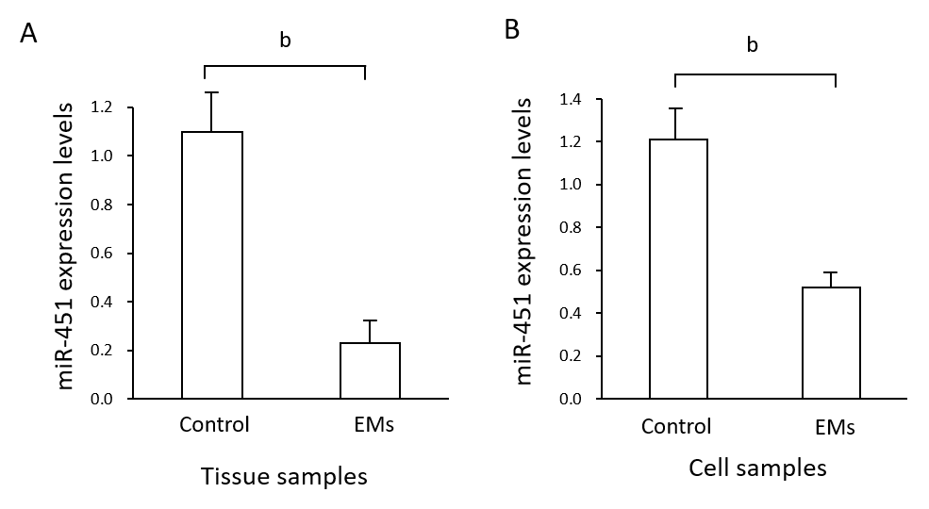

Figure 1 Expression of miR-451 in eutopic tissues and cell lines. A: MiR-451 expression in eutopic tissues from endometriosis (EMs) and control groups was quantified using quantitative real-time PCR. Data are expressed as 2^{−ΔΔCt} (mean ± SE, n = 4). ^{b}p < 0.01 vs control; B: Expression of miR-451 was compared between EMs and control cell lines. Data are expressed as 2^{−ΔΔCt} (mean ± SEM, n = 4). ^{b}p < 0.01 vs control.
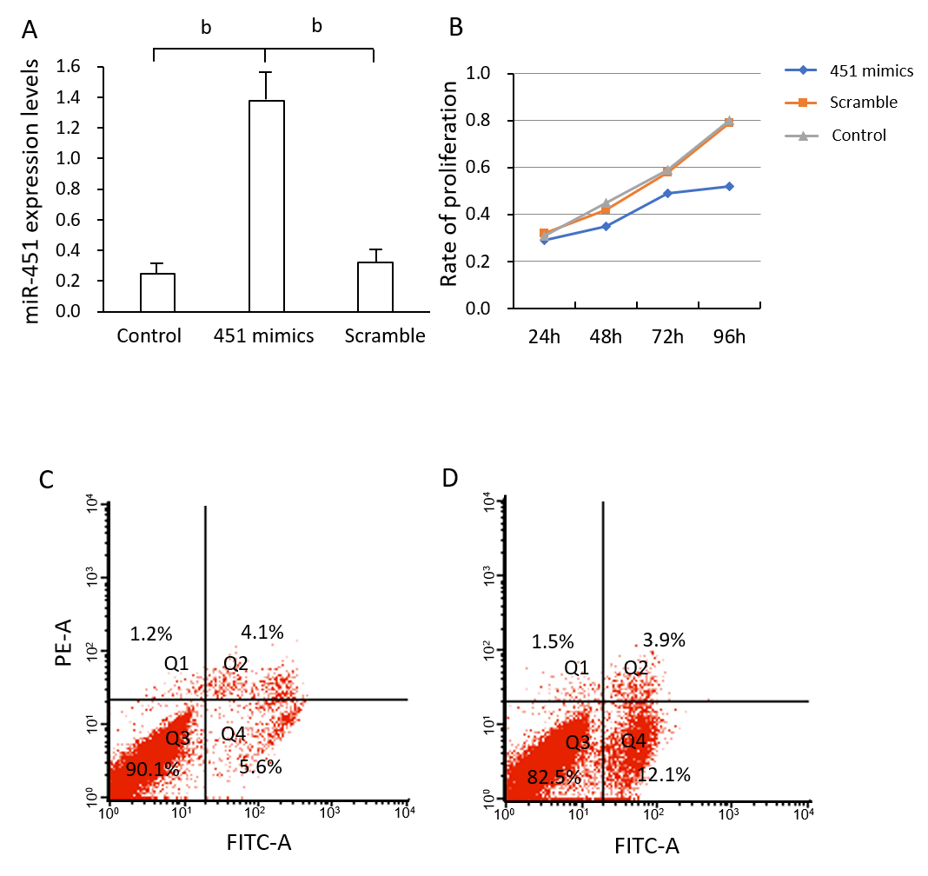
Figure 2 Transfection with miR-451 mimic inhibits cell proliferation by inducing the apoptosis of eutopic cells in endometriosis. A: MiR-451 expression was significantly increased after transfection with miR-451 mimic. Data are expressed as 2^{−ΔΔCt} (mean ± SEM, n = 4). ^{b}p < 0.01 vs control and scrambled; B: Cell Counting Kit-8 assays revealed a lower proliferation rate of cells transfected with miR-451 mimic compared to cells in the control and scrambled groups (ªp < 0.05); C and D: Flow cytometric analysis of apoptosis in cells transfected with scrambled siRNA and miR-451 mimic, respectively. Cells are divided into four sections: Q1: Annexin V-FITC- PI+ represents mechanical error; Q2: Annexin V-FITC+ PI+ represents late apoptotic or necrotic cells; Q3: Annexin V-FITC- PI- represents non-apoptotic cells; Q4: Annexin V-FITC+ PI- represents early apoptotic cells.

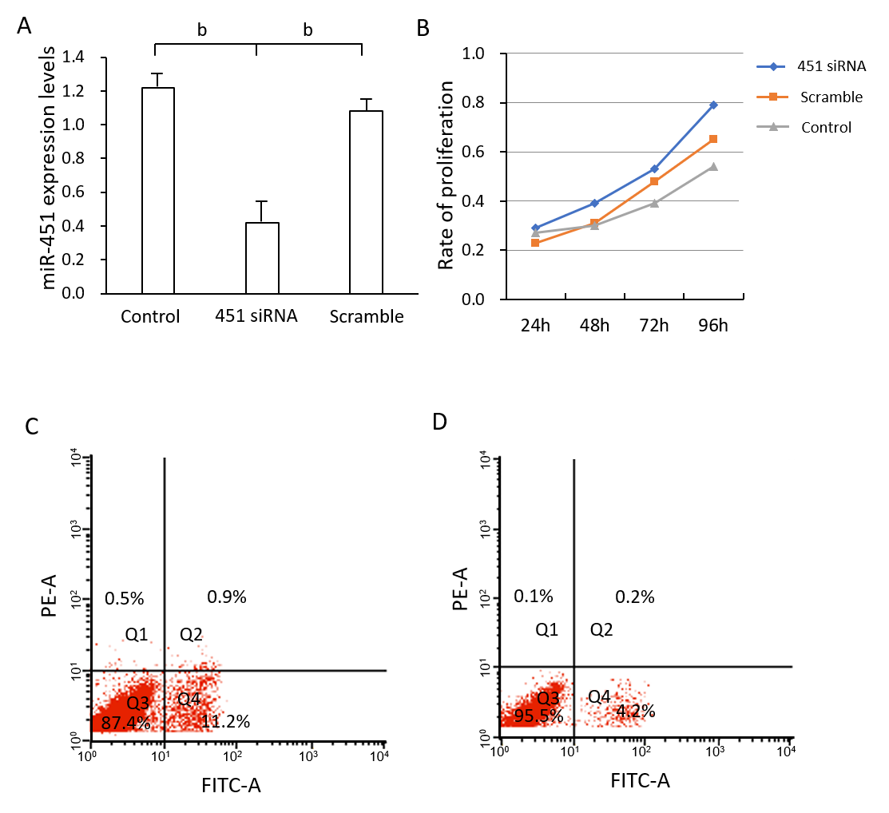
Figure 3 Transfection with miR-451 siRNA decreases apoptosis and promotes cell proliferation in control eutopic cells. A: MiR-451 expression was significantly inhibited after transfection with miR-451 siRNA. Data are expressed as 2^{−ΔΔCt} (mean ± SEM, n = 4). ^{b}p < 0.01 vs control and scrambled; B: Cell Counting Kit-8 assays revealed that the proliferation rate of cells transfected with miR-451 siRNA was higher than those of cells in the control and scrambled groups (ªp < 0.05); C and D: Flow cytometric analysis of apoptosis in cells transfected with scrambled siRNA and miR-451, respectively.
Figure 4 Results of bioinformatics analysis of miR-451 target genes according to the GSE7846 dataset. A: Potential target genes of miR-451 predicted based on miRDB and miRcode databases; B: Heatmap of expression levels of OSR1, YWHAZ, TTN, and CDKN2D; C: Role of YWHAZ and CDKN2D in the cell cycle according to Kyoto Encyclopedia of Genes and Genomes pathway analysis.

Table 1 Comparison of miR-451 expression in patients at different american society for reproductive medicine stages
ASRM stage | Cases (n) | MiR-451 level (2^{-⊿⊿CT}) | p-value
I | 2 | 0.21 | >0.05
II | 6 | 0.16 | >0.05
III | 20 | 0.27 | >0.05
IV | 12 | 0.19 | >0.05
ASRM: American Society for Reproductive Medicine.

