Name of Journal: World Journal of Psychiatry
Manuscript NO: 88206
Manuscript Type: SCIENTOMETRICS

Psychological interventions for depression in children and adolescents: A bibliometric analysis

Wang N et al. A bibliometric analysis of PIDCA

Nan Wang, Jia-Qi Kong, Nan Bai, Hui-Yue Zhang, Min Yin

Nan Wang, Jia-Qi Kong, Nan Bai, Hui-Yue Zhang, Min Yin, School of Nursing, Lanzhou University, Lanzhou 730000, Gansu Province, China

Author contributions: Wang N formulated research questions and designed the research; Kong JQ collected the data; Zhang HY and Bai N conducted the analyses; Wang N interpreted the data and wrote the first draft; Yin M revised the article critically and provided guidance in the research process; All the authors read and approved the final manuscript.

Corresponding author: Min Yin, PhD, Lecturer, School of Nursing, Lanzhou University, No. 28 Yanxi Road, Chengguan District, Lanzhou 730000, Gansu Province, China. minyin@lzu.edu.cn

Received: September 14, 2023
Revised: December 20, 2023
Accepted: February 2, 2024
Published online:

Abstract
BACKGROUND
Depression has gradually become a common psychological disorder among children and adolescents. Depression in children and adolescents affects their physical and mental development. Psychotherapy is considered to be one of the main treatment options for depressed children and adolescents. However, our understanding of the global performance and progress of psychological interventions for depression in children and adolescents (PIDCA) research is limited.

AIM
To identify collaborative research networks in this field and explore the current research status and hotspots through bibliometrics.

METHODS
Articles and reviews related to PIDCA from January 2010 to April 2023 were identified from the Web of Science Core Collection database. The Charticulator website, CiteSpace and VOSviewer software were used to visualize the trends in publications and citations, the collaborative research networks (countries, institutions, and authors), and the current research status and hotspots.

RESULTS
Until April 16, 2023, 1482 publications were identified. The number of documents published each year and citations had increased rapidly in this field. The United States had the highest productivity in this field. The most prolific institution was the University of London. Pim Cuijpers was the most prolific author. In the context of research related to PIDCA, both reference co-citation analysis and keywords co-occurrence analysis identified 10 research hotspots, including third-wave cognitive behavior therapy, short-term psychoanalytic psychotherapy, cognitive behavioral analysis system of psychotherapy, family element in psychotherapy, modular treatment, mobile-health, emotion-regulation-based transdiagnostic intervention program, dementia risk in later life, predictors of the efficacy of psychological intervention, and risks of psychological intervention.

CONCLUSION
This bibliometric study provides a comprehensive overview of PIDCA from 2010 to present. Psychological intervention characterized as psychological-process-focused, short, family-involved, modular, internet-based, emotion-regulation-based, and personalized may benefit more young people.

Key Words: Child; Adolescent; Depression; Psychological intervention; Bibliometrics

Wang N, Kong JQ, Bai N, Zhang HY, Yin M. Psychological interventions for depression in children and adolescents: A bibliometric analysis. World J Psychiatry 2024; In press

Core Tip: This was a bibliometrics study of the research structure and hotspots of psychological interventions for depression in children and adolescents from 2010 to the present. Current research hotspots include third-wave cognitive behavior therapy, short-term psychoanalytic psychotherapy, cognitive behavioral analysis system of psychotherapy, family element in psychotherapy, modular treatment, mobile-health, emotion-regulation-based transdiagnostic intervention program, dementia risk in later life, predictors of the efficacy of psychological intervention, and risks of psychological intervention. The research hotspots may give insight into how to make psychological interventions for young people more accessible and effective.

INTRODUCTION
In recent years, the incidence of depression has been trending toward a younger age. A recent study reported that the rate of increase in depression among children and adolescents is significantly more rapid relative to older groups^{[1]}. Childhood and adolescence are critical periods in the growth and development of the individual, which mark the development of long-term character, the establishment and understanding of interpersonal relationships, the rapid acquisition of knowledge and skills, and the transition to further education and work^{[2]}. As the physical and mental development of children and adolescents is not mature, depressed children and adolescents easily act on impulse, which often manifests as an externalized violent tendency and internalized self-harm and even suicide. Some studies have found depression in childhood and adolescence is strongly associated with mental health outcomes in adulthood, even across the lifespan^{[3]}.
Common treatments for depression include pharmacotherapy, psychotherapy, and combination therapy. Antidepressant medication can control symptoms and improve quality of life in a short period, but the use of medication is often accompanied by some side effects, such as insomnia, loss of mood control, and dysphoria^{[4]}. Psychotherapy is often used as first-line or adjuvant treatment for many mental diseases. Many studies have found that cognitive behavior therapy (CBT) and interpersonal psychotherapy (IPT) are considered the best psychotherapies for depression in children and adolescents^{[5]}. However, both of these therapies require a high level of professional qualification, and they are time-consuming and expensive compared to pharmacotherapy. To expand access to psychotherapy, scholars are still exploring brief, efficacious, time-saving, and low-cost psychotherapy for depression in children and adolescents.
At present, the number of publications concerning psychological interventions for depression in children and adolescents (PIDCA) is increasing rapidly. In the context of interdisciplinary research and practice, the theories and methods involved in this field are becoming increasingly extensive and complex. Traditional review research methods cannot quickly show the trends in publications and citations, the collaborative research networks (countries, institutions, and authors), and the research hotspots and future directions. As a scientific research method, bibliometrics provides an effective way to solve these problems, which can explore the evolution laws of the research from different perspectives to help scholars quickly understand the development features and hotspots of knowledge in a special research field^{[6]}. So far, no papers have been published in terms of PIDCA using bibliometrics. According to the papers we reviewed initially, there has been a major shift in the mainstream of psychotherapy paradigm in the late 19th and early 20th century^{[7]}, as well as a large number of emerging studies on child and adolescent psychotherapy conducted over the past 10 years^{[8]}. Therefore, considering the developmental process and growing trend of psychotherapy, we conducted a bibliometric analysis of PIDCA from 2010 to the present to systematically introduce the knowledge structure and theme trends through data mining and mapping.

MATERIALS AND METHODS
Data source and retrieval strategy
In our study, all the documents were retrieved and downloaded from the Science Citation Index Expanded (SCI-Expanded, covered from 1998-present) of the Web of Science Core Collection database. Web of Science includes > 12000 international academic journals and is one of the most comprehensive and authoritative database platforms for obtaining global academic information. It is highly representative of evaluating the academic development of literature in a specific field.
The MeSH Database in PubMed was used to obtain synonyms. The literature search formula was set as, TS = (child* OR adolescen* OR teen* OR youth* OR student* OR juvenile*) AND TS = (depress* OR “low mood” OR “low moods” OR “low affect” OR “negative mood” OR “negative moods” OR “negative affect” OR dysthymi* OR “affective disorder” OR “affective disorders” OR “mood disorder” OR “mood disorders”) AND TS = (Psychotherap*) AND PY = (2010–2023). TS (Topic) includes seeking in title, abstract, and keywords, and Published year (PY) is the document release period. The search document type was set to “Article” and “Review”, the document language was set to English, and the search time range was from 2010 to 2023 (the date ends on April 16, 2023).

Data analysis and visualization
We used three bibliometric tools to conduct a visual analysis regarding PIDCA, including the Charticulator website and the VOSviewer, CiteSpace software. The Charticulator (https://charticulator.com/) is a powerful and free online visualization platform developed by Microsoft Research. This website was used to conduct the collaborative analysis of countries.
The VOSviewer (version 1.6.17, Leiden University, Leiden, the Netherlands) is a free Java-based bibliometric software^{[9]}. We used VOSviewer to conduct cooperative network analysis (institutions and authors) and co-occurrence analysis of keywords. The size of the node in each map was proportional to the number of publications of the institution and author or the occurrence times of keywords. The color of the nodes represented different clusters on the network visualization maps. Different clusters represented potential research groups in the distribution of institutions and author collaboration networks. In the overlay visualization map, all these keywords were also marked with different colors according to the average PY (APY) by VOSviewer. Keywords that appeared earlier were colored in yellow, while keywords with a more recent appearance were colored blue. VOSviewer determined the extent of the collaboration between two institutions and authors, or illustrates the relationship between keywords by considering the width of the connecting line and the size of nodes.
CiteSpace is another free Java-based bibliometric software developed by Chen and Song^{[10]}. In our study, CiteSpace (version 6.2. R2) was utilized to perform the reference co-citation cluster analysis and the burst detection algorithm (reference and keywords). Reference co-citation cluster analysis can be used to identify important regions of research by classifying references. Nodes in the network are tree ring nodes, with an outer purple ring that indicated high centrality, which is an indicator used by CiteSpace to measure the importance of nodes in the network. In the reference co-citation analysis map, nodes represent references, and node size, color rings, and links between nodes indicated the number of reference citations, different years, and the strength of the co-citation relationship, respectively. The burst detection algorithm is an effective tool to capture the sharp increases in references and keywords during a certain period. In this map, the blue lines indicated the time interval and the red the period when the reference and keywords burst occurred. From this map, we can see the time interval clearly and the intensity with which the paper was widely cited.

RESULTS
Annual publication outputs and citation trends
Annual publications and citation trends can reflect the development profile of a particular field. Ultimately, 1482 publications, which consisted of 1157 articles and 325 reviews, were obtained as the final database in our study. The specific distribution of annual publications and citation trends regarding PIDCA is shown in Figure 1. The annual number of publications appeared to be low between 2016 and 2017, but the number of publications showed an ascending tendency as a whole. In particular, the annual number of publications soared from 2017 to 2019, with a growth rate of > 30%. It is known from the citation report that the cumulative number of citations reached 45111 times (43300 times after excluding self-citations), with an average of 30.44 citations per publication. The H-index was 84, which indicated that 84 publications were cited > 84 times. Regarding the annual number of citations, we could see that it exhibited a linearly increasing trend. The dynamic changes in these two indicators also suggest a booming trend in this field.

Country ranking and collaboration analysis
The top 10 publishing countries are listed in Table 1. The leadership of the United States is evident in the ranking of publications. The top 10 countries were mostly concentrated in North America, Western Europe, and Australia. Figure 2A shows in detail the annual number of publications in these countries. Prior to 2021, the United States, Germany, and the United Kingdom dominated in this field in terms of publication outputs, while China experienced rapid growth since 2017 and even surpassed the United Kingdom and Germany for the first time in 2022. The country collaboration network analysis is illustrated in Figure 2B. The thickness of the links reflects the intensity of collaboration. We can see that the United States had close partnerships with the United Kingdom, Netherlands, Germany, Canada, Australia and Italy.

Institution ranking and collaboration analysis
Table 2 illustrates the top 10 most popular institutions for publishing papers linking PIDCA. The University of London was the most prolific institution, with an H-index of 31. Harvard University ranked first in the H-index despite being second in the total number of publications, which indicated the high quality of its published papers. Of the top 10 institutions, four were in the United States, two in the Netherlands and Australia, and one each in the United Kingdom and Canada. In addition, we found that, despite being the second most prolific country, no institutions in Germany appeared in the top 10. This suggested that German institutions were more evenly distributed and developed. Figure 3A is a network visualization map showing the collaboration between institutions, which shows a close collaboration between the Universities of London, Cambridge, Manchester and Sheffield, and a more active collaboration between Harvard University, University of California, Columbia University and Vrije Universiteit Amsterdam.

Author ranking and collaboration analysis
The top 10 most prolific authors are listed in Table 3. Pim Cuijpers from Vrije Universiteit Amsterdam was the most productive, with 30 publications, followed by Nick Midgley from the University of London and Sarah E. Hetrick from the University of Melbourne. The number of highly cited publications written by these authors indicated that they occupied an important position in this field. According to the H-index, the most influential authors were Pim Cuijpers and Sarah E Hetrick, both with an H-index of 15, followed by John R. Weisz from Harvard University who had an H-index of 12. We studied the author collaboration network by VOSviewer (see Figure 3B). Different colors represented different clusters, and all authors were clustered into 10 small groups. Some of the groups were closely linked to each other, with the top prolific authors acting as a bridge for collaboration, such as Pim Cuijpers, Nick Midgley, and Sarah E. Hetrick. In addition, there were only a few links between other groups.

Journal ranking and discipline distribution
Journal publications are an important medium for academic knowledge dissemination and learning exchange. The top 10 journals are listed in Table 4. The Journal of Affective Disorders was the most prolific journal. Among the top 10 journals, five were in Q1, four in Q2 and only one in Q3, which represented PIDCA as a popular subject in high-level journals. We also analyzed the published and co-cited journals using a journal dual-map overlay (Figure 4). In the dual-map overlays, the referential links originated from a citing journal on the left side of the dual-map and pointed at a cited journal on the right side. The color of the links distinguished the discipline of the source. With this approach, we could determine how knowledge flowed in different disciplines. There were three core citation paths shown in Figure 4. The green path implied that most papers published in the journals of psychology/education/social were likely to be biased to cite papers published in the journals of medicine/medical/clinical. The two blue paths implied that most papers published in both health/nursing/medicine and psychology/education/social journals were likely to be biased to cite papers published in journals within psychology/education/health.

Reference co-cited cluster analysis and burst detection
Reference analysis is a valuable technique to explore the knowledge structure and evolution in a specific research field. With the help of CiteSpace software, a cluster visualization network map of cited references was plotted (Figure 5A). The parameters were set as follows: time range: 2010–2023, time slice was 1 year. Notably, the modularity value (Q) and mean silhouette value (S) were two valuable parameters to evaluate cluster results. In the map of Figure 3A, Q = 0.7949 > 0.3, S = 0.9191 > 0.7, and the clustering result was considered reasonable. Some of the clusters had a silhouette of 1 and a small size value, which was less informative and therefore not shown on the map.
All the co-cited references were divided into 18 clusters, and antidepressant (#0) was the largest cluster (Figure 5A). Table 5 summarizes the specific information of the 18 clusters in the reference co-citation analysis. The colors of the clusters in Figure 5A and the cluster mean year in Table 5 suggested that the research hotspots had gradually shifted to CBT (#4), mobile-health (M-health, #5), cognitive behavioral analysis system of psychotherapy (CBASP, #7), and psychoanalytic psychotherapy (PP, #18). Figure 5B lists the top 25 references with the strongest citation bursts. The most-cited study was by Zhou et al^{[11]}, with a strength of 11.19, which suggested that IPT and CBT should be considered the best psychotherapy for children and adolescents. Exploring highly cited references could also help us identify hotspots over time. The papers that have experienced a sudden increase in citations over the last 3 years are important for understanding recent research hotspots within the field.

Keywords co-occurrence analysis and burst detection
Keywords analysis is another important method to explore knowledge structure and evolution. After excluding several topic-related or meaningless keywords and merging keywords with the same meaning, Figure 6A shows the co-occurrence of keywords by the APY. Figure 6B shows the frequency distribution of the top 15 high-frequency keywords. It can be seen that CBT ranks first, which represents that CBT is treated as an important choice for children and adolescents with depression. Also, in addition to the keyword “efficacy”, “validation” and “quality of life”, the other common keywords include “predictors” and “risk”. These keywords, such as “program” and “emotion regulation (ER)” showed the latest APY, which indicated that these topics may have gained increasing attention recently and have the potential to become a research hotspot soon. Apart from this, we used CiteSpace for keyword-citation burst detection. There were 22 keywords that had strong bursts (Figure 6C). Figure 6C shows that “internet-based treatment” (strength = 4.33), “persistent depressive disorder (PDD, strength = 2.71)”, “family” (strength = 2.82), and “family therapy” (strength = 2.92) have been a focus topic in recent years.

DISCUSSION
This bibliometric analysis offers a comprehensive overview of PIDCA research. For over a decade, there has been significant growth in worldwide research interest in this topic, with an accelerating trend for the past 5 years. The United States, Germany and United Kingdom were the main contributing countries to the publications, and the quality of publications was also among the highest in the world. In general, the top 10 countries were concentrated in the developed regions of the world, and had close partnerships, while developing countries had less collaboration regarding PIDCA, showing an uneven developmental trend. In recent years, the publication outputs of China in this field have increased annually, which means it has a promising development potential. The top 10 institutions were mostly concentrated in a few countries with well-established mental health services, and collaboration was close between those prolific institutions. The author collaboration network was characterized by extensive dispersion with localized concentrations, indicating that the collaboration is not yet well developed. Most of the top 10 journals were in Q2 or above, indicating that PIDCA is a valuable and worthwhile topic for scholars to continue exploring.
We may gain insight into the structure and evolution of knowledge in this field and clarify the current research hotspots by analyzing the four aspects of the reference co-citation clusters, references with the strongest citation bursts, keywords with the largest occurrence times, and keywords with the strongest citation bursts. After combining the results of the mapping analysis and the research foundation of our research team in this field, we summarize the obtained research hotspots and introduce them as follows.
The third-wave CBT: The cluster CBT is often considered the most recognized psychological intervention for children and adolescents with depression, which can help people learn to identify relationships between cognition, behavior, and mood, and break the cycle of depression by changing distorted cognition or avoidance behaviors^{[11]}. In recent years, the third-wave CBT approach has been becoming popular, and promising results for the use of third-wave CBT with youth were found in a large meta-analysis^{[8]}. By contrast to traditional syndrome-specific CBT, the third-wave CBT has become more flexible and process-focused^{[7]}, which targets core psychological processes of change that are functionally important to long-term outcomes in psychological disease^{[12]}. Instead of focusing specifically on changing the form, frequency, or situational sensitivity of bad emotions or thoughts, it advocates individuals improving the capacity of metacognitive awareness of psychological processes, which means taking an accepting attitude to objectively evaluating their emotions or thoughts^{[13]}. The third-wave CBT methods, such as mindfulness-based cognitive therapy^{[14]}, dialectical behavior therapy^{[15]}, and acceptance and commitment therapy (ACT)^{[16]}, can help depressed adolescents improve their metacognitive awareness, which in turn improve their depressive symptoms. Those approaches represent a paradigm shift in intervention science, called process-based therapy (PBT)^{[17]}. PBT offers us an alternative approach to understanding and treating psychological problems, which would be more committed to fitting treatment methods to the needs of people^{[18]}.
The short-term PP: To our knowledge, cluster “PP” has a strong evidence base in the treatment of adult depression, and for its application in children and adolescents, the evidence base has been accumulating since the success of Trowell et al’s first trial in 2007^{[19]}, indicating that a brief version of a psychological treatment using key therapeutic components might be as effective as the original. The working principle of short-term PP (STPP) assumes that people’s behavioral and emotional responses are based on their early experience of relationships, and the therapist can help the children and adolescents give up the emotional connection patterns that stubborn depression relies on by exploring these relationships and develop emotional insight and awareness^{[20]}. In a recent highly cited reference, Goodyer et al^{[21]} found that CBT or STPP was equally effective with the brief psychosocial intervention in the treatment of depressed adolescents in a randomized controlled trial, the Improving Mood with Psychoanalytic and Cognitive Therapies (IMPACT) in 2017^{[21]}. However, most adolescents responded to STPP well in this trial, but subgroups of depressed adolescents with higher depression severity and comorbidity at baseline did not respond well to STPP^{[22]}. If we can identify adolescents who are likely to respond poorly before treatment and design personalized intervention methods for them, we might be more effective in improving the cost-effectiveness of psychological interventions^{[23]}.
The application of CBASP: The cluster “CBASP” is the only psychotherapy method developed specifically for PDD, which refers to chronic forms of depression in which the depression lasts for 2 years or longer. PDD is a serious mental disorder that may occur in childhood and adolescence accompanied by greater interpersonal difficulties, lower quality of life, and higher frequency of suicide attempts and hospitalization, often using psychotherapy as the core treatment^{[24]}. In the CBASP model, preoperational functioning characterized by global and prelogical thinking, egocentricity, communication in largely monologue form, poor affective control under stress, and an inability to express interpersonal empathy is resulted from childhood maltreatment^{[25]}, which would drive patients to disconnect from others to avoid hurtful social encounters, and leads to reduced social connectedness. The focus of CBASP is on breaking this vicious cycle^{[26]}. In the treatment of PDD, the combination therapy of CBASP and drugs often showed significant superiority is superior to when they are applied alone^{[27]}. The baseline depression, anxiety, previous medications, and traumatic childhood experiences might moderate the efficacy of CBASP, which also suggests the most appropriate treatment decisions should take into account individual characteristics^{[27-29]}. In addition, the most frequently reported negative effect was dependence on the therapist, which might be associated with a worse treatment outcome^{[26]}. However, our knowledge of the specific mechanisms of care dependency is little, it should be investigated broadly in future research^{[30]}.
The family element in psychotherapy: “Family” and “family therapy” were found as keywords with the strongest citation bursts. Involving caregivers/family members of children and adolescents in psychotherapy could increase its efficacy, as their engagement can help address the difficulties that patients may encounter^{[31]}, and the understanding and support of caregiver/family member is of benefit to recovery from depression^{[32]}. What matters is the circumstances and the form in which they are effectively involved in psychotherapy, when caregivers/family members are involved. The caregivers/family members have many different ways of participating in treatment, which include conducting sessions with the children/adolescents and meeting afterward or separately with the caregiver/family; joint participation in sessions; or the different proportion, frequency, and quality of caregiver/family involvement^{[33]}. The intervention outcomes tend to be heterogeneous for different ways of involvement. However, there are fewer relevant studies discussing the choice of participation methods^{[33]}. It is indisputable that patient age should be considered when making the choice of intervention. Family therapy is also an important form of psychosocial intervention that can alleviate the negative family influences on depressed children and adolescents by strengthening harmonious interactions between family members^{[34]}. Positive relationships between family caregivers and adolescents have a long-term supportive effect on the physical and mental development of children and adolescents.
The modular treatments: As the latest high-frequency keyword “program”, modular treatments also can be interpreted as multicomponent psychological intervention programs. According to the paper cited up to 557 times by Weisz et al^{[35]}, the modular approach to therapy for children outperformed usual care and standard evidence-based treatments (EBTs) on multiple clinical outcome measures in 2012^{[35]}. Modular treatments are more effective than EBTs, as they can focus on more for children and adolescents with depression^{[36]}. The selection of the components of modular treatments requires decision-making by therapists after taking into account a complex array of variables, including: the therapist’s expertise and experience; the therapeutic setting; conceptual approach to therapy; the characteristics and preferences of the adolescents and their parents; and the priority problems to be addressed^{[37]}. However, there was less evidence base for how to balance those variables when therapists make decisions and how decision-making structures and procedures influence treatment outcomes. On this issue, decision aids often used the decision flow diagrams to suggest module selection and sequences depending on primary and interfering problems^{[38]}, while still relying heavily on clinician judgment. Future research should focus on developing decision recommendations based on the efficacy data from prior decision-making, and figuring out how these recommendations can be combined with factors such as clinician judgment and client preferences.
The M-health: Although the efficacy of numerous psychological interventions has been validated, a substantial proportion of depressed children and adolescents do not receive adequate professional psychological interventions^{[39]}. It was reported that up to 80% of depressed children and adolescents did not receive formal psychological treatment due to the accessibility of psychotherapy and patients’ reluctance to seek help face-to-face as a result of perceived mental illness stigma or a preference for self-help^{[40]}. In cluster “M-health”, digital health interventions (DHIs), such as internet- and mobile-based psychological interventions (DHI_{PSY}), could overcome many limitations of the traditional medical model and thereby make treatments accessible to children and adolescents, thanks to these advantages including promising cost-effectiveness, guaranteed privacy and security, and a high degree of flexibility and autonomy^{[41]}. In 2015, Ebert et al^{[42]}, in a meta-analysis that was cited 271 times, found that when evidence-based face-to-face treatment is not feasible, computer- or internet-based CBT might be promising alternatives ^{[42]}. Artificial intelligence (AI) has begun to be applied in multiple domains of mental health care in recent years, and many scholars wonder whether psychological interventions could be delivered someday by mental health chatbots in the ChatGPT era. However, there are still some challenges on the path to psychotherapy delivered by AI consisting of limited knowledge of the active ingredients of psychotherapy, therapeutic relationships delivered by non-human agents, and human-like AI being capable of delivering fully-fledged psychotherapy is undeveloped^{[43]}.
The ER-based transdiagnostic intervention program: The latest high-frequency keyword “ER” has recently become a popular theme in psychotherapy research, which refers to regulatory processes for modifying emotional responses^{[44]}. Emotion dysregulation (ED), is the inability to flexibly respond to and manage emotions, which is a central component of psychopathology in adolescence^{[45]}. Psychological interventions such as CBT, which may help improve ER strategies indirectly, were proven to be effective, with improvements in psychopathology^{[46]}. In view of the general importance of ER in psychological therapies, ER is considered to be a transdiagnostic mediator that leads to positive therapeutic change^{[47]}. The Unified Protocol for Emotional Disorders, the ER-based transdiagnostic intervention program, explicitly targets improving ER strategies for reducing psychological distress and improving overall well-being regardless of diagnostic status^{[48]}. Longitudinal data suggest that ED happens before depressive disorders, so the primary intervention goal of most early intervention programs was ER^{[49]}, and the ER strategies are likely to protect them from bad moods and possibly even prevent the onset of mental disorders^{[16]}. Over the last few decades, different theoretical models have developed different ER strategies (distraction, acceptance, problem-solving, reappraisal, etc.), which refer to some methods to keep emotional stability. Further advanced understanding of the ER process can provide a basis for refining ER models and intervention methods^{[50]}. Of the ER studies, ecological momentary assessment and/or intervention could be useful to show how specific ER strategies in daily life link to dysregulated emotions and behaviors, and how these associations may change throughout the intervention^{[51]}.
Dementia risk in later life: In terms of the cluster “dementia”, we found that the incidence of dementia increases significantly with average life expectancy. Dementia can cause considerable deterioration in cognitive functioning, which not only seriously reduces the quality of life of patients in their later years, but also brings a heavy burden to their families and even to society. Intervention strategies targeting the risk factors in early life could reduce the incidence of dementia or substantially delay its onset^{[52]}. Recent studies have found that low adolescent cognitive ability^{[53,54]} and adverse childhood experiences^{[55,56]} have a significant association with dementia risk in later life. Depression that occurs in childhood and adolescence is often accompanied by varying degrees of cognitive impairment in attention, memory, and executive functioning, or even interrupted educational trajectories^{[4]}. Researchers have tried to figure out the relationships and action paths between early cognitive ability, childhood experiences, depression, and dementia, and whether the prevalence of dementia in the population would be lower if depression could be prevented or adequately treated^{[57]}. A lot of research still needs to be done into the relationships of the variables involved. However, it is difficult to conduct prospective cohort studies due to the wide age range.
The predictors of the efficacy of psychological intervention: For the high-frequency keyword “predictors”, we found that a better understanding of predictors of treatment outcome may guide the selection of individualized treatment approaches or adjustment of treatment intensity. In 2017, the prolific author Weersing et al^{[5]} suggested that there was a strong demand to increase the evidence related to predictors of efficacy of treatment of depression in children and adolescents in a recent highly cited evidence update paper. In the next two highly cited papers in 2020, Eckshtain et al^{[58]} stated that the choice of psychological interventions should consider depressed children and adolescents’ individual characteristics, and Cuijpers et al^{[59]} found that psychological interventions were less effective in younger patients, especially in children aged ≤ 13 years. It follows that age might be an important factor in the efficacy of psychological interventions. This might be related to the fact that the therapies for children and adolescents are primarily age-adapted versions of therapies originally designed for adults. Another possibility is that different from adults, young people’s potential for recovery from depression is constrained by parental and family characteristics, which they have little opportunity to escape from or alter.
The risks of psychological intervention: Although psychological interventions have always been shown to be effective in reducing levels of depression, up to 60% of adolescents still do not respond to these treatments, and clinically significant deterioration was 6%^{[60]}. Another high-frequency keyword “risk” in most articles is often described as the risk of depression, suicide, and non-suicidal self-injury, or the risk of not receiving treatment, but it also represents the risk of receiving treatment in some publications. It is widely believed that psychological interventions are always beneficial, but some studies have found that some patients’ symptoms do not improve much after receiving psychological interventions^{[61]} and are even accompanied by adverse events (AEs) (e.g. suicide, suicide attempts, mental health related hospital admissions)^{[62]}. A systematic review by Lodewyk et al^{[63]} summarized the AEs caused by psychological interventions, and they identified that AEs were of the following types, physical, cognitive and/or mental health, social and/or academic, and health care usage, and the most common event monitored was hospitalization^{[63]}. AEs of psychological interventions were mainly, caused by ineffective engagement, ineffective practice, and accidental events^{[64]}. However, the monitoring of AEs is largely absent in studies of psychotherapy with children and adolescents^{[65]}. Assessing and reporting AEs comprehensively in studies of psychotherapy is crucial to improve research and service quality. Furthermore, patients sometimes experienced improvements in other domains despite a lack of depressive symptoms reduction, which suggested that we may gain a more nuanced understanding of current treatment effects in many ways by combining qualitative perceptions and quantitative measurements of patients after the treatment^{[66]}.
Our results highlight the critical research themes and lines in the study of PIDCA, as well as recognition of insufficiently and issues that could be a basis for future studies. From the documents reviewed, it was found that the short, internet-based, multi-component, family-involved, and personalized psychological interventions were more in line with the needs of society considering cost-effectiveness and treatment adherence. Therefore, these factors could be considered in future psychological interventions for children and adolescents, depending on the study design and feasibility factors. As with any study, this was not without limitations. Firstly, the selected articles reflects the characteristics of the documents published in journals referred to in the Web of Science Core Collection database, which may have resulted in some selection bias. Secondly, to explore the latest research developments in the field of PIDCA, only studies from 2010 to the present were included; therefore, a description of the development of the field over the entire historical period cannot be made. Thirdly, the restriction of the reviewed articles to a short period reduced the opportunity to receive full citations.

CONCLUSION
Overall, the results of this study provide insight into new trends in the field of the PIDCA for over a decade. In this research, an attempt was made to review the documents in this field using a comprehensive method and multiple bibliometric tools. It turns out that the PIDCA research has received increasing attention, as reflected in both annual publications and citation quantity. The most influential journals, countries, institutions, and authors were identified, as were hotspots and the latest trends of research. Although our findings are preliminary, they imply that future mental health service trends prefer brief, convenient, and effective psychological intervention methods. We hope that the above results will give some valuable help to later scholars interested in this field.

ARTICLE HIGHLIGHTS
Research background
Child and adolescent depression is a public health problem that needs urgent attention today. Psychological intervention as a promising treatment for depression in children and adolescents. However, a significant number of child and adolescent patients do not receive professional psychological intervention due to the fact that it requires a high level of qualification for its implementation and is usually costly and time-consuming.

Research motivation
Currently, there is a rapid growth of relevant articles within the field. To understand the global performance and progress of papers related to psychological interventions for depression in children and adolescents (PIDCA), and to provide a guide for new researchers in this field.

Research objectives
To understand the distribution of global collaborative networks (countries, institutions, authors) and current research hotspots related to PIDCA in the forms of visual diagrams.

Research methods
We used bibliometric research method, the Charticulator website, CiteSpace, and VOSviewer software. Articles and reviews related to PIDCA from January 2010 to April 2023 were identified from the Web of Science Core Collection database.

Research results
We present a visual representation of the overall performance of relevant papers in the field in terms of countries, institutions, authors and journals, and the current research hotspots we identified were summarized and presented in 10 research perspectives.

Research conclusions
In our study, no new theories were used, but an attempt was made to review the papers in this field using a comprehensive method (the analysis of reference co-citation clusters, references with the strongest citation bursts, keywords with the largest occurrence times, and keywords with the strongest citation bursts) and multiple bibliometric tools (the Charticulator website, CiteSpace, and VOSviewer software).

Research perspectives
Through this study, we find that the psychological intervention characterized as psychological processes-focused, short, family-involved, modular, internet-based, emotion-regulation-based, and personalized may benefit more young people. The brief, efficacious, time-saving, and low-cost psychotherapy would be the promising psychotherapy.

ACKNOWLEDGEMENTS
In writing this paper, I have received a great deal of support and assistance. First and foremost, I would like to show my deepest gratitude to my supervisor, Dr. Yin Min, who has provided me with valuable guidance in every stage of writing this paper. Second, I gratefully acknowledge the assistance of Mr. Xi-Ping Shen in checking the statistical methods of this study. Finally, I would also like to acknowledge my indebtedness to my co-authors who have contributed their time, thoughts, skills, and encouragement in the course of preparing this paper.

REFERENCES
1 Weinberger AH, Gbedemah M, Martinez AM, Nash D, Galea S, Goodwin RD. Trends in depression prevalence in the USA from 2005 to 2015: widening disparities in vulnerable groups. Psychol Med 2018; 48: 1308-1315 [PMID: 29021005 DOI: 10.1017/S0033291717002781]
2 Davidson LL, Grigorenko EL, Boivin MJ, Rapa E, Stein A. A focus on adolescence to reduce neurological, mental health and substance-use disability. Nature 2015; 527: S161-S166 [PMID: 26580322 DOI: 10.1038/nature16030]
3 Clayborne ZM, Varin M, Colman I. Systematic Review and Meta-Analysis: Adolescent Depression and Long-Term Psychosocial Outcomes. J Am Acad Child Adolesc Psychiatry 2019; 58: 72-79 [PMID: 30577941 DOI: 10.1016/j.jaac.2018.07.896]
4 Miller L, Campo JV. Depression in Adolescents. N Engl J Med 2021; 385: 445-449 [PMID: 34320289 DOI: 10.1056/NEJMra2033475]
5 Weersing VR, Jeffreys M, Do MT, Schwartz KT, Bolano C. Evidence Base Update of Psychosocial Treatments for Child and Adolescent Depression. J Clin Child Adolesc Psychol 2017; 46: 11-43 [PMID: 27870579 DOI: 10.1080/15374416.2016.1220310]
6 Small H, Upham P. Citation structure of an emerging research area on the verge of application. Scientometrics 2008; 79: 365-375 [DOI: 10.1007/s11192-009-0424-0]
7 Hayes SC, Hofmann SG. "Third-wave" cognitive and behavioral therapies and the emergence of a process-based approach to intervention in psychiatry. World Psychiatry 2021; 20: 363-375 [PMID: 34505370 DOI: 10.1002/wps.20884]
8 Perkins AM, Meiser-Stedman R, Spaul SW, Bowers G, Perkins AG, Pass L. The effectiveness of third wave cognitive behavioural therapies for children and adolescents: A systematic review and meta-analysis. Br J Clin Psychol 2023; 62: 209-227 [PMID: 36443910 DOI: 10.1111/bjc.12404]
9 van Eck NJ, Waltman L. Software survey: VOSviewer, a computer program for bibliometric mapping. Scientometrics 2010; 84: 523-538 [PMID: 20585380 DOI: 10.1007/s11192-009-0146-3]
10 Chen C, Song M. Visualizing a field of research: A methodology of systematic scientometric reviews. PLoS One 2019; 14: e0223994 [PMID: 31671124 DOI: 10.1371/journal.pone.0223994]
11 Zhou X, Hetrick SE, Cuijpers P, Qin B, Barth J, Whittington CJ, Cohen D, Del Giovane C, Liu Y, Michael KD, Zhang Y, Weisz JR, Xie P. Comparative efficacy and acceptability of psychotherapies for depression in children and adolescents: A systematic review and network meta-analysis. World Psychiatry 2015; 14: 207-222 [PMID: 26043339 DOI: 10.1002/wps.20217]
12 Hayes SC, Hofmann SG, Stanton CE. Process-based functional analysis can help behavioral science step up to novel challenges: COVID - 19 as an example. J Contextual Behav Sci 2020; 18: 128-145 [PMID: 32864323 DOI: 10.1016/j.jcbs.2020.08.009]
13 Teasdale JD, Moore RG, Hayhurst H, Pope M, Williams S, Segal ZV. Metacognitive awareness and prevention of relapse in depression: empirical evidence. J Consult Clin Psychol 2002; 70: 275-287 [PMID: 11952186 DOI: 10.1037//0022-006x.70.2.275]
14 Ford T, Richardson J, Wilkinson K, Smith P, Berry V, Barnhofer T, Fox J, Kuyken W. Could mindfulness-based cognitive therapy prevent a lifelong recurrent course of depression or anxiety by addressing key mechanisms of vulnerability in high-risk adolescents? Br J Psychiatry 2020; 216: 175-177 [PMID: 31352908 DOI: 10.1192/bjp.2019.183]
15 McCauley E, Berk MS, Asarnow JR, Adrian M, Cohen J, Korslund K, Avina C, Hughes J, Harned M, Gallop R, Linehan MM. Efficacy of Dialectical Behavior Therapy for Adolescents at High Risk for Suicide: A Randomized Clinical Trial. JAMA Psychiatry 2018; 75: 777-785 [PMID: 29926087 DOI: 10.1001/jamapsychiatry.2018.1109]
16 Burckhardt R, Manicavasagar V, Batterham PJ, Hadzi-Pavlovic D. A randomized controlled trial of strong minds: A school-based mental health program combining acceptance and commitment therapy and positive psychology. J Sch Psychol 2016; 57: 41-52 [PMID: 27425565 DOI: 10.1016/j.jsp.2016.05.008]
17 Hofmann SG, Hayes SC. The Future of Intervention Science: Process-Based Therapy. Clin Psychol Sci 2019; 7: 37-50 [PMID: 30713811 DOI: 10.1177/2167702618772296]
18 Hayes SC, Hofmann SG, Ciarrochi J. A process-based approach to psychological diagnosis and treatment:The conceptual and treatment utility of an extended evolutionary meta model. Clin Psychol Rev 2020; 82: 101908 [PMID: 32932093 DOI: 10.1016/j.cpr.2020.101908]
19 Trowell J, Joffe I, Campbell J, Clemente C, Almqvist F, Soininen M, Koskenranta-Aalto U, Weintraub S, Kolaitis G, Tomaras V, Anastasopoulos D, Grayson K, Barnes J, Tsiantis J. Childhood depression: a place for psychotherapy. An outcome study comparing individual psychodynamic psychotherapy and family therapy. Eur Child Adolesc Psychiatry 2007; 16: 157-167 [PMID: 17200793 DOI: 10.1007/s00787-006-0584-x]
20 Housby H, Thackeray L, Midgley N. What contributes to good outcomes? The perspective of young people on short-term psychoanalytic psychotherapy for depressed adolescents. PLoS One 2021; 16: e0257334 [PMID: 34559829 DOI: 10.1371/journal.pone.0257334]
21 Goodyer IM, Reynolds S, Barrett B, Byford S, Dubicka B, Hill J, Holland F, Kelvin R, Midgley N, Roberts C, Senior R, Target M, Widmer B, Wilkinson P, Fonagy P. Cognitive behavioural therapy and short-term psychoanalytical psychotherapy vs a brief psychosocial intervention in adolescents with unipolar major depressive disorder (IMPACT): a multicentre, pragmatic, observer-blind, randomised controlled superiority trial. Lancet Psychiatry 2017; 4: 109-119 [PMID: 27914903 DOI: 10.1016/S2215-0366(16)30378-9]
22 Loades ME, Midgley N, Herring GT, O'Keeffe S; IMPACT Consortium, Reynolds S, Goodyer IM. In Context: Lessons About Adolescent Unipolar Depression From the Improving Mood With Psychoanalytic and Cognitive Therapies Trial. J Am Acad Child Adolesc Psychiatry 2024; 63: 122-135 [PMID: 37121393 DOI: 10.1016/j.jaac.2023.03.017]
23 Wienicke FJ, Beutel ME, Zwerenz R, Brähler E, Fonagy P, Luyten P, Constantinou M, Barber JP, McCarthy KS, Solomonov N, Cooper PJ, De Pascalis L, Johansson R, Andersson G, Lemma A, Town JM, Abbass AA, Ajilchi B, Connolly Gibbons MB, López-Rodríguez J, Villamil-Salcedo V, Maina G, Rosso G, Twisk JWR, Burk WJ, Spijker J, Cuijpers P, Driessen E. Efficacy and moderators of short-term psychodynamic psychotherapy for depression: A systematic review and meta-analysis of individual participant data. Clin Psychol Rev 2023; 101: 102269 [PMID: 36958077 DOI: 10.1016/j.cpr.2023.102269]
24 Mattern M, Walter H, Hentze C, Schramm E, Drost S, Schoepf D, Fangmeier T, Normann C, Zobel I, Schnell K. Behavioral evidence for an impairment of affective theory of mind capabilities in chronic depression. Psychopathology 2015; 48: 240-250 [PMID: 26278924 DOI: 10.1159/000430450]
25 Guhn A, Merkel L, Heim C, Klawitter H, Teich P, Betzler F, Sterzer P, Köhler S. Impaired empathic functioning in chronic depression: Behavioral evidence for the Cognitive Behavioral Analysis System of Psychotherapy (CBASP) model. J Psychiatr Res 2022; 152: 79-85 [PMID: 35716512 DOI: 10.1016/j.jpsychires.2022.06.020]
26 Wiersma J, Klein P, Schramm E, Furukawa T, Favorite T. Editorial: CBASP in the Treatment of Persistent Depressive Disorder. Front Psychiatry 2021; 12: 804602 [PMID: 34975596 DOI: 10.3389/fpsyt.2021.804602]
27 Furukawa TA, Efthimiou O, Weitz ES, Cipriani A, Keller MB, Kocsis JH, Klein DN, Michalak J, Salanti G, Cuijpers P, Schramm E. Cognitive-Behavioral Analysis System of Psychotherapy, Drug, or Their Combination for Persistent Depressive Disorder: Personalizing the Treatment Choice Using Individual Participant Data Network Metaregression. Psychother Psychosom 2018; 87: 140-153 [PMID: 29847831 DOI: 10.1159/000489227]
28 Klein JP, Dale R, Glanert S, Grave U, Surig S, Zurowski B, Borgwardt S, Schweiger U, Fassbinder E, Probst T. Does childhood emotional abuse moderate the effect of cognitive behavioral analysis system of psychotherapy vs meta-cognitive therapy in depression? A propensity score analysis on an observational study. J Affect Disord 2022; 300: 71-75 [PMID: 34952120 DOI: 10.1016/j.jad.2021.12.087]
29 Serbanescu I, Backenstrass M, Drost S, Weber B, Walter H, Klein JP, Zobel I, Hautzinger M, Meister R, Härter M, Schramm E, Schoepf D. Impact of Baseline Characteristics on the Effectiveness of Disorder-Specific Cognitive Behavioral Analysis System of Psychotherapy (CBASP) and Supportive Psychotherapy in Outpatient Treatment for Persistent Depressive Disorder. Front Psychiatry 2020; 11: 607300 [PMID: 33408656 DOI: 10.3389/fpsyt.2020.607300]
30 Glanert S, Sürig S, Grave U, Fassbinder E, Schwab S, Borgwardt S, Klein JP. Investigating Care Dependency and Its Relation to Outcome (ICARE): Results From a Naturalistic Study of an Intensive Day Treatment Program for Depression. Front Psychiatry 2021; 12: 644972 [PMID: 34737714 DOI: 10.3389/fpsyt.2021.644972]
31 Hussain H, Dubicka B, Wilkinson P. Recent developments in the treatment of major depressive disorder in children and adolescents. Evid Based Ment Health 2018; 21: 101-106 [PMID: 30045844 DOI: 10.1136/eb-2018-102937]
32 Oud M, de Winter L, Vermeulen-Smit E, Bodden D, Nauta M, Stone L, van den Heuvel M, Taher RA, de Graaf I, Kendall T, Engels R, Stikkelbroek Y. Effectiveness of CBT for children and adolescents with depression: A systematic review and meta-regression analysis. Eur Psychiatry 2019; 57: 33-45 [PMID: 30658278 DOI: 10.1016/j.eurpsy.2018.12.008]
33 Dippel N, Szota K, Cuijpers P, Christiansen H, Brakemeier EL. Family involvement in psychotherapy for depression in children and adolescents: Systematic review and meta-analysis. Psychol Psychother 2022; 95: 656-679 [PMID: 35289047 DOI: 10.1111/papt.12392]
34 Asarnow JR, Tompson MC, Klomhaus AM, Babeva K, Langer DA, Sugar CA. Randomized controlled trial of family-focused treatment for child depression compared to individual psychotherapy: one-year outcomes. J Child Psychol Psychiatry 2020; 61: 662-671 [PMID: 31840263 DOI: 10.1111/jcpp.13162]
35 Weisz JR, Chorpita BF, Palinkas LA, Schoenwald SK, Miranda J, Bearman SK, Daleiden EL, Ugueto AM, Ho A, Martin J, Gray J, Alleyne A, Langer DA, Southam-Gerow MA, Gibbons RD; Research Network on Youth Mental Health. Testing standard and modular designs for psychotherapy treating depression, anxiety, and conduct problems in youth: a randomized effectiveness trial. Arch Gen Psychiatry 2012; 69: 274-282 [PMID: 22065252 DOI: 10.1001/archgenpsychiatry.2011.147]
36 Toyomoto R, Sakata M, Yoshida K, Luo Y, Nakagami Y, Uwatoko T, Shimamoto T, Sahker E, Tajika A, Suga H, Ito H, Sumi M, Muto T, Ito M, Ichikawa H, Ikegawa M, Shiraishi N, Watanabe T, Watkins ER, Noma H, Horikoshi M, Iwami T, Furukawa TA. Prognostic factors and effect modifiers for personalisation of internet-based cognitive behavioural therapy among university students with subthreshold depression: A secondary analysis of a factorial trial. J Affect Disord 2023; 322: 156-162 [PMID: 36379323 DOI: 10.1016/j.jad.2022.11.024]
37 Anderson CM, Iovannone R, Smith T, Levato L, Martin R, Cavanaugh B, Hochheimer S, Wang H, Iadarola S. Thinking Small to Think Big: Modular Approach for Autism Programming in Schools (MAAPS). J Autism Dev Disord 2021; 51: 193-211 [PMID: 32410099 DOI: 10.1007/s10803-020-04532-1]
38 Agarwal S, Glenton C, Tamrat T, Henschke N, Maayan N, Fønhus MS, Mehl GL, Lewin S. Decision-support tools via mobile devices to improve quality of care in primary healthcare settings. Cochrane Database Syst Rev 2021; 7: CD012944 [PMID: 34314020 DOI: 10.1002/14651858.CD012944.pub2]
39 Radez J, Reardon T, Creswell C, Lawrence PJ, Evdoka-Burton G, Waite P. Why do children and adolescents (not) seek and access professional help for their mental health problems? A systematic review of quantitative and qualitative studies. Eur Child Adolesc Psychiatry 2021; 30: 183-211 [PMID: 31965309 DOI: 10.1007/s00787-019-01469-4]
40 Gulliver A, Griffiths KM, Christensen H. Perceived barriers and facilitators to mental health help-seeking in young people: a systematic review. BMC Psychiatry 2010; 10: 113 [PMID: 21192795 DOI: 10.1186/1471-244X-10-113]
41 Domhardt M, Engler S, Nowak H, Lutsch A, Baumel A, Baumeister H. Mechanisms of Change in Digital Health Interventions for Mental Disorders in Youth: Systematic Review. J Med Internet Res 2021; 23: e29742 [PMID: 34842543 DOI: 10.2196/29742]
42 Ebert DD, Zarski AC, Christensen H, Stikkelbroek Y, Cuijpers P, Berking M, Riper H. Internet and computer-based cognitive behavioral therapy for anxiety and depression in youth: a meta-analysis of randomized controlled outcome trials. PLoS One 2015; 10: e0119895 [PMID: 25786025 DOI: 10.1371/journal.pone.0119895]
43 Grodniewicz JP, Hohol M. Waiting for a digital therapist: three challenges on the path to psychotherapy delivered by artificial intelligence. Front Psychiatry 2023; 14: 1190084 [PMID: 37324824 DOI: 10.3389/fpsyt.2023.1190084]
44 Thompson RA. Emotion dysregulation: A theme in search of definition. Dev Psychopathol 2019; 31: 805-815 [PMID: 31030684 DOI: 10.1017/S0954579419000282]
45 Compas BE, Jaser SS, Bettis AH, Watson KH, Gruhn MA, Dunbar JP, Williams E, Thigpen JC. Coping, emotion regulation, and psychopathology in childhood and adolescence: A meta-analysis and narrative review. Psychol Bull 2017; 143: 939-991 [PMID: 28616996 DOI: 10.1037/bul0000110]
46 Elices M, Soler J, Feliu-Soler A, Carmona C, Tiana T, Pascual JC, García-Palacios A, Álvarez E. Combining emotion regulation and mindfulness skills for preventing depression relapse: a randomized-controlled study. Borderline Personal Disord Emot Dysregul 2017; 4: 13 [PMID: 28690851 DOI: 10.1186/s40479-017-0064-6]
47 Taubner S, Ioannou Y, Saliba A, Sales CMD, Volkert J, Protić S, Adler A, Barkauskiene R, Conejo-Cerón S, Di Giacomo D, Mestre JM, Moreno-Peral P, Vieira FM, Mota CP, Henriques MIRS, Røssberg JI, Perdih TS, Schmidt SJ, Zettl M, Ulberg R, Heinonen E. Mediators of outcome in adolescent psychotherapy and their implications for theories and mechanisms of change: a systematic review. Eur Child Adolesc Psychiatry 2023 [PMID: 36918434 DOI: 10.1007/s00787-023-02186-9]
48 Sakiris N, Berle D. A systematic review and meta-analysis of the Unified Protocol as a transdiagnostic emotion regulation based intervention. Clin Psychol Rev 2019; 72: 101751 [PMID: 31271848 DOI: 10.1016/j.cpr.2019.101751]
49 Pedrini L, Meloni S, Lanfredi M, Rossi R. School-based interventions to improve emotional regulation skills in adolescent students: A systematic review. J Adolesc 2022; 94: 1051-1067 [PMID: 36082432 DOI: 10.1002/jad.12090]
50 Boemo T, Nieto I, Vazquez C, Sanchez-Lopez A. Relations between emotion regulation strategies and affect in daily life: A systematic review and meta-analysis of studies using ecological momentary assessments. Neurosci Biobehav Rev 2022; 139: 104747 [PMID: 35716875 DOI: 10.1016/j.neubiorev.2022.104747]
51 Eadeh HM, Breaux R, Nikolas MA. A Meta-Analytic Review of Emotion Regulation Focused Psychosocial Interventions for Adolescents. Clin Child Fam Psychol Rev 2021; 24: 684-706 [PMID: 34275057 DOI: 10.1007/s10567-021-00362-4]
52 Frankish H, Horton R. Prevention and management of dementia: a priority for public health. Lancet 2017; 390: 2614-2615 [PMID: 28735854 DOI: 10.1016/S0140-6736(17)31756-7]
53 Foverskov E, Glymour MM, Mortensen EL, Osler M, Okholm GT, Lund R. Education and adolescent cognitive ability as predictors of dementia in a cohort of Danish men. PLoS One 2020; 15: e0235781 [PMID: 32760096 DOI: 10.1371/journal.pone.0235781]
54 Huang AR, Strombotne KL, Horner EM, Lapham SJ. Adolescent Cognitive Aptitudes and Later-in-Life Alzheimer Disease and Related Disorders. JAMA Netw Open 2018; 1: e181726 [PMID: 30646141 DOI: 10.1001/jamanetworkopen.2018.1726]
55 Tjoelker FM, Jeuring HW, Aprahamian I, Naarding P, Marijnissen RM, Hendriks GJ, Rhebergen D, Lugtenburg A, Lammers MW, van den Brink RHS, Oude Voshaar RC. The impact of a history of child abuse on cognitive performance: a cross-sectional study in older patients with a depressive, anxiety, or somatic symptom disorder. BMC Geriatr 2022; 22: 377 [PMID: 35484493 DOI: 10.1186/s12877-022-03068-6]
56 Ren Z, Su B, Du Y, Zhou T, Zheng X, Liu J. Effect modifications of BMI transition and trajectory in the associations of adverse childhood experiences with new-onset dementia and its subtypes in older US adults. Gen Psychiatr 2023; 36: e101092 [PMID: 37622031 DOI: 10.1136/gpsych-2023-101092]
57 Almeida OP, Hankey GJ, Yeap BB, Golledge J, Flicker L. Depression as a modifiable factor to decrease the risk of dementia. Transl Psychiatry 2017; 7: e1117 [PMID: 28463236 DOI: 10.1038/tp.2017.90]
58 Eckshtain D, Kuppens S, Ugueto A, Ng MY, Vaughn-Coaxum R, Corteselli K, Weisz JR. Meta-Analysis: 13-Year Follow-up of Psychotherapy Effects on Youth Depression. J Am Acad Child Adolesc Psychiatry 2020; 59: 45-63 [PMID: 31004739 DOI: 10.1016/j.jaac.2019.04.002]
59 Cuijpers P, Karyotaki E, Eckshtain D, Ng MY, Corteselli KA, Noma H, Quero S, Weisz JR. Psychotherapy for Depression Across Different Age Groups: A Systematic Review and Meta-analysis. JAMA Psychiatry 2020; 77: 694-702 [PMID: 32186668 DOI: 10.1001/jamapsychiatry.2020.0164]
60 Cuijpers P, Karyotaki E, Ciharova M, Miguel C, Noma H, Stikkelbroek Y, Weisz JR, Furukawa TA. The effects of psychological treatments of depression in children and adolescents on response, reliable change, and deterioration: a systematic review and meta-analysis. Eur Child Adolesc Psychiatry 2023; 32: 177-192 [PMID: 34611729 DOI: 10.1007/s00787-021-01884-6]
61 Holmes EA, Ghaderi A, Harmer CJ, Ramchandani PG, Cuijpers P, Morrison AP, Roiser JP, Bockting CLH, O'Connor RC, Shafran R, Moulds ML, Craske MG. The Lancet Psychiatry Commission on psychological treatments research in tomorrow's science. Lancet Psychiatry 2018; 5: 237-286 [PMID: 29482764 DOI: 10.1016/S2215-0366(17)30513-8]
62 Parry GD, Crawford MJ, Duggan C. Iatrogenic harm from psychological therapies--time to move on. Br J Psychiatry 2016; 208: 210-212 [PMID: 26932481 DOI: 10.1192/bjp.bp.115.163618]
63 Lodewyk K, Bagnell A, Courtney DB, Newton AS. Review: Adverse event monitoring and reporting in studies of pediatric psychosocial interventions: a systematic review. Child Adolesc Ment Health 2023; 28: 425-437 [PMID: 37463769 DOI: 10.1111/camh.12661]
64 Wolpert M, Deighton J, Fleming I, Lachman P. Considering harm and safety in youth mental health: a call for attention and action. Adm Policy Ment Health 2015; 42: 6-9 [PMID: 25052687 DOI: 10.1007/s10488-014-0577-x]
65 Papaioannou D, Cooper C, Mooney C, Glover R, Coates E. Adverse event recording failed to reflect potential harms: a review of trial protocols of behavioral, lifestyle and psychological therapy interventions. J Clin Epidemiol 2021; 136: 64-76 [PMID: 33684508 DOI: 10.1016/j.jclinepi.2021.03.002]
66 Mehta A, Dykiert D, Midgley N. Understanding treatment non-responders: A qualitative study of depressed adolescents' experiences of 'unsuccessful' psychotherapy. Psychol Psychother 2023; 96: 448-463 [PMID: 36748831 DOI: 10.1111/papt.12448]

Footnotes
Conflict-of-interest statement: The authors have no financial disclosures or conflicts of interest to declare.

PRISMA 2009 Checklist statement: The authors have read the PRISMA 2009 Checklist, and the manuscript was prepared and revised according to the PRISMA 2009 Checklist

Open-Access: This article is an open-access article that was selected by an in-house editor and fully peer-reviewed by external reviewers. It is distributed in accordance with the Creative Commons Attribution NonCommercial (CC BY-NC 4.0) license, which permits others to distribute, remix, adapt, build upon this work non-commercially, and license their derivative works on different terms, provided the original work is properly cited and the use is non-commercial. See: https://creativecommons.org/Licenses/by-nc/4.0/

Provenance and peer review: Unsolicited article; Externally peer reviewed.

Peer-review model: Single blind

Peer-review started: September 14, 2023
First decision: December 6, 2023
Article in press:

Specialty type: Psychology
Country/Territory of origin: China
Peer-review report’s scientific quality classification
Grade A (Excellent): A
Grade B (Very good): 0
Grade C (Good): 0
Grade D (Fair): 0
Grade E (Poor): 0

P-Reviewer: Hosak L, Czech Republic S-Editor: Fan JR L-Editor: Kerr C P-Editor:
Figure Legends
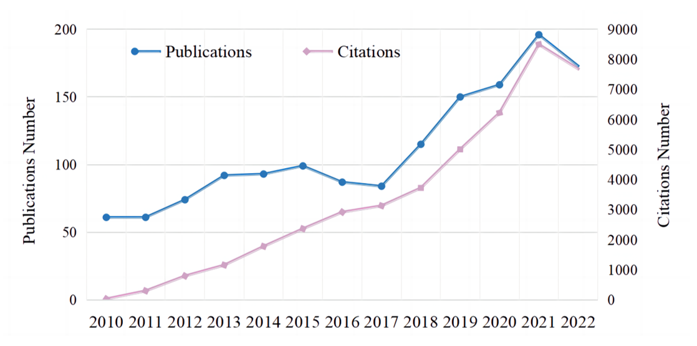
Figure 1 Annual publication outputs and citation trends regarding psychological interventions for depression in children and adolescents from 2010 to 2023.

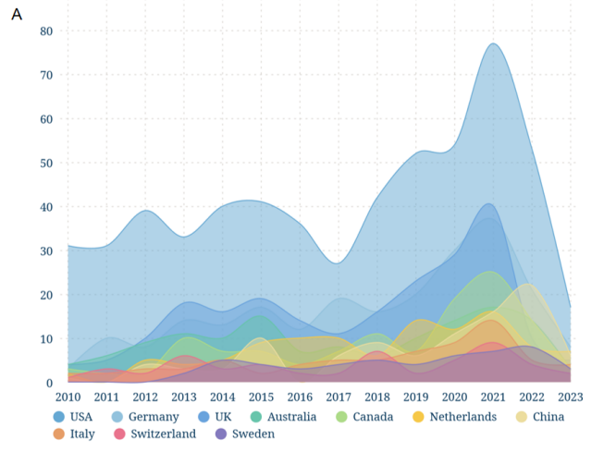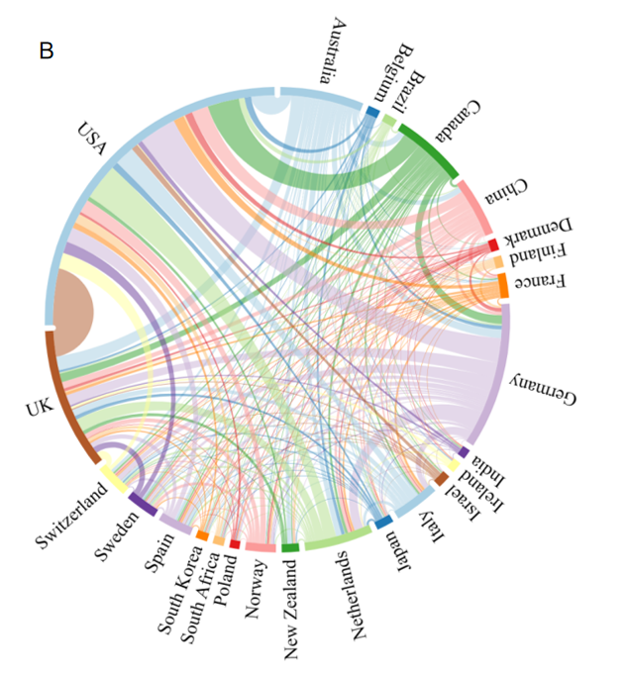
Figure 2 Visualization of country analysis. A: Annual number of publications in the top 10 most productive countries; B: International collaboration analysis among different countries.
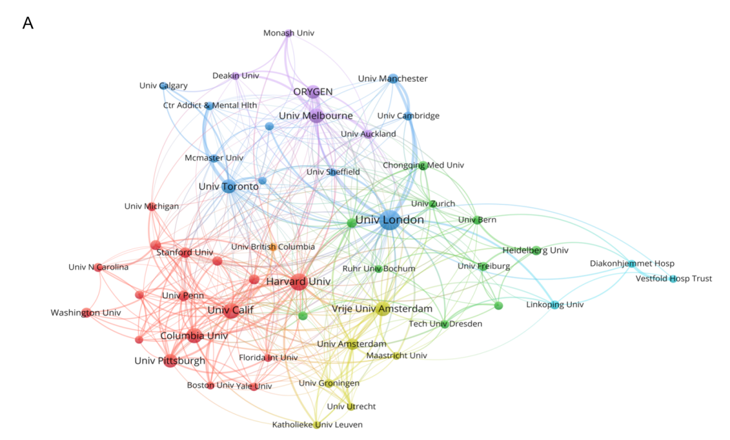
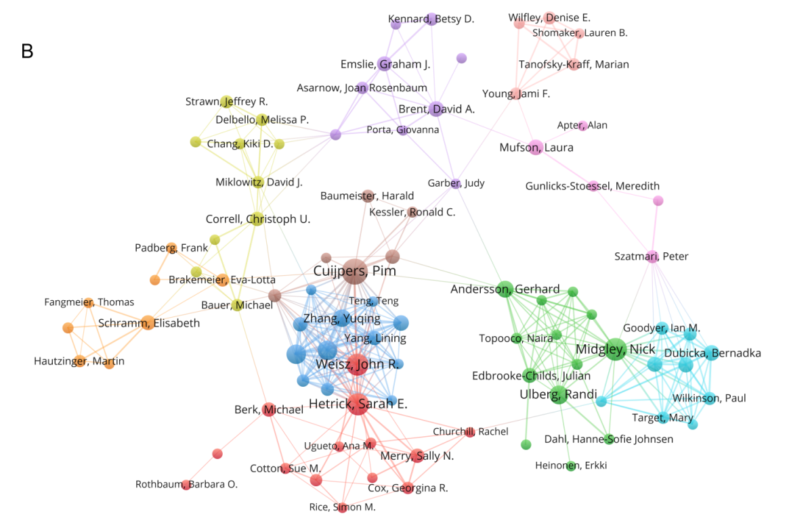
Figure 3 Visualization of institution and author analysis. A: Network visualization map of institution collaboration analysis; B: Network visualization map of author collaboration analysis.
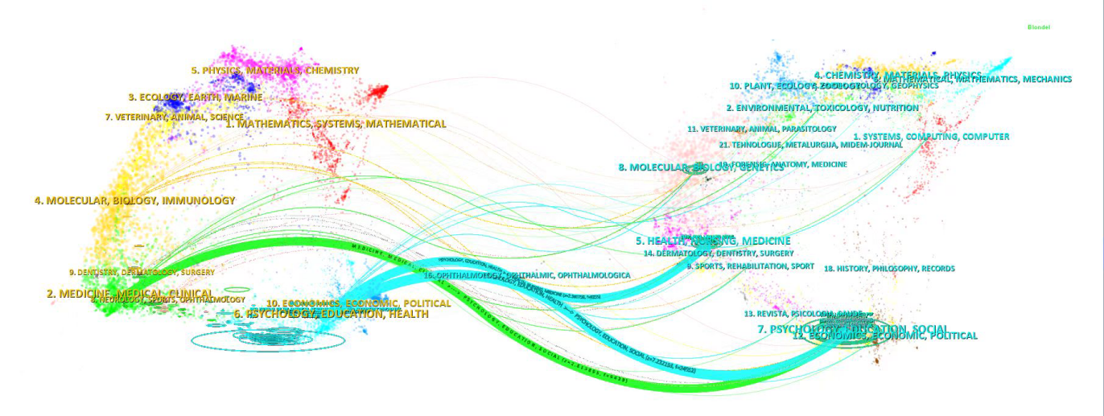
Figure 4 Dual-map overlay of academic journals.
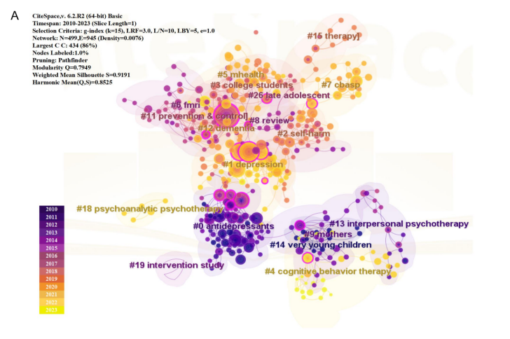
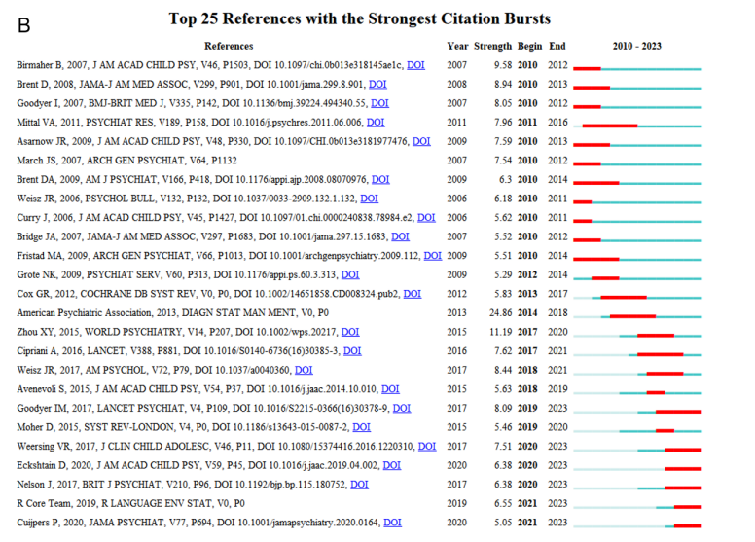
Figure 5 Visualization of reference co-citation analysis. A: Network visualization map of reference co-citation cluster analysis; B: Top 25 references with the strongest citation bursts.
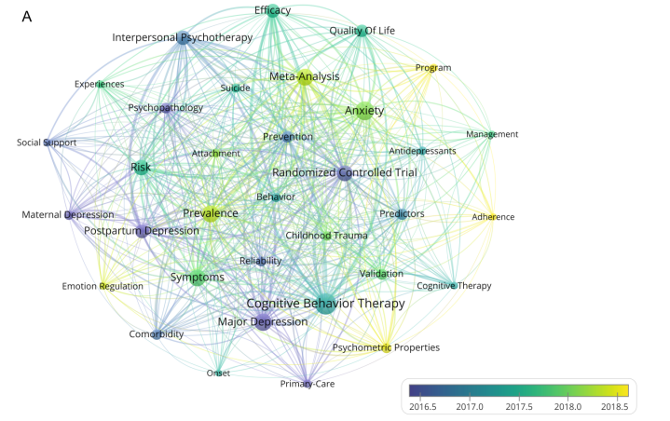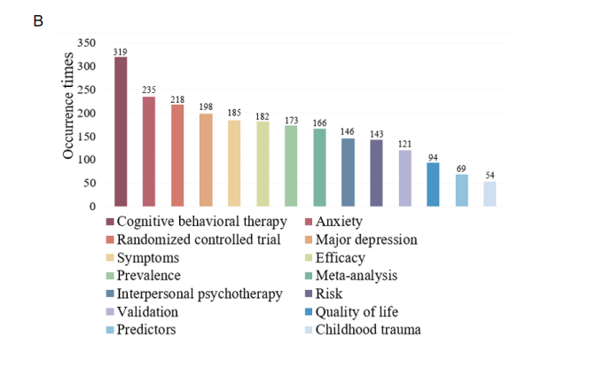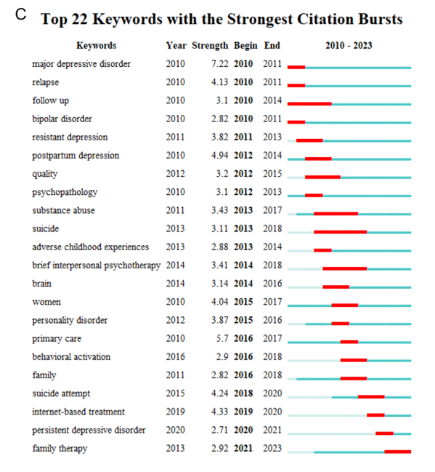
Figure 6 Visualization of keyword co-occurrence analysis. A: Network visualization map of keyword co-occurrence analysis; B: Top 15 keywords with the largest occurrence times; C: Top 22 keywords with the strongest citation bursts.
Table 1 Top 10 countries with most publications regarding psychological interventions for depression in children and adolescents
Rank | Country | Output | % of 1482 | H-index
1 | United States | 581 | 39.20 | 69
2 | Germany | 235 | 15.86 | 41
3 | United Kingdom | 230 | 15.52 | 46
4 | Australia | 134 | 9.04 | 36
5 | Canada | 122 | 8.23 | 31
6 | Netherlands | 110 | 7.42 | 35
7 | China | 97 | 6.61 | 20
8 | Italy | 73 | 4.93 | 23
9 | Switzerland | 55 | 3.71 | 24
10 | Spain | 55 | 3.71 | 18

Table 2 Top 10 institutions with most publications regarding psychological interventions for depression in children and adolescents
Rank | Institutions | Output | % of 1482 | H-index
1 | University of London | 116 | 7.83 | 31
2 | Harvard University | 89 | 6.01 | 33
3 | University of California | 67 | 4.52 | 27
4 | Vrije Universiteit Amsterdam | 59 | 3.91 | 24
5 | Columbia University | 55 | 3.71 | 25
6 | University of Melbourne | 52 | 3.51 | 21
7 | University of Toronto | 50 | 3.37 | 18
8 | University of Pittsburgh | 46 | 3.10 | 25
9 | ORYGEN1 | 41 | 2.77 | 21
10 | University of Amsterdam | 37 | 2.50 | 15
ORYGEN1 refers to The National Centre of Excellence in Youth Mental Health.
Table 3 Top 10 authors with most publications regarding psychological interventions for depression in children and adolescents
Rank | Authors | Output | % of 1482 | H-index
1 | Pim Cuijpers | 30 | 2.02 | 15
2 | Nick Midgley | 22 | 1.48 | 10
3 | Sarah E Hetrick | 20 | 1.35 | 15
4 | John R Weisz | 20 | 1.35 | 12
5 | Peng Xie | 16 | 1.08 | 9
6 | Xin-Yu Zhou | 16 | 1.08 | 9
7 | Randi Ulberg | 15 | 1.01 | 5
8 | Yu-Qing Zhang | 13 | 0.88 | 8
9 | Gerhard Andersson | 13 | 0.88 | 7
10 | David A Brent | 12 | 0.81 | 10

Table 4 Top 10 journals with most publications regarding psychological interventions for depression in children and adolescents
Rank | Journals | Output | % of 1482 | JIF1 (2022) | Quartile in category2 (2022)
1 | Journal of Affective Disorders | 85 | 5.74 | 6.6 | Q1
2 | Frontiers in Psychiatry | 66 | 4.45 | 4.7 | Q2
3 | Journal of the American Academy of Child and Adolescent Psychiatry | 42 | 2.83 | 13.3 | Q1
4 | Cochrane Database of Systematic Reviews | 39 | 2.63 | 8.4 | Q1
5 | BMC Psychiatry | 33 | 2.23 | 4.4 | Q2
6 | Trials | 29 | 1.96 | 2.5 | Q3
7 | European Child & Adolescent Psychiatry | 26 | 1.75 | 6.4 | Q1
8 | Plos One | 26 | 1.75 | 3.7 | Q2
9 | BMJ Open | 25 | 1.69 | 2.9 | Q2
10 | Depression and Anxiety | 24 | 1.62 | 7.4 | Q1
JIF1 (2022) refers to the impact factor of the Journal; Quartile in category2 (2022) is the division to which the journal belongs. Journal Citation Reports split journals into four equal parts based on JIF value, among which the top 25% attributed to Q1 and the top 25%–50% being Q2, etc.
Table 5 The clusters information of references co-citation analysis
Cluster ID | Size | Silhouette | Mean (year) | Top terms (log-likelihood ratio, p-level)
0 | 72 | 0.881 | 2008 | Antidepressants
1 | 53 | 0.931 | 2017 | Depression
2 | 32 | 0.887 | 2015 | Self-harm
3 | 27 | 0.906 | 2015 | College students
4 | 26 | 0.96 | 2019 | Cognitive behavior therapy
5 | 25 | 0.887 | 2018 | M-health
6 | 25 | 0.851 | 2012 | FMRI
7 | 24 | 0.871 | 2017 | CBASP
8 | 23 | 0.906 | 2011 | Review
9 | 23 | 0.998 | 2009 | Mothers
11 | 20 | 0.958 | 2012 | Prevention and Control
12 | 14 | 0.964 | 2016 | Dementia
13 | 13 | 0.985 | 2010 | Interpersonal psychotherapy
14 | 12 | 0.992 | 2007 | Very young children
15 | 11 | 0.978 | 2015 | Therapy
18 | 5 | 0.988 | 2018 | Psychoanalytic psychotherapy
19 | 4 | 0.997 | 2011 | Intervention study
26 | 3 | 0.997 | 2013 | Late adolescent

