Name of journal: World Journal of Gastroenterology
Manuscript NO: 40757
Manuscript type: Minireviews

Split liver transplantation: Current developments

Hackl C et al. current split LT

Christina Hackl, Katharina M Schmidt, Caner Süsal, Bernd Döhler, Martin Zidek, Hans J Schlitt

Christina Hackl, Katharina M Schmidt, Martin Zidek, Hans J Schlitt, Department of Surgery, University Hospital Regensburg, Regensburg 93053, Germany

Caner Süsal, Bernd Döhler, Collaborative Transplant Study (CTS), Institute of Immunology, Heidelberg University, Heidelberg 69120, Germany

ORCID number: Christina Hackl (0000-0002-1346-7238); Katharina M Schmidt (0000-0001-7750-8150); Caner Süsal (0000-0003-2521-8201); Bernd Döhler (0000-0003-0051-096X); Martin Zidek (0000-0002-1931-438X); Hans J Schlitt (0000-0002-3874-0296).

Author contributions: Hackl C contributed to conception and design, acquisition of data, drafting the article, critical revision for important intellectual content, final approval of the version to be published; Schmidt KM and Zidek M contributed to conception and design, critical revision for important intellectual content, final approval of the version to be published; Süsal C and Döhler B contributed to acquisition of data, critical revision for important intellectual content, final approval of the version to be published; Schlitt HJ contributed to conception and design, acquisition of data, drafting the article, critical revision for important intellectual content, final approval of the version to be published.

Conflict-of-interest statement: The authors declare no conflicts of interest.

Open-Access: This article is an open-access article which was selected by an in-house editor and fully peer-reviewed by external reviewers. It is distributed in accordance with the Creative Commons Attribution Non Commercial (CC BY-NC 4.0) license, which permits others to distribute, remix, adapt, build upon this work non-commercially, and license their derivative works on different terms, provided the original work is properly cited and the use is non-commercial. See: http://creativecommons.org/licenses/by-nc/4.0/

Manuscript source: Invited manuscript

Correspondence to: Christina Hackl, MD, Academic Research, Attending Doctor, Lecturer, Surgeon, Surgical Oncologist, Department of Surgery, University Medical Center Regensburg, Franz Josef Strauss Allee 11, 93053 Regensburg, Germany. christina.hackl@ukr.de
Telephone: +49-941-94416806
Fax: +49-941-9446802

Received: July 9, 2018
Peer-review started: July 10, 2018
First decision: July 18, 2018
Revised: October 21, 2018
Accepted:
Article in press:
Published online:

Abstract
In 1988, Rudolf Pichlmayr was the pioneer of split liver transplantation (SLT), enabling the transplantation of one donor liver into two recipients – one pediatric and one adult patient. In the same year, Henri Bismuth and colleagues performed the first full right/full left split procedure with two adult recipients. Both splitting techniques were rapidly adopted within the transplant community. However, a SLT is technically demanding, may cause increased perioperative complications and may potentially transform an excellent deceased donor organ into two marginal quality grafts. Thus, crucial evaluation of donor organs suitable for splitting and careful screening of potential SLT recipients is warranted. Furthermore, the logistic background of the splitting procedure as well as the organ allocation policy must be adapted to further increase the number and the safety of SLT. Under defined circumstances, in selected patients and at experienced transplant centers, SLT outcomes can be similar to those obtained in full organ LT. Thus, SLT is an important tool to reduce the donor organ shortage and wait-list mortality, especially for pediatric patients and small adults. The present review gives an overview of technical aspects, current developments and clinical outcomes of SLT.

Key words: Liver transplantation; organ shortage; in-situ split; extended right lobe; left lateral lobe; living donor

© The Author(s) 2018. Published by Baishideng Publishing Group Inc. All rights reserved.

Core tip: As of today, split liver transplantation (SLT) is a widely adopted but yet technically demanding approach to enable liver transplantation especially in very young recipients, to reduce organ shortage and wait-list mortality. In contrast to full organ liver transplantation, many technical evaluations concerning the donor organ, the recipient, as well as the splitting procedure and the organ allocation policy, must be considered before a SLT can safely be performed. The present review gives an insight into current controversies, technical challenges and clinical outcomes of SLT.

Hackl C, Schmidt KM, Süsal C, Döhler B, Zidek M, Schlitt HJ. Split liver transplantation: Current developments. World J Gastroenterol 2018; In press

INTRODUCTION
The first orthotopic liver transplant (LT), published by Thomas E Starzl, was performed in a 3 year-old patient diagnosed with biliary atresia^{[1]}. During the following years shortage of size-matched grafts for children became an evident dilemma. In the 1980s, Henri Bismuth introduced the method of graft size reduction to enable the use of adult donor grafts for pediatric LT^{[2]}. However, by thus reducing wait-list mortality for pediatric or small adult patients, this technique in parallel increased the organ shortage for adult recipients by sacrificing the remnant liver. In 1988, Rudolf Pichlmayr was the pioneer of split liver transplantation (SLT), enabling the transplantation of one donor liver into two recipients – one pediatric and one adult patient^{[3]}. In the same year Bismuth and colleagues performed the first full right/full left split procedure with two adult recipients^{[4]}. Both split techniques were rapidly adopted within the transplant community and already in 1990, Christoph Broelsch published a report on the outcome of 30 split liver transplants^{[5]}.
While in the 1980s the wait-list mortality of pediatric recipients was 40%, SLT and living-donor liver transplantation (LDLT) helped to reduce it today down to 10% in infants and to 5% in older children^{[6]}. A novel analysis of the development of graft survival rates in LT performed in pediatric patients and reported to the Collaborative Transplant Study (CTS, www.ctstransplant.org) is shown in Figure 1. Graft survival in pediatric LT is steadily increasing and current 5-year post-transplant graft survival is nearly 80%. Furthermore, SLT and LDLT enabled LT of very small infants and newborns. Since 1995, the proportion of 0–5 year old children among recipients of pediatric LT has remained nearly constant at 65%, with a high proportion (almost 30%) in < 1 year old infants (Figure 2). As shown in Figure 3a, the ratio of living donor liver transplantations has been steadily increasing in pediatric LT since 1995. Today, approximately one third of livers transplanted into pediatric recipients are derived from living donors (Figure 3a). On the other hand, the absolute number of livers transplanted into pediatric recipients from deceased donors has not decreased and thus, SLT resulted in an extension of the organ pool and reduction of donor organ scarcity for pediatric as well as adult LT recipients.

Performing an SLT is technically highly demanding in adult patients and may cause increased perioperative complications. The rate of living donors is steadily increasing in patients receiving an SLT and as of today is reported to be 46% (Figure 3b). When comparing SLT recipients and full organ recipients, rates of LT using reduced-size or split grafts have been steadily increasing until the period 2000–2004 and since then leveled off at 13%–15% (Figure 3c). In the first decades of SLT, increased complication rates caused hesitation to further spread the use of SLT. Ethical discussions were raised whether by splitting a liver, an excellent organ is converted into two marginal quality grafts^{[5,7-9]}; whether an adult recipient should be allowed to refuse a split organ remains an unresolved ethical issue. Complication rates of up to 66.7% after SLT versus 45.1% after full organ LT have been described^{[10,11]}, especially due to early biliary complications (18.8% in SLT vs 7.5% in full-organ LT) and portal vein thrombosis (14.6% in SLT versus 3.6% in full-organ LT)^{[11]}.
In recent years however experienced transplant centers have published favourable SLT outcomes similar to those obtained in full organ LT^{[12-15]}, supporting the argument that under defined conditions SLT should continue to be promoted. Therefore, allocation policies focusing on increasing SLT must be developed and transplant center should be encouraged to perform SLT whenever safe and possible.

Surgical techniques
Using the “classical” form of SLT, the liver is divided into a left lateral lobe graft (segments II + III) for a pediatric or small adult recipient and an extended right lobe graft (segments I + IV–VIII) for an adult recipient (Figure 4, yellow line)^{[16]}. During the splitting procedure the hepatoduodenal ligament is first dissected from the left side for adequate identification of the left hepatic artery. Then, the left portal vein is dissected, resulting in a de-portalization of segment IV. The following dissection of the liver parenchyma is performed at the right side of the falciform and round ligament, ending between the left and middle hepatic vein. Bile ducts of segments I and IV should be carefully saved while the hilar plate is sharply divided, including segment II and III bile ducts at the longitudinal section of the left portal vein. Finally, the dissected left portal vein, left artery and left hepatic vein are divided. In case of very small pediatric recipients, mono-segment grafts consisting of segment II or segment III only, can be applied.
In contrast, full size splits consisting of segments I-IV and segments V-VIII (Figure 4, black line) enable transplantation of two adult recipients, although the left lobe (without segment I) is generally only suitable for a small adult. Here, the safe biliary drainage of all segments is especially crucial. In contrast to a “classical split”, the trans-section plane of the liver parenchyma is significantly larger. Furthermore, due to the lack of a clear anatomic structure like the falciform ligament to indicate the resection line, in situ splitting (i.e., splitting before cold perfusion) should, whenever possible, be preferred. Potential anatomic variants of blood vessels and bile ducts must be carefully evaluated. Especially in full splits, the principle of “avoiding multiple small anastomoses”, defined by Henri Bismuth^{[4]}, is crucial. A “normal” left lobe consists of a single portal vein and a single hepatic duct, a venous outflow which often has a common ostium (left+middle vein), and often multiple branches of small hepatic arteries. A “normal” right lobe consists of a single right artery, but often shows multiple venous branches, hepatic ducts and sometimes even multiple branches of the portal vein. During the full split procedure it is therefore recommended that the left lobe retains the celiac trunk, whereas the right lobe retains the main hepatic duct, the main portal vein and the caval vein. For adequate venous drainage the left common ostium of left and middle vein is anastomosed with the recipient venous cuff created from all three hepatic veins during a piggyback LT technique. For excellent venous outflow of the right lobe, reconstruction of the middle vein must be considered, and for reduction of the risk of a small-for-size syndrome, portal inflow modification of the recipient needs deliberation. Potential modifications are: (1) splenic artery ligation, (2) splenectomy, (3) creating a hemi-portocaval shunt, and (4) (temporary) preservation of preexisting portocaval collaterals. If a relevant small-for size syndrome still occurs, early retransplantation must be considered.
A crucial aspect to avoid small-for size (or, in small infants, large-for size) syndromes is the meticulous evaluation of the donor liver volume. For a Caucasian population, liver volume can be calculated as 1072.8 * body surface area (m²) – 345.7^{[17]}. However, multiple formulae exist to calculate the liver volume of a potential donor, considering weight, body surface area, ethnicity and thoracoabdominal circumference (see overview in Table 1^{[17-21]}).
In LDLT, a minimal graft-to-recipient weight ratio of 0.6%-0.8% has been suggested^{[22-24]}. However, since LDLT grafts are derived from very healthy donors under ideal organ procurement conditions that include a minimal cold-ischemia time, the minimal graft-to-recipient weight ratio considered safe in deceased-donor SLT appears to be rather 0.8%-1.0%^{[8,22,25,26]}. As a simplified estimation, the liver weight represents 2% of the body weight of a normal-weight adult. A left lateral lobe split thus consists of approximately 250 ml liver parenchyma and an extended right lobe of 1100 ml liver parenchyma. However, due to the often mal- or non-perfused segments IV and I in extended right lobe grafts, their functional liver parenchyma is often smaller. A full left split consists of approximately 400 ml liver parenchyma, thus being sufficient for adult recipients up to 40–50 kg body weight. A full right split with 800–1000 ml liver parenchyma serves recipients up to 80–100 kg body weight, assuming a perfect venous drainage of the whole parenchyma of the right lobe^{[27,28]}. An overview of mostly used grafts in living donor and deceased donor SLT is given in Figure 5. Within the CTS population the majority of SLT performed using living donors are either left lateral lobe (38.4%) or extended right splits (41%). In contrast, in 4241 SLTs performed with deceased donor organs during 1995–2016, a significant variation in types of SLTs exists (Figure 5).
When SLT from deceased donor organs during 1995–2016 were analyzed in the CTS population, the “classical form” of SLT, namely left-lateral or extended right lobe SLT, is today performed in approximately 74% of SLT, whereas full left/right lobe SLT is performed in 17% of SLT (Figure 6a). As illustrated in Figure 6b, left-lateral splits are used in 33.9% of the cases for < 1 year old recipients and in 50.1% of the cases for 1–5 year old recipients. A minority of left-lateral SLT grafts is used for recipients older than 6 years. Left lobe SLT grafts are in 12.3% of the cases used for < 1 year old recipients, in 31.6% of the cases for 1–5 year old recipients, and in 37.7% of the cases for 6–14 year old recipients. 16.8% of left lobe splits are used for (small) adult recipients. In contrast, almost 90% of right lobe or extended-right lobe grafts are used for adult recipients (Figure 6b).

When SLT from living donor organs were analyzed within the CTS population, 637 right lobe, 217 left lobe and 594 left-lateral lobe donations were performed during 1995–2016 (Figure 6c). 95.1% of right lobes, 18.4% of left lobes and 5.1% of left-lateral lobes were used for adult recipients, whereas 27.6% of left lobes and more than 80% of left-lateral lobes were used for 0–5 year old infants (Figure 6c).
The decision-making for deceased-donor SLT must factor in careful donor selection, logistic aspects concerning the split procedure per se and the condition of the recipient. Concerning donor selection, Liu et al^{[28]} recommend the following criteria for “classical” SLT: hemodynamically stable patients younger than 55 years, duration of ICU treatment less than 5 days, fatty degeneration of the liver of less than 30%, GGT < 50 U/l, GPT < 60 U/l, and serum sodium < 160 mmol/l. For full right/left SLT, donors should weigh more than 70 kg, be younger than 40 years, the duration of ICU treatment should be less than 3 d and fatty degeneration of the liver should be less than 10%^{[28]}. These criteria slightly differ between transplant programs world-wide (see Table 2). Analyzing the CTS data, the median age of deceased donor livers used for SLT is 28–30 years and remains approximately constant since 1995 (Figure 7a). However, the median age of the deceased donor livers slightly increases in relation to the age of the recipient (Figure 7b). This reflects ongoing discussions of the influence of donor age on long-term outcome after LT and SLT^{[29]}. At the same time these data show that the maximum donor age tolerated for SLT in most transplant programs (see Table 2) is not exhausted and decision-making for SLT may be stricter than needed^{[29]}.

Ethical issues
Since splitting a liver is a technically demanding procedure, outstanding surgical expertise is warranted. If the split procedure is performed “in-situ”, an up to 3 hours longer operating time during organ procurement is needed and might result in quality impairment regarding other organs procured from the same donor. If the split is performed after donor hepatectomy, i.e., “ex-situ” in the recipient center, a respective longer cold ischemia time of the donor liver will result.
A current analysis of 37333 deceased donor LT in the United States revealed that 2352 (6.3%) of these livers met strict criteria for potential split, however, only 1418 livers (3.8%) were indeed split. During the study period, less children died on the waitlist than livers were procured that could potentially have been split and used for SLT. Thus, an infant waitlist-mortality of 10% and pediatric waitlist-mortality of 5% in the US could theoretically be eliminated by promoting SLT^{[6]}. An overview of rates of SLT and criteria to perform a SLT in different transplant programs is given in Table 2. While most programs show SLT ratios of up to 6%, programs in the United Kingdom, Brazil and Argentina reach ratios of 10%. The highest ratio published is in the Northern Italian region at a rate of 20% SLTs. According to ideal evaluation regimes of donor organs, in situ splitting and a modified allocation policy promoting SLT in Northern Italy, this region must be regarded as pioneer in promoting SLT with a very high outcome quality in selected patients (see „Outcome“). When comparing the rates of SLT reported to the International Registry in Organ Donation and Transplantation (IRODaT) for 2016, variations of SLT rates between 0 and 20% have been published (Table 3). A weakness of this database is the voluntary reporting of SLT rates to the IRODaT, resulting in underrated SLT rates and a lack of deceased-donor organs due to religious and cultural reasons in Asian countries (where, in contrast, a huge expertise in LDLT exists). Nevertheless, based on published criteria to perform an SLT in different transplant programs and reported SLT numbers, a significant discrepancy can be stated in most transplant programs, and SLT should be further promoted.

Outcomes
In a recent Korean analysis, 86 right-extended lobe deceased-donor split LT in adult recipients were compared to 303 deceased-donor full organ LT. Of note, only < 25% of LT in South Korea are performed using deceased donors, i.e. a great surgical expertise in in-situ splitting for living-donor LT exists. Groups were matched for recipient age, MELD score, duration of ischemia and graft-to-recipient weight ratio. Donors of extended right lobe (eRL) splits were significantly younger. There was no significant difference in complication rates and 5-year graft survival rates between deceased-donor SLT and full organ LT (89% vs 93%, p > 0.05). However, the 5-year overall survival rate and graft failure-free survival rate (both 63%) of eRL splits were significantly worse than in the full organ LT group (79%, p < 0.05). Factors resulting in a reduced overall survival in eRL recipients were MELD-score > 30 and donor-recipient weight ratio < 1.0. In subgroup analyses the outcome of both groups was equavalent if a donor-recipient weight ratio > 1.0 was observed in the eRL recipients^{[30]}.
A recent European Liver Transplant Registry analysis of 1500 pediatric recipients of left-lateral split LTs between 2006 and 2014 describes SLT as safe, when identified risk factors are avoided. Risk factors for graft failure in multivariate analyses were urgency of SLT, recipient body weight < 6 kg, donor age > 50 years and a prolonged cold ischemia time (HR = 1.07/h). The authors conclude that recipients <6 kg and recipients needing urgent SLT need cold-ischemia times < 6 h and careful graft/recipient size-matching^{[31]}. Another recent analysis of the European Liver Transplant Registry showed the impact of the Eurotransplant (ET) allocation policy on the outcome of eRL SLT. Current SLT allocation by ET allocates a splittable organ primarily to the pediatric LT center. After splitting, eRL splits are mostly re-allocated to a second transplant center. 5351 LTs were analyzed, thereof 269 eRL SLTs. Patient survival rates showed no significant differences in eRL SLT versus whole organ LT (5-year OS 73.6% after whole organ as well as after eRL LT). However, cold ischemia times were significantly longer in eRL recipients (12.1 ± 3.3 h vs 8.3 ± 2.8 h, p < 0.001) and eRL recipients had a significantly higher risk for retransplantation (14.4% after eRL SLT; 10.2% after whole organ LT, p = 0.02). Furthermore, overall survival correlated with increasing MELD scores already for MELD-scores > 14 in eRL recipients, whereas this correlation was only seen for MELD-scores > 20 in whole organ LT recipients^{[32]}.
A critical point of this analysis is that splitting was mainly performed ex situ in the transplant center accepting the left-lateral lobe, resulting in re-allocation and prolonged cold ischemia time of the eRL. In contrast, Northern Italy, where splitting procedures are mostly performed as in situ splits, reports on excellent outcomes of 382 eRL SLTs in a multicenter analysis^{[33]}. Since this publication, all deceased donor livers < 50 years donor-age and not allocated to high urgency patients in Italy are now evaluated for SLT. If SLT is done, allocation of the eRL is performed center-specific outside the MELD allocation system^{[34]}. However, a very recent and first long-term analysis of 119 matched-pair recipients of whole LT recipients versus extended right lobe SLT recipients in Italy showed contradictive results; full-organ recipients had highly significant longer 1-year, 5-year and 10-year overall survival rates compared to SLT recipients (1 year: 93% vs 73%, 5 years: 87% vs 65%; 10 years: 83% vs 60%, p < 0.001)^{[35]}. Also graft survival rates were substantially better in full organ recipients (1 year: 90% vs 76%; 5 years: 84% vs 57%; 10 years; 81% vs 52%, p < 0.001). When analyzing the subgroup of patients who survived the first year after LT, 5- and 10-year patient and graft survival did not show more significant differences in this publication. The authors identified the following risk factors for SLT recipients: (1) donor age < 50 years, (2) graft-to-recipient weight ratio < 1%, (3) redo transplantation and (4) recipients with UNOS status I–IIa. The authors conclude that SLT using extended right lobe grafts, if used after careful evaluation and in selected patients, can achieve long-term outcomes similar to full organ LT, but should not be performed in patients with risk factors^{[35]}.

The future of SLT
Recent clinical research has investigated the influence of normothermic machine perfusion on procured livers. A first report on feasibility and safety of normothermic recovery of an initially rejected liver graft was published by the Birmingham group in 2016^{[36]}, and they subsequently reported on 5 additional similar cases^{[37]}. In 2018, the same group published the first splitting procedure (eRL/LLL) during normothermic machine perfusion^{[38]}. Although this marginal organ was not used for LT after the split procedure, further research and development of this technique may positively impact future numbers of SLT in a monitored and safe manner.
Another ongoing discussion is the need to modify organ allocation to promote SLT. The “sickest first” policy, represented by the Model of End Stage Liver Disease (MELD) was implemented in UNOS in 2002 and in ET at the end of 2006^{[39,40]}. SLT allocation according to the MELD system allocates a splittable organ primarily to the center of the recipient with highest priority (mostly the pediatric patient) and, after splitting is confirmed, re-allocates the unused split to a second transplant center. This allocation practice results in reduced rates of in situ splitting, prolonged cold ischemia times and thus potentially higher complication rates with SLT. Center-based allocation is performed in countries with few transplant centers, e.g., Australia and the United Kingdom. In these programs reported SLT rates significantly exceed SLT rates in MELD-based allocation regions. As the Northern Italian experience has shown, all deceased donor livers meeting criteria to perform SLT, and not allocated to high urgency patients, should be offered for SLT. If SLT is performed the allocation of both splits should be performed center-specific outside the MELD allocation system to create another incentive for the transplant centers willing and able to perform an SLT. In situ splitting should be performed whenever possible, but realize that such a new policy may result in further centralization of transplant surgery or even discrimination of centers not able to perform SLT. Also, a center-based allocation system is more prone to subjective decision-making and should be critically monitored. Strasberg and colleagues have suggested here a nation- or transplant program-wide focus of organ allocation on “number of lives saved”, rather than the MELD-based “sickest-first” policy^{[41]}. Due to the increasing shortage of donor organs and still relevant wait-list mortality, such a policy would be an essential step towards improved quantities without reduction of quality in LT.

Conclusion
SLT, although technically demanding, is a routine and safe procedure resulting in increased numbers of LT, increased feasibility of LT in very young recipients, and in reduced wait-list mortality. Short and long-term outcome and survival can be similar to whole organ LT, if meticulous evaluations of donor organs and SLT recipients are performed, and logistics of organ allocation and splitting procedures are adapted. Since donor organ scarcity remains a primary problem in LT today, SLT is a valid solution and should be further promoted by both transplant program regulations and participating transplant centers/surgeons. Organ allocation policies should be adapted to create further incentives for LT centers willing and able to perform SLT. Safety must continue to have highest priority in LT and SLT.

Acknowledgements
The authors thank Professor Edward Geissler for language editing.

References
1 Starzl TE, Marchioro TL, Vonkaulla KN, Hermann G, Brittain RS, Waddell WR. Homotransplantation of the liver in humans. Surg Gynecol Obstet 1963; 117: 659-676 [PMID: 14100514]
2 Bismuth H, Houssin D. Reduced-sized orthotopic liver graft in hepatic transplantation in children. Surgery 1984; 95: 367-370 [PMID: 6367125]
3 Pichlmayr R, Ringe B, Gubernatis G, Hauss J, Bunzendahl H. [Transplantation of a donor liver to 2 recipients (splitting transplantation)--a new method in the further development of segmental liver transplantation]. Langenbecks Arch Chir 1988; 373: 127-130 [PMID: 3287073 DOI: 10.1007/BF01262776]
4 Azoulay D, Castaing D, Adam R, Savier E, Delvart V, Karam V, Ming BY, Dannaoui M, Krissat J, Bismuth H. Split-liver transplantation for two adult recipients: feasibility and long-term outcomes. Ann Surg 2001; 233: 565-574 [PMID: 11303140 DOI: 10.1097/00000658-200104000-00013]
5 Broelsch CE, Emond JC, Whitington PF, Thistlethwaite JR, Baker AL, Lichtor JL. Application of reduced-size liver transplants as split grafts, auxiliary orthotopic grafts, and living related segmental transplants. Ann Surg 1990; 212: 368-75; discussion 375-7 [PMID: 2396888 DOI: 10.1097/00000658-199009000-00015]
6 Perito ER, Roll G, Dodge JL, Rhee S, Roberts JP. Split liver transplantation and pediatric waitlist mortality in the United States: potential for improvement. Transplantation 2018; Epub ahead of print [PMID: 29684000 DOI: 10.1097/TP.0000000000002249]
7 Vagefi PA, Parekh J, Ascher NL, Roberts JP, Freise CE. Outcomes with split liver transplantation in 106 recipients: the University of California, San Francisco, experience from 1993 to 2010. Arch Surg 2011; 146: 1052-1059 [PMID: 21931003 DOI: 10.1001/archsurg.2011.218]
8 Hashimoto K, Quintini C, Aucejo FN, Fujiki M, Diago T, Watson MJ, Kelly DM, Winans CG, Eghtesad B, Fung JJ, Miller CM. Split liver transplantation using Hemiliver graft in the MELD era: a single center experience in the United States. Am J Transplant 2014; 14: 2072-2080 [PMID: 25040819 DOI: 10.1111/ajt.12791]
9 Emond JC, Whitington PF, Thistlethwaite JR, Cherqui D, Alonso EA, Woodle IS, Vogelbach P, Busse-Henry SM, Zucker AR, Broelsch CE. Transplantation of two patients with one liver. Analysis of a preliminary experience with 'split-liver' grafting. Ann Surg 1990; 212: 14-22 [PMID: 2363599]
10 Diamond IR, Fecteau A, Millis JM, Losanoff JE, Ng V, Anand R, Song C; SPLIT Research Group. Impact of graft type on outcome in pediatric liver transplantation: a report From Studies of Pediatric Liver Transplantation (SPLIT). Ann Surg 2007; 246: 301-310 [PMID: 17667510 DOI: 10.1097/SLA.0b013e3180caa415]
11 Hackl C, Schlitt HJ, Melter M, Knoppke B, Loss M. Current developments in pediatric liver transplantation. World J Hepatol 2015; 7: 1509-1520 [PMID: 26085910 DOI: 10.4254/wjh.v7.i11.1509]
12 Moussaoui D, Toso C, Nowacka A, McLin VA, Bednarkiewicz M, Andres A, Berney T, Majno P, Wildhaber BE. Early complications after liver transplantation in children and adults: Are split grafts equal to each other and equal to whole livers? Pediatr Transplant 2017; 21 [PMID: 28261944 DOI: 10.1111/petr.12908]
13 Doyle MB, Maynard E, Lin Y, Vachharajani N, Shenoy S, Anderson C, Earl M, Lowell JA, Chapman WC. Outcomes with split liver transplantation are equivalent to those with whole organ transplantation. J Am Coll Surg 2013; 217: 102-12; discussion 113-4 [PMID: 23639200 DOI: 10.1016/j.jamcollsurg.2013.03.003]
14 Cauley RP, Vakili K, Fullington N, Potanos K, Graham DA, Finkelstein JA, Kim HB. Deceased-donor split-liver transplantation in adult recipients: is the learning curve over? J Am Coll Surg 2013; 217: 672-684.e1 [PMID: 23978530 DOI: 10.1016/j.jamcollsurg.2013.06.005]
15 Battula NR, Platto M, Anbarasan R, Perera MT, Ong E, Roll GR, Ferraz Neto BH, Mergental H, Isaac J, Muiesan P, Sharif K, Mirza DF. Intention to Split Policy: A Successful Strategy in a Combined Pediatric and Adult Liver Transplant Center. Ann Surg 2017; 265: 1009-1015 [PMID: 27257738 DOI: 10.1097/SLA.0000000000001816]
16 Busuttil RW, Goss JA. Split liver transplantation. Ann Surg 1999; 229: 313-321 [PMID: 10077042 DOI: 10.1097/00000658-199903000-00003]
17 Heinemann A, Wischhusen F, Püschel K, Rogiers X. Standard liver volume in the Caucasian population. Liver Transpl Surg 1999; 5: 366-368 [PMID: 10477836 DOI: 10.1002/lt.500050516]
18 Herden U, Wischhusen F, Heinemann A, Ganschow R, Grabhorn E, Vettorazzi E, Nashan B, Fischer L. A formula to calculate the standard liver volume in children and its application in pediatric liver transplantation. Transpl Int 2013; 26: 1217-1224 [PMID: 24118382 DOI: 10.1111/tri.12198]
19 Kokudo T, Hasegawa K, Uldry E, Matsuyama Y, Kaneko J, Akamatsu N, Aoki T, Sakamoto Y, Demartines N, Sugawara Y, Kokudo N, Halkic N. A new formula for calculating standard liver volume for living donor liver transplantation without using body weight. J Hepatol 2015; 63: 848-854 [PMID: 26057995 DOI: 10.1016/j.jhep.2015.05.026]
20 Urata K, Kawasaki S, Matsunami H, Hashikura Y, Ikegami T, Ishizone S, Momose Y, Komiyama A, Makuuchi M. Calculation of child and adult standard liver volume for liver transplantation. Hepatology 1995; 21: 1317-1321 [PMID: 7737637 DOI: 10.1002/hep.1840210515]
21 Vauthey JN, Abdalla EK, Doherty DA, Gertsch P, Fenstermacher MJ, Loyer EM, Lerut J, Materne R, Wang X, Encarnacion A, Herron D, Mathey C, Ferrari G, Charnsangavej C, Do KA, Denys A. Body surface area and body weight predict total liver volume in Western adults. Liver Transpl 2002; 8: 233-240 [PMID: 11910568 DOI: 10.1053/jlts.2002.31654]
22 Hashimoto K, Fujiki M, Quintini C, Aucejo FN, Uso TD, Kelly DM, Eghtesad B, Fung JJ, Miller CM. Split liver transplantation in adults. World J Gastroenterol 2016; 22: 7500-7506 [PMID: 27672272 DOI: 10.3748/wjg.v22.i33.7500]
23 Kaido T, Mori A, Ogura Y, Hata K, Yoshizawa A, Iida T, Yagi S, Uemoto S. Lower limit of the graft-to-recipient weight ratio can be safely reduced to 0.6% in adult-to-adult living donor liver transplantation in combination with portal pressure control. Transplant Proc 2011; 43: 2391-2393 [PMID: 21839274 DOI: 10.1016/j.transproceed.2011.05.037]
24 Selzner M, Kashfi A, Cattral MS, Selzner N, Greig PD, Lilly L, McGilvray ID, Therapondos G, Adcock LE, Ghanekar A, Levy GA, Renner EL, Grant DR. A graft to body weight ratio less than 0.8 does not exclude adult-to-adult right-lobe living donor liver transplantation. Liver Transpl 2009; 15: 1776-1782 [PMID: 19938139 DOI: 10.1002/lt.21955]
25 Lee WC, Chan KM, Chou HS, Wu TJ, Lee CF, Soong RS, Wu TH, Lee CS. Feasibility of split liver transplantation for 2 adults in the model of end-stage liver disease era. Ann Surg 2013; 258: 306-311 [PMID: 23108123 DOI: 10.1097/SLA.0b013e3182754b8e]
26 Hong JC, Yersiz H, Busuttil RW. Where are we today in split liver transplantation? Curr Opin Organ Transplant 2011; 16: 269-273 [PMID: 21467935 DOI: 10.1097/MOT.0b013e328346572e]
27 Lee SG. Living-donor liver transplantation in adults. Br Med Bull 2010; 94: 33-48 [PMID: 20144939 DOI: 10.1093/bmb/ldq003]
28 Liu H, Li R, Fu J, He Q, Li J. Technical Skills Required in Split Liver Transplantation. Ann Transplant 2016; 21: 408-415 [PMID: 27363540 DOI: 10.12659/AOT.896351]
29 Lué A, Solanas E, Baptista P, Lorente S, Araiz JJ, Garcia-Gil A, Serrano MT. How important is donor age in liver transplantation? World J Gastroenterol 2016; 22: 4966-4976 [PMID: 27275089 DOI: 10.3748/wjg.v22.i21.4966]
30 Yoon KC, Song S, Jwa EK, Lee S, Kim JM, Kim OK, Hong SK, Yi NJ, Lee KW, Kim MS, Hwang S, Suh KS, Lee SK. Survival Outcomes in Split Compared to Whole Liver Transplantation. Liver Transpl 2018; Epub ahead of print [PMID: 29747216 DOI: 10.1002/lt.25196]
31 Angelico R, Nardi A, Adam R, Nadalin S, Polak WG, Karam V, Troisi RI, Muiesan P; European Liver and Intestine Transplant Association (ELITA). Outcomes of left split graft transplantation in Europe: report from the European Liver Transplant Registry. Transpl Int 2018; 31: 739-750 [PMID: 29505674 DOI: 10.1111/tri.13147]
32 Andrassy J, Wolf S, Lauseker M, Angele M, van Rosmalen MD, Samuel U, Rogiers X, Werner J, Guba M; Eurotransplant Liver Advisory Committee. Higher retransplantation rate following extended right split-liver transplantation: An analysis from the eurotransplant liver follow-up registry. Liver Transpl 2018; 24: 26-34 [PMID: 29144580 DOI: 10.1002/lt.24980]
33 Maggi U, De Feo TM, Andorno E, Cillo U, De Carlis L, Colledan M, Burra P, De Fazio N, Rossi G; Liver Transplantation and Intestine North Italy Transplant Study Group. Fifteen years and 382 extended right grafts from in situ split livers in a multicenter study: Are these still extended criteria liver grafts? Liver Transpl 2015; 21: 500-511 [PMID: 25545700 DOI: 10.1002/lt.24070]
34 Cillo U, Burra P, Mazzaferro V, Belli L, Pinna AD, Spada M, Nanni Costa A, Toniutto P; I-BELT (Italian Board of Experts in the Field of Liver Transplantation). A Multistep, Consensus-Based Approach to Organ Allocation in Liver Transplantation: Toward a "Blended Principle Model". Am J Transplant 2015; 15: 2552-2561 [PMID: 26274338 DOI: 10.1111/ajt.13408]
35 Ross MW, Cescon M, Angelico R, Andorno E, Rossi G, Pinna A, De Carlis L, Baccarani U, Cillo U, Colledan M, Mazzaferro V, Tisone G, Rossi M, Tuzzolino F, Pagano D, Gruttadauria S, Mazariegos G, Gridelli B, Spada M. A matched pair analysis of multicenter longterm follow-up after split-liver transplantation with extended right grafts. Liver Transpl 2017; 23: 1384-1395 [PMID: 28650108 DOI: 10.1002/lt.24808]
36 Perera T, Mergental H, Stephenson B, Roll GR, Cilliers H, Liang R, Angelico R, Hubscher S, Neil DA, Reynolds G, Isaac J, Adams DA, Afford S, Mirza DF, Muiesan P. First human liver transplantation using a marginal allograft resuscitated by normothermic machine perfusion. Liver Transpl 2016; 22: 120-124 [PMID: 26566737 DOI: 10.1002/lt.24369]
37 Mergental H, Perera MT, Laing RW, Muiesan P, Isaac JR, Smith A, Stephenson BT, Cilliers H, Neil DA, Hübscher SG, Afford SC, Mirza DF. Transplantation of Declined Liver Allografts Following Normothermic Ex-Situ Evaluation. Am J Transplant 2016; 16: 3235-3245 [PMID: 27192971 DOI: 10.1111/ajt.13875]
38 Stephenson BTF, Bonney GK, Laing RW, Bhogal RH, Marcon F, Neil DAH, Perera MTPR, Afford SC, Mergental H, Mirza DF. Proof of concept: liver splitting during normothermic machine perfusion. J Surg Case Rep 2018; 2018: rjx218 [PMID: 29644030 DOI: 10.1093/jscr/rjx218]
39 Malinchoc M, Kamath PS, Gordon FD, Peine CJ, Rank J, ter Borg PC. A model to predict poor survival in patients undergoing transjugular intrahepatic portosystemic shunts. Hepatology 2000; 31: 864-871 [PMID: 10733541 DOI: 10.1053/he.2000.5852]
40 Said A, Williams J, Holden J, Remington P, Gangnon R, Musat A, Lucey MR. Model for end stage liver disease score predicts mortality across a broad spectrum of liver disease. J Hepatol 2004; 40: 897-903 [PMID: 15158328 DOI: 10.1016/j.jhep.2004.02.010]
41 Strasberg SM, Lowell JA, Howard TK. Reducing the shortage of donor livers: what would It take to reliably split livers for transplantation into two adult recipients? Liver Transpl Surg 1999; 5: 437-450 [PMID: 10477846 DOI: 10.1002/lt.500050508]
P-Reviewer: Bramhall S, Hilmi I, Tao R S-Editor: Gong ZM
L-Editor: E-Editor:
Specialty type: Gastroenterology and hepatology
Country of origin: Germany
Peer-review report classification
Grade A (Excellent): 0
Grade B (Very good): 0
Grade C (Good): C, C, C
Grade D (Fair): 0
Grade E (Poor): 0

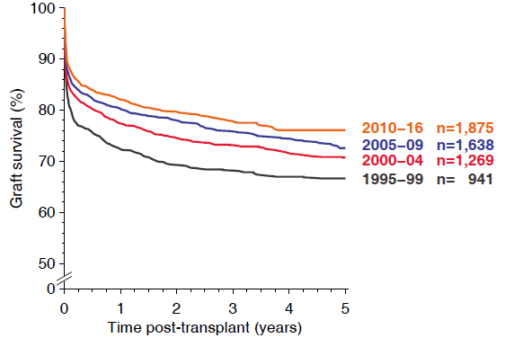
Figure 1 Graft survival of liver transplants in 0–17 year old pediatric patients by transplant year during 1995–2016. Collaborative Transplant Study data are derived from 95 transplant centers in 22 countries (87% European transplants).

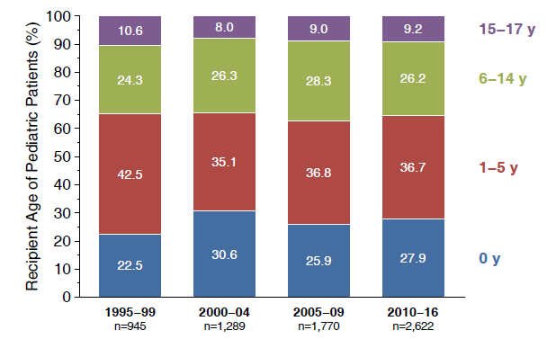
Figure 2 Different pediatric age groups and distribution of liver transplants by transplant year during 1995–2016.

A
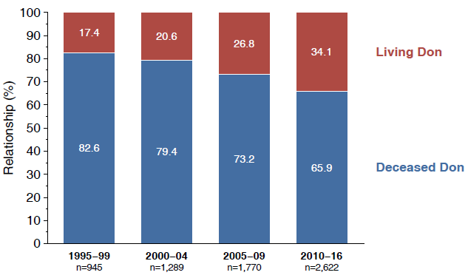
B
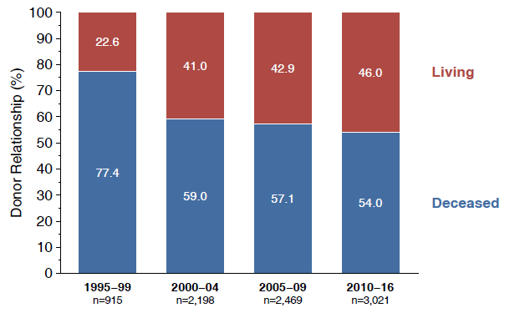
C
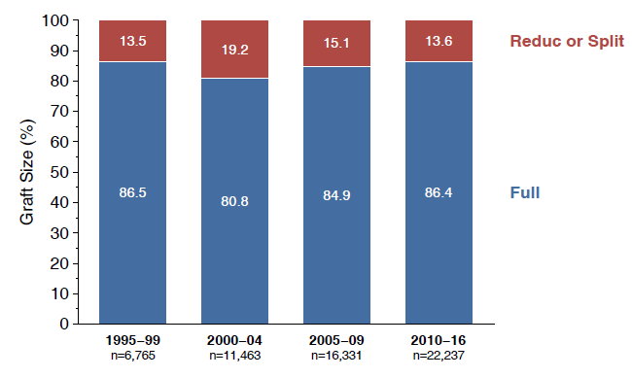
Figure 3 Pediatric (a) and split or reduced liver transplants from living or deceased donors (b) and all liver transplants categorized according to graft size (c) by transplant year during 1995–2016.

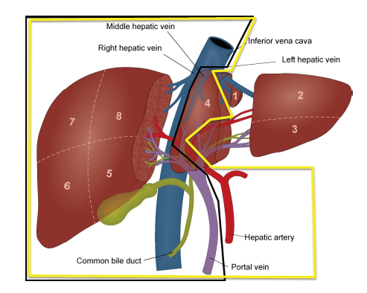
Figure 4 Scheme of a “classical” eRL/LLL split (yellow line) and a full-left/full-right split (black line).

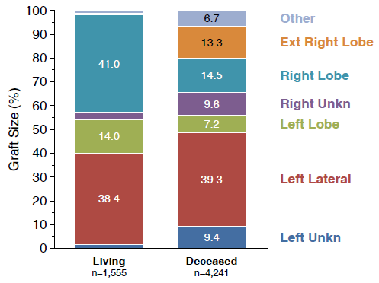
Figure 5 Split or reduced liver transplants during 1995–2016 categorized according to graft size.

A
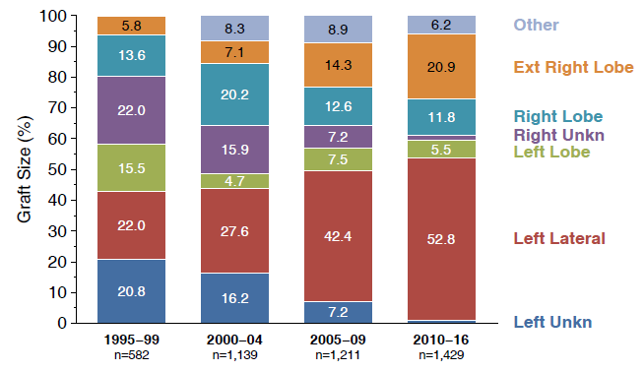
B
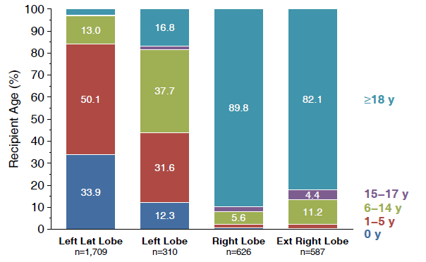
C
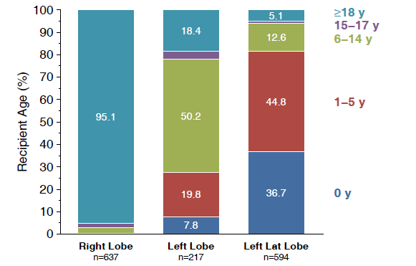
Figure 6 Split or reduced liver transplants during 1995–2016 from deceased donors categorized according to (a) graft size or (b) recipient age and (c) from living donors categorized according to recipient age.

A
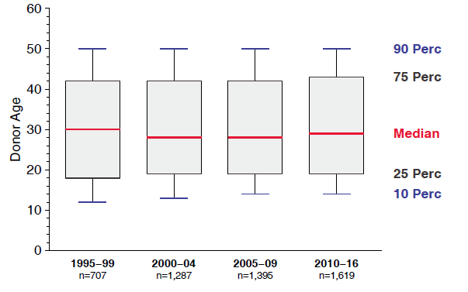
B
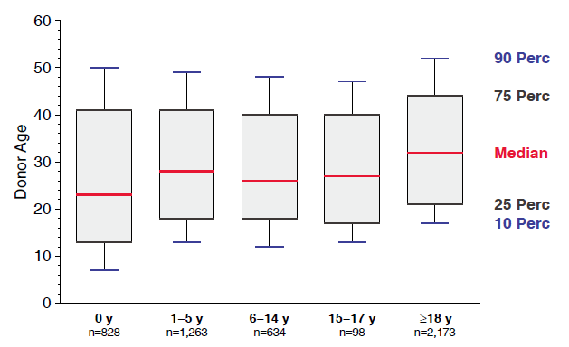
Figure 7 Distribution of donor age according to transplant year (a) and recipient age (b) in deceased donor split or reduced liver transplantations performed during 1995–2016.

Table 1 Recently published formulae to calculate the liver volume
Ref. | Formula | Patient group | Technique
Urata et al^{[20]}, 1995 | LV (mL) = 706.2 × BSA (m²) + 2.4 | 96 patients (65 pediatric) | CT
Vauthey et al^{[21]}, 2002 | Based on BSA:  LV = –794.41 + 1267.28 × BSA (m²)  r² = 0.46; P < 0.0001  Based on patient weight:  LV = 191.80 + 18.51 × body weight (kg)  r² = 0.49; P < 0.0001 | 292 adults | CT
Heinemann et al^{[17]}, 1999 | LV (mL) = 1072.8 × BSA (m²) – 345.7 | 1332 patients | autopsy
Kokudo et al^{[19]}, 2015 | LV = 203.3 – (3.61 × age) + (58.7 × thoracic width [cm]) - (463.7 × race [1 = Asian, 0 = Caucasian]) | 180 Japanese and 160 Swiss patients | CT
Herden et al^{[18]}, 2013 | Children 0 to ≤ 1 yr:  LV [ml] = 143.062973 + 4.274603051 × body length [cm] + 14.78817631 × body weight [kg]  1 yr < Children <16 yr:  LV [ml] = 20.2472281 + 3.339056437 × body length [cm] + 13.11312561 × body weight [kg] | 388 pediatrics | autopsy
LV: liver volume; BSA: body surface area; CT: computed tomography.

Table 2 Criteria and rates of split liver transplantation in different transplant programmes according to the transplant programmes homepages
Programme | Rate of SLT | Donor age | Weight/BMI | Transaminases | Other criteria
UNOS | 1%–4% (but according to UNOS criteria > 10% eligible) | < 40 | < 28 kg/m² | < 3 × ULN | Single vasopressor
ET | 6% | < 50 | > 50 kg
United Kingdom | 10.6% | < 40 | > 50 kg |  | < 5d ICU
Argentina/Brazil | 10% | < 47 | umbilical perimeter < 92 cm | AST < 42 U/l  ALT < 29 U/l
Oceania | 6%
Scandia-transplant | ? | <51 | < 26 kg/m² | ALT/AST < 3 × normal | < 4d ICU
Saudi-Arabia | 5.6%
South Africa | 3%
Japan | 1.8%
Italy | 8% (Northern Italy: 20%) | < 60 |  | near-normal liver function tests | < 5d ICU  low inotropic support
ALT: Alanine transaminase; AST: aspartate aminotransferase; ET: Eurotransplant; ICU: Intensive care unit; SLT: split liver transplantation.
Table 3 Numbers of liver transplantation, living-donor liver transplantation, deceased donor liver transplantation and split liver transplantation and rate of split liver transplantation in deceased donor liver transplantation performed in different transplant programmes in 2016 according to the International Registry in Organ Donation and Transplantation
 | Total number | Living donors | Deceased  donors | Split-liver | Split-liver (%)
UNOS | 8082 | 367 | 7715 | 0 | 0
Eurotransplant:
Germany | 821 | 61 | 760 | 74 | 9.01
Austria | 154 | 2 | 152 | 6 | 3.90
Croatia | 121 | 0 | 121 | 0 | 0
Netherlands | 147 | 0 | 147 | 0 | 0
Belgium | 302 | 46 | 256 | 1 | 0.33
Luxemburg | 0 | 0 | 0 | 0 | 0
Hungary | 74 | 0 | 74 | 0 | 0
Slovenia | 27 | 0 | 27 | 0 | 0
Scandiatransplant | 0
Sweden | 199 | 2 | 197 | 0 | 0
Norway | 100 | 0 | 100 | 0 | 0
Finland | 61 | 0 | 61 | 0 | 0
Iceland | 0 | 0 | 0 | 0 | 0
Dennmark | 57 | 0 | 57 | 0 | 0
China | - | - | - | -
India | - | - | - | -
Japan | 438 | 381 | 57 | 8 | 1.83
South Korea | 1473 | 965 | 508 | 36 | 2.44
Australia | 314 | 2 | 312 | 65 | 20.70
Brazil | 2037 | 157 | 1880 | 0 | 0
Argentina | 349 | 37 | 312 | 0 | 0
Mexico | 178 | 3 | 175 | 0 | 0
Canada | 582 | 73 | 509 | 0 | 0
South Africa | 69 | 15 | 54 | 2 | 2.90
United Kingdom | 953 | 32 | 921 | 101 | 10.60
France | 1317 | 5 | 1312 | 0 | 0
Spain | 1159 | 28 | 1131 | 0 | 0
Italy | 1220 | 7 | 1213 | 98 | 8.03
Poland | 345 | 28 | 317 | 0 | 0
Czech Republic | 179 | 1 | 178 | 0 | 0
Balttransplant | 33 | 0 | 33 | 0 | 0

