Name of Journal: World Journal of Radiology
Manuscript NO: 92298
Manuscript Type: MINIREVIEWS

Endoscopic ultrasound-guided tissue acquisition for the diagnosis of focal liver lesion

Tantău A et al. EUS-guided biopsy of liver lesions

Alina Tantău, Cosmina Sutac, Anamaria Pop, Marcel Tantău

Alina Tantău, Department of Internal Medicine and Gastroenterology, “Iuliu Hatieganu” University of Medicine and Pharmacy, The 4th Medical Clinic CF Hospital, Cluj-Napoca 400012, Cluj, Romania

Cosmina Sutac, Department of Gastroenterology, The 4th Medical Clinic CF Hospital, Cluj-Napoca 400012, Cluj, Romania

Anamaria Pop, Department of Gastroenterology and Hepatology, Gastroenterology and Hepatology Medical Center, Digenio Hospital, Cluj-Napoca 400058, Cluj, Romania

Marcel Tantău, Department of Internal Medicine and Gastroenterology, “Iuliu Hatieganu” University of Medicine and Pharmacy, “Prof. Dr. Octavian Fodor”, Regional Institute of Gastroenterology and Hepatology, Cluj-Napoca 400162, Cluj, Romania

Author contributions: Tantău A wrote the paper; Sutac C and Anamaria P collected the data and draft the paper; Tantău M revised the paper and provided the endoscopic ultrasound imagines from her personal collection; and all authors contributed with expert opinion on the concept paper and critically revising the article, and approved the final article version to be published.

Corresponding author: Anamaria Pop, MD, Doctor, Department of Gastroenterology and Hepatology, Gastroenterology and Hepatology Medical Center, Digenio Hospital, 2 Portelanului Street, Cluj-Napoca 400058, Cluj, Romania. anamaria.pop09@yahoo.com

Received: January 31, 2024
Revised: March 12, 2024
Accepted: March 21, 2024
Published online:

Abstract
In patients with liver tumors, the histopathology examination can assist in diagnosis, staging, prognosis, and therapeutic management strategy. Endoscopic ultrasound (EUS)-guided tissue acquisition using fine needle aspiration (FNA) or more newly fine needle biopsy (FNB) is a well-developed technique in order to evaluate and differentiate the liver masses. The goal of the EUS-FNA or EUS-FNB is to provide an accurate sample for a histopathology examination. Therefore, malignant tumors such as hepatocarcinoma, cholangiocarcinoma and liver metastasis or benign tumors such as liver adenoma, focal hyperplastic nodular tumors and cystic lesions can be accurately diagnosed using EUS-guided tissue acquisition. EUS-FNB using 19 or 22 Ga needle provide longer samples and a higher diagnostic accuracy in patients with liver masses when compared with EUS-FNA. Few data are available on the diagnostic accuracy of EUS-FNB when compared with percutaneously, ultrasound, computer tomography or transjugulary-guided liver biopsies. This review will discuss the EUS-guided tissue acquisition options in patients with liver tumors and its efficacy and safety in providing accurate samples. The results of the last studies comparing EUS-guided liver biopsy with other conventional techniques are presented. The EUS-guided tissue acquisition using FNB can be a suitable technique in suspected liver lesions in order to provide an accurate histopathology diagnosis, especially for those who require endoscopy.

Key Words: Endoscopic ultrasound-guided liver biopsy; Liver tissue acquisition; Fine-needle aspiration; Fine-needle biopsy; Liver tumors; Focal liver lesions

Tantău A, Sutac C, Pop A, Tantău M. Endoscopic ultrasound-guided tissue acquisition for the diagnosis of focal liver lesion. World J Radiol 2024; In press

Core Tip: Endoscopic ultrasound (EUS) guided tissue acquisition with fine needle aspiration or biopsy needles are an effective and safe approach to obtain liver samples. In this review our goal is to discuss the EUS-guided tissue acquisition options in patients with liver tumors and its efficacy and safety in providing accurate samples. The results of the last studies comparing EUS-guided liver biopsy with other conventional techniques are presented.

INTRODUCTION
In patients with liver tumors, the histopathology examination can help in diagnosis, staging, prognosis, and therapeutic management strategy. The gold standard for diagnosis of liver tumors is liver biopsy (LB). Transjugular (TJ) and percutaneous (PC) approaches are the most common techniques for LB^{[1-3]}.
Endoscopic ultrasound (EUS)-guided tissue acquisition (EUS-TA) using fine needle aspiration (FNA) or more recently fine needle biopsy (FNB), is a well-developed technique in order to evaluate and differentiate the liver masses. The goal of the EUS-TA is to provide an accurate sample for a histopathology examination^{[4]}. The common indication for EUS-guided FNA (EUS-FNA) is to obtain cytology or histology from primary or metastatic malignancy^{[5]}.
Nguyen et al^{[6]} reported the utility of EUS-FNA in histological examination of focal liver lesions. In the last two decades there were numerous studies that emphasized the role of EUS-LB in the diagnosis of hepatic malignancies such as hepatocarcinoma carcinoma (HCC), cholangiocarcinoma (CCA), and liver metastasis^{[7-17]} (Table 1).
Furthermore, EUS-LB seems to be efficient in providing a high diagnostic accuracy even in benign liver lesions or diffuse liver conditions^{[18-24]}.
In the majority of EUS-FNA studies where 19 gauge (G) or 22 G needles were used, the diagnostic yield of focal liver lesions vary from 80% to 90%^{[6-10,14-16]}. However, EUS-FNB using 19 G or 22 G needles provide longer samples and a higher diagnostic accuracy in patients with liver masses when compared with EUS-FNA^{[11-13,15,17]}.
Recent data are available on the diagnostic accuracy of EUS-FNB when compared with PC, ultrasonography (US), computer tomography (CT), or TJ-guided liver biopsies^{[25-30]}. In the last studies the yield of EUS-LB and PC or TJ liver sampling was compared. Specimen accuracy and diagnostic yield are at least comparable between those three techniques, ranging from 90% to 100%^{[25-30]}.
In this review we intent to explore and discuss the studies from the last decade regarding EUS-TA options in patients with liver tumors. Furthermore, we assessed the efficacy and safety of EUS-FNA and EUS-FNB from liver masses in providing an accurate diagnostic.

ENDOSCOPIC ULTRASOUND LIVER ASSESSING
EUS has multiple advantages in the evaluation of the liver and its focal or diffuse conditions. Both the liver lobes and liver hilum can be accurately evaluated from the stomach and bulb using the EUS approach due to the close position of the transducer^{[5]}. EUS is an adjuvant method to magnetic resonance imaging (MRI) and CT in detecting and characterizing liver tumors and is superior to CT in diagnosing liver lesions located in the left lobe or smaller than 10 mm in diameter^{[5,31,32]}.
Tissue acquisition under EUS guidance (FNA) or FNB is a helpful technique in the diagnosis of focal liver lesions, perihepatic adenopathy and in the evaluation of biliary tract disease. In contrast with other techniques, liver EUS has some advantages as targeting the caudal lobe, avoiding the biliary tree and vessels during puncture. It is a real-time technique and the perihepatic lymph nodes and portal vein thrombosis can be targeted in the same session^{[32]}.
The malignant tumors such as HCC, CCA, and liver metastasis or benign tumors such as liver adenoma, focal hyperplastic nodular tumors and cystic lesions can be accurately diagnosed using EUS-TA^{[4,5,31,32]} (Figure 1).
There are various factors which can influence the diagnostic yield of EUS or EUS-LB: The features of the liver lesions (localization: Caudal or left lobe or right lobe, size and echogenity), the endosonographer experience, the type of the needle, the number of passes, the aspiration /biopsy technique (stylet and suction), the presence of the cytopathologist in the endoscopy room (ROSE), the preparation of the specimen for cytohistologic examination and the cytopathologist experience^{[33-38]}.

EUS-GUIDED LIVER ACQUISITION
Tru-cut needles: Mathew et al^{[21]} published the first case of EUS-LB using a novel Tru-Cut (QuickCore, Cook Medicale) core biopsy needle. Later in a study by DeWitt et al^{[19]}, 21 patients underwent EUS-guided Tru-Cut biopsy from benign liver disease. A histology diagnosis was obtained in the majority of the cases (90%) but the standard criteria for histology assessment was not met due to the small size of samples^{[19]}. More recently, in a large retrospective study the Tru-Cut needle was compared with a non Tru-Cut needle (ProCore needle, Cook Medical) and the results showed that the ProCore needle was easier to use and provided good tissue with fewer passes than the Tru-Cut needle^{[39]}. Nowadays, the widespread adoption of the Tru-Cut needle is limited due to the inflexibility and the difficulty of use resulting in the manufacturers considering removing this needle from clinical practice.

EUS-FNA for liver tumors
Stavropoulos et al^{[22]}, published in 2012, an important study which demonstrated the efficacy of a 19 G FNA in EUS-LB. Moreover, the efficacy of 19G FNA in EUS-LB was shown in a multicenter prospective study conducted by Diehl et al^{[23]} in patients with elevated liver enzymes or hepatic disease. EUS-LB was performed in 110 patients and in the majority (108 patients) the specimens obtained were sufficient for a pathological diagnosis. The study demonstrated high tissue specimen lengths and portal tract counts. No differentiation in yield was detected between the right lobe, left lobes or both lobes^{[23]}.
In the last two decade, EUS-FNA has demonstrated its role in patients with liver tumors. Earlier previous studies demonstrated a sensitivity of 19G EUS-FNA for liver malignancy and ranged 75%-100% with very low morbidity and mortality^{[8-10]}. In a large study, Dewitt et al^{[19]} assessed the role of EUS-FNA in differentiation benign lesions from malignant liver lesions. From 77 liver specimens, 25 were benign, 45 were malignant, and 7 were nondiagnostic. Of the patients with malignancy identified via cytology, EUS-FNA changed the management in 86% of the subjects^{[19]}.
Studies from the last decade using 22 G FNA evidenced high efficacy and diagnostic accuracy for liver malignancy diagnosis^{[14,40,41]}. In a retrospective small study conducted by Akay et al^{[14]} on 25 patients with liver masses, the success rate and the diagnostic accuracy using FNA 22G and only 1 pass were evaluated. The success rate was 88.00% (22 patients). In 94.45% of cases the rate of aspirate was sufficient. The diagnostic accuracy was 86.30%. Sixty cases were malignant, 3 lesions were benign and in 3 cases the material was inadequate. The results were better, in a prospective study conducted by Ichim et al^{[40]}, on 48 consecutive patients; for those diagnosed with liver lesions, EUS-guided 22G FNA yielded positive results for malignancy in 47 out of 48 patients. Only one case had an inadequate sample, resulting in a diagnostic yield of 0.98. The majority of the biopsies, 83%, were from the left liver lobe and 17% from the right, with no significant difference in diagnostic accuracy between the lobes. Similar results were obtained by Gheorghiu et al^{[41]}.

EUS-FNB for liver tumors
FNB is another approach developed to enhance the histology diagnosis. In the past years, to improve the diagnostic accuracy of EUS-FNB, several core needles were developed. This approach was able to obtain histology core specimens^{[42,43]}. The 3rd generation of EUS biopsy needles had demonstrated a better diagnostic yield compared to the first generation of FNB needles and FNA needles^{[44,45]}. There are several types of FNB needles available for clinical practice (Acquaire, Procore, Sharkcore, EchoTip, EZ shot 3, etc.). The available diameter of needles is 19, 20, 22 and 25 G.
EUS-FNB demonstrated a high diagnostic rate of 93.9%-100.0% with a low complication rate and a lower incidence of inadequate sample size^{[26,46,47]}. In 2015, a prospective randomized study conducted by DeWitt et al^{[46]} compared EUS-TA using two different 19 G core biopsy needles. Eighty-five patients were randomized to FNB (44 patients) and true-cut biopsy (41 patients). FNB specimens had a higher prevalence of diagnostic histology (85 % vs 57 %), accuracy (88 % vs 62%), mean total specimen length (TSL) (19.4 mm vs 4.3 mm), mean complete portal triads (CPTs) from liver biopsies (10.4 vs 1.3). Shah et al^{[26]} showed a similar results in a retrospective study (n = 24) of patients with pancreatobiliary conditions and abnormal liver functional tests (LFTs) who had underwent EUS-TA with a 19 G FNB (SharkCore). A histology diagnosis was obtained in the majority of cases (96%), with a median CPT of 32.5, median TSL of 65.6 mm, and a median of two passes. Nieto et al^{[47]} conducted a retrospective study on 165 patients with elevated LFTs using the wet suction technique FNB in patients with elevated LFTs who had undergone EUS-LB. The median number of CPTs was 18, the median TSL was 60 mm.
FNA biopsy with 19 G needle is the most commonly used method for the diagnosis of liver tumors. Previous studies have revealed a better specimen, a higher diagnostic accuracy and less needle passes when EUS-FNB is used for liver masses diagnostic^{[11-13,15,17,48,49]}. Lee et al^{[11]} conducted a prospective, single center in order to assess the role of EUS-FNB of solid liver lesions following an inconclusive LB guided under abdominal US. A 25 or 22G FNB needle was used according to whether the biopsy was performed using the duodenum approach or stomach approach, respectively. EUS-FNB was able to diagnose malignant lesions in 19 of 21 cases (85.7%). Adler et al^{[49]} performed a multicenter retrospective study of 200 patients undergoing EUS-FNB for solid lesions. Liver lesions were presented in only 14 patients (8 CCA and 6 liver lesions). The median passes were 3 and the rate of a core of tissue was 90%. No adverse events were detected. Chen et al^{[15]} evaluated 34 patients with cirrhosis and left lobe suspected hepatocarcinoma performing EUS-FNB with 30 adequate biopsy specimens. HCC was confirmed in 25 patients and in 5 patients the lesions were benign. The sensitivity, specificity, positive predictive value (PPV) and negative predictive value (NPV) of EUS-FNB for histology diagnosis were 88.0%, 100.0%, 100.0%, respectively 62.5%^{[15]}.
The majority of studies have found that FNB with 19 G needle is better than FNB with 22 G needle in terms of length of the specimens, numbers of portal tracts and eventual histological diagnosis accuracy^{[26,39,48,50]}. In a prospective case series of patients (n = 20) undergoing EUS-LB, Shah et al^{[50]} sought differences in liver tissue acquisition obtained by wet suction technique using a 22 G FNB needle and a 19 G FNB needle from the left lobe of the liver. The mean TSL was significantly longer for the 19 G core sample vs the 22 G core sample: 25.2 mm and 12.7 mm respectively (P < 0.0001). The 19 G needle also resulted in a significantly higher number of CPTs (5.8 vs 1.7, P < 0.0001) when compared to the 22 G needle. The 19 G needle was also superior in providing an adequate and diagnostic specimens (85% vs 10%) and pathology samples (60% vs 5%) than 22 G needle. There were no adverse events in either group^{[50]}.
Interestingly, some recent studies concluded that the diameter of 19 G and 22/25 G of FNB needles seem to be similar in terms of the length of specimen and the diagnostic accuracy from focal and diffuse liver diseases^{[11,51]}. For example, Hasan et al^{[51]} conducted a single-center, prospective, open label, nonrandomized trial on 48 patients with elevated liver function test findings (8 were excluded due to biliary obstruction). The authors compared 22 G FNB with 19 G FNB in terms of the length of specimen and the diagnostic accuracy from diffuse liver diseases. Three passes were made in each of the 40 patients (total 120 passes). An adequate tissue specimen, as judged by on-site visual estimation, was obtained in 119 passes (99.2%). All 40 patients (100.0%) had adequate core tissue samples by visual estimation within the first two passes. Per patient analysis, the median TSL was 55 mm, the median CPTs was 42^{[51]}.

FNB vs FNA for liver tumors
In the case of focal liver lesions, there have been several articles published concerning the needle size or type. The rate of EUS-FNA diagnosis varied between 75% to 100% with two to three needle passes^{[8-10]}. The latter studies have demonstrated that FNB needles are better than FNA needles in terms of tissue specimen acquisition, yield of histology accuracy and regarding time spent^{[26,46,47]}. In a prospective study published by Temnykh et al^{[13]}, compared EUS-FNB in 180 patients with EUS-FNA in 183 patients with solid lesions; the number of passes was higher in the FNA group vs the FNB group (3.8 vs 2.9). The procedural time was longer in the FNA group. The yield of histology accuracy was significantly higher in the FNB group. The same results reached Iqbal et al^{[52]}. when two FNB needles (SharkCore, Medtronic and Acquire, Boston Scientific) and FNA needle (Echotip Cook) were compared. The diagnostic yield was much higher in the EUS-FNB group (96.0%/94.9%) than the EUS-FNA group (86.2%). No difference was reported when FNB needles were compared.
A head-to-head comparison of 22G FNA vs 22G FNB in the diagnosis of focal liver lesions was conducted by Gheorghiu et al^{[41]}. This trial prospectively included 32 patients diagnosed with solid hepatic masses by CT scan and unsuitable for PC LB or requiring a EUS-guided sampling from both pancreas and focal liver lesions. The final diagnosis was based on EUS-FNB or EUS-FNA results in 25 patients with malignant lesions (14 metastases and 11 primary liver tumors). The remainder of the six benign lesions were abscesses. The diagnostic rate for EUS-FNB was reported to be 93.9%, with an adverse rate of 2.3%, and an insufficient core was considered to be 4% compared to 20% in the case of FNA needles. Franseen FNB needles obtained better results than Fork-tip needles. They obtained 100% diagnostic accuracy with Franseen FNB needles^{[41]}.
A small study conducted by Rodrigues-Pinto et al^{[53]}, on 33 patients compared the FNA with ROSE performed with a standard FNA needle with FNB with ROSE performed with a new dedicated core needle in patients with malignancies. The authors did not find any differences in terms of the diagnosis of malignancy, sensitivities, specificity, and accuracy for cancer between these two EUS sampling methods. However, FNB provided qualitative information as a degree of differentiation in malignancy, metastatic origins, and rate of proliferation. The authors concluded that when using FNB the role of the onsite cytopathologist was no longer mandatory^{[53]}.

Localisation of liver tumors: left vs right liver lobe
EUS can properly evaluate the left lobe of the liver but the latest case reports and studies have shown that even lesions located in the right lobe can be targeted^{[12,14,41,54]}.
Oh et al^{[12]}, reported the utility of EUS-FNA on liver masses on 47 patients (24 patients with lesions in the left lobe, 13 patients with lesions in the right lobe and 10 patients with lesions in the both lobes). The median size of the lesion was 26 mm (15-37) and three median number of needle passes were needed. Technical success was reported in 97.9% of cases. EUS-FNA was diagnostic in 38 of 42 patients (90.5%). The technical success was similar in both lobes (100.0% in the left lobe vs 94.1% in the right lobe) but the adequate specimen rate was statistically higher if the FNA was performed from the left lobe rather than from the right lobe (93.3% vs 82.4%). However, the diagnostic accuracy was similar (89.3% vs 92.9%, P = 0.86). There were no complications reported^{[12]}.
Recently, Ichim et al^{[40]} included 48 patients with hepatic tumors. The authors targeted lesions from the left and right lobe (83% lesions from left lobe, 17% lesions from right lobe). In almost all patients (47 patients) the malignancy was detected and in only 1 case the material was insufficient for a proper diagnosis.

Comparison of EUS-guided tissue acquisition with other convetional techniques
EUS-TA were compared with other techniques such as CT, US, and TJ in terms of diagnostic accuracy of hepatic tumors. The majority of the studies found similar results between those techniques with a high diagnostic accuracy^{[25-30]}.
A recent meta-analysis conducted by Shah et al^{[24]} on 12 studies which comprised 885 adults patients who underwent EUS-LB due to elevated liver function tests without biliary obstruction demonstrated the efficacy and safety of EUS-guided LB. Pineda et al^{[25]} compared the liver specimens and diagnostic accuracy of LB guided-EUS with PC-LB and TJ-LB. The authors found no differences between the techniques, the EUS-LB having similar diagnostic accuracy varying between 90% to 100% with the other techniques. Similar results were obtained in a recent study conducted by Bhogal et al^{[27]}. The authors compared EUS-LB, with PC-LB and TJ-LB in terms of adverse events rate, technical success, and diagnostic adequacy of the sample for histology analysis. A total of 513 patients were retrospectively included (135 EUS-LB, 287 PC-LB, and 91 TJ-LB). The indication for EUS-FNB was liver test abnormality. No difference was detected regarding adverse events between the groups. The technical success rate was 100% in each group. No statistical difference was noted in terms of diagnostic adequacy (100% in the YJ-LB group and 99% in both EUS-LB and PC-LB groups).
In a more recent study, Takano et al^{[28]} compared PC-LB (16 G needle) and EUS-LB (192225 G needle) on a total of 106 patients with liver tumors (47 in the PC group and 59 in the EUS group), the authors discovered similar results in terms of sensitivity, specificity, and accuracy of the procedure (95%, 100%, and 96% in the PC group and 100%, 100%, and 100% in the EUS group) respectively. Adverse events were reported in 17% of the PC group, with a significantly lower rate reported in the EUS group (2%; P < 0.01)^{[28]}.
Liver biopsies for focal liver lesions conducted using EUS guidance are comparable with those guided by interventional radiology (IR). Moreover, liver biopsies performed under EUS guidance demonstrated a superior safety profile, evidenced by a notable reduction in hospital admission post-procedure compared to the conventional IR-guided method as it was demonstrated in a retrospective observational cohort study on 152 patients^{[29]}. Shuja et al^{[29]} sought to compare EUS-LB, TJ-LB and PC-LB. The PC-LB technique was subdivided into US and CT guided LB. Average needles sizes were the following: TJ 20G, EUS 19G, PC 18G. Despite an equal number of biopsy pass attempts (median 3 passes), specimen taken via EUS guidance produced significantly more tissue in terms of TSL, compared to IR-guided procedures (46 mm vs 36 mm, P ≤ 0.01). However, the overall tissue yield in terms of CPTs was higher in IR-guided procedures (13.6 vs 10.8, P ≤ 0.01). The overall complication rate from IR-LB was higher compared to EUS-LB (7% vs 0%, P ≤ 0.05)^{[29]}.
A recent study conducted by Patel et al^{[30]}, indicates that performing EUS-LB by new 19 G FNB needles outperforms PC-LB and TJ-LB in numerous respects. The authors, included a total of 92 patients in this study (52 patients underwent 53 EUS-LB). These were compared to 20 patients that underwent PC-LB and 20 patients that underwent TJ-LB. EUS-LB was performed from both lobes (31; 58.5%) and one lobe (22; 41.5%) while PC-LB and TJ-LB were performed from one lobe. Significantly fewer needle passes, were performed in EUS-LB group compared to TJ-LB group. EUS-LB produced a greater number of CPTs compared to PC-LB. The mean TSL was higher in EUS-LB than both PC-LB and TJ-LB. The recovery after EUS-LB was significantly shorter compared to the other procedures. Post procedure pain refractory to narcotics and requiring admission was similar among all 3 groups (EUS, 5.7%; PC, 5.0%; TJ, 5.0%)^{[30]}.
The latter findings underscore the high efficiency and safety profile of EUS-guided liver biopsies, advocating its widespread adoption in patients who require a LB in conjunction with an endoscopic procedure.

Liver tumors
Malignant liver tumors
Metastasis are the most frequent malignant liver tumors detected by diverse imagistic techniques. The liver is a common site for metastases, especially from malignant epithelial tumors in sites drained by the portal venous system (gastrointestinal tract, pancreas). For primary neoplasms, HCC is usually suspected in cirrhotic liver, while CCA is more common in non-cirrhotic liver^{[55]}.

hcc
In cirrhotic patients with hepatic nodules larger than 10 mm, the experts recommend 2 or more imaging techniques for HCC diagnosis^{[56,57]}. In suspected lesions smaller than 20 mm, a histology conformation is mandatory. The European guidelines recommend histology confirmations only in patients with nodules smaller than 20 mm with a value of alpha feto-protein under 200 ng/mL and without a pathognomonic vascularization pattern at imaging assessment^{[56,57]}.
Although liver imaging is typically accurate, in some cases distinguishing between hepatocellular neoplasms and regenerative or dysplastic nodules can be challenging and necessitates histology assessment. Tissue samples can be obtained via ultrasound or CT-guided PC biopsies, or through EUS-guided biopsies^{[5,7,8]}.
Aside of tissue acquisition, the EUS has a lot of advantages when it is performed in patients with cirrhosis. In the same session, it can assess the portal or biliary tree and it can detect focal lesions, even smaller than 10 mm diameter. Moreover, it can be associated with some additional methods such as contrast enhancement and elastography for better characterization of the tumoral lesions. Contrast enhancement EUS can provide information regarding vascular behavior of focal tumors. HCC has an hyperenhancement behavior with a fast wash-out pattern. Elastography with shear wave assess the rigidity of the liver and can provide a histogram and by adding strain ratio calculation it can be helpful in assessing the rigidity and malignancy of the tumor^{[5,8,58-61]}.
In recent literature there are some studies which have assessed the efficacy of either EUS-FNA or EUS-FNB on cirrhotic patients with suspected HCC^{[15,16]}. Chen et al^{[15]} evaluated 34 patients with cirrhosis and left lobe suspected hepatocarcinoma using EUS-FNA. HCC was confirmed in 25 patients, the remaining lesions were benign. The sensitivity was 88%. Chen et al^{[16]} conducted a large retrospective study on 4312 patients with suspected HCC and serum AFP under 200 ng/dL. From 1756 who underwent EUS-FNA, in 1590 cases the malignancy was confirmed (1145 primary liver neoplasms: HCC in 1067 cases, CCA in 63 patients, HCC with CCA in 8 cases and 75 metastasis neoplasms) and in 166 cases the specimens were benign. One hundred and twelve punctures were false negative. The overall accuracy of EUS-FNA was 93.62% without any differences between tumors size under 20 mm or larger than 20mm in terms of sensitivity, specificity, PPV, and NPV, which showed the advantage of FNA in the diagnostic efficacy in small hepatic lesions. The hemorrhage was present in 6 patients but in 3 patients it was fatal. Implantation metastasis was present in four cases (0.23%)^{[16]} (Table 1).

Liver Metastasis
Transabdominal US, CT scan, and MRI are the diagnostic tests of choice to detect hepatic lesions suspicious of metastasis^{[62,63]}. Unfortunately, the detection rate of small liver tumors less than 10 mm is low. Liver EUS evaluation is an additional technique to CT and RMN in order to diagnose focal liver masses, having a better detection rate for small lesions^{[60]}.
The liver is a common site for metastases from the digestive tract or pancreas. Other common primary sites include the lung, breast, kidney, and melanoma. Sarcomas, sarcomatoid carcinomas and lymphomas may also involve the liver^{[62,63]}.
In cases with liver metastasis of unknown origin, EUS is the best method. An endoscopy with an evaluation of the esophagus, stomach and duodenum is performed in conjunction with an EUS assessing the pancreas, CBP, gallbladder, adrenal cortex, retroperitoneal space, mediastinum, and liver^{[60]}.
Recently, Fujii-Lau et al^{[64]} in order to differentiate benign and malignant metastatic liver tumors reported 7 EUS-derived features. The authors obtained a modest inter-observer agreement among experts with a positive predictive value of 88% and an area under the curve of 0.92. The EUS features proposed by Fujii-Lau et al^{[64]} are not suitable for HCC.
Zhang et al^{[17]} retrospectively evaluated 624 malignant cases. The authors performed EUS-FNB and detected 448 cases of metastasis (71.8%). The majority were adenocarcinoma from the gastrointestinal tract and pancreas. The lower frequency of metastasis was from the thyroid, prostate, and adrenal cortex. In 24 cases metastasis from squamous cell carcinoma (3.8%) was detected. The were rare cases of embryional sarcoma, hepatoplastoma, and leiomyosarcoma^{[17]}. EUS-FNA has also good results on liver malignant lesions in terms of histology diagnosis. For example, in a study conducted on 30 patients, in 97% of patients, the results of EUS-FNA were adequate for diagnosis, with 27/30 (90%) being malignant and 2/30 (7%) being benign^{[40]}. However, in suspected malignant focal liver lesions, EUS-FNB is the preferred method for tissue acquisition providing accurate specimens for immunohistochemistry or genetic tests^{[59]}. For example, a study conducted by Choi et al^{[65]} performed an EUS-FNB from solid liver masses from the left lobe and analyzed the KRAS mutation by the PNA-PCR clamping method and the NGS method. Adding the results of KRAS mutation analysis to the histopathology evaluation, the overall diagnostic accuracy of EUS-guided tissue sampling was high (96.4%).

CONCLUSION
In the light of previous and recent results regarding the efficacy of EUS-guided liver FNA and with the further support of new FNB needles, we consider that the EUS-TA is an optimal tool for an accurate histology diagnosis. EUS-LB has comparable efficacy with conventional techniques but with fewer adverse events and a shorter duration of hospitalization. The EUS-TA can be a suitable technique in patients with suspected liver lesions in order to provide an accurate histopathology diagnosis, especially for those who need endoscopy.

REFERENCES
1 Rockey DC, Caldwell SH, Goodman ZD, Nelson RC, Smith AD; American Association for the Study of Liver Diseases. Liver biopsy. Hepatology 2009; 49: 1017-1044 [PMID: 19243014 DOI: 10.1002/hep.22742]
2 Behrens G, Ferral H. Transjugular liver biopsy. Semin Intervent Radiol 2012; 29: 111-117 [PMID: 23729981 DOI: 10.1055/s-0032-1312572]
3 Bravo AA, Sheth SG, Chopra S. Liver biopsy. N Engl J Med 2001; 344: 495-500 [PMID: 11172192 DOI: 10.15722/jds.15.10.201710.15]
4 Parekh PJ, Majithia R, Diehl DL, Baron TH. Endoscopic ultrasound-guided liver biopsy. Endosc Ultrasound 2015; 4: 85-91 [PMID: 26020041 DOI: 10.4103/2303-9027.156711]
5 Bissonnette J, Paquin S, Sahai A, Pomier-Layrargues G. Usefulness of endoscopic ultrasonography in hepatology. Can J Gastroenterol 2011; 25: 621-625 [PMID: 22059170 DOI: 10.1155/2011/367643]
6 Nguyen P, Feng JC, Chang KJ. Endoscopic ultrasound (EUS) and EUS-guided fine-needle aspiration (FNA) of liver lesions. Gastrointest Endosc 1999; 50: 357-361 [PMID: 10462656 DOI: 10.1053/ge.1999.v50.97208]
7 Maheshwari A, Kantsevoy S, Jagannath S, Thuluvath PJ. Endoscopic ultrasound and fine-needle aspiration for the diagnosis of hepatocellular carcinoma. Clin Liver Dis 2010; 14: 325-332 [PMID: 20682238 DOI: 10.1016/j.cld.2010.03.014]
8 Awad SS, Fagan S, Abudayyeh S, Karim N, Berger DH, Ayub K. Preoperative evaluation of hepatic lesions for the staging of hepatocellular and metastatic liver carcinoma using endoscopic ultrasonography. Am J Surg 2002; 184: 601-4; discussion 604-5 [PMID: 12488184 DOI: 10.1016/s0002-9610(02)01092-9]
9 DeWitt J, LeBlanc J, McHenry L, Ciaccia D, Imperiale T, Chappo J, Cramer H, McGreevy K, Chriswell M, Sherman S. Endoscopic ultrasound-guided fine needle aspiration cytology of solid liver lesions: a large single-center experience. Am J Gastroenterol 2003; 98: 1976-1981 [PMID: 14499774 DOI: 10.1111/j.1572-0241.2003.07638.x]
10 Hollerbach S, Willert J, Topalidis T, Reiser M, Schmiegel W. Endoscopic ultrasound-guided fine-needle aspiration biopsy of liver lesions: histological and cytological assessment. Endoscopy 2003; 35: 743-749 [PMID: 12929021 DOI: 10.1055/s-2003-41593]
11 Lee YN, Moon JH, Kim HK, Choi HJ, Choi MH, Kim DC, Lee TH, Lee TH, Cha SW, Kim SG, Kim YS. Usefulness of endoscopic ultrasound-guided sampling using core biopsy needle as a percutaneous biopsy rescue for diagnosis of solid liver mass: Combined histological-cytological analysis. J Gastroenterol Hepatol 2015; 30: 1161-1166 [PMID: 25684303 DOI: 10.1111/jgh.12922]
12 Oh D, Seo DW, Hong SM, Jun JH, Song TJ, Park DH, Son BK, Lee SS, Lee SK, Kim MH. The usefulness of contrast-enhanced harmonic EUS-guided fine-needle aspiration for evaluation of hepatic lesions (with video). Gastrointest Endosc 2018; 88: 495-501 [PMID: 29859228 DOI: 10.1016/j.gie.2018.05.019]
13 Temnykh LM, Rahal MA, Zia Z, Al-Haddad MA. An exclusive fine-needle biopsy approach to sampling solid lesions under EUS guidance: a prospective cohort study. Gastroenterol Rep (Oxf) 2020; 8: 349-354 [PMID: 33163189 DOI: 10.1093/gastro/goaa012]
14 Akay E, Atasoy D, Altınkaya E, Koç A, Ertan T, Karaman H, Caglar E. Endoscopic Ultrasound-Guided Fine Needle Aspiration Using a 22-G Needle for Hepatic Lesions: Single-Center Experience. Clin Endosc 2021; 54: 404-412 [PMID: 33291191 DOI: 10.5946/ce.2020.065]
15 Chen F, Bao H, Deng Z, Zhao Q, Tian G, Jiang TA. Endoscopic ultrasound-guided sampling using core biopsy needle for diagnosis of left-lobe hepatocellular carcinoma in patients with underlying cirrhosis. J Cancer Res Ther 2020; 16: 1100-1105 [PMID: 33004754 DOI: 10.4103/jcrt.JCRT_723_19]
16 Chen QW, Cheng CS, Chen H, Ning ZY, Tang SF, Zhang X, Zhu XY, Vargulick S, Shen YH, Hua YQ, Xie J, Shi WD, Gao HF, Xu LT, Feng LY, Lin JH, Chen Z, Liu LM, Ping B, Meng ZQ. Effectiveness and complications of ultrasound guided fine needle aspiration for primary liver cancer in a Chinese population with serum α-fetoprotein levels ≤200 ng/ml--a study based on 4,312 patients. PLoS One 2014; 9: e101536 [PMID: 25170868 DOI: 10.1371/journal.pone.0101536]
17 Zhang L, Cai Z, Rodriguez J, Zhang S, Thomas J, Zhu H. Fine needle biopsy of malignant tumors of the liver: a retrospective study of 624 cases from a single institution experience. Diagn Pathol 2020; 15: 43 [PMID: 32375822 DOI: 10.1186/s13000-020-00965-5]
18 Wiersema MJ, Levy MJ, Harewood GC, Vazquez-Sequeiros E, Jondal ML, Wiersema LM. Initial experience with EUS-guided trucut needle biopsies of perigastric organs. Gastrointest Endosc 2002; 56: 275-278 [PMID: 12145612 DOI: 10.1016/s0016-5107(02)70193-4]
19 Dewitt J, McGreevy K, Cummings O, Sherman S, Leblanc JK, McHenry L, Al-Haddad M, Chalasani N. Initial experience with EUS-guided Tru-cut biopsy of benign liver disease. Gastrointest Endosc 2009; 69: 535-542 [PMID: 19231495 DOI: 10.1016/j.gie.2008.09.056]
20 Gleeson FC, Clayton AC, Zhang L, Clain JE, Gores GJ, Rajan E, Smyrk TC, Topazian MD, Wang KK, Wiersema MJ, Levy MJ. Adequacy of endoscopic ultrasound core needle biopsy specimen of nonmalignant hepatic parenchymal disease. Clin Gastroenterol Hepatol 2008; 6: 1437-1440 [PMID: 19081532 DOI: 10.1016/j.cgh.2008.07.015]
21 Mathew A. EUS-guided routine liver biopsy in selected patients. Am J Gastroenterol 2007; 102: 2354-2355 [PMID: 17897349 DOI: 10.1111/j.1572-0241.2007.01353_7.x]
22 Stavropoulos SN, Im GY, Jlayer Z, Harris MD, Pitea TC, Turi GK, Malet PF, Friedel DM, Grendell JH. High yield of same-session EUS-guided liver biopsy by 19-gauge FNA needle in patients undergoing EUS to exclude biliary obstruction. Gastrointest Endosc 2012; 75: 310-318 [PMID: 22248599 DOI: 10.1016/j.gie.2011.09.043]
23 Diehl DL, Johal AS, Khara HS, Stavropoulos SN, Al-Haddad M, Ramesh J, Varadarajulu S, Aslanian H, Gordon SR, Shieh FK, Pineda-Bonilla JJ, Dunkelberger T, Gondim DD, Chen EZ. Endoscopic ultrasound-guided liver biopsy: a multicenter experience. Endosc Int Open 2015; 3: E210-E215 [PMID: 26171433 DOI: 10.1055/s-0034-1391412]
24 Shah AR, Al-Hanayneh M, Chowdhry M, Bilal M, Singh S. Endoscopic ultrasound guided liver biopsy for parenchymal liver disease. World J Hepatol 2019; 11: 335-343 [PMID: 31114638 DOI: 10.4254/wjh.v11.i4.335]
25 Pineda JJ, Diehl DL, Miao CL, Johal AS, Khara HS, Bhanushali A, Chen EZ. EUS-guided liver biopsy provides diagnostic samples comparable with those via the percutaneous or transjugular route. Gastrointest Endosc 2016; 83: 360-365 [PMID: 26301407 DOI: 10.1016/j.gie.2015.08.025]
26 Shah ND, Sasatomi E, Baron TH. Endoscopic Ultrasound-guided Parenchymal Liver Biopsy: Single Center Experience of a New Dedicated Core Needle. Clin Gastroenterol Hepatol 2017; 15: 784-786 [PMID: 28126424 DOI: 10.1016/j.cgh.2017.01.011]
27 Bhogal N, Lamb B, Arbeiter B, Malik S, Sayles H, Lazenby AJ, Chandan S, Dhaliwal A, Singh S, Bhat I. Safety and adequacy of endoscopic ultrasound-guided random liver biopsy in comparison with transjugular and percutaneous approaches. Endosc Int Open 2020; 8: E1850-E1854 [PMID: 33269320 DOI: 10.1055/a-1274-9763]
28 Takano Y, Noda J, Yamawaki M, Azami T, Kobayashi T, Niiya F, Maruoka N, Norose T, Ohike N, Wakabayashi T, Matsuo K, Tanaka K, Nagahama M. Comparative Study of an Ultrasound-guided Percutaneous Biopsy and Endoscopic Ultrasound-guided Fine-needle Aspiration for Liver Tumors. Intern Med 2021; 60: 1657-1664 [PMID: 34078770 DOI: 10.2169/internalmedicine.6183-20]
29 Shuja A, Alkhasawneh A, Fialho A, Fialho A, Shukri A, Harris C, Smotherman C, Malespin M, de Melo SW Jr. Comparison of EUS-guided versus percutaneous and transjugular approaches for the performance of liver biopsies. Dig Liver Dis 2019; 51: 826-830 [PMID: 30755347 DOI: 10.1016/j.dld.2019.01.006]
30 Patel HK, Therapondos G, Galliano G, Romero R, Evans J, Cohen A, Mubarak MF, Shah JN, El Chafic AH. Endoscopic Ultrasound-Guided Liver Biopsy Using Newer 19-G Fine Needle Biopsy Needles Compared to Percutaneous and Transjugular Liver Biopsy: A Tertiary Center Experience. Tech Innova Gastrointest Endosc 2022; 24: 127-135 [DOI: 10.1016/j.tige.2021.11.009]
31 Saraireh HA, Bilal M, Singh S. Role of endoscopic ultrasound in liver disease: Where do we stand in 2017? World J Hepatol 2017; 9: 1013-1021 [PMID: 28932347 DOI: 10.4254/wjh.v9.i24.1013]
32 Diehl DL. Endoscopic Ultrasound-guided Liver Biopsy. Gastrointest Endosc Clin N Am 2019; 29: 173-186 [PMID: 30846147 DOI: 10.1016/j.giec.2018.11.002]
33 Mohan BP, Shakhatreh M, Garg R, Ponnada S, Adler DG. Efficacy and safety of EUS-guided liver biopsy: a systematic review and meta-analysis. Gastrointest Endosc 2019; 89: 238-246.e3 [PMID: 30389469 DOI: 10.1016/j.gie.2018.10.018]
34 Hawes RH. The evolution of endoscopic ultrasound: improved imaging, higher accuracy for fine needle aspiration and the reality of endoscopic ultrasound-guided interventions. Curr Opin Gastroenterol 2010; 26: 436-444 [PMID: 20703111 DOI: 10.1097/MOG.0b013e32833d1799]
35 Erickson RA, Sayage-Rabie L, Beissner RS. Factors predicting the number of EUS-guided fine-needle passes for diagnosis of pancreatic malignancies. Gastrointest Endosc 2000; 51: 184-190 [PMID: 10650262 DOI: 10.1016/s0016-5107(00)70416-0]
36 Logroño R, Waxman I. Interactive role of the cytopathologist in EUS-guided fine needle aspiration: an efficient approach. Gastrointest Endosc 2001; 54: 485-490 [PMID: 11577312 DOI: 10.1067/mge.2001.118445]
37 Gleeson FC, Kipp BR, Caudill JL, Clain JE, Clayton AC, Halling KC, Henry MR, Rajan E, Topazian MD, Wang KK, Wiersema MJ, Zhang J, Levy MJ. False positive endoscopic ultrasound fine needle aspiration cytology: incidence and risk factors. Gut 2010; 59: 586-593 [PMID: 20427392 DOI: 10.1136/gut.2009.187765]
38 Siddiqui AA, Kowalski TE, Shahid H, O'Donnell S, Tolin J, Loren DE, Infantolino A, Hong SK, Eloubeidi MA. False-positive EUS-guided FNA cytology for solid pancreatic lesions. Gastrointest Endosc 2011; 74: 535-540 [PMID: 21737075 DOI: 10.1016/j.gie.2011.04.039]
39 Sey MS, Al-Haddad M, Imperiale TF, McGreevy K, Lin J, DeWitt JM. EUS-guided liver biopsy for parenchymal disease: a comparison of diagnostic yield between two core biopsy needles. Gastrointest Endosc 2016; 83: 347-352 [PMID: 26278654 DOI: 10.1016/j.gie.2015.08.012]
40 Ichim VA, Chira RI, Mircea PA. Diagnostic yield of endoscopic ultrasound-guided biopsy of focal liver lesions. Med Pharm Rep 2019; 92: 15-20 [PMID: 30957081 DOI: 10.15386/cjmed-1066]
41 Gheorghiu M, Seicean A, Bolboacă SD, Rusu I, Seicean R, Pojoga C, Moșteanu O, Sparchez Z. Endoscopic Ultrasound-Guided Fine-Needle Biopsy versus Fine-Needle Aspiration in the Diagnosis of Focal Liver Lesions: Prospective Head-to-Head Comparison. Diagnostics (Basel) 2022; 12 [PMID: 36140619 DOI: 10.3390/diagnostics12092214]
42 Iglesias-Garcia J, Poley JW, Larghi A, Giovannini M, Petrone MC, Abdulkader I, Monges G, Costamagna G, Arcidiacono P, Biermann K, Rindi G, Bories E, Dogloni C, Bruno M, Dominguez-Muñoz JE. Feasibility and yield of a new EUS histology needle: results from a multicenter, pooled, cohort study. Gastrointest Endosc 2011; 73: 1189-1196 [PMID: 21420083 DOI: 10.1016/j.gie.2011.01.053]
43 Bang JY, Hebert-Magee S, Trevino J, Ramesh J, Varadarajulu S. Randomized trial comparing the 22-gauge aspiration and 22-gauge biopsy needles for EUS-guided sampling of solid pancreatic mass lesions. Gastrointest Endosc 2012; 76: 321-327 [PMID: 22658389 DOI: 10.1016/j.gie.2012.03.1392]
44 Alatawi A, Beuvon F, Grabar S, Sarah L, Chaussade S, Terris B, Barret M, Prat F. Comparison of fenestrated vs standard needles for endoscopic ultrasound-guided biopsy of solid pancreatic lesions. Gastrointest Endosc 2014; 79: AB428-9 [DOI: 10.1016/j.gie.2014.02.593]
45 Cheng B, Zhang Y, Chen Q, Sun B, Deng Z, Shan H, Dou L, Wang J, Li Y, Yang X, Jiang T, Xu G, Wang G. Analysis of Fine-Needle Biopsy vs Fine-Needle Aspiration in Diagnosis of Pancreatic and Abdominal Masses: A Prospective, Multicenter, Randomized Controlled Trial. Clin Gastroenterol Hepatol 2018; 16: 1314-1321 [PMID: 28733257 DOI: 10.1016/j.cgh.2017.07.010]
46 DeWitt J, Cho CM, Lin J, Al-Haddad M, Canto MI, Salamone A, Hruban RH, Messallam AA, Khashab MA. Comparison of EUS-guided tissue acquisition using two different 19-gauge core biopsy needles: a multicenter, prospective, randomized, and blinded study. Endosc Int Open 2015; 3: E471-E478 [PMID: 26528504 DOI: 10.1055/s-0034-1392222]
47 Nieto J, Khaleel H, Challita Y, Jimenez M, Baron TH, Walters L, Hathaway K, Patel K, Lankarani A, Herman M, Holloman D, Saab S. EUS-guided fine-needle core liver biopsy sampling using a novel 19-gauge needle with modified 1-pass, 1 actuation wet suction technique. Gastrointest Endosc 2018; 87: 469-475 [PMID: 28551024 DOI: 10.1016/j.gie.2017.05.013]
48 Lee BS, Cho CM, Jung MK, Jang JS, Bae HI. Comparison of Histologic Core Portions Acquired from a Core Biopsy Needle and a Conventional Needle in Solid Mass Lesions: A Prospective Randomized Trial. Gut Liver 2017; 11: 559-566 [PMID: 28208006 DOI: 10.5009/gnl16284]
49 Adler DG, Muthusamy VR, Ehrlich DS, Parasher G, Thosani NC, Chen A, Buscaglia JM, Appannagari A, Quintero E, Aslanian H, Taylor LJ, Siddiqui A. A multicenter evaluation of a new EUS core biopsy needle: Experience in 200 patients. Endosc Ultrasound 2019; 8: 99-104 [PMID: 29623911 DOI: 10.4103/eus.eus_53_17]
50 Shah RM, Schmidt J, John E, Rastegari S, Acharya P, Kedia P. Superior Specimen and Diagnostic Accuracy with Endoscopic Ultrasound-Guided Liver Biopsies Using 19-Gauge versus 22-Gauge Core Needles. Clin Endosc 2021; 54: 739-744 [PMID: 33189102 DOI: 10.5946/ce.2020.212]
51 Hasan MK, Kadkhodayan K, Idrisov E, Ali S, Rafiq E, Shor DBA, Abdel-Jalil A, Navaneethan U, Bang J, Varadarajulu S, Hawes R, Pernicone P. Endoscopic ultrasound-guided liver biopsy using a 22 ga fine needle endoscopy: a prospective study. Endoscopy 2019; 51: 818-824 [DOI: 10.1055/a-0967-3640]
52 Iqbal F, Aditi A, Huang BL, Ballonado A. Diagnostic yield of a conventional endoscopic ultrasound-fine needle aspiration (EUS-FNA) and two endoscopic ultrasound-fine needle biopsy (EUS-FNB) needles: A single-center, retrospective study. Am J Gastroenterol 2018; 113 Suppl 3: S442 [DOI: 10.14309/00000434-201810001-00796]
53 Rodrigues-Pinto E, Jalaj S, Grimm IS, Baron TH. Impact of EUS-guided fine-needle biopsy sampling with a new core needle on the need for onsite cytopathologic assessment: a preliminary study. Gastrointest Endosc 2016; 84: 1040-1046 [PMID: 27345131 DOI: 10.1016/j.gie.2016.06.034]
54 Tantau A, Zaharie T. EUS-guided fine needle biopsy for hepatocarcinoma of the right liver lobe as a rescue diagnostic technique after a negative percutaneousguided liver biopsy. Med Ultrason 2023; 25: 115-116 [PMID: 36996398 DOI: 10.11152/mu-3993]
55 Sung H, Ferlay J, Siegel RL, Laversanne M, Soerjomataram I, Jemal A, Bray F. Global Cancer Statistics 2020: GLOBOCAN Estimates of Incidence and Mortality Worldwide for 36 Cancers in 185 Countries. CA Cancer J Clin 2021; 71: 209-249 [PMID: 33538338 DOI: 10.3322/caac.21660]
56 European Association for the Study of the Liver. European Association for the Study of the Liver. EASL Clinical Practice Guidelines: Management of hepatocellular carcinoma. J Hepatol 2018; 69: 182-236 [PMID: 29628281 DOI: 10.1016/j.jhep.2018.03.019]
57 Ducreux M, Abou-Alfa GK, Bekaii-Saab T, Berlin J, Cervantes A, de Baere T, Eng C, Galle P, Gill S, Gruenberger T, Haustermans K, Lamarca A, Laurent-Puig P, Llovet JM, Lordick F, Macarulla T, Mukherji D, Muro K, Obermannova R, O'Connor JM, O'Reilly EM, Osterlund P, Philip P, Prager G, Ruiz-Garcia E, Sangro B, Seufferlein T, Tabernero J, Verslype C, Wasan H, Van Cutsem E. The management of hepatocellular carcinoma. Current expert opinion and recommendations derived from the 24th ESMO/World Congress on Gastrointestinal Cancer, Barcelona, 2022. ESMO Open 2023; 8: 101567 [PMID: 37263081 DOI: 10.1016/j.esmoop.2023.101567]
58 Marques S, Carmo J, Túlio MA, Bispo M, Matos L, Chagas C. Diagnostic Performance of Real-Time Elastography in the Assessment of Advanced Fibrosis in Chronic Hepatitis C. GE Port J Gastroenterol 2016; 23: 13-18 [PMID: 28868425 DOI: 10.1016/j.jpge.2015.10.008]
59 Schulman AR, Lin MV, Rutherford A, Chan WW, Ryou M. A Prospective Blinded Study of Endoscopic Ultrasound Elastography in Liver Disease: Towards a Virtual Biopsy. Clin Endosc 2018; 51: 181-185 [PMID: 29566479 DOI: 10.5946/ce.2017.095]
60 Kitano M, Kamata K. Contrast-enhanced harmonic endoscopic ultrasound: Future perspectives. Endosc Ultrasound 2016; 5: 351-354 [PMID: 28000625 DOI: 10.4103/2303-9027.195852]
61 Fusaroli P, Napoleon B, Gincul R, Lefort C, Palazzo L, Palazzo M, Kitano M, Minaga K, Caletti G, Lisotti A. The clinical impact of ultrasound contrast agents in EUS: a systematic review according to the levels of evidence. Gastrointest Endosc 2016; 84: 587-596.e10 [PMID: 27311654 DOI: 10.1016/j.gie.2016.06.006]
62 Hein E, Albrecht A, Melzer D, Steinhöfel K, Rogalla P, Hamm B, Taupitz M. Computer-assisted diagnosis of focal liver lesions on CT images evaluation of the Perceptron algorithm. Acad Radiol 2005; 12: 1205-1210 [PMID: 16112516 DOI: 10.1016/j.acra.2005.05.009]
63 Namasivayam S, Martin DR, Saini S. Imaging of liver metastases: MRI. Cancer Imaging 2007; 7: 2-9 [PMID: 17293303 DOI: 10.1102/1470-7330.2007.0002]
64 Fujii-Lau LL, Abu Dayyeh BK, Bruno MJ, Chang KJ, DeWitt JM, Fockens P, Forcione D, Napoleon B, Palazzo L, Topazian MD, Wiersema MJ, Chak A, Clain JE, Faigel DO, Gleeson FC, Hawes R, Iyer PG, Rajan E, Stevens T, Wallace MB, Wang KK, Levy MJ. EUS-derived criteria for distinguishing benign from malignant metastatic solid hepatic masses. Gastrointest Endosc 2015; 81: 1188-96.e1-7 [PMID: 25660980 DOI: 10.1016/j.gie.2014.10.035]
65 Choi HJ, Moon JH, Kim HK, Lee YN, Lee TH, Cha SW, Cho YD, Park SH. KRAS mutation analysis by next-generation sequencing in endoscopic ultrasound-guided sampling for solid liver masses. J Gastroenterol Hepatol 2017; 32: 154-162 [PMID: 27118240 DOI: 10.1111/jgh.13423]

Footnotes
Conflict-of-interest statement: The authors declare no conflicts of interest.

Open-Access: This article is an open-access article that was selected by an in-house editor and fully peer-reviewed by external reviewers. It is distributed in accordance with the Creative Commons Attribution NonCommercial (CC BY-NC 4.0) license, which permits others to distribute, remix, adapt, build upon this work non-commercially, and license their derivative works on different terms, provided the original work is properly cited and the use is non-commercial. See: https://creativecommons.org/Licenses/by-nc/4.0/

Provenance and peer review: Invited article; Externally peer reviewed.
Peer-review model: Single blind

Peer-review started: January 31, 2024
First decision: February 28, 2024
Article in press:

Specialty type: Gastroenterology & hepatology
Country/Territory of origin: Romania
Peer-review report’s scientific quality classification
Grade A (Excellent): 0
Grade B (Very good): 0
Grade C (Good): C
Grade D (Fair): 0
Grade E (Poor): 0

P-Reviewer: Mokni M, Tunisia S-Editor: Chen YL L-Editor: A P-Editor:
Figure Legends
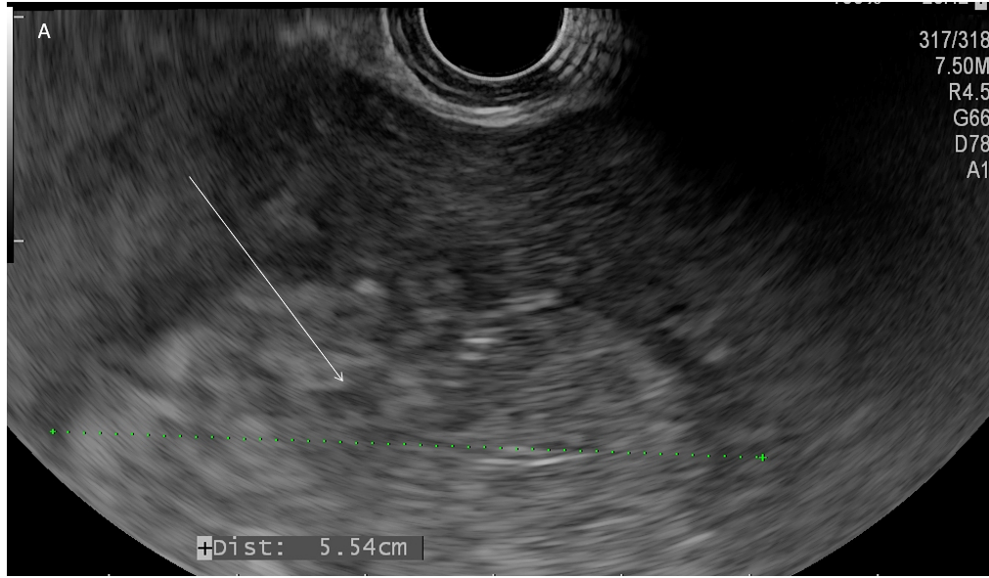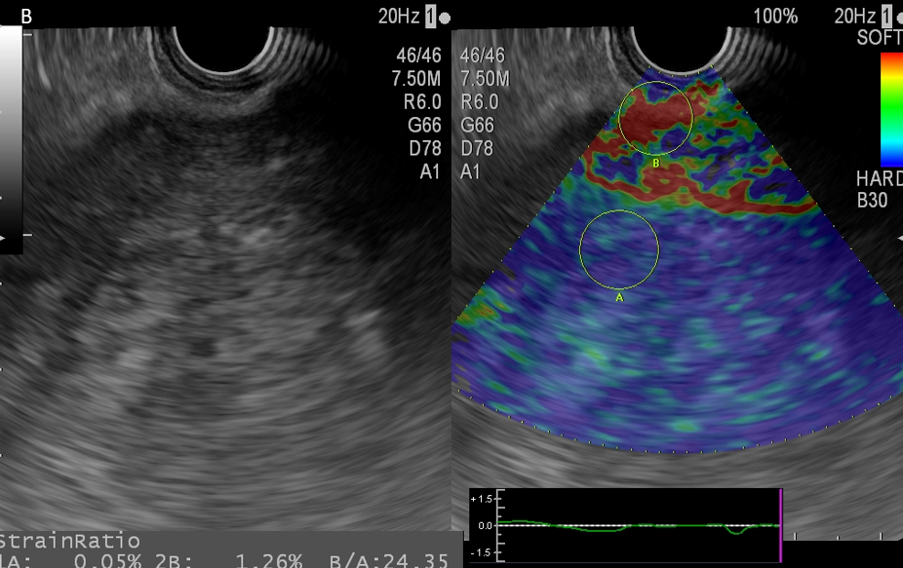
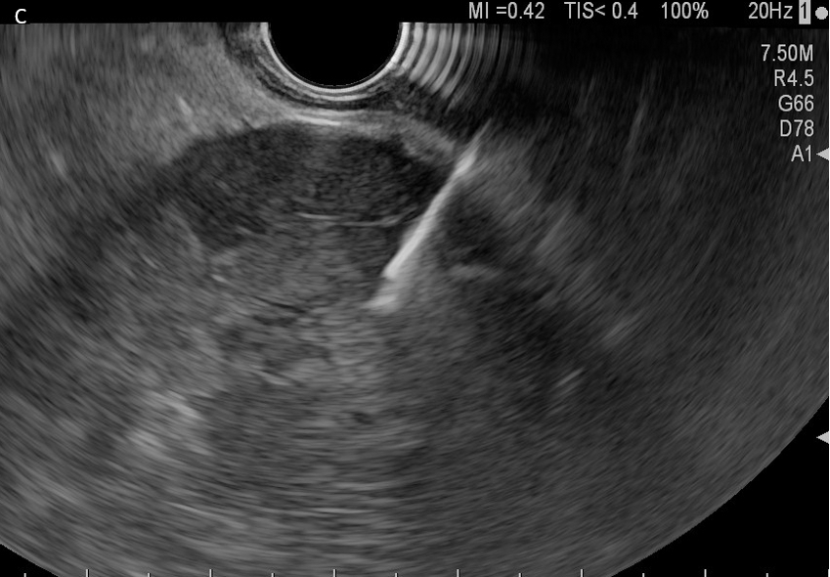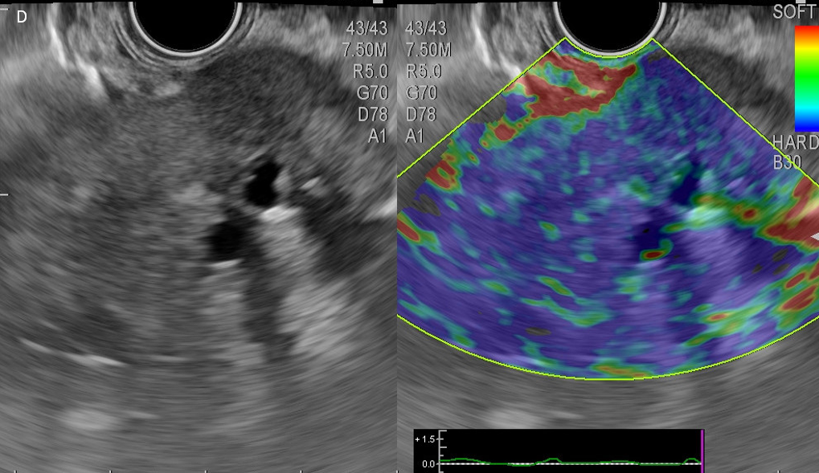
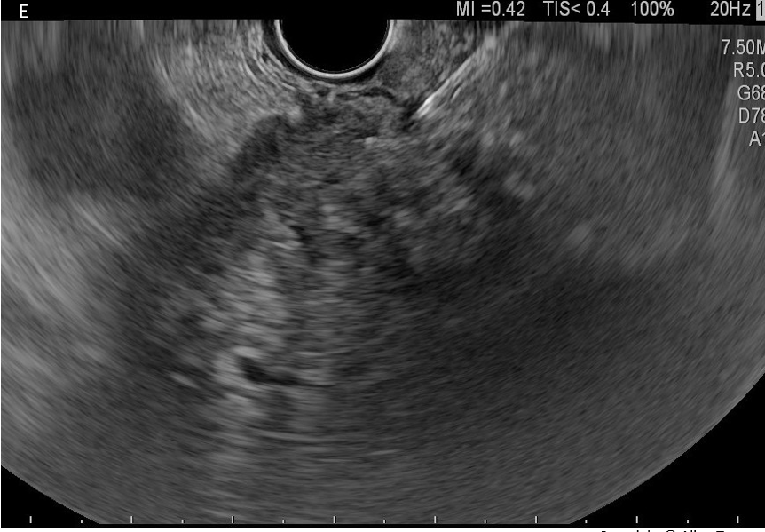
Figure 1 Endoscopic ultrasound. A and B: Endoscopic ultrasound view of a right lobe hepatocarcinoma. Large hyperechoic tumor mass with halo segments V-VIII (A), Ultrasound elastography showing high strain ration predicting malignant character of the lesion (B); C: Endoscopic ultrasound guided fine needle biopsy from a left lobe hepatocarcinoma in a patient with liver cirrhosis; D and E: Endoscopic ultrasound view of a left lobe cholangiocarcinoma. Large inhomogeneous tumor mass with intratumoral left bile duct dilatations (D); Endoscopic ultrasound guided fine needle aspiration from the tumor mass (E).

Table 1 Literature data: Diagnostic accuracy, success rate, adverse events, and complications of endoscopic ultrasound guided biopsies for liver lesions
Ref. | Study design | Lesions/patients, n | Results | Succes rate, adverse events
DeWitt et al^{[9]}, 2003 | Large study | 77 SLT; FNA | 77 liver specimens, 25 benign (33%); 45 malignant (58%), and 7 nondiagnostic (9%) | Sensitivity for the diagnosis of malignancy ranged from 82% to 94%
Lee et al^{[11]}, 2015 | Prospective study | 21 SLT with nonconclusive diagnosis after percutaneous biopsy | 21 lesions were malignant | Diagnostic accuracy-85.7% (diagnosis of malignancy in 19 cases)
Oh et al^{[12]}, 2017 | Study liver masses | 47 patients with liver masses FNA; 24 left lobe (51.1%); 13 right lobe (27.7%); 10 both lobe (21.3%); size of lesion, median, 26 mm (15-37); number of needles passes 3 | 9 benign (19.15%); 38 malignant (80.95%); technical success 97.9%; EUS-FNA was diagnostic in 38 of 42 patients (90.5%); technical success similar in both lobs (100% left lobe vs 94.1% right lobe) | Adequate specimen higher in left lobe (93.3% vs 82.4%); diagnostic accuracy not different between lobes (89.3% vs 92.9%); no complications
Temnykh et al^{[13]}, 2020 | Prospective study | 180 solid lesions; FNB (Franseen) vs 183 solid lesions; FNA (acquire) 32 liver lesions (23 FNA, 9 FNB) | 37.4 min (FNB) vs 44.9 (FNA) min; 2.9 passes FNB vs 3.8 passes FNA | Cytologic diagnostic yield 98.3% (FNB) vs 90.2% (FNA), P = 0.003; adverse events 1.1% (FNB) vs 0.5% (FNA)
Akay et al^{[14]}, 2021 | Retrospective study | 25 patients with SLT, FNA 22 G, 1 pass | 16 malignancies: 7 HCC, 1 CCA, 1 adenoma, 6 metastasis, 1 GB cancer infiltration; 3 benign (3 steatosis), 3 inadequate materials | Diagnostic accuracy 86.30% Success rate 88.00% (22 patients), 94.45% aspirate sufficiency, 86.30% biopsy sufficiency rate
Chen et al^{[15]}, 2020 | Retrospective study | 34 patients with cirrhosis and suspected left lobe HCC, FNB | 30 adequate biopsies specimens; 25 patients confirmed HCC, 5 benign | Se/Sp/PPV/NPV, 88.0%/100.0%/100.0%/62.5%
Chen et al^{[16]}, 2014 | Retrospective study | 4312 patients with suspected HCC with AFP under 200ng/dL FNA; 1756 underwent FNA | 1590 malignant (1145 primary liver neoplasm: HCC 1067, CCA 63, HCC- CCA 8, hepatoblastoma 1, lymphoma 6, metastasis neoplasms 75), 166 benign | 112 false negative, Se 92.00%, Sp 96.00%, PPV 100.00%, NPV 59.71%; overall accuracy 93.62%; complications: 4 implantation metastasis, 6 hemorrhage
Zhang et al^{[17]}, 2020 | Retrospective study | 624 malignant liver cases  FNB | 448 metastases  (71.8%), 97 HCC (28.2%), 73 CCA, 3 HCC-CCA, 58 NET (11.7%), 24 SSC (3.8%); embryonal sarcoma, hepatoblastoma, leiomyosarcoma | 30 different types of malignant tumors
Ichim et al^{[40]}, 2019 | Prospective study | 48 patients with malignant SLT FNA 22 G | 47 malignancies, 1 insufficient, metastasis pancreatic ADK 26% CCA 17% | Diagnostic yield 98%, 83% from left lob, 17% from right lob, no adverse events/complications
Gheorghiu et al^{[41]}, 2022 | Head-to-head study, prospective trial | 38 SLT; 22 G FNB vs 22 G FNA | 25 malignant lesions (14 metastases and 11 primary liver tumors); 6 benign lesions (abscesses); 7 inconclusive | Diagnostic rate for FNB-93.9%; insufficient core 4.0% (FNB) vs 20.0% (FNA)
Choi et al^{[65]}, 2017 | Liver study | 28 patients with SLT located in the left liver lobe FNB | KRAS mutation was analyzed | Diagnostic accuracy for malignancy 89.3%; adding KRAS diagnostic accuracy 96.4%
FNA: Fine needle aspiration; FNB: Fine needle biopsy; SLT: Solid liver tumor; HCC: Hepatocarcinoma carcinoma; CCA: Cholangiocarcinoma; GB: Gallbladder; Se: Sensibility; Sp: Specificity; PPV: Positive predictive value; NPV: Negative predicting value; AFP: Alfa feto protein; NET: Neuroendocrine tumor; ADK: Adenocarcinoma; SSC: Squamous cell carcinoma.

