Name of Journal: World Journal of Gastrointestinal Surgery
Manuscript NO: 80044
Manuscript Type: CASE REPORT

Acute appendicitis in the short term following radical total gastrectomy misdiagnosed as duodenal stump leakage: A case report

Ma J et al. Appendicitis misdiagnosed as duodenal stump leakage

Jun Ma, Zhen-Ping Zha, Chao-Ping Zhou, Xiang Miao, Shu-Qiang Duan, Ya-Ming Zhang

Jun Ma, Chao-Ping Zhou, Xiang Miao, Ya-Ming Zhang, Department of General Surgery, Anqing Municipal Hospital, Anqing 246000, Anhui Province, China

Zhen-Ping Zha, Department of Vascular Surgery, Anqing Municipal Hospital, Anqing 246000, Anhui Province, China

Shu-Qiang Duan, Department of Pathology, Anqing Municipal Hospital, Anqing 246000, Anhui Province, China

Author contributions: Ma J wrote and edited the original draft; Duan SQ and Miao X contributed to data collection and analysis; Zhou CP and Zha ZP reviewed the literature; Zhang YM reviewed and approved the final manuscript; All authors have read and approve the final manuscript.

Corresponding author: Ya-Ming Zhang, MD, Chief Doctor, Surgeon, Surgical Oncologist, Department of General Surgery, Anqing Municipal Hospital, No. 352 Ren-Ming Road, Anqing 246000, Anhui Province, China. zhangyaming2014@163.com

Received: September 15, 2022
Revised: October 28, 2022
Accepted: November 22, 2022
Published online: December 27, 2022

Abstract
BACKGROUND
Common diseases after radical gastrectomy include cholecystitis and pancreatitis, but the sudden onset of acute appendicitis in a short period following radical gastrectomy is very rare, and its clinical symptoms are easily misdiagnosed as duodenal stump leakage.

CASE SUMMARY
This is a case report of a 77-year-old woman with lower right abdominal pain 14 d after radical resection of gastric cancer. Her pain was not relieved by conservative treatment, and her inflammatory markers were elevated. Computed tomography showed effusion in the perihepatic and hepatorenal spaces, right paracolic sulcus and pelvis, as well as exudative changes in the right iliac fossa. Ultrasound-guided puncture revealed a slightly turbid yellow-green fluid. Laparoscopic exploration showed a swollen appendix with surrounding pus moss and no abnormalities of the digestive anastomosis or stump; thus, laparoscopic appendectomy was performed. The patient recovered well after the operation. Postoperative pathology showed acute purulent appendicitis. The patient continued adjuvant chemotherapy after surgery, completing three cycles of oxaliplatin plus S-1 (SOX regimen).

CONCLUSION
Acute appendicitis in the short term after radical gastrectomy needs to be differentiated from duodenal stump leakage, and early diagnosis and surgery are the most important means of treatment.

Key Words: Gastric cancer; Acute appendicitis; Surgery; Complications; Case report

©The Author(s) 2022. Published by Baishideng Publishing Group Inc. All rights reserved.

Citation: Ma J, Zha ZP, Zhou CP, Miao X, Duan SQ, Zhang YM. Acute appendicitis in the short term following radical total gastrectomy misdiagnosed as duodenal stump leakage: A case report. World J Gastrointest Surg 2022; 14(12): 1432-1437
URL: https://www.wjgnet.com/1948-9366/full/v14/i12/1432.htm
DOI: https://dx.doi.org/10.4240/wjgs.v14.i12.1432

Core Tip: Common forms of abdominal inflammation occurring after radical gastrectomy are cholecystitis and pancreatitis, of which cholecystitis has the highest incidence. In contrast, the incidence of appendicitis in the short term after radical gastrectomy is rare and has not been reported before. Herein, we present a case of acute appendicitis in the short term following radical total gastrectomy. We suggest that acute appendicitis in the short term after gastric cancer surgery needs to be differentiated from duodenal stump leakage and that early diagnosis and surgery are the most important means of treatment.
INTRODUCTION
Acute appendicitis is mainly caused by bacteria, fecal stones, and malformations, and the pathogenic condition must be mucosal damage and bacterial invasion^{[1]}. Common forms of abdominal inflammation occurring after radical gastrectomy are cholecystitis and pancreatitis, of which cholecystitis has the highest incidence^{[2]}. In contrast, the incidence of appendicitis in the short term after radical resection of gastric cancer is rare and has not been reported. The lack of typical symptoms of metastatic lower right abdominal pain is attributed to resection of the stomach and greater omentum. The symptoms mainly manifest as persistently aggravated right-sided abdominal pain and a high perforation rate; therefore, the inflammation is not easily confined, and the clinical symptoms are easily misdiagnosed as duodenal stump leakage.

CASE PRESENTATION
Chief complaints
Durative pain in the lower right abdomen 14 d after radical total gastrectomy.

History of present illness
A 77-year-old woman was diagnosed with gastric cancer, and preoperative pathology showed adenocarcinoma, moderately differentiated, HP (-). On May 23, 2022, computed tomography (CT) showed that the cardia was thickened and reinforced (Figure 1A), and the appendix was normal (Figure 1B). Preoperative clinical staging showed cT4Nx; preoperative neoadjuvant therapy was recommended, but the patient refused due to advanced age, and "radical total gastrectomy (D2 lymph node dissection)" was performed under general anesthesia on May 26, 2022. Intraoperative exploration: The gallbladder had been removed; the omentum was adhered to the gallbladder bed, no ascites was seen, and no metastatic nodules were seen in the liver or peritoneum. Postoperative pathology indicated stage IIIB, moderately differentiated, intestinal-type adenocarcinoma with lymph node involvement (7/30) (Figure 2A). The resection margin was negative. The immunohistochemical marker results were as follows: CK (+), Her-2 (3+), MSH2 (+), MSH6 (+), PMS2 (+), MLH1 (+), and Ki-67 (approximately 70%).
The patient recovered well after the operation; all inflammatory indexes gradually decreased, and her blood sugar was well controlled. On June 3, her D-dimer level was significantly elevated, and ultrasound showed intermuscular thrombosis located in the lower right extremity, which was treated with low-molecular-weight heparin. On June 4, CT showed no abnormalities around the anastomosis or stump, no leakage of oral pantothenic glucosamine into the abdominal cavity, no abnormalities in the ileocecal region or appendix, and no significant fluid accumulation in the abdominopelvic cavity (Figure 3). On June 8, her blood count, calcitonin and C-reactive protein (CRP) levels were normal, and she was ready to be discharged. However, during the night of June 9, the patient complained of persistent pain on the right side of the abdomen, and the abdominal pain became significantly worse on the morning of June 10.

History of past illness
The patient had a previous history of diabetes, hypertension, cholecystectomy and no history of chronic appendicitis.

Personal and family history
There was no family history of tumors.

Physical examination
On June 6, the abdominal incision was healing well, and the patient reported tenderness in the lower right abdomen, muscle tension and rebound pain.

Laboratory examinations
The patient’s leukocyte level was 17.18 × 10⁹/L; neutrophil ratio, 88.4%; calcitonin level, 0.19 ng/mL; and CRP level, 65.20 mg/L.

Imaging examinations
On June 10, CT showed effusion in the perihepatic and hepatorenal spaces, right paracolic sulcus and pelvis and exudative changes in the right iliac fossa (Figure 4). Subsequent ultrasound-guided puncture revealed a slightly turbid yellow-green fluid.

FINAL DIAGNOSIS
Acute suppurative appendicitis after radical gastrectomy.

TREATMENT
On June 10, laparoscopic exploration revealed yellow-green fluid in the perihepatic and pelvic cavities (Figure 5A and B); the duodenal stump was wrapped in tissue and did not show leakage (Figure 5C), and there were no abnormalities in the esophageal-jejunal anastomosis or jejunal-jejunal anastomosis. A large amount of pus moss was seen in the ileocecal region, and the terminal ileum wrapped around the appendix (Figure 6A). A septic and swollen appendix was seen after careful laparoscopic separation of the adhesions (Figure 6B). The appendiceal mesentery was treated with harmonic scissors and absorbable clips, the root of the appendix was ligated with thread, and the appendiceal stump was cauterized (Figure 6C). A pelvic drainage tube was placed after aspiration of intra-abdominal fluid.

OUTCOME AND FOLLOW-UP
Postoperative pathology showed acute purulent appendicitis and periapical inflammation (Figure 2B). The patient recovered well after surgery and was successfully discharged two weeks later. Follow-up CT showed no significant abnormalities in the abdominal cavity (Figure 7). The patient continued adjuvant chemotherapy after surgery, completing three cycles of oxaliplatin and S-1 (SOX regimen).

DISCUSSION
Cholecystitis and pancreatitis are common diseases after radical resection of gastric cancer. Appendicitis occurs rarely, as early as several months later, and perioperative combined episodes of appendicitis are even rarer.
There were several reasons for misdiagnosis in this case. First, we usually used one etiology to explain all the symptoms of the patient; we would focus on postoperative complications but might ignore the possibility of common diseases. Second, the most common abdominal complication after radical gastrectomy is duodenal stump leakage^{[3]}. The patient had a history of diabetes and presented with postoperative right abdominal pain. CT showed hepatorenal and pelvic effusion, and the puncture revealed yellow-green turbid fluid, which could not exclude the occurrence of duodenal stump leakage.
This is a successful case in which laparoscopic exploration was promptly performed to clarify the diagnosis. This case is enlightening for the following reasons: (1) For patients with a history of diabetes and postoperative lower right abdominal pain, the possibility of appendicitis must be considered, as diabetes is a high-risk factor for appendicitis^{[4]}; (2) Patients with appendicitis following gastrectomy have atypical abdominal pain due to surgical removal of all or a large part of the stomach, and reconstruction of the digestive tract alters the original physiological structure; (3) The large omentum was removed and could no longer easily confine the acute inflammation of the appendix; thus, as the disease worsened, diffuse peritonitis developed; (4) The occurrence of appendicitis has been reported in conjunction with several other diseases, such as colon cancer, tuberculosis, herniation and gynecological diseases^{[5-8]}; and (5) Gastric cancer combined with appendiceal metastasis would cause symptoms of acute appendicitis, but in this case, there was no peritoneal or appendiceal metastasis^{[9]}. In conclusion, acute appendicitis occurring within a short period after radical gastrectomy has its own characteristics and is easily confused with postoperative complications of gastric cancer; thus, a clear diagnosis and early surgical treatment are needed.

CONCLUSION
Acute appendicitis in the short term after gastric cancer is rare and easily ignored clinically and needs to be differentiated from duodenal stump leakage.

REFERENCES
1 Bhangu A, Søreide K, Di Saverio S, Assarsson JH, Drake FT. Acute appendicitis: modern understanding of pathogenesis, diagnosis, and management. Lancet 2015; 386: 1278-1287 [PMID: 26460662 DOI: 10.1016/S0140-6736(15)00275-5]
2 Seo HS, Na Y, Jung J. Analysis of the Occurrence of Diseases Following Gastrectomy for Early Gastric Cancer: a Nationwide Claims Study. J Gastric Cancer 2021; 21: 279-297 [PMID: 34691812 DOI: 10.5230/jgc.2021.21.e29]
3 Ramos MFKP, Pereira MA, Barchi LC, Yagi OK, Dias AR, Szor DJ, Zilberstein B, Ribeiro-Júnior U, Cecconello I. Duodenal fistula: The most lethal surgical complication in a case series of radical gastrectomy. Int J Surg 2018; 53: 366-370 [PMID: 29653246 DOI: 10.1016/j.ijsu.2018.03.082]
4 Tseng CH. Metformin use is associated with a reduced risk of acute appendicitis in Taiwanese patients with type 2 diabetes mellitus. Sci Rep 2021; 11: 12400 [PMID: 34117321 DOI: 10.1038/s41598-021-91902-z]
5 Hajibandeh S, Hajibandeh S, Morgan R, Maw A. The incidence of right-sided colon cancer in patients aged over 40 years with acute appendicitis: A systematic review and meta-analysis. Int J Surg 2020; 79: 1-5 [PMID: 32387215 DOI: 10.1016/j.ijsu.2020.04.065]
6 Chiș B, Dudric V, Fodor D. Tuberculous appendicitis. A case report. Med Ultrason 2017; 19: 333-335 [PMID: 28845503 DOI: 10.11152/mu-1085]
7 Bettini A, Ulloa JG, Harris H. Appendicitis within Morgagni Hernia and simultaneous Paraesophageal Hernia. BMC Surg 2015; 15: 15 [PMID: 25644716 DOI: 10.1186/1471-2482-15-15]
8 Noor M, Chen A, Gonzalez RS. Clinicopathologic findings in gynecologic proliferations of the appendix. Hum Pathol 2019; 92: 101-106 [PMID: 31430494 DOI: 10.1016/j.humpath.2019.08.004]
9 Wang W, Cui T, Mao W. Acute appendicitis caused by metastatic gastric adenocarcinoma: a case report and literature review. Ann Palliat Med 2021; 10: 7132-7137 [PMID: 34154334 DOI: 10.21037/apm-21-1098]

Footnotes
Informed consent statement: Informed written consent was obtained from the patient for publication of this report and any accompanying images.

Conflict-of-interest statement: The authors declare that they have no conflicts of interest.

CARE Checklist (2016) statement: The authors have read the CARE Checklist (2016), and the manuscript was prepared and revised according to the CARE Checklist (2016).

Open-Access: This article is an open-access article that was selected by an in-house editor and fully peer-reviewed by external reviewers. It is distributed in accordance with the Creative Commons Attribution NonCommercial (CC BY-NC 4.0) license, which permits others to distribute, remix, adapt, build upon this work non-commercially, and license their derivative works on different terms, provided the original work is properly cited and the use is non-commercial. See: https://creativecommons.org/Licenses/by-nc/4.0/

Provenance and peer review: Unsolicited article; Externally peer reviewed.
Peer-review model: Single blind

Peer-review started: September 15, 2022
First decision: October 21, 2022
Article in press: November 22, 2022

Specialty type: Surgery
Country/Territory of origin: China
Peer-review report’s scientific quality classification
Grade A (Excellent): 0
Grade B (Very good): B, B
Grade C (Good): C
Grade D (Fair): 0
Grade E (Poor): 0

P-Reviewer: Arigami T, Japan; Moshref RH, Saudi Arabia; Straksyte V, Lithuania S-Editor: Zhang H L-Editor: A P-Editor: Zhang H
Figure Legends
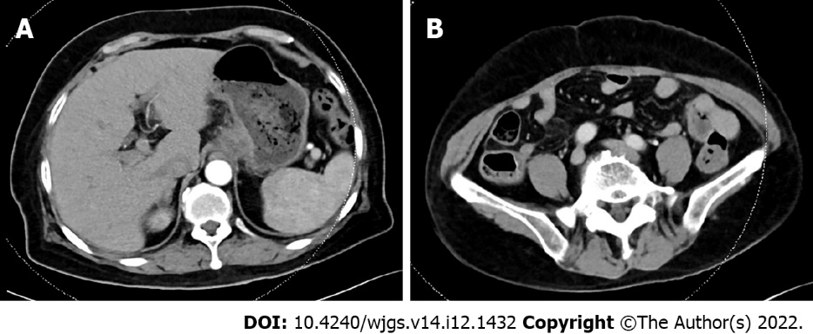
Figure 1 Imaging data of May 23, 2022. A: Computed tomography (CT) showed that the cardia was thickened and reinforced; B: CT showed that the appendix was normal.
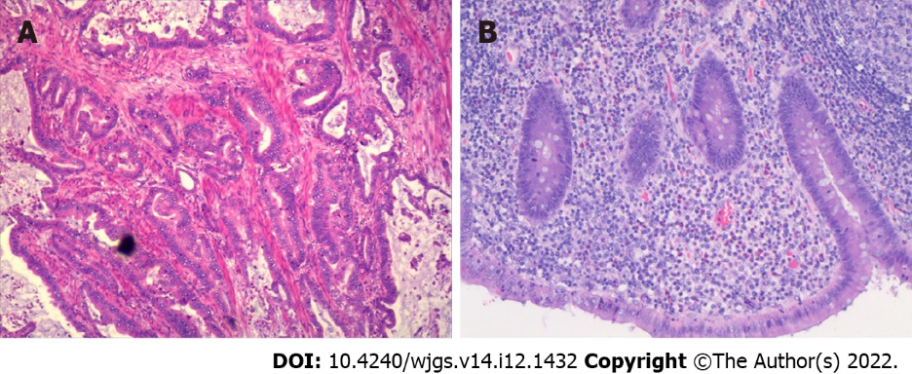
Figure 2 Photomicrographs (hematoxylin and eosin, × 200 magnification). A: Moderately differentiated tubular adenocarcinoma; B: Acute purulent appendicitis and periapical inflammation.
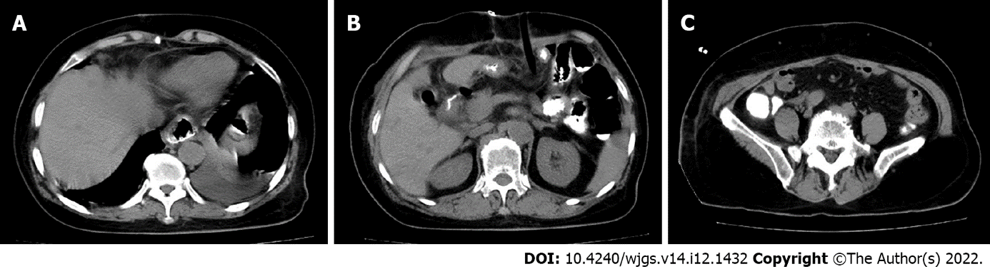
Figure 3 Imaging data of June 4, 2022. A: Computed tomography showed no abnormalities around the anastomosis or stump, no leakage into the abdominal cavity from oral pantothenic glucosamine, no abnormalities in the ileocecal region or appendix, and no significant fluid accumulation in the abdominopelvic cavity; B: No abnormalities were found in the ileocecal region or duodenal stump; C: No abnormalities were found in the appendix.
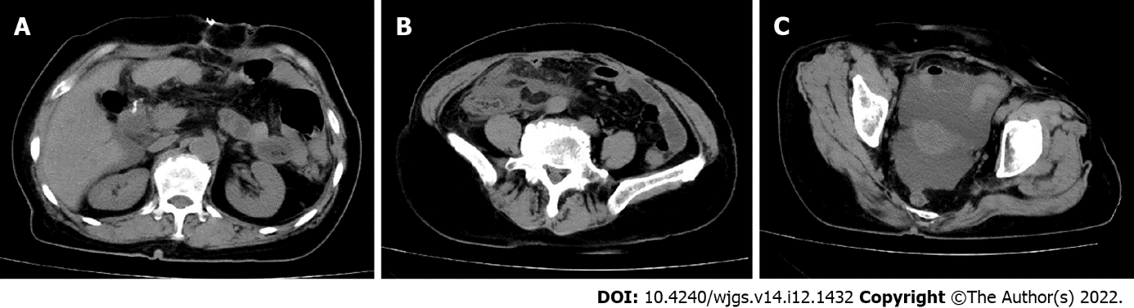
Figure 4 Imaging data of June 10, 2022. A: Computed tomography showed that there was effusion in the perihepatic and hepatorenal interstitial areas; B: There was effusion in the right paracolic sulcus and exudative changes in the right iliac fossa; C: Effusion was seen in the pelvis.
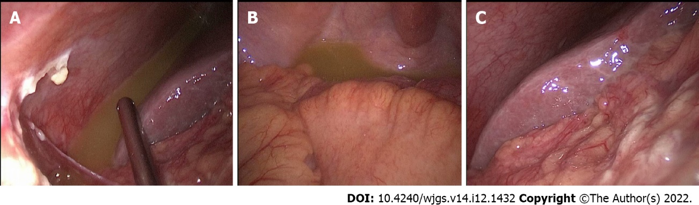
Figure 5 laparoscopic exploration. A and B: Yellow-green fluid could be found in the perihepatic and pelvic cavities; C: The duodenal stump was wrapped in tissue and did not show leakage.
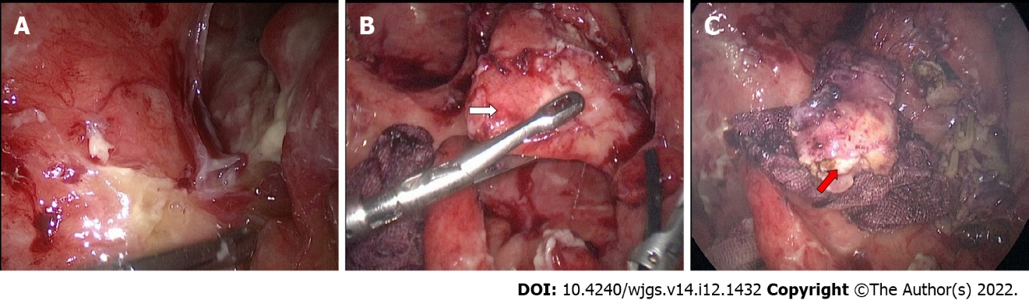
Figure 6 Surgical procedure. A: A large amount of pus moss was seen around the ileocecal region, and the terminal ileum wrapped around the appendix; B: A septic and swollen appendix was seen after careful laparoscopic separation of the adhesions (white arrow); C: Resected appendix (red arrow) and treated appendiceal stump and mesentery.

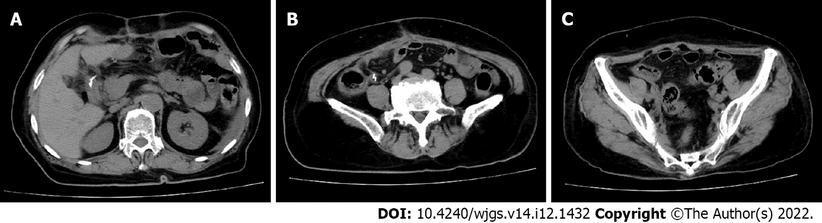Figure 7 Imaging data of July 12, 2022. Computed tomography showed no significant abnormalities of the duodenal stump, appendiceal stump or pelvic. A: Duodenal stump; B: Appendiceal stump; C: Pelvic.

Published by Baishideng Publishing Group Inc
7041 Koll Center Parkway, Suite 160, Pleasanton, CA 94566, USA
Telephone: +1-925-3991568
E-mail: bpgoffice@wjgnet.com
Help Desk: https://www.f6publishing.com/helpdesk
https://www.wjgnet.com

© 2022 Baishideng Publishing Group Inc. All rights reserved.

