Name of journal: World Journal of Diabetes
ESPS Manuscript NO: 11481
Columns: REVIEW

How the kidney hyperfiltrates in diabetes: From molecules to hemodynamics

Takenaka T et al. Mechanisms underlying diabetic nephropathy

Tsuneo Takenaka, Tsutomu Inoue, Yusuke Watanabe

Tsuneo Takenaka, Department of Medicine, International University of Health and Welfare, Minato Tokyo 107-0052, Japan

Tsutomu Inoue, Yusuke Watanabe, Department of Nephrology, Saitama Medical University, Iruma Saitama 350-0495, Japan

Tsuneo Takenaka, Department of Medicine, International University of Health and Welfare, Clinical Research Center, Sanno Hospital, Tokyo 107-0052, Japan

Author contributions: Takenaka T designed the studies and wrote the manuscript; Inoue T and Watanabe Y performed most of the experiments and statistical analyses.

Conflict-of-interest: All authors have no conflicts of interests to declare regarding this manuscript.

Open-Access: This article is an open-access article which was selected by an in-house editor and fully peer-reviewed by external reviewers. It is distributed in accordance with the Creative Commons Attribution Non Commercial (CC BY-NC 4.0) license, which permits others to distribute, remix, adapt, build upon this work non-commercially, and license their derivative works on different terms, provided the original work is properly cited and the use is non-commercial. See: http://creativecommons.org/licenses/by-nc/4.0/

Correspondence to: Tsuneo Takenaka, MD, PhD, Professor, Department of Medicine, International University of Health and Welfare, Clinical Research Center, Sanno Hospital, 8-10-16 Akasaka Minato, Tokyo 107-0052, Japan. takenaka@iuhw.ac.jp

Telephone: +81-3-34023301
Fax: +81-3-34043652

Received: May 23, 2014
Peer-review started: May 24, 2014
First decision: July 10, 2014
Revised: January 26, 2015
Accepted: February 4, 2015
Article in press:
Published online:

Abstract
In this review, we focused on two molecules, connexin and sodium-glucose cotransporter, which can link to diabetic hyperfiltration. In diabetic kidney, the activation of renin-angiotensin system occurs simultaneously with glomerular hyperfiltration. The latter largely depends on pathophysiological afferent arteriolar dilation in the presence of high angiotensin II. As a mechanistic basis for the above, tubular hypothesis has been proposed for type 1 diabetic patients as well as experimental models. Although tubular hypothesis has not been well evaluated in type 2 diabetes, clinical observations support that tubular hypothesis is true also in type 2 diabetes. Recent results on tubular hypothesis along with connexin abnormality in type 2 diabetes were revisited. In addition, the importance of sodium-glucose cotransporter in diabetic hyperfiltration is discussed. The link between salt paradox and the activation of renin-angiotensin system will be also reviewed.

Key words: Tubuloglomerular feedback; Salt paradox; Connexin; Glomerular hyperfiltration; Sodium-glucose co-transporter

© The Author(s) 2015. Published by Baishideng Publishing Group Inc. All rights reserved.

Core tip: A diminished tubuloglomerular feedback (TGF) in diabetes can explain both glomerular hyperfiltration and the activation of renin-angiotensin system. An enhanced absorption through sodium-glucose co-transporter in proximal tubule decreases the delivery to macula densa, reducing TGF signal generation in diabetes. Connexin phosphorylation and subsequent ubiquitination by oxidative stress in type 2 diabetes reduces its expression in juxtaglomerular apparatus, disabling TGF signal transduction. Clinical as well as experimental evidences support that this tubular hypothesis is working, and suggest that drugs targeting the above to normalize TGF, an intrinsic physiological system, would be effective to ameliorate diabetic nephropathy.

Takenaka T, Inoue T, Watanabe Y. How the kidney hyperfiltrates in diabetes: From molecules to hemodynamics. World J Diabetes 2015; In press

OPENING REMARKS
As reported recently^{[1]}, many clinical trials have demonstrated that the inhibitors of renin-angiotensin system (RAS) are effective to prevent the development and progression of diabetic nephropathy (DMN). There is an emerging agreement that the activation of RAS give deleterious influences on DMN. Why is RAS activated even in the early course of diabetes? Many experimental hypotheses for an overproduction of angiotensinogen by hyperglycemia and pathological activation of pro-renin in diabetes have been proposed experimentally^{[2,3]}. They appear very true at least in some aspects of DMN. From the renal hemodynamic point of view, DMN is characterized as glomerular hypertension and hyperfiltration from its early stage. In non-diabetic chronic kidney disease, single nephron glomerular hypertension and hyperfiltration occur in remnant nephrons to suffice the function of lost glomeruli due to its underlying renal disease. Thus, glomerular hyperfiltration starts when renal injury has progressed to some extent. However, all nephrons in diabetes show glomerular hypertension and hyperfiltration before microalbuminuria is developed^{[4]}. The main character of DMN is abnormal afferent arteriolar dilation^{[5]}. Tubular hypothesis is proposed more than 2 decades ago, which explain both glomerular hyperfiltration and RAS activation^{[6]}. Is tubular hypothesis true for type 2 diabetes, which now provides medical as well as socio-economical problems over the world? This has not been well examined. Let us start from basic experiments.

TYPE 1 DIABETES
Tubular hypothesis
Tubular hypothesis is based on physiological responses to hyperglycemia and its mechanisms are following^{[6]}. In type 1 diabetes, insulin deficiency causes marked hyperglycemia, resulting in the ultrafiltrate with high glucose concentration in Bowman capsule. Although proximal tubules reuptake most amounts of filtered glucose, glucose exceeding the capacity of tubular reuptake excretes into urine (glycosuria). Since proximal tubule possesses sodium glucose co-transporter 1 (SGLT1) and SGLT2, glucose is up-taken together with sodium. Then, the reuptake of sodium chloride through SGLT is increased in hyperglycemic condition, which is considered as a cause of salt-sensitive hypertension in diabetes. Furthermore, the delivery of sodium and chloride to macula densa is decreased by the enhanced reuptake through SGLT by proximal tubules (Figure 1). A reduced delivery to macula densa dilates the afferent arteriole by removing constrictor signals from tubuloglomerular feedback (TGF), to induce glomerular hypertension and hyperfiltration. Moreover, TGF signal from macula densa inhibits renin release. Again, a reduced delivery to macula densa during hyperglycemia (due to increased proximal tubular absorption through SGLT) removes TGF signals, to activate RAS which constricts efferent arterioles, worsening glomerular hypertension^{[7]}.

TGF mechanisms (ATP + adenosine) and salt paradox
There are still debates how macula densa cell transduces TGF signal to afferent arterioles. Although two hypotheses have been raised for “second messenger” for TGF, our data support the notion that both ATP and adenosine are required for full expression of TGF responses^{[8]}. Macula densa cell releases ATP into the interstitium when it reabsorbs sodium chloride delivered by tubular flow (Figure 2). On the one hand, ATP released from macula densa binds to ATP receptor located on extraglomerular mesangial cells to induce membrane depolarization and/or an increase in cytosolic calcium^{[9]}. These signals travel to neighboring mesangial cells through gap junctions, and finally the signals are transduced to afferent arteriolar myocytes through gap junction^{[10]}. Gap junction constitutes an important intercellular communication tool. Indeed, the inhibiting the function of connexin (Cx37 or Cx40), which compose of gap junction, elicits both suppression of TGF-dependent autoregulation and RAS activation. There is a possibility that ATP secreted from macula densa diffuses to afferent arteriolar myocytes and directly interacts with ATP receptors to induce afferent arteriolar constriction. On the other hand, ATP is degraded to adenosine by nucleotidase on extraglomerular mesangial cells, and subsequently adenosine binds to its specific receptor on afferent arteriolar myocytes to induce constriction^{[11]}.
Many paracrine factors modulate TGF. Angiotensin and endothelin enhance TGF responsiveness, whereas nitric oxide and prostaglandin diminish it^{[9]}. Under physiological condition, salt load that enhances the renal production of nitric oxide and prostaglandin weakens TGF. However, experimental data indicate that salt intake enhances TGF in type 1 diabetes. Salt load reduces proximal tubular reabsorption, which is enhanced in diabetes. As a result, the delivery to macula densa is increased, thereby restoring TGF that constrict afferent arteriole, thereby ameliorating glomerular hypertension, hyperfiltration and albuminuria in type 1 diabetic model^{[12]}. This is called salt paradox. An inverse relationship between salt intake and glomerular filtration rate is seen in type 1 diabetic patients as well as the animal models. Collectively, both tubular hypothesis and salt paradox are truly working in human^{[13]}.

Insulin deficiency and resistance
In contrast to type 1 diabetes, which is characterized by absolute insulin deficiency due to beta-cell damage, type 2 diabetes shows normal or excessive insulin secretion, especially during its early clinical course. The patients with type 2 diabetes are usually obese and manifest insulin resistance, underlying hyperglycemia in type 2 diabetes. The mechanisms mediating insulin resistance are out of focus of this review, but involve oxidative stress that inhibit insulin signaling by facilitating serine phosphorylation of insulin receptor substrate^{[14]}.

HOW ABOUT TYPE 2 DIABETES?
Connexin
As mentioned above, gap junctions are required for the transmission of TGF signal. Juxtaglomerular apparatus shows the expression of Cx37, Cx40 and Cx43. Type 2 diabetic model animals exhibit Cx abnormality^{[15]}. Six Cxs form one hemichannel on cell membrane^{[16]}. The binding of a hemichannel in a cell with the other one in an adjunct cell forms a gap junction. Gap junctions pass through small molecules such as inositol triphosphate and/or calcium, and transduce membrane depolarization, enabling intercellular communication. Post-transcriptional alterations of Cx induce conformational changes and prevent hemichannels to bind each other, especially when their extracellular loops are modified. Serine residue of Cx can be phosphorylated by protein kinase C and/or MAP. In type 2 diabetes, insulin resistance and associated oxidative stress activate these kinase activities. Phosphorylated Cx diminishes its ability to form gap junction, impairing intercellular signal transduction. Abnormal function of gap junction/connexin is considered to be one of the causes of arrhythmia in diabetes. Indeed, the abundance of phosphorylated Cx43 is elevated in type 2 diabetic animal model. Furthermore, functional analyses demonstrated abnormal gap junction function in juxtaglomerular apparatus that inhibiting Cx37 or Cx40 failed to stimulate renin release. Phosphorylated Cx is prone to be ubiquitinated and broken down. Expression of Cx37 on renin-secreting cells is reduced in type 2 diabetic animals (Figure 3). In type 2 diabetes, functional derangements of Cx induce the removal of TGF signal, which dilates afferent arterioles and activates RAS (Figure 1). As discussed, functional impairments of Cx in DMN cause glomerular hyperfiltration through reductions of TGF signal transmission. The latter may allow direct transmission of systemic blood pressure to glomeruli, facilitating glomerular sclerosis together with systemic hypertension induced by RAS activation^{[4]}. Of interest, there is a report that abnormal Cx is related to the prognosis of DMN intype 2 diabetic patients^{[17]}.

Hyperglycemia and salt
Is tubular hypothesis true for type 2 diabetes? The answer appears to be YES. Our recent data indicate that enhanced proximal tubular reabsorption and glomerular hyperfiltration exist in type 2 diabetic animal model^{[18]}. In addition, renal RAS is activated in this model, as evident that renal angiotensin concentration is elevated. Furthermore, in this model, acute salt load induces the suppression of proximal tubular reabsorption and the amelioration of glomerular hyperfiltration, together with the decrease in renal angiotensin concentration (Figure 4). The observations that salt load reduces albuminuria in this diabetic model suggest that glomerular hypertension is also controlled by high salt intake. These findings provide compelling evidence that salt paradox exists in type 2 diabetes. It is proved that adenosine is a mediator of salt paradox in type 1 diabetes. When salt consumption is increased in type 1 diabetes, the delivery of sodium chloride is increased, restoring TGF signals to produce adenosine that constricts afferent arterioles and ameliorates glomerular hyperfiltration. Our experimental results demonstrated that under adenosine receptor blockade, the amelioration of glomerular hyperfiltration by salt load was not happened. Because TGF signal transmission pathway for ATP has been already diminished due to Cx abnormality in type 2 diabetes, residing adenosine pathway works for salt paradox in type 2 diabetes. Is salt paradox truly functioning in type 2 diabetic patients? No answer was given for this question until recently. However, there is a report that proximal tubular reabsorption positively relates to glomerular hyperfiltration in type 2 diabetic black patients^{[19]}. Furthermore, an inverse relation between salt intake and albuminuria is demonstrated in type 2 diabetic Japanese patients^{[20]}. Taken together, salt paradox is working in type 2 diabetic patients regardless of difference in race.

HOPE FOR NEW ANTI-DIABETIC DRUGS
We would not recommend for diabetes to take high salt diet to prevent the development and progression of DMN. Salt load could induce hypertension and facilitate the development of cardiovascular diseases. How can we prevent DMN? Although it should be important to strongly inhibit RAS, new anti-diabetic drugs have some hope. The inhibition of DDP-4 elevates GLP1, which binds to its specific receptor on proximal tubules to induce natriuresis through suppressing proximal reabsorption of sodium chloride (Figure 5). Emerging evidences indicate that DDP-4 inhibitors show blood pressure lowering effects^{[21]}. Thus, according to tubular hypothesis, GLP1 ameliorates RAS activation, glomerular hypertension and hyperfiltration in DMN independently of its blood glucose lowering actions (Figure 1). Indeed, it was recently reported that DDP-4 inhibitors exhibit antiproteinuric effects in DMN. Many SGLT inhibitors are becoming available for clinical use. SGLT inhibitors may share similar renal actions with DDP-4 inhibitors. According to tubular hypothesis, SGLT inhibitors suppress proximal tubular reabsorption, which is enhanced in diabetes, suggesting that SGLT inhibitors possess blood pressure lowering and renal protective actions beyond its blood glucose lowering effects^{[22]}. Indeed, experimentally SGLT inhibitor showed protective effects on diabetic nephropathy. However, the influences on RAS of SGLT and DDP-4 inhibitors have not been examined. Further studies are required to clarify this issue.

CONCLUDING REMARKS
Recently, the number of patients with DMN is progressively increased, showing medical-economic problem. Research on DMN is promising from many aspects, and numerous new findings have been obtained. This in a good news, and we hope that new results could be applied for clinical care as soon as possible. However, we are sorry that they do not intend to integrate the findings, so that they are isolated to each other. We have tried to sum up several findings in this review, although it might be inadequate. Discussion was focused on the mechanisms underlying DMN common in diabetic patients as well as animal model. The treatment with RAS inhibitors on DMN is effective, but we have to admit that they are not enough. In near future, we wish that new therapy that eventually halts DMN will be developed along with complete understanding of underlying mechanisms for DMN.

REFERENCES
1 Suzuki H, Takenaka T. [Recent clinical evidences of RAS inhibitors on chronic kidney diseases]. Nihon Jinzo Gakkai Shi 2010; 52: 120-124 [PMID: 20415232]
2 Ichihara A, Hayashi M, Kaneshiro Y, Suzuki F, Nakagawa T, Tada Y, Koura Y, Nishiyama A, Okada H, Uddin MN, Nabi AH, Ishida Y, Inagami T, Saruta T. Inhibition of diabetic nephropathy by a decoy peptide corresponding to the "handle" region for nonproteolytic activation of prorenin. J Clin Invest 2004; 114: 1128-1135 [PMID: 15489960 DOI: 10.1172/JCI21398]
3 Saito T, Urushihara M, Kotani Y, Kagami S, Kobori H. Increased urinary angiotensinogen is precedent to increased urinary albumin in patients with type 1 diabetes. Am J Med Sci 2009; 338: 478-480 [PMID: 19884815 DOI: 10.1097/MAJ.0b013e3181b90c25]
4 Bidani AK, Griffin KA, Williamson G, Wang X, Loutzenhiser R. Protective importance of the myogenic response in the renal circulation. Hypertension 2009; 54: 393-398 [PMID: 19546375 DOI: 10.1161/HYPERTENSIONAHA.109.133777]
5 Carmines PK. The renal vascular response to diabetes. Curr Opin Nephrol Hypertens 2010; 19: 85-90 [PMID: 19770755 DOI: 10.1097/MNH.0b013e32833240fc]
6 Thomson SC, Deng A, Bao D, Satriano J, Blantz RC, Vallon V. Ornithine decarboxylase, kidney size, and the tubular hypothesis of glomerular hyperfiltration in experimental diabetes. J Clin Invest 2001; 107: 217-224 [PMID: 11160138 DOI: 10.1172/JCI10963]
7 Takenaka T, Suzuki H, Fujiwara K, Kanno Y, Ohno Y, Hayashi K, Nagahama T, Saruta T. Cellular mechanisms mediating rat renal microvascular constriction by angiotensin II. J Clin Invest 1997; 100: 2107-2114 [PMID: 9329977 DOI: 10.1172/JCI119745]
8 Takenaka T, Inoue T, Kanno Y, Okada H, Hill CE, Suzuki H. Connexins 37 and 40 transduce purinergic signals mediating renal autoregulation. Am J Physiol Regul Integr Comp Physiol 2008; 294: R1-11 [PMID: 17928514]
9 Navar LG, Inscho EW, Majid SA, Imig JD, Harrison-Bernard LM, Mitchell KD. Paracrine regulation of the renal microcirculation. Physiol Rev 1996; 76: 425-536 [PMID: 8618962]
10 Takenaka T, Inoue T, Kanno Y, Okada H, Meaney KR, Hill CE, Suzuki H. Expression and role of connexins in the rat renal vasculature. Kidney Int 2008; 73: 415-422 [PMID: 18046320 DOI: 10.1038/sj.ki.5002673]
11 Sun D, Samuelson LC, Yang T, Huang Y, Paliege A, Saunders T, Briggs J, Schnermann J. Mediation of tubuloglomerular feedback by adenosine: evidence from mice lacking adenosine 1 receptors. Proc Natl Acad Sci USA 2001; 98: 9983-9988 [PMID: 11504952 DOI: 10.1073/pnas.171317998]
12 Vallon V, Blantz RC, Thomson S. Glomerular hyperfiltration and the salt paradox in early [corrected] type 1 diabetes mellitus: a tubulo-centric view. J Am Soc Nephrol 2003; 14: 530-537 [PMID: 12538755 DOI: 10.1097/01.ASN.0000051700.07403.27]
13 Miller JA. Renal responses to sodium restriction in patients with early diabetes mellitus. J Am Soc Nephrol 1997; 8: 749-755 [PMID: 9176844]
14 Takenaka T, Kanno Y, Ohno Y, Suzuki H. Key role of insulin resistance in vascular injury among hemodialysis patients. Metabolism 2007; 56: 153-159 [PMID: 17224326 DOI: 10.1016/j.metabol.2006.08.010]
15 Takenaka T, Inoue T, Okada H, Ohno Y, Miyazaki T, Chaston DJ, Hill CE, Suzuki H. Altered gap junctional communication and renal haemodynamics in Zucker fatty rat model of type 2 diabetes. Diabetologia 2011; 54: 2192-2201 [PMID: 21573906 DOI: 10.1007/s00125-011-2175-8]
16 Saez JC, Berthoud VM, Branes MC, Martinez AD, Beyer EC. Plasma membrane channels formed by connexins: their regulation and functions. Physiol Rev 2003; 83: 1359-1400 [PMID: 14506308]
17 Sawai K, Mukoyama M, Mori K, Yokoi H, Koshikawa M, Yoshioka T, Takeda R, Sugawara A, Kuwahara T, Saleem MA, Ogawa O, Nakao K. Redistribution of connexin43 expression in glomerular podocytes predicts poor renal prognosis in patients with type 2 diabetes and overt nephropathy. Nephrol Dial Transplant 2006; 21: 2472-2477 [PMID: 16820374 DOI: 10.1093/ndt/gfl260]
18 Takenaka T, Inoue T, Ohno Y, Miyazaki T, Nishiyama A, Ishii N, Suzuki H. Elucidating mechanisms underlying altered renal autoregulation in diabetes. Am J Physiol Regul Integr Comp Physiol 2012; 303: R495-R504 [PMID: 22739351 DOI: 10.1152/ajpregu.00217.2012]
19 Pruijm M, Wuerzner G, Maillard M, Bovet P, Renaud C, Bochud M, Burnier M. Glomerular hyperfiltration and increased proximal sodium reabsorption in subjects with type 2 diabetes or impaired fasting glucose in a population of the African region. Nephrol Dial Transplant 2010; 25: 2225-2231 [PMID: 20124214 DOI: 10.1093/ndt/gfq008]
20 Sakabe K, Fukui M, Ushigome E, Hamaguchi M, Senmaru T, Yamazaki M, Hasegawa G, Nakamura N. Low daily salt intake is correlated with albuminuria in patients with type 2 diabetes. Hypertens Res 2012; 35: 1176-1179 [PMID: 22833161 DOI: 10.1038/hr.2012.116]

21 American Diabetes Association. 72nd Scientific Sessions (2012). Philadelphia, Pennsylvania, 2012. Available from: URL: http://medical.nikkeibp.co.jp/leaf/all/gakkai/ada2012/201206/525457.html
22 Arakawa K, Ishihara T, Oku A, Nawano M, Ueta K, Kitamura K, Matsumoto M, Saito A. Improved diabetic syndrome in C57BL/KsJ-db/db mice by oral administration of the Na(+)-glucose cotransporter inhibitor T-1095. Br J Pharmacol 2001; 132: 578-586 [PMID: 11159708 DOI: 10.1038/sj.bjp.0703829]

P-Reviewer: Sulkowski S, Traub M S-Editor: Ji FF L-Editor: E-Editor:

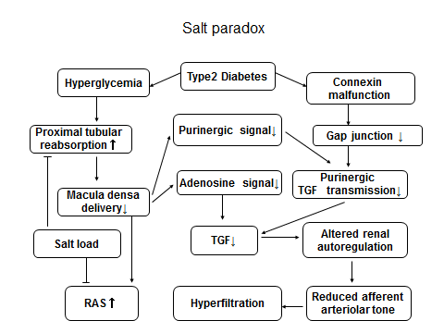
Figure 1 Working hypothesis for glomerular hyperfiltration in diabetes. On the one hand, hyperglycemia enhances sodium reabsorption in type1 and type 2 diabetes, thereby decreasing the delivery to macula densa with resultant weakening of tubuloglomerular feedback (TGF). The latter impairs renal autoregulation that dilats afferent arterioles, and activates renin-angiotensin system (RAS). On the other hand, TGF signal by ATP (P2) is damaged in type2 diabetes due to connexin phosphorylation and gap junction malfunction, worsening glomerular hyperifiltration. High salt intake inhibits proximal tubular reabsorption, thereby increasing the delivery of sodium chloride to macula densa. This ameliorates pathological afferent arteriolar dilation by the restoration of TGF through adenosine (A1) signal^{[18]}.
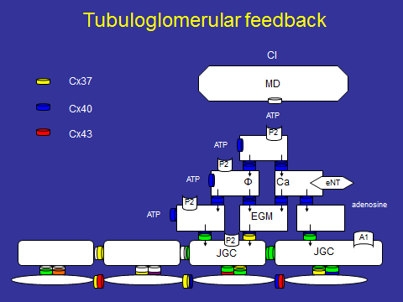
Figure 2 Sodium chloride is delivered to macula densa, macula densa releases ATP. ATP binds to P2 receptor on extraglomerular mesangial cell (EGM), and induces membrane depolarization and/or elevations of cytosolic calcium. These signals are transduced to juxtaglomerular cells (JGC) by intercellular communication through gap junctions consisted of connexins (Cx). In addition, ATP is degraded to adenosince by ecto-nucleotidase（eNT）on EGM. Adenosine binds to A1 receptor on JGC, increasing cytosolic calcium. Calcium waves generated in JGC transduce through gap junctions between afferent arteriolar myocytes to its upstream, eliciting ascending vasoconsitiction (refs 8 and 10). MD: Macula densa; Cl: Chloride.
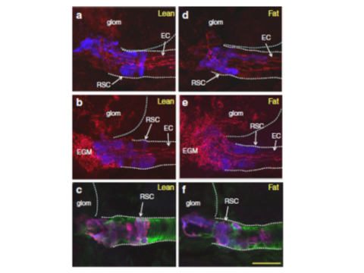
Figure 3 Expression of cennexins (Cx37, 40, 43) in juxtaglomerular apparatus of type2 diabetic (Zucker diabetic fatty) and control (Zucker lean) rats. A, B, D, E: Renin secreting cells (RSC, blue) and endothelial cells (EC) express Cx37 (A, lean; D fat) and Cx40 (B: lean; E: fat). Cx40 is expressed on glomerular and extraglomerular mesangial cells (EGM) in control (B) and diabetes (E). Cx43 is expressed in cytosol of RSC in both groups (C, F). Quantification reveals that the expression of Cx37 in RSC is reduced in diabetic model^{[15]}.
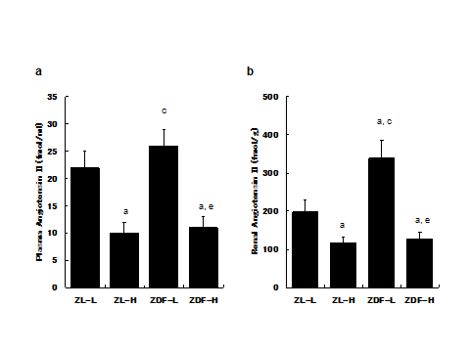
Figure 4 Plasma and kidney concentration of angiotensin II in type2 diabetic model (Zucker diabetic fatty rat) and control rat (Zucker lean rat). ZL-L and ZL-H indicate ZL fed normal and high salt diet, respectively. Alike, ZDF-L, ZDF-H describe ZDF fed normal and high salt diet, respectively. ªP < 0.05 vs ZL-L, ^{c}P < 0.05 vs ZL-H, ^{e}P < 0.05 vs ZDF-L^{[18]}. ZDF: Zucker diabetic fatty rat; ZL: Zucker lean rat.
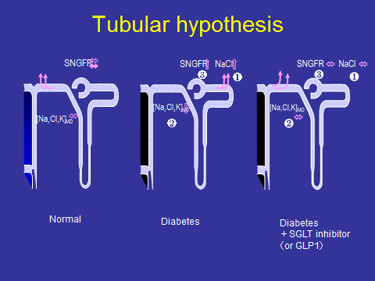
Figure 5 Compared to normal condition (left), ultrafiltrate in Bowman capsule contains significant amount of glucose in diabetes (middle). Because proximal tubules reabsorb more sodium with glucose through SGLT in diabetes (1), the delivery to macula densa is decreased (2). This weakens TGF signals to increase glomerular filtration rate (3), accounting for hyperfiltration in early stage of diabetes. Either GLP or SGLT inhibition (right) inhibits proximal tubular reabsorption (1), restoring sodium chloride delivery to macula densa even under hyperglycemic condition (2). This would have TGF work and normalize glomerular filtration rate (3), ameliorating glomerular hyperfiltration. SGLT: Sodium glucose co-transporter.

