Name of Journal: World Journal of Gastroenterology
Manuscript NO: 87329
Manuscript Type: MINIREVIEWS

Surgical complications after pancreatic transplantation: A computed tomography imaging pictorial review

D'Alessandro et al. Imaging of surgical complications after pancreatic transplantation

Carlo D'Alessandro, Matteo Todisco, Caterina Di Bella, Filippo Crimì, Lucrezia Furian, Emilio Quaia, Federica Vernuccio

Carlo D'Alessandro, Filippo Crimì, Emilio Quaia, Department of Radiology, University of Padova, Padova 35128, Italy

Matteo Todisco, Department of Radiology 2, University Hospital of Padova, Padova 35128, Italy

Caterina Di Bella, Department of Surgical, Kidney and Pancreas Transplantation Unit, Padova 35128, Italy

Lucrezia Furian, Kidney and Pancreas Transplantation Unit, University of Padua, Padova 35128, Italy

Federica Vernuccio, Department of Biomedicine, Neuroscience and Advanced Diagnostics (BiND), University of Palermo, Palermo 90127, Italy

Federica Vernuccio, Department of Radiology, University Hospital of Padova, Padova 35128, Italy

Author contributions: D’Alessandro C, made the literature search, wrote the first draft of the manuscript, and prepared most of the figures; Todisco M conceptualized the manuscript, helped with figures preparation and provided inputs; Di Bella C and Furian L wrote the first draft of the manuscript for the surgical paragraph, provided inputs and revised the draft of the manuscript; Crimì F provided inputs and revised the draft of the manuscript; Quaia E conceptualized the manuscript, provided inputs, and revised the draft of the manuscript; Vernuccio F conceptualized the manuscript, helped with the literature search, wrote the outline of the manuscript, prepared some of the figures and extensively revised the draft of the manuscript.

Corresponding author: Federica Vernuccio, DPhil, Associate Professor, Department of Biomedicine, Neuroscience and Advanced Diagnostics (BiND), University of Palermo, Via del Vespro 129, Palermo 90127, Italy. federicavernuccio@gmail.com

Received: August 3, 2023
Revised: October 25, 2023
Accepted: November 27, 2023
Published online:
Abstract
Pancreatic transplantation is considered by the American Diabetes Association and the European Association for the Study of Diabetes an acceptable surgical procedure in patients with type 1 diabetes also undergoing kidney transplantation in pre-final or end-stage renal disease if no contraindications are present. Pancreatic transplantation, however, is a complex surgical procedure and may lead to a range of postoperative complications that can significantly impact graft function and patient outcomes. Postoperative computed tomography (CT) is often adopted to evaluate perfusion of the transplanted pancreas, identify complications and as a guide for interventional radiology procedures. CT assessment after pancreatic transplantation should start with the evaluation of the arterial Y-graft, the venous anastomosis and the duodenojejunostomy. With regard to complications, CT allows for the identification of vascular complications, such as thrombosis or stenosis of blood vessels supplying the graft, the detection of pancreatic fluid collections, including pseudocysts, abscesses, or leaks, the assessment of bowel complications (anastomotic leaks, ileus or obstruction), and the identification of bleeding. The aim of this pictorial review is to illustrate CT findings of surgical-related complications after pancreatic transplantation. The knowledge of surgical techniques is of key importance to understand postoperative anatomic changes and imaging evaluation. Therefore, we first provide a short summary of the main techniques of pancreatic transplantation. Then, we provide a practical imaging approach to pancreatic transplantation and its complications providing tips and tricks for the prompt imaging diagnosis on CT.

Key Words: Diabetes mellitus; Type 1; Pancreas transplantation; Complications; Computed tomography; Diagnostic imaging

D'Alessandro C, Todisco M, Di Bella C, Crimì F, Furian L, Quaia E, Vernuccio F. Surgical complications after pancreatic transplantation: A computed tomography imaging pictorial review. World J Gastroenterol 2023; In press

Core Tip: Pancreatic transplantation is a complex surgical procedure and, similarly to any major surgical intervention, may lead to a range of postoperative complications that can significantly impact graft function and patient outcomes. Computed tomography offers non-invasive and accurate visualization of the transplanted pancreas and surrounding structures, providing detailed anatomical information and aiding in the detection of complications.

INTRODUCTION
Pancreatic transplantation is considered by the American Diabetes Association (ADA) and the European Association for the Study of Diabetes (EASD) an acceptable surgical procedure in patients with type 1 diabetes (T1D) also undergoing kidney transplantation [i.e. simultaneous pancreas and kidney (SPK) transplant] in pre-final or end-stage renal disease if no contraindications are present^{[1]}. Pancreatic transplantation has been considered for years the only treatment for T1D that consistently establishes an insulin-independent, normoglycemic state, with 5-year graft survival of 83%, 55% and 70%, in case of SPK, pancreatic transplantation alone (PTA) or pancreas after a kidney transplantation (PAK), respectively^{[2-4]}. The main indication of PTA is presence of T1D and normal or near-normal renal function in patients who suffer from hypoglycemia unawareness, which results in impaired quality of life or with difficulty adhering to the requirement of insulin injection^{[5]}. In few selected cases, transplantation of pancreatic islet – a less invasive procedure consisting in the transplantation of islets of Langerhans in the recipient hepatic portal system – is indicated as an alternative to pancreatic transplantation by ADA and EASD^{[1]}. However, intrahepatic islet transplantation for T1D is limited because of the need of multiple infusions and poor islet viability after transplantation, and more recently intracutaneous transplantation of islets has also been investigated^{[6]}. In a 20-year span from 2000 to 2020, only about 4365 islet allotransplants have been performed according to a recent worldwide survey^{[7]}, while the number of pancreatic transplantations in the 10-year span from 2010 to 2019 is of about 23000 procedures^{[8]}.
Pancreatic transplantation is a complex surgical procedure and, similarly to any major surgical intervention, may lead to a range of postoperative complications that can significantly impact graft function and patient outcomes^{[9,10]}. The occurrence of postoperative complications may vary depending on factors such as the type of transplantation (SPK, PAK or PTA) and the specific patient population. Cross-sectional imaging – i.e., Doppler ultrasound (US), contrast‐enhanced US (CEUS) and computed tomography (CT) – plays a pivotal role in the evaluation of the transplanted pancreas. US is the preferred initial imaging modality for evaluating the transplanted pancreas due to its safe, non-invasive, radiation-free, simple, quick, and repeatable approach. However, US is often affected by factors such as intestinal gas interference and operator proficiency, and partial thrombosis may be easily missed^{[11]}. CT offers non-invasive and accurate visualization of the transplanted pancreas and surrounding structures, providing detailed anatomical information and aiding in the detection of complications. Indeed, CT allows for the identification of vascular complications, such as thrombosis or stenosis of blood vessels supplying the graft as well as bleeding or pseudoaneurysms, the detection of pancreatic fluid collections, including pseudocysts, abscesses, or leaks, the assessment of bowel complications (anastomotic leaks, ileus or obstruction), while it has a limited role in the evaluation of graft rejection^{[12,13]}. Magnetic resonance imaging (MRI) is rarely uncommonly used for examination the assessment of pancreatic graft-related complications, and it is preferred particularly in patients with declining renal function. The main adoption of CT compared to MRI is based on different reasons, including wider availability of CT compared to MRI particularly in the emergency and urgent settings, the lower acquisition time of CT exams compared to MRI which is important in imaging acutely ill and intensively monitored patients, but also to the lower spatial and temporal resolution, creating difficulties in the evaluation of the enteric anastomosis and vascular complications. Contrast medium administration in CT should not be a contraindication in kidney transplant recipients. Fananapazir et al^{[14]} demonstrated that the incidence of acute kidney injury in patients with transplanted kidney submitted to CT scans with low-osmolality iodine-based contrast material was 7% when considering the threshold of ≥ 0.3 mg/dL for the increase in serum creatinine levels. The incidence of contrast induced nephropathy after contrast-enhanced CT was similar (6.1%) in a study by Cheungpasitporn et al^{[15]}. However, in a study involving about 6175 patients, McDonald et al^{[16]} demonstrated lack of significant difference in the onset if contrast induced nephropathy between patients with a solitary kidney, including kidney transplant recipients (4.1%), and those with bilateral kidneys (4.2%). The assessment of serum creatinine for calculating the estimated glomerular filtration rate is recommended before contrast medium administration within 7 d before CT in patients with an acute disease, an acute deterioration of a chronic disease or in hospitalized patients, and preventive hydration protocols need to be considered in at-risk patients as indicated by guidelines^{[17-19]}.
This pictorial review is aimed at illustrating CT findings of surgical-related complications after pancreatic transplantation. A comprehensive knowledge of surgical techniques allows understanding the postoperative anatomic changes that are identified on CT images. Therefore, this review will first a short summary of the main techniques of pancreatic transplantation and, then, will discuss imaging tips and tricks for the prompt diagnosis of complications after pancreatic transplantation on CT.

SURGICAL TECHNIQUES
After organ procurement from a deceased donor, a meticulous graft back-table surgery is necessary before pancreatic transplantation. Main steps are: Splenectomy, removal of the excess fat surrounding the pancreas and ligation of small vessels and lymphatics along the inferior margin of the pancreatic tail, coursing anteriorly around the surface of the neck and head of the pancreas to the proximal duodenal staple line. A suture of the vessels at the root of the mesentery and inferior mesenteric vein is performed followed by an oversewing of the mesenteric staple line. A vascular preparation is necessary using a Y conduit of donor iliac artery which is anastomosed to the superior mesenteric and splenic arteries of the graft (Figures 1 and 2). Assessment of blood supply to the entire pancreas graft exclusively via cross-circulation between splenic artery and superior mesenteric artery is mandatory in order to guarantee blood supply to all the pancreas graft. By flushing the superior mesenteric artery and not looking for back-ﬂushing through the gastroduodenal artery is possible to recognize the need for vascular reconstruction of the gastroduodenal artery to guarantee blood supply to head of the pancreas graft and duodenal segment, and possibly reduce the incidence of duodenal complications^{[20]}. A duodenal shortening with stapler and oversewing of the staple line is then completed. At this stage, the graft is ready for implantation.
Through a midline incision, the pancreas allograft is usually placed intraperitoneally, on the right side with the head in a cranial position, and receives arterial inflow from the iliac artery (Figure 1). Venous anastomosis can be performed through systemic vein technique with the graft portal vein (PV) anastomosed to the recipient inferior vena cava or iliac vein, or through the PV technique with the graft PV anastomosed to the recipient inferior vena cava or iliac vein. In the PV technique, the graft PV is connected to the recipient superior mesenteric vein. Systemic drainage theoretically may lead to hyperinsulinemia^{[21]}, while portal drainage could allow a more physiological “first pass” effect through the liver since insulin is immediately extracted by the liver. However, the arterial anastomosis to the iliac artery tends to be more difficult using the PV technique and it requires a very long Y graft. Moreover, obesity, thickened mesentery, or an inadequate caliber of the superior mesenteric vein can make the portal drainage even harder^{[22]}. Long-term studies comparing the two techniques have not demonstrated clear metabolic advantages with portal drainage and the use of the PV has remained marginal over the years^{[23]}. For the exocrine pancreas drainage, anastomosis between the donor duodenum and recipient small bowel loop (i.e., jejunal or an ileal loop) is performed side-to-side with a circular stapler. After firing the stapler (trans-oral anvil delivery system EEA), the end of the donor duodenum is closed using a linear stapler. Alternatively, a bladder diversion can be performed^{[24]}. Bladder drainage can be particularly advantageous in case of PTA, for the assessment of the concentration of urinary amylase as a marker of rejection. Disadvantages of this technique include both urologic complications such as hematuria (16%), leaks (14%), reflux pancreatitis (11%), recurrent urinary infections (10%), urethritis (3%), urethral stricture/disruption (3%), and metabolic complications due to the urinary loss of the bicarbonate-rich pancreatic juice, including hyperchloremic metabolic acidosis and dehydration^{[23,25]}. When these complications became intractable, conversion from bladder to enteric drainage is often necessary^{[26]}. Enteric drainage is currently the predominant technique in pancreatic transplantation^{[23]}.
Usually, recipients start receiving immunosuppression during surgery, consisting in antibody induction and a triple drug immunosuppressive therapy is started immediately postoperatively. Most of the Centers utilize a regimen consisting of tacrolimus, mycophenolate mofetil and steroid.
Heparin prophylaxis is recommended with intravenous heparin administered as a single dose during surgery after pancreas revascularization and it is continued after surgery with low molecular weight heparin or continuous infusion, at the discretion of the Transplant Centre.
Some days after transplantation, a CT scan is advisable to early recognize vascular thrombosis or any signs of vascular alterations, not yet clinically relevant.

COMPLICATIONS AFTER PANCREATIC TRANSPLANTATION
Postoperative surgical complications of pancreatic transplantation are still common despite many improvements in surgical techniques, and may be distinguished based on time of onset^{[27-28]}. Postoperative monitoring of the pancreatic graft by CT is requested in about 89% of cases according to a recent series of 230 pancreatic transplantations and is helpful for optimizing patient management^{[29]}.
The main reasons for requesting imaging are related to the indication per protocol even without acute clinical indication, sudden progressive hyperglycemia, persistent or abdominal tenderness^{[29]}. However, the adoption of CT needs to be patient-tailored particularly in the context of SPK, due to the potentially nephrotoxic effect of contrast agents which is reported to be as low as 5.6% in kidney transplant recipients with the use of hypo-osmolar contrast agent^{[30]}.
Initial complications of pancreatic transplantations are largely related to technical factors, including vascular thrombosis, bleeding, enteric anastomotic leak or graft pancreatitis, and urologic complications^{[8]}. Late complications include pseudocyst formation, post-transplant lymphoproliferative disease, pseudoaneurysms, artero-venous fistulas and rejection (Figure 3).
Graft thrombosis is the most common complication after transplant and may lead to graft failure in about 3.7%, 4.1% and 5.9% of SPK, PAK and PTA, respectively^{[8]}. Graft loss due to infection, pancreatitis, bleeding, leaks, and other reasons occur in up to 0.5%, 0.5%, 0.5%, 0.4%, and 0.6%, respectively^{[8]}.

Graft thrombosis
Graft thrombosis occurs in 7%-34% of patients after pancreas transplant, with high body mass index being a risk factor, may affect arteries or veins and can be partial or complete^{[10,12,29,31]}. Partial graft thrombosis occurs in about 25% of cases after pancreatic transplantation, is subclinical in the majority of cases, and may resolve spontaneously with medical therapy^{[29]}. Venous thrombosis is far more common than arterial thrombosis, but arterial thrombosis is the most dangerous leading to rapid graft loss^{[29,32]}. Acute rejection and CT finding of pancreatitis are risk factors for graft thrombosis^{[12]}.
Contrast-enhanced CT with angiographic phase and venous phase demonstrates thrombosis as a filling defect in a vessel during the vascular phase, and allows to clearly indicate the extension of the filling defect. Arterial thrombosis (Figure 4) may lead to graft dysfunction, pancreatitis, leakage of pancreatic enzymes, sepsis, necrosis and even emphysematous transformation of the graft if it is left untreated. Pancreatic graft venous thrombi (Figure 5) can remain relatively localized possibly maintaining normal graft function, or may propagate into the PV, iliac vein, or vena cava (in case of systemic venous drainage) or superior mesenteric veins (in case of portal venous drainage). In case of vascular thrombosis, a decreased enhancement of the transplanted pancreas usually occurs dure to the organ ischemia, and the main differential diagnosis between arterial and venous thrombosis is made by direct visualization of the thrombus in the vessel.
Percutaneous thrombectomy, followed by anticoagulation, is considered a therapeutical option to remove the thrombus, with low complication rate^{[33]}.
Graft thrombosis may be graded on contrast-enhanced CT based on the system proposed by Hakeem et al^{[12]} into:
Grade 0 – Lack of thrombosis.
Grade 1 – Peripheral thrombosis: Thrombus is located at the transected margin of the superior mesenteric vein/splenic vein or superior mesenteric artery and it is present only in a single branch.
Grade 2 – Intermediate nonocclusive thrombosis.
Venous: Thrombus extends into parenchymal vessels/main trunk of the superior mesenteric vein or splenic vein to the superior mesenteric vein/splenic vein confluence but not into the PV.
Arterial: Thrombus extends into the main trunk of the superior mesenteric artery/splenic artery to the “Y” graft but not into the Y graft.
Grade 3 – Central occlusive thrombosis.
Interestingly, despite the diagnosis of vascular thrombosis seems quite straightforward Hakeem et al^{[12]} showed some discrepancies among radiologists in the detection with 28 new thrombosis identified on retrospective imaging review, with the grade 1 thrombosis being underestimated at initial diagnosis by the reporting radiologists.

Pancreatitis
Graft pancreatitis is amongst the most frequent complications following pancreatic transplantation, the third most common cause for re-operation following bleeding and pancreas graft thrombosis, and a common histologic feature identified in up to 61% of rejected allografts^{[34,35]}. Graft pancreatitis is distinguished in early if it occurs within 3 mo and later after 3 mo, while physiological acute graft pancreatitis occurs within the first 72 h after reperfusion of the transplanted organ secondarily to an acute inflammatory response related to ischemic reperfusion injury^{[36]}.
Common findings in CT include focal or diffuse enlargement of the pancreatic parenchyma, with edematous changes (usually is noted a decreasement in HU value), indistinct pancreatic margins due to inflammation, and surrounding fat stranding (Figure 6). CT imaging allows to differentiate between edematous and necrotizing pancreatitis, to assess the presence of collections and to evaluate long-term evolutions including pseudocyst and walled-off necrosis^{[37]}.
Notably, graft pancreatitis and vascular thrombosis may occur simultaneously; indeed, pancreatitis can predispose to vascular thrombosis, and vascular thrombosis can also lead to graft inflammation, thus leading to some overlapping CT imaging features as shown on Figure 7.

Peripancreatic collection and Infection
Infection may occur in the form of peripancreatic fluid collections (Figure 6), pseudocysts (Figure 8), leakage at the level of the enteric anastomosis (Figure 9), or infection of the abdominal wall surgical wound^{[21,38]}.
Fluid collections are the most common abnormality after pancreatic transplantation, may occur early or late after transplant, are clinically significant in about 16% of patients, and may lead to superinfection^{[38,39]}. Intraabdominal collections also include seroma, hematoma, lymphocele, urinoma, or pseudocyst^{[11,38]}.
CT demonstrates an abnormal fluid collection of low attenuation with surrounding rim-enhancement and possible intralesional gas^{[38]}. Soft tissue edema and fat stranding in the adjacent tissues may also be present. Percutaneous drainage is safe and effective for management of peripancreatic fluid collections after pancreas transplant^{[38]}.

Enteric or Pancreatic Leaks
Duodenal leaks represent about 2.5%-2.9% of complications after pancreatic transplantation^{[40,41]} and represent the cause of re-laparotomy in about 2.1% of cases^{[34]}. Enteric leaks after pancreatic transplantation are usually characterized by extravasation of pancreatic juice from the duodenojejunostomy site leading to focal peritonitis and collections (Figure 9), and eventually abscess formation^{[26]}. Duodenal leaks usually occur early in the postoperative course, but may also be seen late post-transplant and increase 6-mo graft loss risk with a hazard ratio of 13.9^{[40-42]}. Pancreatic duct fistula after focal pancreatitis or ischemia leading to duct disruption, may also result in the development of a peripancreatic collection^{[42]}.

Bleeding
In the early postoperative period, the occurrence of bleeding is the most common cause of reoperation^{[29]}.
The source of bleeding in the early post-operative period may be:
Intra-abdominal: It is usually related to damage of the peripancreatic vessels or vascular anastomosis, enhanced by the antithrombotic prophylaxis or antithrombotic therapy in patients with vascular thrombosis.
Digestive: It comes from the digestive anastomosis or the staple line of the duodenal ends. Gastrointestinal bleeding after pancreas transplant usually occur at the duodenojejunostomy due to reduced blood flow to the graft or due to ulcers at the anastomosis. Digestive bleeding may resolve after conservative measures such as correction of coagulation abnormalities, heparin withdrawal and transfusion; surgical revision may be indicated if the bleeding does not resolve.
Precontrast CT may indicate the presence of an acute hematoma as a hyperattenuating (usually above 60 UH) collection on preconstrast CT in case of intrabdominal bleeding or hyperattenuating content in the GI lumen in case of gastrointestinal bleeding. In case of active bleeding, contrast-enhanced CT acquired in the arterial and venous phases demonstrates pooling/extravasation of the contrast agent within the hematoma or within the bowel lumen and may allow to identify the culprit vessel in case of intrabdominal hemorrhage.
Bleeding due to other arterial complications (e.g. arterio-venous fistula, pseudoaneurysm, arterioenteric fistula, arteriourinary fistula) have been reported but are infrequent, with occurrence of pseudoaneurysm being more common as a late complication^{[32,43]}. Management can be endovascular or surgical and should be individualized^{[43]}.
Pseudoaneurysm may develop particularly at the level of anastomoses as a consequence of chemical damage due to leak of pancreatic enzymes^{[26]}. On CT imaging, pseudoaneurysm appears as a saccular enhancing outpouching from the injured artery, with enhancement similar to other arteries, but does not increase in size on delayed phases and follows the blood pool on all phases. Arterio-venous fistula is a very rare complication of pancreatic transplantation^{[32,43]} which may result from the postoperative or post-biopsy laceration of both arterial and venous walls and may potentially lead to major bleeding or graft loss if untreated^{[43-45]}. On CT, arterio-venous fistula will be demonstrated on arterial phase as enlarged Y-graft arteries with an early opacification of the donor draining vein.

Graft vascular stenosis
Vascular stenosis is relatively uncommon with an incidence of about 2.5% and more commonly occur at the anastomotic level^{[40]}. Early detection of vascular stenosis is critical to avoid complications, including thrombosis, ischemia, and graft dysfunction^{[46]}. The multiplanar reconstruction of the vascular tree provides a reliable method of visualizing the entire vascular anastomoses, detecting a focal decrease in caliber of the vessel (Figure 10).

CONCLUSION
In conclusion, pancreatic transplantation is a complex surgery with high morbidity often related to postoperative complications, which may occur during hospitalization, early in the first three months or in the late period. Cross-sectional imaging with CT plays a critical initial role in the diagnosis and management of postoperative complications in many transplanted patients who present to the emergency department for suspected transplant dysfunction. Therefore, radiologists should be aware of surgical techniques and normal imaging appearance of pancreatic transplantation and should be well-trained to recognize identify acute findings and provide key imaging information to optimize patient management.

REFERENCES
1 Holt RIG, DeVries JH, Hess-Fischl A, Hirsch IB, Kirkman MS, Klupa T, Ludwig B, Nørgaard K, Pettus J, Renard E, Skyler JS, Snoek FJ, Weinstock RS, Peters AL. The management of type 1 diabetes in adults. A consensus report by the American Diabetes Association (ADA) and the European Association for the Study of Diabetes (EASD). Diabetologia 2021; 64: 2609-2652 [PMID: 34590174 DOI: 10.1007/s00125-021-05568-3]
2 Gruessner AC, Sutherland DE, Gruessner RW. Long-term outcome after pancreas transplantation. Curr Opin Organ Transplant 2012; 17: 100-105 [PMID: 22186094 DOI: 10.1097/MOT.0b013e32834ee700]
3 Sutherland DE, Gruessner RW, Gruessner AC. Pancreas transplantation for treatment of diabetes mellitus. World J Surg 2001; 25: 487-496 [PMID: 11344403 DOI: 10.1007/s002680020342]
4 Lipshutz GS, Wilkinson AH. Pancreas-kidney and pancreas transplantation for the treatment of diabetes mellitus. Endocrinol Metab Clin North Am 2007; 36: 1015-38; x [PMID: 17983934 DOI: 10.1016/j.ecl.2007.07.010]
5 Al-Naseem AO, Attia A, Gonnah AR, Al-Naseem AOAS, Spiers HVM, Gruessner A, Leelarathna L, Thabit H, Augustine T. Pancreas transplantation today: quo vadis? Eur J Endocrinol 2023; 188: R73-R87 [PMID: 36929837 DOI: 10.1093/ejendo/lvad032]
6 Rojas-Canales D, Walters SN, Penko D, Cultrone D, Bailey J, Chtanova T, Nitschke J, Johnston J, Kireta S, Loudovaris T, Kay TW, Kuchel TR, Hawthorne W, O'Connell PJ, Korbutt G, Greenwood JE, Grey ST, Drogemuller CJ, Coates PT. Intracutaneous Transplantation of Islets Within a Biodegradable Temporizing Matrix as an Alternative Site for Islet Transplantation. Diabetes 2023; 72: 758-768 [PMID: 36929171 DOI: 10.2337/db21-0841]
7 Berney T, Andres A, Bellin MD, de Koning EJP, Johnson PRV, Kay TWH, Lundgren T, Rickels MR, Scholz H, Stock PG, White S; International Islet Transplant Centers. A Worldwide Survey of Activities and Practices in Clinical Islet of Langerhans Transplantation. Transpl Int 2022; 35: 10507 [PMID: 36033644 DOI: 10.3389/ti.2022.10507]
8 Gruessner AC, Gruessner RWG. The 2022 International Pancreas Transplant Registry Report-A Review. Transplant Proc 2022; 54: 1918-1943 [PMID: 35970624 DOI: 10.1016/j.transproceed.2022.03.059]
9 Gruessner AC, Gruessner RW. Long-term outcome after pancreas transplantation: a registry analysis. Curr Opin Organ Transplant 2016; 21: 377-385 [PMID: 27258580 DOI: 10.1097/MOT.0000000000000331]
10 Troppmann C. Complications after pancreas transplantation. Curr Opin Organ Transplant 2010; 15: 112-118 [PMID: 20009931 DOI: 10.1097/MOT.0b013e3283355349]
11 Hameed M, Hameed S, Harvey C, Moser S, Muthusamy A. Imaging in whole organ pancreatic transplants and a multimodality review of its complications. Br J Radiol 2021; 94: 20200106 [PMID: 33852347 DOI: 10.1259/bjr.20200106]
12 Hakeem A, Chen J, Iype S, Clatworthy MR, Watson CJE, Godfrey EM, Upponi S, Saeb-Parsy K. Pancreatic allograft thrombosis: Suggestion for a CT grading system and management algorithm. Am J Transplant 2018; 18: 163-179 [PMID: 28719059 DOI: 10.1111/ajt.14433]
13 Doherty DT, Khambalia HA, Summers A, Moinuddin Z, Yiannoullou P, Krishnan A, Augustine T, Naish JH, van Dellen D. Future imaging modalities for the assessment of pancreas allografts a scan of the horizon. Transplant Rev (Orlando) 2022; 36: 100692 [PMID: 35364360 DOI: 10.1016/j.trre.2022.100692]
14 Fananapazir G, Troppmann C, Corwin MT, Nikpour AM, Naderi S, Lamba R. Incidences of acute kidney injury, dialysis, and graft loss following intravenous administration of low-osmolality iodinated contrast in patients with kidney transplants. Abdom Radiol (NY) 2016; 41: 2182-2186 [PMID: 27377897 DOI: 10.1007/s00261-016-0827-3]
15 Cheungpasitporn W, Thongprayoon C, Mao MA, Mao SA, D'Costa MR, Kittanamongkolchai W, Kashani KB. Contrast-induced acute kidney injury in kidney transplant recipients: A systematic review and meta-analysis. World J Transplant 2017; 7: 81-87 [PMID: 28280699 DOI: 10.5500/wjt.v7.i1.81]
16 McDonald JS, Katzberg RW, McDonald RJ, Williamson EE, Kallmes DF. Is the Presence of a Solitary Kidney an Independent Risk Factor for Acute Kidney Injury after Contrast-enhanced CT? Radiology 2016; 278: 74-81 [PMID: 26523492 DOI: 10.1148/radiol.2015142676]
17 Isaka Y, Hayashi H, Aonuma K, Horio M, Terada Y, Doi K, Fujigaki Y, Yasuda H, Sato T, Fujikura T, Kuwatsuru R, Toei H, Murakami R, Saito Y, Hirayama A, Murohara T, Sato A, Ishii H, Takayama T, Watanabe M, Awai K, Oda S, Murakami T, Yagyu Y, Joki N, Komatsu Y, Miyauchi T, Ito Y, Miyazawa R, Kanno Y, Ogawa T, Hayashi H, Koshi E, Kosugi T, Yasuda Y; Japanese Society of Nephrology, Japan Radiological Society, and Japanese Circulation Society Joint Working Group. Guideline on the use of iodinated contrast media in patients with kidney disease 2018. Clin Exp Nephrol 2020; 24: 1-44 [PMID: 31709463 DOI: 10.1007/s10157-019-01750-5]
18 van der Molen AJ, Reimer P, Dekkers IA, Bongartz G, Bellin MF, Bertolotto M, Clement O, Heinz-Peer G, Stacul F, Webb JAW, Thomsen HS. Post-contrast acute kidney injury. Part 2: risk stratification, role of hydration and other prophylactic measures, patients taking metformin and chronic dialysis patients : Recommendations for updated ESUR Contrast Medium Safety Committee guidelines. Eur Radiol 2018; 28: 2856-2869 [PMID: 29417249 DOI: 10.1007/s00330-017-5247-4]
19 European Society of Urogenital Radiology. ESUR Guidelines on Contrast Agents V.10.0 Mar 2018. [cited 21 Oct 2023]. Available from: https://www.esur.org/wp-content/uploads/2022/03/ESUR-Guidelines-10_0-Final-Version.pdf
20 Nghiem DD. Revascularization of the gastroepiploic artery in pancreas transplant. Transpl Int 2008; 21: 774-777 [PMID: 18482176 DOI: 10.1111/j.1432-2277.2008.00683.x]
21 Diem P, Abid M, Redmon JB, Sutherland DE, Robertson RP. Systemic venous drainage of pancreas allografts as independent cause of hyperinsulinemia in type I diabetic recipients. Diabetes 1990; 39: 534-540 [PMID: 2185105 DOI: 10.2337/diabetes.39.5.534]
22 Stratta RJ, Shokouh-Amiri MH, Egidi MF, Grewal HP, Kizilisik AT, Nezakatgoo N, Gaber LW, Gaber AO. A prospective comparison of simultaneous kidney-pancreas transplantation with systemic-enteric versus portal-enteric drainage. Ann Surg 2001; 233: 740-751 [PMID: 11371732 DOI: 10.1097/00000658-200106000-00003]
23 Boggi U, Amorese G, Marchetti P. Surgical techniques for pancreas transplantation. Curr Opin Organ Transplant 2010; 15: 102-111 [PMID: 20010103 DOI: 10.1097/MOT.0b013e32833553de]
24 Stratta RJ, Gaber AO, Shokouh-Amiri MH, Reddy KS, Egidi MF, Grewal HP, Gaber LW. A prospective comparison of systemic-bladder versus portal-enteric drainage in vascularized pancreas transplantation. Surgery 2000; 127: 217-226 [PMID: 10686988 DOI: 10.1067/msy.2000.103160]
25 Grewal HP, Garland L, Novak K, Gaber L, Tolley EA, Gaber AO. Risk factors for postimplantation pancreatitis and pancreatic thrombosis in pancreas transplant recipients. Transplantation 1993; 56: 609-612 [PMID: 8212156 DOI: 10.1097/00007890-199309000-00021]
26 Sindhi R, Stratta RJ, Lowell JA, Sudan D, Cushing KA, Castaldo P, Jerius JT. Experience with enteric conversion after pancreatic transplantation with bladder drainage. J Am Coll Surg 1997; 184: 281-289 [PMID: 9060926]
27 Gallego Ferrero P, Crespo Del Pozo J. Imaging in pancreas transplantation complications: Temporal classification. J Med Imaging Radiat Oncol 2018 [PMID: 29808575 DOI: 10.1111/1754-9485.12750]
28 Ventura-Aguiar P, Cabello M, Beneyto I, Navarro Cabello D, Tabernero G, Alonso A, Ruiz JC, Llorente S; EFISPAN group. Patient and graft survival in pancreas transplant recipients: The EFISPAN study. Nefrologia (Engl Ed) 2023; 43: 133-143 [PMID: 36494288 DOI: 10.1016/j.nefroe.2022.11.019]
29 Kopp WH, van Leeuwen CAT, Lam HD, Huurman VAL, de Fijter JW, Schaapherder AF, Baranski AG, Braat AE. Retrospective study on detection, treatment, and clinical outcome of graft thrombosis following pancreas transplantation. Transpl Int 2019; 32: 410-417 [PMID: 30525250 DOI: 10.1111/tri.13384]
30 Haider M, Yessayan L, Venkat KK, Goggins M, Patel A, Karthikeyan V. Incidence of contrast-induced nephropathy in kidney transplant recipients. Transplant Proc 2015; 47: 379-383 [PMID: 25769577 DOI: 10.1016/j.transproceed.2015.01.008]
31 Blundell J, Shahrestani S, Lendzion R, Pleass HJ, Hawthorne WJ. Risk Factors for Early Pancreatic Allograft Thrombosis Following Simultaneous Pancreas-Kidney Transplantation: A Systematic Review. Clin Appl Thromb Hemost 2020; 26: 1076029620942589 [PMID: 33052066 DOI: 10.1177/1076029620942589]
32 Yadav K, Young S, Finger EB, Kandaswamy R, Sutherland DER, Golzarian J, Dunn TB. Significant arterial complications after pancreas transplantation-A single-center experience and review of literature. Clin Transplant 2017; 31 [PMID: 28787529 DOI: 10.1111/ctr.13070]
33 Barrufet M, Burrel M, Angeles García-Criado M, Montañà X, Real MI, Ferrer J, Fernández-Cruz L, Gilabert R. Pancreas transplants venous graft thrombosis: endovascular thrombolysis for graft rescue. Cardiovasc Intervent Radiol 2014; 37: 1226-1234 [PMID: 24305984 DOI: 10.1007/s00270-013-0799-4]
34 Cornejo-Carrasco CE, Fernández-Cruz L. Re-operation in pancreas transplantation. Transplant Proc 2014; 46: 3050-3053 [PMID: 25420820 DOI: 10.1016/j.transproceed.2014.06.058]
35 van Dellen D, Summers A, Trevelyan S, Tavakoli A, Augustine T, Pararajasingam R. Incidence and Histologic Features of Transplant Graft Pancreatitis: A Single Center Experience. Exp Clin Transplant 2015; 13: 449-452 [PMID: 26450468]
36 Nadalin S, Girotti P, Königsrainer A. Risk factors for and management of graft pancreatitis. Curr Opin Organ Transplant 2013; 18: 89-96 [PMID: 23254701 DOI: 10.1097/MOT.0b013e32835c6f0f]
37 Thoeni RF. The revised Atlanta classification of acute pancreatitis: its importance for the radiologist and its effect on treatment. Radiology 2012; 262: 751-764 [PMID: 22357880 DOI: 10.1148/radiol.11110947]
38 Ozturk M, Ozkan O, Laeseke P, Kleedehn MG. Peripancreatic Fluid Collections After Pancreas Transplant: Safety and Efficacy of Percutaneous Drainage. AJR Am J Roentgenol 2021; 217: 404-410 [PMID: 34036810 DOI: 10.2214/AJR.20.23059]
39 Singh RP, Vrakas G, Hayek S, Hayek S, Anam S, Aqueel M, Olsburgh J, Calder F, Mamode N, Callaghan C, Kessaris N, Pattison J, Hilton R, Koffman G, Taylor JD, Drage MW. Clinically significant peripancreatic fluid collections after simultaneous pancreas-kidney transplantation. Transplantation 2013; 95: 1263-1269 [PMID: 23507700 DOI: 10.1097/TP.0b013e318289c978]
40 Khubutia MS, Pinchuk AV, Dmitriev IV, Balkarov AG, Storozhev RV, Anisimov YA. Surgical complications after simultaneous pancreas-kidney transplantation: A single-center experience. Asian J Surg 2016; 39: 232-237 [PMID: 26857852 DOI: 10.1016/j.asjsur.2015.11.003]
41 Fleetwood VA, Falls C, Ohman J, Aziz A, Stalter L, Leverson G, Welch B, Kaufman DB, Al-Adra DP, Odorico JS. Post-pancreatic transplant enteric leaks: The role of the salvage operation. Am J Transplant 2022; 22: 2052-2063 [PMID: 35593379 DOI: 10.1111/ajt.17094]
42 Nath DS, Gruessner A, Kandaswamy R, Gruessner RW, Sutherland DE, Humar A. Late anastomotic leaks in pancreas transplant recipients - clinical characteristics and predisposing factors. Clin Transplant 2005; 19: 220-224 [PMID: 15740558 DOI: 10.1111/j.1399-0012.2005.00322.x]
43 Young SJ, Bergren L, Dunn T, Shrestha P, Yadav K, Frank N, Kandaswamy R, Golzarian J. Outcomes of Endovascular Management of Late Vascular Hemorrhage After Pancreatic Transplant. AJR Am J Roentgenol 2018; 210: 201-206 [PMID: 29045177 DOI: 10.2214/AJR.17.18171]
44 Surowiecka-Pastewka A, Matejak-Górska M, Frączek M, Sklinda K, Walecki J, Durlik M. Endovascular Interventions in Vascular Complications After Simultaneous Pancreas and Kidney Transplantations: A Single-Center Experience. Ann Transplant 2019; 24: 199-207 [PMID: 30975974 DOI: 10.12659/AOT.912005]
45 Bratton CF, Hamid A, Selby JB, Baliga PK. Case report: gastrointestinal hemorrhage caused by a pancreas transplant arteriovenous fistula with large psuedoanuerysm 9 years after transplantation. Transplant Proc 2011; 43: 4039-4043 [PMID: 22172898 DOI: 10.1016/j.transproceed.2011.09.071]
46 Choudhary D, Vijayvergiya R, Sharma A, Lal A, Rajan P, Kasinadhuni G, Singh S, Kenwar DB. Salvage of Graft Pancreas in a Simultaneous Pancreas-kidney Transplant Recipient With Splenic Artery Thrombosis, Infected Walled-off Necrosis, and Stenting of Y Arterial Graft Stenosis. Transplant Direct 2022; 8: e1363 [PMID: 36313128 DOI: 10.1097/TXD.0000000000001363]

Footnotes
Conflict-of-interest statement: All the authors report no relevant conflicts of interest for this article.

Open-Access: This article is an open-access article that was selected by an in-house editor and fully peer-reviewed by external reviewers. It is distributed in accordance with the Creative Commons Attribution NonCommercial (CC BY-NC 4.0) license, which permits others to distribute, remix, adapt, build upon this work non-commercially, and license their derivative works on different terms, provided the original work is properly cited and the use is non-commercial. See: https://creativecommons.org/Licenses/by-nc/4.0/

Provenance and peer review: Invited article; Externally peer reviewed.

Peer-review model: Single blind

Peer-review started: August 3, 2023
First decision: October 9, 2023
Article in press:

Specialty type: Gastroenterology and hepatology
Country/Territory of origin: Italy
Peer-review report’s scientific quality classification
Grade A (Excellent): 0
Grade B (Very good): B, B
Grade C (Good): 0
Grade D (Fair): 0
Grade E (Poor): 0

P-Reviewer: Gong N, China; Uhlmann D, Germany S-Editor: Li L L-Editor: A P-Editor:
Figure Legends
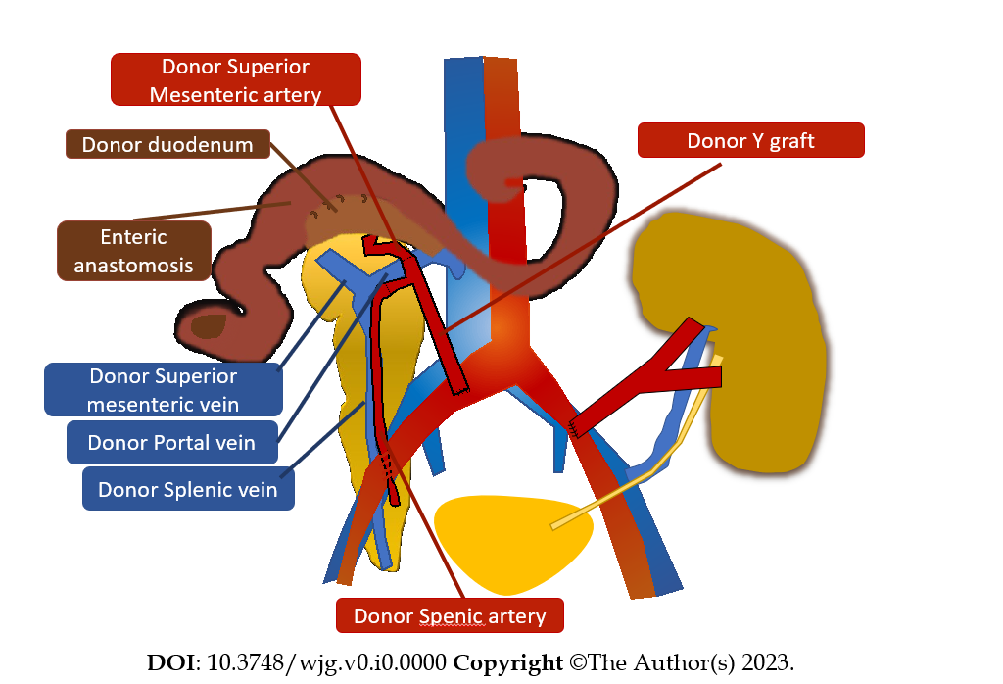
Figure 1 Schematic imaging representation of simultaneous pancreas and kidney transplantation.
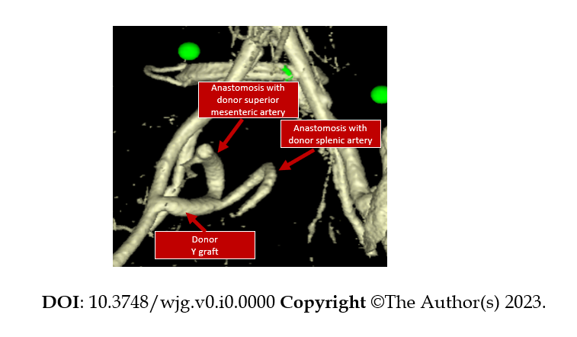
Figure 2 Volume rendering reformat of computed tomography images in the arterial phase demonstrates the Y conduit of donor iliac artery to the superior mesenteric and splenic arteries of the graft.
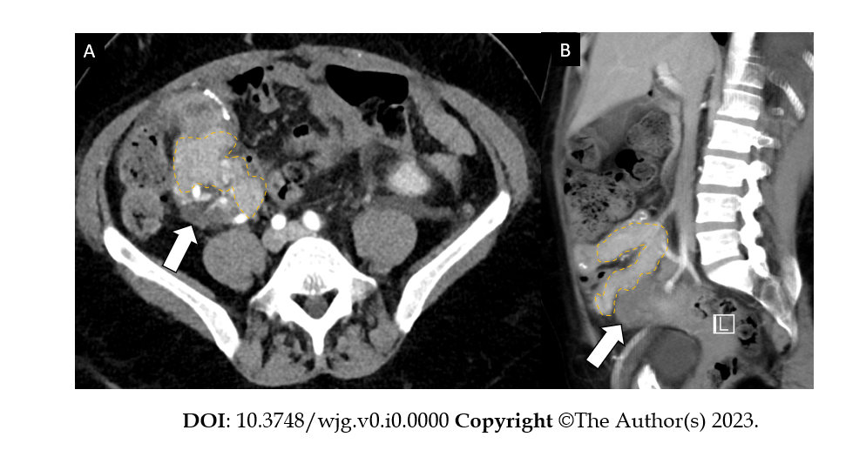
Figure 3 A 51-year-old woman, one month after simultaneous kidney-pancreatic transplantation is admitted to the emergency department for abdominal pain; final diagnosis at biopsy of the pancreatic graft was rejection. A: Contrast enhanced computed tomography in the axial plane shows a minimally inhomogeneous pancreatic graft (dotted yellow line) with peripancreatic fluid (arrows) posteriorly to the graft; B: Sagittal plane of the same contrast enhanced computes tomography.
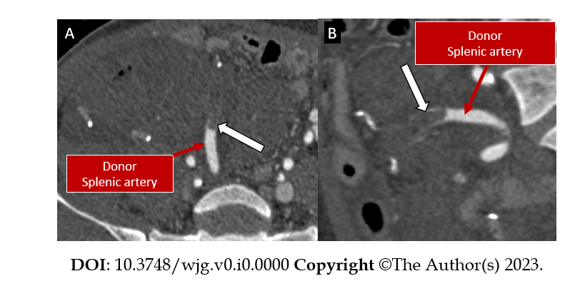
Figure 4 A 46-year-old woman, few days after surgery had low prothrombin time; final diagnosis was graft arterial thrombosis. A: Contrast enhanced computed tomography in the angiographic phase demonstrated arterial thrombosis of the donor splenic artery. In this patient, the transplanted pancreas was explanted thereafter; B: Coronal plane of the same contrast enhanced computed tomography in the angiographic phase.
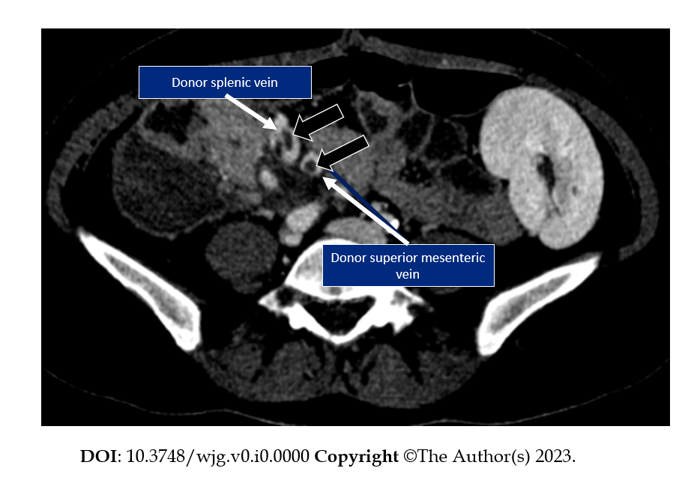
Figure 5 A 35-year-old woman is admitted to the emergency department for abdominal pain; final diagnosis was venous thrombosis. Contrast enhanced computed tomography in the venous phase demonstrates venous thrombi (black arrows) in the donor splenic vein and in the donor superior mesenteric vein.
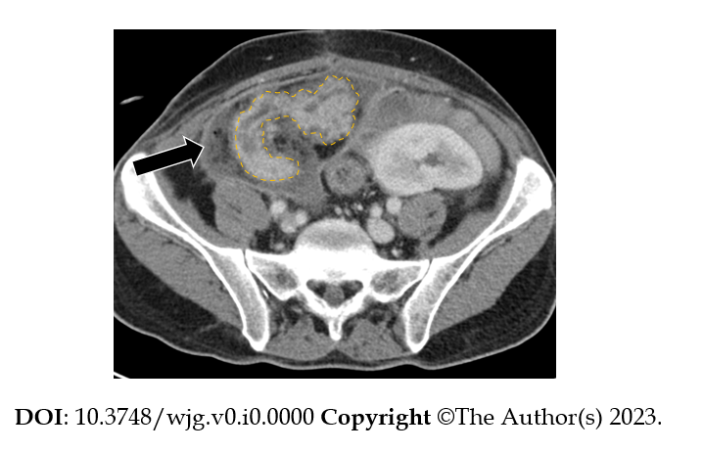
Figure 6 A 35-year-old man is admitted to the emergency department presenting hyperpyrexia and abdominal tenderness; final diagnosis was edematous pancreatitis with acute peripancreatic fluid collection. Contrast enhanced computed tomography in the axial plane shows inhomogeneous transplanted pancreas (dotted yellow lines) with slightly enlarged Wirsung duct and acute peripancreatic fluid collection (arrow) with thick wall and fat stranding surrounding the transplanted pancreas. A diagnosis of edematous pancreatitis was made.
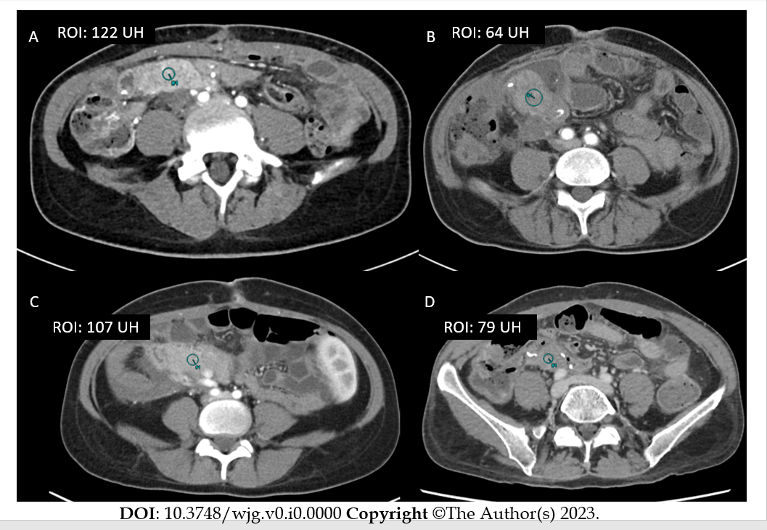
Figure 7 Contrast enhanced computed tomography in four different patients after pancreatic transplantation. A region of interest is drawn in the pancreas in the four patients. A: Normal pancreatic parenchyma; B: Inflammatory pancreatitis; C: Decreased parenchymal enhancement from venous thrombosis; D: Decreased parenchymal enhancement from arterial thrombosis.
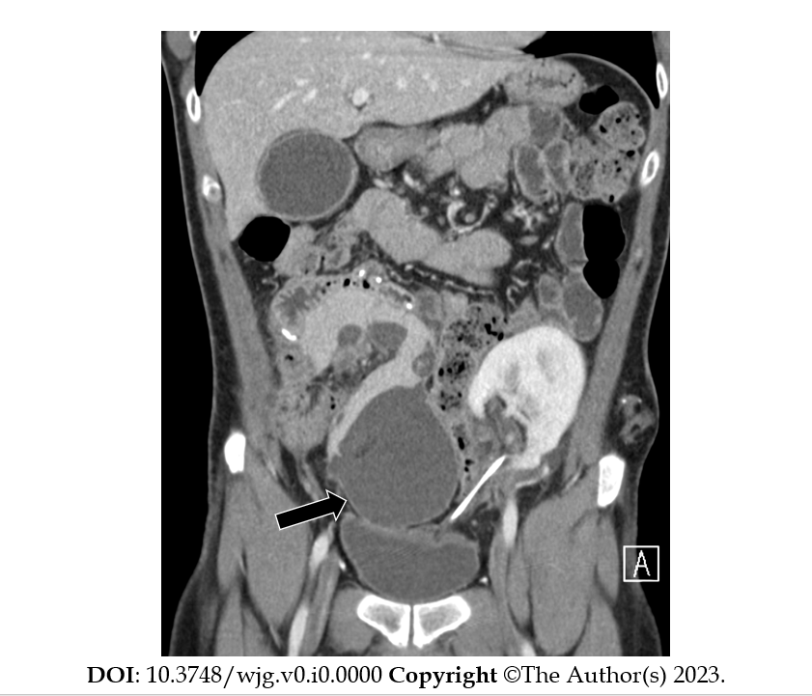
Figure 8 A 35-year-old man after four weeks from edematous pancreatitis. Contrast enhanced computed tomography in the coronal plane shows an encapsulated fluid collection (arrow) of homogeneously low attenuation surrounded by a well-defined enhancing wall consistent with pancreatic pseudocyst.
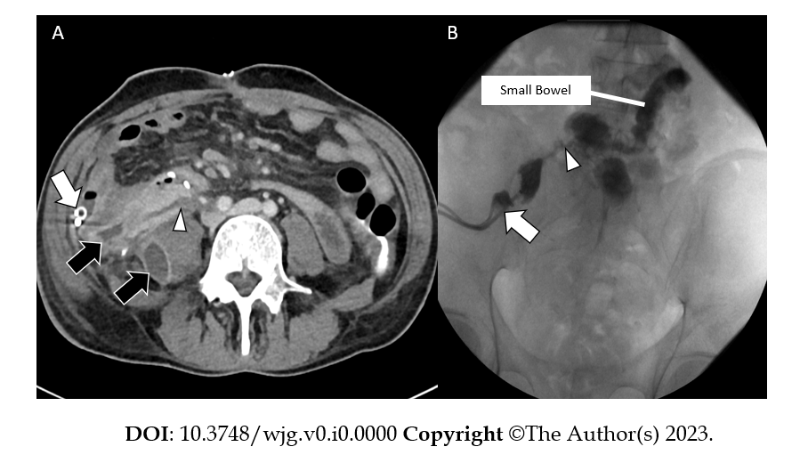
Figure 9 A 43-year-old man admitted to the emergency department for hyperpyrexia and abdominal tenderness; final diagnosis was enteric leakage. A: Contrast enhanced CT demonstrated the presence of an enteric leakage as a fistulous tract (arrowhead) from the small bowel at the level of the duodenojejunostomy, which resulted into fluid collections (black arrows). Abdominal drainage (white arrow) was inserted and the analysis of the fluid was consistent with the diagnosis of enteric leakage; B: Fluoroscopic image demonstrate the presence of an enteric leakage as a fistulous tract (arrowhead) from the small bowel at the level of the duodenojejunostomy. Abdominal drained is also evident (white arrow).
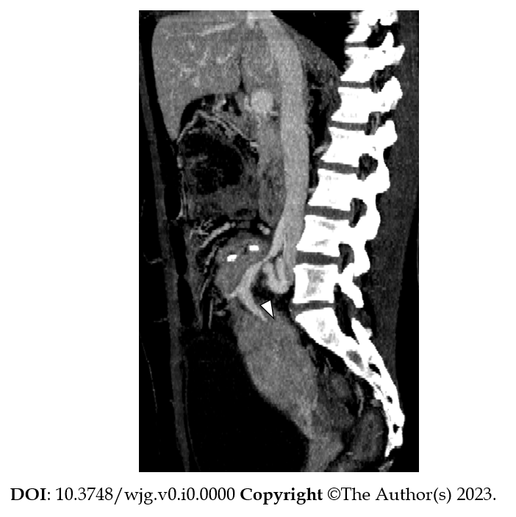
Figure 10 A 42-year-old woman admitted in the hospital for elevation of pancreatic amylase 6 mo after transplant; final diagnosis was venous stenosis. Contrast enhanced computed tomography in the sagittal plane with Maximum Intensity Projection reconstruction demonstrates venous stenosis (arrowhead) at the anastomotic site. The pancreatic graft is enlarged with inhomogeneous enhancement which likely reflects graft dysfunction.

