Name of Journal: World Journal of Clinical Cases
Manuscript NO: 50593
Manuscript Type: CASE REPORT

Urethral pressure profilometry in artificial urinary sphincter implantation: a case report

Meng LF et al. Urethral pressure profilometry

Ling-Feng Meng, Xiao-Dong Liu, Miao Wang, Wei Zhang, Yao-Guang Zhang

Ling-Feng Meng, Xiao-Dong Liu, Miao Wang, Wei Zhang, Yao-Guang Zhang, Department of Urology, Beijing Hospital, National Center of Gerontology, Beijing 100730, China

ORCID number: Ling-Feng Meng (0000-0002-9452-5603); Xiao-Dong Liu (0000-0001-5585-5960); Miao Wang (0000-0002-8970-1756); Wei Zhang (0000-0002-3657-9654); Yao-Guang Zhang (0000-0002-1024-9454).

Author contributions: Meng LF and Liu XD wrote the manuscript and were involved in the concept and submission of the manuscript; Wang M and Zhang W analyzed the patient’s clinical data; Zhang YG treated the patient and revised the manuscript; All authors approved the final version of this manuscript.

Supported by National Key R and D Program of China, No. 2018YFC2002202.

Informed consent statement: The patient involved in this study provided informed consent.

Conflict-of-interest statement: All authors declare that they have no conflict of interest.

CARE Checklist (2016) statement: The authors have read the CARE Checklist (2016), and the manuscript was prepared and revised according to the CARE Checklist (2016).

Open-Access: This article is an open-access article which was selected by an in-house editor and fully peer-reviewed by external reviewers. It is distributed in accordance with the Creative Commons Attribution Non Commercial (CC BY-NC 4.0) license, which permits others to distribute, remix, adapt, build upon this work non-commercially, and license their derivative works on different terms, provided the original work is properly cited and the use is non-commercial. See: http://creativecommons.org/licenses/by-nc/4.0/

Manuscript source: Unsolicited manuscript

Corresponding author: Yao-Guang Zhang, MD, Doctor, Professor, Department of Urology, Beijing Hospital, National Center of Gerontology, No. 1, Dongdan Dahua Road, Dongcheng District, Beijing 100730, China. zhangyaoguang3247@bjhmoh.cn
Telephone: +86-13031099662

Received: July 29, 2019
Peer-review started: July 29, 2019
First decision: October 24, 2019
Revised: October 30, 2019
Accepted: November 14, 2019
Article in press: November 14, 2019
Published online: December 6, 2019

Abstract
BACKGROUND
Artificial urethral sphincter (AUS) implantation is currently the gold standard for treating moderate and severe urinary incontinence. Currently, cuffs are chosen based on the surgeon’s experience, and adjusting cuff tightness is crucial. The T-DOC air-charged catheter has not been proven to be inferior to traditional catheters. We report how intraoperative urethral pressure profilometry is performed using a T-DOC air-charged catheter with ambulatory urodynamic equipment, to guide cuff selection and adjustment.

CASE SUMMARY
A 67-year-old man presented to our hospital with complete urinary incontinence following transurethral prostatectomy, using five pads/d to maintain local dryness. Preoperatively, the maximum urethral pressure (MUP) and maximum urethral closure pressure (MUCP) were 52 cmH2O and 17 cmH2O, respectively. An AUS was implanted. Intraoperatively, in the inactivated state, the MUP and MUCP were 53 cmH2O and 50 cmH2O, respectively; in the activated state, they were 112 cmH2O and 109 cmH2O, respectively. The pump was activated 6 wk postoperatively. Re-measurement of the urethral pressure on the same day showed that in the inactivated state, MUP and MUCP were 89 cmH2O and 51 cmH2O, respectively, and in the activated state, 120 cmH2O and 92 cmH2O, respectively. One month after device activation, telephonic follow-up revealed that pad use had decreased from five pads/d to one pad/d, which met the standard for social continence (0-1 pad per day). There were no complications.

CONCLUSION
The relationship between intraoperative urethral pressure and urinary continence post-surgery can provide data for standardizing AUS implantation and evaluating efficacy.

Keywords: Urethral pressure profilometry; Urinary sphincter, Artificial; Maximum urethral pressure; Maximum urethral closure pressure; Urinary incontinence; Case report

© The Author(s) 2019. Published by Baishideng Publishing Group Inc. All rights reserved.

Core tip: At present, all medical centers choose cuffs based on the experience of the surgeon, without quantitative criteria. We report how the intraoperative urethral pressure profilometry can be performed by combining the T-DOC air-charged catheter and ambulatory urodynamic equipment to guide the selection and adjustment of cuffs. By comparing the effect of intraoperative urethral pressure on postoperative urinary continence, we can establish the relationship between the range of intraoperative urethral pressure and its effect on urinary continence to guide clinical diagnosis and treatment and to standardize artificial urethral sphincter implantation.

Citation: Meng LF, Liu XD, Wang M, Zhang W, Zhang YG. Urethral pressure profilometry in artificial urinary sphincter implantation: a case report. World J Clin Cases 2019; 7(23): 4084-4090
URL: https://www.wjgnet.com/2307-8960/full/v7/i23/4084.htm
DOI: https://dx.doi.org/10.12998/wjcc.v7.i23.4084
INTRODUCTION
Urinary incontinence is a common complication of prostate surgery for treatment of prostate cancer or benign prostatic hyperplasia (BPH), which can significantly affect the quality of life of patients.
The International Continence Society (ICS) defines urinary incontinence after prostate surgery as the unconscious leakage of urine following prostate surgery, with or without bladder dysfunction^{[1]}. Currently, about 22.6 million men worldwide suffer from urinary incontinence, 12.5% of whom have simple stress urinary incontinence^{[2]}, and most of whom have a history of prostate surgery, nerve injury, or trauma. According to related literature, the rate of incontinence is 1% among patients after transurethral resection of the prostate (TURP) and 2%-57% after radical prostatectomy^{[3-5]}.
Artificial urethral sphincter (AUS) implantation has become the gold standard for treatment of moderate to severe urinary incontinence and urinary incontinence due to impaired sphincter function^{[6]}. Before the operation, urodynamic and cystoscopic examinations are recommended to assess bladder and urethral function and to ensure anatomical stability of the bladder and urethra^{[2,7]}. However, there have been few studies on the maximum urethral pressure (MUP) and maximum urethral closure pressure (MUCP) when an AUS is implanted and activated^{[8,9]}. To the best of our knowledge, no literature has reported the changes in MUP and MUCP before, during, and after implantation and activation of an AUS. This article reports the diagnosis and treatment of a patient with urinary incontinence after TURP, admitted to our hospital in March 2019.

CASE PRESENTATION
Chief complaints
A 67-year-old Chinese man was admitted to our hospital complaining of postoperative urinary leakage and incontinence for 11 mo.

History of present illness
The man was diagnosed with BPH following frequent urination and dysuria in April 2018. TURP was performed in the same month, and no malignant lesions were found. He had not undergone any previous surgeries. After removal of the catheter, unconscious leakage of urine was observed. Oral medicine, behavioral therapy, and other conservative treatments were ineffective. Up until presentation, urinary incontinence had gradually increased. The clinical manifestation was continuous leakage of urine; therefore, the patient was using five pads/d to ensure local dryness.

History of past illness
In April 2018, TURP was performed in the hospital due to BPH; the patient denied any history of other diseases and allergies.

Personal and family history
No smoking or drinking history was reported; no genetic family medical history was reported.

Physical examination upon admission
Physical examination showed continuous leakage of urine but no sign of redness, swelling, or eczema on the skin around the penis.

Laboratory examinations
Laboratory findings were unremarkable.

Imaging examinations
Routine examination, cystoscopy, urodynamics, and urethral pressure profilometry were performed. During cystoscopy, no urethral stricture was observed; however, the urethra showed incomplete closure (Figure 1A). Urodynamics and urethral pressure profilometry showed normal bladder function and compliance. The MUP was 52 cmH2O and MUCP was 17 cmH2O (Figure 1B).

FINAL DIAGNOSIS
Post-prostatectomy urinary incontinence.

TREATMENT
AUS implantation through a single perineal incision was performed in March 2019. When measured intraoperatively, the bulbourethral circumference was 6 cm. However, the general circumference of the urethra in Chinese men is usually 4.0-4.5 cm. Considering the height, weight, and general condition of the patient, we could not rule out the possibility of increased urethral circumference being related to abnormal erection and congestion of the periurethral tissue during operation (Figure 2A). Finally, under the guidance of the engineer assisting the surgeon, a 4.5-cm cuff was selected and placed (Figure 2B).
Urethral pressure profilometry was performed after connecting the entire device on inactivation and activation. In the inactivated state, MUP and MUCP were 53 cmH2O and 50 cmH2O, respectively, while in the activated state, MUP and MUCP were 112 cmH2O and 109 cmH2O, respectively (Figure 2C).
On the postoperative day 1, the catheter was removed, and urine continued to flow out. The patient was discharged on postoperative day 5. Six weeks after the operation, the patient returned to the hospital for a checkup and activation of the pump. Urodynamics and urethral pressure were measured again. In the inactivated state, the MUP and MUCP were 89 cmH2O and 51 cmH2O, respectively, while in the activated state, MUP and MUCP were 120 cmH2O and 92 cmH2O, respectively (Figure 3).
Standard urodynamic equipment (Laborie Delphis, Laborie Medical Technologies Canada unlimited liability corporation) and a 7-Fr air sensor (air-charged dual sensor catheter) were used to perform the urodynamic test and urethral pressure profilometry before the operation. The tractor pulls out the catheter at a uniform speed of 1 mm/s. Intraoperative and postoperative urethral pressure measurements were performed using an ambulatory urodynamic device (Laborie, Laborie Medical Technologies Canada unlimited liability corporation) and a 7-Fr air-charged catheter.
After the cuff of the artificial sphincter was closed, we recorded the MUP and MUCP. Thereafter, MUP and MUCP were recorded with the cuff open.
The definitions used in this article are in line with the recommendations of the ICS^{[10]}.

OUTCOME AND FOLLOW-UP
One month after device activation, telephonic follow-up revealed that pad use by the patient decreased from the previous five pads/d to one pad/d to maintain local dryness, reaching the standard social urinary continence of 0-1 pad per day.

DISCUSSION
This report shows how intraoperative urethral pressure profilometry is performed using a T-DOC air-charged catheter with ambulatory urodynamic equipment to guide cuff selection and adjustment.
For many years, AUS has been regarded as the most effective long-term treatment for male urinary incontinence. For over 10 years, AUS has been the first choice for treating permanent urinary incontinence after prostatectomy in European and American countries^{[11,12]}. The implantation of AUS is not complicated. The key to a successful operation is to choose the appropriate cuff size; however, there is no standardized guide for choosing cuff size. The choice of cuff size during operation mainly depends on the measured urethral circumference of the patient. Traditionally, it is agreed that too small a cuff may increase the risk of urethral atrophy and erosion; however, too large a cuff may not achieve the desired control on urine continence and lead to recurrence or persistence of urinary incontinence. At present, all medical centers choose cuffs based on the surgeon’s experience, without quantitative criteria. Unfortunately, this cannot accurately predict the effectiveness of urinary control nor the risk of complications.
These factors restrict the application of AUS; however, they also provide ideas for our research. In the past, urodynamic instruments were bulky and inconvenient to move. The traditional water-perfused catheter for measuring urethral pressure had strict requirements regarding patient position; it could only measure pressure in one direction, and the accuracy and repeatability were not high^{[13]}. All these factors make it difficult for us to accurately measure urethral pressure during the operation. The emergence of ambulatory urodynamic equipment and the T-DOC air-charged catheter have facilitated cuff size measurement. Research on the T-DOC air-charged catheter has proved that it is not inferior to other catheters, such as traditional water-perfused catheters and microtransducer urodynamic catheters, in urethral pressure measurement; the T-DOC air-charged catheter measures the average pressure in a 360-degree environment, which is more readable^{[14-16]}. This is the innovation in our study. We were able to measure the intraoperative urethral pressure, which can provide specific values of intraoperative MUP and MUCP and compare the postoperative continence of patients so that the clinical effects of different urethral pressures can be analyzed. In the future, we aim to determine the relationship between specific ranges of urethral pressure and the measure of urinary control by comparing data among more patients. This will further guide the clinical diagnosis and treatment of urinary incontinence and standardize AUS implantation. Similarly, this method can also be used in patients with stress urinary incontinence undergoing sling surgery. Regardless of the procedure, AUS or sling operation, the measure of urine control after operation is closely related to the individual experience of the surgeon, and there is no quantitative standard.
Although the methodology of urethral pressure measurement is standardized, to our knowledge, there are no generally accepted reference values for a healthy state. Chinese experts have reported that the average MUP of a normal elderly Chinese man is 77 (55-105) cmH2O, and the reference range of MUCP is 60-80 cmH2O^{[17]}. In this study, the MUP of the patient before surgery and in the states of intraoperative activation and inactivation and postoperative activation and inactivation were 52, 112, 53, 120, and 89 cm H2O, respectively, and MUCP was 17, 109, 50, 92, and 51 cm H2O, respectively. The measure of urine control was satisfactory, and no complications related to the operation were found during the 1-mo follow-up appointment.
The purpose of AUS implantation is to acquire the ability to control urinary incontinence, to achieve the standard of social continence (0-1 pads/d), and to minimize the occurrence of complications. Therefore, it is logical to evaluate the changes in urethral pressure in patients after AUS implantation. Ripert et al^{[18]} studied the changes in urethral pressure in patients after AUS implantation. He enrolled 27 patients who underwent AUS implantation from 2012 to 2014 and maintained social continence at the time of follow-up. Urethral pressure was measured. MUP in all the patients was greater than 70 cmH2O, and in 22 (81.48%) patients MUP was greater than 90 cmH2O. The mean MUP was 119.55 (77-180) cmH2O, and the mean MUCP was 88.29 (32-160) cmH2O. In addition, Lowe et al^{[8]} included 24 male patients who underwent AUS implantation and were followed with urinary control for at least one year after operation. They analyzed the results combined with the measurement of urethral pressure. The study found that the MUCP of all patients was above 65 cmH2O; however, there were still eight patients with recurrence of moderate to severe urinary incontinence; the average MUCP was 76.9 cmH2O. It was presumed that the cuff may only be slightly attached to the urethra; it provides higher urethral closure pressure only when the urethral pressure exceeds 100 cmH2O. At the same time, if a larger cuff is used, the pressure transmitted to the urethra decreases accordingly. Therefore, when choosing the cuff, doctors can choose a smaller cuff to make it more suitable for the urethra; however, they should pay attention to the risk of complications, such as urethral erosion. The results obtained in the above study are consistent with the present study and provide a theoretical basis for the present study. However, a smaller cuff may lead to increased MUP; if it does not affect the patient's urinary flow rate, we think it is more appropriate.
To conclude, in the later stage, we can achieve the container zone through this method. If the intraoperative MUCP is lower than the lowest value of the interval, it indicates that the cuff size is too large and should be replaced with a smaller one. If the intraoperative MUCP is higher than the highest value of the interval, it should be considered whether removal of the periurethral tissue is satisfactory. If the removal is not satisfactory, the excess tissue should then be removed. If the removal of the excess tissue is satisfactory, the cuff with a larger size should be replaced to obtain satisfactory clinical effect and reduce the incidence of complications.
One limitation of this study is that, when measuring urethral pressure during and after operation, the catheter was pulled manually and uniformly, which may have caused a certain degree of error. In addition, the follow-up time was short, and the long-term clinical outcomes of the patient are not known. However, with an increase in the number of patients and an extension of the follow-up period, we believe that more rigorous conclusions can be drawn to guide the clinical diagnosis and treatment of urinary incontinence.

CONCLUSION
We report the first successful case of intraoperative urethral pressure management. By comparing the effect of intraoperative urethral pressure on postoperative urinary continence, we can determine the relationship between the range of intraoperative urethral pressure and its effect on urinary continence. This will help guide the clinical diagnosis and treatment of urinary incontinence as well as standardize the AUS implantation procedure.

References
1 Demaagd GA, Davenport TC. Management of urinary incontinence. P T 2012; 37: 345-361H [PMID: 22876096]
2 Cordon BH, Singla N, Singla AK. Artificial urinary sphincters for male stress urinary incontinence: current perspectives. Med Devices (Auckl) 2016; 9: 175-183 [PMID: 27445509 DOI: 10.2147/MDER.S93637]
3 Mebust WK, Holtgrewe HL, Cockett AT, Peters PC. Transurethral prostatectomy: immediate and postoperative complications. A cooperative study of 13 participating institutions evaluating 3,885 patients. J Urol 1989; 141: 243-247 [PMID: 2643719 DOI: 10.1016/s0022-5347(17)40731-2]
4 Goluboff ET, Saidi JA, Mazer S, Bagiella E, Heitjan DF, Benson MC, Olsson CA. Urinary continence after radical prostatectomy: the Columbia experience. J Urol 1998; 159: 1276-1280 [PMID: 9507852 DOI: 10.1097/00005392-199804000-00053]
5 Lepor H, Kaci L. The impact of open radical retropubic prostatectomy on continence and lower urinary tract symptoms: a prospective assessment using validated self-administered outcome instruments. J Urol 2004; 171: 1216-1219 [PMID: 14767305 DOI: 10.1097/01.ju.0000113964.68020.a7]
6 Lucas MG, Bosch RJ, Burkhard FC, Cruz F, Madden TB, Nambiar AK, Neisius A, de Ridder DJ, Tubaro A, Turner WH, Pickard RS; European Association of Urology. EAU guidelines on surgical treatment of urinary incontinence. Eur Urol 2012; 62: 1118-1129 [PMID: 23040204 DOI: 10.1016/j.eururo.2012.09.023]
7 James MH, McCammon KA. Artificial urinary sphincter for post-prostatectomy incontinence: a review. Int J Urol 2014; 21: 536-543 [PMID: 24528387 DOI: 10.1111/iju.12392]
8 Lowe DH, Scherz HC, Parsons CL. Urethral pressure profilometry in Scott artificial urinary sphincter. Urology 1988; 31: 82-85 [PMID: 3336936 DOI: 10.1016/0090-4295(88)90583-3]
9 Kil PJ, De Vries JD, Van Kerrebroeck PE, Zwiers W, Debruyne FM. Factors determining the outcome following implantation of the AMS 800 artificial urinary sphincter. Br J Urol 1989; 64: 586-589 [PMID: 2627633 DOI: 10.1111/j.1464-410X.1989.tb05314.x]
10 Lose G, Griffiths D, Hosker G, Kulseng-Hanssen S, Perucchini D, Schäfer W, Thind P, Versi E; Standardization Sub-Committee, International Continence Society. Standardisation of urethral pressure measurement: report from the Standardisation Sub-Committee of the International Continence Society. Neurourol Urodyn 2002; 21: 258-260 [PMID: 11948719 DOI: 10.1002/nau.10051]
11 Gousse AE, Madjar S, Lambert MM, Fishman IJ. Artificial urinary sphincter for post-radical prostatectomy urinary incontinence: long-term subjective results. J Urol 2001; 166: 1755-1758 [PMID: 11586217 DOI: 10.1097/00005392-200111000-00031]
12 Montague DK, Angermeier KW, Paolone DR. Long-term continence and patient satisfaction after artificial sphincter implantation for urinary incontinence after prostatectomy. J Urol 2001; 166: 547-549 [PMID: 11458065 DOI: 10.1016/S0022-5347(05)65981-2]
13 Abrams P, Damaser MS, Niblett P, Rosier PFWM, Toozs-Hobson P, Hosker G, Kightley R, Gammie A. Air filled, including "air-charged," catheters in urodynamic studies: does the evidence justify their use? Neurourol Urodyn 2017; 36: 1234-1242 [PMID: 27580083 DOI: 10.1002/nau.23108]
14 Zehnder P, Roth B, Burkhard FC, Kessler TM. Air charged and microtip catheters cannot be used interchangeably for urethral pressure measurement: a prospective, single-blind, randomized trial. J Urol 2008; 180: 1013-1017 [PMID: 18639301 DOI: 10.1016/j.juro.2008.05.028]
15 Pollak JT, Neimark M, Connor JT, Davila GW. Air-charged and microtransducer urodynamic catheters in the evaluation of urethral function. Int Urogynecol J Pelvic Floor Dysfunct 2004; 15: 124-8; discussion 128 [PMID: 15014940 DOI: 10.1007/s00192-004-1121-4]
16 McKinney TB, Babin EA, Ciolfi V, McKinney CR, Shah N. Comparison of water and air charged transducer catheter pressures in the evaluation of cystometrogram and voiding pressure studies. Neurourol Urodyn 2018; 37: 1434-1440 [PMID: 29363824 DOI: 10.1002/nau.23466]
17 Liao LM. Urodynamics. Beijing: People’S military medical press, 2012: 245-246
18 Ripert T, Pierrevelcin J. Comparative study of urodynamic tests after AMS 800 and ZSI 375 insertion. Urologia 2018; 85: 15-18 [PMID: 28967063 DOI: 10.5301/uj.5000271]
P-Reviewer: ElSheemy MS S-Editor: Zhang L L-Editor: Wang TQ E-Editor: Qi LL

Specialty type: Medicine, Research and Experimental
Country of origin: China
Peer-review report classification
Grade A (Excellent): 0
Grade B (Very good): 0
Grade C (Good): C
Grade D (Fair): 0
Grade E (Poor): 0
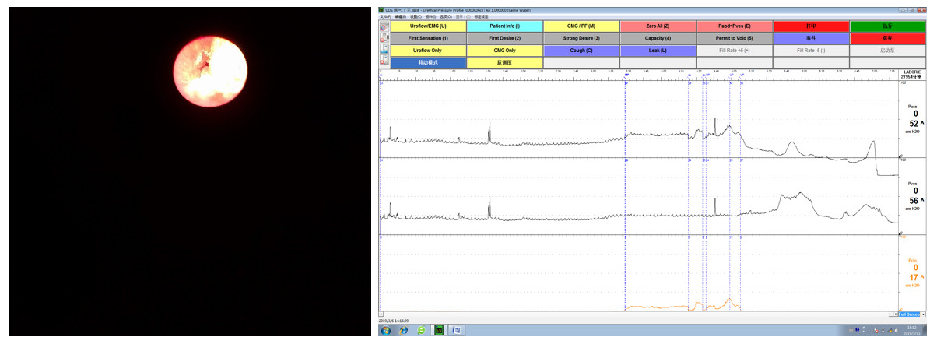Figure 1 Preoperative examination. A: Cystoscopy revealed no urethral stricture, and it was observed that the urethra could not close completely; B: Preoperative urethral pressure profilometry showed that the maximum urethral pressure was 52 cmH2O and maximum urethral closure pressure was 17 cmH2O.
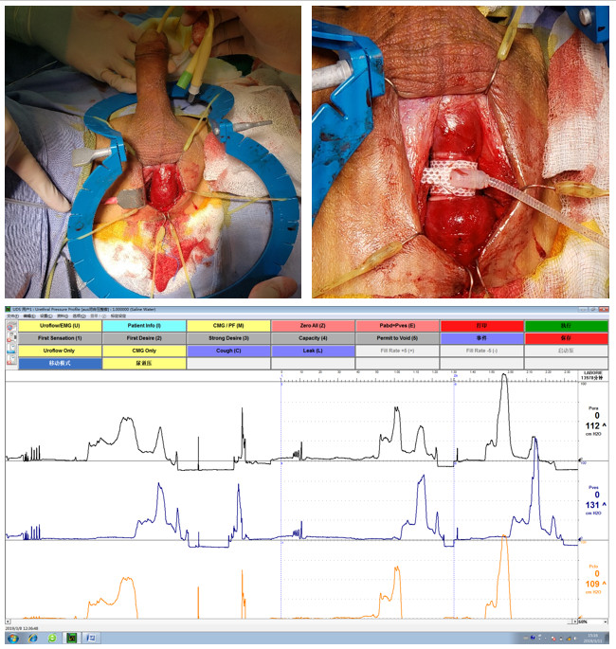
Figure 2 Intraoperative findings. A: Abnormal erection during operation; B: A 4.5-cm cuff was selected and placed; C: During operation, the maximum urethral pressure (MUP) was 53 cmH2O and maximum urethral closure pressure (MUCP) was 50 cmH2O in the inactivated state; the MUP was 112 cmH2O and MUCP was 109 cmH2O in the activated state.
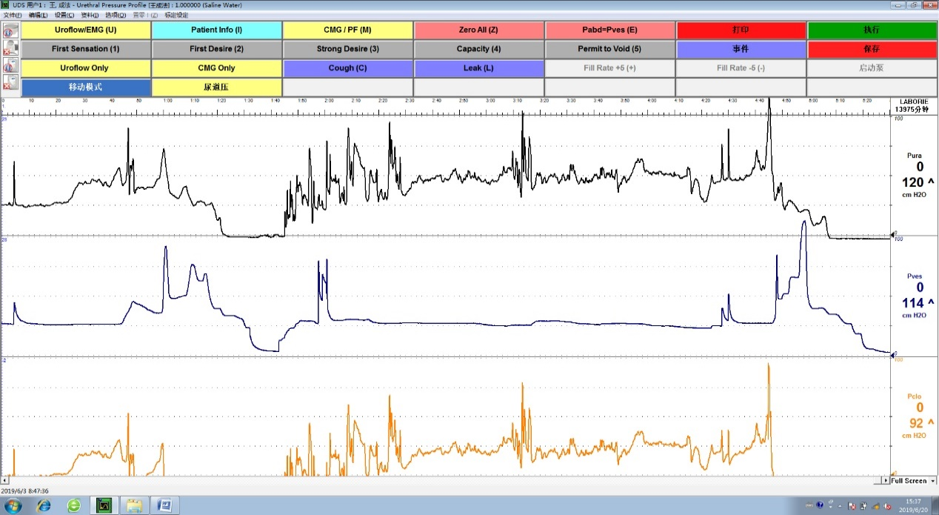
Figure 3 Urethral pressure measured at follow-up. Six weeks after the operation, the maximum urethral pressure (MUP) was 89 cmH2O and maximum urethral closure pressure (MUCP) was 51 cmH2O in the inactivated state; the MUP was 120 cmH2O and MUCP was 92 cmH2O in the activated state.

