Name of Journal: World Journal of Gastroenterology
Manuscript NO: 62078
Manuscript Type: ORIGINAL ARTICLE

Observational Study
Fatigue in patients with inflammatory bowel disease in Eastern China

Gong SS et al. Fatigue in patients with IBD in Eastern China

Shan-Shan Gong, Yi-Hong Fan, Bin Lv, Mie-Qing Zhang, Yi Xu, Jing Zhao

Shan-Shan Gong, Mie-Qing Zhang, Department of Gastroenterology, The Third Affiliated Hospital of Zhejiang Chinese Medical University, Hangzhou 310000, Zhejiang Province, China

Shan-Shan Gong, Yi-Hong Fan, Bin Lv, Yi Xu, Jing Zhao, Department of Gastroenterology, The First Affiliated Hospital of Zhejiang Chinese Medical University, Hangzhou 310006, Zhejiang Province, China

Author contributions: Gong SS conducted clinical observation, analyzed the data, and wrote the paper; Fan YH participated in the statistical analysis; Lv B and Zhang MQ collected the data; Xu Y conducted literature search and provided valuable suggestions for this study; Zhao J designed the research and revised the paper; all authors have read and approved the finial manuscript.

Supported by the National Natural Science Foundation of China, No. 81473506 and No. 81470814; and Zhejiang TCM Science and Technology Project, No. 2021ZA057, No. 2019ZA056, and No. 2018ZB046.

Corresponding author: Jing Zhao, MD, Doctor, Professor, Department of Gastroenterology, The First Affiliated Hospital of Zhejiang Chinese Medical University, No. 54 Youdian Road, Shangcheng District, Hangzhou 310006, Zhejiang Province, China. qiaoxiao_916@163.com

Received: December 28, 2020
Revised: January 14, 2021
Accepted: February 25, 2021
Published online:

Abstract
BACKGROUND
Fatigue is a very common but relatively neglected problem in patients with inflammatory bowel disease (IBD). The prevalence rate of IBD in China is the highest in Asia, but there is little research on fatigue in patients with IBD. Neither the relationship between fatigue and quality of life (QoL) nor the relationship between fatigue and work productivity (WP) in Chinese IBD patients has been reported.

AIM
To investigate the prevalence of fatigue related to IBD in Eastern China, to identify the risk factors associated with fatigue, to assess the impact of fatigue on QoL, and to evaluate the relationship between fatigue and WP.

METHODS
A cross-sectional study was conducted in a Regional Tertiary IBD Diagnostic and Treatment Center in Eastern China. Clinical data of patients were collected, and disease activity was evaluated. Blood samples were analyzed to assess anemia, albumin, and inflammation. Fatigue was assessed using the multidimensional fatigue inventory. QoL and WP were measured using the short inflammatory bowel disease questionnaire and the work productivity and activity impairment general health questionnaire, respectively. The patients also completed assessments of depression (Patient Health Questionnaire-9) and anxiety (Generalized Anxiety Disorder 7-item Scale).

RESULTS
A total of 311 IBD patients, comprising 168 Crohn's disease patients and 143 ulcerative colitis patients, were enrolled. The prevalence of fatigue in patients with IBD was 60.77%. In a univariate logistic regression analysis, factors such as disease activity, depression, anxiety, anemia, and IBD-related surgery were individually related to a significantly increased risk of fatigue in IBD patients. Multivariate logistic regression analysis indicated that depression [odds ratio (OR) = 8.078, 95% confidence interval (CI): 4.113-15.865], anxiety (OR = 2.373, 95%CI: 1.100-5.119), anemia (OR = 2.498, 95%CI: 1.290-4.834), and IBD-related surgery (OR = 2.035, 95%CI: 1.084-3.819) were related to fatigue in IBD patients. There was a negative correlation between fatigue and QoL (r = -0.831; P < 0.0001) but a positive correlation between fatigue and WP loss.

CONCLUSION
The prevalence of fatigue in IBD patients in Eastern China is remarkably high even in clinical remission. Factors such as depression, anxiety, anemia, and IBD-related surgery are major risk factors for fatigue in IBD patients. In addition, fatigue has a negative impact on QoL and is positively correlated with WP loss.

Key Words: Inflammatory bowel disease; Fatigue; Quality of life; Work productivity; Risk factors; Eastern China

Gong SS, Fan YH, Lv B, Zhang MQ, Xu Y, Zhao J. Fatigue in patients with inflammatory bowel disease in Eastern China. World J Gastroenterol 2021; In press

Core Tip: Fatigue is a highly prevalent and burdensome symptom in patients with inflammatory bowel disease (IBD), with an important impact on quality of life and (indirect) health expenditures. The prevalence rate of IBD in China is the highest in Asia, but there is little research on fatigue in patients with IBD. In addition, the relationships of fatigue with quality of life and work productivity in Chinese IBD patients have not been reported.
INTRODUCTION
Inflammatory bowel disease (IBD) is a chronic, nonspecific inflammation of the gastrointestinal tract with an unknown etiology that can be classified as ulcerative colitis (UC) and Crohn's disease (CD)^{[1]}. IBD has a high prevalence in young adults and is characterized by a long course, high recurrence rate, and severe complications (such as toxic megacolon, intestinal perforation, intestinal obstruction, intestinal bleeding, and cancer)^{[2]}. Mucus-bloody stools, diarrhea, abdominal pain, weight loss, and anemia are the main clinical manifestations of IBD^{[3]}, which seriously impact the quality of life (QoL) of patients and increase the financial burden.
Fatigue is expressed as an overwhelming experience of mental and/or physical exhaustion that affects daily living and is unrelieved by rest or sleep^{[4,5]}. Studies in several countries have shown that fatigue is common in patients with IBD^{[6-10]}. Some studies have found that fatigue is associated with active enteritis^{[11]}, especially with mucosal healing in patients with IBD^{[12]}. In addition, fatigue also has a negative psychological impact on patients with IBD, exacerbating clinical symptoms and promoting disease progression^{[13]}. Even as a result of fatigue, IBD patients have to adjust their daily activities and work, and some even choose to resign, which seriously affects their QoL^{[14]} and increases their financial burden^{[15]}. Fatigue is a very common but relatively neglected problem in IBD patients, especially in China. The prevalence rate of IBD in China is the highest in Asia^{[16]}, but there is little research on fatigue in patients with IBD. In addition, the relationship between fatigue and QoL and work productivity (WP) in Chinese IBD patients has not been reported.
In this study, we aimed to investigate the prevalence and risk factors for fatigue in patients with IBD in Eastern China through a cross-sectional study. We also determined the relationships between fatigue and QoL and WP to evaluate the impact of fatigue on IBD patients in Eastern China.
MATERIALS AND METHODS
Study population
This cross-sectional study was conducted at the First Affiliated Hospital of Zhejiang Chinese Medical University, a Regional Tertiary IBD Diagnostic and Treatment Center in Eastern China, from February 2018 to August 2020. The inclusion criteria were a confirmed diagnosis of IBD and signed informed consent. The diagnostic criteria for IBD were based on the Chinese consensus on the diagnosis and treatment of IBD^{[17]}. The exclusion criteria were the inability to understand or complete the questionnaires, refusal to give written informed consent before participation, and concomitant diseases with fatigue as the main symptoms, such as cancer, heart disease, or liver cirrhosis. This study was registered at the Chinese Clinical Trials Registry (ChiCTR1900025890).

Ethics
This study was approved by the ethics committee of the First Affiliated Hospital of Zhejiang Chinese Medical University, and informed consent was obtained from all participants. Patients under the age of 16 were admitted to our study with consent from their parents or guardians.

Clinical and sociodemographic data
The demographic characteristics of the patients were collected, including age, sex, body mass index (BMI), course of the disease, current smoking habits, IBD-related surgery (such as colectomies, other bowel surgery, and perianal surgery), disease activity, type of IBD, location of disease, and current medications. Blood samples were collected (within one week before and after completion of the questionnaires) and analyzed for hemoglobin, albumin, and erythrocyte sedimentation rate.

Definitions
Disease activity and severity were assessed using the following clinical indices: Harvey-Bradshaw activity index^{[18]} was used for CD. Mayo score and Truelove and Witts criteria^{[19]} were used for UC. Anemia was defined as hemoglobin < 130 g/L for males and < 120 g/L for females. Hypoalbuminemia was defined as albumin < 35 g/L. BMI was based on the Chinese criteria of weight for adults^{[20]}. Underweight was defined as BMI < 18.5 kg/m²; normal weight was defined as 18.5 kg/m² ≤ BMI < 24.0 kg/m²; overweight was defined as 24.0 kg/m² ≤ BMI < 28.0 kg/m²; and obesity was defined as BMI ≥ 28.0 kg/m².
The significance level of coefficients is indicated only when they reach the 0.001 criterion. The following cutoffs were used to define the magnitude of the correlation coefficients: < 0.25, low correlation; 0.25 to 0.5, fair correlation; 0.5 to 0.75, moderate-to-good correlation; and > 0.75, good-to-excellent correlation^{[21]}.

Questionnaires
Fatigue was analyzed using the multidimensional fatigue inventory (MFI; ranging from 20 to 100, with higher scores indicating more severe fatigue). This questionnaire, previously validated in Chinese and for IBD patients^{[22]}, comprises 20 items divided into five subscales: General fatigue, physical fatigue, reduced activity, reduced motivation, and mental fatigue^{[23]}. The definition of fatigue was complicated by a lack of clear cutoff scores. Several studies have found that scales of general fatigue are more psychometrically useful than the use of numerical rating scales, so the MFI of general fatigue can be called "fatigue"^{[24-26]}. Combining the values reported in a domestic study^{[27]} and foreign studies^{[28-30]} on the MFI, fatigue was defined as general fatigue score ≥ 12.
Depression was analyzed using the Patient Health Questionnaire-9 (PHQ-9), which has been validated in Chinese IBD patients^{[31]}. The PHQ-9 scores each of the 9 DSM-IV criteria on a scale ranging from "0" (not at all) to "3" (nearly every day). The total PHQ-9 score that categorizes depression is as follows: Nondepression as 0 ≤ PHQ-9 ≤ 4, mild depression as 5 ≤ PHQ-9 ≤ 9, moderate depression as 10 ≤ PHQ-9 ≤ 14, moderate-severe depression as 15 ≤ PHQ-9 ≤19, and severe depression as 20 ≤ PHQ-9 ≤ 27^{[32]}.
The generalized anxiety disorder 7-item scale was completed to measure symptoms of anxiety and has been validated in Chinese patients with IBD^{[31]}. The generalized anxiety disorder 7-item scale is a 7-item self-report instrument that is scaled from 0–3 (not at all, several days, more than half the days, and nearly every day), with total scores ranging from 0 to 21, and it is interpreted as follows: The absence of anxiety (0-4), mild anxiety (5-9), moderate anxiety (10-14), and severe anxiety (15-21)^{[33]}.
The Short Inflammatory Bowel Disease Questionnaire (SIBDQ) was used to assess IBD-specific QoL^{[34]}. The SIBDQ includes 10 items, each with a score from 1 (worst) to 7 (best), with the total score ranging from 10 to 70 (the higher the score, the better the QoL). Furthermore, the SIBDQ has four domains: Bowel symptoms, systemic symptoms, emotional function, and social function.
The work productivity and activity impairment general health questionnaire^{[35]} measures time missed from work and work impairment because of IBD in the past week. The work productivity and activity impairment general health questionnaire includes four items: Work time missed (absenteeism), impaired productivity at work (presenteeism), overall work impairment (OWI; combined absenteeism and presenteeism), and impairment in non-work-related activities due to health problems (activity impairment). Absenteeism was calculated as [hours missed due to health problems/ (hours missed due to health problems + hours worked)] × 100; presenteeism was calculated as (degree health affected productivity while working/10) × 100; OWI was calculated as absenteeism + [(1-absenteeism) × presenteeism]; and (4) daily activity impairment was calculated as (degree of health affected daily activities/10) × 100.

Statistical analysis
Quantitative variables are expressed as the mean ± standard deviation or as medians and interquartile range (IQR), and qualitative variables are expressed as frequencies and percentages. After transforming fatigue from a quantitative to a qualitative variable (with/without fatigue), logistic regression analyses were performed. Variables with P < 0.05 in the univariate analysis were included in the multivariate analysis, and the results are expressed as odds ratios (ORs) with their corresponding 95% confidence intervals (CIs). Correlations between fatigue and QoL and WP were measured with Spearman's rank correlation coefficient. Statistical analyses were performed using Statistic Package for Social Science 24 (Statistic Package for Social Science Inc., Chicago, IL, United States), and P < 0.05 was considered statistically significant.

RESULTS
IBD patients’ demographic and clinical characteristics
A total of 311 IBD patients, including 168 CD and 143 UC patients, were enrolled in this study. The participants had a median age of 42 (IQR: 31-53) years. Most of the participants had health insurance (90.35%, n = 281) and were married (74.28%, n = 231). There were 212 (68.17%) patients who had a job, of whom 208 (66.88%) were working full-time. Regarding the duration of disease, the participants reported a median of 5 (IQR: 2-12) years. A total of 51.45% of IBD patients were in the active phase of the disease, and 32.80% of participants had IBD-related surgery. The demographic and clinical characteristics of IBD patients are summarized in Table 1.

Prevalence and score of fatigue in patients with IBD
The prevalence of fatigue in patients with IBD was 60.77%, including 71.88% in patients with active IBD and 49.01% in patients in remission. The median fatigue total score was 43 (IQR: 33-59) in IBD patients, and the median general fatigue, physical fatigue, mental fatigue, reduced activity, and reduced motivation scores were 12 (IQR: 9-15), 8 (IQR: 6-12), 9 (IQR: 6-12), 7 (IQR: 4-9), and 7 (IQR: 4-12), respectively (Figure 1).

Factors associated with fatigue
The univariate analysis showed that disease activity (P < 0.001, OR = 2.659; 95%CI: 1.663-4.253), depression (P < 0.001, OR = 13.722; 95%CI: 7.608-24.749), anxiety (P < 0.001, OR = 8.134; 95%CI: 4.351-15.204), anemia (P < 0.001, OR = 3.792; 95%CI: 2.232-6.440), and IBD-related surgery (P < 0.05, OR = 1.654; 95%CI: 1.004-2.727) were associated with the presence of fatigue (Figure 2A).
Multivariate logistic regression analysis indicated that depression (P < 0.001, OR = 8.078, 95%CI: 4.113-15.865), anxiety (P = 0.028, OR = 2.373, 95%CI: 1.100-5.119), anemia (P = 0.007, OR = 2.498, 95%CI: 1.290-4.834), and IBD-related surgery (P = 0.027, OR = 2.035, 95%CI: 1.084-3.819) were related to fatigue in IBD patients (Figure 2B).

Fatigue and QoL
The median QoL total score was 53 (IQR: 44-62), and the median scores of bowel symptoms, social function, emotional function, and systemic symptoms were 17 (IQR: 13-20), 12 (IQR: 9-13), 9 (IQR: 6-12), 15 (IQR: 11-19), and 11 (IQR: 10-13), respectively (Figure 3). Fatigue was negatively correlated with QoL (r = - 0.831; P < 0.0001), particularly with emotional function (r = -0.721; P < 0.0001) (Figure 4A). Further analysis revealed that general fatigue (r = -0.785; P < 0.0001) showed a good-to-excellent correlation with negative QoL, and reduced activity (r = -0.731; P < 0.0001) and psychological fatigue (r = -0.704; P < 0.0001) showed a moderate-to-good correlation with negative QoL (Figure 4B).

Fatigue and WP
There were 208 (66.88%) patients who were working full-time, and their prevalence of fatigue was 58.65%. Further analysis found that their median total fatigue score was 41 (IQR: 32.25-58), with median general fatigue, physical fatigue, mental fatigue, reduced activity, and reduced motivation scores of 12 (IQR: 9-15), 9 (IQR: 7-12), 9 (IQR: 6-11), 6 (IQR: 4-9), and 6 (IQR: 4-11), respectively (Figure 5). Fatigue had the strongest positive correlation with OWI (r = 0.605; P < 0.0001), followed by activity impairment (r = 0.566; P < 0.0001), presenteeism (r = 0.543; P < 0.0001), and absenteeism (r = 0.480; P < 0.0001) (Figure 6A). Compared with physical fatigue, mental fatigue, reduced activity, and reduced motivation, general fatigue was the most strongly associated with WP loss (OWI: r = 0.552, P < 0.0001; activity impairment: r = 0.549, P < 0.0001; presenteeism: r = 0.519, P < 0.0001; absenteeism: r = 0.442, P < 0.0001) (Figure 6B).

DISCUSSION
In the present study, we found that the prevalence of fatigue in patients with IBD in Eastern China was 60.77%, including 71.88% in the active stage and 49.01% in the remission stage. Major factors associated with fatigue were depression, anxiety, anemia, and IBD-related surgery. Female sex, disease activity, and hypoalbuminemia do not increase the risk of fatigue. In addition, fatigue had a negative impact on QoL and was positively correlated with WP loss.
Multifactorial analysis showed that depression and anxiety were risk factors for fatigue, and depression, in particular, is the strongest risk factor for fatigue. Several previous studies are consistent with our findings^{[36-38]}. In chronic diseases, fatigue and psychiatric disorders such as depression and anxiety coexist^{[39,40]}, including IBD^{[41]}. The immune-inflammatory pathway and gut-brain axis may be possible pathways for the coexistence of fatigue and psychological disorders in IBD^{[39-42]}. One of the reasons for such a high prevalence of fatigue and psychiatric comorbidity in patients with IBD in Eastern China may be due to limited therapeutic drug options. The use of biologics as an effective treatment for IBD in China is very limited. First, the options are limited, with only infliximab entering the Chinese market. When IBD patients fail to respond to infliximab therapy, they are faced with the situation of either having no drugs available or using hormones with more side effects. Second, it is expensive, as only CD is reimbursed by health insurance, which increases the financial burden of patients. The limited availability of medication, the recurrence of disease symptoms, the side effects of hormone therapy, and the heavy financial burden contribute to the development of fatigue and psychiatric disorders in Chinese patients with IBD. Anemia is the most common extraintestinal manifestation of IBD, which occurs in up to 20% of outpatients and up to 68% of inpatients with IBD^{[43,44]}. The major causes of anemia in IBD are iron^{[45]}, vitamin B12, and folic acid deficiency^{[46]}. The side effects or complications of some drugs for IBD are anemia. For example, methotrexate can lead to folic acid deficiency and megaloblastic anemia^{[47]}. One of the side effects of azathioprine and 6-mercaptopurine is myelosuppression^{[48]}. Sulfadiazine and 5-aminosalicylate have rare hemolytic complications^{[49,50]}. The relationship between fatigue and IBD-related surgery has rarely been reported. In our study, IBD-related surgery was found to be a risk factor for fatigue in IBD patients, which may be related to postoperative complications, postoperative pain, fear of stoma care, environmental (especially family) reactions, and acceptance of new conditions^{[29,51,52]}. However, a clinical study in Poland that included 60 IBD patients concluded that surgical treatment reduced fatigue symptoms^{[53]}, which was contrary to the findings of our study. The difference may be due to different sample sizes, and our study has a larger sample size. In addition, the study in Poland compared the fatigue scores at one day before surgery and three months after surgery. The clinical symptoms of patients at 3 mo after operation were improved, but the postoperative complications were not fully exposed. Our study included not only patients at 3 mo after the operation but also patients many years after operation and repeated surgery. Postoperative complications, disease activity, the annoyance of anastomotic care, and fear of reoperation were fully exposed. All of these factors will lead to fatigue in IBD patients. Surprisingly, female sex, disease activity, and hypoalbuminemia did not significantly increase fatigue among IBD patients in Eastern China. In previous studies^{[37,54]}, female sex was found to be a strong predictor of fatigue, but no good explanation for this association was found. Our study, however, found that female sex was not a risk factor for fatigue. This may have been because of the small sample size in our study. The association between fatigue and disease activity in IBD is controversial. Fatigue scores were higher and more frequent among IBD patients with active disease than in the reference population and among those with quiescent IBD, but contrasts with the findings of others^{[9,36,55]}. In this study, univariate analysis showed that disease activity was a risk factor for fatigue but not in multivariate analyses. Therefore, more research is needed to clarify the relationships between female sex and disease activity and fatigue in Chinese patients with IBD. The common symptom of hypoalbuminemia is fatigue, but our findings suggest that it is not a risk factor for fatigue in patients with IBD in Eastern China. This may have been because of the small number of patients affected (29.3% of all those studied) or because fatigue was strongly associated with other factors, such as depression, anemia, anxiety, or IBD-related surgery.
Risk factors for fatigue, such as depression, anxiety, anemia, and IBD-related surgery, were found to decrease QoL in IBD patients in previous studies^{[56-59}], which explained why fatigue also leads to a decrease in QoL in IBD patients. Our further analysis found that psychological factors are particularly important in the relationship between fatigue and QoL. To improve the QoL of patients with IBD, the risk factors for fatigue should be identified and corrected in time to prevent the occurrence of fatigue. In addition to the impact on the QoL of the patient, fatigue can also lead to WP loss or even unemployment, which has significant economic consequences. Our study found that fatigue had an impact on the OWI, activity impairment, presenteeism, and absenteeism, among which general fatigue had the strongest impact. The appeal conclusion showed that the effect of fatigue on WP loss was also the result of a comprehensive effect, in which physical and psychological factors played an important role.
Although fatigue and its negative consequences are common in patients with IBD, the issue is rarely discussed in China. The underlying cause may be fatigue, especially during remission, which is considered a difficult and frustrating symptom, and the risk factors for fatigue are unclear, so there is little opportunity to help patients. Indeed, in China, there are few studies on the relationship between IBD and fatigue, which cannot provide clinical guidance. It is hoped that our findings will draw the attention of clinicians and patients to the role of fatigue in patients with IBD, improve the QoL of patients with IBD, and reduce the loss of WP by intervening in risk factors that contribute to fatigue. For example, in clinical practice, the joint management of patients' fatigue and psychological disorders is very important. Patients with depression and anxiety should pay close attention to their fatigue through targeted psychological counseling and intervention, such as health lectures, psychological counseling, individual counseling, and other ways to reduce patients' depression and anxiety, improve patients' fatigue, promote patients' health, and improve their QoL. IBD patients with anemia should correct their anemia in time. For IBD patients who have undergone surgery, postoperative complications, postoperative pain, and patients' fear of colostomy nursing should be properly addressed.
There are several limitations to our study. First, the size of the study sample was too small. Further large sample size studies are warranted for a more accurate estimation of the prevalence of fatigue and definitive identification of risk factors for fatigue. Second, our study was a single-center clinical study, which cannot represent the overall situation of IBD patients in China.

CONCLUSION
In conclusion, we have shown that the prevalence of fatigue is considerably high in patients with IBD in Eastern China, even in clinical remission, and the risk factors for fatigue are depression, anxiety, anemia, and IBD-related surgery. Female sex, disease activity, and hypoalbuminemia do not increase the risk of fatigue. In addition, fatigue reduces the QoL of IBD patients in Eastern China and damages WP. The results of our study provide a scientific basis for effectively preventing and improving fatigue in IBD patients.

ARTICLE HIGHLIGHTS
Research background
Fatigue is frequent and disabling in patients with inflammatory bowel disease (IBD), but the prevalence and risk factors for fatigue in Chinese patients with IBD are unknown. In addition, neither the relationship between fatigue and quality of life (QoL) nor the relationship between fatigue and work productivity (WP) has been reported in Chinese IBD patients.

Research motivation
Fatigue is a very common but relatively neglected problem in patients with IBD. The prevalence rate of IBD in China is the highest in Asia, but there is little research on fatigue in patients with IBD. Neither the relationship between fatigue and QoL nor the relationship between fatigue and WP in Chinese IBD patients has been reported.

Research objectives
Our primary aim was to investigate the prevalence of fatigue related to IBD in Eastern China, and to identify the risk factors associated with fatigue. Our second objective was to assess the impact of fatigue on QoL and to evaluate the relationship between fatigue and WP.

Research methods
A cross-sectional study was conducted in a Regional Tertiary IBD Diagnostic and Treatment Center in Eastern China. Clinical data of patients were collected, and disease activity was evaluated. Blood samples were analyzed to assess anemia, albumin, and inflammation. Fatigue was assessed using the multidimensional fatigue inventory. QoL and WP were measured using the short inflammatory bowel disease questionnaire and the work productivity and activity impairment general health questionnaire, respectively. The patients also completed assessments of depression (Patient Health Questionnaire-9) and anxiety (Generalized Anxiety Disorder 7-item Scale).

Research results
A total of 311 IBD patients were enrolled in this study, 168 of whom were Crohn's disease patients, and 143 of whom were ulcerative colitis patients. The prevalence of fatigue in patients with IBD was 60.77%, including 71.88% in the active stage and 49.01% in the remission stage. The median fatigue total score was 43 (IQR: 33-59) in the full study population. In a univariate logistic regression analysis, factors such as disease activity, depression, anxiety, anemia, and IBD-related surgery were individually related to a significantly increased risk of fatigue in IBD patients. Multivariate logistic regression analysis indicated that depression [odds ratio (OR) = 8.078, 95% confidence interval (CI): 4.113-15.865], anxiety (OR = 2.373, 95%CI: 1.100-5.119), anemia (OR = 2.498, 95%CI: 1.290-4.834), and IBD-related surgery (OR = 2.035, 95%CI: 1.084-3.819) were related to fatigue in IBD patients. There was a negative correlation between fatigue and QoL (r = -0.831; P < 0.0001) but a positive correlation between fatigue and WP loss.

Research conclusions
The prevalence of fatigue in IBD patients in Eastern China is remarkably high even in clinical remission. Factors such as depression, anxiety, anemia, and IBD-related surgery are major risk factors for fatigue in IBD patients. In addition, fatigue has a negative impact on QoL and is positively correlated with WP loss.

Research perspectives
The prevalence of fatigue is considerably high in IBD patients in Eastern China even in clinical remission. In addition, fatigue reduces the QoL of IBD patients in Eastern China and damages WP. Clinicians and patients should be aware of and prevent the incidence of fatigue. The future research direction is to conduct a multicenter study to evaluate the incidence of fatigue in Chinses IBD patients, and more accurately screen out the risk factors leading to the incidence of fatigue in Chinese IBD patients, to effectively prevent the incidence of fatigue.

ACKNOWLEDGEMENTS
The authors would like to thank the study participants.

REFERENCES
1 Vanhelst J, Coopman S, Labreuche J, Dupont C, Bertrand V, Djeddi D, Turck D, Ley D. Protocol of a randomised controlled trial assessing the impact of physical activity on bone health in children with inflammatory bowel disease. BMJ Open 2020; 10: e036400 [PMID: 32430452 DOI: 10.1136/bmjopen-2019-036400]
2 Kou FS, Shi L, Li JX, Wang ZB, Shi R, Mao TY, Ke X, Zhang BP, Yang XJ, Wen XL, Zheng WY, Han X, Ding PH, Dong J. Clinical evaluation of traditional Chinese medicine on mild active ulcerative colitis: A multi-center, randomized, double-blind, controlled trial. Medicine (Baltimore) 2020; 99: e21903 [PMID: 32871923 DOI: 10.1097/MD.0000000000021903]
3 Zeng Z, Mukherjee A, Zhang H. From Genetics to Epigenetics, Roles of Epigenetics in Inflammatory Bowel Disease. Front Genet 2019; 10: 1017 [PMID: 31737035 DOI: 10.3389/fgene.2019.01017]
4 Graff LA, Vincent N, Walker JR, Clara I, Carr R, Ediger J, Miller N, Rogala L, Rawsthorne P, Lix L, Bernstein CN. A population-based study of fatigue and sleep difficulties in inflammatory bowel disease. Inflamm Bowel Dis 2011; 17: 1882-1889 [PMID: 21830266 DOI: 10.1002/ibd.21580]
5 Bager P, Befrits R, Wikman O, Lindgren S, Moum B, Hjortswang H, Hjollund NH, Dahlerup JF. Fatigue in out-patients with inflammatory bowel disease is common and multifactorial. Aliment Pharmacol Ther 2012; 35: 133-141 [PMID: 22059387 DOI: 10.1111/j.1365-2036.2011.04914.x]
6 Zand A, van Deen WK, Inserra EK, Hall L, Kane E, Centeno A, Choi JM, Ha CY, Esrailian E, DʼHaens GR, Hommes DW. Presenteeism in Inflammatory Bowel Diseases: A Hidden Problem with Significant Economic Impact. Inflamm Bowel Dis 2015; 21: 1623-1630 [PMID: 26070004 DOI: 10.1097/MIB.0000000000000399]
7 Jelsness-Jørgensen LP, Bernklev T, Henriksen M, Torp R, Moum BA. Chronic fatigue is more prevalent in patients with inflammatory bowel disease than in healthy controls. Inflamm Bowel Dis 2011; 17: 1564-1572 [PMID: 21674713 DOI: 10.1002/ibd.21530]
8 Grimstad T, Norheim KB, Isaksen K, Leitao K, Hetta AK, Carlsen A, Karlsen LN, Skoie IM, Gøransson L, Harboe E, Aabakken L, Omdal R. Fatigue in Newly Diagnosed Inflammatory Bowel Disease. J Crohns Colitis 2015; 9: 725-730 [PMID: 25994356 DOI: 10.1093/ecco-jcc/jjv091]
9 Chavarría C, Casanova MJ, Chaparro M, Barreiro-de Acosta M, Ezquiaga E, Bujanda L, Rivero M, Argüelles-Arias F, Martín-Arranz MD, Martínez-Montiel MP, Valls M, Ferreiro-Iglesias R, Llaó J, Moraleja-Yudego I, Casellas F, Antolín-Melero B, Cortés X, Plaza R, Pineda JR, Navarro-Llavat M, García-López S, Robledo-Andrés P, Marín-Jiménez I, García-Sánchez V, Merino O, Algaba A, Arribas-López MR, Banales JM, Castro B, Castro-Laria L, Honrubia R, Almela P, Gisbert JP. Prevalence and Factors Associated With Fatigue in Patients With Inflammatory Bowel Disease: A Multicentre Study. J Crohns Colitis 2019; 13: 996-1002 [PMID: 30721954 DOI: 10.1093/ecco-jcc/jjz024]
10 Yoo S, Jung YS, Park JH, Kim HJ, Cho YK, Sohn CI, Jeon WK, Kim BI, Park DI. Fatigue severity and factors associated with high fatigue levels in Korean patients with inflammatory bowel disease. Gut Liver 2014; 8: 148-153 [PMID: 24672655 DOI: 10.5009/gnl.2014.8.2.148]
11 Vogelaar L, de Haar C, Aerts BR, Peppelenbosch MP, Timman R, Hanssen BE, van der Woude CJ. Fatigue in patients with inflammatory bowel disease is associated with distinct differences in immune parameters. Clin Exp Gastroenterol 2017; 10: 83-90 [PMID: 28496351 DOI: 10.2147/CEG.S123942]
12 Casellas F, Barreiro de Acosta M, Iglesias M, Robles V, Nos P, Aguas M, Riestra S, de Francisco R, Papo M, Borruel N. Mucosal healing restores normal health and quality of life in patients with inflammatory bowel disease. Eur J Gastroenterol Hepatol 2012; 24: 762-769 [PMID: 22517240 DOI: 10.1097/MEG.0b013e32835414b2]
13 Jonefjäll B, Simrén M, Lasson A, Öhman L, Strid H. Psychological distress, iron deficiency, active disease and female gender are independent risk factors for fatigue in patients with ulcerative colitis. United European Gastroenterol J 2018; 6: 148-158 [PMID: 29435325 DOI: 10.1177/2050640617703868]
14 IsHak WW, Pan D, Steiner AJ, Feldman E, Mann A, Mirocha J, Danovitch I, Melmed GY. Patient-Reported Outcomes of Quality of Life, Functioning, and GI/Psychiatric Symptom Severity in Patients with Inflammatory Bowel Disease (IBD). Inflamm Bowel Dis 2017; 23: 798-803 [PMID: 28301432 DOI: 10.1097/MIB.0000000000001060]
15 Holko P, Kawalec P, Mossakowska M, Pilc A. Health-Related Quality of Life Impairment and Indirect Cost of Crohn's Disease: A Self-Report Study in Poland. PLoS One 2016; 11: e0168586 [PMID: 27992531 DOI: 10.1371/journal.pone.0168586]
16 Ng SC, Tang W, Ching JY, Wong M, Chow CM, Hui AJ, Wong TC, Leung VK, Tsang SW, Yu HH, Li MF, Ng KK, Kamm MA, Studd C, Bell S, Leong R, de Silva HJ, Kasturiratne A, Mufeena MNF, Ling KL, Ooi CJ, Tan PS, Ong D, Goh KL, Hilmi I, Pisespongsa P, Manatsathit S, Rerknimitr R, Aniwan S, Wang YF, Ouyang Q, Zeng Z, Zhu Z, Chen MH, Hu PJ, Wu K, Wang X, Simadibrata M, Abdullah M, Wu JC, Sung JJY, Chan FKL; Asia–Pacific Crohn's and Colitis Epidemiologic Study (ACCESS) Study Group. Incidence and phenotype of inflammatory bowel disease based on results from the Asia-pacific Crohn's and colitis epidemiology study. Gastroenterology 2013; 145: 158-165.e2 [PMID: 23583432 DOI: 10.1053/j.gastro.2013.04.007]
17 Inflammatory enterology group, Chinese society of gastroenterology. Consensus on diagnosis and treatment of inflammatory bowel disease (Beijing, 2018). Zhonghua Xiaohua Zazhi 2018; 38: 292-311 [DOI: 10.3760/cma.j.issn.0254-1432.2018.05.002]
18 Harvey RF, Bradshaw JM. A simple index of Crohn's-disease activity. Lancet 1980; 1: 514 [PMID: 6102236 DOI: 10.1016/s0140-6736(80)92767-1]
19 Truelove SC, Witts LJ. Cortisone in ulcerative colitis; final report on a therapeutic trial. Br Med J 1955; 2: 1041-1048 [PMID: 13260656 DOI: 10.1136/bmj.2.4947.1041]
20 Hu WB, Zhang T, Shi JG, Qin W, Tong L, Jin YX, Qiu HQ, Zhou J, Shen YP. Analysis of relationship between dose-response and intensity of BMI and hypertension. Zhongguo Weisheng Tongji 2015; 32: 971-974 [DOI: CNKI:SUN:ZGWT.0.2015-06-016]
21 Koo TK, Li MY. A Guideline of Selecting and Reporting Intraclass Correlation Coefficients for Reliability Research. J Chiropr Med 2016; 15: 155-163 [PMID: 27330520 DOI: 10.1016/j.jcm.2016.02.012]
22 Chuang LL, Chuang YF, Hsu MJ, Huang YZ, Wong AMK, Chang YJ. Validity and reliability of the Traditional Chinese version of the Multidimensional Fatigue Inventory in general population. PLoS One 2018; 13: e0189850 [PMID: 29746466 DOI: 10.1371/journal.pone.0189850]
23 Smets EM, Garssen B, Bonke B, De Haes JC. The Multidimensional Fatigue Inventory (MFI) psychometric qualities of an instrument to assess fatigue. J Psychosom Res 1995; 39: 315-325 [PMID: 7636775 DOI: 10.1016/0022-3999(94)00125-o]
24 Smets EM, Garssen B, Cull A, de Haes JC. Application of the multidimensional fatigue inventory (MFI-20) in cancer patients receiving radiotherapy. Br J Cancer 1996; 73: 241-245 [PMID: 8546913 DOI: 10.1038/bjc.1996.42]
25 Smets EM, Visser MR, Willems-Groot AF, Garssen B, Oldenburger F, van Tienhoven G, de Haes JC. Fatigue and radiotherapy: (A) experience in patients undergoing treatment. Br J Cancer 1998; 78: 899-906 [PMID: 9764581 DOI: 10.1038/bjc.1998.599]
26 Minderhoud IM, Oldenburg B, van Dam PS, van Berge Henegouwen GP. High prevalence of fatigue in quiescent inflammatory bowel disease is not related to adrenocortical insufficiency. Am J Gastroenterol 2003; 98: 1088-1093 [PMID: 12809832 DOI: 10.1111/j.1572-0241.2003.07414.x]
27 Xia H, Li Z, Yang J, Liu BZ. Diagnostic value of MFI-20 for post-stroke fatigue (PSF). Fudan Xuebao 2020; 47: 704-708 [DOI: 10.3969/j.issn.1672-8467.2020.05.018]
28 Aluzaite K, Al-Mandhari R, Osborne H, Ho C, Williams M, Sullivan MM, Hobbs CE, Schultz M. Detailed Multi-Dimensional Assessment of Fatigue in Inflammatory Bowel Disease. Inflamm Intest Dis 2019; 3: 192-201 [PMID: 31111036 DOI: 10.1159/000496054]
29 Czuber-Dochan W, Ream E, Norton C. Review article: Description and management of fatigue in inflammatory bowel disease. Aliment Pharmacol Ther 2013; 37: 505-516 [PMID: 23311461 DOI: 10.1111/apt.12205]
30 Romberg-Camps MJ, Bol Y, Dagnelie PC, Hesselink-van de Kruijs MA, Kester AD, Engels LG, van Deursen C, Hameeteman WH, Pierik M, Wolters F, Russel MG, Stockbrügger RW. Fatigue and health-related quality of life in inflammatory bowel disease: results from a population-based study in the Netherlands: the IBD-South Limburg cohort. Inflamm Bowel Dis 2010; 16: 2137-2147 [PMID: 20848468 DOI: 10.1002/ibd.21285]
31 Ju JY, Dai YY, Yang JL, Liu CQ, Liu ZJ, Sun XM. Related factors of psychology and quality of life in patients with inflammatory bowel disease. Zhonghua Xiaohua Zazhi 2020; 40: 686-691 [DOI: 10.3760/cma.j.cn311367-20191105-00483]
32 Kroenke K, Spitzer RL, Williams JB. The PHQ-9: validity of a brief depression severity measure. J Gen Intern Med 2001; 16: 606-613 [PMID: 11556941 DOI: 10.1046/j.1525-1497.2001.016009606.x]
33 Spitzer RL, Kroenke K, Williams JB, Löwe B. A brief measure for assessing generalized anxiety disorder: the GAD-7. Arch Intern Med 2006; 166: 1092-1097 [PMID: 16717171 DOI: 10.1001/archinte.166.10.1092]
34 Irvine EJ, Zhou Q, Thompson AK. The Short Inflammatory Bowel Disease Questionnaire: a quality of life instrument for community physicians managing inflammatory bowel disease. CCRPT Investigators. Canadian Crohn's Relapse Prevention Trial. Am J Gastroenterol 1996; 91: 1571-1578 [PMID: 8759664]
35 Reilly MC, Zbrozek AS, Dukes EM. The validity and reproducibility of a work productivity and activity impairment instrument. Pharmacoeconomics 1993; 4: 353-365 [PMID: 10146874 DOI: 10.2165/00019053-199304050-00006]
36 Cohen BL, Zoëga H, Shah SA, Leleiko N, Lidofsky S, Bright R, Flowers N, Law M, Moniz H, Merrick M, Sands BE. Fatigue is highly associated with poor health-related quality of life, disability and depression in newly-diagnosed patients with inflammatory bowel disease, independent of disease activity. Aliment Pharmacol Ther 2014; 39: 811-822 [PMID: 24612278 DOI: 10.1111/apt.12659]
37 Keightley P, Reay RE, Pavli P, Looi JC. Inflammatory bowel disease-related fatigue is correlated with depression and gender. Australas Psychiatry 2018; 26: 508-513 [PMID: 29737197 DOI: 10.1177/1039856218772245]
38 Artom M, Czuber-Dochan W, Sturt J, Murrells T, Norton C. The contribution of clinical and psychosocial factors to fatigue in 182 patients with inflammatory bowel disease: a cross-sectional study. Aliment Pharmacol Ther 2017; 45: 403-416 [PMID: 27868215 DOI: 10.1111/apt.13870]
39 Corfield EC, Martin NG, Nyholt DR. Co-occurrence and symptomatology of fatigue and depression. Compr Psychiatry 2016; 71: 1-10 [PMID: 27567301 DOI: 10.1016/j.comppsych.2016.08.004]
40 Ormstad H, Simonsen CS, Broch L, Maes DM, Anderson G, Celius EG. Chronic fatigue and depression due to multiple sclerosis: Immune-inflammatory pathways, tryptophan catabolites and the gut-brain axis as possible shared pathways. Mult Scler Relat Disord 2020; 46: 102533 [PMID: 33010585 DOI: 10.1016/j.msard.2020.102533]
41 Maes M, Kubera M, Obuchowiczwa E, Goehler L, Brzeszcz J. Depression's multiple comorbidities explained by (neuro)inflammatory and oxidative & nitrosative stress pathways. Neuro Endocrinol Lett 2011; 32: 7-24 [PMID: 21407167]
42 Lee CH, Giuliani F. The Role of Inflammation in Depression and Fatigue. Front Immunol 2019; 10: 1696 [PMID: 31379879 DOI: 10.3389/fimmu.2019.01696]
43 Artom M, Czuber-Dochan W, Sturt J, Norton C. Targets for Health Interventions for Inflammatory Bowel Disease-fatigue. J Crohns Colitis 2016; 10: 860-869 [PMID: 26802088 DOI: 10.1093/ecco-jcc/jjw029]
44 Bager P, Befrits R, Wikman O, Lindgren S, Moum B, Hjortswang H, Dahlerup JF. The prevalence of anemia and iron deficiency in IBD outpatients in Scandinavia. Scand J Gastroenterol 2011; 46: 304-309 [PMID: 21073374 DOI: 10.3109/00365521.2010.533382]
45 Bengi G, Keyvan H, Durmaz SB, Akpınar H. Frequency, types, and treatment of anemia in Turkish patients with inflammatory bowel disease. World J Gastroenterol 2018; 24: 4186-4196 [PMID: 30271083 DOI: 10.3748/wjg.v24.i36.4186]
46 Gasche C, Lomer MC, Cavill I, Weiss G. Iron, anaemia, and inflammatory bowel diseases. Gut 2004; 53: 1190-1197 [PMID: 15247190 DOI: 10.1136/gut.2003.035758]
47 Antwi-Bafour S, Hammond S, Adjei JK, Kyeremeh R, Martin-Odoom A, Ekem I. A case-control study of prevalence of anemia among patients with type 2 diabetes. J Med Case Rep 2016; 10: 110 [PMID: 27142617 DOI: 10.1186/s13256-016-0889-4]
48 Zhang R, Gilbert S, Yao X, Vallance J, Steinbrecher K, Moriggl R, Zhang D, Eluri M, Chen H, Cao H, Shroyer N, Denson L, Han X. Natural compound methyl protodioscin protects against intestinal inflammation through modulation of intestinal immune responses. Pharmacol Res Perspect 2015; 3: e00118 [PMID: 26038694 DOI: 10.1002/prp2.118]
49 Guagnozzi D, Lucendo AJ. Anemia in inflammatory bowel disease: a neglected issue with relevant effects. World J Gastroenterol 2014; 20: 3542-3551 [PMID: 24707137 DOI: 10.3748/wjg.v20.i13.3542]
50 Plikat K, Rogler G, Schölmerich J. Coombs-positive autoimmune hemolytic anemia in Crohn's disease. Eur J Gastroenterol Hepatol 2005; 17: 661-666 [PMID: 15879729 DOI: 10.1097/00042737-200506000-00011]
51 Vogelaar L, van't Spijker A, Timman R, van Tilburg AJ, Bac D, Vogelaar T, Kuipers EJ, van Busschbach JJ, van der Woude CJ. Fatigue management in patients with IBD: a randomised controlled trial. Gut 2014; 63: 911-918 [PMID: 23884638 DOI: 10.1136/gutjnl-2013-305191]
52 Czuber-Dochan W, Dibley LB, Terry H, Ream E, Norton C. The experience of fatigue in people with inflammatory bowel disease: an exploratory study. J Adv Nurs 2013; 69: 1987-1999 [PMID: 23215959 DOI: 10.1111/jan.12060]
53 Bączyk G, Kozłowska KA, Formanowicz D, Białas E, Karoń J, Krokowicz P. The relationship between the symptom of fatigue and the functioning of patients with inflammatory bowel diseases after surgery. Prz Gastroenterol 2019; 14: 242-249 [PMID: 31988670 DOI: 10.5114/pg.2019.90251]
54 Villoria A, García V, Dosal A, Moreno L, Montserrat A, Figuerola A, Horta D, Calvet X, Ramírez-Lázaro MJ. Fatigue in out-patients with inflammatory bowel disease: Prevalence and predictive factors. PLoS One 2017; 12: e0181435 [PMID: 28749985 DOI: 10.1371/journal.pone.0181435]
55 Huppertz-Hauss G, Høivik ML, Jelsness-Jørgensen LP, Opheim R, Henriksen M, Høie O, Hovde Ø, Kempski-Monstad I, Solberg IC, Jahnsen J, Hoff G, Moum B, Bernklev T. Fatigue in a population-based cohort of patients with inflammatory bowel disease 20 years after diagnosis: The IBSEN study. Scand J Gastroenterol 2017; 52: 351-358 [PMID: 27852169 DOI: 10.1080/00365521.2016.1256425]
56 Calixto RP, Flores C, Francesconi CF. Inflammatory bowel disease: impact on scores of quality of life, depression and anxiety in patients attending a tertiary care center in brazil. Arq Gastroenterol 2018; 55: 202-207 [PMID: 30540078 DOI: 10.1590/S0004-2803.201800000-54]
57 Diederen K, de Ridder L, van Rheenen P, Wolters VM, Mearin ML, de Meij TG, van Wering H, Oomen MW, de Jong JR, Sloots CE, Benninga MA, Kindermann A. Quality of life and colorectal function in Crohn's disease patients that underwent ileocecal resection during childhood. Eur J Pediatr 2019; 178: 1413-1421 [PMID: 31327075 DOI: 10.1007/s00431-019-03427-3]
58 de Alvarenga Antunes CV, de Alvarenga Nascimento CR, Campanha da Rocha Ribeiro T, de Alvarenga Antunes P, de Andrade Chebli L, Martins Gonçalves Fava L, Malaguti C, Maria Fonseca Chebli J. Treatment of iron deficiency anemia with liposomal iron in inflammatory bowel disease: efficacy and impact on quality of life. Int J Clin Pharm 2020; 42: 895-902 [PMID: 32367457 DOI: 10.1007/s11096-020-01044-x]
59 Gracie DJ, Irvine AJ, Sood R, Mikocka-Walus A, Hamlin PJ, Ford AC. Effect of psychological therapy on disease activity, psychological comorbidity, and quality of life in inflammatory bowel disease: a systematic review and meta-analysis. Lancet Gastroenterol Hepatol 2017; 2: 189-199 [PMID: 28404134 DOI: 10.1016/S2468-1253(16)30206-0]

Footnotes
Institutional review board statement: This study was reviewed and approved by the ethics committee of the First Affiliated Hospital of Zhejiang Chinese Medical University (Approval No. 2020-K-097-01).

Informed consent statement: All study participants, or their legal guardian, provided informed written consent prior to study enrollment.

Conflict-of-interest statement: The authors declare no conflicts of interest.

Data sharing statement: No additional data are available.

STROBE statement: The authors have read the STROBE Statement-checklist of items, and the manuscript was prepared and revised according to the STROBE Statement-checklist of items.

Open-Access: This article is an open-access article that was selected by an in-house editor and fully peer-reviewed by external reviewers. It is distributed in accordance with the Creative Commons Attribution NonCommercial (CC BY-NC 4.0) license, which permits others to distribute, remix, adapt, build upon this work non-commercially, and license their derivative works on different terms, provided the original work is properly cited and the use is non-commercial. See: http://creativecommons.org/Licenses/by-nc/4.0/

Manuscript source: Unsolicited manuscript

Peer-review started: December 28, 2020
First decision: January 9, 2021
Article in press:

Specialty type: Gastroenterology and hepatology
Country/Territory of origin: China
Peer-review report’s scientific quality classification
Grade A (Excellent): 0
Grade B (Very good): B
Grade C (Good): C, C
Grade D (Fair): 0
Grade E (Poor): 0

P-Reviewer: de Souza HSP, Kani HT, Moradi L S-Editor: Zhang L L-Editor: Wang TQ P-Editor:
Figure Legends
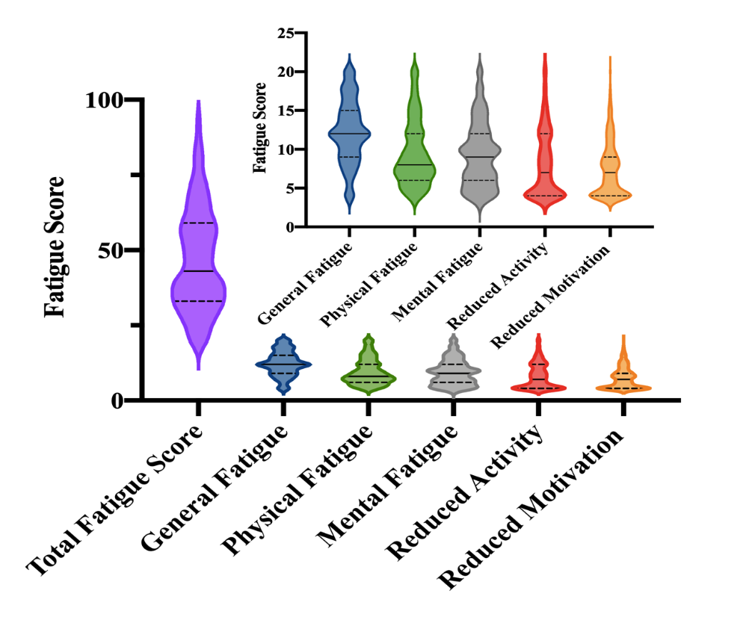
Figure 1 Fatigue score in the inflammatory bowel disease patients. The solid line indicates the median, and the dotted line indicates the interquartile range. The small insert within the graphs in Figure 1 enlarges the scores of the five subscales of multidimensional fatigue inventory (general fatigue, physical fatigue, reduced activity, reduced motivation, and mental fatigue) in the inflammatory bowel disease patients.

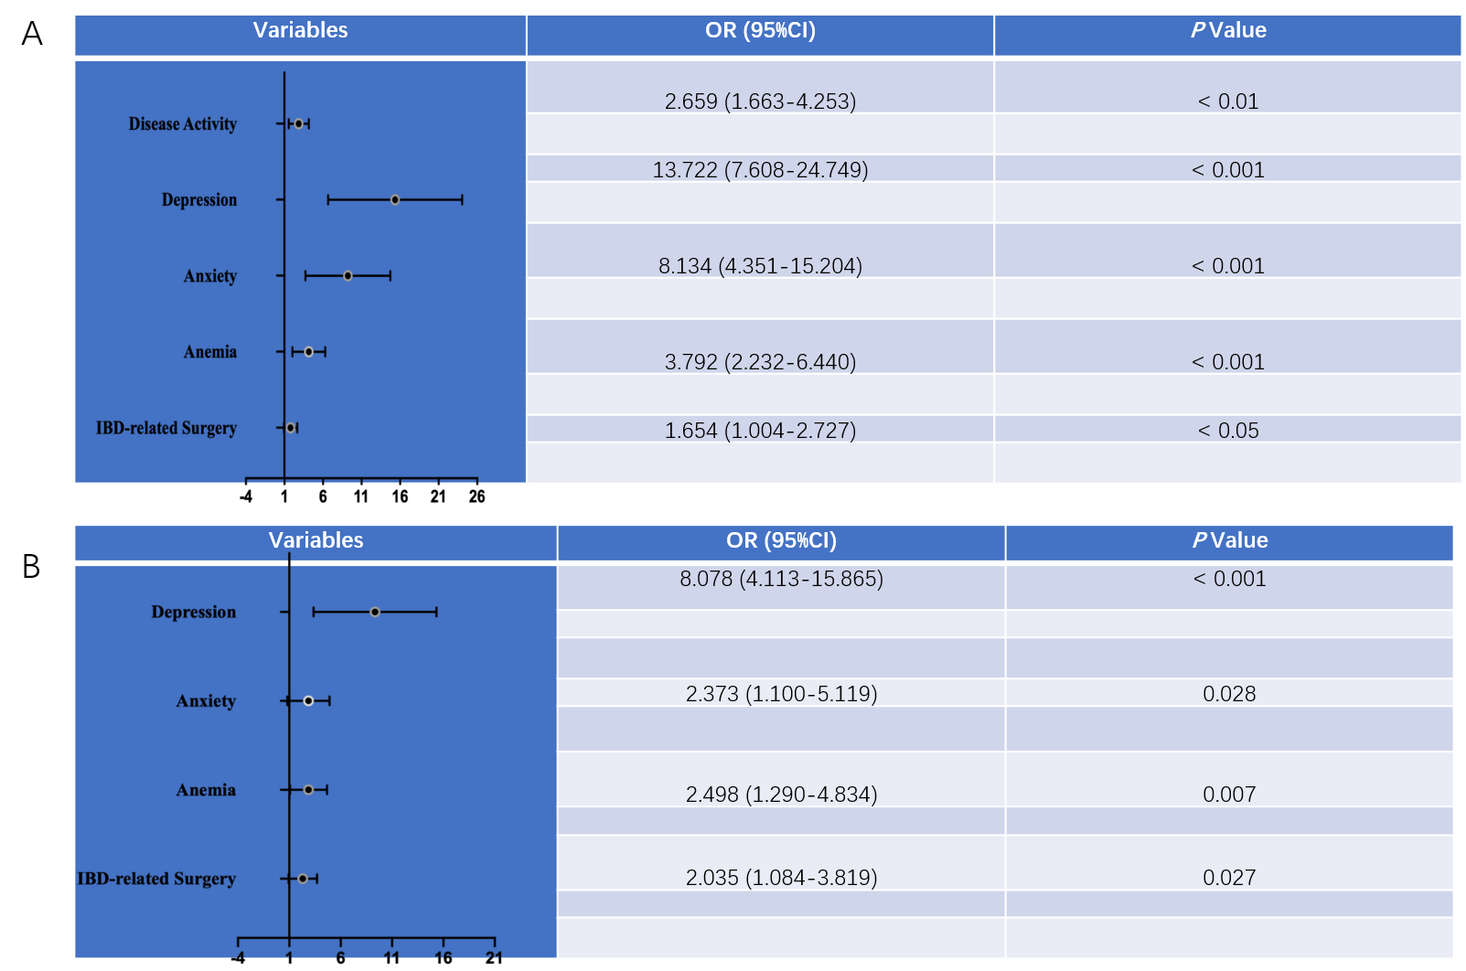
Figure 2 Factors associated with the presence of fatigue. A: Univariate analysis; B: Multivariate analysis. OR: Odds ratio; IBD: Inflammatory bowel disease.

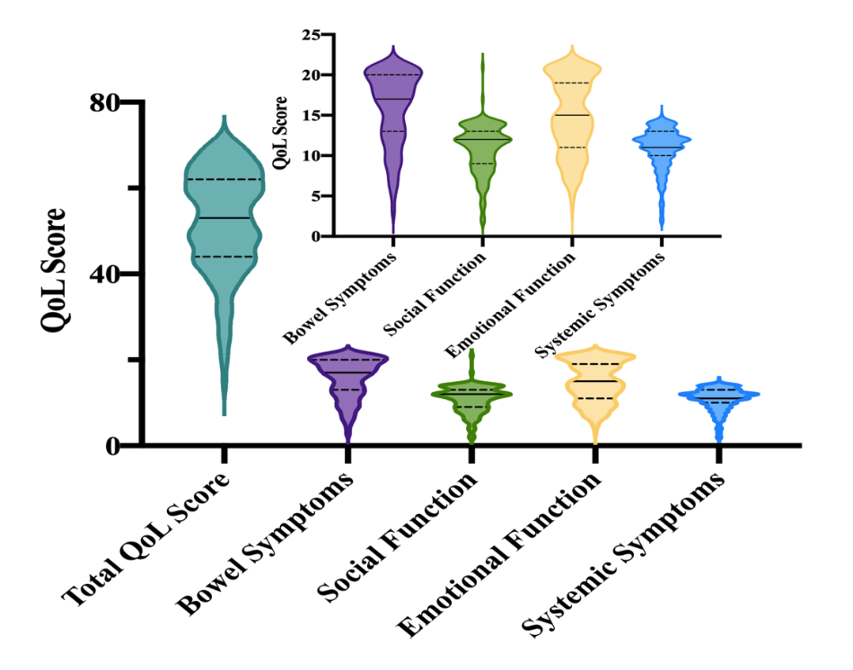
Figure 3 Quality of life score in the inflammatory bowel disease patients. The solid line indicates the median, and the dotted line indicates the interquartile range. The small insert within the graphs in Figure 3 enlarges the scores of the four domains of short inflammatory bowel disease questionnaire (bowel symptoms, systemic symptoms, emotional function, and social function) in the inflammatory bowel disease patients.
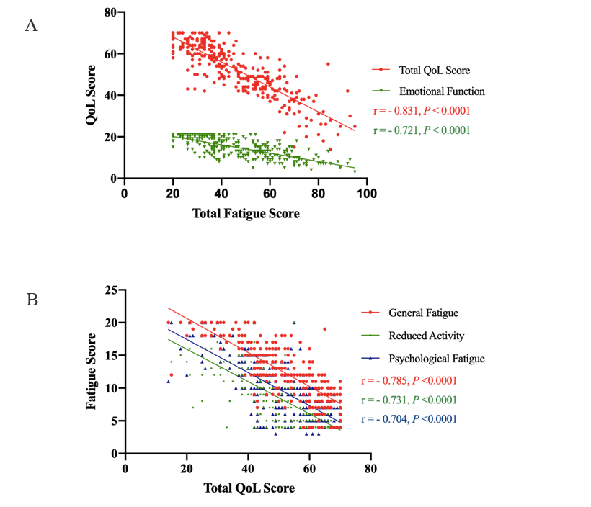
Figure 4 Fatigue and quality of life. A: Correlation between total fatigue scores and quality of life scores (total quality of life scores: Spearman’s r = -0.831, P < 0.0001; emotional function: Spearman’s r = -0.721, P < 0.0001) in the inflammatory bowel disease patients; B: Correlation between total quality of life scores and fatigue (general fatigue: Spearman’s r = -0.785, P < 0.0001; reduced activity: Spearman’s r = -0.731, P < 0.0001; psychological fatigue: Spearman’s r = -0.704, P < 0.0001) in the inflammatory bowel disease patients.

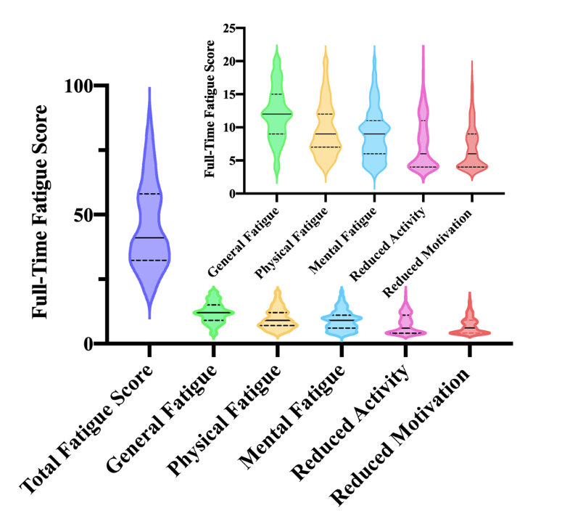
Figure 5 Fatigue score in inflammatory bowel disease patients with full-time jobs. The solid line indicates the median, and the dotted line indicates the interquartile range. The small insert within the graphs in Figure 5 enlarges the scores of the five subscales of multidimensional fatigue inventory (general fatigue, physical fatigue, reduced activity, reduced motivation, and mental fatigue) in the inflammatory bowel disease patients.
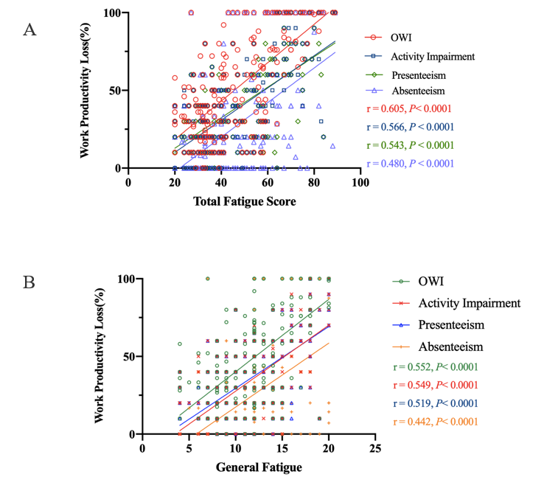
Figure 6 Fatigue and work productivity. A: Correlation between total fatigue scores and work productivity loss [overall work impairment: Spearman’s r = 0.605, P < 0.0001; activity impairment: Spearman’s r = 0.566, P < 0.0001; presenteeism: Spearman’s r = 0.543, P < 0.0001; absenteeism: Spearman’s r = 0.480, P < 0.0001] in inflammatory bowel disease patients with full-time jobs; B: Correlation between general fatigue and work productivity loss (overall work impairment: Spearman’ s r = 0.552, P < 0.0001; activity impairment: Spearman’s r = 0.552, P < 0.0001; presenteeism: Spearman’ s r = 0.552, P < 0.0001; absenteeism: Spearman’s r = 0.552, P < 0.0001) in inflammatory bowel disease patients with full-time jobs. OWI: Overall work impairment.

Table 1 Demographic and clinical characteristics of inflammatory bowel disease patients
 | CD (n = 168) | UC (n = 143)
Age, yr, median (IQR) | 39 (IQR: 28-52.75) | 45 (IQR: 33-54)
Gender, n (%)
Female | 71 (42.26) | 64 (44.76)
Male | 97 (57.74) | 79 (55.24)
BMI, n (%)
Normal | 94 (55.95) | 81 (56.64)
Thinnish | 60 (35.71) | 37 (25.88)
Overweight | 11 (6.55) | 25 (17.48)
Obesity | 3 (1.79) | 0 (0)
Marital status, n (%)
Unmarried | 58 (34.52) | 14 (9.79)
Married | 105 (62.50) | 126 (88.11)
Divorced | 3 (1.79) | 3 (2.10)
Death of a spouse | 2 (1.19) | 0 (0)
Employment status, n (%)
No work | 16 (9.52) | 13 (9.09)
Full time | 117 (69.64) | 91 (63.64)
Retired | 15 (8.93) | 35 (24.48)
Long-term sick leave | 1 (0.60) | 3 (2.10)
Students | 19 (11.31) | 1 (0.69)
Medical insurance, n (%)
Yes | 151 (89.88) | 130 (90.91)
No | 17 (10.12) | 13 (9.09)
Education, n (%)
Primary school or below | 14 (8.33) | 20 (13.99)
Junior high school | 34 (20.24) | 36 (25.17)
Senior high school | 32 (19.05) | 41 (28.67)
Junior college or Undergraduate | 81 (48.21) | 42 (29.37)
Master degree or above | 7 (4.17) | 4 (2.80)
Montreal classification, n (%)
L1 ileal | 38 (22.62)
L2 colonic | 14 (8.33)
L3 ileocolonic | 72 (42.86)
L4 upper gastrointestinal tract | 11 (6.55)
L1 + L4 | 13 (7.74)
L3 + L4 | 20 (11.90)
E1 proctitis |  | 37 (25.88)
E2 left-sided UC |  | 40 (27.97)
E3 extensive UC |  | 66 (46.15)
Disease activity: n (%)
Remission | 100 (59.52) | 51 (35.66)
Mild activity | 26 (15.48) | 43 (30.07)
Moderate activity | 31 (18.45) | 37 (25.88)
Severe activity | 11 (6.55) | 12 (8.39)
Duration of disease, yr, median (IQR) | 5.50 (IQR, 2-11) | 5 (IQR, 2.3-13)
Current medication, n (%)
5-ASA | 19 (11.31) | 88 (61.54)
IS | 42 (25) | 30 (20.98)
5-ASA + IS | 22 (13.09) | 8 (5.59)
Biological preparation | 45 (26.79) | 5 (3.50)
Biological preparation + IS | 34 (20.24) | 8 (5.59)
Other | 6 (3.57) | 4 (2.80)
IBD related surgery, n (%)
No | 80 (47.62) | 129 (90.21)
Yes | 88 (52.38) | 14 (9.79)
CD: Crohn's disease; UC: Ulcerative colitis; IBD: Inflammatory bowel disease; 5-ASA: 5-aminosalisylic acid; IQR: Interquartile range; IS: Immunosuppressant.

