Name of Journal: World Journal of Gastroenterology
Manuscript NO: 54957
Manuscript Type: ORIGINAL ARTICLE

Retrospective Study
Expression of Notch pathway components (Numb, Itch, and Siah-1) in colorectal tumors: a clinicopathological study

Gonulcu SC et al. Notch-1, Numb, Itch and Siah-1 in colon tumors

Sinem Cil Gonulcu, Betul Unal, Ibrahim Cumhur Bassorgun, Mualla Ozcan, Hasan Senol Coskun, Gulsum Ozlem Elpek

Sinem Cil Gonulcu, Betul Unal, Ibrahim Cumhur Bassorgun, Mualla Ozcan, Gulsum Ozlem Elpek, Department of Pathology, Akdeniz University, School of Medicine, Antalya 07070, Turkey

Hasan Senol Coskun, Department of Oncology, Akdeniz University, School of Medicine, Antalya 07070, Turkey

Author contributions: Gonulcu SC was involved in the conceptualization, data curation, funding acquisition, investigation, writing-original draft; Unal B took part in the resources, investigation, and writing review and editing; Bassorgun IC contributed to the investigation, visualization, and writing review and editing; Ozcan M was involved in the data curation, investigation and resources; Coskun HS provided clinical data and resources; Elpek GO performed the conceptualization, data curation, funding acquisition, investigation, methodology, project administration, supervision, visualization, writing review, and editing; all authors have read and approved the final manuscript.

Supported by Akdeniz University Scientific Research Foundation, Turkey, No. 2017040103020.

Corresponding author: Gulsum O Elpek, MD, Professor, Department of Pathology, Akdeniz University, School of Medicine, Dumlupınar Bulvarı, Antalya 07070, Turkey. elpek@akdeniz.edu.tr

Received: February 26, 2020
Revised: May 18, 2020
Accepted: June 25, 2020
Published online: July 14, 2020

Abstract
BACKGROUND
The role of the Notch pathway in carcinogenesis and tumor progression has been demonstrated in many organs, including the colon. Accordingly, studies aimed at developing therapies targeting this pathway in various cancers require the identification of several factors that may play a role in regulating Notch-1 expression. Although Numb, Itch, and seven in absentia homolog-1 (Siah-1) have been shown to contribute to the regulation of Notch signaling, their role in colorectal carcinogenesis and tumor progression has not been fully elucidated to date.

AIM
to evaluate Numb, Itch, and Siah-1 expression in colorectal tumors to clarify their relationship with Notch-1 expression and their role in carcinogenesis and tumor behavior.

METHODS
Expression of Notch-1, Numb, Itch, and Siah-1 was investigated in 50 colorectal carcinomas, 30 adenomas, and 20 healthy colonic tissues by immunohistochemistry and quantitative real-time polymerase chain reaction (PCR) analyses.

RESULTS
In contrast to Notch-1, which is expressed at higher levels in tumor tissues and adenomas, expression of Numb, Itch, and Siah-1 was stronger and more frequent in normal mucosa (P < 0.01). There was a positive correlation between Notch-1 expression and high histological grade, the presence of lymph node metastasis, and advanced-stage tumors, whereas expression of Numb, Itch, and Siah-1 was absent or reduced in tumors with these clinicopathological parameters (P < 0.05). In survival analysis, expression of Notch was related to poor prognosis but that of Numb, Itch, and Siah-1 correlated with improved survival (P < 0.05). Multivariate analysis revealed Notch-1 expression and loss of Numb expression to be independent prognostic parameters together with lymph node metastasis (P < 0.05).

CONCLUSION
Our findings support the role of Notch-1 in colorectal carcinoma and indicate that loss of Numb, Itch, and Siah-1 expression is associated with carcinogenesis. Our data also suggest that these three proteins might be involved in the Notch-1 pathway during colorectal carcinoma (CRC) progression and might play an essential role in approaches targeting Notch as novel molecular therapies for CRC.

Key words: Colorectal adenomas; Colorectal cancer; Notch-1; Numb; Itch; Siah-1

Gonulcu SC, Unal B, Bassorgun IC, Ozcan M, Coskun HS, Elpek GO. Expression of Notch pathway components (Numb, Itch, and Siah-1) in colorectal tumors: A clinicopathological study. World J Gastroenterol 2020; 26(26): 3814-3833
URL: https://www.wjgnet.com/1007-9327/full/v26/i26/3814.htm
DOI: https://dx.doi.org/10.3748/wjg.v26.i26.3814

Core tip: This report describes a preliminary study to investigate Numb, Itch, and Siah-1 expression in colorectal tumors and to evaluate their relationship with Notch-1 expression and their roles in oncogenesis and prognosis. Our findings confirm the role of Notch-1 in colorectal carcinoma (CRC) and emphasize that loss of Numb, Itch, and Siah-1 expression is associated with carcinogenesis. Our data also indicate that Numb, Itch, and Siah-1 might be involved in the Notch-1 signaling pathway during CRC progression. Accordingly, these three proteins might be key in possible therapies targeting Notch-1 to treat colorectal carcinoma.

INTRODUCTION
colorectal carcinoma (CRC) is one of the most common cancers worldwide and, despite significant advances in treatment, ranks third in cancer-related mortality and morbidity^{[1,2]}. Although curative surgery is possible in some cases, the fact that one-fifth of patients have metastatic disease at the time of diagnosis and sixty percent of patients undergoing surgical resection experience recurrence and metastasis emphasizes the need to identify new strategies for the determination of CRC tumor behavior and treatment^{[3,4]}. In this context, numerous studies have been conducted to elucidate signaling pathways that contribute to colorectal tumor development and progression and to use them as potential therapeutic targets, mainly to prevent aggressive tumor behavior and treatment resistance^{[5-7]}.
Although Notch signaling has traditionally been known for its role in determining cell fate, its identification as one of the most active pathways in cancer cells renders it a potential therapeutic target in CRC^{[8]}. In recent years, the role of the Notch signaling pathway in gastrointestinal development and normal gut homeostasis has been thoroughly demonstrated^{[9]}. However, differences in the findings of studies on its use in CRC as a therapeutic target exist, which necessitates an understanding of the roles of other components in the Notch pathway^{[10-12]}.
Numb is a conserved evolutionary protein that antagonizes Notch signaling activities in regulating the balance between proliferation and differentiation in development and homeostasis^{[13]}. Ubiquitination of the membrane-bound Notch receptor Notch-1 and subsequent attenuation of its activity are the basis of this molecular mechanism, which involves the binding of Numb to the E3 ubiquitin-ligase Itch. Numb and Itch function in concert to promote ubiquitination of the Notch receptor before activation^{[14]}. Furthermore, the networking of Numb into E3 ubiquitin ligase-based circuitries in the regulation of Notch signaling involves other E3 ubiquitin ligases, including seven in Siah-1. Siah-1 has an inhibitory effect on Numb but a stimulatory effect on Notch-1^{[15]}. In addition, data obtained in recent years indicate that Siah-1 may also play a role in the degradation of β-catenin^{[16]}. Numb is expressed in many adult tissues, such as the breast, lung, testis, and salivary gland; it is detected in the villus crypt axis in the mouse intestine and participates in goblet cell transformation by inhibiting the Notch pathway in intestinal epithelial cells^{[17]}. Numb also increases mucin secretion in intestinal cells and helps to maintain the integrity of the epithelial barrier. In recent years, there has been evidence that aggressive tumor behavior in various solid tumors is associated with loss of Numb expression^{[18]}.
Some experimental studies have suggested that loss of Numb expression is associated with tumor behavior in CRC^{[19,20]}. Regardless, the relationship between expression of Numb and clinicopathological parameters, survival, and Notch-1 expression in patients with colorectal carcinoma remains to be investigated. Similarly, the roles of Itch and Siah-1 expression in colorectal carcinogenesis and their relationship to tumor behavior, survival, Notch-1 expression, and Numb expression in CRC have not been evaluated.
Therefore, this preliminary study was undertaken to investigate expression of Numb, Itch, and Siah-1 in colorectal tumors to clarify their relationship with Notch-1 expression and their role in carcinogenesis and tumor behavior.

MATERIALS AND METHODS
Study design
Expression of Notch-1, Numb, Itch, and Siah-1 was evaluated in 50 samples of CRC diagnosed as adenocarcinoma, not otherwise specified (NOS), in 30 adenomas (10 tubular, 10 tubulovillous and 10 villous), and in 20 healthy colonic tissues diagnosed at the Department of Pathology. The ethics committee of Akdeniz University Medical School approved the study.

Immunohistochemistry
Tissue sections from surgical specimens fixed in 40 g/L formaldehyde and embedded in paraffin were reviewed, and representative tissue blocks were selected. Slides were immunostained with anti-Notch-1 (Dilution 1/25), anti-Numb (Dilution 1/25), anti-Itch (Dilution 1/100), and anti-Siah-1 (Dilution 1/100) monoclonal antibodies (Thermo Fisher Scientific, United States) using the avidin-biotin immunoperoxidase technique.
Each sample was scored on a scale of 0-4, as follows: 0, negative; 1, positive staining in 1%-25% of tumor cells; 2, positive staining in 26%-50% of tumor cells; 3, positive staining in 51%-75% of tumor cells; and 4, positive staining in 76%-100% of tumor cells. The intensity of immunostaining was determined as follows: 0, negative staining; 1, weakly positive staining; 2, moderately positive staining; and 3, strongly positive staining. The distribution of staining was also evaluated.

Quantitative real-time PCR analysis
PCR analysis was performed using Solaris qPCR Gene Expression Assay for Human Gene Notch-1, Numb, Itch, Siah-1, and GAPDH Kits (Thermo Fisher Scientific). In particular, reverse transcription of total RNA was performed using Maxima First Strand complementary DNA (cDNA) Synthesis Kit for qPCR (Thermo Fisher Scientific). Data were analyzed by the C_{T} method.

RNA isolation
RNA extraction was performed according to the RNeasy formalin-fixed, paraffin- embedded (FFPE) Kit protocol (Qiagen GmbH, Hilden, Germany). Briefly, 10 µm thick sections were cut from formalin-fixed, paraffin-embedded blocks, and tumor areas were collected from the sections and transferred to a microcentrifuge tube. Deparaffinization was performed by adding 1 mL xylene and incubating for 10 min at room temperature. This step was repeated twice, after which 1 mL absolute ethanol was added. The deparaffinized tissue sections were incubated in lysis buffer containing proteinase K at 56 °C for 15 min and then 80 °C for 15 min. This step was followed by DNase treatment to eliminate all genomic DNA, including very small DNA fragments that are often present in FFPE samples. Next, ethanol was added to provide binding conditions for RNA; lysate was applied to an RNeasy MinElute spin column, with the membrane binding total RNA. The RNA was eluted in a minimum V of 14 µL of RNase-free water. The c of the isolated RNA and the ratio of absorbance at 260 nm to 280 nm (A260/A280 ratio) were measured with a NanoDrop ND-1000 spectrophotometer (NanoDrop Technologies, Montchanin, DE, United States).

First-strand cDNA synthesis
Maxima First Strand cDNA Synthesis Kit (Thermo Fisher Scientific, Cat # K1641) was used according to the manufacturer’s instructions. Five micrograms of RNA was transcribed with random primers. Briefly, 5X reaction mix, maximum enzyme mix, nuclease-free water, and template RNA were mixed and incubated for 10 min at 25 °C followed by 15 min at 50 °C; the reaction was terminated by heating at 85 °C for 5 min. The product of the first-strand cDNA synthesis was stored at -20 °C until qPCR.

qPCR
Gene expression analysis was performed using Solaris qPCR Gene Expression Assay (Thermo Fisher Scientific) for Human Gene Notch-1 (Cat # AX-007771-00-0100), Numb (Cat # AX-015902-00-100), Itch (Cat # AX-007196-00-0100), Siah-1 (Cat # AX-012598-00-0100), and GAPDH (Cat # AX-004253-00-0100). The probes were labeled with FAM-MGM dyes. Briefly, the reaction mixture consisted of 12.5 µL of the 2X Solaris qPCR Master Mix, 1.25 µL of the 20X Solaris Primer/Probe set, and PCR grade water. Five microliters of cDNA was used as a template for PCR in a final V of 25 µL. The master mix contains all components for real-time PCR: (1) Thermo-Start DNA polymerase, a hot-start version of Thermoprime DNA polymerase; (2) dNTPs, with dTTP replacing dUTP to maximize amplification efficiency; (3) proprietary reaction buffer, optimized to work with Solaris primer/probe assays; and (4) ROX. The cycle conditions were set as follows: preincubation step for 15 min at 95 °C for activation of the Thermo-Start DNA polymerase (1 cycle) followed by 40 cycles each of 15 s at 95 °C for template denaturation and 60 s at 60 °C for annealing/extension. A Rotor-Gene Q instrument was used. Expression data were normalized to GAPDH using the ∆∆Cq method.

Statistical analysis
Data were analyzed by SPSS 20.0. The χ² test was employed to examine categorical data. Relative gene expression levels between the groups and their relationship with clinicopathological parameters were investigated by t test. Univariate analysis, including survival analysis, was estimated with the Kaplan-Meier method. The log-rank test was employed for comparison of survival rates. A Cox proportional hazards regression model was applied for multivariate analysis. A P-value < 0.05 was considered to be significant. Spearman’s correlation test was used to determine relationships between Notch-1, Numb, Itch, and Siah-1 expression.

RESULTS
As shown in Figure 1, both granular cytoplasmic and nuclear staining for Notch-1, Numb, Itch, and Siah-1 was observed; in some cases, Itch also displayed focal cytoplasmic staining. The intensity and distribution of staining did not differ between the groups. However, when considering the presence or absence of staining, Notch-1 staining occurred at a more frequent rate in CRC than in adenomas and controls, whereas the frequency of Numb, Itch, and Siah-1 staining was higher in controls and adenomas (P < 0.05) (Table 1). In terms of Notch-1, Numb, Itch, and Siah-1 expression, there was no significant difference between adenomas, healthy colon (controls), or tissues adjacent to carcinoma and adenomas (P > 0.05) (Table 1). Similarly, the distribution of Notch-1, Numb, Itch, and Siah-1 expression among adenoma subtypes did not differ (P > 0.05) (Table 1). Table 2 summarizes the correlations between immunohistochemical expression of Notch-1, Numb, Itch, and Siah-1 and clinicopathological parameters. Expression of Notch-1 was more frequently observed in tumors with poor histological grade, lymph node metastasis, and an advanced stage (P < 0.05). In contrast, Numb, Itch, and Siah-1 expression was more frequent in tumors with well-differentiated morphology, without lymph node metastasis, and at an earlier stage (P < 0.05). The survival of patients with Notch-1 expression was shorter than that among those without Notch-1 expression. Conversely, Numb, Itch, and Siah-1 expression was related to better survival (P < 0.05) (Table 2 and Figure 2).
Although the expression levels of Notch-1 were higher in colorectal carcinomas, those of Numb, Itch, and Siah-1 were higher in adenomas and healthy colonic mucosa, consistent with the immunohistochemical findings (P < 0.05) (Table 3, Figures 3 and 4). The relationships between the gene expression levels of Notch-1, Numb, Itch, and Siah-1 and clinicopathological parameters are presented in Table 4, and the significant findings are illustrated in Figure 5. The level of Notch-1 gene expression was significantly higher in poorly differentiated and moderately differentiated tumors than in well-differentiated tumors (P < 0.05). This level was also 7-fold higher in tumors with lymph node metastases and 3-fold higher in advanced-stage tumors than in tumors without lymph node metastasis and in tumors with earlier stages, respectively (P < 0.05). Moreover, the mean level of Notch-1 gene expression was 8-fold higher in patients with shorter survival times than in patients who survived for more than 5 years (P < 0.05). Overall, the expression levels of Numb, Itch, and Siah-1 were higher in well-differentiated tumors (6-fold increase), with lymph node metastasis (8-fold increase) and at advanced stages (5-fold increase) (P < 0.05). The survival of patients with higher Numb, Itch, and Siah-1 expression levels was better than that of patients with a low expression level of these genes (P < 0.05).
Similarly, when cases were grouped according to upregulation and downregulation of gene expression, upregulation of Notch-1 was more frequently observed in poorly differentiated tumors, in tumors with lymph node metastasis and in advanced stages. However, Numb, Itch, and Siah-1 upregulation correlated with better differentiation, absence of lymph node metastasis, and earlier stages (P < 0.05) (Table 5). Downregulation of Notch-1 and upregulation of both Numb and Itch were associated with better prognosis (P < 0.05) (Table 5 and Figure 6). Spearman’s test revealed that the Notch-1 expression correlated inversely with the levels of Numb (r: -0. 4, P < 0.05), Itch (r: -0.3, P < 0.05) and Siah-1 (r: -0.8, P < 0.01) expression.
In log-rank univariate analysis, the status of Notch-1, Numb, Itch, and Siah-1 expression and their expression levels, as well as lymph node metastasis and stage, were found to be significantly associated with survival among CRC patients (Figure 2 and Figure 6). According to Cox regression analysis, lymph node metastasis, upregulation of Notch, and downregulation of Numb were independent prognostic factors (Table 6).

DISCUSSION
In this study, Notch-1 gene and protein expression levels were higher in carcinoma and adenomas than in control tissues, and the expression differences among these three groups were significant. Our observation is not surprising, given the previous clinical and experimental data demonstrating the relationship of the Notch pathway with carcinogenesis in the colon^{[21,22]}. In CRC, expression of Notch-1, its ligand Jagged-1 and its target genes Hes-1 and Hey-1 is significantly higher than in normal mucosa^{[23,24]}, and expression of Notch-1 and its ligands is also higher in precancerous conditions, such as inflammatory bowel diseases, than in the healthy colon^{[25]}. In adenomas of adenomatous polyposis coli gene (APC)-mutant mice, γ-secretase inhibitors that suppress the Notch pathway promote goblet cell differentiation while reducing cell proliferation^{[26]}. In addition, in both familial adenomatous polyposis and adenomas, upregulation of genes that function in the Notch pathway, including Notch-1, as well as the relationship between Notch-1 to Wnt-β-catenin are notable findings demonstrating the role of Notch-1 in tumor development^{[27,28]}. Our findings, together with all these data, support the role of Notch signaling in CRC carcinogenesis.
To date, the relationship between tumor behavior and the Notch pathway in CRC has been investigated in many studies. Although Notch-1 has been shown to be associated with aggressive tumor characteristics, there are some inconsistencies among the results of these studies. In some studies, Notch-1 expression has been found to be associated with grade^{[29]}, lymph node metastasis^{[30]}, and advanced stage^{[31]}, similar to our findings; other studies have reported that Notch-1 expression is related to the presence of distant metastasis^{[32,33]} and lymphatic and vascular invasion^{[34]}. These different results may be explained by differences in the number of cases and in the techniques and antibodies used to detect Notch-1. In our study group, Notch-1 expression was associated with a poor prognosis: 25% of the patients with high Notch expression (32 cases) survived 5 years, but this rate was 88.8% in the group without Notch expression (18 cases). Moreover, multivariate analysis revealed Notch-1 to be an independent prognostic factor. Overall, the number of studies demonstrating that Notch-1 expression is associated with poor prognosis (although not identified as an independent prognostic factor in all of these studies) is considerably higher than those showing that it is not^{[35-39]}. Despite the relatively small number of cases in the present study, our results support that Notch-1 expression plays a role in determining aggressive tumor behavior in CRC and a poor prognosis.
In contrast to Notch-1-related findings, Numb expression levels gradually decreased from normal tissue to carcinoma in our samples, and the difference between the groups was significant. Accumulated evidence indicates that Numb, which plays an essential role in stem cell compartment maintenance and cell fate determination, has the potential to function in the oncogenesis of many tumors^{[40-42]}. However, Numb may have promoter function in some cancers and a suppressor function in others. For example, Numb overexpression inhibits tumor growth and the epithelial-mesenchymal transition in prostate carcinoma, esophageal squamous cell carcinoma, adenocarcinoma of the lung, and breast cancer^{[43,44]}, but it promotes cell proliferation in hepatocellular carcinoma and squamous cell carcinoma of the lung^{[45]}. Therefore, the influence of Numb in oncogenesis might be related to the type of malignancy or the histological subtype. Although Numb has been studied during carcinogenesis in various organs due to its effect on Notch signaling, few studies have investigated variations in Numb expression during human colorectal carcinogenesis, and a vast majority of the studies investigating changes in Numb expression in colorectal tissues are experimental studies, particularly those involving carcinoma cell cultures^{[46,47]}. In intestinal epithelial cells, Numb induces the goblet cell phenotype by inhibiting Notch^{[31]}. In cell culture, inhibition of Numb by several microRNAs (miR-142-3p, miR-34-a, Musashi-1, and 2) induces stemness and proliferation of cancer cells. Parallel to our study, Zhao et al^{[48]} reported that expression of Numb in CRC tissues was significantly lower than that in the adjacent normal intestinal mucosa, suggesting that Numb may exert a suppressor function in the development of CRC. Interestingly, these researchers also observed that splice variants of Numb might have different effects on colorectal carcinogenesis. In a study by Meng et al^{[23]}, Notch-1 expression was detected in patients with colon cancer, but Numb levels were decreased. To the best of our knowledge, no study has evaluated Numb expression in adenoma tissues. In our study, expression levels of Numb decreased significantly from adenomas to CRC. When all these data are evaluated together, our findings support that loss of Numb expression contributes to colorectal carcinogenesis.
The present study revealed that Numb expression is higher in well-differentiated tumors, at earlier stages, and in patients without lymph node metastases, in contrast to the findings for Notch-1. Numerous experimental studies have shown that Numb protein expression is associated with cell differentiation in both normal tissues and tumors, concluding that it is a determinant of cell fate^{[41-44]}. Similar findings have been obtained in experimental studies involving CRC cell culture. Indeed, many microRNAs that induce stemness and aggressive behavior in CRC stem cells stabilize β-catenin through Numb repression^{[46,47]}. A recent study demonstrated that low Numb serum levels are associated with cetuximab resistance and worse prognosis in patients with CRC, suggesting that Numb is a contributor to the prevention of tumor aggression^{[49]}. In another, Numb expression was investigated in patients with CRC^{[48]}, and similar to our data, Numb expression was found to be reduced in patients with lymph node metastasis, deeper invasive tumors, and at a more advanced stage, though the difference was not significant.
Nonetheless, our study revealed a significant inverse correlation between these parameters and Numb expression. Although our results need to be supported by further studies in larger patient series, the results show that Numb plays a role in preventing aggressive tumor behavior in CRC. To the best of our knowledge, the relationship between Numb expression and survival in CRC has not been investigated to date. Our results indicate that loss of Numb expression is an independent prognostic factor and predictor of poor prognosis in CRC.
In our study, Itch gene expression was normal in all healthy colon mucosa samples. In adenomas, Itch levels were decreased, paralleling Numb gene expression, and we observed an inverse correlation between Itch and Notch-1 gene expression. The frequency of cases with low Itch gene expression was higher in the adenocarcinoma group, and our immunohistochemical evaluation revealed similar correlations. This finding is in line with the results of several studies in which Itch was shown to induce activity of the Numb protein, thereby acting as a suppressor of Notch-1 expression and leading to a reduction in its level^{[50]}. Although there are few studies investigating Itch expression in the colon, in an elegant study by Kathania et al^{[51]}, Itch-depleted animals showed increased inflammation in the colon, increased proinflammatory cytokines, and a tendency to develop cancer associated with colitis. Interestingly, in the same study, it was noted that the effect of Itch on homeostasis in the small intestine differed, suggesting organ-specific effects in the gastrointestinal tract. In another study, Huang et al^{[52]} found less frequent expression of Itch in colorectal carcinoma than in normal tissue in 45 cases, and it was concluded that Itch can suppress carcinogenesis by suppressing the Wnt-β catenin pathway. These findings, together with our findings, suggest that loss of Itch expression participates in colorectal carcinogenesis via the Notch-1-Numb axis.
The study presented herein revealed that similar to Numb, increases in Itch expression and upregulation are associated with better characteristics of tumor behavior and better survival in CRC. Recent studies investigating the role of Itch in tumors of different organs have reported different results^{[53-55]}. For instance, some investigators have observed that Itch has a role in treatment resistance and poor prognosis, and the use of Itch inhibitors due to its interaction with p63 and p73, especially in tumors without functional p53, has been proposed^{[56,57]}. Because Itch is associated with many pathways, including Notch-1 signaling, researchers have suggested that not only its inhibition but also its stimulation can be used in some cancers. Peng et al^{[58]} demonstrated that lithium exerts its antitumor effect via Itch stimulation in pancreatic cancer. In general, neither the role of Itch as a potential treatment target nor its role in tumor behavior has been completely clarified. The effect of Itch in the colon has been investigated owing to its association with IL-17, which plays a role in colorectal inflammation and carcinogenesis^{[51]}. Unfortunately, we could not find any studies in the literature examining the relationship between Itch expression and CRC tumor behavior and survival for a comparison with our results. Only one recent study was found, demonstrating that a decrease in circ-Itch, a circulating antitumor-acting RNA that affects the function of Itch, is associated with a poor prognosis in patients with CRC^{[52]}. The current data suggest that loss of Itch expression is associated with a poor prognosis and aggressive tumor behavior in CRC, warranting further large-scale studies.
In our study group, Siah-1 was expressed more frequently in healthy mucosa, and similar to Numb and Itch, its gene expression was normal. However, Siah-1 expression, as detected by immunohistochemistry, and its gene expression level, as determined by molecular methods, were decreased in adenomas compared to the control group, and this decrease was more pronounced in the adenocarcinoma group. Unfortunately, the relationship between Siah-1 and colorectal carcinogenesis and tumor behavior has not been addressed in any study to date. In a few early studies, data suggesting that Siah-1 may act as a stimulator of Notch-1 due to its ability to target Numb for degradation^{[19]}. However, the results of subsequent studies have shown that the effect of Siah-1 is not limited to Numb and Notch and that it also plays a role in Ras and hypoxia pathways. More notably, Siah-1 plays an active role in the degradation of β-catenin, which is constitutively activated in the development of most CRC (90%)^{[59]}. Siah-1 interacts with the carboxyl terminus of APC, recruiting the ubiquitination complex and promoting the degradation of β-catenin in the E3 ubiquitin ligase complex. Although further studies should be carried out to test this hypothesis, in light of all these data, our results suggest that Siah-1 is involved in Notch-1 suppression, rather than its stimulation, in colorectal carcinogenesis.
Among our cases, loss of and downregulation of Siah-1 expression were associated with aggressive tumor behavior and poor prognosis, similar to Numb and Itch and in contrast to Notch-1 expression. At present, data on the potential use of Siah-1 as a prognostic marker and as a therapeutic target vary depending on the organ and even according to different histological types of tumors of the same organ^{[60,61]}. However, in addition to its relationship with Notch-1, numerous studies have shown that Siah-1 is involved in β-catenin degradation, which supports evidence that Siah-1 has a tumor-suppressor role. Indeed, an experimental study in CRC demonstrated that Siah-1 interacts with the APC gene and degrades β-catenin^{[62]}. Regardless, to the best of our knowledge, no study has investigated the relationship between Siah-1 expression and the clinicopathological parameters of and survival in CRC patients. Our results suggest that Siah-1 expression plays an important role in the negative regulation of CRC progression, and our data are not consistent with the findings that Siah-1 induces Notch-1 by inhibiting Numb. In contrast to the negative correlation of Siah-1 with Notch-1, its positive association with Numb and Itch indicates that in CRC, its effect is not limited to Notch-1 induction and also involves other pathways.
In conclusion, this preliminary study indicates that overexpression of Notch-1, as well as loss of Numb, Itch, and Siah-1 expression, contributes to colorectal carcinogenesis. In patients with CRC, Notch-1 expression is associated with aggressive tumor behavior and is an independent adverse prognostic marker. In our study group, decreased Numb expression supports the findings that loss of Numb expression in CRC is a determinant of aggressive tumor behavior, indicating that it is an independent prognostic parameter. Similar to Numb, reductions in Itch and Siah-1 expression are associated with aggressive tumor behavior and prognosis in CRC. Positive relationships between Numb, Itch, and Siah-1 and their inverse correlation with Notch-1 expression indicate that these proteins are involved in the Notch pathway during CRC progression. Finally, Numb, Itch, and Siah-1 may be useful in determining the progression of CRC and are also potential new therapeutic targets. However, our results should be supported by further studies involving large numbers of cases. Another essential factor to be considered is that this study was conducted only using samples from patients diagnosed with adenocarcinoma, NOS. Therefore, the relationship between Notch-1, Numb, Itch, and Siah-1 expression and their impacts on carcinogenesis and tumor behavior should be investigated in other histological subtypes of CRC as well as their precursors, particularly in subtypes with a more aggressive course, such as serrated carcinoma.

Article Highlights
Research background
The advances in immunohistochemical and molecular techniques in recent years, many studies have been carried out, aiming to determine new targets that can be useful in the treatment as well as predicting colorectal carcinoma (CRC) behavior. In this context, the role of Notch-1 in oncogenesis, tumor behavior, and survival have been investigated in recent studies with different results.

Research motivation
The contribution of Numb, Itch and Siah-1 in the Notch pathway is documented. On the other hand, the roles of Numb, Itch and Siah-1 expression in colorectal carcinogenesis and their relationship to tumor behavior, survival, Notch-1 expression have not been evaluated.

Research objectives
In this preliminary study, we aimed to evaluate the expression of Numb, Itch, and Siah-1 in colorectal tumors to clarify their relationship with Notch-1 expression and their role in carcinogenesis and tumor behavior.

Research methods
We retrospectively investigated the expression of Notch, Numb, Itch and Siah-1 in 50 colorectal adenocarcinomas, 30 adenomas, and 10 healthy colon tissue by immunohistochemistry and quantitative real-time PCR analysis. Data were analyzed by the χ² test, t-test and Spearman’s correlation test. Survival probability curves were calculated using the Kaplan-Meier method. A Cox proportional hazards regression model was applied for multivariate analysis. A P-value < 0.05 was considered to be significant.

Research results
Notch-1 staining was more frequent in CRC than in adenomas and controls. However, the frequency of Numb, Itch, and Siah-1 staining was higher in controls and adenomas. While the expression of Notch-1 was more frequently observed in tumors with poor histological grade, lymph node metastasis, and an advanced stage, the expression of Numb, Itch, and Siah-1 was more frequent in tumors with well-differentiated morphology, without lymph node metastasis, and at an earlier stage. Although the survival of patients with Notch-1 expression was shorter than that among those without Notch-1 expression, Numb, Itch, and Siah-1 expression was related to better survival. Similarly, it was noted that the gene expression levels of Notch, Numb, Itch and Siah-1 were in line with the results of the immunohistochemical evaluation. The status of Notch-1, Numb, Itch, and Siah-1 expression and their expression levels, as well as lymph node metastasis and stage, were found to be significantly associated with survival. Cox regression analysis revealed that lymph node metastasis, upregulation of Notch, and downregulation of Numb were independent prognostic factors. The Notch-1 expression correlated inversely with the levels of Numb, Itch and Siah-1 expression.

Research conclusions
Our findings support the role of Notch-1 in CRC and indicate that loss of Numb, Itch, and Siah-1 expression is associated with carcinogenesis. Our data also highlight that Numb, Itch, and Siah-1 might contribute to the Notch-1 signaling pathway during CRC progression. Therefore, these three proteins might be key in possible therapies targeting Notch-1 in the treatment of CRC.

Research perspectives
In CRC, Numb, Itch and Siah-1 contribute to carcinogenesis and tumor behavior. In contrast to Notch-1, the relationship of Numb, Itch and Siah-1 expression with better prognostic parameters and improved survival can make them a potential therapeutic target. In this regard, further studies in large patient series and cell cultures can provide comprehensive information on the efficacy of the Notch pathway in therapy.

References
1 Siegel RL, Miller KD, Jemal A. Cancer statistics, 2019. CA Cancer J Clin 2019; 69: 7-34 [PMID: 30620402 DOI: 10.3322/caac.21551]
2 Siegel R, Naishadham D, Jemal A. Cancer statistics, 2012. CA Cancer J Clin 2012; 62: 10-29 [PMID: 22237781 DOI: 10.3322/caac.20138]
3 Van Cutsem E, Nordlinger B, Adam R, Köhne CH, Pozzo C, Poston G, Ychou M, Rougier P; European Colorectal Metastases Treatment Group. Towards a pan-European consensus on the treatment of patients with colorectal liver metastases. Eur J Cancer 2006; 42: 2212-2221 [PMID: 16904315 DOI: 10.1016/j.ejca.2006.04.012]
4 Davies RJ, Miller R, Coleman N. Colorectal cancer screening: prospects for molecular stool analysis. Nat Rev Cancer 2005; 5: 199-209 [PMID: 15738983 DOI: 10.1038/nrc1569]
5 Heinemann V, von Weikersthal LF, Decker T, Kiani A, Vehling-Kaiser U, Al-Batran SE, Heintges T, Lerchenmüller C, Kahl C, Seipelt G, Kullmann F, Stauch M, Scheithauer W, Hielscher J, Scholz M, Müller S, Link H, Niederle N, Rost A, Höffkes HG, Moehler M, Lindig RU, Modest DP, Rossius L, Kirchner T, Jung A, Stintzing S. FOLFIRI plus cetuximab versus FOLFIRI plus bevacizumab as first-line treatment for patients with metastatic colorectal cancer (FIRE-3): a randomised, open-label, phase 3 trial. Lancet Oncol 2014; 15: 1065-1075 [PMID: 25088940 DOI: 10.1016/S1470-2045(14)70330-4]
6 Spartalis C, Schmidt EM, Elmasry M, Schulz GB, Kirchner T, Horst D. In vivo effects of chemotherapy on oncogenic pathways in colorectal cancer. Cancer Sci 2019; 110: 2529-2539 [PMID: 31119819 DOI: 10.1111/cas.14077]
7 Pandurangan AK, Ismail S, Esa NM, Munusamy MA. Inositol-6 phosphate inhibits the mTOR pathway and induces autophagy-mediated death in HT-29 colon cancer cells. Arch Med Sci 2018; 14: 1281-1288 [PMID: 30393482 DOI: 10.5114/aoms.2018.76935]
8 Venkatesh V, Nataraj R, Thangaraj GS, Karthikeyan M, Gnanasekaran A, Kaginelli SB, Kuppanna G, Kallappa CG, Basalingappa KM. Targeting Notch signalling pathway of cancer stem cells. Stem Cell Investig 2018; 5: 5 [PMID: 29682512 DOI: 10.21037/sci.2018.02.02]
9 Miyamoto S, Rosenberg DW. Role of Notch signaling in colon homeostasis and carcinogenesis. Cancer Sci 2011; 102: 1938-1942 [PMID: 21801279 DOI: 10.1111/j.1349-7006.2011.02049.x]
10 Miyamoto S, Nakanishi M, Rosenberg DW. Suppression of colon carcinogenesis by targeting Notch signaling. Carcinogenesis 2013; 34: 2415-2423 [PMID: 23729655 DOI: 10.1093/carcin/bgt191]
11 Suman S, Das TP, Ankem MK, Damodaran C. Targeting Notch Signaling in Colorectal Cancer. Curr Colorectal Cancer Rep 2014; 10: 411-416 [PMID: 25395896 DOI: 10.1007/s11888-014-0252-3]
12 Mirone G, Perna S, Shukla A, Marfe G. Involvement of Notch-1 in Resistance to Regorafenib in Colon Cancer Cells. J Cell Physiol 2016; 231: 1097-1105 [PMID: 26419617 DOI: 10.1002/jcp.25206]
13 Yang Y, Zhu R, Bai J, Zhang X, Tian Y, Li X, Peng Z, He Y, Chen L, Ji Q, Chen W, Fang D, Wang R. Numb modulates intestinal epithelial cells toward goblet cell phenotype by inhibiting the Notch signaling pathway. Exp Cell Res 2011; 317: 1640-1648 [PMID: 21557937 DOI: 10.1016/j.yexcr.2011.04.008]
14 Di Marcotullio L, Greco A, Mazzà D, Canettieri G, Pietrosanti L, Infante P, Coni S, Moretti M, De Smaele E, Ferretti E, Screpanti I, Gulino A. Numb activates the E3 ligase Itch to control Gli1 function through a novel degradation signal. Oncogene 2011; 30: 65-76 [PMID: 20818436 DOI: 10.1038/onc.2010.394]
15 Jumpertz S, Hennes T, Asare Y, Vervoorts J, Bernhagen J, Schütz AK. The β-catenin E3 ubiquitin ligase SIAH-1 is regulated by CSN5/JAB1 in CRC cells. Cell Signal 2014; 26: 2051-2059 [PMID: 24882689 DOI: 10.1016/j.cellsig.2014.05.013]
16 House CM, Möller A, Bowtell DD. Siah proteins: novel drug targets in the Ras and hypoxia pathways. Cancer Res 2009; 69: 8835-8838 [PMID: 19920190 DOI: 10.1158/0008-5472.CAN-09-1676]
17 Gulino A, Di Marcotullio L, Screpanti I. The multiple functions of Numb. Exp Cell Res 2010; 316: 900-906 [PMID: 19944684 DOI: 10.1016/j.yexcr.2009.11.017]
18 Sun J, Wang K, Teng J, Yu Y, Hua R, Zhou H, Zhong D, Fan Y. Numb had anti-tumor effects in prostatic cancer. Biomed Pharmacother 2017; 92: 108-115 [PMID: 28531799 DOI: 10.1016/j.biopha.2017.04.134]
19 Puca F, Colamaio M, Federico A, Gemei M, Tosti N, Bastos AU, Del Vecchio L, Pece S, Battista S, Fusco A. HMGA1 silencing restores normal stem cell characteristics in colon cancer stem cells by increasing p53 levels. Oncotarget 2014; 5: 3234-3245 [PMID: 24833610 DOI: 10.18632/oncotarget.1914]
20 Lan L, Appelman C, Smith AR, Yu J, Larsen S, Marquez RT, Liu H, Wu X, Gao P, Roy A, Anbanandam A, Gowthaman R, Karanicolas J, De Guzman RN, Rogers S, Aubé J, Ji M, Cohen RS, Neufeld KL, Xu L. Natural product (-)-gossypol inhibits colon cancer cell growth by targeting RNA-binding protein Musashi-1. Mol Oncol 2015; 9: 1406-1420 [PMID: 25933687 DOI: 10.1016/j.molonc.2015.03.014]
21 Prasetyanti PR, Zimberlin CD, Bots M, Vermeulen L, Melo Fde S, Medema JP. Regulation of stem cell self-renewal and differentiation by Wnt and Notch are conserved throughout the adenoma-carcinoma sequence in the colon. Mol Cancer 2013; 12: 126 [PMID: 24144042 DOI: 10.1186/1476-4598-12-126]
22 Fre S, Pallavi SK, Huyghe M, Laé M, Janssen KP, Robine S, Artavanis-Tsakonas S, Louvard D. Notch and Wnt signals cooperatively control cell proliferation and tumorigenesis in the intestine. Proc Natl Acad Sci U S A 2009; 106: 6309-6314 [PMID: 19251639 DOI: 10.1073/pnas.0900427106]
23 Meng RD, Shelton CC, Li YM, Qin LX, Notterman D, Paty PB, Schwartz GK. gamma-Secretase inhibitors abrogate oxaliplatin-induced activation of the Notch-1 signaling pathway in colon cancer cells resulting in enhanced chemosensitivity. Cancer Res 2009; 69: 573-582 [PMID: 19147571 DOI: 10.1158/0008-5472.CAN-08-2088]
24 Gopalakrishnan N, Saravanakumar M, Madankumar P, Thiyagu M, Devaraj H. Colocalization of β-catenin with Notch intracellular domain in colon cancer: a possible role of Notch1 signaling in activation of CyclinD1-mediated cell proliferation. Mol Cell Biochem 2014; 396: 281-293 [PMID: 25073953 DOI: 10.1007/s11010-014-2163-7]
25 Gao J, Liu J, Fan D, Xu H, Xiong Y, Wang Y, Xu W, Wang Y, Cheng Y, Zheng G. Up-regulated expression of Notch1 and Jagged1 in human colon adenocarcinoma. Pathol Biol (Paris) 2011; 59: 298-302 [PMID: 21145176 DOI: 10.1016/j.patbio.2010.11.001]
26 Qiao L, Wong BC. Role of Notch signaling in colorectal cancer. Carcinogenesis 2009; 30: 1979-1986 [PMID: 19793799 DOI: 10.1093/carcin/bgp236]
27 Koch U, Radtke F. Notch and cancer: a double-edged sword. Cell Mol Life Sci 2007; 64: 2746-2762 [PMID: 17687513 DOI: 10.1007/s00018-007-7164-1]
28 van Es JH, van Gijn ME, Riccio O, van den Born M, Vooijs M, Begthel H, Cozijnsen M, Robine S, Winton DJ, Radtke F, Clevers H. Notch/gamma-secretase inhibition turns proliferative cells in intestinal crypts and adenomas into goblet cells. Nature 2005; 435: 959-963 [PMID: 15959515 DOI: 10.1038/nature03659]
29 Chu D, Wang W, Xie H, Li Y, Dong G, Xu C, Chen D, Zheng J, Li M, Lu Z, Ji G. Notch1 expression in colorectal carcinoma determines tumor differentiation status. J Gastrointest Surg 2009; 13: 253-260 [PMID: 18777195 DOI: 10.1007/s11605-008-0689-2]
30 Zhang Y, Li B, Ji ZZ, Zheng PS. Notch1 regulates the growth of human colon cancers. Cancer 2010; 116: 5207-5218 [PMID: 20665495 DOI: 10.1002/cncr.25449]
31 Candy PA, Phillips MR, Redfern AD, Colley SM, Davidson JA, Stuart LM, Wood BA, Zeps N, Leedman PJ. Notch-induced transcription factors are predictive of survival and 5-fluorouracil response in colorectal cancer patients. Br J Cancer 2013; 109: 1023-1030 [PMID: 23900217 DOI: 10.1038/bjc.2013.431]
32 Schmidt EM, Lamprecht S, Blaj C, Schaaf C, Krebs S, Blum H, Hermeking H, Jung A, Kirchner T, Horst D. Targeting tumor cell plasticity by combined inhibition of NOTCH and MAPK signaling in colon cancer. J Exp Med 2018; 215: 1693-1708 [PMID: 29769248 DOI: 10.1084/jem.20171455]
33 Yuan R, Ke J, Sun L, He Z, Zou Y, He X, Chen Y, Wu X, Cai Z, Wang L, Wang J, Fan X, Wu X, Lan P. HES1 promotes metastasis and predicts poor survival in patients with colorectal cancer. Clin Exp Metastasis 2015; 32: 169-179 [PMID: 25636905]
34 Sugiyama M, Oki E, Nakaji Y, Tsutsumi S, Ono N, Nakanishi R, Sugiyama M, Nakashima Y, Sonoda H, Ohgaki K, Yamashita N, Saeki H, Okano S, Kitao H, Morita M, Oda Y, Maehara Y. High expression of the Notch ligand Jagged-1 is associated with poor prognosis after surgery for colorectal cancer. Cancer Sci 2016; 107: 1705-1716 [PMID: 27589478 DOI: 10.1111/cas.13075]
35 Reedijk M, Odorcic S, Zhang H, Chetty R, Tennert C, Dickson BC, Lockwood G, Gallinger S, Egan SE. Activation of Notch signaling in human colon adenocarcinoma. Int J Oncol 2008; 33: 1223-1229 [PMID: 19020755 DOI: 10.3892/ijo_00000112]
36 Ozawa T, Kazama S, Akiyoshi T, Murono K, Yoneyama S, Tanaka T, Tanaka J, Kiyomatsu T, Kawai K, Nozawa H, Kanazawa T, Yamaguchi H, Ishihara S, Sunami E, Kitayama J, Morikawa T, Fukayama M, Watanabe T. Nuclear Notch3 expression is associated with tumor recurrence in patients with stage II and III colorectal cancer. Ann Surg Oncol 2014; 21: 2650-2658 [PMID: 24728738 DOI: 10.1245/s10434-014-3659-9]
37 Fender AW, Nutter JM, Fitzgerald TL, Bertrand FE, Sigounas G. Notch-1 promotes stemness and epithelial to mesenchymal transition in colorectal cancer. J Cell Biochem 2015; 116: 2517-2527 [PMID: 25914224 DOI: 10.1002/jcb.25196]
38 Arcaroli JJ, Tai WM, McWilliams R, Bagby S, Blatchford PJ, Varella-Garcia M, Purkey A, Quackenbush KS, Song EK, Pitts TM, Gao D, Lieu C, McManus M, Tan AC, Zheng X, Zhang Q, Ozeck M, Olson P, Jiang ZQ, Kopetz S, Jimeno A, Keysar S, Eckhardt G, Messersmith WA. A NOTCH1 gene copy number gain is a prognostic indicator of worse survival and a predictive biomarker to a Notch1 targeting antibody in colorectal cancer. Int J Cancer 2016; 138: 195-205 [PMID: 26152787 DOI: 10.1002/ijc.29676]
39 Ishiguro H, Okubo T, Kuwabara Y, Kimura M, Mitsui A, Sugito N, Ogawa R, Katada T, Tanaka T, Shiozaki M, Mizoguchi K, Samoto Y, Matsuo Y, Takahashi H, Takiguchi S. NOTCH1 activates the Wnt/β-catenin signaling pathway in colon cancer. Oncotarget 2017; 8: 60378-60389 [PMID: 28947978 DOI: 10.18632/oncotarget.19534]
40 Pece S, Confalonieri S, R Romano P, Di Fiore PP. NUMB-ing down cancer by more than just a NOTCH. Biochim Biophys Acta 2011; 1815: 26-43 [PMID: 20940030 DOI: 10.1016/j.bbcan.2010.10.001]
41 Wang L, Bu P, Shen X. Asymmetric division: An antitumor player? Mol Cell Oncol 2016; 3: e1164279 [PMID: 27652318 DOI: 10.1080/23723556.2016.1164279]
42 Pastò A, Serafin V, Pilotto G, Lago C, Bellio C, Trusolino L, Bertotti A, Hoey T, Plateroti M, Esposito G, Pinazza M, Agostini M, Nitti D, Amadori A, Indraccolo S. NOTCH3 signaling regulates MUSASHI-1 expression in metastatic colorectal cancer cells. Cancer Res 2014; 74: 2106-2118 [PMID: 24525742 DOI: 10.1158/0008-5472.CAN-13-2022]
43 Zhang C, Kang Y, Ma R, Chen F, Chen F, Dong X. Expression of Numb and Gli1 in malignant pleural mesothelioma and their clinical significance. J Cancer Res Ther 2018; 14: 970-976 [PMID: 30197333 DOI: 10.4103/0973-1482.180614]
44 Kikuchi H, Sakakibara-Konishi J, Furuta M, Kikuchi E, Kikuchi J, Oizumi S, Hida Y, Kaga K, Kinoshita I, Dosaka-Akita H, Nishimura M. Numb has distinct function in lung adenocarcinoma and squamous cell carcinoma. Oncotarget 2018; 9: 29379-29391 [PMID: 30034624 DOI: 10.18632/oncotarget.25585]
45 Wu J, Shen SL, Chen B, Nie J, Peng BG. Numb promotes cell proliferation and correlates with poor prognosis in hepatocellular carcinoma. PLoS One 2014; 9: e95849 [PMID: 24770339 DOI: 10.1371/journal.pone.0095849]
46 Li H, Li F. Exosomes from BM-MSCs increase the population of CSCs via transfer of miR-142-3p. Br J Cancer 2018; 119: 744-755 [PMID: 30220706 DOI: 10.1038/s41416-018-0254-z]
47 Cheng WC, Liao TT, Lin CC, Yuan LE, Lan HY, Lin HH, Teng HW, Chang HC, Lin CH, Yang CY, Huang SC, Jiang JK, Yang SH, Yang MH, Hwang WL. RAB27B-activated secretion of stem-like tumor exosomes delivers the biomarker microRNA-146a-5p, which promotes tumorigenesis and associates with an immunosuppressive tumor microenvironment in colorectal cancer. Int J Cancer 2019; 145: 2209-2224 [PMID: 30980673 DOI: 10.1002/ijc.32338]
48 Zhao YJ, Han HZ, Liang Y, Shi CZ, Zhu QC, Yang J. Alternative splicing of VEGFA, APP and NUMB genes in colorectal cancer. World J Gastroenterol 2015; 21: 6550-6560 [PMID: 26074693 DOI: 10.3748/wjg.v21.i21.6550]
49 Hwang WL, Jiang JK, Yang SH, Huang TS, Lan HY, Teng HW, Yang CY, Tsai YP, Lin CH, Wang HW, Yang MH. MicroRNA-146a directs the symmetric division of Snail-dominant colorectal cancer stem cells. Nat Cell Biol 2014; 16: 268-280 [PMID: 24561623 DOI: 10.1038/ncb2910]
50 Infante P, Lospinoso Severini L, Bernardi F, Bufalieri F, Di Marcotullio L. Targeting Hedgehog Signalling through the Ubiquitylation Process: The Multiple Roles of the HECT-E3 Ligase Itch. Cells. 2019;8 pii: E98 [ PMID: 0699938 DOI10.3390/cells8020098]
51 Kathania M, Khare P, Zeng M, Cantarel B, Zhang H, Ueno H, Venuprasad K. Itch inhibits IL-17-mediated colon inflammation and tumorigenesis by ROR-γt ubiquitination. Nat Immunol 2016; 17: 997-1004 [PMID: 27322655 DOI: 10.1038/ni.3488]
52 Huang G, Zhu H, Shi Y, Wu W, Cai H, Chen X. cir-ITCH plays an inhibitory role in colorectal cancer by regulating the Wnt/β-catenin pathway. PLoS One 2015; 10: e0131225 [PMID: 26110611 DOI: 10.1371/journal.pone.0131225]
53 Hansen TM, Rossi M, Roperch JP, Ansell K, Simpson K, Taylor D, Mathon N, Knight RA, Melino G. Itch inhibition regulates chemosensitivity in vitro. Biochem Biophys Res Commun 2007; 361: 33-36 [PMID: 17640619 DOI: 10.1016/j.bbrc.2007.06.104]
54 Li F, Zhang L, Li W, Deng J, Zheng J, An M, Lu J, Zhou Y. Circular RNA ITCH has inhibitory effect on ESCC by suppressing the Wnt/β-catenin pathway. Oncotarget 2015; 6: 6001-6013 [PMID: 25749389 DOI: 10.18632/oncotarget.3469]
55 Luo L, Gao Y, Sun X. Circ-ITCH correlates with small tumor size, decreased FIGO stage and prolonged overall survival, and it inhibits cells proliferation while promotes cells apoptosis in epithelial ovarian cancer. Cancer Biomark 2018; 23: 505-513 [PMID: 30347599 DOI: 10.3233/CBM-181609]
56 Bongiorno-Borbone L, Giacobbe A, Compagnone M, Eramo A, De Maria R, Peschiaroli A, Melino G. Anti-tumoral effect of desmethylclomipramine in lung cancer stem cells. Oncotarget 2015; 6: 16926-16938 [PMID: 26219257 DOI: 10.18632/oncotarget.4700]
57 Zhou Y, Tao F, Cheng Y, Xu F, Yao F, Feng D, Miao L, Xiao W, Ling B. Up-regulation of ITCH is associated with down-regulation of LATS1 during tumorigenesis and progression of cervical squamous cell carcinoma. Clin Invest Med 2014; 37: E384-E394 [PMID: 25618271 DOI: 10.25011/cim.v37i6.22243]
58 Peng Z, Ji Z, Mei F, Lu M, Ou Y, Cheng X. Lithium inhibits tumorigenic potential of PDA cells through targeting hedgehog-GLI signaling pathway. PLoS One 2013; 8: e61457 [PMID: 23626687 DOI: 10.1371/journal.pone.0061457]
59 Choi H, Gwak J, Cho M, Ryu MJ, Lee JH, Kim SK, Kim YH, Lee GW, Yun MY, Cuong NM, Shin JG, Song GY, Oh S. Murrayafoline A attenuates the Wnt/beta-catenin pathway by promoting the degradation of intracellular beta-catenin proteins. Biochem Biophys Res Commun 2010; 391: 915-920 [PMID: 19962966 DOI: 10.1016/j.bbrc.2009.11.164]
60 Van Sciver RE, Lee MP, Lee CD, Lafever AC, Svyatova E, Kanda K, Colliver AL, Siewertsz van Reesema LL, Tang-Tan AM, Zheleva V, Bwayi MN, Bian M, Schmidt RL, Matrisian LM, Petersen GM, Tang AH. A New Strategy to Control and Eradicate "Undruggable" Oncogenic K-RAS-Driven Pancreatic Cancer: Molecular Insights and Core Principles Learned from Developmental and Evolutionary Biology. Cancers (Basel) 2018; 10: [PMID: 29757973 DOI: 10.3390/cancers10050142]
61 Qi J, Kim H, Scortegagna M, Ronai ZA. Regulators and effectors of Siah ubiquitin ligases. Cell Biochem Biophys 2013; 67: 15-24 [PMID: 23700162 DOI: 10.1007/s12013-013-9636-2]
62 Liu J, Stevens J, Rote CA, Yost HJ, Hu Y, Neufeld KL, White RL, Matsunami N. Siah-1 mediates a novel beta-catenin degradation pathway linking p53 to the adenomatous polyposis coli protein. Mol Cell 2001; 7: 927-936 [PMID: 11389840 DOI: 10.1016/s1097-2765(01)00241-6]

Footnotes
Institutional review board statement: The study was reviewed and approved for publication by our Institutional Reviewer.

Informed constent statement: Patients were not required to give informed consent to the study because the analysis used anonymous data that were obtained after each patient agreed to treatment by written consent.

Conflict-of-interest statement: All the authors have no conflict of interest related to the manuscript.

Data sharing statement: No additional data are available.

Open-Access: This article is an open-access article that was selected by an in-house editor and fully peer-reviewed by external reviewers. It is distributed in accordance with the Creative Commons Attribution NonCommercial (CC BY-NC 4.0) license, which permits others to distribute, remix, adapt, build upon this work non-commercially, and license their derivative works on different terms, provided the original work is properly cited and the use is non-commercial. See: http://creativecommons.org/licenses/by-nc/4.0/

Manuscript source: Invited manuscript

Corresponding Author's Membership(s) in Professional Societies: European Society of Pathology, No. 11950.

Peer-review started: February 26, 2020
First decision: March 18, 2020
Article in press: June 25, 2020

Specialty type: Gastroenterology and hepatology
Country/Territory of origin: Turkey
Peer-review report’s scientific quality classification
Grade A (Excellent): 0
Grade B (Very good): B
Grade C (Good): C
Grade D (Fair): 0
Grade E (Poor): 0

P-Reviewer: Gassler N, Li XB S-Editor: Gong ZM L-Editor: A E-Editor: Zhang YL
Figure Legends
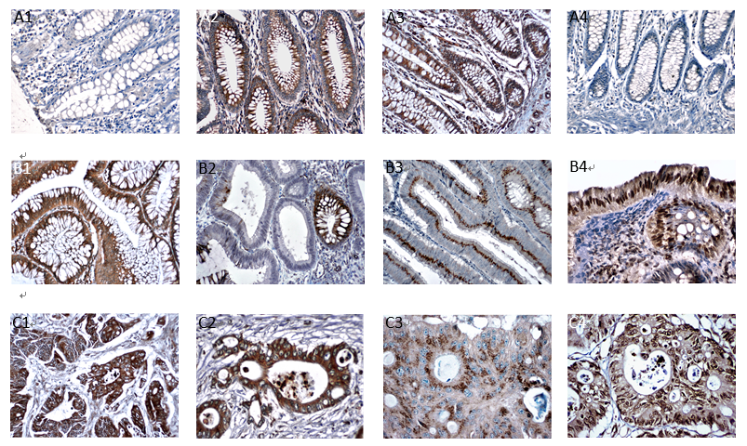
Figure 1 Notch (A1, B1 and C1), Numb (A2, B2 and C2), Itch (A3, B3 and C3), and Siah-1(A4, B4 and C4) immunohistochemical expression in the three groups. Expression of Notch is higher in CRCs (C1-4), and that of Numb Itch and Siah-1 is higher in adenomas (B1-4) and controls (A1-4).
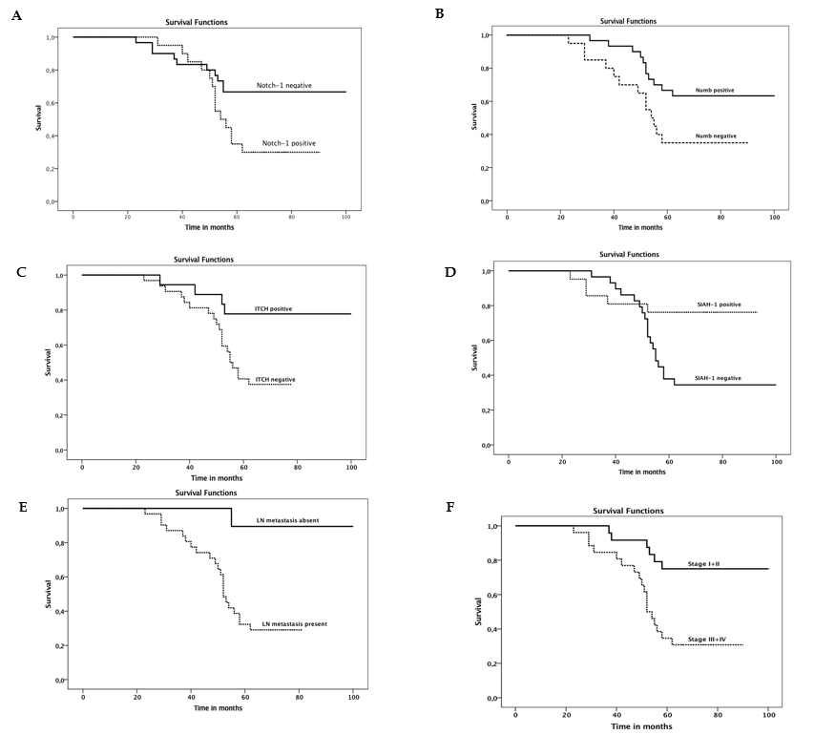
Figure 2 Survival of patients according to Notch (A), Numb (B), Itch (C), and Siah-1 (D) immunohistochemical expression, lymph node metastasis (E), and stage (F). Survival of patients with Notch expression is shorter than that of those without Notch expression. In contrast, expression of Numb, Itch, and Siah-1 is related to better survival.
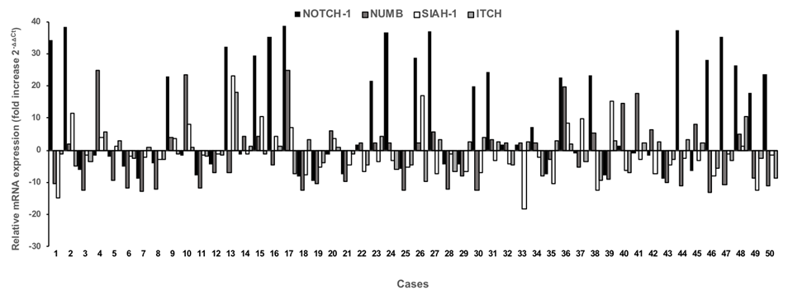
Figure 3 Relative gene expression levels of Notch, Numb, Itch, and Siah-1 in 50 patients diagnosed with colorectal carcinoma (qPCR analysis).

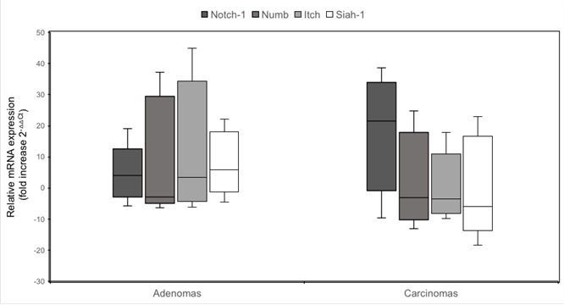
Figure 4 Levels of Notch, Numb, Itch, and Siah-1 expression in adenomas and carcinomas. Expression levels of Notch are higher in colorectal carcinoma; in contrast, expression levels of Numb, Itch, and Siah-1 are higher in adenomas (qPCR analysis).
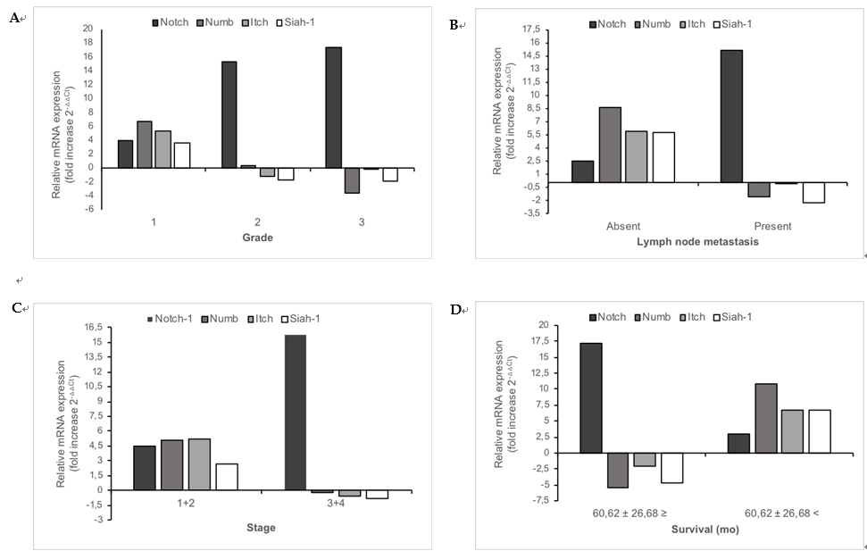
Figure 5 Distribution of relative gene expression levels of Notch, Numb, Itch, and Siah-1 according to grade (A), lymph node metastasis (B), stage (C) and survival (D) in colorectal carcinoma (qPCR analysis).
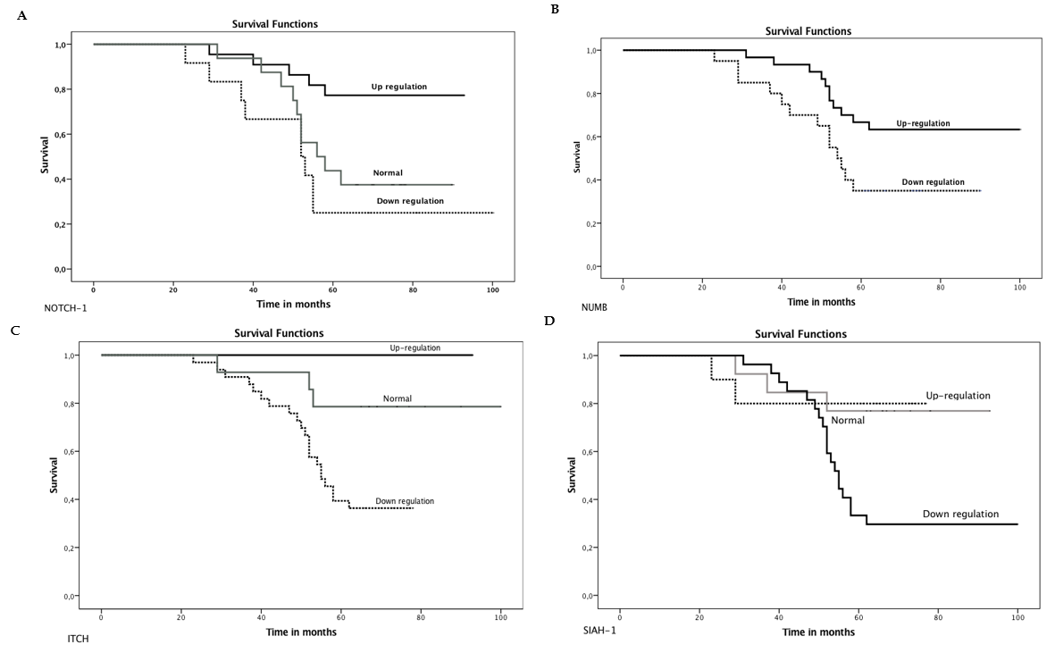
Figure 6 Survival of patients according to expression levels of Notch (A), Numb (B), Itch (C), and Siah-1 (D). Survival of patients with Notch upregulation is shorter than that of patients without Notch upregulation. Conversely, upregulation of Numb, Itch, and Siah-1 is related to better survival.
Table 1 Distribution of immunohistochemical expression of Notch, Numb, Itch, and Siah-1 among the three groups, tissues adjacent to carcinoma, tissues adjacent to adenoma, and subtypes of adenomas
 | Controls | Adenomas | Carcinomas | P value | Tissues adjacent to carcinomaª | Tissues adjacent to adenomaª | Subtypes of adenomasª
 |  |  |  |  |  |  | Tubular | Tubulovillous | Villous
Notch expression
Negative (%) | 15 (75) | 12 (40) | 18 (36) | 0.02 | 25 (50) | 16 (53) | 4 (40) | 5 (50) | 3 (30)
Positive (%) | 5 (25) | 18 (60) | 32 (64) |  | 25 (50) | 14 (47) | 6 (60) | 5 (50) | 7 (70)
Numb expression
Negative (%) | 6 (30) | 21 (70) | 30 (60) | 0.008 | 26 (52) | 14 (47) | 6 (60) | 7 (70) | 8 (80)
Positive (%) | 14 (70) | 9 (30) | 20 (40) |  | 24 (48) | 16 (54) | 4 (40) | 3 (30) | 2 (20)
Itch expression
Negative (%) | 8 (40) | 24 (80) | 30 (60) | 0.01 | 27(54) | 19 (63) | 9 (90) | 7 (70) | 8 (80)
Positive (%) | 12 (60) | 6 (20) | 20 (40) |  | 23 (46) | 11 (37) | 1 (10) | 3 (30) | 2 (20)
Siah-1 expression
Negative (%) | 5 (25) | 19 (63.3) | 29 (58) | 0.024 | 31(62) | 21 (70) | 7 (70) | 5 (50) | 7 (70)
Positive (%) | 15 (75) | 11 (36.7) | 21 (42) |  | 19 (38) | 9 (30) | 3 (30) | 5 (50) | 3 (30)
ªP < 0.05.
Table 2 Correlations between immunohistochemical expression of Notch, Numb, Itch, and Siah-1 and clinicopathological parameters
Parameters | n | Notch |  | Numb |  | Itch |  | Siah-1
 |  | Negative (%) | Positive (%) | Negative (%) | Positive (%) | Negative (%) | Positive (%) | Negative (%) | Positive (%)
Age |  | 18 | 32 | 30 | 20 | 30 | 20 | 29 | 21
64 ± 12.35 ≥ | 24 | 8 (44.3) | 16 (66.7) | 13 (54.1) | 11 (45.9) | 14 (58.3) | 10 (41.7) | 16 (66.7) | 8 (33.3)
64 ± 12.35 < | 26 | 10 (38.5) | 16 (61.5) | 17 (65.3) | 9 (34.7) | 16 (61.5) | 10 (38.5) | 13 (50) | 13 (50)
Gender
Female | 17 | 6 (35.3) | 11 (66.7) | 10 (58.8) | 7 (41.2) | 10 (58.8) | 7 (42.2) | 7 (41.2) | 10 (58.8)
Male | 33 | 12 (36.4) | 21 (63.6) | 20 (60.6) | 13 (39.4) | 20 (60.6) | 13 (39.4) | 22 (66.7) | 11 (33.3)
Localization
Caecum | 8 | 3 (37.59) | 5 (62.5) | 6 (75) | 2 (25) | 5 (62.5) | 3 (37.5) | 4 (50) | 4 (50)
Colon | 16 | 5 (31.3) | 11 (68.7) | 9 (56.3) | 7 (43.7) | 8 (50) | 8 (50) | 10 (62.5) | 6 (37.5)
Sigmoid | 10 | 4 (40) | 6 (60) | 7 (70) | 3 (30) | 7 (70) | 3 (30) | 5 (50) | 5 (50)
Rectum | 16 | 6 (37.5) | 10 (62.5) | 8 (50) | 8 (50) | 10 (62.5) | 6 (37.5) | 10(50) | 6 (50)
Differentiationª
WD | 18 | 16 (88.8) | 2 (11.2) | 3 (16.6) | 15 (83.4) | 5 (27.8) | 13 (72.8) | 8 (44.5) | 10 (55.5)
MD | 15 | 1 (6.6) | 14 (93.4) | 12 (80) | 3 (20) | 10 (66.7) | 5 (33.3) | 10 (66.6) | 5 (33.4)
PD | 17 | 1 (5.8) | 16 (94.2) | 15 (88.2) | 2 (11.8) | 15 (88.2) | 2 (11.8) | 11 (64.8) | 6 (35.2)
Invasion
T1 | 7 | 6 (85.7) | 1 (14.3) | 4 (57.1) | 3 (42.9) | 2 (28.5) | 5 (71.5) | 3 (48.3) | 4 (51.7)
T2 | 10 | 6 (60) | 4 (40) | 7 (70) | 3 (30) | 7 (70) | 3 (30) | 6 (60) | 4 (40)
T3 | 23 | 4 (17.4) | 19 (82.6) | 12 (52.1) | 11 (47.9) | 15 (65.2) | 8 (34.8) | 14 (60.9) | 9 (39.1)
T4 | 10 | 2 (20) | 8 (80) | 7 (70) | 3 (30) | 6 (60) | 4 (40) | 6 (60) | 4 (40)
LNMª
Absent | 17 | 1 (5.3) | 17 (94.7) | 5 (29.4) | 12 (70.6) | 7 (41.1) | 10 (58.9) | 4 (23.6) | 13 (76.4)
Present | 33 | 17 (61.39) | 21(38.7) | 25 (75.8) | 8 (24.2) | 23 (69.6) | 10 (30.4) | 25 (75.8) | 8 (24.2)
Lymphatic invasion
Absent | 37 | 17 (45.9) | 20 (54.1) | 22 (59.4) | 15 (40.6) | 23 (62.1) | 14(37.9) | 25 (67.6) | 12 (32.4)
Present | 13 | 1 (7.6) | 12 (92.4) | 8 (61.5) | 5 (38.5) | 7 (53.8) | 6 (45.2) | 4 (30.8) | 9 (69.2)
Vascular invasion
Absent | 42 | 16 (38.1) | 26 (61.9) | 25 (61.9) | 17(38.1) | 27 (64.3) | 15 (35.7) | 26 (61.9) | 16 (38.1)
Present | 8 | 2 (25) | 6 (75) | 5 (62.5) | 3 (37.5) | 3 (62.5) | 5 (37.5) | 3 (37.5) | 5 (62.5)
Perineural invasion
Absent | 31 | 11 (35,4) | 20 (64.6) | 21 (67.7) | 10 (32.3) | 20 (64.5) | 11 (35.5) | 18 (58.1) | 13 (41.9)
Present | 19 | 7 (36.8) | 12 (63.2) | 9 (47.4) | 10 (52.6) | 10 (52.6) | 9 (47.4) | 11 (57.9) | 8 (42.1)
Stageª
1 + 2 | 24 | 13 (54.1) | 11 (45.9) | 8 (33.4) | 16 (66.6) | 10 (41.6) | 14 (58.4) | 10 (41.7) | 14 (58.3)
3 + 4 | 26 | 5 (19.2) | 21 (80.8) | 22 (84.6) | 4 (15.4) | 20 (76.9) | 6 (23.1) | 19 (73.1) | 7 (26.9)
Distant metastasis
Absent | 26 | 8 (30.7) | 18 (69.3) | 15 (57.6) | 11 (42.4) | 13 (50) | 13 (50) | 15 (57.7) | 11(42.3)
Present | 24 | 10 (41.6) | 14 (58.4) | 15 (62.5) | 9 (37.5) | 17 (70.8) | 7 (29.2) | 14 (58.4) | 10 (41.6)
Survival (mo)ª
60.62 ± 26.68 ≥ | 26 | 2 (7.6) | 24 (92.4) | 20 (76.9) | 6 (23.1) | 22 (84.6) | 4 (15.4) | 19 (73.1) | 7 (26.9)
60.62 ± 26.68 < | 24 | 16 (66.6) | 8 (33.4) | 10 (41.7) | 14 (58.3) | 8 (33.4) | 16 (66.6) | 10 (41.7) | 14 (58.3)
ªP < 0.05. WD: Well-differentiated; MD: Moderately differentiated; PD: Poorly differentiated; LNM: Lymph node metastasis.

Table 3 Distribution of Notch-1, Numb, Itch, and Siah-1 expression levels assessed by qPCR analysis in adenoma and carcinoma groups
Gene expression levels | Adenomas | Carcinomas | P value
Notch
mean ± SD | 3.1016 ± 1.0452 | 10.2628 ± 5.8043 | 0.03
median | 2.6992 | 1.5305
Normal (%) | 0 | 12 (24) | 0.0001
(↑) (%) | 15 (50) | 22 (44)
(↓) (%) | 15 (50) | 16 (32)
Numb
mean ± SD¹ | 8.1362 ± 1.6299 | 2.3153 ± 2.2267 | 0.03
median | 4.0287 | -2.2616
Normal (%) | 4 (13.3) | 0 | 0.0001
(↑) (%) | 18 (60) | 24 (58)
(↓) (%) | 8 (26.7) | 26 (52)
Itch
mean ± SD | 9.2899 ± 2.7369 | 2.1982 ± 1.0461 | 0.006
median | 2.0422 | 1.5933
Normal (%) | 11 (36.7) | 12 (32) | 0.0001
(↑) (%) | 15 (50) | 18 (38)
(↓) (%) | 4 (13,3) | 20 (30)
Siah-1
mean ± SD | 5.9024 ± 1.18671 | 0.8358 ± 1.3831 | 0.03
median | 1.4031 | -2.0322
Normal (%) | 6 (20) | 10 (20) | 0.001
(↑) (%) | 11 (36.7) | 13 (26)
(↓) (%) | 13 (43.3) | 27 (54)
¹fold increase 2^{-△△Ct}. (↑): Upregulation; (↓): Downregulation.

Table 4 Mean and median values of relative gene expression levels of Notch-1, Numb, Itch and Siah-1 in tumors with different clinicopathological parameters (qPCR analysis)
Parameters | n | Notch-1 |  | Numb |  | Itch |  | Siah-1
 |  | mean ± SD¹ | median | mean ± SD | median | mean ± SD | median | mean ± SD | median
Age
64 ± 12.35 ≥ | 24 | 11.23 ± 5.23 | -1.18 | 1.08 ± 1.03 | -1.03 | 1.73 ± 2.34 | -1.22 | 0.81 ± 0.32 | -1.22
64 ± 12.35 < | 26 | 9.20 ± 4.34 | 1.67 | 3.28 ± 4.32 | -2.26 | 3.35 ± 1.64 | 1.99 | 0.85 ± 0.42 | -2.99
Gender
Female | 17 | 10.21 ± 6.02 | 1.38 | 1.74 ± 1.34 | -2.43 | 1.93 ± 1.34 | 1.35 | 0.23 ± 0.03 | -3.19
Male | 33 | 10.58 ± 5.03 | 1.67 | 3.42 ± 3.42 | 4.67 | 2.70 ± 2.10 | -1.21 | 2.00 ± 0.93 | -1.22
Localization
Caecum | 8 | 13.10 ± 5.23 | 12.39 | 1.17 ± 1.45 | 1.31 | 1.85 ± 1.62 | 2.43 | 2.40 ± 1.11 | 0.41
Colon | 16 | 7.99 ± 7.32 | -1.50 | 2.60 ± 2.34 | 1.20 | 3.33 ± 2.03 | 2.30 | 0.26 ± 0.23 | -2.56
Sigmoid | 10 | 15.03 ± 6.23 | 20.79 | 3.69 ± 2.45 | 3.03 | -1.03 ± 0.3 | -1.75 | -0.77 ± 0.22 | -1.49
Rectum | 16 | 8.37 ± 3.41 | 1.16 | 1.72 ± 1.65 | -2.96 | 2.63 ± 1.22 | 1.67 | 1.62 ± 0.51 | -3.48
Differentiationª
WD | 18 | 3.92 ± 2.45 | -3.08 | 6.64 ± 3.46 | 9.92 | 5.26 ± 2.42 | 7.05 | 3.67 ± 1.53 | -1.22
MD  PD | 15  17 | 9.85 ± 4.46  17.28 ± 9.03 | 21.67  22.54 | 1.26 ± 1.04  -3.62 ± 1.81 | -2.26  -4.45 | -1.20 ± 0.84  -0.03 ± 0.01 | -2.41  -1.86 | -1.66 ± 0.66  -1.91 ± 0.65 | -3.24  -4.21
Invasion
T1 | 7 | 5.39 ± 5.93 | -7.70 | 9.40 ± 4.72 | 14.62 | 10.04 ± 5.80 | 12.06 | 2.75 ± 1.36 | -3.89
T2 | 10 | 10.01 ± 6.82 | 4.45 | 3.63 ± 2.45 | -3.06 | 1.41 ± 0.56 | -2.26 | 1.43 ± 0.92 | -3.86
T3 | 23 | 11.38 ± 7.02 | 1.67 | 1.63 ± 1.85 | -2.26 | 1.39 ± 0.8 | -1.91 | 1.87 ± 0.23 | -1.16
T4 | 10 | 11.75 ± 6.88 | 9.59 | -2.40 ± 2.03 | -3.39 | -1.65 ± 0.3 | -1.51 | -3.51 ± 1.48 | -2.94
LNMª
Absent | 17 | 2.45 ± 2.67 | -4.54 | 8.66 ± 4.82 | 13.40 | 5.91 ± 2.20 | 7.84 | 5.77 ± 2.81 | -1.16
Present | 33 | 15.17 ± 6.89 | 19.90 | -1.57 ± 1.24 | -2.35 | -1.07 ± 0.51 | -1.65 | -2.19 ± 1.08 | -3.54
Lymphatic invasion
Absent | 37 | 10.84 ± 6.36 | 1.67 | 1.54 ± 3.42 | -2.26 | 1.68 ± 0.83 | 1.35 | 0.45 ± 0.23 | -3.19
Present | 13 | 8.92 ± 5.32 | 1.38 | 4.51 ± 3.83 | 3.79 | 3.67 ± 1.43 | 1.38 | 1.90 ± 0.92 | -1.35
Vascular invasion
Absent | 42 | 11.77 ± 8.43 | 1.67 | 1.92 ± 1.65 | -2.26 | 1.44 ± 0.96 | 1.07 | -0.48 ± 0.28 | -3.22
Present | 8 | 12.96 ± 7.32 | -2.98 | 9.63 ± 5.32 | 13.13 | 6.17 ± 3.02 | 5.66 | 7.77 ± 3.82 | 5.50
Perineural invasion
Absent  Present | 31  19 | 8.92 ± 5.32  12.65 ± 6.02 | -1.01  17.79 | 2.58 ± 2.48  1.87 ± 1.82 | -2.26  2.27 | 2.86 ± 1.32  1.17 ± 0.61 | 2.00  -1.21 | 1.22 ± 0.32  0.20 ± 0.80 | -3.22  5.50
Stageª
1 + 2 | 24 | 4.45 ± 4.02 | -9.81 | 12.85 ± 5.63 | 7.53 | 5.24 ± 2.31 | 6.89 | 1.24 ± 0.51 | -1.64
3 + 4 | 26 | 15.78 ± 7.94 | -8.25 | 9.72 ± 4.63 | -2.29 | -1.61 ± 0.22 | -1.88 | 0.21 ± 0.03 | -2.42
Distant metastasis
Absent | 26 | 9.83 ± 7.34 | -1.18 | 3.42 ± 1.86 | 1.99 | 3.17 ± 1.24 | 1.77 | 0.99 ± 0.23 | -2.45
Present | 24 | 10.89 ± 6.53 | 1.67 | 1.11 ± 1.02 | -2.86 | 1.14 ± 0.82 | -1.15 | 0.66 ± 0.23 | -2.02
Survival (mo)ª
60.62 ± 26.68 ≥ | 26 | 17.16 ± 6.04 | 21.22 | -5.47 ± 2.24 | -4.90 | -2.03 ± 1.06 | -2.47 | -4.63 ± 2.07 | -4.05
60.62 ± 26.68 < | 24 | 2.95 ± 2.02 | -5.33 | 10.75 ± 5.21 | 13.13 | 6.78 ± 2.83 | 8.51 | 6.76 ± | 3.15
ªP < 0.05. ¹fold increase (2^{-△△Ct}). WD: Well-differentiated; MD: Moderately differentiated; PD: Poorly differentiated; LNM: Lymph node metastasis.

Table 5 Correlations between expression levels of Notch, Numb, Itch, and Siah-1 and clinicopathological parameters in colorectal carcinoma
Levels | n | Notch |  |  | Numb |  | Itch |  |  | Siah-1
Parameters |  | (-) | (↓) | (↑) | (↓) | (↑) | (-) | (↓) | (↑) | (-) | (↓) | (↑)
 |  | 12 | 16 | 22 | 26 | 24 | 16 | 19 | 15 | 10 | 27 | 13
Age
64 ± 12.353 ≥ | 22 | 7 (31.8) | 4 (18.2) | 11 (50) | 12 (54.5) | 10 (45.5) | 7 (31.8) | 6 (27.3) | 9 (40.9) | 4 (18.2) | 13 (59.1) | 5 (22.7)
64 ± 12.353 < | 28 | 5 (17.9) | 12 ( 42 .9) | 11 (39.3) | 14 (50) | 14 (50) | 5 (17.9) | 12 (42.9) | 11(39.3) | 6 (21.4) | 14 (50) | 8 (28.6)
Gender
Female | 17 | 3 (17.6) | 5 ( 29.5) | 9 (52.9) | 17 (51.5) | 16 (48.5) | 6 (35.3) | 7 (41.2) | 4 (23.4) | 3 (17.6) | 10 (58.8) | 4 (23.5)
Male | 33 | 9 (27.3) | 11 (33.3) | 13 (39.4) | 9 (52.9) | 8 (47.1) | 6 (18.2) | 11 (33.3) | 16 (48.5) | 7 (21.2) | 17 (51.5 | 9 (27.3)
Localisation
Caecum | 8 | 1 (12.5) | 3 (37.5) | 4 (50) | 4 (50) | 4(50) | 0 | 3 (37.5) | 5 (62.5) | 2 (25) | 4 (50) | 2 (25)
Colon | 16 | 3 (18.8) | 3 (18.8) | 10 (62.5) | 9 (56.2) | 7 (43.8) | 5 (31.2) | 5 (31.2) | 6 (37.5) | 3 (18.8) | 9 (56.2) | 4 (25)
Sigmoid | 16 | 7 (43.8) | 7 (43.8) | 2 (12.5) | 6 (60) | 4 (40) | 3 (30) | 3 (30) | 4 (40) | 2 (12.5) | 10 (62.5) | 4 (25)
Rectum | 10 | 1 (10) | 3 (30) | 6 (60) | 7 (43.8) | 9 (56.2) | 4 (25) | 7 (43.8) | 5 (31.2) | 3 (30) | 4 (40) | 3 (30)
Differentiationª
WD  MD | 24  13 | 6 (25)  4 (30.7) | 13 (54.1)  2 (15.3) | 5 (20.9)  7 (54) | 8 (33.3)  8 (61.5) | 16 (66.7)  5 (38.5) | 5 (20.8)  3 (23.1) | 5 (20.8)  5 (38.5) | 14 (58.3)  5 (38.5) | 7 (29.2)  2 (15.49 | 7 (29.2)  10 (76.9) | 10 (41.7)  1 (7.7)
PD | 13 | 2 (15.4) | 1 (7.7) | 10 (76.9) | 10 (76.9) | 3 (23.1) | 4 (30.8) | 8 (61.5) | 1 (7.7) | 1 ( 7.7) | 10 (76.9) | 2 (15.4)
Invasion
T1 | 7 | 1 (14.3) | 1 (14.3) | 5 (71.4) | 1 (14.3) | 6 (85.7) | 2 (20) | 0 | 5 (71.4) | 2 (28.6) | 3 (42.9) | 2 (28.6)
T2 | 10 | 3 (30) | 3 (30) | 4 (40) | 6 (60) | 4 (40) | 2 (20) | (30) | 5 (50) | 1 (10) | 5 (50) | 4 (40)
T3 | 23 | 6 (26.1) | 7 (30.4) | 10 (43.5) | 15 (65.2) | 8 (34.8) | 5 (21.7) | 11 (47.8) | 7 (30.4) | 5 (21.7) | 5 (50) | 4 (17.4)
T4 | 10 | 2 (20) | 5 (50) | 3 (30) | 4 (40) | 6 (60) | 24 (30) | 18 (36) | 20 (40) | 2 (20) | 5 (50) | 3 (30)
LNMª
Absent | 19 | 3 (15.8) | 13 (68.4) | 3 (15.8) | 6 (31.6) | 13 (68.4) | 5 (26.3) | 2 (10.5) | 12 (63.2) | 6 (31.6) | 5 (26.3) | 8 (42.1)
Present | 31 | 9 (29) | 3 (9.7) | 19 (61.3) | 20 (64.5) | 11 (35.5) | 7 (22.6) | 16 (88.9) | 8 (25.8) | 4 (12.9) | 22 (71) | 5 (16.1)
Lymphatic invasion
Absent | 37 | 11(29.7) | 13 (35.1) | 13 (35.1) | 20 (54.1) | 17 (45.9) | 7(18.9) | 13 (35.1) | 17 (45.9) | 7 (18.9) | 24 (64.9) | 6 (16.2)
Present | 13 | 1 (7.7) | 3 (23.1) | 9 (69.2) | 6 (46.2) | 7 (53.8) | 5 (38.5) | 5 (38.5) | 3 (23.1) | 3 (23.1) | 3 (23.1) | 7 (53.8)
Vascular invasion
Absent | 42 | 12(28.6) | 14(33.3) | 16 (38.1) | 23 (54.8) | 19 ( 45.2) | 8 (19) | 16 (38.1) | 18 (42.9) | 8 (19) | 25 (59.5) | 9 (21.4)
Present | 8 | 0 | 2 (25) | 6 (75) | 3 (37.5) | 5 (62.5) | 4 (50) | 2 (25) | 2 (25) | 2 (25) | 2 (25) | 4 (50)
Perineural invasion
Absent  Present | 31  19 | 6 (19.4)  6 (31.6) | 12 (38.7)  4 (21.1) | 13 (41.9)  9 (47.4) | 15 (48.4)  11 (57.9) | 16 (51.6)  8 (42.1) | 8 (25.8)  4 (21.1) | 10 (32.3)  8 (42.1) | 13 (41.9)  7 (36.8) | 5 (16.1)  5 (26.3) | 17 (54.8)  10 (52.6) | 9 (29)  4 (21.1)
Stageª
1 + 2 | 24 | 8 (33.3) | 15 (62.5) | 9(4.2) | 7 (29.2) | 17 (70.8) | 5 (20.8) | 4 (16.7) | 15 (62.5) | 7 (29.2) | 9 (37.5) | 8 (33.3)
3 + 4 | 26 | 4 (15.4) | 1(11.6) | 19(73) | 19 (73.1) | 7 (26.9) | 7 (26.9) | 14 (53.8) | 5 (19.1) | 3 (11.5) | 18 (69.2) | 5 (19.2)
Distant metastasis
Absent | 26 | 7 (26.9) | 8 (30.8) | 11 (42.3) | 11 (42.3) | 15 (57.7) | 7 (26.9) | 7 (26.9) | 12 (46.2) | 4 (15.4) | 16 (61.5) | 6 (23.1)
Present | 24 | 12(20.8) | 8 (33.3) | 11 (45.8) | 15 (62.5) | 9 ( 37.5) | 5 (20.8) | 11 (45.8) | 8 (33.3) | 6 (25) | 11 (45.8) | 7 (39.2)
Survival (mo)ª
60.62 ± 26.68 ≥ | 26 | 11 (42.3) | 0 | 15 (57.7) | 22 (84.6) | 4 (15.4) | 7 (26.9) | 15 (57.6) | 4 (42.4) | 4 (15.5) | 21 (80.7) | 1 (3.8)
60.62 ± 26.68 < | 24 | 1 (4.2 ) | 16 (66.6 ) | 7 (29.2) | 4 (16.7) | 20 (83.3) | 5 (20.8) | 3 (12.5) | 16 (87.5) | 6 (25) | 6 (25) | 12 (50)
ªP < 0.05. Downregulation of Notch and upregulation of Numb, Itch, and Siah-1 are associated with better prognosis. (↑): Upregulation, (↓): Downregulation; WD: Well-differentiated; MD: Moderately differentiated; PD: Poorly differentiated; LNM: Lymph node metastasis.

Table 6 Independent prognostic factors according to Cox regression analysis
Parameter | Regression coefficient | P value | Relative risk
LN metastasis | 2.406 | 0.001 | 11.088
Notch expression levels | 1.579 | 0.03 | 3.677
Numb expression levels | -1.166 | 0.01 | 0.561

