Name of Journal: World Journal of Gastrointestinal Oncology
Manuscript NO: 30936
Manuscript Type: Case Report

Gastric plexiform fibromyxoma resected by endoscopic submucosal dissection after observation of chronological changes: A case report

Kawara F et al. Plexiform fibromyxoma resected by ESD

Fumiaki Kawara, Shinwa Tanaka, Takashi Yamasaki, Yoshinori Morita, Yoshiko Ohara, Yoshihiro Okabe, Namiko Hoshi, Takashi Toyonaga, Eiji Umegaki, Hiroshi Yokozaki, Takanori Hirose, Takeshi Azuma

Fumiaki Kawara, Shinwa Tanaka, Yoshinori Morita, Yoshiko Ohara, Yoshihiro Okabe, Namiko Hoshi, Takashi Toyonaga, Eiji Umegaki, Takeshi Azuma, Division of Gastroenterology, Department of Internal Medicine, Kobe University Graduate School of Medicine, Kobe 650-0017, Japan

Takashi Yamasaki, Hiroshi Yokozaki, Division of Pathology, Department of Pathology, Kobe University Graduate School of Medicine, Kobe 650-0017, Japan

Takanori Hirose, Department of Diagnostic Pathology, Hyogo Cancer Center, Akashi 673-8558, Japan

Author contributions: Kawara F, Tanaka S, and Morita Y performed endoscopic resection and wrote the manuscript; Kawara F, Ohara Y, and Okabe Y performed follow-up endoscopy and endoscopic ultrasound; Yamasaki T, Yokozaki H, and Hirose T performed histopathological examinations; Hoshi N, Toyonaga T, Umegaki E, and Azuma T contributed to the literature review and manuscript editing.

Institutional review board statement: This case report was exempt from approval by the Ethics Committee of Kobe University Hospital.

Informed consent statement: Informed consent was obtained from the patient.

Conflict-of-interest statement: The authors declare that they have no conflicts of interest.

Open-Access: This article is an open-access article which was selected by an in-house editor and fully peer-reviewed by external reviewers. It is distributed in accordance with the Creative Commons Attribution Non Commercial (CC BY-NC 4.0) license, which permits others to distribute, remix, adapt, build upon this work non-commercially, and license their derivative works on different terms, provided the original work is properly cited and the use is non-commercial. See: http://creativecommons.org/licenses/by-nc/4.0/

Manuscript source: Invited manuscript
Correspondence to: Fumiaki Kawara, MD, PhD, Division of Gastroenterology, Department of Internal Medicine, Kobe University Graduate School of Medicine, 7-5-1 Kusunoki-cho, Chuo-ku, Kobe 650-0017, Hyogo, Japan. lankey11@med.kobe-u.ac.jp
Telephone: +81-78-3826305
Fax: +81-78-3826309

Received: October 23, 2016
Peer-review started: October 25, 2016
First decision: March 8, 2017
Revised: March 22, 2017
Accepted: May 3, 2017
Article in press:
Published online:

Abstract
A 66-year-old man was diagnosed with a gastric submucosal tumor. Endoscopic ultrasound (EUS) revealed an iso/hypoechoic mass in the third layer. No malignant cells were detected in a histological examination. Yearly follow-up endoscopy and EUS showed the slow growth of the tumor. Endoscopic submucosal dissection (ESD) was performed and a glistening tumor was resected. The lesion showed a multinodular plexiform growth pattern consisting of spindle cells with an abundant fibromyxoid stroma that was rich in small vessels. The tumor was diagnosed as plexiform fibromyxoma (PF) by immunohistochemistry. Although difficulties are associated with reaching a diagnosis preoperatively, chronological changes on EUS may contribute to the diagnosis of PF. ESD may also be useful in the diagnosis and treatment of PF.

Key words: Plexiform fibromyxoma; Plexiform angiomyxoid myofibroblastic tumor; Endoscopic ultrasound; Endoscopic submucosal dissection; Gastrointestinal stromal tumor

© The Author(s) 2017. Published by Baishideng Publishing Group Inc. All rights reserved.

Core tip: Plexiform fibromyxoma (PF) is a very rare gastric submucosal tumor. Therefore, difficulties are associated with diagnosing PF preoperatively, particularly in a differential diagnosis of gastrointestinal stromal tumors with cystic changes. We suggest that the chronological changes observed by endoscopic ultrasound contribute to the preoperative diagnosis of PF. Furthermore, endoscopic submucosal dissection needs to be considered for the diagnostic treatment of PF without muscle invasion.

Kawara F, Tanaka S, Yamasaki T, Morita Y, Ohara Y, Okabe Y, Hoshi N, Toyonaga T, Umegaki E, Yokozaki H, Hirose T, Azuma T. Gastric plexiform fibromyxoma resected by endoscopic submucosal dissection after observation of chronological changes: A case report. World J Gastrointest Oncol 2017; In press

INTRODUCTION
Plexiform fibromyxoma (PF), also known as a plexiform angiomyxoid myofibroblastic tumor (PAMT), is a very rare gastric submucosal tumor (SMT) with a unique plexiform growth pattern of bland spindle cells^{[1-3]}. Few studies have described the endoscopic ultrasound (EUS) characteristics of PF, and its chronological changes also remain unclear. We herein report a case of PF resected by endoscopic submucosal dissection (ESD) after a 4-year follow-up period.

CASE REPORT
A 66-year-old man was referred to our institute for the management of a gastric tumor. An endoscopic examination revealed a submucosal tumor (SMT), approximately 20 mm in diameter, located in the antrum (Figure 1A). EUS showed an iso/hypoechoic mass in the third layer (Figure 1B). Computed tomography (CT) displayed a poorly enhanced lesion (Figure 2). Endoscopic biopsy and endoscopic ultrasound-guided fine-needle aspiration (EUS-FNA) were performed. Histological findings showed no malignant cells, and no further diagnosis was made.
Yearly follow-up endoscopy revealed the slow growth of the tumor, which became pedunculated and showed transpyloric prolapse (Figure 1C-F). EUS revealed gradual increases in the solid and multicystic components without muscle invasion. Based on these findings, our preoperative diagnosis was a hamartomatous inverted polyp^{[4-6]}. In order to avoid outlet obstruction and reach a histological diagnosis, ESD was performed (Figure 3).
On dissection, a glistening, 40 mm × 30 mm tumor covered with normal gastric mucosa was identified. Microscopically, the lesion showed a multinodular plexiform growth pattern, and consisted of bland spindle cells separated by abundant intercellular myxoid or fibromyxoid matrix. The stroma was rich in small vessels (Figure 4). Immunohistochemical tests revealed that tumor cells were focally positive for smooth muscle actin (SMA), muscle-specific actin (HHF35), and calponin, but were negative for c-kit, CD34, DOG-1, desmin, the S-100 protein, CD10, and h-caldesmon. The Ki-67 labeling index was approximately 2% (Figure 5). The pathological assessment led to a diagnosis of PF. Resected margins were histologically tumor-free. Although vascular invasion was positive, the patient did not undergo surgery due to the reportedly good prognosis of PF^{[1,7]}, and remained under careful observation by endoscopy and CT follow-up. There was no recurrence or metastasis in the 12-mo follow-up.

DISCUSSION
Gastric PF is a new benign mesenchymal tumor that has been adopted by the 2010 WHO classification of tumors of digestive system^{[8]}. The term PAMT is also used for this type of tumor. The distinction between these terms has been controversial^{[7,9]}. Previous studies reported that most cases of this tumor are found in the antrum, with approximately half extending into the extragastric soft tissues or proximal duodenum^{[2,7]}. The diagnosis of PF is based on its histological features, including immunohistochemical findings^{[1]}. Its histology indicates a plexiform growth pattern composed of spindle cells, fine small vessels, and a myxoid matrix. Tumor cells are typically immunoreactive for SMA and HHF35, whereas c-kit, CD34, DOG-1, and the S-100 protein are nearly completely negative. Focal immunoreactivity for CD10, caldesmon, or desmin has occasionally been detected^{[1,3,7]}.
In the present case, endoscopy and EUS showed that the tumor grew gradually, with increases in the solid and multicystic components. Spindle cells, with a rich vascular myxoid stroma, were considered to be detected as an isoechoic lesion and fluid leakage was observed as a hypoechoic lesion.
Previous studies reported the lack of recurrence or metastasis of PF after excision^{[1,7]}; however, Miettinen et al^{[1]} demonstrated that some plexiform elements showed intravascular involvement, suggesting that PF occasionally spreads through vessels. Since our case also exhibited vascular invasion, follow-up examinations were carefully performed. Since no patients have developed recurrence, annual endoscopy and CT are considered to be sufficient to monitor patients.
Although PF is considered to be benign, distal or partial gastrectomy is generally performed under the assumption of the presence of GIST^{[7]}. Although GIST typically appears as a solid mass, few studies have described myxoid GIST that also shows a plexiform growth pattern^{[10]}, and some cases of GIST have shown cystic changes as a result of degeneration or necrosis^{[11-13]}. Thus, it may be difficult to distinguish PF from these GIST by performing EUS only once. The chronological changes observed in the present case may contribute to a preoperative diagnosis of PF and the elucidation of its growth process. In this case, even though contrast-enhanced EUS was not performed, it may also be useful for reaching a differential diagnosis^{[14,15]}. The distinction of PF from a hamartomatous inverted polyp is also important. EUS-FNA is the first choice for a definite diagnosis of SMT^{[16]}. Nevertheless, ESD remains an important option for diagnostic treatment, including that for cases of gastric SMT of the submucosal layer[^{6,17]}. Since EUS-FNA revealed no abnormalities in the present case, ESD was selected as a second choice. We performed en bloc ESD, which allowed for the diagnosis of PF. To the best of our knowledge, this is the first case report to describe the successful resection of PF by ESD. Further studies are needed in order to establish the appropriateness of ESD for PF.

COMMENTS
Case characteristics
A 66-year-old man presented with a gastric tumor located in the antrum.

Clinical diagnosis
Gastric submucosal tumor.

Differential diagnosis
A hamartomatous inverted polyp, myxoid gastrointestinal stromal tumor (GIST), and GIST with cystic degeneration.

Laboratory diagnosis
Laboratory test results were within normal limits.

Imaging diagnosis
Endoscopic ultrasound revealed an iso/hypoechoic mass of 20 mm in diameter in the third layer, and it showed gradual increases in the solid and multicystic components without muscle invasion.

Pathological diagnosis
Plexiform fibromyxoma.

Treatment
Endoscopic submucosal dissection was performed as a diagnostic treatment.

Related reports
Few studies have described plexiform fibromyxoma, also known as a plexiform angiomyxoid myofibroblastic tumor. Patients with plexiform fibromyxoma have generally undergone distal or partial gastrectomy.

Term explanation
Plexiform fibromyxoma is a new mesenchymal tumor entity that shows a unique plexiform growth pattern of bland spindle cells.

Experiences and lessons
Plexiform fibromyxoma needs to be considered in a differential diagnosis of gastric submucosal tumors, and follow-up EUS may be able to distinguish plexiform fibromyxoma from other gastric submucosal tumors.
Peer-review
The rarity of the case could be enriched with a brief review of the literature, due to the scarce number of papers reporting similar tumors. Moreover it could be interesting to expand data about EUS, for example explaining the carachteristics of elastometry and eventual contrast enhancement. The quality of the article is augmented by the images, which are impressive and clear. Overall it is a good paper.

REFERENCES
1 Miettinen M, Makhlouf HR, Sobin LH, Lasota J. Plexiform fibromyxoma: a distinctive benign gastric antral neoplasm not to be confused with a myxoid GIST. Am J Surg Pathol 2009; 33: 1624-1632 [PMID: 19675452 DOI: 10.1097/PAS.0b013e3181ae666a]
2 Sakamoto K, Hirakawa M, Atsumi K, Mimori K, Shibata K, Tobo T, Yamamoto H, Honda H. A case of gastric plexiform fibromyxoma: radiological and pathological findings. Jpn J Radiol 2014; 32: 431-436 [PMID: 24744134 DOI: 10.1007/s11604-014-0315-z]
3 Takahashi Y, Shimizu S, Ishida T, Aita K, Toida S, Fukusato T, Mori S. Plexiform angiomyxoid myofibroblastic tumor of the stomach. Am J Surg Pathol 2007; 31: 724-728 [PMID: 17460456 DOI: 10.1097/01.pas.0000213448.54643.2f]
4 Yang TC, Hou MC, Chen PH, Liao WC, Li AF. Gastric hamartomatous inverted polyp mimicking ectopic pancreas on endoscopy and endosonography. Endoscopy 2014; 46 Suppl 1 UCTN: E119-E120 [PMID: 24676819 DOI: 10.1055/s-0034-1364888]
5 Aoki M, Yoshida M, Saikawa Y, Otani Y, Kubota T, Kumai K, Wakabayashi G, Omori T, Mukai M, Kitajima M. Diagnosis and treatment of a gastric hamartomatous inverted polyp: report of a case. Surg Today 2004; 34: 532-536 [PMID: 15170552 DOI: 10.1007/s00595-004-2761-1]
6 Odashima M, Otaka M, Nanjo H, Jin M, Horikawa Y, Matsuhashi T, Ohba R, Koizumi S, Kinoshita N, Takahashi T, Shima H, Watanabe S. Hamartomatous inverted polyp successfully treated by endoscopic submucosal dissection. Intern Med 2008; 47: 259-262 [PMID: 18277026]
7 Takahashi Y, Suzuki M, Fukusato T. Plexiform angiomyxoid myofibroblastic tumor of the stomach. World J Gastroenterol 2010; 16: 2835-2840 [PMID: 20556828]
8 Miettinen M, Fletcher CD, Kindblom LG, Tsui WM. Mesenchymal tumours of the stomach. In: Bosman FT, Carneiro F, Hruban R, Theise ND, editors. Mesenchymal tumours of the stomach. WHO classification of tumours of the digestive system. Lyon: IARC, 2010: 74-79
9 Li P, Yang S, Wang C, Li Y, Geng M. Presence of smooth muscle cell differentiation in plexiform angiomyxoid myofibroblastic tumor of the stomach: a case report. Int J Clin Exp Pathol 2014; 7: 823-827 [PMID: 24551311]
10 Li B, Zhang QF, Han YN, Ouyang L. Plexiform myxoid gastrointestinal stromal tumor: a potential diagnostic pitfall in pathological findings. Int J Clin Exp Pathol 2015; 8: 13613-13618 [PMID: 26722584]
11 Miettinen M, Sobin LH, Lasota J. Gastrointestinal stromal tumors of the stomach: a clinicopathologic, immunohistochemical, and molecular genetic study of 1765 cases with long-term follow-up. Am J Surg Pathol 2005; 29: 52-68 [PMID: 15613856]
12 Naitoh I, Okayama Y, Hirai M, Kitajima Y, Hayashi K, Okamoto T, Akita S, Gotoh K, Mizusima M, Sano H, Ohara H, Nomura T, Joh T, Yokoyama Y, Itoh M. Exophytic pedunculated gastrointestinal stromal tumor with remarkable cystic change. J Gastroenterol 2003; 38: 1181-1184 [PMID: 14714258 DOI: 10.1007/s00535-003-1228-2]
13 Okano H, Tochio T, Suga D, Kumazawa H, Isono Y, Tanaka H, Matsusaki S, Sase T, Saito T, Mukai K, Nishimura A, Baba Y, Murata T. A case of a stomach gastrointestinal stromal tumor with extremely predominant cystic formation. Clin J Gastroenterol 2015; 8: 197-201 [PMID: 26112771 DOI: 10.1007/s12328-015-0577-8]
14 Hirooka Y, Itoh A, Kawashima H, Ohno E, Itoh Y, Nakamura Y, Hiramatsu T, Sugimoto H, Sumi H, Hayashi D, Ohmiya N, Miyahara R, Nakamura M, Funasaka K, Ishigami M, Katano Y, Goto H. Contrast-enhanced endoscopic ultrasonography in digestive diseases. J Gastroenterol 2012; 47: 1063-1072 [PMID: 23001249 DOI: 10.1007/s00535-012-0662-4]
15 Kitano M, Sakamoto H, Kudo M. Contrast-enhanced endoscopic ultrasound. Dig Endosc 2014; 26 Suppl 1: 79-85 [PMID: 24118242 DOI: 10.1111/den.12179]
16 Mekky MA, Yamao K, Sawaki A, Mizuno N, Hara K, Nafeh MA, Osman AM, Koshikawa T, Yatabe Y, Bhatia V. Diagnostic utility of EUS-guided FNA in patients with gastric submucosal tumors. Gastrointest Endosc 2010; 71: 913-919 [PMID: 20226456 DOI: 10.1016/j.gie.2009.11.044]
17 Hoteya S, Iizuka T, Kikuchi D, Yahagi N. Endoscopic submucosal dissection for gastric submucosal tumor, endoscopic sub-tumoral dissection. Dig Endosc 2009; 21: 266-269 [PMID: 19961528 DOI: 10.1111/j.1443-1661.2009.00905.x]

P- Reviewer: de'Angelis GL, Meng ZQ
S- Editor: Song XX L- Editor: E- Editor:

Specialty type: Oncology
Country of origin: Japan
Peer-review report classification
Grade A (Excellent): 0
Grade B (Very good): B
Grade C (Good): C
Grade D (Fair): 0
Grade E (Poor): 0

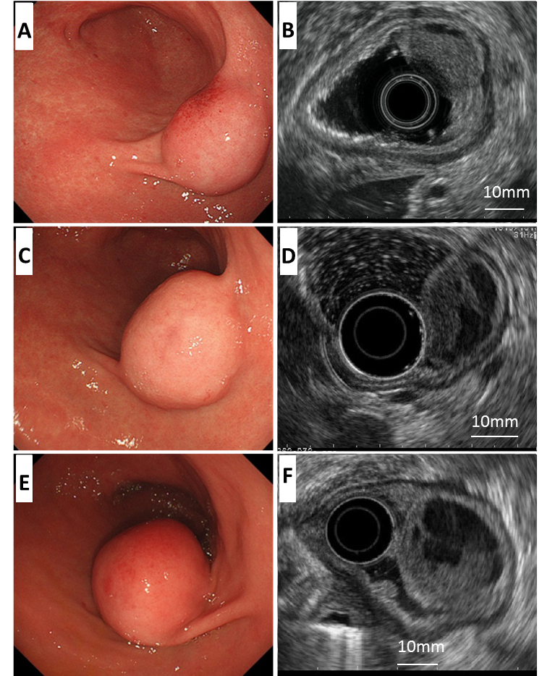
Figure 1 Endoscopic and endoscopic ultrasound findings. A: A submucosal tumor covered with a normal mucosa; B: An iso/hypoechoic mass with cystic components in the third layer; C, D: One year later; E, F: Four years later. The tumor increased in size and became pedunculated. Solid and multicystic parts both grew larger without muscle invasion.

Figure 2 Computed tomography of the patient. A computed tomography scan revealed a poorly enhanced tumor in the antrum.

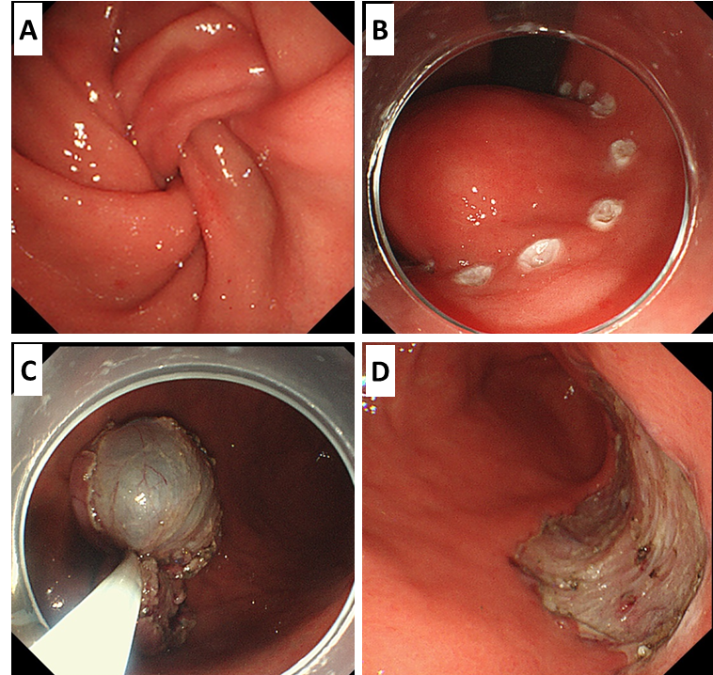
Figure 3 Endoscopic submucosal dissection. A: Tumor prolapse into the duodenum from the pylorus; B: Circumferential marking around the mass; C: Resected tumor retrieved using a snare; D: The ulcer bed after endoscopic submucosal dissection.

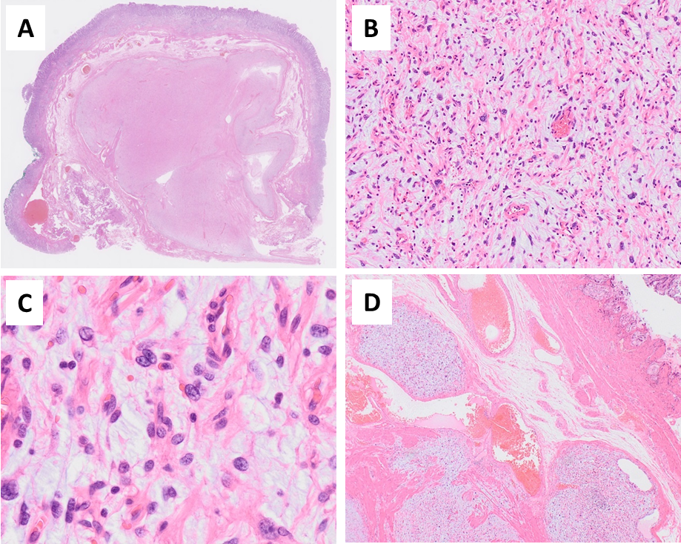
Figure 4 Histological appearance of the tumor. The margins were histologically tumor-free. A: The tumor showed a plexiform growth pattern; B, C: The tumor consisted of spindle-shaped cells with an abundant myxoid or fibromyxoid stroma; D: Some tumor cells intruded into the vessel space.

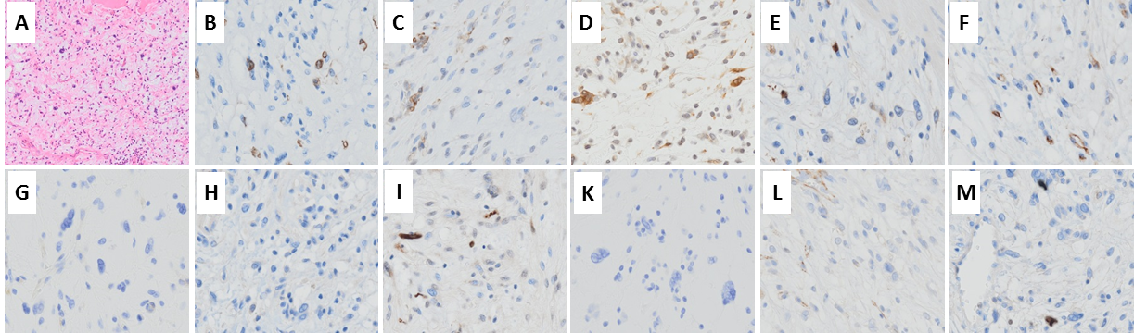
Figure 5 Hematoxylin and eosin. A: Histological appearance with hematoxylin and eosin (HE) staining; C-L: Immunohistochemically, tumor cells were focally positive for SMA (B), HHF35 (C), and calponin (D), but negative for c-kit (E), CD34 (F), DOG-1 (G), desmin (H), the S-100 protein (I), CD10 (K), and h-caldesmon (L); M: The Ki-67 labeling index was 2% at most.

