Name of Journal: World Journal of Clinical Cases
Manuscript NO: 82299
Manuscript Type: MINIREVIEWS

Airway ultrasound for patients anticipated to have a difficult airway: Perspective for personalized medicine

Nakazawa H et al. Airway ultrasound for difficult airway

Harumasa Nakazawa, Kohji Uzawa, Joho Tokumine, Alan Kawarai Lefor, Akira Motoyasu, Tomoko Yorozu

Harumasa Nakazawa, Kohji Uzawa, Joho Tokumine, Akira Motoyasu, Tomoko Yorozu, Department of Anesthesiology, Kyorin University School of Medicine, Mitaka 181-8611, Tokyo, Japan

Alan Kawarai Lefor, Department of Surgery, Jichi Medical University, Shimotsuke 329-0498, Tochigi, Japan

Author contributions: Nakazawa H, Uzawa K, Motoyasu A and Tokumine J helped with literature acquisition and contributed in writing the original daft; Lefor AK contributed in editing the draft; Yorozu T helped in the conceptualization and data validation.

Corresponding author: Joho Tokumine, MD, PhD, Professor, Department of Anesthesiology, Kyorin University School of Medicine, 6-20-2 Sinkawa, Mitaka 181-8611, Tokyo, Japan. dg274825@cf6.so-net.ne.jp

Received: December 14, 2022
Revised: January 28, 2023
Accepted: February 27, 2023
Published online:

Abstract
Airway ultrasound allows for precise airway evaluation, particularly for assessing the difficult airway and the potential for front of neck access. Many studies have shown that identification of the cricothyroid membrane by airway ultrasound is more accurate than digital palpation. However, no reports to date have provided clinical evidence that ultrasound identification of the cricothyroid membrane increases the success rate of cricothyroidotomy. This is a narrative review which describes patients with difficult airways for whom airway ultrasound may have been useful for clinical decision making. The role of airway ultrasound for the evaluation of difficult airways is summarized and an approach to the use of ultrasound for airway management is proposed. The goal of this review is to present practical applications of airway ultrasound for patients predicted to have a difficult airway and who undergo cricothyroidotomy.

Key Words: Airway ultrasound; Difficult airway; Point-of-care ultrasound; Cricothyroidotomy; Intubation; Mask ventilation

Nakazawa H, Uzawa K, Tokumine J, Lefor AK, Motoyasu A, Yorozu T. Airway ultrasound for patients anticipated to have a difficult airway: Perspective for personalized medicine. World J Clin Cases 2023; In press

Core Tip: Airway ultrasound may provide a simpler and more accurate prediction of the difficult airway, especially to distinguish difficult mask ventilation from difficult tracheal intubation. Accurate cricothyroid membrane identification may provide a landmark for securing a surgical airway in clinical practice.

INTRODUCTION
Point-of-care ultrasound (POCUS) is a quickly used and repeatable tool for bedside clinical evaluation. Today, POCUS supports perioperative decision making in all phases and settings of clinical care^{[1]}. POCUS is achieving results for diagnosis and treatment in emergency medicine and intensive care^{[2-4]}.
Airway ultrasound is one form of POCUS. Although it is thought to hold great potential, there is no evidence to date whether airway ultrasound has a significant impact on clinical decision making. This narrative review and perspective discuss what is known about the efficacy of airway ultrasound from existing studies and then reflect on this information with clinical insight from individual patients. Airway ultrasound is considered useful because it provides insights that can facilitate decision-making for securing the airway in patients with an anticipated difficult airway.
The literature search in the present study was conducted using PubMed, Medline, and Scopus with the key words "airway ultrasound" "difficult airway" and "point-of-care ultrasound." Meta-analyses were cited whenever possible to answer clinical questions, and other citations were used when deemed necessary to answer clinical questions.

What can airway ultrasound tell us?
Airway ultrasound is useful for pre-anesthetic airway evaluation, particularly to assess the potential for requiring front of neck access, confirmation of tracheal intubation, prediction of optimal tracheal tube size, and evaluation of vocal cord motion and function^{[1,5-7]}. Among these possible applications of airway ultrasound, prediction and treatment of the difficult airway is expected to be the most important clinically.

Can airway ultrasound predict a difficult airway?
A report on the management of patients with a difficult airway from the United Kingdom described the importance of airway assessment to avoid airway accidents^{[8]}. It has also been noted that current airway evaluations are not adequate^{[9]}. The modified Mallampati classification, mandibular protrusion, neck circumstance and other factors to predict the presence of a difficult airway are traditionally based on observations and measurements on the surface of the patient’s body. Studies to predict the presence of a difficult airway using airway ultrasound have begun. This is not a conventional prediction based on information from the body surface, but from information obtained about the internal anatomy, and belongs to the same family of predictions using information from internal structures such those made with images from computed tomography (CT) scans^{[10]}. The ability to predict the difficult airway by airway ultrasound will likely never exceed that of predicting the difficult airway using information from a CT scan, because CT scans present more information and can reconstruct three-dimensional structures, while airway ultrasound is always limited to two-dimensional information. CT scans have associated problems, such as radiation exposure and high cost as well as the need to usually transport the patient to a dedicated CT scanner location. Even if those problems are ignored, the clinical utility of airway ultrasound may exceed that available with a CT scan. Airway ultrasound is characterized by mobility and repeatability to get the information needed instantly, at the point of care.
Measurements to predict the presence of a difficult airway fall into two categories. The first is the distance from the skin to the airway. There is a hypothesis that an increase in anterior neck thickness restricts the mobility of pharyngeal structures and thereby affects direct laryngoscopy^{[11]}. However, Komatsu et al^{[11]} found no association between the presence of a difficult airway and anterior neck thickness at the level of the vocal cords. In a recent meta-analysis, anterior neck thickness at the vocal cord level or at the cricothyroid membrane is not a predictor for the presence of a difficult airway^{[12]}. However, the distance from the skin to the epiglottis, or hyoid bone, may be a predictor of difficult intubation^{[12,13]}. For direct laryngoscopy, the tongue, epiglottis, and mandible are considered obstacles anterior to the oral airway space^{[14]}. Based on this concept, the thickness of the oropharynx and hypopharynx can be assumed to have more effect on the performance of direct laryngoscopy than the thickness of the anterior larynx.
The second category of measurements to predict the presence of a difficult airway is based on the significance of measuring the hyomental distance. When performing direct laryngoscopy, important obstacles are not only located anteriorly. The posterior obstacles refer to the upper teeth, maxilla, head, and others^{[14]}. The key to overcoming posterior obstacles is the mobility of the upper cervical spine^{[14]}. Mobility of the upper cervical spine, especially at the occipital-atlantoaxial joint, is important, and the ratio of the neutral position to the head extended position of the hyomental distance is reported to be a good indicator as a substitute for radiographic measurement of occipital-atlantoaxial joint extension^{[15]}. In a meta-analysis, hyomental distance did not differ significantly between patients with and without intubation difficulties^{[12]}. However, there was a significant difference in the ratio of hyomental distance between the neutral position and extension, referred to as the hyomental distance ratio. The difference in results for hyomental distance and the hyomental distance ratio may be due to large individual differences in hyomental distance. Ultrasound measurement of hyomental distance does not require x-rays. Therefore, use of the hyomental distance ratio is facilitated in clinical practice.
Studies to predict the presence of a difficult airway in terms of whether direct laryngoscopy is possible may have to be reconsidered in the future due to improvements in, and the widespread use of videolaryngoscopy, which is partially overcoming problems associated with the difficult airway^{[16,17]}. Difficult airways include difficult intubation and difficult mask ventilation. Difficult mask ventilation is even more dangerous than difficult tracheal intubation. Li et al^{[18]} reported that measurement of the submental portion by ultrasound is predictive of difficult mask ventilation. Bianchini et al^{[19]} reported that tongue base thickness is predictive of difficult mask ventilation. Enlargement of the tongue base or submental portion can cause airway narrowing. The Mallampati score reflects the size of the tongue in the oropharyngeal space^{[20]}. There is a belief that ultrasonic measurement of tongue base thickness is a more accurate measure of the property embodied in the Mallampati classification^{[21]}. This idea is anatomically quite reasonable and deserves further study.
Table 1 shows cutoff values for difficult airway predictors that are considered important^{[12]}. Each predictor can be classified based on its anatomical significance. Skin to epiglottis distance is a highly evaluated index with excellent sensitivity and specificity for predicting the difficult airway^{[22]}. Skin to epiglottis distance is anatomically considered to reflect the distance from the skin to the airway^{[22]}. A longer distance is associated with increasing difficultly when performing direct laryngoscopy^{[22]}. Anatomical reasons are explained by the three column model of the upper airway described by Greenland^{[23]}. Briefly, the increase in skin to epiglottis distance makes the orientation of the tracheal axis (secondary curve of the three column model) to be downward. The skin to epiglottis distance may be an indicator of the difficulty for both mask ventilation and direct laryngoscopy. The hyomental distance ratio is as a predictor of difficult direct laryngoscopy^{[24]}, and tongue base thickness is a predictor of difficult mask ventilation^{[25]}.
The measurement of anterior neck thickness may make sense based on the anterior obstacles of the oral airway space theory^{[14]}. These measurement points are the distance from the skin to the hyoid bone, the distance from the skin to the anterior commissure, and the thickness of the anterior neck soft tissues at the level of the hyoid bone. The authors speculate that anterior cervical thickness would be associated with obesity, which is clearly a predictor of an airway difficulty. In this paper, three predictors were chosen based on anatomical considerations. However, there is still the potential for more accurate prediction by combining anterior neck thickness with other independent predictors.
Figure 1 illustrates the evaluation of each difficult airway predictor and its measurement in a man with sleep apnea syndrome who is anticipated to have a difficult airway based on a traditional predictor, the modified Mallampati score, Class IV. The distance from the skin to the epiglottis is 3.42 cm, which is more than the cutoff value of 2.54 (Table 1). The hyomental distance ratio is 6.42/5.77 = 1.11, which is larger than the cutoff value of 1.085. Tongue base thickness is 8.31, which is more than the cutoff value of 5.87. Taken together, the evaluation of these parameters suggest that this man is at high risk for difficult in mask ventilation but not direct laryngoscopy. Administration of anesthesia required an oral airway and two-person bag-valve mask ventilation to secure the airway after inducing general anesthesia, but intubation was performed by a resident with a Macintosh laryngoscope with modified Cormack-Lehane classification grade 2a.
Thus, each difficult airway predictor can be used to predict when difficult airways might be present in a patient and allow the clinician to devise a strategy to safely secure the patient’s airway.

Does observation of the vocal cords fail to predict an airway difficulty?
As previously mentioned, anterior neck thickness at the vocal cord level is not a satisfactory predictor for the presence of a difficult airway^{[12]}. Since the vocal cords are located inside the thyroid cartilage, the ultrasound probe must be manipulated to provide an image through the cricothyroid membrane toward the head to observe the vocal cords. The ultrasound beam for viewing the vocal cords crosses the anterior cervical surface at an angle, not vertically. Therefore, evaluating the thickness of the anterior neck with the thickness of the anterior neck soft tissue at the level of the vocal cords is of questionable value. However, observation of the vocal cords is important when performing airway ultrasound. This is because undiagnosed lesions in the glottis can lead to an otherwise unrecognized difficult airway. In 2016, we reported a patient with a difficult airway due to an undiagnosed subglottic tumor, which could have been identified with airway ultrasound^{[26]}. Recently, Adi et al^{[27]} reported the use of airway ultrasound to diagnose a mass lesion in the glottis which resulted in airway narrowing. If one suspects airway stenosis, we recommend airway ultrasound to observe the vocal cords as the first step.
Case 1: A 93-year-old woman was planned to undergo repair of a femoral neck fracture. She developed a “cannot intubate cannot oxygenate” emergency after induction of general anesthesia, and the anesthesiologist let her awaken. Airway compromise was caused by undiagnosed subglottic tumors (Figure 2).

Is airway ultrasonography an effective adjunct for cricothyroidotomy?
The Fourth National Airways Project in the United Kingdom showed that emergency cricothyroidotomy has a failure rate of 64%^{[8]}. The cause of this high failure rate has not been determined^{[8]}. Identification of the cricothyroid membrane may hold the key to successful emergency cricothyroidotomy. Numerous studies have addressed whether airway ultrasound facilitates accurate cricothyroid membrane identification^{[28-36]}. Other studies have evaluated the accuracy of identifying this membrane by airway ultrasound in pregnant women^{[37,38]}, obese patients^{[39-41]}, and children^{[42-45]}. Most studies concluded that identification of the cricothyroid membrane by airway ultrasound is more accurate than by digital palpation. However, the results of these studies should be interpreted with caution, because there are no clinical reports showing that ultrasound identification of the cricothyroid membrane increases the success rate of cricothyroidotomy. Furthermore, airway ultrasound is not recommended once securing the airway has failed, as it is more time-consuming than digital palpation^{[46]}. Nevertheless, airway ultrasound is expected to be useful for strategy planning in patients with an anticipated difficult airway.

Is cricothyroidotomy an anatomically valid front-of-neck access target?
There are various descriptions of the size and shape of the cricothyroid membrane^{[47]}. Reported length and width ranges (minimum-maximum) of the cricothyroid membrane are 3-12 and 6-18 mm, respectively. The shape of the cricothyroid membrane has been reported to be rhombic, triangular, and trapezoidal. First, it is important to understand that not all of the space between the thyroid and cricoid cartilages is covered solely by the cricothyroid ligament. The cricothyroid membrane is formed mainly by the central median cricothyroid ligament and by the lateral part of a ligament named the conus elasticus on both sides (Figure 3). Most of the conus elasticus is covered by the cricothyroid muscles, and the caudal part of the central median cricothyroid ligament is also covered by the cricothyroid muscles. The cricothyroid muscle attaches to the cricoid cartilage anterolaterally and to the lower lamina of the thyroid cartilage. In cricothyroidotomy, the cricothyroid muscle would give high resistance to needle puncture or surgical incision and is also an obstacle to digital palpation of the cricothyroid membrane for identification due to decreased dimpling of the cricothyroid membrane.
It is necessary to understand the distribution of blood vessels around the cricothyroid membrane since it relates to hemorrhagic complications. The vascular distribution around the cricothyroid membrane exists both inside and outside the membrane (Figure 3). Incision or puncture along the lateral side of the cricothyroid membrane may damage the superior thyroid artery, resulting in rather significant bleeding^{[48]}. The cricothyroid artery runs anterior and cephalad to the cricothyroid membrane and is easily damaged during cricothyroidotomy. Incision or puncture of the cricothyroid membrane is more safely performed in the central to caudal area^{[49]}.
Posterior tracheal wall injury, tracheal laceration, and esophageal perforation are among the complications of cricothyroidotomy^{[50]}. Complications can be caused by applying too much force or the use of unnecessarily long needles during needle cricothyroidotomy and by inserting the blade too deeply during surgical cricothyroidotomy^{[50-52]}.
In summary, it should be recognized that the safe target for a cricothyroidotomy is very small, about 5.5 mm long and 6.9 mm wide^{[47]}. The instrumentation used for puncture and the technique of incision are important to avoid complications.

Identifying the cricothyroid membrane by airway ultrasound
The longitudinal technique and the transverse technique have been reported to aid in identification of the cricothyroid membrane^{[28,38]}. The transverse technique can identify the cricothyroid membrane more quickly than the longitudinal technique, but the transverse technique is not superior to the longitudinal technique in terms of accuracy of identification^{[39,53]}. Kristensen et al^{[39]} recommend that the technique used for identification of the cricothyroid membrane should be chosen by the patient.

Longitudinal technique
The longitudinal technique is called the "string of pearls" technique. It is so called because when the ultrasound probe is placed in a sagittal line from the thyroid cartilage to the caudal side, the cricoid and tracheal cartilages appear to be arranged in a bead-like pattern. The cricothyroid membrane is easily identified between the cricoid cartilage and the thyroid cartilage is widely open, compared to the space between the cricoid cartilage and the tracheal cartilage (Figure 3A and B).

Transverse technique
The transverse technique is also known as TACA technique. The name is derived from the method of performing the procedure. T and C stand for the initials of thyroid cartilage and cricoid cartilage, respectively, and A for the air interface line. The transverse ultrasound view of the thyroid cartilage is easily identified because it looks like a triangular roof. When the probe is moved caudally and the triangular thyroid cartilage disappears, a bright white line appears in the midline. This is the cricothyroid membrane, and the white line is due to the reflection of ultrasound waves from the air on the inner surface of the trachea just below the cricothyroid membrane (the air interface line). The cricoid cartilage is recognized because it is shaped like a black horseshoe. The TACA technique scans the thyroid cartilage – air interface line - cricoid cartilage from cephalad to caudal sides, and then scans the cephalad side again to identify the air interface line (cricothyroid membrane) (Figure 3B and C).
Case 2: We cared for a patient with an anticipated difficult airway^{[54]}. A neck abscess pointing to the left side gave the illusion that the center of the neck was at the location marked by the asterisk in Figure 4. The surgeon believed that this region contained the cricothyroid membrane based on digital palpation. However, the trachea was displaced and rotated to the opposite side. The actual cricothyroid membrane was located to the right of the expected location.

Is airway ultrasound useful to devise a strategy for patients anticipated to have a difficult airway?
There are several approaches to secure an airway in a patient anticipated to have a difficult airway. These include awake tracheal intubation, anesthetized tracheal intubation, and supraglottic ventilation. However, planning the optimal strategy varies and depends on the degree and reason for difficulty in securing the airway, the preference of the medical practitioner, and the constraints of the equipment available. If the prediction of the presence of a difficult airway using airway ultrasound is correct, anesthetized tracheal intubation can be performed in patients with predicted to have difficult tracheal intubation but easy mask ventilation, because video-laryngoscopy and fiberoptic intubation will be attempted between episodes of intermitted ventilation with a mask. Even if tracheal intubation is not possible, the patient can be awakened by stopping the administration of general anesthesia. However, patients with difficult mask ventilation but easy tracheal intubation should be intubated immediately after rapid sequence induction. In many cases, overlap of different degrees of difficult tracheal intubation and difficult mask ventilation are present.
The American Society of Anesthesiologists’ Task Force on Management of the Difficult Airway states that awake intubation should be selected when there is a high risk of difficult mask ventilation and difficult tracheal intubation, a high risk of aspiration, and a high risk of oxyhemoglobin desaturation^{[55,56]}. In patients anticipated to have a difficult airway, making a plan to safely secure the airway is the most important issue. Usually, awake intubation or surgical front-of-neck access should be considered as possible alternatives. In particular, awake intubation will require a back-up plan, referred to as “double setup airway intervention,” which implies preparing simultaneously for both awake intubation and surgical cricothyroidotomy^{[57]}.

Can airway ultrasound be used to predict tracheal tube size?
Tracheal intubation in a pediatric patient may also present difficulty securing the airway for the physician because determination of the optimal diameter of the tracheal tube is difficult. In pediatric patients, the cross-sectional shape of the trachea is circular at the cricothyroid level and oval at the subglottic level^{[58]}. The narrowest part of the trachea is the transverse diameter at the subglottic level^{[58]}. Using airway ultrasound, the subglottic diameter can be directly measured^{[59]}. A recent meta-analysis showed that airway ultrasound can accurately predict tracheal tube size estimates, unlike the usual age or height-based formulas used in pediatric patients^{[60]}. The minimal transverse diameter of the cricoid cartilage level was reported to be important to select the tracheal size for ventilation setting^{[61]}. The ultrasound measurement points for determining tube size vary slightly among investigators, which include the narrowest part of the subglottic airway, the middle or most caudal part of the cricoid cartilage, and so on^{[62]}. Although the usefulness of ultrasound in selecting tube size in pediatric tracheal intubation is unquestioned, further research is needed to standardize this approach.

Limitations of airway ultrasound
POCUS is influenced by factors such as skill of the operator and the measurement environment. Therefore, airway ultrasonography is also influenced by several factors. To overcome this weak point of airway ultrasound, development and standardization of an educational program is needed^{[63]}. Bowness et al showed that the location of the cricothyroid membrane identified by a skilled operator did not change when returned to the extended neck position after moving the neck transiently for tracheal intubation^{[64]}. The study showed that airway ultrasound may provide reproducible and reliable results with sufficient operator proficiency. In the future, as education becomes standardized and acquisition of appropriate airway ultrasound skills becomes more widespread, airway ultrasound will be the best means of assessing the ever-changing airways of patients.

CONCLUSION
Airway ultrasound may provide a simpler and more accurate prediction of the difficult airway compared with traditionally used indicators, especially to distinguish between difficult mask ventilation and difficult tracheal intubation. In addition, accurate cricothyroid membrane identification may provide a benchmark for securing a surgical airway in clinical practice. In conclusion, airway ultrasound has great potential to facilitate airway assessment and make it accurate, however further studies are needed to demonstrate clinical benefits in a variety of situations.

ACKNOWLEDGEMENTS
We thank Mr. Takashi Nozawa (Department of Clinical Engineering, Kyorin University School of Medicine) for his kind support.

REFERENCES
1 Zieleskiewicz L, Ortner C, Bruckert V, Via G, Bouvet L. Point of care ultrasonography: And now, where shall we go in perioperative medicine? Anaesth Crit Care Pain Med 2022; 41: 101014 [PMID: 34954222 DOI: 10.1016/j.accpm.2021.101014]
2 Bobbia X, Zieleskiewicz L, Pradeilles C, Hudson C, Muller L, Claret PG, Leone M, de La Coussaye JE; Winfocus France Group. Electronic address: tomi.petro.77@gmail.com. The clinical impact and prevalence of emergency point-of-care ultrasound: A prospective multicenter study. Anaesth Crit Care Pain Med 2017; 36: 383-389 [PMID: 28412493 DOI: 10.1016/j.accpm.2017.02.008]
3 Zieleskiewicz L, Lopez A, Hraiech S, Baumstarck K, Pastene B, Di Bisceglie M, Coiffard B, Duclos G, Boussuges A, Bobbia X, Einav S, Papazian L, Leone M. Bedside POCUS during ward emergencies is associated with improved diagnosis and outcome: an observational, prospective, controlled study. Crit Care 2021; 25: 34 [PMID: 33482873 DOI: 10.1186/s13054-021-03466-z]
4 Zieleskiewicz L, Muller L, Lakhal K, Meresse Z, Arbelot C, Bertrand PM, Bouhemad B, Cholley B, Demory D, Duperret S, Duranteau J, Guervilly C, Hammad E, Ichai C, Jaber S, Langeron O, Lefrant JY, Mahjoub Y, Maury E, Meaudre E, Michel F, Muller M, Nafati C, Perbet S, Quintard H, Riu B, Vigne C, Chaumoitre K, Antonini F, Allaouchiche B, Martin C, Constantin JM, De Backer D, Leone M; CAR'Echo and AzuRea Collaborative Networks. Point-of-care ultrasound in intensive care units: assessment of 1073 procedures in a multicentric, prospective, observational study. Intensive Care Med 2015; 41: 1638-1647 [PMID: 26160727 DOI: 10.1007/s00134-015-3952-5]
5 You-Ten KE, Siddiqui N, Teoh WH, Kristensen MS. Point-of-care ultrasound (POCUS) of the upper airway. Can J Anaesth 2018; 65: 473-484 [PMID: 29349733 DOI: 10.1007/s12630-018-1064-8]
6 Gottlieb M, Holladay D, Burns KM, Nakitende D, Bailitz J. Ultrasound for airway management: An evidence-based review for the emergency clinician. Am J Emerg Med 2020; 38: 1007-1013 [PMID: 31843325 DOI: 10.1016/j.ajem.2019.12.019]
7 Osman A, Sum KM. Role of upper airway ultrasound in airway management. J Intensive Care 2016; 4: 52 [PMID: 27529028 DOI: 10.1186/s40560-016-0174-z]
8 Cook TM, Woodall N, Frerk C; Fourth National Audit Project. Major complications of airway management in the UK: results of the Fourth National Audit Project of the Royal College of Anaesthetists and the Difficult Airway Society. Part 1: anaesthesia. Br J Anaesth 2011; 106: 617-631 [PMID: 21447488 DOI: 10.1093/bja/aer058]
9 Nørskov AK, Rosenstock CV, Wetterslev J, Astrup G, Afshari A, Lundstrøm LH. Diagnostic accuracy of anaesthesiologists' prediction of difficult airway management in daily clinical practice: a cohort study of 188 064 patients registered in the Danish Anaesthesia Database. Anaesthesia 2015; 70: 272-281 [PMID: 25511370 DOI: 10.1111/anae.12955]
10 Ji C, Ni Q, Chen W. Diagnostic accuracy of radiology (CT, X-ray, US) for predicting difficult intubation in adults: A meta-analysis. J Clin Anesth 2018; 45: 79-87 [PMID: 29306118 DOI: 10.1016/j.jclinane.2017.12.023]
11 Komatsu R, Sengupta P, Wadhwa A, Akça O, Sessler DI, Ezri T, Lenhardt R. Ultrasound quantification of anterior soft tissue thickness fails to predict difficult laryngoscopy in obese patients. Anaesth Intensive Care 2007; 35: 32-37 [PMID: 17323663 DOI: 10.1177/0310057X0703500104]
12 Sotoodehnia M, Rafiemanesh H, Mirfazaelian H, Safaie A, Baratloo A. Ultrasonography indicators for predicting difficult intubation: a systematic review and meta-analysis. BMC Emerg Med 2021; 21: 76 [PMID: 34217221 DOI: 10.1186/s12873-021-00472-w]
13 Carsetti A, Sorbello M, Adrario E, Donati A, Falcetta S. Airway Ultrasound as Predictor of Difficult Direct Laryngoscopy: A Systematic Review and Meta-analysis. Anesth Analg 2022; 134: 740-750 [PMID: 34914641 DOI: 10.1213/ANE.0000000000005839]
14 Isono S. Common practice and concepts in anesthesia: time for reassessment: is the sniffing position a "gold standard" for laryngoscopy? Anesthesiology 2001; 95: 825-827 [PMID: 11605919 DOI: 10.1097/00000542-200110000-00007]
15 Takenaka I, Iwagaki T, Aoyama K, Ishimura H, Kadoya T. Preoperative evaluation of extension capacity of the occipitoatlantoaxial complex in patients with rheumatoid arthritis: comparison between the Bellhouse test and a new method, hyomental distance ratio. Anesthesiology 2006; 104: 680-685 [PMID: 16571962 DOI: 10.1097/00000542-200604000-00011]
16 Stroumpoulis K, Pagoulatou A, Violari M, Ikonomou I, Kalantzi N, Kastrinaki K, Xanthos T, Michaloliakou C. Videolaryngoscopy in the management of the difficult airway: a comparison with the Macintosh blade. Eur J Anaesthesiol 2009; 26: 218-222 [PMID: 19237983 DOI: 10.1097/EJA.0b013e32831c84d1]
17 Lewis SR, Butler AR, Parker J, Cook TM, Smith AF. Videolaryngoscopy versus direct laryngoscopy for adult patients requiring tracheal intubation. Cochrane Database Syst Rev 2016; 11: CD011136 [PMID: 27844477 DOI: 10.1002/14651858.CD011136.pub2]
18 Lin HY, Tzeng IS, Hsieh YL, Kao MC, Huang YC. Submental Ultrasound Is Effective in Predicting Difficult Mask Ventilation but Not in Difficult Laryngoscopy. Ultrasound Med Biol 2021; 47: 2243-2249 [PMID: 34020847 DOI: 10.1016/j.ultrasmedbio.2021.04.004]
19 Bianchini A, Nardozi L, Nardi E, Scuppa MF. Airways ultrasound in predicting difficult face mask ventilation. Minerva Anestesiol 2021; 87: 26-34 [PMID: 33054014 DOI: 10.23736/S0375-9393.20.14455-9]
20 Mallampati SR, Gatt SP, Gugino LD, Desai SP, Waraksa B, Freiberger D, Liu PL. A clinical sign to predict difficult tracheal intubation: a prospective study. Can Anaesth Soc J 1985; 32: 429-434 [PMID: 4027773 DOI: 10.1007/BF03011357]
21 Deriy L, Gerstein NS. Moving past Mallampati: airway ultrasound in predicting difficult face mask ventilation. Minerva Anestesiol 2021; 87: 4-6 [PMID: 33538414 DOI: 10.23736/S0375-9393.20.15283-0]
22 Falcetta S, Cavallo S, Gabbanelli V, Pelaia P, Sorbello M, Zdravkovic I, Donati A. Evaluation of two neck ultrasound measurements as predictors of difficult direct laryngoscopy: A prospective observational study. Eur J Anaesthesiol 2018; 35: 605-612 [PMID: 29889671 DOI: 10.1097/EJA.0000000000000832]
23 Greenland KB. Airway assessment based on a three column model of direct laryngoscopy. Anaesth Intensive Care 2010; 38: 14-19 [PMID: 20191771 DOI: 10.1177/0310057X1003800104]
24 Rana S, Verma V, Bhandari S, Sharma S, Koundal V, Chaudhary SK. Point-of-care ultrasound in the airway assessment: A correlation of ultrasonography-guided parameters to the Cormack-Lehane Classification. Saudi J Anaesth 2018; 12: 292-296 [PMID: 29628843 DOI: 10.4103/sja.SJA_540_17]
25 Xu L, Dai S, Sun L, Shen J, Lv C, Chen X. Evaluation of 2 ultrasonic indicators as predictors of difficult laryngoscopy in pregnant women: A prospective, double blinded study. Medicine (Baltimore) 2020; 99: e18305 [PMID: 32011432 DOI: 10.1097/MD.0000000000018305]
26 Uzawa K, Tokumine J, Lefor AK, Takagi T, Watanabe K, Yorozu T. Difficult Airway Due to an Undiagnosed Subglottic Tumor: A Case Report. Medicine (Baltimore) 2016; 95: e3383 [PMID: 27082606 DOI: 10.1097/MD.0000000000003383]
27 Adi O, Fong CP, Sum KM, Ahmad AH. Usage of airway ultrasound as an assessment and prediction tool of a difficult airway management. Am J Emerg Med 2021; 42: 263.e1-263.e4 [PMID: 32994082 DOI: 10.1016/j.ajem.2020.09.011]
28 Kristensen MS, Teoh WH, Rudolph SS. Ultrasonographic identification of the cricothyroid membrane: best evidence, techniques, and clinical impact. Br J Anaesth 2016; 117 Suppl 1: i39-i48 [PMID: 27432055 DOI: 10.1093/bja/aew176]
29 Kristensen MS, Teoh WH. Ultrasound identification of the cricothyroid membrane: the new standard in preparing for front-of-neck airway access. Br J Anaesth 2021; 126: 22-27 [PMID: 33131758 DOI: 10.1016/j.bja.2020.10.004]
30 Rai Y, You-Ten E, Zasso F, De Castro C, Ye XY, Siddiqui N. The role of ultrasound in front-of-neck access for cricothyroid membrane identification: A systematic review. J Crit Care 2020; 60: 161-168 [PMID: 32836091 DOI: 10.1016/j.jcrc.2020.07.030]
31 Lamb A, Zhang J, Hung O, Flemming B, Mullen T, Bissell MB, Arseneau I. Accuracy of identifying the cricothyroid membrane by anesthesia trainees and staff in a Canadian institution. Can J Anaesth 2015; 62: 495-503 [PMID: 25637060 DOI: 10.1007/s12630-015-0326-y]
32 Hung KC, Chen IW, Lin CM, Sun CK. Comparison between ultrasound-guided and digital palpation techniques for identification of the cricothyroid membrane: a meta-analysis. Br J Anaesth 2021; 126: e9-e11 [PMID: 32896429 DOI: 10.1016/j.bja.2020.08.012]
33 Mallin M, Curtis K, Dawson M, Ockerse P, Ahern M. Accuracy of ultrasound-guided marking of the cricothyroid membrane before simulated failed intubation. Am J Emerg Med 2014; 32: 61-63 [PMID: 24475485 DOI: 10.1016/j.ajem.2013.07.004]
34 Altun D, Ali A, Koltka K, Buget M, Çelik M, Doruk C, Çamcı AE. Role of ultrasonography in determining the cricothyroid membrane localization in the predicted difficult airway. Ulus Travma Acil Cerrahi Derg 2019; 25: 355-360 [PMID: 31297781 DOI: 10.14744/tjtes.2019.65250]
35 Aslani A, Ng SC, Hurley M, McCarthy KF, McNicholas M, McCaul CL. Accuracy of identification of the cricothyroid membrane in female subjects using palpation: an observational study. Anesth Analg 2012; 114: 987-992 [PMID: 22366848 DOI: 10.1213/ANE.0b013e31824970ba]
36 Siddiqui N, Yu E, Boulis S, You-Ten KE. Ultrasound Is Superior to Palpation in Identifying the Cricothyroid Membrane in Subjects with Poorly Defined Neck Landmarks: A Randomized Clinical Trial. Anesthesiology 2018; 129: 1132-1139 [PMID: 30260895 DOI: 10.1097/ALN.0000000000002454]
37 Zieleskiewicz L, Bouvet L, Einav S, Duclos G, Leone M. Diagnostic point-of-care ultrasound: applications in obstetric anaesthetic management. Anaesthesia 2018; 73: 1265-1279 [PMID: 30047997 DOI: 10.1111/anae.14354]
38 You-Ten KE, Desai D, Postonogova T, Siddiqui N. Accuracy of conventional digital palpation and ultrasound of the cricothyroid membrane in obese women in labour. Anaesthesia 2015; 70: 1230-1234 [PMID: 26186092 DOI: 10.1111/anae.13167]
39 Kristensen MS, Teoh WH, Rudolph SS, Hesselfeldt R, Børglum J, Tvede MF. A randomised cross-over comparison of the transverse and longitudinal techniques for ultrasound-guided identification of the cricothyroid membrane in morbidly obese subjects. Anaesthesia 2016; 71: 675-683 [PMID: 27037981 DOI: 10.1111/anae.13465]
40 Lavelle A, Drew T, Fennessy P, McCaul C, Shannon J. Accuracy of cricothyroid membrane identification using ultrasound and palpation techniques in obese obstetric patients: an observational study. Int J Obstet Anesth 2021; 48: 103205 [PMID: 34280884 DOI: 10.1016/j.ijoa.2021.103205]
41 Gadd K, Wills K, Harle R, Terblanche N. Relationship between severe obesity and depth to the cricothyroid membrane in third-trimester non-labouring parturients: a prospective observational study. Br J Anaesth 2018; 120: 1033-1039 [PMID: 29661380 DOI: 10.1016/j.bja.2018.02.010]
42 Walsh B, Fennessy P, Ni Mhuircheartaigh R, Snow A, McCarthy KF, McCaul CL. Accuracy of ultrasound in measurement of the pediatric cricothyroid membrane. Paediatr Anaesth 2019; 29: 744-752 [PMID: 31063634 DOI: 10.1111/pan.13658]
43 Fennessy P, Walsh B, Laffey JG, McCarthy KF, McCaul CL. Accuracy of pediatric cricothyroid membrane identification by digital palpation and implications for emergency front of neck access. Paediatr Anaesth 2020; 30: 69-77 [PMID: 31746536 DOI: 10.1111/pan.13773]
44 Basaran B, Egilmez AI, Alatas N, Yilbas AA, Sargin M. Accuracy of identifying the cricothyroid membrane in children using palpation. J Anesth 2018; 32: 768-773 [PMID: 30054717 DOI: 10.1007/s00540-018-2538-0]
45 Daniel SJ, Bertolizio G, McHugh T. Airway ultrasound: Point of care in children-The time is now. Paediatr Anaesth 2020; 30: 347-352 [PMID: 31901216 DOI: 10.1111/pan.13823]
46 Alerhand S. Ultrasound for identifying the cricothyroid membrane prior to the anticipated difficult airway. Am J Emerg Med 2018; 36: 2078-2084 [PMID: 30025948 DOI: 10.1016/j.ajem.2018.07.027]
47 Develi S, Yalcin B, Yazar F. Topographical anatomy of cricothyroid membrane and its relation with invasive airway access. Clin Anat 2016; 29: 949-954 [PMID: 27481637 DOI: 10.1002/ca.22750]
48 Dover K, Howdieshell TR, Colborn GL. The dimensions and vascular anatomy of the cricothyroid membrane: relevance to emergent surgical airway access. Clin Anat 1996; 9: 291-295 [PMID: 8842535 DOI: 10.1002/(SICI)1098-2353(1996)9:5<291::AID-CA1>3.0.CO;2-G]
49 Boon JM, Abrahams PH, Meiring JH, Welch T. Cricothyroidotomy: a clinical anatomy review. Clin Anat 2004; 17: 478-486 [PMID: 15300867 DOI: 10.1002/ca.10231]
50 Hsiao J, Pacheco-Fowler V. Videos in clinical medicine. Cricothyroidotomy. N Engl J Med 2008; 358: e25 [PMID: 18509116 DOI: 10.1056/NEJMvcm0706755]
51 Abbrecht PH, Kyle RR, Reams WH, Brunette J. Insertion forces and risk of complications during cricothyroid cannulation. J Emerg Med 1992; 10: 417-426 [PMID: 1430978 DOI: 10.1016/0736-4679(92)90270-4]
52 Katayama A, Watanabe K, Tokumine J, Lefor AK, Nakazawa H, Jimbo I, Yorozu T. Cricothyroidotomy needle length is associated with posterior tracheal wall injury: A randomized crossover simulation study (CONSORT). Medicine (Baltimore) 2020; 99: e19331 [PMID: 32118765 DOI: 10.1097/MD.0000000000019331]
53 Jimbo I, Uzawa K, Tokumine J, Mitsuda S, Watanabe K, Yorozu T. Ultrasonographic identification of the cricothyroid membrane in a patient with a difficult airway as a result of cervical hematoma caused by hemophilia: a case report. BMC Anesthesiol 2019; 19: 124 [PMID: 31288737 DOI: 10.1186/s12871-019-0798-3]
54 Okano H, Uzawa K, Watanabe K, Motoyasu A, Tokumine J, Lefor AK, Yorozu T. Ultrasound-guided identification of the cricothyroid membrane in a patient with a difficult airway: a case report. BMC Emerg Med 2018; 18: 5 [PMID: 29422029 DOI: 10.1186/s12873-018-0156-7]
55 Apfelbaum JL, Hagberg CA, Connis RT, Abdelmalak BB, Agarkar M, Dutton RP, Fiadjoe JE, Greif R, Klock PA, Mercier D, Myatra SN, O'Sullivan EP, Rosenblatt WH, Sorbello M, Tung A. 2022 American Society of Anesthesiologists Practice Guidelines for Management of the Difficult Airway. Anesthesiology 2022; 136: 31-81 [PMID: 34762729 DOI: 10.1097/ALN.0000000000004002]
56 Rosenblatt WH, Yanez ND. A Decision Tree Approach to Airway Management Pathways in the 2022 Difficult Airway Algorithm of the American Society of Anesthesiologists. Anesth Analg 2022; 134: 910-915 [PMID: 35171880 DOI: 10.1213/ANE.0000000000005930]
57 Law JA, Duggan LV, Asselin M, Baker P, Crosby E, Downey A, Hung OR, Kovacs G, Lemay F, Noppens R, Parotto M, Preston R, Sowers N, Sparrow K, Turkstra TP, Wong DT, Jones PM; Canadian Airway Focus Group. Canadian Airway Focus Group updated consensus-based recommendations for management of the difficult airway: part 2. Planning and implementing safe management of the patient with an anticipated difficult airway. Can J Anaesth 2021; 68: 1405-1436 [PMID: 34105065 DOI: 10.1007/s12630-021-02008-z]
58 Mizuguchi S, Motomura Y, Maki J, Baba R, Ichimiya Y, Tokuda K, Kaku N, Takada H, Maehara Y, Ohga S. Tracheal Size and Morphology on the Reconstructed CT Imaging. Pediatr Crit Care Med 2019; 20: e366-e371 [PMID: 31162371 DOI: 10.1097/PCC.0000000000001996]
59 Bharathi BM, Somayaji S, Tulasi T, Sheriff NK, Bagliker JS. Prediction of Endotracheal Tube Size in Pediatric Population Using Ultrasonographic Subglottic Diameter and Age-Related Formulas: A Comparative Study. Anesth Essays Res 2022; 16: 1-6 [PMID: 36249135 DOI: 10.4103/aer.aer_11_22]
60 Gupta B, Ahluwalia P. Prediction of endotracheal tube size in the pediatric age group by ultrasound: A systematic review and meta-analysis. J Anaesthesiol Clin Pharmacol 2022; 38: 371-383 [PMID: 36505227 DOI: 10.4103/joacp.JOACP_650_20]
61 Schramm C, Eisleben LS, Kessler J, Jensen K, Plaschke K. Role of ultrasound measuring position and ventilation pressure in determining correct tube size in children. Paediatr Anaesth 2017; 27: 1241-1246 [PMID: 29063711 DOI: 10.1111/pan.13267]
62 Park S, Shin SW, Kim HJ, Byeon GJ, Yoon JU, Kim EJ, Kim HY. Choice of the correct size of endotracheal tube in pediatric patients. Anesth Pain Med (Seoul) 2022; 17: 352-360 [PMID: 36317427 DOI: 10.17085/apm.22215]
63 Li L, Yong RJ, Kaye AD, Urman RD. Perioperative Point of Care Ultrasound (POCUS) for Anesthesiologists: an Overview. Curr Pain Headache Rep 2020; 24: 20 [PMID: 32200432 DOI: 10.1007/s11916-020-0847-0]
64 Bowness J, Teoh WH, Kristensen MS, Dalton A, Saint-Grant AL, Taylor A, Crawley S, Chisholm F, Varsou O, McGuire B. A marking of the cricothyroid membrane with extended neck returns to correct position after neck manipulation and repositioning. Acta Anaesthesiol Scand 2020; 64: 1422-1425 [PMID: 32698252 DOI: 10.1111/aas.13680]

Footnotes
Conflict-of-interest statement: Authors declare no conflict of interests for this article.

Open-Access: This article is an open-access article that was selected by an in-house editor and fully peer-reviewed by external reviewers. It is distributed in accordance with the Creative Commons Attribution NonCommercial (CC BY-NC 4.0) license, which permits others to distribute, remix, adapt, build upon this work non-commercially, and license their derivative works on different terms, provided the original work is properly cited and the use is non-commercial. See: https://creativecommons.org/Licenses/by-nc/4.0/

Provenance and peer review: Invited article; Externally peer reviewed.
Peer-review model: Single blind

Peer-review started: December 14, 2022
First decision: January 19, 2023
Article in press:

Specialty type: Anesthesiology
Country/Territory of origin: Japan
Peer-review report’s scientific quality classification
Grade A (Excellent): 0
Grade B (Very good): B
Grade C (Good): C, C
Grade D (Fair): 0
Grade E (Poor): 0

P-Reviewer: Beyoglu MA, Turkey; Sivanand N, India; Sun P, China S-Editor: Yan JP L-Editor: A P-Editor: Yan JP

Figure Legends
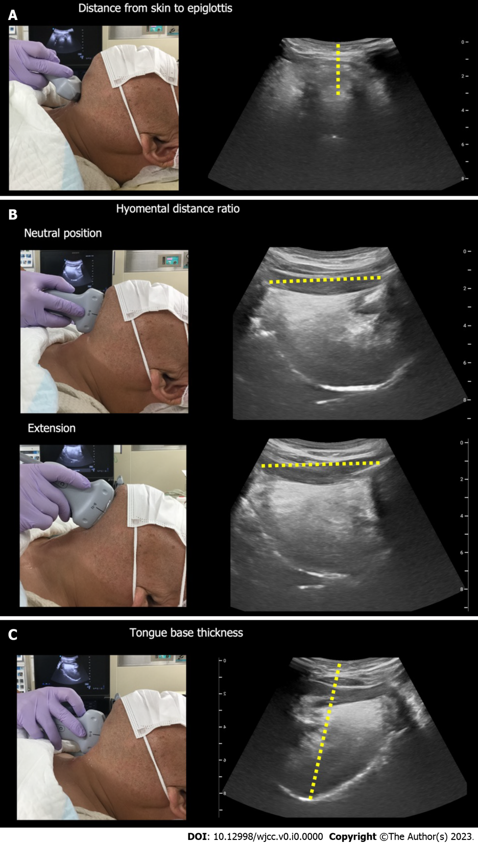
Figure 1 Predicting a difficult airway using airway ultrasound. A: Ultrasound measurement of the distance from skin to epiglottis; B: Ultrasound measurement of the hyomental distance in the neutral and maximal extended neck positions; C: Ultrasound measurement of the distance from skin to tongue base.

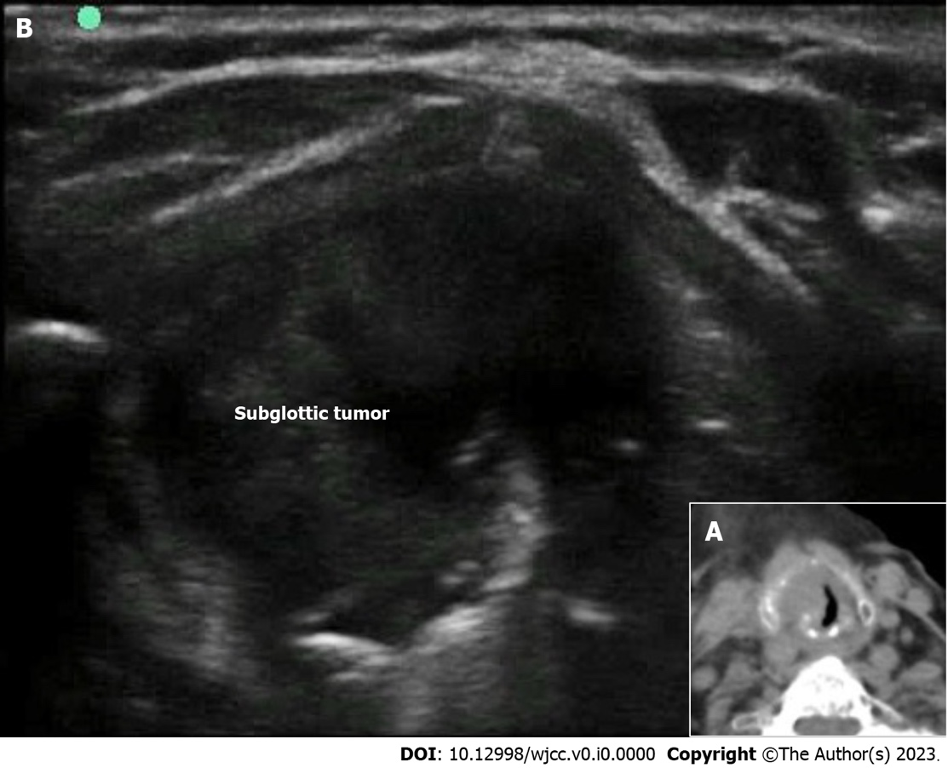

Figure 2 Subglottic tumor (reproduced from Figure 1 of Falcetta et al^{[22]}, with the permission of the copyright holder). A: Transverse image from the computed tomography scan shows a subglottic mass; B: Ultrasound view at the level of the cricothyroid membrane shows a mass (subglottic tumor). Citation: Falcetta S, Cavallo S, Gabbanelli V, Pelaia P, Sorbello M, Zdravkovic I, Donati A. Evaluation of two neck ultrasound measurements as predictors of difficult direct laryngoscopy: A prospective observational study. Eur J Anaesthesiol 2018; 35: 605-612. Copyright© The Authors 2018. Published by Wolters Kluwer. The authors have obtained the permission for figure using (Supplementary material).

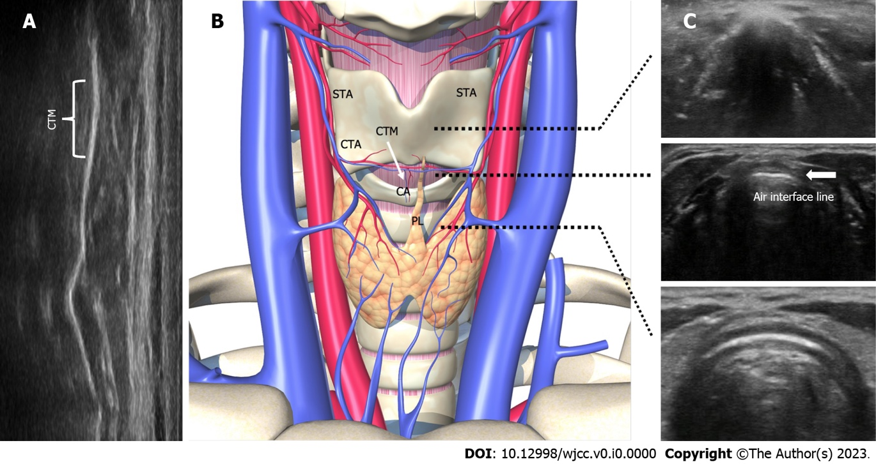
Figure 3 Anatomy and sonographic appearance of the cricothyroid membrane. A: Longitudinal view for identifying the cricothyroid membrane; B: The thyroid, cricoid, and tracheal cartilages are strung together and appear like a string of pearls. Anatomy of the cricothyroid membrane; C: Transverse view for identifying the cricothyroid membrane. Air interface line indicates the cricothyroid membrane. CTM: Cricothyroid membrane; STA: Superior thyroid artery; CTA: Cricothyroid artery; CA: Common artery; PL: Pyramidal lobe of the thyroid gland.

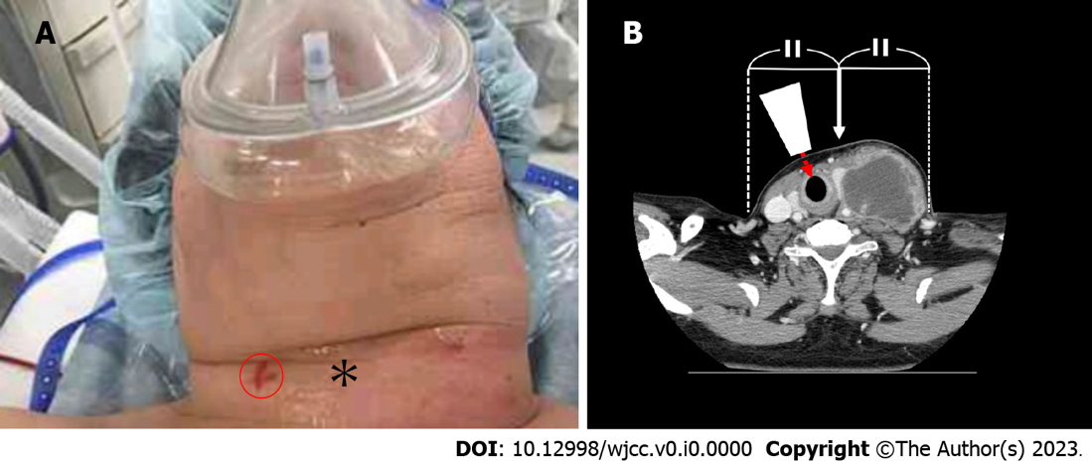
Figure 4 Identification of the cricothyroid membrane by airway ultrasound (reproduced from Figures 1 and 3 of Katayama et al^{[52]}, with the permission of the copyright holder). A: The patient’s neck: The asterisk indicates the area palpated by the surgeon to find the cricothyroid membrane. The red circle shows the cricothyroid membrane identified by ultrasound; B: Cervical computed tomography scan image: The white arrow points to the apparent center of the neck. The true center (sagittal line) of the neck is shifted to the right. The ultrasound probe (white trapezoid) is placed perpendicularly to the skin and the ultrasound beam (red dashed arrow) is directed toward the cricothyroid membrane. Citation: Katayama A, Watanabe K, Tokumine J, Lefor AK, Nakazawa H, Jimbo I, Yorozu T. Cricothyroidotomy needle length is associated with posterior tracheal wall injury: A randomized crossover simulation study (CONSORT). Medicine (Baltimore) 2020; 99: e19331. Copyright© The Authors 2020. Published by MDPI. The authors have obtained the permission for figure using (Supplementary material).

Table 1 Cutoff values for predictors of a difficult airway
Predictor^{[12]} | DDL or DMV | Cutoff value (sensitivity, specificity)
Distance from skin to epiglottis^{[22]} | DDL, DMV | > 2.54 cm (82.0, 91.0)
Hyomental distance ratio^{[23]} (extension/neutral position) | DDL | < 1.085 (75.0, 85.3)
Tongue base thickness | DMV | > 5.87 cm (85.0, 91.0)
DDL: Difficult direct laryngoscopy; DMV: Difficult mask ventilation.

