Name of Journal: World Journal of Clinical Cases
Manuscript NO: 77413
Manuscript Type: CASE REPORT

Alpha-fetoprotein-producing hepatoid adenocarcinoma of the lung responsive to sorafenib after multiline treatment: A case report

Xu SZ et al. Sorafenib treatment for HAL

Su-Zhen Xu, Xiao-Chen Zhang, Qi Jiang, Ming Chen, Meng-Ye He, Peng Shen

Su-Zhen Xu, Xiao-Chen Zhang, Qi Jiang, Ming Chen, Meng-Ye He, Peng Shen, Department of Medical Oncology, The First Affiliated Hospital, Zhejiang University School of Medicine, Hangzhou 310003, Zhejiang Province, China

Author contributions: Xu SZ and Zhang XC contributed equally to the drafting of manuscript and reviewed literature; Jiang Q was involved in planning and supervised the study; Chen M and He MY contributed to clinical data collection and follow-up of the patient; all authors have read and approved the final manuscript.

Corresponding author: Peng Shen, PhD, Chief Doctor, Department of Medical Oncology, The First Affiliated Hospital, Zhejiang University School of Medicine, No. 79 Qingchun Road, Hangzhou 310003, Zhejiang Province, China. shenp@zju.edu.cn

Received: May 3, 2022
Revised: June 29, 2022
Accepted: August 24, 2022
Published online:

Abstract
BACKGROUND
Hepatoid adenocarcinoma of the lung (HAL) is an extremely rare malignant tumor, and many patients with HAL exhibit high levels of alpha-fetoprotein (AFP) expression. Currently, there is no standardized treatment strategy for advanced HAL and its prognosis is poor.

CASE SUMMARY
We report a 55-year-old man with unresectable AFP-related HAL. The largest cross-sectional area of the mass in the upper lobe of the left lung at the beginning of treatment was 8.46 cm × 6.53 cm. The patient’s serum AFP level was 9283 ng/mL. The mass increased in size to 8.86 cm × 8.21 cm after two courses of platinum-based combination chemotherapy and immunotherapy, and serum AFP reached its highest level (71232.2 ng/mL). The patient was treated with sorafenib (400 mg twice daily, per os). Forty days later, the mass was reduced to 5.63 cm × 5.29 cm and serum AFP level dropped to 786.8 ng/mL. The patient achieved partial remission for > 9 mo with sorafenib and an excellent biomarker response, as well as survival > 13 mo, which is among the longest reported for unresectable stage IV HAL.

CONCLUSION
This is the first report to document successful treatment of unresectable AFP-related HAL with single-agent sorafenib after multiline therapy.

Key Words: Hepatoid adenocarcinoma; Lung cancer; Alpha-fetoprotein; Sorafenib; Case report

Xu SZ, Zhang XC, Jiang Q, Chen M, He MY, Shen P. Alpha-fetoprotein-producing hepatoid adenocarcinoma of the lung responsive to sorafenib after multiline treatment: A case report. World J Clin Cases 2022; In press

Core Tip: Hepatoid adenocarcinoma of the lung (HAL) is an extremely rare malignant tumor with poor prognosis and no standardized treatment strategy. To our knowledge, this is the first report to document a patient with unresectable alpha-fetoprotein-related HAL who benefited from single-agent sorafenib after multiline treatment. Sorafenib may be a viable option for inoperable, previously treated, advanced HAL.

INTRODUCTION
Hepatoid adenocarcinoma (HAC) of the lung (HAL) is an extremely rare malignant tumor with a morphology similar to hepatocellular carcinoma (HCC) and high levels of alpha-fetoprotein (AFP) expression in most cases^{[1,2]}. In 1990, Ishikura et al^{[3]} formally defined HAL, which was later described in the form of case reports^{[4,5]}. In 2021, Hou et al^{[1]} published a systematic review of the literature published from 1981 to 2020, summarizing the characteristics of high malignancy, strong invasion, and poor prognosis of HAL. Currently, there is no standardized or effective treatment for advanced HAL. The first option is surgery, followed by chemotherapy and/or radiotherapy. Targeted therapy and immunotherapy have been applied to HAL in recent years^{[6,7]}. Herein, we present a patient with unresectable AFP-related HAL who successfully achieved partial remission (PR) with an excellent biomarker response when treated with sorafenib after failing multiline chemotherapy and immunotherapy. Progression-free survival (PFS) and overall survival (OS) exceeded 9 and 13 mo, respectively.

CASE PRESENTATION
Chief complaints
In March 2021, a 55-year-old man was admitted to a local hospital with the chief complaint of chest pain for four days.

History of present illness
The patient presented with a four-day history of chest pain. On admission, enhanced chest computed tomography (CT) revealed uneven masses on the left upper chest wall, small pleural nodules, and significantly enlarged hilar and mediastinal lymph nodes. Coarse-needle puncture biopsy of the left upper lobe mass revealed a malignant tumor with necrosis. The AFP level was significantly elevated [9283 ng/mL (normal range, 0-20 ng/mL)]. The patient was admitted to our hospital for further pathological confirmation. Pathological consultation following puncture of the left lung mass reported a non-small-cell poorly differentiated carcinoma with neuroendocrine differentiation; and primary lung cancer should be considered after clinical exclusion of HCC metastasis(Figure 1). Immunohistochemical staining results were summarized in Table 1. Ki-67 index was 40%. The patient then underwent another CT-guided percutaneous lung biopsy. Pathological findings from the left lung biopsy specimen were inflammatory cell infiltration with necrosis, and only a few degenerative heteromorphic cells were found. Immunohistochemistry findings were as follows (Figure 2): GPC-3 (+), CK18 (+), AFP (+), CK (Pan) (+), CK5/6 (-), TTF-1 (-), Pax-8 (-), hepatocyte (+), syn (-), P40 (-), P504S (-), PAS (-), and Ki-67 [+ (20%)]. Genetic test results revealed that the driver genes (EGFR, ALK, ROS1, NRAS, BRAF, HER2, KRAS, MET, RET, and PIK3CA) were all wild-type. Furthermore, fluorodeoxyglucose positron emission tomography/CT did not reveal any evidence of hepatic hypermetabolic lesions. Based on these findings, the patient was diagnosed with stage IV AFP-related HAL.

History of past illness
The patient had no previous medical history.

Personal and family history
The patient smoked 70 cigarettes daily for > 20 years. None of the family members had any similar diseases.

Physical examination
The Eastern Cooperative Oncology Group (ECOG) score ranged from 0 to 1, and the numerical pain intensity scale score was 1. Decreased respiratory sounds were heard in the upper left lung.

Laboratory examinations
No obvious abnormalities were found in routine laboratory examinations. The patient’s serum AFP level was 16155.83 ng/mL before treatment (Figure 3).

Imaging examinations
Chest CT revealed a mass, measuring 8.46 cm × 6.53 cm (Figure 4A), on the left upper chest wall, small pleural nodules, and significantly enlarged lymph nodes in the hilar and mediastinum.

FINAL DIAGNOSIS
The final diagnosis in this case was HAL (cT4N3M1a, stage IVA).

TREATMENT
Because the primary lung lesion was surgically unresectable, the patient underwent chemotherapy (albumin-bound paclitaxel plus carboplatin) and immunotherapy (pembrolizumab), both of which are recommended as first-line treatments for non-small cell lung cancer (NSCLC). Plain scan chest CT after two cycles of therapy revealed a huge subpleural mass (8.81 cm × 7.66 cm) in the upper lobe of the left lung, which was larger than that before treatment (8.46 cm × 6.53 cm) (Figure 4B). His serum AFP level increased to an abnormal level (63574.66 ng/mL) (Figure 3). Due to poor treatment outcomes, it was decided to switch to second-line chemotherapy (gemcitabine plus oxaliplatin) and continue immunotherapy (pembrolizumab). However, the mass increased to 8.86 cm × 8.21 cm in size (Figure 4C), and serum AFP reached its highest level (71232.2 ng/mL) (Figure 3). Sorafenib was then administered as a third-line therapy (400 mg orally twice daily). Forty days later, chest CT revealed significant reduction in the size of the subpleural mass (5.63 cm × 5.29 cm) (Figure 4D) and a decrease in serum AFP to 786.8 ng/mL (Figure 3).

OUTCOME AND FOLLOW-UP
The patient successfully achieved sustained PR after oral administration of sorafenib for 4 mo and 7 mo (Figure 4E and F). However, he simultaneously developed grade II hand-foot syndrome (Figure 5); therefore, sorafenib was reduced to 400 mg once daily. At the time of manuscript submission, the patient had been on sorafenib maintenance for > 9 mo, and the OS had exceeded 13 mo, while maintaining an ECOG performance status of 0 to 1.

DISCUSSION
HAC is an invasive extrahepatic tumor that resembles HCC in morphology, but is an uncommon clinical entity. Metzgeroth et al^{[8]} summarized data from 261 cases of HAC in 2010^{[8]}. The stomach (63%), ovary (10%), lungs (5%), gallbladder (4%), pancreas (4%), and uterus (4%) were the most common disease sites. HAL is a rare primary adenocarcinoma of the lung that contains hepatocytes and can be associated with elevated AFP levels^{[1,2]}. Haninger et al^{[9]} modified the diagnostic criteria for HAL in 2014, which are currently described as follows: HAL can be a simple HAC, but it can also be typical acinar or papillary adenocarcinoma, signet ring cell carcinoma, or neuroendocrine carcinoma. Positive expression of liver differentiation markers and AFP is not required for diagnosis and it has morphological characteristics of hepatocytes^{[9]}.
Reviews summarizing the characteristics of HAL have been published^{[1,2]}. HAL is an aggressive tumor with no standard treatment and a poor prognosis. HAL has a reported median OS (mOS) of 14-18 mo. Patient one-, two-, three-, and five-year OS rates were reported to be approximately 40.0%, 35.3%, 35.0%, and 8%-19%, respectively^{[1,2]}. Patients who used a surgery-based strategy, chemotherapy-based strategy, or another strategy had different prognoses; the one-year OS rates were 53%, 30%, and 0%, respectively^{[2]}. The median survival for patients with unresectable HAL ranges from 6 to 11 mo^{[1]}; overall, however, the prognosis of HAL is poor. Additionally, surgery is a significant prognostic factor for HAL, and is the primary treatment for patients with stages I-III disease. On the other hand, stage IV patients are primarily treated with chemotherapy and radiotherapy. The use of targeted therapy and immunotherapy for HAL has recently increased^{[6,7]}.
Because HAC is morphologically similar to HCC, we suspect that HCC treatment is also effective for HAC. The Sorafenib Hepatocellular Carcinoma Assessment Randomized Protocol (SHARP) trial found that, as a first-line standard treatment, sorafenib can improve the prognosis of HCC patients^{[10]}. The sorafenib and placebo groups experienced mOS of 10.7 mo and 7.9 mo, mPFS of 5.5 mo and 2.8 mon, and one-year survival rates of 44% and 33%, respectively. Furthermore, oral sorafenib has been used to treat some HAC cases^{[6,8,11]}. One patient with peritoneal HAC treated with sorafenib after first-line chemotherapy experienced two months of clinical stability^{[8]}. A rare case of metastatic pancreatic HAC treated with sorafenib resulted in PFS > 7 mo^{[11]}. Furthermore, Gavrancic et al^{[6]} reported that sorafenib combined with platinum-based doublet chemotherapy resulted in a partial response and sorafenib monotherapy led to stable disease in AFP-related EGFR wild-type HAL. Therefore, the patient survived for an additional 11 mo.
In contrast, HAL is a type of NSCLC; moreover, some studies have attempted to use sorafenib for the treatment of NSCLC. In a phase II, single-arm, multicenter study involving 51 patients with relapsed or refractory advanced NSCLC, the mPFS was 2.7 mo and the mOS was 6.7 mo, stable disease was achieved in 30 (59%) patients who had a mPFS of 5.5 mo, and tumor shrinkage was observed in 15 (29%) patients^{[12]}. After receiving sorafenib for two months, patients were randomly assigned to the sorafenib group or placebo group if they had stable disease in a double-blind randomized, discontinuation, phase II study (ECOG 2501) of sorafenib vs placebo in previously treated NSCLC^{[13]}. The disease control rate in sorafenib group was significantly higher than in the placebo group (47% vs 19%; P = 0.01), and the mPFS (3.6 mo vs 1.9 mo; P = 0.01) was also significantly higher in the sorafenib group (3.6 mo vs 1.9 mo; P = 0.01). Furthermore, a phase III, multicenter, placebo-controlled trial of sorafenib in patients with relapsed or refractory advanced NSCLC after two or three lines of treatment (MISSION), failed to demonstrate that sorafenib improved OS (8.2 mo vs 8.3 mo; P = 0.47) for NSCLC, but increased PFS (2.8 mo vs 1.4 mo; P < 0.0001)^{[14]}.
Sorafenib was chosen to treat a patient with unresectable AFP-related HAL which had progressed on two lines of chemotherapy and immunotherapy after reviewing all reported cases and studying the above trials. In the present case, the patient developed grade II hand-foot syndrome and tolerated sorafenib 400 mg once daily. Subsequently, the patient successfully achieved PR with an excellent biomarker response, the PFS is already > 9 mo and the OS is > 13 mo, which is among the longest reported for inoperable stage IV HAL.

CONCLUSION
Results of this study suggest that systematic therapeutic drugs for primary liver cancer, such as sorafenib, could be viable treatment options for previously treated advanced HAL. Nevertheless, accumulation of more data from more cases and enriched treatment methods to improve the poor prognosis of HAL are needed.

ACKNOWLEDGEMENTS
We would like to thank the patient for providing written informed consent for publication of this report and all research staff involved in this case study.

REFERENCES
1 Hou Z, Xie J, Zhang L, Dai G, Chen Y, He L. Hepatoid Adenocarcinoma of the Lung: A Systematic Review of the Literature From 1981 to 2020. Front Oncol 2021; 11: 702216 [PMID: 34422656 DOI: 10.3389/fonc.2021.702216]
2 Mao JX, Liu C, Zhao YY, Ding GS, Ma JQ, Teng F, Guo WY. Merged hepatopulmonary features in hepatoid adenocarcinoma of the lung: a systematic review. Am J Transl Res 2021; 13: 898-922 [PMID: 33841629]
3 Ishikura H, Kanda M, Ito M, Nosaka K, Mizuno K. Hepatoid adenocarcinoma: a distinctive histological subtype of alpha-fetoprotein-producing lung carcinoma. Virchows Arch A Pathol Anat Histopathol 1990; 417: 73-80 [PMID: 1694332 DOI: 10.1007/BF01600112]
4 Papatsimpas G, Kamposioras K, Goula K, Papaparaskeva K, Loukides S, Kotoulas C, Kelekis N, Xiros N, Pectasides D, Koumarianou A. Hepatoid pancoast tumor. A case report and review of the literature. Lung Cancer 2012; 77: 239-245 [PMID: 22677427 DOI: 10.1016/j.lungcan.2012.05.102]
5 Hayashi Y, Takanashi Y, Ohsawa H, Ishii H, Nakatani Y. Hepatoid adenocarcinoma in the lung. Lung Cancer 2002; 38: 211-214 [PMID: 12399135 DOI: 10.1016/s0169-5002(02)00214-3]
6 Gavrancic T, Park YH. A novel approach using sorafenib in alpha fetoprotein-producing hepatoid adenocarcinoma of the lung. J Natl Compr Canc Netw 2015; 13: 387-91; quiz 391 [PMID: 25870375 DOI: 10.6004/jnccn.2015.0054]
7 Chen L, Han X, Gao Y, Zhao Q, Wang Y, Jiang Y, Liu S, Wu X, Miao L. Anti-PD-1 Therapy Achieved Disease Control After Multiline Chemotherapy in Unresectable KRAS-Positive Hepatoid Lung Adenocarcinoma: A Case Report and Literature Review. Onco Targets Ther 2020; 13: 4359-4364 [PMID: 32547068 DOI: 10.2147/OTT.S248226]
8 Metzgeroth G, Ströbel P, Baumbusch T, Reiter A, Hastka J. Hepatoid adenocarcinoma - review of the literature illustrated by a rare case originating in the peritoneal cavity. Onkologie 2010; 33: 263-269 [PMID: 20502062 DOI: 10.1159/000305717]
9 Haninger DM, Kloecker GH, Bousamra Ii M, Nowacki MR, Slone SP. Hepatoid adenocarcinoma of the lung: report of five cases and review of the literature. Mod Pathol 2014; 27: 535-542 [PMID: 24030743 DOI: 10.1038/modpathol.2013.170]
10 Llovet JM, Ricci S, Mazzaferro V, Hilgard P, Gane E, Blanc JF, de Oliveira AC, Santoro A, Raoul JL, Forner A, Schwartz M, Porta C, Zeuzem S, Bolondi L, Greten TF, Galle PR, Seitz JF, Borbath I, Häussinger D, Giannaris T, Shan M, Moscovici M, Voliotis D, Bruix J; SHARP Investigators Study Group. Sorafenib in advanced hepatocellular carcinoma. N Engl J Med 2008; 359: 378-390 [PMID: 18650514 DOI: 10.1056/NEJMoa0708857]
11 Petrelli F, Ghilardi M, Colombo S, Stringhi E, Barbara C, Cabiddu M, Elia S, Corti D, Barni S. A rare case of metastatic pancreatic hepatoid carcinoma treated with sorafenib. J Gastrointest Cancer 2012; 43: 97-102 [PMID: 21365478 DOI: 10.1007/s12029-011-9264-2]
12 Blumenschein GR Jr, Gatzemeier U, Fossella F, Stewart DJ, Cupit L, Cihon F, O'Leary J, Reck M. Phase II, multicenter, uncontrolled trial of single-agent sorafenib in patients with relapsed or refractory, advanced non-small-cell lung cancer. J Clin Oncol 2009; 27: 4274-4280 [PMID: 19652055 DOI: 10.1200/JCO.2009.22.0541]
13 Wakelee HA, Lee JW, Hanna NH, Traynor AM, Carbone DP, Schiller JH. A double-blind randomized discontinuation phase-II study of sorafenib (BAY 43-9006) in previously treated non-small-cell lung cancer patients: eastern cooperative oncology group study E2501. J Thorac Oncol 2012; 7: 1574-1582 [PMID: 22982658 DOI: 10.1097/JTO.0b013e31826149ba]
14 Paz-Ares L, Hirsh V, Zhang L, de Marinis F, Yang JC, Wakelee HA, Seto T, Wu YL, Novello S, Juhász E, Arén O, Sun Y, Schmelter T, Ong TJ, Peña C, Smit EF, Mok TS. Monotherapy Administration of Sorafenib in Patients With Non-Small Cell Lung Cancer (MISSION) Trial: A Phase III, Multicenter, Placebo-Controlled Trial of Sorafenib in Patients with Relapsed or Refractory Predominantly Nonsquamous Non-Small-Cell Lung Cancer after 2 or 3 Previous Treatment Regimens. J Thorac Oncol 2015; 10: 1745-1753 [PMID: 26743856 DOI: 10.1097/JTO.0000000000000693]

Footnotes
Informed consent statement: Informed written consent was obtained from the patients for the publication of this report and any accompanying images.

Conflict-of-interest statement: The authors declare that they have no conflict of interest.

CARE Checklist (2016) statement: The authors have read the CARE Checklist (2016), and the manuscript was prepared and revised according to the CARE Checklist (2016).

Open-Access: This article is an open-access article that was selected by an in-house editor and fully peer-reviewed by external reviewers. It is distributed in accordance with the Creative Commons Attribution NonCommercial (CC BY-NC 4.0) license, which permits others to distribute, remix, adapt, build upon this work non-commercially, and license their derivative works on different terms, provided the original work is properly cited and the use is non-commercial. See: https://creativecommons.org/Licenses/by-nc/4.0/

Provenance and peer review: Unsolicited article; Externally peer reviewed.
Peer-review model: Single blind

Peer-review started: May 3, 2022
First decision: June 16, 2022
Article in press:

Specialty type: Oncology
Country/Territory of origin: China
Peer-review report’s scientific quality classification
Grade A (Excellent): 0
Grade B (Very good): B
Grade C (Good): C
Grade D (Fair): 0
Grade E (Poor): 0

P-Reviewer: Kai K, Japan; Leowattana W, Thailand S-Editor: Chen YL L-Editor: Ma JY-MedE P-Editor: Chen YL

Figure Legends
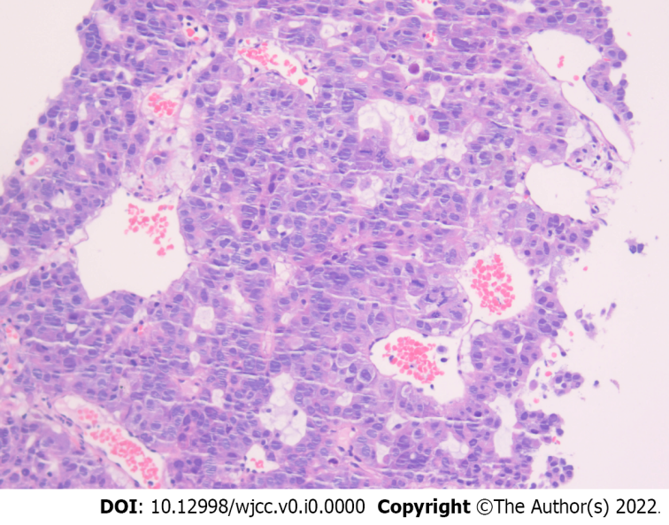
Figure 1 Ultrasound guided coarse-needle puncture biopsy of the left upper lobe mass showed non-small-cell poorly differentiated carcinoma with neuroendocrine differentiation.

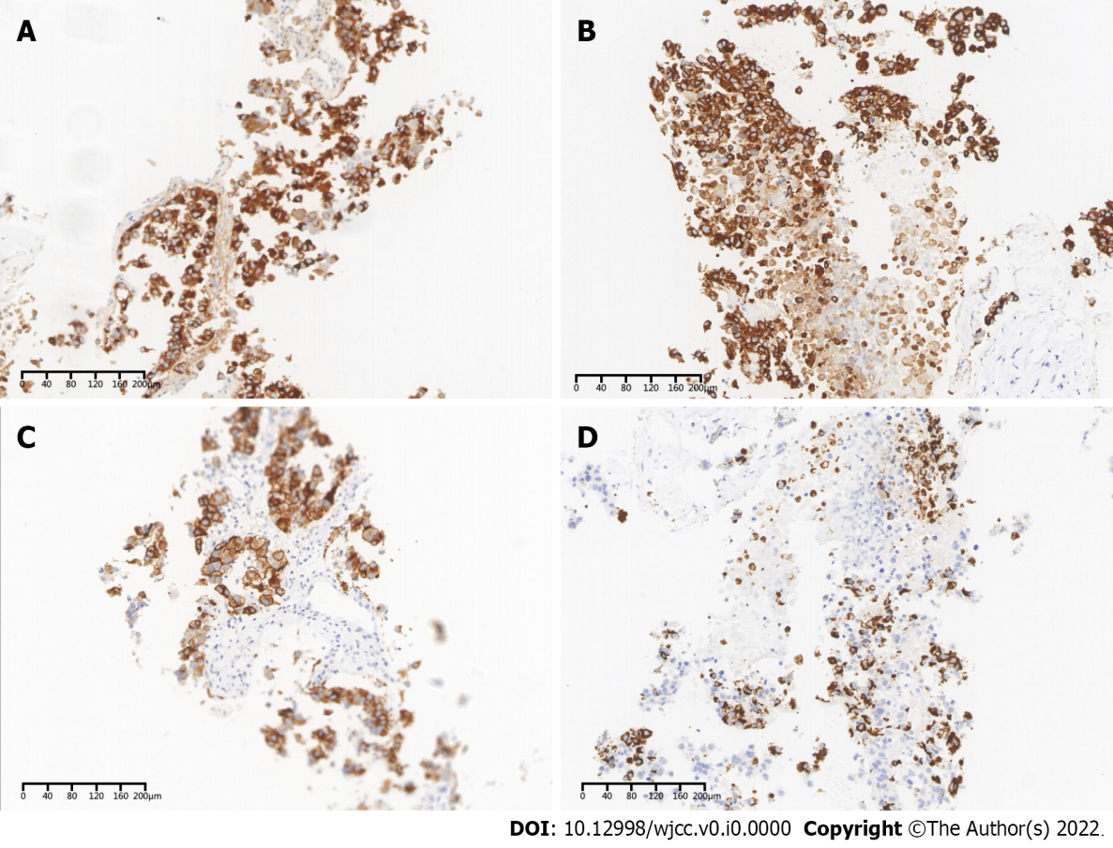
Figure 2 Second immunohistochemical staining analysis on patient’s tumor tissue. A: Alpha-fetoprotein; B: CK18; C: GPC-3; D: Hepatocyte.

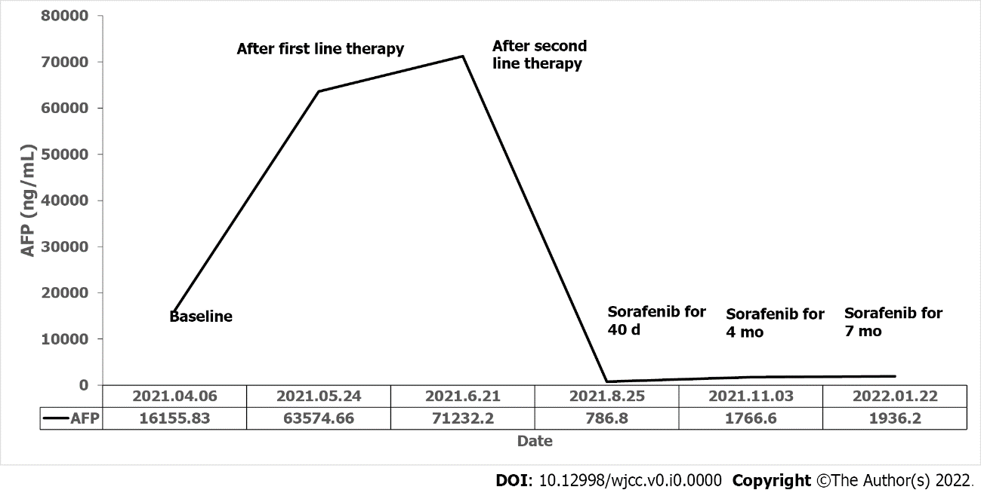
Figure 3 Trend of serum alpha-fetoprotein level during the clinical course.

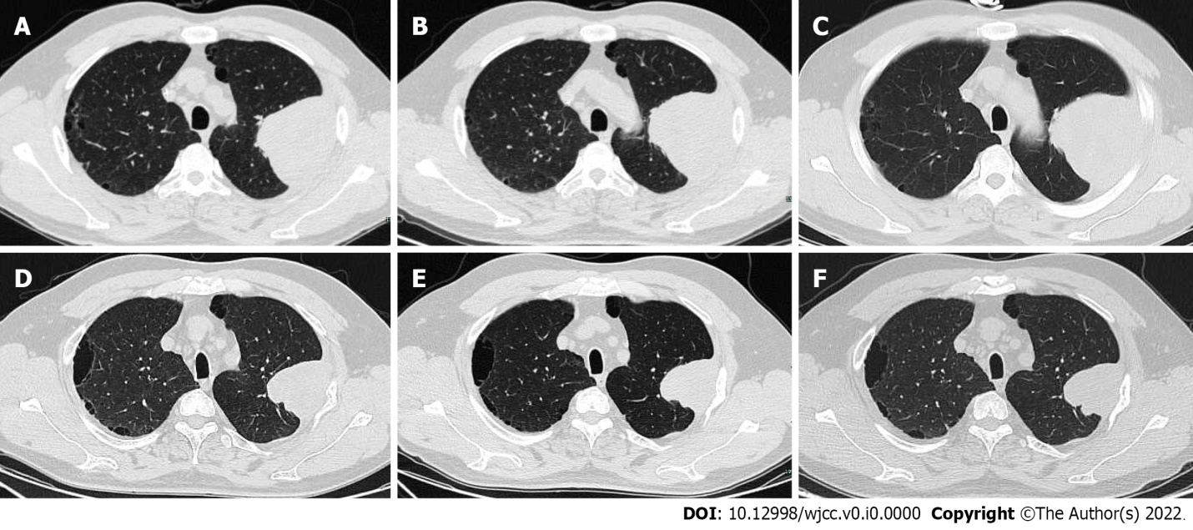
Figure 4 Lung window views of chest-computed tomography scans showed tumor mass at different stages of the disease. A: Baseline scan revealed a 8.46 cm × 6.53 cm mass on the left upper chest wall; B: The computed tomography (CT) scan after first-line therapy showed that the mass increased to 8.81 cm × 7.66 cm; C: The CT scan after second-line therapy showed that the mass increased to 8.86 cm × 8.21 cm; D: After treatment with sorafenib monotherapy for 40 d, the CT revealed a marked decrease in the size of the huge subpleural mass (5.63 cm × 5.29 cm); E and F: The CT showed that the mass still decreased after sorafenib monotherapy for 4 mo (5.08 cm × 4.89 cm) and 7 mo (4.95 cm × 4.69 cm).

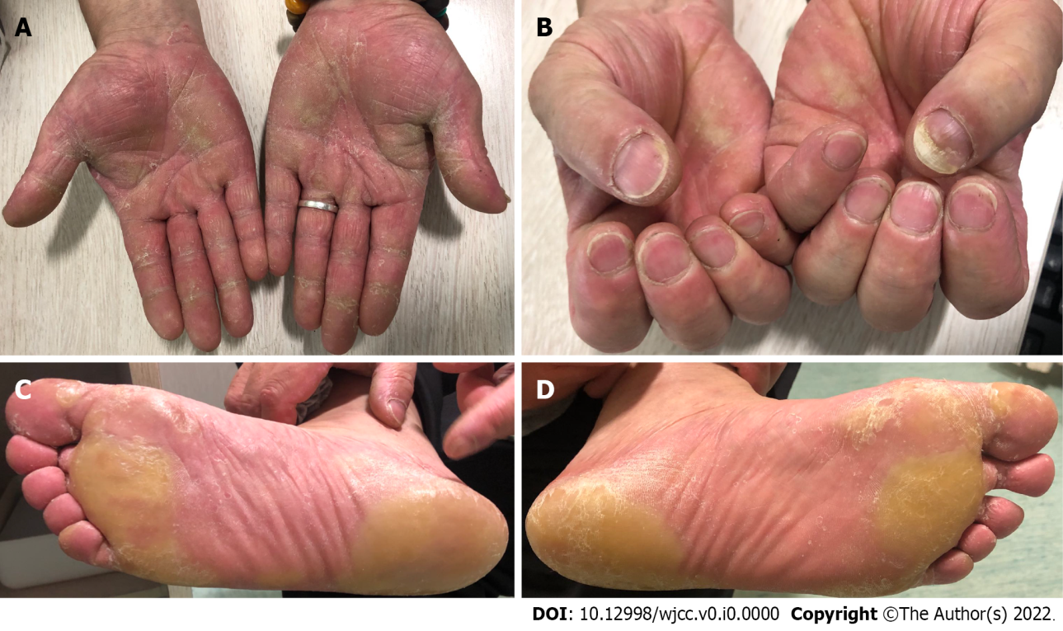
Figure 5 The patient developed grade II hand foot syndrome. A: Palms of both hands; B: Fingernails of both hands; C: Sole of right foot; D: Sole of left foot.

Table 1 Results of immunohistochemical staining analysis on patient’s tumor tissue
Immunohistochemical markers | Results
CAM5.2, SYN, CK18, CK8 | Strongly positive
AFP, P16, CK, GPC-3 | Focally positive
NSE, CD56, VM, PLAP, CD5, CD117, WT1, D2-40, CR, CD34, CD56, CgA, SOX-1, CK5/6, P63, P53, HEP, TTF-1, NapsinA, CK20, CK7 | Negative
AFP: Alpha-fetoprotein.

