Name of Journal: World Journal of Clinical Cases
Manuscript NO: 71692
Manuscript Type: CASE REPORT

Myomatous erythrocytosis syndrome: A case report

Shu XY et al. Myomatous erythrocytosis syndrome

Xin-Yu Shu, Na Chen, Bi-Yun Chen, Hui-Xia Yang, Hui Bi

Xin-Yu Shu, Bi-Yun Chen, Hui-Xia Yang, Hui Bi, Department of Obstetrics and Gynaecology, Peking University First Hospital, Beijing 100034, China

Na Chen, Department of Obstetrics and Gynaecology, The Hospital of Cang Town, Cangzhou 223900, Hebei Province, China

Author contributions: Shu XY wrote the manuscript; Chen N was involved in the acquisition of the data; Chen BY participated in manuscript writing; Yang HX revised the manuscript; Bi H performed the operation and revised the manuscript critically for important intellectual content; and all authors have read and approved the final manuscript.

Corresponding author: Hui Bi, MD, Chief Doctor, Department of Obstetrics and Gynaecology, Peking University First Hospital, Xishiku Street, Beijing 100034, China. bihuipku@163.com

Received: October 1, 2021
Revised: January 20, 2022
Accepted: February 23, 2022
Published online:

Abstract
BACKGROUND
Uterine myoma is the most common benign tumor among women and is often accompanied by anemia. Here, we report the case of a patient with a very large leiomyoma but with a hemoglobin level as high as 197 g/L. After undergoing hysterectomy, all her hematological parameters returned to normal. Immunohistochemical staining of her myoma for erythropoietin showed strong positivity, which suggested that erythropoietin may be the cause of her erythrocytosis. A multidisciplinary team played a significant role in treating the disease.

CASE SUMMARY
A 47-year-old woman visited our department complaining that her abdomen had been continuously growing for the past 2 years. After careful examinations, she was suspected of having a very large leiomyoma. She was also diagnosed with erythrocytosis because her RBC count was 6.49 × 10¹²/L, hemoglobin was 197 g/L. Following a multidisciplinary team consultation, bilateral ureteral stents were placed, and 800 mL blood was removed by phlebotomy. The patient then underwent hysterectomy and bilateral salpingectomy. She recovered well from the operation, and her hemoglobin level decreased sharply following the surgery. Low-molecular-weight heparin was administered daily to prevent postoperative thrombosis. She was discharged from the hospital on the fourth postoperative day. Two months later, all her hematological parameters returned to normal. Pathological analysis of the myoma revealed that it was a benign leiomyoma, with partial hyalinization, and strong positivity for erythropoietin in immunohistochemical staining suggested that erythropoietin may be responsible for the erythrocytosis.

CONCLUSION
Erythropoietin ectopically produced from the myoma was responsible for the erythrocytosis in this patient. A multidisciplinary team is strongly recommended.

Key Words: Myomatous erythrocytosis syndrome; Erythrocytosis; Uterine myoma; Erythropoietin; Multiple disciplinary team; Case report

Shu XY, Chen N, Chen BY, Yang HX, Bi H. Myomatous erythrocytosis syndrome: A case report. World J Clin Cases 2022; In press

Core Tip: Despite chronic lung disease and malignant tumors, uterine myoma can also be the cause of secondary erythrocytosis, the mechanisms of which may be ectopically produced erythropoietin originating from the leiomyoma. A multidisciplinary team is strongly recommended to ensure that the patient has received the optimal treatment and has a good prognosis.
INTRODUCTION
Myoma is the most common benign tumor in the female reproductive system and is often accompanied by anemia but seldom by erythrocytosis. When a patient presents extraordinarily high levels of RBCs, hemoglobin (Hb), or hematocrit (Hct) in routine blood tests, myomatous erythrocytosis syndrome (MES) is indicated, which is a very rare type of secondary erythrocytosis, the occurrence of which is only 0.02%-0.5%^{[1]}. Since Thomson and Marson^{[2]} reported the first case in 1953, only approximately 50 cases have been published worldwide. The diagnostic criteria include (1) Erythrocytosis; (2) Uterine fibroid myoma; and (3) The normalization of the RBC count after surgical removal of the myoma^{[3]}. Here, we report a patient with a large myoma as well as an Hb level as high as 197 g/L, and all of her hematological parameters decreased immediately after hysterectomy. With the immunochemical staining of her myoma for erythropoietin showing strong positivity, we believe that the ectopically produced erythropoietin (EPO) was responsible for her erythrocytosis. The importance of a multidisciplinary team (MDT) cannot be neglected in treating the disease.

CASE PRESENTATION
Chief complaints
A 47-year-old premenopausal nulliparous woman visited our hospital, complaining that her abdomen had been growing in size over the past 2 years.

History of present illness
The patient had a history of myoma more than 20 years previously. At first presentation, the myoma measured 2-3 cm in diameter, but it continued to grow yearly. Six years ago, the myoma had grown to 8 cm, but the patient did not have any symptoms, including abnormal uterine bleeding or frequent micturition, and she refused to undergo surgery at that time. She claimed that her abdomen had grown over the past 2 years, but she thought that she was just gaining weight, so she decided to diet and exercise and lost more than 5 kg within 2 years. Despite these efforts, her abdomen continued to grow, which raised her family’s concern, so she finally visited our hospital.

History of past illness
Her past medical history was unremarkable, and she denied having any history of systemic diseases or allergies. She claimed to have a normal routine blood test 2 years ago, but she had not been reexamined since.

Personal and family history
The patient was gravida 0, para 0, and reported a regular menstrual cycle, with no family history of tumors or chronic diseases. She is an illustrator.

Physical examination
Her height was 163 cm, and her weight was 53 kg (body mass index 19.95 kg/m²). She looked as if she was carrying a full-term fetus. A very large mass was observed rising from the pelvis to the xiphoid, which was hard in texture.

Laboratory examinations
Her routine blood test showed that her Hb was 197 g/L, her RBC count was 6.49 × 10¹²/L, and her Hct was 58.2%.

Imaging examinations
Gynecological ultrasound revealed a very large mass originating from the posterior wall of the uterus, which was more than 35 cm in diameter, with only slight venous vascularity on color flow imaging, suggesting a uterine myoma. The enhanced CT showed a similar result. Right-sided hydronephrosis (1.6 cm in width) was also noted on ultrasound.

FINAL DIAGNOSIS
The patient was diagnosed with a giant uterine leiomyoma and erythrocytosis.

TREATMENT
After careful consultation with an MDT consisting of experienced gynecologists, urologists, anesthesiologists, hematologists, and doctors from the blood transfusion department, transabdominal hysterectomy and bilateral salpingectomy were scheduled. Two days before surgery, bilateral ureteral stents were placed through a cystoscope to ensure the safety of the operation. To minimize the risk of thrombosis, 800 mL blood was removed by phlebotomy before the operation, and 2500 mL normal saline and 500 mL colloid were transfused back into her vein. The first pack of blood was dark brown, while the second pack was dark red (Figure 1). The surgery was difficult but successful, with a blood loss of 200 mL, and the operation lasted 112 min.

OUTCOME AND FOLLOW-UP
The whole uterus weighed 6500 g, with the largest diameter of 35 cm (Figure 2A and B). The pathology revealed a benign uterine leiomyoma with partial hyalinization that originated from the posterior wall of the uterus, and there were no signs of malignancy. Immunohistochemical staining of the myoma of this patient for EPO (ABclonal Technology, China) was compared with that of 2 other large myomas from patients without erythrocytosis as controls. Although three myomas were positive for EPO, but the myoma of this patient showed a stronger positivity than the others (Figure 2C and D).
On the first day after surgery, her RBC count decreased to 5.43 × 10¹²/L, her Hb was 166 g/L, and her Hct was 49.5%. She was encouraged to get out of bed and walk on the first day after surgery, and low-molecular-weight heparin (0.4 mL) was administered daily to prevent thrombosis. She was discharged from the hospital 4 d after surgery and was instructed to continue injecting low-molecular-weight heparin for another 10 d. After 2 mo, all of her hematological parameters returned to normal, with an RBC count of 4.36 × 10¹²/L, an Hb of 129 g/L and an Hct of 38.8%. She was pleased with the outcome and was instructed to undergo routine blood tests regularly. The changes in her hematological parameters are shown in Figure 3.

DISCUSSION
Secondary erythrocytosis is a condition where excessive production of RBCs occurs outside the bone marrow. Secondary erythrocytosis is defined as an elevated Hb of 165 g/L and above or an Hct of 48% and above in females^{[4]}. Etiology includes low oxygen conditions such as living at high altitude, chronic lung diseases, or malignant tumors such as renal cell carcinoma, hepatocellular carcinoma, or cerebellar hemangioblastoma. Under rare conditions, secondary erythrocytosis can originate from benign tumors, such as uterine myoma^{[4]}, which is called myomatous erythrocytosis syndrome. As myoma may cause abnormal uterine bleeding, which leads to fluctuations in hemodynamics such as anemia, the actual occurrence of MES may be higher than reported^{[5,6]}.
Recently, Mui et al^{[5]} reported a case of MES and summarized all 55 previous similar cases. In his study, the mean age at presentation was 48.7 ± 12.3 years, and there was no difference in parity or menopausal status among the patients in the reported cases. The most common symptom was abdominopelvic distension or a mass (93%); myomas weighed 4.9 ± 3.6 kg on average and were 22.6 ± 10 cm in length. However, some small myomas can also cause MES; for instance, the uterus can weigh approximately 1000 g^{[7-9]}.
The mechanism of MES is complex and has not been elucidated. In 1955, Horwitz and McKelway^{[10]} first showed that an arteriovenous shunt was responsible for excessive RBCs and that deoxygenated arteries may stimulate the marrow to generate more RBCs as compensation. However, this notion was rebuked since peripheral arteriovenous fistulas may only increase focal RBCs rather than affect all hemodynamic parameters^{[3]}. Subsequently, the compression theory was proposed, arguing that either the renal parenchyma or the diaphragm was compressed by the large myoma, which caused additional EPO production^{[11,12]}. However, these theories were rejected, as compression symptoms, such as hydronephrosis or dyspnea, were not always seen^{[1]}.
To date, the prevailing view is that uncontrolled ectopically produced EPO is responsible for the overproduction of RBCs^{[7,13-15]}. EPO is a hematopoietic cytokine that is usually produced in the kidneys of adults^{[4]}. EPO acts on progenitor RBCs via the stimulation of cell growth, differentiation, and antiapoptotic factors and interacts with its receptor (EPO-R), which is commonly expressed in erythroid cells, and together they regulate the formation of RBCs during the process of hematopoiesis^{[16]}. Under pathologic conditions, EPO can also be generated ectopically in ischemic tissue, in the retinopathy protection process and in tumor promotion, whereas EPO-R can also be expressed outside RBCs, such as in the endothelial cells of the vascular tissue of embryos and cancer cells, participating in angiogenesis^{[16,17]}. In 2002, Yasuda et al^{[18]} showed that in female reproductive malignant tumors, both the mRNA and protein of EPO are expressed, with EPO-R also expressed in the capillary endothelium of the tumor, suggesting that a paracrine and autocrine loop of EPO and EPO-R may exist and contribute to tumorigenesis. Similar results have been demonstrated in leiomyoma patients. In 1999, Yoshida et al^{[19]} found that the EPO level from the myoma was extremely high. Kohama et al^{[13]} and Suzuki et al^{[20]} later proved that EPO mRNA was also strongly expressed in these patients. However, in myomas without erythrocytosis, the expression of EPO was weaker^{[8]}. This is in accordance with our findings as well as those of Pollio et al^{[14]}, who studied a control group of 16 myoma patients without erythrocytosis (half of whom were pregnant women). By comparing the immunohistochemical expression of EPO and EPO-R, Pollio et al^{[14]} found that in addition to strong expression of EPO and EPO-R in the case group (MES in a pregnant woman), EPO was also moderately or weakly expressed in all 8 pregnant control patients, and EPO-R was weakly expressed in 6 patients. In the nonpregnant control patients, although the expression of EPO and EPO-R was also observed, the frequency and intensity were much lower (4/8 with weak EPO expression and 3/8 with weak EPO-R expression). The author then pointed out that EPO was exclusively localized within the cytoplasm of uterine smooth muscles, whereas EPO-R was almost entirely localized within the vascular endothelial cells, in both the case and the control groups^{[14]}, proving that this autocrine or paracrine mechanism may exist, stimulating myoma cell growth, stabilizing vascular integrity, increasing the number of epithelial cells, protecting them against ischemia and apoptosis, and thus contributing to the unusual size of the myoma^{[15,16]}. According to our findings, we also believe that the EPO produced by the uterine myoma is the cause of the excessive RBCs in the blood system, and the level of erythrocytosis is related to the amount of EPO. Notably, even with the prevailing theory, the EPO level of the myoma may still be normal in some patients. Macciò et al^{[21]} reported the case of a patient with MES with a uterus weighing 5400 g and a high serum EPO level (45 mIU/mL, normal: 0-29 mIU/mL), but surprisingly, the EPO level in the myoma tissue was similar to that in the control samples (1.5 mIU/mg and 1 mIU/mg). The author attributed this to the physiological obstacle preventing the oxygenation of the blood due to the compression of the large uterus, which suggests that some other mechanisms may also exist in this syndrome.
It is important to differentiate MES from polycythemia vera (PCV), a primary erythrocytosis, which is a myeloproliferative neoplasm. PCV is also characterized by elevated RBC, Hb and Hct levels, 98% of which is due to Janus kinase 2 genetic mutation but more notably presents a lower serum EPO level, unlike in MES^{[22]}. In the case of the patient presented here, although screening for Janus kinase 2 gene mutations was not performed, with the sharp decrease in RBC, Hb, and Hct levels after the removal of the myoma together with the EPO immunohistochemistry results, we have reason to believe that it was MES rather PCV that caused erythrocytosis.
As erythrocytosis is a leading cause of thrombotic diseases^{[4,23]}, anticoagulation is essential in the perioperative period. Common treatment includes physical therapy, such as pneumatic compression stockings, and preventive medicine, such as acetylsalicylic acid (75-81 mg/d), hydroxyurea (500 mg/d), and fondaparinux (2.5 mg/d)^{[5,24,25]}. Moreover, phlebotomy is also used, especially when Hct is above 55%, the frequency of which was reported to range from every two days to twice a week, to minimize the risk of thrombosis, embolization, and other cardiovascular complications^{[5,25,26]}, and the average amount of blood removed is 1.8 ± 1.2 L^{[5]}. Normovolemic hemodilution is also helpful in preventing massive bleeding during surgery.
Since leiomyomas are often very large and sometimes cause hydronephrosis, bilateral ureteral stents are often used on such occasions to avoid urinary injuries^{[5]}. Gonadotropin-releasing hormone agonists have also been used in several reports, for instance, to induce amenorrhea while waiting for elective surgery^{[25]} or to decrease estradiol levels and to reduce blood loss^{[13]}; however, they do not reduce the size of the myoma.
The strength of our study is that we not only comprehensively presented this rare case but also attempted to discover the underlying mechanisms of MES via immunohistological analysis of the myomas of this patient and other myoma patients. Furthermore, we are the first to stress the importance of an MDT, and with joint efforts, we successfully completed the surgery without any complications. However, the lack of EPO results in the serum test is one limitation of our study, as the findings would be more convincing if we had quantitatively measured and compared the EPO levels of this patient with those of the other reported patients and performed immunohistochemical staining for EPO-R at the same time. The current findings support the prevailing view that EPO overproduction in the myoma is the cause of the excessive RBCs in the blood system.

CONCLUSION
MES is a rare disease of erythrocytosis secondary to uterine myoma. It is believed that the uncontrolled ectopic production of EPO from the myoma and EPO-R from the vascular endothelium together via an autocrine and paracrine loop contributed to erythrocytosis and resulted in the overgrowth of the myoma. The cooperation of the multidisciplinary team was the key to the thorough evaluation and ensured successful treatment. In the future, EPO/EPO-R inhibitors may be a potential therapy, especially in the preoperative period, or serve as a conservative treatment.

ACKNOWLEDGEMENTS
The author thanks Hong-Bo Su for her pathological assistance in this study.

REFERENCES
1 LevGur M, Levie MD. The myomatous erythrocytosis syndrome: a review. Obstet Gynecol 1995; 86: 1026-1030 [PMID: 7501327 DOI: 10.1016/0029-7844(95)00292-y]
2 Thomson AP, Marson FB. Polycythemia with fibroids. Lancet 1953; 262: 759-760 [DOI: 10.1016/S0140-6736(53)91456-1]
3 Fleming AR, Markley JC. Polycythemia associated with uterine myomas. Am J Obstet Gynecol 1957; 74: 677-679 [PMID: 13458274 DOI: 10.1016/0002-9378(57)90528-8]
4 McMullin MF. Secondary erythrocytosis. Hematology 2014; 19: 183-184 [PMID: 24624893 DOI: 10.1179/1024533214Z.000000000263]
5 Mui J, Yang MMH, Cohen T, McDonald DI, Hunt H. More Than a Myoma: A Review of Myomatous Erythrocytosis Syndrome. J Obstet Gynaecol Can 2020; 42: 198-203.e3 [PMID: 30904341 DOI: 10.1016/j.jogc.2018.12.025]
6 Suresh P, Rizk S. Myomatous Erythrocytosis Syndrome: Case Report and Review of the Literature. Cureus 2020; 12: e6892 [PMID: 32190455 DOI: 10.7759/cureus.6892]
7 Ono Y, Hidaka T, Fukuta K, Kouchi K, Yasoshima K, Takagawa K, Arai T. A case of myomatous erythrocytosis syndrome associated with a large uterine leiomyoma. Case Rep Obstet Gynecol 2014; 2014: 602139 [PMID: 24551466 DOI: 10.1155/2014/602139]
8 Yokoyama Y, Shinohara A, Hirokawa M, Maeda N. Erythrocytosis due to an erythropoietin-producing large uterine leiomyoma. Gynecol Obstet Invest 2003; 56: 179-183 [PMID: 14564105 DOI: 10.1159/000074104]
9 Vlasveld LT, de Wit CW, Verweij RA, Castel A, Jansen PM, Peters AA. Myomatous erythrocytosis syndrome: further proof for the pathogenic role of erythropoietin. Neth J Med 2008; 66: 283-285 [PMID: 18663256]
10 Horwitz A, Mckelway WP. Polycythemia associated with uterine myomas. J Am Med Assoc 1955; 158: 1360-1361 [PMID: 13242355 DOI: 10.1001/jama.1955.02960150030009]
11 Paranjothy D, Vaish SK. Polycythaemia associated with leiomyoma of the uterus. J Obstet Gynaecol Br Commonw 1967; 74: 603-605 [PMID: 6033281 DOI: 10.1111/j.1471-0528.1967.tb04001.x]
12 Menzies DN. Fibromyomata and polycythaemia. J Obstet Gynaecol Br Commonw 1961; 68: 505-509 [PMID: 13769522 DOI: 10.1111/j.1471-0528.1961.tb02762.x]
13 Kohama T, Shinohara K, Takahura M, Inoue M. Large uterine myoma with erythropoietin messenger RNA and erythrocytosis. Obstet Gynecol 2000; 96: 826-828 [PMID: 11094224 DOI: 10.1016/s0029-7844(00)00952-2]
14 Pollio F, Staibano S, Mansueto G, De Rosa G, Persico F, De Falco M, Di Lieto A. Erythropoietin and erythropoietin receptor system in a large uterine myoma of a patient with myomatous erythrocytosis syndrome: possible relationship with the pathogenesis of unusual tumor size. Hum Pathol 2005; 36: 120-127 [PMID: 15712191 DOI: 10.1016/j.humpath.2004.10.009]
15 Viva W, Juhi D, Kristin A, Micaela M, Marcus B, Ibrahim A, Dirk B. Massive uterine fibroid: a diagnostic dilemma: a case report and review of the literature. J Med Case Rep 2021; 15: 344 [PMID: 34253260 DOI: 10.1186/s13256-021-02959-3]
16 Kimáková P, Solár P, Solárová Z, Komel R, Debeljak N. Erythropoietin and Its Angiogenic Activity. Int J Mol Sci 2017; 18 [PMID: 28703764 DOI: 10.3390/ijms18071519]
17 Kertesz N, Wu J, Chen TH, Sucov HM, Wu H. The role of erythropoietin in regulating angiogenesis. Dev Biol 2004; 276: 101-110 [PMID: 15531367 DOI: 10.1016/j.ydbio.2004.08.025]
18 Yasuda Y, Fujita Y, Masuda S, Musha T, Ueda K, Tanaka H, Fujita H, Matsuo T, Nagao M, Sasaki R, Nakamura Y. Erythropoietin is involved in growth and angiogenesis in malignant tumours of female reproductive organs. Carcinogenesis 2002; 23: 1797-1805 [PMID: 12419827 DOI: 10.1093/carcin/23.11.1797]
19 Yoshida M, Koshiyama M, Fujii H, Konishi M. Erythrocytosis and a fibroid. Lancet 1999; 354: 216 [PMID: 10421304 DOI: 10.1016/S0140-6736(99)02273-4]
20 Suzuki M, Takamizawa S, Nomaguchi K, Suzu S, Yamada M, Igarashi T, Sato I. Erythropoietin synthesis by tumour tissues in a patient with uterine myoma and erythrocytosis. Br J Haematol 2001; 113: 49-51 [PMID: 11328280 DOI: 10.1046/j.1365-2141.2001.02682.x]
21 Macciò A, Chiappe G, Lavra F, Sanna E, Nieddu R, Madeddu C. Laparoscopic hysterectomy as optimal approach for 5400 grams uterus with associated polycythemia: A case report. World J Clin Cases 2019; 7: 3027-3032 [PMID: 31624750 DOI: 10.12998/wjcc.v7.i19.3027]
22 Fox S, Griffin L, Robinson Harris D. Polycythemia Vera: Rapid Evidence Review. Am Fam Physician 2021; 103: 680-687 [PMID: 34060791]
23 Unosawa S, Hata M, Sezai A, Niino T, Yoshitake I, Minami K. Pulmonary embolism with myomatous erythrocytosis syndrome and extreme obesity. Thorac Cardiovasc Surg 2009; 57: 313-314 [PMID: 19629899 DOI: 10.1055/s-2008-1038880]
24 Kobayashi M, Akatsu M, Fujita Y, Nishikawa K. Successful perioperative management of a patient with erythropoietin-producing uterine myoma. JA Clin Rep 2018; 4: 50 [PMID: 32025892 DOI: 10.1186/s40981-018-0185-y]
25 de Guzman GS, Manalo EM. Myomatous erythrocytosis syndrome: A case series. Case Rep Womens Health 2019; 24: e00139 [PMID: 31497510 DOI: 10.1016/j.crwh.2019.e00139]
26 Ozsaran AA, Itil IM, Terek C, Kazandi M, Dikmen Y. Giant myoma and erythrocytosis syndrome. Aust N Z J Obstet Gynaecol 1999; 39: 384-386 [PMID: 10554963 DOI: 10.1111/j.1479-828x.1999.tb03426.x]

Footnotes
Informed consent statement: Informed written consent was obtained from the patient for the publication of this report and any accompanying images.

Conflict-of-interest statement: The authors declare that they have no conflicts of interest.

CARE Checklist (2016) statement: The authors have read the CARE Checklist (2016), and the manuscript was prepared and revised according to the CARE Checklist (2016).

Open-Access: This article is an open-access article that was selected by an in-house editor and fully peer-reviewed by external reviewers. It is distributed in accordance with the Creative Commons Attribution NonCommercial (CC BY-NC 4.0) license, which permits others to distribute, remix, adapt, build upon this work non-commercially, and license their derivative works on different terms, provided the original work is properly cited and the use is non-commercial. See: https://creativecommons.org/Licenses/by-nc/4.0/

Provenance and peer review: Unsolicited article; Externally peer reviewed.
Peer-review model: Single blind

Peer-review started: October 1, 2021
First decision: January 11, 2022
Article in press:

Specialty type: Obstetrics and gynecology
Country/Territory of origin: China
Peer-review report’s scientific quality classification
Grade A (Excellent): A
Grade B (Very good): B
Grade C (Good): 0
Grade D (Fair): 0
Grade E (Poor): 0

P-Reviewer: Hidaka E, Dai Hai S-Editor: Ma YJ L-Editor: A P-Editor: Ma YJ

Figure Legends
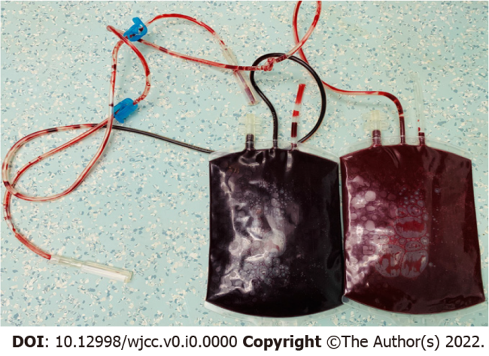
Figure 1 The blood that was removed from the patient. The first pack (left) was dark brown, while the second pack (right) was dark red after fluid infusion.
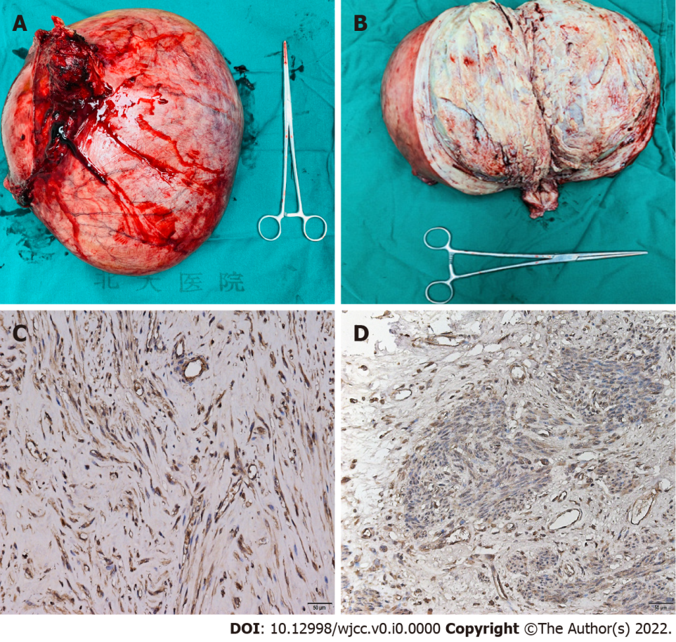
Figure 2 Gross and microscopic analysis of the uterus. A: The uterus weighed 6500 g, with the largest diameter of 35 cm; B: The sagittal plane of the uterus showed that the large myoma originated from the posterior wall of the uterus, with the cut surface appearing yellow white with scattered red hemorrhagic areas; C: Under the microscope (200 ×), via immunohistochemical staining, the cytoplasm of the leiomyoma cells of this patient showed strong positivity for erythropoietin; D: Compared with the myoma of this patient, the myoma of a patient without erythrocytosis showed weaker erythropoietin staining in immunohistochemical analysis (200 ×).
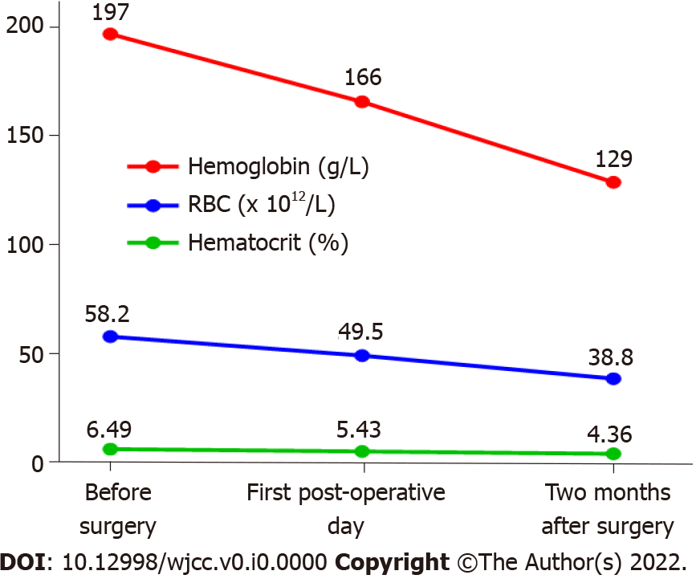
Figure 3 Changes in hematological parameters during the perioperative period. All the hematological parameters decreased following the operation, with hemoglobin declining the most sharply immediately after the surgery.

