Name of Journal: World Journal of Stem Cells
Manuscript NO: 72997
Manuscript Type: LETTER TO THE EDITOR

Physical energy-based ultrasound shifts M1 macrophage differentiation towards M2 state

Qin HC et al. Ultrasound modulates macrophages

Hao-Cheng Qin, Zhi-Wen Luo, Yu-Lian Zhu

Hao-Cheng Qin, Yu-Lian Zhu, Department of Rehabilitation Medicine, Huashan Hospital, Fudan University, Shanghai 200040, China

Zhi-Wen Luo, Department of Sports Medicine, Huashan Hospital, Fudan University, Shanghai 200040, China

Author contributions: Qin HC and Luo ZW conducted the original search, wrote the first draft of the paper, and contributed to subsequent revisions of the manuscript; Zhu YL generated the original idea of this study and provided suggestions; Qin HC and Luo ZW made equal contributions to the work.

Corresponding author: Yu-Lian Zhu, MD, PhD, Chief Doctor, Doctor, Professor, Department of Rehabilitation Medicine, Huashan Hospital, Fudan University, No. 12 Wulumuqi Road, Shanghai 200040, China. zyljully@163.com

Received: November 5, 2021
Revised: December 12, 2021
Accepted: February 16, 2022
Published online: February 26, 2022

Abstract
Recently, we read with interest the article entitled “Unveiling the Morphogenetic Code: A New Path at the Intersection of Physical Energies and Chemical Signaling”. In this paper, the investigation into the systematic and comprehensive bio-effects of physical energies prompted us to reflect on our research. We believe that ultrasound, which possesses a special physical energy, also has a certain positive regulatory effect on macrophages, and we have already obtained some preliminary research results that support our hypothesis.

Key Words: Ultrasound; Macrophages; Stem cells; Physical energies; Inflammation

Qin HC, Luo ZW, Zhu YL. Physical energy-based ultrasound shifts M1 macrophage differentiation towards M2 state. World J Stem Cells 2022; 14(2): 214-218
URL: https://www.wjgnet.com/1948-0210/full/v14/i2/214.htm
DOI: https://dx.doi.org/10.4252/wjsc.v14.i2.214

Core Tip: Because physical energies can contribute to the recovery of tissue damage in multiple aspects, it is widely used in clinical practice. The unique insights of the article “Unveiling the Morphogenetic Code: A New Path at the Intersection of Physical Energies and Chemical Signaling” inspired the direction of our experiments concerning the impact of physical energies on stem cells. In the future, we will conduct experiments and analytical techniques to reveal the mechanism of the regulatory effects behind ultrasound.

TO THE EDITOR
Recently, the article named “Unveiling the Morphogenetic Code: A New Path at the Intersection of Physical Energies and Chemical Signaling” contributed by the Editor-in-Chief Carlo Ventura^{[1]} motivated us to reconsider the biological roles of physical energies. In that article, the authors provided a detailed summary of the developmental history of physical energy, especially bioelectricity, as well as its applications and prospects in stem cell research. We strongly support the proposition about the high efficacy of physical energy in tissue repair. An article recently released in “Science Translational Medicine” described how massage, which is also a physical stimulus, regulates muscle repair^{[2]}. The systematic and accurate explanation of physical energies by the editor echoes our dedicated research, which is the effect of therapeutic ultrasound on macrophages.
As early as the 1920s, Wood and Loomis began to investigate ultrasound as a therapeutic intervention^{[3]}. In recent years, one particular type of ultrasound, low-intensity pulsed ultrasound (LIPUS), has gained much attention. This is due to its non-thermal effects, such as acoustic cavitation and “cellular massage”, which produce a range of biological effects^{[4]}. Clinically, LIPUS can be used as a non-invasive adjunctive therapy for a variety of diseases, such as fractures, muscle injury, osteoarthritis, as well as nerve injury^{[4]}. Besides, LIPUS has received considerable attention in the discipline of stem cell research. Salgarella et al^{[5]} proved the bio-effect of ultrasound therapy on the proliferation and differentiation of C2C12 myoblasts in vitro, while the research of Wang et al^{[6]} indicated that LIPUS promotes the production of mesenchymal stem cells (MSC) derived mainly from bone marrow differentiation. Both of these studies verified the positive bio-effects of this therapeutic technique. Tan et al^{[7]} listed recent studies regarding the action of LIPUS on various neural stem cells and concluded that LIPUS can stimulate stem cells in vitro, promote stem cell proliferation, differentiation, and migration, and maintain stem cell activity. The findings of Wu et al^{[8]} suggested that LIPUS regulates the Notch signalling pathway in the central nervous system, causing neural stem cell proliferation and differentiation. Additionally, LIPUS can also accelerate tissue repair^{[9]} and promote the dissipation of inflammation^{[10]}, angiopoiesis^{[11]}, etc.
Our research focused on discovering how sound waves, a kind of physical energy, exert potential effects on macrophage polarisation, which is of great significance during the inflammation stage. To ensure accurate muscle regeneration, a balance between M1 and M2 activity (pro- and anti-inflammatory, respectively) shifting over time is required^{[12]}. Previous studies have found that ultrasound may regulate macrophages in the spinal fusion model of male Sprague Dawley (SD) rats^{[13]}. However, very few studies have explored the direct effect of ultrasound on macrophages in vitro. We induced macrophages into M1 macrophages using lipopolysaccharide to mimic the inflammatory microenvironment in vivo. Then, we collected and analysed the secretion composition and gene expression following ultrasound therapy. Details of the experiments are presented in Figure 1.
So far, we have already obtained some preliminary results. As Figure 2 indicates, after LIPUS treatment, the secretion of anti-inflammatory cytokine interleukin (IL)-10 significantly increased, while quantities of pro-inflammatory cytokines tumor necrosis factor-α and IL-6 fell substantially at genetic and secreted proteins levels. Besides, we determined that the phenotypes of the macrophages are polarised into M2 after ultrasound stimulation (Figure 3). According to the above experimental data, we can conclude that ultrasound facilitates the transition of macrophages from the M1 to M2 phenotype in vitro, which is consistent with da Silva Junior's discovery^{[14]}. For subsequent research, we will further investigate the underlying mechanism of macrophage polarisation caused by LIPUS, and the potentially affected molecular pathways. Moreover, we will conduct both in vivo (skeletal muscle contusion model^{[15]}) and in vitro experiments to verify the mechanism and ascertain how LIPUS exerts a series of downstream bio-effects.

Conclusion and perspective
Various studies have established that physical energies can modulate inflammation and further promote tissue repair. As a conventional form of physical energy, ultrasound has extensive application prospects due to its non-thermal mechanical effect. Accordingly, it warrants further investigation to elucidate its influence on cell signalling. We predict that subsequent research can be extended from the aspect of monotypic cell regulation to the integral tissue, by employing single-cell transcriptomic analysis and spatial transcriptomic analysis^{[16]}. Thus, we will gain an increasingly comprehensive insight into the role of ultrasound in tissue repair.

REFERENCES
1 Tassinari R, Cavallini C, Olivi E, Taglioli V, Zannini C, Ventura C. Unveiling the morphogenetic code: A new path at the intersection of physical energies and chemical signaling. World J Stem Cells 2021; 13: 1382-1393 [PMID: 34786150 DOI: 10.4252/wjsc.v13.i10.1382]
2 Seo BR, Payne CJ, McNamara SL, Freedman BR, Kwee BJ, Nam S, de Lázaro I, Darnell M, Alvarez JT, Dellacherie MO, Vandenburgh HH, Walsh CJ, Mooney DJ. Skeletal muscle regeneration with robotic actuation-mediated clearance of neutrophils. Sci Transl Med 2021; 13: eabe8868 [PMID: 34613813 DOI: 10.1126/scitranslmed.abe8868]
3 Jiang X, Savchenko O, Li Y, Qi S, Yang T, Zhang W, Chen J. A Review of Low-Intensity Pulsed Ultrasound for Therapeutic Applications. IEEE Trans Biomed Eng 2019; 66: 2704-2718 [PMID: 30596564 DOI: 10.1109/TBME.2018.2889669]
4 Lin G, Reed-Maldonado AB, Lin M, Xin Z, Lue TF. Effects and Mechanisms of Low-Intensity Pulsed Ultrasound for Chronic Prostatitis and Chronic Pelvic Pain Syndrome. Int J Mol Sci 2016; 17 [PMID: 27376284 DOI: 10.3390/ijms17071057]
5 Salgarella AR, Cafarelli A, Ricotti L, Capineri L, Dario P, Menciassi A. Optimal Ultrasound Exposure Conditions for Maximizing C2C12 Muscle Cell Proliferation and Differentiation. Ultrasound Med Biol 2017; 43: 1452-1465 [PMID: 28433437 DOI: 10.1016/j.ultrasmedbio.2017.03.003]
6 Wang X, Lin Q, Zhang T, Wang X, Cheng K, Gao M, Xia P, Li X. Low-intensity pulsed ultrasound promotes chondrogenesis of mesenchymal stem cells via regulation of autophagy. Stem Cell Res Ther 2019; 10: 41 [PMID: 30670079 DOI: 10.1186/s13287-019-1142-z]
7 Tan Y, Guo Y, Reed-Maldonado AB, Li Z, Lin G, Xia SJ, Lue TF. Low-intensity pulsed ultrasound stimulates proliferation of stem/progenitor cells: what we need to know to translate basic science research into clinical applications. Asian J Androl 2021; 23: 602-610 [PMID: 33818526 DOI: 10.4103/aja.aja_25_21]
8 Wu Y, Gao Q, Zhu S, Wu Q, Zhu R, Zhong H, Xing C, Qu H, Wang D, Li B, Ning G, Feng S. Low-intensity pulsed ultrasound regulates proliferation and differentiation of neural stem cells through notch signaling pathway. Biochem Biophys Res Commun 2020; 526: 793-798 [PMID: 32268957 DOI: 10.1016/j.bbrc.2020.03.142]
9 Yang B, Li M, Lei H, Xu Y, Li H, Gao Z, Guan R, Xin Z. Low Intensity Pulsed Ultrasound Influences the Myogenic Differentiation of Muscle Satellite Cells in a Stress Urinary Incontinence Rat Model. Urology 2019; 123: 297.e1-297.e8 [PMID: 30273612 DOI: 10.1016/j.urology.2018.09.020]
10 Zheng C, Wu SM, Lian H, Lin YZ, Zhuang R, Thapa S, Chen QZ, Chen YF, Lin JF. Low-intensity pulsed ultrasound attenuates cardiac inflammation of CVB3-induced viral myocarditis via regulation of caveolin-1 and MAPK pathways. J Cell Mol Med 2019; 23: 1963-1975 [PMID: 30592150 DOI: 10.1111/jcmm.14098]
11 Li J, Guo W, Yu F, Liu L, Wang X, Li L, Fang B, Xia L. Low-intensity pulsed ultrasound promotes angiogenesis via the AKT pathway and DNA methylation in human umbilical vein endothelial cells. Ultrasonics 2022; 118: 106561 [PMID: 34500338 DOI: 10.1016/j.ultras.2021.106561]
12 De Santa F, Vitiello L, Torcinaro A, Ferraro E. The Role of Metabolic Remodeling in Macrophage Polarization and Its Effect on Skeletal Muscle Regeneration. Antioxid Redox Signal 2019; 30: 1553-1598 [PMID: 30070144 DOI: 10.1089/ars.2017.7420]
13 Zhang ZC, Yang YL, Li B, Hu XC, Xu S, Wang F, Li M, Zhou XY, Wei XZ. Low-intensity pulsed ultrasound promotes spinal fusion by regulating macrophage polarization. Biomed Pharmacother 2019; 120: 109499 [PMID: 31707028 DOI: 10.1016/j.biopha.2019.109499]
14 da Silva Junior EM, Mesquita-Ferrari RA, França CM, Andreo L, Bussadori SK, Fernandes KPS. Modulating effect of low intensity pulsed ultrasound on the phenotype of inflammatory cells. Biomed Pharmacother 2017; 96: 1147-1153 [PMID: 29191696 DOI: 10.1016/j.biopha.2017.11.108]
15 Luo Z, Lin J, Sun Y, Wang C, Chen J. Bone Marrow Stromal Cell-Derived Exosomes Promote Muscle Healing Following Contusion Through Macrophage Polarization. Stem Cells Dev 2021; 30: 135-148 [PMID: 33323007 DOI: 10.1089/scd.2020.0167]
16 van den Brink SC, Alemany A, van Batenburg V, Moris N, Blotenburg M, Vivié J, Baillie-Johnson P, Nichols J, Sonnen KF, Martinez Arias A, van Oudenaarden A. Single-cell and spatial transcriptomics reveal somitogenesis in gastruloids. Nature 2020; 582: 405-409 [PMID: 32076263 DOI: 10.1038/s41586-020-2024-3]

Footnotes
Conflict-of-interest statement: The authors declare no conflict of interest for this article.

Open-Access: This article is an open-access article that was selected by an in-house editor and fully peer-reviewed by external reviewers. It is distributed in accordance with the Creative Commons Attribution NonCommercial (CC BY-NC 4.0) license, which permits others to distribute, remix, adapt, build upon this work non-commercially, and license their derivative works on different terms, provided the original work is properly cited and the use is non-commercial. See: https://creativecommons.org/Licenses/by-nc/4.0/

Provenance and peer review: Invited article; Externally peer reviewed.

Peer-review model: Single blind

Peer-review started: November 5, 2021
First decision: December 4, 2021
Article in press: February 16, 2022

Specialty type: Cell and tissue engineering
Country/Territory of origin: China
Peer-review report’s scientific quality classification
Grade A (Excellent): 0
Grade B (Very good): B, B
Grade C (Good): 0
Grade D (Fair): 0
Grade E (Poor): 0

P-Reviewer: Ankrah AO, Prasetyo EP S-Editor: Fan JR L-Editor: Wang TQ P-Editor: Zhang YL
Figure Legends
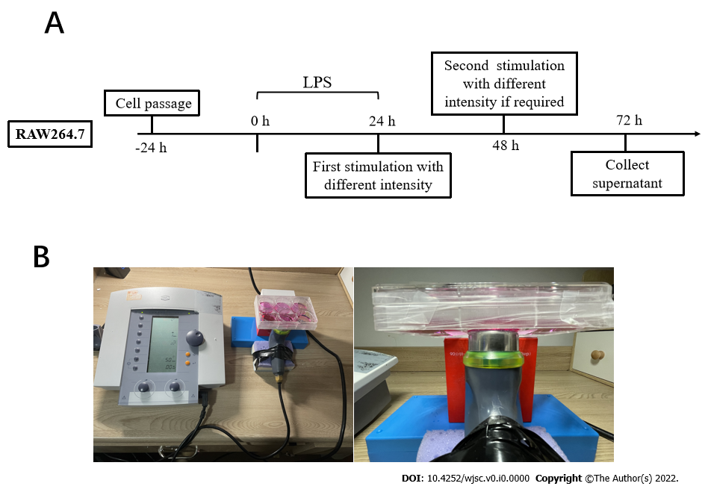
Figure 1 Experimental design for this study in vitro and the method of treating cells. A: At 24 h before lipopolysaccharide (LPS) was added to simulate the inflammatory environment, macrophages at the M1 stage were uniformly subcultured into the six-well plate. Then, The first ultrasound treatment was performed 24 h after the inflammatory environment was maintained. At 48 h, ultrasound was performed on the group requiring a second treatment. The supernatant of culture medium was separated after 24 d of culture (3 d after LPS was added); B: In order to easily adjust the ultrasonic probe to fit the culture holes on the bottom of the six-well plate, we fixed the ultrasonic probe on a sponge pad. Additionally, a box of the same height is used to support the six-hole plate to prevent it from tilting.
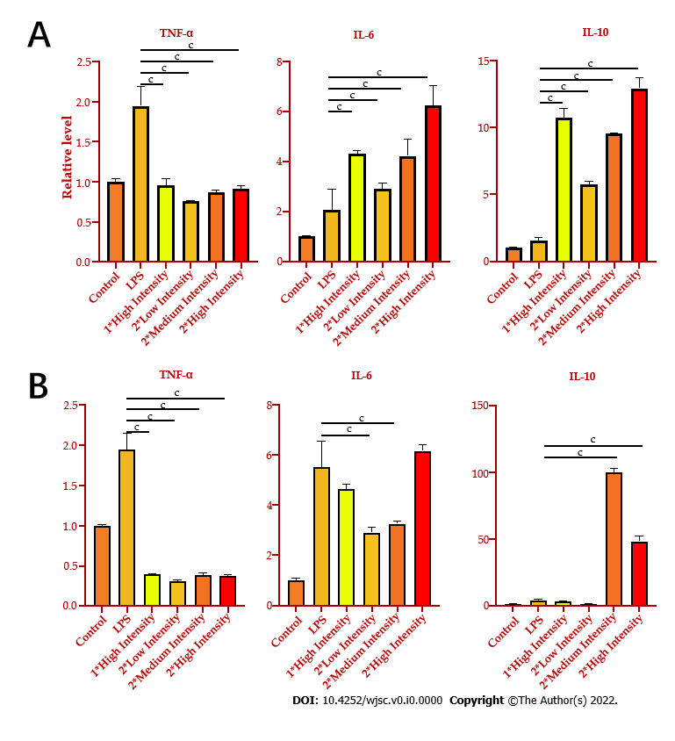
Figure 2 Low-Intensity pulsed ultrasound significantly increases the expression of anti-inflammatory cytokine and decreases the expression of pro-inflammatory cytokine. A: Real-time quantitative polymerase chain reaction (qPCR) was used to detect the gene expression of tumor necrosis factor (TNF)-α, interleukin (IL)-6, and IL-10 after being treated by low-intensity pulsed ultrasound (LIPUS); B: ELISA was used to analyze the protein expression of TNF-α, IL-6, and IL-10 after being treated with LIPUS. Data are expressed as the mean ± standard error of the mean. ªP < 0.05; ^{b}P < 0.01; ^{c}P < 0.001. Low intensity = 0.25 W/cm², medium intensity = 0.5 W/cm², and high intensity = 0.75 W/cm². TNF-α: Tumor necrosis factor-α; IL: Interleukin.
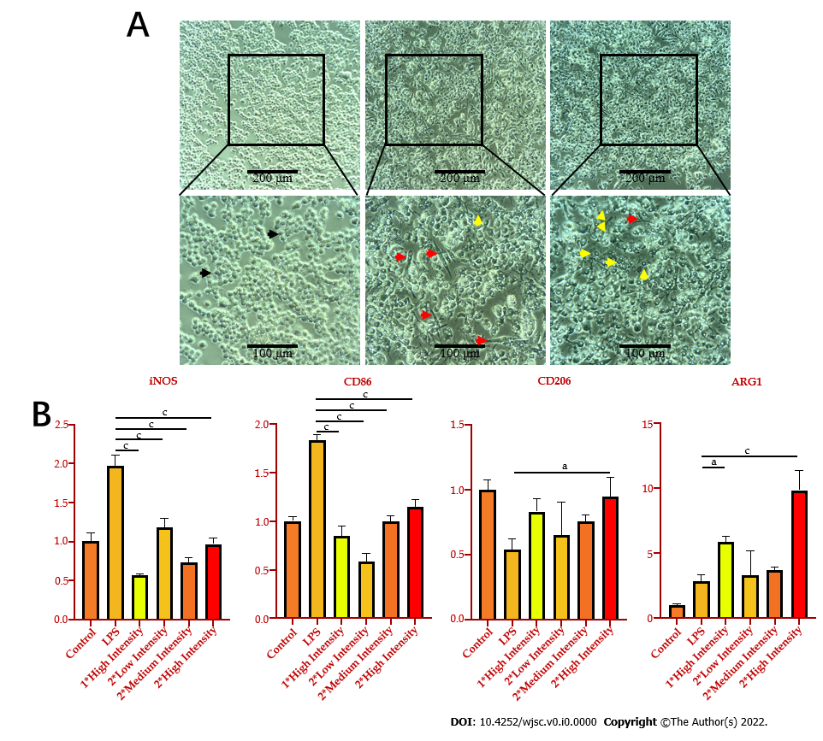
Figure 3 Low-intensity pulsed ultrasound shifts M1 macrophages towards M2 state. A: The morphology of macrophages was observed by microscopy. Black, red, and yellow arrows represent M0, M1, and M2 macrophages, respectively; B: Quantitative polymerase chain reaction was used to detect the gene expression of cell phenotypes maker iNOS, CD86, CD206, and ARG1 after being treated by low-intensity pulsed ultrasound. Data are expressed as the mean ± standard error of the mean. ªP < 0.05; ^{b}P < 0.01; ^{c}P < 0.001. Low intensity = 0.25 W/cm², medium intensity = 0.5 W/cm², and high intensity = 0.75 W/cm².

Published by Baishideng Publishing Group Inc
7041 Koll Center Parkway, Suite 160, Pleasanton, CA 94566, USA
Telephone: +1-925-3991568
E-mail: bpgoffice@wjgnet.com
Help Desk: https://www.f6publishing.com/helpdesk
https://www.wjgnet.com

© 2022 Baishideng Publishing Group Inc. All rights reserved.

