Name of journal: World Journal of Gastroenterology
ESPS Manuscript NO: 28214
Manuscript Type: REVIEW

Role of ultrasound in colorectal diseases

Bor R et al. Role of ultrasound in colorectal diseases

Renáta Bor, Anna Fábián, Zoltán Szepes

Renáta Bor, Anna Fábián, Zoltán Szepes, First Department of Medicine, University of Szeged, 6720 Szeged, Hungary

Author contribution: All authors contributed to this paper.

Conflict-of-interest statement: Authors declare no conflict of interests for this article.

Open-Access: This article is an open-access article which was selected by an in-house editor and fully peer-reviewed by external reviewers. It is distributed in accordance with the Creative Commons Attribution Non Commercial (CC BY-NC 4.0) license, which permits others to distribute, remix, adapt, build upon this work non-commercially, and license their derivative works on different terms, provided the original work is properly cited and the use is non-commercial. See: http://creativecommons.org/licenses/by-nc/4.0/

Manuscript source: Invited manuscript

Correspondence to: Zoltán Szepes, MD, PhD, First Department of Medicine, University of Szeged, 6720 Szeged, Korányi Fasor 8-10, Hungary. szepes.zoltan@med.u-szeged.hu
Telephone: +36-62-545186.
Fax: +36-62-545185

Received: June 28, 2016
Peer-review started: June 29, 2016
First decision: August 29, 2016
Revised: September 11, 2016
Accepted: October 19, 2016
Article in press:
Published online:

Abstract
Ultrasound is an undervalued non-invasive examination in the diagnosis of colonic diseases. It has been replaced by the considerably more expensive magnetic resonance imaging and computed tomography, despite the fact that, as first examination, it can usefully supplement the diagnostic process. Transabdominal ultrasound can provide quick information about bowel status and help in the choice of adequate further examinations and treatment. Ultrasonography, as a screening imaging modality in asymptomatic patients can identify several colonic diseases such as diverticulosis, inflammatory bowel disease or cancer. In addition, it is widely available, cheap, non-invasive technique without the use of ionizing radiation, therefore it is safe to use in childhood or during pregnancy, and can be repeated at any time. New ultrasound techniques such as elastography, contrast enhanced and Doppler ultrasound, mini-probes rectal and transperineal ultrasonography have broadened the indication. It gives an overview of the methodology of various ultrasound examinations, presents the morphology of normal bowel wall and the typical changes in different colonic diseases. We will pay particular attention to rectal and transperineal ultrasound because of their outstanding significance in the diagnosis of rectal and perineal disorders. This article seeks to overview the diagnostic impact and correct indications of bowel ultrasound.

Key words: Ultrasound; Perineal ultrasound; Rectal endosonography; Gastrointestinal diseases

© The Author(s) 2016. Published by Baishideng Publishing Group Inc. All rights reserved.

Core tip: Ultrasound is an easy to perform and widely available examination, which could be useful as a first-line diagnostic modality for the identification of numerous colonic diseases, nevertheless it is undervalued and is not performed in all patients. Therefore, the aim of our publication is to assess the advantages and limitations of transabdominal, rectal, transperineal ultrasound and mini-probe examination in the diagnosis of colonic disorders. In addition, it summarizes the typical ultrasound morphological signs.

Bor R, Fábián A, Szepes Z. Role of ultrasound in colorectal diseases. World J Gastroenterol 2016; In press

Introduction
Endoscopic examination provides the most accurate information about the morphology of intestinal mucosa, although the pathological changes of the colonic wall, surrounding tissues and organs may be examined by cross sectional imaging modalities such as ultrasound (US), computed tomography (CT) and magnetic resonance imaging (MRI). None of these imaging modalities are able to identify all types of colonic diseases, however they can complement each other preferably during the diagnostic process. Detailed transabdominal ultrasound examination forms an essential part of the investigation of gut, nonetheless in many departments it is undervalued and not performed in all patients. US can provide quick information about a variety of bowel diseases as a first, widely available cross section imaging modality, and may help in the choice of adequate further examinations and treatment. In addition, US screening of asymptomatic patients could also identify accidental bowel diseases such as colonic cancer or diverticulosis.
The bowel US examination is a safe, widely available, cheap, noninvasive imaging technique which allows real-time examination of the intestines without the use of ionizing radiation and can be performed at any time^{[1]}. The greatest disadvantage is that the evaluation of the bowel depends more on the operator experience and expertise than the sonographic evaluation of other abdominal organs^{[2]}. Lack of patients’ cooperation, body habitus (abdominal obesity, spinal deformity) or the presence of intraluminal bowel gas can make the visualization of the gut difficult. Although the standard transabdominal US (TAUS) is highly predictive and useful for the diagnosis of bowel processes, it is usually nonspecific, and the negative finding does not exclude the presence of a bowel disease^{[3]}. Therefore, in the last decade the importance of TAUS for the investigation of the gut has become increasingly questioned, and it is often replaced by other cross-sectional imaging modalities such as MRI and CT. The appearance of new US technique such as elastography, contrast-enhanced ultrasound, high resolution US and the development of rectal ultrasound (RUS) and transperineal ultrasound (TPUS) contribute to the extension of the indication area and the improvement of diagnostic accuracy.
The aim of our article is to systematically review the literature dealing with the findings, the diagnostic yield and correct indications of standard TAUS examinations for the diagnosis of colonic diseases. Particular attention will be payed to RUS, TPUS and mini-probes which are increasingly important in the diagnosis of rectal and perianal disorders.

Imaging technique, normal bowel morphology
TAUS is carried out by convex or linear probes with band frequency of 3.5-17 MHz. Two types of probes with different US frequency may be used consecutively for the examination of the intestines and abdominal organs. Firstly, the use of low, 3.5-5 MHz frequency probes is recommended in order to obtain a panoramic view of the abdomen which could help to localize pathological conditions. Specific attention should also be focused on the region of tenderness or pain described or where resistance was found on physical examination. The standard examination should then be followed by high frequency (5-17 MHz) ultrasonography which provides detailed information about bowel wall layers and the surrounding tissues^{[4]}. The five layers of the colonic wall may be clearly distinguishable; they appear in the US image as concentric rings of alternating echogenicity. These rings seen at US examination correspond to the histological layers of the bowel wall: the first echogenic line is the mucosal layer followed by the hypoechoic ring of muscularis mucosae, the echogenic ring of submucosa and the hypoechogenic ring of muscularis propria. Most peripherally is found an echogenic ring that represents the adventitia or serosa depending on the bowel location. (Table 1) The colon and the small intestines may be distinguished from each other based on the presence of haustration or the Kerckring's folds. Several studies considered that colonic diseases may be manifested as decreased compressibility of the thickened bowel walls, dilation of the lumen, conglomeration of loops and they could be associated with extramural lesions such as fistulas, abscesses, lymphadenomegaly, and pericolonic inflammation^{[3,5]}. The measurement of wall thickness is essential. Thickness of the normal intestinal wall does not exceed 3 mm with slight probe compression, stratification is preserved, intramural vascularization is weak and peristalsis is normal^{[6]}. In healthy adults the wall thickness of the sigmoid bowel could be greater due to the wide muscularis propria^{[7]}. Elastography, the use of oral contrast agents, Color Power (Flow) Doppler and the Contrast Enhanced Ultrasonography (CEUS) help to clarify the diagnosis with the examination of intramural blood flow, the identification of the affected intestinal segments, and to differentiate inflammation, fibrotic and neoplastic conditions^{[8,9,10]}.
Elastography can evaluate the stiffness of tissues by measuring their elasticity, and display it as a colored real-time elastogram (qualitative elastography) in the conventional B-mode ultrasound image with a special software. During the examination, the axial change in tissue is continuously monitored in response to the applied ultrasound force^{[11,12]}.
Color Power (Flow) Doppler US is useful for estimating the presence, the density or absence of vascular signals in the large blood vessels, but it is not sensitive enough to detect slow and low-volume flow of smaller vessels of the gastrointestinal organs^{[6,13]}. The flow of big intraabdominal veins and arteries (aorta, coeliac trunk, superior and inferior mesenteric artery, portal vain, etc.), the vascularity of thickened bowel segments and pathological extra- or intraluminal structures could be examined.
The use of CEUS allows precise analysis of the vascularity of bowel abnormalities. This modality is based on the detection of US contrast agents consisting of microbubbles (1-7 µm) which are injected in the peripheral veins, and appear about 20-30 s later in the target tissue. It may help to differentiate ischemic intestinal necrosis (lack of contrast filling), inflammation (symmetric thickening with low resistivity index) and neoplasia (asymmetric thickening with high resistivity index)^{[14]}.
TPUS examinations are performed using a standard transabdominal ultrasonographic microconvex or linear probe with a 16 to 36 MHz frequency range transducer which is covered with ultrasonographic gel and is introduced in gloves for hygienic reasons. TPUS does not require specific preparation of the rectum. The high US frequency allows detailed, high-resolution imaging, however the depth penetration is poor, only the 5-7 cm wide subsurface area can be examined. TPUS examination is effective in the diagnosis of perianal diseases such as perianal Crohn’s disease, cryptogenic perianal fistulas or abscesses^{[15]}. Fistulas are manifested in the form of hypoechogenic tracks near the rectum and anal canal, and the abscesses are large, hypoechogenic structures with or without inhomogeneous, hyperechogenic content^{[16]}. TPUS does not require special patient preparations such as enemas or the injection of contrast agents, and it can be beneficial when other radiological imaging modalities are contraindicated or not appropriate (MRI for patients with metallic clips, for those who suffer from claustrophobia; EUS for patients with anal stenosis or serious perianal inflammation and intense local pain)^{[17]}.
RUS is the firstly developed endosonographic technique, and since the 1980s more and more articles have been published about this imaging method. It is simple, quick, safe and not burdensome for patients, nonetheless it can provide relevant information for the choice of the optimal treatment^{[15]}. It is an easy to learn procedure with a relatively short learning curve. Previous studies suggested that in case of rectal cancer the diagnostic accuracy significantly improved and reached the plateau after 30 examinations^{[18,19]}. A recent investigation of Liu et al revealed that approximately 80 rectal ultrasounds have to be performed before one can assess the in-depth tumor invasion^{[20]}. The limitation of the method is its strong operator dependency, but it also means that RUS performed by an experienced examiner may be a highly qualified and informative imaging technique^{[21,22]}. Rigid, "blind" rectal transducer, flexible echoendoscope and ultrasound microprobe introduced through the working channel of a flexible endoscope are available. The five concentric layers of the rectal wall are well distinguishable with the transducer using standard band frequency of 3.5-17 MHz (Figure 1), additionally high frequency (5-30 MHz) endosonography and 3D imaging may further increase the diagnostic accuracy^{[23,24]}. For the accurate examination, rectal preparation with enema or complete colonic preparation should be performed to avoid artifacts^{[25]}. Sedation and analgesia is optional, but recommended in case of severe, painful perianal infection. During the examination the patient is placed in left lateral position. The ultrasound transducer should be introduced to the recto-sigmoid border after rectal digital examination considering the previous results of endoscopic and rectal digital exam. During the examination the probe with the water-filled balloon is slowly withdrawn to the anal canal. Rectal ultrasound-guided fine needle aspiration (EUS-guided FNA) allows histological and cytological sampling of submucosal/intramural and extraluminal pathological lesions surrounding the rectum even in those cases when other sampling techniques are not feasible. The endosonographic needle is inserted into the rectum through the working channel of the linear echoendoscope and punctures the target lesion under continuous real-time ultrasound guidance. This technique may result in both histological (formalin fixed pieces of tissue) and cytological samples (smears, liquid based cytology). RUS-guided FNA may help to distinguish malignant (recurrent neoplasm, metastatic lymph node, mesenchymal tumor, etc.) and benign (reactive lymphadenopathy, endometriosis, cysts, abscesses, etc.) lesions. The low negative predictive value is the most important disadvantage of the examination; therefore, negative cytological result cannot exclude the presence of malignancy.

INFECTIVE COLORECTAL DISEASES
Gastrointestinal infections are the most common causes of diarrhea worldwide. The diagnosis is based on clinical history, results of laboratory tests, stool microscopy and culture. Imaging such as TAUS examination are usually performed, but the US finding of infective colitis is not specific and not necessary for the diagnosis. TAUS can detect bowel wall thickening, enlarged lymph nodes, ascites and complications of bowel infections such as colon dilatation, toxic megacolon, perforation or intraabdominal abscess^{[26,27]}.

INFLAMMATORY BOWEL DISEASE
The fluctuating disease course of inflammatory bowel diseases (IBD) requires repeated imaging examinations in the majority of patients to assess disease activity, complications and treatment efficacy. Ultrasound is the most appropriate initial imaging modality, especially in case of an emergency. Abdominal ultrasonography is suitable for assessing early stages of Crohn’s disease, and it also facilitates the diagnosis of intraabdominal complications (stricture, fistula and abscess), as well as the evaluation of postoperative state after resection^{[28]}. In Crohn’s disease, intestinal involvement is usually characterized by thickening, decreased compressibility, and increased vascularization of the intestinal wall (≥ 4 mm), occasionally accompanied by pericolic fluid accumulation and lymph node enlargement^{[7,29]} (Figure 2A). Abdominal ultrasound detects these changes with a sensitivity of 85% (95%CI: 83-87%) and a specificity of 98% (95%CI: 95%-98%)^{[30]}, but individual experience, the severity of the disease and the localization of the affected bowel part have a great influence as well. While the sensitivity of US might be as high as 98% in the sigmoid and descending colon, it is only about 15% in the rectum^{[9,31]}. The modality allows monitoring the efficacy of medical therapy, determining the optimal time for control endoscopy, and provides information about areas inaccessible for endoscopy^{[32]}. Intraabdominal complications of CD, such as abscess formation, narrowing of the bowel lumen, fistulas between intestinal loops and entero-cutaneous fistulas, can also be detected with ultrasonography^{[30]} (Figure 2B).
Accurate localization and assessment of the extent of fistulas before choosing the optimal surgical intervention is of crucial importance in perianal Crohn’s disease^{[33]} (Figure 3). Reliable evaluation of the lesions can result in decreased postoperative incontinence and recurrence rates^{[34]}. Although MRI is considered the “gold standard” method for the diagnosis of anorectal abscesses and anal fistulas, a growing amount of published evidence proves that besides financial considerations, transducers with 10 MHz frequency and local hydrogen peroxide contrast, as well as 3D rectal ultrasound can be a real alternative indeed^{[35]}. According to international studies, the sensitivity of the two methods is similar, being around 85%-95%^{[36,37]}, and this might be further improved to 100% by their concomitant use, thus both modalities are recommended in complicated cases^{[38,39]}. The role of rectal ultrasonography in the diagnosis of perianal Crohn’s disease is further confirmed by the guidelines of European Crohn’s and Colitis Organization (ECCO) and the American Gastroenterological Association (AGA)^{[40,41]}. Moreover, persistent fistulas can be recognized with rectal ultrasound even when the surface has started to close due to anti-TNF alfa therapy, therefore it is a potent option for the assessment of treatment efficacy and for avoiding recurrence due to early cessation of the treatment. Computed evaluation with imaging programs and algorithms may further improve the sensitivity of rectal ultrasound. In a study conducted by Caprioli et al^{[42]} in 2006, the efficiency of MRI and computer-assisted rectal ultrasonography proved to be nearly identical (Image Measurement Professional version 3.0, Bersoft Inc., Toronto, Canada – a computer program evaluating the change in grey tones was used). Using the same computer program, Losco et al^{[43]} confirmed that the activity determined with the program correlates with the widely accepted Perianal Disease Activity Index (PDAI) and the activity detected on exploration of the fistulas.
Perianal ultrasound also plays a part in the diagnosis of perianal complications of Crohn’s disease. According to comparative studies, its sensitivity is comparable to that of rectal ultrasound and MRI in diagnosing perianal fistulas and abscesses^{[44,45,46]} (Figures 4). Its availability and cost-effectiveness enable perianal ultrasound to monitor real-time recovery of fistulas, thus more expensive MRI might be avoided. Maconi et al. showed that the sensitivity of TPUS is relatively poor in the identification of extrasphincteric and suprasphincteric fistulas (55.6% and 50%), but it demonstrated an excellent sensitivity and PPV in the recognition of anovaginal and transsphincteric fistulas (sensitivity: 100% and 90%; PPV: 99.4% and 100%)^{[45]}. No special preparation and instrumentation is required, and it can be easily mastered, thus perianal ultrasound might be well applied in gastroenterology and proctology; it can be a fast diagnostic tool as well, especially in urgent cases^{[17]}.

Diverticular disease and diverticulitis
Diverticular disease is defined as clinically significant and symptomatic diverticulosis, in contrast, diverticulitis is the macroscopic inflammation of diverticula which could associate with acute or chronic complications^{[47]}. Both low and high frequency ultrasound examination is appropriate for the identification of diverticula. The diverticula appear in the US image as reduced gut signature due to the absence/thinning of muscularis propria, or as bright "ears" out of the intestinal wall with acoustic shadow caused by the presence of intradiverticular gas^{[48]}. In case of diverticulitis, intestinal wall thickening, pericolic inflammation and fluid could be detected beside the diverticula. During the examination, substantial pain or tenderness occurs by the compression of the affected area^{[1]}. Using color Doppler US increased vascularity could be detected in the affected, inflamed, and thickened gut wall. The US morphology of diverticular abscesses varies widely, they usually appear as anechoic cystic masses containing echogenic debris and gas^{[49]}. Sensitivity and specificity of US in the diagnosis of acute diverticulitis is 84.6-92% and 80.3-90%^{[50-53]}. Diagnostic accuracy of US and CT are comparable in diagnosing diverticulitis. US is the firstly recommended imaging modality, CT is required after an inconclusive or negative US examination^{[52]}.

Gastrointestinal hemorrhage
Ultrasound has limited role in the diagnosis of gastrointestinal hemorrhage (GIH). Endoscopy is the gold-standard diagnostic modality followed by mesenteric angiography and CT-angiography^{[53]}. Ultrasound may be a good first diagnostic procedure as it can sensitively identify the underlying colonic lesions in the background of GIH such as diverticulosis, colonic neoplasm or IBD^{[54]}.

Ischemic colitis
Ischemic colitis is the most common gastrointestinal vascular disease. In 80% of the cases it affects the left colon causing lower GI hemorrhage at the border of the area supplied by the superior and inferior mesenteric artery, or at the junction of the inferior mesenteric and hypogastric artery territory^{[55]}. True arterial occlusion is rare, it is more commonly a result of an impairment in the micro-vascularization of the colonic wall^{[56]}. Significant arterial stenosis could be identified by pulse Doppler scanning with high sensitivity and negative predictive value which could exceed 90%^{[57]}. The characteristic US finding in ischemic colitis is the hypoechoic gut wall thickening with variable loss of mural stratification. Color flow Doppler imaging may help to analyze the microcirculation of the colonic wall. In the acute stage color flow is barely visible, which may be a sign of necrosis^{[58]}. Absence of arterial flow in the wall of the ischemic colon on the initial color Doppler sonography is a good prognostic sign of an unfavorable outcome. This factor is more closely associated with the outcome than early clinical and laboratory findings^{[59]}.

Intussusception
The US morphology of intussusception is characteristic: on the cross-sectional view multilayer pattern can be seen with alternating concentric hypoechogenic and echogenic circles (“onion”, “doughnut” or “bull’s eye” sign)^{[60]}. On the longitudinal image, multiple parallel line can be seen with various echogenicity, this typical, sandwich-like appearance is the so-called "pseudokidney sign"^{[61]}. The sensitivity and specificity of US in the identification of intussusception is about 100% and 90%, so in childhood US alone is sufficient for the diagnosis^{[8]}. In adults, almost 90% of the intussusception cases is caused by an underlying bowel lesion, which is benign or malignant colonic tumor in the vast majority of the cases^{[1]}, therefore CT scan is mandatory to identify the root causes and the complications^{[62]}.

Colorectal cancer
Colorectal cancer has the highest incidence rates of all gastrointestinal malignancies worldwide, thus early diagnosis and staging are of crucial importance^{[63,64]}. In the diagnosis of the primary colon cancers, the role of standard abdominal ultrasonography is negligible compared to endoscopy. Hypoechoic bowel wall thickening with irregular contour, the loss of stratification of the wall layers, and the absence of normal peristalsis can all be suggestive of a malignancy. Hepatic metastases from colorectal malignancies may be detected with TAUS as a first exploratory imaging technique. In fact, TAUS is often the first choice for patients with a suspected malignancy due to its non-invasive character, low costs, and wide availability, even though the better performance of CT scan and MRI should be kept in mind^{[65,66]}. Although the use of contrast agents improves the efficacy of ultrasonography, CEUS still proved to be inferior to multidetector-row computed tomography (MDCT) in the preoperative detection of liver metastases^{[67]}.
Due to their anatomical characteristics, rectal and colon tumors require a different diagnostic and therapeutic approach. The precise location and extension of the tumor as well as locoregional metastases make up the basis for the optimal therapeutic choice, as well as the identification of patients who might benefit from preoperative neoadjuvant treatment or suitable for local resection. Unlike TAUS that is unable to visualize rectal tumors, rectal ultrasound provides accurate assessment of the in-depth invasion of the tumor (appearing as a hypoechoic mass causing disruption to the normal layers of the rectal wall) with an accuracy of 64% to 95%, and its essential role in the local staging of rectal cancer has already been established^{[68,69]}. In case of early rectal tumors, the high resolution of RUS makes it even superior in distinguishing T1 and T2 tumors with a specificity of 86% (95%CI: 80–90%) compared to 69% (95%CI: 52–82%) for MRI^{[70]}. According to the consensus recommendation of the European Organisation for Research and Treatment of Cancer (EORTC) in 2014, RUS is the preferable modality of staging in T1 tumors, whereas otherwise the combination of MRI and RUS is beneficial in advanced stages, regarding the fact that MRI provides better assessment of the mesorectal fascia^{[68,71]}.
The assessment of lymph node involvement of rectal tumors poses a challenge for all available imaging modalities, including RUS. According to a meta-analysis covering 33 studies, it has a moderate diagnostic value in preoperative nodal staging with a pooled sensitivity and specificity of 69% (95%CI: 0.63-0.75) and 77% (95%CI: 0.73-0.82), respectively^{[72]}. Only perirectal lymph nodes can be assessed with RUS, the evaluation of the entire mesorectal area requires high-resolution MRI with appropriate “rectal cancer protocol”^{[71,73]}. Nodal staging is basically based on morphological characteristics (size greater than 5 mm, mixed signal intensity, irregular borders, and spherical rather than ovoid or flat shape)^{[74]}. However, the size criteria might lead to deceptions and substantial overstaging as enlarged reactive lymph nodes of a benign character can easily be mistaken for a metastasis^{[71]}. Rectal EUS-FNA can assist the diagnosis of metastatic lymph nodes, but considering its moderate negative predictive value (77%) and the possible sampling errors, negative FNA results cannot rule out a presence of a metastasis^{[68,75]}. Color and pulsed Doppler technique might also facilitate the diagnosis of malignant lymph nodes. Peak systolic velocity > 20 cm/sec and resistivity index (RI) > 0.61 can be suggestive of a lymph node metastasis. Although the former parameter might also be increased in case of reactive lymph nodes, RI can still be informative due to the fact that the compression of blood vessels in the tumor formation often alters the vessels’ resistance, while inflammation results in dilated blood vessels with lower RI^{[76]}.
Due to the shift to preoperative chemotherapy-irradiation in the management of rectal tumors, restaging of lesions after neoadjuvant treatment has come into focus. Tissue changes as a consequence of neoadjuvant therapy (like peritumoral inflammation, edema, fibrosis and necrosis) have a similar hypoechoic appearance as tumorous lesions, therefore they can be hardly distinguished^{[77,78]}. As a result, the accuracy of RUS impairs (65% for T staging and 72% for N staging) and overstaging becomes dominant leading to more radical surgical solutions. Similar to other imaging modalities (CT scan, MRI), RUS fails to provide sufficient information about the response to neoadjuvant therapy^{[79,80]}. However, the use of three-dimensional reconstructions with higher resolution and multiplanar display of the rectal and perirectal anatomy might improve the performance of restaging^{[25]}. Volume measurements also provide an opportunity to monitor the tumor mass changes induced by chemo-irradiation^{[81]}.
Considering the high recurrence rate of rectal tumors, early detection is of crucial importance. RUS-guided FNA might assist the diagnosis of perirectal recurrence. Its sensitivity and specificity in this setting can be as high as 97% and 100%, respectively^{[82]}. With the application of Doppler technique, information about the vasculature of the intra- and peritumoral areas can further facilitate the differentiation of recurrence and postoperative scarring^{[83]}.
The use of mini-probes that can be inserted through the working channel of the conventional colonoscope expands the indications of endoscopic ultrasonography as they make proximal rectal and colonic lesions accessible. Moreover, stenotic lesions might also be passed easier with the reduced diameter of mini-probes, thus staging becomes available in the entire colon. However, even if the high-frequency of mini-probes (12-30 MHz) provides excellent assessment of superficial lesions, impaired in-depth acoustic penetration limits their accuracy in case of larger or more advanced tumors. Neither are they capable of lymph node assessment^{[71]}.
The development of forward viewing radial echoendoscopes has also brought new perspectives to colorectal cancer staging beyond the rectum. The forward viewing design makes safe maneuvering through the sigmoid colon feasible, and the radial-array provides circumferential evaluation of colorectal lesions. An additional benefit of the design is the opportunity for diagnosing and staging colorectal cancer at the same time^{[69,91]}.
Elastography offers a promising and highly accurate method for differentiating benign and malignant colorectal lesions based on the differences in tissue hardness. A strain ratio (SR) of 1.25 serves as a cut-off for the optimal distinction – malignant tumors have a SR > 1.25, whereas benign lesions present with a SR < 1.25. Moreover, elastography is even superior to MRI and tissue sampling in terms of identifying early adenocarcinomas and distinguishing them from adenomas. The characterization of pathological lymph nodes has not involved their elasticity yet, but reports suggest that they might be more rigid than the perirectal fat tissue. Thus, elastography might as well play a part in the lymph node assessment^{[69,77,84,92,93]}.
Contrast-enhanced EUS (CE-EUS) might provide dynamic measurement of the tumor angiogenesis in rectal tumors. Although the information is still limited regarding the exact role of CE-EUS in rectal cancer, initial research suggests that one of the computed parameters – enhanced intensity – might serve as a noninvasive biomarker of tumor angiogenesis as microbubble contrast agents make visualization of the microcirculation possible. Different microvessel structure of adenomas (homogenous appearance, later contrast enhancement with lower intensity) and adenocarcinomas (irregular appearance, earlier contrast enhancement) may assist the detection of these lesions, but large tumors with intratumoral necrosis might as well present with low contrast uptake. CE-EUS parameters might also contribute to the improvement of the inter-observer variability of RUS^{[69,77,84,94]}.
In certain cases, RUS might also assist in the treatment of rectal cancer. Fiducial markers used to delineate the target lesion in radiotherapy can be placed safely with the guidance of RUS, although there are only case reports available about this application^{[69]}.

Colonic submucosal lesions
Submucosal/subepithelial lesions (SML) are endoscopically detectable abnormalities which could be defined as mass-like lesions located under the normal-appearing mucosal layer. They may arise from the colonic wall (intramural origin) or from extrinsic processes (extramural origin); and could be benign (vascular or cystic lesions, hematoma, endometriosis, etc.) or neoplastic (lipoma, carcinoid tumor, gastrointestinal stromal tumor, primary or metastatic carcinoma, etc.)^{[84]}. Colonoscopy allows only a visual evaluation of the mucosal changes, therefore it can only assist in the identification and localization of submucosal lesions. Cross-section imaging techniques have essential role in the diagnosis of SML, because they allow evaluation of the entire bowel wall and the surrounding tissues. Due to its low sensitivity, the importance of TAUS is limited in the diagnosis of SML, it is replaced by CT, CT-colonography, MRI and endoscopic ultrasound. RUS is able to distinguish the extramural and intramural origin (Figure 5A). In case of intramural lesions, it is able to characterize the layers of origin or involvement, echogenicity, smoothness of the border and internal features which are different in benign and malignant processes^{[85]}. Benign lesions are usually homogeneous hypo- or hyperechoic lesions which sharply separated from the surrounding tissues or organs, and are often limited to only one mural layer. RUS allows histological and cytological sampling as well^{[86]}. RUS-guided fine needle aspiration (RUS-FNA) has high diagnostic accuracy in the detection of cancer relapse: it was more accurate than RUS alone in diagnosing malignancy recurrence (92% vs 69%, P < 0.01)^{[87-89]} (Figure 5B).

Conclusion
TAUS is usually the first diagnostic procedure in the investigation of acute or chronic abdominal complaints, but in most cases it does not include the examination of the intestines. This article would like to draw attention to the importance of ultrasonography of the colon, since its importance has not decreased in the diagnosis of colonic disorders due to its simplicity, wide availability and low cost, despite the higher diagnostic accuracy of CT and MRI. In urgent care, TAUS is able to reveal intussusception, diverticulosis or diverticulitis, thickening of the colonic wall caused by infection, inflammatory bowel disease or neoplasia, and it could help in the choice of further examination and treatment. Ultrasonography, as a screening imaging modality can identify several colonic diseases such as diverticulosis, inflammatory bowel disease or cancer in asymptomatic patients. In addition, endosonography (TPUS and RUS) has an indisputable role in the diagnosis of certain colorectal diseases, such as perianal Crohn’s disease, perianal abscesses and submucosal lesions; as well as in the local staging of rectal cancer. Novel ultrasound techniques (3D reconstruction, elastography, CEUS) can further improve the diagnostic accuracy, thus they might open new perspectives to the general usage of ultrasonography.
REFERENCES
1 Muradali D, Goldberg DR. US of gastrointestinal tract disease. Radiographics 2015; 35: 50-68 [PMID: 25590387 DOI: 10.1148/rg.351140003]
2 Novak KL, Wilson SR. Sonography for surveillance of patients with Crohn disease. J Ultrasound Med 2012; 31: 1147-1152 [PMID: 22837277]
3 Hollerbach S, Geissler A, Schiegl H, Kullmann F, Lock G, Schmidt J, Schlegel J, Schoelmerich J, Andus T. The accuracy of abdominal ultrasound in the assessment of bowel disorders. Scand J Gastroenterol 1998; 33: 1201-1208 [PMID: 9867100 DOI: 10.1080/00365529850172575]
4 Neye H, Ensberg D, Rauh P, Peitz U, Mönkemüller K, Treiber G, Klauck S, Malfertheiner P, Rickes S. Impact of high-resolution transabdominal ultrasound in the diagnosis of complications of Crohn's disease. Scand J Gastroenterol 2010; 45: 690-695 [PMID: 20235899 DOI: 10.3109/00365521003710190]
5 Astegiano M, Bresso F, Cammarota T, Sarno A, Robotti D, Demarchi B, Sostegni R, Macchiarella V, Pera A, Rizzetto M. Abdominal pain and bowel dysfunction: diagnostic role of intestinal ultrasound. Eur J Gastroenterol Hepatol 2001; 13: 927-931 [PMID: 11507357 DOI: 10.1097/00042737-200108000-00009]
6 Kralik R, Trnovsky P, Kopáčová M. Transabdominal ultrasonography of the small bowel. Gastroenterol Res Pract 2013; 2013: 896704 [PMID: 24348544 DOI: 10.1155/2013/896704]
7 Cammarota T, Sarno A, Robotti D, Bonenti G, Debani P, Versace K, Astegiano M, Pera A. US evaluation of patients affected by IBD: how to do it, methods and findings. Eur J Radiol 2009; 69: 429-437 [PMID: 19121906 DOI: 10.1016/j.ejrad.2008.11.008]
8 Nylund K, Hausken T, Gilja OH. Ultrasound and inflammatory bowel disease. Ultrasound Q 2010; 26: 3-15 [PMID: 20216190 DOI: 10.1097/RUQ.0b013e3181ce0929]
9 Deepak P, Bruining DH. Radiographical evaluation of ulcerative colitis. Gastroenterol Rep (Oxf) 2014; 2: 169-177 [PMID: 24843072 DOI: 10.1093/gastro/gou026]
10 Piscaglia F, Nolsøe C, Dietrich CF, Cosgrove DO, Gilja OH, Bachmann Nielsen M, Albrecht T, Barozzi L, Bertolotto M, Catalano O, Claudon M, Clevert DA, Correas JM, D'Onofrio M, Drudi FM, Eyding J, Giovannini M, Hocke M, Ignee A, Jung EM, Klauser AS, Lassau N, Leen E, Mathis G, Saftoiu A, Seidel G, Sidhu PS, ter Haar G, Timmerman D, Weskott HP. The EFSUMB Guidelines and Recommendations on the Clinical Practice of Contrast Enhanced Ultrasound (CEUS): update 2011 on non-hepatic applications. Ultraschall Med 2012; 33: 33-59 [PMID: 21874631 DOI: 10.1055/s-0031-1281676]
11 Havre R, Gilja OH. Elastography and strain rate imaging of the gastrointestinal tract. Eur J Radiol 2014; 83: 438-441 [PMID: 23769191 DOI: 10.1016/j.ejrad.2013.05.018]
12 Garra BS. Elastography: history, principles, and technique comparison. Abdom Imaging 2015; 40: 680-697 [PMID: 25637125 DOI: 10.1007/s00261-014-0305-8]
13 Alvarez-Sánchez MV, Napoléon B. Contrast-enhanced harmonic endoscopic ultrasound imaging: basic principles, present situation and future perspectives. World J Gastroenterol 2014; 20: 15549-15563 [PMID: 25400439 DOI: 10.3748/wjg.v20.i42.15549]
14 Roccarina D, Garcovich M, Ainora ME, Caracciolo G, Ponziani F, Gasbarrini A, Zocco MA. Diagnosis of bowel diseases: the role of imaging and ultrasonography. World J Gastroenterol 2013; 19: 2144-2153 [PMID: 23599640 DOI: 10.3748/wjg.v19.i14.2144]
15 Ziech M, Felt-Bersma R, Stoker J. Imaging of perianal fistulas. Clin Gastroenterol Hepatol 2009; 7: 1037-1045 [PMID: 19602450 DOI: 10.1016/j.cgh.2009.06.030]
16 Maconi G, Ardizzone S, Greco S, Radice E, Bezzio C, Bianchi Porro G. Transperineal ultrasound in the detection of perianal and rectovaginal fistulae in Crohn's disease. Am J Gastroenterol 2007; 102: 2214-2219 [PMID: 17680844 DOI: 10.1111/j.1572-0241.2007.01441.x]
17 Wedemeyer J, Kirchhoff T, Sellge G, Bachmann O, Lotz J, Galanski M, Manns MP, Gebel MJ, Bleck JS. Transcutaneous perianal sonography: a sensitive method for the detection of perianal inflammatory lesions in Crohn's disease. World J Gastroenterol 2004; 10: 2859-2863 [PMID: 15334686 DOI: 10.3748/wjg.v10.i19.2859]
18 Marusch F, Ptok H, Sahm M, Schmidt U, Ridwelski K, Gastinger I, Lippert H. Endorectal ultrasound in rectal carcinoma--do the literature results really correspond to the realities of routine clinical care? Endoscopy 2011; 43: 425-431 [PMID: 21234855 DOI: 10.1055/s-0030-1256111]
19 Badger SA, Devlin PB, Neilly PJ, Gilliland R. Preoperative staging of rectal carcinoma by endorectal ultrasound: is there a learning curve? Int J Colorectal Dis 2007; 22: 1261-1268 [PMID: 17294198 DOI: 10.1007/s00384-007-0273-3]
20 Liu ZL, Zhou T, Liang XB, Ma JJ, Zhang GJ. Learning curve of endorectal ultrasonography in preoperative staging of rectal carcinoma. Mol Clin Oncol 2014; 2: 1085-1090 [PMID: 25279202 DOI: 10.3892/mco.2014.352]
21 Carmody BJ, Otchy DP. Learning curve of transrectal ultrasound. Dis Colon Rectum 2000; 43: 193-197 [PMID: 10696893 DOI: 10.1007/BF02236981]
22 Bor R, Fábián A, Farkas K, Bálint A, Tiszlavicz L, Wittmann T, Nagy F, Molnár T, Szepes Z. [The role of endoscopic ultrasonography in the diagnosis of rectal cancers]. Orv Hetil 2013; 154: 1337-1344 [PMID: 23955969 DOI: 10.1556/OH.2013.29686]
23 Felt-Bersma RJ. Endoanal ultrasound in benign anorectal disorders: clinical relevance and possibilities. Expert Rev Gastroenterol Hepatol 2008; 2: 587-606 [PMID: 19072406 DOI: 10.1586/17474124.2.4.587]
24 Sudoł-Szopińska I, Kołodziejczak M, Szopiński TR. The accuracy of a postprocessing technique--volume render mode--in three-dimensional endoanal ultrasonography of anal abscesses and fistulas. Dis Colon Rectum 2011; 54: 238-244 [PMID: 21228675 DOI: 10.1007/DCR.0b013e3181ff44de]
25 Kim MJ. Transrectal ultrasonography of anorectal diseases: advantages and disadvantages. Ultrasonography 2015; 34: 19-31 [PMID: 25492891 DOI: 10.14366/usg.14051]
26 Casburn-Jones AC, Farthing MJ. Management of infectious diarrhoea. Gut 2004; 53: 296-305 [PMID: 14724167 DOI: 10.1136/gut.2003.022103]
27 Farooq PD, Urrunaga NH, Tang DM, von Rosenvinge EC. Pseudomembranous colitis. Dis Mon 2015; 61: 181-206 [PMID: 25769243 DOI: 10.1016/j.disamonth.2015.01.006]
28 Maconi G, Sampietro GM, Sartani A, Bianchi Porro G. Bowel ultrasound in Crohn's disease: surgical perspective. Int J Colorectal Dis 2008; 23: 339-347 [PMID: 18188575 DOI: 10.1007/s00384-007-0418-4]
29 Migaleddu V, Quaia E, Scano D, Virgilio G. Inflammatory activity in Crohn disease: ultrasound findings. Abdom Imaging 2008; 33: 589-597 [PMID: 18172707 DOI: 10.1007/s00261-007-9340-z]
30 Panés J, Bouzas R, Chaparro M, García-Sánchez V, Gisbert JP, Martínez de Guereñu B, Mendoza JL, Paredes JM, Quiroga S, Ripollés T, Rimola J. Systematic review: the use of ultrasonography, computed tomography and magnetic resonance imaging for the diagnosis, assessment of activity and abdominal complications of Crohn's disease. Aliment Pharmacol Ther 2011; 34: 125-145 [PMID: 21615440 DOI: 10.1111/j.1365-2036.2011.04710.x]
31 Ziech ML, Hummel TZ, Smets AM, Nievelstein RA, Lavini C, Caan MW, Nederveen AJ, Roelofs JJ, Bipat S, Benninga MA, Kindermann A, Stoker J. Accuracy of abdominal ultrasound and MRI for detection of Crohn disease and ulcerative colitis in children. Pediatr Radiol 2014; 44: 1370-1378 [PMID: 24903659 DOI: 10.1007/s00247-014-3010-4]
32 Moreno N, Ripollés T, Paredes JM, Ortiz I, Martínez MJ, López A, Delgado F, Moreno-Osset E. Usefulness of abdominal ultrasonography in the analysis of endoscopic activity in patients with Crohn's disease: changes following treatment with immunomodulators and/or anti-TNF antibodies. J Crohns Colitis 2014; 8: 1079-1087 [PMID: 24613399 DOI: 10.1016/j.crohns.2014.02.008]
33 Nielsen OH, Rogler G, Hahnloser D, Thomsen OØ. Diagnosis and management of fistulizing Crohn's disease. Nat Clin Pract Gastroenterol Hepatol 2009; 6: 92-106 [PMID: 19153563 DOI: 10.1038/ncpgasthep1340]
34 Lewis RT, Bleier JI. Surgical treatment of anorectal crohn disease. Clin Colon Rectal Surg 2013; 26: 90-99 [PMID: 24436656 DOI: 10.1055/s-0033-1348047]
35 Engin G. Endosonographic imaging of anorectal diseases. J Ultrasound Med 2006; 25: 57-73 [PMID: 16371556]
36 Siddiqui MR, Ashrafian H, Tozer P, Daulatzai N, Burling D, Hart A, Athanasiou T, Phillips RK. A diagnostic accuracy meta-analysis of endoanal ultrasound and MRI for perianal fistula assessment. Dis Colon Rectum 2012; 55: 576-585 [PMID: 22513437 DOI: 10.1097/DCR.0b013e318249d26c]
37 Ruffolo C, Citton M, Scarpa M, Angriman I, Massani M, Caratozzolo E, Bassi N. Perianal Crohn's disease: is there something new? World J Gastroenterol 2011; 17: 1939-1946 [PMID: 21528071 DOI: 10.3748/wjg.v17.i15.1939]
38 Wiese DM, Schwartz DA. Managing Perianal Crohn’s Disease. Curr Gastroenterol Rep 2012; 14: 153-161 [PMID: 22302507 DOI: 10.1007/s11894-012-0243-y]
39 Schwartz DA. Editorial: Imaging and the treatment of Crohn's perianal fistulas: to see is to believe. Am J Gastroenterol 2009; 104: 2987-2989 [PMID: 19956118 DOI: 10.1038/ajg.2009.518]
40 Van Assche G, Dignass A, Reinisch W, van der Woude CJ, Sturm A, De Vos M, Guslandi M, Oldenburg B, Dotan I, Marteau P, Ardizzone A, Baumgart DC, D'Haens G, Gionchetti P, Portela F, Vucelic B, Söderholm J, Escher J, Koletzko S, Kolho KL, Lukas M, Mottet C, Tilg H, Vermeire S, Carbonnel F, Cole A, Novacek G, Reinshagen M, Tsianos E, Herrlinger K, Oldenburg B, Bouhnik Y, Kiesslich R, Stange E, Travis S, Lindsay J. The second European evidence-based Consensus on the diagnosis and management of Crohn's disease: Special situations. J Crohns Colitis 2010; 4: 63-101 [PMID: 21122490 DOI: 10.1016/j.crohns.2009.09.009]
41American Gastroenterological Association Clinical Practice Committee. American Gastroenterological Association medical position statement: perianal Crohn's disease. Gastroenterology 2003; 125: 1503-1507 [PMID: 14598267 DOI: 10.1016/j.gastro.2003.08.024]
42 Caprioli F, Losco A, Viganò C, Conte D, Biondetti P, Forzenigo LV, Basilisco G. Computer-assisted evaluation of perianal fistula activity by means of anal ultrasound in patients with Crohn's disease. Am J Gastroenterol 2006; 101: 1551-1558 [PMID: 16863560 DOI: 10.1111/j.1572-0241.2006.00561.x]
43 Losco A, Viganò C, Conte D, Cesana BM, Basilisco G. Assessing the activity of perianal Crohn's disease: comparison of clinical indices and computer-assisted anal ultrasound. Inflamm Bowel Dis 2009; 15: 742-749 [PMID: 19023861 DOI: 10.1002/ibd.20826]
44 Nevler A, Beer-Gabel M, Lebedyev A, Soffer A, Gutman M, Carter D, Zbar AP. Transperineal ultrasonography in perianal Crohn's disease and recurrent cryptogenic fistula-in-ano. Colorectal Dis 2013; 15: 1011-1018 [PMID: 23489598 DOI: 10.1111/codi.12204]
45 Maconi G, Tonolini M, Monteleone M, Bezzio C, Furfaro F, Villa C, Campari A, DellʼEra A, Sampietro G, Ardizzone S, de Franchis R. Transperineal perineal ultrasound versus magnetic resonance imaging in the assessment of perianal Crohn's disease. Inflamm Bowel Dis 2013; 19: 2737-2743 [PMID: 24193154 DOI: 10.1097/01.MIB.0000436274.95722.e5]
46 Plaikner M, Loizides A, Peer S, Aigner F, Pecival D, Zbar A, Kremser C, Gruber H. Transperineal ultrasonography as a complementary diagnostic tool in identifying acute perianal sepsis. Tech Coloproctol 2014; 18: 165-171 [PMID: 23681302 DOI: 10.1007/s10151-013-1031-x]
47 Tursi A. Diverticulosis today: unfashionable and still under-researched. Therap Adv Gastroenterol 2016; 9: 213-228 [PMID: 26929783 DOI: 10.1177/1756283X15621228]
48 Mazzei MA, Cioffi Squitieri N, Guerrini S, Stabile Ianora AA, Cagini L, Macarini L, Giganti M, Volterrani L. Sigmoid diverticulitis: US findings. Crit Ultrasound J 2013; 5 Suppl 1: S5 [PMID: 23902791 DOI: 10.1186/2036-7902-5-S1-S5]
49 Snyder MJ. Imaging of colonic diverticular disease. Clin Colon Rectal Surg 2004; 17: 155-162 [PMID: 20011270 DOI: 10.1055/s-2004-832696]
50 Verbanck J, Lambrecht S, Rutgeerts L, Ghillebert G, Buyse T, Naesens M, Tytgat H. Can sonography diagnose acute colonic diverticulitis in patients with acute intestinal inflammation? A prospective study. J Clin Ultrasound 1989; 17: 661-666 [PMID: 2514202 DOI: 10.1002/jcu.1870170909]
51 Laméris W, van Randen A, Bipat S, Bossuyt PM, Boermeester MA, Stoker J. Graded compression ultrasonography and computed tomography in acute colonic diverticulitis: meta-analysis of test accuracy. Eur Radiol 2008; 18: 2498-2511 [PMID: 18523784 DOI: 10.1007/s00330-008-1018-6]
52 Andeweg CS, Wegdam JA, Groenewoud J, van der Wilt GJ, van Goor H, Bleichrodt RP. Toward an evidence-based step-up approach in diagnosing diverticulitis. Scand J Gastroenterol 2014; 49: 775-784 [PMID: 24874087 DOI: 10.3109/00365521.2014.908475]
53 Strate LL, Gralnek IM. ACG Clinical Guideline: Management of Patients With Acute Lower Gastrointestinal Bleeding. Am J Gastroenterol 2016; 111: 755 [PMID: 27151132 DOI: 10.1038/ajg.2016.155]
54 Yamaguchi T, Manabe N, Hata J, Tanaka S, Haruma K, Chayama K. The usefulness of transabdominal ultrasound for the diagnosis of lower gastrointestinal bleeding. Aliment Pharmacol Ther 2006; 23: 1267-1272 [PMID: 16611289 DOI: 10.1111/j.1365-2036.2006.02883.x]
55 Moszkowicz D, Mariani A, Trésallet C, Menegaux F. Ischemic colitis: the ABCs of diagnosis and surgical management. J Visc Surg 2013; 150: 19-28 [PMID: 23433833 DOI: 10.1016/j.jviscsurg.2013.01.002]
56 Carlson RM, Madoff RD. Is "ischemic" colitis ischemic? Dis Colon Rectum 2011; 54: 370-373 [PMID: 21304312 DOI: 10.1007/DCR.0b013e31820481a9]
57 Dietrich CF, Jedrzejczyk M, Ignee A. Sonographic assessment of splanchnic arteries and the bowel wall. Eur J Radiol 2007; 64: 202-212 [PMID: 17923366 DOI: 10.1016/j.ejrad.2007.06.034]
58 Hollerweger A. Colonic diseases: the value of US examination. Eur J Radiol 2007; 64: 239-249 [PMID: 17889476 DOI: 10.1016/j.ejrad.2007.06.038]
59 Danse EM, Van Beers BE, Jamart J, Hoang P, Laterre PF, Thys FC, Kartheuser A, Pringot J. Prognosis of ischemic colitis: comparison of color doppler sonography with early clinical and laboratory findings. AJR Am J Roentgenol 2000; 175: 1151-1154 [PMID: 11000181]
60 Holt S, Samuel E. Multiple concentric ring sign in the ultrasonographic diagnosis of intussusception. Gastrointest Radiol 1978; 3: 307-309 [PMID: 212339 DOI: 10.1007/BF01887084]
61 Byrne AT, Geoghegan T, Govender P, Lyburn ID, Colhoun E, Torreggiani WC. The imaging of intussusception. Clin Radiol 2005; 60: 39-46 [PMID: 15642291 DOI: 10.1016/j.crad.2004.07.007]
62 Baleato-González S, Vilanova JC, García-Figueiras R, Juez IB, Martínez de Alegría A. Intussusception in adults: what radiologists should know. Emerg Radiol 2012; 19: 89-101 [PMID: 22200965 DOI: 10.1007/s10140-011-1006-z]
63 Torre LA, Bray F, Siegel RL, Ferlay J, Lortet-Tieulent J, Jemal A. Global cancer statistics, 2012. CA Cancer J Clin 2015; 65: 87-108 [PMID: 25651787 DOI: 10.3322/caac.21262]
64 Martínez-Ares D, Martín-Granizo Barrenechea I, Souto-Ruzo J, Yáñez López J, Pallarés Peral A, Vázquez-Iglesias JL. The value of abdominal ultrasound in the diagnosis of colon cancer. Rev Esp Enferm Dig 2005; 97: 877-886 [PMID: 16454607 DOI: 10.4321/S1130-01082005001200004]
65 Kekelidze M, D'Errico L, Pansini M, Tyndall A, Hohmann J. Colorectal cancer: current imaging methods and future perspectives for the diagnosis, staging and therapeutic response evaluation. World J Gastroenterol 2013; 19: 8502-8514 [PMID: 24379567 DOI: 10.3748/wjg.v19.i46.8502]
66 Mainenti PP, Romano F, Pizzuti L, Segreto S, Storto G, Mannelli L, Imbriaco M, Camera L, Maurea S. Non-invasive diagnostic imaging of colorectal liver metastases. World J Radiol 2015; 7: 157-169 [PMID: 26217455 DOI: 10.4329/wjr.v7.i7.157]
67 Vialle R, Boucebci S, Richer JP, Velasco S, Herpe G, Vesselle G, Ingrand P, Tasu JP. Preoperative detection of hepatic metastases from colorectal cancer: Prospective comparison of contrast-enhanced ultrasound and multidetector-row computed tomography (MDCT). Diagn Interv Imaging 2016; 97: 851-855 [PMID: 27132590 DOI: 10.1016/j.diii.2015.11.017]
68 Cârțână ET, Gheonea DI, Săftoiu A. Advances in endoscopic ultrasound imaging of colorectal diseases. World J Gastroenterol 2016; 22: 1756-1766 [PMID: 26855535 DOI: 10.3748/wjg.v22.i5.1756]
69 Heo SH, Kim JW, Shin SS, Jeong YY, Kang HK. Multimodal imaging evaluation in staging of rectal cancer. World J Gastroenterol 2014; 20: 4244-4255 [PMID: 24764662 DOI: 10.3748/wjg.v20.i15.4244]
70 Bipat S, Glas AS, Slors FJ, Zwinderman AH, Bossuyt PM, Stoker J. Rectal cancer: local staging and assessment of lymph node involvement with endoluminal US, CT, and MR imaging--a meta-analysis. Radiology 2004; 232: 773-783 [PMID: 15273331 DOI: 10.1148/radiol.2323031368]
71 Lutz MP, Zalcberg JR, Glynne-Jones R, Ruers T, Ducreux M, Arnold D, Aust D, Brown G, Bujko K, Cunningham C, Evrard S, Folprecht G, Gerard JP, Habr-Gama A, Haustermans K, Holm T, Kuhlmann KF, Lordick F, Mentha G, Moehler M, Nagtegaal ID, Pigazzi A, Puciarelli S, Roth A, Rutten H, Schmoll HJ, Sorbye H, Van Cutsem E, Weitz J, Otto F. Second St. Gallen European Organisation for Research and Treatment of Cancer Gastrointestinal Cancer Conference: consensus recommendations on controversial issues in the primary treatment of rectal cancer. Eur J Cancer 2016; 63: 11-24 [PMID: 27254838 DOI: 10.1016/j.ejca.2016.04.010]
72 Li L, Chen S, Wang K, Huang J, Liu L, Wei S, Gao HY. Diagnostic Value of Endorectal Ultrasound in Preoperative Assessment of Lymph Node Involvement in Colorectal Cancer: a Meta-analysis. Asian Pac J Cancer Prev 2015; 16: 3485-3491 [PMID: 25921166 DOI: 10.7314/APJCP.2015.16.8.3485]
73 Kaur H, Choi H, You YN, Rauch GM, Jensen CT, Hou P, Chang GJ, Skibber JM, Ernst RD. MR imaging for preoperative evaluation of primary rectal cancer: practical considerations. Radiographics 2012; 32: 389-409 [PMID: 22411939 DOI: 10.1148/rg.322115122]
74 Kav T, Bayraktar Y. How useful is rectal endosonography in the staging of rectal cancer? World J Gastroenterol 2010; 16: 691-697 [PMID: 20135716 DOI: 10.3748/wjg.v16.i6.691]
75 Maleki Z, Erozan Y, Geddes S, Li QK. Endorectal ultrasound-guided fine-needle aspiration: a useful diagnostic tool for perirectal and intraluminal lesions. Acta Cytol 2013; 57: 9-18 [PMID: 23221104 DOI: 10.1159/000342919]
76 Gersak MM, Badea R, Graur F, Hajja NA, Furcea L, Dudea SM. Endoscopic ultrasound for the characterization and staging of rectal cancer. Current state of the method. Technological advances and perspectives. Med Ultrason 2015; 17: 227-234 [PMID: 26052575 DOI: 10.11152/mu.2013.2066.172.gsk]
77 Vanagunas A, Lin DE, Stryker SJ. Accuracy of endoscopic ultrasound for restaging rectal cancer following neoadjuvant chemoradiation therapy. Am J Gastroenterol 2004; 99: 109-112 [PMID: 14687151 DOI: 10.1097/DCR.0b013e31821c4a60]
78 Gavioli M, Bagni A, Piccagli I, Fundaro S, Natalini G. Usefulness of endorectal ultrasound after preoperative radiotherapy in rectal cancer: comparison between sonographic and histopathologic changes. Dis Colon Rectum 2000; 43: 1075-1083 [PMID: 10950005 DOI: 10.1007/BF02236553]
79 Memon S, Lynch AC, Bressel M, Wise AG, Heriot AG. Systematic review and meta-analysis of the accuracy of MRI and endorectal ultrasound in the restaging and response assessment of rectal cancer following neoadjuvant therapy. Colorectal Dis 2015; 17: 748-761 [PMID: 25891148 DOI: 10.1111/codi.12976]
80 Marone P, de Bellis M, D'Angelo V, Delrio P, Passananti V, Di Girolamo E, Rossi GB, Rega D, Tracey MC, Tempesta AM. Role of endoscopic ultrasonography in the loco-regional staging of patients with rectal cancer. World J Gastrointest Endosc 2015; 7: 688-701 [PMID: 26140096 DOI: 10.4253/wjge.v7.i7.688]
81 Saftoiu A, Gheonea DI. Tridimensional (3D) endoscopic ultrasound - a pictorial review. J Gastrointestin Liver Dis 2009; 18: 501-505 [PMID: 20076829 DOI: 10.1055/s-2000-9015]
82 Fernández-Esparrach G, Alberghina N, Subtil JC, Vázquez-Sequeiros E, Florio V, Zozaya F, Araujo I, Ginès A. Endoscopic ultrasound-guided fine needle aspiration is highly accurate for the diagnosis of perirectal recurrence of colorectal cancer. Dis Colon Rectum 2015; 58: 469-473 [PMID: 25850832 DOI: 10.1097/DCR.0000000000000329]
83 Badea R, Gersak MM, Dudea SM, Graur F, Hajjar NA, Furcea L. Characterization and staging of rectal tumors: endoscopic ultrasound versus MRI / CT. Pictorial essay. Med Ultrason 2015; 17: 241-247 [PMID: 26052577 DOI: 10.11152/mu.2013.2066.172.mri]
84 Pickhardt PJ, Kim DH, Menias CO, Gopal DV, Arluk GM, Heise CP. Evaluation of submucosal lesions of the large intestine: part 1. Neoplasms. Radiographics 2007; 27: 1681-1692 [PMID: 18025511 DOI: 10.1148/rg.276075027]
85 Chak A. EUS in submucosal tumors. Gastrointest Endosc 2002; 56: S43-S48 [PMID: 12297748 DOI: 10.1016/S0016-5107(02)70085-0]
86 Dumonceau JM, Polkowski M, Larghi A, Vilmann P, Giovannini M, Frossard JL, Heresbach D, Pujol B, Fernández-Esparrach G, Vazquez-Sequeiros E, Ginès A. Indications, results, and clinical impact of endoscopic ultrasound (EUS)-guided sampling in gastroenterology: European Society of Gastrointestinal Endoscopy (ESGE) Clinical Guideline. Endoscopy 2011; 43: 897-912 [PMID: 21842456 DOI: 10.1055/s-0030-1256754]
87 Hünerbein M, Totkas S, Moesta KT, Ulmer C, Handke T, Schlag PM. The role of transrectal ultrasound-guided biopsy in the postoperative follow-up of patients with rectal cancer. Surgery 2001; 129: 164-169 [PMID: 11174709 DOI: 10.1067/msy.2001.110428]
88 Gall TM, Markar SR, Jackson D, Haji A, Faiz O. Mini-probe ultrasonography for the staging of colon cancer: a systematic review and meta-analysis. Colorectal Dis 2014; 16: O1-O8 [PMID: 24119196 DOI: 10.1111/codi.12445]

P-Reviewer: Lakatos PL, Somani P S-Editor: Qi Y L-Editor: E-Editor:
Specialty type: Gastroenterology and hepatology
Country of origin: Hungary
Peer-review report classification
Grade A (Excellent): 0
Grade B (Very good): 0
Grade C (Good): C, C
Grade D (Fair): 0
Grade E (Poor): 0

Table 1 Ultrasonic features of the gut wall: Five concentric ring with alternating echogenicity can be distinguished by ultrasound examination the rings correspond to the histological layers of the gut wall

echogenicity | Anatomic structure
Central area with variable echogenicity (fluid – hypoechoic; gas – echogenic) | Bowel lumen
- Echogenic layer | Interface between the bowel lumen and mucosa
- Hypoechoic layer | Mucosa/muscularis mucosae
- Echogenic layer | Submucosa
- Hypoechoic layer | Muscularis propria
- Echogenic layer | Interface between adventitia/serosa and  Surrounding structures

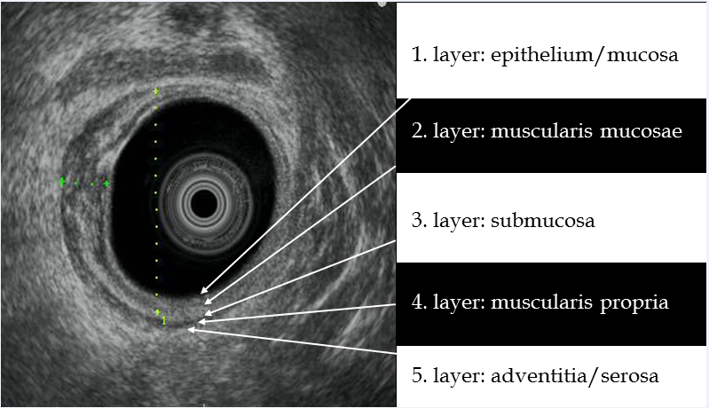
Figure 1 Radial rectal endoscopic ultrasound image: On the right side of the rectum, layering of the rectal wall is retained (white arrows); but normal wall structure has disappeared on the left part of rectum, rectal cancer which involves the third/submucosal layer (uT2).

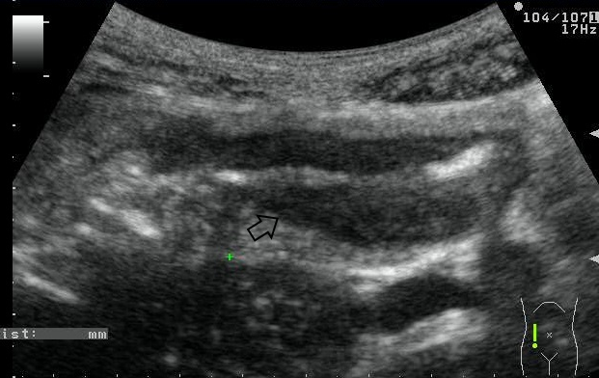
A
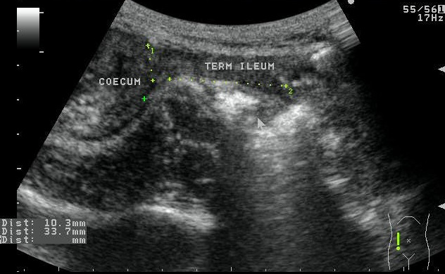
B
Figure 2 Transabdominal ultrasound image of patient. A: Active extensive ulcerative colitis. The wall of the transverse colon is widened (largest diameter: 12 mm) and the lumen is narrowed. B: Stricturing ileocolonic Crohn’s disease. Thirty-three millimeter long fibrotic stenosis at the end of the terminal ileum.

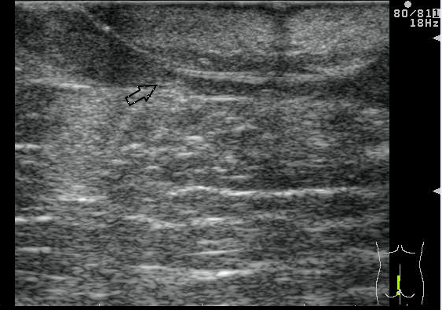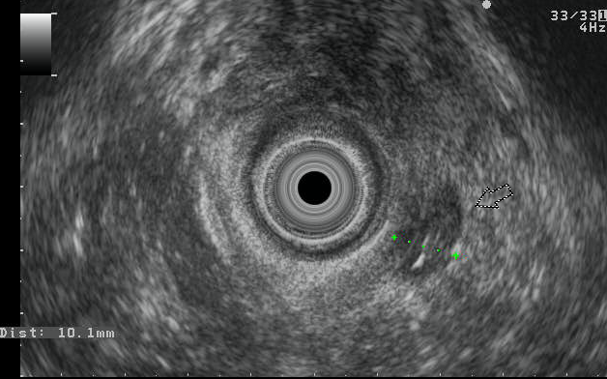
Figure 3 Transperineal and rectal ultrasound images of a patient with complicated perianal Crohn’s disease: wide, hypoechoic fistula with seton thread.

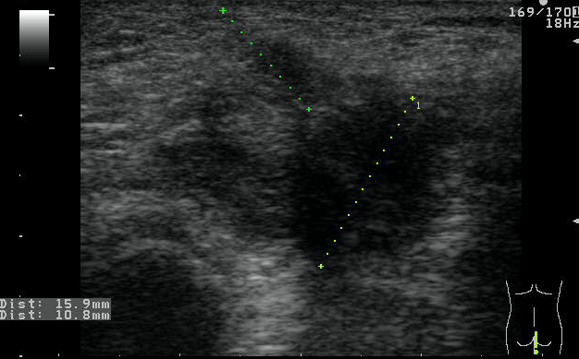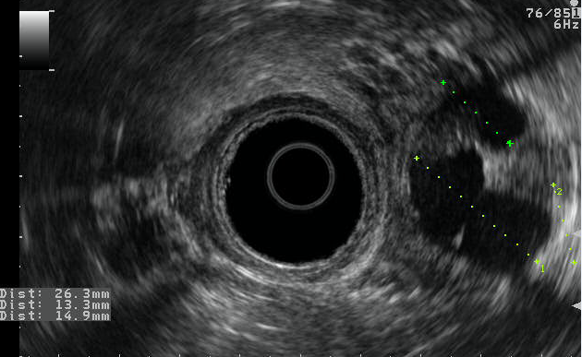
Figure 4 Multiplex, hypoechoic pararectal abscesses in rectal and perianal ultrasound images of a patient with perianal Crohn’s disease.

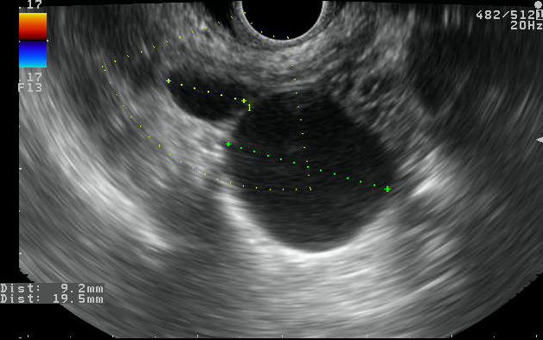
A
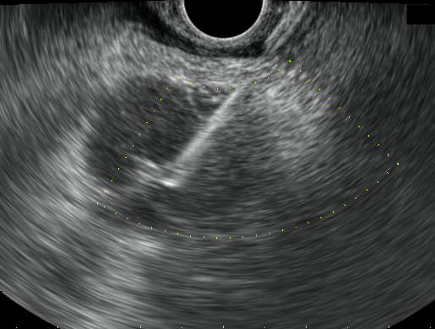
B
Figure 5 Rectal ultrasound image: A: Cystic lesion between the rectum and the uterus, it shows typical morphology of endometriosis; B: Inhomogeneous perirectal tissue with rectal wall enlargement and lymphadenomegaly 2-years after resection of rectal cancer. RUS-FNA confirmed the recurrence of rectal adenocarcinoma.

