Name of Journal: World Journal of Clinical Cases
Manuscript NO: 68959
Manuscript Type: CASE REPORT

Treatment of a giant low-grade appendiceal mucinous neoplasm: A case report

Xu R et al. A case of appendiceal mucinous neoplasm

Rong Xu, Zhi-Long Yang

Rong Xu, Department of Gynecology and Obstetrics, Nanjing Lishui People’s Hospital, Nanjing 211200, Jiangsu Province, China

Zhi-Long Yang, Department of General Surgery, Nanjing Lishui People’s Hospital, Nanjing 211200, Jiangsu Province, China

Author contributions: Xu R contributed to the data collection, interpretation, writing the paper, editing the paper; Yang ZL contributed to the study concept, data interpretation, writing the paper, editing the paper; and all authors read and approved the manuscript for publication.

Corresponding author: Zhi-Long Yang, MM, Chief Doctor, Department of General Surgery, Nanjing Lishui People’s Hospital, No. 86 Chongwen Road, Nanjing 211200, Jiangsu Province, China. 641952830@qq.com

Received: June 10, 2021
Revised: July 28, 2021
Accepted: September 16, 2021
Published online:

Abstract
BACKGROUND
Low-grade appendiceal mucinous neoplasm (LAMN) is extremely rare and easily misdiagnosed before surgery.

CASE SUMMARY
We report the treatment of an asymptomatic case of LAMN diagnosed by magnetic resonance imaging (MRI) and surgical findings. A 70-year-old woman presented with an adnexal mass found by physical examination in July 2020. Gynecologic ultrasonography revealed a cystic mass in the right adnexa, and computed tomography showed a cystic mass in the pelvic cavity. All tumor markers were normal. A further MRI examination suggested mucinous neoplasm in the right pelvic cavity, excluding the possibility of adnexal cyst. Laparoscopic exploration found a huge cystic mass of about 10 cm × 7 cm that originated from the apex of the appendix, with spontaneous rupture. LAMN was confirmed by pathological examination. As of May 2021, no disease recurrence occurred after an open appendectomy.

CONCLUSION
This case indicates that we should pay more attention to female patients who are clinically diagnosed with an adnexal mass at admission,. The physical examination should be done carefully, and the laboratory and imaging examination results should be comprehensively analyzed to avoid misdiagnosis and to ensure prompt diagnosis and treatment, and to improve prognosis. MRI may be a better option for the diagnosis of appendiceal mucinous neoplasm.

Key Words: Appendiceal mucinous neoplasm; Diagnosis; Cystic mass; Pelvic cavity; Appendectomy; Case report

Xu R, Yang ZL. Treatment process of a giant low-grade appendiceal mucinous neoplasm: A case report. World J Clin Cases 2021; In press

Core Tip: Low-grade appendiceal mucinous neoplasm (LAMN) is extremely rare and easily misdiagnosed before surgery. We report the treatment of an asymptomatic case of LAMN diagnosed by magnetic resonance imaging and surgical findings. This case indicates that we should pay more attention to female patients who are clinically diagnosed with an adnexal mass at admission,. The physical examination should be done carefully, and the laboratory and imaging examination results should be comprehensively evaluated to avoid misdiagnosis and ensure prompt diagnosis and treatment, and to improve prognosis.

INTRODUCTION
Low-grade appendiceal mucinous neoplasm (LAMN) is a rare heterogeneous disease, characterized by well-differentiated tumors. It is often complicated by spontaneous or iatrogenic rupture that results in pseudomyxoma or distant metastasis of the abdominal wall, which can be life threatening^{[1]}. LAMN is easily misdiagnosed because most patients are asymptomatic. It is generally found during the surgery because of the difficulty of preoperative diagnosis. Here, we report a case of LAMN diagnosed by magnetic resonance imaging (MRI) and surgical findings.

CASE PRESENTATION
Chief complaints
The patient presented with an adnexal mass found by physical examination more than 1 mo previously.

History of present illness
On August 23, 2020, a 70-year-old postmenopausal woman who presented with an adnexal mass found by physical examination 1 mo previously was admitted to the department of gynecology at our hospital. She did not complain of any clinical symptoms or discomfort.

History of past illness
The past medical history was unremarkable. One month prior, a right adnexal mass was found by ultrasonography at the local hospital.

Personal and family history
The patient had no remarkable personal or family history.

Physical examination
Upon arrival at our hospital, the patient was well-nourished, and without pain, pallor, or jaundice. Abdominal examination revealed distension without tenderness.

Laboratory examinations
Laboratory examination demonstrated found hemoglobin: 10.3 g/dL, leucocyte count: 4.86 × 10⁹/L, hematocrit: 31.7%, and platelet count: 210 × 10⁹/L. Liver and renal function tests, and the coagulation profile were all within normal ranges. Cancer antigen markers including carcinoembryonic antigen and carbohydrate antigen 19.9 were all within normal ranges.

Imaging examinations
B-ultrasound re-examination at our hospital showed a small amount of pelvic effusion (122 mm × 64 mm) in the right adnexal area (Figure 1A). No tenderness or rebound pain was found in the lower abdomen, and a mass of about 12 cm × 6 cm in the pelvic cavity with a tough texture and low mobility was detected by palpation. Whole abdomen computed tomography (CT) showed a small amount of effusion in the pelvic cavity, with lesions on the right (Figure 1B). The irregular cyst wall and thick soft tissue seen in the CT image might have resulted from tumor transformation. However the tumor markers were all normal. An MRI examination suggested a mucinous neoplasm in the right pelvic cavity (Figure 1C). It was not clear whether the neoplasm originated from abdominal mesodermal tissue or the appendix. The patient was transferred to the general surgery department. During laparoscopic exploration, a large amount of jelly-like mucosubstance was found in the right lower abdomen and pelvic cavity, and a huge cystic mass of about 10 cm × 7 cm originating from the apex of the appendix were found (Figure 2A).

FINAL DIAGNOSIS
Giant low-grade appendiceal mucinous neoplasm.

TREATMENT
An open appendectomy was performed, followed by peritoneal lavage and drainage. Postoperative pathological examination revealed a LAMN (Figure 2B). Anti-infective and symptomatic treatments were given after surgery; no obvious abnormalities was found on whole abdomen CT.

OUTCOME AND FOLLOW-UP
Tumor markers and a colonoscopy performed 3 mo after surgery were all normal. No disease recurrence or other conditions were found on follow-up in May 2021.

DISCUSSION
Appendiceal mucinous neoplasm accounts for 8%-10% of appendiceal tumors and 58% of malignant appendiceal tumors. The incidence is 0.2%-0.3% in patients who underwent appendectomy. LAMN is a borderline or low-grade malignant tumor, regardless of rupture, and is characterized by implantation metastasis and a rate of recurrence rate^{[2-4]}. Its pathogenesis involves atypical hyperplasia of the glandular appendix epithelium that obstructs the appendix with a gradual accumulation of mucus resulting in increased pressure. Mucus penetrates the muscularis mucosa and produces mucinous masses around the appendix and in the retroperitoneum^{[5,6]}. Most cases are asymptomatic, and in the absence of acute infection, the symptoms and signs of LAMN resemble those of chronic appendicitis. A correct diagnosis may be difficult, but on physical examination large tumors can be found as a complete oval mass with no surrounding adhesions. An appendiceal mucinous cyst that forms from an appendiceal lesion can easily be misdiagnosed as a common appendiceal abscess, right adnexal cyst, and so on^{[7,8]}. A recent case report described a patient with LAMN that was initially diagnosed as an ovarian tumor^{[9]}. As in this case, an appendiceal mucinous neoplasm should still be taken into consideration even if the tumor marker results are negative.
Abdominal ultrasound and CT are auxiliary diagnostic methods that can distinguish appendiceal mucinous cysts from other lesions before surgery^{[10,11]}. Color Doppler ultrasound for mucinous cystadenoma of the appendix shows a dark liquid area in the appendix, with a small number of small flocculent light spots. Ultrasound exhibits better sound transmission, a round or oval shape, and smooth wall. There were no findings suggestive of LAMN by echo. CT is a more accurate imaging method for the diagnosis of appendiceal mucinous neoplasms, and shows a cystic mass closely adjacent to the cecum, with a round or long tubular shape, thin wall, and a smooth and regular outline, suggesting LAMN. When CT shows an irregular cyst wall and thick soft tissue, it is more likely to be malignant^{[10]}. In this case, gynecologic ultrasonography revealed a cystic mass in the right adnexa, and CT showed a cystic mass in the pelvic cavity. However, there was still a possibility that it was an adnexal cyst. MRI performed with a variety of sequences and scanning methods, and high tissue resolution can clearly and consistently distinguish the wall and fluid of the appendiceal mucinous cyst, and more accurately show the integrity and boundary of the cyst wall. In this case, additional MRI evaluation showed typical manifestations of appendiceal cysts. The lesion was located in the right lower abdomen, had a with clear boundary, and was closely related to the cecum, which showed changes in external pressure. MRI had uniform long T1 and long T2 signals, and the cyst wall was thin and uniform, with similar signals to those of the intestinal wall. The cross section of the mass was round or elliptical, and the sagittal or coronal plane presented as a long tubular or gourd-shaped structure^{[12,13]}. We thus successfully excluded the possibility of adnexal cyst by MRI. Subsequent surgery and pathological examination finally confirmed the diagnosis of LAMN.
Surgery is still the only treatment option for appendiceal mucinous neoplasms. Iatrogenic rupture of the tumor should be avoided during surgery to reduce the risk of implantation metastasis and disease recurrence. Unfortunately, preoperative abdominal ultrasound and CT examinations had shown effusion in the pelvic cavity. Spontaneous rupture of the tumor and the spread of mucus to the abdominal cavity were observed during laparoscopic exploration, indicating that the patient might have a relatively high risk of disease recurrence. Open surgery was performed after finding the spontaneous rupture of the tumor. Although appendectomy and peritoneal lavage and drainage were performed, and a negative incision margin was obtained, postoperative follow-up should be continued for a long time. Chen et al^{[14]} reported a patient with recurrence of appendix mucinous adenocarcinoma at 26 mo after appendectomy.

CONCLUSION
LAMN is a rare clinical or imaging diagnosis. The female appendix is adjacent to the adnexa, which may lead to a misdiagnosis of either an appendiceal cyst or adnexal mass. The diagnosis and treatment of this patient suggested that for female patients who are clinically diagnosed with an adnexal mass at admission, we must broaden our minds and look further. Diagnosis should not be limited to the common diseases that we are familiar with. The physical examination should be done carefully, and the laboratory and imaging examination results should be comprehensively analyzed to reduce the possibility of misdiagnosis and to ensure prompt diagnosis and treatment, and to improve patient prognosis. MRI may be a better option for the diagnosis of appendiceal mucinous neoplasms.

REFERENCES
1 Shaib WL, Assi R, Shamseddine A, Alese OB, Staley C 3rd, Memis B, Adsay V, Bekaii-Saab T, El-Rayes BF. Appendiceal Mucinous Neoplasms: Diagnosis and Management. Oncologist 2017; 22: 1107-1116 [PMID: 28663356 DOI: 10.1634/theoncologist.2017-0081]
2 Ramaswamy V. Pathology of Mucinous Appendiceal Tumors and Pseudomyxoma Peritonei. Indian J Surg Oncol 2016; 7: 258-267 [PMID: 27065718 DOI: 10.1007/s13193-016-0516-2]
3 Motsumi MJ, Motlaleselelo P, Ayane G, Sesay SO, Valdes JR. A case report of a giant appendiceal mucocele and literature review. Pan Afr Med J 2017; 28: 106 [PMID: 29515724 DOI: 10.11604/pamj.2017.28.106.13832]
4 Padmanaban V, Morano WF, Gleeson E, Aggarwal A, Mapow BL, Stein DE, Bowne WB. Incidentally discovered low-grade appendiceal mucinous neoplasm: a precursor to pseudomyxoma peritonei. Clin Case Rep 2016; 4: 1112-1116 [PMID: 27980743 DOI: 10.1002/ccr3.694]
5 Pai RK, Longacre TA. Appendiceal mucinous tumors and pseudomyxoma peritonei: histologic features, diagnostic problems, and proposed classification. Adv Anat Pathol 2005; 12: 291-311 [PMID: 16330927 DOI: 10.1097/01.pap.0000194625.05137.51]
6 Rampone B, Roviello F, Marrelli D, Pinto E. Giant appendiceal mucocele: report of a case and brief review. World J Gastroenterol 2005; 11: 4761-4763 [PMID: 16094726 DOI: 10.3748/wjg.v11.i30.4761]
7 Aleter A, El Ansari W. Incidental appendiceal mucinous neoplasm mimicking a left adnexal mass: A case report. Int J Surg Case Rep 2020; 74: 132-135 [PMID: 32836208 DOI: 10.1016/j.ijscr.2020.07.081]
8 Omari AH, Khammash MR, Qasaimeh GR, Shammari AK, Yaseen MK, Hammori SK. Acute appendicitis in the elderly: risk factors for perforation. World J Emerg Surg 2014; 9: 6 [PMID: 24428909 DOI: 10.1186/1749-7922-9-6]
9 Perivoliotis K, Christodoulidis G, Samara AA, Sgantzou IK, Floros T, Volakakis G, Karasavvidou F, Tepetes K. Low-Grade Appendiceal Mucinous Neoplasm (LAMN) Primarily Diagnosed as an Ovarian Mucinous Tumor. Case Rep Surg 2021; 2021: 5523736 [PMID: 33976950 DOI: 10.1155/2021/5523736]
10 Yang JM, Zhang WH, Yang DD, Jiang H, Yu L, Gao F. Giant low-grade appendiceal mucinous neoplasm: A case report. World J Clin Cases 2019; 7: 1726-1731 [PMID: 31367633 DOI: 10.12998/wjcc.v7.i13.1726]
11 Cubro H, Cengic V, Burina N, Kravic Z, Beciragic E, Vranic S. Mucocele of the appendix presenting as an exacerbated chronic tubo-ovarian abscess: A case report and comprehensive review of the literature. Medicine (Baltimore) 2019; 98: e17149 [PMID: 31574819 DOI: 10.1097/MD.0000000000017149]
12 Pickhardt PJ, Levy AD, Rohrmann CA Jr, Kende AI. Primary neoplasms of the appendix: radiologic spectrum of disease with pathologic correlation. Radiographics 2003; 23: 645-662 [PMID: 12740466 DOI: 10.1148/rg.233025134]
13 Tirumani SH, Fraser-Hill M, Auer R, Shabana W, Walsh C, Lee F, Ryan JG. Mucinous neoplasms of the appendix: a current comprehensive clinicopathologic and imaging review. Cancer Imaging 2013; 13: 14-25 [PMID: 23439060 DOI: 10.1102/1470-7330.2013.0003]
14 Chen W, Ye JW, Tan XP, Peng X, Zhang Y, Liang JL, Huang MJ. A case report of appendix mucinous adenocarcinoma that recurred after additional surgery and a brief literature review. BMC Surg 2020; 20: 182 [PMID: 32778094 DOI: 10.1186/s12893-020-00842-4]

Footnotes
Informed consent statement: Informed written consent was obtained from the patient for publication of this report and any accompanying images.

Conflict-of-interest statement: The authors declare that they have no conflicting interests.

CARE Checklist (2016) statement: The authors have read the CARE Checklist (2016), and the manuscript was prepared and revised according to the CARE Checklist (2016).

Open-Access: This article is an open-access article that was selected by an in-house editor and fully peer-reviewed by external reviewers. It is distributed in accordance with the Creative Commons Attribution NonCommercial (CC BY-NC 4.0) license, which permits others to distribute, remix, adapt, build upon this work non-commercially, and license their derivative works on different terms, provided the original work is properly cited and the use is non-commercial. See: http://creativecommons.org/Licenses/by-nc/4.0/

Manuscript source: Unsolicited manuscript

Peer-review started: June 10, 2021
First decision: July 15, 2021
Article in press:

Specialty type: Gastroenterology and Hepatology
Country/Territory of origin: China
Peer-review report’s scientific quality classification
Grade A (Excellent): 0
Grade B (Very good): B
Grade C (Good): C
Grade D (Fair): D
Grade E (Poor): 0

P-Reviewer: Kitagawa Y, Samara AA S-Editor: Wang JL L-Editor: Filipodia P-Editor:

Figure Legends
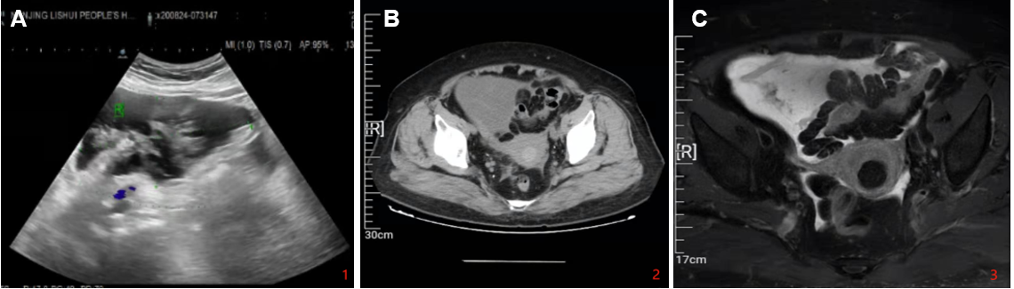
Figure 1 Preoperative examination of the mass. A: Ultrasound; B: Computed tomography; and C: Magnetic resonance imaging.

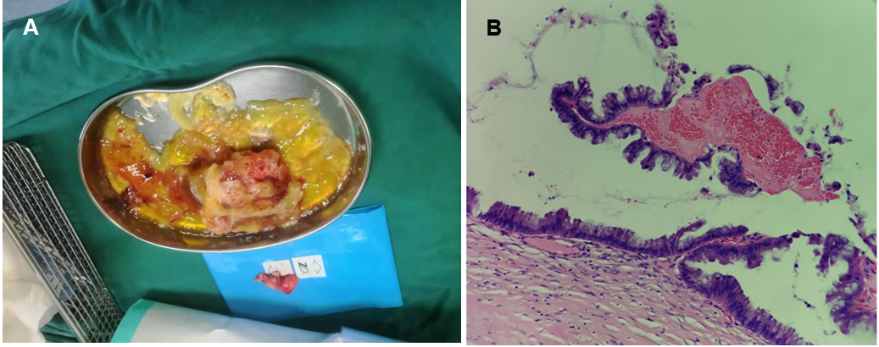
Figure 2 Postoperative images. A: The macroscopic view the resected mass; and B: Microscopic pathology of the low-grade appendiceal mucinous neoplasm (Magnification × 4).

