Name of Journal: World Journal of Clinical Cases
Manuscript NO: 80566
Manuscript Type: CASE REPORT

Interventional urethral balloon dilatation before endoscopic visual internal urethrotomy for post-traumatic bulbous urethral stricture: A case report

Ha JY et al. Interventional urethral balloon dilatation pre-EVIU

Ji Yong Ha, Mu Sook Lee

Ji Yong Ha, Department of Urology, Keimyung University Dongsan Hospital, Keimyung University School of Medicine, Daegu 42601, South Korea

Mu Sook Lee, Department of Radiology, Keimyung University Dongsan Hospital, Keimyung University School of Medicine, Daegu 42601, South Korea

Author contributions: Ha JY and Lee MS contributed to the manuscript writing and editing and data collection and analysis; Lee MS contributed to the conceptualization and supervision; all authors have read and approved the final manuscript.

Supported by the National Research Foundation of Korea Grant founded by the Korea Government, No. NRF-2022R1A2C1007169.

Corresponding author: Mu Sook Lee, MD, Professor, Department of Radiology, Keimyung University Dongsan Hospital, Keimyung University School of Medicine, 1035 Dalgubeol-daero, Dalseo-gu, Daegu 42601, South Korea. musukilee@dsmc.or.kr

Received: October 3, 2022
Revised: October 22, 2022
Accepted: November 7, 2022
Published online: December 6, 2022

Abstract
BACKGROUND
While several treatment options are available for pediatric urethral strictures, the appropriate treatment must be based on several factors. Although endoscopic visual internal urethrotomy (EVIU) could be a first-line treatment option for short pediatric urethral strictures, it is not feasible if the urethroscope cannot pass through the stricture point. Herein, we present a pediatric case of severe post-traumatic bulbous urethral stricture that was successfully treated by EVIU after securing the urethral route via interventional balloon dilatation.

CASE SUMMARY
A 12-year-old boy presented at our outpatient clinic with the inability to urinate. He had sustained a straddle injury three months prior. The post-void residual urine volume was 644 mL, and retrograde urethrography confirmed severe stricture of the bulbous urethra. EVIU was planned; however, the first attempt to treat the stricture failed because the urethroscope could not pass through the stricture point. The urethral route was subsequently secured via balloon dilatation of the stricture, which was performed in collaboration with specialists from the department of interventional radiology. The urethroscope was then able to pass, and the repeat EVIU was successful.

CONCLUSION
Interventional urethral balloon dilatation before EVIU may help secure the urethral route in the treatment of pediatric urethral strictures.

Key words: Urethral stricture; Endoscopic visual internal urethrotomy; Urethroplasty; Urethral balloon dilatation; Interventional radiology; Case report

©The Author(s) 2022. Published by Baishideng Publishing Group Inc. All rights reserved.

Citation: Ha JY, Lee MS. Interventional urethral balloon dilatation before endoscopic visual internal urethrotomy for post-traumatic bulbous urethral stricture: A case report. World J Clin Cases 2022; 10(34):12787-12792
URL: https://www.wjgnet.com/2307-8960/full/v10/i34/12787.htm
DOI: https://dx.doi.org/10.12998/wjcc.v10.i34.12787

Core Tip: Urethral stricture is one of the most challenging problems in urology, with traumatic and iatrogenic etiologies accounting for most cases. Appropriate treatment methods, including endoscopic management [dilation and endoscopic visual internal urethrotomy (EVIU)], urethroplasty, and urethral stenting, depend on the site and length of urethral stricture and the clinical situation. EVIU could be the first-line treatment for pediatric urethral stricture, although it is not a viable option when the urethroscope cannot pass through the stricture. Herein, we describe the successful management of a severe urethral stricture by EVIU after securing the urethral route via interventional balloon dilatation.

INTRODUCTION
A urethral stricture is a narrowing of the urethral lumen caused by the formation of scar tissue due to collagen and fibroblast proliferation, which ultimately causes lower urinary tract obstruction^{[1]}. The etiologies of pediatric anterior urethral stricture include iatrogenic (hypospadia-associated or post-catheterization), traumatic, inflammatory (lichen sclerosus-associated), post-infectious, and congenital^{[2]}. Symptoms of pediatric anterior urethral stricture include hematuria, pain, nighttime or daytime wetting, urinary tract infection, decreased stream, high post-void residual (PVR) urine volume, straining to void, and dysuria^{[3]}. While several surgical treatment options for pediatric urethral stricture have been introduced in recent years, there is no consensus regarding the optimal treatment method^{[4,5]}. However, reserving open urethroplasty as the final option for the treatment of short bulbous urethral stricture is an important and cost-effective strategy^{[6]}.
Endoscopic visual internal urethrotomy (EVIU) could be a first-line treatment option for pediatric patients with short urethral stricture. However, when the urethroscope cannot pass through the stricture point, EVIU is not viable. Herein, we report a case involving a 12-year-old boy with severe urethral stricture through which a urethroscope could not pass. The patient was successfully treated by EVIU after securing the urethral route by interventional balloon dilatation.

CASE PRESENTATION
Chief complaints
A 12-year-old boy presented at our outpatient clinic with the inability to urinate.

History of present illness
The patient experienced difficulty urinating for approximately three weeks before the outpatient visit. He could not begin urinating properly when he felt the urge to urinate and could not completely empty his bladder. He frequently woke up in the night to urinate. He could not recollect any characteristics of his urine stream or any aggravating or relieving factors influencing his symptoms.

History of past illness
The patient reported suffering a straddle injury after falling from a trampoline three months before his presentation. He presented to the emergency room (ER) with blood in the urethra meatus and the inability to urinate. Retrograde urethrography (RGU) performed in the ER confirmed partial rupture of the bulbous urethra, which was treated via the insertion of a 12F foley catheter (Figure 1).

Personal and family history
The patient reported no relevant family history.

Physical examination
The boy appeared well oriented and cooperative, and his vital signs were stable.

Laboratory examinations
At the outpatient visit, the PVR urine volume was 644 mL.

Imaging examinations
RGU performed during the outpatient visit confirmed severe stricture of the bulbous urethra.

FINAL DIAGNOSIS
The patient was diagnosed with post-traumatic severe bulbous urethral stricture.

TREATMENT
EVIU was attempted after the patient was admitted to the hospital; however, the endoscopic guide wire could not be passed through the stricture point due to the severity of the bulbous urethral stricture. Forcibly performing EVIU under such circumstances could cause unnecessary urethral injury; therefore, we discontinued the operation after an emergency suprapubic cystostomy. The operative outcome was explained to the patient and his guardian, and the need for an open urethroplasty was discussed. However, the patient and his guardian desired another EVIU attempt. Interventional urethral dilatation was attempted based on our consultation with specialists from interventional radiology.
The patient was placed in the supine position on the fluoroscopy table in the intervention suite. A 5F catheter (KMP; Cook, Inc, Bloomington, Indiana, United States) was inserted into the anterior urethra, and 10 mL of 2% lidocaine was injected through the catheter for local anesthesia. Antegrade urethrography was performed by injecting 10 mL of 50% diluted contrast medium with normal saline through the suprapubic cystostomy catheter (Figure 2A). Under fluoroscopic guidance, a 0.035-inch angled guide wire (Radifocus glidewire; Terumo, Tokyo, Japan) was placed onto the 5F catheter and manipulated until it passed through the site of the urethral stricture. After the guide wire was successfully navigated to the entrance of the bladder neck, a 6-mm balloon catheter (Mustang, Boston Scientific Corporation, Natick, MA, United States) was advanced over the guide wire and laid across the site of the urethral stricture (Figure 2B). The balloon catheter then was inflated for three minutes to widen the urethra. After balloon dilatation, the balloon catheter was removed and a 10F foley catheter was inserted along the guide wire.
On the following day, a urethroscopic guide wire was inserted into the 10F foley catheter to secure the urethral route, and EVIU was successfully completed. RGU performed after EVIU demonstrated an improved caliber of the affected urethra (Figure 3).

OUTCOME AND FOLLOW-UP
RGU performed two months after the initial EVIU revealed a mild stricture; therefore, a second EVIU was performed. At present, the patient is being monitored carefully, as an open urethroplasty may be required if symptoms recur in the future.

DISCUSSION
Pediatric anterior urethral strictures can be iatrogenic (associated with hypospadias or catheterization), traumatic, inflammatory (associated with lichen sclerosus), post-infectious, or congenital^{[2]}. The majority of children present with anterior urethral strictures, with bulbar, penile, and bulbopenile strictures accounting for 45%, 35%, and 3% cases, respectively^{[7]}. Almost all adult strictures are acquired, with iatrogenic strictures (from urethral manipulations) being the most common^{[8]}. Several treatment options for urethral strictures have rapidly evolved in recent years^{[9]}. Surgical options include urethral dilatation, EVIU, and urethroplasty. Urethroplasty techniques include excision and primary anastomosis, substitution urethroplasty, augmented anastomotic urethroplasty, and pull through urethroplasty^{[7,9,10]}. Perineal urethrostomy and permanent urethral stenting are additional treatment options^{[11]}.
However, there is no consensus regarding the first-line treatment method^{[9,10]}. As most studies regarding the treatment of an urethral stricture have focused on adults, treatment methods for a pediatric urethral stricture have yet to be established. Despite this, reserving open urethroplasty as the final treatment option for bulbous urethral strictures is considered an important and cost-effective treatment strategy^{[6,10]}. Nonetheless, the appropriate treatment method depends on the site, length, and underlying pathology of the stricture; patient’s previous surgery history and preference; and experience and preference of the urosurgeon^{[12]}.
For the treatment of a short (< 2 cm) bulbous urethral stricture, EVIU with or without urethral dilatation is commonly used^{[10,13]}. The American Urological Association and Korean Urological Society recommend EVIU for initial management due to its lower complexity, cost, level of invasiveness, amount of time required, and subsequently, reduced length of hospital stay^{[10,13]}. However, several studies have reported that excision and primary anastomosis should be the standard treatment for short bulbous urethral strictures, although it is more invasive, owing to a favorable overall success rate^{[5,7]}. Although the success rate of single EVIU is 26%-53%, that of repeated EVIU is up to 71%^{[5,14,15]}, which is similar to the success rate of excision and primary anastomosis (82%)^{[7]}. During excision and primary anastomosis, excision of the urethral stricture segment and opposing 1-cm proximal and distal spatulation may lead to penile and urethral shortening^{[16]}. Especially in adolescent boys who are still developing, such as our patient, urethral shortening may result in complications such as chordee^{[17]}. Additional complications of open urethroplasty include erectile and ejaculatory dysfunction, insensate glans, urine dribbling, and incontinence, while stricture recurrence is the most common complication after EVIU^{[17,18]}. Therefore, when treating pediatric urethral strictures, it is necessary to consider the site and length of the strictures as well as treatment methods and complications when consulting with the patient.
When the guide wire cannot pass through the stricture point during EVIU, the operation is often converted from EVIU to open urethroplasty^{[14]}. In our patient, the urethroscope and guide wire could not pass through the stricture point during the first attempt of EVIU. Accordingly, we explained the need for an open urethroplasty to the patient and his guardian, but they expressed a strong desire to attempt a repeat EVIU. However, excessively forcing the urethroscope through the stricture point may lead to additional urethral injury; therefore, the primary urologist consulted with the department of interventional radiology regarding interventional urethral balloon dilatation and foley catheter insertion. Under the guidance of urethrographic and fluoroscopic images, the stricture point on the bulbous urethra was successfully located using the guide wire and catheter, and urethral balloon dilatation was performed to allow for subsequent EVIU. Therefore, for patients in whom EVIU cannot be performed due to the inability of the urethroscope to pass through the stricture point, interventional urethral balloon dilatation can be used to secure the urethral route prior to subsequent EVIU.

CONCLUSION
EVIU is a common treatment method of urethral stricture for various reasons, including its lower complexity, lower cost, lower time requirement, and subsequently, reduced length of hospital stay. EVIU may be a safe and useful first-line treatment option regardless of the stricture site and etiology, especially for pediatric urethral strictures measuring < 1 cm. When EVIU cannot be performed due to the urethroscope not passing through the stricture point, interventional urethral balloon dilatation is helpful to secure the urethral route prior to subsequent EVIU.

REFERENCES
1 Sievert KD, Selent-Stier C, Wiedemann J, Greiner TO, Amend B, Stenzl A, Feil G, Seibold J. Introducing a large animal model to create urethral stricture similar to human stricture disease: a comparative experimental microscopic study. J Urol 2012; 187: 1101-1109 [PMID: 22266012 DOI: 10.1016/j.juro.2011.10.132]
2 Latini JM, McAninch JW, Brandes SB, Chung JY, Rosenstein D. SIU/ICUD Consultation On Urethral Strictures: Epidemiology, etiology, anatomy, and nomenclature of urethral stenoses, strictures, and pelvic fracture urethral disruption injuries. Urology 2014; 83: S1-S7 [PMID: 24210733 DOI: 10.1016/j.urology.2013.09.009]
3 Kaplan GW, Brock JW, Fisch M, Koraitim MM, Snyder HM. SIU/ICUD Consultation on Urethral Strictures: Urethral strictures in children. Urology 2014; 83: S71-S73 [PMID: 24231203 DOI: 10.1016/j.urology.2013.09.010]
4 Alwaal A, Blaschko SD, McAninch JW, Breyer BN. Epidemiology of urethral strictures. Transl Androl Urol 2014; 3: 209-213 [PMID: 26813256 DOI: 10.3978/j.issn.2223-4683.2014.04.07]
5 Diamond DA, Xuewu J, Bauer SB, Cilento BG Jr, Borer JG, Nguyen H, Cendron M, Rosoklija I, Retik AB. What is the optimal surgical strategy for bulbous urethral stricture in boys? J Urol 2009; 182: 1755-1758 [PMID: 19692008 DOI: 10.1016/j.juro.2009.02.082]
6 Wright JL, Wessells H, Nathens AB, Hollingworth W. What is the most cost-effective treatment for 1 to 2-cm bulbar urethral strictures: societal approach using decision analysis. Urology 2006; 67: 889-893 [PMID: 16698347 DOI: 10.1016/j.urology.2005.11.003]
7 Vetterlein MW, Weisbach L, Riechardt S, Fisch M. Anterior Urethral Strictures in Children: Disease Etiology and Comparative Effectiveness of Endoscopic Treatment vs. Open Surgical Reconstruction. Front Pediatr 2019; 7: 5 [PMID: 30805317 DOI: 10.3389/fped.2019.00005]
8 Tritschler S, Roosen A, Füllhase C, Stief CG, Rübben H. Urethral stricture: etiology, investigation and treatments. Dtsch Arztebl Int 2013; 110: 220-226 [PMID: 23596502 DOI: 10.3238/arztebl.2013.0220]
9 Singh O, Gupta SS, Arvind NK. Anterior urethral strictures: a brief review of the current surgical treatment. Urol Int 2011; 86: 1-10 [PMID: 20956850 DOI: 10.1159/000319501]
10 Lee YJ, Kim SW. Current management of urethral stricture. Korean J Urol 2013; 54: 561-569 [PMID: 24044088 DOI: 10.4111/kju.2013.54.9.561]
11 Bayne DB, Gaither TW, Awad MA, Murphy GP, Osterberg EC, Breyer BN. Guidelines of guidelines: a review of urethral stricture evaluation, management, and follow-up. Transl Androl Urol 2017; 6: 288-294 [PMID: 28540238 DOI: 10.21037/tau.2017.03.55]
12 Peterson AC, Webster GD. Management of urethral stricture disease: developing options for surgical intervention. BJU Int 2004; 94: 971-976 [PMID: 15541111 DOI: 10.1111/j.1464-410X.2004.05088.x]
13 Aboulela W, ElSheemy MS, Shoukry M, Shouman AM, Shoukry AI, Ghoneima W, El Ghoneimy M, Morsi HA, Mohsen MA, Badawy H. Visual internal urethrotomy for management of urethral strictures in boys: a comparison of short-term outcome of holmium laser versus cold knife. Int Urol Nephrol 2018; 50: 605-609 [PMID: 29397549 DOI: 10.1007/s11255-018-1809-x]
14 Hafez AT, El-Assmy A, Dawaba MS, Sarhan O, Bazeed M. Long-term outcome of visual internal urethrotomy for the management of pediatric urethral strictures. J Urol 2005; 173: 595-597 [PMID: 15643267 DOI: 10.1097/01.ju.0000151339.42841.6e]
15 Launonen E, Sairanen J, Ruutu M, Taskinen S. Role of visual internal urethrotomy in pediatric urethral strictures. J Pediatr Urol 2014; 10: 545-549 [PMID: 24388665 DOI: 10.1016/j.jpurol.2013.11.018]
16 Guralnick ML, Webster GD. The augmented anastomotic urethroplasty: indications and outcome in 29 patients. J Urol 2001; 165: 1496-1501 [PMID: 11342904]
17 Al-Qudah HS, Santucci RA. Extended complications of urethroplasty. Int Braz J Urol 2005; 31: 315-23; discussion 324-5 [PMID: 16137399 DOI: 10.1590/s1677-55382005000400004]
18 Gallegos MA, Santucci RA. Advances in urethral stricture management. F1000Res 2016; 5: 2913 [PMID: 28105329 DOI: 10.12688/f1000research.9741.1]

Footnotes
Informed consent statement: Informed written consent was obtained from the patient and his parents for publication of this report and any accompanying images.

Conflict-of-interest statement: All authors declare that they have no conflict of interest to disclose.

CARE Checklist (2016) statement: All authors have read the CARE Checklist (2016), and the manuscript was prepared and revised according to the CARE Checklist (2016).

Open-Access: This article is an open-access article that was selected by an in-house editor and fully peer-reviewed by external reviewers. It is distributed in accordance with the Creative Commons Attribution NonCommercial (CC BY-NC 4.0) license, which permits others to distribute, remix, adapt, build upon this work non-commercially, and license their derivative works on different terms, provided the original work is properly cited and the use is non-commercial. See: https://creativecommons.org/Licenses/by-nc/4.0/

Provenance and peer review: Unsolicited article; Externally peer reviewed.
Peer-review model: Single blind

Peer-review started: October 3, 2022
First decision: October 13, 2022
Article in press: November 7, 2022

Specialty type: Medicine, research and experimental
Country/Territory of origin: South Korea
Peer-review report’s scientific quality classification
Grade A (Excellent): 0
Grade B (Very good): B
Grade C (Good): C, C
Grade D (Fair): D
Grade E (Poor): 0

P-Reviewer: Gao C, China; Jian X, China; Salimi M, Iran S-Editor: Wang LL L-Editor: A P-Editor: Wang LL

Figure Legends
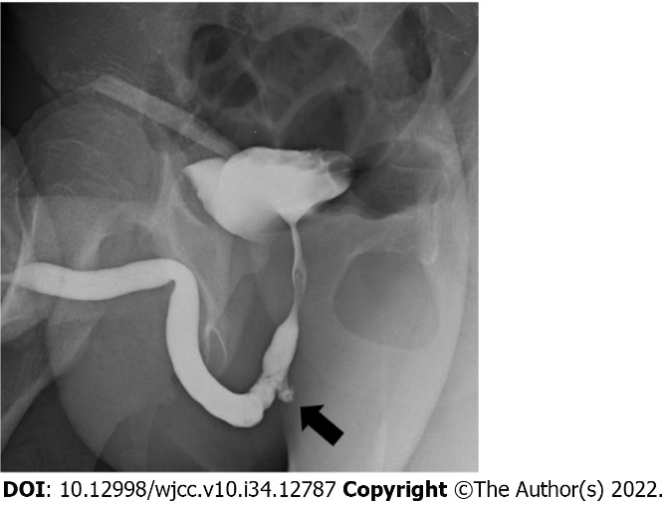
Figure 1 Retrograde urethrography of a 12-year-old boy with straddle injury. Retrograde urethrography performed in the emergency room after a straddle injury confirms partial rupture of the bulbous urethra (arrow).

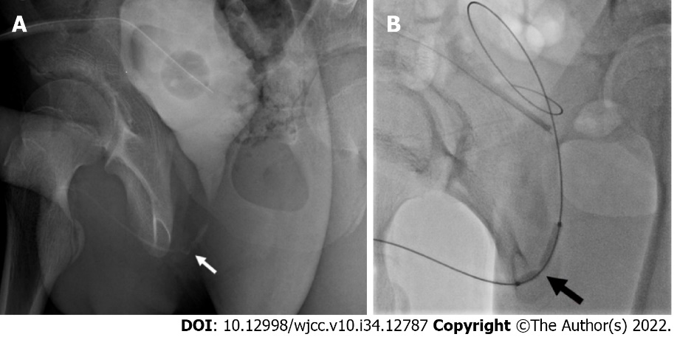
Figure 2 Interventional urethral balloon dilatation. A: Severe stricture of the bulbous urethra (white arrow) is identified using antegrade urethrography with injection of contrast agent using a suprapubic catheter. B: After the guide wire is successfully navigated to reach the entrance of the bladder neck, a 6-mm balloon catheter is advanced over the guide wire and laid across the site of the urethral stricture (black arrow).

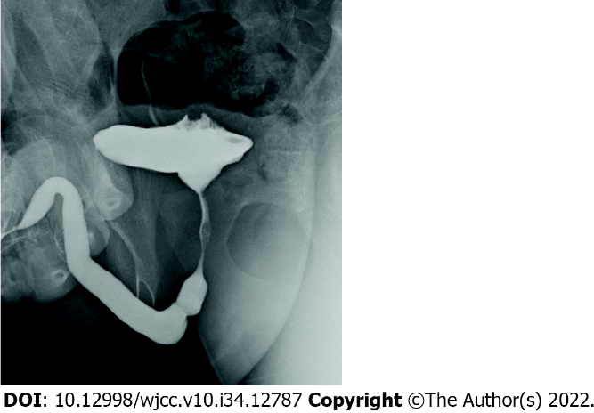
Figure 3 Retrograde urethrography after successful endoscopic visual internal urethrotomy. Retrograde urethrography after successful endoscopic visual internal urethrotomy demonstrates improved caliber of the affected urethra, relative to that on preoperative images.

Published by Baishideng Publishing Group Inc
7041 Koll Center Parkway, Suite 160, Pleasanton, CA 94566, USA
Telephone: +1-925-3991568
E-mail: bpgoffice@wjgnet.com
Help Desk: https://www.f6publishing.com/helpdesk
https://www.wjgnet.com

© 2022 Baishideng Publishing Group Inc. All rights reserved.

