Name of Journal: World Journal of Gastroenterology
Manuscript NO: 66578
Manuscript Type: MINIREVIEWS

Colonoscopy-related colonic ischemia

Sadalla S et al. Colonoscopy-related colonic ischemia

Sinan Sadalla, Andrea Lisotti, Lorenzo Fuccio, Pietro Fusaroli

Sinan Sadalla, Unità Operativa Complessa di Gastroenterologia e Endoscopia Digestiva, Università di Bologna/ Ospedale di Imola, Imola (BO) 40024, Italy

Andrea Lisotti, Pietro Fusaroli, Unità Operativa Complessa di Gastroenterologia e Endoscopia Digestiva, Università di Bologna/ Ospedale di Imola, Imola (BO) 40026, Italy

Lorenzo Fuccio, Divisione di Gastroenterologia, Dipartimento di Scienze Medico-Chirurgiche (DIMEC), IRCSS- Azienda Ospedaliero-Universitaria di Bologna, Bologna 40138, Italy

Author contributions: Fusaroli P designed the research study; Sadalla L and Lisotti A performed the research and wrote the article; Fuccio L analyzed the data for relevant intellectual content; All authors have read and approved the final manuscript.

Corresponding author: Pietro Fusaroli, MD, Associate Professor, Unità Operativa Complessa di Gastroenterologia e Endoscopia Digestiva, Università di Bologna/ Ospedale di Imola, Via Montericco 4, Imola (BO) 40026, Italy. pietro.fusaroli@unibo.it

Received: March 30, 2021
Revised: July 6, 2021
Accepted: October 20, 2021
Published online:

Abstract
Colonoscopy is a risk factor for colon ischemia. The colon is susceptible to ischemia due to its minor blood flow compared to other abdominal organs; the etiology of colon ischemia after colonoscopy is multifactorial. The causative mechanisms include splanchnic circulation impairment, bowel preparation, drugs used for sedation, bowel wall ischemia due to insufflation/barotrauma, and introduction of the endoscope. Gastroenterologists must be aware of this condition and its risk factors for risk minimization, early diagnosis, and proper treatment.

Key Words: Endoscopy; Colon ischemia; Colonoscopy; Bowel preparation; Mesenteric circulation; Ischemic colitis

Sadalla S, Lisotti A, Fuccio L, Fusaroli P. Colonoscopy-related colonic ischemia. World J Gastroenterol 2021; In press

Core Tip: Colonic ischemia is the main form of vascular injury to the gastrointestinal tract and is characterized by sudden onset of nausea and abdominal pain, followed by bloody diarrhea. Among the different etiologies, colonoscopy has been proposed as a risk factor for colon ischemia.

INTRODUCTION
At the end of 2018, an elderly retired physician came to our attention because of worsening post-prandial epigastric pain, hyporexia and weight loss. Complete blood cell count showed moderate anemia (hemoglobin 10.2 g/dL). The patient had sought medical attention in the emergency room of our hospital 1 mo prior for the same symptoms. At that time, doctors mainly focused on premature atrial complexes and hypokalemia, as the patient was suffering from hypertensive cardiopathy and had undergone percutaneous transluminal coronary angioplasty. Comorbidities were mild chronic renal failure, type-2 diabetes mellitus, and stable metastatic hormone-sensitive prostate cancer.
Upon presentation to our unit, no remarkable physical findings were noted. Medications included low-dose aspirin, beta-blockers, anti-hypertensive agents (candesartan and amlodipine), simvastatin, glibenclamide, bicalutamide, and omeprazole. We performed percutaneous abdominal ultrasound and esophagogastroduodenoscopy, which were unremarkable. As the patient was strongly determined not to neglect any diagnostic possibility, consent to undergo colonoscopy was given too. Being a fragile individual, we elected to administer the bowel preparation in our in-hospital facility with a 2-liter same-day ascorbate-based polyethylene glycol regimen. After the first laxative dose, the patient had syncope and was brought to the emergency room. No notable findings emerged; serum sodium was 147 mmol/L (136-145) while potassium concentration was normal. The patient was able to complete the preparation and was still determined to undergo a colonoscopy. The exam went smoothly and failed to show any relevant findings. The patient was discharged home in good condition and relieved as no malignancy was found.
However, 48 hours after the exam, disaster struck. The patient came back to the hospital suffering from severe abdominal pain of sudden onset. Urgent computed tomography showed complete thrombosis of the superior mesenteric artery, ileocolic arteries, and common hepatic artery (Figure 1). Large bowel loops were over-distended with a lack of parietal perfusion as per severe ischemic changes. Due to the rapidly deteriorating conditions, the patient died 24 h later despite intensive care.
Colonic ischemia, also described as ischemic colitis if an inflammatory component is present^{[1]}, is usually a benign condition that occurs when there is sudden and temporary hypoperfusion of the large bowel wall^{[2]}. Colonic ischemia can usually be managed conservatively and must be differentiated from other causes of acute and chronic ischemic injury, such as emboli and thrombosis^{[3]}, which often require urgent intervention^{[4]}.
Ischemia occurs when blood supply is inadequate to fulfill the metabolic requirements of tissues and can occur in every district of the body^{[5]}. When there is a decrease in blood flow, the affected tissues initially react with vasodilation. However, if hypoperfusion persists, vasoconstriction may ensue^{[6]}.
The colon is susceptible to ischemia due to its minor blood flow compared to other abdominal organs and to its decrease in perfusion when functionally inactive^{[7]}. In the colon, ischemic injury displays a wide spectrum of manifestations. Reversible ischemia determines the rupture of the sub-epithelial microvasculature, which evolves in a colitis phase when the mucosa ulcerates and subepithelial hemorrhage is reabsorbed^{[8]}. On the other hand, irreversible damage leads to necrosis of the bowel wall, gangrene, strictures, and ultimately to fulminant colitis^{[9]}.
Colonic ischemia represents the predominant form of vascular injury to the gastrointestinal tract with an estimated incidence ranging from 7.2 to 15.6 per 100000 population^{[10]}. It is also one of the main causes of lower gastrointestinal bleeding^{[8]}. Women seem affected more than men, especially among patients < 40 years of age^{[10]}. However, the incidence of colonic ischemia is probably underestimated because many patients never seek medical attention due to its frequent presentation with mild symptoms^{[2]}.

Etiology
Colonic ischemia is multifactorial. Previous studies identified risk factors for colonic ischemia such as cardiovascular, pulmonary, and renal comorbidities, history of irritable bowel syndrome, and surgical interventions^{[10,11]}. As far as drugs are concerned, immunomodulators and constipation-inducing drugs have been associated more frequently with colonic ischemia^{[12]}. The use of vasopressors, alfa-adrenergic agents, diuretics as well as cocaine has also been described as contributing factors^{[8]}. Additionally, in most cases, no specific cause of colonic ischemia can be determined^{[13]}.
Colonoscopy has been proposed as a risk factor for colonic ischemia although only few reports are available in this respect^{[14]}. To our knowledge, no current epidemiologic data exist about colonic ischemia after colonoscopy.

Splanchnic vascular anatomy
Visceral blood supply is strictly connected to the function of the gastrointestinal organs. The celiac trunk, the superior mesenteric artery (SMA), and the inferior mesenteric artery (IMA), all of which originate from the abdominal aorta (Figure 2)^{[15]}, represent the main abdominal vessels.
The SMA and IMA sustain colon perfusion. The SMA is the largest abdominal artery supplying the inferior part of the duodenum, the entire jejunum and ileum, the proximal colon, and a portion of the pancreas^{[16]}. The IMA feeds the distal colon through three different branches and the rectum with its terminal branch, the superior rectal artery^{[17]}.
These vessels are deeply interconnected through collateral branches to ensure visceral perfusion also in case of deficiency of a single vessel^{[18]}. Despite this network, some segments of the colon can be more frequently affected by ischemia due to their location between two different vascular supplies. These are known as “water-shed areas”, the most important being the splenic flexure (Griffith’s point) and the sigmoid colon (Sudeck’s point)^{[2]}.

Colonic ischemia after colonoscopy
Colonoscopy is the gold standard for colorectal screening programs and the number of colonoscopies is progressively increasing worldwide^{[19]}. This exam allows direct visualization of the colonic mucosa and allows resecting of pre-neoplastic lesions. Colonoscopy is considered relatively safe being associated with a perforation rate of about 4 in 10000 procedures, a major bleeding rate of 8 in 10000 procedures, and an estimated overall mortality of 0.007-0.07%^{[20,21]}.
An extensive search of the literature showed 25 reports of colonoscopy-related colonic ischemia^{[22]}. The first report in 1990 described a young woman with a history of systemic lupus erythematosus who developed abdominal pain and bloody diarrhea after a diagnostic colonoscopy. Arteriography showed no abnormalities of mesenteric vessels while sigmoidoscopy showed severe inflammation with biopsies suggestive for necrotic areas, compatible with ischemic colitis. The authors suggested that the impairment in small circulation due to the connective tissue disease combined with the mechanical stress of the colonoscopy probably led to colonic ischemia^{[14]}. Subsequently, more cases of ischemic colitis were published^{[23]}. More recent literature reported one case of SMA thrombosis and one case of SMA embolism^{[24]}. Other case reports of colonic ischemia after colonoscopy described patients with cardiovascular comorbidities^{[25]} or without any known risk factor^{[26]}.
Based on the previous considerations, we propose five different mechanisms by which colonoscopy-related colonic ischemia might arise.

Splanchnic circulation impairment
Colonic ischemia can develop in patients with bowel circulation impairment. Chronic mesenteric ischemia is predominantly related to atherosclerotic disease, patients with this condition usually being elderly and with a history of smoking^{[27]}. A study reported an 18% prevalence of asymptomatic stenoses of abdominal vessels in individuals over 65 years^{[28]}. Studies with magnetic resonance showed a significant postprandial reduction of mesenteric flow in patients with vascular stenoses compared to healthy subjects^{[29,30]}.
Moreover, conditions such as antiphospholipid syndrome, systemic lupus erythematosus and diabetes can determine an endothelial dysfunction of the colonic vasculature^{[8]}. In these conditions, the involvement of the splanchnic vessels can range from mesenteric thrombosis in the largest veins to mild ischemic injury in the mesenteric microcirculation^{[23,31]}. In all these cases, the colon suffers a condition of chronic ischemia. Therefore, when subjected to gas insufflation and mechanical compression during colonoscopy, the previously impaired blood flow can easily drop to a critical level leading to ischemic injury^{[14]}.

Bowel preparation
Adequate bowel cleansing is fundamental to perform a high-quality colonoscopy. Various combinations of volume, timing, and adjuvants have been validated for bowel preparations^{[32]}.
The isotonic polyethylene glycol (PEG) bowel preparations are generally considered safe as they minimize electrolyte and water loss^{[33]}. Hypertonic bowel preparations include PEG solutions combined with osmotically active molecules to reduce the volume of total fluid, oral sulfate solutions, and magnesium picosulfate solutions. It is generally assumed that hypertonic preparations have potential risks of inducing serum electrolyte imbalance. Furthermore, as they bind with water molecules, PEG monomers cause fluid retention that can increase intraluminal pressure^{[34]}. This effect, combined with an inadequate assumption of fluids during the preparation, can thus lead to dehydration^{[35]} and potentially precipitate an ischemic injury. We found on the Federal Drug Administration Adverse Events Report System a study from Bielefeldt et al^{[36]} describing bowel preparations as the suspected causative agents of 60 cases of colonic ischemia. Adjunctive drugs such as bisacodyl and magnesium citrate are often administered with low volume preparations to improve colon cleansing. Of note, case reports of ischemic colitis have been reported following the intake of bisacodyl^{[32]}.

Drugs used for endoscopy
Sedation during colonoscopy aims to reduce discomfort and improve outcomes. Narcotics such as meperidine and fentanyl, benzodiazepines (midazolam) and propofol represent the most common drugs. Although considered safe, sedation has been associated with cardiovascular and pulmonary adverse events such as hypotension and hypoxemia with an overall frequency of 1.1 per 100 procedures^{[37]}.
Midazolam, alone or in combination with opioids, is frequently used in colonoscopy as it has a rapid onset and a short duration of action. However, it can induce cardiovascular effects such as vasodilation, depression of myocardial contractility, and hypotension. In a recent study, Kim et al^{[38]} demonstrated a reduction of heart rate, systolic and diastolic blood pressure in patients undergoing colonoscopy with midazolam compared to no sedation. Given that hypoperfusion plays a key role in the multifactorial pathogenesis of colonic ischemia, the risk of anesthesia-related cardiovascular depression deserves consideration. In a recent prospective study, Wernli et al^{[39]} found that the overall risk of complications associated with colonoscopy increases in patients receiving anesthesia services. Moreover, propofol is often used in combination with benzodiazepines and/or opioids with the combination effects on cardiovascular and respiratory depression still being under investigation.

Bowel wall ischemia due to insufflation/barotrauma
Gas insufflation fills the colon up to the cecum, which is the highest point when the patient is in the left lateral decubitus^{[40,41]}. It is necessary to correctly inspect the mucosa but it leads to an increase in luminal pressure and consequently in vascular resistance. As a result, barotrauma should be considered the main cause of reduction in parietal blood flow during colonoscopy.
When the pressure on the vessels reaches 30-60 mmHg, it causes a reduction in parietal blood flow that can cause mucosal damage in about 20 min^{[26,42]}. Light source air pumps generate a maximal pressure of 375 mmHg, which is reduced by 30%-40% when measured at the tip of the endoscope because of air leakage^{[43]}. In a seminal study, Kozarek et al^{[44]} showed that in human cadaver colon air pressures leading to serosal tears, pneumatosis and transmural rupture ranged between 52 and 226 mmHg. Caecum rupture was observed with 81 mmHg of air pressure while tearing of the sigma required pressure of 169 mmHg. In the same study, the authors measured the intraluminal pressure during routine colonoscopies. Intraluminal pressure ranged from 9 to 57 mmHg when the tip of the endoscope was free, while it reached a maximum of 138 mmHg when the tip was impacted against the bowel wall.

Advancement of the scope
Scope manipulation can traumatize the vascular pedicles and lead to mesocolon injury^{[45]}. Anatomical conditions of the colon such as length, mobility, and redundancy can affect procedures such as colonoscopy^{[46]}. The ascending and the descending colon are fixed and retroperitoneal, while the sigmoid and transverse colon are suspended in a double layer of peritoneum, the mesentery or mesocolon^{[47]}. Excessive traction and torsion on the mesocolon can occur in the context of abdominal adhesions or during pull-back maneuvers, slide-by advancement, alpha maneuver, and straightening of the sigmoid loop^{[48]}. The stress on the mesocolon can reduce blood flow, impair microcirculation and activate the inflammatory cascade, eventually leading to vascular thrombosis. Cases of splenic trauma due to colonoscopy are also described in the literature^{[49,50]}, suggesting caution with straightening maneuvers and manual compression of the abdominal wall.

Clinical presentation
The symptoms of acute colonic ischemia after colonoscopy do not differ from those of colonic ischemia per se. These include the sudden onset of abdominal pain associated with nausea, vomiting, bloating, and passage of bright bloody diarrhea within 24 h, which often evolve in melena^{[8]}. Zizzo et al^{[22]} found that abdominal pain and bloody diarrhea were present in 95% of patients reported to have colonic ischemia after colonoscopy. Moreover, it is assumed that a non-negligible number of cases may be paucisymptomatic and thereby go undetected.

Diagnosis
Given the scant literature focusing on the association between colonoscopy and colonic ischemia, we rely on the general evidence of ischemic colitis per se. In a patient with progressive abdominal pain and/or bloody diarrhea after colonoscopy, colonic ischemia related to the procedure must be suspected along with other possible adverse events (e.g., perforation, post-polypectomy syndrome)^{[51]}. Laboratory tests such as complete blood count, albumin, and acid-base status should be requested to help predict the severity of ischemia.
Computed tomography with intravenous and oral contrast can show signs of ischemia such as mesenteric fat stranding, bowel wall thickening, and abnormal wall enhancement, regardless of the disease severity^{[52]}.
Colonoscopy is also the gold standard for the optical diagnosis of colonic ischemia along with biopsies for histological confirmation. When signs of colonic ischemia are found, the endoscopic procedure should be halted at the most distal part of the affected segment^{[8]}. In the existing reports of post-colonoscopy colonic ischemia, the diagnosis was confirmed with a second colonoscopy with biopsies in 85% of the cases^{[22]}. Nevertheless, we believe that the indication to repeat colonoscopy must be weighed against clinical and radiological presentation in order not to worsen existing conditions.
Typical endoscopic signs of ischemia include patchy petechial hemorrhages, erosions, and edematous mucosal inflammation (Figure 3)^{[26]}. Zuckerman et al^{[53]} described a typical single linear ulcer running longitudinally along the anti-mesenteric left colonic wall^{[54]}. Notably, Cheema et al^{[55]} described a dynamic in-vivo appearance of bowel ischemia, where an intermittent blanching of the colonic mucosa was observed.

Treatment
Treatment of colonic ischemia after colonoscopy should be based on general knowledge of a disease that may vary from a mild to a severe and life-threatening condition. In the available literature, the majority of patients suffered from transient reversible ischemic colitis, which required just a conservative therapy^{[2]}. In such cases, therapeutic options included general supportive measures, intravenous hydration, bowel rest, and correction of possible precipitating conditions including withdrawal of putative causative medications^{[36]}. On the other hand, emergent surgery was needed in two cases of irreversible ischemia^{[22]}.

Prevention
Double-check colonoscopy indications and risk factors
Physicians must be aware of risk factors for colonic ischemia such as advanced age, recent vascular surgery, atherosclerotic and vascular disease such as a peripheral artery, cerebrovascular, coronary artery, and renovascular disease^{[8]}. Additionally, a careful drug history should be obtained with particular attention to constipation-inducing agents^{[12]}. A history of either coronary heart disease, peripheral obliterative arteriopathy, or ischemic stroke could be suggestive for the presence of mesenteric thrombosis while abdominal angina, as well as gastroparesis and gastric ulcers, could be indirect signs of chronic ischemia^{[4]}. Doppler ultrasound and/or computed tomography angiography of the major abdominal arteries can be helpful when suspicion arises. Antiplatelet and anticoagulant agents should be managed according to the available clinical guidelines. As a result, whether to perform a colonoscopy in high-risk cases must always be weighed in every case by accurately balancing colonoscopy indications with the individual risk factors (Table 1).

Optimize bowel preparation
Bowel laxatives determine a large loss of fluids that can lead to volume depletion. Therefore, physicians should assess the presence of cardiovascular and renal comorbidities before recommending a specific bowel preparation, above all in elderly and fragile patients.
Phosphate-based preparations should be avoided due to their adverse effects on kidney function^{[32]}. On the contrary, high volume PEG-based regimens account for a higher safety profile due to their osmotically balanced formulation and reduced sodium load^{[56]}. However, the high volume accounts for poor tolerability in elderly people. Alternatively, low-volume PEG-based regimens should be considered^{[56]}. In both cases, split regimens should always be advised with written and oral information to achieve the best patients’ adherence and optimize the results^{[32]}.
As all bowel preparations can determine electrolyte imbalance, baseline serum testing should be obtained in patients with risk factors. Finally, to prevent dehydration induced by osmotic diarrhea, patients should be instructed to drink enough replacement water prior, during, and after colonoscopy^{[57]}. Because of reports about bisacodyl-associated colonic ischemia, this drug should be avoided in patients with multiple risk factors^{[58]}.

Check sedation protocol
Sedation in colonoscopy is generally safe. However, sedation-related adverse events such as hypotension and hypoxemia could act as precipitating factors in individuals at risk for colonic ischemia. Therefore, physicians should understand the pharmacokinetics, pharmacodynamics, and the potential adverse effects of each sedative agent^{[59]}. Patients should be evaluated before colonoscopy to assess their cardiopulmonary risk to better gauge the sedation protocol.
Minimal sedation, defined as a normal response to verbal stimulation and ability to maintain patent airways, spontaneous ventilation, and cardiovascular function^{[59]} should be preferred in patients at risk for colonic ischemia. Unsedated endoscopy could also be considered in selected patients.
Monitoring during colonoscopy includes repeated assessment of blood pressure, heart rate, and pulse oximetry. Oxygen should be routinely administered to reduce the risk of hypoxemia.
Hypotension is considered a key factor for the development of colon hypoperfusion. Tang et al^{[60]} found that, in patients undergoing sedated colonoscopy with fentanyl and midazolam, the presence of pre-procedural low blood pressure was a primary risk factor for the development of hypotension during the procedure. Moreover, there was no evidence to suspend antihypertensive drugs in the morning before colonoscopy to prevent procedural hypotension. Even if prophylactic intravenous fluid infusion did not prevent procedural hypotension in a study by Leslie et al^{[61]}, it could be considered in patients with pre-existent low blood pressure.

Minimize air insufflation
Although air insufflation through endoscopic light source air pumps has been the most common technique for luminal distension, it is now recognized that this method can potentially damage the colon^{[43]}. On the other hand, carbon dioxide (CO₂) is rapidly absorbed from the bowel and eliminated through the lungs. In an animal study, Brandt et al^{[62]} demonstrated that CO₂ insufflation minimized the reduction in blood flow and intraluminal pressure compared to air insufflation during colonoscopy. Moreover, it has been demonstrated that CO₂ insufflation is more advantageous than air in terms of reduced procedural and post-procedural pain^{[63,64].} Other studies showed less residual gas with CO₂ insufflation at 1 h after colonoscopy compared to air insufflation^{[65]}, and even suggested that CO₂ has a potential dilating effect on colonic microvasculature when insufflated at low pressure^{[66]}.
Water-assisted colonoscopy may represent another way to minimize air insufflation^{[40,67]}. Moreover, as procedural pain is also reduced with this technique, the amount of sedation can be minimized^{[68]}. Therefore, CO₂ insufflation and water-assisted colonoscopy should be adopted in patients with multiple risk factors for colonic ischemia.

Minimize mechanical trauma
The sudden observation of a dry and pale mucosa during a colonoscopy could represent a real-time sign of ischemia^{[55,69]}. In these cases, interruption of the procedure should be always considered. Special attention should be taken in patients undergoing combined procedures such as same-session gastroscopy and colonoscopy.
Experienced endoscopists often rely on torqueing maneuvers to pass the sigmoid tract, thus stretching the mesentery. Using left/right controls can reduce the mechanical stress on the mesentery, as well as patient discomfort. Caution with straightening maneuvers and manual compression of the abdominal wall is also suggested^{[49]}. Change of decubitus to right or supine position can be useful in difficult segments^{[19]}.
Consider switching to pediatric or ultraslim endoscopes in difficult cases as thinner instruments may allow negotiation of fixed angulations. Finally, if the patient still manifests discomfort, consider rescheduling the procedure with a more experienced operator and/or anesthesia care.

CONCLUSION
In our patient, the abdominal computed tomography performed after colonoscopy showed thrombosis of the main abdominal arteries. We suppose that in this fragile person, bowel preparation led to general dehydration and hypoperfusion. Subsequently, colonoscopy-related procedural factors (sedation, advancement of the scope, gas insufflation) could have precipitated a pre-existing state of chronic mesenteric ischemia, leading to thrombosis of the colonic vascular supply, and to the fatal acute colonic injury.
In conclusion, colonoscopy-related colonic ischemia is a rare complication that needs to be considered in the differential diagnosis of abdominal pain after colonoscopy, particularly in elderly, fragile, and comorbid patients. Given the increasing number of colonoscopies performed every year in an aging population with multiple comorbidities, endoscopists must be aware of this dreaded adverse event and should adopt all the possible preventive measures.

REFERENCES
1 Trotter JM, Hunt L, Peter MB. Ischaemic colitis. BMJ 2016; 355: i6600 [PMID: 28007701 DOI: 10.1136/bmj.i6600]
2 Feuerstadt P, Brandt LJ. Update on Colon Ischemia: Recent Insights and Advances. Curr Gastroenterol Rep 2015; 17: 45 [PMID: 26446556 DOI: 10.1007/s11894-015-0469-6]
3 Oldenburg WA, Lau LL, Rodenberg TJ, Edmonds HJ, Burger CD. Acute mesenteric ischemia: a clinical review. Arch Intern Med 2004; 164: 1054-1062 [PMID: 15159262 DOI: 10.1001/archinte.164.10.1054]
4 Herbert GS, Steele SR. Acute and chronic mesenteric ischemia. Surg Clin North Am 2007; 87: 1115-1134, ix [PMID: 17936478 DOI: 10.1016/j.suc.2007.07.016]
5 Clair DG, Beach JM. Mesenteric Ischemia. N Engl J Med 2016; 374: 959-968 [PMID: 26962730 DOI: 10.1056/NEJMra1503884]
6 Boley SJ, Brandt LJ, Sammartano RJ. History of mesenteric ischemia. The evolution of a diagnosis and management. Surg Clin North Am 1997; 77: 275-288 [PMID: 9146712 DOI: 10.1016/s0039-6109(05)70548-x]
7 intestinal ischemia. In: Feldman M, Friedman L, Brandt LJ. Sleisenger and Fordtran’s Gastrointestinal and Liver Disease: pathophysiology/diagnosis/management. 10th ed. Philadelphia: Saunders/Elsevier, 2016
8 Brandt LJ, Feuerstadt P, Longstreth GF, Boley SJ; American College of Gastroenterology. ACG clinical guideline: epidemiology, risk factors, patterns of presentation, diagnosis, and management of colon ischemia (CI). Am J Gastroenterol 2015; 110: 18-44; quiz 45 [PMID: 25559486 DOI: 10.1038/ajg.2014.395]
9 Corcos O, Nuzzo A. Gastro-intestinal vascular emergencies. Best Pract Res Clin Gastroenterol 2013; 27: 709-725 [PMID: 24160929 DOI: 10.1016/j.bpg.2013.08.006]
10 Longstreth GF, Yao JF. Epidemiology, clinical features, high-risk factors, and outcome of acute large bowel ischemia. Clin Gastroenterol Hepatol 2009; 7: 1075-80.e1-2; quiz 1023 [PMID: 19500689 DOI: 10.1016/j.cgh.2009.05.026]
11 Yadav S, Dave M, Edakkanambeth Varayil J, Harmsen WS, Tremaine WJ, Zinsmeister AR, Sweetser SR, Melton LJ 3rd, Sandborn WJ, Loftus EV Jr. A population-based study of incidence, risk factors, clinical spectrum, and outcomes of ischemic colitis. Clin Gastroenterol Hepatol 2015; 13: 731-8.e1-6; quiz e41 [PMID: 25130936 DOI: 10.1016/j.cgh.2014.07.061]
12 Chang L, Chey WD, Harris L, Olden K, Surawicz C, Schoenfeld P. Incidence of ischemic colitis and serious complications of constipation among patients using alosetron: systematic review of clinical trials and post-marketing surveillance data. Am J Gastroenterol 2006; 101: 1069-1079 [PMID: 16606352 DOI: 10.1111/j.1572-0241.2006.00459.x]
13 Mosli M, Parfitt J, Gregor J. Retrospective analysis of disease association and outcome in histologically confirmed ischemic colitis. J Dig Dis 2013; 14: 238-243 [PMID: 23419044 DOI: 10.1111/1751-2980.12045]
14 Wheeldon NM, Grundman MJ. Ischaemic colitis as a complication of colonoscopy. BMJ 1990; 301: 1080-1081 [PMID: 2249072 DOI: 10.1136/bmj.301.6760.1080]
15 Gray. Superior Mesenteric Artery, Case courtesy of Associate Professor Craig Hacking, Radiopaedia.org, rID: 54523. Available from: https://upload.wikimedia.org/wikipedia/commons/6/62/Gray534.png
16 Cappell MS. Intestinal (mesenteric) vasculopathy. I. Acute superior mesenteric arteriopathy and venopathy. Gastroenterol Clin North Am 1998; 27: 783-825, vi [PMID: 9890114 DOI: 10.1016/s0889-8553(05)70033-9]
17 Geboes K, Geboes KP, Maleux G. Vascular anatomy of the gastrointestinal tract. Best Pract Res Clin Gastroenterol 2001; 15: 1-14 [PMID: 11355897 DOI: 10.1053/bega.2000.0152]
18 Rosenblum JD, Boyle CM, Schwartz LB. The mesenteric circulation. Anatomy and physiology. Surg Clin North Am 1997; 77: 289-306 [PMID: 9146713 DOI: 10.1016/s0039-6109(05)70549-1]
19 Lee SH, Park YK, Lee DJ, Kim KM. Colonoscopy procedural skills and training for new beginners. World J Gastroenterol 2014; 20: 16984-16995 [PMID: 25493011 DOI: 10.3748/wjg.v20.i45.16984]
20 Lin JS, Piper MA, Perdue LA, Rutter CM, Webber EM, O'Connor E, Smith N, Whitlock EP. Screening for Colorectal Cancer: Updated Evidence Report and Systematic Review for the US Preventive Services Task Force. JAMA 2016; 315: 2576-2594 [PMID: 27305422 DOI: 10.1001/jama.2016.3332]
21 Kim SY, Kim HS, Park HJ. Adverse events related to colonoscopy: Global trends and future challenges. World J Gastroenterol 2019; 25: 190-204 [PMID: 30670909 DOI: 10.3748/wjg.v25.i2.190]
22 Zizzo M, Castro Ruiz C, Ugoletti L, Giunta A, Bonacini S, Manzini L, Aguzzoli F, Colognesi A, Pedrazzoli C. Transmural Colonic Infarction after Routine Colonoscopy in a Young Patient without Risk Factors. Case Rep Gastroenterol 2016; 10: 479-488 [PMID: 27721736 DOI: 10.1159/000448884]
23 Versaci A, Macrì A, Scuderi G, Bartolone S, Familiari L, Lupattelli T, Famulari C. Ischemic colitis following colonoscopy in a systemic lupus erythematosus patient: report of a case. Dis Colon Rectum 2005; 48: 866-869 [PMID: 15750796 DOI: 10.1007/s10350-004-0837-z]
24 Sanchez-Aldehuelo R, Martinez-Ortega A, García García de Paredes A, Martin-Mateos RM. An infrequent cause of abdominal pain following a colonoscopy. Dig Liver Dis 2019; 51: 1346 [PMID: 31239215 DOI: 10.1016/j.dld.2019.05.026]
25 Nozawa H, Akiyama Y, Sunaga S, Tsurita G. Ischemic colitis following colonoscopy in an elderly patient on cardiovascular medication. Endoscopy 2007; 39 Suppl 1: E344-E345 [PMID: 18273789 DOI: 10.1055/s-2007-995329]
26 Lee SO, Kim SH, Jung SH, Park CW, Lee MJ, Lee JA, Koo HC, Kim A, Han HY, Kang DW. Colonoscopy-induced ischemic colitis in patients without risk factors. World J Gastroenterol 2014; 20: 3698-3702 [PMID: 24707156 DOI: 10.3748/wjg.v20.i13.3698]
27 van Dijk LJ, van Noord D, de Vries AC, Kolkman JJ, Geelkerken RH, Verhagen HJ, Moelker A, Bruno MJ. Clinical management of chronic mesenteric ischemia. United European Gastroenterol J 2019; 7: 179-188 [PMID: 31080602 DOI: 10.1177/2050640618817698]
28 Roobottom CA, Dubbins PA. Significant disease of the celiac and superior mesenteric arteries in asymptomatic patients: predictive value of Doppler sonography. AJR Am J Roentgenol 1993; 161: 985-988 [PMID: 8273642 DOI: 10.2214/ajr.161.5.8273642]
29 Li KC, Whitney WS, McDonnell CH, Fredrickson JO, Pelc NJ, Dalman RL, Jeffrey RB Jr. Chronic mesenteric ischemia: evaluation with phase-contrast cine MR imaging. Radiology 1994; 190: 175-179 [PMID: 8259400 DOI: 10.1148/radiology.190.1.8259400]
30 Burkart DJ, Johnson CD, Reading CC, Ehman RL. MR measurements of mesenteric venous flow: prospective evaluation in healthy volunteers and patients with suspected chronic mesenteric ischemia. Radiology 1995; 194: 801-806 [PMID: 7862982 DOI: 10.1148/radiology.194.3.7862982]
31 England RJ, Woodcock B, Zeiderman MR. Superior mesenteric artery thrombosis in a patient with the antiphospholipid syndrome. Eur J Vasc Endovasc Surg 1995; 10: 372-373 [PMID: 7552543 DOI: 10.1016/s1078-5884(05)80061-9]
32 Hassan C, East J, Radaelli F, Spada C, Benamouzig R, Bisschops R, Bretthauer M, Dekker E, Dinis-Ribeiro M, Ferlitsch M, Fuccio L, Awadie H, Gralnek I, Jover R, Kaminski MF, Pellisé M, Triantafyllou K, Vanella G, Mangas-Sanjuan C, Frazzoni L, Van Hooft JE, Dumonceau JM. Bowel preparation for colonoscopy: European Society of Gastrointestinal Endoscopy (ESGE) Guideline - Update 2019. Endoscopy 2019; 51: 775-794 [PMID: 31295746 DOI: 10.1055/a-0959-0505]
33 Anastassopoulos K, Farraye FA, Knight T, Colman S, Cleveland MV, Pelham RW. A Comparative Study of Treatment-Emergent Adverse Events Following Use of Common Bowel Preparations Among a Colonoscopy Screening Population: Results from a Post-Marketing Observational Study. Dig Dis Sci 2016; 61: 2993-3006 [PMID: 27278957 DOI: 10.1007/s10620-016-4214-2]
34 Dabaja A, Dabaja A, Abbas M. Polyethylene Glycol. In: StatPearls. Treasure Island (FL): StatPearls Publishing, 2021
35 Ishii R, Sakai E, Nakajima K, Matsuhashi N, Ohata K. Non-occlusive mesenteric ischemia induced by a polyethylene glycol with ascorbate-based colonic bowel preparation. Clin J Gastroenterol 2019; 12: 403-406 [PMID: 30937697 DOI: 10.1007/s12328-019-00970-2]
36 Bielefeldt K. Ischemic Colitis as a Complication of Medication Use: An Analysis of the Federal Adverse Event Reporting System. Dig Dis Sci 2016; 61: 2655-2665 [PMID: 27073073 DOI: 10.1007/s10620-016-4162-x]
37 Sharma VK, Nguyen CC, Crowell MD, Lieberman DA, de Garmo P, Fleischer DE. A national study of cardiopulmonary unplanned events after GI endoscopy. Gastrointest Endosc 2007; 66: 27-34 [PMID: 17591470 DOI: 10.1016/j.gie.2006.12.040]
38 Kim YH, Kim JW, Lee KL, Joo SK, Lee J, Koh SJ, Kim BG, Park CK. Effect of midazolam on cardiopulmonary function during colonoscopy with conscious sedation. Dig Endosc 2014; 26: 417-423 [PMID: 24164632 DOI: 10.1111/den.12189]
39 Wernli KJ, Brenner AT, Rutter CM, Inadomi JM. Risks Associated With Anesthesia Services During Colonoscopy. Gastroenterology 2016; 150: 888-94; quiz e18 [PMID: 26709032 DOI: 10.1053/j.gastro.2015.12.018]
40 Cadoni S, Leung FW. Water-Assisted Colonoscopy. Curr Treat Options Gastroenterol 2017; 15: 135-154 [PMID: 28205108 DOI: 10.1007/s11938-017-0119-1]
41 Duncan JE, McNally MP, Sweeney WB, Gentry AB, Barlow DS, Jensen DW, Cash BD. CT colonography predictably overestimates colonic length and distance to polyps compared with optical colonoscopy. AJR Am J Roentgenol 2009; 193: 1291-1295 [PMID: 19843744 DOI: 10.2214/AJR.09.2365]
42 Boley SJ, Agrawal GP, Warren AR, Veith FJ, Levowitz BS, Treiber W, Dougherty J, Schwartz SS, Gliedman ML. Pathophysiologic effects of bowel distention on intestinal blood flow. Am J Surg 1969; 117: 228-234 [PMID: 5773936 DOI: 10.1016/0002-9610(69)90308-0]
43 GE Technology Assessment Committee., Maple JT, Banerjee S, Barth BA, Bhat YM, Desilets DJ, Gottlieb KT, Pfau PR, Pleskow DK, Siddiqui UD, Tokar JL, Wang A, Song LM, Rodriguez SA. Methods of luminal distention for colonoscopy. Gastrointest Endosc 2013; 77: 519-525 [PMID: 23415258 DOI: 10.1016/j.gie.2012.09.025]
44 Kozarek RA, Earnest DL, Silverstein ME, Smith RG. Air-pressure-induced colon injury during diagnostic colonoscopy. Gastroenterology 1980; 78: 7-14 [PMID: 7350038 DOI: 10.1016/0016-5085(80)90185-7]
45 Friedman KB, Cohen B, DePalo LR, Aisenberg J. Stirring the embers: mesenteric panniculitis provoked by colonoscopy. Endoscopy 2015; 47 Suppl 1 UCTN: E470 [PMID: 26465189 DOI: 10.1055/s-0034-1392864]
46 Saunders BP, Halligan S, Jobling C, Fukumoto M, Moussa ME, Williams CB, Bartram CI. Can barium enema indicate when colonoscopy will be difficult? Clin Radiol 1995; 50: 318-321 [PMID: 7743720 DOI: 10.1016/s0009-9260(05)83424-5]
47 Phillips M, Patel A, Meredith P, Will O, Brassett C. Segmental colonic length and mobility. Ann R Coll Surg Engl 2015; 97: 439-444 [PMID: 26274737 DOI: 10.1308/003588415X14181254790527]
48 Choi YJ, Park JS, Kim GE, Han JY, Nah SY, Bang BW. Mesocolon laceration following colonoscopy. Korean J Gastroenterol 2014; 63: 313-315 [PMID: 24870304 DOI: 10.4166/kjg.2014.63.5.313]
49 Andrade EG, Olufajo OA, Drew EL, Bochicchio GV, Punch LJ. Blunt splenic injury during colonoscopy: Is it as rare as we think? Am J Surg 2018; 215: 1042-1045 [PMID: 29776642 DOI: 10.1016/j.amjsurg.2018.05.010]
50 Zhang AN, Sherigar JM, Guss D, Mohanty SR. A delayed presentation of splenic laceration and hemoperitoneum following an elective colonoscopy: A rare complication with uncertain risk factors. SAGE Open Med Case Rep 2018; 6: 2050313X18791069 [PMID: 30083323 DOI: 10.1177/2050313X18791069]
51 Jehangir A, Bennett KM, Rettew AC, Fadahunsi O, Shaikh B, Donato A. Post-polypectomy electrocoagulation syndrome: a rare cause of acute abdominal pain. J Community Hosp Intern Med Perspect 2015; 5: 29147 [PMID: 26486121 DOI: 10.3402/jchimp.v5.29147]
52 Cruz C, Abujudeh HH, Nazarian RM, Thrall JH. Ischemic colitis: spectrum of CT findings, sites of involvement and severity. Emerg Radiol 2015; 22: 357-365 [PMID: 25732355 DOI: 10.1007/s10140-015-1304-y]
53 Parikh MP, Satiya J, Berger-Saunderson M, Gupta NM, Sanaka MR. The Colonic Single Stripe Sign: A Case of Ischemic Colitis. Cureus 2019; 11: e4622 [PMID: 31281764 DOI: 10.7759/cureus.4622]
54 Zuckerman GR, Prakash C, Merriman RB, Sawhney MS, DeSchryver-Kecskemeti K, Clouse RE. The colon single-stripe sign and its relationship to ischemic colitis. Am J Gastroenterol 2003; 98: 2018-2022 [PMID: 14499781 DOI: 10.1111/j.1572-0241.2003.07633.x]
55 Cheema U, Ali A. Right colon blanching: endoscopic epiphany for mesenteric ischemia. Dig Endosc 2012; 24: 391 [PMID: 22925307 DOI: 10.1111/j.1443-1661.2012.01304.x]
56 Ho SB, Hovsepians R, Gupta S. Optimal Bowel Cleansing for Colonoscopy in the Elderly Patient. Drugs Aging 2017; 34: 163-172 [PMID: 28214970 DOI: 10.1007/s40266-017-0436-z]
57 Lichtenstein GR, Cohen LB, Uribarri J. Review article: Bowel preparation for colonoscopy--the importance of adequate hydration. Aliment Pharmacol Ther 2007; 26: 633-641 [PMID: 17697197 DOI: 10.1111/j.1365-2036.2007.03406.x]
58 Ajani S, Hurt RT, Teeters DA, Bellmore LR. Ischaemic colitis associated with oral contraceptive and bisacodyl use. BMJ Case Rep 2012; 2012 [PMID: 22843752 DOI: 10.1136/bcr-12-2011-5451]
59 American Association for the Study of Liver Diseases; American College of Gastroenterology; American Gastroenterological Association Institute; American Society for Gastrointestinal Endoscopy; Society for Gastroenterology Nurses and Associates, Vargo JJ, DeLegge MH, Feld AD, Gerstenberger PD, Kwo PY, Lightdale JR, Nuccio S, Rex DK, Schiller LR. Multisociety sedation curriculum for gastrointestinal endoscopy. Gastroenterology 2012; 143: e18-e41 [PMID: 22624720 DOI: 10.1053/j.gastro.2012.05.001]
60 Tang DM, Simmons K, Friedenberg FK. Anti-hypertensive therapy and risk factors associated with hypotension during colonoscopy under conscious sedation. J Gastrointestin Liver Dis 2012; 21: 165-170 [PMID: 22720305]
61 Leslie K, Tay T, Neo E. Intravenous fluid to prevent hypotension in patients undergoing elective colonoscopy. Anaesth Intensive Care 2006; 34: 316-321 [PMID: 16802483 DOI: 10.1177/0310057X0603400314]
62 Brandt LJ, Boley SJ, Sammartano R. Carbon dioxide and room air insufflation of the colon. Effects on colonic blood flow and intraluminal pressure in the dog. Gastrointest Endosc 1986; 32: 324-329 [PMID: 3095168 DOI: 10.1016/s0016-5107(86)71876-2]
63 Sajid MS, Caswell J, Bhatti MI, Sains P, Baig MK, Miles WF. Carbon dioxide insufflation vs conventional air insufflation for colonoscopy: a systematic review and meta-analysis of published randomized controlled trials. Colorectal Dis 2015; 17: 111-123 [PMID: 25393051 DOI: 10.1111/codi.12837]
64 Serrani M, Lisotti A, Spada A, Sferrazza S, Calvanese C, Fusaroli P. CO ₂ vs. air insufflation in endoscopic ultrasonography: a prospective study. Endosc Int Open 2019; 7: E317-E321 [PMID: 30834290 DOI: 10.1055/a-0809-4912]
65 Rogers AC, Van De Hoef D, Sahebally SM, Winter DC. A meta-analysis of carbon dioxide versus room air insufflation on patient comfort and key performance indicators at colonoscopy. Int J Colorectal Dis 2020; 35: 455-464 [PMID: 31900583 DOI: 10.1007/s00384-019-03470-4]
66 Yasumasa K, Nakajima K, Endo S, Ito T, Matsuda H, Nishida T. Carbon dioxide insufflation attenuates parietal blood flow obstruction in distended colon: potential advantages of carbon dioxide insufflated colonoscopy. Surg Endosc 2006; 20: 587-594 [PMID: 16437273 DOI: 10.1007/s00464-005-0252-0]
67 Maida M, Sferrazza S, Murino A, Lisotti A, Lazaridis N, Vitello A, Fusaroli P, de Pretis G, Sinagra E. Effectiveness and safety of underwater techniques in gastrointestinal endoscopy: a comprehensive review of the literature. Surg Endosc 2021; 35: 37-51 [PMID: 32856154 DOI: 10.1007/s00464-020-07907-8]
68 Siau K, Beintaris I. My approach to water-assisted colonoscopy. Frontline Gastroenterol 2019; 10: 194-197 [PMID: 31205663 DOI: 10.1136/flgastro-2018-101143]
69 Cheng YC, Wu CC, Lee CC, Lee TY, Hsiao KC. Rare complication following screening colonoscopy: ischemic colitis. Dig Endosc 2012; 24: 379 [PMID: 22925295 DOI: 10.1111/j.1443-1661.2011.01231.x]

Footnotes
Conflict-of-interest statement: All authors declare that there are no conflicts of interest.

Open-Access: This article is an open-access article that was selected by an in-house editor and fully peer-reviewed by external reviewers. It is distributed in accordance with the Creative Commons Attribution NonCommercial (CC BY-NC 4.0) license, which permits others to distribute, remix, adapt, build upon this work non-commercially, and license their derivative works on different terms, provided the original work is properly cited and the use is non-commercial. See: http://creativecommons.org/Licenses/by-nc/4.0/

Manuscript source: Invited manuscript

Corresponding Author's Membership in Professional Societies: American Gastroenterological Association; American Society for Gastrointestinal Endoscopy; European society of gastrointestinal endoscopy.

Peer-review started: March 30, 2021
First decision: June 23, 2021
Article in press:

Specialty type: Gastroenterology and hepatology
Country/Territory of origin: Italy
Peer-review report’s scientific quality classification
Grade A (Excellent): 0
Grade B (Very good): B
Grade C (Good): C
Grade D (Fair): 0
Grade E (Poor): 0

P-Reviewer: Gkolfakis P, Imaeda H S-Editor: Ma YJ L-Editor: Filipodia P-Editor:
Figure Legends
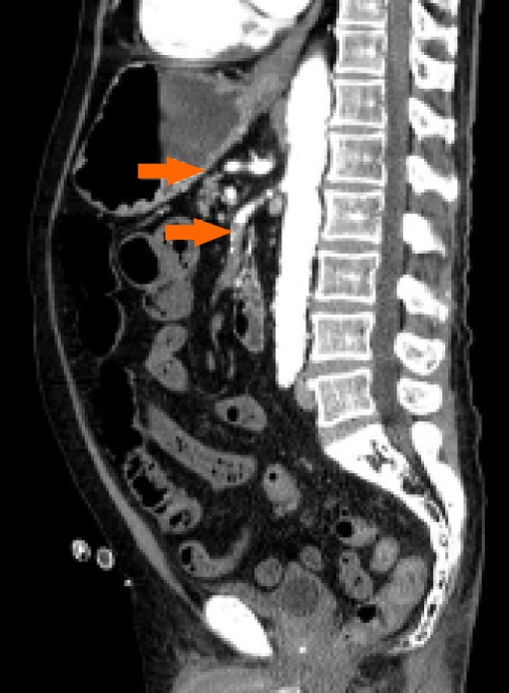
Figure 1 Abdominal computed tomography with intravenous contrast, sagittal scan showing thrombosis of the superior mesenteric artery and the common hepatic artery (arrows).
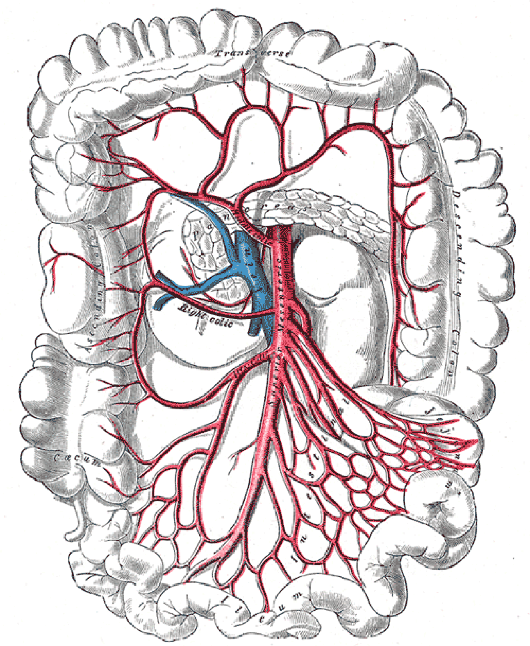
Figure 2 Splanchnic vascular anatomy, detail of colonic arteries (Case courtesy of Assoc Prof Craig Hacking, Radiopaedia.org, rID: 54523.

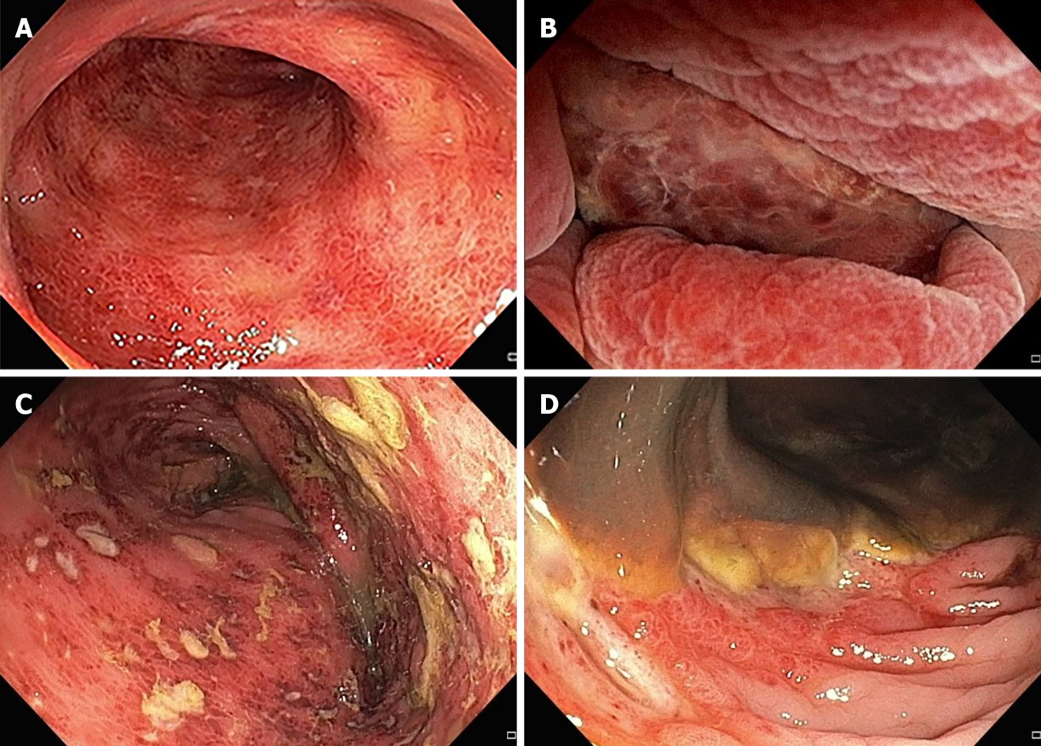
Figure 3 Endoscopic signs of ischemia, showing moderate diffuse erythema (A), severe erythema with mucosal edema and erosions (B), multiple ulcerations and inflammatory exudate (C), necrosis (D).

Table 1 Summary of proposed pathogenetic factors for colonoscopy-related mesenteric ischemia and suggested interventions to reduce the risk
Pathogenetic factor | Mechanism of action | Type of ischemia | Prevention
Splanchnic circulation impairment | Chronic mesenteric ischemia (atherosclerosis, smoking habits), parietal vessels inflammation (connective tissue diseases, LES, antiphospholipid syndrome) | Vascular thrombosis; microcirculatory mild ischemic injury | Careful evaluation of medical history. Specific and indirect symptoms assessment. Antiplatelet agents according to guidelines. Consider pre-colonoscopy assessments (serum electrolyte, color-Doppler ultrasound)
Bowel preparation (hypertonic, isotonic, laxative) | Serum electrolyte imbalance, dehydration. Potential additional risk if laxative were used (i.e. bisacodyl) | Multifactorial | Give specific information. Consider high-volume isotonic formulations; split-dose regimens; avoid bisacodyl-containing preparations
Sedation (midazolam, opioids, propofol) | Vasodilation, depression of myocardial contractility and hypotension | Multifactorial | Minimal sedation protocol (response to verbal stimulation, patent airways, spontaneous ventilation, and normal cardiovascular function) in high-risk patients. Consider prophylactic fluid infusion
Air insufflation/barotrauma | Increased luminal pressure and consequent vascular resistance | Non-occlusive mesenteric ischemia | Use carbon dioxide (CO₂) insufflation. Consider water-exchange colonoscopy technique
Scope manipulation | Mechanical stress on mesocolon, blood flow reduction, microcirculatory damage, and inflammatory cascade activation | Vascular thrombosis | Procedure interruption in case of intense discomfort or endoscopic findings of ischemia. Consider pediatric or “ultra-slim” colonoscopes. Reschedule or reconsider indication in case of complex exams

