Name of Journal: World Journal of Gastrointestinal Oncology
Manuscript NO: 83766
Manuscript Type: ORIGINAL ARTICLE

Retrospective Cohort Study
Development of a model based on the age-adjusted Charlson comorbidity index to predict survival for resected perihilar cholangiocarcinoma

Pan Y et al. Impact of the ACCI on pCCA

Yu Pan, Zhi-Peng Liu, Hai-Su Dai, Wei-Yue Chen, Ying Luo, Yu-Zhu Wang, Shu-Yang Gao, Zi-Ran Wang, Jin-Ling Dong, Yun-Hua Liu, Xian-Yu Yin, Xing-Chao Liu, Hai-Ning Fan, Jie Bai, Yan Jiang, Jun-Jie Cheng, Yan-Qi Zhang, Zhi-Yu Chen

Yu Pan, Zhi-Peng Liu, Hai-Su Dai, Wei-Yue Chen, Yu-Zhu Wang, Shu-Yang Gao, Yun-Hua Liu, Xian-Yu Yin, Jie Bai, Yan Jiang, Jun-Jie Cheng, Zhi-Yu Chen, Department of Hepatobiliary Surgery, Southwest Hospital, Third Military Medical University (Army Medical University), Chongqing 400038, China

Wei-Yue Chen, Clinical Research Center of Oncology, Lishui Hospital of Zhejiang University, Lishui 323000, Zhejiang Province, China

Ying Luo, Faculty of Education, Southwest University, Chongqing 400715, China

Zi-Ran Wang, Department of General Surgery, 903rd Hospital of People’s Liberation Army, Hangzhou 310000, Zhejiang Province, China

Jin-Ling Dong, Department of Clinical Pharmacy, The General Hospital of Western Theater Command, Chengdu 610000, Sichuan Province, China

Xing-Chao Liu, Department of Hepatobiliary Surgery, Sichuan Provincial People's Hospital, Chengdu 610000, Sichuan Province, China

Hai-Ning Fan, Department of Hepatobiliary Surgery, Affiliated Hospital of Qinghai University, Xining 810000, Qinghai Province, China

Yan-Qi Zhang, Department of Health Statistics, College of Military Preventive Medicine, Third Military Medical University (Army Medical University), Chongqing 400038, China

Author contributions: Pan Y, Liu ZP, Dai HS, and Chen ZY contributed to the conception; Pan Y, Liu ZP, Wang YZ, Chen WY, Luo Y, Gao SY, Chen ZY, and Dai HS designed the study; Chen ZY and Dai HS performed the administrative support; Pan Y, Dong JL, Liu YH, Yin XY, Liu XC, Fan HN, Bai J, Jiang Y, and Cheng JJ contributed to the data collection and acquisition; Pan Y, Liu ZP, Chen WY, Luo Y, Gao SY, Wang ZR, and Zhang YQ performed the data analysis; Pan Y, Liu ZP, and Dai HS contributed to the manuscript preparation; Chen ZY and Dai HS performed the critical revision; All authors agree to the final approval of the manuscript.

Supported by National Natural Science Foundation of China, No. 81874211; and Chongqing Technology Innovation and Application Development Special Key Project, No. CSTC2021jscx-gksb-N0009.

Corresponding author: Zhi-Yu Chen, MD, PhD, Academic Editor, Academic Research, Deputy Director, Doctor, Professor, Surgeon, Department of Hepatobiliary Surgery, Southwest Hospital, Third Military Medical University (Army Medical University), No. 30 Gaotanyan Road, Chongqing 400038, China. chenzhiyu_umn@163.com

Received: February 11, 2023
Revised: April 18, 2023
Accepted: May 4, 2023
Published online: June 15, 2023

Abstract
BACKGROUND
Perihilar cholangiocarcinoma (pCCA) has a poor prognosis and urgently needs a better predictive method. The predictive value of the age-adjusted Charlson comorbidity index (ACCI) for the long-term prognosis of patients with multiple malignancies was recently reported. However, pCCA is one of the most surgically difficult gastrointestinal tumors with the poorest prognosis, and the value of the ACCI for the prognosis of pCCA patients after curative resection is unclear.

AIM
To evaluate the prognostic value of the ACCI and to design an online clinical model for pCCA patients.

METHODS
Consecutive pCCA patients after curative resection between 2010 and 2019 were enrolled from a multicenter database. The patients were randomly assigned 3:1 to training and validation cohorts. In the training and validation cohorts, all patients were divided into low-, moderate-, and high-ACCI groups. Kaplan-Meier curves were used to determine the impact of the ACCI on overall survival (OS) for pCCA patients, and multivariate Cox regression analysis was used to determine the independent risk factors affecting OS. An online clinical model based on the ACCI was developed and validated. The concordance index (C-index), calibration curve, and receiver operating characteristic (ROC) curve were used to evaluate the predictive performance and fit of this model.

RESULTS
A total of 325 patients were included. There were 244 patients in the training cohort and 81 patients in the validation cohort. In the training cohort, 116, 91 and 37 patients were classified into the low-, moderate- and high-ACCI groups. The Kaplan-Meier curves showed that patients in the moderate- and high-ACCI groups had worse survival rates than those in the low-ACCI group. Multivariable analysis revealed that moderate and high ACCI scores were independently associated with OS in pCCA patients after curative resection. In addition, an online clinical model was developed that had ideal C-indexes of 0.725 and 0.675 for predicting OS in the training and validation cohorts. The calibration curve and ROC curve indicated that the model had a good fit and prediction performance.

CONCLUSION
A high ACCI score may predict poor long-term survival in pCCA patients after curative resection. High-risk patients screened by the ACCI-based model should be given more clinical attention in terms of the management of comorbidities and postoperative follow-up.

Key Words: Perihilar cholangiocarcinoma; Age-adjusted Charlson comorbidity index; Resection; Survival; Model; Prognosis

©The Author(s) 2023. Published by Baishideng Publishing Group Inc. All rights reserved.

Citation: Pan Y, Liu ZP, Dai HS, Chen WY, Luo Y, Wang YZ, Gao SY, Wang ZR, Dong JL, Liu YH, Yin XY, Liu XC, Fan HN, Bai J, Jiang Y, Cheng JJ, Zhang YQ, Chen ZY. Development of a model based on the age-adjusted Charlson comorbidity index to predict survival for resected perihilar cholangiocarcinoma. World J Gastrointest Oncol 2023; 15(6): 1036-1050
URL: https://www.wjgnet.com/1948-5204/full/v15/i6/1036.htm
DOI: https://dx.doi.org/10.4251/wjgo.v15.i6.1036

Core Tip: Our study assessed the prognostic value of the age-adjusted Charlson comorbidity index (ACCI) and designed an online clinical model for perihilar cholangiocarcinoma (pCCA). We retrospectively evaluated 496 pCCA patients from multiple centers who underwent radical resection. This study proposed that the ACCI is an independent predictor of pCCA prognosis, and a nomogram based on the ACCI is a promising predictive model for overall survival in pCCA patients.

INTRODUCTION
Cholangiocarcinoma (CCA) is the most common biliary malignancy and the second most common hepatic malignancy after hepatocellular carcinoma (HCC)^{[1]}. Perihilar CCA (pCCA), arising at the site of biliary fusion or in the right or left hepatic duct, represents 60% of CCA cases^{[2,3]}. The overall incidence of pCCA has increased progressively worldwide over the past four decades^{[4-6]}. Curative resection provides a possible cure for eligible patients with pCCA^{[7]}. However, even after successful curative resection, the prognosis of most pCCA patients remains unsatisfactory, with a five-year survival rate of approximately 20%^{[8]}. Therefore, the accurate identification of important factors affecting long-term prognosis and screening of patients with a high survival risk is essential to improve long-term survival. However, the specificity and complexity of the anatomical location of pCCA greatly increases the difficulty of surgery. The relationship between whether a patient is "strong" enough to withstand the shock of surgery and long-term prognosis may be overlooked in existing forecasting models.
Comorbidity is defined as the “coexistence of disorders in addition to a primary disease of interest”^{[9]}. The coexistence of cancer and other chronic diseases has significant implications for cancer treatment decisions and outcomes^{[10-12]}. Recent studies indicated the substantial influence of comorbidities on postoperative survival in different kinds of solid neoplasms, including breast, vulvar and colorectal cancers^{[13,14]}. Regrettably, most cancer treatment guidelines do not consider the complex interrelationships between cancer and comorbidities and instead adopt a “single-disease” approach to management. Currently, most clinicians also judge prognosis based on tumor-related information alone, ignoring the patient's own disease status. Although some previous studies have taken comorbidities into account, the simple classification into the presence/absence of comorbidities is not comprehensive^{[13]}.
At present, the most frequently used system for evaluating the grade of patients’ comorbidity burden is the Charlson comorbidity index (CCI). The CCI has excellent clinical efficacy in predicting patient prognosis by assessing the number of certain comorbidities and their severity^{[15]}. Since age had been determined to affect prognosis, Charlson et al^{[16]} developed an additional age-adjusted CCI (ACCI) to correct the final score of the CCI^{[16]}. Recently, the predictive value of the ACCI for long-term prognosis in patients with multiple malignancies, such as prostate cancer, pancreatic cancer, colorectal cancer and HCC, has been determined^{[17-20]}. Nevertheless, pCCA is one of the most surgically difficult gastrointestinal tumors with the poorest prognosis, and the relationship between the ACCI and the prognosis of pCCA has not been studied.
Therefore, a multicenter database was utilized to assess the impact of the ACCI on the long-term prognosis of patients with pCCA after curative resection. Furthermore, to help surgeons make better clinical decisions, a prognostic model to predict the overall survival (OS) of pCCA patients after curative resection was developed in this study based on the ACCI and tumor-related indicators.

MATERIALS AND METHODS
Patient selection
This study retrospectively enrolled newly diagnosed pCCA patients who underwent curative resection between January 2010 and December 2019 at three institutions (Southwest Hospital, Sichuan Provincial People's Hospital and the Affiliated Hospital of Qinghai University) in China. Computer-generated random numbers were used to assign three-quarters of the patients to the training cohort and the remaining one-quarter to the validation cohort. Drawing on the previous methods, the patients in the training and validation cohorts were categorized into three groups by the ACCI score: Low-ACCI (ACCI = 0-1), moderate-ACCI (ACCI = 2-3) and high-ACCI (ACCI ≥ 4) groups^{[20,21]}. The patients were classified by the CCI into low- and high-risk groups according to zero and nonzero scores. All tumors originated from the left or right hepatic ducts, biliary confluence, or common hepatic duct, which were confirmed by postoperative histological examination. All patients underwent hepatectomy, bile duct resection, locoregional lymphadenectomy and choledochojejunostomy. Hepatectomy-pancreaticoduodenectomy and revascularization were performed when necessary. Curative resection was defined as a clear-cut edge without tumor cells under macroscopy and microscopy. The exclusion criteria included the following: (1) recurrent pCCA; (2) death within 30 d after resection; (3) incomplete medical records; and (4) loss to follow-up.
The study followed the ethical guidelines of the World Medical Association and Declaration of Helsinki. Approval for the present study was obtained from the Ethics Committee of Southwest Hospital (approval number: KY2021129). An informed consent form was signed by all patients prior to surgery.

Data collection
The multicenter database was prospectively created and dynamically maintained, and data were retrospectively collected. Demographic information included sex, age, American Society of Anesthesiologists score, various comorbidities and preoperative percutaneous transhepatic cholangial drainage. Preoperative laboratory variables included alanine aminotransferase, aspartate transaminase, platelet count, albumin, total bilirubin, international normalized ratio, and carbohydrate antigen 19-9 (CA19-9). Surgical variables included extent of hepatectomy, intraoperative blood loss and perioperative blood transfusion. Pathological variables included cirrhosis, maximum tumor size, macrovascular invasion, microvascular invasion, peripheral nerve invasion, tumor differentiation, lymphoid metastasis, 8th American Joint Committee on Cancer (AJCC) stage^{[22]} and Bismuth classification^{[23]}.
Major hepatectomy was defined as three or more resected Couinaud liver segments, while minor hepatectomy was defined as two or fewer resected Couinaud liver segments. All pathological variables were confirmed by postoperative pathological examination.

Assessment of comorbidities
The patients' preoperative comorbidities were rigorously assessed based on the disease definition^{[15]}. The comorbidity severity was assessed by the CCI and ACCI^{[16]}. The CCI incorporates nineteen common preoperative comorbidities, with each weighing from 1 to 6 points. On the basis of the CCI, the ACCI considers the influence of age on prognosis. As shown in Table 1, the risk increases by 1 point for each decade of age over 40 years (50-59 years, 1 point; 60-69 years, 2 points; 70-79 years, 3 points; and > 80 years, 4 points), and the points for age are added to the total ACCI score.

Follow-up
All patients were followed up in the participating hospitals after discharge. A standardized follow-up protocol was strictly followed, which included a physical examination, laboratory tests (tumor biomarkers and liver function) and imaging examinations. Imaging examinations included abdominal contrast-enhanced ultrasound (CEUS), contrast-enhanced computed tomography (CT) and magnetic resonance imaging (MRI). Imaging examinations were performed at least once every 2 mo in the first year after resection and then every 3 mo from the second year on. Recurrence was defined as the appearance of a new lesion or multiple new lesions on CEUS, contrast-enhanced CT or MRI. In the case of recurrence, conservative treatment, systemic chemotherapy, and repeat surgical resection were available options, and the treatment strategy was determined considering the doctor's advice and the patient's own wishes. The endpoint was OS after pCCA resection, which was defined as the interval between the date of surgery and the date of patient death or the last follow-up. The last follow-up date for all patients was September 2022.

Statistical analysis
Continuous variables with a normal distribution are expressed as the mean ± SD or median (range), and Student’s t test or the Mann-Whitney U test was used as appropriate. Categorical variables are expressed as numbers and percentages, and the χ² test or Fisher’s exact test was used as appropriate. According to our previous studies, the included continuous variables were transformed into categorical variables^{[24,25]}. The Kaplan-Meier method was used to calculate the OS of patients. The log-rank test was used to compare OS between the low- and moderate-ACCI groups and between the low- and high-ACCI groups. Multivariate Cox regression analysis was then performed to determine independent risk factors associated with reduced OS after curative resection of pCCA. The hazard ratio (HR) and its 95% confidence interval (CI) were estimated in univariate and multivariate Cox regression analyses. In particular, variables with a significant P value < 0.10 in the univariate analysis were included in the multivariate Cox regression analysis.
The nomogram factors were selected based on the independent variables associated with OS in multivariate Cox regression analysis to construct the nomogram model. Calibration curves and Harrell’s concordance index (C-index) were applied to evaluate the fit and accuracy of the nomogram. Furthermore, the discriminative power of the model was assessed by a receiver operating characteristic (ROC) curve through the "survivalROC" package in R. The comparison between the nomogram and the 8th AJCC staging system was achieved using decision curve analysis (DCA) through the "rmda" package in R. For the validation cohort, the performance evaluation of the model was performed using the same approach as that in the training cohort. According to the ROC curve for the prediction of 1-year OS, the optimal cutoff value of the nomogram score was calculated, and all patients were divided into high- and low-risk groups. Using the Kaplan-Meier method and the log-rank test, OS rates were compared between the low- and high-risk groups.
Statistical analysis was performed using SPSS 26.0 (SPSS, Chicago, IL, United States) and R software (version 4.1.3.https://www.r-project.org/wDyn). An internet browser calculator based on the model was constructed by using the “DynNom” package in R. Statistical significance was set at P < 0.05 for all analyses.

RESULTS
Baseline characteristics and clinical variables
Of 496 pCCA patients who underwent radical resection during the study period, 171 patients were excluded according to the exclusion criteria, and 325 pCCA patients were finally included in this study. Of these, 244 patients were assigned to the training cohort, and the remaining 81 patients were assigned to the validation cohort, as shown in Supplementary Figure 1. In the training cohort, the low-, moderate-, and high-ACCI groups had 116, 91 and 37 patients, respectively. The distribution of the different comorbidities is summarized in Table 1. Among 325 patients, the most common comorbidities were mild liver disease and diabetes mellitus without end-organ damage, with 54 cases each (16.6%). Of the 1-point comorbidities, mild liver disease, peptic ulcer disease and peripheral vascular disease were the most frequent, with proportions of 16.6%, 4.6% and 4.3%, followed by congestive heart failure. Among the 2-point comorbidities, 14 patients (4.3%) were diagnosed with moderate/severe renal disease, and 9 patients (2.8%) were diagnosed with diabetes with end-organ damage. Of all comorbidities greater than 2 points, 3 patients (0.9%) were diagnosed with moderate/severe liver disease. A comparison of patient characteristics across the ACCI groups in the training cohort is shown in Table 2. Compared to patients in the low-ACCI and moderate-ACCI groups, those in the high-ACCI group were more often older than 70 years and had higher CCI scores. There were no significant differences in other characteristics across the groups. Similar results for the comparison of patient characteristics by the ACCI groups in the validation cohort are shown in Supplementary Table 1.

Long-term outcomes after resection
The median follow-up time was 24.0 (21.2-26.8) mo in the whole dataset. In the training cohort, 75.0% of the patients (183/244) developed recurrence, and 68.0% of the patients (166/244) died during follow-up. The 1-, 3- and 5-year OS rates were 72.7%, 32.4% and 22.9%, respectively. The 1-, 3-, and 5-year OS rates were 81.7%, 45.6%, and 31.1% in the low-ACCI group; 74.7%, 19.8%, and 15.8% in the moderate-ACCI group; and 39.9%, 14.6%, and 6.0% in the high-ACCI group, as shown in Table 2. The survival rate was lowest in the high-ACCI group and the highest in the low-ACCI group, with a significant difference in survival rates among the three groups (P < 0.001), as shown in Figure 1A. In the validation cohort, 73.8% of the patients (59/81) developed recurrence, and 63.0% of the patients (51/81) died during follow-up. The 1-, 3- and 5-year OS rates were 80.1%, 34.7% and 25.2%, respectively, as shown in Supplementary Table 1. Compared with the low-ACCI group, the survival rates were lower in the moderate-ACCI and high-ACCI groups (P = 0.018), as shown in Figure 1B.

Multivariable Cox regression analysis of OS
The results of univariate and multivariate analyses of OS for pCCA patients after curative resection are shown in Table 3 Considering the effect of covariance between covariates on the results, age was excluded from the Cox regression model. Finally, seven variables were found to be independently associated with the OS of pCCA, as shown in Table 3: ACCI (2-3 vs 0-1) (HR: 1.605, 95%CI: 1.133-2.273, P = 0.008); ACCI (≥ 4 vs 0-1) (HR: 2.498, 95%CI: 1.614-3.866, P < 0.001); CA19-9 (> 150 vs ≤ 150 U/L) (HR: 1.471, 95%CI: 1.059-2.043, P = 0.021); maximum tumor size (> 5 vs < 3 cm) (HR: 1.990, 95%CI: 1.166-3.396, P = 0.011); macrovascular invasion (yes vs no) (HR: 1.700, 95%CI: 1.198-2.412, P = 0.003); microvascular invasion (yes vs no) (HR: 1.752, 95%CI: 1.166-2.634, P = 0.007); tumor differentiation (poor vs well/moderate) (HR: 1.550, 95%CI: 1.042-2.305, P = 0.030); and lymphoid metastasis [yes vs no (ELN > 4)] (HR: 2.549, 95%CI: 1.684-3.859, P < 0.001).

Development and validation of a nomogram for OS
Using the variables from multivariate analysis, a nomogram to assess the OS of patients after curative resection was constructed based on the clinically relevant factors, as shown in Figure 2. To optimize its practicality, the nomogram was also transformed into an internet browser calculator (https://acci.shinyapps.io/newDynNomapp/). The relevant information of patients can be input, and information on the postoperative survival of patients could be obtained. The C-indexes of the prognostic nomogram for predicting OS were 0.725 (95%CI: 0.706-0.744) and 0.675 (95%CI: 0.635-0.715) in the training and validation cohorts, respectively. The calibration curves for the probability of 1-year OS in the training and validation cohorts were plotted, and the results revealed optimal accordance between the nomogram predictions and actual observations in both cohorts, as shown in Figure 3A and B.

Comparing the predictive power of the nomogram and 8th AJCC staging system
The ROC curves for the training and validation cohorts suggested that the nomogram performed better than the 8th AJCC staging system in predicting OS within 1 year after curative resection, as shown in Figure 3C and D. Furthermore, the nomogram was compared with the 8th AJCC staging system by utilizing DCA. As shown in Figure 3E and F, the nomogram demonstrated superior net benefits with a wider range of threshold probabilities compared to the 8th AJCC staging system in predicting the OS of patients in both the training and validation cohorts. All these results indicated that this nomogram was an excellent predictive model for predicting the long-term outcomes of pCCA patients following curative resection.

Risk classification based on the nomogram
According to the ROC curve for the prediction of 1-year OS, the optimal cutoff value of the nomogram score was 156. Therefore, all patients were effectively separated into low- and high-risk groups. In the training cohort, patients in the high-risk group had 1-, 3-, and 5-year OS rates of 51.1%, 11.1%, and 0%, and patients in the low-risk group had 1-, 3-, and 5-year OS rates of 91.5%, 50.1%, and 36.5%, as shown in Figure 4A. The high-risk group had a significantly lower survival rate than the low-risk group (P < 0.001). In the validation cohort, patients in the high-risk group had 1-, 3-, and 5-year OS rates of 64.5%, 23.0%, and 0%, and patients in the low-risk group had 1-, 3-, and 5-year OS rates of 91.5%, 61.2%, and 35.7%, as shown in Figure 4B. Similarly, the survival rate was found to be significantly lower in the high-risk group than in the low-risk group (P = 0.012).

DISCUSSION
Comorbidities are common in cancer patients and are becoming more prevalent as the population ages^{[26]}. An increasing number of studies have demonstrated that comorbidities potentially affect the development, diagnosis, treatment and prognosis of patients with cancer^{[11,12,27]}. The ACCI is an excellent indicator that combines age and comorbidities. A higher ACCI implies a more complex preoperative situation, more difficult postoperative care, longer postoperative recovery, and lower tolerance for complicated surgery. These conditions will directly impact the patient's perioperative safety and long-term prognosis. There is evidence that patient comorbidities can directly affect the choice of patient treatment modality^{[28]}. Recently, the impact of the ACCI on the long-term prognosis of patients with various gastrointestinal carcinomas, such as gastric, colorectal, and pancreatic cancers, has been demonstrated^{[18,29,30]}. Nevertheless, pCCA is one of the most surgically difficult gastrointestinal tumors with a poor prognosis, but the relationship between the ACCI and the prognosis of pCCA has not been studied. Therefore, our team conducted the first multicenter study to explore the impact of the ACCI on the long-term prognosis of patients after curative resection for pCCA.
In this study, we investigated for the first time the comorbidity distribution of 325 pCCA patients from multiple centers who underwent curative resection. The ACCI was used to assess comorbidity status, and drawing on previous methods, the patients were categorized into three groups by the ACCI score: Low-ACCI (ACCI = 0-1), moderate-ACCI (ACCI = 2-3) and high-ACCI (ACCI ≥ 4) groups. Multivariable analysis revealed that moderate and high ACCI scores were independently associated with reduced OS after curative resection for pCCA. To enhance guidance on treatment strategies, a clinical prediction model for the OS of pCCA patients after curative resection was constructed based on the ACCI and other independent risk factors associated with worse OS and validated. The satisfactory predictive performance of the model and its ability to identify patients with a high-risk prognosis allows it to guide clinical decision making.
In the long-term survival analysis, the univariate analysis results indicated that CCI did not significantly affect the long-term prognosis of pCCA, whereas ACCI was ultimately proven to be an independent prognostic factor for pCCA. This result suggests that the ACCI, a composite of age and comorbidity, provides a better prognostic assessment for patients. Multivariate Cox regression analysis revealed that moderate and high ACCI scores were independently associated with reduced OS in patients with pCCA after curative resection. This exciting and interesting result might be explained by the following findings.
Advanced age is not a contraindication to hepatobiliary surgery^{[31]}, nor is it a comorbidity^{[32]}. However, elderly patients with comorbidities have a slow metabolism and poor recovery. The ACCI is a composite of age and comorbidities, and a high ACCI score indicates that the patient is elderly and/or has one or more comorbidities. Preoperative comorbidities, including diabetes, respiratory disease, and cardiovascular disease, are more common in older patients. Organ reserve function is reduced, and the long-term use of multiple medications can lead to further liver damage. Some pCCA patients may have prolonged obstructive jaundice prior to admission, which leads to a further decline in liver function. Moreover, pCCA patients may require hemihepatectomy or more extensive liver resection to achieve radical resection, further increasing the risk of perioperative liver failure. In addition, patients with high ACCI scores have worse nutritional status^{[33]}, and gastrointestinal diseases such as pCCA often lead to a reduction in the nutritional intake of patients, resulting in a substantially increased incidence of perioperative malnutrition. The combination of these factors leads to a significant increase in the perioperative risk of patients with high ACCI scores.
The National Comprehensive Cancer Network guidelines recommend that adjuvant therapy be considered after pCCA resection, especially for patients at high risk of recurrence with lymphatic metastases or R1 resection^{[34]}. Cisplatin and S1 are two key drugs used in the postoperative adjuvant treatment of CCA, and their combination with gemcitabine significantly prolongs survival in patients with bile duct cancer^{[35]}. However, some elderly patients with comorbidities cannot tolerate this treatment, resulting in the need for dose adjustment or contraindication^{[35,36]}. Indeed, age and comorbidity burden led to lower rates of introduction of first-line combination chemotherapy and second-line chemotherapy^{[37]}. In addition, various reasons, such as damage to liver and kidney function after adjuvant therapy, have forced patients to discontinue adjuvant therapy midway, resulting in a worse prognosis for the patient. Hence, reduced intensity or discontinuation of postoperative adjuvant therapy in elderly patients with comorbidities may be associated with poor prognosis.
In our opinion, patients with high ACCI scores should undergo a more careful multidisciplinary evaluation in terms of both the choice of the surgical procedure and the choice of postoperative adjuvant treatment.
In addition to the ACCI, a number of other independent risk factors for reduced OS were identified in the present study. These risk factors included CA19-9 (> 150 U/L), maximum tumor size (> 5 cm), lymphoid metastasis (yes), macrovascular invasion, microvascular invasion, and tumor differentiation. All these risk factors have been reported previously^{[38-40]}. We constructed a nomogram using the above independent risk factors.
Nomograms are a visual tool for predicting the prognosis of patients with various cancers and are widely recognized in clinical practice for their applicability and accuracy^{[41]}. Thus, based on the ACCI and these independent risk factors, a clinical prediction model to assess the OS of pCCA patients after curative resection was constructed and validated. To optimize its practicality, the nomogram was also further transformed into an internet browser calculator. According to the nomogram, we were able to identify high-risk patients (nomogram score > 156), who had a worse OS.
The ROC curves and DCA results for both the training and validation cohorts showed that the nomogram performed better than the 8th AJCC staging system in terms of its ability to predict OS after curative resection and its superior net clinical benefits. The TNM staging system has been promoted in abdominal surgery for a long time. With the continuous optimization of the staging system, the prediction of prognosis for many gastrointestinal tumors, such as gastric and colon cancers, has become increasingly accurate^{[42]}. However, for parenchymal organs, whether pancreatic or liver tumors, the predictive accuracy of TNM staging is greatly reduced. For HCC, the clinical significance of N stage may be overestimated by the TNM staging system due to the exceptionally small probability of lymphatic metastasis. For pCCA, in addition to N stage, MVI and degree of differentiation are also critical in predicting prognosis. Thus, our model not only incorporates more comprehensive oncological information, including a highly specific serum tumor marker of pCCA, CA19-9, but also takes into account the patient’s comorbidity status. This allows our model to obtain a better predictive performance than TNM staging and to better guide clinical decisions.
Nevertheless, this study has several limitations. First, this was a retrospective study, and bias in data collection was inevitable. However, we included consecutive patients, so this study was closer to the real world than a randomized controlled trial. Second, although this was a multicenter study, there was a dearth of patient data from Western countries. We tried external validation using data from public databases such as surveillance, epidemiology, and end results but ultimately failed because only CCA but not pCCA could be identified in the database. Third, this study lacks data on postoperative adjuvant therapy. The patients in this study were recruited between 2011 and 2020. Due to the uncertainty of the efficacy, we did not record the adjuvant treatment in detail and will add these data in the future^{[43]}.

CONCLUSION
In conclusion, this multicenter study showed that a high ACCI score was independently associated with worse OS following curative resection for pCCA. The nomogram based on the ACCI provides a good prediction of OS, which can help surgeons make better clinical decisions.

ARTICLE HIGHLIGHTS
Research background
Curative resection provides a possible cure for eligible patients with perihilar cholangiocarcinoma (pCCA). The predictive value of the age-adjusted Charlson comorbidity index (ACCI) for the long-term prognosis of patients with multiple malignancies was recently reported. However, pCCA is one of the most surgically difficult gastrointestinal tumors with the poorest prognosis, and the value of the ACCI for the prognosis of pCCA patients after curative resection is unclear.

Research motivation
The present study attempted to evaluate the prognostic value of the ACCI and to design an online clinical model to predict the overall survival (OS) of pCCA patients after curative resection.

Research objectives
This study aimed to identify the prognostic value of the ACCI in pCCA patients and to construct an online clinical model to predict the OS of pCCA patients after curative resection.

Research methods
Consecutive pCCA patients after curative resection between 2010 and 2019 were enrolled from a multicenter database. The patients were randomly assigned 3:1 to training and validation cohorts. In the training and validation cohorts, all patients were divided into low-, moderate-, and high-ACCI groups. Kaplan-Meier curves were used to determine the impact of the ACCI on OS for pCCA patients, and multivariate Cox regression analysis was used to determine the independent risk factors affecting OS. An online clinical model based on the ACCI was developed and validated. The concordance index (C-index), calibration curve, and receiver operating characteristic (ROC) curve were used to evaluate the predictive performance and fit of this model.

Research results
Mild liver disease and diabetes were the most common comorbidities in pCCA patients undergoing radical surgery. The Kaplan-Meier curves showed that patients in the moderate- and high-ACCI groups had worse survival rates than those in the low-ACCI group. Multivariable analysis revealed that moderate and high ACCI scores were independently associated with OS in pCCA patients after curative resection. In addition, an online clinical model was developed that had ideal C-indexes of 0.725 and 0.675 for predicting OS in the training and validation cohorts, respectively. The calibration curve and ROC curve indicated that the model had a good fit and prediction performance.

Research conclusions
A high ACCI score may predict poor long-term survival in pCCA patients after curative resection. High-risk patients screened by the ACCI-based model should be given more clinical attention in terms of the management of comorbidities and postoperative follow-up.

Research perspectives
Although our multicenter study identified the prognostic value of the ACCI in pCCA patients after curative resection, future prospective studies with larger samples should be conducted to further explore the association between the ACCI and the prognosis of pCCA patients and the guidance of the ACCI on treatment allocation.

REFERENCES
1 Welzel TM, McGlynn KA, Hsing AW, O'Brien TR, Pfeiffer RM. Impact of classification of hilar cholangiocarcinomas (Klatskin tumors) on the incidence of intra- and extrahepatic cholangiocarcinoma in the United States. J Natl Cancer Inst 2006; 98: 873-875 [PMID: 16788161 DOI: 10.1093/jnci/djj234]
2 Cardinale V. Classifications and misclassification in cholangiocarcinoma. Liver Int 2019; 39: 260-262 [PMID: 30694026 DOI: 10.1111/liv.13998]
3 Klatskin G. Adenocarcinoma of the hepatic duct at its bifurcation within the PORTA hepatis. An unusual tumor with distinctive clinical and pathological features. Am J Med 1965; 38: 241-256 [PMID: 14256720 DOI: 10.1016/0002-9343(65)90178-6]
4 Saha SK, Zhu AX, Fuchs CS, Brooks GA. Forty-Year Trends in Cholangiocarcinoma Incidence in the U.S.: Intrahepatic Disease on the Rise. Oncologist 2016; 21: 594-599 [PMID: 27000463 DOI: 10.1634/theoncologist.2015-0446]
5 Khan SA, Taylor-Robinson SD, Toledano MB, Beck A, Elliott P, Thomas HC. Changing international trends in mortality rates for liver, biliary and pancreatic tumours. J Hepatol 2002; 37: 806-813 [PMID: 12445422 DOI: 10.1016/s0168-8278(02)00297-0]
6 Taylor-Robinson SD, Toledano MB, Arora S, Keegan TJ, Hargreaves S, Beck A, Khan SA, Elliott P, Thomas HC. Increase in mortality rates from intrahepatic cholangiocarcinoma in England and Wales 1968-1998. Gut 2001; 48: 816-820 [PMID: 11358902 DOI: 10.1136/gut.48.6.816]
7 van Keulen AM, Franssen S, van der Geest LG, de Boer MT, Coenraad M, van Driel LMJW, Erdmann JI, Haj Mohammad N, Heij L, Klümpen HJ, Tjwa E, Valkenburg-van Iersel L, Verheij J, Groot Koerkamp B, Olthof PB; Dutch Hepatocellular & Cholangiocarcinoma Group (DHCG). Nationwide treatment and outcomes of perihilar cholangiocarcinoma. Liver Int 2021; 41: 1945-1953 [PMID: 33641214 DOI: 10.1111/liv.14856]
8 DeOliveira ML, Cunningham SC, Cameron JL, Kamangar F, Winter JM, Lillemoe KD, Choti MA, Yeo CJ, Schulick RD. Cholangiocarcinoma: thirty-one-year experience with 564 patients at a single institution. Ann Surg 2007; 245: 755-762 [PMID: 17457168 DOI: 10.1097/01.sla.0000251366.62632.d3]
9 Feinstein AR. The pre-therapeutic classification of co-morbidity in chronic disease. J Chronic Dis 1970; 23: 455-468 [PMID: 26309916 DOI: 10.1016/0021-9681(70)90054-8]
10 Extermann M. Measurement and impact of comorbidity in older cancer patients. Crit Rev Oncol Hematol 2000; 35: 181-200 [PMID: 10960800 DOI: 10.1016/s1040-8428(00)00090-1]
11 Satariano WA, Silliman RA. Comorbidity: implications for research and practice in geriatric oncology. Crit Rev Oncol Hematol 2003; 48: 239-248 [PMID: 14607386 DOI: 10.1016/j.critrevonc.2003.08.002]
12 Liu ZP, Chen WY, Zhang YQ, Jiang Y, Bai J, Pan Y, Zhong SY, Zhong YP, Chen ZY, Dai HS. Postoperative morbidity adversely impacts oncological prognosis after curative resection for hilar cholangiocarcinoma. World J Gastroenterol 2022; 28: 948-960 [PMID: 35317056 DOI: 10.3748/wjg.v28.i9.948]
13 Boakye D, Rillmann B, Walter V, Jansen L, Hoffmeister M, Brenner H. Impact of comorbidity and frailty on prognosis in colorectal cancer patients: A systematic review and meta-analysis. Cancer Treat Rev 2018; 64: 30-39 [PMID: 29459248 DOI: 10.1016/j.ctrv.2018.02.003]
14 Di Donato V, Page Z, Bracchi C, Tomao F, Musella A, Perniola G, Panici PB. The age-adjusted Charlson comorbidity index as a predictor of survival in surgically treated vulvar cancer patients. J Gynecol Oncol 2019; 30: e6 [PMID: 30479090 DOI: 10.3802/jgo.2019.30.e6]
15 Charlson ME, Pompei P, Ales KL, MacKenzie CR. A new method of classifying prognostic comorbidity in longitudinal studies: development and validation. J Chronic Dis 1987; 40: 373-383 [PMID: 3558716 DOI: 10.1016/0021-9681(87)90171-8]
16 Charlson M, Szatrowski TP, Peterson J, Gold J. Validation of a combined comorbidity index. J Clin Epidemiol 1994; 47: 1245-1251 [PMID: 7722560 DOI: 10.1016/0895-4356(94)90129-5]
17 Lee JY, Kang HW, Rha KH, Cho NH, Choi YD, Hong SJ, Cho KS. Age-adjusted Charlson comorbidity index is a significant prognostic factor for long-term survival of patients with high-risk prostate cancer after radical prostatectomy: a Bayesian model averaging approach. J Cancer Res Clin Oncol 2016; 142: 849-858 [PMID: 26660495 DOI: 10.1007/s00432-015-2093-0]
18 Dias-Santos D, Ferrone CR, Zheng H, Lillemoe KD, Fernández-Del Castillo C. The Charlson age comorbidity index predicts early mortality after surgery for pancreatic cancer. Surgery 2015; 157: 881-887 [PMID: 25704415 DOI: 10.1016/j.surg.2014.12.006]
19 Wu CC, Hsu TW, Chang CM, Yu CH, Lee CC. Age-adjusted Charlson comorbidity index scores as predictor of survival in colorectal cancer patients who underwent surgical resection and chemoradiation. Medicine (Baltimore) 2015; 94: e431 [PMID: 25590852 DOI: 10.1097/MD.0000000000000431]
20 Shinkawa H, Tanaka S, Takemura S, Amano R, Kimura K, Nishioka T, Miyazaki T, Kubo S. Predictive Value of the Age-Adjusted Charlson Comorbidity Index for Outcomes After Hepatic Resection of Hepatocellular Carcinoma. World J Surg 2020; 44: 3901-3914 [PMID: 32651603 DOI: 10.1007/s00268-020-05686-w]
21 Kahl A, du Bois A, Harter P, Prader S, Schneider S, Heitz F, Traut A, Alesina PF, Meier B, Walz M, Brueckner A, Groeben HT, Brunkhorst V, Heikaus S, Ataseven B. Prognostic Value of the Age-Adjusted Charlson Comorbidity Index (ACCI) on Short- and Long-Term Outcome in Patients with Advanced Primary Epithelial Ovarian Cancer. Ann Surg Oncol 2017; 24: 3692-3699 [PMID: 28871563 DOI: 10.1245/s10434-017-6079-9]
22 Chun YS, Pawlik TM, Vauthey JN. 8th Edition of the AJCC Cancer Staging Manual: Pancreas and Hepatobiliary Cancers. Ann Surg Oncol 2018; 25: 845-847 [PMID: 28752469 DOI: 10.1245/s10434-017-6025-x]
23 Bismuth H, Corlette MB. Intrahepatic cholangioenteric anastomosis in carcinoma of the hilus of the liver. Surg Gynecol Obstet 1975; 140: 170-178 [PMID: 1079096]
24 Liu ZP, Cheng ZJ, Dai HS, Zhong SY, Zhao DC, Gong Y, Zuo JH, Che XY, Chen WY, Wang ZR, Yu T, Cheng JJ, Liu XC, Bai J, Jiang Y, Zhang YQ, Lau WY, Deng SQ, Chen ZY. Impact of perioperative blood transfusion on long-term survival in patients with different stages of perihilar cholangiocarcinoma treated with curative resection: A multicentre propensity score matching study. Front Oncol 2022; 12: 1059581 [PMID: 36387093 DOI: 10.3389/fonc.2022.1059581]
25 Chen C, Liu ZP, Chen WY, Wang X, Liu YH, Wang Y, Liu XC, Fan HN, Bai J, Jiang Y. Anatomical hepatectomy for achieving textbook outcome for perihilar cholangiocarcinoma treated with curative-intent resection A multicenter study. iLIVER 2022; 1: 7
26 Williams GR, Deal AM, Lund JL, Chang Y, Muss HB, Pergolotti M, Guerard EJ, Shachar SS, Wang Y, Kenzik K, Sanoff HK. Patient-Reported Comorbidity and Survival in Older Adults with Cancer. Oncologist 2018; 23: 433-439 [PMID: 29242282 DOI: 10.1634/theoncologist.2017-0404]
27 Lee L, Cheung WY, Atkinson E, Krzyzanowska MK. Impact of comorbidity on chemotherapy use and outcomes in solid tumors: a systematic review. J Clin Oncol 2011; 29: 106-117 [PMID: 21098314 DOI: 10.1200/JCO.2010.31.3049]
28 Gross CP, McAvay GJ, Guo Z, Tinetti ME. The impact of chronic illnesses on the use and effectiveness of adjuvant chemotherapy for colon cancer. Cancer 2007; 109: 2410-2419 [PMID: 17510973 DOI: 10.1002/cncr.22726]
29 Kellokumpu I, Kairaluoma M, Mecklin JP, Kellokumpu H, Väyrynen V, Wirta EV, Sihvo E, Kuopio T, Seppälä TT. Impact of Age and Comorbidity on Multimodal Management and Survival from Colorectal Cancer: A Population-Based Study. J Clin Med 2021; 10 [PMID: 33920665 DOI: 10.3390/jcm10081751]
30 Lin JX, Huang YQ, Xie JW, Wang JB, Lu J, Chen QY, Cao LL, Lin M, Tu R, Huang ZN, Lin JL, Zheng CH, Huang CM, Li P. Association of the age-adjusted Charlson Comorbidity Index and systemic inflammation with survival in gastric cancer patients after radical gastrectomy. Eur J Surg Oncol 2019; 45: 2465-2472 [PMID: 31350072 DOI: 10.1016/j.ejso.2019.07.010]
31 Fong Y, Blumgart LH, Fortner JG, Brennan MF. Pancreatic or liver resection for malignancy is safe and effective for the elderly. Ann Surg 1995; 222: 426-34; discussion 434-7 [PMID: 7574924 DOI: 10.1097/00000658-199522240-00002]
32 Cucchetti A, Ercolani G, Vivarelli M, Cescon M, Ravaioli M, Ramacciato G, Grazi GL, Pinna AD. Is portal hypertension a contraindication to hepatic resection? Ann Surg 2009; 250: 922-928 [PMID: 19855258 DOI: 10.1097/SLA.0b013e3181b977a5]
33 Takada Y, Kawashima H, Ohno E, Ishikawa T, Mizutani Y, Iida T, Yamamura T, Kakushima N, Furukawa K, Nakamura M, Honda T, Ishigami M, Ito A, Hirooka Y. The impact of the age-adjusted Charlson comorbidity index as a prognostic factor for endoscopic papillectomy in ampullary tumors. J Gastroenterol 2022; 57: 199-207 [PMID: 35098349 DOI: 10.1007/s00535-022-01853-z]
34 Benson AB, D'Angelica MI, Abbott DE, Anaya DA, Anders R, Are C, Bachini M, Borad M, Brown D, Burgoyne A, Chahal P, Chang DT, Cloyd J, Covey AM, Glazer ES, Goyal L, Hawkins WG, Iyer R, Jacob R, Kelley RK, Kim R, Levine M, Palta M, Park JO, Raman S, Reddy S, Sahai V, Schefter T, Singh G, Stein S, Vauthey JN, Venook AP, Yopp A, McMillian NR, Hochstetler C, Darlow SD. Hepatobiliary Cancers, Version 2.2021, NCCN Clinical Practice Guidelines in Oncology. J Natl Compr Canc Netw 2021; 19: 541-565 [PMID: 34030131 DOI: 10.6004/jnccn.2021.0022]
35 Morizane C, Okusaka T, Mizusawa J, Katayama H, Ueno M, Ikeda M, Ozaka M, Okano N, Sugimori K, Fukutomi A, Hara H, Mizuno N, Yanagimoto H, Wada K, Tobimatsu K, Yane K, Nakamori S, Yamaguchi H, Asagi A, Yukisawa S, Kojima Y, Kawabe K, Kawamoto Y, Sugimoto R, Iwai T, Nakamura K, Miyakawa H, Yamashita T, Hosokawa A, Ioka T, Kato N, Shioji K, Shimizu K, Nakagohri T, Kamata K, Ishii H, Furuse J; members of the Hepatobiliary and Pancreatic Oncology Group of the Japan Clinical Oncology Group (JCOG-HBPOG). Combination gemcitabine plus S-1 versus gemcitabine plus cisplatin for advanced/recurrent biliary tract cancer: the FUGA-BT (JCOG1113) randomized phase III clinical trial. Ann Oncol 2019; 30: 1950-1958 [PMID: 31566666 DOI: 10.1093/annonc/mdz402]
36 Takahara N, Isayama H, Nakai Y, Sasaki T, Ishigaki K, Saito K, Akiyama D, Uchino R, Mizuno S, Yagioka H, Kogure H, Togawa O, Matsubara S, Ito Y, Toda N, Tada M, Koike K. Gemcitabine and S-1 versus gemcitabine and cisplatin treatment in patients with advanced biliary tract cancer: a multicenter retrospective study. Invest New Drugs 2017; 35: 269-276 [PMID: 28124197 DOI: 10.1007/s10637-017-0430-7]
37 Takahara N, Nakai Y, Saito K, Sasaki T, Suzuki Y, Inokuma A, Oyama H, Kanai S, Suzuki T, Sato T, Hakuta R, Ishigaki K, Saito T, Hamada T, Mizuno S, Kogure H, Tada M, Isayama H, Koike K. The impact of age and comorbidity in advanced or recurrent biliary tract cancer receiving palliative chemotherapy. J Gastroenterol Hepatol 2020; 35: 1828-1835 [PMID: 32267557 DOI: 10.1111/jgh.15066]
38 Liu ZP, Zhang QY, Chen WY, Huang YY, Zhang YQ, Gong Y, Jiang Y, Bai J, Chen ZY, Dai HS. Evaluation of Four Lymph Node Classifications for the Prediction of Survival in Hilar Cholangiocarcinoma. J Gastrointest Surg 2022; 26: 1030-1040 [PMID: 34973138 DOI: 10.1007/s11605-021-05211-x]
39 Ercolani G, Dazzi A, Giovinazzo F, Ruzzenente A, Bassi C, Guglielmi A, Scarpa A, D'Errico A, Pinna AD. Intrahepatic, peri-hilar and distal cholangiocarcinoma: Three different locations of the same tumor or three different tumors? Eur J Surg Oncol 2015; 41: 1162-1169 [PMID: 26095704 DOI: 10.1016/j.ejso.2015.05.013]
40 Fabris L, Alvaro D. The prognosis of perihilar cholangiocarcinoma after radical treatments. Hepatology 2012; 56: 800-802 [PMID: 22532318 DOI: 10.1002/hep.25808]
41 Balachandran VP, Gonen M, Smith JJ, DeMatteo RP. Nomograms in oncology: more than meets the eye. Lancet Oncol 2015; 16: e173-e180 [PMID: 25846097 DOI: 10.1016/S1470-2045(14)71116-7]
42 Oh SE, An JY, Choi MG, Lee JH, Sohn TS, Bae JM. Comparisons of remnant primary, residual, and recurrent gastric cancer and applicability of the 8th AJCC TNM classification for remnant gastric cancer staging. Eur J Surg Oncol 2020; 46: 2236-2242 [PMID: 32788098 DOI: 10.1016/j.ejso.2020.06.032]
43 Mallick S, Benson R, Haresh KP, Julka PK, Rath GK. Adjuvant radiotherapy in the treatment of gall bladder carcinoma: What is the current evidence. J Egypt Natl Canc Inst 2016; 28: 1-6 [PMID: 26265290 DOI: 10.1016/j.jnci.2015.07.004]

Footnotes
Institutional review board statement: The study was approved by the Institutional Review Board of the Southwest Hospital, China, No. KY2021129.

Informed consent statement: Patients were not required to give informed consent to the study because the analysis used anonymized clinical data, which were obtained after each patient gave written consent to treatment. For full disclosure, the details of the study are published on the home page of Southwest Hospital.

Conflict-of-interest statement: All the authors report no relevant conflicts of interest for this article.

Data sharing statement: Technical appendix, statistical code, and dataset available from the corresponding author at chenzhiyu_umn@163.com. Participants gave informed consent for data sharing.

STROBE statement: The authors have read the STROBE Statement—checklist of items, and the manuscript was prepared and revised according to the STROBE Statement—checklist of items.

Open-Access: This article is an open-access article that was selected by an in-house editor and fully peer-reviewed by external reviewers. It is distributed in accordance with the Creative Commons Attribution NonCommercial (CC BY-NC 4.0) license, which permits others to distribute, remix, adapt, build upon this work non-commercially, and license their derivative works on different terms, provided the original work is properly cited and the use is non-commercial. See: https://creativecommons.org/Licenses/by-nc/4.0/

Provenance and peer review: Unsolicited article; Externally peer reviewed.

Peer-review model: Single blind

Peer-review started: February 11, 2023
First decision: April 10, 2023
Article in press: May 4, 2023

Specialty type: Oncology
Country/Territory of origin: China
Peer-review report’s scientific quality classification
Grade A (Excellent): A, A
Grade B (Very good): 0
Grade C (Good): 0
Grade D (Fair): 0
Grade E (Poor): 0

P-Reviewer: Broering DC, Saudi Arabia; Yildiz K, Turkey S-Editor: Fan JR L-Editor: A P-Editor: Zhang XD

Figure Legends
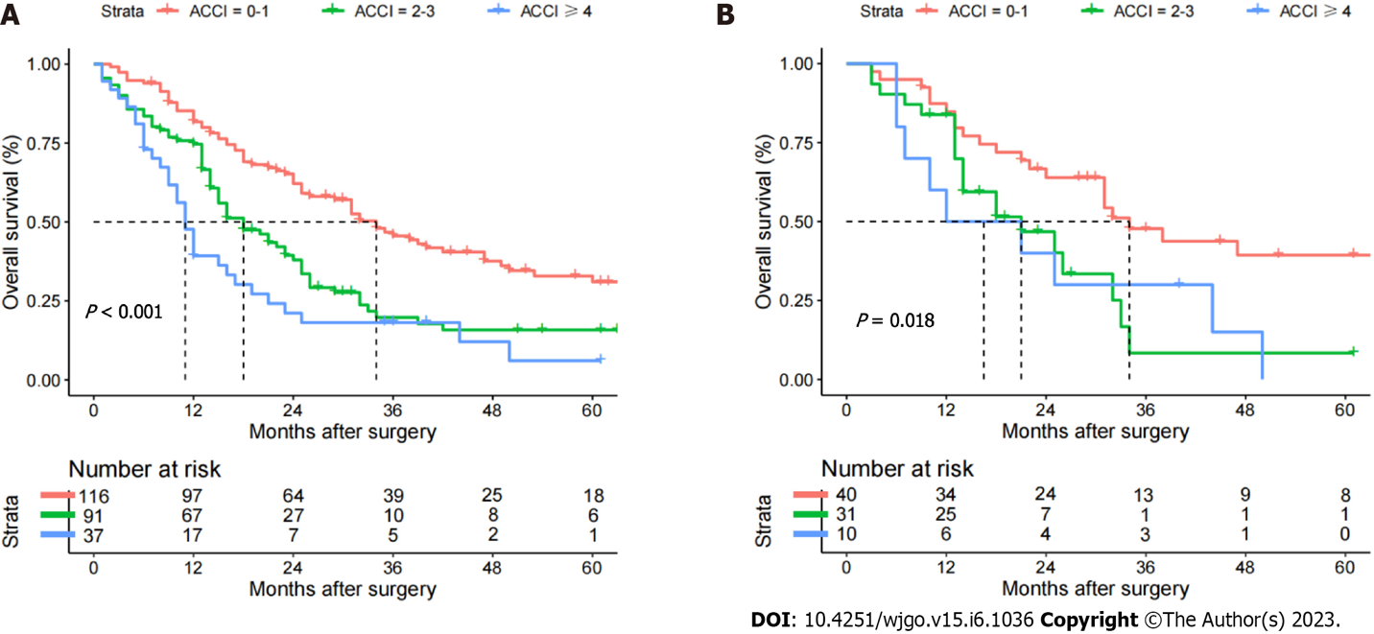
Figure 1 Overall survival of perihilar cholangiocarcinoma patients in the training and validation cohorts according to the three age-adjusted Charlson comorbidity index groups. Low age-adjusted Charlson comorbidity index (ACCI): 0-1; moderate ACCI: 2-3; high ACCI: ≥ 4. A: Training; B: Validation cohorts. ACCI: Age-adjusted Charlson comorbidity index.
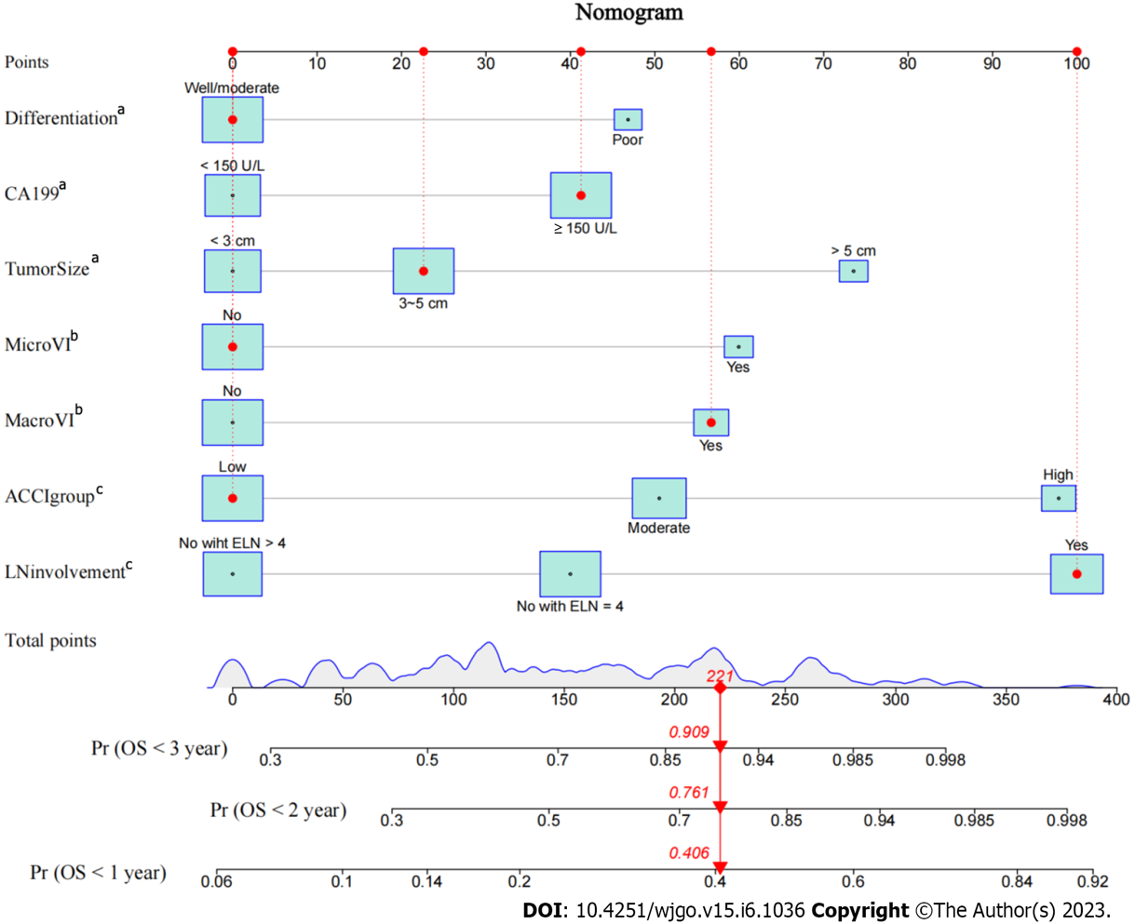
Figure 2 Age-adjusted Charlson comorbidity index-based enhanced regression nomogram to predict the overall survival of perihilar cholangiocarcinoma patients. ACCI: Age-adjusted Charlson comorbidity index; OS: Overall survival. ªP < 0.05, ^{b}P < 0.01, ^{c}P < 0.001.
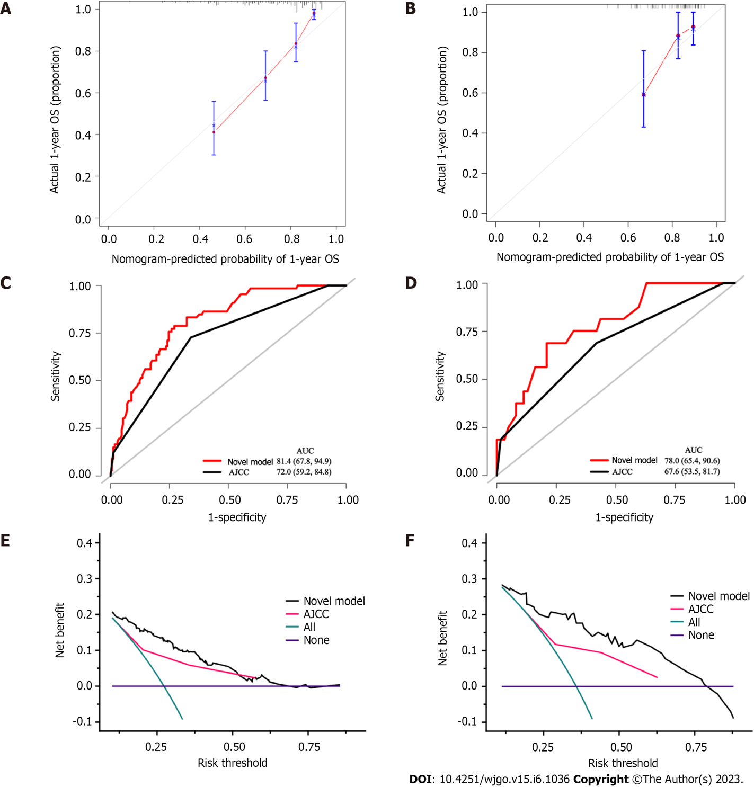
Figure 3 Calibration curves, receiver operating characteristic curves and decision curve. A and B: Calibration curves for predicting 1-yr overall survival in the training (A) and validation cohorts (B); C-F: Receiver operating characteristic curves (C and D) and decision curve analysis (E and F) for the prognostic model and 8th American Joint Committee on Cancer staging system in the training (C and E) and validation cohorts (D and F). AJCC: American Joint Committee on Cancer; AUC: Area under the curve; OS: Overall survival.
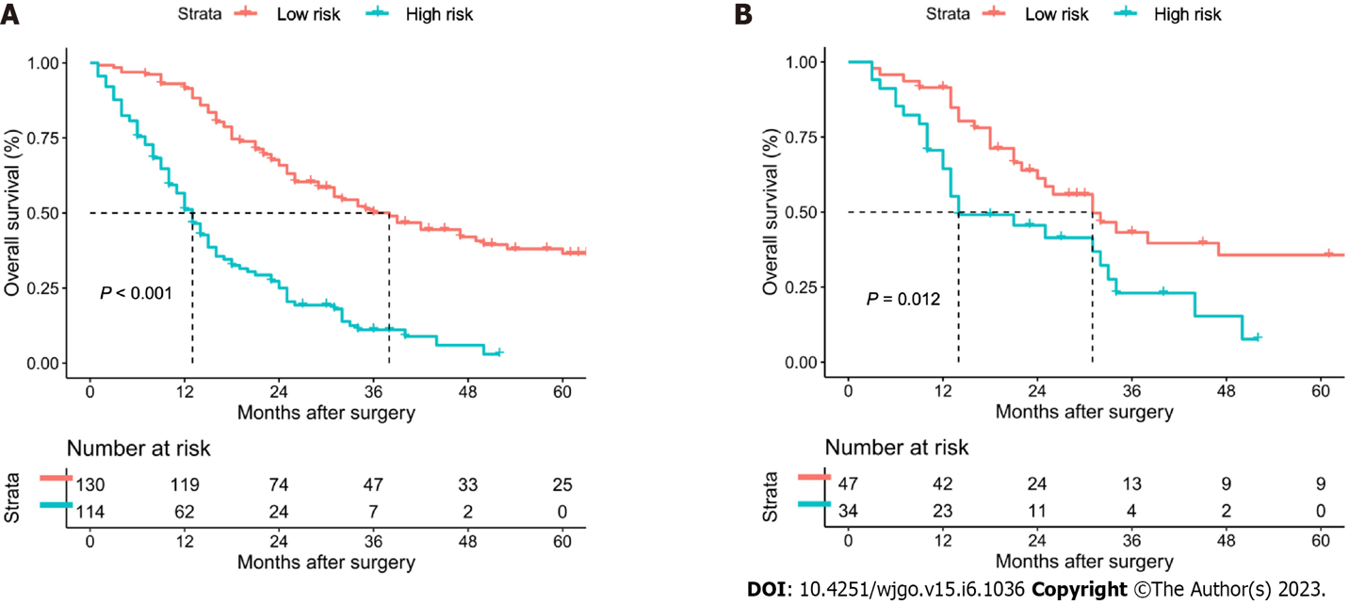
Figure 4 Risk classifications satisfactorily determined the risk of postoperative survival in perihilar cholangiocarcinoma patients after curative resection in the training and validation cohorts. A: Training; B: Validation cohorts.
Table 1 Weighted index of comorbidities in the age-adjusted Charlson comorbidity index and patient distribution
Conditions | Training cohort (n = 244) | Validation cohort (n = 81) | Total patients (n = 325)
1 point per decade for age > 40 (0 to 4 points)
< 50 | 88 (36.1) | 27 (33.3) | 115 (35.4)
50-59 | 64 (26.2) | 25 (30.9) | 89 (27.4)
60-69 | 55 (22.5) | 19 (23.5) | 74 (22.8)
70-79 | 27 (11.1) | 7 (8.6) | 34 (10.5)
≥ 80 | 10 (4.1) | 3 (3.7) | 13 (4.0)
1 point
Mild liver disease | 42 (17.2) | 12 (14.8) | 54 (16.6)
Peptic ulcer disease | 11 (4.5) | 4 (4.9) | 15 (4.6)
Congestive heart failure | 9 (3.6) | 2 (2.4) | 11 (3.4)
Peripheral vascular disease | 9 (3.6) | 5 (6.1) | 14 (4.3)
Cerebrovascular disease | 6 (2.4) | 1 (1.2) | 7 (2.2)
Chronic pulmonary disease | 6 (2.4) | 1 (1.2) | 7 (2.2)
Connective tissue disease | 4 (1.6) | 3 (3.7) | 7 (2.2)
Myocardial infarction | 0 (0.0) | 0 (0.0) | 0 (0.0)
Dementia | 0 (0.0) | 0 (0.0) | 0 (0.0)
Diabetes without end-organ damage | 42 (17.2) | 12 (14.8) | 54 (16.6)
2 points
Diabetes with end-organ damage | 10 (4.1) | 4 (4.9) | 14 (4.3)
Moderate/severe renal disease | 8 (3.2) | 1 (1.2) | 9 (2.8)
Other tumor | 0 (0.0) | 0 (0.0) | 0 (0.0)
Leukemia | 0 (0.0) | 0 (0.0) | 0 (0.0)
Hemiplegia/paraplegia | 0 (0.0) | 0 (0.0) | 0 (0.0)
Malignant lymphoma | 0 (0.0) | 0 (0.0) | 0 (0.0)
3 points
Moderate/severe liver disease | 3 (1.2) | 0 (0.0) | 3 (0.9)
6 points
Metastatic solid tumor | 0 (0.0) | 0 (0.0) | 0 (0.0)
AIDS | 0 (0.0) | 0 (0.0) | 0 (0.0)
AIDS: Acquired immune deficiency syndrome.

Table 2 Comparison of patient characteristics between the age-adjusted Charlson comorbidity index groups in the training cohort
Patient demographics | Total (n = 244) | ACCI = 0-1 (n = 116) | ACCI = 2-3 (n = 91) | ACCI ≥ 4 (n = 37) | P value
Sex, Female/Male | 102/142 (41.8/58.2) | 48/68 (41.4/58.6) | 38/53 (41.8/58.2) | 16/21 (43.2/56.8) | 0.980
Age (years), ≤ 70/> 70 | 207/37 (84.8/15.2) | 116/0 (100.0/0) | 91/0 (100.0/0) | 0/37 (0/100.0) | < 0.001
CCI, Low/High | 96/148 (39.3/60.7) | 57/59 (49.1/50.9) | 34/57 (37.4/62.6) | 5/22 (13.5/86.5) | 0.001
Diabetes, No/Yes | 224/20 (91.8/8.2) | 106/10 (91.4/8.6) | 85/6 (93.4/6.6) | 33/4 (89.2/10.8) | 0.714
Cirrhosis, No/Yes | 222/22 (91.0/9.0) | 109/7 (94.0/6.0) | 82/9 (90.1/9.9) | 31/6 (83.8/16.2) | 0.159
ALT (U/L), ≤ 40/> 40 | 64/180 (26.2/73.8) | 28/88 (24.1/75.9) | 29/62 (31.9/68.1) | 7/30 (18.9/81.1) | 0.249
AST (U/L), ≤ 40/> 40 | 63/181 (25.8/74.2) | 35/81 (30.2/69.8) | 21/70 (23.1/76.9) | 7/30 (18.9/81.1) | 0.297
PLT (× 10⁹/L), ≥ 100/< 100 | 11/233 (4.5/95.5) | 6/110 (5.2/94.8) | 4/87 (4.4/95.6) | 1/36 (2.7/97.3) | 0.818
ALB (g/L), ≥ 35/< 35 | 161/83 (66.0/34.0) | 80/38 (69.0/31.0) | 60/31 (65.9/34.1) | 21/16 (56.8/43.2) | 0.394
TB (mg/dL), ≤ 1/> 1 | 51/193 (20.9/79.1) | 26/90 (22.4/77.6) | 20/71 (22.0/78.0) | 5/32 (13.5/86.5) | 0.485
INR, ≤ 1.25/> 1.25 | 211/33 (86.5/13.5) | 102/14 (87.9/12.1) | 78/13 (85.7/14.3) | 31/6 (83.8/16.2) | 0.785
CA19-9 (U/L), ≤ 150/> 150 | 111/133 (45.5/54.5) | 57/59 (49.1/50.9) | 37/54 (40.7/59.3) | 17/20 (45.9/54.1) | 0.477
Preoperative PTCD, No/Yes | 168/76 (68.9/31.1) | 82/34 (70.7/29.3) | 60/31 (65.9/34.1) | 26/11 (70.3/29.7) | 0.749
Maximum tumor size (cm), < 3/3-5/> 5 | 101/117/26 (41.4/48.0/10.7) | 55/49/12 (47.4/42.2/10.3) | 35/46/10 (38.5/50.5/11.0) | 11/22/4 (29.7/59.5/10.8) | 0.357
Macrovascular invasion, No/Yes | 183/61 (75.0/25.0) | 89/27 (76.7./23.3) | 66/25 (72.5/27.5) | 28/9 (75.7/24.3) | 0.783
Microvascular invasion, No/Yes | 199/45 (81.6/18.4) | 99/17 (85.3/14.7) | 69/22 (75.8/24.2) | 31/6 (83.8/16.2) | 0.200
Perineural infiltration, No/Yes | 196/48 (80.3/19.7) | 96/20 (82.8/17.2) | 70/21 (76.9/23.1) | 30/7 (81.1/18.9) | 0.573
Tumor differentiation, well/(moderate/poor) | 202/42 (82.8/17.2) | 98/18 (84.5/15.5) | 72/19 (79.1/20.9) | 32/5 (86.5/13.5) | 0.485
Extent of resection, Minor/Major | 62/182 (25.4/74.6) | 34/82 (29.3/70.7) | 21/70 (23.1/76.9) | 7/30 (18.9/81.1) | 0.365
8th AJCC staging system, I-II/III/IV | 134/99/11 (54.9/40.6/4.5) | 67/45/4 (57.8/38.8/3.4) | 52/35/4 (57.1/38.5/4.4) | 15/19/3 (40.5/51.4/8.1) | 0.373
Bismuth classification, I-II/III/IV | 55/51/138 (22.5/20.9/56.6) | 25/23/68 (21.6/19.8/58.6) | 21/22/48 (23.1/24.2/52.7) | 9/6/22 (24.3/16.2/59.5) | 0.843
Lymphoid metastasis, No (ELN > 4)/No (ELN ≤ 4)/Yes | 85/91/68 (34.8/37.3/27.9) | 44/40/32 (37.9/34.5/27.6) | 31/37/23 (34.1/40.7/25.3) | 10/14/13 (27.0/37.8/35.1) | 0.657
Intraoperative blood loss (mL), ≤ 500/> 500 | 91/153 (37.3/62.7) | 42/74 (36.2/63.8) | 37/54 (40.7/59.3) | 12/25 (32.4/67.6) | 0.646
Perioperative blood transfusion, No/Yes | 85/159 (34.8/65.2) | 42/74 (36.2/63.8) | 30/61 (33.0/67.0) | 13/24 (35.1/64.9) | 0.888
Period of follow-up, months¹ | 25.7 ± 22.7 | 32.7 ± 25.4 | 20.9 ± 18.9 | 15.7 ± 14.5 | 0.222
Recurrence during follow-up | 183 (75.0) | 81 (69.8) | 69 (75.8) | 33 (89.2) | 0.059
Death during follow-up | 166 (68.0) | 69 (59.5) | 66 (72.5) | 31 (83.8) | 0.011
OS, months² | 23.0 (19.1-26.9) | 34.0 (27.1-40.9) | 18.0 (12.9-23.1) | 11.0 (9.1-12.9) | < 0.001
1-yr OS rate, % | 72.7 | 91.4 | 74.6 | 39.3
3-yr OS rate, % | 32.4 | 45.6 | 19.8 | 14.6
5-yr OS rate, % | 22.3 | 31.1 | 11.9 | 6.0
¹Values are the mean ± SD.
²Values are the median and 95% confidence interval.
ACCI: Age-adjusted Charlson comorbidity index; AJCC: American Joint Committee on Cancer; ALT: Alanine aminotransferase; ASA: American Society of Anesthesiologists; AST: Aspartate transaminase; CA19-9: Carbohydrate antigen 19-9; CCI: Charlson comorbidity index; INR: International normalized ratio; PLT: Platelet count; PTCD: Percutaneous transhepatic cholangial drainage; OS: Overall survival; ALB: Albumin; TB: Total bilirubin.
Table 3 Univariable and multivariable Cox regression analyses of overall survival in the training cohort
Variable | R comparison | Univariable Cox regression |  | Multivariable Cox regression
 |  | HR (95%CI) | P value | HR (95%CI) | P value¹
Age | > 70 vs ≤ 70 yr | 1.793 (1.314-2.447) | < 0.001
Sex | Male vs Female | 1.141 (0.838-1.555) | 0.402
Diabetes | Yes vs No | 1.203 (0.718-2.017) | 0.482
Cirrhosis | Yes vs No | 1.220 (0.738-2.016) | 0.438
PLT | > 100 vs ≤ 100 × 10⁹/L | 1.538 (0.719-3.290) | 0.267
Albumin | < 35 vs ≥ 35 | 1.131 (0.823-1.555) | 0.447
ALT | > 40 vs ≤ 40 U/L | 1.202 (0.848-1.704) | 0.302
AST | > 40 vs ≤ 40 U/L | 1.155 (0.815-1.638) | 0.418
TB | > 1 vs ≤ 1 mg/dL | 1.204 (0.813-1.785) | 0.354
INR | > 1.25 vs ≤ 1.25 | 1.217 (0.795-1.863) | 0.365
CA19-9 | > 150 vs ≤ 150 U/L | 1.768 (1.289-2.426) | < 0.001 | 1.471 (1.059-2.043) | 0.021
Preoperative PTCD | Yes vs No | 1.172 (0.848-1.620) | 0.336
Maximum tumor size | 3-5 vs < 3 cm | 1.777 (1.269-2.488) | 0.001 | 1.236 (0.858-1.779) | 0.255
 | > 5 vs < 3 cm | 2.289 (1.377-3.803) | 0.001 | 1.990 (1.166-3.396) | 0.011
Macrovascular invasion | Yes vs No | 2.165 (1.539-3.045) | < 0.001 | 1.700 (1.198-2.412) | 0.003
Microvascular invasion | Yes vs No | 2.212 (1.526-3.205) | < 0.001 | 1.752 (1.166-2.634) | 0.007
Perineural infiltration | Yes vs No | 1.267 (0.878-1.827) | 0.205
Tumor differentiation | Poor vs Well/moderate | 1.616 (1.102-2.369) | 0.014 | 1.550 (1.042-2.305) | 0.030
Extent of resection | Major vs Minor | 1.348 (0.941-1.931) | 0.104
Intraoperative blood loss | > 500 vs ≤ 500 mL | 1.128 (0.821-1.550) | 0.457
Perioperative blood transfusion | Yes vs No | 1.069 (0.773-1.477) | 0.688
Lymphoid metastasis | No (ELN ≤ 4) vs No (ELN > 4) | 1.673 (1.146-2.441) | 0.008 | 1.454 (0.987-2.141) | 0.058
 | Yes vs No (ELN > 4) | 2.403 (1.618-3.567) | < 0.001 | 2.549 (1.684-3.859) | < 0.001
CCI | High vs Low | 1.239 (0.901-1.703) | 0.187
ACCI | Moderate vs Low | 1.818 (1.292-2.558) | 0.001 | 1.605 (1.133-2.273) | 0.008
 | High vs Low | 2.791 (1.818-4.287) | < 0.001 | 2.498 (1.614-3.866) | < 0.001
¹Variables found significant at P < 0.10 in univariable analysis.
ACCI: Age-adjusted Charlson comorbidity index; ALT: Alanine aminotransferase; ASA: American Society of Anesthesiologists; AST: Aspartate transaminase; CA19-9: Carbohydrate antigen 19-9; CCI: Charlson comorbidity index; CI: Confidence interval; HR: Hazard ratio; INR: International normalized ratio; PLT: Platelet count; PTCD: Percutaneous transhepatic cholangial drainage; ALB: Albumin; TB: Total bilirubin.

Published by Baishideng Publishing Group Inc
7041 Koll Center Parkway, Suite 160, Pleasanton, CA 94566, USA
Telephone: +1-925-3991568
E-mail: bpgoffice@wjgnet.com
Help Desk: https://www.f6publishing.com/helpdesk
https://www.wjgnet.com

© 2023 Baishideng Publishing Group Inc. All rights reserved.

