Name of Journal: World Journal of Gastrointestinal Surgery
Manuscript NO: 85873
Manuscript Type: ORIGINAL ARTICLE

Retrospective Study
Effects of an Omaha System-based follow-up regimen on self-care and quality of life in gastrointestinal surgery patients

Li YD et al. Follow-up in gastrointestinal surgery patients

Ying-Dong Li, Na Qu, Jie Yang, Chun-Yan Lv, Yu Tang, Ping Li

Ying-Dong Li, Na Qu, Chun-Yan Lv, Department of Gastroenterology, Yantai Affiliated Hospital of Binzhou Medical University, Yantai 264100, Shandong Province, China

Jie Yang, Department of Endoscopy Center, Yantai Affiliated Hospital of Binzhou Medical University, Yantai 264100, Shandong Province, China

Yu Tang, College of Basic Medicine, Binzhou Medical University, Yantai 264000, Shandong Province, China

Ping Li, Department of Nursing, Yantai Affiliated Hospital of Binzhou Medical University, Yantai 264100, Shandong Province, China

Author contributions: Li YD initiated the project and designed the experiment; Qu N conducted clinical data collection; Yang J, Lv CY performed postoperative follow-up and recorded data; Tang Y conducted a number of collation and statistical analysis; Li P wrote the original and revised the paper; all authors reviewed and approved the paper; and all authors have read and approved the final manuscript.

Supported by Yantai Science and Technology Plan Project, No. 2019YD061.

Corresponding author: Ping Li, MM, Nurse, Department of Nursing, Yantai Affiliated Hospital of Binzhou Medical University, No. 717 Jinbu Street, Muping District, Yantai 264100, Shandong Province, China. mupingliping@163.com

Received: June 19, 2023
Revised: July 28, 2023
Accepted: August 17, 2023
Published online:

Abstract
BACKGROUND
Currently, a variety of new nursing methods and routine nursing have been widely used in the nursing of gastrointestinal surgery patients.

AIM
To investigate the effect of follow-up protocol based on the Omaha System on self-care ability and quality of life of gastrointestinal surgery patients.

METHODS
A total of 128 patients with inflammatory bowel disease in gastrointestinal surgery in gastrointestinal surgery from March 2019 to August 2021 were divided into A (n = 64) and B (n = 64) groups according to different nursing methods. The group A received a follow-up program Omaha System-based intervention of the group B, whereas the group B received the routine nursing intervention. Medical Coping Modes Questionnaire, Crohn’s and Colitis Knowledge Score (CCKNOW), inflammatory bowel disease questionnaire (IBDQ), Exercise of Self-nursing Agency Scale (ESCA), The Modified Mayo Endoscopic Score, and Beliefs about Medicine Questionnaire (BMQ) were compared between the two groups.

RESULTS
Following the intervention, the group A were facing score significantly increased than group B, while the avoidance and yield scores dropped below of group B (all P < 0.05); in group A, the level of health knowledge, personal care abilities, self-perception, self-awareness score and ESCA total score were more outstanding than group B (all P < 0.05); in group A the frequency of defecation, hematochezia, endoscopic performance, the total evaluation score by physicians and the disease activity were lower than group B (all P < 0.05); in the group A, the total scores of knowledge in general, diet, drug, and complication and CCKNOW were higher than group B (all P < 0.05); in group A, the necessity of taking medicine, score of medicine concern and over-all score of BMQ were more significant than group B (all P < 0.05); at last in the group A, the scores of systemic and intestinal symptoms, social and emotional function, and IBDQ in the group A were higher than group B (all P < 0.05).

CONCLUSION
For gastrointestinal surgery patients, the Omaha System-based sequel protocol can improve disease awareness and intervention compliance, help them to face the disease positively, reduce disease activity, and improve patients’ self-nursing ability and quality of life.

Key Words: Gastrointestinal surgery; Omaha System; Follow-up protocol; Disease activity; Intervention compliance; Inflammatory bowel disease questionnaire

Li YD, Qu N, Yang J, Lv CY, Tang Y, Li P. Effects of an Omaha System-based follow-up regimen on self-care and quality of life in gastrointestinal surgery patients. World J Gastrointest Surg 2023; In press

Core Tip: The Omaha System was applied in the follow-up of gastrointestinal surgery patients in this study, and the previous follow-up care of gastrointestinal surgery was integrated and re-innovated. The purpose of this study was to compare the nursing effect of conventional gastrointestinal surgery care and the follow-up plan based on the Omaha System on gastrointestinal surgery patients. The follow-up program based on Omaha System has a good nursing effect on gastrointestinal surgery patients.

INTRODUCTION
The primary cause of inflammatory bowel disease (IBD) is still unknown. It is believed that the damage of intestinal epithelial mucosa cells is an essential pathophysiological basis of IBD. Normal intestinal mucosa constitutes the intestinal barrier of patients, and intestinal mucosal epithelial cells, intestinal flora, and mucus are in a relatively stable state^{[1]}. IBD is a long-course disease that requires prolonged intervention due to easy recurrence and needs long-term nursing. However, most patients receive intervention and nursing in a passive manner, lack awareness of participation, and lack self-nursing after discharge, leading to repeated illness after discharge^{[2]}. Previous studies have suggested that continuous care used to consolidate the therapeutic effect of IBD patients can improve patients’ awareness of the disease, stimulate their self-initiative, enable patients to actively participate in the disease, develop and ensure their self-management and quality of life, and reduce the recurrence rate and economic burden^{[3]}. Omaha System is a standardized nursing language system established by the American Nursing Association, and it evaluates the nursing degree through comprehensive evaluation, effective intervention, and corresponding effect evaluation^{[4]}. This nursing model has been widely used in inpatient, community, and continuing care, but its application in IBD is still in the exploration stage. In order to serve as a guide for establishing a nursing intervention program for IBD, this study sought to investigate the impact of an Omaha System-based follow-up program on the disease activity, intervention compliance, and life quality of patients.

MATERIALS AND METHODS
Clinical data
Data of 128 patients with IBD in gastrointestinal surgery from March 2019 to August 2021 were retrospectively analyzed, and they were divided into group A and group B according to different nursing methods, with 64 cases in group A and 64 cases in group B.

Inclusion criteria
Patients matched the diagnostic standards of IBD in the Consensus Opinion on the Diagnosis and intervention of Inflammatory Bowel Disease in gastrointestinal surgery (2018, Beijing)^{[5]}; all patients underwent surgical intervention; and patients signed the consent form.

Exclusion criteria
Patients with chronic heart, liver, and kidney function; patients with lingual function and intellectual impairment; patients with ischemic colitis, infectious colitis, and other colonic diseases; patients with intestinal cancer and obstructive diseases; and patients with incomplete clinical case data.

Methods
The lecture discussed patients’ health knowledge of inflammatory enteritis during hospitalization and answered the questions on the spot. Propaganda posters were posted in the department, and medication guidance was given to the patients when hospitalized. The patients were instructed to follow the doctor’s prescription in taking medicine, recognize adverse drug reactions, and ask for return visits regularly.
Group A was given a follow-up intervention based on the Omaha System on the basis of routine intervention for a total of three months. As the framework of nursing practice, Omaha System consists of three parts: Problem classification system, intervention system, and effect evaluation.

Problem classification system: Based on the patient’s clinical symptoms, signs, and basic personal situation, the related nursing problems were put forward from the physiology, psychology, health behavior, and ecological perspectives of the Omaha System. The nursing problems were described and ranked in the priority order by evaluating the patients’ coping styles, disease awareness, and self-nursing ability using corresponding scales. The nursing problems include low awareness of the disease, high psychological pressure, and poor living habits.

Health education, guidance, and consultation: Scientific knowledge lectures on inflammatory diseases were organized regularly every week, and on-site guidance and explanation were provided for patients’ problems. A patient association, an example, or a mutual aid group can be established. The patient with outstanding comprehensive quality was selected as the group leader, showing strong self-management ability, outgoing personality, sense of responsibility, and communication ability. The purpose was to assist the nursing staff of the transitional care group in managing IBD patients. Tencent’s official account of inflammatory diseases in our department was established. Patients used the scale in the official account to conduct self-assessment, and targeted intervention was given based on the evaluation results of patients. The Handbook of Out-of-Hospital Self-nursing for IBD Patients was issued (compiled by members of the transitional care team based on clinical nursing experience and literature, approved by physicians). This manual included knowledge of IBD disease, dietary advice, behavioral contraindications, common symptoms during the recovery period, intervention plans in case of particular accidents, and other matters needing attention. Health registration forms were issued, which were registered by the nursing staff while the patient was in the hospital. After discharge, the record of the diet, exercise, medication, adverse reactions, self-feeling, and other symptoms of patients were performed by patients themselves. WeChat groups and QQ groups for doctor-patient interaction were created. Each patient or his or her family members were ensured in the group when discharged. Their real names were marked to facilitate follow-up disease communication, doubts answering, supervision and guidance. Each patient was informed of the department’s hotline. WeChat official account to ensure that each patient records and follows, as well as the push cycle and content arrangement of the WeChat official account (regular push at 13:00 on Mondays, Wednesdays, and Fridays, mainly with pictures and texts, supplemented by videos, and the pushed content included disease knowledge, self-nursing knowledge, and health knowledge).

Operating procedures: (1) Medication guide: Based on the registration form of the patient during hospitalization and the recovery status of the patient, the relevant knowledge of medication was popularized to the patient and his family members, and the adverse reactions and symptoms of the drug were informed, the time and dosage of medication were told to the patient, and the dosage of medication was ensured; (2) Diet nursing: The nursing staff emphasized the importance of dietary care to the patients and their families. Eating foods rich in cellulose, protein, easy to digest, and high calories and prohibiting functional stimulant foods are suggested. If the patients suffer from food intake obstruction, it is suggested that the patients should be hospitalized for a follow-up visit. The intravenous injection of nutrients was taken to reduce the burden on the digestive system, and the patients and their families were guided to write diet diaries; (3) Abdominal pain nursing: Analgesic methods were explained to the patient based on the location, degree, and changes of abdominal pain. Antispasmodic drugs were given according to the patient’s situation, and the dosage of drugs was reminded for the patient; (4) Diarrhea care: Patients with mild diarrhea should strengthen perianal cleaning and nursing, keep the bed dry and smooth to avoid infection, and monitor the occurrence of diarrhea. It is also essential to monitor the number of diarrheas, stool color, bleeding, blood stool care, and severe IBD patients with gastrointestinal pus and blood symptoms should seek intervention immediately; (5) Daily life: Patients were instructed to work and rest regularly and to take low-intensity physical exercises, such as walking and playing Tai Chi; (6) Self-nursing ability: Patients were guided to measure the changes in body temperature and weight regularly every day to identify related symptoms and complications, such as severe abdominal pain and stool bleeding, which were needed to seek medical attention in time; and (7) Follow-up frequency: Home follow-up was conducted once a week after discharge < 1 mo and once every 2 wk after discharge 1-3 mo. The primary objective of the sequel was to diagnose the effect on patients, understand medication compliance, diet, exercise, and psychological changes, answer complex problems encountered during the nursing process on-site, and correct bad behavior, emphasizing the importance of persistent nursing.

Case management: Achievable goals were made, and corresponding nursing measures were executed based on the ability of patients and caregivers to promote rehabilitation. For example, establishing self-health management, record daily habits, abdominal pain, diarrhea and possible symptoms and signs, guide patients to self-supervision, actively participate in disease management, and improve patients’ self-care awareness and self-health management ability. Patient’s family members can also be invited to participate, urge patients to get rid of bad habits, encourage patients to exercise actively, and promote collaborative management of family members.

Nursing evaluation: The coping style, disease awareness, quality of life, self-nursing ability, disease activity, and compliance of patients after the intervention were evaluated.

Data collection
Medical Coping Modes Questionnaire (MCMQ)^{[6]}, Crohn’s and Colitis Knowledge Score (CCKNOW)^{[7]}, Inflammatory bowel disease in gastrointestinal surgery questionnaire (IBDQ)^{[8]}, Exercise of Self-nursing Agency Scale (ESCA)^{[9]}, The Modified Mayo Endoscopic Score^{[10]}, and Beliefs about Medicine Questionnaire (BMQ)^{[11]} date were collected and analyzed of the two groups. MCMQ mainly included three dimensions: Facing (8 objects, 0-32 points), avoidance (7 objects, 0-28 points) and surrender (5 objects, 0-20 points). CCKNOW was used to evaluate patients’ disease awareness before and after the intervention. It mainly included general knowledge (11 questions), diet knowledge (2 questions), drug knowledge (6 questions), and complications knowledge (5 questions). The score ranged from 0 to 23 (the 14th and 15th questions applied to Crohn’s disease and respective ulcerative colitis). The score was positively proportional to the awareness of the disease. IBDQ mainly included four aspects: Systemic symptoms, intestinal symptoms, social function, and emotional function, and each aspect included seven items. Each item ranges from 1-8 points, with an overall score of 28 to 224. ESCA mainly included four aspects, including the level of health knowledge, personal care-abilities, self-perception, and self-awareness score, totaling 43 items. The range of a single object starts from 1 to 4 points, and overall the score ranges between 43-172 points. Modified Mayo scoring system included four aspects: Frequency of defecation, frequency of bloody stool, endoscopic performance, and the overall evaluation of doctors. Single objects range from 0-3 points; overall, the score range was 0-12. The score of the disease was positively correlated with the severity of the disease. BMQ were used to assess patients’ medication beliefs. This scale mainly included two dimensions: Medication necessity (5 items) and medication concern (5 items). A single item from 1 to 5 points, and the range of scores was 10-50 points. The score was directly proportional to the more substantial the medication belief.

Statistical analysis
Data descriptive statistics were analyzed using SPSS (version 22.0). The scoring data were measured as a percentage (%) and then compared between groups using a χ² test. The categorical variables were represented as mean ± SD after the normality test, and then the data of both groups were compared using the independent sample t-test. The paired sample of the t-test was used to compare differences within the groups. GraphPad Prism-5 was used for representing the data in graphs keeping the significance level at P < 0.05.

RESULTS
Comparison of general information between the two groups
The study showed no significant differences in the general data between these two groups (all P < 0.05, Table 1).

Comparison of MCMQ scores before and after the intervention
As before, the intervention showed no significant differences in confronting, avoidance, and surrender scores between both groups (all P < 0.05). After an intervention, it showed that the group A scored higher in confronting but lower in avoidance and surrender scores than the group B (all P < 0.05, Figure 1A). The confronting score of the group A was more significant than the group B, and the avoidance and surrender scores were lower than the group B (all P < 0.05, Table 2, Figure 1A).

Comparison of ESCA scores before and after the intervention
Before the intervention, showed no significance in the differences in individual scores and total scores on the ESCA scale between both groups (all P > 0.05). After the intervention, the level of health knowledge, self-nursing skills, self-concept, self-responsibility score, and ESCA total scores of the group A were more significant than the group B (all P < 0.05, Table 3, Figure 1B).

Comparison of disease activity before and after the intervention
Before the intervention showed no significant differences in the score of disease activity and total scores between the two groups (all P > 0.05), after the intervention, the hematochezia, endoscopic manifestations, overall physician evaluation score, and total score of disease activity in the group A were lower than in the group B (all P < 0.05, Table 4, Figure 1C).

Comparison of CCKNOW scores before and after the intervention
No significant difference was existed between the individual score and total score of the CCKNOW scale (all P > 0.05). After the intervention, the score of general knowledge, drug knowledge, complication knowledge, and total CCKNOW score in the group A was more significant than in the group B (all P < 0.05, Table 5, Figure 1D).

Comparison of intervention compliance between two groups
Before the intervention, no significant differences were observed in individual scores and total score of BMQ between the two groups (all P > 0.05). After the intervention, the scores of medication necessity, medication concern, and BMQ total score in the group A were more significant than in the group B (all P < 0.05, Table 6, Figure 1E).

Comparison of IBDQ scores between two groups before and after intervention
Showed no significant differences in individual scores and total scores of IBDQ between both groups (all P > 0.05). After the intervention, the scores of systemic symptoms, intestinal symptoms, social function, emotional function, and IBDQ total score in the group A were more significant than in the group B (all P < 0.05, Table 7, Figure 1F).

DISCUSSION
IBD is a known idiopathic inflammatory disease of the intestinal tract. Its onset sites are primarily concentrated in the ileum and rectum, and patients often manifest abdominal pain, diarrhea, and tenesmus. Some patients are also accompanied by symptoms such as fever and anemia. This disease is characterized by prolonged course and easy relapse, with the tendency of carcinogenesis being one of the modern refractory diseases. The psychological burden of patients is heavy, which can affect their personal quality of life^{[12]}. Relevant studies have pointed out that improving patients’ cognition of disease can indirectly improve their quality of life^{[13]}. The follow-up program based on the Omaha System can formulate targeted interventions based on patients’ conditions and help patients and their families quickly improve their understanding of the disease^{[14]}. The present study showed that the CCKNOW score of the group A was more significant than the group B, confronting score was greater than the group B. The avoidance and surrender scores were lower than the group B, suggesting that the follow-up program Omaha System based on the intervention could improve disease awareness and change the cognitive mode of the disease in patients with IBD. This is mainly due to the establishment of the patient association, the use of a health handbook, and the conduction of lectures during the intervention of the program, which strengthened the understanding of the disease patients, making them face the disease with a positive attitude. Furthermore, the present study showed that the application of Omaha System-based follow-up protocol in the clinical intervention of IBD patients could improve their intervention compliance, mainly related to improving their disease awareness. In addition, this study also gave patients detailed medication guidance, so that they understand the knowledge of drug use, adverse reactions and symptoms, medication time and dosage, to ensure that patients take drugs correctly. A number of follow-up visits were conducted to urge patients to take drugs on time to improve intervention compliance.
When IBD patients are in the active stage of disease, their abdominal pain, diarrhea, and gastrointestinal bleeding are more severe and frequent, which has a significant impact on their life, work and social life, and they are more likely to be affected by negative emotions, namely anxiety and depression^{[13]}. Hence, it is necessary to strengthen nursing care for IBD patients in the active stage, strictly monitor patients’ vital signs, strengthen pain management, and give psychological support to encourage patients to express their own needs and ideas. Studies have shown that improving coping strategies positively impacts the survival of IBD patients. Cognitive behavioral therapy to improve coping styles can develop the quality of life of IBD children and even lessen their disease activity^{[15,16]}. This study found that after intervention, the scores of defecation, hematochezia, endoscopy, overall evaluation of physicians and total score of disease activity in the group A were lower than those in the group B, indicating that the follow-up plan of IBD patients based on Omaha could reduce disease activity. This is mainly related to the strict diet guidance, exercise nursing, and medication guidance for patients in this study. Abdominal pain is the most common symptom in the active stage of the disease. In this study, nursing staff took precautionary measures to relieve abdominal pain that helped the patients to improve their quality of life and further expand the intervention effect of this nursing mode in IBD.
Self-nursing ability is a kind of ability developed by patients in coping with chronic diseases, including symptom control, intervention monitoring, behavior and emotion regulation, and lifestyle change^{[17]}. Relevant reports indicate that good self-nursing ability can positively affect health outcomes and reduce medical costs^{[18,19]}. Patients with a high level of self-nursing ability can safeguard and enhance their health through their behaviors, monitor and manage signs and symptoms of their diseases, and minimize the impact of diseases on their social functions, emotions, and interpersonal relationships^{[20,21]}. This study also found that after intervention, the level of health knowledge, self-nursing skills, self-concept, self-responsibility score and ESCA total score of the group A were higher than those of the group B, indicating that the follow-up project intervention of IBD patients based on Omaha System can improve the self-care ability of patients. This is due to the fact that medical staff instruct patients to take regular changes in body temperature and weight every day, identify whether there are related symptoms and complications, and inform them of their coping plans during nursing intervention, so as to improve patients’ understanding of the disease and improve their self-care ability.

CONCLUSION
The follow-up program intervention based on Omaha System for IBD patients in gastrointestinal surgery can improve patients’ disease awareness and intervention compliance, make them face the disease positively, reduce disease activity, and develop their self-nursing ability and quality of life. The limitation of this study is that it is a regressive study with a small sample size, and the results may be biased. It is expected that a large sample and prospective study will further verify the effectiveness of the follow-up protocol based on the Omaha System.

ARTICLE HIGHLIGHTS
Research background
Postoperative follow-up nursing of gastrointestinal surgery patients can effectively improve the quality of life of patients. Currently, a variety of new nursing methods and routine nursing have been widely used in the nursing of gastrointestinal surgery patients. The purpose of this study is to explore a more effective nursing plan for postoperative follow-up nursing of gastrointestinal surgery patients.

Research motivation
The main content of this study is postoperative follow-up care for gastrointestinal surgery patients. Currently, more effective follow-up care plans are needed to improve the prognosis of gastrointestinal surgery patients. The significance of this study is to affirm the effectiveness of new nursing methods for gastrointestinal surgery patients, encourage clinical teams to continue to explore better nursing methods for gastrointestinal surgery patients, and promote continuous improvement and innovation of nursing plans.

Research objectives
The main objective of this study was to compare the nursing effects of different nursing methods, observe the advantages of the follow-up program based on the Omaha System in the follow-up care of intestinal surgery patients, confirm that the follow-up program based on the Omaha System can effectively improve the disease awareness, treatment compliance, self-care ability and quality of life of gastrointestinal surgery patients, and prove that the nursing method has a good nursing effect. It provides a new reference for postoperative follow-up nursing of gastrointestinal surgery patients.

Research methods
In this study, data of patients with inflammatory bowel disease in gastrointestinal surgery were retrospectively analyzed and grouped according to nursing methods. Then, independent sample t test, paired sample t test and χ² test were used to conduct statistical analysis on the general information, disease coping style, disease awareness, quality of life, self-care ability, disease activity and compliance of the two groups of patients. The characteristics of retrospective study are that it is easier to obtain case data by exploring the causes through the results.

Research results
The follow-up program based on the Omaha system has a remarkable nursing effect, with better improvements in patients’ disease coping style, disease awareness, quality of life, self-care ability, disease activity and compliance, providing a new nursing method for postoperative follow-up care of gastrointestinal surgery patients, and further prospective exploration is needed to further explore the effectiveness of inflammation modification nursing method.

Research conclusions
The postoperative coping style of gastrointestinal surgery patients can affect their prognosis and quality of life, so clinical nursing should pay attention to improving the coping style of patients and strengthening the psychological nursing management. The follow-up plan based on the Omaha System has a good nursing effect, and the best nursing plan should be given priority in clinic.

Research perspectives
Follow-up care based on the Omaha System can improve the objective indicators of gastrointestinal surgery patients, while the impact of subjective indicators on patients such as postoperative recovery and complications needs to be further explored.

REFERENCES
1 Marion L, Amélie B, Zoubir D, Guillaume C, Elise MS, Hedia B, Margaux LS, Aude M, Camille BR. Histological Indices and Risk of Recurrence in Crohn's Disease: A Retrospective Study of a Cohort of Patients in Endoscopic Remission. Inflamm Bowel Dis 2022; 28: 1395-1404 [PMID: 35429159 DOI: 10.1093/ibd/izac074]
2 Wang SH. [Study on the effect of continuous nursing intervention on the compliance with doctor's orders and disease recurrence rate in patients with ulcerative colitis]. Chinese General Practice 2019; 22
3 Wei L, Wang J, Li Z, Zhang Y, Gao Y. Design and implementation of an Omaha System-based integrated nursing management model for patients with newly-diagnosed diabetes. Prim Care Diabetes 2019; 13: 142-149 [PMID: 30497955 DOI: 10.1016/j.pcd.2018.11.001]
4 Lamb CA, Kennedy NA, Raine T, Hendy PA, Smith PJ, Limdi JK, Hayee B, Lomer MCE, Parkes GC, Selinger C, Barrett KJ, Davies RJ, Bennett C, Gittens S, Dunlop MG, Faiz O, Fraser A, Garrick V, Johnston PD, Parkes M, Sanderson J, Terry H; IBD guidelines eDelphi consensus group, Gaya DR, Iqbal TH, Taylor SA, Smith M, Brookes M, Hansen R, Hawthorne AB. British Society of Gastroenterology consensus guidelines on the management of inflammatory bowel disease in adults. Gut 2019; 68: s1-s106 [PMID: 31562236 DOI: 10.1136/gutjnl-2019-318484]
5 Inflammatory Bowel Disease Group, Chinese Society of Gastroenterology, Chinese Medical Association. Chinese consensus on diagnosis and treatment in inflammatory bowel disease (2018, Beijing). J Dig Dis 2021; 22: 298-317 [PMID: 33905603 DOI: 10.1111/1751-2980.12994]
6 Zhang XL, Wang Q, Shen H, Jiang Y, Zeng BF. Minimally invasive two-incision total hip arthroplasty: a short-term retrospective report of 27 cases. Chin Med J (Engl) 2007; 120: 1131-1135 [PMID: 17637239 DOI: 10.1097/00029330-200707010-00003]
7 Lee KH, Shiu AT. Reliability and validity of the Chinese version of heart disease fact questionnaire. J Clin Nurs 2012; 21: 2094-2096 [PMID: 22672466 DOI: 10.1111/j.1365-2702.2011.04061.x]
8 Ruan J, Chen Y, Zhou Y. Development and Validation of a Questionnaire to Assess the Quality of Life in Patients with Inflammatory Bowel Disease in Mainland China. Inflamm Bowel Dis 2017; 23: 431-439 [PMID: 28129287 DOI: 10.1097/MIB.0000000000001024]
9 Gao H, Söderhamn U, Cliffordson C, Guo L, Guo Q, Liu K. Reliability and validity of the Chinese version of the Self-care Ability Scale for the Elderly. J Clin Nurs 2017; 26: 4489-4497 [PMID: 28231632 DOI: 10.1111/jocn.13779]
10 Lobatón T, Bessissow T, De Hertogh G, Lemmens B, Maedler C, Van Assche G, Vermeire S, Bisschops R, Rutgeerts P, Bitton A, Afif W, Marcus V, Ferrante M. The Modified Mayo Endoscopic Score (MMES): A New Index for the Assessment of Extension and Severity of Endoscopic Activity in Ulcerative Colitis Patients. J Crohns Colitis 2015; 9: 846-852 [PMID: 26116558 DOI: 10.1093/ecco-jcc/jjv111]
11 Kang HB, Li YJ. [Discussion on the clinical application value of the Chinese version of the modified medication belief scale]. Chinese Health Statistics 2021; 38: 766-768 [DOI: 10.3969/j.issn.1002-3674.2021.05.034]
12 D'Amico F, Tasopoulou O, Fiorino G, Zilli A, Furfaro F, Allocca M, Sileri P, Spinelli A, Peyrin-Biroulet L, Danese S. Early Biological Therapy in Operated Crohn's Disease Patients Is Associated With a Lower Rate of Endoscopic Recurrence and Improved Long-term Outcomes: A Single-center Experience. Inflamm Bowel Dis 2023; 29: 539-547 [PMID: 35640113 DOI: 10.1093/ibd/izac110]
13 Luo H, Sun Y, Li Y, Lv H, Sheng L, Wang L, Qian J. Perceived stress and inappropriate coping behaviors associated with poorer quality of life and prognosis in patients with ulcerative colitis. J Psychosom Res 2018; 113: 66-71 [PMID: 30190050 DOI: 10.1016/j.jpsychores.2018.07.013]
14 Wu HL. [Influence of family-centered personalized nursing model on self-management ability of patients with ulcerative colitis]. Chongqing Med 2020: 425-427
15 Sun J, Teng YL. [Application of Omaha system intervention in stroke management]. Chongqing Med 2019; 48
16 Zhang M, Lv H, Yang H, Zhang H, Bai X, Qian J. Elderly Patients with Moderate-To-Severe Ulcerative Colitis Are More Likely to Have Treatment Failure and Adverse Outcome. Gerontology 2023; 69: 119-129 [PMID: 35385844 DOI: 10.1159/000522569]
17 Kamp KJ, West P, Holmstrom A, Luo Z, Wyatt G, Given B. Systematic Review of Social Support on Psychological Symptoms and Self-Management Behaviors Among Adults With Inflammatory Bowel Disease. J Nurs Scholarsh 2019; 51: 380-389 [PMID: 31119856 DOI: 10.1111/jnu.12487]
18 Knisely MR, Conley YP, Szigethy E. Cytokine Genetic Variants and Health-Related Quality of Life in Crohn's Disease: An Exploratory Study. Biol Res Nurs 2019; 21: 544-551 [PMID: 31272196 DOI: 10.1177/1099800419860906]
19 Slipka AF, Monsen KA. Toward Improving Quality of End-of-Life Care: Encoding Clinical Guidelines and Standing Orders Using the Omaha System. Worldviews Evid Based Nurs 2018; 15: 26-37 [PMID: 28755497 DOI: 10.1111/wvn.12248]
20 Yin S, Ou Y, Ting E. Impacts of Omaha System-Based Continuing Care on the Medication Compliance, Quality of Life, and Prognosis of Coronary Heart Disease Patients After PCI. Braz J Cardiovasc Surg 2022; 37: 472-480 [PMID: 35976205 DOI: 10.21470/1678-9741-2021-0222]
21 Peng L, Gao Y, Lu R, Zhou R. Efficacy of Omaha system-based nursing management on nutritional status in patients undergoing peritoneal dialysis: A randomized controlled trial protocol. Medicine (Baltimore) 2020; 99: e23572 [PMID: 33371086 DOI: 10.1097/MD.0000000000023572]

Footnotes
Institutional review board statement: This study was approved by the Ethics Committee of Yantai Affiliated Hospital of Binzhou Medical University and the Research Ethics Committee agreed to waive the informed consent.

Informed consent statement: The informed consent has been waived by the Research Ethics Committee.

Conflict-of-interest statement: All the authors report no relevant conflicts of interest for this article.

Data sharing statement: All data generated or analyzed during this study are included in this published article.

Open-Access: This article is an open-access article that was selected by an in-house editor and fully peer-reviewed by external reviewers. It is distributed in accordance with the Creative Commons Attribution NonCommercial (CC BY-NC 4.0) license, which permits others to distribute, remix, adapt, build upon this work non-commercially, and license their derivative works on different terms, provided the original work is properly cited and the use is non-commercial. See: https://creativecommons.org/Licenses/by-nc/4.0/

Provenance and peer review: Unsolicited article; Externally peer reviewed.
Peer-review model: Single blind

Peer-review started: June 19, 2023
First decision: July 6, 2023
Article in press:

Specialty type: Gastroenterology and hepatology
Country/Territory of origin: China
Peer-review report’s scientific quality classification
Grade A (Excellent): 0
Grade B (Very good): 0
Grade C (Good): C, C
Grade D (Fair): 0
Grade E (Poor): 0

P-Reviewer: Bhansali A, India; Bottalico L, Italy S-Editor: Wang JJ L-Editor: A P-Editor: Wang JJ

Figure Legends
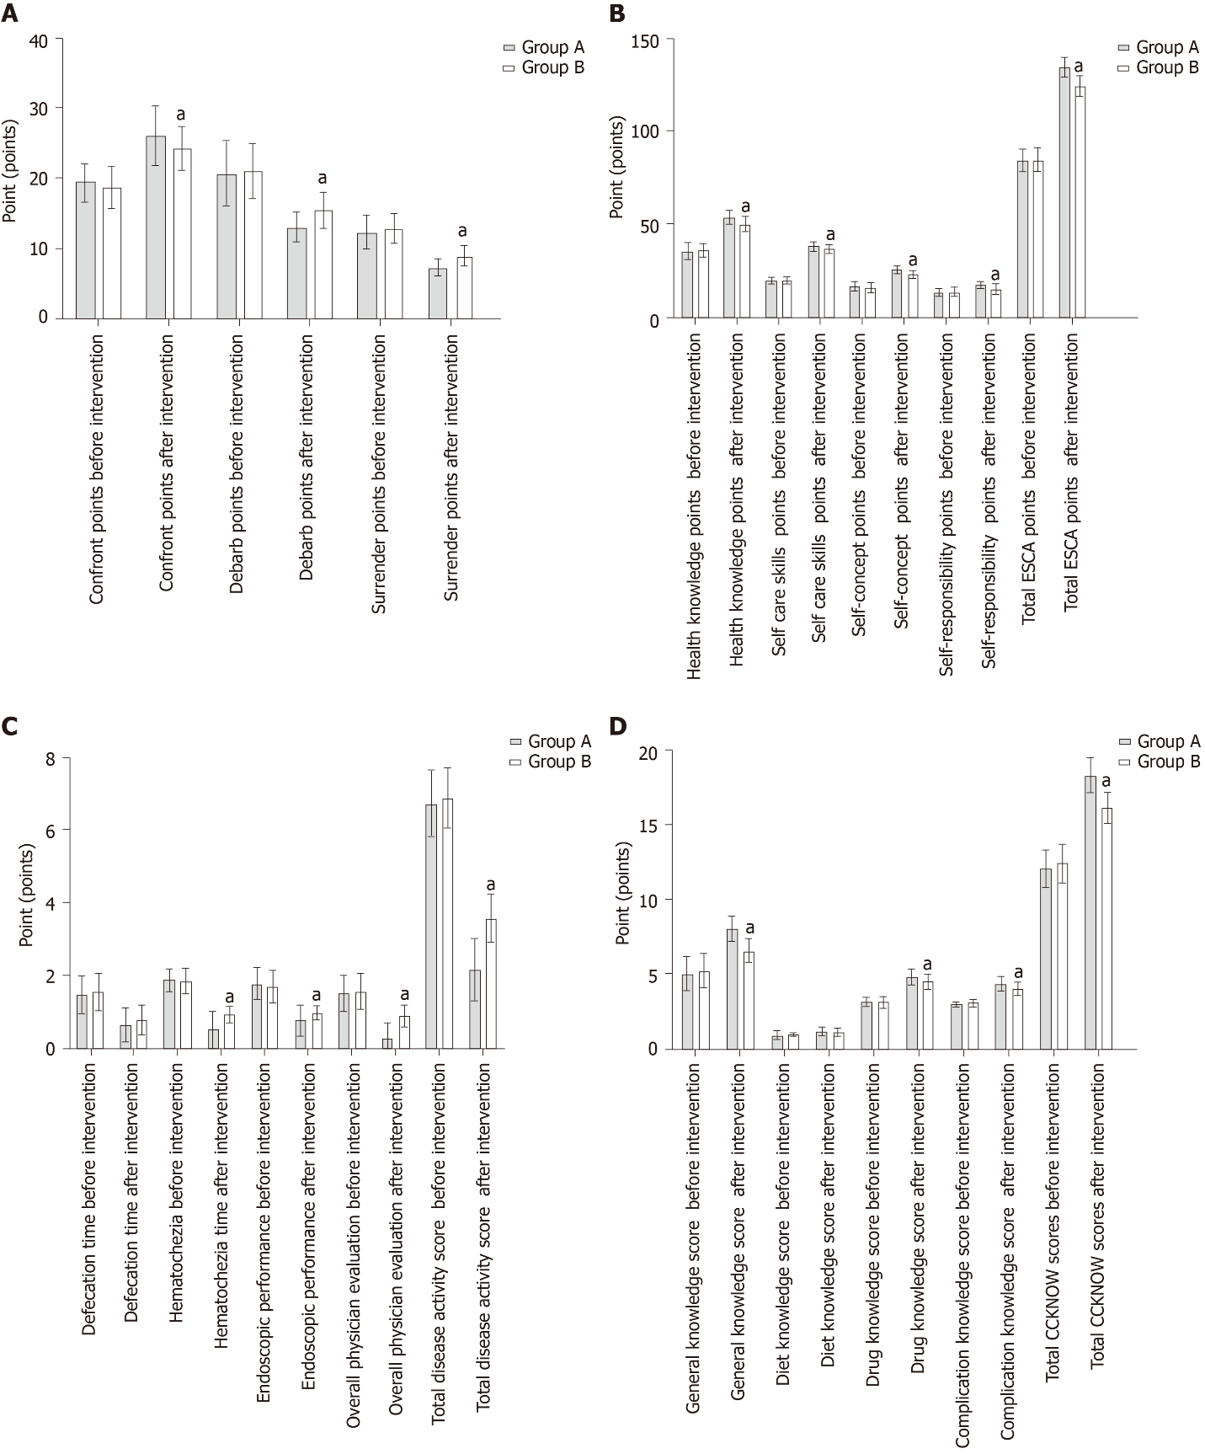
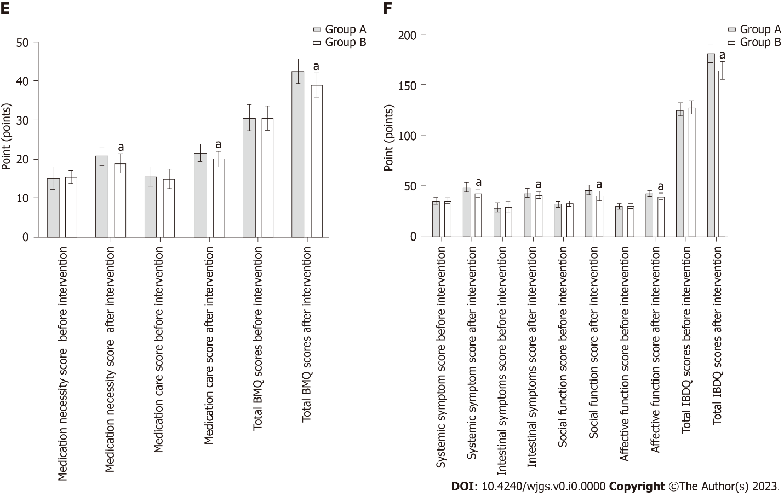
Figure 1 Comparison of different methods among both groups before and after the intervention (points). A: Medical Coping Modes Questionnaire scores; B: Exercise of Self-nursing Agency scores; C: Disease activity; D: Crohn’s and Colitis Knowledge scores; E: Intervention compliance; F: Inflammatory bowel disease questionnaire scores. ªP < 0.05, comparison with the group A. ESCA: Exercise of Self-nursing Agency; CCKNOW: Crohn’s and Colitis Knowledge; BMQ: Beliefs about Medicine Questionnaire; IBDQ: Inflammatory bowel disease questionnaire.

Table 1 Comparison of general information between the two groups (n)
Group | Group A (n = 64) | Group B (n = 64) | χ²/t | P value
Gender
Male | 38 | 35 | 0.287 | 0.592
Female | 26 | 29
Age | 43.11 ± 4.77 | 41.80 ± 4.48 | 1.605 | 0.111
Course of disease | 1.25 ± 0.25 | 1.18 ± 0.25 | 1.392 | 0.166
Degree of education
Junior high school and below | 19 | 21 | 0.145 | 0.703
High school and above | 45 | 43
Disease type
Ulcerative colitis | 56 | 59 | 0.771 | 0.380
Crohn’s disease | 8 | 5
Family history of digestive disorders | 7 | 5 | 0.368 | 0.544

Table 2 Comparison of Medical Coping Modes Questionnaire scores before and after the intervention (mean ± SD, points)
Group | Group A (n = 64) | Group B (n = 64) | t value | P value
Confront points
Before intervention | 19.44 ± 2.65 | 18.66 ± 3.11 | 1.528 | 0.129
After intervention | 25.98 ± 4.23ª | 24.19 ± 3.11ª | 2.741 | 0.007
Debarb points
Before intervention | 20.64 ± 4.70 | 20.94 ± 3.97 | 0.386 | 0.700
After intervention | 13.00 ± 2.15ª | 15.44 ± 2.54ª | 5.859 | < 0.001
Surrender points
Before intervention | 12.28 ± 2.51 | 12.84 ± 2.08 | 1.381 | 0.170
After intervention | 7.28 ± 1.34ª | 9.02 ± 1.46ª | 6.994 | < 0.001
ªP < 0.05, compared with the same group before intervention.

Table 3 Comparison of Exercise of Self-nursing Agency scores before and after the intervention (mean ± SD, points)
Group | Group A (n = 64) | Group B (n = 64) | t value | P value
Health knowledge points
Before intervention | 35.13 ± 4.68 | 35.75 ± 3.56 | 0.851 | 0.396
After intervention | 53.33 ± 4.07ª | 49.81 ± 4.23ª | 4.786 | < 0.001
Self care skills points
Before intervention | 19.39 ± 2.00 | 19.66 ± 2.04 | 0.744 | 0.458
After intervention | 37.97 ± 2.77ª | 36.45 ± 2.44ª | 3.286 | 0.001
Self-concept points
Before intervention | 16.14 ± 2.84 | 15.72 ± 2.78 | 0.849 | 0.398
After intervention | 25.47 ± 2.43ª | 22.75 ± 2.30ª | 6.507 | < 0.001
Self-responsibility points
Before intervention | 13.33 ± 2.64 | 13.30 ± 2.65 | 0.067 | 0.947
After intervention | 17.22 ± 2.00ª | 14.98 ± 2.83ª | 5.154 | < 0.001
Total ESCA points
Before intervention | 83.98 ± 6.22 | 84.42 ± 6.26 | 0.397 | 0.692
After intervention | 133.98 ± 5.56ª | 124.00 ± 5.56ª | 10.153 | < 0.001
ªP < 0.05, compared with the same group before intervention.
ESCA: Exercise of Self-nursing Agency.

Table 4 Comparison of disease activity before and after the intervention (mean ± SD, points)
Group | Group A (n = 64) | Group B (n = 64) | t value | P value
Defecation time
Before intervention | 1.48 ± 0.50 | 1.55 ± 0.50 | 0.703 | 0.483
After intervention | 0.63 ± 0.49ª | 0.78 ± 0.42ª | 1.948 | 0.054
Hematochezia
Before intervention | 1.89 ± 0.31 | 1.86 ± 0.35 | 0.531 | 0.596
After intervention | 0.52 ± 0.50ª | 0.94 ± 0.24ª | 6.030 | < 0.001
Endoscopic performance
Before intervention | 1.77 ± 0.46 | 1.70 ± 0.46 | 0.766 | 0.445
After intervention | 0.77 ± 0.43ª | 0.97 ± 0.18ª | 3.521 | < 0.001
Overall physician evaluation
Before intervention | 1.50 ± 0.50 | 1.55 ± 0.50 | 0.527 | 0.599
After intervention | 0.27 ± 0.45ª | 0.89 ± 0.31ª | 9.173 | < 0.001
Total disease activity score
Before intervention | 6.72 ± 0.93 | 6.88 ± 0.83 | 1.003 | 0.318
After intervention | 2.17 ± 0.83ª | 3.58 ± 0.66ª | 10.618 | < 0.001
ªP < 0.05, compared with the same group before intervention.

Table 5 Comparison of Crohn’s and Colitis Knowledge scores before and after the intervention (mean ± SD, points)
Group | Group A (n = 64) | Group B (n = 64) | t value | P value
General knowledge score
Before intervention | 5.03 ± 1.18 | 5.23 ± 1.15 | 0.985 | 0.326
After intervention | 8.00 ± 0.84ª | 6.55 ± 0.85ª | 9.734 | < 0.001
Diet knowledge score
Before intervention | 0.91 ± 0.29 | 0.98 ± 0.13 | 1.958 | 0.054
After intervention | 1.14 ± 0.35ª | 1.09 ± 0.29ª | 0.820 | 0.414
Drug knowledge score
Before intervention | 3.13 ± 0.33 | 3.14 ± 0.35 | 0.258 | 0.796
After intervention | 4.78 ± 0.58ª | 4.48 ± 0.53ª | 3.022 | 0.003
Complication knowledge score
Before intervention | 3.02 ± 0.13 | 3.06 ± 0.24 | 1.368 | 0.175
After intervention | 4.31 ± 0.50ª | 4.02 ± 0.42ª | 3.646 | < 0.001
Total CCKNOW scores
Before intervention | 12.08 ± 1.25 | 12.42 ± 1.29 | 1.527 | 0.129
After intervention | 18.23 ± 1.21ª | 16.14 ± 1.07ª | 10.406 | < 0.001
ªP < 0.05, compared with the same group before intervention.
CCKNOW: Crohn’s and Colitis Knowledge.

Table 6 Comparison of intervention compliance between two groups (mean ± SD, points)
Group | Group A (n = 64) | Group B (n = 64) | t value | P value
Medication necessity score
Before intervention | 15.05 ± 2.90 | 15.50 ± 1.76 | 1.069 | 0.288
After intervention | 20.80 ± 2.30ª | 18.94 ± 2.39ª | 4.481 | < 0.001
Medication care score
Before intervention | 15.53 ± 2.49 | 14.95 ± 2.41 | 1.336 | 0.184
After intervention | 21.66 ± 2.35ª | 20.00 ± 2.08ª | 4.222 | < 0.001
Total BMQ scores
Before intervention | 30.58 ± 3.42 | 30.45 ± 3.14 | 0.215 | 0.830
After intervention | 42.45 ± 3.22ª | 38.94 ± 3.15ª | 6.241 | < 0.001
ªP < 0.05, compared with the same group before intervention.
BMQ: Beliefs about Medicine Questionnaire.

Table 7 Comparison of inflammatory bowel disease questionnaire scores between two groups before and after intervention (mean ± SD, points)
Group | Group A (n = 64) | Group B (n = 64) | t value | P value
Systemic symptom score
Before intervention | 35.13 ± 3.45 | 35.23 ± 2.91 | 0.194 | 0.847
After intervention | 48.75 ± 4.86ª | 42.78 ± 4.70ª | 7.069 | < 0.001
Intestinal symptoms score
Before intervention | 28.48 ± 4.69 | 29.17 ± 5.28 | 0.778 | 0.438
After intervention | 43.05 ± 4.55ª | 40.61 ± 3.49ª | 3.399 | 0.001
Social function score
Before intervention | 31.92 ± 2.70 | 32.78 ± 3.07 | 1.680 | 0.096
After intervention | 46.27 ± 4.97ª | 40.66 ± 4.85ª | 6.463 | < 0.001
Affective function score
Before intervention | 29.89 ± 2.59 | 30.38 ± 2.09 | 1.163 | 0.247
After intervention | 42.55 ± 2.96ª | 39.55 ± 3.32ª | 5.397 | < 0.001
Total IBDQ scores
Before intervention | 125.42 ± 6.72 | 127.78 ± 6.88 | 1.962 | 0.052
After intervention | 180.61 ± 8.77ª | 164.44 ± 8.62ª | 10.523 | < 0.001
ªP < 0.05, compared with the same group before intervention.
IBDQ: Inflammatory bowel disease questionnaire.

