Name of Journal: World Journal of Clinical Oncology
Manuscript NO: 62807
Manuscript Type: SYSTEMATIC REVIEWS

Mixed odontogenic tumors: a review of the clinicopathological and molecular features and changes in the WHO classification

Sánchez-Romero C et al. Mixed odontogenic tumors: a review

Celeste Sánchez-Romero, Oslei Paes de almeida, Ronell Bologna-Molina

Celeste Sánchez-Romero, Ronell Bologna-Molina, Department of Oral Pathology, Faculty of Dentistry, University Juarez of the Durango State, Durango 33106, Mexico

Oslei Paes de almeida, Department of Diagnosis, Faculty of Piracicaba, State University of Campinas, São Paulo Brazil, Piracicaba 13414-903, Sao Paulo, Brazil

Ronell Bologna-Molina, Department of Oral and Maxillofacial Pathology, Universidad de la República UDELAR (URUGUAY), Montevideo 16400, Uruguay

Author contributions: Sánchez-Romero C, Bologna-Molina R and Paes de Almeida O participated in the conceptualization, bibliographic search, selection of information, interpretation of data, writing of the manuscript as well as in the subsequent revision of the manuscript.

Corresponding author: Ronell Bologna-Molina, DDS, MSc, PhD, Professor, Department of Oral and Maxillofacial Pathology, Universidad de la República UDELAR (URUGUAY), Montevideo 16400, Uruguay. ronellbologna@hotmail.com

Received: January 19, 2021
Revised: May 25, 2021
Accepted: November 25, 2021
Published online:

Abstract
BACKGROUND
Ameloblastic fibromas and ameloblastic fibrosarcomas are rare odontogenic tumors, and controversy exists in the classification of cases presenting hard-tissue production: ameloblastic fibrodentinoma (AFD) and ameloblastic fibro-odontoma (AFO). These cases are currently considered “developing odontomas” (hamartomatous lesions).

AIM
to analyze the clinicopathologic features of these lesions and discuss the changes in the 2017 World Health Organization classification.

METHODS
An electronic literature search was performed in the PubMed/Medline database. An electronic search of the English language literature was performed and last updated in September 2020 in the PubMed/Medline database using the following terms: “ameloblastic fibroma”, “ameloblastic fibrodentinoma”, “ameloblastic fibro-odontoma”, “ameloblastic sarcoma”, “ameloblastic fibrosarcoma”, “ameloblastic fibrodentinosarcoma”, “ameloblastic fibroodontosarcoma” and “odontogenic carcinosarcoma”. The inclusion criteria were odontogenic tumor series, case reports and systematic reviews that provided sufficient clinical, radiological and microscopic documentation to confirm the diagnosis.

RESULTS
The database search strategy resulted in 947 papers. Articles focusing on other topics, articles that were not in English, duplicate articles, and articles without fulfilling the inclusion criteria were excluded. Finally, 96 publications were included in this review to describe and discuss the main features of the searched entities. Several aspects of AFO and AFD, such as biological behavior, age of occurrence, amount of hard tissue, and potential for malignant transformation into odontogenic sarcomas, support the neoplastic nature in most of the reported cases. Considering the clinical, radiographic, histopathological and molecular characteristics of odontogenic lesions with hard tissue production, we suggest that these types of lesions should continue to be recognized as odontogenic tumors by maintaining the classically used terms.

CONCLUSION
This recommendation will be relevant for future clinical, microscopic, and molecular studies to better understand the biology of these interesting odontogenic tumors.

Key Words: Ameloblastic fibroma; ameloblastic fibrosarcoma; odontogenic carcinosarcoma; odontogenic tumors

Sánchez-Romero C, Paes de almeida O, Bologna-Molina R. Mixed odontogenic tumors: A review of the clinicopathological and molecular features and changes in the WHO classification. World J Clin Oncol 2021; In press

Core Tip: We consider that the recent 2017 World Health Organization classification does not clarify the subject when considering ameloblastic fibrodentinoma (AFD) and ameloblastic fibro-odontoma (AFO) as “developing odontomas”. According to the clinical, radiographical, histopathological and molecular features of the cases reviewed, we suggest that AFD and AFO should continue to be considered benign neoplasms. Thus, the nomenclature of these mixed benign odontogenic tumors would be congruent with the classification of ameloblastic/odontogenic sarcomas. Additionally, further studies are warranted to compare these interesting odontogenic tumors and finally better clarify and understand their similarities and differences.
INTRODUCTION
Ameloblastic fibroma (AF) is a rare, benign odontogenic tumor formed by odontogenic ectomesenchyme that resembles the dental papilla, has embedded epithelial strands and nests, and is similar to dental lamina and enamel organs but without the presence of hard tissues. If the lesion has dentinoid material, it must be denominated as ameloblastic fibrodentinoma (AFD); when it produces enamel/enamel matrix, it is known as ameloblastic fibro-odontoma (AFO), independent of the amount of hard tissue present^{[1]}. In 2005, WHO classified AF and AFD together, making no distinctions regarding epidemiological and clinical features. Microscopically, the only difference between AF and AFD is the presence of dentinoid in the latter. AFO affects younger patients and has shown a better prognosis than AF/AFD^{[1]}. However, the WHO classification of 2017 states that AF rarely produces dental hard tissues and cases formerly considered AFD/AFO rather represent developing odontomas^{[2]}.
This group of mixed odontogenic tumors (AF and related-lesions) histologically resembles different tooth formation stages, particularly when dentin and enamel are produced, sharing similar morphologic features with the so-called “developing odontoma”, which is considered a tumor-like malformation or hamartoma by WHO. Nevertheless, unlike odontomas, these mixed tumors present characteristics that support the concept of a true neoplasm, such as biological behavior, age of occurrence, and well-documented cases of malignant transformation into odontogenic sarcomas, namely, ameloblastic fibrosarcoma (AFS), ameloblastic fibrodentinosarcoma (AFDS) and ameloblastic fibro-odontosarcoma (AFOS). Moreover, the recent publication of a few reports of odontogenic carcinosarcomas led to its inclusion as a specific tumor by WHO in 2017^{[2-4]}.
This review is based on the WHO classification of 2005, because most of the literature is based on this nomenclature, and it was performed to analyze the clinicopathologic features of these lesions to discuss the changes in the 2017 WHO classification.

MATERIALS AND METHODS
An electronic search of the English language literature was performed and last updated in September 2020 in the PubMed/Medline database using the following terms: “ameloblastic fibroma”, “ameloblastic fibrodentinoma”, “ameloblastic fibro-odontoma”, “ameloblastic sarcoma”, “ameloblastic fibrosarcoma”, “ameloblastic fibrodentinosarcoma”, “ameloblastic fibroodontosarcoma” and “odontogenic carcinosarcoma”.
Previous cases that did not use the current terminology for these tumors, recently identified as AF, AFD, AFO, AFS, AFDS or AFOS, were also found and evaluated for possible inclusion.
The inclusion criteria were odontogenic tumor series, case reports and systematic reviews including AF, AFD, AFO, AFS, AFDS or AFOS, which provided sufficient clinical, radiological and microscopic documentation to confirm the diagnosis. Reports without this information were excluded.

RESULTS
The database search strategy resulted in 947 papers. Articles focusing on other topics, articles that were not in English, duplicate articles, and articles without fulfilling the inclusion criteria were excluded. Finally, 96 publications were included in this review to describe and discuss the main features of the searched entities.

AF
Clinical characteristics: This uncommon benign mixed odontogenic tumor occurs preferentially in children and young adults, with a mean age of 14.9 years, ranging from 7 wk to 57 years. Only 20% of the cases are diagnosed in patients older than 20 years. Considering all odontogenic tumors, AF represents only 0.6% to 3.1% of these neoplasms. Most of the cases affect the mandible, with a slight predilection for male patients, with a male/female ratio of 1.4:1. The size of AF when diagnosed varies from 0.7 to 16 cm (mean of 4.05 cm)^{[5]}.
Most cases present as painless jaw swelling or are discovered during routine radiographical examination due to delayed tooth eruption, eventually causing cortical expansion and facial asymmetry. Approximately 80% of AF involves the posterior region of the mandible but has also been found on the posterior maxilla and rarely in the anterior region of the jaws^{[5,6]}.

Radiographic features: Radiographically, AF presents as a well-defined, unilocular (56%) or multilocular (44%) radiolucent lesion, with regular and well-defined margins, typically sclerotic (94%). Tumors measuring less than 5 cm usually tend to be unilocular. Approximately 80% of cases are associated with a single or several unerupted teeth, usually of permanent dentition. Root resorption and cortical perforation are uncommon and described in 8.1% and 5.2% of cases, respectively^{[5,6]}.

Histopathology: Microscopically, AF is a mixed tumor with variable amounts of epithelial and ectomesenchymal components in different areas of the same lesion. The ectomesenchyme resembles the embryonic dental papilla, comprising a myxoid cell-rich stroma involving odontogenic epithelial elements that may present different patterns: epithelial strands, comprising a double layer of cuboidal cells (Figure 1A); cords with tooth bud-like projections of cuboidal cells (Figure 1B); epithelial follicles comprising a layer of peripheral tall columnar ameloblast-like cells and a central area, displaying more loosely arranged stellate/spindle-shaped cells, similar to the stellate reticulum of the enamel organ (Figure 1C); clefts of mesenchymal tissue surrounding follicular epithelial proliferation can be present (Figure 1D); and smaller epithelial rosette-like islands that resemble remnants of dental lamina may be observed (Figure 1E). Mitotic figures in either the epithelium or mesenchyme are uncommon, a finding consistent with the benign nature of the tumor. According to the 2005 WHO classification, no hard tissues, such as enamel or dentin, are present^{[1]}. In the 2017 classification, AF rarely presented dental hard tissue formation that eventually reached an exceptional size^{[2]}. According to the histopathological criteria of 2005, 280 cases of AF were identified in the literature. The proliferation rate is low, with a Ki-67 Labeling index generally lower than 3% (Figure 1F)^{[5-7]}.

Treatment and prognosis: Most reported AFs were treated conservatively by enucleation and curettage. Radical surgery is used in more extensive tumors or recurrent lesions. Recurrence was reported in 16.3% of cases, and malignant transformation into AFS was cited in 6.4%. Recurrence seems to be more common in younger patients and malignant transformation more common in older patients^{[5]}.

AFD
Clinical characteristics: AFD is a rare benign odontogenic tumor with histopathological features of AF and the formation of dysplastic dentin. The WHO classification of 2005 describes AF and AFD together, without further considerations of the latter, beyond the presence of dentin/dentinoid. No strong evidence of differences in the biological behavior of AF and AFD is available^{[1,8]}. However, the 2017 WHO classification of tumors cited that lesions referred to as AFDs are more likely “developing odontomas”, and the editors suggest that they are no longer being considered mixed odontogenic tumors, as in the previous classification^{[2]}.
AFD is rare, corresponding to less than 1% of all odontogenic tumors in most reported series. It usually presents as asymptomatic swelling, more frequently at the posterior mandible (mandible/maxilla ratio of 2.4:1), often associated with a permanent unerupted tooth. When a deciduous tooth is involved, the lesions are generally located in the incisor area. From the 45 cases reviewed, we found a slight male predilection, corresponding to 59.5% of cases, usually in the first and second decades of life; however, 17 of 45 (37.7%) cases occurred in the third decade and beyond. The mean age was 17.8 years, with an age range of 1 to 63 years (Table 1).

Radiographic features: Radiographically, AFD presents as a well-defined radiolucency with varying degrees of radiopacity, depending on the amount of calcified dentinoid. In 2012, Giraddi and Garg^{[9]} reported a large and aggressive AFD with irregular borders, with considerable expansion and perforation of the cortical bone; however, the possibility of eventual foci of malignant transformation to AFDS should be considered in this case.

Histopathology: Microscopically, AFD is formed by odontogenic epithelium and ectomesenchyme arranged in an indistinguishable pattern from AF, in addition to the presence of dentinoid (Figure 2A, B). The epithelial cords and islands resemble the dental lamina and enamel organ, lying in myxoid cell-rich ectomesenchymal tissue with stellate-shaped fibroblasts resembling dental papilla. The amount of dentinoid material is variable, but minimal evidence is sufficient for the diagnosis to be accepted^{[1]}. We found only 45 cases of AFD in the English literature according to these characteristics. Similar to AF, the Ki-67 index in AFD is low in both epithelial and mesenchymal components^{[8]}.

Treatment and prognosis: The treatment of choice is surgical, with enucleation of the lesion and unerupted tooth involvement. Recurrence is uncommon (9%) and likely a consequence of incomplete surgical removal. Radical surgery has been used in aggressive, atypical or recurrent lesions^{[9]}. AFD rarely progresses into ameloblastic fibrodentinosarcoma, in which only the mesenchymal component shows malignant transformation. Only 4 cases of AFDS with a preexisting benign lesion have been described in the English literature (Table 2).

AFO
Clinical characteristics: AFO is a slow-growing, expansive, benign mixed odontogenic tumor that is histologically similar to AFD but also contains enameloid material in variable amounts^{[1]}. Similar to AFD, the term AFO was excluded from the latest WHO classification, in which lesions with these characteristics are considered developing odontomas^{[2]}.
According to the literature, AFO occurs mainly in children, with a mean age of 9.6 years. It has a male predilection, with a ratio of 1.85:1 and an average size of 3.3 cm, ranging from 0.8 to 14 cm. More than 80% of cases affect the posterior portion of the mandible, eventually causing facial asymmetry^{[10,11]}. To our knowledge, 222 cases have been reported in the English literature, among which 211 were reviewed by Chrcanovic et al^{[5]} and 11 additional cases were published later^{[12-22]}, including one peripheral case^{[23]}. One case was associated with paresthesia of the chin and lower lip in a 12-year-old girl^{[22]}.

Radiographic features: AFO usually appears as a well-defined unilocular mixed radiolucent-radiopaque lesion, frequently in close association with the crown of an unerupted tooth. It commonly causes painless cortical expansion but no perforation^{[10,11]}.
We reviewed the literature and found 82 cases with optimal radiographic documentation, among which 22 (26.8%) presented radiographically as a single large opaque mass similar to odontoma and 11 (13.4%) presented several foci of opacities; however, most cases were poor in hard tissues, with 43 cases presenting few opacities (52.4%) and 6 cases appearing as radiolucent lesions (7.3%).

Histopathology: Similar to AF, AFO comprises odontogenic epithelium and ectomesenchyme, but it also contains hard dental tissues in variable amounts and degrees of maturation, such as enameloid and dentinoid (Figure 2C-F). Frequently, Ki-67 is lower than 1% in epithelial and mesenchymal cells^{[1,24]}.

Treatment and prognosis: The treatment of choice is conservative surgery through enucleation and curettage, with removal of the unerupted tooth. Recurrence is uncommon, and malignant transformation is very rare, with only 6 cases reported to date^{[5,10]}.

AFS
Clinical characteristics: AFS is a very rare malignant odontogenic tumor, considered the malignant counterpart of AF, in which the ectomesenchymal component shows features of sarcoma, while the odontogenic epithelium remains bland^{[1]}. To date, up to 100 cases of AFS have been reported in the English language literature. The mean age of the affected patients was 28 years (range: 3 to 89 years), with a slight predilection for male patients (male-to-female ratio: 1.6:1). AFS is more frequent in the mandible, and up to one-third of the cases have been derived from previously documented AF. Patients with AFS originating from AF have a mean age of 33 years, and those with de novo AFS (previous AF not demonstrated) are one decade younger. AFS usually appears as painful swelling, and paraesthesia may be present^{[5,25,26]}.

Radiographic features: As with most malignant intraosseous tumors, AFS presents as expansive ill-defined unilocular or multilocular radiolucency with bone destruction areas, perforation of cortical areas, irregular margins and occasional root resorption. It can be associated with unerupted teeth and eventually cause diffuse expansion and thinning of the cortex^{[2,27]}.

Histopathology: Histologically, AFS is similar to AF; however, the ectomesenchyme is hypercellular and malignant, while the epithelial component tends to decrease and virtually disappears in recurrent tumors (Figure 3A-C)^{[1,28]}. Epithelial nests and cords remain inactive, presenting an immunohistochemical profile similar to AF and positivity for AE1/AE3^{[15-17]} (Figure 3E). Proliferation-related markers such as Ki-67 and p53 can help distinguish AF and AFS, because they are virtually negative in the mesenchymal component and epithelium of AF and positive in a variable percentage in the malignant cells of AFS (Figure 3F).

Treatment and prognosis: Because AFS is locally very aggressive, with a high tendency to relapse, treatment includes wide surgical removal and long-term follow-up. Adjuvant radiotherapy has been used in some cases with favorable results^{[29]}, while the usefulness of chemotherapy has not been confirmed^{[26]}. Recurrence occurs in approximately 20% and metastasis in only 4.5% of cases, but the mortality after 5 years of treatment is relatively high, estimated in 25.4% of cases^{[1,25,27]}.

Ameloblastic fibrodentinosarcoma/ameloblastic fibro-odontosarcoma
In the 2005 and 2017 WHO classifications of tumors, AFDS/AFOS are described together as tumors with histological features of AFS presenting dentinoid (fibrodentinosarcoma) or dentinoid and enameloid (fibro-odontosarcoma) (Figure 3D)^{[1,2]}.

Clinical and histopathological features: Clinically, AFDS/AFOS present as painful swelling of the jaws, with only 21 cases reported in the literature, as summarized in Table 2^{[9,30]}. From these cases, 10 described enameloid formation, corresponding to AFOS. The age range of the reported cases was from 4 mo to 83 years, with a peak in the third decade. Approximately 40% of the cases recurred, two developed metastasis, and three patients died because of aggressive local invasion^{[31-33]}.
Immunohistochemically, AFDS/AFOS are similar to AFS, with odontogenic epithelium positive for AE1/AE3, facilitating the localization of epithelial nests in cases of mesenchymal predominance, excluding the diagnosis of other sarcomas. As discussed previously, proliferation markers such as Ki-67 and p53 confirm the aggressiveness of the lesion, helping to differentiate it from its respective benign counterpart^{[30,34,35]}.

Radiographic features: Radiographically, they appear as a uni- or multilocular radiolucency with variable dense opacities associated with impacted teeth. Irregular borders, expansion and perforation of the cortex are common, indicating a malignant tumor^{[34]}.

Treatment and prognosis: Treatment is based on wide local surgical excision, and long-term follow-up is advised^{[30]}. We found 21 cases of AFDS/AFOS in the English language literature, 8 of which (38%) recurred, 2 developed distant metastasis, and 3 cases (15%) caused death.

Molecular characterization of mixed odontogenic tumors
To date, few studies have investigated the genetic/molecular profiling of mixed odontogenic tumors. Molecular testing (polymerase chain reaction followed by direct sequencing and next-generation sequencing) has revealed that 33% to 100% of benign mixed odontogenic tumors (AF, AFD, and AFO) and 71% of AFS harbor BRAF p. V600E mutation in their mesenchymal component (and rare cases in both components), unlike odontomas, which are BRAF wild-type. This finding suggests that a subset of AF, AFD and AFO differs molecularly from odontomas, likely supporting the distinct nature of these entities (neoplastic vs hamartomatous). The BRAF p.V600E mutation is involved in the pathogenesis of several tumors, including ameloblastoma, playing a role as a downstream activator of the MAPK signaling pathway, which regulates several cell processes, such as proliferation, survival and apoptosis^{[36-38]}.Confirming these findings, immunohistochemical reactions against BRAFV600E exhibited specific staining only in the stromal component, supporting the role of this mutation as a driver of the malignant stromal component^{[38]}. Although the BRAF p.V600E mutation seems to be present in most AFSs in the study of Agaimy et al^{[38]}, the NRAS p.Gln61Lys mutation was also detected in one AFS case, and another case was wild type.

DISCUSSION
AF, AFD and AFO present similar clinical, radiographic and microscopic features and were accepted as different entities until the 2017 WHO classification, which considers these entities as representing diverse stages of maturation of a developing odontoma, as suggested by Cahn and Blum in the past^{[39]}. In summary, we suggest that the lesions referred to as AFD and AFO are more likely “developing odontomas” and are no longer considered mixed odontogenic tumors, as in the previous classifications of odontogenic tumors.
We consider that the WHO classification of these tumors in 2017 is unclear because it states that it is not possible to differentiate histologically between AF (true neoplasms) and early-stage odontomas before they differentiate and mature; therefore, the existence of both lesions is accepted. However, no evidence has shown that AF matures to odontoma. If maturation of AF occurred, it would be expected that AF (immature lesion) would be diagnosed at an earlier age than AFO (mature lesion). However, an opposite trend has occurred: as the mean age of diagnosis of AFO is 9.6 years and that of AF is 14.9 years. However, because several AFOs have been reported in children in areas of odontogenesis, some cases might represent odontomas. Nevertheless, some cases of AFD/AFO arise in age groups that are not consistent with a hamartoma: from the 45 reviewed cases of AFD, 17 cases (37.7%) were aged ≥ 20 years, and 7 cases (15.5%) were aged ≥ 30 years, 4 of which were in the sixth and seventh decades of life.
The terms AFD and AFO were practically discarded from the latest WHO tumor classification, considering that once hard tissues are produced, these tumors are more likely to form odontomas^{[2,40]}. Nevertheless, in this WHO classification, AFD and AFO might conceptually be neoplastic when reaching an exceptionally large size but without establishing a measure for this statement^{[2]}.
To avoid concepts that may be confusing and that are not appropriately supported by scientific evidence, we suggest not using the term developing odontomas and simply continuing to use odontomas if the clinical, radiographical and microscopic characteristics support this well-established diagnosis. Cases of a typical odontoma associated with AF could be termed AF associated with odontoma because odontomas can eventually be associated with other odontogenic tumors.
We accept that some cases are difficult to classify as AFO or odontoma because of the large amounts of hard dental tissues and because some cases of odontoma have been diagnosed as AFO. However, a cut off could be considered based on the proportion of hard and epithelial-ectomesenchymal tissues, as well as clinical (size, location, age, and clinical behavior) and radiographic features.
No evidence exists that all AF/AFD/AFO are “developing odontomas” because each of these tumors has its own clinicopathological features. AF is a well-recognized entity, and it should also be emphasized that no evidence is available that AF matures and forms small or large amounts of hard dental tissues, even in cases of recurrence.
AFD has no potential to produce enamel/enameloid; therefore, it cannot mature to an odontoma. However, some AFOs can produce large amounts of hard dental tissues and may mimic radiographically and microscopically odontomas; nevertheless, most AFOs present relatively few calcified areas. We reviewed 82 cases in the English literature with adequate radiographic documentation, most of which had small amounts of hard tissues: 59.8% presented few opacities or radiolucent images, 13.4% showed a higher number of scattered opacities, and only 26.8% presented a single opaque mass similar to odontoma. Even considering these cases rich and poor in calcified dental tissues diagnosed as AFO, evidence exists that cases poor in dental calcified structures evolve to those that mimic odontomas.
Recent molecular studies have shown genetic differences (principally, BRAFV600E mutation) between odontoma (BRAF wild type) and a subset of AF, AFD, AFO and most AFS, supporting that these lesions may represent distinct entities with a neoplastic nature^{[36-38]}.
In summary, we propose to continue to use the classical terms AFD and AFO because it is part of the 2017 WHO classification for malignant counterparts. This recommendation can be relevant for future clinical, microscopic and molecular studies to better clarify the subject and better understand the biology of these interesting odontogenic tumors.
Several aspects support the neoplastic nature of AF, AFD and AFO, such as their biological behavior, significant frequency of BRAF mutation, age of occurrence, amount of hard tissue and potential for malignant transformation into odontogenic sarcomas with or without the production of dental hard tissues. Among the 18 cases of AFDS/AFOS reported in the literature, 6 were related to a preexisting AFO, and this malignant transformation would not be expected in a hamartomatous lesion as a developing odontoma. The 2017 WHO classification accepts AFS, AFDS and AFOS as entities, and they can be de novo or derived from AF. This inconsistency in the nomenclature between benign and malignant corresponding tumors probably occurred because the topics of “odontogenic sarcomas” and “ameloblastic fibroma” were written by different authors in the 2017 WHO classification.
Odontogenic carcinosarcoma was added to the 2017 WHO classification based on 6 case reports, considering that it may arise de novo or can be derived from previous AF or AFS. However, we also found in the literature that, in two cases, ameloblastoma and malignant ameloblastoma were reported as the preceding tumors (Table 3). In contrast to AFS, in which metastasis is rare, 33% (3 cases) of odontogenic/ameloblastic carcinosarcomas presented biphasic metastasis (epithelial and sarcomatous components), and 5 of 9 cases resulted in death^{[3]}. Thus, this entity was recently recognized at the present WHO classification. Immunohistochemically, positivity for p53 and a Ki-67 index > 45% in both carcinomatous and sarcomatous components can be useful to confirm the diagnosis^{[2]}.
It is reasonable to consider that basic benign and malignant neoplasms are AF and AFS and that the presence of small amounts of dental hard tissues does not significantly alter the biological characteristics and clinical behaviors of these entities^{[1,13]}. Although not clearly established, the presence and higher amount of hard tissues may indicate less aggressiveness and possibly lower potential of malignant transformation. In this context, AFO should have a better prognosis than AF/AFD, with a lesser tendency for malignant transformation. AFDS/AFOS seem to have a similar rate of recurrence as AF; however, the metastasis and mortality indexes seem to be higher in AFSs. Additionally, the number of cases of AFD/AFO and AFDS/AFOS reported is very small, making comparisons of these tumors with AF/AFS difficult.
Reports of AFSs have been present for several years, possibly as AF/AFO/AFD that have suddenly followed an aggressive course before being treated, indicating a possible malignant transformation^{[25,41]}.

CONCLUSION
In summary, we reviewed the principal clinical, histopathological and molecular characteristics of AF, AFD and AFO and their malignant counterparts. Odontogenic/ameloblastic carcinosarcoma was cited because, according to reports, it can arise from preexisting AF. We consider that the recent 2017 WHO classification does not clarify the subject when considering AFD and AFO as developing odontomas. According to the clinical, radiographical, histopathological and molecular features of the cases reviewed, we suggest that AFD and AFO should continue to be considered benign neoplasms. Thus, the nomenclature of these mixed benign odontogenic tumors would be congruent with the classification of ameloblastic/odontogenic sarcomas. Additionally, further studies are warranted to compare these interesting odontogenic tumors and finally better clarify and understand their similarities and differences.

ARTICLE HIGHLIGHTS
Research background
Ameloblastic fibromas and ameloblastic fibrosarcomas are rare odontogenic tumors, and controversy exists in the classification of cases presenting hard-tissue production: ameloblastic fibrodentinoma (AFD) and ameloblastic fibro-odontoma (AFO). These cases are currently considered “developing odontomas” (hamartomatous lesions). There is still controversy as to whether they are true hamartomas or neoplasms.

Research motivation
The authors consider that the recent 2017 WHO classification does not clarify the subject when considering AFD and AFO as “developing odontomas”. According to the clinical, radiographical, histopathological and molecular features of the cases reviewed, we suggest that AFD and AFO should continue to be considered benign neoplasms.

Research objectives
The objective was to analyze the clinicopathologic features of these lesions and discuss the changes in the 2017 WHO classification.

Research methods
For this systematic review an electronic literature search was performed in the PubMed/Medline database. An exhaustive search was made of all the existing information on these mixed odontogenic tumors.

Research results
Several aspects of AFO and AFD, such as biological behavior, age of occurrence, amount of hard tissue, and potential for malignant transformation into odontogenic sarcomas, support the neoplastic nature in most of the reported cases.

Research conclusions
Considering the clinical, radiographic, histopathological, and molecular characteristics of odontogenic lesions with hard tissue production, we suggest that these types of lesions should continue to be recognized as odontogenic tumors by maintaining the classically used terms. This recommendation will be relevant for future clinical, microscopic, and molecular studies to better understand the biology of these interesting odontogenic tumors. This new information will be relevant for the clinical conduct to be followed in these tumors.

Research perspectives
Future research should be focused on the comparative molecular study between these odontogenic neoplasms and odontomas; trying to clarify molecular differences between neoplasia and hamartoma.

REFERENCES
1 Barnes L, Eveson JW, Reichart P, Sidransky D, editors. World Health Organization Classification of Tumours: Pathology and Genetics of Head and Neck Tumours. Lyon: IARC Press; 2005
2 El-Naggar A, Chan JK, Grandis JR, Takata T, Slootweg PJ. WHO Classification of Head and Neck Tumours. 4th ed. Lyon: IARC Press; 2017
3 Kunkel M, Ghalibafian M, Radner H, Reichert TE, Fischer B, Wagner W. Ameloblastic fibrosarcoma or odontogenic carcinosarcoma: a matter of classification? Oral Oncol 2004; 40: 444-449 [PMID: 14969825 DOI: 10.1016/j.oraloncology.2003.09.010]
4 Kim IK, Pae SP, Cho HY, Cho HW, Seo JH, Lee DH, Park IS. Odontogenic carcinosarcoma of the mandible: a case report and review. J Korean Assoc Oral Maxillofac Surg 2015; 41: 139-144 [PMID: 26131431 DOI: 10.5125/jkaoms.2015.41.3.139]
5 Chrcanovic BR, Brennan PA, Rahimi S, Gomez RS. Ameloblastic fibroma and ameloblastic fibrosarcoma: A systematic review. J Oral Pathol Med 2018; 47: 315-325 [PMID: 28776760 DOI: 10.1111/jop.12622]
6 Chen Y, Li TJ, Gao Y, Yu SF. Ameloblastic fibroma and related lesions: a clinicopathologic study with reference to their nature and interrelationship. J Oral Pathol Med 2005; 34: 588-595 [PMID: 16202078 DOI: 10.1111/j.1600-0714.2005.00361.x]
7 Sano K, Yoshida S, Ninomiya H, Ikeda H, Ueno K, Sekine J, Iwamoto H, Uehara M, Inokuchi T. Assessment of growth potential by MIB-1 immunohistochemistry in ameloblastic fibroma and related lesions of the jaws compared with ameloblastic fibrosarcoma. J Oral Pathol Med 1998; 27: 59-63 [PMID: 9526730 DOI: 10.1111/j.1600-0714.1998.tb02094.x]
8 Bologna-Molina R, Salazar-Rodríguez S, Bedoya-Borella AM, Carreón-Burciaga RG, Tapia-Repetto G, Molina-Frechero N. A histopathological and immunohistochemical analysis of ameloblastic fibrodentinoma. Case Rep Pathol 2013; 2013: 604560 [PMID: 23476862 DOI: 10.1155/2013/604560]
9 Giraddi GB, Garg V. Aggressive atypical ameloblastic fibrodentinoma: Report of a case. Contemp Clin Dent 2012; 3: 97-102 [PMID: 22557908 DOI: 10.4103/0976-237X.94557]
10 Boxberger NR, Brannon RB, Fowler CB. Ameloblastic fibro-odontoma: a clinicopathologic study of 12 cases. J Clin Pediatr Dent 2011; 35: 397-403 [PMID: 22046699 DOI: 10.17796/jcpd.35.4.t3387t25865758w3]
11 Buchner A, Kaffe I, Vered M. Clinical and radiological profile of ameloblastic fibro-odontoma: an update on an uncommon odontogenic tumor based on a critical analysis of 114 cases. Head Neck Pathol 2013; 7: 54-63 [PMID: 23001451 DOI: 10.1007/s12105-012-0397-9]
12 Melo Filho MR, Pêgo SPB, Cardoso CM, Rocha BA, Martelli-Júnior H, Flores IL, Dos Santos LAN, Paranaiba LMR. Metachronous ameloblastic fibro-odontoma and dentigerous cyst in the posterior mandible. Gen Dent 2017; 65: 69-72 [PMID: 29099370]
13 Aly N, Amer H, Khatib OE. Ameloblastic fibro-odontoma with chondroid tissue formation. Contemp Oncol (Pozn) 2018; 22: 50-53 [PMID: 29692665 DOI: 10.5114/wo.2018.74395]
14 Kufta K, Kang S, Alawi F, Moran A, Panchal N. Ameloblastic Fibro-Odontoma of the Maxilla in a Pierre-Robin Sequence Patient. Fetal Pediatr Pathol 2017; 36: 416-422 [PMID: 28557592 DOI: 10.1080/15513815.2017.1324547]
15 Mashhadiabba F, Shamloo N, Jafari M, Vafadar S. Ameloblastic Fibro-Odontoma in a 7-Month-Old Infant: A Case Report. J Dent (Shiraz) 2017; 18: 234-236 [PMID: 29034280]
16 Peters SM, Bergen MS, Philipone EM, Yoon AJ. Ameloblastic Fibro-Odontoma in an Adolescent: A Case Report and Review of Literature. J Clin Pediatr Dent 2018; 42: 458-460 [PMID: 30085878 DOI: 10.17796/1053-4625-42.6.10]
17 Kalra A, Pajpani M, Webb R. Ameloblastic Fibro-Odontoma. J Dent Child (Chic) 2018; 85: 143-146 [PMID: 30869592]
18 Kale SG, Shetty A, Balakrishnan J, Purvey P. Ameloblastic Fibro-odontoma with a Predominant Radiopaque Component. Ann Maxillofac Surg 2017; 7: 304-307 [PMID: 29264304 DOI: 10.4103/ams.ams_84_17]
19 Thulasirman SK, Thuasidoss G, Prabhu NK, Krishnakumar Raja VB. A Rare Case of Ameloblastic Fibro-Odontoma of Mandible with Literature Review. Ann Maxillofac Surg 2018; 8: 324-326 [PMID: 30693255 DOI: 10.4103/ams.ams_127_18]
20 Abdulla AM, Sivadas G, Surej Kumar LK, Sheejith Hari Peeceeyen CS, Vedam V. Ameloblastic Fibroodontoma: Uncommon Case Presentation in a 6-Year-Old Child with Review of the Literature. Case Rep Med 2017; 2017: 9483738 [PMID: 28883834 DOI: 10.1155/2017/9483738]
21 Rao AJP, Reddy M, Mahanthi VL, Chalapathi KV. Ameloblastic fibro-odontoma in a 14 year old girl: A case report. J Cancer Res Ther 2019; 15: 715-718 [PMID: 31169249 DOI: 10.4103/jcrt.JCRT_215_17]
22 Saeed DM, Setty S, Markiewicz MR, Cabay RJ. Ameloblastic fibro-odontoma associated with paresthesia of the chin and lower lip in a 12-year-old girl. SAGE Open Med Case Rep 2019; 7: 2050313X19870642 [PMID: 31452891 DOI: 10.1177/2050313X19870642]
23 Chrcanovic BR, Gomez RS. Ameloblastic Fibrodentinoma and Ameloblastic Fibro-Odontoma: An Updated Systematic Review of Cases Reported in the Literature. J Oral Maxillofac Surg 2017; 75: 1425-1437 [PMID: 28153756 DOI: 10.1016/j.joms.2016.12.038]
24 Martínez Martínez M, Romero CS, Piña AR, Palma Guzmán JM, de Almeida OP. Pigmented ameloblastic fibro-odontoma: clinical, histological, and immunohistochemical profile. Int J Surg Pathol 2015; 23: 52-60 [PMID: 25339415 DOI: 10.1177/1066896914553663]
25 Bregni RC, Taylor AM, García AM. Ameloblastic fibrosarcoma of the mandible: report of two cases and review of the literature. J Oral Pathol Med 2001; 30: 316-320 [PMID: 11334469 DOI: 10.1034/j.1600-0714.2001.300510.x]
26 Pourdanesh F, Mohamadi M, Moshref M, Soltaninia O. Ameloblastic Fibrosarcoma of the Mandible With Distant Metastases. J Oral Maxillofac Surg 2015; 73: 2067.e1-2067.e7 [PMID: 26207695 DOI: 10.1016/j.joms.2015.07.003]
27 Lai J, Blanas N, Higgins K, Klieb H. Ameloblastic fibrosarcoma: report of a case, study of immunophenotype, and comprehensive review of the literature. J Oral Maxillofac Surg 2012; 70: 2007-2012 [PMID: 22177804 DOI: 10.1016/j.joms.2011.09.012]
28 Gilani SM, Raza A, Al-Khafaji BM. Ameloblastic fibrosarcoma: a rare malignant odontogenic tumor. Eur Ann Otorhinolaryngol Head Neck Dis 2014; 131: 53-56 [PMID: 23845294 DOI: 10.1016/j.anorl.2013.03.001]
29 Hu YY, Deng MH, Yuan LL, Niu YM. Ameloblastic fibrosarcoma of the mandible: A case report and mini review. Exp Ther Med 2014; 8: 1463-1466 [PMID: 25289041 DOI: 10.3892/etm.2014.1940]
30 Wang S, Shi H, Wang P, Yu Q. Ameloblastic fibro-odontosarcoma of the mandible: imaging findings. Dentomaxillofac Radiol 2011; 40: 324-327 [PMID: 21697160 DOI: 10.1259/dmfr/80061108]
31 Howell RM, Burkes EJ Jr. Malignant transformation of ameloblastic fibro-odontoma to ameloblastic fibrosarcoma. Oral Surg Oral Med Oral Pathol 1977; 43: 391-401 [PMID: 265043 DOI: 10.1016/0030-4220(77)90326-7]
32 Takeda Y, Kaneko R, Suzuki A. Ameloblastic fibrosarcoma in the maxilla, malignant transformation of ameloblastic fibroma. Virchows Arch A Pathol Anat Histopathol 1984; 404: 253-263 [PMID: 6437063 DOI: 10.1007/BF00694891]
33 Takeda Y, Kuroda M, Suzuki A. Ameloblastic odontosarcoma (ameloblastic fibro-odontosarcoma) in the mandible. Acta Pathol Jpn 1990; 40: 832-837 [PMID: 2077816 DOI: 10.1111/j.1440-1827.1990.tb02497.x]
34 Mainenti P, Oliveira GS, Valério JB, Daroda LS, Daroda RF, Brandão G, Rosa LE. Ameloblastic fibro-odontosarcoma: a case report. Int J Oral Maxillofac Surg 2009; 38: 289-292 [PMID: 19150219 DOI: 10.1016/j.ijom.2008.11.025]
35 Zabolinejad N, Hiradfar M, Anvari K, Razavi AS. Ameloblastic fibrosarcoma of the maxillary sinus in an infant: a case report with long-term follow-up. J Pediatr Surg 2008; 43: e5-e8 [PMID: 18280269 DOI: 10.1016/j.jpedsurg.2007.09.077]
36 Coura BP, Bernardes VF, de Sousa SF, Diniz MG, Moreira RG, de Andrade BAB, Romañach MJ, Pontes HAR, Gomez RS, Odell EW, Gomes CC. Targeted Next-Generation Sequencing and Allele-Specific Quantitative PCR of Laser Capture Microdissected Samples Uncover Molecular Differences in Mixed Odontogenic Tumors. J Mol Diagn 2020; 22: 1393-1399 [PMID: 32966885 DOI: 10.1016/j.jmoldx.2020.08.005]
37 You Z, Xu LL, Li XF, Zhang JY, DU J, Sun LS. [BRAF gene mutations in ameloblastic fibromas]. Beijing Da Xue Xue Bao Yi Xue Ban 2019; 51: 4-8 [PMID: 30773536 DOI: 10.19723/j.issn.1671-167X.2019.01.002]
38 Agaimy A, Skalova A, Franchi A, Alshagroud R, Gill AJ, Stoehr R, Baumhoer D, Bauer S. Ameloblastic fibrosarcoma: clinicopathological and molecular analysis of seven cases highlighting frequent BRAF and occasional NRAS mutations. Histopathology 2020; 76: 814-821 [PMID: 31899815 DOI: 10.1111/his.14053]
39 Cahn LR, Blum T. Ameloblastic odontoma: case report critically analyzed. J Oral Surg (Chic) 1952; 10: 169–170
40 Wright JM, Vered M. Update from the 4th Edition of the World Health Organization Classification of Head and Neck Tumours: Odontogenic and Maxillofacial Bone Tumors. Head Neck Pathol 2017; 11: 68-77 [PMID: 28247226 DOI: 10.1007/s12105-017-0794-1]
41 Altini M, Thompson SH, Lownie JF, Berezowski BB. Ameloblastic sarcoma of the mandible. J Oral Maxillofac Surg 1985; 43: 789-794 [PMID: 3862778 DOI: 10.1016/0278-2391(85)90336-2]
42 Straith FE. Odontoma. A rare type. Report of a case. Dent Dig 1936; 42: 196
43 Field H, Ackerman A. Calcifying fibro-adamantoblastoma. Am J Orthod 1942; 28: 543–545
44 Stafne E. Dentinoma; report of 2 cases. Am J Orthod 1943; 29: 156–159
45 Stafne EC. Dentinoma; report of a case. J Oral Surg (Chic) 1946; 4: 145-147 [PMID: 20983332]
46 Thoma KH, Goldman HM. Odontogenic tumors; a survey of seventy-five cases. Am J Orthod 1946; 32: 763-791 [PMID: 20276219 DOI: 10.1016/0096-6347(46)90040-3]
47 Ingham GG. Dentinoma. Oral Surg Oral Med Oral Pathol 1952; 5: 353-358 [PMID: 14920026 DOI: 10.1016/0030-4220(52)90290-9]
48 Sirsat MV. Odontogenic tumors. Indian J Med Res 1952; 40: 555-567 [PMID: 13061064]
49 Husted E, Pindborg JJ. Odontogenic tumours; clinical and roentgenological aspects, treatment and pathology. Odontol Tidskr 1953; 61: 275-292 [PMID: 13145176]
50 Hitchin A, White J. A dentinoma related to the deciduous dentition. Br Dent J 1955; 98: 163–165
51 Pindborg JJ. On dentinomas; with report of a case. Acta Pathol Microbiol Scand Suppl 1955; 105: 135-144 [PMID: 14398285]
52 Gorlin RJ, Chaudhry AP, Pindborg JJ. Odontogenic tumors. Classification, histopathology, and clinical behavior in man and domesticated animals. Cancer 1961; 14: 73-101 [PMID: 13707265 DOI: 10.1002/1097-0142(196101/02)14:1<73::aid-cncr2820140111>3.0.co;2-t]
53 Azaz B, Ulmansky M, Lewin-Epstein J. Dentinoma. Report of a case. Oral Surg Oral Med Oral Pathol 1967; 24: 659-663 [PMID: 5234284 DOI: 10.1016/0030-4220(67)90212-5]
54 Manning GL, Browne RM. Dentinoma. Br Dent J 1970; 128: 178-181 [PMID: 5270266 DOI: 10.1038/sj.bdj.4802444]
55 Hoggins GS, Browne RM. Dentinoma: a case report. Br J Oral Surg 1976; 14: 179-184 [PMID: 1070346 DOI: 10.1016/0007-117x(76)90038-x]
56 Gulmen S, Adams RJ, Boggiano JJ. "Dentinoma" of the mandible. J Oral Surg 1976; 34: 921-926 [PMID: 1067390]
57 Godjesk JE, Dolinsky HB, Schneider LC, Doyle JL. Ameloblastic fibro-dentinoma in the gingiva: report of a case. J Oral Med 1980; 35: 59-61 [PMID: 6931877]
58 Rennie JS, Critchlow HA. Dentinoma of the maxilla. Br J Oral Surg 1981; 19: 138-141 [PMID: 6942880 DOI: 10.1016/0007-117x(81)90040-8]
59 van Wyk CW, van der Vyver PC. Ameloblastic fibroma with dentinoid formation/immature dentinoma. A microscopic and ultrastructural study of the epithelial-connective tissue interface. J Oral Pathol 1983; 12: 37-46 [PMID: 6403684 DOI: 10.1111/j.1600-0714.1983.tb00314.x]
60 Villafañe OC, Fonseca MM, Gendelman H, Grotti MA. Dentinoma of the maxilla: report of a case. Acta Stomatol Belg 1986; 83: 203-209 [PMID: 3471068]
61 Lukinmaa PL, Hietanen J, Laitinen JM, Malmström M. Mandibular dentinoma. J Oral Maxillofac Surg 1987; 45: 60-64 [PMID: 3467039 DOI: 10.1016/0278-2391(87)90088-7]
62 Anker AH, Radden BG. Dentinoma of the mandible. Oral Surg Oral Med Oral Pathol 1989; 67: 731-733 [PMID: 2740094 DOI: 10.1016/0030-4220(89)90016-9]
63 Ulmansky M, Bodner L, Praetorius F, Lustmann J. Ameloblastic fibrodentinoma: report on two new cases. J Oral Maxillofac Surg 1994; 52: 980-984 [PMID: 8064465 DOI: 10.1016/s0278-2391(10)80085-0]
64 Cassidy JP, Crocker DJ, Grau WH. Ameloblastic fibrodentinoma. J Oral Maxillofac Surg 1987; 45: 734-736 [PMID: 3475448 DOI: 10.1016/0278-2391(87)90323-5]
65 Akal UK, Günhan O, Güler M. Ameloblastic fibrodentinoma. Report of two cases. Int J Oral Maxillofac Surg 1997; 26: 455-457 [PMID: 9418150 DOI: 10.1016/s0901-5027(97)80013-6]
66 Takeda Y, Sato H, Satoh M, Nakamura S, Yamamoto H. Pigmented ameloblastic fibrodentinoma: a novel melanin-pigmented intraosseous odontogenic lesion. Virchows Arch 2000; 437: 454-458 [PMID: 11097374 DOI: 10.1007/s004280000249]
67 Karasu HA, Akman H, Uyanik LO, Sayan NB. Ameloblastic fibrodentinoma. A case report. N Y State Dent J 2004; 70: 22-23 [PMID: 15683218]
68 Bhargava D, Dave A, Sharma B, Nanda KD. Ameloblastic fibrodentinoma. Indian J Dent Res 2011; 22: 345-347 [PMID: 21891911 DOI: 10.4103/0970-9290.84287]
69 Sankireddy S, Kaushik A, Krishna BA, Reddy AL, Vinod VC, Sridevi V. Ameloblastic fibrodentinoma involving anterior maxilla: a rare case report. J Indian Soc Pedod Prev Dent 2013; 31: 275-278 [PMID: 24262404 DOI: 10.4103/0970-4388.121832]
70 Salehinejad J, Langaroodi AJ, Shahakbari R, Yazdani N. Ameloblastic fibrodentinoma: report of a rare case. J Contemp Dent Pract 2013; 14: 548-551 [PMID: 24172005 DOI: 10.5005/jp-journals-10024-1360]
71 Ikeda H, Minamizato T, Fujita S, Asahina I. Ameloblastic fibrodentinoma with a congenitally missing second premolar tooth: a case report. Oral Surg Oral Med Oral Pathol Oral Radiol 2014; 117: e88-e91 [PMID: 23830803 DOI: 10.1016/j.oooo.2013.05.009]
72 Lee J, Song YG, Moon SY, Choi B, Kim BC, Yoon JH. Calcifying cystic odontogenic tumor associated with ameloblastic fibro-odontoma of the anterior mandible. J Craniofac Surg 2014; 25: e259-e260 [PMID: 24785751 DOI: 10.1097/SCS.0000000000000563]
73 Unsal H, Eren H, Inceoglu B, Oncul AM. Mature form of ameloblastic fibrodentinoma: a case report. J Craniofac Surg 2014; 25: e299-e301 [PMID: 24777020 DOI: 10.1097/SCS.0000000000000728]
74 Joseph S, Priya L, Gopal D, Devachen M, Narayan A, Afnan M. Ameloblastic fibrodentinoma presenting as a false gingival enlargement in the maxillary anterior region. Case Rep Dent 2015; 2015: 812087 [PMID: 25709845 DOI: 10.1155/2015/812087]
75 Costa FW, Silva PG, Soares EC, Sousa FB, Alves AP, Scarparo HC. Surgical approach in a large ameloblastic fibrodentinoma. J Craniofac Surg 2015; 26: 950-951 [PMID: 25978781 DOI: 10.1097/SCS.0000000000001398]
76 Bhargava M, Sood S, Rathore P. Ameloblastic Fibrodentinoma: Report of a Case in an Infant. J Clin Diagn Res 2016; 10: ZD06-ZD07 [PMID: 26894185 DOI: 10.7860/JCDR/2016/16518.7070]
77 Bavle RM, Muniswammappa S, Venugopal R, R AS. Ameloblastic Fibrodentinoma: A Case with Varied Patterns of Dysplastic Dentin. Cureus 2017; 9: e1349 [PMID: 28721317 DOI: 10.7759/cureus.1349]
78 Sabu AM, Gandhi S, Singh I, Solanki M, Sakharia AR. Ameloblastic Fibrodentinoma: A Rarity in Odontogenic Tumors. J Maxillofac Oral Surg 2018; 17: 444-448 [PMID: 30344385 DOI: 10.1007/s12663-017-1062-3]
79 Villa VG. Ameioblastic sarcoma in the mandible; report of a case. Oral Surg Oral Med Oral Pathol 1955; 8: 123-129 [PMID: 13236294 DOI: 10.1016/0030-4220(55)90180-8]
80 Forman G, Garrett J. Ameloblastic sarcoma: report of case. J Oral Surg 1972; 30: 50-54 [PMID: 4500330]
81 Altini M, Smith I. Ameloblastic dentinosarcoma- a case report. Int J Oral Surg 1976; 5: 142-147 [PMID: 820663 DOI: 10.1016/s0300-9785(76)80063-4]
82 Corominas-Villafañe O, Cuestas-Carnero R, Corominas O Jr, Gendelman H. Ameloblastic odontosarcoma: report of a case. Acta Stomatol Belg 1993; 90: 149-156 [PMID: 8122585]
83 Herzog U, Putzke HP, Bienengräber V, Radke C. [The ameloblastic fibro-odontoma--an odontogenic mixed tumor progressing into an odontogenic sarcoma]. Dtsch Z Mund Kiefer Gesichtschir 1991; 15: 90-93 [PMID: 1816940]
84 Muller S, Parker DC, Kapadia SB, Budnick SD, Barnes EL. Ameloblastic fibrosarcoma of the jaws. A clinicopathologic and DNA analysis of five cases and review of the literature with discussion of its relationship to ameloblastic fibroma. Oral Surg Oral Med Oral Pathol Oral Radiol Endod 1995; 79: 469-477 [PMID: 7614208 DOI: 10.1016/s1079-2104(05)80130-1]
85 Reiser V, Alterman M, Shuster A, Kaplan I. Pediatric ameloblastic fibro-odontosarcoma of the mandible: a challenge of diagnosis and treatment. J Oral Maxillofac Surg 2013; 71: e45-e57 [PMID: 23245775 DOI: 10.1016/j.joms.2012.08.027]
86 Khan M, Ramachandra VK, Kampasi N. Clinical, radiographic, and histologic presentation of fibrodentinosarcoma. Quintessence Int 2014; 45: 169-172 [PMID: 24389571 DOI: 10.3290/j.qi.a30991]
87 Gatz SA, Thway K, Mandeville H, Kerawala C, MacVicar D, Chisholm J. Chemotherapy responsiveness in a patient with multiply relapsed ameloblastic fibro-odontosarcoma of the maxilla. Pediatr Blood Cancer 2015; 62: 2029-2032 [PMID: 26178860 DOI: 10.1002/pbc.25627]
88 Chen SJ, Zheng XW, Lin X, Liu H. Ameloblastic fibro-odontosarcoma of the mandible in a pediatric patient. Eur Ann Otorhinolaryngol Head Neck Dis 2016; 133: 419-421 [PMID: 27130809 DOI: 10.1016/j.anorl.2015.11.010]
89 Niu H, Liu J, Chen Y, Geng N. Ameloblastic fibro-odontosarcoma of the mandible with active epithelial proliferation: A rare case report. Mol Clin Oncol 2017; 7: 971-975 [PMID: 29285358 DOI: 10.3892/mco.2017.1448]
90 Atarbashi-Moghadam S, Lotfi A, Mokhtari S. A mixed odontogenic sarcoma: A challenging histopathologic case and brief review of the literature. J Oral Maxillofac Pathol 2018; 22: S29-S34 [PMID: 29491601 DOI: 10.4103/jomfp.JOMFP_74_17]
91 Tanaka T, Ohkubo T, Fujitsuka H, Tatematsu N, Oka N, Kojima T, Morishita Y, Yoshimi N, Mori H. Malignant mixed tumor (malignant ameloblastoma and fibrosarcoma) of the maxilla. Arch Pathol Lab Med 1991; 115: 84-87 [PMID: 1987921]
92 Slama A, Yacoubi T, Khochtali H, Bakir A. [Mandibular odontogenic carcinosarcoma: a case report]. Rev Stomatol Chir Maxillofac 2002; 103: 124-127 [PMID: 11997741]
93 DeLair D, Bejarano PA, Peleg M, El-Mofty SK. Ameloblastic carcinosarcoma of the mandible arising in ameloblastic fibroma: a case report and review of the literature. Oral Surg Oral Med Oral Pathol Oral Radiol Endod 2007; 103: 516-520 [PMID: 17395065 DOI: 10.1016/j.tripleo.2006.02.025]
94 Chikosi R, Segall N, Augusto P, Freedman P. Odontogenic carcinosarcoma: case report and literature review. J Oral Maxillofac Surg 2011; 69: 1501-1507 [PMID: 21195529 DOI: 10.1016/j.joms.2010.05.071]
95 Dos Santos JN, Servato JPS, Cardoso SV, de Faria PR, Pires BC, Loyola AM. Odontogenic carcinosarcoma: morphologic and immunohistochemical description of a case. Oral Surg Oral Med Oral Pathol Oral Radiol 2018; 126: e264-e270 [PMID: 30554629 DOI: 10.1016/j.oooo.2018.05.013]
96 Soares CD, Delgado-Azañero W, Morais TML, de Almeida OP, Ghersi Miranda H. Odontogenic Carcinosarcoma: Clinicopathologic Features of 2 Cases. Int J Surg Pathol 2020; 28: 421-426 [PMID: 31786969 DOI: 10.1177/1066896919888578]

Footnotes
Conflict-of-interest statement: All the authors have indicated that they have no potential conflicts of interest and no financial relationships relevant to this article to disclose.

PRISMA 2009 Checklist statement: The authors have read the PRISMA 2009 Checklist, and the manuscript was prepared and revised according to the PRISMA 2009 Checklist.

Open-Access: This article is an open-access article that was selected by an in-house editor and fully peer-reviewed by external reviewers. It is distributed in accordance with the Creative Commons Attribution NonCommercial (CC BY-NC 4.0) license, which permits others to distribute, remix, adapt, build upon this work non-commercially, and license their derivative works on different terms, provided the original work is properly cited and the use is non-commercial. See: https://creativecommons.org/Licenses/by-nc/4.0/

Manuscript source: Invited manuscript; Externally peer reviewed.
Peer-review model: Single blind

Corresponding Author's Membership in Professional Societies: Interational Association of Oral and Maxillofacial Pathology, No. 0176.

Peer-review started: January 19, 2021
First decision: May 14, 2021
Article in press:

Specialty type: Dentistry, oral surgery and medicine
Country/Territory of origin: Uruguay
Peer-review report’s scientific quality classification
Grade A (Excellent): 0
Grade B (Very good): B, B
Grade C (Good): 0
Grade D (Fair): 0
Grade E (Poor): 0

P-Reviewer: Mesquita RA, Rattan V S-Editor: Ma YJ L-Editor: A P-Editor: Ma YJ

Figure Legends
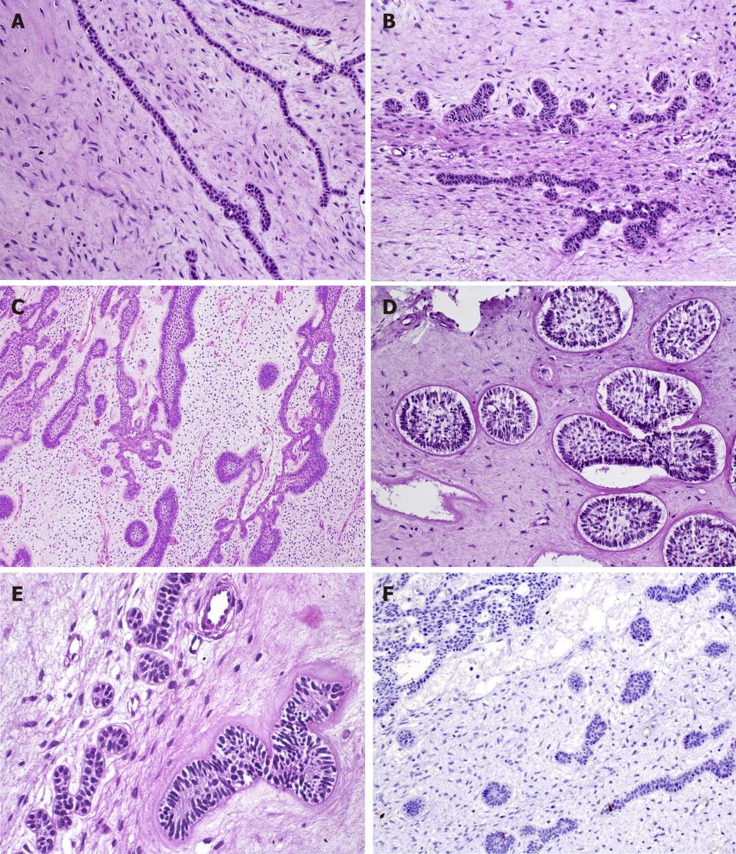
Figure 1 Diverse aspects of the odontogenic epithelium in ameloblastic fibromas within the cell-rich myxoid stroma. A: Epithelial strands, comprising a double layer of cuboidal cells (HE, 20×); B: Epithelial proliferation with primitive appearance that resembles tooth bud-like structures (HE, 20×); C: Epithelial component with a follicular pattern comprising columnar cells at the periphery of the nests with central stellate reticulum-like cells (HE, 10×); D: Clefts of mesenchymal tissue surrounding follicular epithelial proliferations (HE, 20×); E: Mild hyalinization surrounding the basal layer of the epithelial nest (left). Smaller epithelial rosette-like islands resemble remnants of dental lamina (right) (HE, 40×); F: A very low rate of proliferation in both mesenchymal and epithelial components, showing the benign behavior of ameloblastic fibromas (IHC for Ki-67, 20×).

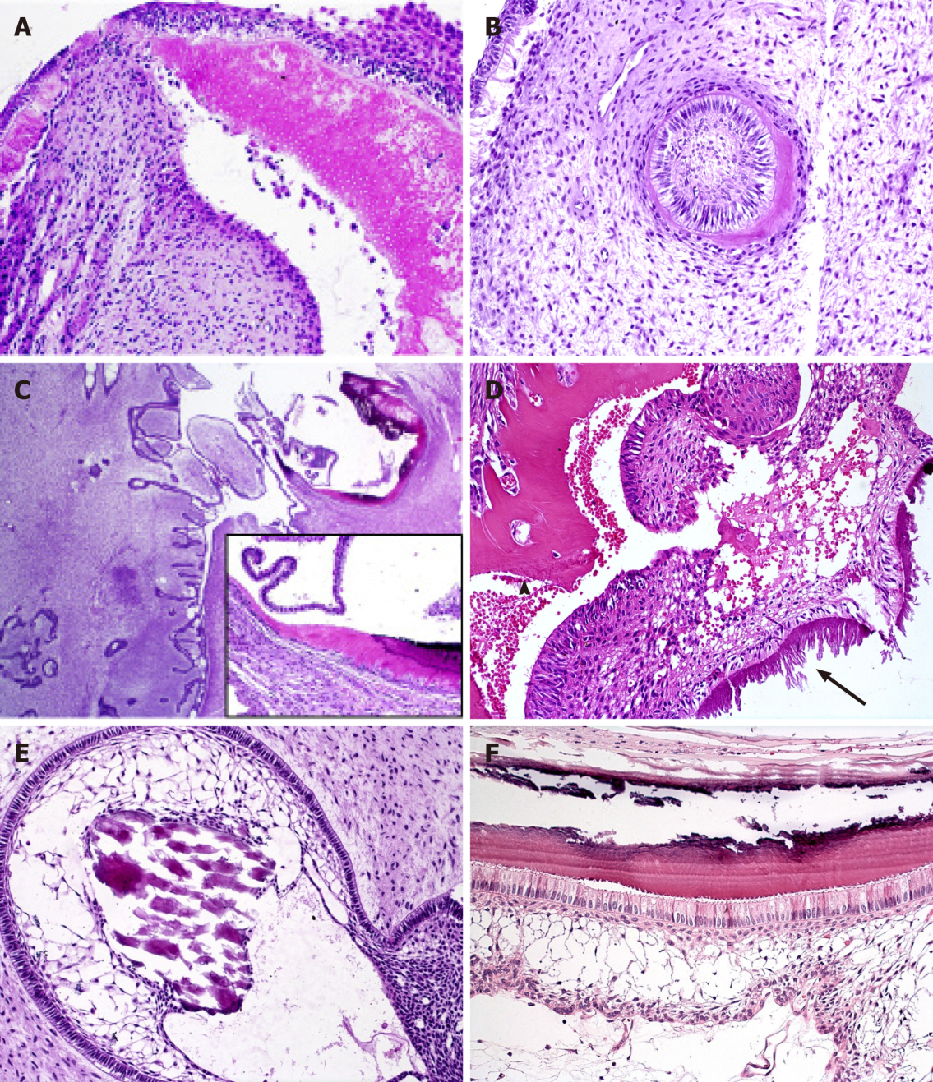
Figure 2 Mineralized tissue formation in ameloblastic fibrodentinoma and ameloblastic fibro-odontoma. A, B: Dentinoid induction by epithelial cells in ameloblastic fibrodentinoma; note the presence of tubules in (A) (HE, 20×); C: Prominent proliferation of soft tissue similar to ameloblastic fibromas and focal areas of dentinoid and enamel matrix production in close relationship with the epithelial component in ameloblastic fibro-odontoma (HE, 2.5×; inset 20×); D: Structures similar to tubules are observed in the dentinoid (arrowhead), which can be associated with odontogenic epithelium or ectomesenchymal tissue, while enamel matrix (arrow) associated with columnar odontogenic appears more basophilic, with different patterns of deposition that can resemble prisms or globules (HE, 20×); E: Calcificated material, compatible with enameloid, in direct relationship with epithelial cells of the stellate reticulum-like area (HE, 20×); F: Details of the columnar ameloblast-like cells with reverse polarization producing enamel matrix in which the “fish scale” pattern is visible. Flattened cells between the columnar cells and stellate reticulum-like area resemble the stratum intermedium of the tooth germ, which is believed to assist the ameloblast in producing enamel during odontogenesis (HE, 40×).
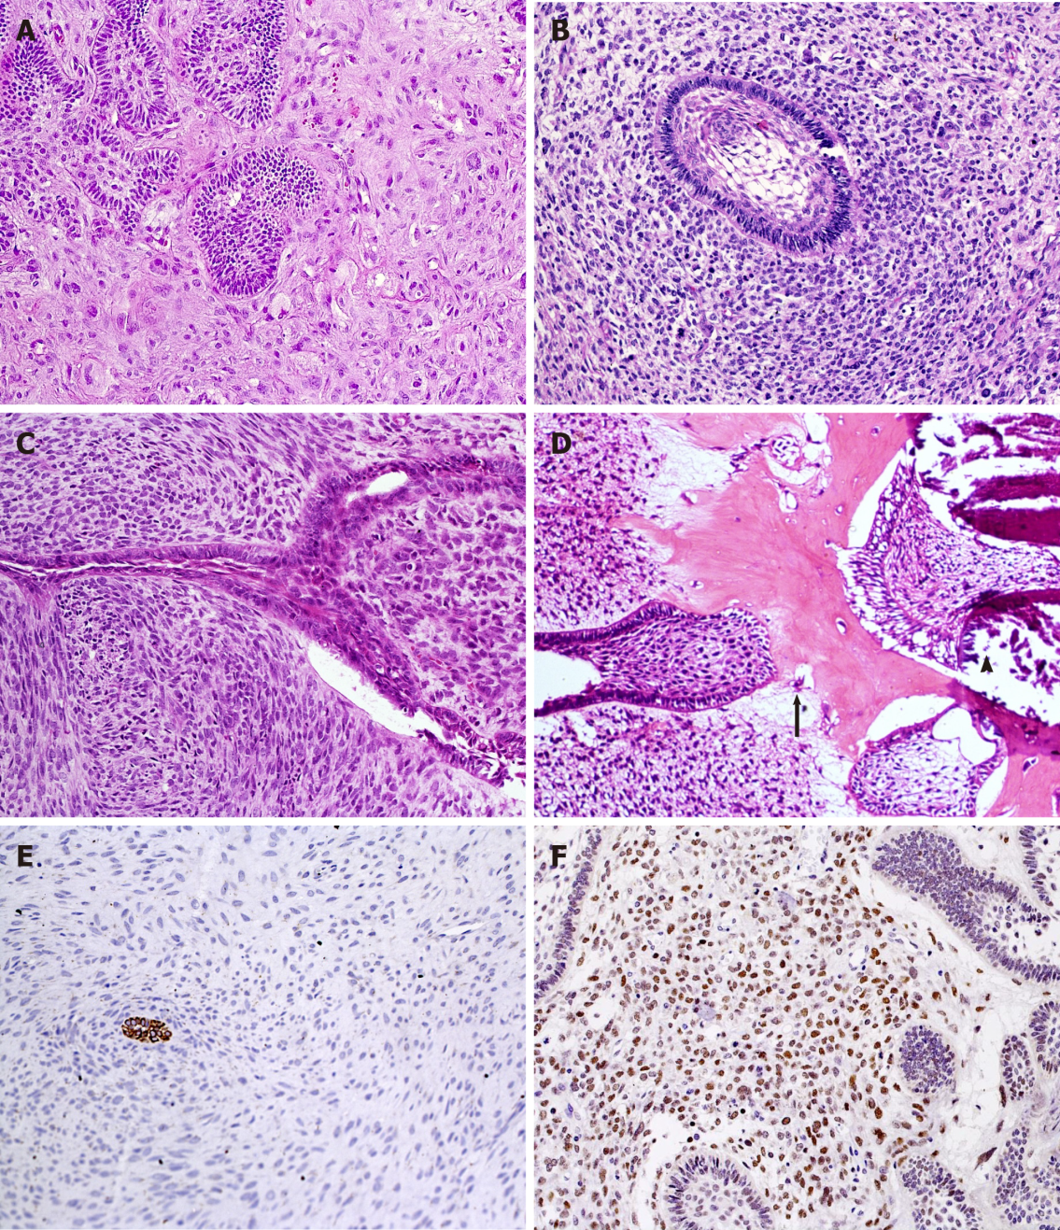
Figure 3 Histopathological aspects of ameloblastic fibromas and ameloblastic fibro-odontosarcoma. Marked pleomorphism and atypia in mesenchymal cells (HE, 20×) (A-C). A: Several mitotic figures, nuclear hyperchromatism and multinucleated and aberrant cells are seen in a highly pleomorphic sarcomatous component of ameloblastic fibromas, while epithelial islands remain benign; B: A follicular benign epithelial island is surrounded by hypercellularized sarcomatous proliferation; C: Malignant mesenchymal tissue resembling a storiform pattern and haphazard disposition of sarcomatous cells around an epithelial branching cord; D: Production of enamel matrix (arrowhead) and dentinoid (arrow) as well as malignant mesenchymal tissue (left side) are components of this ameloblastic fibro-odontosarcoma (A-D: HE, 20×); E: Cytokeratins can help to localize odontogenic epithelial cells within dominant sarcomatous proliferation (IHC for AE1/AE3, 20×); F: Most mesenchymal malignant cells show nuclear positivity for p53 antigen (IHC for p53, 20×).
Table 1 Reported 45 cases of ameloblastic fibrodentinoma found in the English language literature
Case | Ref. | Year | Sex/age | Location
1 | Straith^{[42]} | 1936 | F/30 | Posterior mandible
2 | Field and Ackerman^{[43]} | 1942 | NA/9 | Posterior mandible
3 | Stafne^{[44]} | 1943 | F/25 | Posterior mandible
4 | Stafne^{[44]} | 1943 | NA/23 | Posterior mandible
5 | Stafne^{[45]} | 1946 | NA | NA
6 | Thoma and Goldman^{[46]} | 1946 | M/6 | Maxillary sinus area
7 | Ingham^{[47]} | 1952 | F/19 | Posterior mandible
8 | Sirsat^{[48]} | 1952 | M/36 | Maxillary sinus area
9 | Husted and Pindborg^{[49]} | 1953 | M/4 | Anterior maxilla
10 | Husted and Pindborg^{[49]} | 1953 | F/63 | Posterior mandible
11 | Hitchin and White^{[50]} | 1955 | M/4 | Anterior mandible
12 | Pindborg^{[51]} | 1955 | M/20 | Posterior mandible
13 | Gorlin et al^{[52]} | 1961 | F/4 | Anterior maxilla
14 | Gorlin et al^{[52]} | 1961 | F/13 | Posterior mandible
15 | Gorlin et al^{[52]} | 1961 | M/8 | Posterior mandible
16 | Azaz et al^{[53]} | 1967 | M/4.5 | Anterior mandible
17 | Manning and Browne^{[54]} | 1970 | F/55 | Posterior mandible
18 | Hoggins and Browne^{[55]} | 1976 | M/24 | Posterior mandible
19 | Gulmen et al^{[56]} | 1976 | M/30 | Anterior mandible
20 | Godjesk et al^{[57]} | 1980 | M/3.5 | Anterior mandible
21 | Rennie and Critchlow^{[58]} | 1981 | M/7 | Posterior maxilla
22 | van Wyk and van der Vyver^{[59]} | 1983 | M/8 | Posterior mandible
23 | Villafañe et al^{[60]} | 1986 | F/22 | Posterior maxilla
24 | Lukinmaa et al^{[61]} | 1897 | M/11 | Posterior mandible
25 | Anker and Radden^{[62]} | 1989 | F/24 | Posterior mandible
26 | Ulmansky et al^{[63]} | 1994 | M/60 | Posterior maxilla
27 | Ulmansky et al^{[63]} | 1994 | M/8 | Posterior maxilla
28 | Cassidy et al^{[64]} | 1987 | M/12 | Posterior maxilla
29 | Akal et al^{[65]} | 1997 | M/9 | Posterior mandible
30 | Akal et al^{[65]} | 1997 | M/22 | Mandible
31 | Takeda et al^{[66]} | 2000 | M/21 | Mandibular retromolar area
32 | Karasu et al^{[67]} | 2004 | F/21 | NA
33 | Bhargava et al^{[68]} | 2011 | M/51 | Anterior maxilla
34 | Giraddi and Garg^{[9]} | 2012 | F/17 | Mandible
35 | Bologna-Molina et al^{[8]} | 2013 | F/1.5 | Mandible
36 | Sankireddy et al^{[69]} | 2013 | M/14 | Anterior maxilla
37 | Salehinejad et al^{[70]} | 2013 | F/13 | Anterior mandible
38 | Ikeda et al^{[71]} | 2014 | F/8 | Posterior mandible
39 | Lee et al^{[72]1} | 2014 | F/4 | Anterior mandible
40 | Unsal et al^{[73]} | 2014 | M/11 | Anterior mandible
41 | Joseph et al^{[74]} | 2015 | M/12 | Anterior Maxilla
42 | Costa et al^{[75]} | 2015 | F/12 | Posterior mandible
43 | Bhargava et al^{[76]} | 2016 | M/1 | Anterior mandible
44 | Bavle et al^{[77]} | 2017 | F/14 | Posterior mandible
45 | Sabu et al^{[78]} | 2018 | M/20 | Mandible (left body to right parasymphysis)
¹associated with calcifying cystic odontogenic tumor, only dentinoid production.
F: female; M: male; NA: not available.

Table 2 Main data of 21 cases reported of ameloblastic fibrodentinosarcoma/ameloblastic fibro-odontosarcoma in the literature
Case | Ref. | Sex/age | Location | Mineralized tissues | Preexisting tumor | Progression
1 | Villa^{[79]} | F/20 yr | Posterior mandible | Enamel | Yes (NA) | Recurrence
2 | Forman and Garret^{[80]} | M/17 yr | Posterior mandible | Dentin and enamel | No | No recurrence
3 | Altini and Smith^{[81]} | M/27 yr | Mandible | Dentin | No | NA
4 | Takeda et al^{[32]} | M/19 yr | Maxilla | Dentin | AF | Recurrence and death
5 | Howell and Burkes^{[31]} | F/18 yr | Posterior mandible | Dentin and enamel | AFO | Recurrence, metastasis and death
6 | Howell and Burkes^{[31]} | M/36 yr | Posterior mandible | Dentin | AFO | Recurrence
7 | Altini et al^{[41]} | M/25 yr | Mandible | Dentin | No | No recurrence
8 | Takeda et al^{[33]} | M/23 yr | Mandible | Dentin and enamel | No | Recurrence and death
9 | Corominas-Villafañe et al^{[82]} | M/12 yr | Mandible | NA | AF | No recurrence
10 | Herzog et al^{[83]1} | F/14 yr | Mandible | NA | AFO | NA
11 | Bregni et al^{[25]} | M/32 yr | Mandible | Dentin | No | NA
12 | Muller et a^{[84]} | M/83 yr | Mandible | Dentin and enamel | AFO | Recurrence
13 | Zabolinejad et al^{[35]} | M/4 mo | Maxillary sinus | Dentin | No | No recurrence
14 | Mainenti et al^{[34]} | F/12 yr | Mandible | Dentin and enamel | AFO | No recurrence
15 | Wang et al^{[30]} | F/45 yr | Posterior mandible | Dentin and enamel | No | No recurrence
16 | Reiser et al^{[85]} | F/6 yr | Mandible | Dentin and enamel | No | No recurrence
17 | Khan et al^{[86]} | F/17 yr | Mandible | NA | No | NA
18 | Gatz et al et al^{[87]} | F/14 yr | Maxilla | Dentin | AFO | Recurrence
19 | Chen et al^{[88]} | M/4 yr | Mandible | Dentin and enamel | No | No recurrence
20 | Niu et al^{[89]} | F/31 yr | Mandible | Dentin and enamel | No | No recurrence at 3 months, lost follow-up
21 | Atarbashi-Moghadam et al^{[90]} | F/32 yr | Mandible | Dentin | No | Recurrence and metastasis
¹Article in German, abstract in English.
F: Female; M: Male; AF: Ameloblastic fibroma; AFO: Ameloblastic fibro-odontoma; AFDS: Ameloblastic fibrodentinosarcoma; AFOS: Ameloblastic fibroodontosarcoma; NA: Not available.

Table 3 Main data of 9 cases reported of ameloblastic/odontogenic carcinosarcoma in the literature
Case | Ref. | Sex/age | Location | Preexisting tumor | Progression
1 | Tanaka et al^{[91]} | M/63 | Maxilla | Malignant ameloblastoma | Recurrence, metastasis and death
2 | Slama et a^{[92]1} | F/26 | Mandible | AF | Metastasis and death
3 | Kunkel et al^{[3]} | M/52 | Mandible | No | Recurrence, metastasis and death
4 | DeLair et al^{[93]} | F/19 | Mandible | AF | No recurrence
5 | Chikosi et al^{[94]} | F/9 | Mandible | Ameloblastoma | Recurrence and death
6 | Kim et al^{[4]} | M/61 | Mandible | No | No recurrence
7 | Dos Santos et al^{[95]} | M/42 | Maxilla | No | Unknown
8 | Soares et al^{[96]} | M/22 | Mandible | No | No recurrence
9 | Soares et al^{[96]} | F/19 | Mandible | Rhabdomyosarcoma (parotid region)² | Post-surgical systemic infection and death
¹Article in French, abstract in English.
²Thirteen years before, treated with surgical resection followed by radiotherapy.
M: Male; F: Female; AF: Ameloblastic fibroma.

