Name of Journal: World Journal of Radiology
ESPS Manuscript NO: 22605
Manuscript Type: Minireviews

Radiological interventions in malignant biliary obstruction

Madhusudhan KS et al. Biliary interventions in malignancy

Kumble Seetharama Madhusudhan, Shivanand Gamanagatti, Deep Narayan Srivastava, Arun Kumar Gupta

Kumble Seetharama Madhusudhan, Shivanand Gamanagatti, Deep Narayan Srivastava, Arun Kumar Gupta, Department of Radiodiagnosis, All India Institute of Medical Sciences, New Delhi 110029, India

Author contributions: Madhusudhan KS and Gamanagatti S collected the data and wrote the paper; Srivastava DN and Gupta AK edited the paper.

Conflict-of-interest statement: The authors declare no conflicts of interest for this article.

Open-Access: This article is an open-access article which was selected by an in-house editor and fully peer-reviewed by external reviewers. It is distributed in accordance with the Creative Commons Attribution Non Commercial (CC BY-NC 4.0) license, which permits others to distribute, remix, adapt, build upon this work non-commercially, and license their derivative works on different terms, provided the original work is properly cited and the use is non-commercial. See: http://creativecommons.org/licenses/by-nc/4.0/

Correspondence to: Shivanand Gamanagatti, MD, Additional Professor, Department of Radiodiagnosis, All India Institute of Medical Sciences, Ansari Nagar, New Delhi 110029, India. shiv223@gmail.com
Telephone: +91-11-26594567
Fax: +91-11-26588663

Received: September 8, 2015
Peer-review started: September 9, 2015
First decision: October 27, 2015
Revised: January 25, 2016
Accepted: March 7, 2016
Article in press:
Published online:
Abstract
Malignant biliary obstruction is commonly caused by gall bladder carcinoma, cholangiocarcinoma and metastatic nodes. Percutaneous interventions play an important role in managing these patients. Biliary drainage, which forms the major bulk of radiological interventions, can be palliative in inoperable patients or pre-operative to improve liver function prior to surgery. Other interventions include cholecystostomy and radiofrequency ablation. We present here the indications, contraindications, technique and complications of the radiological interventions performed in patients with malignant biliary obstruction.

Key words: Biliary obstruction; Biliary malignancy; Biliary drainage; Cholecystostomy; Biliary interventions; Interventional radiology

© The Author(s) 2016. Published by Baishideng Publishing Group Inc. All rights reserved.

Core tip: Malignant biliary obstruction is a common cause of jaundice and frequently needs percutaneous radiological interventions as a part of pre-operative or palliative treatment. Various techniques are available for biliary drainage and tumor palliation. The indications, technique, advantages and complications of each of the procedures are presented in this review.

Madhusudhan KS, Gamanagatti S, Srivastava DN, Gupta AK. Radiological interventions in malignant biliary obstruction. World J Radiol 2016; In press
INTRODUCTION
Biliary obstruction is caused by many conditions, including benign and malignant diseases. Malignant biliary obstruction (MBO) is usually caused by cholangiocarcinoma, gall bladder and pancreatic malignancies, metastatic lymphadenopathy and infrequently by hepatic and advanced gastric and duodenal malignancies. Frequently the tumors are unresectable at diagnosis and only palliative treatment is possible to improve patients’ quality of life^{[1]}. The key purpose of biliary interventions in these patients is to decompress the obstructed biliary system and if possible to develop a communication between the biliary tree and the bowel allowing physiological bile flow. This decreases pain, jaundice and occurrence of cholangitis by relieving the obstruction. As hepatic dysfunction is a risk factor for major hepatic resection, biliary drainage helps in improving the liver function prior to surgery or neoadjuvant chemotherapy^{[2,3]}.
The treatment modalities available for the management of MBO can be categorized into surgical, endoscopic and percutaneous. Each approach has its own benefits and drawbacks. The choice of the method of treatment depends on the local protocols and expertise, type of biliary stricture, and patients’ condition and choice. Surgical palliation comprise of a biliary bypass (usually hepatico-jejunostomy) and a gastric bypass (gastrojejunostomy), which are usually done for advanced cancers of head of pancreas^{[4,5]}. This approach is associated with longer duration of hospital stay^{[6]}. Elective surgical palliation is less frequently done at present due to the availability of minimally invasive techniques and duodenal and biliary stents. Endoscopic drainage and stenting is very effective in treatment of mid and distal malignant biliary strictures^{[7]}. The advantages of this technique include lesser pain, absence of discomfort caused by external catheter and lower incidence of biliary peritonitis^{[8,9]}. Pancreatitis is the main complication. The incidence of cholangitis is higher when compared with percutaneous treatment (PCT) due to non-drainage of some segments, especially in hilar obstructions^{[2,10]}. However, in too low or too high obstructions the success rate of endoscopic approach is less and in such cases percutaneous technique is preferred^{[11,12]}. Recently, endoscopic ultrasound has been used to assist biliary drainage in low obstructions where ERCP fails^{[13]}. Endoscopic ultrasound helps in performing intrahepatic (hepatogastrostomy) and extrahepatic (choledochoduodenostomy, choledochojejunostomy) drainage procedures with success rates above 90%, but is associated with significant complications^{[13]}.
PCT is a well-recognised and acceptable treatment modality in the management of MBO. Percutaneous transhepatic biliary drainage (PTBD) is in practice as a part of treatment of biliary obstruction for more than four decades. This procedure has undergone immense technical modifications and improvement with the advent of newer and effective stents. Further, percutaneous technique is successful in cases where endoscopy has failed like, duodenal stricture, high or multiple obstructions, failure to traverse the biliary stricture or failure to canulate papilla, post surgical patients with altered anatomy or biliary enteric anastomosis^{[1,11]}. Drainage of 25%-30% of normal liver is adequate to improve jaundice and liver functions^{[7,14]}. Nevertheless, as bile stasis in any dilated biliary segment can result in infection, drainage of such segments is necessary. Baseline imaging is important to evaluate the extent and severity of biliary dilatation and level of obstruction. Any dilated biliary tree which gets opacified on preliminary cholangiogram needs separate drainage if the communication is narrow, as there is very high incidence of post intervention cholangitis^{[15,16]}. Hence, cholangiogram should be carefully done in cases hilar obstruction of unilateral drainage to prevent infection^{[17-19]}. In this article we review the indications, technique and complications of percutaneous management of malignant biliary obstructions.

INDICATIONS AND CONTRAINDICATIONS
The percutaneous drainage is performed as a pre-operative procedure for resectable malignancies, prior to neoadjuvant chemotherapy or as a palliative technique^{[7]}. Indications of percutaneous management of malignant biliary obstruction includes high biliary obstructions, failed endoscopic drainage, post-operative cases with biliary obstruction, recurrent malignancies and multiple segment strictures. There are no absolute contraindication for PCT of MBO. Relative contraindications are hemorrhagic disorders, allergy to iodinated contrast agents and ascites.
Various percutaneous techniques which are available in the treatment of MBO include PTBD, biliary stenting, percutaneous cholecystostomy, and therapeutic techniques like photodynamic therapy, brachytherapy and radiofrequency ablation.

PRE-PROCEDURE IMAGING AND PREPARATION
All patients with surgical obstructive jaundice should undergo multiphase contrast enhanced computed tomography (CT) scan and/or magnetic resonance imaging (MRI) with magnetic resonance cholangiopancreatography (MRCP) prior to percutaneous management^{[20]}. Contrast enhanced CT scan and MRI are useful in identifying the level and cause of obstruction and defining the extent of the disease, thus providing a platform to plan further management (Figures 1 and 2). MRCP provides information about the extent of biliary obstruction and dilatation, level of obstruction and presence of any variations in biliary anatomy (Figure 3). Once the baseline imaging diagnosis is done, the best possible management in each case is discussed and decided at the gastrointestinal-radiology meeting involving gastrointestinal surgeons, gastroenterologists and radiologists.
The role of ultrasonography cannot be underestimated^{[20]}. It is very useful as a screening procedure prior to percutaneous intervention. It helps in assessment of the biliary dilatation, presence of ascites, volume of the liver lobes/segments and patency of biliary confluence (primary and secondary) as this decides the approach used, lobe to be drained and the paraphernalia needed.
Before percutaneous intervention is done, patient’s coagulation profile should be checked. Routinely, prothrombin time (PT) and international normalized ratio (INR) are usually sufficient. PT values should preferably be less than four seconds above the control level and INR less than 1.5 for the procedure to be free of any significant bleeding complications^{[21]}. If coagulation parameters are deranged, vitamin K injection can be given for three days (in elective cases) and the procedure should be done after normalization. In case of emergencies (patient in cholangitis with risk of septicaemia), if PT and INR are deranged, fresh frozen plasma is given before and during the procedure and drainage should be performed. In emergent situations where coagulation profile is not known, drainage can be done immediately. However, fresh frozen plasma is kept ready in case of any uncontrolled bleeding.
A dose of intravenous antibiotics (preferably cephalosporins) and fluids are given prior to the procedure. In elective cases, the procedure is performed after at least three hours of fasting. Ascites is a relative contraindication and should be drained before PTBD is performed. Preliminary ultrasound provides good information of the approach to be used for intervention. The procedure is performed under local anesthesia (1% lignocaine) and light conscious sedation.

TECHNIQUES
Percutaneous transhepatic biliary drainage - external/internal
The procedure is done with the patient in supine position after preliminary screening with ultrasonography. The skin area, depending on whether the right or left or both ductal system needs drainage, is cleaned and draped. The sectoral duct (usually segment 3 or 6 for left and right sided PTBD respectively) is punctured by 18G Chiba needle, using ultrasonography as guidance at approximately 1-3 cm away from the secondary biliary confluence. Once there is backflow of bile, a 0.032/0.035 inch soft “J” tip guide wire (Terumo, Japan) is passed through the needle, which is then exchanged for a 5F or 6F dilator followed by removal of the guidewire. Cholangiogram is performed slowly to define the biliary anatomy and type of obstruction (tapered, abrupt, irregular) (Figure 4A). Subsequently, the dilator is exchanged for a biliary manipulation catheter or an angled tip angiographic catheter over the wire. When the catheter tip is at the site of obstruction, attempt is made to manipulate the soft hydrophilic guidewire (either straight or “J” tip) to cross the stricture. Once the wire is across the stricture and in the duodenum, the catheter is pushed over the wire into the duodenum. The soft wire is then replaced by superstiff Amplatz guidewire over which the tract and stricture are dilated with 7F and 8F dilators. Then, an 8.3F internal-external drainage catheter (Ring biliary catheter, Cook) is positioned across the stricture and the position is confirmed with contrast injection (Figure 4B). In patients where initial attempt to cross the stricture fails, an external drainage catheter is left with tip proximal to the obstruction (Figure 4C) and internalization is attempted after a gap of two-four days. This two-step procedure frequently facilitates reduction of inflammation and edema and enhances the likelihood of negotiating the obstruction^{[20,22]}.
For strictures distal to the hilum, i.e., with patent primary biliary confluence, the technique is usually simple and single drainage is sufficient. Drainage of single or both systems can be done when the primary biliary confluence is completely occluded (Figure 4D)^{[17]}. Multiple segment drainage may also be performed when secondary confluence is involved. Chronically obstructed biliary segments with parenchymal atrophy need not be drained as improvement in liver function is unlikely^{[1]}. However their drainage becomes necessary when they get infected due to stasis.
Various difficulties are encountered while performing PTBD. If biliary dilatation is mild or minimal, a micropuncture access set (Cook, Bloomington, United States) with 21G needle and 0.018 wire can be used for initial puncture. In grossly dilated biliary system, it is difficult to identify the point of obstruction and to obtain stability for passing the guide wire. Here, an external drainage is done initially to decompress the system which increases stability, reduces edema, straightens the wire course and also helps in identifying the point for passing the wire in subsequent sitting^{[22]}. Some studies however have shown no difference in success rates between dilated and non-dilated biliary systems^{[23,24]}. Sometimes there may be kinking of the manipulation catheter at the entry site on the surface of the liver or the bile duct which can be bridged by vascular sheath to provide stability. When there is difficulty in dilating the stricture over the stiff wire, dilatation with balloon catheter can be done. The technique of poking with the wire is also important for a successful procedure. Whenever there is a beak seen, one can wedge the catheter to the beak and attempt to push the wire (usually straight tip) through it. If the obstruction is irregular or abrupt plateau or rounded, it is better to keep the catheter proximally and use “J” tip wire to cross the stricture. Failure rates are higher with obstructive lesions which have flat or ovoid shape^{[25]}. The type of stricture may also affect success rate depending on the type of drainage procedure used, with PCT with internal drainage being best for Bismuth type IV strictures^{[26]}. For Bismuth type II and type III, endoscopic and percutaneous procedures have equal success and patency rates. Overall, the success rates depend on the local protocol for the types of strictures and individual expertise.
Another advantage of the procedure is the facility to take endobiliary tissue sample for histopathology^{[27,28]}. The sampling can be done using cytologic brush or forceps introduced through 8F sheath prior to dilatation and stenting (Figure 5). Cholangiosopes have also been used to improve sampling results^{[28]}.

BILIARY STENTING
Once the obstruction is traversed, stenting can be done in the same sitting to reduce the incidence of procedure related complications^{[29]}. Self expandable metallic stents are preferred. Metallic stents have higher patency rates, lesser overall cost and shorter hospital stay than plastic stents^{[30,31]}. The stricture is dilated with plastic dilators, if necessary, so that the stent apparatus could be passed. Once the proximal and distal markers of the stent are at appropriate positions, the stent is released (Figure 6A). The proximal and distal ends of the stent should be at least 1 cm and preferably 2 cm from the proximal and distal ends of obstruction, respectively^{[30]}. Pre-stent dilatation with balloon catheter increases tumor bleeding and hence is generally not done^{[29]}. The metallic stent self expands and results in biliary drainage and decompression of the biliary system (Figure 6B). The metallic stents have thermal memory and expand to their maximum width when they reach the body temperature, usually occurring in 24-48 h. If the expansion is not adequate after 48 h, dilatation of the stent with balloon catheter may be needed for successful drainage. Self expandable metallic stents can be either covered or uncovered. Uncovered stents are usually preferred due to their lower costs, very low incidence of migration and lower complications of cholangitis and pancreatitis^{[32,33]}. But, there is higher incidence of blockage due to tumor ingrowth. Covered stents are coated with polyurethane material and have no gaps between the struts which reduce the chances of tumor in-growth and thus improve stent patency^{[34]}. But they are associated with increased risks of stent migration and side branch occlusion. The latter potentially leads to cholangitis, cholecystitis and pancreatitis^{[34,35]}. The patency rate for uncovered stents is about 70% at 6 mo and 50% at one year^{[36,37]}. With the availability of newer chemotherapy and radiotherapy regimens in unresectable malignancies, better stents with longer patency rates are needed.
As with PTBD, unilateral stents are usually sufficient in cases of hilar obstruction. When bilateral stenting is needed, they should be deployed simultaneously by placing them side-by-side for optimal expansion of both the stents and successful drainage (Figure 6C)^{[16]}. When stenting is needed for the contralateral side after unilateral stenting, it is important to place the lower part of the stent within pre-existing stent to allow its expansion and biliary drainage. This requires passing the device through the struts of the existing stent and often balloon dilatation of the entry point in the stent. In cases of blocked endoscopically placed plastic stent, percutaneous drainage may be needed if endoscopic retrieval fails (Figure 6D).
Stent blockage may occur due to tumor ingrowth, tumor overgrowth or sludge. This needs repeat procedure. PTBD can be done again and a ring biliary catheter or another stent can be placed through the blocked stent (Figure 7). Another problem is stent fracture which can occur when balloon dilatation is attempted. This may cause early blockage of the stent.

COMPLICATIONS OF PTBD AND STENTING
Although safe, PCT of malignant biliary obstruction is associated with complications, which can be immediate or late^{[7]}. The incidence of complications of PCT with metallic stents ranges from 8%-42%^{[11]}. The complications can be categorized into early (occurring within 30 d) and late.
Early complications, with exception of pain, are seen in about 25%-50% of patients of which about half were procedure related^{[29,32,37-39]}. The complications include pain at the site of puncture (more common with right sided punctures), bile leak with risk of biliary peritonitis and biloma formation, hemorrhage including haemobilia (Figure 8A), biliovenous fistula (Figure 8B), arterial injury (Figure 8C), cholangitis and septicaemia, acute pancreatitis and catheter related problems like kinking or dislocation (Figure 9). The right lobe punctures are painful as the needle has to traverse the intercostal space. Left lobe punctures are associated with higher risk of bile leak and thus biliary peritonitis which may cause acute abdomen. Right sided punctures are also associated with the risk of pneumothorax and hemothorax. The rates of complications are lower with metallic stents compared with plastic stents (16% vs 29%)^{[40]}. Vascular injury during the procedure can be arterial or venous. Arterial injury occurs in 1%-2% of cases and is more commonly associated with 18-gauge puncture needles and placement of three or more catheters in a single day^{[41,42]}. Left sided punctures are associated with higher incidence of hemorrhagic complications and is due to the lack of tamponading effect in left lobe punctures (Figure 8C)^{[41,43]}. The hemorrhage usually resolves spontaneously, and may need temporary clamping of the catheter. If it is persistent, CT angiography should be done and if it shows active contrast extravasation or pseudoaneurysm, treatment by embolization is needed. Biliovenous fistulas present with hemorrhage in the catheter or hemobilia and can be diagnosed on cholangiogram with filling of portal venous or hepatic venous radicles (Figure 8B). They can be managed by temporary catheter clamping or by changing the catheter to a larger bore catheter^{[29]}. Balloon dilatation was associated with early complication rate of 8.4% and stenting with 5.2%. Cholangitis occurs in about 15%-20 % patients and may result in abscess formation (Figure 10)^{[37,39]}. Acute pancreatitis is uncommon, but may be severe and is seen in less than 5% patients (Figure 10)^{[38,39]}. Other complications like bilioma with biliary peritonitis and hemoperitoneum may also occur (Figure 10C-E).
Late complications include cholangitis, liver abscess, septicaemia, drainage catheter or stent blockage. Stent occlusion could be due to tumor ingrowth, tumor overgrowth or sludge. Recurrent cholangitis due to stent occlusion is seen in about 30% cases, which needs repeat stenting^{[29]}.
The effects of procedure related radiation exposure also needs emphasis. Average effective patient radiation doses for percutaneous transhepatic interventions vary from 1.8 to 12 mSv^{[44]}. The maximum surface dose is found to be for left forearm^{[45]}. Radiation-induced cancer risk is considerable for young patients undergoing these interventions. Effective measures need to be taken to control patient and staff doses.

PERCUTANEOUS CHOLECYSTOSTOMY
Percutaneous cholecystostomy is usually done to decompress acutely inflamed gall bladder in patients with comorbid conditions where surgery is not possible^{[46,47]}. It is infrequently performed in malignant biliary obstructions to relieve jaundice especially when endoscopic approach has failed, in cases of acute cholangitis and the biliary radicles are not dilated^{[48,49]}. For this procedure to be successful, the gall bladder should be distended and obstruction must be below the level of cystic duct insertion into the bile duct. The two ultrasound guided approaches available are transhepatic and transperitoneal, of which the former is preferred^{[47,48]}. In transhepatic approach, the gall bladder is punctured through small parenchyma of liver (Figure 11). This provides better catheter support and helps in avoiding biliary leak and thus biliary peritonitis. However, there is risk of bleeding as liver is punctured and hence this approach should be avoided in patients with bleeding disorder and liver disease. In transperitoneal approach, gall bladder wall is directly punctured through the abdominal wall. Seldinger or single puncture trocar technique can be used for both approaches depending on individual preferences. An 8F catheter is usually sufficient. The catheter must be left in-situ for 2 wk (transhepatic approach) or 3 wk (transperitoneal route) for maturation of the tract and reduce the risk of complications and patient discomfort^{[50]}. Contrast study may be performed prior to catheter removal to confirm maturation of the tract. This route can subsequently be used for safe and effective stent placement across the stricture^{[49,51]}. The wire must be passed through the cystic duct and passed across the obstruction followed by stricture dilatation and catheter or stent placement. Although, the procedure is similar to PTBD, it may be associated with higher failure rates due to smaller tortuous cystic duct, valves in the cystic duct and mobile gall bladder^{[48]}.
Complications of percutaneous cholecystostomy are seen in 5%-15% of cases and include pain, bleeding, pneumothorax, biliary peritonitis and fistula formation^{[52]}. Another complication of cholecystostomy is catheter dislodgement, which occurs due to collapse of the gall bladder. This may cause bile leak and biliary peritonitis, more commonly with transperitoneal punctures. This may be prevented by the use of locking catheters.
PATIENT CARE AFTER BILIARY INTERVENTIONS
After the procedure, parenteral antibiotics should be given for a day followed by oral antibiotics for a week. Procedure related cholangitis is more common with endoscopic procedure or PCT with internal drainage^{[26]}. Adequate care of the external catheter must also be taken. The entry site of the catheter must be kept clean. The catheter must be flushed regularly, about 2-3 times a day with normal saline^{[53]}. The catheter must preferably be changed every 1-2 mo. Loss of fluid and bile salts is seen in cases with prolonged external drainage, and this can be reduced by refeeding or instilling the drained bile into the nasojejunal tube. The catheter must be well secured to the skin to prevent its dislodgement. Adequate adhesive tape or appropriate fixating devices must be used to prevent kinking of the catheter at the skin entry site. Catheters with locking loop (Cook Medical, Bloomington, United States) may also be used when external drainage catheter needs to be placed for longer duration. Patients, in whom external-internal drainage catheter is placed, must be advised to remove the cap of external opening and connect it to a drainage bag in case of fever and to visit the hospital.
A problem with catheter placement is pericatheter leak of fluid at the skin entry site^{[53]}. Any such patient should be initially assessed with ultrasonography to look for ascites (which may be leaking around the catheter) or biliary dilatation (which suggests catheter blockage). In case of ascites, it needs to be drained. A cholangiogram should be performed to check the position of the catheter and its holes. In case of catheter malposition causing leak, it should be repositioned. If none of these is present, then the catheter should be upgraded to a larger bore catheter. If leak still occurs, a colostomy bag can be placed around the catheter to collect the leaking fluid and stenting should be suggested.

RE-INTERVENTION
Repeat procedure may be needed in cases of blocked stent, stent migration, dislodged catheters, infection in non-drained system and when there is no improvement in jaundice^{[34]}. Occlusion of metallic biliary stent may be caused by biliary sludge or by tumor ingrowth or over growth. This complication is managed by endoscopic or percutaneous approach. Endoscopically, a plastic stent may often be placed through the blocked primary stent successfully^{[54,55]}. Management by percutaneous approach involves dilatation of the occluded stent by balloon catheter or placement of a ring biliary catheter or smaller calibre stent coaxially within the blocked stent (Figure 7)^{[34,54]}. ePTFE/FEP covered metallic stents prevent tumor ingrowth and help in improvement of patency of stent and decrease in frequency of re-intervention^{[56]}. However, tumor progression longitudinally may lead to involvement of more proximal ducts thus reducing the efficiency of the stent. Further drainage may be needed in these patients, but this is often challenging. Stent migration is another complication which requires repeat procedure. This, however, is rare with metallic stents, and is seen with plastic stents^{[2]}.
In cases of dislodged catheter, repeat intervention is needed. If the tract has been already formed (catheter placed 2-3 wk prior to dislodgement) it can be meticulously and carefully probed under fluoroscopy with a dilator or catheter and “J” tip guide wire to enter the biliary system. If not successful, repeat procedure should be performed afresh either immediately or later depending on the biliary dilatation. In cases of infection or non-resolving jaundice, the non-drained biliary system should be drained with PTBD or stenting.

INTRALUMINAL PALLIATIVE THERAPY
Intraluminal palliative treatments can be performed through PTBD routes especially in cases of cholangiocarcinoma to improve life expectancy of patients and also stent patency^{[57,58]}. These include intrabiliary brachytherapy, photodynamic therapy and radiofrequency ablation which can be done either prior to or after biliary stenting. These techniques are mostly performed for unresectable cholangiocarcinoma. Intraluminal brachytherapy can be done after PTBD, before or after stenting^{[59,60]}. The procedure has high success rates and is a safe palliative therapy which improves patient survival and stent patency. In photodynamic therapy, a photosensitising agent is injected intravenously and 24-48 h later a laser probe is placed at the site of biliary stricture where it activates the agent to release oxygen free radicals which kill cancer cells^{[61-63]}. This causes tumor necrosis and improves stent patency and median survival time. Intrabiliary radiofrequency ablation is a recent addition in the palliation of malignant biliary obstruction^{[58]}. The RF probe is inserted through a sheath placed by PTBD and the active part of the probe is placed across the stricture. The output power is about 10W and ablation is done for 1-2 min at each level, depending on the length of the stricture. This procedure is safe and has the potential to improve stent patency and survival^{[64]}.
Complications of intrabiliary palliative techniques include cholangitis, liver abscess, gall bladder empyema, hemobilia, gastroduodenal ulcerations, bile duct perforation and peritonitis, some of which may be life threatening^{[58,60,61]}.
A summary of various techniques used, their indications and complications is described in Table 1.

FOLLOW-UP
After a biliary procedure, follow-up of patients is important to study the long term outcome of the intervention performed. Although initial studies showed higher success rates of endoscopic methods and higher complication rates of percutaneous techniques, recent studies show comparable technical success and complications for both these procedures ^{[38,39]}. Long term survival of patients is not affected by the type of procedure (single stage or two-stage) or type of stent (covered or uncovered)^{[32]}. But patients treated with chemotherapy after biliary drainage or stenting have longer survival rates^{[37]}. Variable results are found in literature regarding survival rates with respect to unilateral and bilateral stents, with some showing longer survival rates with bilateral stenting and others showing no difference^{[17,36,65]}. Due to increasing survival rates with better chemotherapy, stents with longer patency rates are needed to maintain biliary drainage. For Bismuth type II and type III strictures, endoscopic and percutaneous procedures have equal success and patency rates^{[26]}. However, PCT with internal drainage is best for Bismuth type IV strictures^{[26]}. The mean survival of patients of malignant biliary obstruction post percutaneous intervention ranges from 103-225 d^{[29,32,37,66]}. Mean stent patency rates ranged from 82-372 d. The stent patency rates are higher for metallic stents (85%) compared with plastic stents (67.6%)^{[40]}.

CONCLUSION
In conclusion, percutaneous management of malignant biliary obstruction is a well-established method of treatment. Appropriate pre-procedure planning and interdisciplinary discussions are required for optimal patient management. A complete knowledge of the available techniques, success rates and risk of complications is needed for successful procedure. Further developments in stent structure and in intraluminal treatments for the malignancies would potentially improve the survival and long term patency rates.

REFERENCES
1 van Delden OM, Laméris JS. Percutaneous drainage and stenting for palliation of malignant bile duct obstruction. Eur Radiol 2008; 18: 448-456 [PMID: 17960388 DOI: 10.1007/s00330-007-0796-6]
2 Kloek JJ, van der Gaag NA, Aziz Y, Rauws EA, van Delden OM, Lameris JS, Busch OR, Gouma DJ, van Gulik TM. Endoscopic and percutaneous preoperative biliary drainage in patients with suspected hilar cholangiocarcinoma. J Gastrointest Surg 2010; 14: 119-125 [PMID: 19756881 DOI: 10.1007/s11605-009-1009-1]
3 Dixon JM, Armstrong CP, Duffy SW, Davies GC. Factors affecting morbidity and mortality after surgery for obstructive jaundice: a review of 373 patients. Gut 1983; 24: 845-852 [PMID: 6604001 DOI: 10.1136/gut.24.9.845]
4 Taylor MC, McLeod RS, Langer B. Biliary stenting versus bypass surgery for the palliation of malignant distal bile duct obstruction: a meta-analysis. Liver Transpl 2000; 6: 302-308 [PMID: 10827230 DOI: 10.1053/lv.2000.5196]
5 van den Bosch RP, van der Schelling GP, Klinkenbijl JH, Mulder PG, van Blankenstein M, Jeekel J. Guidelines for the application of surgery and endoprostheses in the palliation of obstructive jaundice in advanced cancer of the pancreas. Ann Surg 1994; 219: 18-24 [PMID: 7507656 DOI: 10.1097/00000658-199401000-00004]
6 Bornman PC, Harries-Jones EP, Tobias R, Van Stiegmann G, Terblanche J. Prospective controlled trial of transhepatic biliary endoprosthesis versus bypass surgery for incurable carcinoma of head of pancreas. Lancet 1986; 1: 69-71 [PMID: 2417075 DOI: 10.1016/S0140-6736(86)90719-1]
7 George C, Byass OR, Cast JE. Interventional radiology in the management of malignant biliary obstruction. World J Gastrointest Oncol 2010; 2: 146-150 [PMID: 21160822 DOI: 10.4251/wjgo.v2.i3.146]
8 Naggar E, Krag E, Matzen P. Endoscopically inserted biliary endoprosthesis in malignant obstructive jaundice. A survey of the literature. Liver 1990; 10: 321-324 [PMID: 2074729 DOI: 10.1111/j.1600-0676.1990.tb00476.x]
9 Dowsett JF, Williams SJ, Hatfield ARW, Vaira D, Ainley C, Polydorou AA, Cotton PB, Russell RCG. Endoscopic management of low biliary obstruction due to irresectable primary pancreato-biliary malignancy. A review of 463 consecutive cases. Gastroenterology 1989; 96: A129
10 Kim KM, Park JW, Lee JK, Lee KH, Lee KT, Shim SG. A Comparison of Preoperative Biliary Drainage Methods for Perihilar Cholangiocarcinoma: Endoscopic versus Percutaneous Transhepatic Biliary Drainage. Gut Liver 2015; 9: 791-799 [PMID: 26087784 DOI: 10.5009/gnl14243]
11 Indar AA, Lobo DN, Gilliam AD, Gregson R, Davidson I, Whittaker S, Doran J, Rowlands BJ, Beckingham IJ. Percutaneous biliary metal wall stenting in malignant obstructive jaundice. Eur J Gastroenterol Hepatol 2003; 15: 915-919 [PMID: 12867803 DOI: 10.1097/00042737-200308000-00013]
12 De Palma GD, Galloro G, Siciliano S, Iovino P, Catanzano C. Unilateral versus bilateral endoscopic hepatic duct drainage in patients with malignant hilar biliary obstruction: results of a prospective, randomized, and controlled study. Gastrointest Endosc 2001; 53: 547-553 [PMID: 11323577 DOI: 10.1067/mge.2001.113381]
13 Poincloux L, Rouquette O, Buc E, Privat J, Pezet D, Dapoigny M, Bommelaer G, Abergel A. Endoscopic ultrasound-guided biliary drainage after failed ERCP: cumulative experience of 101 procedures at a single center. Endoscopy 2015; 47: 794-801 [PMID: 25961443 DOI: 10.1055/s-0034-1391988]
14 Larghi A, Tringali A, Lecca PG, Giordano M, Costamagna G. Management of hilar biliary strictures. Am J Gastroenterol 2008; 103: 458-473 [PMID: 18028506 DOI: 10.1111/j.1572-0241.2007.01645.x]
15 Lee MJ, Dawson SL, Mueller PR, Saini S, Hahn PF, Goldberg MA, Lu DS, Mayo-Smith WW. Percutaneous management of hilar biliary malignancies with metallic endoprostheses: results, technical problems, and causes of failure. Radiographics 1993; 13: 1249-1263 [PMID: 8290722 DOI: 10.1148/radiographics.13.6.8290722]
16 Inal M, Akgül E, Aksungur E, Seydaoğlu G. Percutaneous placement of biliary metallic stents in patients with malignant hilar obstruction: unilobar versus bilobar drainage. J Vasc Interv Radiol 2003; 14: 1409-1416 [PMID: 14605106 DOI: 10.1097/01.RVI.0000096762.74047.A6]
17 Chang WH, Kortan P, Haber GB. Outcome in patients with bifurcation tumors who undergo unilateral versus bilateral hepatic duct drainage. Gastrointest Endosc 1998; 47: 354-362 [PMID: 9609426 DOI: 10.1016/S0016-5107(98)70218-4]
18 Cowling MG, Adam AN. Internal stenting in malignant biliary obstruction. World J Surg 2001; 25: 355-359; discussion 359-361 [PMID: 11343193 DOI: 10.1007/s002680020384]
19 Rerknimitr R, Kladcharoen N, Mahachai V, Kullavanijaya P. Result of endoscopic biliary drainage in hilar cholangiocarcinoma. J Clin Gastroenterol 2004; 38: 518-523 [PMID: 15220688 DOI: 10.1097/01.mcg.0000123204.36471.be]
20 Madhusudhan KS, Gamanagatti S, Gupta AK. Imaging and interventions in hilar cholangiocarcinoma: A review. World J Radiol 2015; 7: 28-44 [PMID: 25729485 DOI: 10.4329/wjr.v7.i2.28]
21 Patel IJ, Davidson JC, Nikolic B, Salazar GM, Schwartzberg MS, Walker TG, Saad WA. Consensus guidelines for periprocedural management of coagulation status and hemostasis risk in percutaneous image-guided interventions. J Vasc Interv Radiol 2012; 23: 727-736 [PMID: 22513394 DOI: 10.1016/j.jvir.2012.02.012]
22 Mueller PR, van Sonnenberg E, Ferrucci JT. Percutaneous biliary drainage: technical and catheter-related problems in 200 procedures. AJR Am J Roentgenol 1982; 138: 17-23 [PMID: 6976698 DOI: 10.2214/ajr.138.1.17]
23 Weber A, Gaa J, Rosca B, Born P, Neu B, Schmid RM, Prinz C. Complications of percutaneous transhepatic biliary drainage in patients with dilated and nondilated intrahepatic bile ducts. Eur J Radiol 2009; 72: 412-417 [PMID: 18926655 DOI: 10.1016/j.ejrad.2008.08.012]
24 Kühn JP, Busemann A, Lerch MM, Heidecke CD, Hosten N, Puls R. Percutaneous biliary drainage in patients with nondilated intrahepatic bile ducts compared with patients with dilated intrahepatic bile ducts. AJR Am J Roentgenol 2010; 195: 851-857 [PMID: 20858809 DOI: 10.2214/AJR.09.3461]
25 Küçükay F, Okten RS, Yurdakul M, Ozdemir E, Parlak E, Olçer T, Cumhur T. Percutaneous management of malignant biliary disease: factors influencing the ability to overcome the stricture. Diagn Interv Radiol 2011; 17: 169-173 [PMID: 20698007 DOI: 10.4261/1305-3825]
26 Lee SH, Park JK, Yoon WJ, Lee JK, Ryu JK, Yoon YB, Kim YT. Optimal biliary drainage for inoperable Klatskin's tumor based on Bismuth type. World J Gastroenterol 2007; 13: 3948-3955 [PMID: 17663508 DOI: 10.3748/wjg.v13.i29.3948]
27 Jung GS, Huh JD, Lee SU, Han BH, Chang HK, Cho YD. Bile duct: analysis of percutaneous transluminal forceps biopsy in 130 patients suspected of having malignant biliary obstruction. Radiology 2002; 224: 725-730 [PMID: 12202706 DOI: 10.1148/radiol.2242011501]
28 Xing GS, Geng JC, Han XW, Dai JH, Wu CY. Endobiliary brush cytology during percutaneous transhepatic cholangiodrainage in patients with obstructive jaundice. Hepatobiliary Pancreat Dis Int 2005; 4: 98-103 [PMID: 15730930]
29 Inal M, Akgül E, Aksungur E, Demiryürek H, Yağmur O. Percutaneous self-expandable uncovered metallic stents in malignant biliary obstruction. Complications, follow-up and reintervention in 154 patients. Acta Radiol 2003; 44: 139-146 [PMID: 12694096 DOI: 10.1034/j.1600-0455.2003.00049.x]
30 Lammer J, Hausegger KA, Flückiger F, Winkelbauer FW, Wildling R, Klein GE, Thurnher SA, Havelec L. Common bile duct obstruction due to malignancy: treatment with plastic versus metal stents. Radiology 1996; 201: 167-172 [PMID: 8816539 DOI: 10.1148/radiology.201.1.8816539]
31 Schmassmann A, von Gunten E, Knuchel J, Scheurer U, Fehr HF, Halter F. Wallstents versus plastic stents in malignant biliary obstruction: effects of stent patency of the first and second stent on patient compliance and survival. Am J Gastroenterol 1996; 91: 654-659 [PMID: 8677925]
32 Gwon DI, Ko GY, Kim JH, Yoon HK, Lee IS, Kim KA, Sung KB. A comparative analysis of PTFE-covered and uncovered stents for palliative treatment of malignant extrahepatic biliary obstruction. AJR Am J Roentgenol 2010; 195: W463-W469 [PMID: 21098180 DOI: 10.2214/AJR.10.4658]
33 Almadi MA, Barkun AN, Martel M. No benefit of covered vs uncovered self-expandable metal stents in patients with malignant distal biliary obstruction: a meta-analysis. Clin Gastroenterol Hepatol 2013; 11: 27-37.e1 [PMID: 23103324 DOI: 10.1016/j.cgh.2012.10.019]
34 Ornellas LC, Stefanidis G, Chuttani R, Gelrud A, Kelleher TB, Pleskow DK. Covered Wallstents for palliation of malignant biliary obstruction: primary stent placement versus reintervention. Gastrointest Endosc 2009; 70: 676-683 [PMID: 19560137 DOI: 10.1016/j.gie.2009.02.012]
35 Miyayama S, Matsui O, Akakura Y, Yamamoto T, Nishida H, Yoneda K, Kawai K, Toya D, Tanaka N, Mitsui T, Asada Y. Efficacy of covered metallic stents in the treatment of unresectable malignant biliary obstruction. Cardiovasc Intervent Radiol 2004; 27: 349-354 [PMID: 15136887 DOI: 10.1007/s00270-003-2676-z]
36 Mukai T, Yasuda I, Nakashima M, Doi S, Iwashita T, Iwata K, Kato T, Tomita E, Moriwaki H. Metallic stents are more efficacious than plastic stents in unresectable malignant hilar biliary strictures: a randomized controlled trial. J Hepatobiliary Pancreat Sci 2013; 20: 214-222 [PMID: 22415652 DOI: 10.1007/s00534-012-0508-8]
37 Li M, Bai M, Qi X, Li K, Yin Z, Wang J, Wu W, Zhen L, He C, Fan D, Zhang Z, Han G. Percutaneous transhepatic biliary metal stent for malignant hilar obstruction: results and predictive factors for efficacy in 159 patients from a single center. Cardiovasc Intervent Radiol 2015; 38: 709-721 [PMID: 25338831 DOI: 10.1007/s00270-014-0992-0]
38 Saluja SS, Gulati M, Garg PK, Pal H, Pal S, Sahni P, Chattopadhyay TK. Endoscopic or percutaneous biliary drainage for gallbladder cancer: a randomized trial and quality of life assessment. Clin Gastroenterol Hepatol 2008; 6: 944-950.e3 [PMID: 18585976 DOI: 10.1016/j.cgh.2008.03.028]
39 Walter T, Ho CS, Horgan AM, Warkentin A, Gallinger S, Greig PD, Kortan P, Knox JJ. Endoscopic or percutaneous biliary drainage for Klatskin tumors? J Vasc Interv Radiol 2013; 24: 113-121 [PMID: 23182938 DOI: 10.1016/j.jvir.2012.09.019]
40 Guo YX, Li YH, Chen Y, Chen PY, Luo PF, Li Y, Shan H, Jiang ZB. Percutaneous transhepatic metal versus plastic biliary stent in treating malignant biliary obstruction: a multiple center investigation. Hepatobiliary Pancreat Dis Int 2003; 2: 594-597 [PMID: 14627526]
41 Choi SH, Gwon DI, Ko GY, Sung KB, Yoon HK, Shin JH, Kim JH, Kim J, Oh JY, Song HY. Hepatic arterial injuries in 3110 patients following percutaneous transhepatic biliary drainage. Radiology 2011; 261: 969-975 [PMID: 21875851 DOI: 10.1148/radiol.11110254]
42 Fidelman N, Bloom AI, Kerlan RK, Laberge JM, Wilson MW, Ring EJ, Gordon RL. Hepatic arterial injuries after percutaneous biliary interventions in the era of laparoscopic surgery and liver transplantation: experience with 930 patients. Radiology 2008; 247: 880-886 [PMID: 18487540 DOI: 10.1148/radiol.2473070529]
43 Rivera-Sanfeliz GM, Assar OS, LaBerge JM, Wilson MW, Gordon RL, Ring EJ, Kerlan RK. Incidence of important hemobilia following transhepatic biliary drainage: left-sided versus right-sided approaches. Cardiovasc Intervent Radiol 2004; 27: 137-139 [PMID: 15259807 DOI: 10.1007/s00270-003-0022-0]
44 Stratakis J, Damilakis J, Hatzidakis A, Perisinakis K, Gourtsoyiannis N. Radiation dose and risk from fluoroscopically guided percutaneous transhepatic biliary procedures. J Vasc Interv Radiol 2006; 17: 77-84 [PMID: 16415136 DOI: 10.1097/01.RVI.0000188754.97465.13]
45 Oonsiri S, Jumpangern C, Sanghangthum T, Krisanachinda A, Suriyapee S. Radiation dose to medical staff in interventional radiology. J Med Assoc Thai 2007; 90: 823-828 [PMID: 17487142]
46 Teoh WM, Cade RJ, Banting SW, Mackay S, Hassen AS. Percutaneous cholecystostomy in the management of acute cholecystitis. ANZ J Surg 2005; 75: 396-398 [PMID: 15943724 DOI: 10.1111/j.1445-2197.2005.03392.x]
47 Venara A, Carretier V, Lebigot J, Lermite E. Technique and indications of percutaneous cholecystostomy in the management of cholecystitis in 2014. J Visc Surg 2014; 151: 435-439 [PMID: 25168577 DOI: 10.1016/j.jviscsurg.2014.06.003]
48 Hatzidakis A, Venetucci P, Krokidis M, Iaccarino V. Percutaneous biliary interventions through the gallbladder and the cystic duct: What radiologists need to know. Clin Radiol 2014; 69: 1304-1311 [PMID: 25172204 DOI: 10.1016/j.crad.2014.07.016]
49 Harding J, Mortimer A, Kelly M, Loveday E. Interval biliary stent placement via percutaneous ultrasound guided cholecystostomy: another approach to palliative treatment in malignant biliary tract obstruction. Cardiovasc Intervent Radiol 2010; 33: 1262-1265 [PMID: 19688367 DOI: 10.1007/s00270-009-9680-x]
50 Hatjidakis AA, Karampekios S, Prassopoulos P, Xynos E, Raissaki M, Vasilakis SI, Gourtsoyiannis NC. Maturation of the tract after percutaneous cholecystostomy with regard to the access route. Cardiovasc Intervent Radiol 1998; 21: 36-40 [PMID: 9518138 DOI: 10.1007/s002709900208]
51 Yasumoto T, Yokoyama S, Nagaike K. Percutaneous transcholecystic metallic stent placement for malignant obstruction of the common bile duct: preliminary clinical evaluation. J Vasc Interv Radiol 2010; 21: 252-258 [PMID: 20123209 DOI: 10.1016/j.jvir.2009.10.010]
52 Ginat D, Saad WE. Cholecystostomy and transcholecystic biliary access. Tech Vasc Interv Radiol 2008; 11: 2-13 [PMID: 18725137 DOI: 10.1053/j.tvir.2008.05.002]
53 Huang SY, Engstrom BI, Lungren MP, Kim CY. Management of dysfunctional catheters and tubes inserted by interventional radiology. Semin Intervent Radiol 2015; 32: 67-77 [PMID: 26038615 DOI: 10.1055/s-0035-1549371]
54 Cho JH, Jeon TJ, Park JY, Kim HM, Kim YJ, Park SW, Chung JB, Song SY, Bang S. Comparison of outcomes among secondary covered metallic, uncovered metallic, and plastic biliary stents in treating occluded primary metallic stents in malignant distal biliary obstruction. Surg Endosc 2011; 25: 475-482 [PMID: 20602138 DOI: 10.1007/s00464-010-1196-6]
55 Ridtitid W, Rerknimitr R, Janchai A, Kongkam P, Treeprasertsuk S, Kullavanijaya P. Outcome of second interventions for occluded metallic stents in patients with malignant biliary obstruction. Surg Endosc 2010; 24: 2216-2220 [PMID: 20177930 DOI: 10.1007/s00464-010-0931-3]
56 Hatzidakis A, Krokidis M, Kalbakis K, Romanos J, Petrakis I, Gourtsoyiannis N. ePTFE/FEP-covered metallic stents for palliation of malignant biliary disease: can tumor ingrowth be prevented? Cardiovasc Intervent Radiol 2007; 30: 950-958 [PMID: 17508236 DOI: 10.1007/s00270-007-9049-y]
57 Killeen RP, Harte S, Maguire D, Malone DE. Achievable outcomes in the management of proximal cholangiocarcinoma: an update prepared using "evidence-based practice" techniques. Abdom Imaging 2008; 33: 54-57 [PMID: 17874306 DOI: 10.1007/s00261-007-9312-3]
58 Li TF, Huang GH, Li Z, Hao CF, Ren JZ, Duan XH, Zhang K, Chen C, Han XW, Jiao DC, Zhang MF, Wang YL. Percutaneous transhepatic cholangiography and intraductal radiofrequency ablation combined with biliary stent placement for malignant biliary obstruction. J Vasc Interv Radiol 2015; 26: 715-721 [PMID: 25817458 DOI: 10.1016/j.jvir.2015.01.037]
59 Chen Y, Wang XL, Yan ZP, Cheng JM, Wang JH, Gong GQ, Qian S, Luo JJ, Liu QX. HDR-192Ir intraluminal brachytherapy in treatment of malignant obstructive jaundice. World J Gastroenterol 2004; 10: 3506-3510 [PMID: 15526374 DOI: 10.3748/wjg.v10.i23.3506]
60 Aggarwal R, Patel FD, Kapoor R, Kang M, Kumar P, Chander Sharma S. Evaluation of high-dose-rate intraluminal brachytherapy by percutaneous transhepatic biliary drainage in the palliative management of malignant biliary obstruction--a pilot study. Brachytherapy 2013; 12: 162-170 [PMID: 23186613 DOI: 10.1016/j.brachy.2012.06.002]
61 Pereira SP, Ayaru L, Rogowska A, Mosse A, Hatfield AR, Bown SG. Photodynamic therapy of malignant biliary strictures using meso-tetrahydroxyphenylchlorin. Eur J Gastroenterol Hepatol 2007; 19: 479-485 [PMID: 17489058 DOI: 10.1097/MEG.0b013e328013c0bd]
62 Fuks D, Bartoli E, Delcenserie R, Yzet T, Celice P, Sabbagh C, Chatelain D, Joly JP, Cheron N, Dupas JL, Regimbeau JM. Biliary drainage, photodynamic therapy and chemotherapy for unresectable cholangiocarcinoma with jaundice. J Gastroenterol Hepatol 2009; 24: 1745-1752 [PMID: 19780885 DOI: 10.1111/j.1440-1746.2009.05915.x]
63 Lee TY, Cheon YK, Shim CS. Current status of photodynamic therapy for bile duct cancer. Clin Endosc 2013; 46: 38-44 [PMID: 23423177 DOI: 10.5946/ce.2013.46.1.38]
64 Mizandari M, Pai M, Xi F, Valek V, Tomas A, Quaretti P, Golfieri R, Mosconi C, Guokun A, Kyriakides C, Dickinson R, Nicholls J, Habib N. Percutaneous intraductal radiofrequency ablation is a safe treatment for malignant biliary obstruction: feasibility and early results. Cardiovasc Intervent Radiol 2013; 36: 814-819 [PMID: 23232859 DOI: 10.1007/s00270-012-0529-3]
65 Naitoh I, Ohara H, Nakazawa T, Ando T, Hayashi K, Okumura F, Okayama Y, Sano H, Kitajima Y, Hirai M, Ban T, Miyabe K, Ueno K, Yamashita H, Joh T. Unilateral versus bilateral endoscopic metal stenting for malignant hilar biliary obstruction. J Gastroenterol Hepatol 2009; 24: 552-557 [PMID: 19220678 DOI: 10.1111/j.1440-1746.2008.05750.x]
66 Piñol V, Castells A, Bordas JM, Real MI, Llach J, Montañà X, Feu F, Navarro S. Percutaneous self-expanding metal stents versus endoscopic polyethylene endoprostheses for treating malignant biliary obstruction: randomized clinical trial. Radiology 2002; 225: 27-34 [PMID: 12354980 DOI: 10.1148/radiol.2243011517]

P- Reviewer: Kassir R, Rungsakulkij N S- Editor: Gong XM
L- Editor: E- Editor:

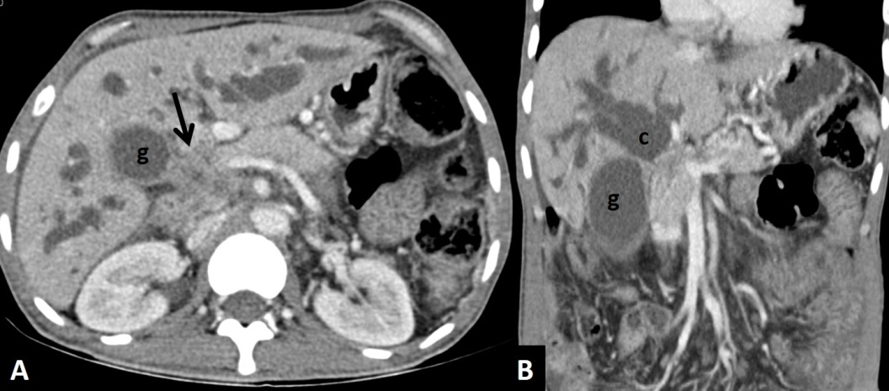
Figure 1 Axial (A) and coronal (B) contrast enhanced computed tomography scan of a patient with carcinoma of gall bladder showing mass (arrow) arising from the neck of gall bladder (g) involving common hepatic duct with patent primary biliary confluence (c).

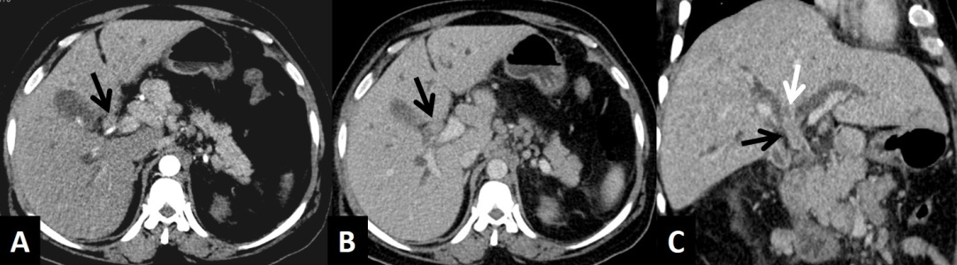
Figure 2 Arterial (A) and venous (B) phase axial and venous phase oblique coronal (C) computed tomography scan images of hilar cholangiocarcinoma showing soft tissue mass involving the common hepatic duct (black arrow), blocking the primary biliary confluence (white arrow).

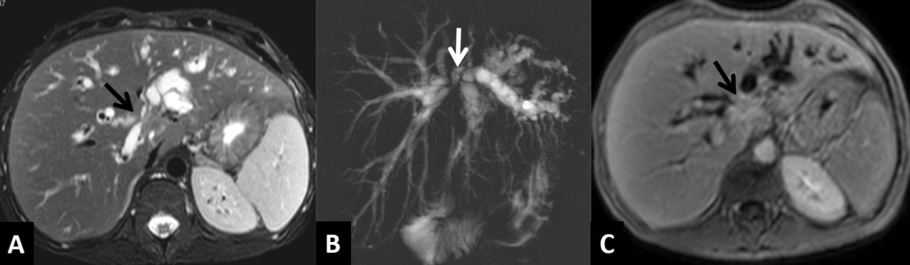
Figure 3 Hilar cholangiocarcinoma. A: Axial T2-weighted MR image showing isointense mass involving the primary biliary confluence (arrow) causing biliary dilatation; B: MRCP showing dilated ducts with blocked primary confluence (arrow); C: Axial contrast enhanced T1-weighted image in delayed phase showing enhancing mass in the primary biliary confluence (arrow). MR: Magnetic resonance; MRCP: Magnetic resonance cholangiopancreatography.

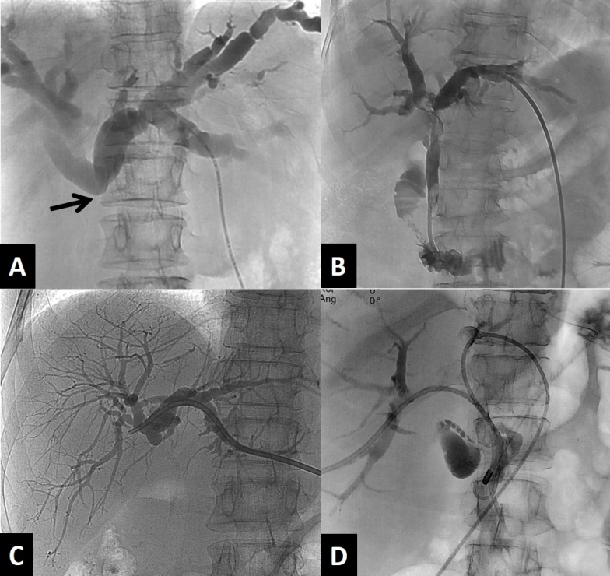
Figure 4 Cholangiograms. A: Initial cholangiogram after puncture showing block below the primary biliary confluence (arrow); B: Internal/external drainage by ring biliary catheter; C: External drainage by a pig tail catheter; D: Internal/external drainages of both lobes with ring biliary catheter in obstruction of primary biliary confluence.

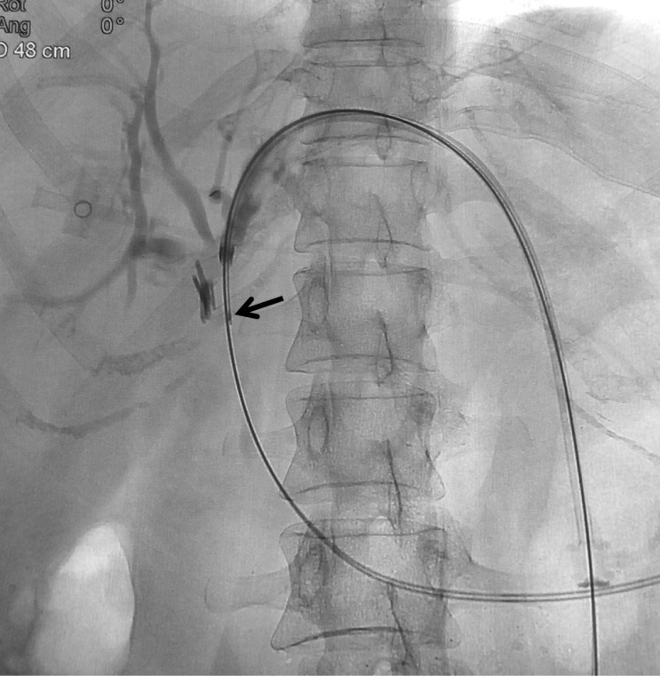
Figure 5 Brush biopsy needle (arrow) seen inserted through the sheath to obtain sample from the mass at the level of obstruction.

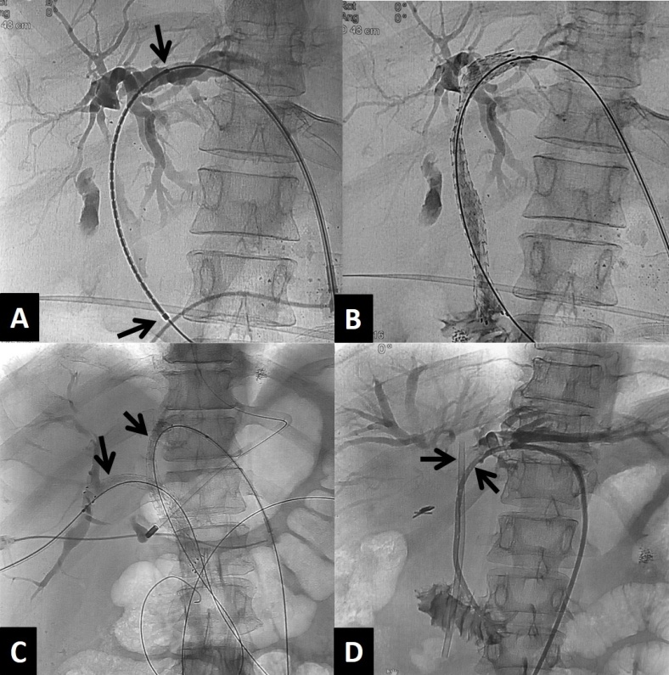
Figure 6 Biliary stenting. A: Positioning of the metallic stent with markers (arrows) for optimal deployment; B: Expanded metallic stent after deployment across the stricture; C: Bilobar metallic stent placement (arrows); D: Placement of ring biliary catheter by the side of blocked plastic stent after failed endoscopic exchange.

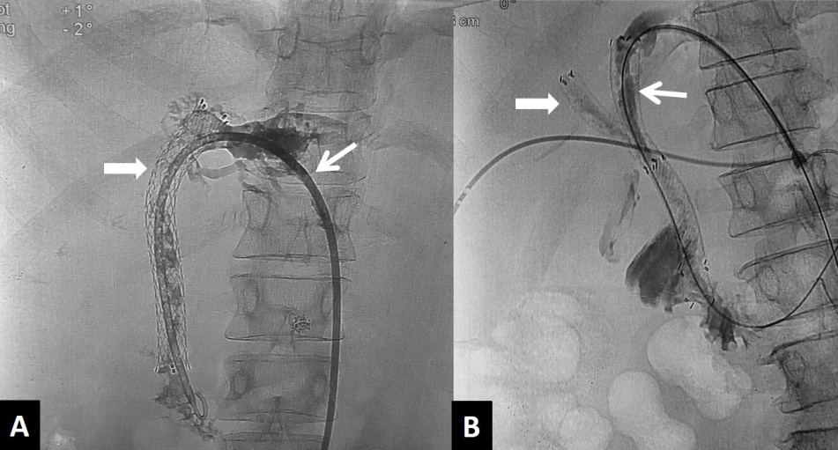
Figure 7 Stent block. A: Ring biliary catheter (arrow) placed through a blocked metallic stent (block arrow) due to disease progression; B: Second metallic stent (arrow) placed through the initial blocked right sided metallic stent (block arrow).
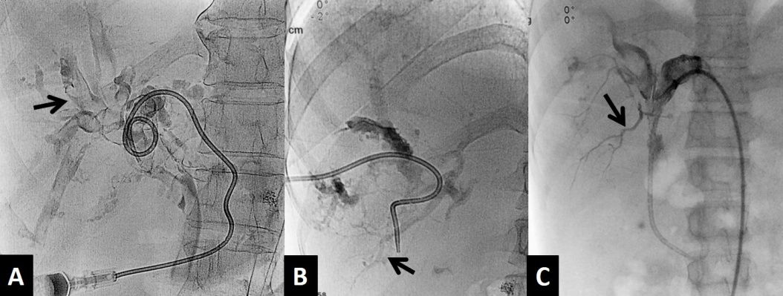
Figure 8 Hemobilia. A: Cholangiogram in a case of hemobilia shows multiple filling defects (arrow) within the biliary ducts; B: Cholangiogram showing opacification of branches of portal vein (arrow) suggesting bilio-venous fistula; C: Cholangiogram showing opacification of branches of right hepatic artery (arrow).

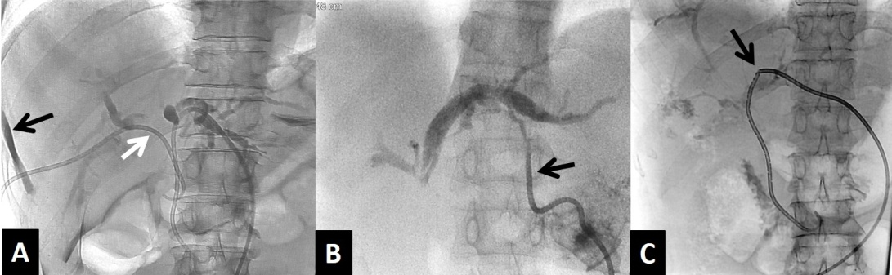
Figure 9 Catheter related complications. A: Cholangiogram showing pericatheter leak (black arrow) due to proximally dislodged ring biliary catheter (white arrow); B: Dislodged external drainage catheter (arrow) with only tip in the left hepatic duct; C: Fracture (arrow) of ring biliary catheter.

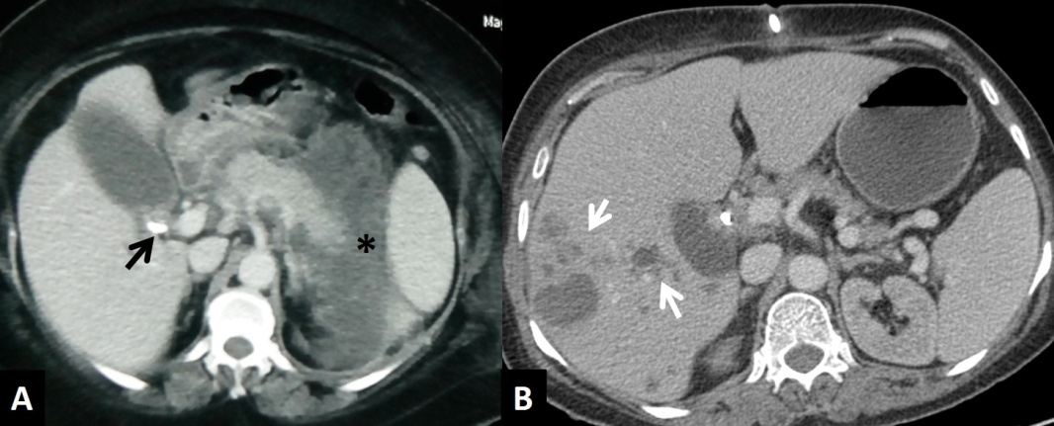
A B
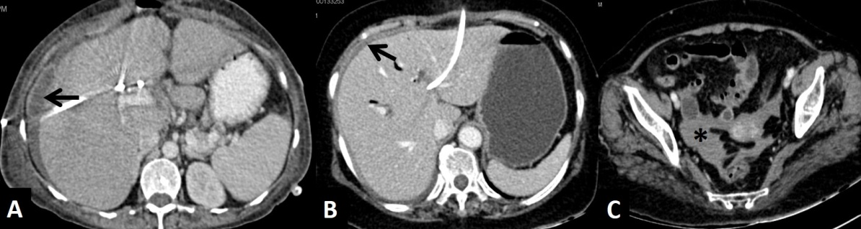
C D E
Figure 10 Complications. A: Axial contrast enhanced CT scan showing bulky pancreas with peripancreatic necrotic collection (asterisk) developing after PTBD in a patient of carcinoma of gall bladder (arrow); B: Axial contrast enhanced CT scan after PTBD showing multiple abscesses in right lobe of liver (arrows); C: Axial CT scan after PTBD showing perihepatic bilioma (arrow); D and E: Axial CT scans after PTBD showing hyperdense fluid in perihepatic (arrow) region and pelvis (asterisk) suggesting hemoperitoneum. CT: Computed tomography; PTBD: Percutaneous transhepatic biliary drainage.

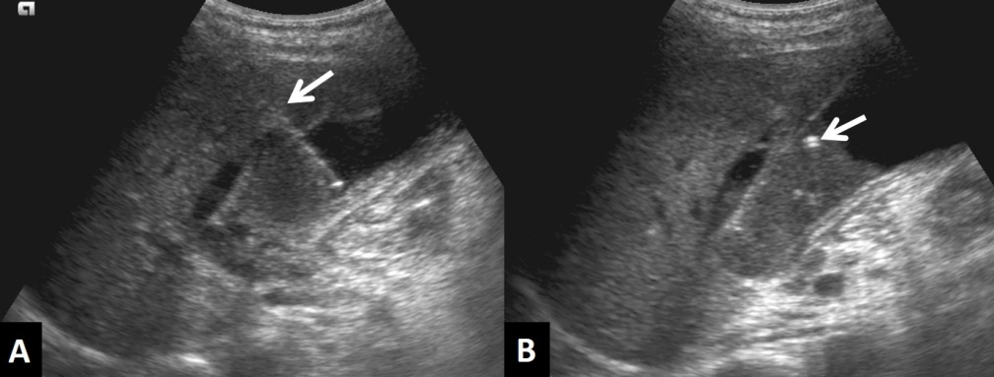
Figure 11 Cholecystostomy. Ultrasonography images showing transhepatic puncturing of gall bladder (arrow in A) and placement of pigtail catheter (arrow in B).

Table 1 Summary of various techniques used in malignant biliary obstruction
 | PTBD – catheter drainage | Biliary stenting | Percutaneous cholecystostomy | Intraluminal palliation (PDT, RFA, BT)
Indications | MBO - pre-operative/palliative | MBO - inoperable for palliation | Temporary relief of biliary obstruction | Palliation for inoperable MBO
Technique | Percutaneous, USG and fluoroscopy guidance | Fluoroscopy guidance | USG guidance, transhepatic route preferred | Placement of probe under fluoroscopy
Advantages | Improve liver function | Palliation - improves liver function and quality of life | Improves liver function | Relieves obstruction, increases stent patency rates
Complications | Cholangitis, hemorrhage, pericatheter leak | Hemorrhage, stent block, tumor over or ingrowth | Catheter displacement, biliary peritonitis | Cholangitis, hemorrhage, bile duct perforation
Limitations | Discomfort due to the catheter | -- | Discomfort due to the catheter | --
PTBD: Percutaneous transhepatic biliary drainage; MBO: Malignant biliary obstruction; BT: Brachytherapy; PDT: Photodynamic therapy; RFA: Radiofrequency ablation; USG: Ultrasonography.

