Name of Journal: World Journal of Clinical Cases
Manuscript NO: 75690
Manuscript Type: CASE REPORT

Rare case of compartment syndrome provoked by inhalation of polyurethane agent: A case report

Choi JH et al. Rare case of compartment syndrome

Jun Ho Choi, Hyun Myung Oh, Jae Ha Hwang, Kwang Seog Kim, Sam Yong Lee

Jun Ho Choi, Hyun Myung Oh Department of Plastic and Reconstructive Surgery, Chonnam National University Hospital, Gwangju 61469, South Korea

Jae Ha Hwang, Kwang Seog Kim, Sam Yong Lee, Department of Plastic and Reconstructive Surgery, Chonnam National University Medical School, Gwangju 61469, South Korea

Author contributions: Choi JH and Oh HM contributed to manuscript writing and data collection; Hwang JH and Kim KS contributed to editing and conceptualization; Lee SY contributed to supervision; all authors have read and approved the final manuscript.

Corresponding author: Jae Ha Hwang, MD, PhD, Professor, Surgeon, Department of Plastic and Reconstructive Surgery, Chonnam National University Hospital, 42 Jebong-ro, Dong-gu, Gwangju 61469, South Korea. psjhhwang@daum.net

Received: February 10, 2022
Revised: June 18, 2022
Accepted: July 6, 2022
Published online:

Abstract
BACKGROUND
The most common causes of compartment syndrome in the lower extremities include lower limb fractures, trauma-induced crushing injuries, severe burns, and non-traumatic factors. However, there have been no reports of compartment syndrome secondary to toxic inhalation.

CASE SUMMARY
A 59-year-old man, who lost consciousness after applying polyurethane-based paint on a water tank, was brought to the emergency room. The initial blood test showed apparent rhabdomyolysis. One day later, pain and swelling in both legs were observed, and the physical examination confirmed the presence of compartment syndrome. Double-incision fasciotomy was performed on both legs. Frequent dressings and negative pressure wound treatment were done on both legs, and skin grafting was performed after healthy granulation tissue had been identified. No other complications were observed after treatment. However, symptoms of peroneal neuropathy, particularly limited ankle dorsiflexion and reduced sensation on the lower extremities, were observed.

CONCLUSION
Workers using polyurethane agents should wear gas masks and be evaluated for compartment syndrome and rhabdomyolysis secondary to toxic inhalation.

Key Words: Compartment syndrome; Polyurethanes; Rhabdomyolysis; Hypoxia; Peroneal neuropathies; Case report

Choi JH, Oh HM, Hwang JH, Kim KS, Lee SY. Rare case of compartment syndrome provoked by inhalation of polyurethane agent: A case report. World J Clin Cases 2022; In press

Core Tip: Compartment syndrome secondary to non-traumatic etiology is often diagnostically challenging based solely on history taking and may be misdiagnosed in the absence of comprehensive physical evaluation. Moreover, to date, no study has reported compartment syndrome caused by inhalation toxicity. We report a rare case of compartment syndrome secondary to polyurethane inhalation.

INTRODUCTION
According to Matsen, compartment syndrome occurs when increased pressure within a limited space compromises the circulation and function of tissues within that space^{[1]}. It is a medical emergency, that necessitates immediate intervention, to avoid complications, such as muscle ischemia, neuropathy, and necrosis, which may result in limb amputation^{[2]}. Compartment syndrome is a common complication of lower extremity fractures, trauma-induced crush injuries, severe burns, and some non-traumatic conditions^{[3]}. Compartment syndrome secondary to a non-traumatic etiology is difficult to diagnose based on history taking only, and it may be misdiagnosed, based on an incomplete physical evaluation. Moreover, there have been no studies documenting the development of compartment syndrome secondary to inhalation toxicity. This study reports a rare case of compartment syndrome secondary to polyurethane inhalation.

CASE PRESENTATION
Chief complaints
A 59-year-old man, who lost consciousness after applying polyutherane-based paint to a water tank, was brought to the emergency department.

History of present illness
The patient was found lying prone in the tank one hour after he had entered. He did not wear a mask to protect against the inhalation of harmful chemicals while painting the water tank (a closed space of 32000 L).

History of past illness
The patient denied a history of diseases that could have triggered such a medical condition such as intense physical activities.

Personal and family history
The patient had no previous disease history.

Physical examination
There were no noted signs of trauma in the lower extremities and other regions of the body.

Laboratory examinations
The initial blood test results suggested rhabdomyolysis with an increased serum creatine kinase of 15250 IU/L and myoglobin greater than 20000 IU/L. The blood urea nitrogen and creatinine values remained within the normal range, but the alanine transaminase and aspartate transaminase reached up to 917 and 3765 IU/L, respectively. The electrocardiogram showed sinus tachycardia with nonspecific T wave abnormalities, which indicated an electrolyte imbalance without significant cardiac injuries.

Imaging examinations
No imaging studies were performed.

FINAL DIAGNOSIS
One day after admission, the patient developed pain and edema of the lower extremities, and the physical examination confirmed the presence of compartment syndrome. It is characterized by pain, pallor, paresthesia, pulselessness, and paralysis, which are typically referred to as the 5Ps of compartment syndrome (Figure 1). The intracompartmental pressure in the lower extremities ranged from 100 to 130 mmHg in all fascial compartments.

TREATMENT
The patient was admitted to the intensive care unit (ICU), and extensive hydration and hyperbaric oxygen therapy were initiated to manage the acute drug intoxication syndrome, accompanied by rhabdomyolysis. No glucocorticoid or dehydration diuretics were administered during the patient’s course in ICU.
Bilateral lower extremity fasciotomy was performed on the lateral and medial aspects of the extremities to relieve the pressure in the anterior, lateral, superficial posterior, and deep posterior compartments (Figure 2). The pain, pallor, and paresthesia improved in both lower extremities postoperatively. Frequent dressing changes using betadine-soaked gauze and weekly serial debridement were performed for wound management.
One month later, the dressing method was shifted to negative-pressure wound therapy. Growth of healthy granulation tissue within the wound was observed three months later, and meshed split-thickness skin grafting was performed (Figure 3).

OUTCOME AND FOLLOW-UP
The patient showed no other signs of compartment syndrome. However, he developed symptoms of peroneal neuropathy, particularly limited ankle dorsiflexion and sensory loss in areas of the lower extremities innervated by the peroneal nerve. Nerve conduction studies were performed to evaluate the motor and sensory functions of the left and right lower extremities (Table 1). The patient’s symptoms gradually improved, but complete recovery of the nerve functions has not been achieved. Therefore, further physical treatment is required.

DISCUSSION
Polyurethane polymers are highly stable materials that are primarily used in fabrics and paints^{[4]}. Due to its high risk of respiratory toxicity, routine room ventilation or working outside is advised when using polyurethane polymers^{[5]}. Polyurethane inhalation within a closed space without a protective mask possibly resulted in the loss of consciousness and rhabdomyolysis in this patient.
Rhabdomyolysis is associated with traumatic and non-traumatic etiologies, including infections, drugs, and toxin inhalation^{[6]}. Carbon monoxide (CO), one of the most common environmental toxins, has reportedly caused various medical conditions, including muscle injury and consequent rhabdomyolysis^{[7]}. In this case, the rhabdomyolysis was attributed to polyurethane inhalation-induced injury, which was similar to that associated with CO intoxication. However, a similar clinical presentation has not been reported in previous studies. The underlying mechanism behind polyurethane-induced muscle injury remains unknown. Melandri et al^{[8]} presented a case of prolonged hypoxia due to opiate overdose, resulting in rhabdomyolysis and myocardial damage. This was similar to the present case in that toxic inhalation induced hypoxia, rhabdomyolysis, and compartment syndrome. Acute compartment syndrome of the extremities most commonly results from traumatic injuries, such as long bone fractures, severe burns, and crush injuries^{[9]}. Additional risk factors include age, sex, and bleeding tendency^{[10]}. It is difficult to diagnose, particularly in patients with a vague history and no identifiable cause. In the present case, the causal relationship between polyurethane inhalation and compartment syndrome was not established. However, other attributable causes were not identified for the patient’s disease. Therefore, toxic inhalation was likely involved in the development of rhabdomyolysis and compartment syndrome^{[11]}. Polyurethane-induced asphyxiation likely induced prolonged hypoxia and consequent muscle injury^{[12]}.
The accurate diagnosis and prompt management of acute compartment syndrome are important to avoid permanent neurological and functional injuries of the extremities, fatal necrosis, and even amputation. Eliminating the probable cause by performing an emergency reduction of the long bone fractures, followed by immediate fasciotomy (the only available treatment for compartment syndrome), is indicated in patients suspected of acute compartment syndrome^{[13,14]}. Double-incision fasciotomy is the most frequently used technique because it allows access to all four compartments of the lower extremities^{[15]}. In the present case, an immediate fasciotomy was performed at the time of consultation for surgical intervention. Although nerve injury was not observed intraoperatively, the patient developed peroneal neuropathy later in the course of treatment.

CONCLUSION
Workers, using polyurethane agents in confined spaces, must wear protective gear, including a gas mask. A thorough physical evaluation is essential to avoid a missed diagnosis and to exclude toxic inhalation-induced rhabdomyolysis in patients, presenting with compartment syndrome. Considering other diagnoses and radiological evaluation findings is an appealing option, but the subsequent delay results in unwanted complications. Therefore, rhabdomyolysis and compartment syndrome should be considered in the differential diagnosis, and fasciotomy should be the preferred treatment option in patients with the aforementioned clinical presentation.

REFERENCES
1 Matsen FA 3rd, Winquist RA, Krugmire RB Jr. Diagnosis and management of compartmental syndromes. J Bone Joint Surg Am 1980; 62: 286-291 [PMID: 7358759]
2 Rush DS, Frame SB, Bell RM, Berg EE, Kerstein MD, Haynes JL. Does open fasciotomy contribute to morbidity and mortality after acute lower extremity ischemia and revascularization? J Vasc Surg 1989; 10: 343-350 [PMID: 2778898 DOI: 10.1067/mva.1989.14338]
3 McQueen MM, Gaston P, Court-Brown CM. Acute compartment syndrome. Who is at risk? J Bone Joint Surg Br 2000; 82: 200-203 [PMID: 10755426]
4 Singh H, Jain AK. Ignition, combustion, toxicity, and fire retardancy of polyurethane foams: a comprehensive review. J Appl Polym Sci 2009; 111: 1115-1143 [DOI: 10.1002/app.29131]
5 Mckenna ST, Hull TR. The fire toxicity of polyurethane foams. Fire Sci Rev 2016; 5: 1-27 [DOI: 10.1186/s40038-016-0012-3]
6 Huerta-Alardín AL, Varon J, Marik PE. Bench-to-bedside review: Rhabdomyolysis -- an overview for clinicians. Crit Care 2005; 9: 158-169 [PMID: 15774072 DOI: 10.1186/cc2978]
7 Harper A, Croft-Baker J. Carbon monoxide poisoning: undetected by both patients and their doctors. Age Ageing 2004; 33: 105-109 [PMID: 14960423 DOI: 10.1093/ageing/afh038]
8 Melandri R, Re G, Lanzarini C, Rapezzi C, Leone O, Zele I, Rocchi G. Myocardial damage and rhabdomyolysis associated with prolonged hypoxic coma following opiate overdose. J Toxicol Clin Toxicol 1996; 34: 199-203 [PMID: 8618254 DOI: 10.3109/15563659609013770]
9 Grottkau BE, Epps HR, Di Scala C. Compartment syndrome in children and adolescents. J Pediatr Surg 2005; 40: 678-682 [PMID: 15852278 DOI: 10.1016/j.jpedsurg.2004.12.007]
10 Mubarak SJ, Hargens AR. Acute compartment syndromes. Surg Clin North Am 1983; 63: 539-565 [PMID: 6346542 DOI: 10.1016/s0039-6109(16)43030-6]
11 Allison RC, Bedsole DL. The other medical causes of rhabdomyolysis. Am J Med Sci 2003; 326: 79-88 [PMID: 12920439 DOI: 10.1097/00000441-200308000-00005]
12 Paletta CE, Lynch R, Knutsen AP. Rhabdomyolysis and lower extremity compartment syndrome due to influenza B virus. Ann Plast Surg 1993; 30: 272-273 [PMID: 8494311 DOI: 10.1097/00000637-199303000-00013]
13 Styf J, Wiger P. Abnormally increased intramuscular pressure in human legs: comparison of two experimental models. J Trauma 1998; 45: 133-139 [PMID: 9680026 DOI: 10.1097/00005373-199807000-00028]
14 Sheridan GW, Matsen FA 3rd. Fasciotomy in the treatment of the acute compartment syndrome. J Bone Joint Surg Am 1976; 58: 112-115 [PMID: 1249096]
15 Singh K, Bible JE, Mir HR. Single and Dual-Incision Fasciotomy of the Lower Leg. JBJS Essent Surg Tech 2015; 5: e25 [PMID: 30405959 DOI: 10.2106/JBJS.ST.O.00007]

Footnotes
Informed consent statement: Informed written consent was obtained from the patient for publication of this report and any accompanying images.

Conflict-of-interest statement: The authors declare that they have no conflict of interest to disclose.

CARE Checklist (2016) statement: The authors have read the CARE Checklist (2016), and the manuscript was prepared and revised according to the CARE Checklist (2016)

Open-Access: This article is an open-access article that was selected by an in-house editor and fully peer-reviewed by external reviewers. It is distributed in accordance with the Creative Commons Attribution NonCommercial (CC BY-NC 4.0) license, which permits others to distribute, remix, adapt, build upon this work non-commercially, and license their derivative works on different terms, provided the original work is properly cited and the use is non-commercial. See: https://creativecommons.org/Licenses/by-nc/4.0/

Provenance and peer review: Unsolicited article; Externally peer reviewed.
Peer-review model: Single blind

Peer-review started: February 10, 2022
First decision: June 15, 2022
Article in press:

Specialty type: Surgery
Country/Territory of origin: South Korea
Peer-review report’s scientific quality classification
Grade A (Excellent): 0
Grade B (Very good): B, B, B, B
Grade C (Good): C
Grade D (Fair): 0
Grade E (Poor): 0

P-Reviewer: Apiratwarakul K, Thailand; Aydin S, Turkey; Jian X, China S-Editor: Zhang H L-Editor: A P-Editor: Zhang H

Figure Legends
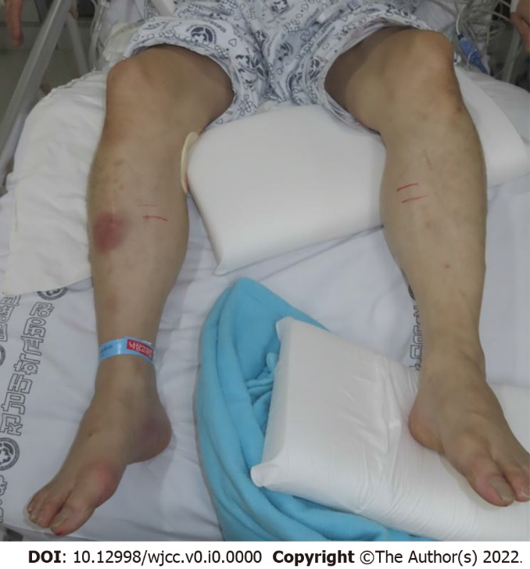
Figure 1 Clinical photograph showing bilateral lower leg compartment syndrome characterized by tense and painful swelling.
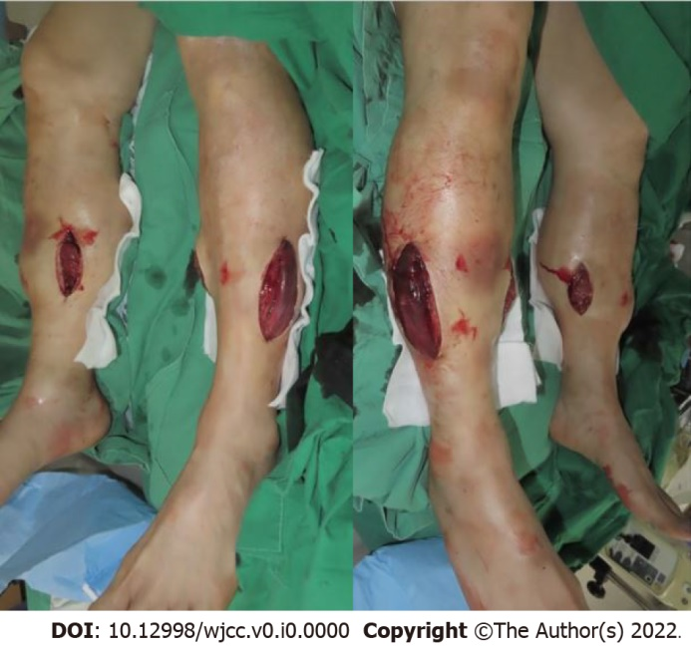
Figure 2 Intraoperative photograph of the medial and lateral aspects of both lower limbs after fasciotomy.
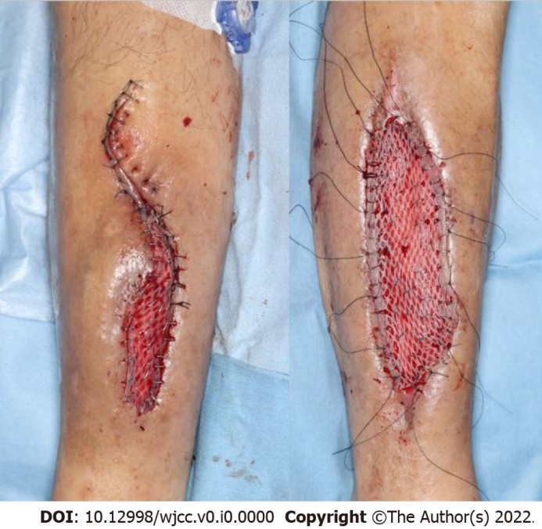
Figure 3 Meshed split-thickness skin graft was used to cover the defect area.
Table 1 Electrodiagnostic testing results. Initial test results done right after the fasciotomy suggested that the patient developed both peroneal and tibial neuropathy
Needle electromyography |  |  | Initial | After eight months
Right lower limb | Extensor digitorum  Brevis | Spontaneous activity | Abnormal activity | Silent
 |  | MUAPs | No MUAPs | No MUAPs
 | Abductor hallucis | Spontaneous activity | Abnormal activity | Abnormal activity
 |  | MUAPs | No MUAPs | No MUAPs
 | Tibialis anterior | Spontaneous activity | - | Silent
 |  | MUAPs | - | DIP, normal MUAPs
 | Peroneus longus | Spontaneous activity | - | Abnormal activity
 |  | MUAPs | - | PIP, normal MUAPs
 | Gastrocnemius (medial head) | Spontaneous activity | - | Silent
 |  | MUAPs | - | DIP, normal MUAPs
Left lower limb | Extensor digitorum  brevis | Spontaneous activity | Abnormal activity | Silent
 |  | MUAPs | No MUAPs | No MUAPs
 | Abductor hallucis | Spontaneous activity | Abnormal activity | Abnormal activity
 |  | MUAPs | No MUAPs | DIP, normal MUAPs
 | Tibialis anterior | Spontaneous activity | - | Abnormal activity
 |  | MUAPs | - | DIP, normal MUAPs
 | Peroneus  longus | Spontaneous activity | - | Silent
 |  | MUAPs | - | PIP, normal MUAPs
 | Gastrocnemius (medial head) | Spontaneous activity | - | Abnormal activity
 |  | MUAPs | - | DIP, polyphasic MUAPs
MUAP: Motor unit action potential; DIP: Discrete interference pattern; PIP: Partial interference pattern. The full test was not completed due to the wound status. Electromyography done eight months after suggested that the patient developed both incomplete peroneal and tibial neuropathy. Motor unit action potential and conduction study indicated that the left lower limb had some regeneration evidence, but no significant changes were observed compared to the previous test.

