Name of Journal: World Journal of Clinical Cases
Manuscript NO: 61115
Manuscript Type: CASE REPORT

Sarcoidosis mimicking metastases in an echinoderm microtubule-associated protein-like 4 anaplastic lymphoma kinase positive non-small-lung cancer patient: A case report

Chen X et al. Sarcoidosis mimicking metastases in ALK + NSCLC

Xi Chen, Jie Wang, Wei-Li Han, Kui Zhao, Zhen Chen, Jian-Ying Zhou, Yi-Hong Shen

Xi Chen, Jie Wang, Jian-Ying Zhou, Yi-Hong Shen, Department of Respiratory Diseases, The First Affiliated Hospital, College of Medicine, Zhejiang University, Hangzhou 310003, Zhejiang Province, China

Wei-Li Han, Department of Lung Transplantation, The First Affiliated Hospital, College of Medicine, Zhejiang University, Hangzhou 310003, Zhejiang Province, China

Kui Zhao, Positron Emission Tomography Center, The First Affiliated Hospital, College of Medicine, Zhejiang University, Hangzhou 310003, Zhejiang Province, China

Zhen Chen, Department of Pathology, The First Affiliated Hospital, College of Medicine, Zhejiang University, Hangzhou 310003, Zhejiang Province, China

Author contributions: Chen X and Wang J wrote the original draft; Han WL, Zhao K, and Chen Z collected the data; Zhou JY, Chen X, and Wang J performed the investigation; Shen YH performed the project administration and wrote, reviewed, and edited the manuscript.

Supported by the Zhejiang Provincial Natural Science Foundation of China, No. LQ17H160005.

Corresponding author: Yi-Hong Shen, MD, Chief Doctor, Department of Respiratory Diseases, The First Affiliated Hospital, College of Medicine, Zhejiang University, No. 79 Qingchun Road, Hangzhou 310003, Zhejiang Province, China. drsyh@zju.edu.cn

Received: December 17, 2020
Revised: February 7, 2021
Accepted: March 4, 2021
Published online: May 6, 2021

Abstract
BACKGROUND
Rearrangements of the anaplastic lymphoma kinase (ALK) gene (ALK-positive) represent an oncogenic driver in approximately 3%-5% of non-small-lung cancer (NSCLC) patients. Sarcoidosis is a multisystem disease, and its reported incidence in Asia is 1 or less per 100000 people per year. The co-occurrence of sarcoidosis and ALK-positive NSCLC is rare, and ALK-positive lung cancer is likely to spread quickly. Therefore, the co-occurrence of sarcoidosis is more easily misdiagnosed as metastatic lung cancer by radiological examination.

CASE SUMMARY
A 50-year-old man had a nodule in the left superior lobe, many small nodules in left superior and right lungs, and enlarged bilateral hilar, mediastinal, and right supraclavicular lymph nodes. Computed tomography-guided pulmonary biopsy of the nodule in the left superior lobe revealed echinoderm microtubule-associated protein-like 4 gene-ALK positive NSCLC with concomitant noncaseating granuloma. This patient was treated with crizotinib. Thirty days later, a chest computed tomography scan revealed a dramatic decrease in the size of the left superior lobe nodule; however, the lesions in the right lung progressed. The right supraclavicular lymph nodes showed granulomas, and no tumor cells were identified in the specimens. The angiotensin-converting enzyme level was high. After 1 wk of methylprednisolone treatment, a significant response of all lesions was revealed. Following radical resection of the lung cancer, noncaseating granulomas were observed in both lung tissues and lymph nodes, which resulted in a diagnosis of echinoderm microtubule-associated protein-like 4-ALK positive NSCLC accompanied with sarcoidosis.

CONCLUSION
Our experience illustrates that pathological evidence is needed to confirm metastatic disease, especially when some suspected metastatic lesions are negative for malignancy.

Key Words: Lung cancer; Sarcoidosis; Anaplastic lymphoma kinase; Echinoderm microtubule-associated protein-like 4 anaplastic lymphoma kinase; Metastasis; Case report

©The Author(s) 2021. Published by Baishideng Publishing Group Inc. All rights reserved.

Chen X, Wang J, Han WL, Zhao K, Chen Z, Zhou JY, Shen YH. Sarcoidosis mimicking metastases in an echinoderm microtubule-associated protein-like 4 anaplastic lymphoma kinase positive non-small-lung cancer patient: A case report. World J Clin Cases 2021; 9(13): 3140-3146 URL: https://www.wjgnet.com/2307-8960/full/v9/i13/3140.htm DOI: https://dx.doi.org/10.12998/wjcc.v9.i13.3140

Core Tip: The co-occurrence of sarcoidosis and echinoderm microtubule-associated protein-like 4 anaplastic lymphoma kinase (ALK)-positive non-small-cell lung cancer is rare. Here, we present one case of sarcoidosis mimicking metastases in an echinoderm microtubule-associated protein-like 4-ALK positive non-small-cell lung cancer patient. From this case, our experience illustrates that ALK-positive lung cancer is likely to spread quickly; therefore, the co-occurrence of sarcoidosis is more easily misdiagnosed as metastatic lung cancer by radiological examination. We suggest that pathological evidence is needed to confirm metastatic disease, especially when some suspected metastatic lesions are negative for malignancy or when the post-treatment follow-up evaluation results are unexpected.

INTRODUCTION
Rearrangements of the anaplastic lymphoma kinase (ALK) gene (ALK-positive) represent an oncogenic driver in approximately 3%-5% of non-small-cell lung cancer (NSCLC) patients^{[1,2]}. The most common ALK partner is the echinoderm microtubule-associated protein-like 4 gene (EML4) and generates EML4-ALK fusion transcripts^{[3].} ALK tyrosine kinase inhibitors, including crizotinib, ceritinib, and alectinib, are the standard first-line treatment for advanced ALK positive NSCLC patients.
Sarcoidosis is a multisystem disease characterized by persistent granulomatous inflammation, affecting the intrathoracic region and lungs in over 90% of cases^{[4]}. The reported incidence of sarcoidosis in Asia is 1 or less per 100000 people per year^{[5,6]}. The co-occurrence of sarcoidosis and ALK positive NSCLC is rare. Here, we present one interesting case of sarcoidosis mimicking metastases in an EML4-ALK positive NSCLC patient.

CASE PRESENTATION
Chief complaints
A 50-year-old man was admitted to our hospital for chest tightness and a productive cough.

History of present illness
The patient reported that the chest tightness and productive cough have lasted 2 wk.

History of past illness
The patient had no history of past illness.

Personal and family history
The patient was a former heavy smoker and a former heavy drinker.

Physical examination
There were no physical findings to note.

Laboratory examinations
TSPOT-tuberculosis test was negative. His tumor marker levels were as follows: carcinoembryonic antigen 2.1 (0.0-5.0 ng/mL), carbohydrate antigen 199 2.3 (0.0-37.0 ng/mL), cancer antigen 125 115.9 (0.0-35.0 ng/mL), neuron-specific enolase 15.8 (0-30.0 ng/mL), C-terminus of cytokeratin 19 7.0 (0-7.0 ng/mL), squamous cell carcinoma antigen 0.9 (0.0-1.5 ng/mL), and cancer antigen 724 20.8 (0.0-16.4 ng/mL).

Imaging examinations
Chest computed tomography (CT) showed a 2.3 cm × 2.7 cm nodule in the left superior lobe, many small nodules in left superior and right lungs, and enlarged bilateral hilar and mediastinal lymph nodes (Figure 1A and B). Fluorine-18 fluorodeoxyglucose (FDG) positron emission tomography (PET)-CT revealed hypermetabolic activity in the left superior lobe nodule [maximum standardized uptake value (SUVmax) = 11.8], bilateral pulmonary small nodules (SUVmax = 20.3), and left sacrum (SUVmax = 6.3) as well as lymphadenopathy (right supraclavicular (SUVmax = 8.3) and bilateral hilar and mediastinal lymph nodes (SUVmax = 10.6), suggesting a neoplasm with extensive metastasis (Figure 1C).

Further diagnostic work-up
The left upper lung nodule was diagnosed as adenocarcinoma with concomitant noncaseating granulomas by CT-guided biopsy (Figure 1D). The diagnosis was clinical stage IVa (cT3N3M1b) adenocarcinoma. EML4-ALK fusion was detected using the amplification refractory mutation system method. Thus, the patient began receiving crizotinib 250 mg twice daily. CT was repeated 30 d later and revealed that the left upper lung nodule decreased dramatically in size; however, the lesions in the right lung progressed, and the mediastinal lymph nodes did not show a significant reduction except for the lymph nodes in station 5 (Figure 1E and F).
Therefore, this patient was admitted to our hospital for further evaluation. An elevated level of angiotensin-converting enzyme (ACE) (194 U/L, normal value, 24-139 U/L) was noted. Purified protein derivative skin tests and serum calcium levels were normal. The right supraclavicular lymph node was diagnosed with noncaseating granulomatous inflammation with negative acid-fast bacillus staining. Bronchoscope showed multiple nodular infiltrations in the right middle lobe (Figure 1G), and the pathological diagnosis was granulomas. The endobronchial ultrasound images showed enlarged lymph nodes in stations 4R, 7, and 11L, but no tumor cells were identified by endobronchial ultrasound-guided transbronchial needle aspiration.
Therefore, he was diagnosed as lung adenocarcinoma accompanied by sarcoidosis (stage II). As the disease progressed within 1 mo, he was administered oral methylprednisolone 8 mg twice daily as well as crizotinib. One week later, repeat chest CT revealed a significant response in all lesions in both lungs (Figure 1H and I). PET-CT showed a dramatic decrease in FDG uptake in all pulmonary lesions (Figure 1J) and no abnormal metabolic activity in the left sacrum. A magnetic resonance imaging scan of the left sacrum was also normal.

FINAL DIAGNOSIS
The final diagnosis was stage IIIA (cT1N2M0) lung adenocarcinoma accompanied by sarcoidosis (stage II).

TREATMENT
The multidisciplinary team therefore considered that the patient was suitable for surgery, and the patient underwent radical resection of left superior pulmonary carcinoma by video-assisted thoracic surgery. The intraoperative findings showed a hard nodule approximately 2 cm in diameter on the left superior lobe and enlarged hilar and mediastinal lymph nodes.
The pathologic findings revealed a small cluster of heteromorphic cells in the nodule and that the remaining lung tissues had granulomatous inflammation. One of eight parabronchial lymph nodes and one of one lymph node in station 5 contained metastases with concomitant granulomatous inflammation (Figure 1K). The pathologic diagnosis was stage IIIA (ypT1N2M0) lung adenocarcinoma accompanied by pulmonary sarcoidosis.

OUTCOME AND FOLLOW-UP
This patient refused chemotherapy and radiotherapy after surgery. He continued to receive crizotinib and methylprednisolone. Methylprednisolone was gradually tapered to a maintenance dose of 4 mg daily. The serum ACE activity was reexamined 9 mo after the diagnosis of sarcoidosis and the level was normal. To date, he has been followed-up for 24 mo and remains recurrence-free.

DISCUSSION
This is one case of sarcoidosis mimicking metastases in an EML4-ALK positive NSCLC patient. ALK-positive patients tend to be younger, have little to no smoking history, and have histologic characteristics of adenocarcinoma^{[7]}. Sarcoidosis is more common in young adults, African Americans, and women^{[4]}. The exact etiology of sarcoidosis remains largely unknown. However, both environmental and genetic factors, including specific occupations and exposures, human leukocyte antigen class II, and cytokine polymorphisms, are likely to define the risk of developing the disease^{[4,8]}. Furthermore, a history of ever smoking instead is protective against sarcoidosis^{[8]}. Therefore, both ALK-positive NSCLC and sarcoidosis tend to occur in younger patients, but no other common susceptibility factors exist between the two diseases.
Sarcoidosis can develop as local sarcoid reactions that are induced by lung cancer^{[9]} or medical treatments including chemotherapy^{[10]}, tyrosine kinase inhibitors^{[11]}, or immune check-point inhibitors^{[12]}. In this case, the primary lung cancer lesion was in the left upper lobe, but granulomas were found even in the nonneoplastic right lung and supraclavicular lymph node. Moreover, the serum ACE level was high. These findings suggest that the granulomas were more likely to be coincidental, true sarcoidosis rather than sarcoid reactions in respond to lung cancer.
Apart from affecting the lungs and lymph nodes, both sarcoidosis and lung cancer can affect bone. Bone involvement is moderately rare in sarcoidosis, occurring in 3%-13% of patients^{[13]}. Earlier studies demonstrated that the small bones of the hands and feet are typically affected^{[13]}. However, axial bone involvement including spine and pelvis was found to be more frequent with the usage of magnetic resonance imaging and PET-CT scanning^{[14,15]}. In contrast, bone metastases are a common complication in lung cancer^{[16]}, and sacrum involvement is frequently observed^{[17]}. In this case, the lesions in the sacrum were initially assessed as a sign of extensive metastasis based on the PET-CT findings, and the pathological findings of concomitant granulomas obtained by CT-guided biopsy were ignored by us at first. Moreover, the use of PET/CT led to a false-positive result in this case due to the absorption of fluorine-18 FDG by the inflammatory lesions associated with sarcoidosis^{[18,19]}. As such, this case illustrates that when found in cancer patients, sarcoidosis can easily be misdiagnosed as metastatic lesions.

CONCLUSION
Herein, we described a case of sarcoidosis mimicking metastases in an EML4-ALK positive NSCLC patient. From this case, we can learn that sarcoidosis is easily misdiagnosed as metastatic lesions of lung cancer by radiological examinations and that pathological evidence is needed to confirm metastatic disease, especially when some suspected metastatic lesions are negative for malignancy. Moreover, further examinations are needed when posttreatment follow-up evaluation results are unexpected.

REFERENCES
1 Camidge DR, Doebele RC. Treating ALK-positive lung cancer--early successes and future challenges. Nat Rev Clin Oncol 2012; 9: 268-277 [PMID: 22473102 DOI: 10.1038/nrclinonc.2012.43]
2 Wang J, Cai Y, Dong Y, Nong J, Zhou L, Liu G, Su D, Li X, Wu S, Chen X, Qin N, Zeng X, Zhang H, Zhang Z, Zhang S. Clinical characteristics and outcomes of patients with primary lung adenocarcinoma harboring ALK rearrangements detected by FISH, IHC, and RT-PCR. PLoS One 2014; 9: e101551 [PMID: 24992725 DOI: 10.1371/journal.pone.0101551]
3 Soda M, Choi YL, Enomoto M, Takada S, Yamashita Y, Ishikawa S, Fujiwara S, Watanabe H, Kurashina K, Hatanaka H, Bando M, Ohno S, Ishikawa Y, Aburatani H, Niki T, Sohara Y, Sugiyama Y, Mano H. Identification of the transforming EML4-ALK fusion gene in non-small-cell lung cancer. Nature 2007; 448: 561-566 [PMID: 17625570 DOI: 10.1038/nature05945]
4 Iannuzzi MC, Rybicki BA, Teirstein AS. Sarcoidosis. N Engl J Med 2007; 357: 2153-2165 [PMID: 18032765 DOI: 10.1056/NEJMra071714]
5 Morimoto T, Azuma A, Abe S, Usuki J, Kudoh S, Sugisaki K, Oritsu M, Nukiwa T. Epidemiology of sarcoidosis in Japan. Eur Respir J 2008; 31: 372-379 [PMID: 17959635 DOI: 10.1183/09031936.00075307]
6 Jeon MH, Kang T, Yoo SH, Swan HS, Kim HJ, Ahn HS. The incidence, comorbidity and mortality of sarcoidosis in Korea, 2008-2015: a nationwide population-based study. Sarcoidosis Vasc Diffuse Lung Dis 2020; 37: 24-26 [PMID: 33093766 DOI: 10.36141/svdld.v37i1.7660]
7 Shaw AT, Yeap BY, Mino-Kenudson M, Digumarthy SR, Costa DB, Heist RS, Solomon B, Stubbs H, Admane S, McDermott U, Settleman J, Kobayashi S, Mark EJ, Rodig SJ, Chirieac LR, Kwak EL, Lynch TJ, Iafrate AJ. Clinical features and outcome of patients with non-small-cell lung cancer who harbor EML4-ALK. J Clin Oncol 2009; 27: 4247-4253 [PMID: 19667264 DOI: 10.1200/JCO.2009.22.6993]
8 Newman LS, Rose CS, Bresnitz EA, Rossman MD, Barnard J, Frederick M, Terrin ML, Weinberger SE, Moller DR, McLennan G, Hunninghake G, DePalo L, Baughman RP, Iannuzzi MC, Judson MA, Knatterud GL, Thompson BW, Teirstein AS, Yeager H Jr, Johns CJ, Rabin DL, Rybicki BA, Cherniack R; ACCESS Research Group. A case control etiologic study of sarcoidosis: environmental and occupational risk factors. Am J Respir Crit Care Med 2004; 170: 1324-1330 [PMID: 15347561 DOI: 10.1164/rccm.200402-249OC]
9 Sugio K, Inoue T, Yokoyama H, Ishida T, Nakano S, Sugimachi K. Sarcoid reactions in regional lymph nodes of primary lung cancer. Respiration 1993; 60: 133-136 [PMID: 8341856 DOI: 10.1159/000196187]
10 Umezu H, Chida M, Inoue T, Araki O, Tamura M, Tatewaki M, Fukushima Y, Honma K. Sarcoidosis development during induction chemotherapy for lung cancer mimicked progressive disease. Gen Thorac Cardiovasc Surg 2010; 58: 434-437 [PMID: 20703868 DOI: 10.1007/s11748-009-0549-3]
11 Facchinetti F, Gnetti L, Balestra V, Silva M, Silini EM, Ventura L, Majori M, Bordi P, Tiseo M. Sarcoid-like reaction mimicking disease progression in an ALK-positive lung cancer patient receiving lorlatinib. Invest New Drugs 2019; 37: 360-363 [PMID: 30066208 DOI: 10.1007/s10637-018-0652-3]
12 Paydas S. Pulmonary sarcoidosis induced by the anti-PD-1 monoclonal antibody pembrolizumab or post-immunotherapy granulomatous reaction: which is more appropriate terminology? Ann Oncol 2016; 27: 1650-1651 [PMID: 27143637 DOI: 10.1093/annonc/mdw193]
13 Wilcox A, Bharadwaj P, Sharma OP. Bone sarcoidosis. Curr Opin Rheumatol 2000; 12: 321-330 [PMID: 10910186 DOI: 10.1097/00002281-200007000-00016]
14 Zhou Y, Lower EE, Li H, Farhey Y, Baughman RP. Clinical characteristics of patients with bone sarcoidosis. Semin Arthritis Rheum 2017; 47: 143-148 [PMID: 28274482 DOI: 10.1016/j.semarthrit.2017.02.004]
15 Sparks JA, McSparron JI, Shah N, Aliabadi P, Paulson V, Fanta CH, Coblyn JS. Osseous sarcoidosis: clinical characteristics, treatment, and outcomes--experience from a large, academic hospital. Semin Arthritis Rheum 2014; 44: 371-379 [PMID: 25129260 DOI: 10.1016/j.semarthrit.2014.07.003]
16 Riihimäki M, Hemminki A, Fallah M, Thomsen H, Sundquist K, Sundquist J, Hemminki K. Metastatic sites and survival in lung cancer. Lung Cancer 2014; 86: 78-84 [PMID: 25130083 DOI: 10.1016/j.lungcan.2014.07.020]
17 Tsuya A, Kurata T, Tamura K, Fukuoka M. Skeletal metastases in non-small cell lung cancer: a retrospective study. Lung Cancer 2007; 57: 229-232 [PMID: 17451841 DOI: 10.1016/j.lungcan.2007.03.013]
18 Hellwig D, Graeter TP, Ukena D, Georg T, Kirsch CM, Schäfers HJ. Value of F-18-fluorodeoxyglucose positron emission tomography after induction therapy of locally advanced bronchogenic carcinoma. J Thorac Cardiovasc Surg 2004; 128: 892-899 [PMID: 15573074 DOI: 10.1016/j.jtcvs.2004.07.031]
19 Kaira K, Oriuchi N, Otani Y, Yanagitani N, Sunaga N, Hisada T, Ishizuka T, Endo K, Mori M. Diagnostic usefulness of fluorine-18-alpha-methyltyrosine positron emission tomography in combination with 18F-fluorodeoxyglucose in sarcoidosis patients. Chest 2007; 131: 1019-1027 [PMID: 17426205 DOI: 10.1378/chest.06-2160]

Footnotes
Informed consent statement: The patient provided his written informed consent.

Conflict-of-interest statement: No conflicts of interest to disclose.

CARE Checklist (2016) statement: The authors have read the CARE Checklist (2016), and the manuscript was prepared and revised according to the CARE Checklist (2016).

Open-Access: This article is an open-access article that was selected by an in-house editor and fully peer-reviewed by external reviewers. It is distributed in accordance with the Creative Commons Attribution NonCommercial (CC BY-NC 4.0) license, which permits others to distribute, remix, adapt, build upon this work non-commercially, and license their derivative works on different terms, provided the original work is properly cited and the use is non-commercial. See: http://creativecommons.org/Licenses/by-nc/4.0/

Manuscript source: Unsolicited manuscript

Peer-review started: December 17, 2020
First decision: January 24, 2021
Article in press:

Specialty type: Oncology
Country/Territory of origin: China
Peer-review report’s scientific quality classification
Grade A (Excellent): 0
Grade B (Very good): B
Grade C (Good): 0
Grade D (Fair): 0
Grade E (Poor): 0

P-Reviewer: Jiang D S-Editor: Zhang H L-Editor: Filipodia P-Editor:

Figure Legends
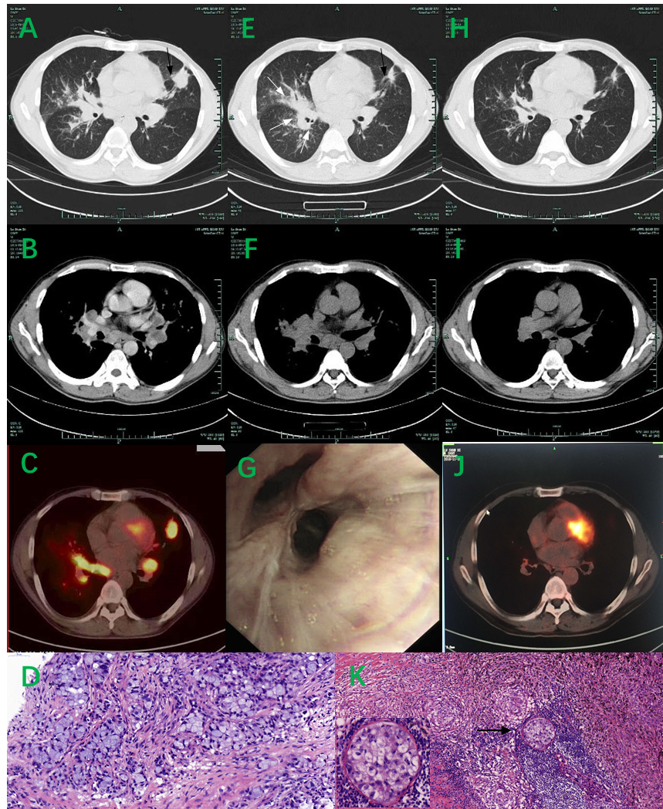
Figure 1 Thoracic computed tomography-scan, positron emission tomography- computed tomography, flexible bronchoscopy, and histopathological images. A and B: Computed tomography (CT) image obtained on August 7, 2018, showing a 2.3 cm × 2.7 cm nodule (↓) in the left superior lobe, small nodules of varying sizes in the left superior lobe and right lung, and enlarged bilateral hilar and mediastinal lymph nodes; C: Positron emission tomography-CT image obtained on August 8, 2018 showing hypermetabolic activity in the left superior lobe nodule and lymphadenopathy, suggestive of a neoplasm; D: Histopathological images obtained showing an adenocarcinoma sample from the superior lung nodule obtained by CT-guided pulmonary biopsy (hematoxylin and eosin, × 40); E and F: CT image obtained on September 7, 2018 after 30 d of treatment with crizotinib showed a dramatic decrease in the size of the left superior lobe nodule (↓); however, the lesions in the right lung progressed ( ); G: Flexible bronchoscopy image showing multiple nodular infiltrations in the right middle lobe; H and I: CT image obtained on September 19, 2018 after 1 wk of methylprednisolone showing a significant response of all lesions in both lungs; J: Positron emission tomography-CT image obtained on November 15, 2018 showing a dramatic decrease in fluorodeoxyglucose uptake in pulmonary lesions; K: Histopathological image showing changes within the adenocarcinoma (↓) with concomitant noncaseating granulomatous inflammation in samples from the parabronchial lymph nodes obtained by video-assisted thoracic surgery (hematoxylin and eosin, × 20).

Published by Baishideng Publishing Group Inc
7041 Koll Center Parkway, Suite 160, Pleasanton, CA 94566, USA
Telephone: +1-925-3991568
E-mail: bpgoffice@wjgnet.com
Help Desk: https://www.f6publishing.com/helpdesk
https://www.wjgnet.com

© 2021 Baishideng Publishing Group Inc. All rights reserved.

