Name of Journal: World Journal of Clinical Cases
Manuscript NO: 85909
Manuscript Type: CASE REPORT

Predicting apical hypertrophic cardiomyopathy using T-wave inversion: Three case reports

Kang L et al. ECG changes and apical hypertrophic cardiomyopathy

Liang Kang, Yi-Hua Li, Rong Li, Qing-Min Chu

Liang Kang, Yi-Hua Li, The First Clinical Medical College, Guangzhou University of Chinese Medicine, Guangzhou 510000, Guangdong Province, China

Rong Li, Qing-Min Chu, Department of Cardiovascular Disease, The First Affiliated Hospital of Guangzhou University of Chinese Medicine, Guangzhou 510000, Guangdong Province, China

Author contributions: Kang L and Li YH reviewed the literature and contributed to manuscript drafting; Li R and Chu QM analyzed and interpreted the electrocardiogram and coronary angiography findings; Chu QM was responsible for the revision of the manuscript for important intellectual content; all authors issued final approval for the version to be submitted.

Corresponding author: Qing-Min Chu, MD, Associate Chief Physician, Associate Professor, Department of Cardiovascular Disease, The First Affiliated Hospital of Guangzhou University of Chinese Medicine, No. 16 Jichang Road, Baiyun District, Guangzhou 510000, Guangdong Province, China. 13929504676@163.com

Received: May 22, 2023
Revised: July 11, 2023
Accepted: July 31, 2023
Published online: September 6, 2023

Abstract
BACKGROUND
Apical hypertrophic cardiomyopathy (AHCM) is a subtype of hypertrophic cardiomyopathy. Due to its location, the thickening of the left ventricular apex can be missed on echocardiography. Giant negative T waves (GNTs) in left-sided chest leads are the hallmark electrocardiogram (ECG) change of AHCM.

CASE SUMMARY
The first patient was a 68-year-old woman complaining of recurrent chest tightness persisting for more than 3 years. The second was a 59-year-old man complaining of spasmodic chest tightness persisting for more than 2 years. The third was a 55-year-old woman complaining of recurrent chest pain persisting for 4 mo. In all three cases, GNTs were observed several years prior to apical cardiac hypertrophy after other causes of T-wave inversion were ruled out.

CONCLUSION
Electrophysiological abnormalities of AHCM appear earlier than structural abnormalities, confirming the early predictive value of ECG for AHCM.

Key Words: Electrocardiogram; Negative T waves; Hypertrophic cardiomyopathy; Apical hypertrophic cardiomyopathy; Echocardiography; Case report

©The Author(s) 2023. Published by Baishideng Publishing Group Inc. All rights reserved.

Citation: Kang L, Li YH, Li R, Chu QM. Predicting apical hypertrophic cardiomyopathy using T-wave inversion: Three case reports. World J Clin Cases 2023; 11(25): 5970-5976
URL: https://www.wjgnet.com/2307-8960/full/v11/i25/5970.htm
DOI: https://dx.doi.org/10.12998/wjcc.v11.i25.5970

Core Tip: Apical hypertrophic cardiomyopathy (AHCM) is a subtype of hypertrophic cardiomyopathy that is thought to be associated with sudden death. Owing to its atypical clinical symptoms and insidious progression, early diagnosis is difficult. We followed up three patients who eventually progressed to AHCM over a period of several years. Giant negative T waves in the left-sided chest leads of these three patients occurred earlier than thickening of the left ventricular apex as detected via echocardiography. Therefore, we suggest that electrophysiological abnormalities in AHCM appear earlier than structural abnormalities and that electrocardiogram may have early predictive value for AHCM.

INTRODUCTION
Apical hypertrophic cardiomyopathy (AHCM) is an uncommon type of hypertrophic cardiomyopathy (HCM) characterized by thickening of the left ventricular apex. The prevalence rate of AHCM is higher in Asia than those in Europe and America^{[1]}. In China, AHCM accounts for 16% of all cases of HCM^{[2]}. It lacks specificity in clinical symptoms with about 50% of patients not having obvious symptoms^{[3]}. The concept of AHCM was first proposed in 1976 by Sakamoto et al^{[4]}, who summarized its features as giant negative T waves (GNTs) in leads V3-V4 on electrocardiogram (ECG) and a spade-like configuration of the left ventricular cavity at end-diastole on left ventriculography. Because the lesion site of AHCM is the left ventricular apex, its diagnosis may be overlooked on echocardiography. Therefore, patients considered likely to progress to AHCM can initially be screened by ECG. In addition, if patients with AHCM tendencies are identified early, early medical intervention can be initiated to delay disease progression. This could reduce the hospitalization rate and risk of sudden death in patients with AHCM. Before the diagnosis of AHCM, some patients exhibit T-wave changes similar to AHCM on their ECG, but echocardiography at the time shows no left ventricular apical myocardial thickening. Only several years later is AHCM diagnosed by echocardiography. Despite not reaching the diagnostic criteria of AHCM, cardiac hypertrophy in such patients appears in the left ventricular apical myocardium. Here, we report three cases of patients presenting with T-wave changes several years prior to apical cardiac hypertrophy being detected on echocardiography.

CASE PRESENTATION
Chief complaints
Case 1: A 68-year-old woman complained of recurrent chest tightness persisting for more than 3 years.

Case 2: A 59-year-old man complained of spasmodic chest tightness that had persisted for over two years and was aggravated two days prior to his hospital visit.

Case 3: A 55-year-old woman complained of recurrent chest pain persisting for more than 4 mo.

History of present illness
Case 1: For the previous 3 years, the patient had experienced recurrent episodes of chest tightness, each lasting no more than 10 min. Her chest tightness was often induced by exercise and could be relieved by rest. She experienced no marked radiating discomfort in the shoulder or back.

Case 2: The patient had developed spasmodic chest tightness more than 2 years before the current visit. The episodes of chest tightness had no obvious trigger, occurred once or twice a week, lasted 3-5 min each, and resolved spontaneously. In the previous 2 days, the frequency of chest tightness attacks had increased to three to five times per day, prompting the patient’s hospital visit.

Case 3: The patient had recurrent episodes of chest pain for nearly 4 mo. Her chest pain was often induced by exercise or emotional excitement, lasted about 5 min per episode, and was relieved after rest. She did not experience marked radiating pain in the shoulder or back when she had chest pain.

History of past illness
Case 1: She had a medical history of rheumatoid arthritis and had been admitted repeatedly for chest tightness or arthralgia from 2016 to 2020.

Case 2: The patient had a medical history of type 2 diabetes and an abnormal lipid profile.

Case 3: The patient had a medical history of systemic lupus erythematosus.

Personal and family history
Case 1: The patient had no related personal or family history.

Case 2: The patient had a history of smoking of more than 30 years and no family history of related diseases.

Case 3: The patient had no relevant personal or family history.

Physical examination
Case 1: Physical examination of the patient’s heart, lungs, and abdomen was unremarkable. Her first interphalangeal joint and wrist joint were swollen and painful.

Case 2: Physical examination results were unremarkable.

Case 3: Physical examination of the heart, lungs, and abdomen was unremarkable. The patient had butterfly-shaped erythema on the face, swelling and pain of the knee joints and elbows, and scattered ring erythema on the legs.

Laboratory examinations
Case 1: Laboratory test results were unremarkable.

Case 2: Laboratory test results were unremarkable.

Case 3: Laboratory test results were unremarkable.

Imaging examinations
Case 1: After echocardiography was performed four times over the years, she was finally diagnosed with AHCM in 2020. In 2016, the patient’s ECG showed negative or biphasic T waves in leads V4 to V6, which evolved dynamically. ECG changes were seen significantly earlier than hypertrophy in the left ventricular apex and the diagnosis of AHCM (Figure 1). In addition, the patient had undergone coronary angiography in 2016, and the results showed no coronary artery stenosis.

Case 2: The patient underwent echocardiography twice in 2016 and 2020. In 2016, the patient underwent cardiac MR examination, and no obvious abnormalities were found Echocardiography in 2020 showed cardiac hypertrophy in the left ventricular apex. However, the ECG of the patient in 2016 showed GNTs in leads V3-V6 (Figure 2). The patient had undergone coronary angiography in 2016, and the results showed no coronary artery stenosis.

Case 3: The patient underwent echocardiography three times between 2016 and 2020. Echocardiography in 2020 showed cardiac hypertrophy at the left ventricular apex. The ECG of the patient in 2016 showed GNTs in leads V3-V6 (Figure 3). The patient underwent coronary angiography in 2019, and the results showed no coronary artery stenosis.

FINAL DIAGNOSIS
Based on the examination findings, the final diagnosis was AHCM in all three cases.

TREATMENT
The underlying diseases and comorbidities of the three patients were treated with symptomatic treatment.
In case 1, sublingual nitroglycerin was given to relieve the patient’s paroxysmal chest tightness and chest pain. Methotrexate and leflunomide were taken continuously and regularly, and oral glucocorticoids were used intermittently for the patient’s rheumatoid arthritis. Celecoxib was also administered to relieve joint pain.
In case 2, sublingual nitroglycerin was given to relieve paroxysmal chest tightness, oral metformin and acarbose were given to treat type 2 diabetes mellitus, oral atorvastatin was given to treat dyslipidemia, and aspirin was given to inhibit platelet aggregation.
In case 3, sublingual nitroglycerin was given for relief of paroxysmal chest pain. Cyclophosphamide, taken regularly and continuously, and oral glucocorticoids were used for systemic lupus erythematosus.

OUTCOME AND FOLLOW-UP
The patient in case 1 died from malignant arrhythmia in 2020. The remaining patients are still being monitored.

DISCUSSION
The three patients reported herein had extensive T-wave changes in left-sided chest leads (V3-V6) and GNTs on average 2.3 years before the diagnosis of AHCM. These diagnoses were made after excluding myocardial ischemia due to coronary artery disease by coronary angiography. No cerebrovascular accidents had occurred, nor did the patients have Takotsubo syndrome or other possible conditions that might lead to the observed ECG changes. The T-wave changes of these patients did not disappear and showed a trend of continuous evolution even after hypertrophy in the left ventricular apex was found by echocardiography and AHCM was diagnosed. Unexplained T-wave inversion in left-sided chest leads is not uncommon, but the final diagnosis of AHCM by echocardiography after long-term follow-up is rare.
AHCM is considered an autosomal dominant disease with familial clustering. It is more prevalent in men (74.4%)^{[5]}. From the perspective of pathophysiology, left ventricular apical hypertrophy impacts left ventricular diastolic function. This reduces left ventricular filling volume, resulting in lower cardiac output and progressive heart failure. Apical myocardial fibrosis reduces the relaxation and compliance of ventricular muscles, resulting in increased left ventricular filling pressures potentially leading to left atrial enlargement, atrial fibrillation, and an increased risk of stroke. Hypertrophic apical myocardium could lead to myocardial ischemia unrelated to coronary arteries owing to papillary muscle microvascular dysplasia and low blood flow reserve. This could then develop into myocardial infarction or apical ventricular aneurysm, thereby increasing the chances of malignant arrhythmias and sudden death^{[6,7]}. In short, AHCM is a latent threat to patients’ lives. Early prediction and early intervention could profoundly delay its progression and prevent complications.
The diagnosis of AHCM is based on echocardiography and myocardial magnetic resonance imaging. Currently, the most accepted diagnostic criteria are a maximum apical thickness ≥ 15 mm, maximum apical thickness/left ventricular posterior wall thickness ≥ 15 mm, and exclusion of other causes of cardiac hypertrophy^{[6]}. Some experts argue that the imaging diagnostic criterion of maximum apical thickness ≥ 15 mm could be lowered to ≥ 13 mm when a patient with a thin myocardium at the apex has typical ECG changes, a family history of HCM, or genetic testing results indicating AHCM^{[8]}.
ECG also has value in the diagnosis of AHCM. Sakamoto et al^{[4]} emphasized the value of GNTs in the diagnosis of AHCM, which has been affirmed in the European Society of Cardiology HCM Diagnosis and Treatment Guidelines^{[9]}. Studies have shown that approximately 90% of patients with AHCM have T-wave inversion, and the incidence of GNTs is approximately 11%-47%^{[3]}.
We found that the ECG showed obvious GNT changes several years before the imaging findings of hypertrophy in the left ventricular apex, which implies the greater sensitivity of ECG for apical hypertrophy compared to imaging. Thus, it follows that for AHCM, cardiac electrophysiological abnormalities are seen earlier than structural abnormalities. In the three patients reported herein, significant T-wave inversion in left-sided chest leads was observed at an average of 2.3 years before the appearance of hypertrophy in the left ventricular apex on echocardiography. The average duration of ECG changes is affected by the frequency of echocardiography and ECG during follow-up. Although the small sample in our report inevitably subjects our results to bias, it suggests the predictive value of ECG on cardiac hypertrophy in the left ventricular apex. It can also prove the importance of long-term follow-up in patients with T-wave inversion in left-sided chest leads.
In addition, the clinical symptoms of the three patients appeared later than the changes found on echocardiography, and only when cardiac hypertrophy evolved to a certain degree did the symptoms become apparent. Simultaneously, because ECG is more sensitive in the prediction of apical cardiac hypertrophy, its auxiliary diagnostic value for early asymptomatic patients with AHCM should not be ignored.
In the future, more patients with extensive T-wave inversion in left-sided chest leads need to be evaluated in case-control studies with higher levels of evidence in order to enable evidence-based medicine for such patients. At the same time, early genetic testing combined with T-wave changes in ECG should provide a more accurate clinical diagnosis.

CONCLUSION
Extensive T-wave inversion in leads V3-V6 occurred significantly earlier than left ventricular apical cardiac hypertrophy detected by echocardiography. Therefore, after excluding other conditions that may cause extensive T-wave inversion in left-sided chest leads, extensive T-wave inversion in leads V3-V6 may have early predictive value for AHCM. For patients with extensive T-wave inversion in left-sided chest leads, no left ventricular apical cardiac hypertrophy on echocardiography, and exclusion of other causes such as ischemia, the possibility of AHCM should be considered. This may improve clinical decision-making.

ACKNOWLEDGEMENTS
The authors wish to thank Dr. Ling Shen and Dr. Xiaolian He for their contribution to the data collection process, and the patients for their cooperation regarding this publication.

REFERENCES
1 Kitaoka H, Doi Y, Casey SA, Hitomi N, Furuno T, Maron BJ. Comparison of prevalence of apical hypertrophic cardiomyopathy in Japan and the United States. Am J Cardiol 2003; 92: 1183-1186 [PMID: 14609593 DOI: 10.1016/j.amjcard.2003.07.027]
2 Tao YK, Yan LR, Li YS, Xu ZM, Zhang GQ, Zu LM, DU HY, Fan CM. [Clinical features and prognosis of 188 Chinese patients with apical hypertrophic cardiomyopathy]. Zhonghua Xin Xue Guan Bing Za Zhi 2011; 39: 106-109 [PMID: 21426741]
3 Klarich KW, Attenhofer Jost CH, Binder J, Connolly HM, Scott CG, Freeman WK, Ackerman MJ, Nishimura RA, Tajik AJ, Ommen SR. Risk of death in long-term follow-up of patients with apical hypertrophic cardiomyopathy. Am J Cardiol 2013; 111: 1784-1791 [PMID: 23540548 DOI: 10.1016/j.amjcard.2013.02.040]
4 Sakamoto T, Tei C, Murayama M, Ichiyasu H, Hada Y. Giant T wave inversion as a manifestation of asymmetrical apical hypertrophy (AAH) of the left ventricle. Echocardiographic and ultrasono-cardiotomographic study. Jpn Heart J 1976; 17: 611-629 [PMID: 136532 DOI: 10.1536/ihj.17.611]
5 Ommen SR, Semsarian C. Hypertrophic cardiomyopathy: a practical approach to guideline directed management. Lancet 2021; 398: 2102-2108 [PMID: 34600606 DOI: 10.1016/S0140-6736(21)01205-8]
6 Gruner C, Care M, Siminovitch K, Moravsky G, Wigle ED, Woo A, Rakowski H. Sarcomere protein gene mutations in patients with apical hypertrophic cardiomyopathy. Circ Cardiovasc Genet 2011; 4: 288-295 [PMID: 21511876 DOI: 10.1161/CIRCGENETICS.110.958835]
7 Yan L, Wang Z, Xu Z, Li Y, Tao Y, Fan C. Two hundred eight patients with apical hypertrophic cardiomyopathy in china: clinical feature, prognosis, and comparison of pure and mixed forms. Clin Cardiol 2012; 35: 101-106 [PMID: 22125122 DOI: 10.1002/clc.20995]
8 Jan MF, Todaro MC, Oreto L, Tajik AJ. Apical hypertrophic cardiomyopathy: Present status. Int J Cardiol 2016; 222: 745-759 [PMID: 27521551 DOI: 10.1016/j.ijcard.2016.07.154]
9 Authors/Task Force members, Elliott PM, Anastasakis A, Borger MA, Borggrefe M, Cecchi F, Charron P, Hagege AA, Lafont A, Limongelli G, Mahrholdt H, McKenna WJ, Mogensen J, Nihoyannopoulos P, Nistri S, Pieper PG, Pieske B, Rapezzi C, Rutten FH, Tillmanns C, Watkins H. 2014 ESC Guidelines on diagnosis and management of hypertrophic cardiomyopathy: the Task Force for the Diagnosis and Management of Hypertrophic Cardiomyopathy of the European Society of Cardiology (ESC). Eur Heart J 2014; 35: 2733-2779 [PMID: 25173338 DOI: 10.1093/eurheartj/ehu284]

Footnotes
Informed consent statement: Informed written consent was obtained from the patients for the publication of this report and any accompanying images.

Conflict-of-interest statement: The authors declare that they have no conflict of interest to disclose.

CARE Checklist (2016) statement: The authors have read the CARE Checklist (2016), and the manuscript was prepared and revised according to the CARE Checklist (2016).

Open-Access: This article is an open-access article that was selected by an in-house editor and fully peer-reviewed by external reviewers. It is distributed in accordance with the Creative Commons Attribution NonCommercial (CC BY-NC 4.0) license, which permits others to distribute, remix, adapt, build upon this work non-commercially, and license their derivative works on different terms, provided the original work is properly cited and the use is non-commercial. See: https://creativecommons.org/Licenses/by-nc/4.0/

Provenance and peer review: Unsolicited article; Externally peer reviewed.
Peer-review model: Single blind

Peer-review started: May 22, 2023
First decision: July 6, 2023
Article in press: July 31, 2023

Specialty type: Cardiac and cardiovascular systems
Country/Territory of origin: China
Peer-review report’s scientific quality classification
Grade A (Excellent): A
Grade B (Very good): B, B, B
Grade C (Good): 0
Grade D (Fair): 0
Grade E (Poor): 0

P-Reviewer: Buccheri D, Italy; Darbari A, India; Ong H, Malaysia; Vyshka G, Albania S-Editor: Chen YL L-Editor: A P-Editor: Yu HG
Figure Legends
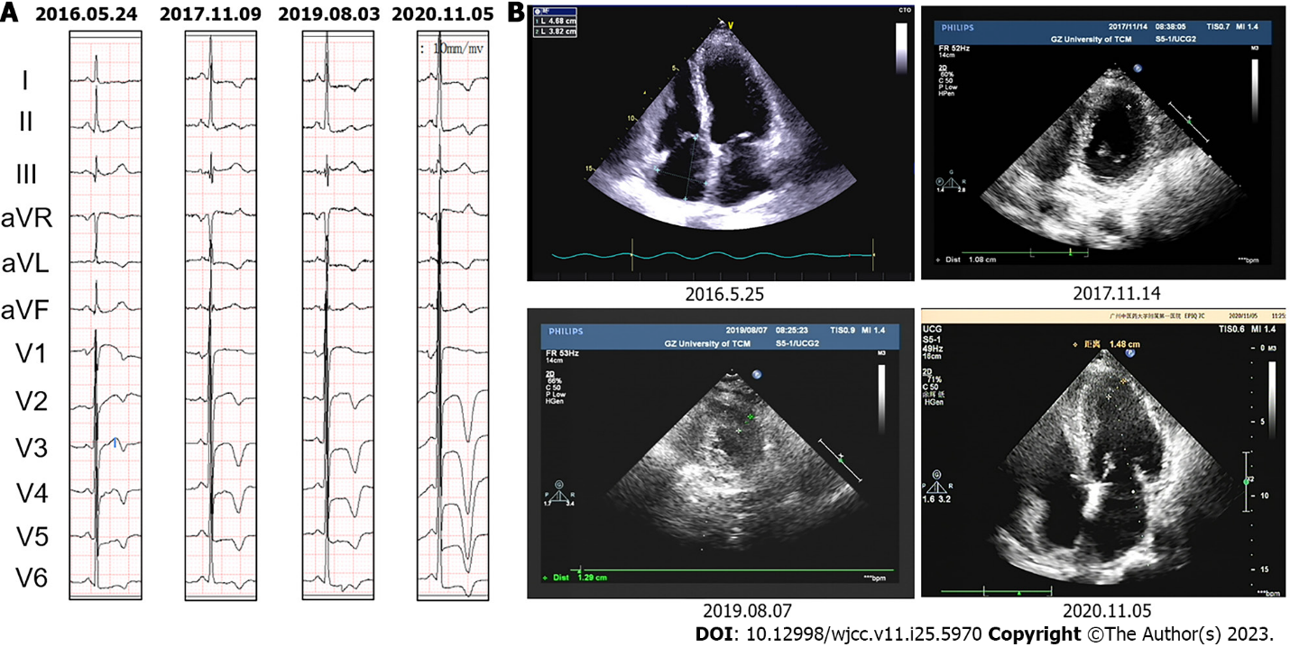
Figure 1 Evolution of left ventricular apical thickness and T-wave amplitude in chest leads of electrocardiogram in case 1. A: Electrocardiogram showed that T-wave inversion amplitude in chest leads gradually deepened from 2016 to 2020; B: Echocardiography showed that the left ventricular apical thickness gradually increased from 2016 to 2020.

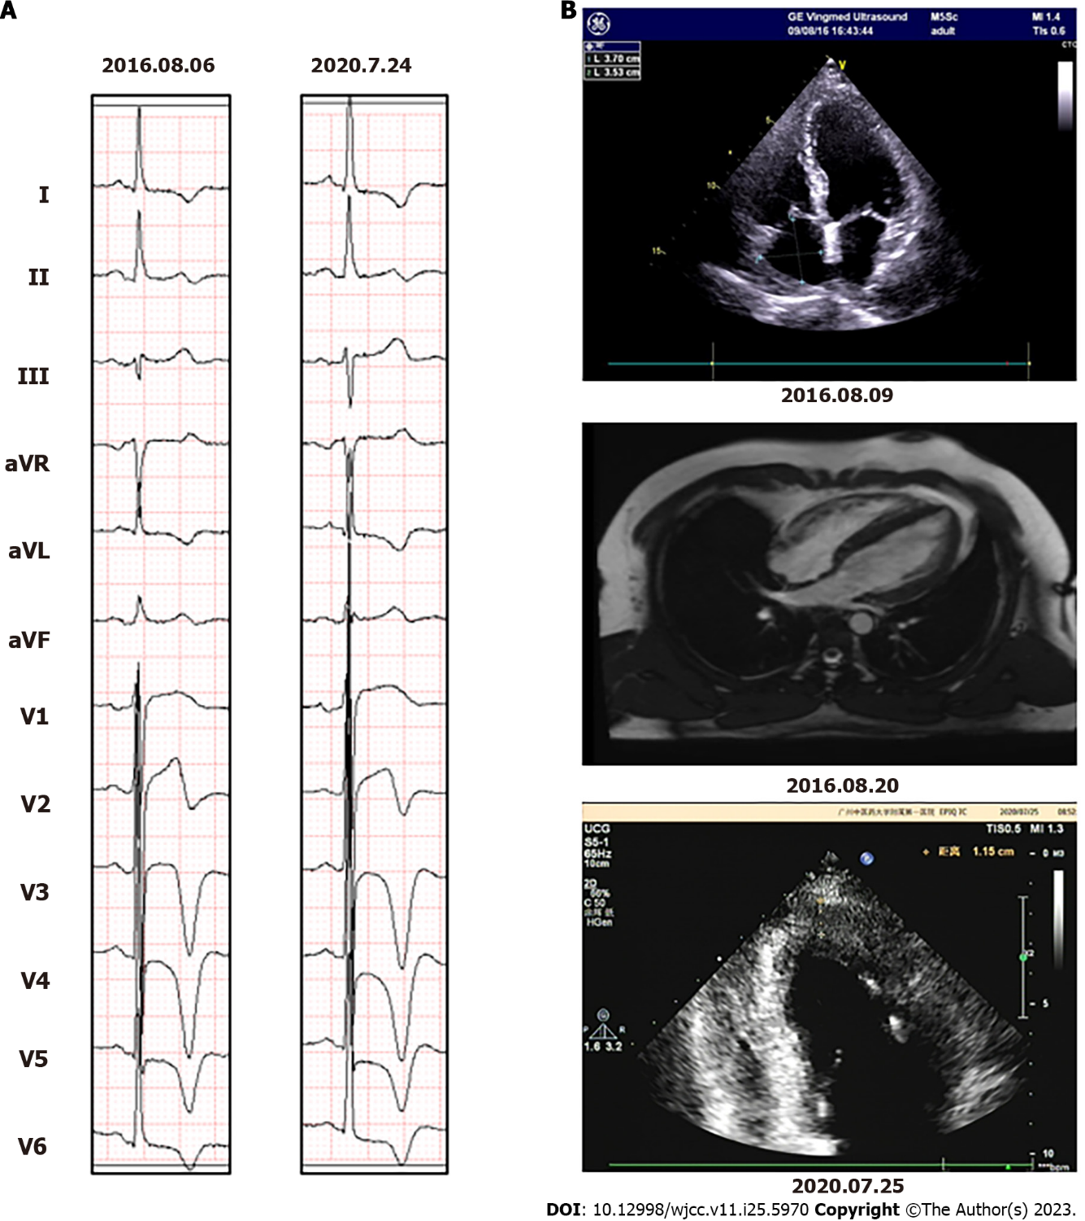
Figure 2 Evolution of left ventricular apical thickness and T-wave amplitude in chest leads of electrocardiogram in case 2. A: Electrocardiogram showed that T-wave inversion amplitude in chest leads gradually deepened from 2016 to 2020; B: Echocardiography and cardiac magnetic resonance showed that the left ventricular apical thickness gradually increased from 2016 to 2020.

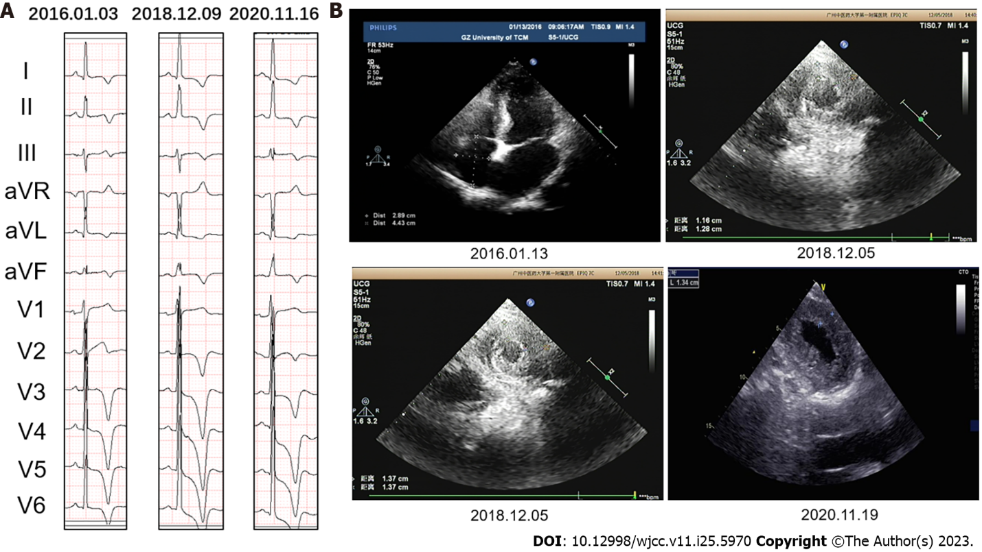
Figure 3 Evolution of left ventricular apical thickness and T-wave amplitude in chest leads of electrocardiogram in case 3. A: Electrocardiogram showed that T-wave inversion amplitude in chest leads gradually deepened from 2016 to 2020; B: Echocardiography showed that the left ventricular apical thickness gradually increased from 2016 to 2020.

Published by Baishideng Publishing Group Inc
7041 Koll Center Parkway, Suite 160, Pleasanton, CA 94566, USA
Telephone: +1-925-3991568
E-mail: bpgoffice@wjgnet.com
Help Desk: https://www.f6publishing.com/helpdesk
https://www.wjgnet.com

© 2023 Baishideng Publishing Group Inc. All rights reserved.

