Name of Journal: World Journal of Clinical Cases
Manuscript NO: 84835
Manuscript Type: CASE REPORT

Hepatoid adenocarcinoma of the stomach with neuroendocrine differentiation: A case report and review of literature

Fei H et al. HAS with NED

He Fei, Ze-Feng Li, Ying-Tai Chen, Dong-Bing Zhao

He Fei, Ze-Feng Li, Ying-Tai Chen, Dong-Bing Zhao, Department of Pancreatic and Gastric Surgical Oncology, National Cancer Center/National Clinical Research Center for Cancer/Cancer Hospital, Chinese Academy of Medical Sciences and Peking Union Medical College, Beijing 100021, China

Author contributions: Chen YT and Zhao DB designed the research study; Fei H contributed to manuscript writing and editing; Li ZF reviewed the pathological sections; All authors wrote the manuscript; All authors have read and approved the final manuscript.

Corresponding author: Dong-Bing Zhao, MD, Surgeon, Department of Pancreatic and Gastric Surgical Oncology, National Cancer Center/National Clinical Research Center for Cancer/Cancer Hospital, Chinese Academy of Medical Sciences and Peking Union Medical College, No. 17 Panjiayuan Nanli, Chaoyang District, Beijing 100021, China. dbzhao@cicams.ac.cn

Received: April 25, 2023
Revised: June 24, 2023
Accepted: July 17, 2023
Published online: August 6, 2023

Abstract
BACKGROUND
Both hepatoid adenocarcinoma of the stomach (HAS) and neuroendocrine differentiation (NED) are rare histological subtypes of gastric cancer with unique clinicopathological features and unfavorable outcomes. HAS with NED is even rarer.

CASE SUMMARY
Here, we report a 61-year-old man with HAS with NED, as detected by gastric wall thickening by positron emission tomography/computed tomography for a pulmonary nodule. Distal gastrectomy was performed, and pathological examination led to the diagnosis of HAS with NED. However, liver metastases occurred 6 mo later despite adjuvant chemotherapy, and the patient died 27 mo postoperatively.

CONCLUSION
We treated a patient with HAS with NED who underwent adjuvant chemotherapy after radical surgery and still developed liver metastases. We first report the detailed processes of the treatment and development of HAS with NED, providing an important reference for the clinical diagnosis and treatment of this condition.

Key Words: Gastric cancer; Hepatoid adenocarcinoma; Neuroendocrine differentiation; Liver metastasis; Case report

©The Author(s) 2023. Published by Baishideng Publishing Group Inc. All rights reserved.

Citation: Fei H, Li ZF, Chen YT, Zhao DB. Hepatoid adenocarcinoma of the stomach with neuroendocrine differentiation: A case report and review of literature. World J Clin Cases 2023; 11(22): 5329-5337
URL: https://www.wjgnet.com/2307-8960/full/v11/i22/5329.htm
DOI: https://dx.doi.org/10.12998/wjcc.v11.i22.5329

Core Tip: Hepatoid adenocarcinoma of the stomach (HAS) with neuroendocrine differentiation (NED) is rare histological subtype. We first reported the detailed processes of surgery and chemotherapy of HAS with NED and the survival time was 27 mo combined with postoperative chemotherapy, which provided an important reference for clinical diagnosis and treatment of this condition.

INTRODUCTION
Hepatoid adenocarcinoma of the stomach (HAS) accounts for approximately 0.3% to 1.0% of all gastric cancers and is an extremely rare subtype with tissue morphology similar to hepatocellular carcinoma (HCC)^{[1]}. Most, but not all, HAS cases produce alpha-fetoprotein (AFP)^{[2]}, and increased serum AFP is mainly due to hepatoid cells^{[3-5]}. Neuroendocrine neoplasms (NENs) can be divided into neuroendocrine tumors and neuroendocrine carcinomas (NECs). NEC is characterized by neuroendocrine differentiation (NED) and divided into small-cell NEC (SCNEC) and large-cell NEC (LCNEC); the latter has better survival prognosis than the former ^{[6]}. Ninety percent of SCNECs originate from the lung. The incidence of LCNEC is 1.8/100000, with only 3% occurring in the stomach^{[7]}. Nonneuroendocrine components (adenocarcinoma and squamous carcinoma) are frequently observed in high-grade NECs^{[8]}, and adenocarcinoma with NED is also found in other organs. However, HAS with NED is extremely rare. Herein, we report a case of a 61-year-old male who underwent radical surgery, and we also summarize the relevant literature.

CASE PRESENTATION
Chief complaints
Positron emission tomography/computed tomography (PET/CT) revealed thickening of the gastric lesser curvature at 1 wk.

History of present illness
A 61-year-old man underwent PET/CT for pulmonary nodules. PET/CT revealed thickening of the gastric lesser curvature with metabolic hyperplasia.

History of past illness
In addition, he was diagnosed with hypertension 5 years prior and took nifedipine daily. He had been drinking alcohol at approximately 250 g/day and smoking 20 cigarettes/day for over 40 years.

Personal and family history
The patient denied any family history of malignant tumors.

Physical examination
Physical assessment revealed no abnormalities.

Laboratory examinations
Laboratory examinations, including tumor marker levels, revealed no abnormalities.

Imaging examinations
PET/CT (Figure 1) revealed thickening of the gastric lesser curvature with metabolic hyperplasia. Gastroscopy (Figure 2) showed a localized ulcerative lesion extending from the angle to the antrum of the stomach that was mainly located in the mucosal layer and submucosal layer. The lesion was diagnosed as poorly differentiated carcinoma based on biopsy pathology.

Postoperative pathological results
The surgically resected specimen showed an ulcer-type tumor with a size of 2 cm × 1.5 cm × 0.5 cm in the lesser curvature of the gastric antrum. Postoperative pathology revealed HAS with NED. Histological examination showed that the tumor invaded the submucosal layer and subserous fat with multifocal growth. There was angiolymphatic invasion, but no nerve invasion was noted. The surrounding gastric mucosa showed chronic active inflammation with massive Helicobacter Pylori infection (Figure 3). Some lymph nodes were found to have metastatic carcinoma (4/29). One lymph node on the greater curvature (1/8) was positive, and two lymph nodes on the lesser curvature (2/16) were positive. The tumor node metastasis classification was T3N2M0 (stage III) (Figure 4). Immunohistochemical staining showed SALL4 (+), AFP (+), Glypican-3 (GPC-3) (+), Synaptophysin (Syn) (+), and Chromogranin A (CgA) (+) (Figure 5). Hepatoid components produced SALL4, AFP and GPC-3, and the neuroendocrine markers Syn and CgA revealed the presence of NED.

FINAL DIAGNOSIS
The patient was diagnosed with HAS with NED pT3N2M0 (stage III), accompanied by hypertension.

TREATMENT
The patient underwent distal gastrectomy with D2 lymphadenectomy at our hospital. He was discharged from the hospital with satisfactory recovery. The patient then received ten cycles of systemic chemotherapy (regimen: 60 mg docetaxel on day 1, 140 mg oxaliplatin on day 2, and 1.5 g capecitabine twice a day on days 1-8, half a month on each course). CT scanning revealed lymph node metastasis in the cardia and peritoneum at 4 mo postsurgery and multiple liver metastases at 6 mo postsurgery. In addition, he underwent thoracentesis and intrapleural injection chemotherapy (regimen: 40 mg cisplatin four times, 60 mg Endostar twice, and 2.3 million units interleukin-2 twice) for malignant pleural effusion. He then received three cycles of second-line chemotherapy treatment (280 mg irinotecan on day 1, 60 mg S-1 twice a day on days 1-10, and 500 mg apatinib once a day, two weeks on each course). S-1 is a combination product of tegafur, gimeracil, and oteracil potassium. Unfortunately, the liver metastases continued to progress, and he experienced grade 3 neutropenia, causing him to refuse further treatment.

OUTCOME AND FOLLOW-UP
He died at 27 mo after the operation due to the tumor multiple metastases. We think that aggressive surgical resection with postoperative chemotherapy to control tumor progression may improve patients’ outcome.

DISCUSSION
We retrieved 6 patients with stomach cancer including hepatoid adenocarcinoma and neuroendocrine Components. The clinicopathologic features of these cases are summarized in Table 1. The average age of the patients was 65 years (range: 48–83 years). Four of 6 patients were men. All of them developed lymph node metastases, which indicated the aggressive nature of these components. AFP and CgA expression was detected in the carcinomatous elements. Six patients underwent surgery, and 2 patients received chemotherapy. For the 4 patients with survival data, survival was 6 to 53 mo after gastrectomy; 2 patients developed liver recurrence.
Although hepatoid adenocarcinoma can occur in various organs, the stomach is the most common site. HAS mixed with common adenocarcinoma components is frequently observed^{[9]}, but the origin remains obscure. Previous studies have indicated that adenocarcinoma cells can switch from the intestinal type to the hepatoid phenotype^{[10]}, with the two components possibly arising from pluripotent precursor cells^{[11]}. Pathological diagnosis is still the gold standard for HAS. In our case, gastric lesions were detected by PET, which can diagnose and stage HAS accurately. Immunohistochemistry staining for AFP, SALL4, and GCP3 indicated hepatoid differentiation^{[12,13]}. All three markers were detected in this case. HAS is highly aggressive, and patients with high serum AFP levels are more likely to have lymph nodes and liver metastases^{[14]}. LIN28 combined with SALL4 shows 98% specificity in discriminating HAS from HCC^{[15]}. In summary, the availability of various auxiliary tests assists in accurate diagnosis.
The clinical manifestations of HAS lack specificity, and are were no significant differences from gastric cancer with regard to symptoms. In most cases, the tumor is at an advanced stage when diagnosed. In general, HAS is aggressive and has a high recurrence rate^{[15]}. Current research on HAS is controversial. The median OS was reported to be 11 mo (range 0.1-102), with a one-year survival rate of 55%^{[16]}. The five-year disease-free survival was only 20.7%^{[17-19]}. However, Zhou et al^{[18]} found that the prognosis of HAS is not as poor as previously believed^{[18]}, and the 5-year survival reached 41.1% after radical surgery^{[5]}. One recent study showed that the independent prognostic factors of OS include the serum AFP level^{[20,21]} in gastric cancer; another study showed that preoperative carcinoembryonic antigen levels of 5 ng/mL or more can be used to predict worse prognosis^{[9]}.
Radical surgery combined with adjuvant chemotherapy is considered the primary choice for these patients, but no consensus has been reached regarding therapy^{[22]}. Adjuvant chemotherapy is an independent favorable prognostic factor of HAS^{[23,24]}. Retrospectively, more than half of cases are at advanced stages at diagnosis, and the recurrence rate is quite high (47%)^{[25,26]}. Metastatic HAS lacks standard therapy; therefore, determining a suitable treatment regimen is a clinically urgent issue to be solved. Cisplatin-based chemotherapy is considered the mainstay of therapy^{[27]}. Two patients who received cisplatin and etoposide regimens achieved complete responses^{[28,29]}. FOLFOX might be a therapeutic option for HAS^{[30]}. The antiangiogenic agent ramucirumab led to a clinical response in a chemotherapy-resistant patient^{[31]}, offering a novel perspective on treatment. Immune checkpoint inhibitors are a promising class of anticancer drugs. Li et al^{[14]} reported that patients benefited from programmed cell death 1 (PD-1) monoclonal antibody plus chemotherapy compared with chemotherapy alone or combined with Herceptin/Apatinib regarding the median progression-free survival time (22.0 mo vs 5.0 mo)^{[14]}. For another case of recurrence, the patient achieved complete remission after five cycles of PD-1, and the serum AFP level decreased from more than 1210 mg/L to normal^{[32]}. However, another patient responded poorly^{[33]}. Microsatellite instability has been reported for a minority of patients^{[34]}, and the mechanism needs further study.
The stomach is the most common organ of mixed adeno-neuroendocrine carcinoma^{[35]}, and NED is usually the dominant component^{[36]}. NED represents a special type of tumor that can express various polypeptide hormones, such as synaptophysin and chromogranin A^{[37]}, and the Ki67 index is always more than 20%. Our case was mixed with two distinct components, and the etiopathogenesis of this phenomenon is still controversial. Domori and colleagues found that nearly 70% of gastric NECs presented with an adenocarcinoma component, and a previous report indicated that NECs originate from a preceding adenocarcinoma^{[38]}. Conversely, Fujimoto et al^{[39]} considered that the adenocarcinoma component might arise from the NEC component^{[39]}. Sun et al^{[40]} found that the NED component in gastric mixed adeno-neuroendocrine carcinoma (MANEC) showed marked genetic heterogenicity because the NED components of different cases were not clustered in hierarchical clustering analysis^{[40]}. Similar to gastric adenocarcinoma, TP53 is the most commonly mutated gene in gastric MANEC^{[41]}. Scardoni et al^{[42]} considered a monoclonal origin of gastric MANECs with the same TP53 mutation and level of p53 protein expression in two cases, as detected by next-generation sequencing^{[42]}.
G-NEC is a highly aggressive neoplasm with a large proportion of metastasis at diagnosis, and NED is the principal component of the metastatic foci in MANECs^{[43]}. Moreover, the presence of liver metastases correlates with poor prognosis in G-NEC patients^{[44,45]}. Because of its rare occurrence, systemic treatment options are limited, and currently, chemotherapy is still the main therapeutic approach. Cisplatin or carboplatin combined with etoposide is the standard chemotherapeutic regimen for the treatment of G-NEC according to the standard systemic therapy of pulmonary small-cell lung cancer (SCLC)^{[46,47]}. A multicenter retrospective analysis reported a median overall survival (OS) of 13.3 mo for GNEC^{[48]}. No evident difference was apparent between platinum-based chemotherapy regimens^{[49]}. The choice of treatment options should be selected based on the toxicity profile^{[50]}. Nevertheless, the prognosis of gastric NEC remains dismal^{[46]}. There are limited data on the efficacy of second-line therapy. The FOLFIRI regimen has the potential to improve outcomes of patients for whom first-line therapy fails^{[51]}. Peptide receptor radionuclide therapy should be considered an alternative to existing treatment options, and more research is needed^{[52,53]}. Immune checkpoint inhibitors offer new hope for treatment of NECs. Gastric tumor tissues express higher levels of PD-L1 mRNA than respective controls^{[54]}. Kim et al^{[55]} found significantly increased expression of PD-L1 in high-grade tumors, and PD-L1-positive tumors were associated with decreased OS^{[55]}. Yang and colleagues confirmed that high expression of PD-L1 in G-NECs correlates with poor prognosis, providing a basis for immunotherapy targeting the PD-1/PD-L1 pathway in G-NECs^{[56,57]}. After combination immunotherapy with ipilimumab and nivolumab, 43% of patients with pancreatic NENs^{[58]} and 19% of SCLC patients^{[59]} achieve an objective response. Further research is necessary to investigate the therapeutic efficacy of immune checkpoint inhibitors.

CONCLUSION
Mixed carcinomas usually raise a clinical dilemma with respect to diagnosis and treatment decisions. Only a few cases of HAS with NED have been reported, and we first report the detailed processes of treatment and development, we thought that aggressive surgical resection with postoperative chemotherapy to control tumor progression may improve patients’ outcome, providing an important reference for clinical diagnosis and treatment of this condition. We hope that our report provides valuable experience to other clinicians.

REFERENCES
1 Su JS, Chen YT, Wang RC, Wu CY, Lee SW, Lee TY. Clinicopathological characteristics in the differential diagnosis of hepatoid adenocarcinoma: a literature review. World J Gastroenterol 2013; 19: 321-327 [PMID: 23372352 DOI: 10.3748/wjg.v19.i3.321]
2 Zhang ZR, Wu J, Li HW, Wang T. Hepatoid adenocarcinoma of the stomach: Thirteen case reports and review of literature. World J Clin Cases 2020; 8: 1164-1171 [PMID: 32258088 DOI: 10.12998/wjcc.v8.i6.1164]
3 Inagawa S, Shimazaki J, Hori M, Yoshimi F, Adachi S, Kawamoto T, Fukao K, Itabashi M. Hepatoid adenocarcinoma of the stomach. Gastric Cancer 2001; 4: 43-52 [PMID: 11706627 DOI: 10.1007/s101200100016]
4 Yu C. Comment on: "Hepatoid adenocarcinoma of the stomach: a unique subgroup with distinct clinicopathological and molecular features. Gastric Cancer, 2019: 1-10" by Wang et al Gastric Cancer 2019; 22: 1312 [PMID: 31444590 DOI: 10.1007/s10120-019-00996-y]
5 Wang Y, Sun L, Li Z, Gao J, Ge S, Zhang C, Yuan J, Wang X, Li J, Lu Z, Gong J, Lu M, Zhou J, Peng Z, Shen L, Zhang X. Hepatoid adenocarcinoma of the stomach: a unique subgroup with distinct clinicopathological and molecular features. Gastric Cancer 2019; 22: 1183-1192 [PMID: 30989433 DOI: 10.1007/s10120-019-00965-5]
6 Abdel-Rahman O, Fazio N. Outcomes of small-cell vs large-cell gastroenteropancreatic neuroendocrine carcinomas: A population-based study. J Neuroendocrinol 2021; 33: e12971 [PMID: 33870570 DOI: 10.1111/jne.12971]
7 Korse CM, Taal BG, van Velthuysen ML, Visser O. Incidence and survival of neuroendocrine tumours in the Netherlands according to histological grade: experience of two decades of cancer registry. Eur J Cancer 2013; 49: 1975-1983 [PMID: 23352435 DOI: 10.1016/j.ejca.2012.12.022]
8 Yamamoto K, Itoi T, Sofuni A, Tsuchiya T, Tanaka R, Tonozuka R, Honjo M, Mukai S, Fujita M, Asai Y, Matsunami Y, Kurosawa T, Yamaguchi H, Nagakawa Y. Expanding the indication of endoscopic papillectomy for T1a ampullary carcinoma. Dig Endosc 2019; 31: 188-196 [PMID: 30161275 DOI: 10.1111/den.13265]
9 Lin JX, Wang ZK, Hong QQ, Zhang P, Zhang ZZ, He L, Wang Q, Shang L, Wang LJ, Sun YF, Li ZX, Liu JJ, Ding FH, Lin ED, Fu YA, Lin SM, Xie JW, Li P, Zheng CH, Huang CM. Assessment of Clinicopathological Characteristics and Development of an Individualized Prognostic Model for Patients With Hepatoid Adenocarcinoma of the Stomach. JAMA Netw Open 2021; 4: e2128217 [PMID: 34609494 DOI: 10.1001/jamanetworkopen.2021.28217]
10 Akiyama S, Tamura G, Endoh Y, Fukushima N, Ichihara Y, Aizawa K, Kawata S, Motoyama T. Histogenesis of hepatoid adenocarcinoma of the stomach: molecular evidence of identical origin with coexistent tubular adenocarcinoma. Int J Cancer 2003; 106: 510-515 [PMID: 12845645 DOI: 10.1002/ijc.11246]
11 Liu Z, Wang A, Pu Y, Li Z, Xue R, Zhang C, Xiang X, E JY, Bu Z, Bai F, Ji J. Genomic and transcriptomic profiling of hepatoid adenocarcinoma of the stomach. Oncogene 2021; 40: 5705-5717 [PMID: 34326469 DOI: 10.1038/s41388-021-01976-2]
12 Zhao M, Sun L, Lai JZ, Shi H, Mei K, He X, Jin X, Lai J, Cao D. Expression of RNA-binding protein LIN28 in classic gastric hepatoid carcinomas, gastric fetal type gastrointestinal adenocarcinomas, and hepatocellular carcinomas: An immunohistochemical study with comparison to SALL4, alpha-fetoprotein, glypican-3, and Hep Par1. Pathol Res Pract 2018; 214: 1707-1712 [PMID: 30196987 DOI: 10.1016/j.prp.2018.07.037]
13 Ushiku T, Shinozaki A, Shibahara J, Iwasaki Y, Tateishi Y, Funata N, Fukayama M. SALL4 represents fetal gut differentiation of gastric cancer, and is diagnostically useful in distinguishing hepatoid gastric carcinoma from hepatocellular carcinoma. Am J Surg Pathol 2010; 34: 533-540 [PMID: 20182341 DOI: 10.1097/PAS.0b013e3181d1dcdd]
14 Li W, Li Q, Yu Y, Wang Y, Chen E, Chen L, Wang Z, Cui Y, Liu T. Effect of Immune Checkpoint Inhibitors Plus Chemotherapy on Advanced Gastric Cancer Patients with Elevated Serum AFP or Hepatoid Adenocarcinoma. Cancer Manag Res 2020; 12: 11113-11119 [PMID: 33173344 DOI: 10.2147/CMAR.S276969]
15 Xia R, Zhou Y, Wang Y, Yuan J, Ma X. Hepatoid Adenocarcinoma of the Stomach: Current Perspectives and New Developments. Front Oncol 2021; 11: 633916 [PMID: 33912455 DOI: 10.3389/fonc.2021.633916]
16 Metzgeroth G, Ströbel P, Baumbusch T, Reiter A, Hastka J. Hepatoid adenocarcinoma - review of the literature illustrated by a rare case originating in the peritoneal cavity. Onkologie 2010; 33: 263-269 [PMID: 20502062 DOI: 10.1159/000305717]
17 Zeng XY, Yin YP, Xiao H, Zhang P, He J, Liu WZ, Gao JB, Shuai XM, Wang GB, Wu XL, Tao KX. Clinicopathological Characteristics and Prognosis of Hepatoid Adenocarcinoma of the Stomach: Evaluation of a Pooled Case Series. Curr Med Sci 2018; 38: 1054-1061 [PMID: 30536069 DOI: 10.1007/s11596-018-1983-1]
18 Zhou K, Wang A, Ao S, Chen J, Ji K, He Q, Ji X, Wu X, Zhang J, Li Z, Bu Z, Ji J. The prognosis of hepatoid adenocarcinoma of the stomach: a propensity score-based analysis. BMC Cancer 2020; 20: 671 [PMID: 32680468 DOI: 10.1186/s12885-020-07031-9]
19 Liu X, Cheng Y, Sheng W, Lu H, Xu X, Xu Y, Long Z, Zhu H, Wang Y. Analysis of clinicopathologic features and prognostic factors in hepatoid adenocarcinoma of the stomach. Am J Surg Pathol 2010; 34: 1465-1471 [PMID: 20871221 DOI: 10.1097/PAS.0b013e3181f0a873]
20 Wang B, Xie Y, Zheng L, Zheng X, Gao J, Liu X, Yuan Y, Li Z, Lu N, Xue L. Both the serum AFP test and AFP/GPC3/SALL4 immunohistochemistry are beneficial for predicting the prognosis of gastric adenocarcinoma. BMC Gastroenterol 2021; 21: 408 [PMID: 34706681 DOI: 10.1186/s12876-021-01986-0]
21 Liu X, Cheng Y, Sheng W, Lu H, Xu Y, Long Z, Zhu H, Wang Y. Clinicopathologic features and prognostic factors in alpha-fetoprotein-producing gastric cancers: analysis of 104 cases. J Surg Oncol 2010; 102: 249-255 [PMID: 20740583 DOI: 10.1002/jso.21624]
22 Lin CY, Yeh HC, Hsu CM, Lin WR, Chiu CT. Clinicopathologial features of gastric hepatoid adenocarcinoma. Biomed J 2015; 38: 65-69 [PMID: 25163499 DOI: 10.4103/2319-4170.126860]
23 Zhang JF, Shi SS, Shao YF, Zhang HZ. Clinicopathological and prognostic features of hepatoid adenocarcinoma of the stomach. Chin Med J (Engl) 2011; 124: 1470-1476 [PMID: 21740800]
24 Xiao C, Wu F, Jiang H, Teng L, Song F, Wang Q, Yang H. Hepatoid adenocarcinoma of the stomach: Nine case reports and treatment outcomes. Oncol Lett 2015; 10: 1605-1609 [PMID: 26622718 DOI: 10.3892/ol.2015.3430]
25 Baek SK, Han SW, Oh DY, Im SA, Kim TY, Bang YJ. Clinicopathologic characteristics and treatment outcomes of hepatoid adenocarcinoma of the stomach, a rare but unique subtype of gastric cancer. BMC Gastroenterol 2011; 11: 56 [PMID: 21592404 DOI: 10.1186/1471-230X-11-56]
26 Kumashiro Y, Yao T, Aishima S, Hirahashi M, Nishiyama K, Yamada T, Takayanagi R, Tsuneyoshi M. Hepatoid adenocarcinoma of the stomach: histogenesis and progression in association with intestinal phenotype. Hum Pathol 2007; 38: 857-863 [PMID: 17320150 DOI: 10.1016/j.humpath.2006.10.020]
27 Yoshizawa J, Ishizone S, Ikeyama M, Nakayama J. Gastric hepatoid adenocarcinoma resulting in a spontaneous gastric perforation: a case report and review of the literature. BMC Cancer 2017; 17: 368 [PMID: 28545511 DOI: 10.1186/s12885-017-3357-7]
28 Søreide JA. Therapeutic Approaches to Gastric Hepatoid Adenocarcinoma: Current Perspectives. Ther Clin Risk Manag 2019; 15: 1469-1477 [PMID: 31920320 DOI: 10.2147/TCRM.S204303]
29 Simmet V, Noblecourt M, Lizée T, Morvant B, Girault S, Soulié P, Capitain O. Chemotherapy of metastatic hepatoid adenocarcinoma: Literature review and two case reports with cisplatin etoposide. Oncol Lett 2018; 15: 48-54 [PMID: 29387209 DOI: 10.3892/ol.2017.7263]
30 Velut G, Mary F, Wind P, Aparicio T. Adjuvant chemotherapy by FOLFOX for gastric hepatoid adenocarcinoma. Dig Liver Dis 2014; 46: 1135-1136 [PMID: 25179158 DOI: 10.1016/j.dld.2014.08.036]
31 Doi Y, Takii Y, Mitsugi K, Kimura K, Mihara Y. The Effectiveness of Hepatic Arterial Infusion Chemotherapy with 5-Fluorouracil/Cisplatin and Systemic Chemotherapy with Ramucirumab in Alpha-Fetoprotein-Producing Gastric Cancer with Multiple Liver Metastases. Case Rep Oncol Med 2018; 2018: 5402313 [PMID: 30534453 DOI: 10.1155/2018/5402313]
32 Sun Y, Chang W, Yao J, Liu H, Zhang X, Wang W, Zhao K. Effect of immune checkpoint inhibitors in patients with gastric hepatoid adenocarcinoma: a case report and literature review. J Int Med Res 2022; 50: 3000605221091095 [PMID: 35469480 DOI: 10.1177/03000605221091095]
33 Zou M, Li Y, Dai Y, Sun L, Huang T, Yuan X, Qiu H. AFP-producing hepatoid adenocarcinoma (HAC) of peritoneum and omentum: a case report and literature review. Onco Targets Ther 2019; 12: 7649-7654 [PMID: 31571915 DOI: 10.2147/OTT.S216501]
34 Tsuruta S, Ohishi Y, Fujiwara M, Ihara E, Ogawa Y, Oki E, Nakamura M, Oda Y. Gastric hepatoid adenocarcinomas are a genetically heterogenous group; most tumors show chromosomal instability, but MSI tumors do exist. Hum Pathol 2019; 88: 27-38 [PMID: 30946937 DOI: 10.1016/j.humpath.2019.03.006]
35 Chang CY, Wei CY, Chen PH, Hou MC, Chao Y, Chau GY, Lee RC, Huang YH, Su YH, Wu JC, Su CW. The role of albumin-bilirubin grade in determining the outcomes of patients with very early-stage hepatocellular carcinoma. J Chin Med Assoc 2021; 84: 136-143 [PMID: 33433133 DOI: 10.1097/JCMA.0000000000000482]
36 Düzköylü Y, Aras O, Bostancı EB, Keklik Temuçin T, Ulaş M. Mixed Adeno-Neuroendocrine Carcinoma; Case Series of Ten Patients with Review of the Literature. Balkan Med J 2018; 35: 263-267 [PMID: 29551754 DOI: 10.4274/balkanmedj.2017.1471]
37 Verbeek WH, Korse CM, Tesselaar ME. GEP-NETs UPDATE: Secreting gastro-enteropancreatic neuroendocrine tumours and biomarkers. Eur J Endocrinol 2016; 174: R1-R7 [PMID: 26162406 DOI: 10.1530/EJE-14-0971]
38 Domori K, Nishikura K, Ajioka Y, Aoyagi Y. Mucin phenotype expression of gastric neuroendocrine neoplasms: analysis of histopathology and carcinogenesis. Gastric Cancer 2014; 17: 263-272 [PMID: 23828549 DOI: 10.1007/s10120-013-0281-7]
39 Fujimoto M, Matsuzaki I, Nishino M, Iwahashi Y, Warigaya K, Kojima F, Ono K, Murata SI. HER2 is frequently overexpressed in hepatoid adenocarcinoma and gastric carcinoma with enteroblastic differentiation: a comparison of 35 cases to 334 gastric carcinomas of other histological types. J Clin Pathol 2018; 71: 600-607 [PMID: 29305518 DOI: 10.1136/jclinpath-2017-204928]
40 Sun L, Zhang J, Wang C, Zhao S, Shao B, Guo Y, Liu Y, Sun Y. Chromosomal and molecular pathway alterations in the neuroendocrine carcinoma and adenocarcinoma components of gastric mixed neuroendocrine-nonneuroendocrine neoplasm. Mod Pathol 2020; 33: 2602-2613 [PMID: 32461621 DOI: 10.1038/s41379-020-0579-z]
41 Toyomasu Y, Mochiki E, Ishiguro T, Ito T, Suzuki O, Ogata K, Kumagai Y, Ishibashi K, Saeki H, Shirabe K, Ishida H. Clinical outcomes of gastric tube reconstruction following laparoscopic proximal gastrectomy for early gastric cancer in the upper third of the stomach: experience with 100 consecutive cases. Langenbecks Arch Surg 2021; 406: 659-666 [PMID: 33611694 DOI: 10.1007/s00423-021-02132-w]
42 Scardoni M, Vittoria E, Volante M, Rusev B, Bersani S, Mafficini A, Gottardi M, Giandomenico V, Malleo G, Butturini G, Cingarlini S, Fassan M, Scarpa A. Mixed adenoneuroendocrine carcinomas of the gastrointestinal tract: targeted next-generation sequencing suggests a monoclonal origin of the two components. Neuroendocrinology 2014; 100: 310-316 [PMID: 25342539 DOI: 10.1159/000369071]
43 Gurzu S, Fetyko A, Bara T, Banias L, Butiurca VO, Bara T Jr, Tudorache V, Jung I. Gastrointestinal mixed adenoneuroendocrine carcinoma (MANEC): An immunohistochemistry study of 13 microsatellite stable cases. Pathol Res Pract 2019; 215: 152697 [PMID: 31704155 DOI: 10.1016/j.prp.2019.152697]
44 Ahmed A, Turner G, King B, Jones L, Culliford D, McCance D, Ardill J, Johnston BT, Poston G, Rees M, Buxton-Thomas M, Caplin M, Ramage JK. Midgut neuroendocrine tumours with liver metastases: results of the UKINETS study. Endocr Relat Cancer 2009; 16: 885-894 [PMID: 19458024 DOI: 10.1677/ERC-09-0042]
45 Pape UF, Berndt U, Müller-Nordhorn J, Böhmig M, Roll S, Koch M, Willich SN, Wiedenmann B. Prognostic factors of long-term outcome in gastroenteropancreatic neuroendocrine tumours. Endocr Relat Cancer 2008; 15: 1083-1097 [PMID: 18603570 DOI: 10.1677/ERC-08-0017]
46 Fazio N, Spada F, Giovannini M. Chemotherapy in gastroenteropancreatic (GEP) neuroendocrine carcinomas (NEC): a critical view. Cancer Treat Rev 2013; 39: 270-274 [PMID: 22819619 DOI: 10.1016/j.ctrv.2012.06.009]
47 Shah MH, Goldner WS, Halfdanarson TR, Bergsland E, Berlin JD, Halperin D, Chan J, Kulke MH, Benson AB, Blaszkowsky LS, Eads J, Engstrom PF, Fanta P, Giordano T, He J, Heslin MJ, Kalemkerian GP, Kandeel F, Khan SA, Kidwai WZ, Kunz PL, Kuvshinoff BW, Lieu C, Pillarisetty VG, Saltz L, Sosa JA, Strosberg JR, Sussman CA, Trikalinos NA, Uboha NA, Whisenant J, Wong T, Yao JC, Burns JL, Ogba N, Zuccarino-Catania G. NCCN Guidelines Insights: Neuroendocrine and Adrenal Tumors, Version 2.2018. J Natl Compr Canc Netw 2018; 16: 693-702 [PMID: 29891520 DOI: 10.6004/jnccn.2018.0056]
48 Yamaguchi T, Machida N, Morizane C, Kasuga A, Takahashi H, Sudo K, Nishina T, Tobimatsu K, Ishido K, Furuse J, Boku N, Okusaka T. Multicenter retrospective analysis of systemic chemotherapy for advanced neuroendocrine carcinoma of the digestive system. Cancer Sci 2014; 105: 1176-1181 [PMID: 24975505 DOI: 10.1111/cas.12473]
49 Sorbye H, Welin S, Langer SW, Vestermark LW, Holt N, Osterlund P, Dueland S, Hofsli E, Guren MG, Ohrling K, Birkemeyer E, Thiis-Evensen E, Biagini M, Gronbaek H, Soveri LM, Olsen IH, Federspiel B, Assmus J, Janson ET, Knigge U. Predictive and prognostic factors for treatment and survival in 305 patients with advanced gastrointestinal neuroendocrine carcinoma (WHO G3): the NORDIC NEC study. Ann Oncol 2013; 24: 152-160 [PMID: 22967994 DOI: 10.1093/annonc/mds276]
50 Thomas KEH, Voros BA, Boudreaux JP, Thiagarajan R, Woltering EA, Ramirez RA. Current Treatment Options in Gastroenteropancreatic Neuroendocrine Carcinoma. Oncologist 2019; 24: 1076-1088 [PMID: 30635447 DOI: 10.1634/theoncologist.2018-0604]
51 Hentic O, Hammel P, Couvelard A, Rebours V, Zappa M, Palazzo M, Maire F, Goujon G, Gillet A, Lévy P, Ruszniewski P. FOLFIRI regimen: an effective second-line chemotherapy after failure of etoposide-platinum combination in patients with neuroendocrine carcinomas grade 3. Endocr Relat Cancer 2012; 19: 751-757 [PMID: 22940375 DOI: 10.1530/ERC-12-0002]
52 Ezziddin S, Opitz M, Attassi M, Biermann K, Sabet A, Guhlke S, Brockmann H, Willinek W, Wardelmann E, Biersack HJ, Ahmadzadehfar H. Impact of the Ki-67 proliferation index on response to peptide receptor radionuclide therapy. Eur J Nucl Med Mol Imaging 2011; 38: 459-466 [PMID: 20852858 DOI: 10.1007/s00259-010-1610-2]
53 Montanier N, Joubert-Zakeyh J, Pétorin C, Montoriol PF, Maqdasy S, Kelly A. The prognostic influence of the proliferative discordance in metastatic pancreatic neuroendocrine carcinoma revealed by peptide receptor radionuclide therapy: Case report and review of literature. Medicine (Baltimore) 2017; 96: e6062 [PMID: 28178157 DOI: 10.1097/MD.0000000000006062]
54 Oktay E, Yalcin GD, Ekmekci S, Kahraman DS, Yalcin A, Degirmenci M, Dirican A, Altin Z, Ozdemir O, Surmeli Z, Diniz G, Ayhan S, Bulut G, Erdogan A, Uslu R. Programmed cell death ligand-1 expression in gastroenteropancreatic neuroendocrine tumors. J BUON 2019; 24: 779-790 [PMID: 31128036]
55 Kim ST, Ha SY, Lee S, Ahn S, Lee J, Park SH, Park JO, Lim HY, Kang WK, Kim KM, Park YS. The Impact of PD-L1 Expression in Patients with Metastatic GEP-NETs. J Cancer 2016; 7: 484-489 [PMID: 26958083 DOI: 10.7150/jca.13711]
56 Yang MW, Fu XL, Jiang YS, Chen XJ, Tao LY, Yang JY, Huo YM, Liu W, Zhang JF, Liu PF, Liu Q, Hua R, Zhang ZG, Sun YW, Liu DJ. Clinical significance of programmed death 1/programmed death ligand 1 pathway in gastric neuroendocrine carcinomas. World J Gastroenterol 2019; 25: 1684-1696 [PMID: 31011254 DOI: 10.3748/wjg.v25.i14.1684]
57 Yamashita S, Abe H, Kunita A, Yamashita H, Seto Y, Ushiku T. Programmed cell death protein 1/programmed death ligand 1 but not HER2 is a potential therapeutic target in gastric neuroendocrine carcinoma. Histopathology 2021; 78: 381-391 [PMID: 32767778 DOI: 10.1111/his.14230]
58 Klein O, Kee D, Markman B, Michael M, Underhill C, Carlino MS, Jackett L, Lum C, Scott C, Nagrial A, Behren A, So JY, Palmer J, Cebon J. Immunotherapy of Ipilimumab and Nivolumab in Patients with Advanced Neuroendocrine Tumors: A Subgroup Analysis of the CA209-538 Clinical Trial for Rare Cancers. Clin Cancer Res 2020; 26: 4454-4459 [PMID: 32532787 DOI: 10.1158/1078-0432.CCR-20-0621]
59 Antonia SJ, López-Martin JA, Bendell J, Ott PA, Taylor M, Eder JP, Jäger D, Pietanza MC, Le DT, de Braud F, Morse MA, Ascierto PA, Horn L, Amin A, Pillai RN, Evans J, Chau I, Bono P, Atmaca A, Sharma P, Harbison CT, Lin CS, Christensen O, Calvo E. Nivolumab alone and nivolumab plus ipilimumab in recurrent small-cell lung cancer (CheckMate 032): a multicentre, open-label, phase 1/2 trial. Lancet Oncol 2016; 17: 883-895 [PMID: 27269741 DOI: 10.1016/S1470-2045(16)30098-5]
60 Rassidakis GZ, Delladetsima JK, Letsos SP, Polyzos A, Yannopoulos A. Hepatoid adenocarcinoma of the stomach with extensive neuroendocrine differentiation and a coexisting carcinoid tumour. Histopathology 1998; 33: 186-188 [PMID: 9762555 DOI: 10.1046/j.1365-2559.1998.1019c.x]
61 Okamoto T, Ogasahara K, Fujiki M, Takagi H, Ikeda H, Makino T, Moriga T, Kawamoto K, Sano K, Yoshida Y, Itoh T, Takasan H, Wani Y, Kono Y. Primary coexistent neuroendocrine carcinoma, hepatoid adenocarcinoma, and tubular adenocarcinoma of the stomach with focal trophoblastic differentiation in metastatic lymph nodes. J Gastroenterol 2003; 38: 608-610 [PMID: 12858843]
62 Suzuki A, Koide N, Kitazawa M, Mochizuka A, Ota H, Miyagawa S. Gastric composite tumor of alpha fetoprotein-producing carcinoma/hepatoid adenocarcinoma and endocrine carcinoma with reference to cellular phenotypes. Patholog Res Int 2012; 2012: 201375 [PMID: 22482081 DOI: 10.1155/2012/201375]
63 Lipi L, Sachdev R, Gautam D, Singh J, Mohapatra I. Triple composite tumor of stomach: a rare combination of alpha fetoprotein positive hepatoid adenocarcinoma, tubular adenocarcinoma and large cell neuroendocrine carcinoma. Indian J Pathol Microbiol 2014; 57: 98-100 [PMID: 24739843 DOI: 10.4103/0377-4929.130912]
64 Wincewicz A, Kowalik A, Zięba S, Lewitowicz P, Góźdź S, Sulkowski S. α-Fetoprotein-Producing Hepatoid Gastric Adenocarcinoma With Osteoclast-Like Giant Cells and Neuroendocrine Differentiation: A Case Study With Molecular Profiling. Int J Surg Pathol 2015; 23: 537-541 [PMID: 26009570 DOI: 10.1177/1066896915586807]
65 Li T, Liu T, Wang M, Zhang M. Α-fetoprotein producing hepatoid gastric adenocarcinoma with neuroendocrine differentiation: A case report. Medicine (Baltimore) 2018; 97: e12359 [PMID: 30212993 DOI: 10.1097/MD.0000000000012359]

Footnotes
Informed consent statement: Informed written consent was obtained from the patient for publication of this report and any accompanying images.

Conflict-of-interest statement: The authors declare that they have no conflicts of interest to disclose.

CARE Checklist (2016) statement: The authors have read the CARE Checklist (2016), and the manuscript was prepared and revised according to the CARE Checklist (2016).

Open-Access: This article is an open-access article that was selected by an in-house editor and fully peer-reviewed by external reviewers. It is distributed in accordance with the Creative Commons Attribution NonCommercial (CC BY-NC 4.0) license, which permits others to distribute, remix, adapt, build upon this work non-commercially, and license their derivative works on different terms, provided the original work is properly cited and the use is non-commercial. See: https://creativecommons.org/Licenses/by-nc/4.0/

Provenance and peer review: Unsolicited article; Externally peer reviewed.

Peer-review model: Single blind

Peer-review started: April 25, 2023
First decision: June 12, 2023
Article in press: July 17, 2023

Specialty type: Medicine, research and experimental
Country/Territory of origin: China
Peer-review report’s scientific quality classification
Grade A (Excellent): 0
Grade B (Very good): 0
Grade C (Good): C, C
Grade D (Fair): 0
Grade E (Poor): 0

P-Reviewer: Hegazy AA, Egypt; Koganti SB, United States S-Editor: Fan JR L-Editor: A P-Editor: Zhang XD
Figure Legends
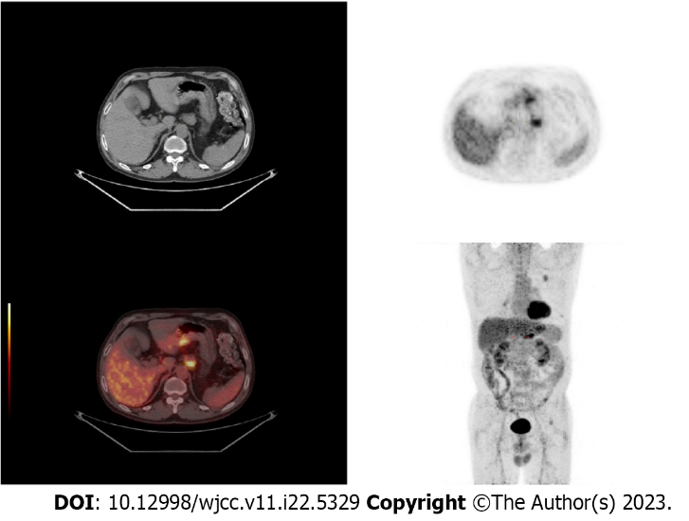
Figure 1 Positron emission tomography/computed tomography images: Thickening of the gastric lesser curvature with metabolic hyperplasia.
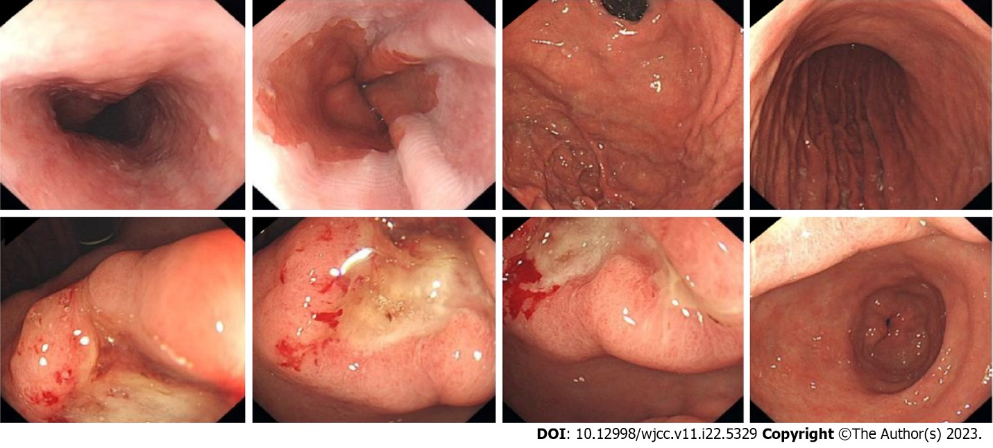
Figure 2 Endoscopic images: Localized ulcerative lesion extending from the angle to the antrum of the stomach.
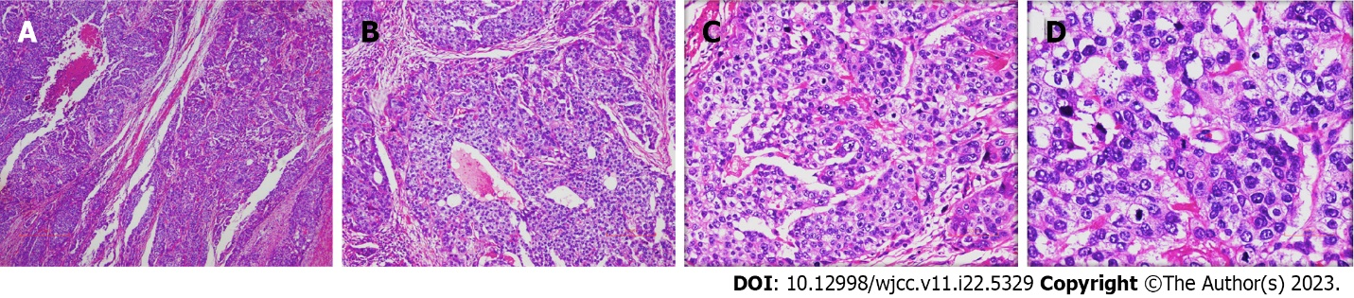
Figure 3 Histological findings of the primary lesion. A: A low-power histological view, hepatoid adenocarcinoma of the stomach [hematoxylin-eosin (HE), × 40]; B-D: High-power view shows that the characteristics and arrangement of the cancer cells are similar to those of liver cancer cells, with abundant and eosinophilic cytoplasm. Some of the tumor cells have clear cytoplasm with large and prominent nucleoli located in the center of the cell (B: HE, × 100); (C: HE, × 200); (D: HE, × 400).
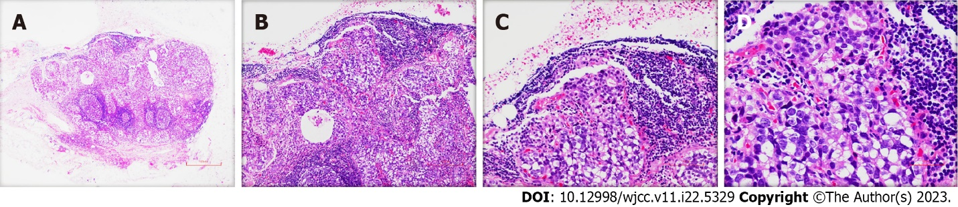
Figure 4 Histological findings of metastatic lymph nodes. A: A low-power histological view and metastatic lymph nodes show hepatoid adenocarcinoma cells [hematoxylin-eosin (HE), × 40]; B-D: A high-power view shows that the tumor cells are similar to those of the primary lesion; (B: HE, × 100); (C: HE, × 200); (D: HE, × 400).
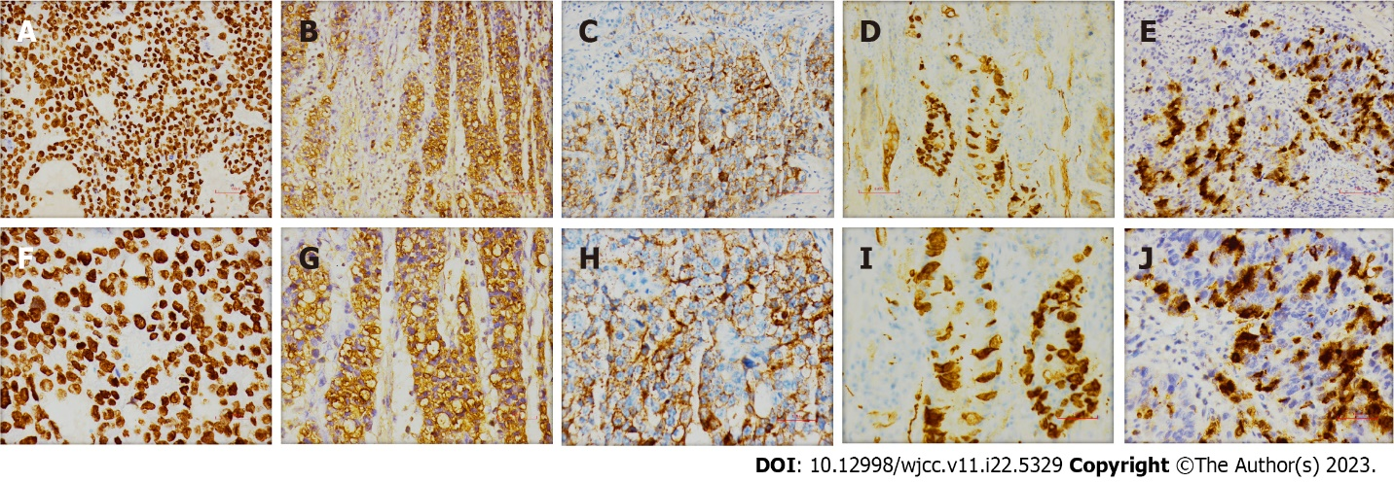
Figure 5 Presentations of immunohistochemical stains. A: SALL4 (+, × 200); B: Alpha-fetoprotein (AFP) (+, × 200); C: Glypican-3 (GPC-3) (+, × 200); D: Synaptophysin (Syn) (+, × 200); E: Chromogranin A (CgA) (+, × 200); F: SALL4 (+, × 400); G: AFP (+, × 400); H: GPC-3 (+, × 400); I: Syn (+, × 400); J: CgA (+, × 400).

Table 1 Reported cases of gastric cancer including hepatoid adenocarcinoma and neuroendocrine components
Ref. | Rassidakis et al^{[60]} | Okamoto et al^{[61]} | Suzuki et al^{[62]} | Lipi et al^{[63]} | Wincewicz et al^{[64]} | Li et al^{[65]} | Current case
Age | 48 | 78 | 83 | 50 | 73 | 60 | 61
Sex | Man | Woman | Man | Man | Woman | Man | Man
TNM stage | N3 | T3N2M0 | T4N2M1 | N3 | T3N3M1 | T2N1Mx | T3N2M0
Tumor location | Anterior wall of the gastric body | Pyloric antrum | Upper-third of the stomach | Cardia |  | Gastric antrum | Gastric antrum
Tumor size | 70 mm × 55 mm | 90 mm × 60 mm × 30 mm | 75 mm × 110 mm | 85 mm × 65 mm × 45 mm | 60 mm × 40 mm | 16 mm | 20 mm × 15 mm × 5 mm
Histologic patterns | HAC, NED | HAC, NEC, TAC | HAC, NEC, TAC | HAC, LCNEC, TAC | HAC, NED, OGCs | HAC, NED | HAC, NED
Immunohistochemistry | CGA, AFP | CK8, AE1/AE3, AFP, CGA | CGA, AFP, SP | AFP, Syn, CGA, CK | CGA, AFP, AE1/AE3, CK | AFP, Syn, CGA | SALL4, AFP, GPC-3, Syn, CgA
Surgery | Total gastrectomy | Subtotal gastrectomy with lymphadenectomy | Gastrectomy | Total gastrectomy |  | R2 radical gastrectomy | Distal gastrectomy with D2 lymphadenectomy
Treatment | Doxorubicin, mitomycin-C, 5-fluorouracil, octreotide (4 cycles) |  |  | Cisplatin + VP 16 (2 cycles) |  |  | Docetaxel + oxaliplatin + capecitabine (10 cycles), irinotecan + S-1 + apatinib (3 cycles)
AFP, ng/mL | 800 (post-op) | 168 (pre-op) |  |  |  | 1683 (pre-op)
Outcome | Alive, 12 mo | Died, 53 mo, liver recurrence | Died, 6 mo |  | Liver recurrence | Alive, 6 mo | Died, 27 mo, liver recurrence
GC: Gastric cancer; HAC: Hepatoid adenocarcinoma; NEC: Neuroendocrine carcinoma; NED: Neuroendocrine differentiation; TAC: Tubular adenocarcinoma; OGCs: Osteoclast-like giant cells; AFP: Alpha-fetoprotein; CGA: Chromogranin A; Syn: Synaptophysin; CK: Cytokeratin; pre-op: Preoperatively; post-op: Postoperatively; LCNEC: Large-cell NEC.

Published by Baishideng Publishing Group Inc
7041 Koll Center Parkway, Suite 160, Pleasanton, CA 94566, USA
Telephone: +1-925-3991568
E-mail: bpgoffice@wjgnet.com
Help Desk: https://www.f6publishing.com/helpdesk
https://www.wjgnet.com

© 2023 Baishideng Publishing Group Inc. All rights reserved.

