Name of Journal: World Journal of Clinical Cases
Manuscript NO: 66887
Manuscript Type: CASE REPORT

Choriocarcinoma misdiagnosed as cerebral hemangioma: A case report

Huang HQ et al. Choriocarcinoma misdiagnosed as cerebral hemangioma

Hui-Qiong Huang, Feng-Ming Gong, Ru-Tie Yin, Xiao-Juan Lin

Hui-Qiong Huang, Feng-Ming Gong, Ru-Tie Yin, Xiao-Juan Lin, Gynecological Oncology of Biotherapy Laboratory, Department of Gynecology and Obstetrics, Key Laboratory of Birth Defects and Related Diseases of Women and Children (Sichuan University), Ministry of Education, West China Second University Hospital, Sichuan University, Chengdu 610041, Sichuan Province, China

Author contributions: Huang HQ analyzed the data and wrote the manuscript; Lin XJ and Gong FM analyzed the data; Yin RT designed the research study; All authors have read and approve the final manuscript.

Corresponding author: Ru-Tie Yin, MD, Doctor, Professor, Gynecological Oncology of Biotherapy Laboratory, Department of Gynecology and Obstetrics, Key Laboratory of Birth Defects and Related Diseases of Women and Children (Sichuan University), Ministry of Education, West China Second University Hospital, Sichuan University, No. 20 Section 3 South People’s Road, Chengdu 610041, Sichuan Province, China. yrtt2013@163.com

Received: April 13, 2021
Revised: July 9, 2021
Accepted: September 10, 2021
Published online:

Abstract
BACKGROUND
Choriocarcinoma is a subtype of gestational trophoblastic disease, gestational trophoblastic neoplasia. Patients with brain metastasis are rare and information on the optimal treatment and patient outcome is limited. In order to improve the prognosis of this disease, accurate and timely treatments are very important for the patient of brain metastasis by choriocarcinoma.

CASE SUMMARY
A 17-year-old unmarried girl was misdiagnosed with a cerebral hemangioma with intracranial hemorrhage in a local hospital after presentation with severe head pain. She underwent craniotomy three times for treatment. The pathological results of posterior intracranial hematoma showed choriocarcinoma, and the patient was diagnosed as choriocarcinoma (21 points in stage IV). After uterine artery embolization, etoposide, methotrexate, actinomycin D, cyclophosphamide, and vincristine chemotherapy for 7 cycles, and whole brain radiotherapy, the patient achieved remission. She has been followed for 2 years with no signs of tumor recurrence.

CONCLUSION
For female patients of childbearing age with an intracranial hematoma, the possibility of brain metastasis by choriocarcinoma should be considered. It is necessary to obtain a detailed history, including menstruation, beginning age of first sex, contraception, etc. The level of β-human chorionic gonadotropin should be tested at the beginning, and a stratified treatment should be administered according to the International Federation of Gynecology and Obstetrics staging and World Health Organization prognostic scoring systems.

Key Words: Brain metastasis; Choriocarcinoma; Uterine artery embolization; Chemotherapy; Whole brain radiotherapy; Craniotomy; Case report

Huang HQ, Gong FM, Yin RT, Lin XJ. Choriocarcinoma misdiagnosed as cerebral hemangioma: A case report and literature review. World J Clin Cases 2021; In press

Core Tip: A 17-year-old unmarried girl was misdiagnosed with a cerebral hemangioma with intracranial hemorrhage in a local hospital after presentation with severe head pain. The patient was treated with craniotomy three times. The pathological results of posterior intracranial hematoma showed choriocarcinoma, and the patient was diagnosed as choriocarcinoma (21 points in stage IV). For female patients of childbearing age with an intracranial hematoma, the possibility of brain metastasis by choriocarcinoma should be considered. It is necessary to obtain a detailed sexual history, include menstruation, beginning age of first sex, contraception, etc. The level of β-human chorionic gonadotropin should be tested at the beginning, and a stratified treatment should be administered according to the International Federation of Gynecology and Obstetrics staging and World Health Organization prognostic scoring systems.

INTRODUCTION
Gestational trophoblastic neoplasia (GTN) is a group of malignant tumors characterized by abnormal growth of trophoblastic tissue, which can occur after a molar or non-molar pregnancy. Choriocarcinoma, a subtype of gestational trophoblastic disease first described in 400 BC by Hippocrates, is a rare and aggressive neoplasm^{[1]} that can easily metastasize via the hematogenous pathway to multiple organs, such as uterus, vagina, lung, kidney, brain, liver, etc.^{[2]}. GTN patients with brain metastasis are rare and information on the optimal treatment and patient outcome is limited^{[3]}. However, since this type of tumor shows a high cure rate, early diagnosis and subsequent treatment are important. In this report, we present a rare case of choriocarcinoma with brain metastasis in a 17-year-old girl with intracerebral hemorrhage at initial presentation, which may provide a clinical references for aiding in diagnosing and treating brain metastases of choriocarcinoma, especially in adolescent women.

CASE PRESENTATION
Chief complaints
A 17-year-old girl with no disease history initially presented to a local community hospital for the acute onset of intense cephalagia, emesis, and left hemiplegia with normal mental state with bilateral pupils equal and reacting.

History of present illness
Computed tomography (CT) scan of the brain showed the right frontal parietal lobe intracerebral hemorrhage of the patient at the local hospital, and the patient underwent evacuation of hematoma by emergency craniotomy. Nine days after the first surgery, the patient complaint of severe headache, accompanied by jet vomiting, and the vomit was gastric contents. The patient underwent another evacuation of hematoma by craniotomy. Five days after the second operation, a third attack of headache and vomiting began, and the patient underwent the third evacuation of hematoma by craniotomy to control the hemorrhage. Postoperative pathological examination showed foam-like histiocyte proliferation, and tumor cells were found in the hemorrhagic and necrotic tissues (Figure 1). Immunohistochemical results: pan-cytokeratin (+), epithelial membrane antigen (+), human chorionic gonadotropin (HCG) (+), granulocyte chemotactic protein-3 (+, focal area), Sal-like protein 4 (+), octamer binding transcription factor 3/4 (-), and placental alkaline phosphatase (-), supporting metastatic choriocarcinoma. After confrontation, the patient admitted to having a sexual history and having had an abortion 2 years ago. She hid her medical history for fear that her parents would find out. Laboratory findings revealed that serum β-HCG level was more than 200000 U/mL. Based on all these findings, choriocarcinoma was strongly indicated. She received mannitol dehydration and brain protective treatment, and was then transferred to a general hospital for further treatment, at which time she was transferred to our center.

History of past illness
The patient’s menstrual cycle was regular and she declared no history of sexual intercourse or abortion. No history of hypertension could be identified.

Personal and family history
No personal and family history available.

Physical examination
On presentation in our hospital, the patient was in a normal mental state with bilateral pupils equal and reacting. The muscle strength of left limb was grade III, the right limb grade V. The physical examination showed there was a bluish violet nodule with a diameter of about 6 cm at the cervix.

Laboratory examinations
The blood level of β-HCG was 766510.0 mIU/mL (normal value, < 2.0 mIU/mL).

Imaging examinations
Brain CT with contrast enhancement showed the right parietal lobe in the area of the previous operations had obvious edema, and local softening foci were formed. The adjacent meninges and brain were swollen, indicating residual tumor at the surgical area. Chest CT showed multiple round nodules and masses of variable sizes in both lungs, with scanty amounts of right pleural effusion, compatible with lung metastasis. Abdomen CT showed an abnormal, high and low mixed density in the spleen and kidneys, and the cervical was enlarged with uneven and enhancement CT value.

FINAL DIAGNOSIS
On the basis of clinical and laboratory investigations, the patient was diagnosed with choriocarcinoma, International Federation of Gynecology and Obstetrics (FIGO) stage IV and score of the Prognostic Scoring Index modified by the FIGO score was 21 (extreme high risk).

TREATMENT
The patient underwent a multidisciplinary approach to treatment which consisted of a modified multi-agent chemotherapy regimen of etoposide, methotrexate, actinomycin D, cyclophosphamide and vincristine (EMA-CO) with higher doses of methotrexate. The regimen was as follows: methotrexate 100 mg/m², followed by methotrexate 200 mg/m² over 12 h day 1, etoposide 100 mg/m² and dactinomycin 0.5 mg days 1 and 2, calcium folate 15 mg intramuscular injection every 12 h days 2 and 3, alternating with cyclophosphamide 600 mg/m² and vincristine 2 mg day 8, every 14 days. During the first chemotherapy regimen, the patient suddenly had vaginal bleeding. Physical examination found a large amount of blood in the vagina and the bluish violet nodule on the cervix had ruptured. After vaginal gauze packing, there was still active bleeding. Uterine artery embolization was performed to selectively embolize the bleeding vessel and successfully control uterine hemorrhage (Figure 2). The patient underwent a blood transfusion to compensate for blood loss. Because of the brain metastasis and indications of residual tumor at the brain operation area, the patient underwent whole-brain radiotherapy with 50 Gy in 25 fractions. Usually patients with lung metastasis or disease in the pulmonary vasculature might have a combination of hemoptysis, shortness of breath, or pleuritic chest pain; however, the patient fortunately had no sign of those symptoms, and after the treatments, the lung CT showed favorable therapeutic response.

OUTCOME AND FOLLOW-UP
Serumβ-HCG decreased logarithmically to normal levels after the 7th chemotherapy regimen (Figure 3). The patient then completed 4 consolidation courses of chemotherapy. The results of lung CT, brain magnetic resonance imaging (MRI), and chest radiograph after treatments all showed favorable therapeutic response (Figures 4, 5 and 6). However, the patient still experienced alopecia, I° liver dysfunction, I-II° canker sore, I-II° nausea and vomiting, and II° granulocytopenia.
Long-term follow-up with evaluation of serum β-HCG levels every 3 mo and CT of her chest and MRI of her brain every 6 mo showed no evidence of disease. The patient has been followed up for 14 mo at the outpatient clinic. She complained of no self-conscious discomfort and the β-HCG value has been maintained in the normal range. The muscle strength of her limbs was almost normal. The patient consented to publication of the case.

DISCUSSION
Metastatic brain tumors are not frequently the cause of the intracerebral hemorrhage in the young, which is usually caused by arteriovenous malformations and aneurysms. About 10%-20% of brain metastases cases are found in choriocarcinoma, which most often manifests as an intracerebral or subdural hematoma because of the innate capacity of trophoblastic cells to invade vessel walls^{[4]}.
The pathological mechanism of choriocarcinoma metastasis to the brain is still controversial, and the formation mechanism may have the following points: (1) Vascular injury mechanism: microthrombotic injury of blood vessels, vascular endothelial scar formation, resulting in changes in vascular hydrodynamics, and hematoma formation^{[5]}; (2) After the destruction of arterial blood vessels, tumor cells invade cerebral blood vessels through vascular nutrient tubes. However, vascular trophoblast tubes in experimental animals and humans are rare^{[6]}; and (3) Tumor crossing mechanism: tumor cells have the ability to bind closely with endothelial cells at the terminal deposition site, and even destroy endothelial cells. With the growth of endothelial cells, they eventually cross and destroy arterial blood vessels^{[7]}. No matter which of the three mechanisms mentioned above, microthrombosis is the earliest. More scholars now agree with the theory of tumor traversing mechanism because histopathologists have found that tumor cells proliferate in hemangioma cells and invaded the inner elastic membrane in various tumors. In conclusion, the biological characteristics of brain metastatic tumor cells play a very important role in the formation of brain metastatic hemangioma.
The strategy to treat patients who have GTN and brain metastases is with intravenous multidrug chemotherapy; however, the 2013 Cochrane review could not come to a conclusion on what the most effective multidrug chemotherapy regime was to treat high-risk GTN. The EMA-CO combination is most commonly used with an increased dose of Methotrexate from 300 to 1000 mg/m² in the case of brain metastases (EMA-CO CNS), as recommended by the FTDRC^{[8]}. According to our center's data on previous cases of GTN with brain metastasis, increasing the methotrexate (MTX) dose to 1.0 g/m² results in unbearable side effects in patients. Patients who are administered low-dose 5-FU and actinomycin D chemotherapy with intermittent intrathecal MTX (15 mg) injection (2–3 times per cycle) until β-HCG is absent in the cerebrospinal fluid, with or without radiotherapy based on the efficacy of chemotherapy, have a remission rate of 75%^{[9,10]}. These patients experience fewer side effects and can tolerate chemotherapy. The patient in this report received EMA-CO combination with usual dose of Methotrexate chemotherapy and showed a good prognosis. Reported by Soper et al^{[11]}, treating brain metastases from choriocarcinoma by using systemic intravenous chemotherapy (although alternative regimens to EMA-CO) with surgery or stereotactic brain radiation without the need for whole brain radiation and intrathecal chemotherapy is successful. HCG is key to effective management of gestational trophoblastic disease as the choriocarcinomas are malignant HCG-producing epithelial tumors. HCG is comprised of an α subunit and a β subunit that confers specificity. β-HCG is a good predictive indicator of prognosis and recurrence^{[12]}. However, apart from clinical and radiological signs, the key diagnostic feature of choriocarcinoma is an elevated serum β-HCG. Elevation of β-HCG in the serum of a patient with a history of normal or abnormal pregnancy suggests the diagnosis of choriocarcinoma^{[12]}.
Because of the characteristics of trophoblast cell growth, it is easy for choriocarcinoma lesions to hemorrhage throughout the therapy. In this case, the patient presented with hemorrhages at both the cervix and the brain. Conservative treatment for choriocarcinoma hemorrhagic lesions should first be considered due to chemosensitivity. Arterial embolization has also proven to be an effective nonsurgical way to treat acute and massive genital bleeding in gestational trophoblastic disease, providing specific occlusion of the uterine vessels. Transcatheter angiographic embolization is an accepted treatment modality to control recurrent massive genital bleeding and can avoiding of hysterectomy and preserve fertility^{[13]}.

CONCLUSION
The literature advises that early diagnosis and treatment can significantly improve the prognosis of this disease^{[14]}. In this case brain metastases were already present at time of diagnosis, which worsened the long-term prognosis of the choriocarcinoma. This highlights the importance of increasing awareness of the disease on the part of general practitioners, midwives, and emergency medicine staff, as they are most likely to receive the first presentations of patients with choriocarcinoma, and this will to ensure timely diagnosis and will improve prognosis and reduce morbidity^{[15]}. Because of the Chinese traditional dichotomy, Chinese parents do not allow their daughters to have premarital sex, and therefore, adolescent girls often hide their sexual life history, and doctors in China always ignore their intercourse history. Therefore, there are no reliable data on the age of sexual debut in Chinese women, and the proportion of young women aged 15-19 years who had experienced sexual activity with a partner ranged from 4.5% among rural respondents to 10.8% among urban respondents^{[16]}. In women at childbearing age, metastatic choriocarcinoma must be considered in the differential diagnosis of intracerebral hemorrhage because of its multiple clinical and radiological presentations. It is difficult to differentiate the imaging appearances from those due to cerebrovascular disease^{[17]}.

REFERENCES
1 Seckl MJ, Fisher RA, Salerno G, Rees H, Paradinas FJ, Foskett M, Newlands ES. Choriocarcinoma and partial hydatidiform moles. Lancet 2000; 356: 36-39 [PMID: 10892763 DOI: 10.1016/S0140-6736(00)02432-6]
2 Bonnet L, Raposo N, Blot-Souletie N, Faruch Bilfeld M, Chollet F, Mazière J, Olivot JM, Albucher JF. Stroke Caused by a Pulmonary Vein Thrombosis Revealing a Metastatic Choriocarcinoma. Circulation 2015; 131: 2093-2094 [PMID: 26056347 DOI: 10.1161/CIRCULATIONAHA.114.011429]
3 Piura E, Piura B. Brain metastases from gestational trophoblastic neoplasia: review of pertinent literature. Eur J Gynaecol Oncol 2014; 35: 359-367 [PMID: 25118474 DOI: 10.5732/cjc.013.10214]
4 Savage P, Kelpanides I, Tuthill M, Short D, Seckl MJ. Brain metastases in gestational trophoblast neoplasia: an update on incidence, management and outcome. Gynecol Oncol 2015; 137: 73-76 [PMID: 25598530 DOI: 10.1016/j.ygyno.2015.01.530]
5 Ashalatha R, Moosa A, Gupta AK, Krishna Manohar SR, Sandhyamani S. Cerebral aneurysms in atrial myxoma: a delayed, rare manifestation. Neurol India 2005; 53: 216-218 [PMID: 16010063 DOI: 10.4103/0028-3886.16416]
6 Sedat J, Chau Y, Dunac A, Gomez N, Suissa L, Mahagne MH. Multiple cerebral aneurysms caused by cardiac myxoma. A case report and present state of knowledge. Interv Neuroradiol 2007; 13: 179-184 [PMID: 20566147 DOI: 10.1177/159101990701300209]
7 Radoi MP, Stefanescu F, Arsene D. Brain metastases and multiple cerebral aneurysms from cardiac myxoma: case report and review of the literature. Br J Neurosurg 2012; 26: 893-895 [PMID: 22686128 DOI: 10.3109/02688697.2012.692841]
8 Deng L, Zhang J, Wu T, Lawrie TA. Combination chemotherapy for primary treatment of high-risk gestational trophoblastic tumour. Cochrane Database Syst Rev 2013: CD005196 [PMID: 23440800 DOI: 10.1002/14651858.CD005196.pub4]
9 Song L, Li Q, Yin R, Wang D. Choriocarcinoma with brain metastasis after term pregnancy: A case report. Medicine (Baltimore) 2018; 97: e12904 [PMID: 30335019 DOI: 10.1097/MD.0000000000012904]
10 Hiramatsu Y, Masuyama H, Ishida M, Murakami K, Sakurai M. Term delivery choriocarcinoma patient with brain and lung metastases successfully treated by etoposide, methotrexate, actomycin D, cyclophosphamide and vincristine (EMA-CO) chemotherapy. Acta Med Okayama 2005; 59: 235-238 [PMID: 16286962 DOI: 10.18926/AMO/31972]
11 Soper JT, Spillman M, Sampson JH, Kirkpatrick JP, Wolf JK, Clarke-Pearson DL. High-risk gestational trophoblastic neoplasia with brain metastases: individualized multidisciplinary therapy in the management of four patients. Gynecol Oncol 2007; 104: 691-694 [PMID: 17137617 DOI: 10.1016/j.ygyno.2006.10.027]
12 Ngan HYS, Seckl MJ, Berkowitz RS, Xiang Y, Golfier F, Sekharan PK, Lurain JR, Massuger L. Update on the diagnosis and management of gestational trophoblastic disease. Int J Gynaecol Obstet 2018; 143 Suppl 2: 79-85 [PMID: 30306586 DOI: 10.1002/ijgo.12615]
13 Frati A, Ducarme G, Wernet A, Chuttur A, Vilgrain V, Luton D. Uterine artery embolization as treatment for life-threatening haemorrhage from a cervical choriocarcinoma: a case report. Eur J Obstet Gynecol Reprod Biol 2008; 141: 87-88 [PMID: 18649986 DOI: 10.1016/j.ejogrb.2008.05.008]
14 Wreczycka-Cegielny P, Cegielny T, Oplawski M, Sawicki W, Kojs Z. Current treatment options for advanced choriocarcinoma on the basis of own case and review of the literature. Ginekol Pol 2018; 89: 711-715 [PMID: 30618041 DOI: 10.5603/GP.a2018.0120]
15 Ma Y, Xiang Y, Wan XR, Chen Y, Feng FZ, Lei CZ, Yang XY. The prognostic analysis of 123 postpartum choriocarcinoma cases. Int J Gynecol Cancer 2008; 18: 1097-1101 [PMID: 18021220 DOI: 10.1111/j.1525-1438.2007.01132.x]
16 Zhao FH, Tiggelaar SM, Hu SY, Xu LN, Hong Y, Niyazi M, Gao XH, Ju LR, Zhang LQ, Feng XX, Duan XZ, Song XL, Wang J, Yang Y, Li CQ, Liu JH, Liu JH, Lu YB, Li L, Zhou Q, Liu JF, Zhao N, Schmidt JE, Qiao YL. A multi-center survey of age of sexual debut and sexual behavior in Chinese women: suggestions for optimal age of human papillomavirus vaccination in China. Cancer Epidemiol 2012; 36: 384-390 [PMID: 22377277 DOI: 10.1016/j.canep.2012.01.009]
17 Lappin JM, Darke S, Duflou J, Kaye S, Farrell M. Fatal Stroke in Pregnancy and the Puerperium. Stroke 2018; 49: 3050-3053 [PMID: 30571397 DOI: 10.1161/STROKEAHA.118.023274]

Footnotes
Informed consent statement: All study participants, or their legal guardian, provided informed written consent prior to study enrollment.

Conflict-of-interest statement: We declare that we have no financial and personal relationships with other people or organizations that can inappropriately influence our work, there is no professional or other personal interest of any nature or kind in any product, service and/or company that could be construed as influencing the position presented in, or the review of, the manuscript entitled.

CARE Checklist (2016) statement: The authors have read the CARE Checklist (2016), and the manuscript was prepared and revised according to the CARE Checklist (2016).

Open-Access: This article is an open-access article that was selected by an in-house editor and fully peer-reviewed by external reviewers. It is distributed in accordance with the Creative Commons Attribution NonCommercial (CC BY-NC 4.0) license, which permits others to distribute, remix, adapt, build upon this work non-commercially, and license their derivative works on different terms, provided the original work is properly cited and the use is non-commercial. See: http://creativecommons.org/Licenses/by-nc/4.0/

Manuscript source: Unsolicited manuscript

Peer-review started: April 13, 2021
First decision: June 24, 2021
Article in press:

Specialty type: Oncology
Country/Territory of origin: China
Peer-review report’s scientific quality classification
Grade A (Excellent): 0
Grade B (Very good): B
Grade C (Good): C
Grade D (Fair): 0
Grade E (Poor): 0

P-Reviewer: Jeong KY, Schulten HJ S-Editor: Wang JL L-Editor: Filipodia P-Editor:

Figure Legends
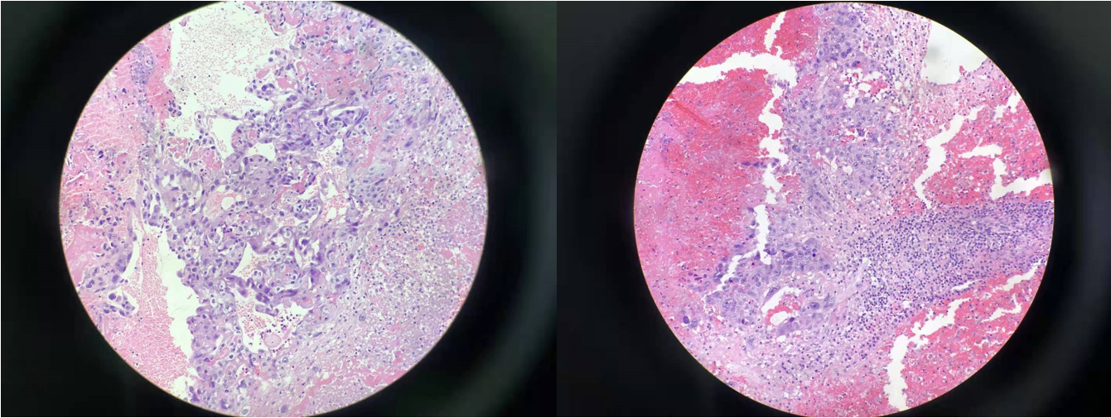
Figure 1 Pathological pictures of the patient showed infiltrating large and pleomorphic tumor cells into the brain parenchyma with extensive hemorrhage and necrosis. Hematoxylin and eosin stain, intermediate power.

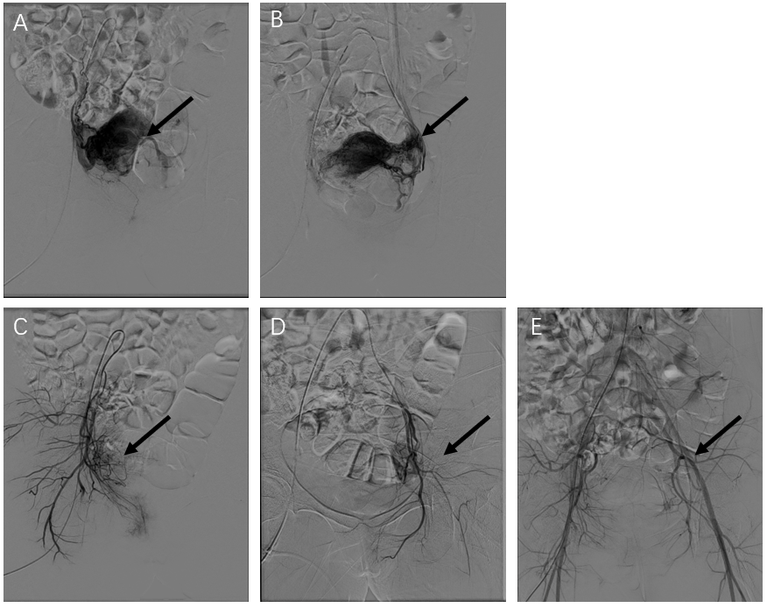
Figure 2 The pictures of uterine artery angiograms for the patient. A, B: Selective uterine artery angiograms proved active bleeding of the branches of uterine arteries before operation (arrows); C-E: Hemorrhage of blood vessels was ceased immediately after selective embolization (arrows).

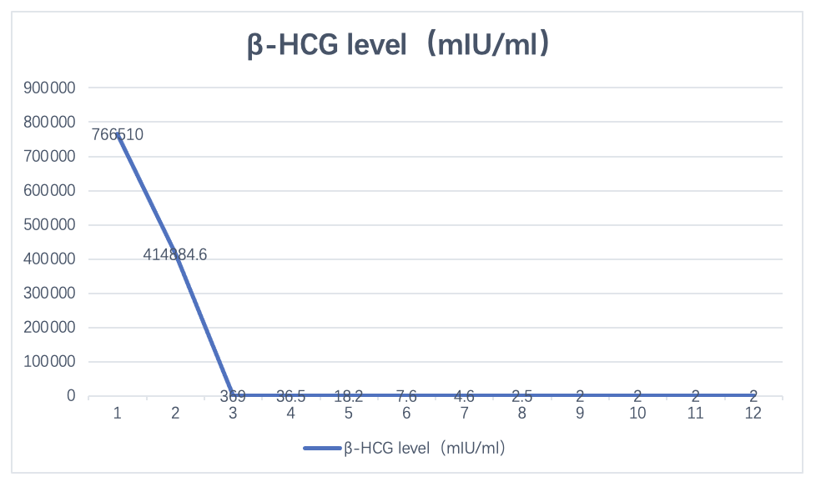
Figure 3 Diagram of curves of β-human chorionic gonadotropin level decreased with the course of chemotherapy. β-HCG: β-human chorionic gonadotropin.

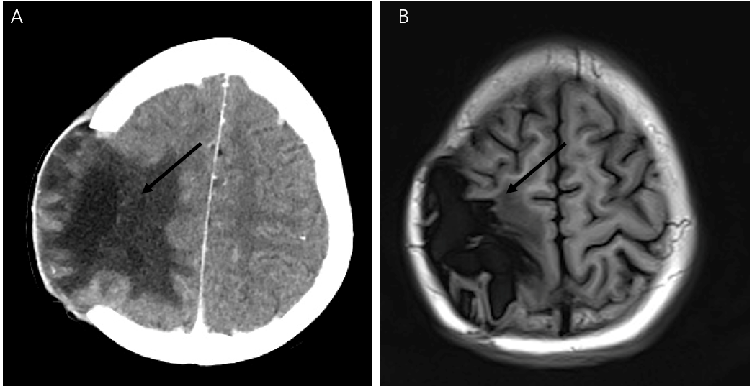
Figure 4 Brain images of the patient before and after therapy. A: Brain computed tomography image of the patient before therapy indicated residual tumor at the brain operation area; B: Brain magnetic resonance image of the patient after treatment was significantly decreased compared with that before treatment and there was no sign of residual tumor.

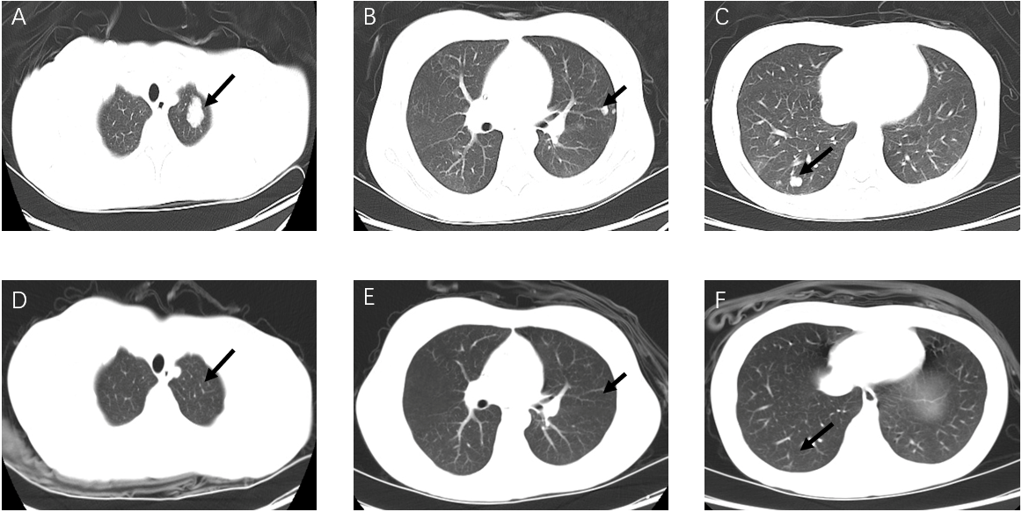
Figure 5 Lung computed tomography images of the patient at different stages of treatment. A-C: Multiple nodules of bilateral pulmonary were shown on computed tomography (CT) image before chemotherapy (black arrows, metastatic nodules); D-F: CT images revealed an almost normal lung field after treatment.

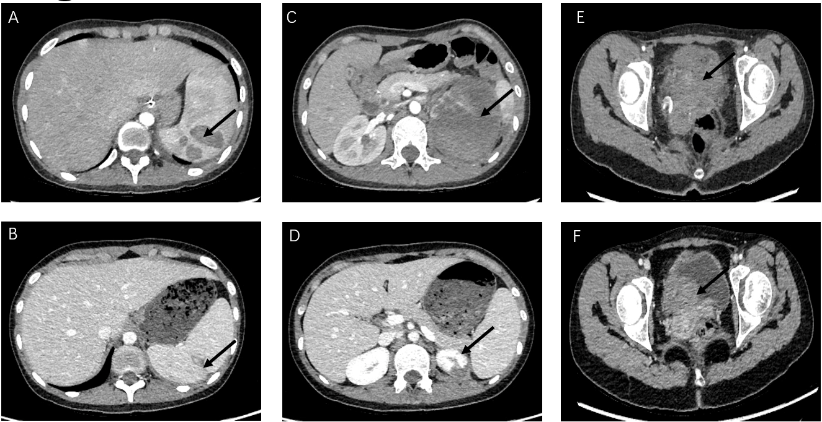
Figure 6 Abdominal computed tomography images of the patient at different stages of treatment. A: Multiple nodules of spleen were shown on computed tomography (CT) image before chemotherapy(black arrows, metastatic nodules); B: CT images revealed an almost normal spleen after treatment; C: Large cystic occupying lesion of left renal was shown on CT image before chemotherapy(black arrows, metastatic cystic occupying lesion); D: CT images revealed an almost normal but smaller left kidney after treatment; E: Large solid occupying lesion of cervix was shown on CT image before chemotherapy (black arrows, metastatic solid occupying lesion); F: CT images revealed an almost normal cervix after treatment.

