Name of Journal: World Journal of Clinical Cases
Manuscript NO: 62644
Manuscript Type: CASE REPORT

Primary primitive neuroectodermal tumor in the pericardium—a focus on imaging findings: A case report

Xu SM et al. Pericardial PNET imaging findings

Shu-Ming Xu, Juan Bai, Jin-Hua Cai

Shu-Ming Xu, Department of Radiology, Children’s Hospital of Shanxi, Taiyuan 030013, Shanxi Province, China

Juan Bai, Department of Medical Imaging, Shanxi Medical University, Taiyuan 030001, Shanxi Province, China

Jin-Hua Cai, Department of Radiology, Children’s Hospital, Chongqing Medical University, Chongqing 400014, China

Author contributions: Xu SM and Bai J performed the data analyses and drafted the manuscript; Cai JH helped perform the analysis with constructive discussions and revised the article for important intellectual content.

Supported by Fund Program for the Scientific Activities of Selected Returned Overseas Professionals in Shanxi Province, No. (2016) 97.

Corresponding author: Jin-Hua Cai, MD, Chief Doctor, Department of Radiology, Children’s Hospital, Chongqing Medical University, No. 136 Zhongshan 2 Road, Yuzhong District, Chongqing 400014, China. cai_jinhua@126.com

Received: January 19, 2021
Revised: February 19, 2021
Accepted: March 15, 2021
Published online:

Abstract
BACKGROUND
Primitive neuroectodermal tumors (PNETs) are rare, sporadic malignant tumors of the peripheral nervous system, bone, or soft tissues. However, to the best of our knowledge, only three cases of PNET in the pericardium have been reported in the English literature, and their magnetic resonance imaging findings have not previously been described.

CASE SUMMARY
A 3-year-old boy was hospitalized with a 1-wk history of recurrent vomiting and weakness. Detailed history-taking revealed no evidence of heart disease. Computed tomography demonstrated a soft tissue mass in the left pericardial cavity with heterogeneous contrast enhancement. The border between the mass and the heart was poorly defined. Thoracotomy revealed a mass invading the left ventricle, with a high risk of bleeding. The mass was considered inoperable. A biopsy was performed, and the histological and immunohistochemical findings confirmed the diagnosis of primary PNET of the pericardium. The patient received four cycles of standard chemotherapy. Chest magnetic resonance imaging 3 mo after the initiation of chemotherapy revealed that the tumor in the pericardium still existed, but its volume had slightly decreased. The patient was lost to follow-up, and the final outcome was therefore unknown.

CONCLUSION
Medical imaging plays an important role in defining the pericardial origin of PNET and understanding its characteristics. Magnetic resonance imaging can provide more information on the tumor than computed tomography and may thus aid therapeutic planning.

Key Words: Primary primitive neuroectodermal tumors; Pericardium; Tumor; Computed tomography; Magnetic resonance imaging; Case report

Xu SM, Bai J, Cai JH. Primary primitive neuroectodermal tumor in the pericardium—a focus on imaging findings: A case report. World J Clin Cases 2021; In press

Core Tip: Primitive neuroectodermal tumors (PNETs) are rare, high-grade malignant tumors derived from neural crest cells exhibiting neuroectodermal differentiation. Primary PNET in the pericardium is extremely rare. We present the case of a primary pericardial PNET in a 3-year-old boy, with an emphasis on the computed tomography and magnetic resonance imaging findings. This case adds to the literature on pericardial PNET and provides the first report of the magnetic resonance imaging manifestations of this type of tumor.
INTRODUCTION
Primitive neuroectodermal tumors (PNETs) are rare, high-grade malignant tumors derived from neural crest cells and exhibiting neuroectodermal differentiation. PNETs occur sporadically in the peripheral nervous system, bone, or soft tissues; however, primary PNET in the pericardium is extremely rare. To the best of our knowledge, only three cases of PNET in the pericardium have been reported in the English literature to date^{[1-3]}, and their magnetic resonance imaging (MRI) findings have not previously been described. We present the case of a primary pericardial PNET in a 3-year-old boy, with an emphasis on the computed tomography (CT) and MRI findings.

CASE PRESENTATION
Chief complaints
A 3-year-old boy was hospitalized with a 1-wk history of recurrent vomiting and weakness.

History of past illness
A detailed history-taking revealed no evidence of heart disease.

Physical examination
Physical examination showed jugular vein distension and positive hepatojugular reflux.

Imaging examinations
Chest radiography (Figure 1) showed an enlarged, flask-shaped cardiac silhouette, suggesting pericardial effusion. A small amount of effusion was also detected in the right pleural cavity. Plain CT scan showed pericardial effusion and an indefinite soft tissue density mass in the left pericardial cavity (Figure 2A). The mass was heterogeneously enhanced after intravenous administration of contrast medium (Figure 2B and 2C). The border between the mass and the heart was poorly defined. A coronary artery branch was detected passing through the mass (Figure 2B). Other CT findings included right pleural effusion and displacement of the heart to the right side (Figure 2C). CT findings thus indicated a malignant tumor, but no conclusive diagnosis could be made regarding its etiology.

Further diagnostic work-up
The patient underwent a thoracotomy with the primary aim of resecting the mass. However, during surgery, the mass was found to be invading the left ventricle and had a rich blood supply, presenting a high risk of bleeding. The mass was therefore considered to be surgically inoperable. Subsequent biopsy was performed and histological examination showed a cellular malignant tumor composed of small, round, uniform cells. These cells were characterized with vesicular nuclei and scanty neoplasm. A few Homer-Wright rosettes with a central core of neuropil were formed. Immunohistochemical results were strongly positive for CD99 and synuclein, but negative for desmin, smooth muscle actin, chromogranin A, leukocyte common antigen, and cytokeratin.

FINAL DIAGNOSIS
The histological and immunohistochemical findings confirmed the diagnosis of primary PNET of the pericardium.

TREATMENT
Following confirmation of the diagnosis, the patient was treated with four cycles of a standard chemotherapy regimen (etoposide d 1-3, cyclophosphamide d 4-5).

OUTCOME AND FOLLOW-UP
Chest MRI examination (Figure 3) 3 mo after the initiation of chemotherapy revealed that the pleural and pericardial effusions had disappeared. The tumor was still present in the pericardium, but its volume had slightly decreased. The mass showed a heterogeneous signal, mainly slightly hyperintense on T1-weighted images (Figure 3A) and isointense on T2-weighted images (Figure 3B). Intravenous injection of contrast medium showed the mass was inhomogeneous with marked enhancement, with a clear and definite border between the mass and the left ventricle wall (Figure 3C). The left coronary artery branch was shown to be embedded within the mass (Figure 3B), suggesting a pericardial origin of the tumor. The patient was unfortunately lost to follow-up, and his final outcome was therefore unknown.

DISCUSSION
PNETs are rare, high-grade malignant tumors derived from neural crest cells, exhibiting neuroectodermal differentiation. Primary PNETs have been reported in the peripheral nervous system, thymus, lung, bone, heart, adrenal gland, kidney, pancreas, liver, urogenital tract, and uterus^{[4-9]}. However, primary PNET in the pericardium is extremely rare. To the best of our knowledge, only three cases of primary pericardial PNET have been reported to date^{[1-3]}, and none of the reports described MRI findings that might provide useful diagnostic information. In the current report, we presented the case of a 3-year-old boy with a primary pericardial PNET, with an emphasis on the CT and MRI findings. This case provided a significant addition to the literature regarding pericardial PNET, as only the fourth reported case in the English literature and the first to describe the MRI manifestations of the tumor.
The diagnosis of primary pericardial PNET depends on pathological examination and immunohistochemistry. Primary PNET of the pericardium have morphological appearances similar to those arising in other locations^{[1,9]}. PNET belongs to small, round cell malignancies in histomorphology with hyperchromatic nuclei and features of neural differentiation, which typically form either Homer-Wright or Flexner-Winterstein rosettes^{[1]}. It is difficult to differentiate PNET from other small round-cell tumors including malignant lymphoma, neuroendocrine carcinoma, and rhabdomyosarcoma. Immunohistochemical examinations with myogenic, neurogenic, and lymphoid cell markers can rule out many of these tumors^{[1,2,9]}. According to the previous reports, the expression of CD99 (MIC2) and FLI1 are highly specific for PNETs^{[10]}. In our case, the immunohistochemical examination revealed a strong CD99 staining, which is consistent with other reports in the literature.
The imaging findings of PNET arising from cardium or other locations have been described in the previous reports^{[11,12]}. On plain CT images, the majority of PNET lesions showed as ill-defined, irregularly shaped, hypodense masses accompanied with persistent moderate heterogeneous enhancement. The cystic or necrotic changes were frequently observed in larger tumors, which may be due to the rapid growth and lack of blood supply^{[11]}. On MRI images, the tumors generally showed iso- to hypointense T1-weighted signal and intermediate to hyperintense T2-weighted signal. After the administration of intravenous gadolinium, the tumors demonstrated homogeneous to heterogeneous enhancement^{[12]}.
Although imaging examinations lack specificity for diagnosing PNET, CT and MRI may reveal the size and location of the tumor and its relationship with the neighboring heart, thus providing valuable information for evaluating and formulating surgical treatment plans. In the current case, CT and MRI both showed a large, solid, heterogeneously enhanced mass circumscribed by a capsule. Compared with CT, MRI was more sensitive for displaying the relationship between the mass and the heart. In addition, the tumor MRI signal was characterized by slight hyperintensity on T1-weighted and iso- to hyperintensity on T2-weighted images. These signal features may relate to the presence of more tumor cells and fewer water molecules in the tumor stroma, indicating the malignant nature of the tumor.

CONCLUSION
We present the fourth reported case of a primary pericardial PNET and the first to describe the MRI manifestations of this type of tumor. The diagnosis of primary pericardial PNET depends on pathological examination and immunohistochemistry. Medical imaging plays an important role in detecting the mass and understanding its characteristics. MRI can provide more information on the tumor than CT and may thus aid therapeutic planning.

ACKNOWLEDGEMENTS
We also thank Dr. Zhu J, from the Department of Pathology, Children’s Hospital of Chongqing Medical University, for interpretation of the pathological and immunohistochemical findings.

REFERENCES
1 Chen Z, Chen R, Ng C, Shi H. Primary pericardial primitive neuroectodermal tumor: a case report and review of literature. Int J Clin Exp Pathol 2018; 11: 2155-2159 [PMID: 31938326]
2 Azribi F, Razak AR, Bough G, Lee D, Rowe D, Bown N, Dildey P, Clark S, Plummer R. Extraosseous pericardial Ewing's sarcoma. J Clin Oncol 2010; 28: e48-e50 [PMID: 19917868 DOI: 10.1200/JCO.2009.23.7487]
3 Mohandas KM, Chinoy RF, Merchant NH, Lotliker RG, Desai PB. Malignant small cell tumour (Askin-Rosai) of the pericardium. Postgrad Med J 1992; 68: 140-142 [PMID: 1315028 DOI: 10.1136/pgmj.68.796.140]
4 Koufopoulos N, Kokkali S, Manatakis D, Balalis D, Nasi D, Ardavanis A, Korkolis D, Khaldi L. Primary peripheral neuroectodermal tumor (PNET) of the adrenal gland: a rare entity. J BUON 2019; 24: 770-778 [PMID: 31128035]
5 Zhong J, Chen N, Chen X, Gong J, Nie L, Xu M, Zhou Q. Peripheral primitive neuroectodermal tumor of the kidney in a 51-year-old female following breast cancer: A case report and review of the literature. Oncol Lett 2015; 9: 108-112 [PMID: 25435942 DOI: 10.3892/ol.2014.2695]
6 Nishizawa N, Kumamoto Y, Igarashi K, Nishiyama R, Tajima H, Kawamata H, Kaizu T, Watanabe M. A peripheral primitive neuroectodermal tumor originating from the pancreas: a case report and review of the literature. Surg Case Rep 2015; 1: 80 [PMID: 26380804 DOI: 10.1186/s40792-015-0084-7]
7 Elizalde CR, Yagüe A, Fernandez J, Dieste P, Puente MJ, Hernandez J. Primitive neuroectodermal tumor of the uterus. Gynecol Oncol Rep 2016; 18: 25-28 [PMID: 27822490 DOI: 10.1016/j.gore.2016.07.001]
8 Gao L, Zhu Y, Shi X, Gao Z, Chen X. Peripheral primitive neuroectodermal tumors: A retrospective analysis of 89 cases and literature review. Oncol Lett 2019; 18: 6885-6890 [PMID: 31788128 DOI: 10.3892/ol.2019.11011]
9 Vogel H, Fuller GN. Primitive neuroectodermal tumors, embryonal tumors, and other small cell and poorly differentiated malignant neoplasms of the central and peripheral nervous systems. Ann Diagn Pathol 2003; 7: 387-398 [PMID: 15018124 DOI: 10.1016/j.anndiagpath.2003.09.007]
10 Nutman A, Postovsky S, Zaidman I, Elhasid R, Vlodavsky E, Kreiss Y, Ben Arush MW. Primary intraspinal primitive neuroectodermal tumor treated with autologous stem cell transplantation: case report and review of the literature. Pediatr Hematol Oncol 2007; 24: 53-61 [PMID: 17130114 DOI: 10.1080/08880010601001396]
11 Xiao H, Bao F, Tan H, Wang B, Liu W, Gao J, Gao X. CT and clinical findings of peripheral primitive neuroectodermal tumour in children. Br J Radiol 2016; 89: 20140450 [PMID: 26847997 DOI: 10.1259/bjr.20140450]
12 Restrepo CS, Vargas D, Ocazionez D, Martínez-Jiménez S, Betancourt Cuellar SL, Gutierrez FR. Primary pericardial tumors. Radiographics 2013; 33: 1613-1630 [PMID: 24108554 DOI: 10.1148/rg.336135512]

Footnotes
Informed consent statement: Informed written consent was obtained from the patient and legal guardian for publication of this report and any accompanying images.

Conflict-of-interest statement: The authors declare that they have no conflicts of interest.

CARE Checklist (2016) statement: The authors have read the CARE Checklist (2016), and the manuscript was prepared and revised according to the CARE Checklist (2016).

Open-Access: This article is an open-access article that was selected by an in-house editor and fully peer-reviewed by external reviewers. It is distributed in accordance with the Creative Commons Attribution NonCommercial (CC BY-NC 4.0) license, which permits others to distribute, remix, adapt, build upon this work non-commercially, and license their derivative works on different terms, provided the original work is properly cited and the use is non-commercial. See: http://creativecommons.org/Licenses/by-nc/4.0/

Manuscript source: Unsolicited manuscript

Peer-review started: January 19, 2021
First decision: February 11, 2021
Article in press:

Specialty type: Medicine, research and experimental
Country/Territory of origin: China
Peer-review report’s scientific quality classification
Grade A (Excellent): 0
Grade B (Very good): 0
Grade C (Good): C, C
Grade D (Fair): D
Grade E (Poor): 0

P-Reviewer: Elpek GO, Ho CM S-Editor: Gao CC L-Editor: Filipodia P-Editor:

Figure Legends
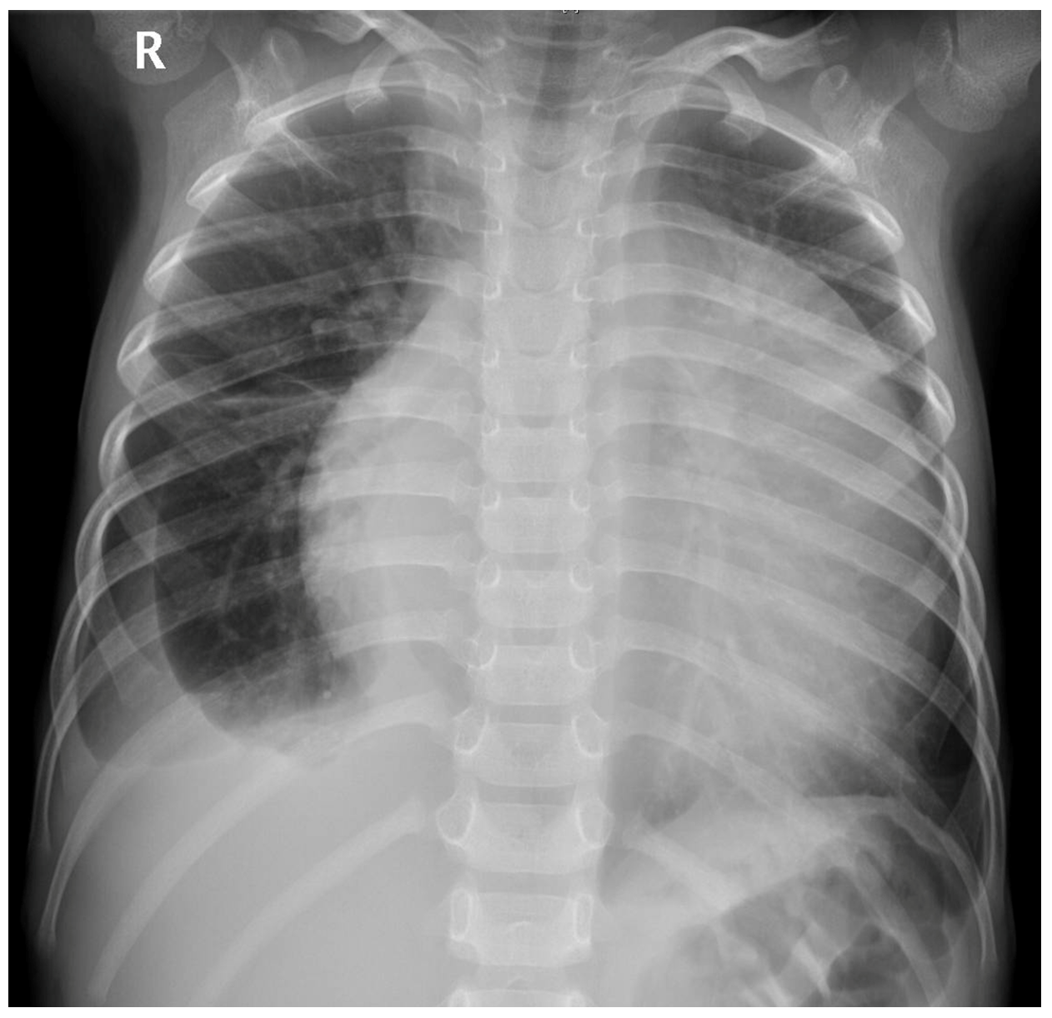
Figure 1 Chest radiography of pericardial primitive neuroectodermal tumor in a 3-year-old boy. Anteroposterior chest radiography revealed an enlarged, flask-shaped heart shadow, and a small amount of effusion in the right pleural cavity.
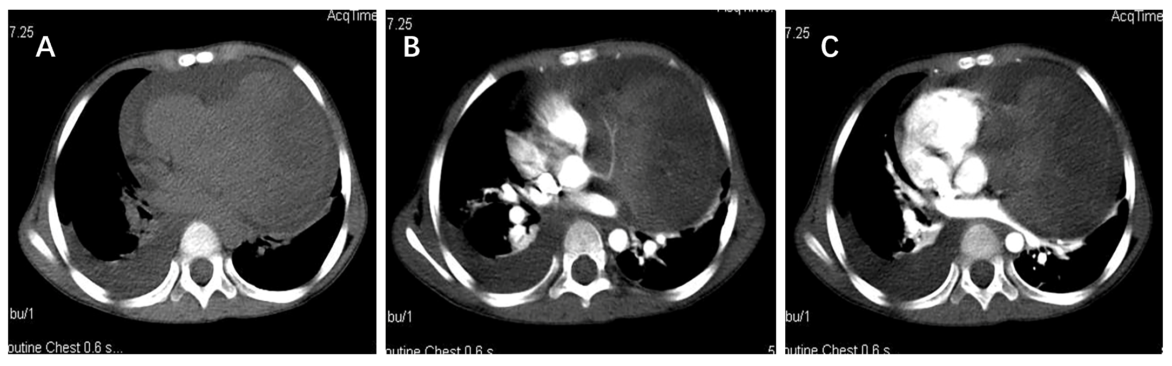
Figure 2 Computed tomography images of pericardial primitive neuroectodermal tumor in a 3-year-old boy. A: Plain computed tomography scan showed pericardial effusion and an indefinite soft tissue density mass in the left pericardial cavity; B and C: The mass was heterogeneously enhanced after intravenous administration of contrast medium (B and C). A coronary artery branch was detected passing through the mass (B).
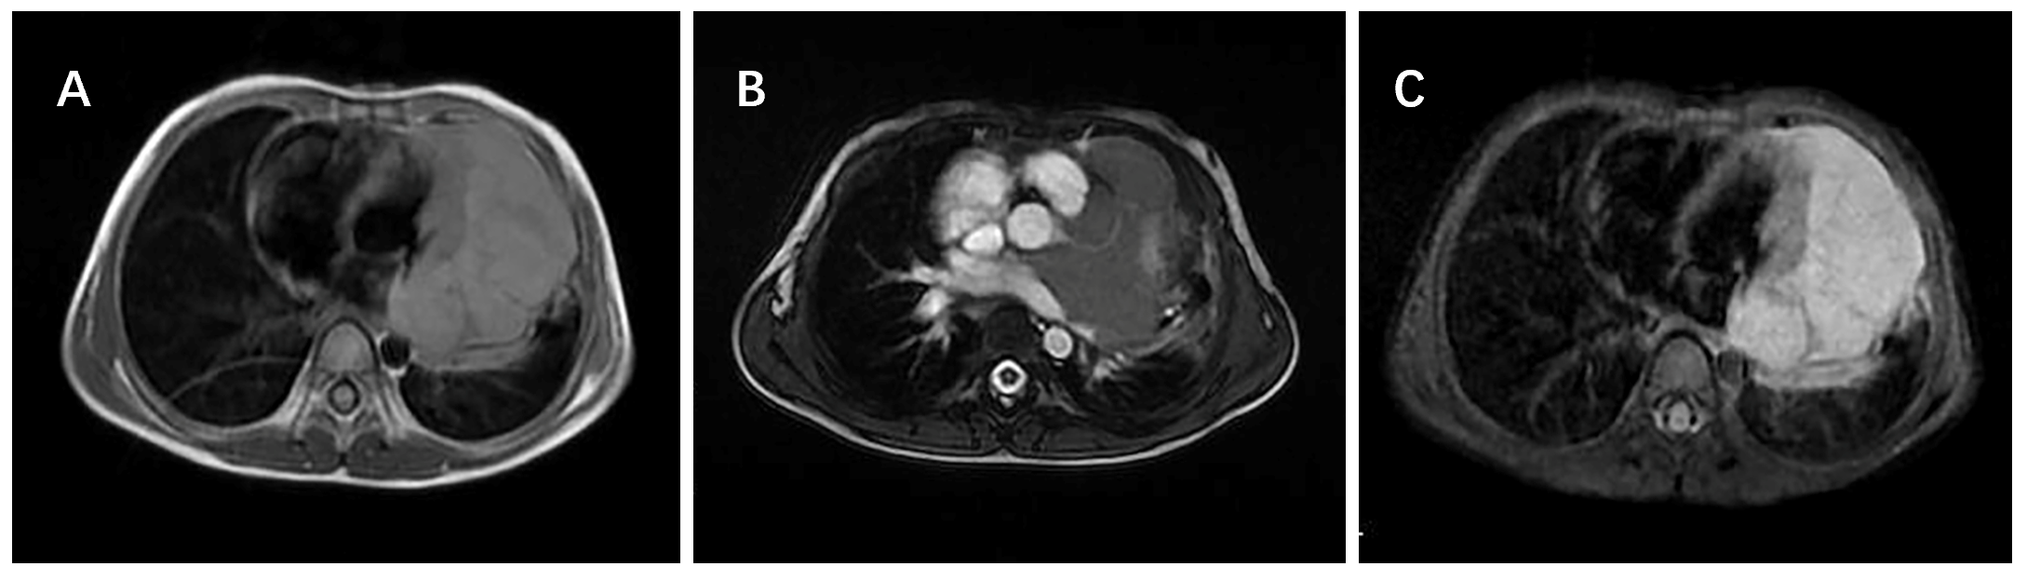
Figure 3 Magnetic resonance imaging of pericardial primitive neuroectodermal tumor in a 3-year-old boy. A and B: The mass showed a heterogeneous signal, mainly slightly hyperintense on T1-weighted images (A) and isointense on T2-weighted images (B). The left coronary artery branch was shown to be embedded within the mass (B), suggesting a pericardial origin of the tumor; C: Contrast enhanced magnetic resonance imaging showed the mass was inhomogeneous with marked enhancement, with a clear and definite border between the mass and the left ventricle wall.

