Name of Journal: World Journal of Hepatology
Manuscript NO: 58000
Manuscript Type: LETTER TO THE EDITOR

Role of platelet-albumin-bilirubin score in predicting re-bleeding after band ligation for acute variceal hemorrhage

Faisal et al. Accuracy of PALBI score in predicting re-bleeding

Muhammad S Faisal, Tavankit Singh, Hina Amin, Jamak Modaresi Esfeh

Muhammad S Faisal, Department of Internal Medicine, Cleveland Clinic, Cleveland, OH 44195, United States

Tavankit Singh, Hina Amin, Jamak Modaresi Esfeh, Department of Gastroenterology and Hepatology, Cleveland Clinic, Cleveland, OH 44195, United States

Author contributions: Faisal MS and Amin H collected data. Singh T and Modaresi Esfeh J designed the study, reviewed the data and letter. Faisal MS performed the statistical analysis and wrote the letter, Modaresi Esfeh J revised the letter.

Corresponding author: Muhammad S Faisal, MD, Doctor, Department of Internal Medicine, Cleveland Clinic, 9500 Euclid Ave, Cleveland, OH 44195, United States. faisalm@ccf.org

Received: July 2, 2020
Revised: September 17, 2020
Accepted: September 25, 2020
Published online: October 27, 2020

Abstract
Platelet-albumin-bilirubin (PALBI) score was proposed by Roayaie et al with modification of previously studied albumin-bilirubin score to include platelet as an indicator of portal hypertension in 2015. Predictive value of this score was recently tested by Elshaarawy et al for re-bleeding in patients presenting with acute variceal hemorrhage. We did a similar study at our center (n = 170) to look at incidence of re-bleeding after band ligation defined as drop in 2 units of hemoglobin and witnessed melena or hematemesis within 2 wk of the procedure. We calculated PALBI scores for all patients based on lab values prior to the procedure. Of 25.3% had re-bleeding episodes, area under receiver operating characteristic curve for PALBI as predictor of re-bleeding was 0.601 (95% confidence interval: 0.502-0.699). PALBI score showed moderate accuracy at predicting re-bleeding in our population.

Key Words: Cirrhosis; Band ligation; Portal hypertension; Ascites; Platelet-albumin-bilirubin; Model of end stage liver disease

Citation: Faisal MS, Singh T, Amin H, Modaresi Esfeh J. Role of platelet-albumin-bilirubin score in predicting re-bleeding after band ligation for acute variceal hemorrhage. World J Hepatol 2020; 12(10): 880-882
URL: https://www.wjgnet.com/1948-5182/full/v12/i10/880.htm
DOI: https://dx.doi.org/10.4254/wjh.v12.i10.880

Core Tip: Platelet-albumin-bilirubin score showed moderate accuracy in predicting re-bleeding after band ligation in patients presenting with acute variceal hemorrhage.
TO THE EDITOR
We read with great interest article by Elshaarawy et al^{[1]} regarding the role of platelet-albumin-bilirubin (PALBI) score in predicting re-bleeding and in-patient mortality for patients presenting with acute variceal hemorrhage^{[1]}. The authors found that area under receiver operating characteristic (AUROC) for PALBI with outcome of re-bleeding was 0.794. This was higher than Child-Turcot-Pugh (CTP), Model of End Stage Liver Disease and Albumin-Bilirubin (ALBI) scores, which were 0.681, 0.74 and 0.766, respectively. PALBI score was proposed by Roayaie et al^{[2]} with modification of previously proposed ALBI score to include platelet as an indicator of portal hypertension in 2015^{[2]}. It has been studied as a predictor of liver transplant outcomes^{[3]}, rate of decompensation in compensated cirrhosis^{[4]}, outcomes of locoregional treatment for liver cancer^{[5]} and now for re-bleeding after acute variceal hemorrhage.
We did a similar study at our center and calculated the PALBI score to validate this data. Our study comprised of 170 patients with a diagnosis of cirrhosis who presented with acute variceal hemorrhage and underwent esophageal variceal band ligation from 2017 to 2018. Of our patients, 18.8% were CTP-A, 48.2% CTP-B and 32.9% CTP-C. In comparison, Elshaarawy et al^{[1]} had 4.5% CTP-A, 29.2% CTP-B and 66.8% CTP-C patients. Our outcome of interest was re-bleeding with the definition proposed by Baveno VI: Drop in two units of hemoglobin along with hematemesis or melena observed clinically within 2 wk of the procedure. 25.3% had re-bleeding in our population based on this definition. 12.1%, 22.6% and 64.3% of our patients qualified for PALBI category 1 (score ≤ -2.53), 2 (score > -2.53 and ≤ -2.09) and 3 (score >-2.09) respectively.
AUROC for PALBI score in predicting re-bleeding was calculated to be 0.601 (95% confidence interval: 0.502-0.699) and the curve is shown in Figure 1. This indicates moderate quality at best of the PALBI score in predicting re-bleeding after band ligation. This is lower than the reported AUROC by Elshaarawy et al^{[1]} by 24.3%. 4.5% of re-bleeders in our cohort belonged to PALBI category 1, 28.9% to PALBI category 2 and 28.7% to PALBI category 3. Rates of re-bleeding in each category are shown in Figure 2.
We found PALBI score to be relatively less accurate than reported by Elshaarawy et al^{[1]} in predicting re-bleeding after band ligation. This discrepancy can be due to differences in the size and characteristics of patient population and definition of the outcome. We only included patients who underwent band ligation for acute variceal hemorrhage from esophageal varices. In contrast, only 51.7% of Elshaarawy et al^{[1]} underwent band ligation alone as treatment for variceal hemorrhage. Their outcome of interest was re-bleeding within 5 d, but we evaluated for re-bleeding within 2 wk following the procedure. Both studies were limited by retrospective design, small number of patients and data from a single institution.
In conclusion, PALBI score is a promising tool for predicting re-bleeding after initial presentation with acute variceal hemorrhage. More data is needed to validate its use in clinical settings post band ligation procedure.

REFERENCES
1 Elshaarawy O, Allam N, Abdelsameea E, Gomaa A, Waked I. Platelet-albumin-bilirubin score - a predictor of outcome of acute variceal bleeding in patients with cirrhosis. World J Hepatol 2020; 12: 99-107 [PMID: 32231763 DOI: 10.4254/wjh.v12.i3.99]
2 Poster Sessions. Hepatology 2015; 62 Suppl 1: 93A-207A [PMID: 26425959 DOI: 10.1002/hep.28162]
3 Chedid MF, Picon RV, Chedid AD. ALBI and PALBI: Novel Scores for Outcome Prediction of Cirrhotic Outpatients Awaiting Liver Transplantation. Ann Hepatol 2018; 17: 906-907 [PMID: 30600306 DOI: 10.5604/01.3001.0012.7190]
4 Oikonomou T, Goulis L, Doumtsis P, Tzoumari T, Akriviadis E, Cholongitas E. ALBI and PALBI Grades Are Associated with the Outcome of Patients with Stable Decompensated Cirrhosis. Ann Hepatol 2019; 18: 126-136 [PMID: 31113581 DOI: 10.5604/01.3001.0012.7904]
5 Ho CHM, Chiang CL, Lee FAS, Choi HCW, Chan JCH, Yeung CSY, Huang JJ, Chan MKH, Blanck O, Wong FCS. Comparison of platelet-albumin-bilirubin (PALBI), albumin-bilirubin (ALBI), and child-pugh (CP) score for predicting of survival in advanced hcc patients receiving radiotherapy (RT). Oncotarget 2018; 9: 28818-28829 [PMID: 29988960 DOI: 10.18632/oncotarget.25522]

Footnotes
Conflict-of-interest statement: Authors have no conflict of interests to disclose

Open-Access: This article is an open-access article that was selected by an in-house editor and fully peer-reviewed by external reviewers. It is distributed in accordance with the Creative Commons Attribution NonCommercial (CC BY-NC 4.0) license, which permits others to distribute, remix, adapt, build upon this work non-commercially, and license their derivative works on different terms, provided the original work is properly cited and the use is non-commercial. See: http://creativecommons.org/Licenses/by-nc/4.0/

Manuscript source: Unsolicited manuscript

Peer-review started: July 2, 2020
First decision: July 30, 2020
Article in press: September 25, 2020

Specialty type: Gastroenterology and hepatology
Country/Territory of origin: United States
Peer-review report’s scientific quality classification
Grade A (Excellent): 0
Grade B (Very good): 0
Grade C (Good): C
Grade D (Fair): 0
Grade E (Poor): 0

P-Reviewer: Garbuzenko DV S-Editor: Liu M L-Editor: A P-Editor: Li X

Figure Legends
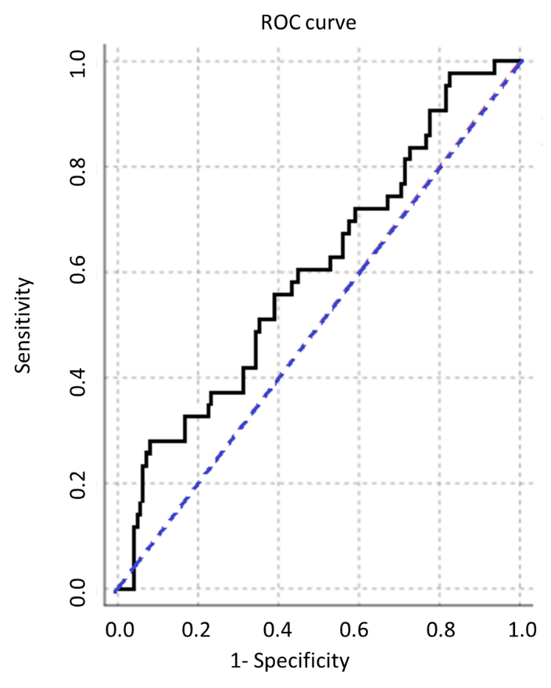
Figure 1 Receiver operating characteristic curve for platelet-albumin-bilirubin score and occurrence of re-bleeding. ROC: Receiver operating characteristic.
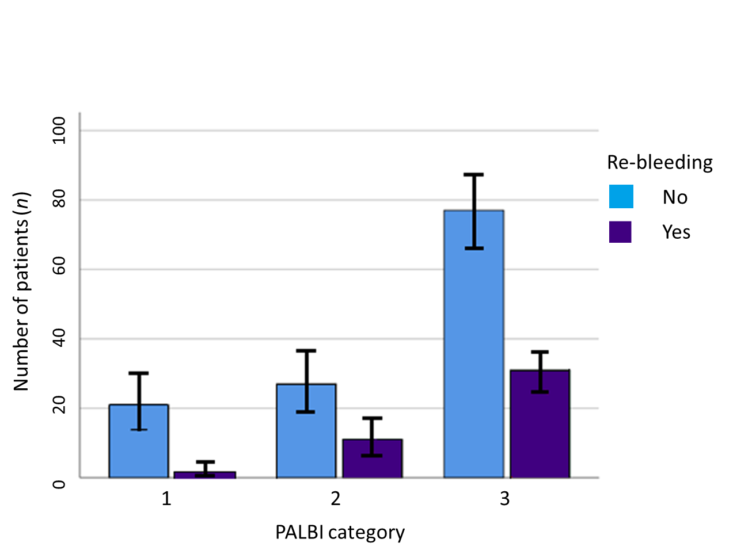
Figure 2 Comparison of different platelet-albumin-bilirubin categories with regards to number of patients who had re-bleeding. PALBI: platelet-albumin-bilirubin.

