Name of Journal: World Journal of Gastrointestinal Oncology
Manuscript NO: 73608
Manuscript Type: CASE REPORT

Primary hepatic angiosarcoma manifesting as hepatic sinusoidal obstruction syndrome: A case report

Ha FS et al. Primary hepatic angiosarcoma

Fu-Shuang Ha, Hua Liu, Tao Han, De-Zhao Song

Fu-Shuang Ha, Hua Liu, Tao Han, De-Zhao Song, The Third Central Clinical College of Tianjin Medical University, Tianjin 300170, China

Fu-Shuang Ha, Hua Liu, Tao Han, De-Zhao Song, Tianjin Key Laboratory of Extracorporeal Life Support for Critical Diseases, Tianjin 300170, China

Fu-Shuang Ha, Hua Liu, Tao Han, De-Zhao Song, Artificial Cell Engineering Technology Research Center, Tianjin 300170, China

Fu-Shuang Ha, Hua Liu, Tao Han, De-Zhao Song, Tianjin Institute of Hepatobiliary Disease, Tianjin 300170, China

Tao Han, Tianjin Union Medical Center, Naikai University Affiliated Hospital, Tianjin 300121, China

Author contributions: Ha FS and Liu H contributed equally to this work; Ha FS and Liu H wrote the original draft; Song DZ performed the transjugular liver biopsy; Han T reviewed and edited the manuscript; all authors have read and approved the final manuscript.

Supported by Tianjin Science and Technology Plan Project, No. 19ZXDBSY00030; and Beijing iGandan Foundation, No. RGGJJ-2021-014.

Corresponding author: Tao Han, MD, PhD, Professor, The Third Central Clinical College of Tianjin Medical University, No. 83 Jintang Road, Tianjin 300170, China. hantaomd@126.com

Received: November 27, 2021
Revised: January 20, 2022
Accepted: April 20, 2022
Published online: May 15, 2022

Abstract
BACKGROUND
Primary hepatic angiosarcoma (PHA) is a rare malignancy with a poor prognosis. It is difficult to diagnose PHA because of the lack of specific symptoms or tumour markers, and it rapidly progresses and has a high mortality. To our knowledge, PHA has not been reported to mimic hepatic sinusoidal obstruction syndrome. Herein, we present a case of PHA manifesting as hepatic sinusoidal obstruction syndrome, diagnosed using transjugular liver biopsy, that resulted in the death of the patient.

CASE SUMMARY
A 71-year-old man was admitted with the primary complaint of abdominal distension, decreased appetite, fatigue in the previous month, and loss of 10 kg of weight in the past 2 years. Both the liver and spleen were enlarged, and the liver had a medium-hard texture on percussion. Laboratory examinations were performed, and abdominal plain computed tomography (CT) and contrast-enhanced CT showed hepatomegaly and splenomegaly, as well as diffuse low-density shadows distributed in the liver and spleen. Contrast-enhanced CT revealed diffuse, hypodense, nodular or flake shadows in the liver and heterogeneous enhancement in the spleen. A transjugular liver biopsy was performed. Based on the pathology results, the patient was diagnosed with hepatic sinusoidal obstruction syndrome secondary to PHA. The patient’s status further deteriorated and he developed serious hepatic failure. The patient was discharged, and died 3 d later.

CONCLUSION
PHA is rare and has a poor prognosis; however, transjugular liver biopsy can be safely performed to aid in diagnosis.

Key Words: Hepatic angiosarcoma; Hepatic sinusoidal obstruction syndrome; Outcome; Primary cancer; High mortality; Case report

©The Author(s) 2022. Published by Baishideng Publishing Group Inc. All rights reserved.

Citation: Ha FS, Liu H, Han T, Song DZ. Primary hepatic angiosarcoma manifesting as hepatic sinusoidal obstruction syndrome: A case report. World J Gastrointest Oncol 2022; 14(5): 1050-1056
URL: https://www.wjgnet.com/1948-5204/full/v14/i5/1050.htm
DOI: https://dx.doi.org/10.4251/wjgo.v14.i5.1050

Core Tip: To our knowledge, primary hepatic angiosarcoma (PHA) has not been reported to mimic hepatic sinusoidal obstruction syndrome. Here, we present a patient who died from PHA, which manifested as hepatic sinusoidal obstruction syndrome and was diagnosed by transjugular liver biopsy.

INTRODUCTION
Primary hepatic angiosarcoma (PHA) is a rare form of malignancy, accounting for 2% of all primary liver tumours. Despite the low incidence, PHA is still the most common malignant mesenchymal tumour of the liver and the third most common primary liver malignancy^{[1,2]}. Accurate diagnosis of this tumour is usually difficult because the symptoms and signs are not specific, and tumours are difficult to distinguish radiologically from other hepatic tumours^{[3]}. In addition, a tissue sample is required for a diagnosis, and very few patients opt to undergo a needle biopsy^{[4]}. Herein, we report a case of PHA, which manifested as hepatic sinusoidal obstruction syndrome.

CASE PRESENTATION
Chief complaints
A 71-year-old man was admitted to our hospital with the primary complaint of abdominal distension that commenced a fortnight before presentation.

History of present illness
The patient had ingested herbal medicine for 20 d prior, to maintain his health, but complained of decreased appetite and fatigue in the previous month, and had lost 10 kg of weight in the past 2 years.

History of past illness
The patient denied any history of hepatitis, diabetes mellitus, or cancer.

Personal and family history
The patient was not a habitual drinker and did not have any significant history of exposure to carcinogenic chemicals such as thorium dioxide, vinyl chloride monomer, or arsenic.

Physical examination
Both the liver and spleen were enlarged, and the liver had a medium-hard texture on percussion.

Laboratory examinations
Laboratory examinations on admission were as follows: White blood cell count, 6.57 × 10⁹/L; haemoglobin, 88 g/L; platelet count, 45 × 10⁹/L; albumin, 32.5 g/L; alanine aminotransferase, 90 U/L; aspartate transaminase, 124 U/L; alkaline phosphatase, 231 U/L; γ-glutamyl transpeptidase, 257 U/L; total bilirubin, 82.6 μmol/L; direct bilirubin, 48.2 μmol/L; prothrombin time, 18.9 s; international normalised ratio, 1.6; and plasma D-dimer, > 10 mg/L. Tumour markers, including α-fetoprotein, carcinoembryonic antigen, and carbohydrate antigen 19-9, were within normal ranges. Screening tests for autoantibodies and viral hepatitis returned negative results.

Imaging examinations
Abdominal plain computed tomography (CT) and contrast-enhanced CT showed hepatomegaly and splenomegaly, as well as diffuse low-density shadows distributed in the liver and spleen (Figure 1A). Contrast-enhanced CT revealed diffuse, hypodense, nodular or flake shadows in the liver and heterogeneous enhancement in the spleen (Figure 1B).

FINAL DIAGNOSIS
The patient presented with abdominal distension, jaundice, ascites, and hepatomegaly, in conjunction with the evidence on enhanced computed tomography; in addition, Budd-Chiari syndrome was ruled out because there were no communicating branches between the narrowed hepatic veins. The patient had a history of herbal medicine intake. After excluding other known causes of liver injury, a preliminary diagnosis of hepatic sinusoidal obstruction syndrome was made; however, there remained some doubts as the herbal medicine that the patient had ingested in its common form does not contain pyrrolidine alkaloid and splenomegaly was significant in the acute phase. The occurrence of splenomegaly during the acute phase of hepatic sinusoidal obstruction syndrome is rare. A transjugular liver biopsy was subsequently performed to improve the diagnosis.
Anticoagulation therapy was administered the following day. Three days later, pathological examination of a liver biopsy sample showed that the hepatic sinusoids were obviously dilated and filled with red blood cells. Hepatocytes around the sinusoid atrophy were found. Significant cytological atypia was observed with anastomosing channels, which was suggestive of angiosarcoma (Figure 2). Immunohistochemically, the specimen was positive for CD31, CD34, and electroretinography (ERG), supporting the diagnosis of PHA (Figure 3). The Ki-67 proliferative index was almost 20%–30%. Based on the pathology results, the patient was diagnosed with hepatic sinusoidal obstruction syndrome secondary to PHA.

TREATMENT
Whole-body positron emission tomography/CT fusion scanning was performed after administration of 18F-fluorodeoxyglucose (¹⁸F-FDG) for staging purposes to identify metastatic sites. Diffuse areas of increased uptake were seen in the liver, which corresponded to images on CT (Figure 4A). The maximum standardised uptake value in the liver was 4.3. In addition, multiple areas of increased uptake were detected in the spleen and right ilium, suggestive of spleen dissemination (Figure 4A) and bone metastasis (Figure 4B), respectively.

OUTCOME AND FOLLOW-UP
The patient’s status further deteriorated, with the development of serious hepatic failure, and progressive reduction in haemoglobin levels and platelet counts. The patient complained of further aggravated abdominal distension. At the family’s request, the patient was discharged; he died 3 d later.

DISCUSSION
This case highlights the rarity and complex nature of the diagnosis of PHA. Owing to its rare occurrence, nonspecific symptomatology, nonspecific tumour makers, challenging radiographic findings, and low biopsy rate, confirming a diagnosis of PHA is difficult. The aetiology of PHA remains unclear. According to an epidemiological study, vinyl chloride monomer, thorium dioxide, arsenic, and androgenic anabolic steroids are associated with the development of PHA in 25% of all cases^{[5]}.
The symptoms of PHA are variable. Most patients have nonspecific symptoms including abdominal pain, fatigue, weakness, anorexia, weight loss, fever, and low back pain, and these symptoms mimic chronic liver diseases^{[6]}. PHA is more predominantly found in men, with a male to female diagnosis ratio of 3:1, and presents in the fifth or sixth decade of life^{[7]}.
It has been suggested that PHA can be elucidated by counting the number and size of hepatic tumours on CT images. PHA can appear as multiple nodules, a dominant mass, or a mixed pattern of a dominant mass and multiple nodules, but rarely manifests as an infiltrative, micronodular subtype^{[1]}. In our case, the tumour manifested as an infiltrative, micronodular subtype and the findings on contrast-enhanced CT were consistent with hepatic sinusoidal obstruction syndrome. To our knowledge, this is the first reported case of hepatic sinusoidal obstruction syndrome that was diagnosed as PHA.
The history of herbal medicine intake made this diagnosis more difficult. In China, hepatic sinusoidal obstruction syndrome is often associated with the oral intake of plants that contain pyrrolidine alkaloids. Our case met the ‘Nanjing criteria’ for the diagnosis of hepatic sinusoidal obstruction syndrome except that the herbal medicine that the patient had ingested does not contain pyrrolidine alkaloid in its common form^{[8]}. Budd-Chiari syndrome, especially the type with simple hepatic vein obstruction, can be easily misdiagnosed. Communicating branches between the narrowed hepatic veins are seen in Budd-Chiari syndrome and are a critical feature that distinguishes Budd-Chiari syndrome from other similar conditions^{[8]}.
The patient’s condition progressed rapidly. Thus, the diagnosis was questionable. A liver biopsy was necessary to establish a definitive diagnosis. However, because the patient’s platelet count continued to decline and coagulation disorders and jaundice could not be controlled, a percutaneous liver biopsy was not performed, due to the associated increased risk of bleeding. There is evidence that transjugular liver biopsy is a highly efficacious, well-tolerated, and safe procedure. It can be safely performed multiple times in the same patient or in critically ill patients with severe coagulopathy and does not significantly increase the rate of complications while maintaining an extremely favourable diagnostic yield^{[9]}. It is difficult to make a diagnosis of PHA using only a CT scan, and a biopsy might be a reasonable option; however, percutaneous liver biopsy in patients with PHA is not safe because of the vascular nature of the tumour and its tendency to haemorrhage^{[2]}. Thus, sometimes, transjugular liver biopsy is a good choice.
Microscopic examination could show cytological atypia such as spindle-shaped cells, and immunohistochemical staining positive for CD31, CD34, ERG, and factor VIII in patients with PHA^{[10,11]}.
There is report that ¹⁸F-FDG positron emission tomography is helpful for distinguishing between PHA and giant cavernous hepatic haemangioma^{[8]}, and it can help to identify metastatic sites for staging purposes. At the time of presentation, most patients with PHA have metastatic lesions, such as lung or spleen lesions^{[12]}.
The treatment of PHA has not been defined owing to its rarity and association with high mortality. The median survival duration is 6 mo if the patient does not undergo treatment, and only 3% of patients live longer than 2 years^{[2]}. There are several choices of treatment for patients with PHA. Ideal treatment is complete resection, especially when the tumour is limited to one segment of the liver^{[13]}. The prognoses of these patients depend on the ability to achieve complete tumour resection^{[14]}. However, more than 80% of patients are diagnosed at advanced stage, with only a few patients meeting the criteria for tumour resection, thus curative surgery is difficult to perform^{[15]}. PHA is considered to be a contraindication for liver transplantation as survival is poor and recurrence rates are high^{[16]}.
PHA is also reported to be radioresistant^{[3]}. Alternative palliative therapies, including transarterial chemoembolization and systemic chemotherapy, are considered to be effective for unresectable PHA^{[17,18]}. Transarterial chemoembolization is useful to treat acute arterial bleeding from the liver of patients with PHA^{[18]}.

CONCLUSION
PHA is a rare malignancy with a poor prognosis. This case highlights the rarity of the disease, and the difficulty of diagnosis. Transjugular liver biopsy may be a safe choice in patients with PHA to aid in diagnosis.

REFERENCES
1 Koyama T, Fletcher JG, Johnson CD, Kuo MS, Notohara K, Burgart LJ. Primary hepatic angiosarcoma: findings at CT and MR imaging. Radiology 2002; 222: 667-673 [PMID: 11867783 DOI: 10.1148/radiol.2223010877]
2 Locker GY, Doroshow JH, Zwelling LA, Chabner BA. The clinical features of hepatic angiosarcoma: a report of four cases and a review of the English literature. Medicine (Baltimore) 1979; 58: 48-64 [PMID: 368508 DOI: 10.1097/00005792-197901000-00003]
3 Molina E, Hernandez A. Clinical manifestations of primary hepatic angiosarcoma. Dig Dis Sci 2003; 48: 677-682 [PMID: 12741455 DOI: 10.1023/a:1022868221670]
4 Kew MC, Dos Santos HA, Sherlock S. Diagnosis of primary cancer of the liver. Br Med J 1971; 4: 408-411 [PMID: 5124443 DOI: 10.1136/bmj.4.5784.408]
5 Falk H, Herbert J, Crowley S, Ishak KG, Thomas LB, Popper H, Caldwell GG. Epidemiology of hepatic angiosarcoma in the United States: 1964-1974. Environ Health Perspect 1981; 41: 107-113 [PMID: 7199426 DOI: 10.1289/ehp.8141107]
6 Zhu YP, Chen YM, Matro E, Chen RB, Jiang ZN, Mou YP, Hu HJ, Huang CJ, Wang GY. Primary hepatic angiosarcoma: A report of two cases and literature review. World J Gastroenterol 2015; 21: 6088-6096 [PMID: 26019478 DOI: 10.3748/wjg.v21.i19.6088]
7 Abegunde AT, Aisien E, Mba B, Chennuri R, Sekosan M. Fulminant hepatic failure secondary to primary hepatic angiosarcoma. Case Rep Gastrointest Med 2015; 2015: 869746 [PMID: 25815217 DOI: 10.1155/2015/869746]
8 Zhuge Y, Liu Y, Xie W, Zou X, Xu J, Wang J; Chinese Society of Gastroenterology Committee of Hepatobiliary Disease. Expert consensus on the clinical management of pyrrolizidine alkaloid-induced hepatic sinusoidal obstruction syndrome. J Gastroenterol Hepatol 2019; 34: 634-642 [PMID: 30669184 DOI: 10.1111/jgh.14612]
9 Sue MJ, Lee EW, Saab S, McWilliams JP, Durazo F, El-Kabany M, Kaldas F, Busuttil RW, Kee ST. Transjugular Liver Biopsy: Safe Even in Patients With Severe Coagulopathies and Multiple Biopsies. Clin Transl Gastroenterol 2019; 10: e00063 [PMID: 31259750 DOI: 10.14309/ctg.0000000000000063]
10 Wang ZB, Wei LX. [Primary hepatic angiosarcoma: a clinical and pathological analysis]. Zhonghua Bing Li Xue Za Zhi 2013; 42: 376-380 [PMID: 24060070 DOI: 10.3760/cma.j.issn.0529-5807.2013.06.005]
11 Wang ZB, Yuan J, Chen W, Wei LX. Transcription factor ERG is a specific and sensitive diagnostic marker for hepatic angiosarcoma. World J Gastroenterol 2014; 20: 3672-3679 [PMID: 24707153 DOI: 10.3748/wjg.v20.i13.3672]
12 Park YS, Kim JH, Kim KW, Lee IS, Yoon HK, Ko GY, Sung KB. Primary hepatic angiosarcoma: imaging findings and palliative treatment with transcatheter arterial chemoembolization or embolization. Clin Radiol 2009; 64: 779-785 [PMID: 19589416 DOI: 10.1016/j.crad.2009.02.019]
13 Adson MA, Beart RW Jr. Elective hepatic resections. Surg Clin North Am 1977; 57: 339-360 [PMID: 322336 DOI: 10.1016/s0039-6109(16)41186-2]
14 Weitz J, Klimstra DS, Cymes K, Jarnagin WR, D'Angelica M, La Quaglia MP, Fong Y, Brennan MF, Blumgart LH, Dematteo RP. Management of primary liver sarcomas. Cancer 2007; 109: 1391-1396 [PMID: 17315167 DOI: 10.1002/cncr.22530]
15 Bioulac-Sage P, Laumonier H, Laurent C, Blanc JF, Balabaud C. Benign and malignant vascular tumors of the liver in adults. Semin Liver Dis 2008; 28: 302-314 [PMID: 18814083 DOI: 10.1055/s-0028-1085098]
16 Gatta G, Ciccolallo L, Kunkler I, Capocaccia R, Berrino F, Coleman MP, De Angelis R, Faivre J, Lutz JM, Martinez C, Möller T, Sankila R; EUROCARE Working Group. Survival from rare cancer in adults: a population-based study. Lancet Oncol 2006; 7: 132-140 [PMID: 16455477 DOI: 10.1016/S1470-2045(05)70471-X]
17 Ratan R, Patel SR. Chemotherapy for soft tissue sarcoma. Cancer 2016; 122: 2952-2960 [PMID: 27434055 DOI: 10.1002/cncr.30191]
18 Leowardi C, Hormann Y, Hinz U, Wente MN, Hallscheidt P, Flechtenmacher C, Buchler MW, Friess H, Schwarzbach MH. Ruptured angiosarcoma of the liver treated by emergency catheter-directed embolization. World J Gastroenterol 2006; 12: 804-808 [PMID: 16521200 DOI: 10.3748/wjg.v12.i5.804]

Footnotes
Informed consent statement: The patient and his legal guardian provided informed written consent prior to the case report.

Conflict-of-interest statement: Nothing to disclosed.

CARE Checklist (2016) statement: The authors have read the CARE checklist (2016), and the manuscript was prepared and revised according to the CARE checklist (2016).

Open-Access: This article is an open-access article that was selected by an in-house editor and fully peer-reviewed by external reviewers. It is distributed in accordance with the Creative Commons Attribution NonCommercial (CC BY-NC 4.0) license, which permits others to distribute, remix, adapt, build upon this work non-commercially, and license their derivative works on different terms, provided the original work is properly cited and the use is non-commercial. See: https://creativecommons.org/Licenses/by-nc/4.0/

Provenance and peer review: Unsolicited article; Externally peer reviewed.
Peer-review model: Single blind

Peer-review started: November 27, 2021
First decision: January 8, 2022
Article in press: April 20, 2022

Specialty type: Oncology
Country/Territory of origin: China
Peer-review report’s scientific quality classification
Grade A (Excellent): 0
Grade B (Very good): 0
Grade C (Good): C, C
Grade D (Fair): 0
Grade E (Poor): E

P-Reviewer: Ferraioli G, Italy; Ghannam WM, Egypt; Kumar A, India S-Editor: Fan JR L-Editor: Wang TQ P-Editor: Fan JR

Figure Legends
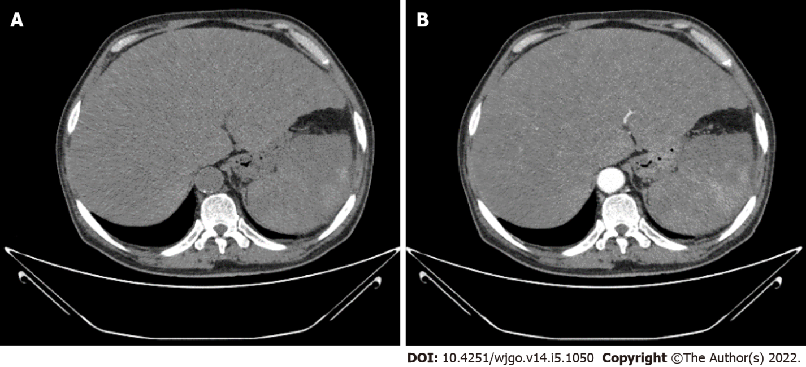
Figure 1 Abdominal plain computed tomography and contrast-enhanced computed tomography images. A: Abdominal plain computed tomography (CT) image; B: Contrast-enhanced CT image. Abdominal plain CT and contrast-enhanced CT showed hepatomegaly and splenomegaly and diffuse low-density shadows distributed in the liver and spleen. Contrast-enhanced CT revealed diffuse, hypodense, nodular or flake shadows in the liver and heterogeneous enhancement in the spleen.

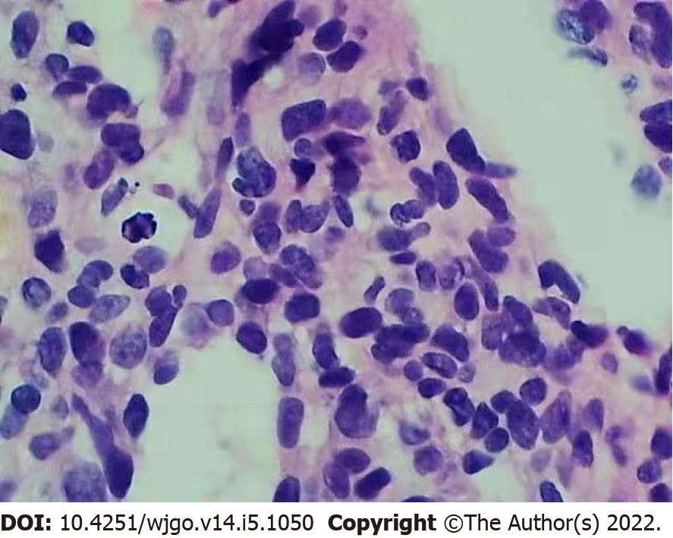
Figure 2 Haematoxylin and eosin-stained liver biopsy (× 400) demonstrating significant cytological atypia with anastomosing channels.

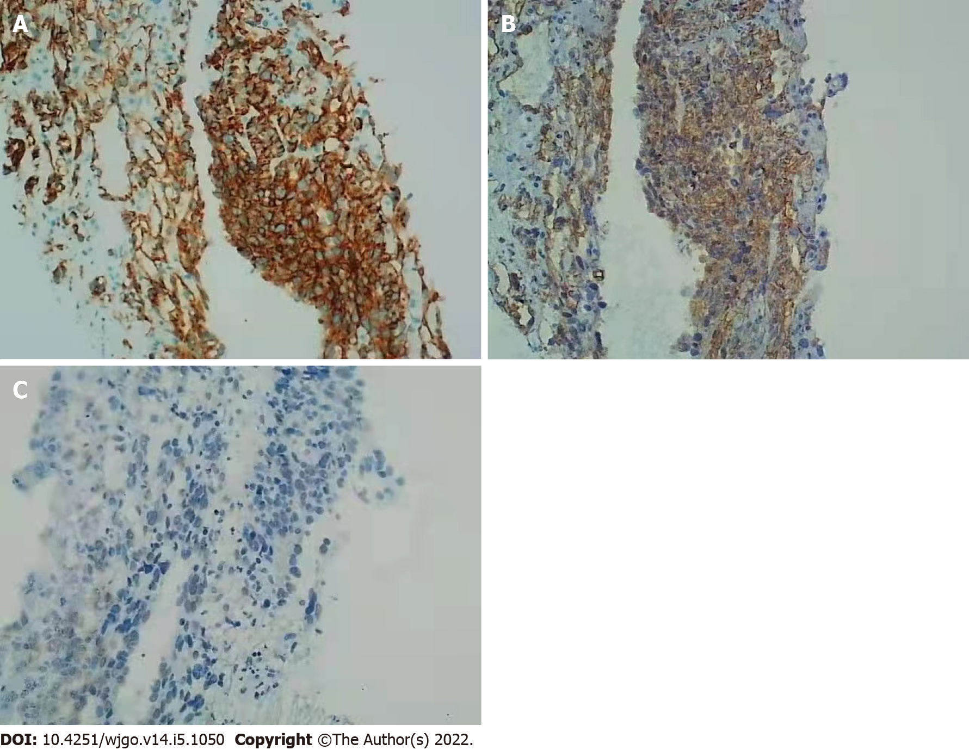
Figure 3 Immunohistochemical staining. The hepatic angiosarcoma components are positive for CD31 and CD34 and weakly positive for electroretinography (ERG) (original magnification, × 200). A: CD31; B: CD34; C: ERG.

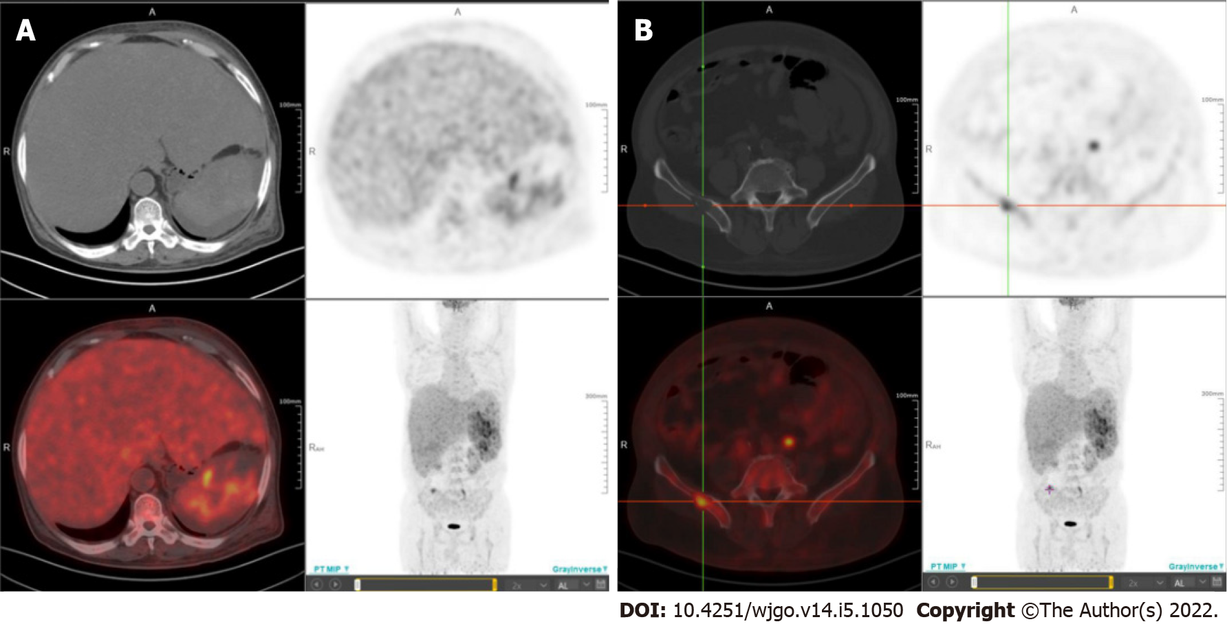
Figure 4 18F-fluorodeoxyglucose positron emission tomography/computed tomography images. A: 18F-fluorodeoxyglucose (¹⁸F-FDG) positron emission tomography/computed tomography (PET/CT) images show marked FDG accumulation within the liver and spleen; B: ¹⁸F-FDG PET/CT images show marked FDG accumulation within the right ilium.

Published by Baishideng Publishing Group Inc
7041 Koll Center Parkway, Suite 160, Pleasanton, CA 94566, USA
Telephone: +1-925-3991568
E-mail: bpgoffice@wjgnet.com
Help Desk: https://www.f6publishing.com/helpdesk
https://www.wjgnet.com

© 2022 Baishideng Publishing Group Inc. All rights reserved.

