Copyright Information of the Article Published Online
TITLE | High-resolution computed tomography findings in humoral primary immunodeficiencies and correlation with pulmonary function tests
AUTHOR(s) | Lorenzo Cereser, Marco De Carli, Paola d'Angelo, Elisa Zanelli, Chiara Zuiani and Rossano Girometti
CITATION | Cereser L, De Carli M, d’Angelo P, Zanelli E, Zuiani C, Girometti R. High-resolution computed tomography findings in humoral primary immunodeficiencies and correlation with pulmonary function tests. World J Radiol 2018; 10(11): 170-181
URL | http://www.wjgnet.com/1949-8470/full/v10/i11/170.htm
DOI | http://dx.doi.org/10.4329/wjr.v10.i11.170
OPEN ACCESS | This article is an open-access article which was selected by an in-house editor and fully peer-reviewed by external reviewers. It is distributed in accordance with the Creative Commons Attribution Non Commercial (CC BY-NC 4.0) license, which permits others to distribute, remix, adapt, build upon this work non-commercially, and license their derivative works on different terms, provided the original work is properly cited and the use is non-commercial. See: http://creativecommons.org/licenses/by-nc/4.0/
CORE TIP | Humoral primary immunodeficiencies (hPIDs) are a group of conditions characterized by impaired antibody production and presenting with recurrent respiratory infections, autoimmune diseases, and malignancy. Chest high-resolution computed tomography (HRCT) is the imaging technique of choice for detecting, characterizing, and quantifying lung complications in these patients. The aims of this study were to compare HRCT findings in 52 patients with hPIDs subtypes (common variable immunodeficiency disorders - CVID vs CVID-like), and evaluate whether these findings may predict pulmonary function tests results. CVID vs CVID-like patients showed comparable HRCT findings. The presence of tree-in-bud and linear and/or irregular opacities were independent predictors of, respectively, significant obstructive and restrictive defects.
KEY WORDS | Bronchiectasis, Multidetector computed tomography, Common variable immunodeficiency, Immunologic deficiency syndromes, and Respiratory function tests
COPYRIGHT | © The Author(s) 2018. Published by Baishideng Publishing Group Inc. All rights reserved.
NAME OF JOURNAL | World Journal of Radiology
ISSN | 1949-8470
PUBLISHER | Baishideng Publishing Group Inc, 7901 Stoneridge Drive, Suite 501, Pleasanton, CA 94588, USA
WEBSITE | Http://www.wjgnet.com

Name of Journal: World Journal of Radiology
Manuscript NO: 40801
Manuscript Type: ORIGINAL ARTICLE

Retrospective Study
High-resolution computed tomography findings in humoral primary immunodeficiencies and correlation with pulmonary function tests

Cereser L et al. HRCT findings in humoral primary immunodeficiencies

Lorenzo Cereser, Marco De Carli, Paola d’Angelo, Elisa Zanelli, Chiara Zuiani, Rossano Girometti

Lorenzo Cereser, Paola d’Angelo, Elisa Zanelli, Chiara Zuiani, Rossano Girometti, Institute of Radiology, Department of Medicine, University of Udine, Azienda Sanitaria Universitaria Integrata di Udine, Udine 33100, Italy

Marco De Carli, Second Unit of Internal Medicine, Azienda Sanitaria Universitaria Integrata di Udine, Udine 33100, Italy

Paola d’Angelo, Department of Imaging, Bambino Gesù Children Hospital, IRCCS, Rome 00165, Italy

ORCID number: Lorenzo Cereser (0000-0003-4480-8872); Marco De Carli (0000-0003-4845-205X); Paola d’Angelo (0000-0003-2218-5571); Elisa Zanelli (0000-0002-7271-0613); Chiara Zuiani (0000-0001-5132-3115); Rossano Girometti (0000-0002-0904-5147).

Author contributions: All authors helped performing the research; Cereser L drafted the concept of the research, designed the study, read the HRCT examinations and wrote the manuscript; De Carli M contributed to designing the study and writing the manuscript; d’Angelo P and Zanelli E collected the data and contributed to analysing the data and writing the manuscript; Zuiani C drafted the concept of the research and contributed to designing the study; Girometti R designed the study, analysed the data and contributed to writing the manuscript.

Institutional review board statement: Our referring Ethical Committee approved this study.

Informed consent statement: By Italian regulations (decision n. 531, December 15, 2016 by the Authority for personal data protection) informed consent acquisition is waived for retrospective studies involving analysis of anonymized data.

Conflict-of-interest statement: All authors declare no conflicts of interest related to this article.

Open-Access: This article is an open-access article which was selected by an in-house editor and fully peer-reviewed by external reviewers. It is distributed in accordance with the Creative Commons Attribution Non Commercial (CC BY-NC 4.0) license, which permits others to distribute, remix, adapt, build upon this work non-commercially, and license their derivative works on different terms, provided the original work is properly cited and the use is non-commercial. See: http://creativecommons.org/licenses/by-nc/4.0/

Manuscript source: Unsolicited manuscript

Correspondence to: Lorenzo Cereser, MD, Doctor, Institute of Radiology, Department of Medicine, University of Udine, Azienda Sanitaria Universitaria Integrata di Udine, p.le S. Maria della Misericordia 15, Udine 33100, Italy. lcereser@sirm.org
Telephone: +39-432-559266
Fax: +39-432-559867

Received: July 17, 2018
Peer-review started: July 17, 2018
First decision: August 8, 2018
Revised: Septermber 22, 2018
Accepted: October 7, 2018
Article in press: October 7, 2018
Published online: November 28, 2018

Abstract
AIM
To compare high-resolution computed tomography (HRCT) findings between humoral primary immunodeficiencies (hPIDs) subtypes and correlated to pulmonary function tests (PFTs).

METHODS
We retrospectively identified 52 consecutive adult patients with hPIDs who underwent 64-row HRCT and PFTs at the time of diagnosis. On a per-patient basis, an experienced radiologist recorded airway abnormalities (bronchiectasis, airway wall thickening, mucus plugging, tree-in-bud, and air-trapping) and parenchymal-interstitial abnormalities (consolidations, ground-glass opacities, linear and/or irregular opacities, nodules, and bullae/cysts) found on HRCT. The chi-square test was performed to compare the prevalence of each abnormality among patients with different subtypes of hPIDs. Overall logistic regression analysis was performed to assess whether HRCT findings predicted obstructive and/or restrictive PFTs results (absent-to-mild vs moderate-to-severe).

RESULTS
Thirty-eight of the 52 patients with hPIDs showed common variable immunodeficiency disorders (CVID), while the remaining 14 had CVID-like conditions (i.e., 11 had isolated IgG subclass deficiencies and 3 had selective IgA deficiencies). The prevalence of most HRCT abnormalities was not significantly different between CVID and CVID-like patients (P > 0.05), except for linear and/or irregular opacities (prevalence of 31.6% in the CVID group and 0 in the CVID-like group; P = 0.0427). Airway wall thickening was the most frequent HRCT abnormality found in both CVID and CVID-like patients (71% of cases in both groups). The presence of tree-in-bud abnormalities was an independent predictor of moderate-to-severe obstructive defects at PFTs (Odds Ratio, OR, of 18.75, P < 0.05), while the presence of linear and/or irregular opacities was an independent predictor of restrictive defects at PFTs (OR = 13.00; P < 0.05).

CONCLUSION
CVID and CVID-like patients showed similar HRCT findings. Tree-in-bud and linear and/or irregular opacities predicted higher risks of, respectively, obstructive and restrictive defects at PFTs.

Key words: Multidetector computed tomography; Immunologic deficiency syndromes; Common variable immunodeficiency; Respiratory function tests; Bronchiectasis

© The Author(s) 2018. Published by Baishideng Publishing Group Inc. All rights reserved.

Core tip: Humoral primary immunodeficiencies (hPIDs) are a group of conditions characterized by impaired antibody production and presenting with recurrent respiratory infections, autoimmune diseases, and malignancy. Chest high-resolution computed tomography (HRCT) is the imaging technique of choice for detecting, characterizing, and quantifying lung complications in these patients. The aims of this study were to compare HRCT findings in 52 patients with hPIDs subtypes (common variable immunodeficiency disorders - CVID vs CVID-like), and evaluate whether these findings may predict pulmonary function tests results. CVID vs CVID-like patients showed comparable HRCT findings. The presence of tree-in-bud and linear and/or irregular opacities were independent predictors of, respectively, significant obstructive and restrictive defects.

Cereser L, De Carli M, d’Angelo P, Zanelli E, Zuiani C, Girometti R. High-resolution computed tomography findings in humoral primary immunodeficiencies and correlation with pulmonary function tests. World J Radiol 2018; 10(11): 172-183 Available from: URL: http://www.wjgnet.com/1949-8470/full/v10/i11/172.htm DOI: http://dx.doi.org/10.4329/wjr.v10.i11.172

INTRODUCTION
Humoral primary immunodeficiencies (hPIDs), also known as primary predominantly antibody deficiencies, constitute the most common subgroup of primary immunodeficiency disorders (about 50% of diagnoses)^{[1]}. hPIDs encompass a spectrum of conditions characterized by impaired antibody production, manifesting with recurrent respiratory tract infections, increased susceptibility to autoimmune diseases, and malignancy^{[1,2]}. Common variable immunodeficiency disorders (CVID) are the most clinically significant group of hPIDs (with a prevalence of about 1:25000-1:50000 subjects). These disorders show distinct clinical and laboratory phenotypes associated with low levels of IgG and IgA and/or IgM^{[3,4]}. CVID onset is during adult life in 70% of the cases, generally occurring between 20 and 40 years of age^{[5,6]}. Other hPIDs are often referred as “CVID-like” conditions: these conditions are in most cases asymptomatic and include selective IgA deficiency (the most frequent hPID, with a prevalence of 1/600 in white people) and isolated IgG subclass deficiency^{[2,7,8]}.
Overall, thoracic complications develop in 60% of patients with hPIDs, representing the leading cause of morbidity and mortality. Chest high-resolution computed tomography (HRCT) is the imaging technique of choice for detecting, characterizing, and quantifying lung complications, as well as for evaluating the response to therapy^{[1,9,10]}. It is generally accepted that the initial evaluation of newly diagnosed patients should include HRCT and pulmonary function tests (PFTs). Early identification of respiratory complications provides a baseline assessment of lung involvement, allows prompt treatment to reduce the number of pulmonary infections, and impacts on quality of life and mortality, the latter being influenced by both structural and functional pulmonary impairment^{[5,11,12]}.
Several studies have reported HRCT findings in hPIDs; these findings include non-infective airway disorders (i.e., bronchiectasis, airway wall thickening, and air trapping), pulmonary infections, diffuse lung parenchymal diseases [e.g., Granulomatous and Lymphocytic Interstitial Lung Disease (GLILD), and organising pneumonia], and thoracic neoplasms (e.g., lymphoma)^{[10,13-16]}. However, most papers refer only to CVID patients, and report that HRCT abnormalities are present in more than 90% of those patients^{[9,17]}. While some Authors reported that the severity of HRCT abnormalities was not significantly different between CVID and CVID-like paediatric patients^{[18,19]}, to the best of our knowledge no studies have addressed this issue in adult patients. Demonstrating a difference between CVID and CVID-like patients may influence the time intervals between HRCT examinations during follow-up in these 2 subgroups of hPIDs. In addition to this, previous studies assessing a correlation between HRCT findings and PFTs results demonstrated contradictory results^{[9,17,18,20]}.
The purpose of this study was twofold: (1) to compare HRCT pulmonary findings in adult patients among different subgroups of hPIDs (i.e., CVID and CVID-like); and (2) to assess whether HRCT findings predict PFTs results.

MATERIALS AND METHODS
Study population and PFTs
Our referring Ethical Committee approved this study. The need for informed consent was waived due to the retrospective design of the study. By performing a computerized search, we identified 56 adult patients who received a definite diagnosis of hPIDs, in accordance with the European Society for Immunodeficiencies criteria^{[21]}, in our tertiary referral centre and between 2012 and 2016. Diagnosis was performed after a history of previously undefined respiratory disease ranging from 1 to 5 years in duration. All patients underwent HRCT and PFTs within one month from diagnosis as a part of the diagnostic workflow performed at our institute. Accordingly, hereinafter we are going to refer to the HRCT performed at the time of diagnosis as baseline HRCT. Four patients were excluded from the study due to infectious respiratory disease at the time of HRCT (clinically unstable disease) or unavailability of the PFTs results. Therefore, the final population included 52 patients and had the following distribution of disease subtypes: 38 CVID, 11 isolated IgG subclass deficiency, and 3 selective IgA deficiency cases.
Lung function was evaluated according to the criteria of the European Respiratory Society/American Thoracic Society task force^{[22]}. The following parameters were measured with a spirometer (Vmax 29c; Sensor Medics, Yorba Linda, CA, United States): Forced expiratory volume in one second (FEV1), forced vital capacity (FVC), vital capacity (VC), peak expiratory flow (PEF), and total lung capacity (TLC). Obstructive ventilatory defects were diagnosed when the reduced FEV1/VC ratio was below the 5th percentile of the predicted value; restrictive ventilatory disorders were diagnosed when a reduction in TLC below the 5th percentile of the predicted value was detected in the presence of a normal FEV1/VC ratio. The severity of ventilatory defects was assessed using a six-point scale (absent, mild, moderate, moderately severe, severe, and very severe)^{[23]}. For the purposes of analysis, patients with obstructive or restrictive defects were classified in two groups: (1) patients with absent-to-mild defects (i.e., ≥ 70% of predicted values); and (2) patients with moderate-to-severe defects (i.e., < 70% of predicted values).

HRCT examinations
HRCT examinations were performed with a 64-row MDCT scanner (Discovery HD 750, GE Healthcare, Milwaukee, WI, United States), with the patient in the supine position. The whole thorax was scanned volumetrically at suspended full inspiration using the following acquisition parameters: tube potential, 120 kV; tube current modulation range, 150-400 mA (based on a Noise Index set at 18.4); rotation time, 0.8 s; detector configuration, 64 mm × 0.625 mm; reconstructed section thickness and reconstructed interval, 1.25 mm; field of view according to patient size. In 32/52 patients an additional end-expiratory volumetric scan with the same parameters was also acquired.
Images were reconstructed using a high-spatial-frequency algorithm, and displayed with lung parenchyma (level, -500 HU; width, 1500 HU) and mediastinum windowing (level, 50 HU; width, 350 HU).

Image analysis
A radiologist with 8 years of experience in pulmonary imaging, blinded to patient history and lung function, reviewed the HRCT examinations on a picture archiving and communication system workstation (Suitestensa Ebit srl, Esaote Group Company, Genoa, Italy). Post-processing techniques, including Multiplanar Reconstruction (MPR), Maximum Intensity Projection (MIP) and Minimum Intensity Projection (MinIP), were available to complement the analysis of thin source images.
For each patient, the reader recorded two classes of abnormalities: airway abnormalities (i.e., airway wall thickening, tree-in-bud, bronchiectasis, mucus plugging, and air trapping), and parenchymal-interstitial abnormalities (i.e., linear and/or irregular opacities, nodules, consolidations, ground-glass opacities, and bullae/cysts). Radiological features were evaluated according to the Fleischner Society glossary^{[24]}. In particular, “linear and/or irregular opacities” describe any linear opacity of irregular thickness that does not respect the lung architecture^{[9]} and has been reported as being a key feature of lung disease in CVID patients.
Any individual abnormality was scored using a double three-point scale (with a total score ranging from 2 to 6), for coding two aspects simultaneously: (1) extension, with 1 = involvement of a single pulmonary lobe, 2 = two-to-three lobes involved, 3 = more than three lobes involved; and (2) conspicuity in the most involved lobe, with 1 = mild, 2 = moderate, and 3 = severe. As to include in the analysis only findings that are reasonably related to hPIDs, the minimum required total score for an abnormality was 3.

Statistical analysis
We calculated the per-patient prevalence of each of the aforementioned HRCT abnormalities in the overall population and in different subgroups of hPIDs patients, i.e., the CVID group vs CVID-like group (the latter including both isolated IgG subclass deficiencies and selective IgA deficiencies). Main clinical features (age, duration of symptoms before definite diagnosis, and ventilatory defects) and prevalence of HRCT abnormalities were compared between the two groups using, respectively, the u-Mann-Whitney and χ² tests. A logistic regression analysis (stepwise approach) was performed to assess whether the HRCT findings could predict a significant obstructive or restrictive defect at PFTs on the overall study population. As variables we used each of the aforementioned airway abnormalities and parenchymal-interstitial abnormalities. Obstructive and restrictive defects were defined as relevant only if they were of moderate-to-severe nature, and not if they were absent-to-mild. Air trapping was excluded from the model since HRCT additional expiratory scan was not available for all patients. Analysis was performed with a commercially available software (MedCalc version 12.5.0.0, MariaKerke, Belgium). The α level was set to 0.05.

RESULTS
Study population and PFTs results
Of the 52 hPIDs patients 37 were females and 15 were males, with a mean age of 53.9 ± 12.7 years. Thirty-eight of the 52 patients (73%) were included in the CVID group, and 14/52 patients (27%) were in the CVID-like group. No significant differences between the two groups were found in terms of age (mean 54.9 ± 12.9 years in the CVID group vs 51 ± 11.9 years in the CVID-like group) and average duration of symptoms before definite diagnosis of hPIDs (2 years, range 1-3, in the CVID group vs 4 years, range 1-5, in the CVID-like group, P > 0.05). None of the patients underwent HRCT before hPIDs diagnosis. Standard CTs were available for 15 of the 52 patients (one examination each) and had been performed 2-4 years before the HRCT at the time of hPIDs diagnosis.
The results of the PFTs show that almost half of the patients (25/52, 48.1%) had ventilatory defects (Table 1). Three patients in the CVID group had concomitant moderate-to-severe obstructive defects and restrictive defects. None of the patients in the CVID-like group showed restrictive defects. No statistically significant differences were found between the two subgroups of hPIDs in terms of prevalence of obstructive (CVID: 44.7% vs CVID-like: 42.9%, P = 0.8474) and restrictive defects (CVID: 13.1% vs CVID-like: 0%, P = 0.2052).

Distribution of HRCT abnormalities in the study groups
We recorded a high prevalence of HRCT findings, with one or more abnormalities detected in 47/52 hPIDs patients (90.4%). The prevalence of specific airway abnormalities was not significantly different between the CVID and CVID-like groups (P > 0.05, Table 2). Airway wall thickening was the most commonly found abnormality and showed a comparable prevalence in both groups (71.0% in the CVID group and 71.4% in the CVID-like group, Figure 1).
Regarding HRCT parenchymal-interstitial abnormalities, linear and/or irregular opacities were present in 31.6% of the patients in the CVID group and in none of those in the CVID-like group, with borderline significance (P = 0.0427, Table 2). Nodules were the most frequent finding in both groups, with a prevalence of 50.0% (Figure 2).
Correlation between HRCT abnormalities and PFTs
The distributions of HRCT-detected airway and parenchymal-interstitial abnormalities according to severity of ventilatory defects assessed at PFTs are reported in Tables 3 and Table 4.
Regarding HRCT-detected airway abnormalities, both mucus plugging (P = 0.0112, Figure 3) and tree-in-bud (P = 0.0014, Figure 4) were found to be significantly associated with a significant obstructive defect assessed at PFTs. However, on multivariate analysis, tree-in-bud was the only independent predictor (P = 0.0027) of significant obstructive defect, with an odds ratio (OR) of 18.75 (95%CI: 2.76- 127.52).
Additionally, regarding HRCT-detected parenchymal-interstitial abnormalities, the presence of linear and/or irregular opacities (Figure 5) was the only predictor of relevant restrictive defect both at univariate (P = 0.0029) and multivariate analysis (P = 0.0344; OR, 13.00; 95%CI: 1.21-139.97).

DISCUSSION
Pulmonary abnormalities in hPIDs adult patients were common in our series: Only 9.6% of our patients had negative HRCTs at the time of diagnosis, a finding in agreement with the literature (range 4%-17%)^{[9,17,25]}. The prevalence of most of airways and parenchymal-interstitial findings was not significantly different between the CVID and the CVID-like groups. Similarly, PFTs results were comparable between the two subtypes of hPIDs, showing a larger prevalence of obstructive defects (45% in the CVID group and 43% in the CVID-like group) over restrictive defects (13% in the CVID group and 0 in the CVID-like group). These findings are in agreement with the previously reported prevalences in CVID patients (9%-53% for obstructive defects and 5%-34% for restrictive defects)^{[9,17,26,27]}. Conversely, to the best of our knowledge, this is the first study reporting prevalences in adult CVID-like patients. Overall, our findings support the hypothesis that neither imaging nor PFTs can reliably differentiate between the two groups of CVID and CVID-like patients. One might argue that the relevance of this result is impaired by the relatively small population included in the present study. However, our series reflects the rarity of both conditions, and is one of the largest published reports on HRCT as far as we know.
Of note, linear and/or irregular opacities were more frequently found in CVID patients (32%) than in CVID-like patients (0), although statistical significance was borderline (P = 0.0427). Gregersen et al^{[9]} highlighted the importance of this abnormality in CVID adult patients, both because of its frequency (about 52% of cases) and its close association with impaired gas diffusion. In line with the relevant literature^{[11,28]}, we found that only one HRCT abnormality, linear and/or irregular opacities, was a predictor of significant restrictive defects. This result emphasizes the importance of prompt identification of this abnormality at baseline evaluation. Overall, our results support the assumption that CVID-like patients are clinically and immunologically comparable to CVID patients^{[18,29]}, although the latter show more frequently radiological abnormalities associated to interstitial disease (i.e., linear and/or irregular opacities).
It is likely that the prevalence of different HRCT findings might reflect the effects of the specific disease on the lungs in CVID and CVID-like patients. The most frequent findings in our cohort were bronchiectasis (69.2%) and airway wall thickening (71.2%, Figure 2), and are in line with those previously reported in adult patients (range 40%-70% for bronchiectasis and 68%-75% for airway wall thickening)^{[9,10,17,25,26]}. Such a high prevalence can be explained by the cumulative effect of respiratory tract infections^{[17,30,31]}. Other common findings in our study were nodules (found in 50% of patients vs 29%-55% reported in literature)^{[9,17,25]} and mucus plugging (in 44.2% of patients). We did not differentiate among various types of nodules, since their characteristics reflect a wide spectrum of conditions (including infectious diseases, previous infections or lymphoproliferative and/or granulomatous conditions) that cannot be histologically confirmed in most patients^{[14,25]}. We believe that the high prevalence of nodules should be considered as an epiphenomenon of other coexisting pulmonary abnormalities rather than a definite hallmark of CVID or CVID-like hPIDs. However, the finding of mucus plugging mirrors more specifically the inflammation of large airways^{[9]}, with a reported prevalence in hPIDs ranging between 25% and 35%^{[9,17]}. Last, air trapping was frequent (50%) in the subgroup of patients for whom an expiratory scan was available. Although incomplete, the prevalence we describe is in the range of those previously reported in CVID patients (45%-63%)^{[9,17,25]}.
Concerning the less frequent HRCT findings, we detected tree-in-bud abnormalities in 19% of the patients, similarly to what reported by Tanaka et al^{[25]} (20%) in a study assessing a CVID population. This sign reflects a spectrum of both endobronchiolar and peribronchiolar disorders^{[24]}. The main causes of tree-in-bud findings in the general population are reported to be acute or chronic infections mainly from nontuberculous mycobacteria and bacteria (e.g., Staphylococcus aureus and Pseudomonas aeruginosa)^{[32,33]}. Previous studies demonstrated the presence of potentially pathogenic bacteria (and viruses) in the lungs of patients with clinically stable hPIDs^{[34]}. In our series, most of the tree-in-bud cases were of infectious origin, albeit asymptomatic, at the time of HRCT. The majority of these patients (80%) showed coexisting bronchiectasis, a major predisposing factor for infections^{[32]}. Follicular bronchiolitis (FB) is another cause of tree-in-bud sign detected at HRCT^{[35,36]}. FB is a reactive pulmonary lymphoid disorder reported in CVID patients, is presumably related to recurrent pneumonia, and is characterized by the development of lymphoid follicles and germinal centres with peribronchial/peribronchiolar distribution^{[37]}. In our population, 2 of the 10 cases with tree-in-bud abnormalities were CVID patients who developed GLILD, a condition in which FB is a typical finding^{[38,39]}. In addition, consolidation was found in 27% of our study population (vs 17%-64% reported in the literature) and ground-glass opacities in 25% of the patients (vs 12-34% in the literature)^{[9,10,17,25]}. Although the nature of most of these abnormalities remained undetermined, it is likely that they represent the effects of subclinical or previous infections, thus not requiring specific radiological work-up in the absence of clinical suspicion of lymphoma or cancer.
In patients with CVID, HRCT was proven to detect silent progression earlier than PFTs, because of its capability to assess even subtle structural abnormalities^{[34,40]}. Not surprisingly, alterations detected by PFTs are less frequent than those detected by HRCT^{[40]}, an observation confirmed in our study that also includes CVID-like patients (prevalence was 48.1% by PFTs vs 90.4% by HRCT). This observation raises some questions on how to follow up the patient after baseline evaluation. Current recommendations suggest PFTs intervals of 6-12 mo, and HRCT intervals ranging from 1 to 5 years^{[11,17]}. By multivariate analysis, we found that detection of tree-in-bud abnormalities predicts obstructive defects (OR 18.75), and detection of linear and/or irregular opacities predicts restrictive defects (OR 13.00). By contrast, none of the other, more frequent findings were independent predictors of obstructive or restrictive defects. This observation supports previous data on CVID showing a moderate correlation between PFTs and HRCT results, as well as the idea that these two examinations assess different aspects of the disease^{[40]}. Of note, Maarschalk-Ellerbroek et al^{[17]} found a poor correlation between detection of tree-in-bud abnormalities and PFTs. However, these authors evaluated tree-in-bud abnormalities in a combined score with mucus plugging, which impairs a direct comparison with our findings. Our results suggest that morphological assessment with HCRT might be postponed as much as possible to maximize cost-effectiveness and reduce radiation exposure. A possible exception to this might be the case of patients showing tree-in-bud or linear and/or irregular opacities: scheduling HRCTs at shorter intervals for these patients might provide a reliable morphological counterpart of pulmonary function. Our hypothesis is extrapolated from the observation of baseline examinations in our population; therefore, further studies with a more specific purpose and a prospective design should be performed to confirm this statement.
We acknowledge that our study has some limitations. First, an HRCT supplementary expiratory scan was not available in 38% of the patients because of the retrospective nature of the study. Hence, we were not able to include air trapping as a variable in the logistic regression analysis to predict PFTs results. Previous studies found a significant correlation between air trapping and airway obstruction both in children and in adult patients with CVID^{[9,20]}. While we acknowledge that we should have included air trapping to study both CVID and CVID-like groups, we believe that most of the relevant HRCT findings support our conclusions. Second, we did not consider the extent and/or distribution of individual HRCT findings in the prediction analysis of PFTs results. The use of dedicated HRCT scoring systems, which were originally developed for CVID patients and/or for paediatric populations only, could help studying this issue also in adult patients with CVID and CVID-like conditions^{[9,17,18,20]}. Third, we were not able to assess the radiologic evolution of the disease over time because of the lack of previous HRCTs, which could have been used for a comparison with the baseline HRCT. However, our study actually reflects the clinical reality, in which a delay between the onset of respiratory infections-related symptoms and the definite diagnosis of hPIDs is common (median of 8 years in adults aged over 30 years old, according to The United Kingdom Primary Immunodeficiency Registry)^{[41]}. In this scenario, the first HRCT is frequently performed only at the time of diagnosis.
In conclusion, we found no significant difference in the prevalence of most of HRCT findings or PFTs abnormalities between CVID and CVID-like conditions. Our results support the hypothesis that these two conditions are comparable hPIDs subtypes and candidate to similar management. The detection of tree-in-bud abnormalities was found to be an independent predictor of obstructive defects assessed at PFTs, while the detection of linear and/or irregular opacities was an independent predictor of restrictive defects assessed at PFTs. Our observations suggest that patients showing these findings might benefit from more frequent HRCTs during follow-up as to evaluate the morphological abnormalities associated with their function impairment.

ACKNOWLEDGMENTS
The authors thank Viviana Moroso of MV Medical Writing (Lulea, Sweden) for copyediting the manuscript, a service that was funded by Department of Medicine, University of Udine (Udine, Italy) in accordance with Good Publication Practice (GPP3) guidelines (http://www.ismpp.org/gpp3).

ARTICLE HIGHLIGHTS
Research background
Common variable immunodeficiency disorders (CVID) are the most clinically significant group of humoral primary immunodeficiency diseases (hPIDs), manifesting with recurrent respiratory tract infections and increased susceptibility to autoimmune diseases and malignancy. Other hPIDs are often termed “CVID-like” conditions, and include selective IgA deficiency and isolated IgG subclass deficiency.
The initial evaluation of patients newly diagnosed with hPIDs should include high-resolution computed tomography (HRCT) and pulmonary function tests (PFTs).

Research motivation
To the best of our knowledge no previous studies assessed whether HRCT findings differ in terms of prevalence among the two subtypes of hPIDs in adult patients. Demonstrating a difference between CVID and CVID-like patients may influence the time intervals between HRCT examinations during follow-up in these 2 subgroups of hPIDs Moreover, previous studies assessing a possible correlation between HRCT findings and PFTs results demonstrated contradictory results.

Research objectives
The purpose of this study was twofold: (1) to compare HRCT pulmonary findings in adult patients with different subgroups of hPIDs (i.e., CVID vs CVID-like); and (2) to assess whether HRCT findings predict PFTs results.

Research methods
We included 52 adult patients (38 CVID and 14 CVID-like) who received a definite diagnosis of hPIDs and underwent HRCT and PFTs within one month from the time of diagnosis. One pulmonary radiologist, blinded to patient history and lung function: (1) reviewed the HRCT examinations; (2) recorded two classes of abnormalities, namely airway abnormalities and/or parenchymal-interstitial abnormalities; and (3) scored all abnormalities according to their extension and conspicuity. We calculated the per-patient prevalence of each HRCT abnormality in the overall population and in both subgroups of hPIDs patients, (CVID and CVID-like groups). We performed a logistic regression analysis to assess whether HRCT findings were predictive of a relevant obstructive or restrictive defect at PFTs on the overall study population.

Research results
Of the 52 hPIDs patients, 37 were females and 15 were males, with a mean age of 53.9 ± 12.7 years. We found a high prevalence of HRCT findings (90.4% patients had one or more abnormalities). The prevalence of each of the airway abnormalities considered was not significantly different between the CVID and CVID-like group. Regarding HRCT-detected parenchymal-interstitial abnormalities, the only relevant result was the finding of linear and/or irregular opacities, showing a prevalence of 31.6% in the CVID group and 0 in the CVID-like group, with borderline significance. The presence of tree-in-bud abnormalities was an independent predictor of obstructive defects at PFTs (Odds Ratio, OR, of 18.75, P < 0.05), while the presence of linear and/or irregular opacities was an independent predictor of restrictive defects at PFTs (OR = 13.00; P < 0.05).

Research conclusions
No previous research compared the prevalence of HRCT findings in different subtypes of hPIDs adult patients. After dividing hPIDs patients in CVID vs CVID-like groups, we observed no significant difference in the prevalence of most of airways and parenchymal-interstitial findings between the two groups. This observation supports the hypothesis that these two groups represent comparable hPIDs subtypes, and are candidate to similar management. Tree-in-bud and linear and/or irregular opacities were found to be independent predictors of, respectively, obstructive and restrictive defects on PFTs.

Research perspectives
Our results suggest that morphological assessment with HRCT might be delayed as much as possible to maximize cost-effectiveness and reduce radiation exposure. A possible exception to this might be the case of patients showing tree-in-bud or linear and/or irregular opacities: Scheduling HRCTs at shorter intervals for these patients might provide a reliable morphological counterpart of pulmonary function. Further prospective studies with a proper design are needed to confirm this hypothesis in the follow-up period.
REFERENCES
1 Bonilla FA, Khan DA, Ballas ZK, Chinen J, Frank MM, Hsu JT, Keller M, Kobrynski LJ, Komarow HD, Mazer B, Nelson RP Jr, Orange JS, Routes JM, Shearer WT, Sorensen RU, Verbsky JW, Bernstein DI, Blessing-Moore J, Lang D, Nicklas RA, Oppenheimer J, Portnoy JM, Randolph CR, Schuller D, Spector SL, Tilles S, Wallace D; Joint Task Force on Practice Parameters, representing the American Academy of Allergy, Asthma & Immunology; the American College of Allergy, Asthma & Immunology; and the Joint Council of Allergy, Asthma & Immunology. Practice parameter for the diagnosis and management of primary immunodeficiency. J Allergy Clin Immunol 2015; 136: 1186-1205.e1-78 [PMID: 26371839 DOI: 10.1016/j.jaci.2015.04.049]
2 Notarangelo LD. Primary immunodeficiencies. J Allergy Clin Immunol 2010; 125: S182-S194 [PMID: 20042228 DOI: 10.1016/j.jaci.2009.07.053]
3 Primary immunodeficiency diseases. Report of an IUIS Scientific Committee. International Union of Immunological Societies. Clin Exp Immunol 1999; 118 Suppl 1: 1-28 [PMID: 10540200 DOI: 10.1046/j.1365-2249.1999.00109.x]
4 Picard C, Bobby Gaspar H, Al-Herz W, Bousfiha A, Casanova JL, Chatila T, Crow YJ, Cunningham-Rundles C, Etzioni A, Franco JL, Holland SM, Klein C, Morio T, Ochs HD, Oksenhendler E, Puck J, Tang MLK, Tangye SG, Torgerson TR, Sullivan KE. International Union of Immunological Societies: 2017 Primary Immunodeficiency Diseases Committee Report on Inborn Errors of Immunity. J Clin Immunol 2018; 38: 96-128 [PMID: 29226302 DOI: 10.1007/s10875-017-0464-9]
5 Resnick ES, Moshier EL, Godbold JH, Cunningham-Rundles C. Morbidity and mortality in common variable immune deficiency over 4 decades. Blood 2012; 119: 1650-1657 [PMID: 22180439 DOI: 10.1182/blood-2011-09-377945]
6 Tam JS, Routes JM. Common variable immunodeficiency. Am J Rhinol Allergy 2013; 27: 260-265 [PMID: 23883805 DOI: 10.2500/ajra.2013.27.3899]
7 Janzi M, Kull I, Sjöberg R, Wan J, Melén E, Bayat N, Ostblom E, Pan-Hammarström Q, Nilsson P, Hammarström L. Selective IgA deficiency in early life: association to infections and allergic diseases during childhood. Clin Immunol 2009; 133: 78-85 [PMID: 19541543 DOI: 10.1016/j.clim.2009.05.014]
8 Palmer DS, O'Toole J, Montreuil T, Scalia V, Yi QL, Goldman M, Towns D. Screening of Canadian Blood Services donors for severe immunoglobulin A deficiency. Transfusion 2010; 50: 1524-1531 [PMID: 20158683 DOI: 10.1111/j.1537-2995.2010.02588.x]
9 Gregersen S, Aaløkken TM, Mynarek G, Kongerud J, Aukrust P, Frøland SS, Johansen B. High resolution computed tomography and pulmonary function in common variable immunodeficiency. Respir Med 2009; 103: 873-880 [PMID: 19181508 DOI: 10.1016/j.rmed.2008.12.015]
10 Bondioni MP, Duse M, Plebani A, Soresina A, Notarangelo LD, Berlucchi M, Grazioli L. Pulmonary and sinusal changes in 45 patients with primary immunodeficiencies: computed tomography evaluation. J Comput Assist Tomogr 2007; 31: 620-628 [PMID: 17882044 DOI: 10.1097/RCT.0b013e31802e3c11]
11 Verma N, Grimbacher B, Hurst JR. Lung disease in primary antibody deficiency. Lancet Respir Med 2015; 3: 651-660 [PMID: 26188881 DOI: 10.1016/S2213-2600(15)00202-7]
12 Hurst JR, Workman S, Garcha DS, Seneviratne SL, Haddock JA, Grimbacher B. Activity, severity and impact of respiratory disease in primary antibody deficiency syndromes. J Clin Immunol 2014; 34: 68-75 [PMID: 24136152 DOI: 10.1007/s10875-013-9942-x]
13 Bierry G, Boileau J, Barnig C, Gasser B, Korganow AS, Buy X, Jeung MY, Roy C, Gangi A. Thoracic manifestations of primary humoral immunodeficiency: a comprehensive review. Radiographics 2009; 29: 1909-1920 [PMID: 19926753 DOI: 10.1148/rg.297095717]
14 Hampson FA, Chandra A, Screaton NJ, Condliffe A, Kumararatne DS, Exley AR, Babar JL. Respiratory disease in common variable immunodeficiency and other primary immunodeficiency disorders. Clin Radiol 2012; 67: 587-595 [PMID: 22226567 DOI: 10.1016/j.crad.2011.10.028]
15 Cereser L, Girometti R, d'Angelo P, De Carli M, De Pellegrin A, Zuiani C. Humoral primary immunodeficiency diseases: clinical overview and chest high-resolution computed tomography (HRCT) features in the adult population. Clin Radiol 2017; 72: 534-542 [PMID: 28433201 DOI: 10.1016/j.crad.2017.03.018]
16 Bang TJ, Richards JC, Olson AL, Groshong SD, Gelfand EW, Lynch DA. Pulmonary Manifestations of Common Variable Immunodeficiency. J Thorac Imaging 2018 [PMID: 30067570 DOI: 10.1097/RTI.0000000000000350]
17 Maarschalk-Ellerbroek LJ, de Jong PA, van Montfrans JM, Lammers JW, Bloem AC, Hoepelman AI, Ellerbroek PM. CT screening for pulmonary pathology in common variable immunodeficiency disorders and the correlation with clinical and immunological parameters. J Clin Immunol 2014; 34: 642-654 [PMID: 24952009 DOI: 10.1007/s10875-014-0068-6]
18 van de Ven AA, van Montfrans JM, Terheggen-Lagro SW, Beek FJ, Hoytema van Konijnenburg DP, Kessels OA, de Jong PA. A CT scan score for the assessment of lung disease in children with common variable immunodeficiency disorders. Chest 2010; 138: 371-379 [PMID: 20299624 DOI: 10.1378/chest.09-2398]
19 van de Ven AA, de Jong PA, Hoytema van Konijnenburg DP, Kessels OA, Boes M, Sanders EA, Terheggen-Lagro SW, van Montfrans JM. Airway and interstitial lung disease are distinct entities in paediatric common variable immunodeficiency. Clin Exp Immunol 2011; 165: 235-242 [PMID: 21635229 DOI: 10.1111/j.1365-2249.2011.04425.x]
20 van Zeggeren L, van de Ven AA, Terheggen-Lagro SW, Mets OM, Beek FJ, van Montfrans JM, de Jong PA. High-resolution computed tomography and pulmonary function in children with common variable immunodeficiency. Eur Respir J 2011; 38: 1437-1443 [PMID: 21659412 DOI: 10.1183/09031936.00173410]
21 European Society for Immunodeficiencies Registry Working Party. Working definitions for clinical diagnosis of PID. Available from: URL: http://esid.org/Working-Parties/Registry/Diagnosis-criteria
22 Miller MR, Hankinson J, Brusasco V, Burgos F, Casaburi R, Coates A, Crapo R, Enright P, van der Grinten CP, Gustafsson P, Jensen R, Johnson DC, MacIntyre N, McKay R, Navajas D, Pedersen OF, Pellegrino R, Viegi G, Wanger J; ATS/ERS Task Force. Standardisation of spirometry. Eur Respir J 2005; 26: 319-338 [PMID: 16055882 DOI: 10.1183/09031936.05.00034805]
23 Pellegrino R, Viegi G, Brusasco V, Crapo RO, Burgos F, Casaburi R, Coates A, van der Grinten CP, Gustafsson P, Hankinson J, Jensen R, Johnson DC, MacIntyre N, McKay R, Miller MR, Navajas D, Pedersen OF, Wanger J. Interpretative strategies for lung function tests. Eur Respir J 2005; 26: 948-968 [PMID: 16264058 DOI: 10.1183/09031936.05.00035205]
24 Hansell DM, Bankier AA, MacMahon H, McLoud TC, Müller NL, Remy J. Fleischner Society: glossary of terms for thoracic imaging. Radiology 2008; 246: 697-722 [PMID: 18195376 DOI: 10.1148/radiol.2462070712]
25 Tanaka N, Kim JS, Bates CA, Brown KK, Cool CD, Newell JD, Lynch DA. Lung diseases in patients with common variable immunodeficiency: chest radiographic, and computed tomographic findings. J Comput Assist Tomogr 2006; 30: 828-838 [PMID: 16954938 DOI: 10.1097/01.rct.0000228163.08968.26]
26 Thickett KM, Kumararatne DS, Banerjee AK, Dudley R, Stableforth DE. Common variable immune deficiency: respiratory manifestations, pulmonary function and high-resolution CT scan findings. QJM 2002; 95: 655-662 [PMID: 12324637 DOI: 10.1093/qjmed/95.10.655]
27 Martínez García MA, de Rojas MD, Nauffal Manzur MD, Muñoz Pamplona MP, Compte Torrero L, Macián V, Perpiñá Tordera M. Respiratory disorders in common variable immunodeficiency. Respir Med 2001; 95: 191-195 [PMID: 11266236 DOI: 10.1053/rmed.2000.1020]
28 Aghamohammadi A, Allahverdi A, Abolhassani H, Moazzami K, Alizadeh H, Gharagozlou M, Kalantari N, Sajedi V, Shafiei A, Parvaneh N, Mohammadpour M, Karimi N, Sadaghiani MS, Rezaei N. Comparison of pulmonary diseases in common variable immunodeficiency and X-linked agammaglobulinaemia. Respirology 2010; 15: 289-295 [PMID: 20051045 DOI: 10.1111/j.1440-1843.2009.01679.x]
29 van de Ven AA, van de Corput L, van Tilburg CM, Tesselaar K, van Gent R, Sanders EA, Boes M, Bloem AC, van Montfrans JM. Lymphocyte characteristics in children with common variable immunodeficiency. Clin Immunol 2010; 135: 63-71 [PMID: 20006554 DOI: 10.1016/j.clim.2009.11.010]
30 Sweinberg SK, Wodell RA, Grodofsky MP, Greene JM, Conley ME. Retrospective analysis of the incidence of pulmonary disease in hypogammaglobulinemia. J Allergy Clin Immunol 1991; 88: 96-104 [PMID: 2071789 DOI: 10.1016/0091-6749(91)90306-9]
31 Berger M, Geng B, Cameron DW, Murphy LM, Schulman ES. Primary immune deficiency diseases as unrecognized causes of chronic respiratory disease. Respir Med 2017; 132: 181-188 [PMID: 29229095 DOI: 10.1016/j.rmed.2017.10.016]
32 Miller WT Jr, Panosian JS. Causes and imaging patterns of tree-in-bud opacities. Chest 2013; 144: 1883-1892 [PMID: 23948769 DOI: 10.1378/chest.13-1270]
33 Rossi SE, Franquet T, Volpacchio M, Giménez A, Aguilar G. Tree-in-bud pattern at thin-section CT of the lungs: radiologic-pathologic overview. Radiographics 2005; 25: 789-801 [PMID: 15888626 DOI: 10.1148/rg.253045115]
34 Kainulainen L, Nikoskelainen J, Vuorinen T, Tevola K, Liippo K, Ruuskanen O. Viruses and bacteria in bronchial samples from patients with primary hypogammaglobulinemia. Am J Respir Crit Care Med 1999; 159: 1199-1204 [PMID: 10194166 DOI: 10.1164/ajrccm.159.4.9807067]
35 Gosset N, Bankier AA, Eisenberg RL. Tree-in-bud pattern. AJR Am J Roentgenol 2009; 193: W472-W477 [PMID: 19933620 DOI: 10.2214/AJR.09.3401]
36 Tashtoush B, Okafor NC, Ramirez JF, Smolley L. Follicular Bronchiolitis: A Literature Review. J Clin Diagn Res 2015; 9: OE01-OE05 [PMID: 26500941 DOI: 10.7860/JCDR/2015/13873.6496]
37 Camarasa Escrig A, Amat Humaran B, Sapia S, León Ramírez JM. Follicular bronchiolitis associated with common variable immunodeficiency. Arch Bronconeumol 2013; 49: 166-168 [PMID: 22963957 DOI: 10.1016/j.arbres.2012.06.007]
38 Bates CA, Ellison MC, Lynch DA, Cool CD, Brown KK, Routes JM. Granulomatous-lymphocytic lung disease shortens survival in common variable immunodeficiency. J Allergy Clin Immunol 2004; 114: 415-421 [PMID: 15316526 DOI: 10.1016/j.jaci.2004.05.057]
39 Tashtoush B, Memarpour R, Ramirez J, Bejarano P, Mehta J. Granulomatous-lymphocytic interstitial lung disease as the first manifestation of common variable immunodeficiency. Clin Respir J 2018; 12: 337-343 [PMID: 27243233 DOI: 10.1111/crj.12511]
40 Touw CM, van de Ven AA, de Jong PA, Terheggen-Lagro S, Beek E, Sanders EA, van Montfrans JM. Detection of pulmonary complications in common variable immunodeficiency. Pediatr Allergy Immunol 2010; 21: 793-805 [PMID: 19912551 DOI: 10.1111/j.1399-3038.2009.00963.x]
41 Edgar JD, Buckland M, Guzman D, Conlon NP, Knerr V, Bangs C, Reiser V, Panahloo Z, Workman S, Slatter M, Gennery AR, Davies EG, Allwood Z, Arkwright PD, Helbert M, Longhurst HJ, Grigoriadou S, Devlin LA, Huissoon A, Krishna MT, Hackett S, Kumararatne DS, Condliffe AM, Baxendale H, Henderson K, Bethune C, Symons C, Wood P, Ford K, Patel S, Jain R, Jolles S, El-Shanawany T, Alachkar H, Herwadkar A, Sargur R, Shrimpton A, Hayman G, Abuzakouk M, Spickett G, Darroch CJ, Paulus S, Marshall SE, McDermott EM, Heath PT, Herriot R, Noorani S, Turner M, Khan S, Grimbacher B. The United Kingdom Primary Immune Deficiency (UKPID) Registry: report of the first 4 years' activity 2008-2012. Clin Exp Immunol 2014; 175: 68-78 [PMID: 23841717 DOI: 10.1111/cei.12172]

P-Reviewer: Bazeed MF, Chow J, Gao BL, Lacalzada-Almeida J, Tang GH S-Editor: Ji FF L-Editor: E-Editor:

Specialty type: Radiology, nuclear medicine and medical imaging
Country of origin: Italy
Peer-review report classification
Grade A (Excellent): 0
Grade B (Very good): B, B
Grade C (Good): C, C
Grade D (Fair): D
Grade E (Poor): 0

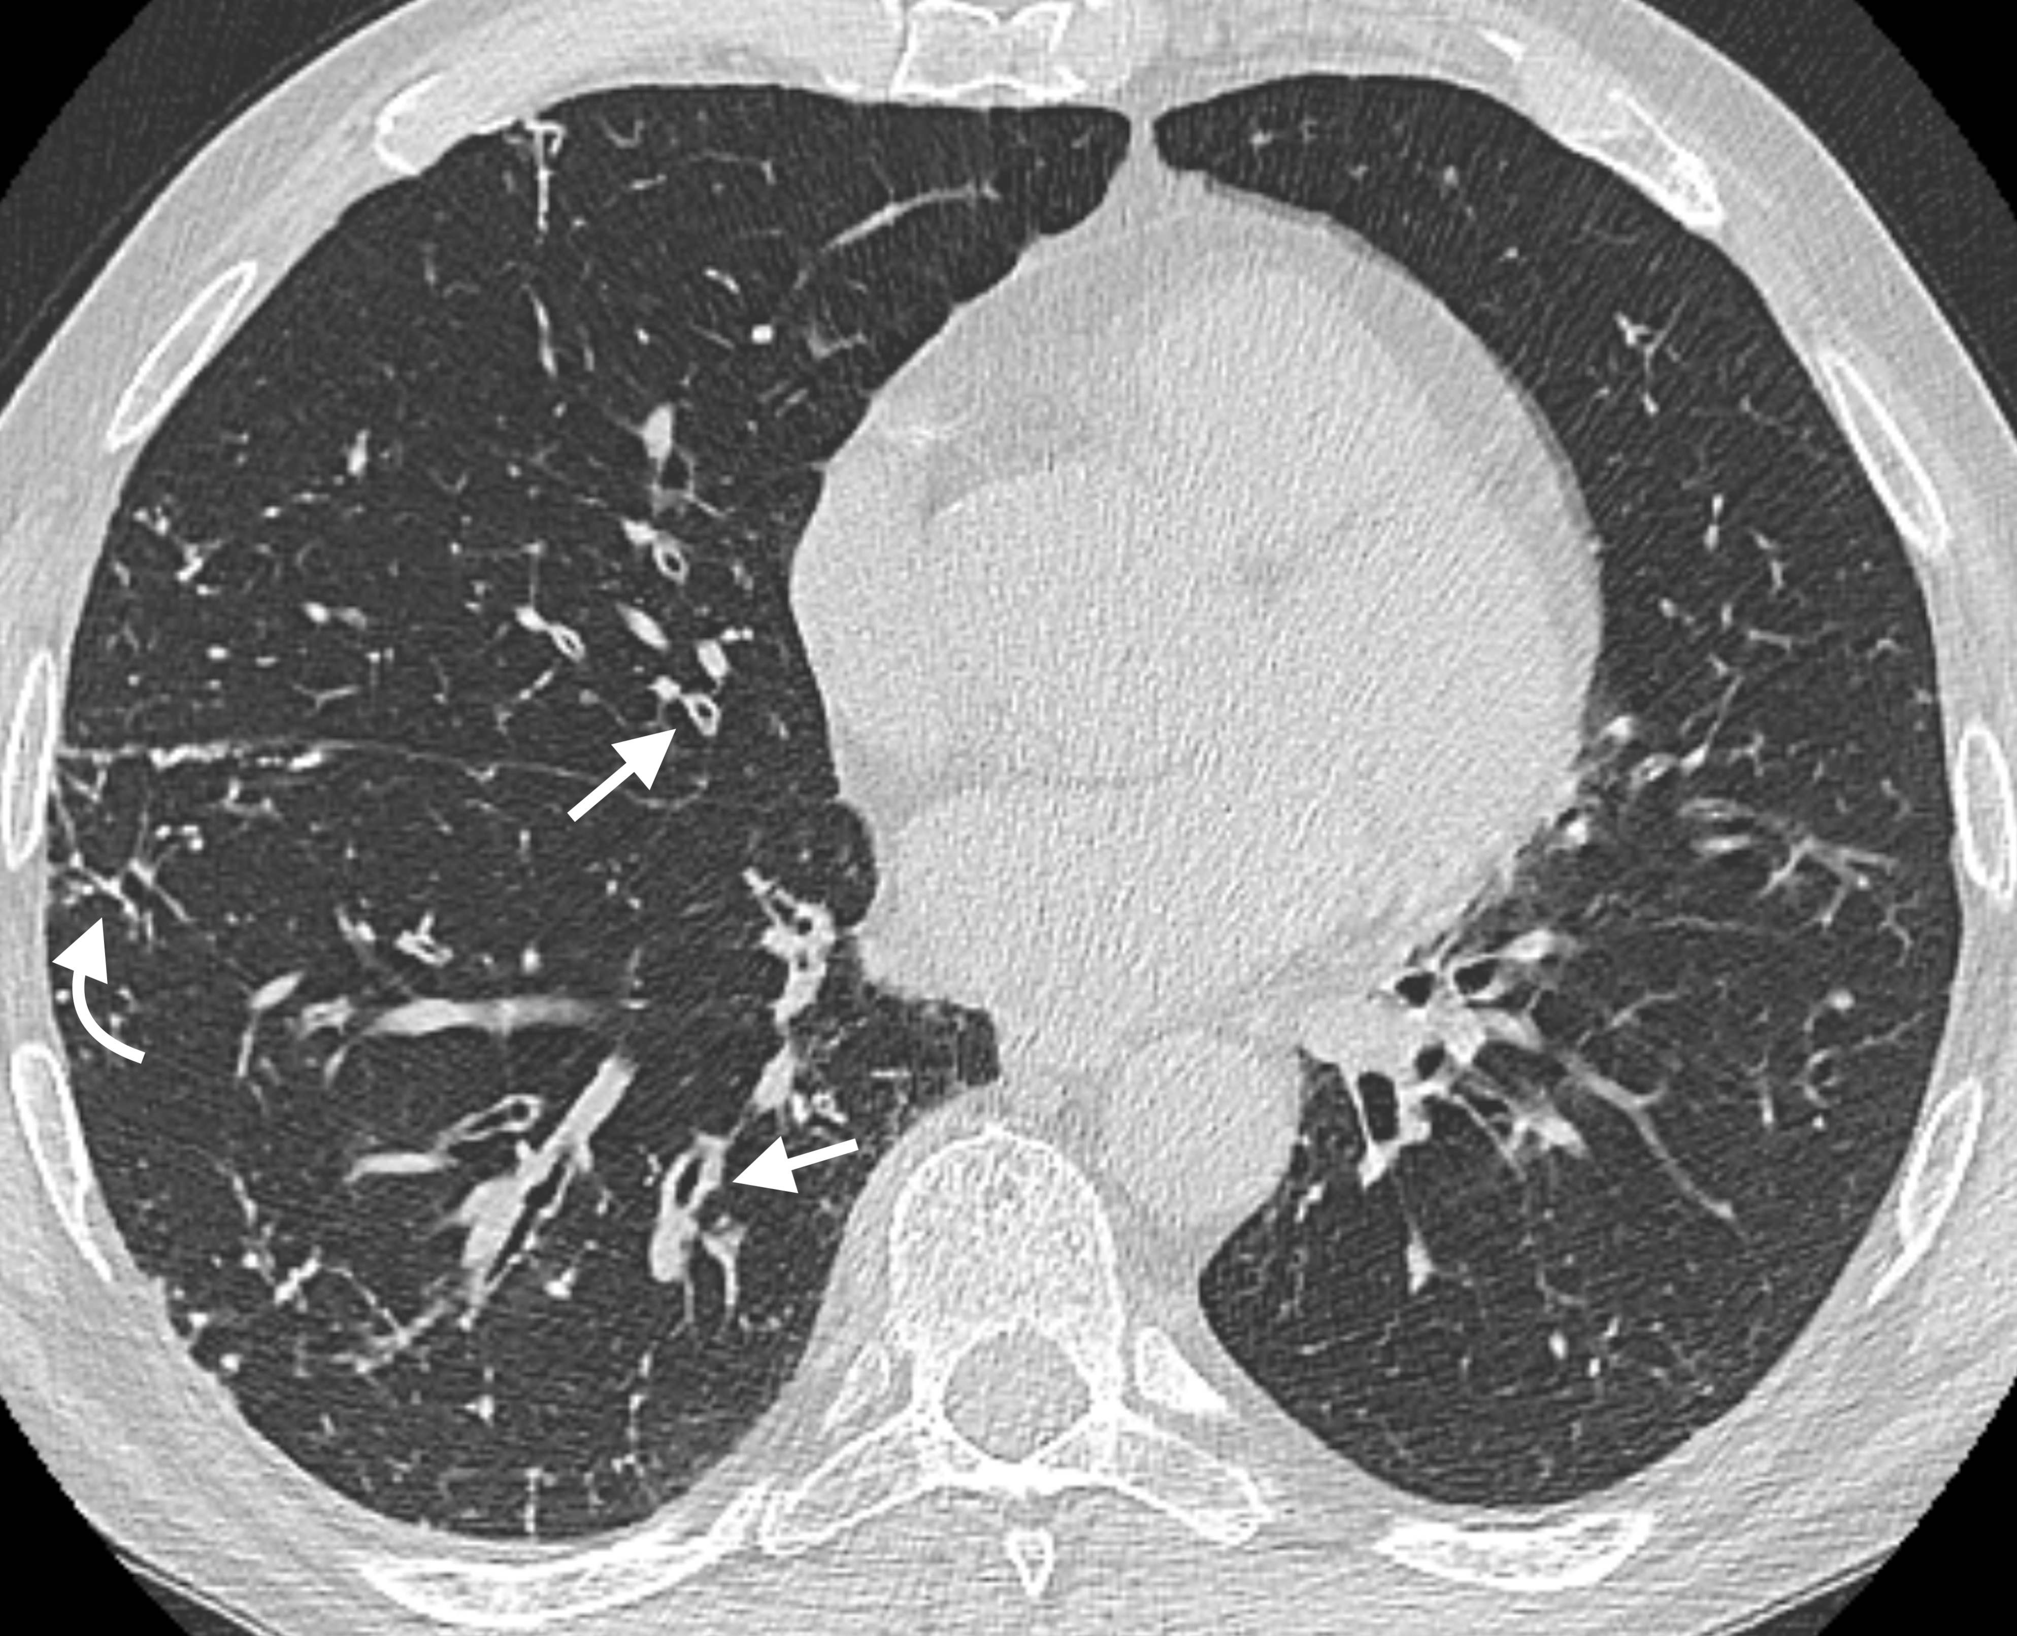
Figure 1 Airway wall thickening. A 65-year-old male patient with common variable immunodeficiency disorder. High-resolution computed tomography shows diffuse airway wall thickening in the right middle and lower lobes (straight arrows); centrilobular and tree-in-bud nodules in the right lung are also detected (curved arrow).

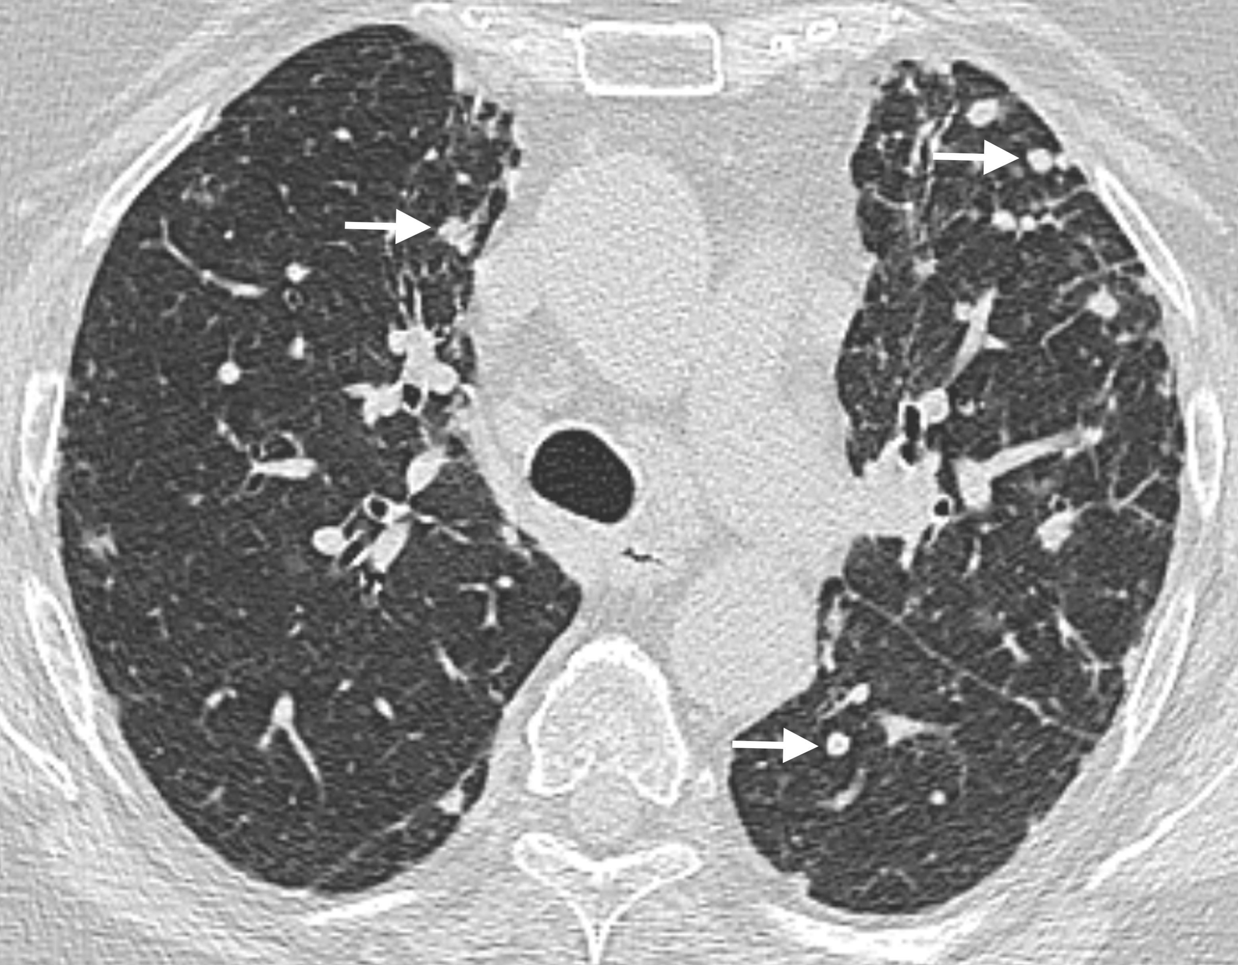
Figure 2 Nodules. A 64-year-old female patient with common variable immunodeficiency disorder. High-resolution computed tomography shows multiple, small nodules with peribronchial and perifissural location in the upper and lower lobes of both lungs (arrows). A diagnosis of granulomatous and lymphocytic interstitial lung disease was subsequently made.

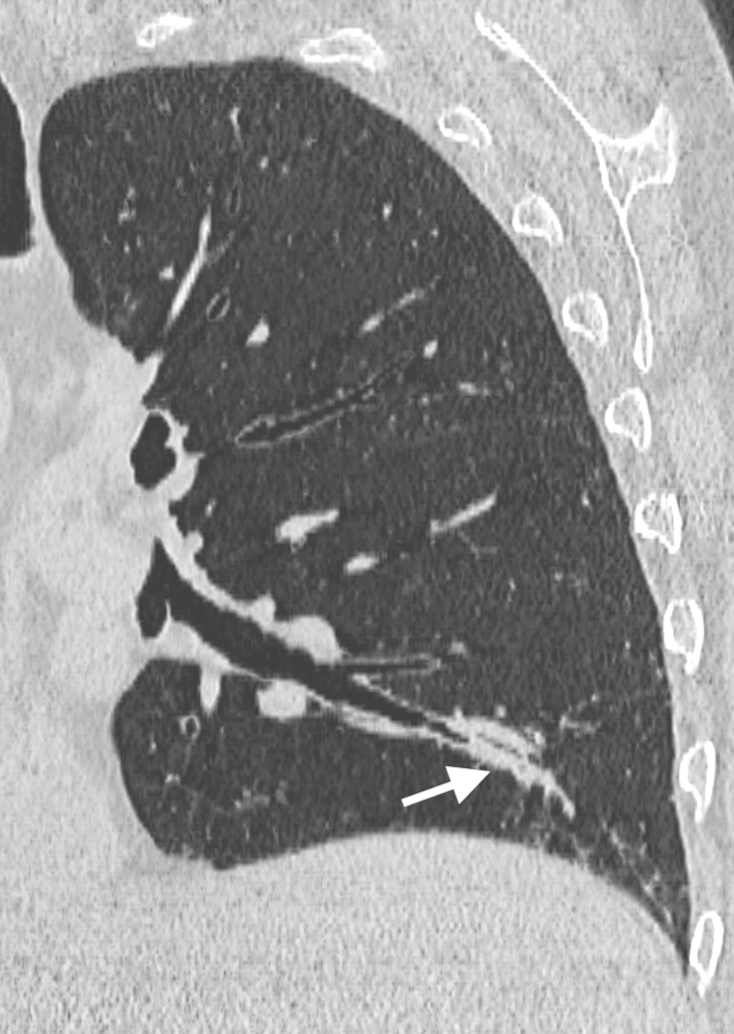
Figure 3 Mucus plugging. A 65-year-old male patient with common variable immunodeficiency disorder. Para-coronal 2-mm minimum intensity projection high-resolution computed tomography image shows mild bronchiectasis with extensive mucus plugging in the left lower lobe (arrow).

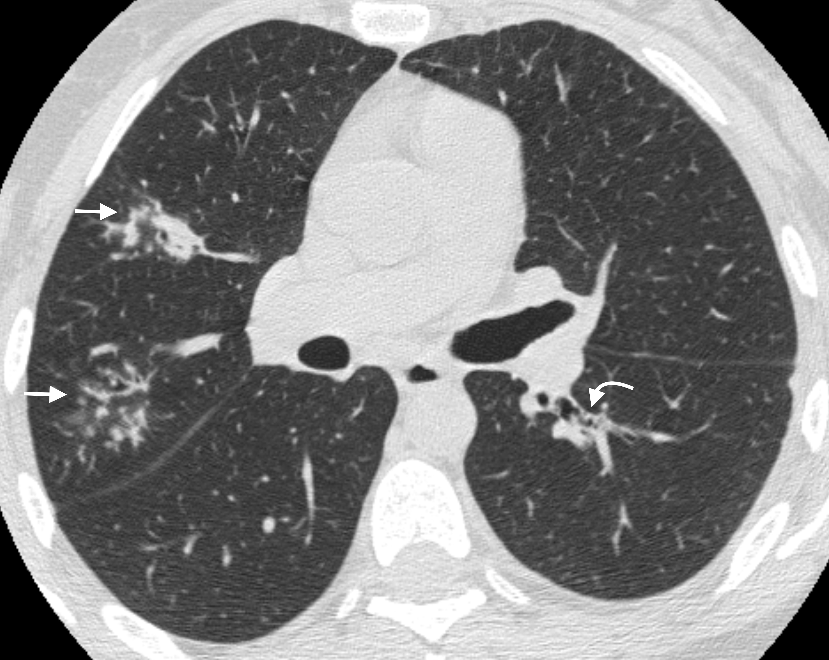
Figure 4 Tree-in-bud. A 40-year-old female patient with isolated IgG2 subclass deficiency. High-resolution computed tomography shows centrilobular and tree-in-bud nodules in the right upper lobe (straight arrows); small mucus plugging in the left lower lobe is also detected (curved arrow).

A B
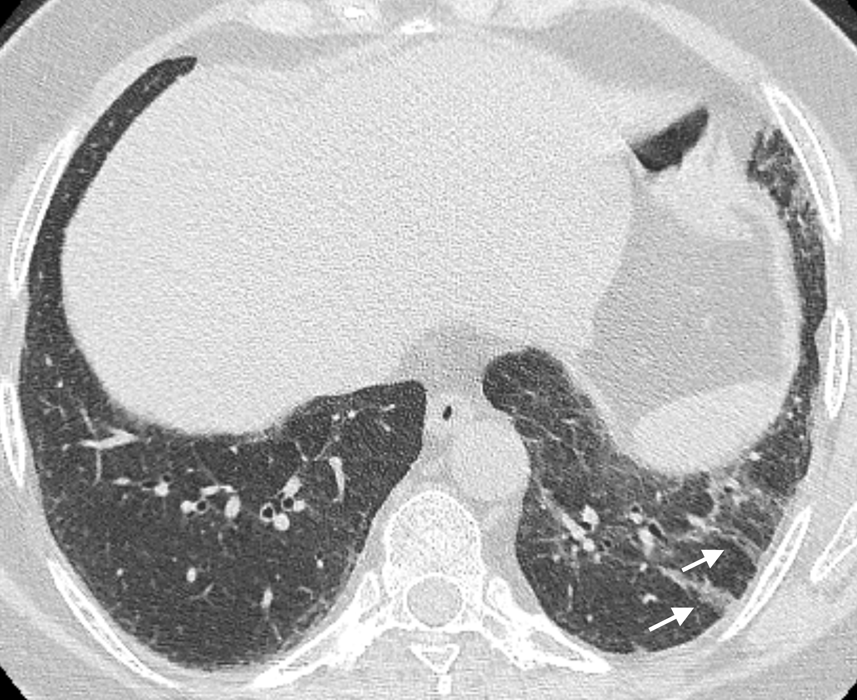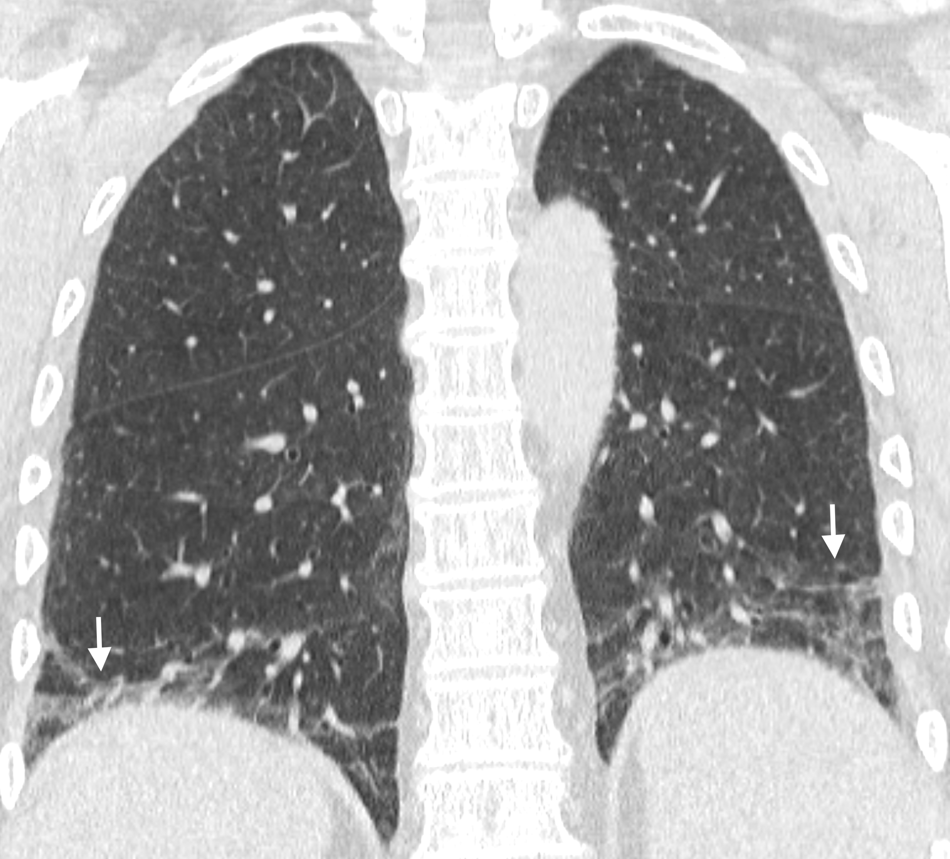
Figure 5 Linear and/or irregular opacities. A 66-year-old female patient with common variable immunodeficiency disorder. A: High-resolution computed tomography shows patchy areas of ground-glass opacity, along with reticulation and linear and/or irregular opacities (arrows) in both lower lobes; B: Coronal reformatted image shows the peripheral and basal-predominant distribution of the findings (arrows).

Table 1 Pulmonary function tests results n (%)
 | Obstructive defect |  |  |  | Restrictive defect
 | Absent | Mild | Significant¹ | Any | Absent | Mild | Significant¹ | Any
CVID  (n = 38) | 21 (55.3) | 10 (26.3) | 7 (18.4) | 17 (44.7) | 33 (86.9) | 1 (2.6) | 4 (10.5) | 5 (13.1)
CVID-like  (n = 14) | 8 (57.1) | 2 (14.3) | 4 (28.6) | 6 (42.9) | 14 (100) | 0 (0) | 0 (0) | 0 (0)
All patients  (n = 52) | 29 (55.8) | 12 (23.1) | 11 (21.2) | 23 (44.2) | 47 (90.4) | 1 (1.9) | 4 (7.7) | 5 (9.6)

Data are presented as number of patients with percentages in parentheses. ¹Moderate-to-severe defect. CVID: Common variable immunodeficiency disorder; CVID-like: Including isolated IgG subclass deficiency and selective IgA deficiency.

Table 2 Prevalence of high-resolution computed tomography-detected abnormalities in the two humoral primary immunodeficiencies subtypes (CVID and CVID-like), and comparison between the two groups n (%)
Abnormality |  | All patients  n = 52 |  | CVID  n = 38 |  | CVID-like  n = 14 |  | P-value (CVID vs CVID-like)
Airway abnormalities
Bronchiectasis |  | 36 (69.2) |  | 27 (71) |  | 9 (64.3) |  | 0.8964
Airway wall thickening |  | 37 (71.2) |  | 27 (71) |  | 10 (71.4) |  | 0.7501
Tree-in-bud |  | 10 (19.2) |  | 6 (15.8) |  | 4 (28.6) |  | 0.8464
Mucus plugging |  | 23 (44.2) |  | 16 (42.1) |  | 7 (50) |  | 0.8888
Air trapping¹ |  | 16 (50) |  | 12 (52.2) |  | 4 (44.4) |  | 0.8557
Parenchymal-interstitial abnormalities
Consolidation |  | 14 (26.9) |  | 11 (28.9) |  | 3 (21.4) |  | 0.8495
Ground-glass opacity |  | 13 (25) |  | 12 (31.6) |  | 1 (7.1) |  | 0.1487
Nodules |  | 26 (50) |  | 19 (50) |  | 7 (50) |  | 1.0000
Linear and/or irregular opacities |  | 12 (23.1) |  | 12 (31.6) |  | 0 (0)ª |  | 0.0427
Bullae/cysts |  | 5 (9.6) |  | 5 (13.2) |  | 0 (0) |  | 0.3695

Chi-square test: CVID vs CVID-like patients; ªP <0.05. ¹Values are calculated on the 32 patients (23 CVID + 9 CVID-like) for whom additional expiratory scan was acquired. CVID: Common variable immunodeficiency disorders; CVID-like: Including isolated IgG subclass deficiency and selective IgA deficiency.

Table 3 Distribution of high-resolution computed tomography-detected airway abnormalities according to the severity of obstructive defect at pulmonary function tests in the overall study population, and results of logistic regression analysis for prediction of moderate-to-severe obstructive defects at PFTs n (%)

Abnormality | Absent  n = 29 | Mild  n = 12 | Moderate  n = 9 | Severe  n = 2 | Univariate analysis  P-value | Multivariate analysis  P-value (odds ratio)
Bronchiectasis | 19 (66.5) | 9 (75) | 7 (77.8) | 1 (50) | NS | NS
Airway wall thickening | 20 (69) | 9 (75) | 6 (66.7) | 2 (100) | NS | NS
Tree-in-bud | 2 (6.9) | 2 (16.7) | 5 (55.6) | 1 (50) | 0.0014 | 0.0027 (18.75)
Mucus plugging | 8 (27.6) | 8 (66.7) | 5 (55.6) | 2 (100) | 0.0112 | NS

NS: Non-significant.

Table 4 Distribution of high-resolution computed tomography-detected parenchymal-interstitial abnormalities according to the severity of the restrictive defects at pulmonary function tests in the overall study population, and results of logistic regression analysis for prediction of moderate-to-severe restrictive defects at pulmonary function tests

Abnormality | Absent  n = 47 | Mild  n = 1 | Moderate  n = 4 | Severe  n = 0 | Univariate analysis  P-value | Multivariate analysis  P-value (odds ratio)
Consolidation | 11 (23.4) | 1 (100) | 2 (50) | 0 (0) | NS | NS
Ground-glass opacity | 10 (21.3) | 1 (100) | 2 (50) | 0 (0) | NS | NS
Nodules | 23 (48.9) | 1 (100) | 2 (50) | 0 (0) | NS | NS
Linear and/or irregular opacities | 8 (17) | 1 (100) | 3 (75) | 0 (0) | 0.0029 | 0.0344
Bullae/cysts | 5 (10.6) | 0 (0) | 0 (0) | 0 (0) | NS | NS

NS: Non-significant.

