Name of Journal: World Journal of Clinical Cases
Manuscript NO: 79035
Manuscript Type: CASE REPORT

Minimal change disease caused by polycythemia vera: A case report

Xu L et al. MCD caused by PV

Li Xu, Li-Li Lu, Jian-Dong Gao

Li Xu, Li-Li Lu, Jian-Dong Gao, Department of Nephrology, Shuguang Hospital Affiliated to the Shanghai University of Traditional Chinese Medicine, TCM Institute of Kidney Disease, Shanghai University of Traditional Chinese Medicine, Key Laboratory of Liver and Kidney Diseases (Shanghai University of Traditional Chinese Medicine), Ministry of Education, Shanghai Key Laboratory of Traditional Chinese Clinical Medicine (20DZ2272200), Shanghai 201203, China

Author contributions: Xu L was responsible for writing the manuscript and data analysis; Lu LL helped with document retrieval; Gao JD was responsible for supervision; all authors agree with the final version of the manuscript.

Supported by the National Natural Science Foundation of China, No. 81874437 and 81904126; Science and Technology Commission of Shanghai Municipality, No. 20Y21901800.

Corresponding author: Jian-Dong Gao, PhD, Professor, Department of Nephrology, Shuguang Hospital Affiliated to the Shanghai University of Traditional Chinese Medicine, TCM Institute of Kidney Disease, Shanghai University of Traditional Chinese Medicine, Key Laboratory of Liver and Kidney Diseases (Shanghai University of Traditional Chinese Medicine), Ministry of Education, Shanghai Key Laboratory of Traditional Chinese Clinical Medicine (20DZ2272200), No. 528 Road ZhangHeng, Shanghai 201203, China. jiandong.gao@shutcm.edu.cn

Received: August 24, 2022
Revised: September 27, 2022
Accepted: October 19, 2022
Published online: November 16, 2022

Abstract
BACKGROUND
Polycythemia vera (PV), often attributed to the JAK2 V617F mutation, is characterized by enhanced red blood cell counts in the peripheral blood. PV-associated renal disease is clinically rare; to date, there have been reports of other chronic kidney diseases related to PV, but no reports on PV-associated minimal change disease.

CASE SUMMARY
A 37-year-old man presented with proteinuria and high red blood cell count on January 4, 2021. The patient underwent bone marrow and renal biopsies, then was subsequently diagnosed with PV and minimal change in disease. Hydroxyurea was administered and proteinuria remission was achieved. The patient’s last visit was on April 14, 2022.

CONCLUSION
We inferred that there may be a causal relationship between PV and minimal change disease.

Key Words: Polycythemia vera; Minimal change disease; Proteinuria; Chronic kidney disease; JAK2 V617F mutation; Case report

©The Author(s) 2022. Published by Baishideng Publishing Group Inc. All rights reserved.

Citation: Xu L, Lu LL, Gao JD. Minimal change disease caused by polycythemia vera: A case report. World J Clin Cases 2022; 10(32): 11993-11999
URL: https://www.wjgnet.com/2307-8960/full/v10/i32/11993.htm
DOI: https://dx.doi.org/10.12998/wjcc.v10.i32.11993

Core Tip: Polycythemia vera (PV) is a myeloproliferative neoplasm that can influence the immune system and affect organs such as the kidneys. This is the first report of PV-associated minimal change disease. In our case, hydroxyurea administration was effective and proteinuria remission was achieved. Therefore, we infer there may be a causal relationship between PV and minimal change disease.

INTRODUCTION
Polycythemia vera (PV)^{[1]}, a myeloproliferative neoplasm (MPN), is the ultimate phenotype of the JAK2 V1617F mutation, and is characterized by erythrocytosis, leukocytosis, thrombocytosis, splenomegaly, and occasional myelofibrosis. PV-associated renal disease is rare. A literature review^{[2]} referred to cases of PV-associated renal diseases, including immunoglobulin (Ig) A nephropathy, membranoproliferative glomerulonephritis, focal segmental glomerulosclerosis, and rapidly progressive glomerulonephritis. However, to the best of our knowledge, there have been no reports of minimal changes in disease. Here, we report the case of our patient.

CASE PRESENTATION
Chief complaints
A 37-year-old man, a base station engineer, was admitted to the Shuguang Hospital affiliated with the Shanghai University of Traditional Chinese Medicine, Department of Nephrology (Shanghai, China), on January 4, 2021. He complained of proteinuria for approximately one month.

History of present illness
During inpatient care, the patient presented with dizziness, slight weakness, no hematuria, no back pain, good appetite, sound sleep, and normal urine and stool.

History of past illness
The patient claimed no history of past illness.

Personal and family history
The patient claimed no personal or family history.

Physical examination
Physical examination revealed no abnormities, except for blood pressure, which was 153/106 mmHg

Laboratory examinations
On December 15, 2020, the patient underwent physical examination, and the report showed positive urine protein (++), blood routine: white blood cell count, 16.531 × 10⁹/L; hemoglobin level, 229 g/L; red blood cell > 7.8 × 10¹²/L; and platelet count, 489 × 10⁹/L. Biochemistry test: albumin 37 g/L, total albumin 60 g/L, blood uric acid 490 µmol/L, triglyceride 3.87 mmol/L, and blood creatinine 88 µmol/L.
On December 31, 2020, the 24-hour urine total protein quantitative was 5.08 g/24 h.
On January 7, 2021, routine blood tests showed white blood cells: 21.71 × 10⁹/L; platelets, 431 × 10⁹/L; red blood cells, 7.65 × 10¹²/L; and hemoglobin, 216.7 g/L.
On January 11 and 15, the patient underwent bone marrow and renal biopsies, respectively, after providing informed consent. A bone marrow biopsy revealed dense bone and a small amount of bone marrow tissue. The ratio of hematopoietic cells to structural fat in the area available for observation was 85%:15%, and the grain-to-red ratio was approximately 4–5:1. Hematopoietic cells in all stages of the red line could be seen; megakaryocytes were 7–17 per high-power field, distributed in clusters, and the cell bodies were relatively large with more nuclear lobes.
On January 11, 2021, a bone marrow biopsy showed that PV was first considered, and further genetic examination was recommended to clarify the type. IHC2021-0042: CD34 (individual +), CD117 (individual +), CD15 (partial +), MPO (partial +), CD56 (-), CD138 (individual +), CD61 (discrete +), CD71 (part +), Kappa: Lambda (not restricted expression), and special stain results: mesh (-), Periodic Acid-Schiff stain (+/-), Prussian blue (-).
On January 13, 2021, karyotype analysis showed the following karyotype: 46,XY (Figure 1). Gene test: JAK2 V617F (+). The mutation ratio of JAK2 V617F was 86.60%.
On January 15, 2021, renal biopsy (renal puncture tissue) revealed four glomeruli. The morphology and structure of glomeruli were normal. Some glomeruli showed mild proliferation of mesangial cells and increased matrix. No glomerular sclerosis changes, crescents, or infiltration of inflammatory cells were observed. Protein casts were observed in individual tubules, and some renal tubules showed atrophy and unclear structure. No obvious abnormalities were observed in the renal interstitium or blood vessels. Diagnosis: Minimal change disease (MCD). Fluorescence staining: IgG (-), IgA (-), IgM (-), C3 (-), C4 (-), C1q (-), Fb (+/-). Special staining: PAS (+), silver staining (+), Masson’s trichrome (+), Congo red (-). IHC2021-0045: TGF B1 (-) (Figure 2).

Imaging examinations
Abdominal ultrasonography showed splenomegaly.

FINAL DIAGNOSIS
The patient was diagnosed with the following conditions: (1) MCD; (2) PV; and (3) hypertension.

TREATMENT
The patient was given hydroxyurea 0.5 g qd p.o. (total duration of administration: 3 mo), olmesartan 20 mg qd p.o. (till last vist) and has been receiving interferon biweekly since cessation of hydroxyurea.

OUTCOME AND FOLLOW-UP
On March 13, 2021, the patient visited the hospital for a second visit. Routine blood test results revealed the following findings: hemoglobin, 167 g/L; red blood cells: 5.34 × 10¹²/L; white blood cells: 5.5 × 10⁹/L; and platelets, 170 × 10⁹/L. On March 18, 2021, the patient’s 24 h proteinuria was 1.33 g/24 h. The patient is currently in good condition. Other laboratory data for each visit are shown in Table 1 and Figures 3-5.

DISCUSSION
MCD is a primary cause of idiopathic nephrotic syndrome (NS), which manifests as mass proteinuria, resulting in edema and depletion of intravascular volume^{[3]}. MCD occurs much less frequently in adults than in children^{[3]}. The pathological features of MCD include a lack of visible changes on light microscopy and depletion of foot processes on electron microscopy. Podocyte modifications and immune disorders synergize to change the integrity of the glomerular basement membrane (GBM), thereby determining proteinuria^{[3]}. MCD is primarily associated with extra-glomerular diseases, including neoplastic processes and undesirable reactions to drugs.
MCD has been frequently associated with hematologic malignancies such as Hodgkin’s lymphoma^{[4]}, and this relationship indicates that MCD is a disease that results from lymphocyte dysfunction. The benefit of immunosuppressants and steroids also implies that the cause of MCD is immune dysregulation. The pathogenesis of PV-associated MCD is likely related to T cell dysfunction. The mechanism is speculated to be a T helper cell class 1 and 2 imbalance in MCD^{[5,6]}. In brief, the main cause of MCD is immune disorders, particularly T cell dysfunction. These T lymphocytes can produce circulating lymphokines which are toxic to GBM, and thus alter their permeability to proteins. In 1974, Shalhoub postulated the existence of a circulating mediator produced by abnormal T-lymphocytes^{[7]}. In our case, T-lymphocyte disorder also induced concurrent MCD with PV. Studies have shown that the immune system is thrown into enormous disruption by myeloproliferative neoplasms (MPNs)^{[8]}. JAK2V617F mutation results in the overexpression of many cytokines and chemokines such as interleukins IL-2, IL-8, as reported in samples from both mice and patients^{[8,9]}. Nephrotic-level proteinuria has been reported in cancer patients treated with IL-2^{[10]}. Evidence indicates that IL-2 is associated with proteinuria^{[10]}. Hermouet et al^{[11]} were the first to report that serum IL-8 Levels were elevated in PV patients. Garin et al^{[12]} speculated that circulating IL-8 may play a role in MCD.
Our patient’s business trip to Chernobyl 8 years ago lasted approximately 4 months. We suspected nuclear contamination, which would have affected the immune system.
Our question in this case was as follows: Was the occurrence of MCD with PV purely coincidental or was it etiologically linked, either by a common pathogenesis or could the MCD be secondary to the PV? We can see that proteinuria remission was positively associated with treatment with hydroxyurea, so it is reasonable to consider a causal relationship.
However, the exact mechanisms underlying the pathogenesis of MCD associated with PV remain unclear. In addition to immune dysregulation, kidney injury might also be attributed to hyperviscosity, abnormal function, and/or excessive neoplastic blood cell activation and growth factor production^{[13]}. Increased blood viscosity and platelet hypersensitivity can induce microcirculatory disturbances, resulting in endothelial damage. Many cytokines and growth factors such as interferon-γ, IL-6, and platelet-derived growth factor, which have documented in patients with MPNs, can directly elicit endothelial damage. Growth factors can be generated locally by marginating platelets and cells of extramedullary hematopoiesis, accompanied by hyperviscosity, which exacerbates endothelial damage^{[13]}. PV can not only result in thrombosis in the main blood vessels^{[14]}, but can also induce thrombotic microangiopathy^{[15]}. Glomerular microvasculature is particularly vulnerable to injury due to thrombotic microangiopathy. Therefore, we posit that PV-induced hyperviscosity could be an important factor in the pathogenesis of MCD, except in immune disorders.
Nonetheless, two potential mechanisms, microcirculatory disturbances and immune disorders, may explain the development of MCD in PV patients.

CONCLUSION
Based on our findings, there may be a causal relationship between minimal change in disease and PV. However, this is a clinical inference rather than a critical appraisal of the differences between chance and causal relationships, which would require a study of extensive epidemiological data.

REFERENCES
1 Spivak JL. Polycythemia Vera. Curr Treat Options Oncol 2018; 19: 12 [PMID: 29516275 DOI: 10.1007/s11864-018-0529-x]
2 Chen H, Zhang B, Li M, Hu R, Zhou C. Polycythemia vera associated with IgA nephropathy: A case report and literature review. Exp Ther Med 2015; 10: 555-560 [PMID: 26622353 DOI: 10.3892/etm.2015.2572]
3 Vivarelli M, Massella L, Ruggiero B, Emma F. Minimal Change Disease. Clin J Am Soc Nephrol 2017; 12: 332-345 [PMID: 27940460 DOI: 10.2215/CJN.05000516]
4 Jhaveri KD, Shah HH, Patel C, Kadiyala A, Stokes MB, Radhakrishnan J. Glomerular diseases associated with cancer, chemotherapy, and hematopoietic stem cell transplantation. Adv Chronic Kidney Dis 2014; 21: 48-55 [PMID: 24359986 DOI: 10.1053/j.ackd.2013.08.003]
5 Souadjian JV, Enriquez P, Silverstein MN, Pépin JM. The spectrum of diseases associated with thymoma. Coincidence or syndrome? Arch Intern Med 1974; 134: 374-379 [PMID: 4602050 DOI: 10.1001/archinte.1974.00320200184029]
6 Bertelli R, Bonanni A, Di Donato A, Cioni M, Ravani P, Ghiggeri GM. Regulatory T cells and minimal change nephropathy: in the midst of a complex network. Clin Exp Immunol 2016; 183: 166-174 [PMID: 26147676 DOI: 10.1111/cei.12675]
7 Shalhoub RJ. Pathogenesis of lipoid nephrosis: a disorder of T-cell function. Lancet 1974; 2: 556-560 [PMID: 4140273 DOI: 10.1016/s0140-6736(74)91880-7]
8 Nasillo V, Riva G, Paolini A, Forghieri F, Roncati L, Lusenti B, Maccaferri M, Messerotti A, Pioli V, Gilioli A, Bettelli F, Giusti D, Barozzi P, Lagreca I, Maffei R, Marasca R, Potenza L, Comoli P, Manfredini R, Maiorana A, Tagliafico E, Luppi M, Trenti T. Inflammatory Microenvironment and Specific T Cells in Myeloproliferative Neoplasms: Immunopathogenesis and Novel Immunotherapies. Int J Mol Sci 2021; 22 [PMID: 33672997 DOI: 10.3390/ijms22041906]
9 Panteli KE, Hatzimichael EC, Bouranta PK, Katsaraki A, Seferiadis K, Stebbing J, Bourantas KL. Serum interleukin (IL)-1, IL-2, sIL-2Ra, IL-6 and thrombopoietin levels in patients with chronic myeloproliferative diseases. Br J Haematol 2005; 130: 709-715
10 Zea AH, Stewart T, Ascani J, Tate DJ, Finkel-Jimenez B, Wilk A, Reiss K, Smoyer WE, Aviles DH. Activation of the IL-2 Receptor in Podocytes: A Potential Mechanism for Podocyte Injury in Idiopathic Nephrotic Syndrome? PLoS One 2016; 11: e0157907 [PMID: 27389192 DOI: 10.1371/journal.pone.0157907]
11 Hermouet S, Godard A, Pineau D, Corre I, Raher S, Lippert E, Jacques Y. Abnormal production of interleukin (IL)-11 and IL-8 in polycythaemia vera. Cytokine 2002; 20: 178-183 [PMID: 12543083 DOI: 10.1006/cyto.2002.1994]
12 Garin EH, West L, Zheng W. Effect of interleukin-8 on glomerular sulfated compounds and albuminuria. Pediatr Nephrol 1997; 11: 274-279 [PMID: 9203172 DOI: 10.1007/s004670050276]
13 Büttner-Herold M, Sticht C, Wiech T, Porubsky S. Renal disease associated with myeloproliferative neoplasms and myelodysplastic syndrome/myeloproliferative neoplasms. Histopathology 2021; 78: 738-748 [PMID: 33078472 DOI: 10.1111/his.14282]
14 Vannucchi AM, Guglielmelli P. JAK2 mutation-related disease and thrombosis. Semin Thromb Hemost 2013; 39: 496-506 [PMID: 23633193 DOI: 10.1055/s-0033-1343890]
15 Eremina V, Jefferson JA, Kowalewska J, Hochster H, Haas M, Weisstuch J, Richardson C, Kopp JB, Kabir MG, Backx PH, Gerber HP, Ferrara N, Barisoni L, Alpers CE, Quaggin SE. VEGF inhibition and renal thrombotic microangiopathy. N Engl J Med 2008; 358: 1129-1136 [PMID: 18337603 DOI: 10.1056/NEJMoa0707330]

Footnotes
Informed consent statement: Informed written consent was obtained from the patient for the publication of this report and any accompanying images.

Conflict-of-interest statement: The authors declare that they have no conflict of interest.

CARE Checklist (2016) statement: The authors have read the CARE Checklist (2016), and the manuscript was prepared and revised according to the CARE Checklist (2016).

Open-Access: This article is an open-access article that was selected by an in-house editor and fully peer-reviewed by external reviewers. It is distributed in accordance with the Creative Commons Attribution NonCommercial (CC BY-NC 4.0) license, which permits others to distribute, remix, adapt, build upon this work non-commercially, and license their derivative works on different terms, provided the original work is properly cited and the use is non-commercial. See: https://creativecommons.org/Licenses/by-nc/4.0/

Provenance and peer review: Unsolicited article; Externally peer reviewed.
Peer-review model: Single blind

Peer-review started: August 24, 2022
First decision: September 23, 2022
Article in press: October 19, 2022

Specialty type: Hematology
Country/Territory of origin: China
Peer-review report’s scientific quality classification
Grade A (Excellent): 0
Grade B (Very good): 0
Grade C (Good): C, C
Grade D (Fair): 0
Grade E (Poor): 0

P-Reviewer: Boilard E, Canada; Tanabe K S-Editor: Ma YJ L-Editor: A P-Editor: Ma YJ
Figure Legends
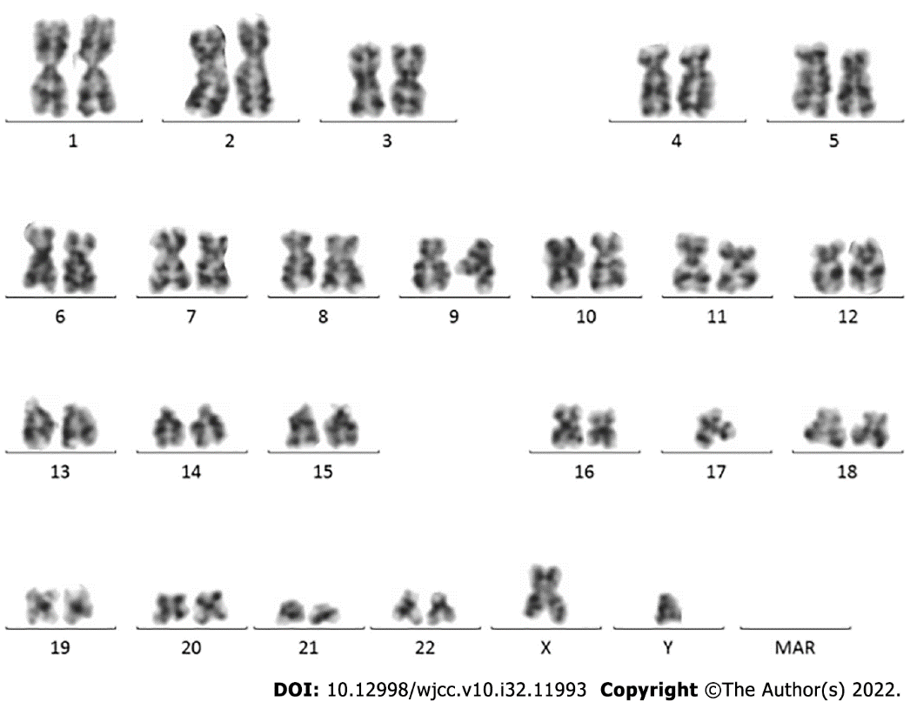
Figure 1 Karyotype analysis results.
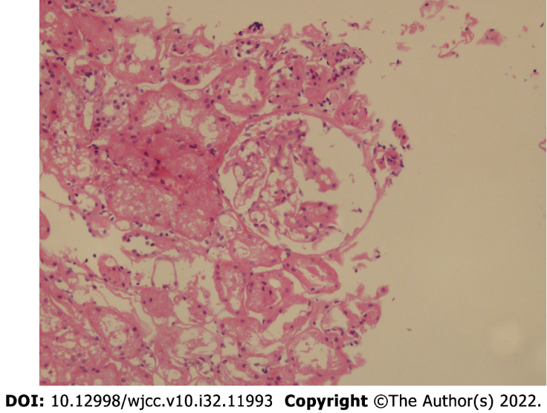
Figure 2 Renal biopsy results.
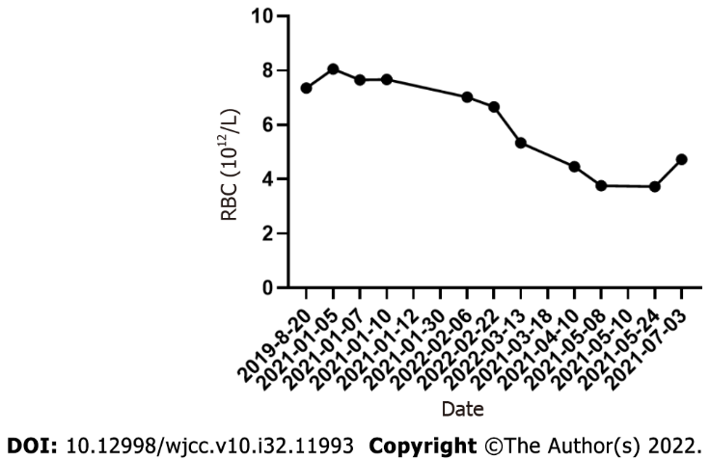
Figure 3 Red blood cell counts at each visit. RBC: Red blood cell.

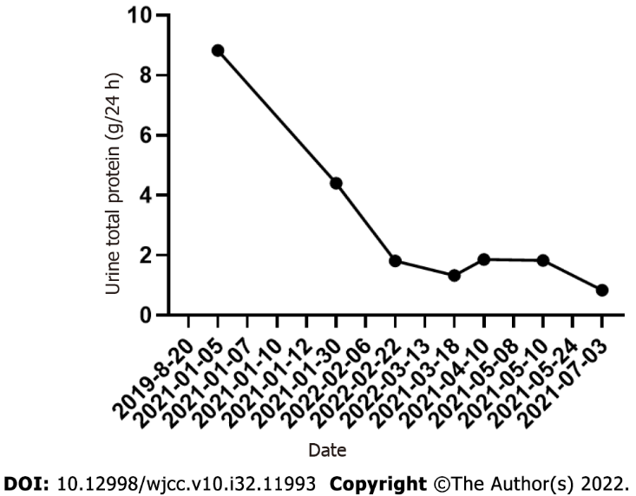
Figure 4 Urine total protein at each visit.

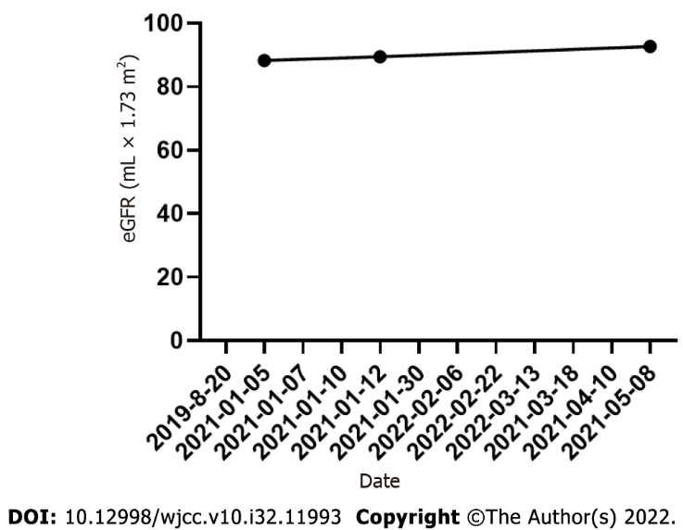
Figure 5 Estimated glomerular filtration rate at each visit. eGFR: Estimated glomerular filtration rate.
Table 1 Laboratory data according to each visit based on timeline
Date | WBC (10⁹/L) | HB (g/L) | RBC (10¹²/L) | PLT (10⁹/L) | Hematocrits | UTP (g/24 h) | eGFR (mL × 1.73 m²)
2019-08-20 | 12.7 | 205 | 7.35 | 474 | 0.636 | - | -
2021-01-05 | 16.57 | 226.1 | 8.05 | 435 | 0.665 | 8.83 | 88.33
2021-01-07 | 21.71 | 216.7 | 7.65 | 431 | 0.664 | - | -
2021-01-10 | 15.77 | 218 | 7.67 | 500 | 0.659 | - | -
2021-01-12 | - | - | - | - | - | - | 89.47
2021-01-30 | - | - | - | - | - | 4.4 | -
2022-02-06 | 2.79 | 211 | 7.02 | 168 | 0.63 | - | -
2022-02-22 | 3.97 | 203 | 6.66 | 161 | 0.591 | 1.81 | -
2022-03-13 | 5.51 | 167 | 5.34 | 170 | 0.475 | - | -
2021-03-18 | - | - | - | - | - | 1.33 | -
2021-04-10 | 4 | 141 | 4.46 | 263 | 0.408 | 1.86 | -
2021-05-08 | 4.53 | 125 | 3.76 | 337 | 0.362 |  | 92.69
2021-05-10 | - | - | - | - | - | 1.83 | -
2021-05-24 | 6.3 | 128 | 3.73 | 450 | 0.369 | - | -
2021-07-03 | 6.5 | 156 | 4.73 | 525 | 0.452 | 0.84 | -
WBC: White blood cell; HB, hemoglobin; RBC: Red blood cell; PLT: Platelet; UTP: Urine total protein; eGFR: estimated glomerular filtration rate.

Published by Baishideng Publishing Group Inc
7041 Koll Center Parkway, Suite 160, Pleasanton, CA 94566, USA
Telephone: +1-925-3991568
E-mail: bpgoffice@wjgnet.com
Help Desk: https://www.f6publishing.com/helpdesk
https://www.wjgnet.com

© 2022 Baishideng Publishing Group Inc. All rights reserved.

