Name of Journal: World Journal of Psychiatry
Manuscript NO: 75217
Manuscript Type: SCIENTOMETRICS

Mapping the landscape and structure of global research on binge eating disorder: Visualization and bibliometric analysis

Zyoud SH et al. Global research in BED

Sa'ed H Zyoud, Muna Shakhshir, Amani S Abushanab, Amer Koni, Moyad Shahwan, Ammar Abdulrahman Jairoun, Samah W Al-Jabi

Sa'ed H Zyoud, Amani S Abushanab, Amer Koni, Samah W Al-Jabi, Department of Clinical and Community Pharmacy, College of Medicine and Health Sciences, An-Najah National University, Nablus 44839, Palestine

Sa'ed H Zyoud, Poison Control and Drug Information Center, College of Medicine and Health Sciences, An-Najah National University, Nablus 44839, Palestine

Sa'ed H Zyoud, Clinical Research Centre, An-Najah National University Hospital, Nablus 44839, Palestine

Muna Shakhshir, Department of Nutrition, An-Najah National University Hospital, Nablus 44839, Palestine

Amer Koni, Division of Clinical Pharmacy, Hematology and Oncology Pharmacy Department, An-Najah National University Hospital, Nablus 44839, Palestine

Moyad Shahwan, Department of Pharmacy, Ajman University, Ajman 346, United Arab Emirates

Moyad Shahwan, Centre of Medical and Bio allied Health Sciences Research, Ajman University, Ajman 346, United Arab Emirates

Ammar Abdulrahman Jairoun, Department of Health and Safety, Dubai Municipality, Dubai 67, United Arab Emirates

Author contributions: Zyoud SH conceptualized and designed the research project, took care of data management and analysis, generated figures, made significant contributions to the manuscript’s existing literature search and interpretation of the manuscript, and drafted the manuscript; Shakhshir M, Abushanab AS, Al-Jabi SW, Jairoun AA, Shahwan M and Koni A were involved in the interpretation of the data, contributed to the manuscript writing, and made revisions to the initial draft; all authors provided a critical review and approved the final manuscript before submission.

Corresponding author: Sa'ed H Zyoud, PhD, Associate Professor, Department of Clinical and Community Pharmacy, College of Medicine and Health Sciences, An-Najah National University, Academic Street, Nablus 44839, Palestine. saedzyoud@yahoo.com

Received: January 18, 2022
Revised: May 22, 2022
Accepted: June 23, 2022
Published online: July 19, 2022

Abstract
BACKGROUND
Binge-eating disorder (BED) is a clinical syndrome and is considered the most common type of eating disorder. However, our understanding of the global performance and progress of BED research is limited.

AIM
To describe and perform a bibliometric analysis of the state of BED research.

METHODS
The term ‘Binge eating’ was searched in the title throughout the previous year’s up to December 31, 2020. We searched the Scopus and Reference Citation Analysis for publications on Binge eating. The VOSviewer software version 1.6.17 was used to produce the network visualization map of the most frequent author, collaborative relationships between countries/regions, and to determine the hotspots related to binge eating research. In addition, conventional bibliometric indicators were generated.

RESULTS
The search strategy found 2713 total articles and an average of 62 articles per year. Among them, ‘Article’ represented 82.49% of the publications (n = 2238 articles) and was the most frequent type, followed by reviews (n = 243; 8.96%). The number of publications increased steadily during the last decade of the study period. One hundred and thirty-two countries contributed to binge eating research, with 1495 (55.11%) articles published in the United States, followed by Italy with 256 (9.44%), the United Kingdom with 183 (6.75%), and Germany with 182 (6.71%). Currently, the main hot topics related to BED are ‘type of treatment and management and treatment provided to BED”; “processes and pathways to binge eating”; and ‘diagnosis, signs and symptoms, comorbidities and prevalence and associated factors with BED’.

CONCLUSION
The number of publications has increased noticeably during the previous decade. There are indeed relatively few publications on BED from low-and middle-income nations, so much is to be learned from the experience of all countries. Studies on this topic are critical in all countries to discover risk factors and effective intervention measures. Although our findings are preliminary, they imply that the future prospects for interventions aimed at BED management are bright, focusing on complex models of care and long-term maintenance of therapeutic gains.

Key Words: Binge-eating disorder; Scopus; Bibliometric; VOSviewer; Eating disorders.

©The Author(s) 2022. Published by Baishideng Publishing Group Inc. All rights reserved.

Citation: Zyoud SH, Shakhshir M, Abushanab AS, Koni A, Shahwan M, Jairoun AA, Al-Jabi SW. Mapping the landscape and structure of global research on binge eating disorder: Visualization and bibliometric analysis. World J Psychiatry 2022; 12(7): 982-994
URL: https://www.wjgnet.com/2220-3206/full/v12/i7/982.htm
DOI: https://dx.doi.org/10.5498/wjp.v12.i7.982

Core Tip: Over the last decade, research on binge eating disorder (BED) has focused on various issues. A review of the published literature would aid in determining the density and gaps of research. The number of publications related to BED has significantly increased over the last decade. Research on this topic is critical for identifying risk factors and developing effective intervention strategies in all countries. Although our findings are preliminary, they suggest that the future of BED management interventions is bright, emphasizing complex models of care and long-term maintenance of therapeutic gains.

INTRODUCTION
Disordered eating is a common condition that is often comorbid, especially when associated with obesity. Patients may suffer from various forms of eating disorders, including anorexia nervosa, bulimia nervosa, and binge eating disorder (BED). In the general population, almost 1%–3% of individuals will develop BED during their lifetime, making this form the most common eating disorder^{[1-3]}. Psychiatrist Albert Stunkard first identified BED in 1959^{[4]}. Stunkard outlines an eating habit characterized by eating large amounts of food at irregular intervals in his study "Eating Patterns and Obesity"^{[4]}.
BED is characterized by recurrent episodes in which people eat larger amounts of food than most people could eat simultaneously and under similar circumstances while experiencing feelings of loss of control and the absence of compensatory behaviors such as vomiting. Individuals suffering from BED can experience rapid eating in the absence of hunger, uncomfortable fullness, and afterward feelings of disgust, guilt, or sadness^{[5-9]}.
Several studies reported that many factors could facilitate binge eating, including impulsivity, inability to control emotions, and negative mood conditions^{[10-13]}. In 2015, a meta-analysis of 33 studies found that negative mood conditions increase food intake in patients with BED compared to those who do not suffer from BED, suggesting a strong relationship between negative mood conditions and binge eating behaviors^{[14]}.
However, despite the significant physical and psychological impairment, a higher percentage of binge-eaters did not seek treatment or receive any treatment^{[15,16]}. Therefore, current treatments for BED primarily focus on behavioral, psychological, and physical outcomes that include cognitive behavioral therapy (CBT) and behavioral weight loss therapy (BWLT)^{[15,17]}. CBT is considered the most effective approach for BED episodes, while BWLT is more effective in weight loss^{[18]}.
Over the last decades, research on BED has focused on a variety of topics. An examination of the published literature would aid in determining the density of research and the gaps. We found some bibliometric publications related to certain nutritional subjects^{[19-22]}, but none related to BED; therefore, this article is a novelty in this field. This study investigates the global performance and progress of BED research and maps the research patterns and trends using a visualization tool to address this gap. A bibliometric study of previous publications could serve as a foundation for a comprehensive understanding of existing research on BED and highlight some future research topics.

MATERIALS AND METHODS
Data source
The Scopus database was used to perform a descriptive bibliometric evaluation of BED publications. The Scopus database has a wider coverage of health and biomedical disciplines than the Web of Science and PubMed and has a higher coverage of citation reports^{[23,24]}. It is also simple to access various legitimate analytical tools, making it an ideal choice for our research^{[23,24]}. Scopus has also been used and validated in bibliometric analyses published in the previous two years^{[25-29]}.

Search strategies
On October 1, 2021, the search and download procedure was completed in order to avoid significant mistakes caused by daily database changes. The data was immediately retrieved from the Scopus database and Reference Citation Analysis (RCA) (https://www.referencecitationanalysis.com/). “Binge eating” was used as a search term in the Scopus database for the whole preceding year, up to December 31, 2020. This search term included ‘Binge eating’, ‘Binge-eating’, ‘Binge eating disorder’, and ‘Binge-eating disorder’. We used the keyword ‘binge-eating’ because we are concerned with binge-eating per se rather than related terminology. The search method for phrases relevant to binge-eating was confined to title alone to gain higher accuracy in the findings since when other search fields such as Abstract and Keywords were widened; numerous publications were found that were not connected to binge-eating (i.e., false-positive data). According to the researchers' experience^{[30-32]}, including search elements in the title rather than a topic search (title, abstract, and keywords) substantially improves specificity with minimal loss of sensitivity.

Bibliometric indicators
Document types, yearly number of publications, author names, journal names, country names, institution names, funding agency names, and number of citations were included in the data exported from the Scopus. The impact index per article for the top ten most-cited publications based on RCA was calculated. RCA is an open, multidisciplinary citation analysis database owned by Baishideng Publishing Group Inc. (Pleasanton, CA 94566, United States)^{[33]}.

Network visualization maps
The VOSviewer 1.6.17 software produced the network visualization map of the most frequent author, collaborative relationships between countries/regions, and the hotspots related to binge-eating research. The size of the nodes on the network visualization map is proportional to the number of occurrences, while the distance between words reflects the strength of the relationship between countries, authors, and terms, with a closer distance suggesting a stronger relationship^{[34]}.

Ethical approval
Because all data were collected from previously published articles, there was no ethical approval requirement for this bibliometric study.

RESULTS
General description of the retrieved publications
The search strategy found 2713 total documents and an average of 62 documents per year. Among them, ‘Article’ represented 82.49% of the publications (n = 2238 articles) and was the most frequent type, followed by reviews (n = 243; 8.96%). The remaining publication types were 232 documents (8.54%).

Annual growth of publications
The oldest paper was written by Wilson^{[35]} in 1976 entitled ‘Obesity, binge eating, and behavior therapy: Some clinical observations’ in Behavior Therapy. After this, the number of publications grew slowly from 1976 to 1990, with little fluctuation. Figure 1 shows the publication trend related to BED from 1976 to 2020. Clearly, the number of relevant publications has increased sharply since 2011, while 2020 netted the largest amount of binge eating research (195 published documents).

Active countries
One hundred and thirty-two countries contributed to binge eating research, with 1,495 (55.11%) articles published in the United States, followed by Italy with 256 (9.44%), the United Kingdom with 183 (6.75%), and Germany with 182 (6.71%) (Table 1). Figure 2 shows the collaboration of the international network. Countries with a minimum contribution of ten articles (n = 26) were included in the network. The map is divided into eight clusters of varying colors, each representing one of eight different cross-country network collaborations. The United States and Canada had the strongest cross-country collaboration, as indicated by the thickness of the connecting line.

Active institutions
Table 2 lists the top ten core institutions publishing the most documents on the BED. The most active institutions in this field were those associated with American colleges. The top 10 active institutions contributed 835 articles (30.77%). Ten of the top active institutions were located in North America. The Yale School of Medicine came in first with 172 articles, followed by Yale University with 116, the University of Minnesota Twin Cities with 91, and the Neuropsychiatric Research Institute, Fargo with 85.

Contributions of funding agencies
Table 3 includes the top ten core funding agencies with the most documents in the BED. Among them, nine agencies were from the United States, and one agency was from the United Kingdom. The National Institutes of Health came first, with 562 studies that the Department of Health supported. The US Department of Health and Human Services came second (n = 537). In contrast, the National Institute of Diabetes and Digestive and Kidney Diseases came third (n = 319), and the National Institute of Mental Health came fourth (n = 289).

Active authors
The total number of authors who published on BED was 6223, of whom 40 (0.64%) published more than 20 documents for each author. Figure 3 shows the map of the co-authorship network of authors with at least ten publications. The authors with the largest node size contributed the most and included Grilo CM; Masheb RM; Mitchell JE; Crosby RD; White MA; McElroy SL; Crow SJ; Peterson CB; Wilfley DE; and Bulik CM.

Active journals
Table 4 shows the top ten active journals for the literature related to BED. The International Journal of Eating Disorders (n = 398, 14.57%) was first ranked, followed by Eating Behaviors (n = 139, 5.12%), Appetite (n = 94, 3.46%), and the European Eating Disorders Review (n = 85; 3.13%).

Citation analysis
According to citation analysis, the retrieved articles got 99491 citations, with an average of 36.7 per article and an h-index of 137. The number of citations ranged from 0 to 1454. Two hundred and fifty of the articles retrieved had zero citations, while 248 received 100 or more citations. The top 10 most-cited papers received 7126 citations in all. The total citations of these articles that quoted the research on BED research ranged from 458 to 1454 (Table 5). Furthermore, the ten most cited articles have an impact index per article of 0.7 to 64.4 (Table 5).

Research themes
Three clusters emerged from the mapping of terms in the titles and abstracts of the retrieved literature, reflecting three major research themes in this field (Figure 4). The first group (blue) signifies a research theme on the management and treatment provided for BED (psychotherapy, CBT, interpersonal psychotherapy, and pharmacotherapy). The second cluster (green) is a research theme that focuses on processes and pathways to binge eating (dietary restriction theory, cognitive models of binge eating, cognitive behavior model of BED, and emotional regulation theory). Finally, the third theme (red) is the largest topic and discusses diagnosis, signs and symptoms, comorbidities, and prevalence and associated factors with BED.

DISCUSSION
The present study used a bibliometric methodology to analyze global research publications on BED. In addition to reviewing current research on BED, this study identifies hot topics in this field and suggests future study options. The interest in global research in BED has increased significantly in recent years. Furthermore, it is clear that the output in this field has risen steadily as the risk of BED has been better understood. In addition, there is a shift from surgical to preventative techniques for BED management, including lifestyle interventions such as physical therapy or pharmacological treatment^{[36-40]}.
The United States, Italy, the United Kingdom, Germany, and Canada had the most binge eating research published in the literature, accounting for 83.8% of all publications in the study. Although no bibliometric study on BED has been published on BED, some studies have been conducted on nutrition research productivity in various fields^{[41,42]}, as measured by publications, and found that the United States, the United Kingdom, and Europe countries were the top producers of binge eating publications during this time. Eating disorders are more common in western societies than in non-western societies, although the incidence appears to be increasing^{[43,44]}. Furthermore, the burden of eating disorders is likely to increase in low- and middle-income countries as they grow and experience cultural change^{[44]}. As a result, the rising prevalence of eating disorders among Western cultures or in low- and middle-income countries and the scarcity of research documents published in these areas point to an urgent need for more research on this subject.
Based on the analysis of terms and specific domains of research interest, three significant research themes were identified in binge-eating research. This study identified the terms most often used terms in the scientific literature and showed how they appeared in various publications. One of the main hot topics in the current study was the ‘type of treatment and management provided for BED’. The most well-known psychotherapy treatment for BED is cognitive-behavioral therapy. In addition, interpersonal psychotherapy has been investigated as an alternative treatment for BED by targeting these individuals' social and interpersonal impairments^{[45]}. BED's remission rates for the CBT and interpersonal psychotherapy have been higher than remission rates for anorexia nervosa and bulimia nervosa^{[46]}.
Other pharmacological treatment methods that are effective for BED include antidepressants, antiepileptic drugs, anti-obesity medications, and central nervous system stimulants. These treatments show modest short-term efficacy in reducing binge eating, and fewer eating compulsions without losing weight than patients experienced when using antidepressants, while topiramate showed a greater weight reduction^{[47]}. However, the use of pharmacological treatment is limited due to potential adverse effects and harms, which are reported in 80% of studies and lead to higher rates of discontinuation^{[48]}.
In 2015, the United States Food and Drug Administration approved lisdexamfetamine dimesylate (LDX) as the first and only drug for BED. LDX was previously approved as a central nervous system stimulant for treating Attention Deficit Hyperactivity Disorder and is now considered the only currently approved drug for BED^{[49]}.
Another subject that has received much attention has focused on processes and pathways to binge eating, including concepts related to dietary restriction theory, cognitive models of binge eating, the cognitive-behavioral model of BED, and emotional regulation theory. Most research on cognitive models of binge eating has concentrated on limiting or dieting behavior, negative affect, emotional control and behavioral dysregulation, preoccupations with body, shape, and weight, and low self-esteem^{[50,51]}. Dietary restriction and body image or weight worries may cause the development and/or maintenance of binge eating behavior in certain people. However, for others, highly processed meals may induce neuroplastic changes in the brain, resulting in an addictive process^{[52]}. Some theoretical advances have focused on investigating the persistence of beliefs or schemas that can contribute to the high rate of post-treatment relapse found in the binge eating group^{[53,54]}.
Another hot topic is the diagnosis, signs and symptoms, comorbidities, prevalence, and associated factors with BED. Furthermore, BED has a major burden on psychiatric and physical health^{[55]}. Almost 80% of individuals with BED have suffered from mood disorders, such as major depressive disorder, anxiety, suicidal tendency, and bipolar disorder, as well as physical comorbidities, such as hypertension, obesity, chronic types of pain, and chronic diabetes^{[1,55,56]}.
Several studies estimate the prevalence, incidence, and sex differences in BED in adolescents and children and found that the prevalence rates are the same as those of adults and count between 1 and 3%, with almost double the number of girls compared to boys, which are similar to the results in adults^{[57]}. Late adolescence to early adulthood was the age of onset of BED and is also associated with physical and psychological impairments^{[58]}. BED was found to be strongly associated with diabetes and metabolic syndrome. Furthermore, those with obesity and BED have a higher risk of respiratory and gastrointestinal diseases than those without obesity and BED^{[59]}. This makes people with BED suffer from a lower quality of life-related to health^{[60,61]}.
Citation analysis is one of the most important ways to evaluate the influence or importance of a specific publication for some time or determine its level of recognition. The most cited articles can determine which study topic has received the most attention from the scientific community^{[62,63]}. The findings of our analysis show that the most widely cited articles on BED focused on a number of subtopics in cooccurring terms that are close to the study hotspots, including “type of treatment and management provided to BED”; “processes and pathways to binge eating”; and “diagnosis, signs and symptoms, comorbidities and prevalence and associated factors with BED”.
The most cited article was by Heatherton and Baumeister^{[64]} and published in the Psychological Bulletin. This study put a hypothesis for BED to break away from self-awareness. Specifically, binge eaters tend to avoid the surrounding stimuli and significant ideas that will result in disinhibition of eating. The second most cited article was by Gormally et al^{[65]} and published in Addictive Behaviors. Using two tools to assess binge eating among obese individuals, the study found a varied degree of binge disorder. It should be noted that those with severe binge eating were more likely to plan rigorous eating habits that are difficult to follow and maintain. The third most cited article was Spitzer et al^{[66]}, published in the International Journal of Eating Disorders. This study discussed the deep associations of certain characteristics with binge eating problems, including, but not limited to, the frailty of social and working life, inappropriate feelings toward body weight, and having psychological problems or substance abuse. The fourth most cited article was by Spitzer et al^{[67]} and was published in International Journal of Eating Disorders. The researchers in this article have tested the criteria for the diagnosis of binge disorder. They found that this problem is prevalent in women and people who follow hospital weight control programs, and it was correlated with the degree of obesity of individuals. The fifth most cited article was by Kessler et al^{[1]} and published in Biological Psychiatry. A public survey reported a prevalence of binge eating problems, which is slightly closer to bulimia nervosa. The binger begins in late adolescence, and its risk increases in females. However, the study identified the clinical value of asking patients about eating abnormalities.
The sixth most cited article was undertaken in 2002 by Stice et al^{[68]}. This publication concluded a list of biological and psychological variables that predict BED. For example, the need to be thin, modeling of eating disorder, exaggerated appearance, body shape umbrage, depression, body weight, and low self-confidence were potential risk factors for binge eating. The seventh most cited article was published in 2000 by Stice et al^{[69]}. This study established a self-diagnostic tool for binge eating problems, tested for reliability and validity, and showed acceptable levels for both tests. Consequently, the researchers recommend that this instrument be used clinically and for research purposes.
The eighth article most cited was the study by Telch et al’s using dialectical behavioral treatment in women with BED^{[70]}. It found a great improvement in binge eating measures, and most of them curbed this diet problem compared to the control group. However, factors related to changes in mood and weight were not found to be significant. The ninth most cited article was carried out in 1981 by Halmi et al^{[71]}. This research was conducted to characterize BED among college students. It was found that 13% of students had main symptoms of eating disorder, with the main skewed toward the female gender. Additionally, people with a history of increased weight were associated with symptoms of eating disorders. Lastly, the tenth most cited article was published in 2000 by Fairburn et al^{[72]}. This article explained the natural sequence of BED in young women (aged 16 to 35 years) for five years. In general, a great improvement was initially observed, and then the improvement gradually became gradual. The percentage with any form of the clinical eating problem was decreased to 18% at the end of the study. However, the weight increased in thirty-nine percent of this population.

Strengths and limitations
This is the first study to use bibliometrics to report and evaluate global trends in binge eating research. In addition, this study will assist researchers seeking to find hotspots and issues in need of investigation in this subject and those seeking to identify influential articles and the most prolific authors in this research niche. The present study has some limitations. Only one database (Scopus) was used to obtain bibliometric data; some binge-eating-related publications might have been missed. On the other hand, Scopus remains the finest accessible database for analyzing research activity and locating research hotspots on a certain topic. Another limitation is the possibility of errors in ranking institutions or authors due to differing spelling in various publications. Furthermore, publications that do not include the binge-eating term in the title might not be considered for our analysis. Despite these limitations, the findings of this investigation were sufficient to provide an accurate picture of the situation in binge-eating-related publications.
It’s interesting and perhaps worthy of comment that there are few articles on the neurobiology or cognitive neuroscience of BED. This is truly a ‘hot topic’ in the field of eating disorders in general, and it is possible that less has been published on BED than on other eating disorders or that these types of articles are more often based on transdiagnostic dimensional features or underlying constructs (i.e., RDoC) that do not map neatly onto diagnoses such as BED and would be detected by a methodology as that employed herein.

CONCLUSION
This timely bibliometric review examines the findings of the BED, which could help advance the discipline and establish the basis for future research. Over the last decade, the amount of global research output on BED has expanded substantially, accounting for most publications in relevant journals. The United States and the United Kingdom have made significant contributions to the number of publications. Furthermore, research institutions from the United States have contributed to the centrality of publications. There are indeed relatively few publications on BED from low-and middle-income nations, so there is much to be learned from the experience of all countries
Studies on this topic are critical in all countries to discover risk factors and effective intervention measures. Currently, the main hot topics related to BED are “type of treatment and management provided to BED”; “processes and pathways to binge eating”; and “diagnosis, signs and symptoms, comorbidities and prevalence and associated factors with BED”. Although our findings are preliminary, they imply the future prospects to identify some of the currently most important categories of studies, such as randomized clinical trials.

ARTICLE HIGHLIGHTS
Research background
Binge-eating disorder (BED) is associated with various psychological and non-psychological issues that impair daily life to varying degrees, with a few severe impairments. Diabetes, obesity, chronic pain, and hypertension are some of its comorbid conditions.

Research motivation
A growing body of evidence shows that the BED appears to impact human health significantly. We discovered some bibliometric publications on specific nutritional topics, but none on BED; thus, this article is novel in this field.

Research objectives
This study aims to analyze research publications on the BED and identify global hotspots on this topic.

Research methods
A comprehensive research technique was undertaken using the SciVerse Scopus database to meet the study's goal.

Research results
This is the first bibliometric analysis of trends in BED publications. The interest in global research in BED has increased significantly in recent years. It is clear that the output in this field has risen steadily as the risk of BED has been better understood.

Research conclusions
In conclusion, based on our timely examination and analysis of hotspots and research trends, we found that the main hot topics related to BED are “type of treatment and management provided to BED”; “processes and pathways to binge eating”; and “diagnosis, signs and symptoms, comorbidities and prevalence and associated factors with BED”.

Research perspectives
This study explores the global performance and advancement of BED research and maps the research patterns and trends using a visualization tool to fill this knowledge gap. In addition, a bibliometric analysis of prior articles could lay the groundwork for a full understanding of existing research on BED and indicate some potential future research subjects.

REFERENCES
1 Kessler RC, Berglund PA, Chiu WT, Deitz AC, Hudson JI, Shahly V, Aguilar-Gaxiola S, Alonso J, Angermeyer MC, Benjet C, Bruffaerts R, de Girolamo G, de Graaf R, Maria Haro J, Kovess-Masfety V, O'Neill S, Posada-Villa J, Sasu C, Scott K, Viana MC, Xavier M. The prevalence and correlates of binge eating disorder in the World Health Organization World Mental Health Surveys. Biol Psychiatry 2013; 73: 904-914 [PMID: 23290497 DOI: 10.1016/j.biopsych.2012.11.020]
2 Bhattacharya A, DeFilipp L, Timko CA. Feeding and eating disorders. Handb Clin Neurol 2020; 175: 387-403 [PMID: 33008539 DOI: 10.1016/B978-0-444-64123-6.00026-6]
3 Kelly NR, Shank LM, Bakalar JL, Tanofsky-Kraff M. Pediatric feeding and eating disorders: current state of diagnosis and treatment. Curr Psychiatry Rep 2014; 16: 446 [PMID: 24643374 DOI: 10.1007/s11920-014-0446-z]
4 Stunkard AJ. Eating patterns and obesity. Psychiatr Q 1959; 33: 284-295 [PMID: 13835451 DOI: 10.1007/BF01575455]
5 Mourilhe C, Moraes CE, Veiga GD, Q da Luz F, Pompeu A, Nazar BP, Coutinho ESF, Hay P, Appolinario JC. An evaluation of binge eating characteristics in individuals with eating disorders: A systematic review and meta-analysis. Appetite 2021; 162: 105176 [PMID: 33639247 DOI: 10.1016/j.appet.2021.105176]
6 Wons OB, Michael ML, Lin M, Juarascio AS. Characterizing rates of physical activity in individuals with binge eating disorder using wearable sensor technologies and clinical interviews. Eur Eat Disord Rev 2021; 29: 292-299 [PMID: 33247869 DOI: 10.1002/erv.2811]
7 Reas DL, Grilo CM. Pharmacological treatment of binge eating disorder: update review and synthesis. Expert Opin Pharmacother 2015; 16: 1463-1478 [PMID: 26044518 DOI: 10.1517/14656566.2015.1053465]
8 Agüera Z, Lozano-Madrid M, Mallorquí-Bagué N, Jiménez-Murcia S, Menchón JM, Fernández-Aranda F. A review of binge eating disorder and obesity. Neuropsychiatr 2021; 35: 57-67 [PMID: 32346850 DOI: 10.1007/s40211-020-00346-w]
9 Wilfley DE, Citrome L, Herman BK. Characteristics of binge eating disorder in relation to diagnostic criteria. Neuropsychiatr Dis Treat 2016; 12: 2213-2223 [PMID: 27621631 DOI: 10.2147/NDT.S107777]
10 Moustafa AF, Quigley KM, Wadden TA, Berkowitz RI, Chao AM. A systematic review of binge eating, loss of control eating, and weight loss in children and adolescents. Obesity (Silver Spring) 2021; 29: 1259-1271 [PMID: 34227229 DOI: 10.1002/oby.23185]
11 Rozakou-Soumalia N, Dârvariu Ş, Sjögren JM. Dialectical Behaviour Therapy Improves Emotion Dysregulation Mainly in Binge Eating Disorder and Bulimia Nervosa: A Systematic Review and Meta-Analysis. J Pers Med 2021; 11 [PMID: 34575707 DOI: 10.3390/jpm11090931]
12 Iceta S, Rodrigue C, Legendre M, Daoust J, Flaudias V, Michaud A, Bégin C. Cognitive function in binge eating disorder and food addiction: A systematic review and three-level meta-analysis. Prog Neuropsychopharmacol Biol Psychiatry 2021; 111: 110400 [PMID: 34256024 DOI: 10.1016/j.pnpbp.2021.110400]
13 İnce B, Schlatter J, Max S, Plewnia C, Zipfel S, Giel KE, Schag K. Can we change binge eating behaviour by interventions addressing food-related impulsivity? A systematic review. J Eat Disord 2021; 9: 38 [PMID: 33736708 DOI: 10.1186/s40337-021-00384-x]
14 Cardi V, Leppanen J, Treasure J. The effects of negative and positive mood induction on eating behaviour: A meta-analysis of laboratory studies in the healthy population and eating and weight disorders. Neurosci Biobehav Rev 2015; 57: 299-309 [PMID: 26299807 DOI: 10.1016/j.neubiorev.2015.08.011]
15 Forrest LN, Smith AR, Swanson SA. Characteristics of seeking treatment among U.S. adolescents with eating disorders. Int J Eat Disord 2017; 50: 826-833 [PMID: 28323350 DOI: 10.1002/eat.22702]
16 Hay P, Ghabrial B, Mannan H, Conti J, Gonzalez-Chica D, Stocks N, Heriseanu A, Touyz S. General practitioner and mental healthcare use in a community sample of people with diagnostic threshold symptoms of bulimia nervosa, binge-eating disorder, and other eating disorders. Int J Eat Disord 2020; 53: 61-68 [PMID: 31591750 DOI: 10.1002/eat.23174]
17 Grilo CM, Masheb RM, Wilson GT, Gueorguieva R, White MA. Cognitive-behavioral therapy, behavioral weight loss, and sequential treatment for obese patients with binge-eating disorder: a randomized controlled trial. J Consult Clin Psychol 2011; 79: 675-685 [PMID: 21859185 DOI: 10.1037/a0025049]
18 McElroy SL, Guerdjikova AI, Mori N, Munoz MR, Keck PE. Overview of the treatment of binge eating disorder. CNS Spectr 2015; 20: 546-556 [PMID: 26594849 DOI: 10.1017/S1092852915000759]
19 Yeung AWK, Mocan A, Atanasov AG. Let food be thy medicine and medicine be thy food: A bibliometric analysis of the most cited papers focusing on nutraceuticals and functional foods. Food Chem 2018; 269: 455-465 [PMID: 30100460 DOI: 10.1016/j.foodchem.2018.06.139]
20 Li X, Wang L, Zhao B, Mei D, Jiang J. Enteral nutrition bibliometry from 2010 to 2019. Asia Pac J Clin Nutr 2020; 29: 681-689 [PMID: 33377361 DOI: 10.6133/apjcn.202012_29(4).0002]
21 Sanz-Valero J, Gil Á, Wanden-Berghe C, Martínez de Victoria E; Grupo de Comunicación y Documentación Científica en Nutrición CDC-Nut SENPE. [Bibliometric and thematic analysis of the scientific literature about omega-3 fatty acids indexed in international databases on health sciences]. Nutr Hosp 2012; 27 Suppl 2: 41-48 [PMID: 23568396 DOI: 10.3305/nh.2012.27.sup2.6272]
22 Kiss A, Temesi Á, Tompa O, Lakner Z, Soós S. Structure and trends of international sport nutrition research between 2000 and 2018: bibliometric mapping of sport nutrition science. J Int Soc Sports Nutr 2021; 18: 12 [PMID: 33546728 DOI: 10.1186/s12970-021-00409-5]
23 Falagas ME, Pitsouni EI, Malietzis GA, Pappas G. Comparison of PubMed, Scopus, Web of Science, and Google Scholar: strengths and weaknesses. FASEB J 2008; 22: 338-342 [PMID: 17884971 DOI: 10.1096/fj.07-9492LSF]
24 Kulkarni AV, Aziz B, Shams I, Busse JW. Comparisons of citations in Web of Science, Scopus, and Google Scholar for articles published in general medical journals. JAMA 2009; 302: 1092-1096 [PMID: 19738094 DOI: 10.1001/jama.2009.1307]
25 Doskaliuk B, Yatsyshyn R, Klishch I, Zimba O. COVID-19 from a rheumatology perspective: bibliometric and altmetric analysis. Rheumatol Int 2021; 41: 2091-2103 [PMID: 34596719 DOI: 10.1007/s00296-021-04987-0]
26 Sweileh WM. Substandard and falsified medical products: bibliometric analysis and mapping of scientific research. Global Health 2021; 17: 114 [PMID: 34556126 DOI: 10.1186/s12992-021-00766-5]
27 Sweileh WM. Contribution of researchers in the Arab region to peer-reviewed literature on mental health and well-being of university students. Int J Ment Health Syst 2021; 15: 50 [PMID: 34039394 DOI: 10.1186/s13033-021-00477-9]
28 Abushamma F, Barqawi A, Al-Jabi SW, Akkawi M, Maree M, Zyoud SH. Global Analysis of Research Trends on Kidney Function After Nephron-Sparing Surgery: A Bibliometric and Visualised Study. Cancer Manag Res 2021; 13: 7479-7487 [PMID: 34611441 DOI: 10.2147/CMAR.S324284]
29 Al-Jabi SW. Current global research landscape on COVID-19 and depressive disorders: Bibliometric and visualization analysis. World J Psychiatry 2021; 11: 253-264 [PMID: 34168972 DOI: 10.5498/wjp.v11.i6.253]
30 Sweileh WM, Wickramage K, Pottie K, Hui C, Roberts B, Sawalha AF, Zyoud SH. Bibliometric analysis of global migration health research in peer-reviewed literature (2000-2016). BMC Public Health 2018; 18: 777 [PMID: 29925353 DOI: 10.1186/s12889-018-5689-x]
31 Lastella M, Memon AR, Vincent GE. Global Research Output on Sleep Research in Athletes from 1966 to 2019: A Bibliometric Analysis. Clocks Sleep 2020; 2: 99-119 [PMID: 33089195 DOI: 10.3390/clockssleep2020010]
32 Sweileh WM, Huijer HA, Al-Jabi SW, Zyoud SH, Sawalha AF. Nursing and midwifery research activity in Arab countries from 1950 to 2017. BMC Health Serv Res 2019; 19: 340 [PMID: 31138250 DOI: 10.1186/s12913-019-4178-y]
33 Baishideng Publishing Group Inc. Reference Citation Analysis. 2022. [cited 10 January 2022]. Available from: https://www.referencecitationanalysis.com/
34 van Eck NJ, Waltman L. Software survey: VOSviewer, a computer program for bibliometric mapping. Scientometrics 2010; 84: 523-538 [PMID: 20585380 DOI: 10.1007/s11192-009-0146-3]
35 Wilson GT. Obesity, binge eating, and behavior therapy: Some clinical observations. Behav Ther 1976 [DOI: 10.1016/S0005-7894(76)80131-1]
36 Hilbert A, Petroff D, Herpertz S, Pietrowsky R, Tuschen-Caffier B, Vocks S, Schmidt R. Meta-analysis of the efficacy of psychological and medical treatments for binge-eating disorder. J Consult Clin Psychol 2019; 87: 91-105 [PMID: 30570304 DOI: 10.1037/ccp0000358]
37 Vinai P, Da Ros A, Cardetti S, Casey H, Studt S, Gentile N, Tagliabue A, Vinai L, Vinai P, Bruno C, Mansueto G, Palmieri S, Speciale M. The DSM-5 effect: psychological characteristics of new patients affected by Binge Eating Disorder following the criteria of the DSM-5 in a sample of severe obese patients. Eat Weight Disord 2016; 21: 107-113 [PMID: 26373854 DOI: 10.1007/s40519-015-0218-8]
38 Vocks S, Tuschen-Caffier B, Pietrowsky R, Rustenbach SJ, Kersting A, Herpertz S. Meta-analysis of the effectiveness of psychological and pharmacological treatments for binge eating disorder. Int J Eat Disord 2010; 43: 205-217 [PMID: 19402028 DOI: 10.1002/eat.20696]
39 Hilbert A, Petroff D, Herpertz S, Kersting A, Pietrowsky R, Tuschen-Caffier B, Vocks S, Schmidt R. Meta-analysis of the effectiveness of psychological and medical treatments for binge-eating disorder (MetaBED): study protocol. BMJ Open 2017; 7: e013655 [PMID: 28360240 DOI: 10.1136/bmjopen-2016-013655]
40 Hilbert A. Binge-Eating Disorder. Psychiatr Clin North Am 2019; 42: 33-43 [PMID: 30704638 DOI: 10.1016/j.psc.2018.10.011]
41 Wang Y, Liu Q, Chen Y, Qian Y, Pan B, Ge L, Wang Q, Ding G, Wang J. Global Trends and Future Prospects of Child Nutrition: A Bibliometric Analysis of Highly Cited Papers. Front Pediatr 2021; 9: 633525 [PMID: 34568235 DOI: 10.3389/fped.2021.633525]
42 Sweileh WM, Al-Jabi SW, Sawalha AF, Zyoud SH. Bibliometric analysis of nutrition and dietetics research activity in Arab countries using ISI Web of Science database. Springerplus 2014; 3: 718 [PMID: 25674458 DOI: 10.1186/2193-1801-3-718]
43 Makino M, Tsuboi K, Dennerstein L. Prevalence of eating disorders: a comparison of Western and non-Western countries. MedGenMed 2004; 6: 49 [PMID: 15520673]
44 Erskine HE, Whiteford HA, Pike KM. The global burden of eating disorders. Curr Opin Psychiatry 2016; 29: 346-353 [PMID: 27532942 DOI: 10.1097/YCO.0000000000000276]
45 Wilfley DE, Welch RR, Stein RI, Spurrell EB, Cohen LR, Saelens BE, Dounchis JZ, Frank MA, Wiseman CV, Matt GE. A randomized comparison of group cognitive-behavioral therapy and group interpersonal psychotherapy for the treatment of overweight individuals with binge-eating disorder. Arch Gen Psychiatry 2002; 59: 713-721 [PMID: 12150647 DOI: 10.1001/archpsyc.59.8.713]
46 Brown TA, Keel PK. Current and emerging directions in the treatment of eating disorders. Subst Abuse 2012; 6: 33-61 [PMID: 22879753 DOI: 10.4137/SART.S7864]
47 Palavras MA, Hay P, Filho CA, Claudino A. The Efficacy of Psychological Therapies in Reducing Weight and Binge Eating in People with Bulimia Nervosa and Binge Eating Disorder Who Are Overweight or Obese-A Critical Synthesis and Meta-Analyses. Nutrients 2017; 9 [PMID: 28304341 DOI: 10.3390/nu9030299]
48 Brownley KA, Berkman ND, Peat CM, Lohr KN, Cullen KE, Bann CM, Bulik CM. Binge-Eating Disorder in Adults: A Systematic Review and Meta-analysis. Ann Intern Med 2016; 165: 409-420 [PMID: 27367316 DOI: 10.7326/M15-2455]
49 Guerdjikova AI, Mori N, Casuto LS, McElroy SL. Novel pharmacologic treatment in acute binge eating disorder - role of lisdexamfetamine. Neuropsychiatr Dis Treat 2016; 12: 833-841 [PMID: 27143885 DOI: 10.2147/NDT.S80881]
50 Burton AL, Abbott MJ. Conceptualising Binge Eating: A Review of the Theoretical and Empirical Literature. Behav Cha 2017; 34: 168-198 [DOI: 10.1017/bec.2017.12]
51 Burton AL, Abbott MJ. Processes and pathways to binge eating: development of an integrated cognitive and behavioural model of binge eating. J Eat Disord 2019; 7: 18 [PMID: 31183111 DOI: 10.1186/s40337-019-0248-0]
52 Schulte EM, Grilo CM, Gearhardt AN. Shared and unique mechanisms underlying binge eating disorder and addictive disorders. Clin Psychol Rev 2016; 44: 125-139 [PMID: 26879210 DOI: 10.1016/j.cpr.2016.02.001]
53 Waller G. Schema-level cognitions in patients with binge eating disorder: a case control study. Int J Eat Disord 2003; 33: 458-464 [PMID: 12658675 DOI: 10.1002/eat.10161]
54 Kober H, Boswell RG. Potential psychological & neural mechanisms in binge eating disorder: Implications for treatment. Clin Psychol Rev 2018; 60: 32-44 [PMID: 29329692 DOI: 10.1016/j.cpr.2017.12.004]
55 Udo T, Grilo CM. Psychiatric and medical correlates of DSM-5 eating disorders in a nationally representative sample of adults in the United States. Int J Eat Disord 2019; 52: 42-50 [PMID: 30756422 DOI: 10.1002/eat.23004]
56 Peters EM, Bowen R, Balbuena L. Mood instability contributes to impulsivity, non-suicidal self-injury, and binge eating/purging in people with anxiety disorders. Psychol Psychother 2019; 92: 422-438 [PMID: 30003688 DOI: 10.1111/papt.12192]
57 Smink FR, van Hoeken D, Oldehinkel AJ, Hoek HW. Prevalence and severity of DSM-5 eating disorders in a community cohort of adolescents. Int J Eat Disord 2014; 47: 610-619 [PMID: 24903034 DOI: 10.1002/eat.22316]
58 Mustelin L, Raevuori A, Hoek HW, Kaprio J, Keski-Rahkonen A. Incidence and weight trajectories of binge eating disorder among young women in the community. Int J Eat Disord 2015; 48: 1106-1112 [PMID: 25846672 DOI: 10.1002/eat.22409]
59 Thornton LM, Watson HJ, Jangmo A, Welch E, Wiklund C, von Hausswolff-Juhlin Y, Norring C, Herman BK, Larsson H, Bulik CM. Binge-eating disorder in the Swedish national registers: Somatic comorbidity. Int J Eat Disord 2017; 50: 58-65 [PMID: 27642179 DOI: 10.1002/eat.22624]
60 Ágh T, Kovács G, Pawaskar M, Supina D, Inotai A, Vokó Z. Epidemiology, health-related quality of life and economic burden of binge eating disorder: a systematic literature review. Eat Weight Disord 2015; 20: 1-12 [PMID: 25571885 DOI: 10.1007/s40519-014-0173-9]
61 Ágh T, Kovács G, Supina D, Pawaskar M, Herman BK, Vokó Z, Sheehan DV. A systematic review of the health-related quality of life and economic burdens of anorexia nervosa, bulimia nervosa, and binge eating disorder. Eat Weight Disord 2016; 21: 353-364 [PMID: 26942768 DOI: 10.1007/s40519-016-0264-x]
62 Durieux V, Gevenois PA. Bibliometric indicators: quality measurements of scientific publication. Radiology 2010; 255: 342-351 [PMID: 20413749 DOI: 10.1148/radiol.09090626]
63 Leydesdorff L, Bornmann L, Comins JA, Milojević S. Citations: Indicators of Quality? The Impact Fallacy. Front Res Metr Anal 2016; 1 [DOI: 10.3389/frma.2016.00001]
64 Heatherton TF, Baumeister RF. Binge eating as escape from self-awareness. Psychol Bull 1991; 110: 86-108 [PMID: 1891520 DOI: 10.1037/0033-2909.110.1.86]
65 Gormally J, Black S, Daston S, Rardin D. The assessment of binge eating severity among obese persons. Addict Behav 1982; 7: 47-55 [PMID: 7080884 DOI: 10.1016/0306-4603(82)90024-7]
66 Spitzer RL, Yanovski S, Wadden T, Wing R, Marcus MD, Stunkard A, Devlin M, Mitchell J, Hasin D, Horne RL. Binge eating disorder: its further validation in a multisite study. Int J Eat Disord 1993; 13: 137-153 [PMID: 8477283]
67 Spitzer RL, Devlin M, Walsh BT, Hasin D, Wing R, Marcus M, Stunkard A, Wadden T, Yanovski S, Agras S, Mitchell J, Nonas C. Binge eating disorder: A multisite field trial of the diagnostic criteria. Int J Eat Disord 1992; 11: 191-203
68 Stice E, Presnell K, Spangler D. Risk factors for binge eating onset in adolescent girls: a 2-year prospective investigation. Health Psychol 2002; 21: 131-138 [PMID: 11950103]
69 Stice E, Telch CF, Rizvi SL. Development and validation of the Eating Disorder Diagnostic Scale: a brief self-report measure of anorexia, bulimia, and binge-eating disorder. Psychol Assess 2000; 12: 123-131 [PMID: 10887758 DOI: 10.1037//1040-3590.12.2.123]
70 Telch CF, Agras WS, Linehan MM. Dialectical behavior therapy for binge eating disorder. J Consult Clin Psychol 2001; 69: 1061-1065 [PMID: 11777110 DOI: 10.1037//0022-006x.69.6.1061]
71 Halmi KA, Falk JR, Schwartz E. Binge-eating and vomiting: a survey of a college population. Psychol Med 1981; 11: 697-706 [PMID: 6948315 DOI: 10.1017/s0033291700041192]
72 Fairburn CG, Cooper Z, Doll HA, Norman P, O'Connor M. The natural course of bulimia nervosa and binge eating disorder in young women. Arch Gen Psychiatry 2000; 57: 659-665 [PMID: 10891036 DOI: 10.1001/archpsyc.57.7.659]

Footnotes
Conflict-of-interest statement: All the authors report no relevant conflicts of interest for this article.

PRISMA 2009 Checklist statement: The authors have read the PRISMA 2009 Checklist, and the manuscript was prepared and revised according to the PRISMA 2009 Checklist.

Open-Access: This article is an open-access article that was selected by an in-house editor and fully peer-reviewed by external reviewers. It is distributed in accordance with the Creative Commons Attribution NonCommercial (CC BY-NC 4.0) license, which permits others to distribute, remix, adapt, build upon this work non-commercially, and license their derivative works on different terms, provided the original work is properly cited and the use is non-commercial. See: https://creativecommons.org/Licenses/by-nc/4.0/

Provenance and peer review: Invited article; Externally peer reviewed.

Peer-review model: Single blind

Peer-review started: January 18, 2022
First decision: May 11, 2022
Article in press: June 23, 2022

Specialty type: Psychiatry
Country/Territory of origin: Palestine
Peer-review report’s scientific quality classification
Grade A (Excellent): 0
Grade B (Very good): B
Grade C (Good): C, C
Grade D (Fair): 0
Grade E (Poor): 0

P-Reviewer: Khosravi M, Iran; Wang DJ, China S-Editor: Fan JR L-Editor: A P-Editor: Fan JR

Figure Legends
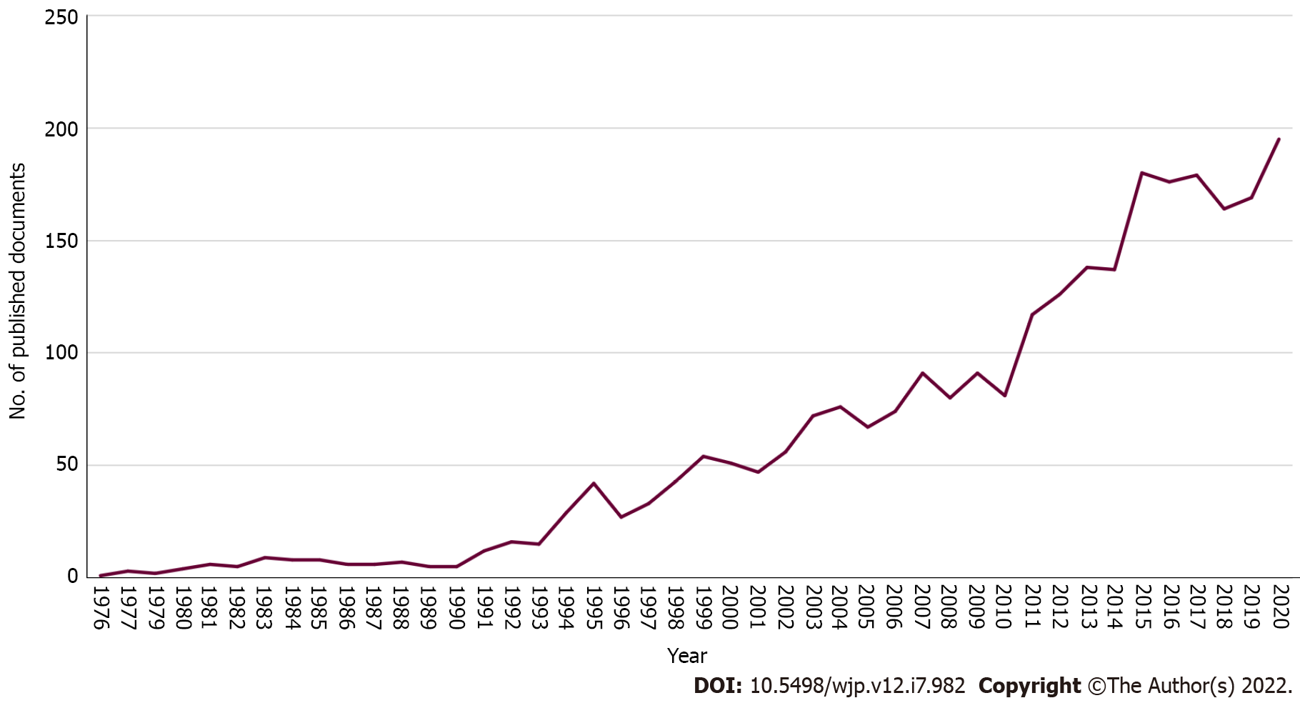
Figure 1 Annual growth of publications in the field of binge-eating. The publication trend related to binge-eating disorder from 1976 to 2020. Clearly, the number of relevant publications has increased sharply since 2011, while 2020 netted the largest amount of binge eating research (195 published documents). There is zero publication in the year 1978.
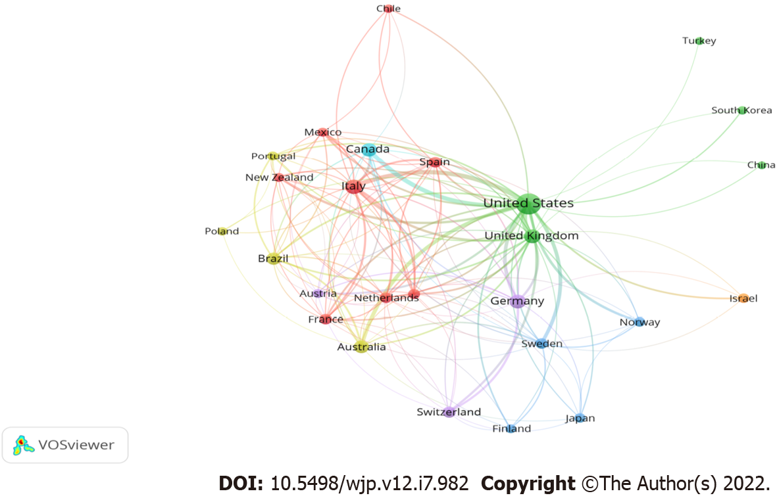
Figure 2 Network visualization map of country collaboration in the field of binge-eating with a minimum contribution of 10 documents per the country was set as a threshold (n = 26).
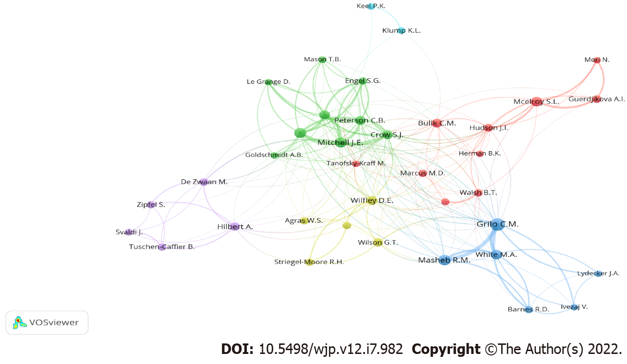
Figure 3 Network visualization map of authors in the field of binge-eating with a minimum contribution of 20 documents.
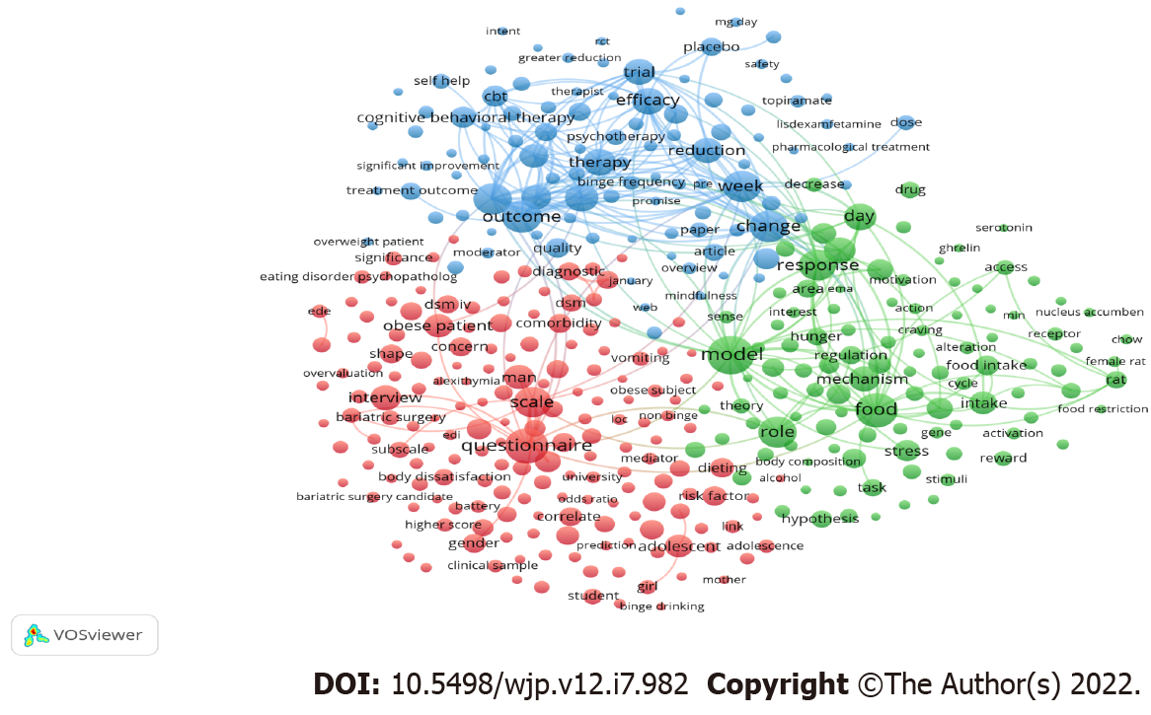
Figure 4 Network visualization map of terms related to the field of binge eating with minimum occurrence of 30 in the titles/abstracts of the retrieved publications.
Table 1 List the top ten core countries publishing the most documents on binge-eating disorder
Ranking | Country | Number of documents | %
1st | United States | 1495 | 55.11
2nd | Italy | 256 | 9.44
3rd | United Kingdom | 183 | 6.75
4th | Germany | 182 | 6.71
5th | Canada | 157 | 5.79
6th | Australia | 127 | 4.68
7th | Brazil | 101 | 3.72
8th | Spain | 59 | 2.17
9th | Switzerland | 58 | 2.14
10th | France | 57 | 2.10

Table 2 List the top ten core institutions publishing the most documents on binge-eating disorder
Ranking | Institution | Country | n | %
1st | Yale School of Medicine | United States | 172 | 6.34
2nd | Yale University | United States | 116 | 4.28
3rd | University of Minnesota Twin Cities | United States | 91 | 3.35
4th | Neuropsychiatric Research Institute, Fargo | United States | 85 | 3.13
5th | The University of North Carolina at Chapel Hill | United States | 70 | 2.58
6th | Harvard Medical School | United States | 67 | 2.47
7th | University of Cincinnati College of Medicine | United States | 65 | 2.40
8th | Columbia University | United States | 60 | 2.21
9th | University of North Dakota | United States | 56 | 2.06
10th | Stanford University School of Medicine | United States | 53 | 1.95

Table 3 List the top ten core funding agencies that have the most documents on binge-eating disorder
Ranking | Funding agencies | Country | n | %
1st | National Institutes of Health | United States | 562 | 20.72
2nd | U.S. Department of Health and Human Services | United States | 537 | 19.79
3rd | National Institute of Diabetes and Digestive and Kidney Diseases | United States | 319 | 11.76
4th | National Institute of Mental Health | United States | 289 | 10.65
5th | National Institute on Drug Abuse | United States | 71 | 2.62
6th | Eunice Kennedy Shriver National Institute of Child Health and Human Development | United States | 39 | 1.44
7th | National Institute of Alcohol Abuse and Alcoholism | United States | 36 | 1.33
8th | Shire | United Kingdom | 32 | 1.18
9th | National Center for Advancing Translational Sciences | United States | 31 | 1.14
9th | National Institute of Heart, Lung, and Blood Institute | United States | 31 | 1.14

Table 4 List the top ten core journals that have the most documents on binge-eating disorder
Ranking | Journal | n | % | IF¹
1st | International Journal of Eating Disorders | 398 | 14.67 | 3.668
2nd | Eating Behaviors | 139 | 5.12 | 2.156
3rd | Appetite | 94 | 3.46 | 3.608
4th | European Eating Disorders Review | 85 | 3.13 | 3.560
5th | Eating and Weight Disorders | 67 | 2.47 | 3.634
6th | Behaviour Research and Therapy | 48 | 1.77 | 4.500
7th | Journal of Consulting and Clinical Psychology | 45 | 1.66 | 4.632
8th | Obesity | 40 | 1.47 | 3.742
9th | Comprehensive Psychiatry | 35 | 1.29 | 2.567
10th | Eating Disorders | 33 | 1.22 | 2.013
10th | Journal of Clinical Psychiatry | 33 | 1.22 | 4.204
10th | Physiology and Behavior | 33 | 1.22 | 2.826
10th | Psychiatry Research | 33 | 1.22 | 2.118
¹Impact factor (IF) from 2020 Journal Citation Reports (Clarivate Analytics).
Table 5 List of the top 10 cited articles for studies related to binge-eating disorder
Ranking | Ref. | Year | Source title | Cited by | Impact index per article¹
1st | Heatherton and Baumeister^{[64]} | 1991 | Psychological Bulletin | 1454 | 7.4
2nd | Gormally et al^{[65]} | 1982 | Addictive Behaviors | 1292 | 29.1
3rd | Spitzer et al^{[66]} | 1993 | International Journal of Eating Disorders | 686 | 17.2
4th | Spitzer et al^{[67]} | 1992 | International Journal of Eating Disorders | 659 | 17.3
5th | Kessler et al^{[1]} | 2013 | Biological Psychiatry | 602 | 64.4
6th | Stice et al^{[68]} | 2002 | Health Psychology | 531 | 23.3
7th | Stice et al^{[69]} | 2000 | Psychological Assessment | 506 | 0.7
8th | Telch et al^{[70]} | 2001 | Journal of Consulting and Clinical Psychology | 473 | 19.4
9th | Halmi et al^{[71]} | 1981 | Psychological Medicine | 465 | 34.2
10th | Fairburn et al^{[72]} | 2000 | Archives of General Psychiatry | 458 | 16.7
¹The impact index per article is presented based on Reference Citation Analysis [Source: Baishideng Publishing Group Inc. (Pleasanton, CA 94566, United States)].

Published by Baishideng Publishing Group Inc
7041 Koll Center Parkway, Suite 160, Pleasanton, CA 94566, USA
Telephone: +19253991568
Email: bpgoffice@wjgnet.com
Help Desk: https://www.f6publishing.com/helpdesk
https://www.wjgnet.com

© 2022 Baishideng Publishing Group Inc. All rights reserved.

