Name of Journal: World Journal of Clinical Cases
Manuscript NO: 73685
Manuscript Type: CASE REPORT

Esophagogastric junctional neuroendocrine tumor with adenocarcinoma: A case report

Zhen-Zhen Kong et al. Esophagogastric junctional NET with adenocarcinoma

Zhen-Zhen Kong, Lu Zhang

Zhen-Zhen Kong, Lu Zhang, Department of Gastroenterology, The First Affiliated Hospital of Zhejiang Chinese Medical University, Hangzhou 310000, Zhejiang Province, China

Author contributions: Kong ZZ was involved in writing the article; Zhang L was involved in the conception of the study; all authors read and approved the final manuscript.

Supported by Zhejiang Provincial Department of Health Clinical Research Application Project, No. 2022KY924; and General Project of Zhejiang Provincial Department of Health, No. 2021KY835.

Corresponding author: Lu Zhang, Department of Gastroenterology, The First Affiliated Hospital of Zhejiang Chinese Medical University, No. 54 Post Road, Shangcheng District, Hangzhou 310000, Zhejiang Province, China. zl06302021@163.com

Received: November 30, 2021
Revised: March 16, 2022
Accepted: April 27, 2022
Published online: June 26, 2022

Abstract
BACKGROUND
At present, cases of esophageal neuroendocrine tumors combined with cardia adenocarcinoma are extremely rare worldwide, and there are no clinical reports. Herein, we describe such a case for clinical reference.

CASE SUMMARY
The presence of cardia cancer and esophageal neuroendocrine tumors in a single patient has not yet been reported. The patient in this case underwent prompt endoscopic treatment and additional surgical resection. Pathology revealed the following: The distance between the cardia cancer and the esophageal neuroendocrine tumors was small, approximately 3 mm. Vascular invasion was observed. The esophageal neuroendocrine tumor was determined to be grade G3. According to the treatment guidelines, after the patient received an explanation of their condition, additional surgical procedures were provided in a timely manner. Early detection and early treatment can successfully prolong survival and improve the quality of life of patients.

CONCLUSION
Early detection and early treatment can successfully prolong survival and improve the quality of life of such patients.

Key Words: Esophageal neuroendocrine tumor; Cardia moderately differentiated adenocarcinoma; Endoscopic treatment; Surgery; Pathology; Case report

©The Author(s) 2022. Published by Baishideng Publishing Group Inc. All rights reserved.

Citation: Kong ZZ, Zhang L. Esophagogastric junctional neuroendocrine tumor with adenocarcinoma: A case report. World J Clin Cases 2022; 10(18): 6241-6246
URL: https://www.wjgnet.com/2307-8960/full/v10/i18/6241.htm
DOI: https://dx.doi.org/10.12998/wjcc.v10.i18.6241

Core Tip: Cases of esophageal neuroendocrine tumors combined with moderately differentiated gastric cardia adenocarcinoma are very rare. Pathology is the gold standard for diagnosis. Endoscopy and additional surgical resection proved to be successful in our case. Early detection and early treatment are both of great significance to the life and health of patients. Considering the successful resection of this case, we provide this case report to serve as a clinical reference.

INTRODUCTION
At present, cases of esophageal neuroendocrine tumors (NETs) combined with cardia adenocarcinoma are extremely rare worldwide. The presence of cardia cancer and esophageal NETs (E-NETs) in a single patient has not yet been reported. Herein, we describe such a case for clinical reference.

CASE PRESENTATION
Chief complaints
A 76-year-old man was hospitalized due to the presence of a cardia mass.

History of present illness
Previous gastroscopy showed a 0-IIa-like cardia lesions and chronic atrophic gastritis with erosions. The pathological examination revealed the following: Tubular adenoma with high-grade intraepithelial neoplasia; mild chronic atrophic gastritis of the antrum; intestinal metaplasia; and Helicobacter pylori infection (Figure 1).

History of past illness
The patient’s medical history was unremarkable.

Personal and family history
The patient’s personal/family history was unremarkable.

Physical examination
No remarkable characteristics were found during the physical examination.

Laboratory examinations
The laboratory results were all normal.

Imaging examinations
Previous gastroscopy showed a 0-IIa-like lesion of the cardia and chronic atrophic gastritis with erosions. Enhanced computed tomography scan of the full abdomen was performed after hospitalization, which revealed that the local gastric wall of the gastric cardia was slightly thickened, no significantly enlarged lymph node shadow was seen around the cardia, and the rest of the region appeared unchanged (Figures 2-4).

FINAL DIAGNOSIS
The final diagnosis was differentiated cardia adenocarcinoma and E-NET (G3).

TREATMENT
Endoscopic submucosal dissection and surgical resection were performed.

OUTCOME AND FOLLOW-UP
The patient was in good general condition without obvious discomfort (Figures 5 and 6).

DISCUSSION
NENs are a group of highly heterogeneous tumors originating from neuroendocrine cells. They can occur in many parts of the body but are most often found in the digestive system, followed by the lungs. E-NETs are very rare^{[1]}, accounting for only 1.4% of all gastrointestinal pancreatic tumors^{[2]} and 0.15%-2.80% of all esophageal tumors^{[3]}. This is due to the poor development of the neuroendocrine system in this area of the body^{[2]}. The incidence rate varies across countries^{[4]}; these tumors are more commonly found in Asian countries than in Western countries^{[5]}. Studies have found that smoking (present in 49%) and drinking (present in 31%) may be a high-risk factor^{[6,7]}. At present, cases of E-NETs combined with cardia adenocarcinoma are extremely rare worldwide, and there are no clinical reports.
Pathology is the gold standard for the diagnosis of NETs. The proliferation activity of tumor cells can be evaluated by the number of mitotic figures or the Ki-67 index. According to the 2019 WHO classification standards, NETs are divided into three grades: G1, G2, and G3. The classification criteria are as follows: G1 is defined as < 2 mitotic cells/10 high-power fields (HPFs), G2 as 2-20 cells/10 HPFs, and G3 as > 20 cells/10 HPFs. The Ki-67 index is classified as follows: G1, ≤ 2%; G2, 3%-20%; and G3, > 20%^{[8]}. When the Ki-67 index is inconsistent with the mitotic cell classification, it can instead be classified as high or low. DAXX/ATRX and p53/RB mutations can be used to distinguish G3 NETs from neuroendocrine carcinomas (NECs). According to the guidelines, NETs are < 1 cm in size, are grade G1/G2, have a low metastasis rate (< 3%), and do not infiltrate into the muscularis propria (T1 stage). Thus, they are suitable for endoscopic treatment. For tumors or NECs more than 2 cm in diameter, the metastasis rate can reach as high as 60% to 80%, so radical resection is the first choice.

CONCLUSION
A case of cardia adenocarcinoma combined with E-NETs has not yet been reported. In our patient, after timely endoscopic treatment, pathology revealed that the distance between the cardia cancer and the E-NETs was small, approximately 3 mm, vascular invasion was observed, and the E-NET was determined to be grade G3. According to the treatment guidelines, after the patient received an explanation of their condition, additional surgical procedures were provided in a timely manner. Complete resection of the lesion significantly improved the patient’s quality of life.

REFERENCES
1 Chin YP, Lai WF, Chiang MT, Chang SC. Esophageal neuroendocrine tumor with initial presentation as painless forehead and neck masses: A case report. Medicine (Baltimore) 2017; 96: e9282 [PMID: 29390385 DOI: 10.1097/MD.0000000000009282]
2 Lee CG, Lim YJ, Park SJ, Jang BI, Choi SR, Kim JK, Kim YT, Cho JY, Yang CH, Chun HJ, Song SY; Neuroendocrine tumor study group. The clinical features and treatment modality of esophageal neuroendocrine tumors: a multicenter study in Korea. BMC Cancer 2014; 14: 569 [PMID: 25098730 DOI: 10.1186/1471-2407-14-569]
3 Weinberg JS, Suki D, Hanbali F, Cohen ZR, Lenzi R, Sawaya R. Metastasis of esophageal carcinoma to the brain. Cancer 2003; 98: 1925-1933 [PMID: 14584076 DOI: 10.1002/cncr.11737]
4 Egashira A, Morita M, Kumagai R, Taguchi KI, Ueda M, Yamaguchi S, Yamamoto M, Minami K, Ikeda Y, Toh Y. Neuroendocrine carcinoma of the esophagus: Clinicopathological and immunohistochemical features of 14 cases. PLoS One 2017; 12: e0173501 [PMID: 28288180 DOI: 10.1371/journal.pone.0173501]
5 Sorbye H, Welin S, Langer SW, Vestermark LW, Holt N, Osterlund P, Dueland S, Hofsli E, Guren MG, Ohrling K, Birkemeyer E, Thiis-Evensen E, Biagini M, Gronbaek H, Soveri LM, Olsen IH, Federspiel B, Assmus J, Janson ET, Knigge U. Predictive and prognostic factors for treatment and survival in 305 patients with advanced gastrointestinal neuroendocrine carcinoma (WHO G3): the NORDIC NEC study. Ann Oncol 2013; 24: 152-160 [PMID: 22967994 DOI: 10.1093/annonc/mds276]
6 Wu IC, Chu YY, Wang YK, Tsai CL, Lin JC, Kuo CH, Shih HY, Chung CS, Hu ML, Sun WC, Wang JP, Wang HP. Clinicopathological features and outcome of esophageal neuroendocrine tumor: A retrospective multicenter survey by the digestive endoscopy society of Taiwan. J Formos Med Assoc 2021; 120: 508-514 [PMID: 32600867 DOI: 10.1016/j.jfma.2020.06.024]
7 Huang Q, Wu H, Nie L, Shi J, Lebenthal A, Chen J, Sun Q, Yang J, Huang L, Ye Q. Primary high-grade neuroendocrine carcinoma of the esophagus: a clinicopathologic and immunohistochemical study of 42 resection cases. Am J Surg Pathol 2013; 37: 467-483 [PMID: 23426118 DOI: 10.1097/PAS.0b013e31826d2639]
8 Nagtegaal ID, Odze RD, Klimstra D, Paradis V, Rugge M, Schirmacher P, Washington KM, Carneiro F, Cree IA; WHO Classification of Tumours Editorial Board. The 2019 WHO classification of tumours of the digestive system. Histopathology 2020; 76: 182-188 [PMID: 31433515 DOI: 10.1111/his.13975]

Footnotes
Informed consent statement: Informed written consent was obtained from the patient for publication of this report and any accompanying images.

Conflict-of-interest statement: The authors declare that they have no conflicts of interest to disclose.

CARE Checklist (2016) statement: The authors have read the CARE Checklist (2016), and the manuscript was prepared and revised according to the CARE Checklist (2016).

Open-Access: This article is an open-access article that was selected by an in-house editor and fully peer-reviewed by external reviewers. It is distributed in accordance with the Creative Commons Attribution NonCommercial (CC BY-NC 4.0) license, which permits others to distribute, remix, adapt, build upon this work noncommercially, and license their derivative works on different terms, provided the original work is properly cited and the use is noncommercial. See: https://creativecommons.org/Licenses/by-nc/4.0/

Provenance and peer review: Unsolicited article; Externally peer reviewed.

Peer-review model: Single blind

Peer-review started: November 30, 2021
First decision: March 11, 2022
Article in press: April 27, 2022

Specialty type: Medicine, research and experimental
Country/Territory of origin: China
Peer-review report’s scientific quality classification
Grade A (Excellent): 0
Grade B (Very good): 0
Grade C (Good): C, C, C
Grade D (Fair): D, D
Grade E (Poor): 0

P-Reviewer: Casella C, Italy; Chiba H, Japan; Hunasanahalli Giriyappa V, India; Mohamed SY, Egypt; Viswanath Y, United Kingdom S-Editor: Fan JR L-Editor: Wang TQ P-Editor: Fan JR

Figure Legends
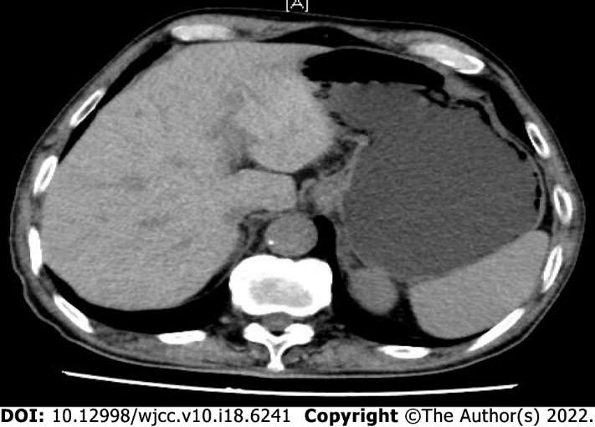
Figure 1 Full abdominal enhanced computed tomography.

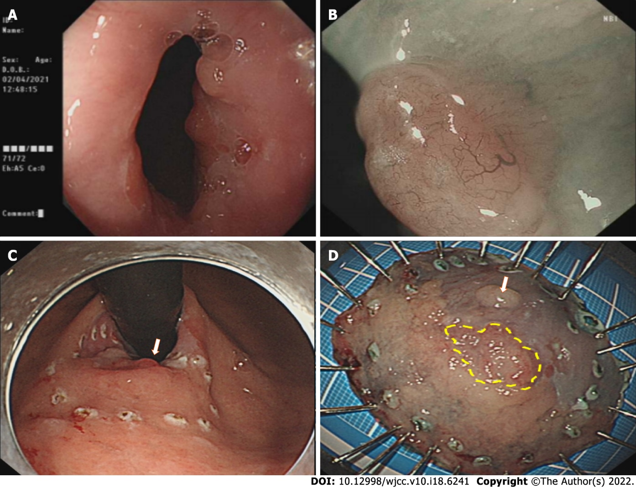
Figure 2 Endoscopic submucosal dissection. A: Cardia mass; B: Submucosal injection; C: Tick to mark the lesion area; D: Lesion specimen.

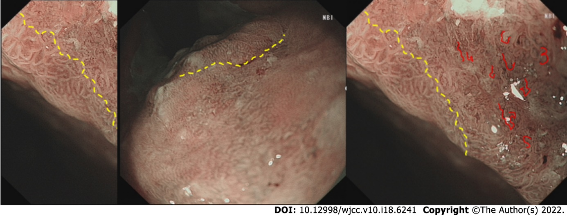
Figure 3 Narrow-band imaging.
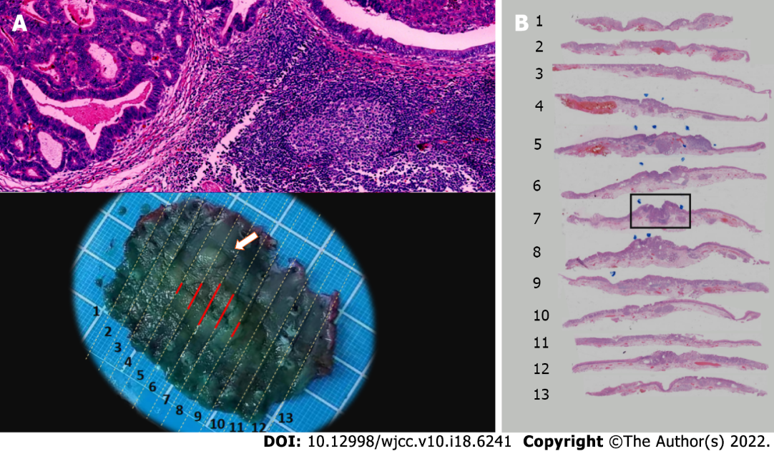
Figure 4 Pathology of cardia endoscopic submucosal dissection specimens. A: Moderately differentiated adenocarcinoma of the cardia; B: Esophageal neuroendocrine tumors (G3).
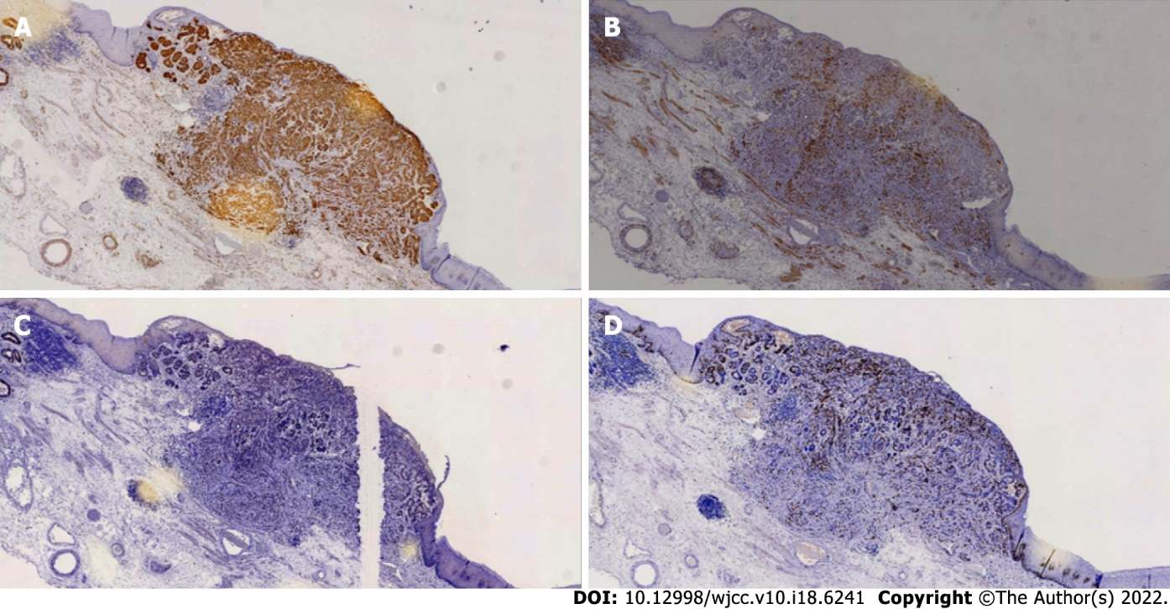
Figure 5 Immunohistochemical staining of esophageal neuroendocrine tumors. A: Syn; B: CD56; C: CgA; D: Ki-67 (25%+).

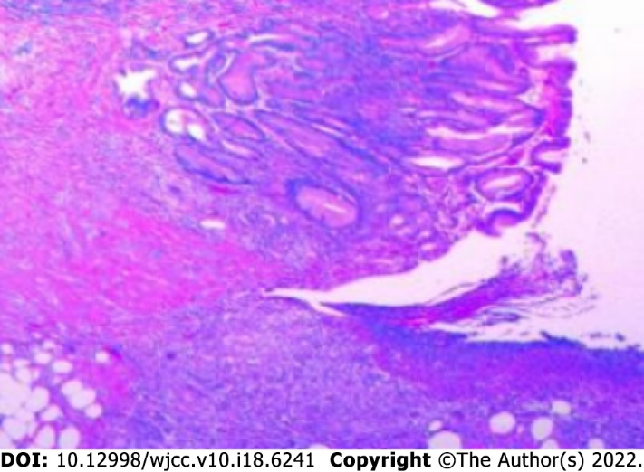
Figure 6 Representative pathology of excised gastric specimens.

Published by Baishideng Publishing Group Inc
7041 Koll Center Parkway, Suite 160, Pleasanton, CA 94566, USA
Telephone: +1-925-3991568
E-mail: bpgoffice@wjgnet.com
Help Desk: https://www.f6publishing.com/helpdesk
https://www.wjgnet.com

© 2022 Baishideng Publishing Group Inc. All rights reserved.

