Name of Journal: World Journal of Clinical Cases
Manuscript NO: 45243
Manuscript Type: CASE REPORT

Type I congenital extrahepatic portosystemic shunt treated by orthotopic liver transplantation: A case report

Xiang W et al. Type I Abernethy deformation liver transplantation

Wen Xiang, Hao Wang, Zhong-Zhou Si, Guang-Shun Chen, Guan-Wu Wang, Ting Li

Wen Xiang, Hao Wang, Zhong-Zhou Si, Guang-Shun Chen, Guan-Wu Wang, Ting Li, Organ Transplantation Center, The Second Xiang-Ya Hospital, Central South University, Changsha 410011, Hunan Province, China

ORCID number: Wen Xiang (0000-0002-7785-347X); Hao Wang (0000-0002-2841-8834); Zhong-Zhou Si (0000-0003-2021-3081); Guang-Shun Chen (0000-0002-5314-8282); Guan-Wu Wang (0000-0001-6272-4555); Ting Li (0000-0002-9366-7116).

Author contributions: All authors contributed to the acquisition of data and the writing and revision of the manuscript.

Supported by the Natural Science Foundation of Hunan Province, No. 2016JJ3165 and No. 2015JJ2169; and the Fundamental Research Funds for the Central Universities of Central South University, No. 2017zzts902.

Informed consent statement: The patient provided informed written consent.

Conflict-of-interest statement: The authors declare that they have no conflicts of interest.

CARE Checklist (2016) statement: The authors have read the CARE Checklist (2016), and the manuscript was prepared and revised according to the CARE Checklist (2016).

Open-Access: This article is an open-access article that was selected by an in-house editor and fully peer-reviewed by external reviewers. It is distributed in accordance with the Creative Commons Attribution Non Commercial (CC BY-NC 4.0) license, which permits others to distribute, remix, adapt, build upon this work non-commercially, and license their derivative works on different terms, provided the original work is properly cited and the use is non-commercial. See: http://creativecommons.org/licenses/by-nc/4.0/

Manuscript source: Unsolicited manuscript

Corresponding author: Ting Li, MD, PhD, Associate Research Scientist, Attending Doctor, Surgeon, Organ Transplantation Center, The Second Xiang-Ya Hospital, Central South University, No. 139 Middle Renmin Road, Changsha 410011, Hunan Province, China. liting001@csu.edu.cn
Telephone: +86-731-85295108
Fax: +86-731-85295808

Received: December 19, 2018
Peer-review started: December 19, 2018
First decision: January 6, 2019
Revised: January 24, 2019
Accepted: February 26, 2019
Article in press: February 26, 2019
Published online: April 6, 2019

Abstract
BACKGROUND
Congenital extrahepatic portosystemic shunt, also known as Abernethy deformation, is a rare malformation caused by dysplasia in the portal vein system. There are few reports of liver transplantation as a treatment for Abernethy deformation, and our report is the first case in China. This is the second reported case with congenital extrahepatic portosystemic shunt combined with focal nodular hyperplasia and hepatopulmonary treated with liver transplantation.

CASE SUMMARY
The patient was a 14-year-old girl, diagnosed preoperatively as type Ib Abernethy deformation, intrahepatic multiple space-occupying lesion, and hepatopulmonary syndrome. The patient recovered well after undergoing classic orthotopic liver transplantation. Liver function, pulmonary function, and portal vein computed tomography angiography imaging were reexamined 20 mo postoperatively, and no abnormality was observed.

CONCLUSION
Liver transplantation is an effective treatment for type I Abernethy deformation combined with focal nodular hyperplasia and hepatopulmonary syndrome.

Key words: Congenital extrahepatic portosystemic shunt; Abernethy deformation; Liver transplantation; Case report

© The Author(s) 2019. Published by Baishideng Publishing Group Inc. All rights reserved.

Core tip: Congenital extrahepatic portosystemic shunt is a rare congenital abnormal vascular anastomosis between the portal vein and vena cava. This report discusses clinical, angiographic diagnostic and histopathological features in one patient with congenital extrahepatic portosystemic shunt, as well as its surgical strategy. Liver transplantation appears to be a feasible treatment option for patients with congenital extrahepatic portosystemic shunt because it achieves optimal treatment effectiveness.

Xiang W, Wang H, Si ZZ, Chen GS, Wang GW, Li T. Type I congenital extrahepatic portosystemic shunt treated by orthotopic liver transplantation: A case report. World J Clin Cases 2019; In press

INTRODUCTION
The first case of congenital absence of the portal vein was found during an autopsy on a girl aged 1 yr and 10 mo by John Abernethy in 1793^{[1]}. With a gradual understanding of the disease and development of vascular ultrasound, abdominal computed tomography (CT), nuclear magnetic resonance, abdominal vascular ultrasound, more clinical cases have been published^{[2]}. It has been reported that a patient with Abernethy deformation can be diagnosed as early as the prenatal stage. The oldest age at diagnosis has been 64 yr. Approximately 80% of patients are diagnosed in childhood. Clinical manifestations of Abernethy deformation are primarily associated with hepatic vascular shunt. Liver transplantation is the only treatment that can reverse Abernethy deformation symptoms. However, there is still no unified regimen for the selection of the surgical procedure. There are a few reports on liver transplant as a treatment for Abernethy deformation. This article is the first reported case of Abernethy deformation treated with orthotopic liver transplantation in China and is the second reported case of congenital extrahepatic portosystemic shunt combined with focal nodular hyperplasia and hepatopulmonary syndrome treated with liver transplantation.

CASE PRESENTATION
Chief complaints and history of illness
A 14-year-old girl had pain in the left epigastrium for more than 10 d, with no tarry stool, hematemesis, or coma history. She normally liked squatting, and her activity tolerance was low. She was normally developed without positive signs.

Laboratory examinations
The results of laboratory examinations were as follows: routine blood examination: red blood cell 4.64 × 10⁹/L, white blood cell 4.83 × 10⁹/L, blood platelet 218 × 10⁹/L; blood biochemistry: alanine aminotransferase 36.9 μ/L, aspartate aminotransferase 30.6 μ/L, serum albumin 41.9 g/L, total bilirubin 21.7 μmol/L, direct bilirubin 8.0 μmol/L, PT 12.8 s, international normalized ratio 1.13. Blood ammonia 22.4 μmol/L, lactic acid 3.28 mmol/L. No abnormality was observed in arterial blood gas parameters at resting state.

Imaging examinations
CT suggested congenital extrahepatic portacaval diversion (Type Ib Abernethy deformation). The superior mesenteric vein and splenic vein joined to form a short extra-hepatic portal vein that drained into a postcava with left hepatic vein, associated with double pulmonary congestion and pulmonary arterial hypertension. There were multiple space-occupying lesions in the liver, and the size of the relatively large tumor was approximately 50 mm. To exclude malignant tumor transformation, positron emission tomography-CT examination was performed (Figure 1 and Figure 2). The results indicated nodules and mass imaging with multiple increased glycometabolism in the liver parenchyma and increased 11C-choline metabolism in some lesions. Multiple focal nodular hyperplasia combined with partial malignant transformation was highly possible. Echocardiography suggested the mean pressure of pulmonary artery at 36 mmHg and light pulmonary arterial hypertension. Pulmonary function examination indicated severe diffusion impairment.

FINAL DIAGNOSIS
(1) Type 1b Abernethy deformation; (2) Focal nodular hyperplasia; and (3) Hepatopulmonary disease.

TREATMENT
Liver transplantation from donation after cardiac death of the donor liver was performed. The patient recovered well after being given anti-infective therapy, baliximab immune induction, and FK-506 + mycophenolate mofetil antirejection therapy postoperatively.

OUTCOME AND FOLLOW-UP
After discharge, the patient was followed up for 20 mo. Reexamination results showed normal liver function, with no abnormalities observed during the pulmonary respiratory function examination.

DISCUSSION
Congenital extrahepatic portosystemic shunt, also known as Abernethy deformation, is a rare malformation in congenital extrahepatic portosystemic shunt caused by dysplasia in the portal vein system. It is characterized by congenital abnormal vascular anastomosis between the portal vein and vena cava. Blood flow in the portal vein does not or only partially drains into the liver, mostly via the lateral branch of the extrahepatic portal vein.
Based on the characteristics of abnormal vascular anastomosis between the portal vein and vena cava, the congenital portal-systemic shunt can be divided into two types. Type I: complete loss of portal vein perfusion in the liver or type II: partial portal vein blood flow draining to the liver. Type I is further divided into type Ia and type Ib. Type Ia: separate drainage of the superior mesenteric vein and splenic vein; type Ib: superior mesenteric vein and splenic vein join and drain into the inferior vena cava^{[3]}. Congenital portal vein absence belongs to type I Abernethy deformation. The occurrence may be related to abnormal development of the ovarian vein and azygos vein during embryogenesis. Type I deformation mostly occurs in females. The most common abnormality is the communication between the superior mesenteric vein and infrahepatic vena cava or left renal vein, often associated with congenital malformation of other organs (such as heart malformation, biliary atresia, and polysplenia), hepatic nodular hyperplasia, and tumors. Generally, type II is the deformation of the portal vein alone, which often occurs in men. Venous blood in the gastrointestinal tract shunts into the vena cava via abnormal side-to-side anastomosis.
The clinical manifestations of congenital hydrodynamic shunt patients are primarily related to liver vascular shunt. The main manifestations include hepatic encephalopathy, pulmonary arterial hypertension, and hepatopulmonary syndrome. Some patients may also have with spontaneous hypoglycemia, followed by normal manifestations of liver function damage, such as hyperammonemia, jaundice, weakness, and right upper quadrant pain.
The patient in this study had clinical hepatopulmonary characteristics: liver disease, right-left shunt caused by hypoxia and pulmonary vasodilation, and pulmonary arterial hypertension. It could be related to the influence of portal-systemic shunt on the metabolism of hepatic vasoactive substances^{[4]}. Cirrhosis combined with portal-systemic shunt is the most common hepatopulmonary pathogenesis^{[5]}. Patients with Abernethy deformation often have no obvious or delayed portal hypertension, due to abnormal blood flow between the portal vein and vena cava^{[6]}. Young patients often develop hyperammonemia, and most older patients show hepatic encephalopathy, which may be related to increased sensitivity to blood ammonia and other toxicants and portal-systemic shunt in the aging brain. Patients with 60% portal-systemic shunt or above have a high possibility of developing hepatic encephalopathy^{[7,8]}. In this case, the patient had normal blood ammonia without symptoms of hepatic encephalopathy. A few patients may have hepatic space-occupying lesions, such as liver focal nodular hyperplasia, hepatic adenoma, and liver cancer^{[9,10]}. It may be related to nutrient substance transfer in the liver and increased blood flow in the hepatic artery, leading to changes in liver function and regeneration function.
Because all patients have the possibility of malignant transformation, we should regularly follow up with serology and imaging, whether combined with space-occupying liver or hyperplastic lesion. Some patients may display deformations in other sites, such as heart, vessel, biliary tract, pancreas, and intestinal tract^{[4]}. Treatment for Abernethy deformation, typing and symptom complications are related to the accompanying diseases. For type I Abernethy deformation patients, given the development into hepatic nodular regeneration, hepatic benign tumor, or the possibility of malignant transformation, liver transplantation has been considered a good treatment. Transplantation not only hinders the development of hepatic pathological changes, but also rebuilds a normal portal vein system, with recovery to a normal anatomical structure^{[11,12]}. Liver transplantation is also considered an ideal therapeutic method for Abernethy deformation combined with hepatopulmonary defects^{[13,14]}. Liver transplantation is the only treatment that can reverse Abernethy deformation symptoms.
However, the selection of surgical procedure is still controversial^{[7,8,10]}. Residual donor liver cannot be guaranteed to meet the requirements of a normal body. More importantly, the characteristics of hepatic focal nodule of Abernethy deformation are not clear, and the possibility of malignant transformation of lesions or recurrence after transplantation is very high. Thus, assisted partial orthotopic liver transplantation is not a recommended surgical procedure^{[8,15]}. Therefore, we chose orthotopic liver transplantation from a corpse donor. The patient has recovered well without appearance of hepatic encephalopathy symptoms or regenerative nodules in the transplanted liver.

CONCLUSION
Liver transplantation is an effective treatment for Abernethy deformation combined with focal nodular hyperplasia and hepatopulmonary syndrome.

REFERENCES
1 Abernethy J. Account of Two Instances of Uncommon Formation in the Viscera of the Human Body: From the Philosophical Transactions of the Royal Society of London. Med Facts Obs 1797; 7: 100-108 [PMID: 29106224]
2 Brasoveanu V, Ionescu MI, Grigorie R, Mihaila M, Bacalbasa N, Dumitru R, Herlea V, Iorgescu A, Tomescu D, Popescu I. Living Donor Liver Transplantation for Unresectable Liver Adenomatosis Associated with Congenital Absence of Portal Vein: A Case Report and Literature Review. Am J Case Rep 2015; 16: 637-644 [PMID: 26386552 DOI: 10.12659/AJCR.895235]
3 Morgan G, Superina R. Congenital absence of the portal vein: two cases and a proposed classification system for portasystemic vascular anomalies. J Pediatr Surg 1994; 29: 1239-1241 [PMID: 7807356 DOI: 10.1016/0022-3468(94)90812-5]
4 Fallon MB, Abrams GA. Pulmonary dysfunction in chronic liver disease. Hepatology 2000; 32: 859-865 [PMID: 11003635 DOI: 10.1053/jhep.2000.7519]
5 Abrams GA, Jaffe CC, Hoffer PB, Binder HJ, Fallon MB. Diagnostic utility of contrast echocardiography and lung perfusion scan in patients with hepatopulmonary syndrome. Gastroenterology 1995; 109: 1283-1288 [PMID: 7557096 DOI: 10.1016/0016-5085(95)90589-8]
6 Witters P, Maleux G, George C, Delcroix M, Hoffman I, Gewillig M, Verslype C, Monbaliu D, Aerts R, Pirenne J, Van Steenbergen W, Nevens F, Fevery J, Cassiman D. Congenital veno-venous malformations of the liver: widely variable clinical presentations. J Gastroenterol Hepatol 2008; 23: e390-e394 [PMID: 17868331 DOI: 10.1111/j.1440-1746.2007.05156.x]
7 Crespin J, Nemcek A, Rehkemper G, Blei AT. Intrahepatic portal-hepatic venous anastomosis: a portal-systemic shunt with neurological repercussions. Am J Gastroenterol 2000; 95: 1568-1571 [PMID: 10894598 DOI: 10.1111/j.1572-0241.2000.02096.x]
8 Singhal A, Srivastava A, Goyal N, Vij V, Wadhawan M, Bera M, Gupta S. Successful living donor liver transplant in a child with Abernethy malformation with biliary atresia, ventricular septal defect and intrapulmonary shunting. Pediatr Transplant 2009; 13: 1041-1047 [PMID: 19254272 DOI: 10.1111/j.1399-3046.2009.01092.x]
9 Chevallier P, Oddo F, Souci J, Diaine B, Padovani B. [Macroscopic intrahepatic portosystemic venous shunt: review of the literature and reclassification]. J Radiol 2000; 81: 597-604 [PMID: 10844336]
10 Murray CP, Yoo SJ, Babyn PS. Congenital extrahepatic portosystemic shunts. Pediatr Radiol 2003; 33: 614-620 [PMID: 12879313 DOI: 10.1007/s00247-003-1002-x]
11 Hobeika J, Houssin D, Bernard O, Devictor D, Grimon G, Chapuis Y. Orthotopic liver transplantation in children with chronic liver disease and severe hypoxemia. Transplantation 1994; 57: 224-228 [PMID: 8310512 DOI: 10.1097/00007890-199401001-00012]
12 Howard ER, Davenport M. Congenital extrahepatic portocaval shunts--the Abernethy malformation. J Pediatr Surg 1997; 32: 494-497 [PMID: 9094026 DOI: 10.1016/S0022-3468(97)90614-X]
13 Guérin F, Blanc T, Gauthier F, Abella SF, Branchereau S. Congenital portosystemic vascular malformations. Semin Pediatr Surg 2012; 21: 233-244 [PMID: 22800976 DOI: 10.1053/j.sempedsurg.2012.05.006]
14 Kanamori Y, Hashizume K, Kitano Y, Sugiyama M, Motoi T, Tange T. Congenital extrahepatic portocaval shunt (Abernethy type 2), huge liver mass, and patent ductus arteriosus--a case report of its rare clinical presentation in a young girl. J Pediatr Surg 2003; 38: E15 [PMID: 12677602 DOI: 10.1053/jpsu.2003.50153]
15 Elias N, Scirica CV, Hertl M. Liver transplantation for the Abernathy malformation. N Engl J Med 2008; 358: 858 [PMID: 18287614 DOI: 10.1056/NEJMc0707762]
P-Reviewer: Boin IF, Stanciu C, Takama Y
S-Editor: Wang JL L-Editor: Filipodia E-Editor: Wu YXJ

Specialty type: Medicine, research and experimental
Country of origin: China
Peer-review report classification
Grade A (Excellent): 0
Grade B (Very good): 0
Grade C (Good): C, C
Grade D (Fair): D
Grade E (Poor): 0

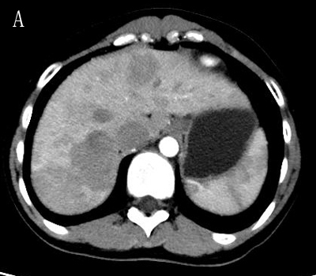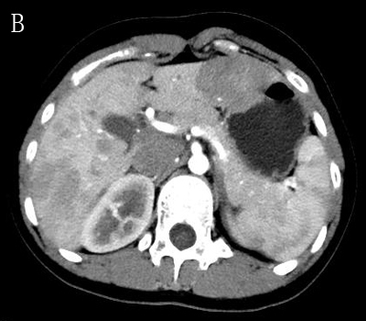

Figure 1 Computed tomography arterial phase. Several hypovascular masses are seen in the right hemiliver (A); and the left hemiliver (B).

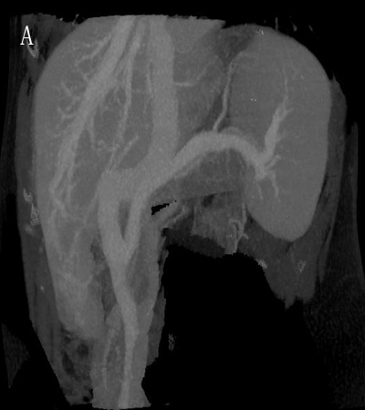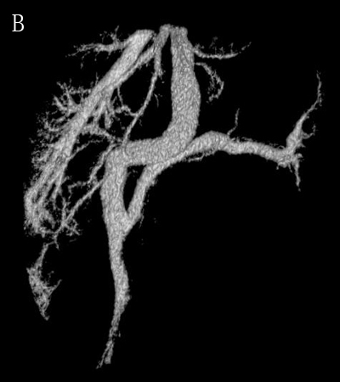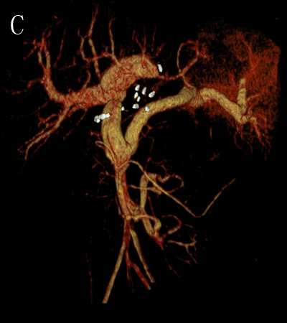

Figure 2 Computed tomography 3D reconstruction and portal vein image reconstruction. A, B: Pre-operation computed tomography 3D reconstruction and portal vein image reconstruction show that the superior mesenteric vein and splenic vein converge to form the portal vein, and the portal vein directly enters the inferior vena cava; C: Post-operation computed tomography portal vein image reconstruction shows the liver transplantation corrects the patient's anatomical abnormalities.

