Name of Journal: World Journal of Clinical Cases
Manuscript NO: 64475
Manuscript Type: CASE REPORT

Rosai-Dorfman disease in the spleen of a pediatric patient: A case report

Ryu H et al. Pediatric RDD in the spleen

Hwaseong Ryu, Jae-Yeon Hwang, Yong-Woo Kim, Tae-Un Kim, Joo-Yeon Jang, Su-Eun Park, Eu-Jeen Yang, Dong-Hoon Shin

Hwaseong Ryu, Jae-Yeon Hwang, Yong-Woo Kim, Tae-Un Kim, Joo-Yeon Jang, Department of Radiology, Pusan National University Yangsan Hospital, Yangsan 50612, South Korea

Su-Eun Park, Eu-Jeen Yang, Department of Pediatrics, Pusan National University Children’s Hospital, Yangsan 50612, South Korea

Dong-Hoon Shin, Department of Pathology, Pusan National University Yangsan Hospital, Yangsan 50612, South Korea

Author contributions: Ryu H and Hwang JY reviewed the literature and contributed to manuscript drafting; Kim YW, Kim TU, and Jang JY reviewed the images and contributed to manuscript drafting; Park SE made the diagnosis; Yang EJ, the patient’s doctor, performed the treatment; Shin DH performed the pathological examination; Hwang JY was responsible for revising the manuscript for important intellectual content; all authors issued the final approval for the version to be submitted.

Corresponding author: Jae-Yeon Hwang, MD, PhD, Associate Professor, Department of Radiology, Pusan National University Yangsan Hospital, Geumo-ro 20, Yangsan 50612, South Korea. jyhwang79@gmail.com

Received: March 15, 2021
Revised: April 14, 2021
Accepted: May 24, 2021
Published online: July 26, 2021

Abstract
BACKGROUND
Rosai–Dorfman disease (RDD) is a rare histiocytic proliferation of unknown etiology commonly found in children and adolescents. The common manifestation of RDD is massive and painless bilateral cervical lymphadenopathy with extranodal disease. While extranodal involvement in RDD is common, the spleen is an infrequent site of disease.

CASE SUMMARY
We report a 10-mo-old female infant with RDD presenting multiple splenic masses without cervical lymphadenopathy. She had fever, and blood tests showed leukocytosis, anemia, and elevated erythrocyte sedimentation rate and C-reactive protein. Ultrasound, computed tomography, and magnetic resonance images demonstrated multiple splenic masses. Despite antibiotic therapy, her symptoms were not relived. She underwent diagnostic splenectomy and was discharged with recovery.

CONCLUSION
In pediatric patients with refractory infectious symptoms or hematological abnormalities, clinicians should suspect RDD, even in patients without significant lymphadenopathy.

Key Words: Rosai–Dorfman disease; Sinus histiocytosis with massive lymphadenopathy; Ultrasonography; Computed tomography; Magnetic resonance imaging; Case report

©The Author(s) 2021. Published by Baishideng Publishing Group Inc. All rights reserved.

Citation: Ryu H, Hwang JY, Kim YW, Kim TU, Jang JY, Park SE, Yang EJ, Shin DH. Rosai-Dorfman disease in the spleen of a pediatric patient: A case report. World J Clin Cases 2021; 9(21): 6032-6040
URL: https://www.wjgnet.com/2307-8960/full/v9/i21/6032.htm
DOI: https://dx.doi.org/10.12998/wjcc.v9.i21.6032

Core Tip: Rosai–Dorfman disease (RDD) is a rare histiocytic proliferation of unknown etiology, characterized by massive and painless bilateral cervical lymphadenopathy accompanied by fever, commonly found in children and adolescents. The spleen is an infrequent site of extranodal involvement in RDD. We report a 10-mo-old girl with RDD with extranodal involvement of the spleen without significant cervical lymphadenopathy.

INTRODUCTION
Rosai–Dorfman disease (RDD), also called sinus histiocytosis with massive lymphadenopathy, is a rare histiocytic proliferation of unknown etiology, usually occurring in children and adolescents. It is characterized by massive and painless bilateral cervical lymphadenopathy accompanied by fever, leukocytosis, elevated erythrocyte sedimentation rate, and polyclonal hypergammaglobulinemia^{[1]}. More than 40% of patients have an extranodal involvement, and commonly affected sites are the upper respiratory system, skin, eyes, bones, genitourinary system, oral cavity, central nervous system, and soft tissue^{[2,3]}. The spleen is an infrequent site of disease, and if involved, combined nodal and extranodal disease is more frequent. Here we report a case of a 10-mo-old female infant with RDD with extranodal involvement of the spleen and provide a review of the available literature on extranodal RDD involvement in pediatric patients.

CASE PRESENTATION
Chief complaints
A 10-mo-old female infant visited our hospital due to fever.

History of present illness
The patient had persistent fever during the previous 10 d. Her body temperature was elevated to 39 ℃. The patient did not have any respiratory or gastrointestinal symptoms, except for mild rhinorrhea.

History of past illness
The patient had a free previous medical history.

Personal and family history
No notable family history was found.

Physical examination
Physical examination showed no abnormal findings.

Laboratory examinations
At presentation, blood tests showed leukocytosis (leukocyte count, 25.29 × 10⁶/L), anemia (hemoglobin, 9.3 g/dL), a high erythrocyte sedimentation rate (ESR) (72 mm/h), and an elevated C-reactive protein level (CRP) (11.04 mg/dL). Peripheral blood smear showed normocytic normochromic anemia with spherocytes and tear drop cells and leukocytosis with monocytosis, basophilia, and neutrophilia.

Imaging examinations
On plain radiography, an approximately 4-cm mass was observed in the left upper quadrant of the abdomen with displacement of the bowel loops. Ultrasonography showed two hypoechoic solid masses in the spleen with diameters between 1 cm and 1.5 cm. The lower pole of the spleen was enlarged, forming a 4.5-cm solid lump, which contained irregular and well-defined hypoechoic areas with intervening normal spleen tissue. The lesions did not show cystic portions or necrotic changes, but showed similar vascularity to the spleen on both color Doppler study and superb microvascular imaging and showed comparable shear wave velocity to a normal area of the spleen with a median value of 21.5 kPa on elastography, which was repeatedly measured 10 times (21.5 kPa for the lesion vs. 24.7 kPa for the normal spleen) (Figure 1).
Contrast-enhanced computed tomography (CT) of the abdomen obtained in the portal venous phase showed hypo-enhanced splenic masses. The exophytic lesion at the inferior pole of the spleen showed heterogeneous enhancement with low attenuation and isoattenuation to the spleen. No significant lymphadenopathy was observed in the abdominal and pelvic cavities (Figure 2). Magnetic resonance imaging (MRI) was performed for further characterization of the masses. On T2-weighted images, the lesions showed low signal intensity to the spleen. However, on T1-weighted images, the lesions showed variable signal intensities: three lesions showed low signal intensity, one lesion showed iso signal intensity, and two lesions showed high signal intensity. After gadolinium administration, the lesions showed low signal intensity with peripheral enhancement in both the arterial and portal venous phases. The lesions showed persistent low signal intensity until 5 min after gadolinium administration (Figure 3).

Pathological findings
Histopathology showed histiocytic proliferation with emperipolesis in an ill-defined ovoid splenic mass and splenic hilar lymph nodes. Immunohistochemistry revealed that the proliferating histiocytes were positive for CD68 antigen and S-100 protein, but negative for CD1a (Figure 4). These findings were consistent with RDD. Epstein–Barr virus (EBV) was not detected in the specimen using EBV in situ hybridization for EBV-encoded RNA.

FINAL DIAGNOSIS
The patient was diagnosed with extranodal involvement of RDD in the spleen.

TREATMENT
Although 1 mg of piperacillin-tazobactam were administered three times daily for five days, the patient had persistent fever and anemia. Considering laboratory and radiological findings, diagnostic splenectomy was performed. Following a laparotomy, a slightly hard and round-shaped exophytic mass approximately 6 cm in size was found at the inferior pole of the spleen, and a few enlarged lymph nodes around the splenic hilum and pancreas tail and along the gastroepiploic vessels were found. After splenectomy, one accessory spleen and a few enlarged lymph nodes along the gastoepiploic vessels were found and retrieved.

OUTCOME AND FOLLOW-UP
The patient’s symptoms, including fever, anemia, and leukocytosis, improved after splenectomy. The patient was discharged 14 d after the operation. At one month follow-up, the patient had no fever or other discomfort. The lab findings including leukocyte count, hemoglobin, ESR and CRP were within normal limit. The patient underwent contrast-enhanced CT exams one month, six months, and two year surgery. Those examinations demonstrated no abnormal finding except splenectomy state.

DISCUSSION
Histiocytoses are a group of hematological disorders characterized by pathological mononuclear phagocytic cell infiltration of normal tissues. Mononuclear phagocytes can be classified into two major classes: macrophages and dendritic cells. The World Health Organization has classified histiocytic disorders into three classes based on pathological cells: dendritic cell histiocytoses, non-dendritic cell histiocytoses, and malignant histiocytoses^{[4]}. RDD, originally named sinus histiocytosis with massive lymphadenopathy, is a rare histiocytic disorder, but is the most common non-dendritic cell histiocytosis^{[5]}. RDD was initially described by Rosai and Dorfman in 1969; however, its exact etiology and pathogenesis remained unknown. Some studies have proposed that RDD is a type of chronic inflammatory lymphoid hyperplasia due to antigenic stimuli, such as malignant tumors and acute lymphadenitis disorder^{[6,7]}. Lu et al^{[8]} have reported four cases in which RDD and malignant lymphoma were confirmed in the same lymph node. di Dio et al^{[9]} have reported one case in which RDD and EBV infection were diagnosed in the same biopsied cervical lymph node specimen. In addition, Arakaki et al^{[5]} have reported human herpesvirus 6 detection in a biopsied RDD renal sample. However, here, the patient had no simultaneous hematological disorder or definite infection.
RDD affects males more frequently than females^{[10]} and commonly occurs in the first two decades of life^{[11]}. The most commonly affected site is the lymph nodes, and the most common clinical symptom is painless and isolated lymphadenopathy^{[12]}. Over 90% of patients with RDD present with cervical lymphadenopathy, but any group of lymph nodes can be invaded. Axillary, inguinal, mediastinal, hilar, and retroperitoneal lymph node involvements have been reported^{[9,10]}. Extranodal involvement of RDD has been reported in up to 40% of all cases^{[2]}; however, few cases are available in the literature. The most commonly affected extranodal sites are the skin and soft tissue. The involvement of the upper respiratory tract, eyes, salivary gland, central nervous system, bones, lungs, urogenital and gastrointestinal tracts, breast, thyroid, and heart has also been described^{[9,11-16]}. Concurrent involvement of nodal and extranodal sites is more commonly observed. According to some studies, no correlation was observed between the type of RDD and clinical outcomes, but a significant difference was observed between the mean age of children and the type of RDD, with younger children more frequently affected by purely nodal RDD^{[9,17]}. We summarized further case reports of RDD in pediatric patients in Table 1^{[4,5,7,9,12,14-16,18]}.
Few cases of splenic involvement of RDD have been reported to date. In the English literature, all patients were middle-aged women and presented with hematological symptoms, such as anemia and thrombocytopenia that improved after splenectomy^{[19,20]}. To the best of our knowledge, splenic involvement of RDD in pediatric patients is extremely rare.
Imaging examinations are not pathognomonic in the diagnosis of RDD because of their nonspecific findings. Furthermore, the appearance of extranodal RDD on imaging studies often mimics malignancy^{[12]}. Therefore, biopsy is necessary to establish diagnosis^{[12,18]}. In our case, CT images showed multiple hypodense masses in the spleen in accordance with other studies^{[19,20]}.
The definitive diagnosis of RDD can only be made by histological analysis. One of the pathognomonic findings is emperipolesis defined as the presence of phagocytized cells in a histiocyte. In immunohistochemical analysis, positivity for CD68 antigen and S-100 protein, but negativity for CD1a antigen is diagnostic for RDD. Emperipolesis can also be found in Langerhans cell histiocytosis (LCH), but the absence of Birbeck granules and negativity for CD1a antigen help differentiate RDD from LCH^{[9,12]}.
The clinical course of RDD is benign and may regress spontaneously. Given that fact, observation may be a good treatment option. However, treatment is required in cases of significant extranodal disease because locoregional recurrence or even dissemination can be possible. Compression of vital organs or severe constitutional symptoms, such as fever, is also indications for therapy^{[7,9]}. Although there is no consensus for the optimum treatment option, surgery is probably the best curative treatment if complete resection is possible. In addition, medical therapy, including corticosteroids, antibiotics, antiviral agents, chemotherapy, and radiotherapy, is available^{[9]}.

CONCLUSION
In conclusion, although splenic involvement is rare, especially in pediatric patients with RDD, RDD should be considered a differential diagnosis, even in patients without significant lymphadenopathy, especially in the setting of hematological abnormality or infectious symptoms.

REFERENCES
1 Gupta P, Babyn P. Sinus histiocytosis with massive lymphadenopathy (Rosai-Dorfman disease): a clinicoradiological profile of three cases including two with skeletal disease. Pediatr Radiol 2008; 38: 721-8; quiz 821-2 [PMID: 18246343 DOI: 10.1007/s00247-007-0701-0]
2 Zhu F, Zhang JT, Xing XW, Wang DJ, Zhu RY, Zhang Q, Wang HT, Lang SY. Rosai-Dorfman disease: a retrospective analysis of 13 cases. Am J Med Sci 2013; 345: 200-210 [PMID: 22652821 DOI: 10.1097/MAJ.0b013e3182553e2d]
3 Adeleye AO, Amir G, Fraifeld S, Shoshan Y, Umansky F, Spektor S. Diagnosis and management of Rosai-Dorfman disease involving the central nervous system. Neurol Res 2010; 32: 572-578 [PMID: 20350368 DOI: 10.1179/016164109X12608733393836]
4 Rasool MN, Genzengane V. Rosai-Dorfman disease of the distal radius in a child: A case report and review of the literature. SA Orthopaedic Journal 2015; 14: 67-70 [DOI: 10.17159/2309-8309/2015/v14n410]
5 Arakaki N, Gallo G, Majluf R, Diez B, Arias E, Riudavets MA, Sevlever G. Extranodal rosai-dorfman disease presenting as a solitary mass with human herpesvirus 6 detection in a pediatric patient. Pediatr Dev Pathol 2012; 15: 324-328 [PMID: 22400904 DOI: 10.2350/11-11-1110-CR.1]
6 Ambati S, Chamyan G, Restrepo R, Escalon E, Fort J, Pefkarou A, Khatib ZA, Dehner LP. Rosai-Dorfman disease following bone marrow transplantation for pre-B cell acute lymphoblastic leukemia. Pediatr Blood Cancer 2008; 51: 433-435 [PMID: 18493991 DOI: 10.1002/pbc.21606]
7 Nandi M, Mondal RK, Datta S, Karmakar BC, Mukherjee K, Dhibar TK. Rosai-Dorfman disease. Indian J Pediatr 2008; 75: 290-294 [PMID: 18376102 DOI: 10.1007/s12098-008-0063-0]
8 Lu D, Estalilla OC, Manning JT Jr, Medeiros LJ. Sinus histiocytosis with massive lymphadenopathy and malignant lymphoma involving the same lymph node: a report of four cases and review of the literature. Mod Pathol 2000; 13: 414-419 [PMID: 10786808 DOI: 10.1038/modpathol.3880071]
9 di Dio F, Mariotti I, Coccolini E, Bruzzi P, Predieri B, Iughetti L. Unusual presentation of Rosai-Dorfman disease in a 14-month-old Italian child: a case report and review of the literature. BMC Pediatr 2016; 16: 62 [PMID: 27142277 DOI: 10.1186/s12887-016-0595-9]
10 Sodhi KS, Suri S, Nijhawan R, Kang M, Gautam V. Rosai-Dorfman disease: unusual cause of diffuse and massive retroperitoneal lymphadenopathy. Br J Radiol 2005; 78: 845-847 [PMID: 16110109 DOI: 10.1259/bjr/23127241]
11 Foucar E, Rosai J, Dorfman R. Sinus histiocytosis with massive lymphadenopathy (Rosai-Dorfman disease): review of the entity. Semin Diagn Pathol 1990; 7: 19-73 [PMID: 2180012]
12 Mantilla JG, Goldberg-Stein S, Wang Y. Extranodal Rosai-Dorfman Disease: Clinicopathologic Series of 10 Patients With Radiologic Correlation and Review of the Literature. Am J Clin Pathol 2016; 145: 211-221 [PMID: 26803323 DOI: 10.1093/ajcp/aqv029]
13 Brenn T, Calonje E, Granter SR, Leonard N, Grayson W, Fletcher CD, McKee PH. Cutaneous rosai-dorfman disease is a distinct clinical entity. Am J Dermatopathol 2002; 24: 385-391 [PMID: 12357197 DOI: 10.1097/00000372-200210000-00001]
14 Rodriguez-Galindo C, Helton KJ, Sánchez ND, Rieman M, Jeng M, Wang W. Extranodal Rosai-Dorfman disease in children. J Pediatr Hematol Oncol 2004; 26: 19-24 [PMID: 14707706 DOI: 10.1097/00043426-200401000-00007]
15 Sridhara SK, Shah RK. Rosai-Dorfman in the submandibular salivary glands of a pediatric patient. Laryngoscope 2010; 120 Suppl 4: S228 [PMID: 21225826 DOI: 10.1002/lary.21695]
16 Tubbs RS, Kelly DR, Mroczek-Musulman EC, Hammers YA, Berkow RL, Oakes WJ, Grabb PA. Spinal cord compression as a result of Rosai-Dorfman disease of the upper cervical spine in a child. Childs Nerv Syst 2005; 21: 951-954 [PMID: 15650889 DOI: 10.1007/s00381-004-1121-1]
17 Warrier R, Chauhan A, Jewan Y, Bansal S, Craver R. Rosai-Dorfman disease with central nervous system involvement. Clin Adv Hematol Oncol 2012; 10: 196-198 [PMID: 22402429]
18 Rittner RE, Baumann U, Laenger F, Hartung D, Rosenthal H, Hueper K. Whole-body diffusion-weighted MRI in a case of Rosai-Dorfman disease with exclusive multifocal skeletal involvement. Skeletal Radiol 2012; 41: 709-713 [PMID: 22139086 DOI: 10.1007/s00256-011-1328-7]
19 Ha H, Kim KH, Ahn YJ, Kim JH, Kim JE, Yoon SS. A rare case of Rosai-Dorfman disease without lymphadenopathy. Korean J Intern Med 2016; 31: 802-804 [PMID: 26837011 DOI: 10.3904/kjim.2015.026]
20 Knox SK, Kurtin PJ, Steensma DP. Isolated splenic sinus histiocytosis (Rosai-Dorfman disease) in association with myelodysplastic syndrome. J Clin Oncol 2006; 24: 4027-4028 [PMID: 16921057 DOI: 10.1200/JCO.2005.05.3967]

Footnotes
Informed consent statement: Written informed consent was obtained from the patient’s parents for the publication of this report and any accompanying images.

Conflict-of-interest statement: The authors declare that they have no conflicts of interest.

CARE Checklist (2016) statement: The authors have read the CARE Checklist (2016), and the manuscript was prepared and revised according to the CARE Checklist (2016).

Open-Access: This article is an open-access article that was selected by an in-house editor and fully peer-reviewed by external reviewers. It is distributed in accordance with the Creative Commons Attribution NonCommercial (CC BY-NC 4.0) license, which permits others to distribute, remix, adapt, build upon this work non-commercially, and license their derivative works on different terms, provided the original work is properly cited and the use is non-commercial. See: http://creativecommons.org/Licenses/by-nc/4.0/

Manuscript source: Unsolicited manuscript

Peer-review started: March 15, 2021
First decision: April 4, 2021
Article in press: May 24, 2021

Specialty type: Radiology, nuclear medicine and medical imaging
Country/Territory of origin: South Korea
Peer-review report’s scientific quality classification
Grade A (Excellent): 0
Grade B (Very good): 0
Grade C (Good): C
Grade D (Fair): 0
Grade E (Poor): 0

P-Reviewer: Wen J S-Editor: Zhang H L-Editor: A P-Editor: Wang LYT
Figure Legends
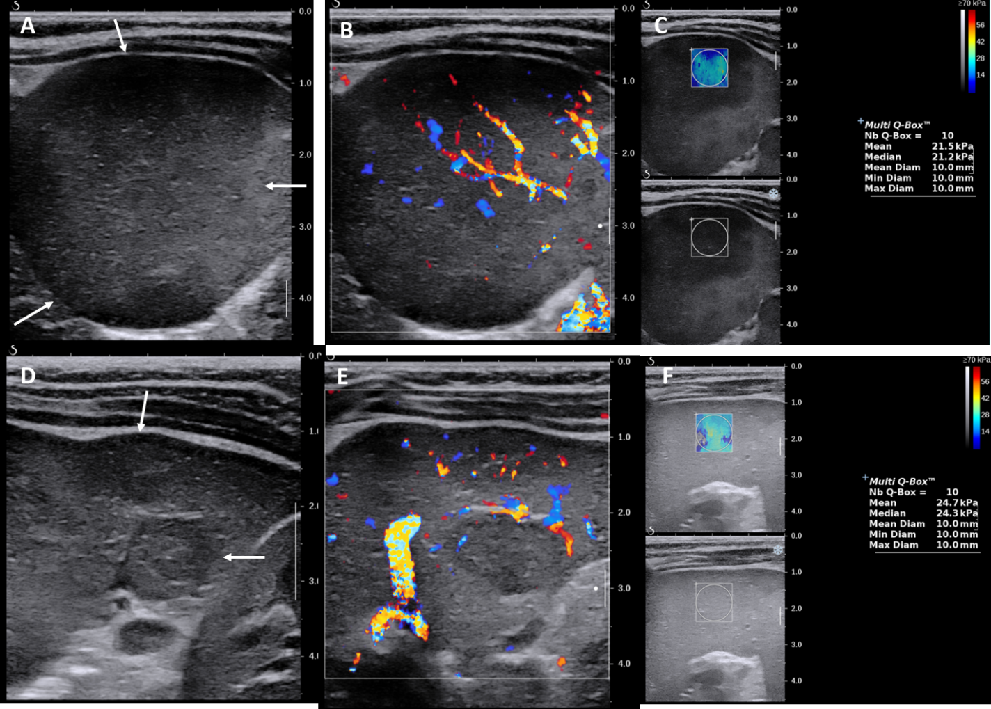
Figure 1 Ultrasound images of two solid spleen masses. A and D: B-mode images demonstrated irregular and hypoechoic masses; B and E: Color Doppler images showed similar mass vascularity to that of a normal area of the spleen; C and F: Shear wave elastography showed similar shear wave velocity to that of ad normal area of the spleen.

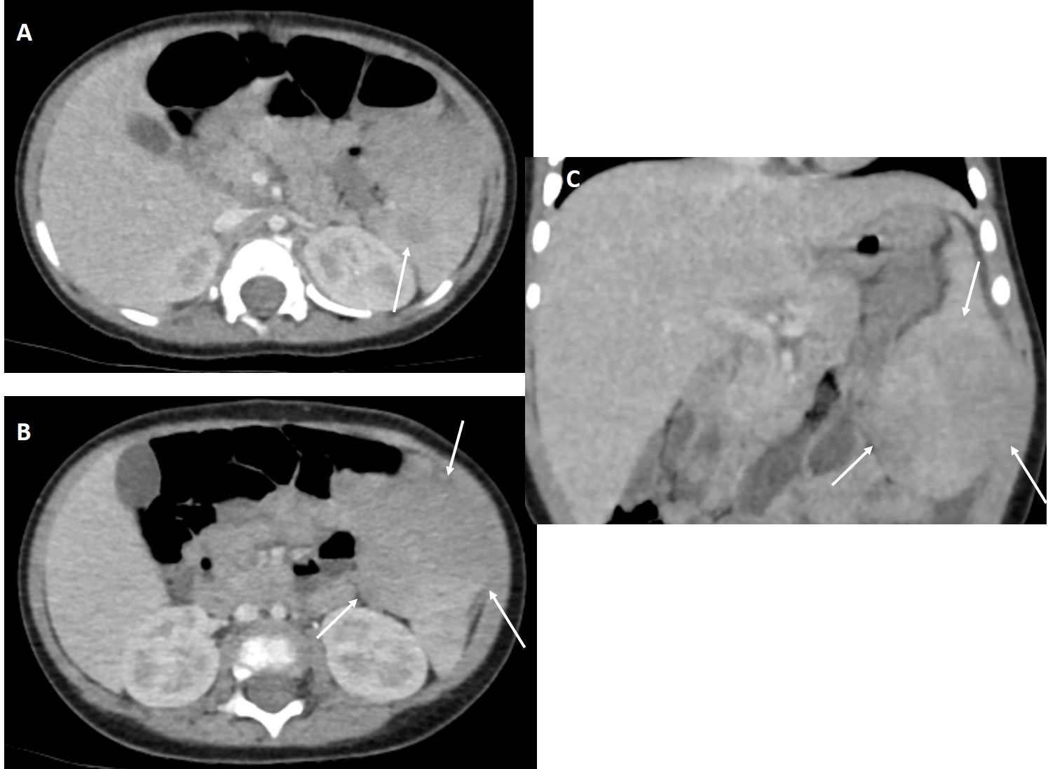
Figure 2 Computed tomography images of two solid splenic masses. A: Axial image showed smaller hypodense mass; B: Axial image demonstrated larger exophytic hypodense mass; C: Coronal image revealed larger exophytic hypodense mass.
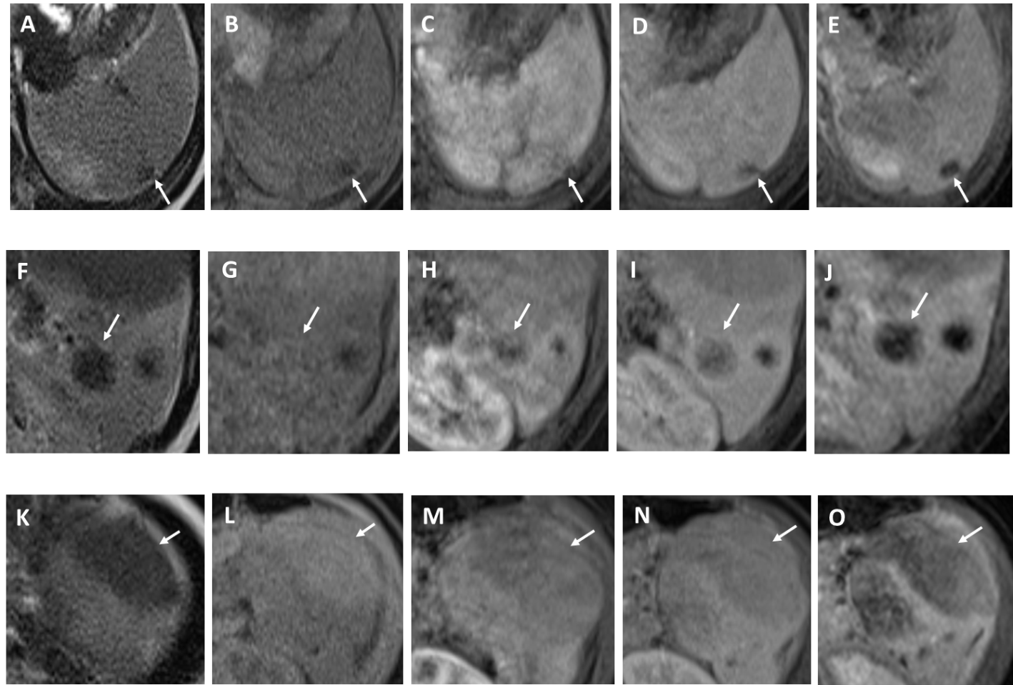
Figure 3 Magnetic resonance images of splenic masses. A-E: Magnetic resonance imaging (MRI) images demonstrated mass in upper level of spleen; F-J: MRI images showed mass in middle level of spleen; K-O: MRI images illustrated mass in lower level of spleen. A, F and K: Splenic masses showed low signal intensity on T2-weighted images; B, G and L: Splenic masses demonstrated various signal intensities on T1-weighted images; C, H and M: Splenic masses showed low signal intensity in the late arterial phase; D, I and N: Splenic masses showed persistent low signal intensity in the portal venous phase; E, J and O: Splenic masses showed still low signal intensity in the 5-min delayed phase.
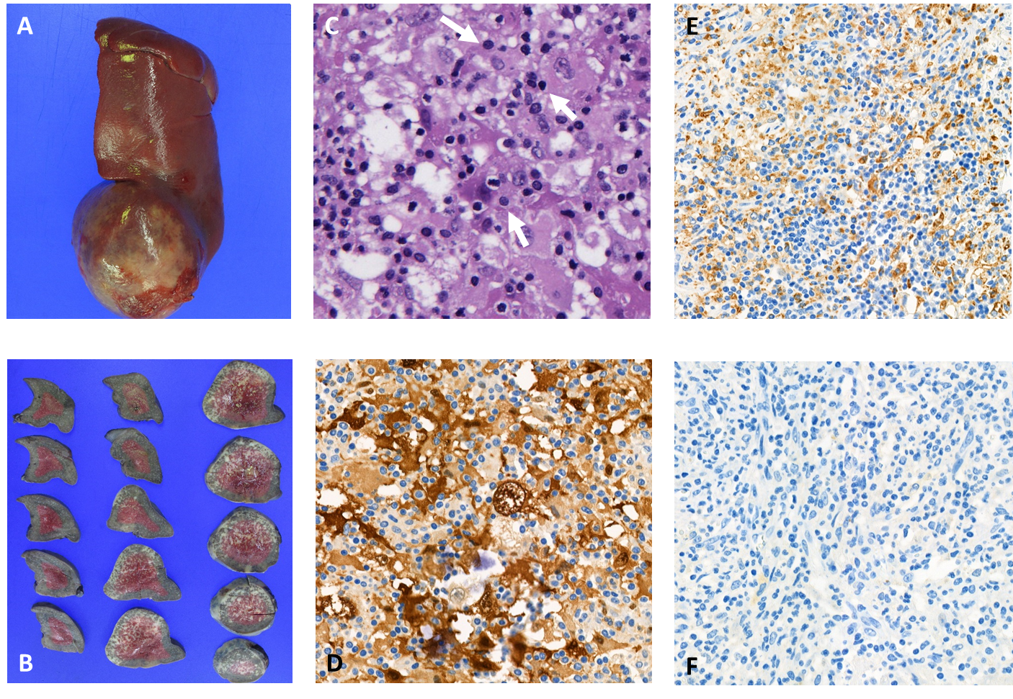
Figure 4 Pathologic images of splenic masses. A: Resected specimen showed contour bulging splenic mass; B: Cut surface of the resected specimen; C: Hematoxylin and eosin-stained section (200 ×) showed histiocytic proliferation with emperipolesis (arrows); D: Proliferating histiocytes were positive for S-100 protein stained section (400 ×); E: Proliferating histiocytes were positive for CD68 antigen stained section (400 ×); F: proliferating histiocytes were negative for CD1a stained section (400 ×).

Table 1 Literature review of pediatric Rosai–Dorfman disease
Ref. | Age | Gender | Symptoms | Underlying disease | Nodal disease | Extranodal disease | Radiologic findings
 |  |  |  |  |  |  | Location | US | X-ray / CT | MRI
di Dio  et al^{[9]}, 2016 | 14M | (-) | Swelling of the right parotid gland | Recent EBV infection | Bilateral cervical, hilar | Bilateral parotid gland | Multiple intraparotid LNs | Cystic and solid | (-) | Enhancement: Irregular
Rasool et al^{[4]}, 2015 | 15M | F | Pain and swelling of distal forearm | Not described | No | Physis of distal radius | Well-defined intramedullary lesion | (-) | Radiolucent lesion with scalloping and thin rim | (-)
Mantilla et al^{[12]}, 2016 | 2 | F | Proptosis, headache | H syndrome (SLC29A3 mutation) | No | Bilateral orbit | Numerous well-circumscribed intraorbital masses | (-) | (-) | T2WI: Moderately hyperintense; enhancement: Mild
Nandi et al^{[7]}, 2008 | 5 | M | Painless huge neck swelling, fever | HHV-6 infection | Bilateral cervical | No |  | (-) | (-) | (-)
Nandi et al^{[7]}, 2008 | 5 | M | Bilateral proptosis, swelling over the mandibular area | No | Preauricular, mandibular | Bilateral orbit | Ill-defined irregular masses involving mainly intraconal parts | (-) | Enhancement: heterogeneous | (-)
Rodriguez-Galindo et al^{[14]}, 2004 | 6 | F | Orbital swelling, proptosis, and blindness | No | Ipsilateral cervical | Orbit | Retroconal and preseptal mass extended to cavernous sinus | (-) | (-) | Enhancement: Mild
Arakaki et al^{[5]}, 2012 | 7 | M | Abdominal pain and diarrhea | HHV-6 infection | No | Kidney | Mass at anterior portion of kidney | Homogeneous echogenecity | Soft tissue density; enhancement: Homogeneous | Enhancement: Homogeneous
Rodriguez-Galindo et al^{[14]}, 2004 | 9 | F | Left frontal swelling and tenderness | No | No | Skull | Well-defined lesions in frontal bone |  | Radiolucent lesions without sclerotic margin | (-)
Sridhara et al^{[15]}, 2012 | 11 | M | Painless bilateral neck swelling | Recent EBV infection | No | Bilateral submandibular gland | Enlarged submandibular glands | (-) | Enhancement: Homogeneous | (-)
Tubbs et al^{[16]}, 2005 | 13 | M | Neck pain, headache, blurred vision | No | No | Right parietal bone | Intraosseous lesion | (-) | (-) | (-)
 |  |  |  |  |  | Suboccipital musculature |  | (-) | (-) | Enhancement: Mild
Rittner et al^{[18]}, 2012 | 15 | M | Fever, back and left hip pain | No | No | Multiple bone lesions (cranial bone, spine, pelvis, upper/lower extremities) |  | (-) | Lytic lesions | T1WI: Hypointense; T2WI: Hyperintense; enhancement: Strong
Rodriguez-Galindo et al^{[14]}, 2004 | 15 | F | Headache, proptosis | Recent EBV infection | Mediastinal | Brain | Anterior and posterior falx | (-) | (-) | T1WI and T2WI: Isointense; Enhancement: Strong
 |  |  |  |  |  | Bilateral orbit | Retroconal, preseptal space
T1WI: T1-weighted image; T2WI: T2-weighted image; US: Ultrasound; CT: Computed tomography; MRI: Magnetic resonance imaging; EBV: Epstein–Barr virus; HHV: Human herpesvirus.

Published by Baishideng Publishing Group Inc
7041 Koll Center Parkway, Suite 160, Pleasanton, CA 94566, USA
Telephone: +1-925-3991568
E-mail: bpgoffice@wjgnet.com
Help Desk: https://www.f6publishing.com/helpdesk
https://www.wjgnet.com

© 2021 Baishideng Publishing Group Inc. All rights reserved.

