Name of Journal: World Journal of Clinical Cases
Manuscript NO: 57787
Manuscript Type: CASE REPORT

Massive gastric bleeding - perforation of pancreatic pseudocyst into the stomach: A case report and review of literature

Jin Z et al. Massive gastric bleeding

Zhe Jin, Yi-Wei Xiang, Qiu-Shi Liao, Xiao-Xu Yang, Hui-Chao Wu, Bi-Guang Tuo, Rui Xie

Zhe Jin, Yi-Wei Xiang, Qiu-Shi Liao, Xiao-Xu Yang, Hui-Chao Wu, Bi-Guang Tuo, Rui Xie, Department of Gastroenterology, Affiliated Hospital of Zunyi Medical University, Zunyi 563003, Guizhou Province, China

Author contributions: Jin Z and Xiang YW contributed equally to this article; Jin Z and Xiang YW wrote the manuscript; Jin Z, Xiang YW, Liao QS, and Yang XX managed the patients and collected the data; Xie R and Wu HC conducted the pathological examination; Xie R and Tuo BG revised and finalized the manuscript; All authors read and approved the final manuscript.

Supported by the National Natural Science Foundation of China, No. 81660412 (to Rui Xie).

Corresponding author: Rui Xie, MD, PhD, Chief Doctor, Senior Researcher, Department of Gastroenterology, Affiliated Hospital of Zunyi Medical University, No. 149 Dalian Road, Huichuan District, Zunyi 563003, Guizhou Province, China. xr19841029@aliyun.com

Received: June 27, 2020
Revised: August 11, 2020
Accepted: November 21, 2020
Published online: January 16, 2021

Abstract
BACKGROUND
Pancreatic pseudocyst may cause serious gastrointestinal complications including necrosis, infection, and perforation of the gastrointestinal tract wall, but massive gastric bleeding is very rare.

CASE SUMMARY
We report a rare case of a 49-year-old man with life-threatening gastric bleeding from a pseudoaneurysm of the splenic artery perforating the stomach induced by pancreatic pseudocyst. During hospitalization, gastroscopy revealed a bare blood vessel in an ulcer-like depression of the greater gastric curvature, and computed tomography scan confirmed a pancreatic pseudocyst invading part of the spleen and gastric wall of the greater curvature. Arteriography showed that the bare blood vessel originated from a pseudoaneurysm of the splenic artery. The bleeding was controlled by the trans-arterial embolization, the patient’s recovery was rapid and uneventful.

CONCLUSION
Massive gastrointestinal bleeding could be a rare complication of pancreatic pseudo aneurysm.

Key Words: Gastric bleeding; Pseudoaneurysm of the arteria lienalis; Pancreatic pseudocyst; Trans-arterial embolization; Case report

©The Author(s) 2021. Published by Baishideng Publishing Group Inc. All rights reserved.

Citation: Jin Z, Xiang YW, Liao QS, Yang XX, Wu HC, Tuo BG, Xie R. Massive gastric bleeding - a serious complication of perforation of a pancreatic pseudocyst into the stomach: A case report and review of literature. World J Clin Cases 2021; 9(2): 389-395
URL: https://www.wjgnet.com/2307-8960/full/v9/i2/389.htm
DOI: https://dx.doi.org/10.12998/wjcc.v9.i2.389

Core Tip: Massive hemorrhage of the gastrointestinal tract is an infrequent complication of the pancreatic pseudocyst and pseudoaneurysm. We present herein, a novel case of a patient with life-threatening gastric bleeding from a pseudoaneurysm of the splenic artery as a complication of pancreatic pseudocyst perforating into the stomach, with trans-arterial embolization as a potential therapeutic modality for achieving hemostasis.

INTRODUCTION
Erosion caused by the pancreatic inflammatory process or pseudocyst development in an adjacent vessel may lead to a pseudoaneurysm. Its rupture in the gastrointestinal tract can target the pancreatic duct, stomach, duodenum, or colon^{[1,2]}. Massive hemorrhage of the gastrointestinal tract is an infrequent complication of pancreatic pseudocyst and pseudoaneurysm but can be lethal, with a reported death rate of approximately 50%^{[3,4]}. Therefore, spontaneous rupture of a pancreatic pseudocyst into adjacent organs with massive bleeding from a pseudoaneurysm requires rapid management. Here, we report a novel case of a 49-year-old man with life-threatening gastric bleeding from a pseudoaneurysm of the splenic artery as a complication of pancreatic pseudocyst perforating into the stomach, with trans-arterial embolization (TAE) as a potential therapeutic modality for achieving hemostasis.

CASE PRESENTATION
Chief complaints
A 49-year-old male presented to the emergency room with pain in the left upper abdomen and melena, accompanied by symptoms of dizziness and weakness.

History of present illness
Patient had intermittent left upper abdomen pain and melena for 5 d.

History of past illness
He had a history of alcoholism and was diagnosed with pancreatitis and type 2 diabetes for 1 year.

Physical examination
On admission, physical examination revealed only slight tenderness in the left upper abdomen and pale conjunctiva of eye. No muscular tension or rebound tenderness was noted. Digital rectal examination showed negative results.

Laboratory examinations
Laboratory tests showed that hemoglobin was 63 g/L (normal range: > 120 g/L). The fecal occult blood result was positive, and the remaining biochemical tests including amylase were normal.

Imaging examinations
Gastroscopic examination revealed an ulcer-like depression on the upper part of the greater gastric curvature and mucus secretions adhered to the epithelial surface. The surrounding mucosa exhibited thickening and edema with obscured structural outlines. The gastric folds could not be fully extended after gas charging. We suspected that upper gastrointestinal bleeding was caused by a gastric ulcer or gastric cancer. The condition improved after proton pump inhibitors and octreotide pumping hemostasis treatment for 1 wk, but the patient suddenly excreted watery dark red stool again, accompanied by massive hematemesis. Gastroscopy was repeated, and oozing blood was found in the ulcer-like depression of the gastric greater curvature previously observed, blood vessels were exposed after repeated rinsing (Figure 1). Computed tomography (CT) scan confirmed widespread subversion of pancreatic parenchyma, with evidence of multiple inhomogeneous hypodense and partially confluent cystic formations. The pancreatic pseudocyst invaded part of the spleen and greater curvature of the stomach; the invaded gastric mucosa was irregularly thickened and emitted an uneven signal (Figure 2). Emergency digital subtraction angiography (DSA) revealed that the pseudoaneurysm arose from the splenic artery (Figure 3).

FINAL DIAGNOSIS
Finally, the patient was diagnosed with upper gastrointestinal bleeding from a pseudo aneurysm of the arteria lienalis secondary to perforated pancreatic pseudoaneurysm invading into the stomach.

TREATMENT
The patient underwent surgical treatment with TAE (coil embolization) of the splenic artery, which was successfully performed and the bleeding was effectively controlled (Figure 4).

OUTCOME AND FOLLOW-UP
One week after the operation, the patient’s recovery was rapid and uneventful.

DISCUSSION
The incidence of pancreatic pseudocyst associated with hemorrhage is approximately 5%-10%, with a mortality rate of about 50%^{[3,4]}. The clinical feature varies depending on the location and severity of the bleeding, thus presenting in different forms, from abdominal pain to hypovolemic shock^{[5,6]}. Massive bleeding has been reported in 2%-10% of patients with pancreatitis and occurs as upper or lower gastrointestinal tract bleeding^{[7,8]}. The rapid development of an abdominal painful mass suggests intracystic bleeding. Intraperitoneal bleeding causes abdominal distension and hemorrhagic shock.
The main pathogenesis involves erosion of the pancreas, peripancreatic vessels, and surrounding tissues because of elastase and trypsin, which weaken tensile strength and cause rupture or bleeding after pseudoaneurysm formation. The splenic artery is the most frequently involved site of pancreatitis complicated with pseudoaneurysm^{[9]}. Other sites include the gastroduodenal artery, the pancreaticoduodenal artery, and the hepatic artery. We conducted a review of published case reports. These reports described patients with pancreatic pseudoaneurysms that communicated with the bowel lumen in the past 5 years (Table 1)^{[10-26]}. When the cyst invades the gastro-intestinal tract, bleeding can appear in the abdomen, stomach, duodenum and even the lower digestive tract, presenting as massive bloody stool and hematemesis or chronic intermittent bleeding after abdominal pain^{[27,28]}. Regarding hemorrhage of the digestive tract or abdominal cavity in pancreatitis, localization of the bleeding in a timely and accurate manner is very important. CT and B-ultrasound are the first choices for imaging evaluation of pancreatitis. These methods clarify the severity and extent of pancreatitis to determine whether the condition is associated with pancreatic abscess or pseudoaneurysms, and accurately assess the condition of peripancreatic vessels^{[29,30]}. Computed-tomography angiography (CTA) can improve the diagnostic positive rate during the bleeding period. CTA can demonstrate the full extent of a pseudoaneurysm, in case of partial thrombosis, and its effect on the adjacent viscera. But CTA has the disadvantage of radiation exposure, which is particularly critical in young patients^{[31]}. DSA is the gold standard for the diagnosis of hemorrhage of pancreatic pseudoaneurysms, contrast agent extravasation can be found when the bleeding is greater than 0.5 mL/min, which is important for the diagnosis of hemorrhage position. We compared three therapeutic modalities (Table 2).
In such cases, effective therapeutic procedures include percutaneous, intravascular embolization (TAE), or immediate laparotomy^{[28]}, laparotomy during hemorrhagic shock can give rise to serious complications. Endovascular treatment has several advantages compared to open surgical repair, allowing accurate localization of pseudoaneurysm and assessment of collateral vessels; it is associated with a lower post-operative morbidity and mortality (4%-19%) compared to surgery and a high rate of technical success (67%-97%)^{[32]}. Moreover, if rebleeding occurs, the procedure can be promptly repeated. Therefore, for patients who are at risk for massive bleeding, accompanied with unstable vital signs, selectively DSA examination should be performed immediately to identify the bleeding location, and TAE is likely to be the first choice for temporary control of bleeding. Supplementary endovascular options include use of liquid embolic agents, temporary embolic materials (Gelfoam slurry; Upjohn Co., Kalamazoo, MI, United States) or coil embolization^{[33]}. Many endovascular treatment options are today available mainly depending on expendability of parent artery and size of pseudoaneurysmal neck. Parent artery is expendable when adequate extensive collateral circulation is present; in this case aggressive coil embolization can be performed. Coil embolization of expendable arteries is preferable distally and proximally to the site of extravasation (the so called “sandwich” technique), thereby preventing backflow from the collateral circulation^{[34,35]}. Rebleeding has been reported in 37% of patients, and urgent surgery should be limited to when embolization fails. Even after successful immediate embolization^{[28]}, the safety and success rate of TAE treatment for the pseudoaneurysm hemorrhage need to be improved in the future.
CONCLUSION
Gastrointestinal bleeding is a relatively rare but potentially lethal complication of pancreatic pseudoaneurysms. Endovascular treatment should always be considered the first-line option for the management of peripancreatic pseudoaneurysm in patients who are at risk of massive bleeding, accompanied by unstable vital signs.

REFERENCES
1 Lin YH, Chen CY, Chen CP, Kuo TY, Chang FY, Lee SD. Hematemesis as the initial complication of pancreatic adenocarcinoma directly invading the duodenum: a case report. World J Gastroenterol 2005; 11: 767-769 [PMID: 15655842 DOI: 10.3748/wjg.v11.i5.767]
2 Tanaka A, Takeda R, Utsunomiya H, Kataoka M, Mukaihara S, Hayakawa K. Severe complications of mediastinal pancreatic pseudocyst: report of esophagobronchial fistula and hemothorax. J Hepatobiliary Pancreat Surg 2000; 7: 86-91 [PMID: 10982597 DOI: 10.1007/s005340050159]
3 Gagliano E, Barbuscia MA, Tonante A, Taranto F, Paparo D, Papalia E, Cascio R, Damiano C, Sturniolo G. Pancreatic pseudocyst: case report and short literature review. G Chir 2012; 33: 415-419 [PMID: 23140929]
4 Lee P, Sutherland D, Feller ER. Massive gastrointestinal bleeding as the initial manifestation of pancreatic carcinoma. Int J Pancreatol 1994; 15: 223-227 [PMID: 7930783 DOI: 10.1007/BF02924198]
5 Kim KO, Kim TN. Acute pancreatic pseudocyst: incidence, risk factors, and clinical outcomes. Pancreas 2012; 41: 577-581 [PMID: 22228046 DOI: 10.1097/MPA.0b013e3182374def]
6 Braganza JM, Lee SH, McCloy RF, McMahon MJ. Chronic pancreatitis. Lancet 2011; 377: 1184-1197 [PMID: 21397320 DOI: 10.1016/S0140-6736(10)61852-1]
7 Xiao B, Zhang XM, Tang W, Zeng NL, Zhai ZH. Magnetic resonance imaging for local complications of acute pancreatitis: a pictorial review. World J Gastroenterol 2010; 16: 2735-2742 [PMID: 20533593 DOI: 10.3748/wjg.v16.i22.2735]
8 Lerch MM, Gorelick FS. Models of acute and chronic pancreatitis. Gastroenterology 2013; 144: 1180-1193 [PMID: 23622127 DOI: 10.1053/j.gastro.2012.12.043]
9 Urakami A, Tsunoda T, Kubozoe T, Takeo T, Yamashita K, Imai H. Rupture of a bleeding pancreatic pseudocyst into the stomach. J Hepatobiliary Pancreat Surg 2002; 9: 383-385 [PMID: 12353152 DOI: 10.1007/s005340200045]
10 Fujio A, Usuda M, Ozawa Y, Kamiya K, Nakamura T, Teshima J, Murakami K, Suzuki O, Miyata G, Mochizuki I. A case of gastrointestinal bleeding due to right hepatic artery pseudoaneurysm following total remnant pancreatectomy: A case report. Int J Surg Case Rep 2017; 41: 434-437 [PMID: 29546010 DOI: 10.1016/j.ijscr.2017.11.025]
11 Eftimie MA, Stanciulea OM, David L, Lungu V, Dima S, Mosteanu I, Tirca L, Popescu I. Surgical Treatment of Splenic Artery Pseudoaneurysm with Digestive Tract Communication - Presentation of Two Cases. Chirurgia (Bucur) 2017; 112: 157-164 [PMID: 28463675 DOI: 10.21614/chirurgia.112.2.157]
12 Budzyński J, Meder G, Suppan K. Giant gastroduodenal artery pseudoaneurysm as a pancreatic tumor and cause of acute bleeding into the digestive tract. Prz Gastroenterol 2016; 11: 299-301 [PMID: 28053687 DOI: 10.5114/pg.2016.61478]
13 O'Brien J, Muscara F, Farghal A, Shaikh I. Haematochezia from a Splenic Artery Pseudoaneurysm Communicating with Transverse Colon: A Case Report and Literature Review. Case Rep Vasc Med 2016; 2016: 8461501 [PMID: 27559488 DOI: 10.1155/2016/8461501]
14 Zhang YM, Wang J, Chen DF. A Rare Cause of Massive Upper Gastrointestinal Bleeding. Gastroenterology 2016; 151: e5-e6 [PMID: 27713043 DOI: 10.1053/j.gastro.2016.06.008]
15 Zhao J, Kong X, Cao D, Jiang L. Hematochezia From Splenic Arterial Pseudoaneurysm Ruptured Into Pancreatic Pseudocyst Coexisting With Fistula to the Colon: A Case Report and Literature Review. Gastroenterology Res 2014; 7: 73-77 [PMID: 27785274 DOI: 10.14740/gr607w]
16 Razik R, May GR, Saibil F. Non-operative Management of Necrotic Pancreatic Collection and Bleeding Pseudoaneurysm Communicating with Bowel Lumen at Multiple Sites: a Case Report and Review of the Literature. J Gastrointestin Liver Dis 2016; 25: 109-114 [PMID: 27014762 DOI: 10.15403/jgld.2014.1121.251.cll]
17 Hoshimoto S, Aiura K, Shito M, Kakefuda T, Sugiura H. Successful resolution of a hemorrhagic pancreatic pseudocyst ruptured into the stomach complicating obstructive pancreatitis due to pancreatic cancer: a case report. World J Surg Oncol 2016; 14: 46 [PMID: 26911459 DOI: 10.1186/s12957-016-0812-x]
18 Larrey Ruiz L, Luján Sanchis M, Peño Muñoz L, Barber Hueso C, Cors Ferrando R, Durá Ayet AB, Sempere García-Argüelles J. Pseudoaneurysm associated with complicated pancreatic pseudocysts. Rev Esp Enferm Dig 2016; 108: 583-585 [PMID: 26787541 DOI: 10.17235/reed.2016.3855/2015]
19 Chia C, Pandya GJ, Kamalesh A, Shelat VG. Splenic Artery Pseudoaneurysm Masquerading as a Pancreatic Cyst-A Diagnostic Challenge. Int Surg 2015; 100: 1069-1071 [PMID: 26414829 DOI: 10.9738/INTSURG-D-14-00149.1]
20 Sawicki M, Marlicz W, Czapla N, Łokaj M, Skoczylas MM, Donotek M, Kołaczyk K. Massive Upper Gastrointestinal Bleeding from a Splenic Artery Pseudoaneurysm Caused by a Penetrating Gastric Ulcer: Case Report and Review of Literature. Pol J Radiol 2015; 80: 384-387 [PMID: 26309450 DOI: 10.12659/PJR.894465]
21 Ferreira J, Tavares AB, Costa E, Maciel J. Hemosuccus pancreaticus: a rare complication of chronic pancreatitis. BMJ Case Rep 2015; 2015: bcr2015209872 [PMID: 26113590 DOI: 10.1136/bcr-2015-209872]
22 Shah AA; Sultan-E-Rome, Charon JP. Haemosuccus pancreaticus, an uncommon cause of upper gastro intestinal bleeding: Case report and review of the literature. J Pak Med Assoc 2015; 65: 669-671 [PMID: 26060169]
23 Maddah G, Abdollahi A, Golmohammadzadeh H, Abdollahi M. Hemosuccus pancreaticus as a rare cause of gastrointestinal bleeding: a report of two cases. Acta Med Iran 2015; 53: 320-323 [PMID: 26024709]
24 Peynircioğlu B, Karaosmanoğlu AD, İdilman İS, Akata D, Şimşek H. Intrapancreatic pseudoaneurysm causing massive gastrointestinal hemorrhage and chronic pancreatitis. Turk J Gastroenterol 2015; 26: 270-273 [PMID: 26006205 DOI: 10.5152/tjg.2015.6548]
25 Mandaliya R, Krevsky B, Sankineni A, Walp K, Chen O. Hemosuccus Pancreaticus: A Mysterious Cause of Gastrointestinal Bleeding. Gastroenterology Res 2014; 7: 32-37 [PMID: 27785267 DOI: 10.14740/gr596w]
26 Herrera-Fernández FA, Palomeque-Jiménez A, Serrano-Puche F, Calzado-Baeza SF, Reyes-Moreno M. [Rupture of splenic artery pseudoaneurysm: an unusual cause of upper gastrointetinal bleeding]. Cir Cir 2014; 82: 551-555 [PMID: 25259435]
27 Araki K, Shimura T, Watanabe A, Kobayashi T, Suzuki H, Suehiro T, Kuwano H. Gastric bleeding from a penetrating pancreatic pseudocyst with pseudoaneurysm of the splenic artery. Hepatogastroenterology 2009; 56: 1411-1413 [PMID: 19950801]
28 Boudghène F, L'Herminé C, Bigot JM. Arterial complications of pancreatitis: diagnostic and therapeutic aspects in 104 cases. J Vasc Interv Radiol 1993; 4: 551-558 [PMID: 8353353 DOI: 10.1016/s1051-0443(93)71920-x]
29 Balthazar EJ, Fisher LA. Hemorrhagic complications of pancreatitis: radiologic evaluation with emphasis on CT imaging. Pancreatology 2001; 1: 306-313 [PMID: 12120209 DOI: 10.1159/000055829]
30 Mir MF, Shaheen F, Gojwari TA, Singh M, Nazir P, Ahmad S. Uncomplicated spontaneous rupture of the pancreatic pseudocyst into the gut--CT documentation: a series of two cases. Saudi J Gastroenterol 2009; 15: 135-136 [PMID: 19568582 DOI: 10.4103/1319-3767.48975]
31 Glockner JF. Three-dimensional gadolinium-enhanced MR angiography: applications for abdominal imaging. Radiographics 2001; 21: 357-370 [PMID: 11259700 DOI: 10.1148/radiographics.21.2.g01mr14357]
32 Kim J, Shin JH, Yoon HK, Ko GY, Gwon DI, Kim EY, Sung KB. Endovascular intervention for management of pancreatitis-related bleeding: a retrospective analysis of thirty-seven patients at a single institution. Diagn Interv Radiol 2015; 21: 140-147 [PMID: 25616269 DOI: 10.5152/dir.2014.14085]
33 Lopera JE. Embolization in trauma: principles and techniques. Semin Intervent Radiol 2010; 27: 14-28 [PMID: 21359011 DOI: 10.1055/s-0030-1247885]
34 Saad NE, Saad WE, Davies MG, Waldman DL, Fultz PJ, Rubens DJ. Pseudoaneurysms and the role of minimally invasive techniques in their management. Radiographics 2005; 25 Suppl 1: S173-S189 [PMID: 16227490 DOI: 10.1148/rg.25si055503]
35 Barge JU, Lopera JE. Vascular complications of pancreatitis: role of interventional therapy. Korean J Radiol 2012; 13 Suppl 1: S45-S55 [PMID: 22563287 DOI: 10.3348/kjr.2012.13.S1.S45]

Footnotes
Informed consent statement: Informed written consent was obtained from the patient for publication of this report and any accompanying images.

Conflict-of-interest statement: The authors declare that they have no conflict of interests.

CARE Checklist (2016) statement: The authors have read the CARE Checklist (2016), and the manuscript was prepared and revised according to the CARE Checklist (2016).

Open-Access: This article is an open-access article that was selected by an in-house editor and fully peer-reviewed by external reviewers. It is distributed in accordance with the Creative Commons Attribution NonCommercial (CC BY-NC 4.0) license, which permits others to distribute, remix, adapt, build upon this work non-commercially, and license their derivative works on different terms, provided the original work is properly cited and the use is non-commercial. See: http://creativecommons.org/licenses/by-nc/4.0/

Manuscript source: Unsolicited manuscript

Peer-review started: June 27, 2020
First decision: July 28, 2020
Article in press: November 21, 2020

Specialty type: Medicine, research and experimental
Country/Territory of origin: China
Peer-review report’s scientific quality classification
Grade A (Excellent): 0
Grade B (Very good): 0
Grade C (Good): C
Grade D (Fair): 0
Grade E (Poor): 0

P-Reviewer: Aziz M S-Editor: Chen XF L-Editor: Filipodia P-Editor: Wang LL

Figure Legends
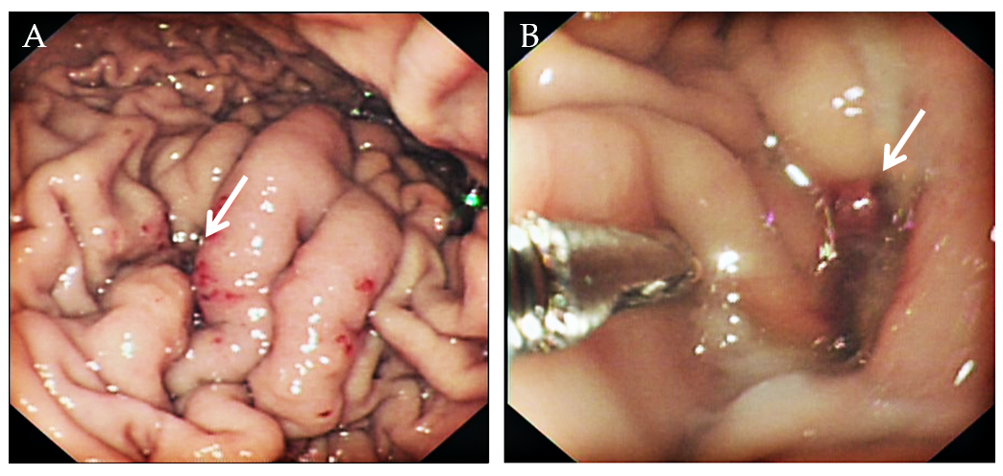
Figure 1 Gastroscopy images. A: The first gastroscopy showed an ulcer-like depression of the gastric greater curvature (orange arrow); B: The second gastroscopy showed exposed blood vessels in the ulcer-like depression of the greater curvature (orange arrow).

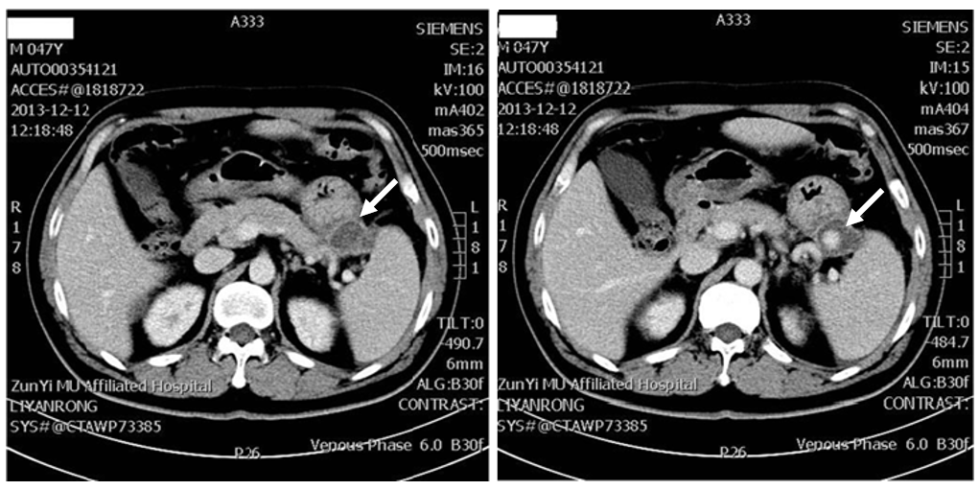
Figure 2 Computed tomography images confirmed that the pancreatic pseudocyst invaded part of the spleen and greater curvature of the stomach.

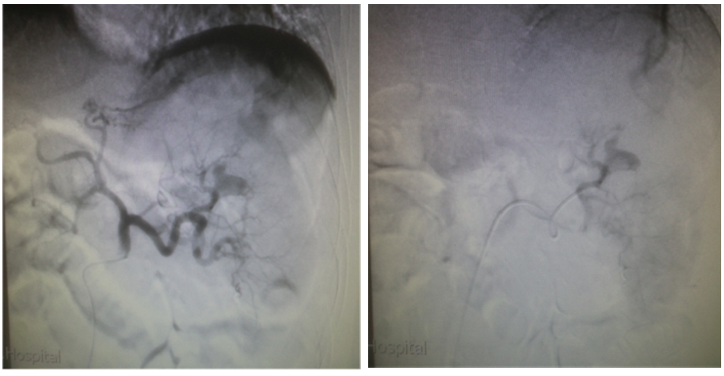
Figure 3 Angiography found a pseudoaneurysm of the splenic artery.

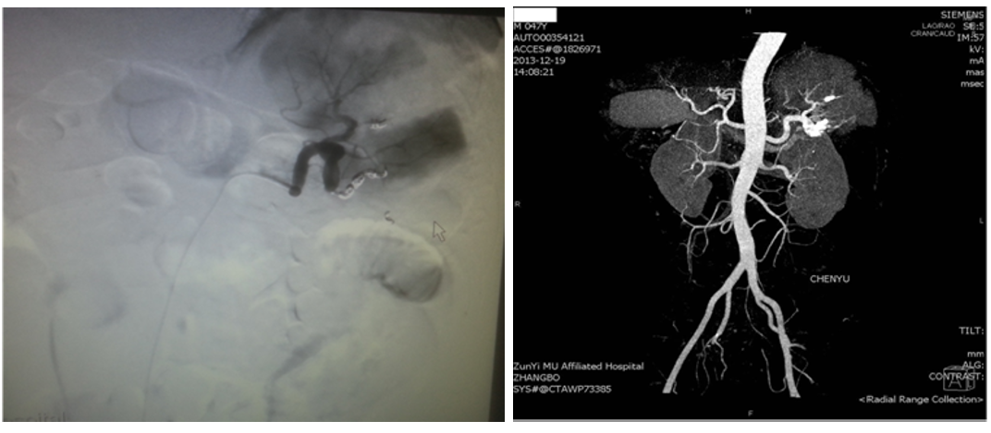
Figure 4 Trans-arterial embolization (coil embolization) of the splenic artery was successfully performed.

Table 1 Summary of case reports in the literature of gastrointestinal bleeding from pancreatic pseudoaneurysm
Ref. | Age in yr | Sex | Involved hollow viscus and bleeding part | Treatment
Fujio et al^{[10]}, 2017 | 75 | Male | Jejunum | TAE
Eftimie et al^{[11]}, 2017 | 55 | Male | Colon | Surgery
 | 59 | Male | Stomach | Surgery
Budzyński et al^{[12]}, 2016 | 42 | Female | Stomach | TAE
O’Brien et al^{[13]}, 2016 | 88 | Female | Colon | TAE
Zhang et al^{[14]}, 2016 | 58 | Female | Stomach | TAE
Zhao et al^{[15]}, 2014 | 64 | Male | Colon | Surgery
Razik et al^{[16]}, 2016 | 62 | Female | Duodenum | TAE
Hoshimoto et al^{[17]}, 2016 | 61 | Male | Stomach | TAE
Larrey Ruiz et al^{[18]}, 2016 | 40 | Male | Duodenum | TAE and Surgery
Chia et al^{[19]}, 2015 | 24 | Male | Stomach | Surgery
Sawicki et al^{[20]}, 2015 | 57 | Male | Stomach and abdominal cavity | Surgery
Ferreira et al^{[21]}, 2015 | 54 | Male | Duodenum | TAE
Shah et al^{[22]}, 2015 | 69 | Male | Duodenum | TAE
Maddah et al^{[23]}, 2015 | 32 | Female | Stomach | Surgery
 | 54 | Male | Stomach | Surgery
Peynircioğlu et al^{[24]}, 2015 | 62 | Male | Duodenum | TAE
Mandaliya et al^{[25]}, 2014 | 61 | Female | Duodenum | TAE
Herrera-Fernández et al^{[26]}, 2014 | 34 | Female | Stomach | Surgery
TAE: Trans-arterial embolization.

Table 2 Advantages and disadvantages of therapeutic options
Therapeutic options | Advantages | Disadvantages
Endoscopic | Minimally invasive, accurate localization, rapid, safe, high success rate, few complications, and rapid recovery | Limited for operating site, rebleeding
Endovascular | Minimally invasive, accurate localization, rapid, safe, high success rate, few complications, and rapid recovery | Radiation exposure, rebleeding
Surgical | Selection after endoscopy and endovascular are ineffective in the treatment of gastrointestinal bleeding | Massive trauma, many complications, slow recovery

Published by Baishideng Publishing Group Inc
7041 Koll Center Parkway, Suite 160, Pleasanton, CA 94566, USA
Telephone: +1-925-3991568
E-mail: bpgoffice@wjgnet.com
Help Desk: https://www.f6publishing.com/helpdesk
https://www.wjgnet.com

© 2021 Baishideng Publishing Group Inc. All rights reserved.

