Name of Journal: World Journal of Gastrointestinal Surgery
Manuscript NO: 77502
Manuscript Type: ORIGINAL ARTICLE

Retrospective Study
Personal predictive model based on systemic inflammation markers for estimation of postoperative pancreatic fistula following pancreaticoduodenectomy

Long ZD et al. Machine learning for predicting pancreatic fistula

Zhi-Da Long, Chao Lu, Xi-Gang Xia, Bo Chen, Zhi-Xiang Xing, Lei Bie, Peng Zhou, Zhong-Lin Ma, Rui Wang

Zhi-Da Long, Chao Lu, Xi-Gang Xia, Bo Chen, Zhi-Xiang Xing, Lei Bie, Peng Zhou, Rui Wang, Department of Hepatobiliary and Pancreaticosplenic Surgery, Jingzhou Hospital, Yangtze University, Jingzhou 434020, Hubei Province, China

Zhong-Lin Ma, Department of Hepatobiliary Surgery, Lu’an Hospital of AnHui Medical University, Hefei 237006, Anhui Province, China

Author contributions: Long ZD, Lu C, Xia XG, Chen B, Xing ZX, Bie L, Zhou P, Ma ZL, and Wang R designed the research study; Long ZD, Lu C, Xia XG, and Chen B performed the research; Xia XG, Chen B, and Xing ZX contributed new reagents and analytic tools; Long ZD, Lu C, Xia XG, Chen B, Xing ZX, Bie L, Zhou P, Ma ZL, and Wang R analyzed the data and wrote the manuscript; all authors have read and approve the final manuscript.

Corresponding author: Rui Wang, MD, Surgical Oncologist, Department of Hepatobiliary and Pancreaticosplenic Surgery, Jingzhou Hospital, Yangtze University, No. 60 Chuyuan Road, Jingzhou District, Jingzhou 434020, Hubei Province, China. wangrui_20222022@163.com

Received: May 3, 2022
Revised: May 22, 2022
Accepted: July 27, 2022
Published online: September 27, 2022

Abstract
BACKGROUND
Postoperative pancreatic fistula (PF) is a serious life-threatening complication after pancreaticoduodenectomy (PD). Our research aimed to develop a machine learning (ML)-aided model for PF risk stratification.

AIM
To develop an ML-aided model for PF risk stratification.

METHODS
We retrospectively collected 618 patients who underwent PD from two tertiary medical centers between January 2012 and August 2021. We used an ML algorithm to build predictive models, and subject prediction index, that is, decision curve analysis, area under operating characteristic curve (AUC) and clinical impact curve to assess the predictive efficiency of each model.

RESULTS
A total of 29 variables were used to build the ML predictive model. Among them, the best predictive model was random forest classifier (RFC), the AUC was [0.897, 95% confidence interval (CI): 0.370–1.424], while the AUC of the artificial neural network, eXtreme gradient boosting, support vector machine, and decision tree were between 0.726 (95%CI: 0.191–1.261) and 0.882 (95%CI: 0.321–1.443).

CONCLUSION
Fluctuating serological inflammatory markers and prognostic nutritional index can be used to predict postoperative PF.

Key Words: Pancreatoduodenectomy; Pancreatic fistula; Machine learning algorithm; Systemic inflammatory biomarker; Risk prediction

©The Author(s) 2022. Published by Baishideng Publishing Group Inc. All rights reserved.

Citation: Long ZD, Lu C, Xia XG, Chen B, Xing ZX, Bie L, Zhou P, Ma ZL, Wang R. Personal predictive model based on systemic inflammation markers for estimation of postoperative pancreatic fistula following pancreaticoduodenectomy. World J Gastrointest Surg 2022; 14(9): 963-975
URL: https://www.wjgnet.com/1948-9366/full/v14/i9/963.htm
DOI: https://dx.doi.org/10.4240/wjgs.v14.i9.963

Core tip: Our research is based on machine learning (ML) algorithms and integrates the correlation between serum inflammatory factors and high risk of postoperative pancreatic fistula (PF), and constructs early warning models that can predict postoperative PF, and the predictive efficiency of these ML-based models may be at the population-based level. In the future, we expect these findings to expand external research to strengthen valuable supporting information and guide treatment decisions.

INTRODUCTION
Pancreaticoduodenectomy (PD), also known as a Whipple procedure, is one of the most difficult and complex surgeries that carries a high rate of major complications^{[1]}. Post-operative pancreatic fistula (PF), as one of the most difficult complications after PD, can seriously endanger the lives of patients, so it has become a field of continuous concern for pancreatic surgeons^{[1,2]}. Although the safety of PD has improved significantly in the past three decades^{[3,4]}. Alarmingly, previous prospective studies have reported that postoperative PF occupied an incidence of > 10%^{[5-7]}.
In recent years, people have studied different styles of surgery and perioperative attempts to reduce the incidence of postoperative PF. However, regardless of the type of surgery, PF is still the most common fatal complication after pancreatectomy. Understanding the potential complications and early warning of these complications is important for the care of these severe patients.
Previous studies have utilized preoperative radiology and clinical variables combined with specific intraoperative factors to predict the risk of postoperative PF^{[8-11]}. Despite advances in predictive platforms for postoperative PF, they have undergone a constantly changing approach. However, because of its unsatisfactory predictive performance, an improved delivery system is deemed necessary. Therefore, exploring an optimal risk score range model may contribute to eliminating potential life-threatening complications, and stratifying patients with postoperative PF risk, which can be better applied to clinical management.
Nowadays, a series of serum markers suggest that detecting systemic inflammation may be associated with the risk of benign and malignant disease progression^{[12-14]}. At the same time, the systemic reaction stimulated by local inflammation is closely related to the complications after gastrointestinal surgery^{[15,16]}. In addition, machine learning (ML) algorithms have been widely used in the field of medicine. These unceasing new algorithms and iterative analyses might be useful for prognostication in cases and optimize individual treatment decisions^{[17]}. Collectively, this combination has facilitated elevated predictive performance while minimizing the prediction error.
Given this situation, we searched for the help of inflammatory factors and ML-based algorithms to optimize the predictive accuracy for postoperative PF. In this study, we tried to identify alternative predictors independently related to postoperative PF and develop an optimal risk stratification model that can accurately identify high-risk patients with postoperative PF.

MATERIALS AND METHODS
Patients selection
Patients who underwent PD to treat various periampullary tumors from two tertiary medical centers (Jingzhou Hospital and Lu’an Hospital of Anhui Medical University) between January 2012 and August 2021 were retrospectively reviewed. The inclusion criteria were: (1) Resected tumor specimens were confirmed to be malignant by pathological examination; (2) Blood routine examination and liver function examination results were found within 3 d before surgery; and (3) The patient had complete case data and relevant indicators of imaging, pathology and laboratory examination. The exclusion criteria were: (1) Patients receiving preoperative treatment, such as thermal ablation, neoadjuvant chemotherapy or radiotherapy; (2) Severe respiratory and circulatory diseases; (3) Severe acute cholangitis or infection in other parts of the body before surgery; (4) Metastasis from other parts of the primary tumor or direct invasion of adjacent organs from the primary tumor; and (5) Parathyroid diseases or other factors interfering with abnormal changes of procalcitonin (PCT). This study was a retrospective cohort study, which was approved by the Ethics Committee of Jingzhou Central Hospital (Reference: 2021-JH005) and conformed to the Declaration of Helsinki. Because this study adopted anonymous follow-up, the patients’ personal privacy information was strictly confidential. The detailed research flow chart is shown in Figure 1.

Diagnostic criteria for postoperative PF
According to the standards defined by the International Study Group for Pancreatic Fistula (ISGPF) in 2016, that is, drainage flow > 30 mL for ≥ 72 h after an operation, the amylase content of the drainage fluid is measured. If it exceeds ≥ 3 times the upper limit of normal and had a clinical impact (such as abdominal pain or fever) and needed clinical treatment, it is judged that PF has occurred. The grade of PF updated by ISGPF in 2016 removes the diagnosis of grade A PF. The increase in amylase in asymptomatic drainage fluid is considered biochemical leakage, i.e., non-real PF. The occurrence of significant clinical symptoms based on biochemical leakage and the change of treatment strategy (such as puncture and drainage, interventional hemostasis, indwelling abdominal drainage tube for > 3 wk, infection, etc.) is defined as grade B PF. If grade B PF needs surgical treatment, or is complicated with organ failure or even death, the grade of PF increases to grade C. Therefore, grades B and C PF are also known as clinical postoperative PF^{[18,19]}.

Blood sample collection
We chose to collect 3–5 mL blood samples from each patient on an empty stomach in the morning of 3 d before the operation, and included the latest blood routine and liver function tests in this study. Peripheral venous blood was taken in the morning of d 1, 3 and 5 after the operation, and the changes in C-reactive protein (CRP), serum PCT, and white blood cells were continuously observed.

Data collection and quality assessment
We obtained population baseline data and clinical pathological data from the patients’ medical records. For instance, the pancreatic texture was evaluated by the surgeon during the operation (soft 1, hard 0), and the diameter of the main pancreatic was obtained by computed tomography or magnetic resonance imaging before the operation. We also collected routine laboratory measurement results, and when the missing value was ≥ 10% of the bias of the total variable, the variable was directly discarded and not included in the final model variable screening^{[20]}. Finally, a total of 29 variables that met the inclusion criteria were used to build ML-based models.

Construction and verification of ML-based models
At the beginning of building the model, we randomly divided the population data into two parts, namely, the training queue and the verification queue. The training queue was used to construct the predictive model, and the validation queue was used as the internal validation of the model to evaluate the robustness of the model. When screening candidate variables, we adopted the “two-step segmentation evaluation”, that is, the principle of random sorting to obtain the intersection^{[21]}. In short, by sorting the intersection of variable sets, the optimal subset modeling was obtained. Finally, these models were evaluated through inspection, discrimination and calibration.

Statistical analysis
As for descriptive variables (i.e. continuous or classified variables), the median (interquartile range) or frequency (percentage) were used for statistical analysis. The χ² test or Mann–Whitney test was used to calculate the variables between groups to evaluate whether there was a statistical difference. Stepwise regression based on the minimum value of the Akaike information standard was used to select the variables. All data analysis was completed with the help of R language software (version 4.0.4, http://www.r-project.org/). All P values were double tailed, and P < 0.05 was statistically significant.

RESULTS
Clinicopathological baseline characteristics of patients
In this study, all patients were randomly divided into a training set (n = 432, 70%) and validation set (n = 186, 30%) via the caret package. Seventy-eight (18.06%) and 20 (10.75%) patients developed postoperative PF in the training and validation group, respectively, as shown in Table 1. There were 76 (12.3%) grade B and 22 (3.6%) grace C. One patient died of multiple organ failure due to drug-resistant bacterial infection; five underwent reoperation because of continuous blood drainage via the drainage tube, which was confirmed to be abdominal bleeding caused by intraoperative PF; and two were transferred to intensive care.

Selection of candidate variables
Feature selection is a universal problem in ML^{[22]}. We performed an iterative analysis of 29 potential candidate variables, and the correlation matrix showed that there was a significant correlation between postoperative PF and inflammatory factors and some clinical variables (Figure 2A), including CRP, PCT, neutrophil-to-lymphocyte ratio (NLR), platelet-to-lymphocyte ratio (PLR), and hemoglobin level × albumin level × lymphocyte count/platelet count ratio (HALP). As shown in Figure 2B, HALP, PCT, neutrophil-to-albumin ratio (NAR), PLR and PNI were the top important predictors. Meanwhile, the seven top-ranked predictors were HALP, remnant texture, PCT, NAR, PLR, PNI, and body mass index (BMI).

Construction of PF predictive model based on ML algorithm
In the training queue, each patient could use positive or negative training and output the final judgment results. For example, a random forest classifier (RFC) algorithm could be used to effectively navigate the free parameter space to obtain a robust model (Figure 3A). The variable Gini index in the RFC model is shown in Supplementary Table 1. In addition, data mining through the decision tree (DT) model was useful, as shown in Figure 3B, among the candidate variables related to inflammatory factors, PCT and BMI also played an important role in DT as branch weight, which could be used as an important predictor of postoperative PF. The artificial neural network (ANN) model also showed relatively robust predictive performance, but slightly lower than that of RFC (Figure 4). We also constructed nomographs, which depended on the parameters obtained by LR, as shown in Supplementary Table 2. Compared with traditional predictive models, inflammatory factors also accounted for an important proportion.

Comparison between ML-based models
To explore the effectiveness of five supervised learning models for postoperative PF evaluation, we used decision curve analysis (DCA) for evaluation, which was consistent with the results of the included candidate variables. Even if different predictive models included the same variables, there were certain differences in their predictive effectiveness, as shown in Figure 5. In addition, as shown in Table 2, the predictive efficiency of RFC was the best [0.897, 95% confidence interval (CI): 0.370–1.424] compared with the other four predictive models, followed by ANN (0.882, 95%CI: 0.321–1.443), DT (0.807, 95%CI: 0.250–1.364), extreme gradient boosting (XGboost) (0.793, 95%CI: 0.270–1.316), and support vector machine (SVM) (0.726, 95%CI: 0.191–1.261). In conclusion, the iterative algorithm analysis using supervised learning, RFC and ANN, as well as DT (ML-aided decision support) models were properly used to guide postoperative PF prediction.

Internal validation of the optimal postoperative PF predictive model
We evaluated the clinical predictive efficiency of the optimal prediction model (RFC), as shown in Supplementary Figure 1. RFC can be used to achieve accurate stratification of patients’ postoperative PF via clinical impact curve (CIC). In general, RFC performed best in the construction of prediction models by fusing inflammatory markers.

DISCUSSION
Our study revealed two major findings. First, accurate risk stratification of postoperative PF in patients who received PD, which mainly depended on the added value of systemic inflammation markers. Second, the ML-based predictive model is better than the traditional predictive algorithm model, which is suitable for identifying whether patients have postoperative PF.
Several risk factors leading to such complications have been reported in the relevant literature, including pancreas texture, BMI, intraoperative blood loss, blood transfusion, and operating time^{[9,23,24]}. We summarize updated literature on predicting postoperative PF, in combination with various candidate predictive markers in Supplementary Table 3. Guo et al^{[25]} reported that the texture of pancreas, size of the main pancreatic duct, portal vein invasion and confirmed pathology are the risk factors of postoperative PF. Tajima et al^{[26]} summarized that preoperative imaging evaluation of pancreatic pathologies would be also beneficial for stratifying. Not surprisingly, systemic inflammatory markers such as neutrophils, lymphocytes, platelets, CRP, albumin, and biomarkers may help predict postoperative PF. The systemic response to postoperative local inflammatory stimulation is tightly related to the complications after gastrointestinal surgery^{[27]}. Gasteiger et al^{[15]} reported that postoperative pancreatitis and inflammatory reaction are the main determinants of postoperative PF^{[15]}. Intriguingly, our calculated risk factors for postoperative PF and inflammatory factors accounted for an irreplaceable weight in the predictive model.
In this study, an attempt was made to improve early postoperative risk stratification by combining local pancreatic residual inflammatory status and systemic response. We found that abnormal HALP, PCT, NAR, PLR and PNI showed reliable predictive value for postoperative PF. Previous studies have confirmed that neutrophils, as the source of vascular endothelial growth factor and tissue inhibitor protease, can promote tumor infiltration and distant metastasis^{[28-30]}. Additionally, the number of lymphocytes in cancer patients changes frequently, which seriously affects the prognosis and survival rate^{[31,32]}. As noted above, it appears that inflammatory factors were highly related to the presence of postoperative PF. Combined with these findings, our analysis showed that systemic inflammatory markers are of value in predicting postoperative PF.
Our ML-based model was based on clinical parameters and laboratory test results, which were consistent with previous research results. Clinical indicators including preoperative serum albumin, lipase level, and amount of intraoperative fluid infusion were independent risk factors of postoperative PF^{[23,24,33]}. Therefore, we further analyzed the accuracy of the predictive model constructed between clinical parameters and systemic inflammatory markers based on an ML-based algorithm. Not surprisingly, we found that systemic inflammatory markers accounted for a high weight in each model. Among these predictive models, RFC allowed the calculation of risk level based on candidate variables, so the best predictive efficiency was obtained. It is not surprising that RFC adopted the resampling technique of bootstrapping to repeatedly focus on the “bagging” procedure^{[34]}. To detect the discrimination of the ML-based model, the DCA and CIC methods were used to evaluate the predictive performance, and the results were consistent with the expected goal. Taken together, our model may apply to patients who intended to receive PD, especially to help surgeons decide whether to prevent postoperative PF after surgery.
Despite several strengths, there were some noteworthy limitations to this study. First, patients included were from two tertiary referral hospitals, which may have resulted in selection bias. Second, although we have established a perfect predictive model through an ML-based algorithm, our model still needs to be confirmed in other hospital settings. Although we adopted internal data cross-validation, we still need more external data to verify its feasibility in the future. Third, we only adopted simple data obtained from classification, missing clinical data were not considered throughout the study. Hence, incorporating specific new technologies such as immunodiagnostic biomarkers may help to improve the accuracy of predictive models.

CONCLUSION
Our results provide new insights into candidate predictive markers associated with high risk of PF. With the help of HALP, NAR, CRP, PCT and PLR, we developed ML-based predictive models, and the performance of these unsupervised integrated models was superior to that of traditional predictive models. We expect these findings to extend research to strengthen clinical decision-making and guide treatment.

ARTICLE HIGHLIGHTS
Research background
We provide insights into the candidate predictive markers associated with a high risk of postoperative pancreatic fistula (PF) via serum inflammatory secretion. With the help of hemoglobin level × albumin level × lymphocyte count/platelet count ratio, neutrophil-to-albumin ratio, C-reactive protein, procalcitonin and platelet-to-lymphocyte ratio, we develop machine learning (ML)-based predictive models, and the predictive performance of these unsupervised integrated models was superior to that of traditional predictive models. We expect these findings to extend research to strengthen clinical decision-making and guide treatment.

Research motivation
Fluctuating serological inflammation markers and prognostic nutritional index can be detected in the early postoperative period, and clinically well established to predict postoperative PF; in particular, random forest classifier (RFC) performed best, which can guide optimal treatment, clinical management and prevent or mitigate adverse consequences.

Research objectives
A total of 29 variables were used to build the ML predictive model. Among them, the best predictive model was RFC, the area under the curve (AUC) was [0.897, 95% confidence interval (CI): 0.370–1.424], while the AUC of the artificial neural network, eXtreme gradient boosting, support vector machine, and decision tree were between 0.726 (95%CI: 0.191–1.261) and 0.882 (95%CI: 0.321–1.443).

Research methods
As for descriptive variables (i.e., continuous or classified variables), the median (interquartile range) or frequency (percentage) were used for statistics in this study. The χ² test or Mann–Whitney test was used to calculate the variables between groups to evaluate whether there was a statistical difference. Stepwise regression based on the minimum value of the Akaike information standard was used to select the variables. All data analysis was completed with the help of R language software (version 4.0.4, http://www.r-project.org/). All P values were double tailed, and P < 0.05 was statistically significant.

Research results
A total of 29 variables were used to build the ML predictive model. Among them, the best predictive model was RFC, the area under the curve (AUC) was [0.897, 95% confidence interval (CI): 0.370–1.424], while the AUC of the artificial neural network, eXtreme gradient boosting, support vector machine, and decision tree were between 0.726 (95%CI: 0.191–1.261) and 0.882 (95%CI: 0.321–1.443).

Research conclusions
Fluctuating serological inflammatory markers and prognostic nutritional index (PNI) can be detected in the early postoperative period, which has been clinically proved to predict postoperative PF. In particular, RFC performed best, which can guide optimal treatment, clinical management, and prevent or mitigate adverse consequences.

Research perspectives
PD, also known as a Whipple procedure, is one of the most difficult and complex surgeries that carries a high rate of major complications. Postoperative PF, as one of the most difficult complications after PD, can seriously endanger the lives of patients, so it has become an area of continuous concern for pancreatic surgeons. Although the safety of PD has improved significantly in the past three decades, previous prospective studies have reported that postoperative PF has an incidence of > 10%. Understanding the potential complications and early warning of these complications is important for the care of these
patients.

ACKNOWLEDGEMENTS
The authors thank all medical workers and patients involved in this study, including those involved in data collection and compilation.

REFERENCES
1 Karim SAM, Abdulla KS, Abdulkarim QH, Rahim FH. The outcomes and complications of pancreaticoduodenectomy (Whipple procedure): Cross sectional study. Int J Surg 2018; 52: 383-387 [PMID: 29438817 DOI: 10.1016/j.ijsu.2018.01.041]
2 Xiang Y, Wu J, Lin C, Yang Y, Zhang D, Xie Y, Yao X, Zhang X. Pancreatic reconstruction techniques after pancreaticoduodenectomy: a review of the literature. Expert Rev Gastroenterol Hepatol 2019; 13: 797-806 [PMID: 31282769 DOI: 10.1080/17474124.2019.1640601]
3 Narayanan S, Martin AN, Turrentine FE, Bauer TW, Adams RB, Zaydfudim VM. Mortality after pancreaticoduodenectomy: assessing early and late causes of patient death. J Surg Res 2018; 231: 304-308 [PMID: 30278945 DOI: 10.1016/j.jss.2018.05.075]
4 Kawaida H, Kono H, Hosomura N, Amemiya H, Itakura J, Fujii H, Ichikawa D. Surgical techniques and postoperative management to prevent postoperative pancreatic fistula after pancreatic surgery. World J Gastroenterol 2019; 25: 3722-3737 [PMID: 31391768 DOI: 10.3748/wjg.v25.i28.3722]
5 Wellner UF, Brett S, Bruckner T, Limprecht R, Rossion I, Seiler C, Sick O, Wegener I, Hopt UT, Keck T; RECOPANC Trial Group. Pancreatogastrostomy versus pancreatojejunostomy for RECOnstruction after partial PANCreatoduodenectomy (RECOPANC): study protocol of a randomized controlled trial UTN U1111-1117-9588. Trials 2012; 13: 45 [PMID: 22540372 DOI: 10.1186/1745-6215-13-45]
6 Chen BP, Bennett S, Bertens KA, Balaa FK, Martel G. Use and acceptance of the International Study Group for Pancreatic Fistula (ISGPF) definition and criteria in the surgical literature. HPB (Oxford) 2018; 20: 69-75 [PMID: 28927654 DOI: 10.1016/j.hpb.2017.08.022]
7 Fu SJ, Shen SL, Li SQ, Hu WJ, Hua YP, Kuang M, Liang LJ, Peng BG. Risk factors and outcomes of postoperative pancreatic fistula after pancreatico-duodenectomy: an audit of 532 consecutive cases. BMC Surg 2015; 15: 34 [PMID: 25887526 DOI: 10.1186/s12893-015-0011-7]
8 Akgul O, Merath K, Mehta R, Hyer JM, Chakedis J, Wiemann B, Johnson M, Paredes A, Dillhoff M, Cloyd J, Pawlik TM. Postoperative Pancreatic Fistula Following Pancreaticoduodenectomy-Stratification of Patient Risk. J Gastrointest Surg 2019; 23: 1817-1824 [PMID: 30478529 DOI: 10.1007/s11605-018-4045-x]
9 Callery MP, Pratt WB, Kent TS, Chaikof EL, Vollmer CM Jr. A prospectively validated clinical risk score accurately predicts pancreatic fistula after pancreatoduodenectomy. J Am Coll Surg 2013; 216: 1-14 [PMID: 23122535 DOI: 10.1016/j.jamcollsurg.2012.09.002]
10 You Y, Han IW, Choi DW, Heo JS, Ryu Y, Park DJ, Choi SH, Han S. Nomogram for predicting postoperative pancreatic fistula. HPB (Oxford) 2019; 21: 1436-1445 [PMID: 30982739 DOI: 10.1016/j.hpb.2019.03.351]
11 Mungroop TH, van Rijssen LB, van Klaveren D, Smits FJ, van Woerden V, Linnemann RJ, de Pastena M, Klompmaker S, Marchegiani G, Ecker BL, van Dieren S, Bonsing B, Busch OR, van Dam RM, Erdmann J, van Eijck CH, Gerhards MF, van Goor H, van der Harst E, de Hingh IH, de Jong KP, Kazemier G, Luyer M, Shamali A, Barbaro S, Armstrong T, Takhar A, Hamady Z, Klaase J, Lips DJ, Molenaar IQ, Nieuwenhuijs VB, Rupert C, van Santvoort HC, Scheepers JJ, van der Schelling GP, Bassi C, Vollmer CM, Steyerberg EW, Abu Hilal M, Groot Koerkamp B, Besselink MG; Dutch Pancreatic Cancer Group. Alternative Fistula Risk Score for Pancreatoduodenectomy (a-FRS): Design and International External Validation. Ann Surg 2019; 269: 937-943 [PMID: 29240007 DOI: 10.1097/SLA.0000000000002620]
12 Singh N, Baby D, Rajguru JP, Patil PB, Thakkannavar SS, Pujari VB. Inflammation and cancer. Ann Afr Med 2019; 18: 121-126 [PMID: 31417011 DOI: 10.4103/aam.aam_56_18]
13 Lontchi-Yimagou E, Sobngwi E, Matsha TE, Kengne AP. Diabetes mellitus and inflammation. Curr Diab Rep 2013; 13: 435-444 [PMID: 23494755 DOI: 10.1007/s11892-013-0375-y]
14 Hotamisligil GS. Inflammation, metaflammation and immunometabolic disorders. Nature 2017; 542: 177-185 [PMID: 28179656 DOI: 10.1038/nature21363]
15 Gasteiger S, Primavesi F, Göbel G, Braunwarth E, Cardini B, Maglione M, Sopper S, Öfner D, Stättner S. Early Post-Operative Pancreatitis and Systemic Inflammatory Response Assessed by Serum Lipase and IL-6 Predict Pancreatic Fistula. World J Surg 2020; 44: 4236-4244 [PMID: 32901324 DOI: 10.1007/s00268-020-05768-9]
16 van Hilst J, Brinkman DJ, de Rooij T, van Dieren S, Gerhards MF, de Hingh IH, Luyer MD, Marsman HA, Karsten TM, Busch OR, Festen S, Heger M, Besselink MG; Dutch Pancreatic Cancer Group. The inflammatory response after laparoscopic and open pancreatoduodenectomy and the association with complications in a multicenter randomized controlled trial. HPB (Oxford) 2019; 21: 1453-1461 [PMID: 30975599 DOI: 10.1016/j.hpb.2019.03.353]
17 LeCun Y, Bengio Y, Hinton G. Deep learning. Nature 2015; 521: 436-444 [PMID: 26017442 DOI: 10.1038/nature14539]
18 Bassi C, Dervenis C, Butturini G, Fingerhut A, Yeo C, Izbicki J, Neoptolemos J, Sarr M, Traverso W, Buchler M; International Study Group on Pancreatic Fistula Definition. Postoperative pancreatic fistula: an international study group (ISGPF) definition. Surgery 2005; 138: 8-13 [PMID: 16003309 DOI: 10.1016/j.surg.2005.05.001]
19 Bassi C, Marchegiani G, Dervenis C, Sarr M, Abu Hilal M, Adham M, Allen P, Andersson R, Asbun HJ, Besselink MG, Conlon K, Del Chiaro M, Falconi M, Fernandez-Cruz L, Fernandez-Del Castillo C, Fingerhut A, Friess H, Gouma DJ, Hackert T, Izbicki J, Lillemoe KD, Neoptolemos JP, Olah A, Schulick R, Shrikhande SV, Takada T, Takaori K, Traverso W, Vollmer CR, Wolfgang CL, Yeo CJ, Salvia R, Buchler M; International Study Group on Pancreatic Surgery (ISGPS). The 2016 update of the International Study Group (ISGPS) definition and grading of postoperative pancreatic fistula: 11 Years After. Surgery 2017; 161: 584-591 [PMID: 28040257 DOI: 10.1016/j.surg.2016.11.014]
20 Miot HA. Anomalous values and missing data in clinical and experimental studies. J Vasc Bras 2019; 18: e20190004 [PMID: 31320882 DOI: 10.1590/1677-5449.190004]
21 Fan J, Lv J. A Selective Overview of Variable Selection in High Dimensional Feature Space. Stat Sin 2010; 20: 101-148 [PMID: 21572976]
22 Deo RC. Machine Learning in Medicine. Circulation 2015; 132: 1920-1930 [PMID: 26572668 DOI: 10.1161/CIRCULATIONAHA.115.001593]
23 Peng YP, Zhu XL, Yin LD, Zhu Y, Wei JS, Wu JL, Miao Y. Risk factors of postoperative pancreatic fistula in patients after distal pancreatectomy: a systematic review and meta-analysis. Sci Rep 2017; 7: 185 [PMID: 28298641 DOI: 10.1038/s41598-017-00311-8]
24 Han IW, Cho K, Ryu Y, Shin SH, Heo JS, Choi DW, Chung MJ, Kwon OC, Cho BH. Risk prediction platform for pancreatic fistula after pancreatoduodenectomy using artificial intelligence. World J Gastroenterol 2020; 26: 4453-4464 [PMID: 32874057 DOI: 10.3748/wjg.v26.i30.4453]
25 Guo CX, Shen YN, Zhang Q, Zhang XZ, Wang JL, Gao SL, Lou JY, Que RS, Ma T, Liang TB, Bai XL. Prediction of postoperative pancreatic fistula using a nomogram based on the updated definition. Ann Surg Treat Res 2020; 98: 72-81 [PMID: 32051815 DOI: 10.4174/astr.2020.98.2.72]
26 Tajima Y, Kawabata Y, Hirahara N. Preoperative imaging evaluation of pancreatic pathologies for the objective prediction of pancreatic fistula after pancreaticoduodenectomy. Surg Today 2018; 48: 140-150 [PMID: 28421350 DOI: 10.1007/s00595-017-1529-3]
27 Rettig TC, Verwijmeren L, Dijkstra IM, Boerma D, van de Garde EM, Noordzij PG. Postoperative Interleukin-6 Level and Early Detection of Complications After Elective Major Abdominal Surgery. Ann Surg 2016; 263: 1207-1212 [PMID: 26135695 DOI: 10.1097/SLA.0000000000001342]
28 Strieter RM, Burdick MD, Mestas J, Gomperts B, Keane MP, Belperio JA. Cancer CXC chemokine networks and tumour angiogenesis. Eur J Cancer 2006; 42: 768-778 [PMID: 16510280 DOI: 10.1016/j.ejca.2006.01.006]
29 Balestrieri ML, Balestrieri A, Mancini FP, Napoli C. Understanding the immunoangiostatic CXC chemokine network. Cardiovasc Res 2008; 78: 250-256 [PMID: 18252760 DOI: 10.1093/cvr/cvn029]
30 Ocana A, Nieto-Jiménez C, Pandiella A, Templeton AJ. Neutrophils in cancer: prognostic role and therapeutic strategies. Mol Cancer 2017; 16: 137 [PMID: 28810877 DOI: 10.1186/s12943-017-0707-7]
31 Ménétrier-Caux C, Ray-Coquard I, Blay JY, Caux C. Lymphopenia in Cancer Patients and its Effects on Response to Immunotherapy: an opportunity for combination with Cytokines? J Immunother Cancer 2019; 7: 85 [PMID: 30922400 DOI: 10.1186/s40425-019-0549-5]
32 Blankenstein T, Coulie PG, Gilboa E, Jaffee EM. The determinants of tumour immunogenicity. Nat Rev Cancer 2012; 12: 307-313 [PMID: 22378190 DOI: 10.1038/nrc3246]
33 Ellis RJ, Brock Hewitt D, Liu JB, Cohen ME, Merkow RP, Bentrem DJ, Bilimoria KY, Yang AD. Preoperative risk evaluation for pancreatic fistula after pancreaticoduodenectomy. J Surg Oncol 2019; 119: 1128-1134 [PMID: 30951614 DOI: 10.1002/jso.25464]
34 Rigatti SJ. Random Forest. J Insur Med 2017; 47: 31-39 [PMID: 28836909 DOI: 10.17849/insm-47-01-31-39.1]

Footnotes
Institutional review board statement: This retrospective study was following the declaration of Helsinki, and was ethically reviewed and approved by the Institutional Ethics Committee of Jingzhou Hospital, No. 2021-JH005.

Informed consent statement: Since the patient information contained in this study was anonymous, written informed consent was not obtained from all participants.

Conflict-of-interest statement: All authors declare that there is no conflict of interest.

Data sharing statement: No additional data are available.

Open-Access: This article is an open-access article that was selected by an in-house editor and fully peer-reviewed by external reviewers. It is distributed in accordance with the Creative Commons Attribution NonCommercial (CC BY-NC 4.0) license, which permits others to distribute, remix, adapt, build upon this work non-commercially, and license their derivative works on different terms, provided the original work is properly cited and the use is non-commercial. See: https://creativecommons.org/Licenses/by-nc/4.0/

Provenance and peer review: Unsolicited article; Externally peer reviewed.
Peer-review model: Single blind

Peer-review started: May 3, 2022
First decision: May 11, 2022
Article in press: July 27, 2022

Specialty type: Gastroenterology and hepatology
Country/Territory of origin: China
Peer-review report’s scientific quality classification
Grade A (Excellent): 0
Grade B (Very good): B
Grade C (Good): C
Grade D (Fair): 0
Grade E (Poor): 0

P-Reviewer: Cabezuelo AS, Spain; Gaspar AF, Brazil S-Editor: Chen YL L-Editor: Kerr C P-Editor: Chen YL

Figure Legends

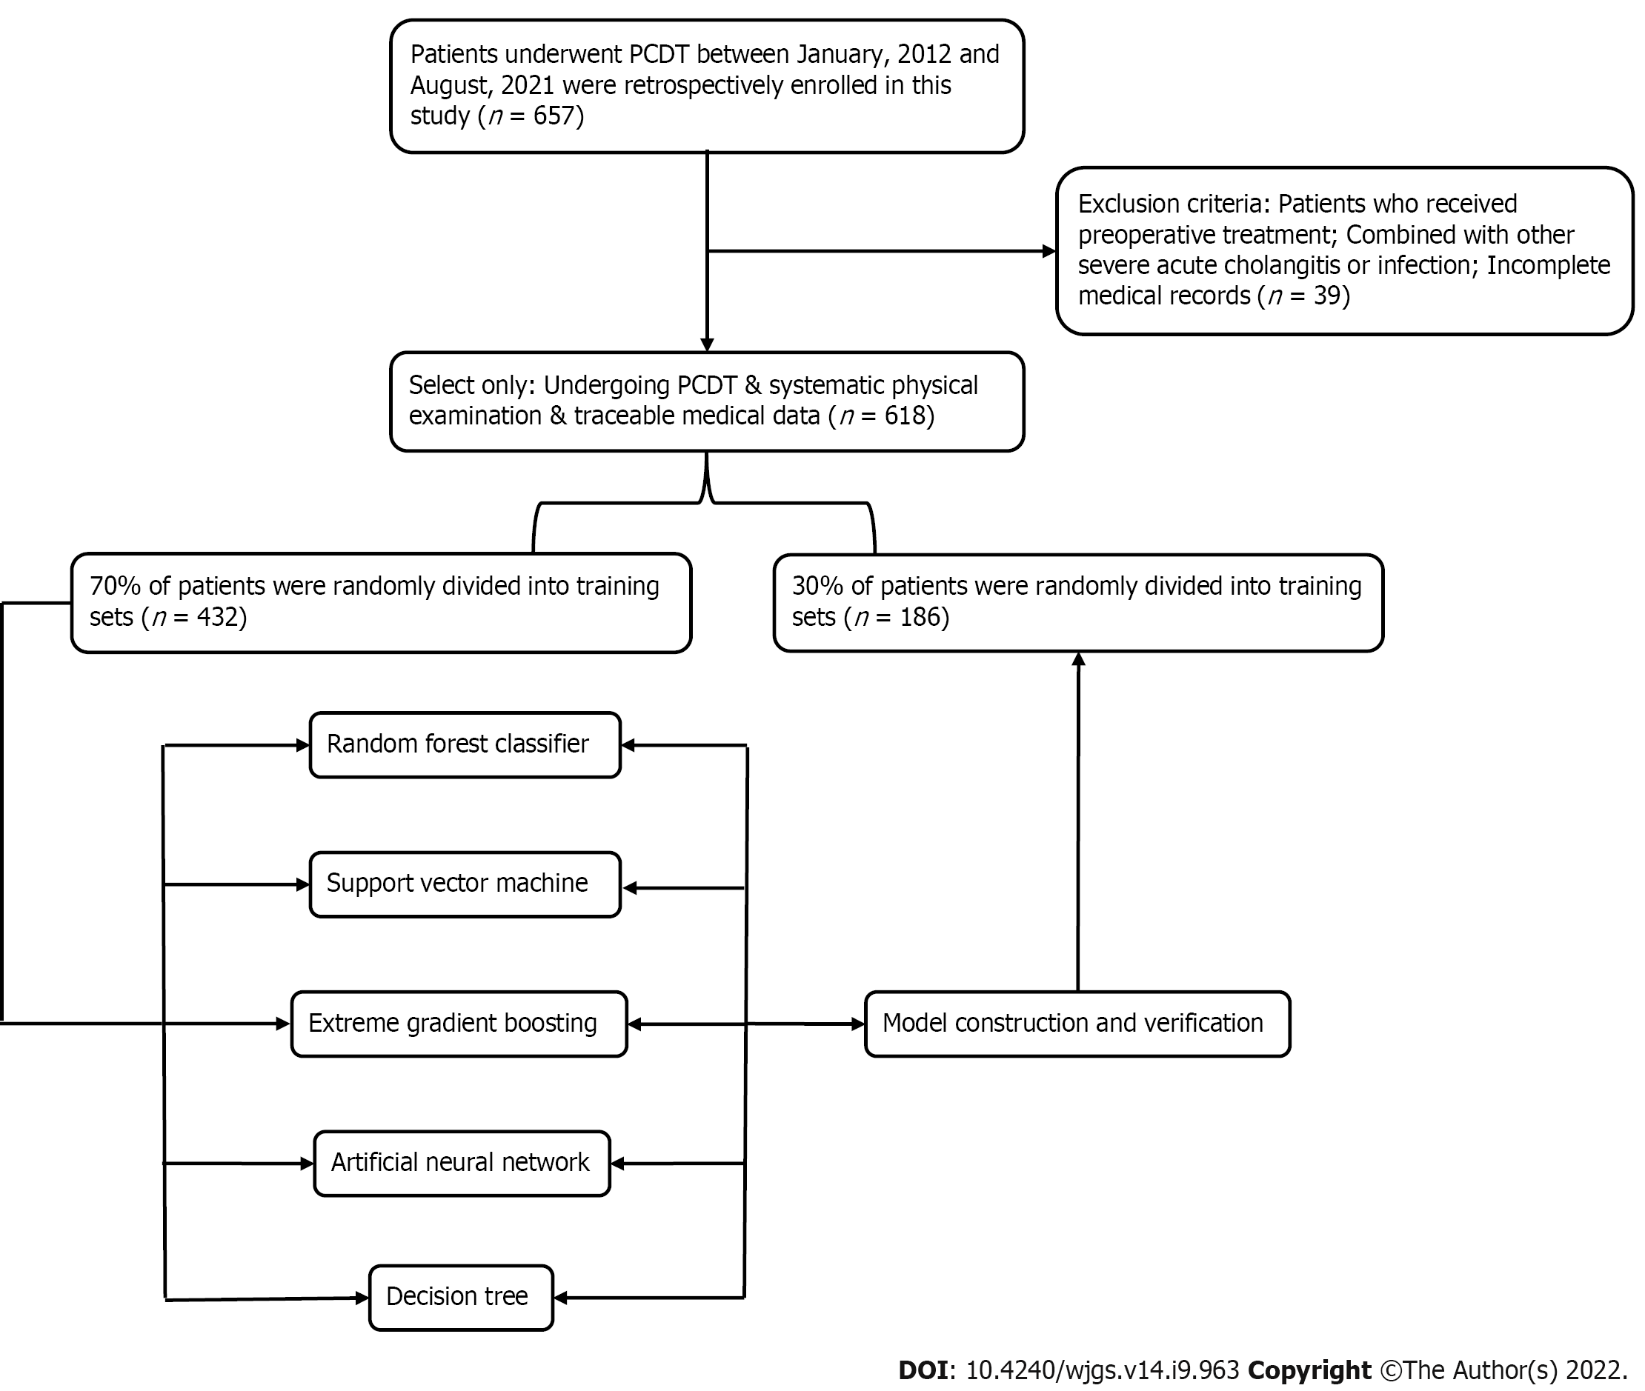
Figure 1 The flow chart. PD: Pancreatoduodenectomy.

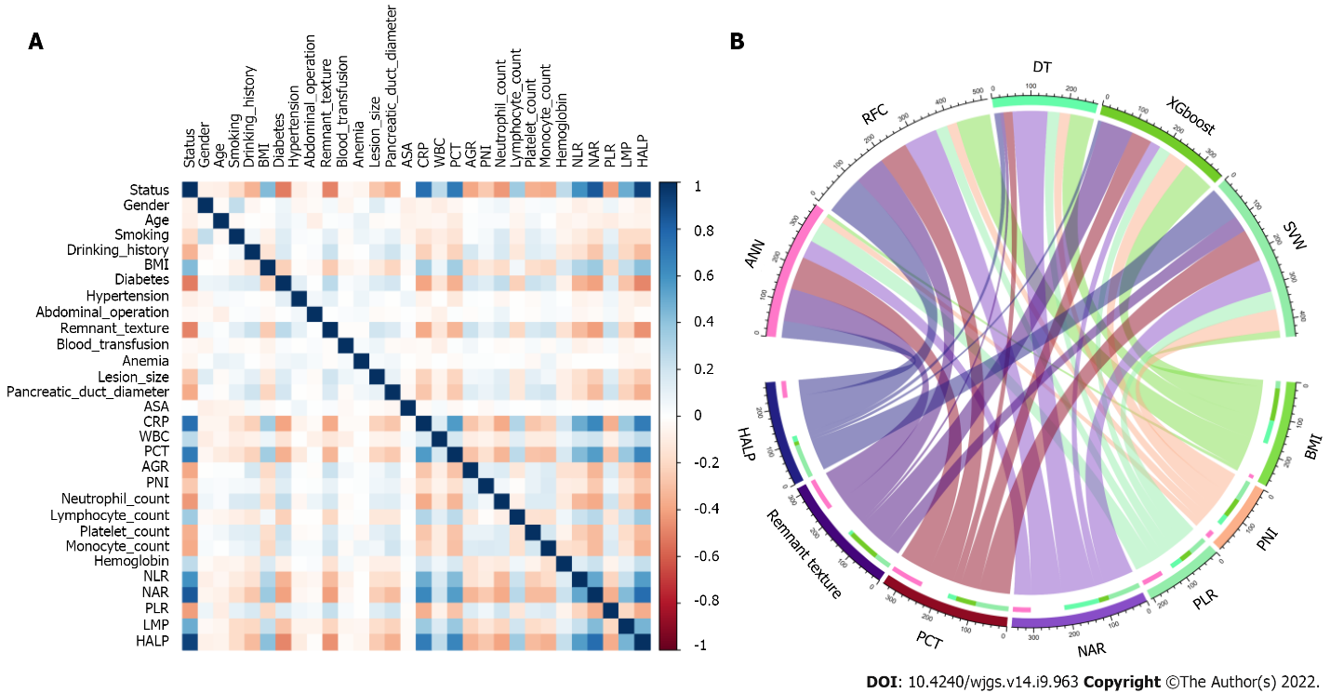
Figure 2 Variable filtering and weight allocation. A: Correlation matrix analysis; B: Weight distribution of the candidate variables. BMI: Body mass index; ASA: American Society of Anesthesiologists; CRP: C-reactive protein; WBC: White blood cell; PCT: Procalcitonin; AGR: Albumin-to-globulin ratio; PNI: Prognostic nutrition index; NLR: Neutrophil-to-lymphocyte ratio; NAR: Neutrophil-to-albumin ratio; PLR: Platelet-to-lymphocyte ratio; LMR: Lymphocyte-to-monocyte ratio; HALP: Hemoglobin level × albumin level × lymphocyte count/platelet count ratio; RFC: Random forest classifier; SVM: Support vector machine; DT: Decision tree; ANN: Artificial neural network; XGboost: Extreme gradient boosting.

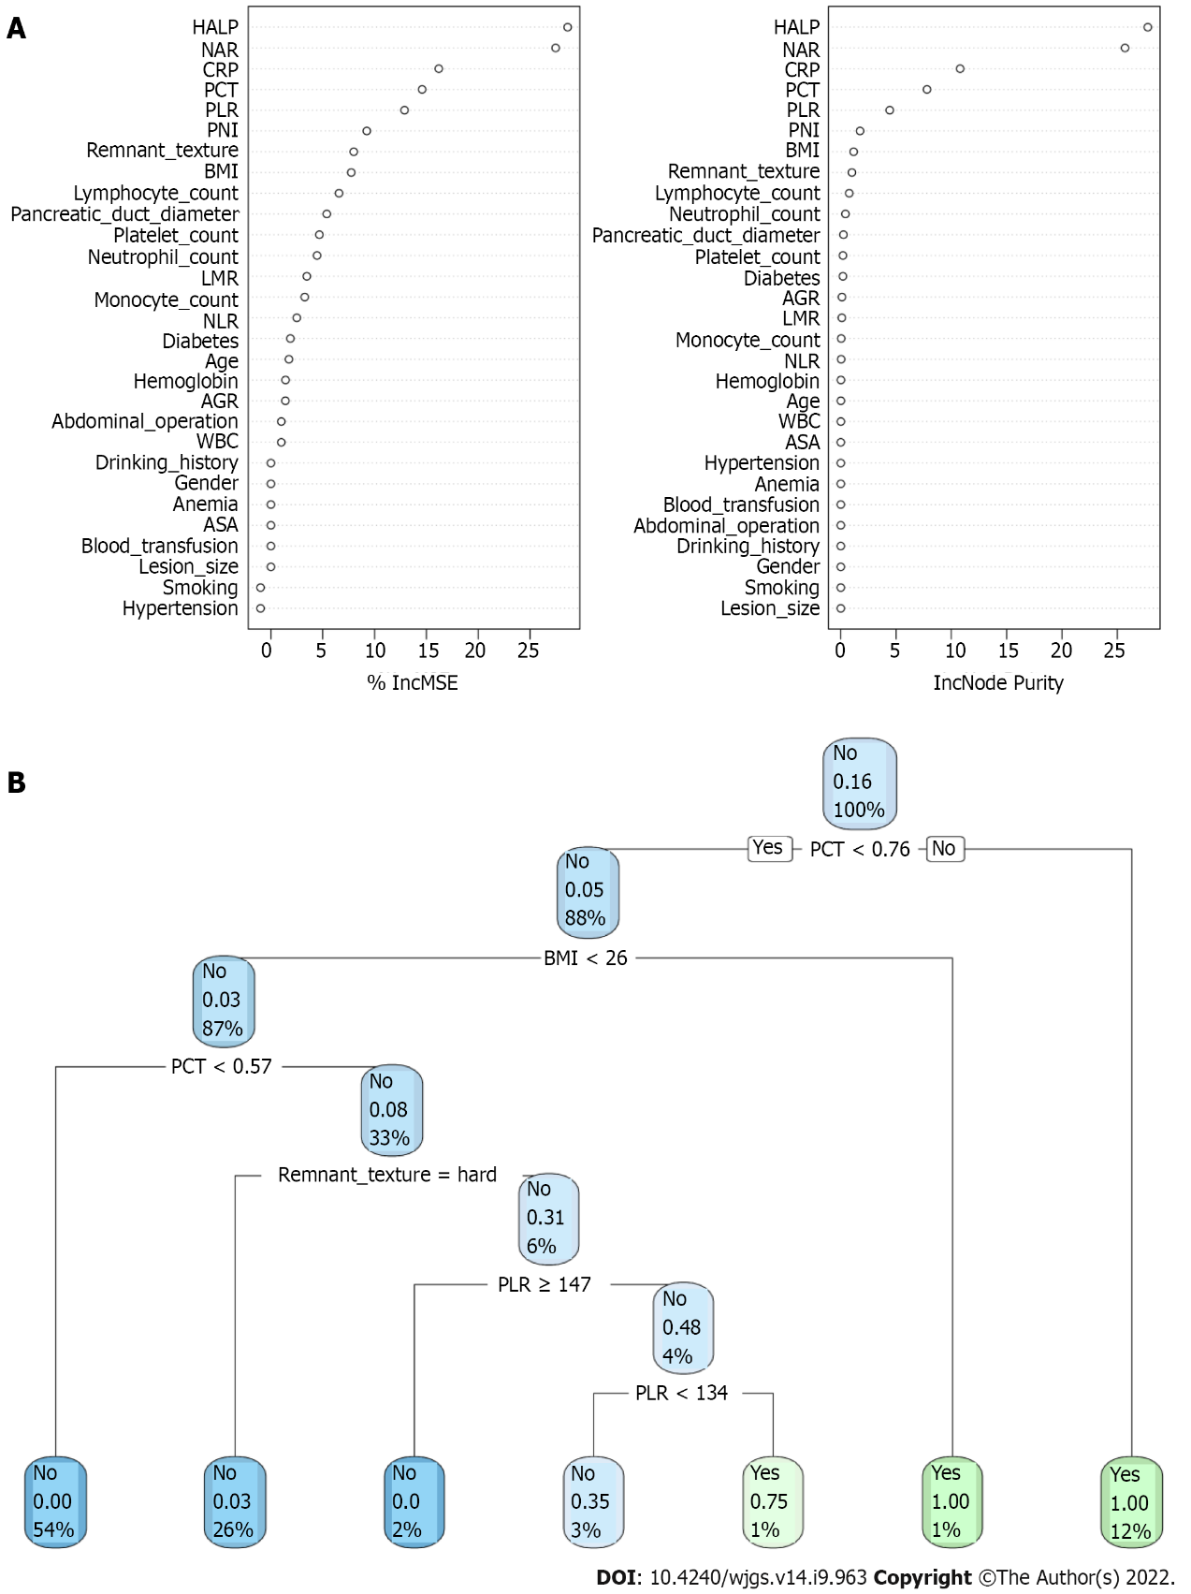
Figure 3 Visualization of predictive model based on machine learning algorithm. A: Random forest classifier model; B: Decision tree (DT) model. The candidate factors associated with postoperative pancreatic fistula were ordered via RFC algorithm (A) and (B) prediction node and weight were allocated via DT algorithm. BMI: Body mass index; ASA: American Society of Anesthesiologists; CRP: C-reactive protein; WBC: White blood cell; PCT: Procalcitonin; AGR: Albumin-to-globulin ratio; PNI: Prognostic nutrition index; NLR: Neutrophil-to-lymphocyte ratio; NAR: Neutrophil-to-albumin ratio; PLR: Platelet-to-lymphocyte ratio; LMR: Lymphocyte-to-monocyte ratio; HALP: Hemoglobin level × albumin level × lymphocyte count/platelet count ratio; RFC: Random forest classifier; SVM: Support vector machine; DT: Decision tree; ANN: Artificial neural network.

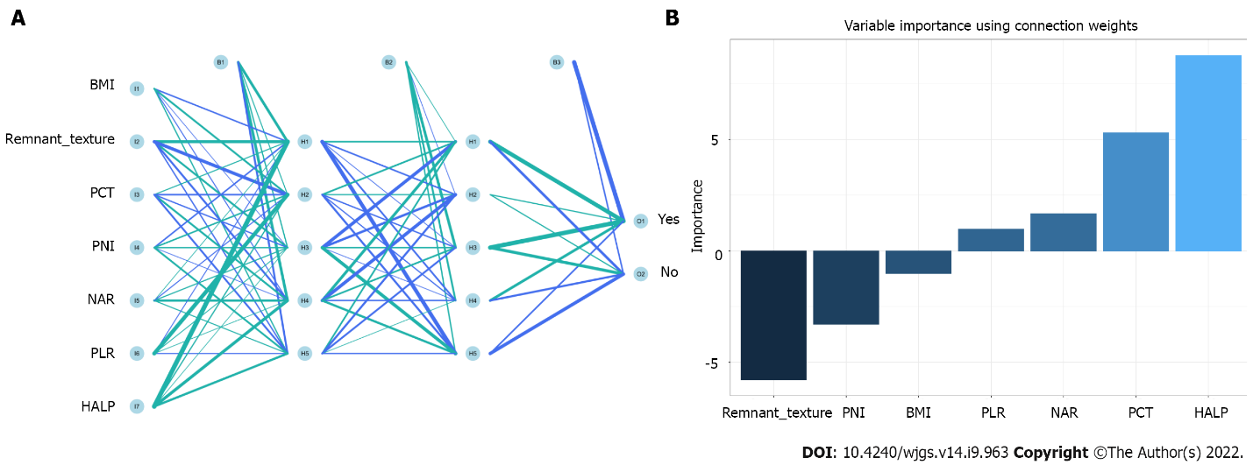
Figure 4 Visualization of predictive model based on artificial neural network algorithm. A: Artificial neural network model; B: Variable importance using connection weight. BMI: Body mass index; PCT: Procalcitonin; PNI: Prognostic nutrition index; NAR: Neutrophil-to-albumin ratio; PLR: Platelet-to-lymphocyte ratio; HALP: Hemoglobin level × albumin level × lymphocyte count/platelet count ratio.

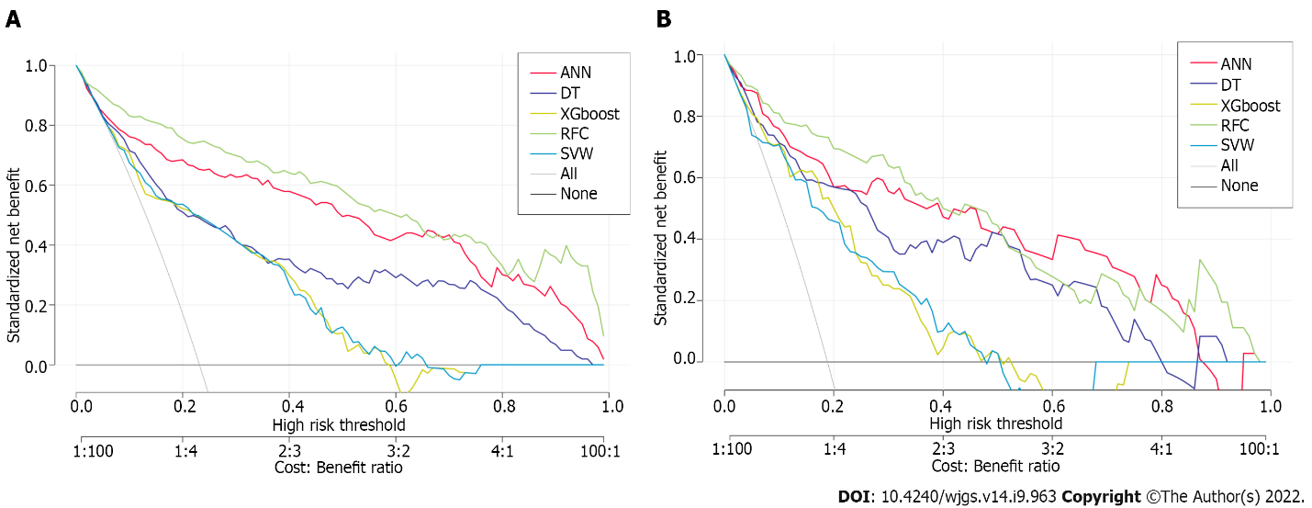

Figure 5 Efficiency evaluation of machine learning-based prediction model. A: Decision curve analysis (DCA) of training set; B: DCA of testing set. SVM: Support vector machine; DT: Decision tree; ANN: Artificial neural network; RFC: Random forest classifier; XGboost: Extreme gradient boosting.

Table 1 Baseline demographic and clinicopathological characteristics of patients
Variables | Training set |  |  |  | Testing set
 | Overall (n = 432) | Non-POPF (n = 354) | POPF (n = 78) | P value | Overall (n = 186) | Non-POPF (n = 166) | POPF (n = 20) | P value
Age, median (IQR) | 55.0 (49.0–61.0) | 55.0 (49.0–61.0) | 53.0 (47.25–61.0) | 0.147 | 55.0 (50.0–60.0) | 55.0 (50.0–60.0) | 51.50 (45.75–59.50) | 0.182
BMI, median (IQR) | 23.10 (21.80–24.60) | 22.80 (21.50–24.20) | 25.0 (23.33–26.92) | < 0.001 | 22.85 (21.72–24.30) | 22.70 (21.52–23.98) | 24.35 (22.88–26.13) | < 0.001
Gender (%)
Male | 283 (65.5) | 227 (64.1) | 56 (71.8) | 0.247 | 127 (68.3) | 110 (66.3) | 17 (85.0) | 0.148
Female | 149 (34.5) | 127 (35.9) | 22 (28.2) |  | 59 (31.7) | 56 (33.7) | 3 (15.0)
Smoking (%)
Yes | 198 (45.8) | 143 (40.4) | 55 (70.5) | < 0.001 | 89 (47.8) | 76 (45.8) | 13 (65.0) | 0.165
No | 234 (54.2) | 211 (59.6) | 23 (29.5) |  | 97 (52.2) | 90 (54.2) | 7 (35.0)
Drinking history (%)
Yes | 129 (29.9) | 78 (22.0) | 51 (65.4) | < 0.001 | 54 (29.0) | 40 (24.1) | 14 (70.0) | < 0.001
No | 303 (70.1) | 276 (78.0) | 27 (34.6) |  | 132 (71.0) | 126 (75.9) | 6 (30.0)
Diabetes (%)
Yes | 110 (25.5) | 49 (13.8) | 61 (78.2) | < 0.001 | 44 (23.7) | 30 (18.1) | 14 (70.0) | < 0.001
No | 322 (74.5) | 305 (86.2) | 17 (21.8) |  | 142 (76.3) | 136 (81.9) | 6 (30.0)
Hypertension (%)
Yes | 164 (38.0) | 129 (36.4) | 35 (44.9) | 0.208 | 59 (31.7) | 49 (29.5) | 10 (50.0) | 0.108
No | 268 (62.0) | 225 (63.6) | 43 (55.1) |  | 127 (68.3) | 117 (70.5) | 10 (50.0)
Abdominal operation (%)
Yes | 130 (30.1) | 103 (29.1) | 27 (34.6) | 0.409 | 53 (28.5) | 47 (28.3) | 6 (30.0) | 1
No | 302 (69.9) | 251 (70.9) | 51 (65.4) |  | 133 (71.5) | 119 (71.7) | 14 (70.0)
Remnant texture (%)
Soft | 121 (28.0) | 62 (17.5) | 59 (75.6) | < 0.001 | 44 (23.7) | 27 (16.3) | 17 (85.0) | < 0.001
Hard | 311 (72.0) | 292 (82.5) | 19 (24.4) |  | 142 (76.3) | 139 (83.7) | 3 (15.0)
Blood transfusion (%)
Yes | 232 (53.7) | 188 (53.1) | 44 (56.4) | 0.686 | 96 (51.6) | 84 (50.6) | 12 (60.0) | 0.577
No | 200 (46.3) | 166 (46.9) | 34 (43.6) |  | 90 (48.4) | 82 (49.4) | 8 (40.0)
Anemia (%)
Yes | 218 (50.5) | 179 (50.6) | 39 (50.0) | 1 | 84 (45.2) | 69 (41.6) | 15 (75.0) | 0.009
No | 214 (49.5) | 175 (49.4) | 39 (50.0) |  | 102 (54.8) | 97 (58.4) | 5 (25.0)
Lesion size (%), cm
> 3 | 182 (42.1) | 125 (35.3) | 57 (73.1) | < 0.001 | 67 (36.0) | 54 (32.5) | 13 (65.0) | 0.009
≤ 3 | 250 (57.9) | 229 (64.7) | 21 (26.9) |  | 119 (64.0) | 112 (67.5) | 7 (35.0)
Pancreatic duct diameter (%), mm
< 3 | 154 (35.6) | 93 (26.3) | 61 (78.2) | < 0.001 | 63 (33.9) | 49 (29.5) | 14 (70.0) | 0.001
≥ 3 | 278 (64.4) | 261 (73.7) | 17 (21.8) |  | 123 (66.1) | 117 (70.5) | 6 (30.0)
ASA classification (%)
I + II | 231 (53.5) | 188 (53.1) | 43 (55.1) | 0.843 | 85 (45.7) | 78 (47.0) | 7 (35.0) | 0.436
III + IV | 201 (46.5) | 166 (46.9) | 35 (44.9) |  | 101 (54.3) | 88 (53.0) | 13 (65.0)
CRP, median (IQR), mg/L | 32.0 (22.0–44.0) | 29.0 (21.0–38.0) | 88.50 (56.0–120.0) | < 0.001 | 30.0 (22.0–40.0) | 29.0 (21.0–38.0) | 84.50 (42.25–109.25) | < 0.001
WBC, median (IQR), 10⁹ | 5.70 (5.30–6.30) | 5.70 (5.20–6.20) | 6.0 (5.60–6.60) | < 0.001 | 5.70 (5.20–6.30) | 5.60 (5.20–6.20) | 6.40 (5.52–6.82) | 0.002
PCT, median (IQR), μg/L | 0.54 (0.37–0.68) | 0.49 (0.34–0.61) | 1.06 (0.78–1.21) | < 0.001 | 0.52 (0.37–0.67) | 0.49 (0.35–0.63) | 0.84 (0.68–1.09) | < 0.001
AGR, median (IQR) | 1.50 (1.30–1.60) | 1.50 (1.40–1.60) | 1.35 (1.20–1.40) | < 0.001 | 1.50 (1.30–1.60) | 1.50 (1.40–1.60) | 1.35 (1.17–1.52) | 0.003
PNI, median (IQR) | 49.60 (48.10–51.23) | 49.90 (48.32–51.60) | 48.60 (47.35–49.60) | < 0.001 | 50.10 (48.40–51.48) | 50.30 (48.42–51.60) | 49.30 (46.85–50.37) | 0.02
Neutrophil count, median (IQR), 10⁹ | 4.02 (3.49–4.59) | 4.18 (3.70–4.68) | 3.36 (3.03–3.74) | < 0.001 | 3.94 (3.51–4.54) | 4.03 (3.57–4.57) | 3.46 (3.11–3.76) | < 0.001
Lymphocyte count, median (IQR), 10⁹ | 1.64 (1.51–1.78) | 1.63 (1.50–1.76) | 1.79 (1.60–1.94) | < 0.001 | 1.64 (1.53–1.76) | 1.63 (1.52–1.73) | 1.83 (1.69–1.98) | < 0.001
Platelet count, median (IQR), 10⁹ | 230.0 (208.0–252.0) | 236.0 (213.0–255.0) | 206.0 (185.25–229.75) | < 0.001 | 229.0 (206.0–253.75) | 232.0 (208.25–257.75) | 200.0 (182.50–225.0) | < 0.001
Monocyte count, median (IQR), 10⁹ | 0.52 (0.45–0.60) | 0.55 (0.47–0.62) | 0.44 (0.39–0.49) | < 0.001 | 0.53 (0.46–0.61) | 0.54 (0.47–0.62) | 0.48 (0.42–0.52) | 0.003
Hemoglobin, median (IQR), g/L | 132.0 (124.0–139.0) | 130.0 (121.25–138.0) | 138.0 (133.0–142.75) | < 0.001 | 132.0 (126.0–140.0) | 132.0 (126.0–139.75) | 134.50 (130.0–141.0) | 0.026
NLR, median (IQR) | 2.0 (1.70–2.30) | 1.90 (1.70–2.20) | 2.70 (2.22–3.10) | < 0.001 | 2.0 (1.70–2.30) | 1.90 (1.60–2.20) | 2.80 (2.42–3.05) | < 0.001
NAR, median (IQR) | 0.08 (0.07–0.09) | 0.08 (0.07–0.09) | 0.60 (0.30–0.88) | < 0.001 | 0.08 (0.07–0.09) | 0.08 (0.07–0.09) | 0.65 (0.38–0.80) | < 0.001
PLR, median (IQR) | 136.20 (116.68–157.43) | 143.85 (123.23–161.70) | 113.15 (102.58–128.0) | < 0.001 | 136.45 (120.62–155.80) | 141.0 (121.22–159.78) | 120.15 (104.78–128.57) | < 0.001
LMR, median (IQR) | 3.40 (2.90–3.80) | 3.30 (2.80–3.70) | 3.90 (3.52–4.70) | < 0.001 | 3.50 (3.0–3.80) | 3.40 (2.90–3.70) | 4.15 (3.75–4.48) | < 0.001
HALP, median (IQR) | 53.95 (51.08–56.50) | 52.90 (50.50–55.20) | 72.75 (69.32–75.25) | < 0.001 | 52.45 (50.40–55.18) | 51.95 (50.10–54.30) | 70.10 (68.18–72.62] | < 0.001
POPF: Postoperative pancreatic fistula; IQR: Inter-quartile range; BMI: Body mass index; ASA: American Society of Anesthesiologists; CRP: C-reactive protein; WBC: White blood cell; PCT: Procalcitonin; AGR: Albumin-to-globulin ratio; PNI: Prognostic nutrition index; NLR: Neutrophil-to-lymphocyte ratio; NAR: Neutrophil-to-albumin ratio; PLR: Platelet-to-lymphocyte ratio; LMR: Lymphocyte-to-monocyte ratio; HALP: Hemoglobin level × albumin level × lymphocyte count/platelet count ratio.

Table 2 The operating characteristic curve analyses for each machine learning-based model
Model | AUC |  | No. of candidate variables
 | Mean | 95%CI
RFC | 0.897 | 0.370–1.424 | 7
SVM | 0.726 | 0.191–1.261 | 8
DT | 0.807 | 0.250–1.364 | 8
ANN | 0.882 | 0.321–1.443 | 7
XGboost | 0.793 | 0.270–1.316 | 9
95%CI: 95% confidence interval; RFC: Random forest classifier; SVM: Support vector machine; DT: Decision tree; ANN: Artificial neutral network; XGboost: Extreme gradient boosting; AUC: Area under curve.

Published by Baishideng Publishing Group Inc
7041 Koll Center Parkway, Suite 160, Pleasanton, CA 94566, USA
Telephone: +1-925-3991568
E-mail: bpgoffice@wjgnet.com
Help Desk: https://www.f6publishing.com/helpdesk
https://www.wjgnet.com

© 2022 Baishideng Publishing Group Inc. All rights reserved.

