Name of Journal: World Journal of Diabetes
Manuscript NO: 60226
Manuscript Type: META-ANALYSIS

Coffee consumption and risk of type 2 diabetes mellitus in Asians: A meta-epidemiological study of population-based cohort studies

Bae JM. Coffee and T2DM risk in Asians

Jong-Myon Bae

Jong-Myon Bae, Department of Preventive Medicine, Jeju National University School of Medicine, Jeju-si 63243, South Korea

Author contributions: Bae JM designed the research study, performed the research; analyzed the data and wrote the manuscript.

Corresponding author: Jong-Myon Bae, MD, PhD, Professor, Department of Preventive Medicine, Jeju National University School of Medicine, 102 Jejudaehak-ro, Jeju-si 63243, South Korea. jmbae@jejunu.ac.kr

Received: November 27, 2020
Revised: December 23, 2020
Accepted: May 19, 2021
Published online: June 15, 2021

Abstract
BACKGROUND
Previous systematic reviews have consistently reported that coffee consumption has a preventive effect on the occurrence of type 2 diabetes mellitus (T2DM). However, further evaluations between coffee consumption and the risk of T2DM in Asian populations are needed.

AIM
To conduct a meta-epidemiological study on systematic reviews evaluating the association between coffee consumption and the risk of T2DM in Asian people.

METHODS
The selection criterion was defined as a population-based prospective cohort study evaluating the association between coffee consumption and the risk of T2DM in Asian populations, reporting the adjusted relative risk (RR) and its 95% confidence interval (CI) for potential confounders. A fixed-effect model meta-analysis was applied to calculate the summary RR and its 95%CI in less than 50% of the I² value indicating the level of heterogeneity. A two-stage fixed-effects dose-response meta-analysis (DRMA) was performed to calculate the risk per unit dose (a cup per day).

RESULTS
A total of seven studies were selected in this meta-epidemiological study. The risk of T2DM in Asian populations was significantly reduced in the highest to the lowest dose group (summary RR = 0.73, 95%CI: 0.66-0.82; I² value = 0.0%). The DRMA showed that drinking one cup of coffee per day reduced the risk of T2DM in Asian populations by 8% (RR = 0.92, 95%CI: 0.90-0.95).

CONCLUSION
These findings support the conclusion that coffee consumption has a protective effect on the occurrence of T2DM in Asian men and women.

Key Words: Coffee; Diabetes mellitus; Cohort studies; Meta-analysis; Systematic reviews

©The Author(s) 2021. Published by Baishideng Publishing Group Inc. All rights reserved.

Citation: Bae JM. Coffee consumption and risk of type 2 diabetes mellitus in Asians: A meta-epidemiological study of population-based cohort studies. World J Diabetes 2021; 12(6): 908-915
URL: https://www.wjgnet.com/1948-9358/full/v12/i6/908.htm
DOI: https://dx.doi.org/10.4239/wjd.v12.i6.908

Core Tip: Previous systematic reviews have consistently reported that coffee consumption has a preventive effect on the occurrence of type 2 diabetes mellitus (T2DM). However, differences in coffee consumption habits by region could create heterogeneity. This research aimed to conduct a meta-epidemiological study on systematic reviews evaluating the association between coffee consumption and the risk of T2DM in Asian populations. From a total of seven Asian cohort studies, it was concluded that coffee consumption has a protective effect on the occurrence of T2DM in Asian men and women.

INTRODUCTION
The prevalence and incidence of type 2 diabetes mellitus (T2DM) has increased globally^{[1]}. T2DM has a huge disease burden because of several cardiovascular, neuronal, renal, or ophthalmic complications^{[2]}.
Coffee consumption has been known to reduce the risk of T2DM since van Dam and Hu^{[3]} reported it in 2005^{[3-8]}. Further, Carlström and Larsson^{[8]} reported an inverse association between coffee consumption and the risk of T2DM in Asian [summary relative risk (sRR) = 0.73, 95% confidence interval (CI): 0.64-0.82], European (sRR = 0.69, 95%CI: 0.62-0.75), and American (sRR = 0.74, 95%CI: 0.65-0.84) populations through a systematic review published in 2018. However, when analyzing the subgroups by geographical region, the I² values of the United States, Europe, and Asia were 73.8%, 46.8%, and 0.0%, respectively. Therefore, it can be inferred that the differences in coffee consumption habits by region could create heterogeneity. The Western Pacific region has the largest number of people with diabetes as reported by the International Diabetes Federation Diabetes Atlas^{[1]}; therefore, further evaluations between coffee consumption and the risk of T2DM in Asian populations are needed.
In addition, the results of dose-response meta-analysis (DRMA) by sex as reported by Carlström and Larsson^{[8]} showed that there was an indication of a stronger association in women (P for difference by sex = 0.03). Hence, it is necessary to determine whether there is a difference in the risk of T2DM between men and women in Asian populations according to coffee consumption.
Therefore, this research aimed to conduct a meta-epidemiological study on systematic reviews evaluating the association between coffee consumption and the risk of T2DM in Asian men and women.

MATERIALS AND METHODS
Selection strategies
The study subjects of the meta-epidemiological study were the original articles selected by previous systematic reviews^{[9,10]}. Carlström and Larsson^{[8]} selected five Asian cohort studies^{[11-15]}, with the latest year of publication in 2015^{[15]}. Thus, it was necessary to include additional papers up to May 31, 2020. Hence, the “cited by” option provided by PubMed^{[16]} was applied to make a list of papers citing the 31 papers selected in previous systematic reviews^{[4-8]}.
Papers were selected in the list according to the following criteria: (1) Population-based prospective cohort studies evaluating the association between coffee consumption and T2DM risk in the Asian population; and (2) Studies reporting the adjusted RR and its 95%CI for potential confounders. Therefore, retrospective cohort studies, case-control studies, studies involving non-Asian populations, or studies that did not adjust for potential confounders were excluded.

Control of confounders
In the studies selected through the above selection processes, the level of adjusting smoking status (LAS) and level of adjusting alcohol intake (LAA) were evaluated by the levels reported by Thomas and Hodges^{[17]}, as smoking status and alcohol consumption are highly related to coffee consumption^{[17,18]}. The low level was defined as adjusting for only status and the high level was defined as adjusting for intensity and status.

Statistical analysis
The RR and its 95%CI values adjusted for potential confounders in the highest vs lowest dose groups were extracted from each study for conducting a meta-analysis. The level of heterogeneity among the studies was evaluated as an I² value (%). A fixed-effect model was applied to calculate the sRR and its 95%CI in less than 50% of the I² value^{[19]}. Subgroup analyses by sex (men, women), LAS (high, low), LAA (high, low), and family history of T2DM (FHX; yes, no) were conducted. The Egger test for small-study effects and funnel plots were performed to check for publication bias^{[20]}. The non-parametric trim and fill analysis was performed to estimate the sRR reflecting publication bias^{[21]}.
In addition, a two-stage fixed-effects DRMA was performed to estimate the incidence risk per unit dose (a cup per day) considering the P value of the goodness-of-fit. The linear relationship was confirmed by testing the null hypothesis that the coefficients of the second and third splines were all equal to zero^{[22]}. The fixed-effect meta-analysis, Egger’s test, non-parametric trim and fill analysis, and two-stage fixed-effects DRMA were performed using metan, metabias, metatrim, and glst commands of STATA software, respectively (version 14.2, StataCorp, TX, United States). A P value of < 0.05 was considered statistically significant.

RESULTS
Final selection
A total of 560 papers cited 31 studies selected by previous systematic reviews until May 31, 2020. After applying the selection criteria, two new studies were selected^{[23,24]}. Accordingly, a total of seven cohort studies were finally selected for the meta-analysis^{[11-15,23,24]} (Figure 1). The distribution of these studies by nationality was four published in Japan, and one each in Singapore, Taiwan, and Korea. Seven studies had 12 cohorts by sex, including five men, five women, and two cohorts adjusted for sex. A total of 6348 T2DM cases developed in 141813 participants during the follow-up period. The results of evaluating LAS, LAA, and FHX in each study are shown in Figure 2.

Summary effect size
The risk of T2DM in Asian populations was significantly reduced in the highest coffee dose group compared to the lowest dose group (sRR = 0.73, 95%CI: 0.66-0.82; I² value = 0.0%) (Figure 2). As the funnel plot and Egger’s test for small-study effects showed that a publication bias (P = 0.01) was present (Figure 3), a non-parametric trim and fill analysis was conducted. Furthermore, coffee consumption still prevented T2DM in Asian populations (sRR = 0.73, 95%CI: 0.54-0.91; P value of test for heterogeneity = 0.99).
The statistical significance of the preventive effect did not change in the results of subgroup analysis according to sex, LAS, LAA, or FHX (Table 1). The results of DRMA showed that drinking a cup of coffee per day reduced the risk of T2DM in Asian populations by approximately 8% (RR = 0.92, 95%CI: 0.90-0.95) with a linear relationship (Figure 4). In addition, men and women in Asia had a protective dose-response effect with statistical significance (Table 2).

DISCUSSION
The findings of this study can be summarized as follows: Coffee consumption could decrease the occurrence of T2DM in Asian populations, and drinking a cup of coffee per day reduced the risk of T2DM in Asian population by approximately 8%.

Comparison with previous evidence
The results of this study consisting of 12 cohorts were consistent with the results of the study by Carlström and Larsson^{[8]}, which consisted of seven cohorts, in a meta-analysis comparing the highest to lowest coffee consumption. Women had a stronger association (11%) than men (5%) in the dose-response analysis per additional cup of coffee per day. In contrast to the results reported by Carlström and Larsson^{[8]}, this study showed statistically significant results in men. Hence, coffee consumption has a protective effect on the occurrence of T2DM in Asian men and women.
Natella and Scaccini^{[25]} summarized the five effects of coffee in the modulation of diabetes mellitus risk and effects on glucose metabolism, thermogenic effects, antioxidant effects, anti-inflammatory effects, and chelating effects.

Strengths
This meta-epidemiological study was able to find and include two cohort studies^{[23,24]}, which should have been selected from existing systematic reviews. This was because they were cohort studies published before May 2017. It was re-confirmed that application of the “cited by” option of PubMed could be an effective search strategy^{[16]}.
As the Egger’s test and funnel plot reported a publication bias, a non-parametric trim and fill analysis was conducted. Nevertheless, there was no change in the conclusion that coffee consumption reduced the risk of T2DM in Asian populations. As smoking and alcohol status would be highly related to coffee consumption, the LAS and LAA in each study were evaluated, and subsequently, subgroup analysis was performed. However, the preventive effect remained regardless of the LAS, LAA, and FHX. Therefore, coffee consumption had a protective effect on T2DM in Asian populations.

Limitations
The limitations of this meta-epidemiological study are the same as the limitations derived from the research design of prospective cohort studies that became the unit of meta-analysis.
Firstly, the information on coffee consumption and its quantity was usually obtained at the time of the cohort participation through a self-reported questionnaire. This should consider the possibility of measurement error^{[26]}. The risk of T2DM decreased when the quantity of coffee consumption increased during the follow-up period, and the risk of T2DM increased when the quantity decreased^{[27]}. Based on these findings, it can be inferred that the higher the coffee consumption, the more T2DM prevention, even if the coffee dose changes during the follow-up period.
In addition, when presenting the results obtained through follow-up, each cohort study had a different category of consumption and different references. Accordingly, the DRMA and meta-analysis using high vs low dose levels were conducted, and it was observed that coffee consumption prevented T2DM in Asian population.

CONCLUSION
This meta-epidemiological study confirmed that coffee consumption could prevent the occurrence of T2DM in Asian populations. Furthermore, the findings in the subgroup analyses by sex, LAS, LAA, and FHX showed the similar result consistently with statistical significance. In addition, the same results were obtained from the DRMA according to the daily consumption and the non-parametric trim and fill analysis in consideration of a publication bias. However, further studies are needed to investigate the preventive mechanism of coffee using a metabolomics study^{[28]}.

ARTICLE HIGHLIGHTS
Research background
The previous systematic reviews showed that an inverse association between coffee consumption and the risk of type 2 diabetes mellitus (T2DM).

Research motivation
While the differences in coffee consumption habits by region could create heterogeneity, further evaluations between coffee consumption and the risk of T2DM in Asian populations are needed.

Research objectives
The aimed to conduct a meta-epidemiological study to evaluate the association between coffee consumption and the risk of T2DM in Asian men and women.

Research methods
After selecting the studies meeting the selection criteria, a fixed-effect model meta-analysis and two-stage fixed-effects dose-response meta-analysis were performed.

Research results
Coffee consumption could decrease the occurrence of T2DM in the Asian population, and drinking a cup of coffee per day reduced the risk of T2DM in the Asian population by approximately 8%.

Research conclusions
This meta-epidemiological study concluded that coffee consumption could prevent the occurrence of T2DM in Asian populations.

Research perspectives
Further studies are needed to investigate the preventive mechanism of coffee using a metabolomics study.

REFERENCES
1 Cho NH, Shaw JE, Karuranga S, Huang Y, da Rocha Fernandes JD, Ohlrogge AW, Malanda B. IDF Diabetes Atlas: Global estimates of diabetes prevalence for 2017 and projections for 2045. Diabetes Res Clin Pract 2018; 138: 271-281 [PMID: 29496507 DOI: 10.1016/j.diabres.2018.02.023]
2 Kim SH, Lee ES, Yoo J, Kim Y. Predicting risk of type 2 diabetes mellitus in Korean adults aged 40-69 by integrating clinical and genetic factors. Prim Care Diabetes 2019; 13: 3-10 [PMID: 30477970 DOI: 10.1016/j.pcd.2018.07.004]
3 van Dam RM, Hu FB. Coffee consumption and risk of type 2 diabetes: a systematic review. JAMA 2005; 294: 97-104 [PMID: 15998896 DOI: 10.1001/jama.294.1.97]
4 Neuenschwander M, Ballon A, Weber KS, Norat T, Aune D, Schwingshackl L, Schlesinger S. Role of diet in type 2 diabetes incidence: umbrella review of meta-analyses of prospective observational studies. BMJ 2019; 366: l2368 [PMID: 31270064 DOI: 10.1136/bmj.l2368]
5 Huxley R, Lee CM, Barzi F, Timmermeister L, Czernichow S, Perkovic V, Grobbee DE, Batty D, Woodward M. Coffee, decaffeinated coffee, and tea consumption in relation to incident type 2 diabetes mellitus: a systematic review with meta-analysis. Arch Intern Med 2009; 169: 2053-2063 [PMID: 20008687 DOI: 10.1001/archinternmed.2009.439]
6 Ding M, Bhupathiraju SN, Chen M, van Dam RM, Hu FB. Caffeinated and decaffeinated coffee consumption and risk of type 2 diabetes: a systematic review and a dose-response meta-analysis. Diabetes Care 2014; 37: 569-586 [PMID: 24459154 DOI: 10.2337/dc13-1203]
7 Jiang X, Zhang D, Jiang W. Coffee and caffeine intake and incidence of type 2 diabetes mellitus: a meta-analysis of prospective studies. Eur J Nutr 2014; 53: 25-38 [PMID: 24150256 DOI: 10.1007/s00394-013-0603-x]
8 Carlström M, Larsson SC. Coffee consumption and reduced risk of developing type 2 diabetes: a systematic review with meta-analysis. Nutr Rev 2018; 76: 395-417 [PMID: 29590460 DOI: 10.1093/nutrit/nuy014]
9 Bae JM. Meta-epidemiology. Epidemiol Health 2014; 36: e2014019 [PMID: 25266419 DOI: 10.4178/epih/e2014019]
10 Murad MH, Wang Z. Guidelines for reporting meta-epidemiological methodology research. Evid Based Med 2017; 22: 139-142 [PMID: 28701372 DOI: 10.1136/ebmed-2017-110713]
11 Iso H, Date C, Wakai K, Fukui M, Tamakoshi A; JACC Study Group. The relationship between green tea and total caffeine intake and risk for self-reported type 2 diabetes among Japanese adults. Ann Intern Med 2006; 144: 554-562 [PMID: 16618952 DOI: 10.7326/0003-4819-144-8-200604180-00005]
12 Odegaard AO, Pereira MA, Koh WP, Arakawa K, Lee HP, Yu MC. Coffee, tea, and incident type 2 diabetes: the Singapore Chinese Health Study. Am J Clin Nutr 2008; 88: 979-985 [PMID: 18842784 DOI: 10.1093/ajcn/88.4.979]
13 Kato M, Noda M, Inoue M, Kadowaki T, Tsugane S; JPHC Study Group. Psychological factors, coffee and risk of diabetes mellitus among middle-aged Japanese: a population-based prospective study in the JPHC study cohort. Endocr J 2009; 56: 459-468 [PMID: 19270421 DOI: 10.1507/endocrj.k09e-003]
14 Oba S, Nagata C, Nakamura K, Fujii K, Kawachi T, Takatsuka N, Shimizu H. Consumption of coffee, green tea, oolong tea, black tea, chocolate snacks and the caffeine content in relation to risk of diabetes in Japanese men and women. Br J Nutr 2010; 103: 453-459 [PMID: 19818197 DOI: 10.1017/S0007114509991966]
15 Lee JK, Kim K, Ahn Y, Yang M, Lee JE. Habitual coffee intake, genetic polymorphisms, and type 2 diabetes. Eur J Endocrinol 2015; 172: 595-601 [PMID: 25755232 DOI: 10.1530/EJE-14-0805]
16 Bae JM, Kim EH. Citation Discovery Tools for Conducting Adaptive Meta-analyses to Update Systematic Reviews. J Prev Med Public Health 2016; 49: 129-133 [PMID: 27055549 DOI: 10.3961/jpmph.15.074]
17 Thomas DR, Hodges ID. Dietary Research on Coffee: Improving Adjustment for Confounding. Curr Dev Nutr 2020; 4: nzz142 [PMID: 31938763 DOI: 10.1093/cdn/nzz142]
18 Treur JL, Taylor AE, Ware JJ, McMahon G, Hottenga JJ, Baselmans BM, Willemsen G, Boomsma DI, Munafò MR, Vink JM. Associations between smoking and caffeine consumption in two European cohorts. Addiction 2016; 111: 1059-1068 [PMID: 26750569 DOI: 10.1111/add.13298]
19 Harris RJ, Bradburn MJ, Deeks JJ, Harbord RM, Altman DG, Sterne JAC. Metan: Fixed- and random-effects meta-analysis. Stata J 2008; 8: 3-28 [DOI: 10.1201/9781420064759.ch1]
20 Rücker G, Carpenter JR, Schwarzer G. Detecting and adjusting for small-study effects in meta-analysis. Biom J 2011; 53: 351-368 [PMID: 21374698 DOI: 10.1002/bimj.201000151]
21 Steichen TJ. Nonparametric trim and fill analysis of publication bias in meta-analysis. Stata Tech Bull 2000; STB-57: 8-14
22 Orsini N, Bellocco R, Greenland S. Generalized least squares for trend estimation of summarized dose-response data. Stata J 2006; 6: 40-57
23 Lin WY, Xaiver Pi-Sunyer F, Chen CC, Davidson LE, Liu CS, Li TC, Wu MF, Li CI, Chen W, Lin CC. Coffee consumption is inversely associated with type 2 diabetes in Chinese. Eur J Clin Invest 2011; 41: 659-666 [PMID: 21226707 DOI: 10.1111/j.1365-2362.2010.02455.x]
24 Hirata A, Ohnaka K, Tashiro N, Wang Z, Kohno M, Kiyohara C, Kono S, Takayanagi R. Effect modification of green tea on the association between rice intake and the risk of diabetes mellitus: a prospective study in Japanese men and women. Asia Pac J Clin Nutr 2017; 26: 545-555 [PMID: 28429922 DOI: 10.6133/apjcn.042016.04]
25 Natella F, Scaccini C. Role of coffee in modulation of diabetes risk. Nutr Rev 2012; 70: 207-217 [PMID: 22458694 DOI: 10.1111/j.1753-4887.2012.00470.x]
26 Larsson SC, Orsini N. Coffee Consumption and Risk of Dementia and Alzheimer's Disease: A Dose-Response Meta-Analysis of Prospective Studies. Nutrients 2018; 10 [PMID: 30322179 DOI: 10.3390/nu10101501]
27 Bhupathiraju SN, Pan A, Manson JE, Willett WC, van Dam RM, Hu FB. Changes in coffee intake and subsequent risk of type 2 diabetes: three large cohorts of US men and women. Diabetologia 2014; 57: 1346-1354 [PMID: 24771089 DOI: 10.1007/s00125-014-3235-7]
28 van Dam RM. Can 'omics' studies provide evidence for causal effects of coffee consumption on risk of type 2 diabetes? J Intern Med 2018; 283: 588-590 [PMID: 29611293 DOI: 10.1111/joim.12754]

Footnotes
Conflict-of-interest statement: The author declares no conflict of interests and no funding sources for this article.

PRISMA 2009 Checklist statement: The authors have read the PRISMA 2009 Checklist, and the manuscript was prepared and revised according to the PRISMA 2009 Checklist.

Open-Access: This article is an open-access article that was selected by an in-house editor and fully peer-reviewed by external reviewers. It is distributed in accordance with the Creative Commons Attribution NonCommercial (CC BY-NC 4.0) license, which permits others to distribute, remix, adapt, build upon this work non-commercially, and license their derivative works on different terms, provided the original work is properly cited and the use is non-commercial. See: http://creativecommons.org/Licenses/by-nc/4.0/

Manuscript source: Invited manuscript

Peer-review started: November 27, 2020
First decision: December 20, 2020
Article in press: May 19, 2021

Specialty type: Endocrinology and metabolism
Country/Territory of origin: South Korea
Peer-review report’s scientific quality classification
Grade A (Excellent): 0
Grade B (Very good): B, B
Grade C (Good): 0
Grade D (Fair): D
Grade E (Poor): 0

P-Reviewer: Manfredini R, Yu EYW S-Editor: Fan JR L-Editor: Filipodia P-Editor: Li JH

Figure Legends
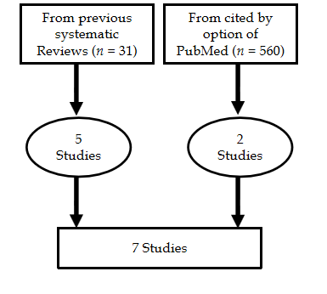
Figure 1 Flow chart of final selection.
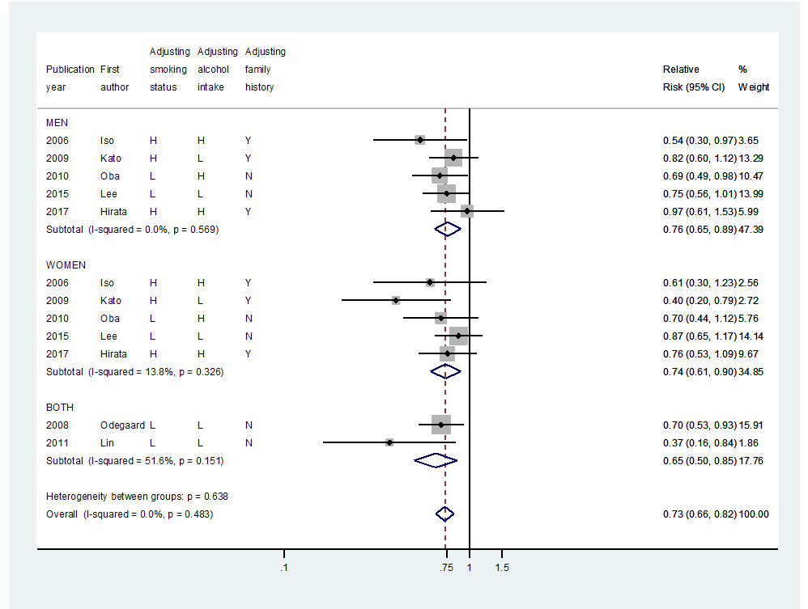
Figure 2 Forest plot to estimate summary relative risks by sex. CI: Confidence interval; H: High level; L: Low level; N: Not adjust; Y: Adjust.
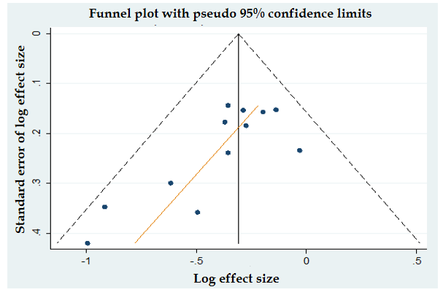
Figure 3 Funnel plot with Egger’s test (P = 0.01).
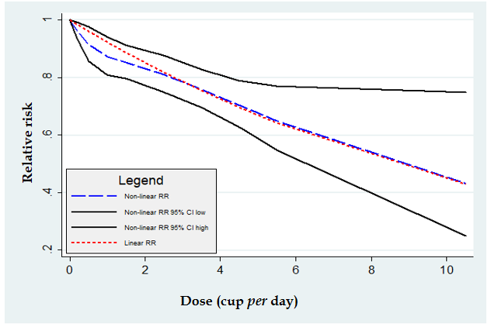
Figure 4 Dose-response meta-analysis in Asians. Relative risk and its low/high 95% confidence intervals. CI: Confidence interval; RR: Relative risk.
Table 1 Summary relative risk and its 95% confidence intervals
Group |  | Summary relative risk (95% confidence intervals) [I-squared %]
All |  | 0.73 (0.66-0.82) [0.0]
Sex | Men | 0.76 (0.65-0.89) [0.0]
 | Women | 0.73 (0.59-0.90) [13.8]
Level of adjusting¹ tobacco smoking | High | 0.72 (0.58-0.90) [21.0]
 | Low | 0.73 (0.63-0.84) [0.0]
Level of adjusting¹ alcohol drinking | High | 0.72 (0.60-0.87) [0.0]
 | Low | 0.72 (0.60-0.87) [34.0]
Adjusting family history | Yes | 0.72 (0.58-0.90) [21.0]
 | No | 0.73 (0.63-0.84) [0.0]
¹High: Adjusted for intensity as well as status; Low: Adjusted for only status.
Table 2 Dose-response meta-analysis by the intaking unit (cup per day)
 | Relative risk  (95% confidence interval) | P value  of heterogeneity | P value of non-linearity
All | 0.92 (0.90-0.95) | 0.42 | 0.31
Men | 0.95 (0.91-0.98) | 0.72 | 0.08
Women | 0.89 (0.85-0.94) | 0.40 | 0.56

Published by Baishideng Publishing Group Inc
7041 Koll Center Parkway, Suite 160, Pleasanton, CA 94566, USA
Telephone: +1-925-3991568
E-mail: bpgoffice@wjgnet.com
Help Desk: https://www.f6publishing.com/helpdesk
https://www.wjgnet.com

© 2021 Baishideng Publishing Group Inc. All rights reserved.

