Name of Journal: World Journal of Clinical Cases
Manuscript NO: 75093
Manuscript Type: CASE REPORT

Immunotherapy combined with antiangiogenic agents in patients with advanced malignant pleural mesothelioma: A case report

Xuan TT et al. Advanced malignant pleural mesothelioma

Tian-Tian Xuan, Guang-Yi Li, Si-Bo Meng, Zhan-Mei Wang, Lin-Li Qu

Tian-Tian Xuan, Si-Bo Meng, Zhan-Mei Wang, Lin-Li Qu, Department of Medical Oncology, Qilu Hospital (Qingdao), Cheeloo College of Medicine, Shandong University, Qingdao 266035, Shandong Province, China

Guang-Yi Li, Department of Respiratory, Qilu Hospital (Qingdao), Cheeloo College of Medicine, Shandong University, Qingdao 266035, Shandong Province, China

Author contributions: TT Xu and LL Qu reviewed the literature and contributed to manuscript drafting; TT Xu, GY Li, SB Meng, and ZM Wang analyzed and interpreted the imaging findings; all authors issued final approval for the version to be submitted.

Corresponding author: Linli Qu, MD, PhD, Chief Doctor, Department of Medical Oncology, Qilu Hospital (Qingdao), Cheeloo College of Medicine, Shandong University, No. 758 Hefei Road, Qingdao 266035, Shandong Province, China. qulinli2021@163.com

Received: January 16, 2022
Revised: April 12, 2022
Accepted: June 21, 2022
Published online: August 16, 2022

Abstract
BACKGROUND
Malignant pleural mesothelioma has limited therapeutic options and a poor outcome. Antiangiogenic agents might increase the efficacy of immunotherapy as second-line treatment of advanced-stage malignancies.

CASE SUMMARY
A patient with stage IIIB pleural mesothelioma received second-line treatment with a combination of pembrolizumab, bevacizumab and chemotherapy following standard chemotherapy under the guidance of second-generation sequencing. He achieved a partial response after four cycles of treatment with progression-free survival of 5 mo. Pembrolizumab was suspended due to grade 2 immune-related pneumonia, which was resolved by oral glucocorticoids. However, disease progression was observed after immunotherapy rechallenge and anlotinib therapy. The patient had disease progression, multiorgan dysfuntion and died suddenly in October 2019.

CONCLUSION
The combination of immune checkpoint inhibitor, anti-angiogenic agents and chemotherapy showed effective response for advanced pleural mesothelioma, but with adverse reactions.

Key Words: Pleural mesothelioma; Immune checkpoint inhibitor; Next-generation Sequencing; Immune-related pneumonia; Immunotherapy rechallenge; Case report

©The Author(s) 2022. Published by Baishideng Publishing Group Inc. All rights reserved.

Citation: Xuan TT, Li GY, Meng SB, Wang ZM, Qu LL. Immunotherapy combined with antiangiogenic agents in patients with advanced malignant pleural mesothelioma: A case report. World J Clin Cases 2022; 10(23): 8284-8290
URL: https://www.wjgnet.com/2307-8960/full/v10/i23/8284.htm
DOI: https://dx.doi.org/10.12998/wjcc.v10.i23.8284

Core Tip: A patient with stage IIIB pleural mesothelioma received second-line treatment with a combination of pembrolizumab, bevacizumab and chemotherapy following standard chemotherapy, and achieved partial response after four cycles, with progression-free survival of 5 mo.

INTRODUCTION
Malignant pleural mesothelioma (MPM) occurs in the pleural mesothelium, which is a rare and aggressive neoplasm. As the most common malignant mesothelioma, pleural mesothelioma accounts for about 90% of cases^{[1,2]}. Histological subtypes of MPM are divided into epithelioid (about 60%) and nonepithelioid (about 40%) variants^{[3]}. The later variants include subtypes of spindle, sarcomatoid, desmoplastic, fibrous and biphasic.
Poor prognosis is observed in MPM, partly because of the late-stage diagnosis. The median survival period for untreated MPM is usually < 1 year.
Treatments include palliative surgical resection, radiotherapy or chemotherapy. Currently first-line therapy is chemotherapy with pemetrexed plus cisplatin^{[5]}. No standard second-line therapy is suggested after the initial combined treatment with cisplatin and pemetrexed. Gemcitabine or vinorelbine is often administrated but showed limited efficacy^{[6]}. Immune checkpoint inhibitors (ICIs), such as those targeting programmed cell death-1/programmed death-ligand 1 (PD-1/PD-L1) and cytotoxic T-lymphocyte-associated antigen 4 (CTLA4), have made a breakthrough in the treatment of multiple solid tumors. Compared with the conventional chemotherapeutic drugs, ICIs-based therapy improves the prognosis of patients with various tumors^{[7]}. Recent investigations have suggested that ICIs, pembrolizumab or nivolumab with (or without) ipilimumab, may be useful as a subsequent systemic therapy for patients with MPM^{[8]}. Combinations of antiangiogenic agents with immunotherapy, including ICIs, indicated promising antitumor effects according to laboratory data and clinical analysis, although there are few reports of combinations of antiangiogenic agents with immunotherapy for MPM.
Here, we report a case of MPM who received a second-line treatment of pembrolizumab, bevacizumab and chemotherapy, and achieved a partial response (PR).

CASE PRESENTATION
Chief complaints
A 51-year-old Asian man presented with a fever.

History of present illness
The patient was admitted to our hospital with fever for 3 d in November 2018 (Figure 1).

History of past illness
No significant past medical history was inquiry, including asbestosis.

Family history
No remarkable family history.

Physical examination
Physical examination suggested lower breath sounds on the right side.

Laboratory examinations
To determine potential therapeutic methods, the whole blood was collected for next-generation sequencing with a gene panel (Yucebio, Shenzhen, China). The sequencing showed TP53 splicing exon 4 (6.44%), microsatellite stability and moderate tumor mutational burden (2.70 Mut/Mb). The patient refused repeat biospy and PD-L1 detection could not be performed.

Imaging examinations
Chest computed tomography (CT) showed right pleural occupation with effusion (Figure 2A). Whole-body CT showed a tumor involving all ipsilateral pleural surfaces, without distant metastasis.

MULTIDISCIPLINARY EXPERT CONSULTATION
Pathological diagnosis
The tumor cells were arranged in sheets, clusters and pleomorphism. Histopathological diagnosis was MPM (epithelial type) based on a biopsy specimen of the right pleura (Figure 2B). Immunohistochemistry of the tumor tissue indicated positive staining of calretinin, podoplanin, and cytokeratin 7, but negative for carcinoembryonic antigen, thyroid transcription factor-1 and Wilms tumour-1.

FINAL DIAGNOSIS
MPM (epithelial type), and the clinical stage was determined as cT4N0M0, stage IIIB.

TREATMENT
The patient received one cycle of chemotherapy with carboplatin plus pemetrexed. He showed disease progression with a larger lesion in the right pleura and lung metastasis. Second-line treatment with combination of pembrolizumab, bevacizumab and chemotherapy were administered. Four cycles of treatment with pembrolizumab (200 mg, every 3 wk), bevacizumab (600 mg, every 3 wk) and liposome taxol (175 mg/m², d1) was performed from January to April 2019.

OUTCOME AND FOLLOW-UP
CT examination showed that the pleural lesions and lung metastases had significantly reduced, which was evaluated as PR according to the RECIST1.1 criteria (Figure 3). However, the patient had worsening symptoms including difficulty breathing and cough, with multiple patchy high-density foci in both lungs, indicating moderate (grade 2) immune-related pneumonia (IRP). After pembrolizumab treatment suspension, the patient received glucocorticoid (1 mg/kg), followed by two cycles of bevacizumab and chemotherapy. The IRP resolved to grade ≤ 1 and glucocorticoid treatment was discontinued after 2 mo. Unfortunately, CT and magnetic resonance imaging revealed progressive disease with liver metastasis in July 2019. Next-generation sequencing of the whole blood was performed with a gene panel (Yucebio), which showed low tumor mutational burden (< 1 Mut/Mb). As the previous combination therapy had a significantly curative effect, and the pneumonitis resolved, the patient received immunotherapy rechallenge and antiangiogenic agent anlotinib as third-line therapy. However, grade 2 IRP recurred after one cycle of pembrolizumab retreatment. Subsequently, methylprednisolone was administered (1 mg/kg for 1 wk with gradual reduction). Five days later, CT showed IRP remission and the new foci disappeared after 1 mo. However, disease progression recurred in August 2019 with increased liver metastases. We tried capecitabine and temozolomide treatment for one cycle, but failed to control the disease. The patient developed persistent severe pneumonia, anemia, hypoproteinemia, and electrolyte disturbance and died suddenly in October 2019.

DISCUSSION
It has been estimated that age-adjusted mesothelioma death rates expended by 5.37% each year worldwide in the range of 1994 and 2008. USA, Australia, Russia, Western Europe, Turkey, South Africa, and Argentina showed the highest age-standardized incidence according to the 2018 report from World Health Organization^{[9]}. Most mesothelioma patients were treated with palliative chemotherapy rather than surgery, because of the disease progression, old age, poor Eastern Cooperative Oncology Group estimation, or comorbidities. The combination treatment of cisplatin and pemetrexed was used as standard treatment for mesothelioma^{[10]}. Notably, the addition of bevacizumab improved survival compared to those with platinum-doublet therapy alone according to a recent clinical study^{[11]}. However, the median survival for resectable MPM remains at 17-25 mo with aggressive trimodal or bimodal therapy. Median survival for unresectable MPM is 9-12 mo. It is crucial to identify novel targets for MPM treatment.
Immunotherapy achieved great breakthrough during the last decade in the treatment of different tumors, including non-small cell lung cancer (NSCLC), urothelial carcinoma, melanoma and head/neck carcinoma. ICIs reverse the immunosuppression phenotype as activated status in the tumor microenvironment by blocking the PD-1/PD-L1 axis or CTLA4. In a phase 1b trial, 25 patients with PD-L1-positive MPM (positive tumor cells > 1%) revived a second-line treatment of pembrolizumab, which showed an objective response as 20% [95% confidence interval (CI) 6.8%-40.7%] and stable disease in 52% of the patients. The median duration of response was calculated as 12 mo (3.7 mo to not reached), and the treatment was judged as well tolerated^{[12]}. Results of the MAPS-2 trial supported either nivolumab or nivolumab plus ipilimumab as options for second-line or third-line therapy in patients with relapsed MPM, which was recommend by the National Comprehensive Cancer Network panel^{[13]}.
Evidence from several studies indicates that a subset of patients might present with nonresponse or accelerated disease progression after immunotherapy. It is a strategy currently under study to combinate antiangiogenic agents with immunotherapy to improve the response rates and therapeutic response duration. The strategy seems paradoxical given that antiangiogenic agents eliminate blood vessels and increase tumor hypoxia within tumors^{[14]}. However, immunotherapy, especially ICIs, might contribute to the tumor vasculature modification to increase the efficacy of antiangiogenic agents^{[15]}. It is proposed that interactions between ICIs and antiangiogenic agents could be considered as a “two-way street”. Phase III clinical trials was conducted to evaluate the combinations of antiangiogenic treatment with immunotherapy in various tumors, including NSCLC, hepatocellular carcinoma, advanced renal cell carcinoma, and ovarian cancer. Besides, the proangiogenic factors also showed immunosuppressive activity, which attracted researchers to evaluate the potentially synergistic effects of the combination therapy. Several trials are registered to evaluate the combination treatment of ICIs and antiangiogenic agents (either monoclonal antibodies such as bevacizumab or tyrosine kinase inhibitors) in MPM patients (NCT03762018, NCT02856425 and NCT03502746). In the present case, PR was achieved after treatment with pembrolizumab, antiangiogenic agents and chemotherapy.
Although ICI-associated adverse events are less common than those associated with chemotherapy, they necessitate corticosteroid treatment, leading to ICI treatment interruption^{[16,17]}. Most immune-related adverse events (irAEs) was observed in the colon, liver, lungs, pituitary gland, thyroid, and skin. The other uncommon adverse events occurred in the heart, nervous system, and other organs^{[18]}. Most symptom was rapid alleviated after ICI treatment interruption and corticosteroid treatment. Thus, ICIs rechallenge appears as a conceivable option after temporary interruption, but only limited reports are available for ICI rechallenge after irAE occurred. The identical irAE recurrence rate in ICI rechallenge was reported as ranging from 18% to 42% in a recent small cohort study^{[19-21]}. Dolladille et al^{[22]} analyzed 24079 irAEs associated with ICI treatment. Among the 6123 irAEs, 452 were correlated with ICI rechallenges (7.4%). Totally 130 recurrences (28.8%; 95%CI, 24.8%-33.1%) of the initial irAE were calculated. Screening for appropriate patients for ICI rechallenge should be considered, as well as closely monitoring irAEs during the process of the treatment. A previous study reported that poor clinical outcomes associated with pneumonitis were more frequent in current smokers and those with underlying lung conditions^{[23]}. Our patient was rechallenged with immunotherapy after ICI interruption because of IRP and received corticosteroid treatment. Therefore, ICI rechallenge should be carefully considered when IRP has occurred previously in patients with advanced MPM treated with pembrolizumab.

CONCLUSION
ICIs have substantially improved clinical outcomes in many types of cancer. However, the benefits of ICIs as second-line therapy of MPM are still unclear. This case represents a PR with pembrolizumab, bevacizumab and chemotherapy in a patient with MPM but he failed to achieve a durable clinical benefit on rechallenge. Serial biopsies demonstrated the primary immune activation and rapid immune exhaustion in the tumor microenvironment. Future studies are needed for the drug combinations to overcome ICI resistance and adverse reaction prediction for rechallenge.

REFERENCES
1 Robinson BM. Malignant pleural mesothelioma: an epidemiological perspective. Ann Cardiothorac Surg 2012; 1: 491-496 [PMID: 23977542 DOI: 10.3978/j.issn.2225-319X.2012.11.04]
2 Goudar RK. Review of pemetrexed in combination with cisplatin for the treatment of malignant pleural mesothelioma. Ther Clin Risk Manag 2008; 4: 205-211 [PMID: 18728709 DOI: 10.2147/tcrm.s1603]
3 Carbone M, Adusumilli PS, Alexander HR Jr, Baas P, Bardelli F, Bononi A, Bueno R, Felley-Bosco E, Galateau-Salle F, Jablons D, Mansfield AS, Minaai M, de Perrot M, Pesavento P, Rusch V, Severson DT, Taioli E, Tsao A, Woodard G, Yang H, Zauderer MG, Pass HI. Mesothelioma: Scientific clues for prevention, diagnosis, and therapy. CA Cancer J Clin 2019; 69: 402-429 [PMID: 31283845 DOI: 10.3322/caac.21572]
4 Milano MT, Zhang H. Malignant pleural mesothelioma: a population-based study of survival. J Thorac Oncol 2010; 5: 1841-1848 [PMID: 20975379 DOI: 10.1097/JTO.0b013e3181f1cf2b]
5 Ettinger DS, Wood DE, Akerley W, Bazhenova LA, Borghaei H, Camidge DR, Cheney RT, Chirieac LR, D'Amico TA, Dilling T, Dobelbower M, Govindan R, Hennon M, Horn L, Jahan TM, Komaki R, Lackner RP, Lanuti M, Lilenbaum R, Lin J, Loo BW Jr, Martins R, Otterson GA, Patel JD, Pisters KM, Reckamp K, Riely GJ, Schild SE, Shapiro TA, Sharma N, Swanson SJ, Stevenson J, Tauer K, Yang SC, Gregory K, Hughes M. NCCN Guidelines Insights: Malignant Pleural Mesothelioma, Version 3.2016. J Natl Compr Canc Netw 2016; 14: 825-836 [PMID: 27407123 DOI: 10.6004/jnccn.2016.0087]
6 Buikhuisen WA, Hiddinga BI, Baas P, van Meerbeeck JP. Second line therapy in malignant pleural mesothelioma: A systematic review. Lung Cancer 2015; 89: 223-231 [PMID: 26162564 DOI: 10.1016/j.lungcan.2015.06.018]
7 Champiat S, Ferrara R, Massard C, Besse B, Marabelle A, Soria JC, Ferté C. Hyperprogressive disease: recognizing a novel pattern to improve patient management. Nat Rev Clin Oncol 2018; 15: 748-762 [PMID: 30361681 DOI: 10.1038/s41571-018-0111-2]
8 Alley EW, Lopez J, Santoro A, Morosky A, Saraf S, Piperdi B, van Brummelen E. Clinical safety and activity of pembrolizumab in patients with malignant pleural mesothelioma (KEYNOTE-028): preliminary results from a non-randomised, open-label, phase 1b trial. Lancet Oncol 2017; 18: 623-630 [PMID: 28291584 DOI: 10.1016/S1470-2045(17)30169-9]
9 Malekzadeh P, Good M, Hughes MS. Cytoreductive surgery and hyperthermic intraperitoneal chemotherapy (HIPEC) with cisplatin in pediatric patients with peritoneal mesothelioma: a single institution experience and long term follow up. Int J Hyperthermia 2021; 38: 326-331 [PMID: 34139940 DOI: 10.1080/02656736.2020.1858194]
10 Vogelzang NJ, Rusthoven JJ, Symanowski J, Denham C, Kaukel E, Ruffie P, Gatzemeier U, Boyer M, Emri S, Manegold C, Niyikiza C, Paoletti P. Phase III study of pemetrexed in combination with cisplatin vs cisplatin alone in patients with malignant pleural mesothelioma. J Clin Oncol 2003; 21: 2636-2644 [PMID: 12860938 DOI: 10.1200/JCO.2003.11.136]
11 Zalcman G, Mazieres J, Margery J, Greillier L, Audigier-Valette C, Moro-Sibilot D, Molinier O, Corre R, Monnet I, Gounant V, Rivière F, Janicot H, Gervais R, Locher C, Milleron B, Tran Q, Lebitasy MP, Morin F, Creveuil C, Parienti JJ, Scherpereel A; French Cooperative Thoracic Intergroup (IFCT). Bevacizumab for newly diagnosed pleural mesothelioma in the Mesothelioma Avastin Cisplatin Pemetrexed Study (MAPS): a randomised, controlled, open-label, phase 3 trial. Lancet 2016; 387: 1405-1414 [PMID: 26719230 DOI: 10.1016/S0140-6736(15)01238-6]
12 Reardon DA, Kim TM, Frenel JS, Simonelli M, Lopez J, Subramaniam DS, Siu LL, Wang H, Krishnan S, Stein K, Massard C. Treatment with pembrolizumab in programmed death ligand 1-positive recurrent glioblastoma: Results from the multicohort phase 1 KEYNOTE-028 trial. Cancer 2021; 127: 1620-1629 [PMID: 33496357 DOI: 10.1002/cncr.33378]
13 Scherpereel A, Mazieres J, Greillier L, Lantuejoul S, Dô P, Bylicki O, Monnet I, Corre R, Audigier-Valette C, Locatelli-Sanchez M, Molinier O, Guisier F, Urban T, Ligeza-Poisson C, Planchard D, Amour E, Morin F, Moro-Sibilot D, Zalcman G; French Cooperative Thoracic Intergroup. Nivolumab or nivolumab plus ipilimumab in patients with relapsed malignant pleural mesothelioma (IFCT-1501 MAPS2): a multicentre, open-label, randomised, non-comparative, phase 2 trial. Lancet Oncol 2019; 20: 239-253 [PMID: 30660609 DOI: 10.1016/S1470-2045(18)30765-4]
14 Khan KA, Kerbel RS. Improving immunotherapy outcomes with anti-angiogenic treatments and vice versa. Nat Rev Clin Oncol 2018; 15: 310-324 [PMID: 29434333 DOI: 10.1038/nrclinonc.2018.9]
15 Schoenfeld J, Jinushi M, Nakazaki Y, Wiener D, Park J, Soiffer R, Neuberg D, Mihm M, Hodi FS, Dranoff G. Active immunotherapy induces antibody responses that target tumor angiogenesis. Cancer Res 2010; 70: 10150-10160 [PMID: 21159637 DOI: 10.1158/0008-5472.CAN-10-1852]
16 Herbst RS, Baas P, Kim DW, Felip E, Pérez-Gracia JL, Han JY, Molina J, Kim JH, Arvis CD, Ahn MJ, Majem M, Fidler MJ, de Castro G Jr, Garrido M, Lubiniecki GM, Shentu Y, Im E, Dolled-Filhart M, Garon EB. Pembrolizumab vs docetaxel for previously treated, PD-L1-positive, advanced non-small-cell lung cancer (KEYNOTE-010): a randomised controlled trial. Lancet 2016; 387: 1540-1550 [PMID: 26712084 DOI: 10.1016/S0140-6736(15)01281-7]
17 Rittmeyer A, Barlesi F, Waterkamp D, Park K, Ciardiello F, von Pawel J, Gadgeel SM, Hida T, Kowalski DM, Dols MC, Cortinovis DL, Leach J, Polikoff J, Barrios C, Kabbinavar F, Frontera OA, De Marinis F, Turna H, Lee JS, Ballinger M, Kowanetz M, He P, Chen DS, Sandler A, Gandara DR; OAK Study Group. Atezolizumab vs docetaxel in patients with previously treated non-small-cell lung cancer (OAK): a phase 3, open-label, multicentre randomised controlled trial. Lancet 2017; 389: 255-265 [PMID: 27979383 DOI: 10.1016/S0140-6736(16)32517-X]
18 Postow MA, Sidlow R, Hellmann MD. Immune-Related Adverse Events Associated with Immune Checkpoint Blockade. N Engl J Med 2018; 378: 158-168 [PMID: 29320654 DOI: 10.1056/NEJMra1703481]
19 Nakajima EC, Lipson EJ, Brahmer JR. Challenge of Rechallenge: When to Resume Immunotherapy Following an Immune-Related Adverse Event. J Clin Oncol 2019; 37: 2714-2718 [PMID: 31461381 DOI: 10.1200/JCO.19.01623]
20 Abu-Sbeih H, Ali FS, Naqash AR, Owen DH, Patel S, Otterson GA, Kendra K, Ricciuti B, Chiari R, De Giglio A, Sleiman J, Funchain P, Wills B, Zhang J, Naidoo J, Philpott J, Gao J, Subudhi SK, Wang Y. Resumption of Immune Checkpoint Inhibitor Therapy After Immune-Mediated Colitis. J Clin Oncol 2019; 37: 2738-2745 [PMID: 31163011 DOI: 10.1200/JCO.19.00320]
21 Simonaggio A, Michot JM, Voisin AL, Le Pavec J, Collins M, Lallart A, Cengizalp G, Vozy A, Laparra A, Varga A, Hollebecque A, Champiat S, Marabelle A, Massard C, Lambotte O. Evaluation of Readministration of Immune Checkpoint Inhibitors After Immune-Related Adverse Events in Patients With Cancer. JAMA Oncol 2019; 5: 1310-1317 [PMID: 31169866 DOI: 10.1001/jamaoncol.2019.1022]
22 Dolladille C, Ederhy S, Sassier M, Cautela J, Thuny F, Cohen AA, Fedrizzi S, Chrétien B, Da-Silva A, Plane AF, Legallois D, Milliez PU, Lelong-Boulouard V, Alexandre J. Immune Checkpoint Inhibitor Rechallenge After Immune-Related Adverse Events in Patients With Cancer. JAMA Oncol 2020; 6: 865-871 [PMID: 32297899 DOI: 10.1001/jamaoncol.2020.0726]
23 Naidoo J, Wang X, Woo KM, Iyriboz T, Halpenny D, Cunningham J, Chaft JE, Segal NH, Callahan MK, Lesokhin AM, Rosenberg J, Voss MH, Rudin CM, Rizvi H, Hou X, Rodriguez K, Albano M, Gordon RA, Leduc C, Rekhtman N, Harris B, Menzies AM, Guminski AD, Carlino MS, Kong BY, Wolchok JD, Postow MA, Long GV, Hellmann MD. Pneumonitis in Patients Treated With Anti-Programmed Death-1/Programmed Death Ligand 1 Therapy. J Clin Oncol 2017; 35: 709-717 [PMID: 27646942 DOI: 10.1200/JCO.2016.68.2005]

Footnotes
Informed consent statement: Informed written consent was obtained from the patient for the publication of this report and any accompanying images.

Conflict-of-interest statement: The authors declare that there are no conflicts of interest related to this report.

CARE Checklist (2016) statement: The authors have read the CARE Checklist (2016), and the manuscript was prepared and revised according to the CARE Checklist (2016).

Open-Access: This article is an open-access article that was selected by an in-house editor and fully peer-reviewed by external reviewers. It is distributed in accordance with the Creative Commons Attribution NonCommercial (CC BY-NC 4.0) license, which permits others to distribute, remix, adapt, build upon this work non-commercially, and license their derivative works on different terms, provided the original work is properly cited and the use is non-commercial. See: https://creativecommons.org/Licenses/by-nc/4.0/

Provenance and peer review: Unsolicited article; Externally peer reviewed.
Peer-review model: Single blind

Peer-review started: January 16, 2022
First decision: March 16, 2022
Article in press: June 21, 2022

Specialty type: Oncology
Country/Territory of origin: China
Peer-review report’s scientific quality classification
Grade A (Excellent): 0
Grade B (Very good): B, B
Grade C (Good): C
Grade D (Fair): D
Grade E (Poor): 0

P-Reviewer: Awad AK, Egypt; Fazilat-Panah D, Iran; Yelamanchi R, India A-Editor: Lin FY, China S-Editor: Liu JH L-Editor: A P-Editor: Liu JH
Figure Legends
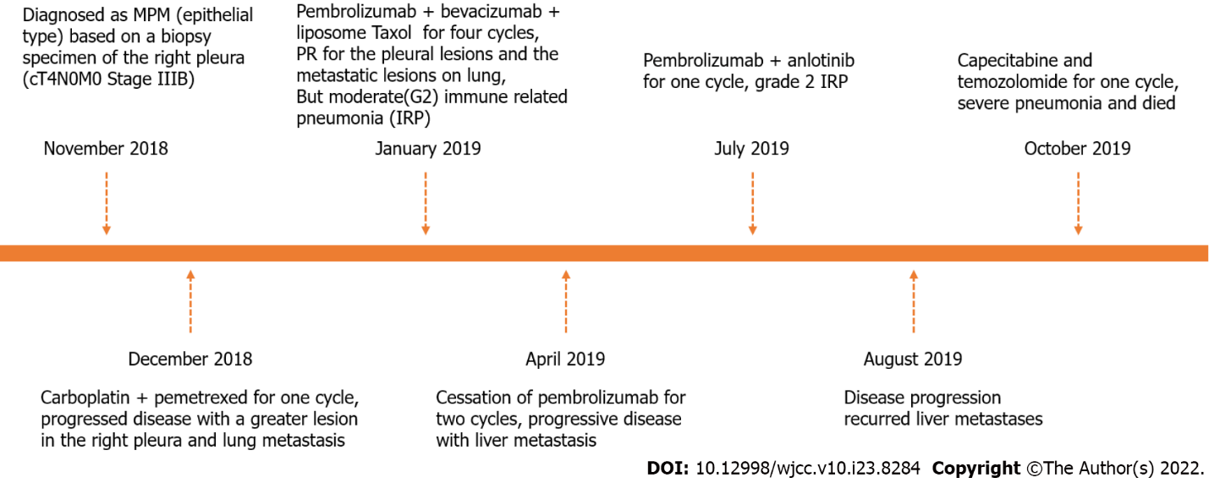
Figure 1 Timeline of treatment course of patient with malignant pleural mesothelioma. PFS: Progression-free survival; SRS: Stereotactic radiosurgery.
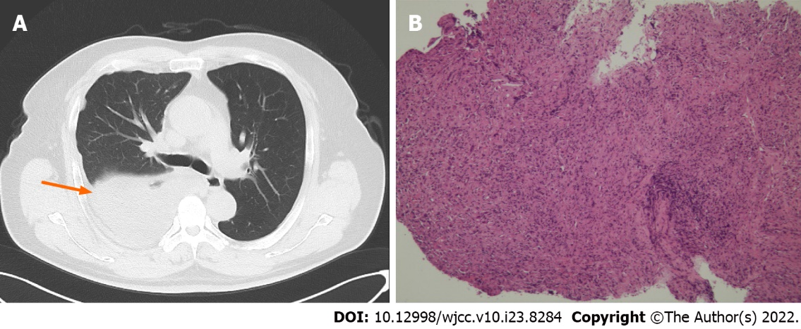
Figure 2 Representative images. A: Representative images of computed tomography images showing right pleural occupation with effusion; B: Representative images of pleural mesothelioma tissue stained with hematoxylin and eosin.
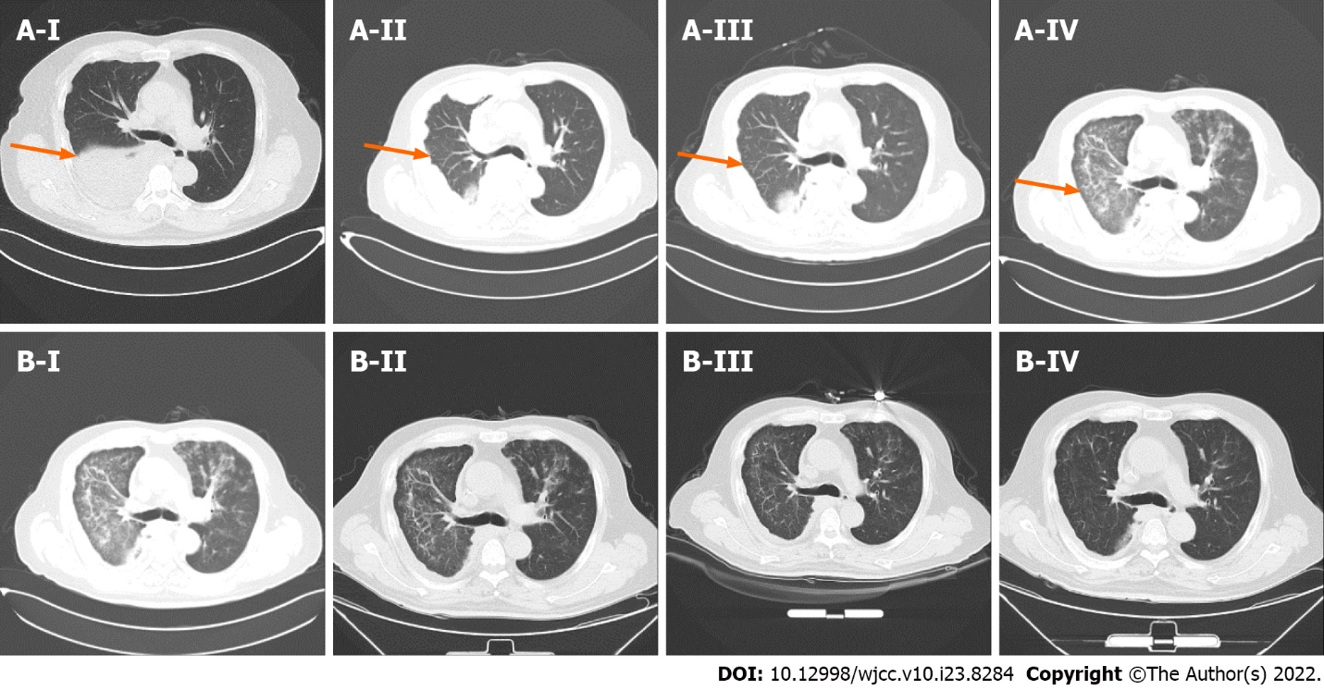
Figure 3 Computed tomography examination. A: Response of the main lesion estimated by computed tomography. The pleural mass significantly progressed after one cycle of carboplatin plus pemetrexed (A-II). Partial response after two (A-III) and four (A-IV) cycles of pembrolizumab and bevacizumab with chemotherapy; B: Image of immune-related pneumonia (IRP) before and after immunotherapy. B-I: IRP occurred after five cycles of Immune checkpoint inhibitor. B-II: One week after administration of methylprednisolone; B-III: 2 wk after administration of methylprednisolone; B-IV: IRP decreased after 1 mo of methylprednisolone therapy.

Published by Baishideng Publishing Group Inc
7041 Koll Center Parkway, Suite 160, Pleasanton, CA 94566, USA
Telephone: +1-925-3991568
E-mail: bpgoffice@wjgnet.com
Help Desk: https://www.f6publishing.com/helpdesk
https://www.wjgnet.com

© 2022 Baishideng Publishing Group Inc. All rights reserved.

