Name of Journal: World Journal of Gastrointestinal Surgery
Manuscript NO: 57479
Manuscript Type: CASE REPORT

Gastric splenosis mimicking a gastrointestinal stromal tumor: A case report

Isopi C et al. An intragastric nodule mimicking GIST

Claudio Isopi, Giulia Vitali, Federica Pieri, Leonardo Solaini, Giorgio Ercolani

Claudio Isopi, Giulia Vitali, Leonardo Solaini, Giorgio Ercolani, Department of Surgery, Morgagni-Pierantoni Hospital, Forli 47121, Italy

Federica Pieri, Pathology Unit, Morgagni-Pierantoni Hospital, Forli 47121, Italy

Leonardo Solaini, Giorgio Ercolani, Department of Medical and Surgical Sciences, University of Bologna, Bologna 47100, Italy

Author contributions: Isopi C and Vitali G reviewed the literature and drafted the manuscript in consultation with Solaini L and Ercolani G; Isopi C and Vitali G are joint first authors; Pieri F performed the final pathology; Pieri F, Solaini L and Ercolani G critically revised the manuscript; All authors issued final approval for the version to be submitted.

Corresponding author: Leonardo Solaini, MD, Assistant Professor, Department of Surgery, Morgagni-Pierantoni Hospital, Via Carlo Forlanini, 34, Forli 47121, Italy. leonardo.solaini2@unibo.it

Received: June 30, 2020
Revised: August 13, 2020
Accepted: September 14, 2020
Published online: October 27, 2020

Abstract
BACKGROUND
Mass lesions located in the wall of the stomach (and also of the bowel) are referred to as “intramural.” The differential diagnosis of such lesions can be challenging in some cases. As such, it may occur that an inconclusive fine needle aspiration (FNA) result give way to an unexpected diagnosis upon final surgical pathology. Herein, we present a case of an intramural gastric nodule mimicking a gastric gastrointestinal stromal tumor (GIST).

CASE SUMMARY
A 47-year-old Caucasian woman, who had undergone splenectomy for trauma at the age of 16, underwent gastroscopy for long-lasting epigastric pain and dyspepsia. It revealed a 15 mm submucosal nodule bulging into the gastric lumen with smooth margins and normal overlying mucosa. A thoraco-abdominal computed tomography scan showed in the gastric fundus a rounded mass (30 mm in diameter) with an exophytic growth and intense enhancement after administration of intravenous contrast. Endoscopic ultrasound scan showed a hypoechoic nodule, and fine needle FNA was inconclusive. Gastric GIST was considered the most probable diagnosis, and surgical resection was proposed due to symptoms. A laparoscopic gastric wedge resection was performed. The postoperative course was uneventful, and the patient was discharged on the seventh postoperative day. The final pathology report described a rounded encapsulated accumulation of lymphoid tissue of about 4 cm in diameter consistent with spleen parenchyma implanted during the previous splenectomy.

CONCLUSION
Splenosis is a rare condition that should always be considered as a possible diagnosis in splenectomized patients who present with an intramural gastric nodule.

Key Words: Splenosis; Intramural gastric mass; Gastric nodule; Laparoscopic gastric surgery; Gastrointestinal stromal tumor; Case report

Citation: Isopi C, Vitali G, Pieri F, Solaini L, Ercolani G. Gastric splenosis mimicking a gastrointestinal stromal tumor: A case report. World J Gastrointest Surg 2020; 12(10): 435-441
URL: https://www.wjgnet.com/1948-9366/full/v12/i10/435.htm
DOI: https://dx.doi.org/10.4240/wjgs.v12.i10.435

Core Tip: Intramural gastric nodules are rare, but all differential diagnoses must always be considered. If feasible, a preoperative fine needle aspiration can help the surgeon in selecting the best treatment option. Splenosis is uncommon in the general population, but it must be considered in each patient with a history of splenectomy (especially after trauma). In this specific cluster it is reasonable to insist on ruling out splenosis even making a second histologic sampling after a first failure.

INTRODUCTION
The masses arising from the wall of the stomach are referred to as “intramural”. In these cases the endoscopic and radiologic features may lead to several differential diagnoses because several overlapping characteristics have been shown to exist among the various gastric masses. Intramural lesions can be benign or malignant, and the most common diagnosis is gastrointestinal stromal tumors (GISTs).
Only a preoperative sampling allows planning the best therapeutic approach, but when the nature of the nodule cannot be preoperatively determined, an assessment about size, possible diagnoses, patient’s characteristics and clinical symptoms should be done before considering an upfront surgical approach.
Herein, we present a case of an intramural gastric nodule mimicking gastric gastrointestinal stromal tumor, whose nature could be defined only after surgery.

CASE PRESENTATION
Chief complaints
A 47-year-old Caucasian woman was referred to our unit for an intragastric nodule detected during a gastroscopy.

History of present illness
The gastroscopy was performed for long lasting epigastric pain and dyspepsia.

History of past illness
Patient’s past medical history included: Asthma, hypothyroidism, migraine and a splenectomy for trauma.

Personal and family history
No family histories were identified.

Physical examination
The patient was in good general condition and slightly overweight (body mass index: 25.6). There were no abdominal mass and no pain on palpation.

Laboratory examinations
Routine laboratory tests revealed no abnormalities.

Imaging examinations
Endoscopy showed a 15 mm submucosal nodule bulging into the gastric lumen with smooth margins and macroscopically normal overlying mucosa. Biopsies were negative for malignancy and showed superficial chronic gastritis.
Consequently, a thoraco-abdominal computed tomography scan (Figure 1A and 1B) and an endoscopic ultrasound with a fine needle aspiration were planned. Those investigations found a roundish formation on the gastric fundus of about 30 mm in diameter with an exophytic development. The mass was in close contiguity with the left adrenal gland and the left pillar of the diaphragm with no signs of infiltration. The ultrasound appearance was of a solid mass with well-defined margins with a homogeneous and well vascularized internal texture in the absence of calcified or necrotic areas. The fine needle aspiration (FNA) was performed without complications, but the result was nondiagnostic due to inadequate tissue yield.

FINAL DIAGNOSIS
Our main diagnostic suspect remained a gastric GIST and the symptoms could be related to the location of the mass. After a careful evaluation of the risks and benefits and according to the European Society for Medical Oncology guidelines^{[1]}, the surgical excision was planned.

TREATMENT
The laparoscopic resection was performed with a three trocars technique (10 mm supraumbilical and right hypochondrium and 5 mm left hypochondrium). After a careful lysis of the adhesions related to the previous splenectomy, the exophytic mass of the fundus was identified. The perigastric vessels were dissected in order to expose the nodule; the resection was performed with a linear stapler.

OUTCOME AND FOLLOW-UP
The postoperative course was uneventful, and the patient was discharged on the seventh postoperative day. The final pathology of the specimen did not confirm our hypothesis but reported a rounded encapsulated accumulation of lymphoid tissue of 4 cm in diameter consistent with spleen parenchyma probably implanted during the previous splenectomy (Figure 2).
At the 6 mo follow-up the patient was symptom free.

DISCUSSION
Ectopic splenic tissue can be found in the body as accessory spleens and splenosis^{[2]}. The former is congenital and receives blood supply from the splenic artery. The latter is a benign condition caused by the spillage upon the peritoneal surface of cells from the spleen after splenic trauma or surgical procedures.
Splenosis is usually considered to be a rare phenomenon, but its real prevalence is difficult to define. Pearson et al^{[3]} showed that recurrent splenic activity after urgent splenectomy is frequent, and according to Sikov et al^{[4]}, its incidence could be as high as 76% in patients who had undergone splenectomy for trauma.
Splenosis is a benign condition, usually found incidentally and unless symptomatic surgery is not indicated^{[5]}. In some cases the implantation could be responsible for serious conditions like gastrointestinal hemorrhage, pain from compression of the abdominal structures and bowel obstruction^{[6]}. Splenosis may resemble several abdominal malignancies. As such several studies reported cases of splenosis mimicking a pancreatic mass^{[7]}, lymphomas^{[8]}, neuroendocrine tumors^{[9]}, intramural colonic masses^{[10]}, liver masses^{[11,12]} and GISTs^{[13-16]}. For this variability, the diagnosis of splenosis may be challenging. On a peripheral smear the absence of Howell-Jolly and Heinz bodies and siderocytes despite a history of splenectomy could mildly suggest the presence of a splenosis^{[17]}. Imaging may not be accurate in defining this condition^{[18]}. Differential diagnoses between benign^{[19-26]} and malignant^{[27-32]} forms and the radiologic features of intramural gastric masses^{[33,34]} are presented in the Table 1.
Nowadays, there is a general consensus that the mainstay for the diagnosis of splenosis is the noninvasive scintigraphy using technetium-99m-labeled heat damaged red blood cell or indium 111-labeled platelets^{[35]}. However, it must be highlighted that the real critical point in diagnosing splenosis is thinking about it in a suggestive past medical history.
During the assessment of a gastric intramural nodule, mass biopsy may help solving the diagnostic dilemma. However, in our case preoperative diagnosis was not possible, and the patient was submitted to surgery according to her symptoms and the most probable diagnosis.

CONCLUSION
Splenosis is a rare condition that should always be considered as a possible diagnosis in patients who had undergone splenectomy. If feasible, a preoperative FNA may be the best preoperative investigation to rule out other diagnoses and to plan the most appropriate treatment.

REFERENCES
1 Casali PG, Abecassis N, Aro HT, Bauer S, Biagini R, Bielack S, Bonvalot S, Boukovinas I, Bovee JVMG, Brodowicz T, Broto JM, Buonadonna A, De Álava E, Dei Tos AP, Del Muro XG, Dileo P, Eriksson M, Fedenko A, Ferraresi V, Ferrari A, Ferrari S, Frezza AM, Gasperoni S, Gelderblom H, Gil T, Grignani G, Gronchi A, Haas RL, Hassan B, Hohenberger P, Issels R, Joensuu H, Jones RL, Judson I, Jutte P, Kaal S, Kasper B, Kopeckova K, Krákorová DA, Le Cesne A, Lugowska I, Merimsky O, Montemurro M, Pantaleo MA, Piana R, Picci P, Piperno-Neumann S, Pousa AL, Reichardt P, Robinson MH, Rutkowski P, Safwat AA, Schöffski P, Sleijfer S, Stacchiotti S, Sundby Hall K, Unk M, Van Coevorden F, van der Graaf WTA, Whelan J, Wardelmann E, Zaikova O, Blay JY; ESMO Guidelines Committee and EURACAN. Gastrointestinal stromal tumours: ESMO-EURACAN Clinical Practice Guidelines for diagnosis, treatment and follow-up. Ann Oncol 2018; 29: iv68-iv78 [PMID: 29846513 DOI: 10.1093/annonc/mdy095]
2 Varga I, Galfiova P, Adamkov M, Danisovic L, Polak S, Kubikova E, Galbavy S. Congenital anomalies of the spleen from an embryological point of view. Med Sci Monit 2009; 15: RA269-RA276 [PMID: 19946246]
3 Pearson HA, Johnston D, Smith KA, Touloukian RJ. The born-again spleen. Return of splenic function after splenectomy for trauma. N Engl J Med 1978; 298: 1389-1392 [PMID: 652006 DOI: 10.1056/NEJM197806222982504]
4 Sikov WM, Schiffman FJ, Weaver M, Dyckman J, Shulman R, Torgan P. Splenosis presenting as occult gastrointestinal bleeding. Am J Hematol 2000; 65: 56-61 [PMID: 10936865 DOI: 10.1002/1096-8652(200009)65:1<56::AID-AJH10>3.0.CO;2-1]
5 Fremont RD, Rice TW. Splenosis: a review. South Med J 2007; 100: 589-593 [PMID: 17591312 DOI: 10.1097/SMJ.0b013e318038d1f8]
6 Ksiadzyna D, Peña AS. Abdominal splenosis. Rev Esp Enferm Dig 2011; 103: 421-426 [PMID: 21867352 DOI: 10.4321/S1130-01082011000800006]
7 Mascioli F, Ossola P, Esposito L, Iascone C. A rare case of pancreatic splenosis and a literature review. Ann Ital Chir 2020; 9 [PMID: 32129178]
8 Priola AM, Picciotto G, Priola SM. Diffuse abdominal splenosis: a condition mimicking abdominal lymphoma. Int J Hematol 2009; 90: 543-544 [PMID: 19957058 DOI: 10.1007/s12185-009-0454-7]
9 Matsubayashi H, Bando E, Kagawa H, Sasaki K, Ishiwatari H, Ono H. A Multinodular Mass of Abdominal Splenosis: Case Report of Uncommon Images of a Rare Disease. Diagnostics (Basel) 2019; 9: 111 [PMID: 31487850 DOI: 10.3390/diagnostics9030111]
10 Obokhare ID, Beckman E, Beck DE, Whitlow CB, Margolin DA. Intramural colonic splenosis: a rare case of lower gastrointestinal bleeding. J Gastrointest Surg 2012; 16: 1632-1634 [PMID: 22450955 DOI: 10.1007/s11605-012-1875-9]
11 Kang KC, Cho GS, Chung GA, Kang GH, Kim YJ, Lee MS, Kim HK, Park SJ. Intrahepatic splenosis mimicking liver metastasis in a patient with gastric cancer. J Gastric Cancer 2011; 11: 64-68 [PMID: 22076204 DOI: 10.5230/jgc.2011.11.1.64]
12 Luo X, Zeng J, Wang Y, Min Y, Shen A, Zhang Y, Deng H, Gong N. Hepatic splenosis: Rare yet important - A case report and literature review. J Int Med Res 2019; 47: 1793-1801 [PMID: 30810057 DOI: 10.1177/0300060519828901]
13 Wang W, Li W, Sun Y, Zhao Y, Zhu R, Li J, Zhang H. Intra-gastric Ectopic Splenic Tissue. J Gastrointest Surg 2016; 20: 218-220 [PMID: 26438481 DOI: 10.1007/s11605-015-2940-y]
14 Xiao SM, Xu R, Tang XL, Ding Z, Li JM, Zhou X. Splenosis with lower gastrointestinal bleeding mimicking colonical gastrointestinal stromal tumour. World J Surg Oncol 2017; 15: 78 [PMID: 28399879 DOI: 10.1186/s12957-017-1153-0]
15 Li B, Huang Y, Chao B, Zhao Q, Hao J, Qin C, Xu H. Splenosis in gastric fundus mimicking gastrointestinal stromal tumor: a report of two cases and review of the literature. Int J Clin Exp Pathol 2015; 8: 6566-6570 [PMID: 26261537]
16 Guan B, Li XH, Wang L, Zhou M, Dong ZW, Luo GJ, Meng LP, Hu J, Jin WY. Gastric fundus splenosis with hemangioma masquerading as a gastrointestinal stromal tumor in a patient with schistosomiasis and cirrhosis who underwent splenectomy: A case report and literature review. Medicine (Baltimore) 2018; 97: e11461 [PMID: 29979450 DOI: 10.1097/MD.0000000000011461]
17 Tavakkoli A. The Spleen. In: Zinner MJ, Ashley SW. Maingot’s Abdominal Operations, 12th Edition. New York: Mc Gray Hill, 2013: 1239-1269
18 Kang HC, Menias CO, Gaballah AH, Shroff S, Taggart MW, Garg N, Elsayes KM. Beyond the GIST: mesenchymal tumors of the stomach. Radiographics 2013; 33: 1673-1690 [PMID: 24108557 DOI: 10.1148/rg.336135507]
19 Maderal F, Hunter F, Fuselier G, Gonzales-Rogue P, Torres O. Gastric lipomas--an update of clinical presentation, diagnosis, and treatment. Am J Gastroenterol 1984; 79: 964-967 [PMID: 6507422]
20 Harig BM, Rosen Y, Dallemand S, Farman J. The radiology corner*: glomus tumor of the stomach. Am J Gastroenterol 1975; 63: 423-428 [PMID: 167578]
21 Li R, Gan H, Ni S, Fu Y, Zhu H, Peng W. Differentiation of Gastric Schwannoma From Gastric Gastrointestinal Stromal Tumor With Dual-Phase Contrast-Enhanced Computed Tomography. J Comput Assist Tomogr 2019; 43: 741-746 [PMID: 31356524 DOI: 10.1097/RCT.0000000000000902]
22 Stolte M, Sticht T, Eidt S, Ebert D, Finkenzeller G. Frequency, location, and age and sex distribution of various types of gastric polyp. Endoscopy 1994; 26: 659-665 [PMID: 7859674 DOI: 10.1055/s-2007-1009061]
23 Miettinen M, Makhlouf HR, Sobin LH, Lasota J. Plexiform fibromyxoma: a distinctive benign gastric antral neoplasm not to be confused with a myxoid GIST. Am J Surg Pathol 2009; 33: 1624-1632 [PMID: 19675452 DOI: 10.1097/PAS.0b013e3181ae666a]
24 Lee MJ, Lim JS, Kwon JE, Kim H, Hyung WJ, Park MS, Kim MJ, Kim KW. Gastric true leiomyoma: computed tomographic findings and pathological correlation. J Comput Assist Tomogr 2007; 31: 204-208 [PMID: 17414754 DOI: 10.1097/01.rct.0000237812.95875.bd]
25 Levy AD, Abbott RM, Rohrmann CA Jr, Frazier AA, Kende A. Gastrointestinal hemangiomas: imaging findings with pathologic correlation in pediatric and adult patients. AJR Am J Roentgenol 2001; 177: 1073-1081 [PMID: 11641173 DOI: 10.2214/ajr.177.5.1771073]
26 Attwell A, Sams S, Fukami N. Diagnosis of ectopic pancreas by endoscopic ultrasound with fine-needle aspiration. World J Gastroenterol 2015; 21: 2367-2373 [PMID: 25741143 DOI: 10.3748/wjg.v21.i8.2367]
27 Aggarwal G, Sharma S, Zheng M, Reid MD, Crosby JH, Chamberlain SM, Nayak-Kapoor A, Lee JR. Primary leiomyosarcomas of the gastrointestinal tract in the post-gastrointestinal stromal tumor era. Ann Diagn Pathol 2012; 16: 532-540 [PMID: 22917807 DOI: 10.1016/j.anndiagpath.2012.07.005]
28 Coffin CM, Hornick JL, Fletcher CD. Inflammatory myofibroblastic tumor: comparison of clinicopathologic, histologic, and immunohistochemical features including ALK expression in atypical and aggressive cases. Am J Surg Pathol 2007; 31: 509-520 [PMID: 17414097 DOI: 10.1097/01.pas.0000213393.57322.c7]
29 Levy AD, Sobin LH. From the archives of the AFIP: Gastrointestinal carcinoids: imaging features with clinicopathologic comparison. Radiographics 2007; 27: 237-257 [PMID: 17235010 DOI: 10.1148/rg.271065169]
30 Weigt J, Malfertheiner P. Metastatic Disease in the Stomach. Gastrointest Tumors 2015; 2: 61-64 [PMID: 26674003 DOI: 10.1159/000431304]
31 Januszewicz W, Corrie P, Liu H, Chan J, Fitzgerald RC, di Pietro M. A sinister black finding in the stomach. Lancet 2019; 393: 1149 [PMID: 30894270 DOI: 10.1016/S0140-6736(19)30423-4]
32 Weissman S, Mehta TI, Zhornitskiy A, Tondon R, Tabibian JH. "Homomorphic" Tumor Metastases as an Endodiagnostic Clue: A Case Series of Renal-Cell Carcinoma Metastatic to the Stomach. Gastrointest Tumors 2019; 6: 147-152 [PMID: 31768359 DOI: 10.1159/000502520]
33 Fishman EK, Urban BA, Hruban RH. CT of the stomach: spectrum of disease. Radiographics 1996; 16: 1035-1054 [PMID: 8888389 DOI: 10.1148/radiographics.16.5.8888389]
34 Park SH, Han JK, Kim TK, Lee JW, Kim SH, Kim YI, Choi BI, Yeon KM, Han MC. Unusual gastric tumors: radiologic-pathologic correlation. Radiographics 1999; 19: 1435-1446 [PMID: 10555667 DOI: 10.1148/radiographics.19.6.g99no051435]
35 Hagman TF, Winer-Muram HT, Meyer CA, Jennings SG. Intrathoracic splenosis: superiority of technetium Tc 99m heat-damaged RBC imaging. Chest 2001; 120: 2097-2098 [PMID: 11742945 DOI: 10.1378/chest.120.6.2097]

Footnotes
Informed consent statement: Informed written consent was obtained from the patient for publication of this report and any accompanying images.

Conflict-of-interest statement: The authors declare that they have no conflict of interest.

CARE Checklist (2016) statement: The authors have read the CARE Checklist (2016), and the manuscript was prepared and revised according to the CARE Checklist (2016).

Open-Access: This article is an open-access article that was selected by an in-house editor and fully peer-reviewed by external reviewers. It is distributed in accordance with the Creative Commons Attribution NonCommercial (CC BY-NC 4.0) license, which permits others to distribute, remix, adapt, build upon this work non-commercially, and license their derivative works on different terms, provided the original work is properly cited and the use is non-commercial. See: http://creativecommons.org/Licenses/by-nc/4.0/

Manuscript source: Invited manuscript

Peer-review started: June 30, 2020
First decision: July 30, 2020
Article in press: September 14, 2020

Specialty type: Surgery
Country/Territory of origin: Italy
Peer-review report’s scientific quality classification
Grade A (Excellent): 0
Grade B (Very good): B, B, B
Grade C (Good): C, C
Grade D (Fair): D
Grade E (Poor): 0

P-Reviewer: Alshomimi S, Gong N, Tabibian JH, Tian YT, Zhang XF S-Editor: Wang JL L-Editor: Filipodia P-Editor: Zhang YL

Figure Legends
A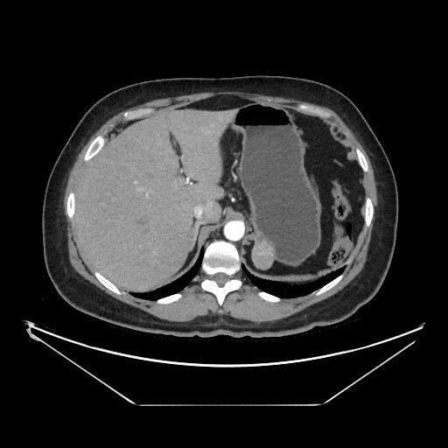 B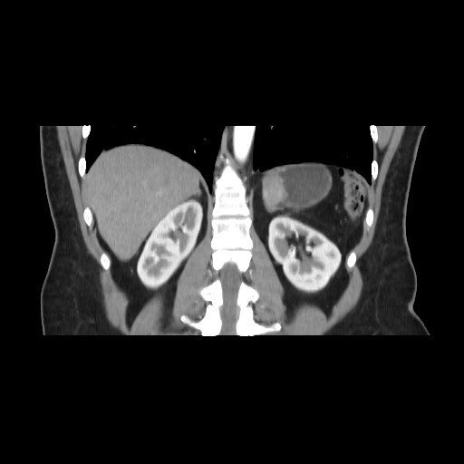
Figure 1 Preoperative abdominal computed tomography scan with intravenous contrast administration: A: Transverse; B: Coronal.

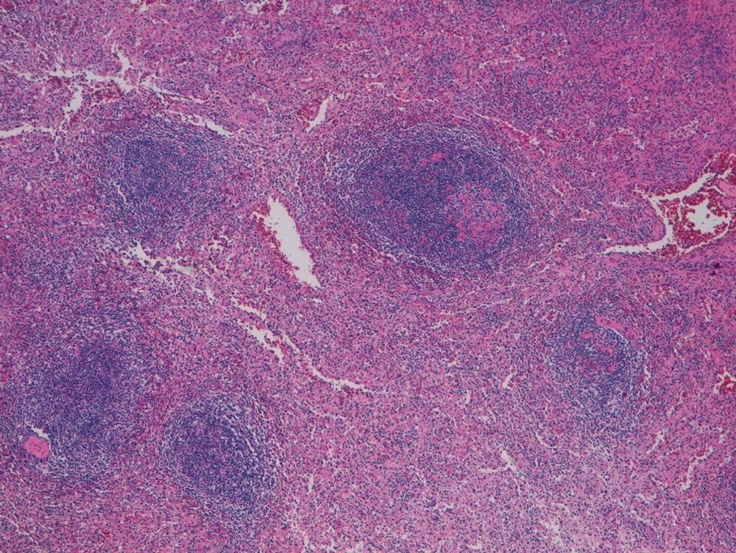
Figure 2 Lymphoid tissue found in the gastric nodule (hematoxylin and eosin staining, ×4).

Table 1 Characteristics of intramural gastric masses
 | Location in the stomach | CT special features | Special features
Benign lesions
Lipoma^{[19]} | Antrum | Attenuation values -70 HU to -120 HU | Solitary, fibrous capsulated, soft (change in size and shape with peristalsis), no vessels
Leiomyoma^{[24]} | Cardia | Low attenuation, endoluminal growth pattern | Negative for c-kit, positive for desmin and smooth muscle actin
Schwannoma^{[21]} | Body | Minimal enhancement on the arterial phase | Absence of calcification, hemorrhage, necrosis; not encapsulated; positive for S-100
Glomus tumor^{[20]} | Antrum | Strong enhancement on early-phase | Highly vascular; positive for calponin and smooth muscle actin
Inflammatory fibroid polyp^{[22]} | Antrum | Enhancement on arterial phase | Positive for CD34 and vimentin
Hemangioma^{[25]} | - | Strong enhancement on early-phase | Phleboliths are pathognomonic
Plexiform fibromyxoma^{[23]} | Antrum | Myxoid tissue interspersed with vessels | Unique to the stomach, size from 2 cm to 15 cm
Ectopic pancreas^{[26]} | Greater curvature | Similar to normal pancreas | -
Splenosis^{[5]} | - | Enhancement on arterial phase | Splenectomized patients
Malignant lesions
GIST^{[18]} | Body | Smoothly circumscribed, bullseye sign | Positive for c-kit or dog-1; 50% greater than 2 cm
Non-GIST sarcoma (liposarcoma, leiomyosarcoma, unclassified sarcoma)^{[27]} | - | Usually large, heterogeneous enhancement | Positive for desmin and smooth muscle actin, negative for c-kit
Lymphoma^{[33]} | - | Wall thickening | Distant (more than close) and large adenopathy
Carcinoid^{[29]} | - | Multiple small lesions | Reactive to synaptophysin and chromogranin A, hypergastrinemia related symptoms
Inflammatory myofibroblastic tumor^{[28]} | - | Heterogeneously enhancing tumor (malignant appearance) | Borderline tumor, more frequent in young adults and children; reactivity for ALK
Metastasis^{[30-32]} | - | - | “Homomorphic” endoscopic features; dyschromic lesions
CT: Computed tomography; GIST: Gastrointestinal stromal tumor; ALK: Anaplastic lymphoma kinase.

