Name of Journal: World Journal of Clinical Cases
Manuscript NO: 75818
Manuscript Type: CASE REPORT

Primary squamous cell carcinoma of the liver: A case report

Kang LM et al. Primary squamous cell carcinoma of the liver

Li-Min Kang, Di-Ping Yu, Yong Zheng, Ya-Hao Zhou

Li-Min Kang, Yong Zheng, Ya-Hao Zhou, Department of Hepatobiliary and Pancreatic Surgery, Puer People's Hospital, Puer 665000, Yunnan Province, China

Di-Ping Yu, Department of Pathology, Puer People's Hospital, Puer 665000, Yunnan Province, China

Author contributions: Kang LM, Zheng Y and Zhou YH collected the clinical data; and Kang LM and Yu DP analyzed the data and wrote the paper.

Corresponding author: Li-Min Kang, MD, PhD, Attending Doctor, Department of Hepatobiliary and Pancreatic Surgery, Puer People's Hospital, No. 44 Zhenxing Street, Puer 665000, Yunnan Province, China. kanglimin2010@163.com

Received: February 16, 2022
Revised: March 18, 2022
Accepted: April 22, 2022
Published online: July 6, 2022

Abstract
BACKGROUND
Squamous cell carcinoma (SCC) of the liver is rare, and is more commonly found in the skin, rectum, cervical or inguinal lymph nodes.

CASE SUMMARY
A 73-year-old man had been experiencing right upper quadrant discomfort for some weeks. He had a 50-year history of smoking and drinking. On average, he smoked 20 cigarettes and consumed 200 galcoholdaily. He didn’t have a history of hepatitis or surgery. Fever, vomiting, jaundice, dysuria, chills, and abdominal distention were not observed at the time of admission. Tenderness in the right upper quadrant was found on physical examination, but there was no palpable abdominal mass. No obvious abnormalities in laboratory tests and tumor markers were found. The plasma retention rate of indocyanine green (ICG) at 15 min was 1.35%. Subsequent abdominal ultrasonography showed a mixed echoic mass approximately 3.8 cm diameter in the left caudate lobe of the liver. Abdominal computed tomography confirmed a 3.0 cm × 3.5 cm irregular mass with inhomogeneous density and moderate delayed enhancement in the left caudate lobe of the liver. Laparoscopic left caudate lobectomy was performed to remove the liver mass. Intra-operative findings confirmed a non-cirrhotic liver, with a 3 cm × 3.5 cm white tumor mass in the left caudate lobe with no tumor rupture and no hemoperitoneum. The resection margin was 1.0 cm in width.

CONCLUSION
We describe the first case of SCC in the left caudate lobe of the liver, which was successfully treated by surgical resection and postoperative immunotherapy. No tumor recurrence was observed during the 8-mo follow-up.

Key Words: Squamous cell carcinoma; Liver; Left caudate lobe; Immunotherapy; Case report

©The Author(s) 2022. Published by Baishideng Publishing Group Inc. All rights reserved.

Citation: Kang LM, Yu DP, Zheng Y, Zhou YH. Primary squamous cell carcinoma of the liver: A case report. World J Clin Cases 2022; 10(19): 6744-6749
URL: https://www.wjgnet.com/2307-8960/full/v10/i19/6744.htm
DOI: https://dx.doi.org/10.12998/wjcc.v10.i19.6744

Core Tip: Primary squamous cell carcinoma (SCC) of the liver is very rare. Here we report the first case of SCC of the left caudate liver lobe successfully treated by laparoscopic hepatectomy. The patient refused to undergo systemic chemotherapy, and received immunotherapy, and the disease-free survival was 8 mo. However, there is no available literature on the effectiveness of immunotherapy in this disease, and this requires further study.
INTRODUCTION
Squamous cell carcinoma (SCC) of the liver is rare, and is more commonly found in the skin, rectum, cervical or inguinal lymph nodes. It accounts for 4%-5% of cancers with unclear primary locations^{[1]}. However, there have been a total of 31 similar occurrences described in the literature^{[2]}. Hepatic teratoma, hepatic cyst, and hepatolithiasis have all been linked to primary SCC of the liver. Poorly differentiated SCC of the liver can be completely cured with systemic chemotherapy and surgery, and it also responds to hepatic arterial injections of low-dose chemotherapeutic agents^{[3,4]}. We present the first case of primary SCC in the left caudate liver lobe which was successfully resected with an 8 mo disease-free survival. To our knowledge, 31 cases of primary SCC of the liver have been reported. Here, we here describe a case of left liver caudate lobe SCC which was treated successfully by surgical resection, with a disease-free survival of 8 mo.

CASE PRESENTATION
Chief complaints
Before his admission in June 2021, the 73-year-old man had been experiencing right upper quadrant discomfort for some weeks.

History of present illness
The patient’s symptoms started some weeks ago with recurrent right upper quadrant discomfort. There was no obvious aggravation of symptoms.

History of past illness
The patient had a 50-year history of smoking and drinking. On average, he smoked 20 cigarettes and consumed 200 g alcohol daily. He didn’t have a history of hepatitis or surgery.

Physical examination
No fever, vomiting, jaundice, dysuria, chills, or abdominal distention were observed at the time of admission. Tenderness in the right upper quadrant was found on physical examination, but no palpable abdominal mass was identified.

Laboratory examinations
Laboratory test results were as follows: hemoglobin 12.8 g/dL; white blood cell count 12100/mm³; platelet count 21000/μL; prothrombin time 10.7/11.2 s; international normalized ratio 1.43; albumin 3.7 g/dL; direct bilirubin 0.32 mg/dL; complete bilirubin 0.57 mg/dL; aspartate aminotransferase 24 IU/L; alanine aminotransferase 3 IU/L; alkaline phosphatase 113 U/L; blood urea nitrogen 12mg/dL; creatinine 1.1 mg/dL; sodium 136 meq/L; potassium 3.8 meq/L. The serum level of carcinoembryonic antigen (CEA) was < 5 ng/mL, alpha-fetoprotein was < 10 ng/mL, and carbohydrate antigen 19-9 was < 34 U/mL, which had previously been 2.05 ng/mL, < 3 ng/mL, and 4.78 U/mL, respectively. Urine analysis was normal. Electrocardiogram, chest x-ray and arterial blood gas was also normal.

Imaging examinations
Subsequent abdominal ultrasonography showed a mixed echoic mass approximately 3.8 cm diameter in the left caudate lobe of the liver. Abdominal computed tomography (CT) confirmed an irregular mass 3.0 cm × 3.5 cm in size with inhomogeneous density and moderate delayed enhancement in the left caudate liver lobe (Figure 1). The patient was unable to undergo magnetic resonance examination as he had difficulty holding his breath.

FINAL DIAGNOSIS
According to the postoperative pathological results, the final diagnosis in this patient was primary SCC of the liver.

TREATMENT
In June 2021, the patient underwent laparoscopic left caudate lobectomy to remove the liver mass. Intra-operative findings confirmed a non-cirrhotic liver with a 3 cm × 3.5 cm white tumor mass with no tumor rupture and no hemoperitoneum. The resection margin was 1.0 cm in width (Figure 2).

OUTCOME AND FOLLOW-UP
Histopathological examination confirmed a moderately differentiated SCC of the liver composed of non-keratinized squamous cells (Figure 3A). SCC of the liver had the pathological characteristics of different sized cancer cells, nest-like in appearance, intercellular bridges, large and deep staining nuclei, a mitotic phase, abundant cytoplasm, dichroism, incomplete keratosis of cancer cells, the formation of keratotic beads, and no adenoid carcinoma tissue. According to previous research, immunohistochemistry is often positive for cytokeratin (CK) 10, CK14, CK19 and CEA^{[5]}.We used the immunohistochemical Envision two-step method for further examination of liver samples. Immunohistochemistry revealed positivity for CK5/6 (mouse anti-human monoclonal antibody, Fuzhou Maixin Biotech., Co., Ltd), P40 (rabbit anti-human monoclonal antibody, Fuzhou Maixin Biotech., Co., Ltd) (Figure 3B and C), and occasional positivity for Ki-67 (90%) (mouse anti-human monoclonal antibody, Fuzhou Maixin Biotech., Co., Ltd). However negativity for thyroid transcription CD34, Arg-1, CPS1, and Syn indicated a SCC of the liver. Subsequent gastroscopy showed that the esophagus and stomach were normal. The results of postoperative pathological examination showed a primary hepatic SCC. We doubted that this tumor was a metastatic tumor from the skin, nasopharynx, lung or gastrointestinal tract, and the patient underwent further physical examination, CT of the brain, nasopharynx and chest, in addition to gastroscopy and enteroscopy. These tests were negative. Limited by hospital conditions, we were unable to perform a positron emission tomography-CT examination. The patient refused systemic chemotherapy, and was treated witha 3 wk regimen of immunotherapy consisting of 200 mg xindilimab (Daboshu) injections [Xinda Biopharmaceutical (Suzhou) Co., Ltd.]. His postoperative course was uneventful and no tumor recurrence or distant metastasis developed during the 8mo follow-up period (Figure 4).

DISCUSSION
Primary SCC of the liver is very rare. It has been stated that primary SCC of the liver is caused by chronic inflammation of bile duct epithelium or the formation of a hepatic cyst with subsequent malignant transformation^{[6-8]}; however, the underlying mechanism is still unclear.
Here, we report the first case of SCC in the left caudate lobe of the liver, with a solitary solid tumor without parasitic infection, which was successfully treated by laparoscopic hepatectomy. Pathological examination of the tumor showed moderately differentiated SCC composed of squamous cells without keratinization. Positive staining of acidic CK5/6 indicated basal cells of non-keratinized squamous epithelium and the beginning of cancer cells. Strong positivity of P40 suggested possible lung cancer; however, chest CT examinations were negative. Clinically, panendoscopy, chest CT, and ENT examination revealed negative results in this case. Taken together, these findings indicated primary SCC of the liver.
The prognosis of primary SCC of the liver is dismal with a survival of less than one year, as the tumor is typically recognized late^{[9]}. Complete remission of poorly differentiated SCC after systemic chemotherapy (cisplatin and 5-fluorouracil) and surgery has been reported^{[10,11]}. If tumor recurrence is found in the late stage, reoperation, systemic chemotherapy or hepatic artery infusion chemotherapy are considered treatment options^{[4]}.However, in the present case, as the patient refused systemic chemotherapy, he received immunotherapy, and the disease-free survival was 8 mo. However, there is no available literature on the effectiveness of immunotherapy for this disease, and this requires further study.

CONCLUSION
We describe the first case of SCC in the left caudate lobe of the liver, which was successfully managed by surgical resection. The patient was also treated with continuous postoperative immunotherapy and disease-free survival was 8 mo. Further research on the treatment and prognosis of primary SCC of the liver is required.

REFERENCES
1 Nosaka T, Ohtani M, Namikawa S, Takahashi K, Naito T, Ofuji K, Matsuda H, Hiramatsu K, Imamura Y, Nakamoto Y. Advanced primary adenosquamous carcinoma of the liver with a small cell carcinoma component: an autopsy case report. Clin J Gastroenterol 2021; 14: 1496-1502 [PMID: 34216375 DOI: 10.1007/s12328-021-01474-8]
2 Zhao R, Zhu K, Wang R, Gao J, Cui K, Yu F, Zhang B, Li S. Primary squamous cell carcinoma of the liver: A case report and review of the literature. Oncol Lett 2012; 4: 1163-1166 [PMID: 23197996 DOI: 10.3892/ol.2012.894]
3 Weimann A, Klempnauer J, Gebel M, Maschek H, Bartels M, Ringe B, Pichlmayr R. Squamous cell carcinoma of the liver originating from a solitary non-parasitic cyst case report and review of the literature. HPB Surg 1996; 10: 45-49 [PMID: 9187552 DOI: 10.1155/1996/97680]
4 Zhang XF, Du ZQ, Liu XM, Lv Y. Primary Squamous Cell Carcinoma of Liver: Case Series and Review of Literatures. Medicine (Baltimore) 2015; 94: e868 [PMID: 26181570 DOI: 10.1097/MD.0000000000000868]
5 Lee HL, Liu YY, Yeh CN, Chiang KC, Chen TC, Jan YY. Primary squamous cell carcinoma of the liver: a successful surgically treated case. World J Gastroenterol 2006; 12: 5419-5421 [PMID: 16981283 DOI: 10.3748/wjg.v12.i33.5419]
6 Xiao J, Ma L, Li J, Yin B, Liang J, Wang J. Primary Squamous Cell Carcinoma of the Liver is Rare but Hostile: Case Series and Comprehensive Review of the Literature. Cancer Manag Res 2021; 13: 829-837 [PMID: 33542657 DOI: 10.2147/CMAR.S290523]
7 Sun Y, Jin G. Primary squamous cell carcinoma of the liver: a case report. J Int Med Res 2021; 49: 3000605211021275 [PMID: 34139871 DOI: 10.1177/03000605211021275]
8 Yagi H, Ueda M, Kawachi S, Tanabe M, Aiura K, Wakabayashi G, Shimazu M, Sakamoto M, Kitajima M. Squamous cell carcinoma of the liver originating from non-parasitic cysts after a 15 year follow-up. Eur J Gastroenterol Hepatol 2004; 16: 1051-1056 [PMID: 15371931 DOI: 10.1097/00042737-200410000-00016]
9 Wei D, Lu L, Ying C, Qingsong K, Dongbo L, Feibo L. Primary hepatic adenosquamous carcinoma: A rare case report. Indian J Pathol Microbiol 2021; 64: S140-S142 [PMID: 34135156 DOI: 10.4103/IJPM.IJPM_785_18]
10 Yoo TK, Kim BI, Han EN, Kim DH, Yoo JH, Lee SJ, Cho YK, Kim HJ. Primary squamous cell carcinoma of the liver: a case report. Clin Mol Hepatol 2016; 22: 177-182 [PMID: 27044770 DOI: 10.3350/cmh.2016.22.1.177]
11 Zhu KL, Li DY, Jiang CB. Primary squamous cell carcinoma of the liver associated with hepatolithiasis: a case report. World J Gastroenterol 2012; 18: 5830-5832 [PMID: 23155329 DOI: 10.3748/wjg.v18.i40.5830]

Footnotes
Informed consent statement: Informed written consent was obtained from the patient for publication of this report and any accompanying images.

Conflict-of-interest statement: The authors declare that they have no conflict of interest.

CARE Checklist (2016) statement: The authors have read the CARE Checklist (2016), and the manuscript was prepared and revised according to the CARE Checklist (2016).

Open-Access: This article is an open-access article that was selected by an in-house editor and fully peer-reviewed by external reviewers. It is distributed in accordance with the Creative Commons Attribution NonCommercial (CC BY-NC 4.0) license, which permits others to distribute, remix, adapt, build upon this work non-commercially, and license their derivative works on different terms, provided the original work is properly cited and the use is non-commercial. See: https://creativecommons.org/Licenses/by-nc/4.0/

Provenance and peer review: Unsolicited article; Externally peer reviewed.
Peer-review model: Single blind

Peer-review started: February 16, 2022
First decision: March 10, 2022
Article in press: April 22, 2022

Specialty type: Gastroenterology and hepatology
Country/Territory of origin: China
Peer-review report’s scientific quality classification
Grade A (Excellent): 0
Grade B (Very good): 0
Grade C (Good): 0
Grade D (Fair): D, D
Grade E (Poor): 0

P-Reviewer: Chudek JT, Poland; Limaiem F, Tunisia S-Editor: Ma YJ L-Editor: A P-Editor: Ma YJ
Figure Legends
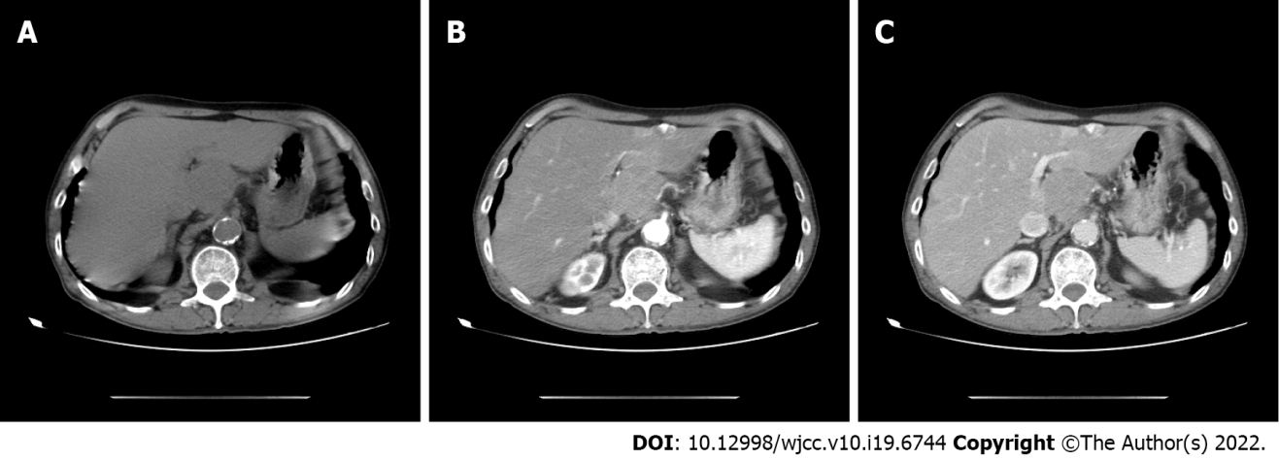
Figure 1 Abdominal computed tomography shows a 3.0 cm x 3.5 cm irregular tumor, with uneven density, and mild enhancement in the arterial phase in the left caudate lobe. A: Preoperative computed tomography (CT) plain scan period; B: Preoperative CT arterial phase; C: Preoperative CT venous phase.
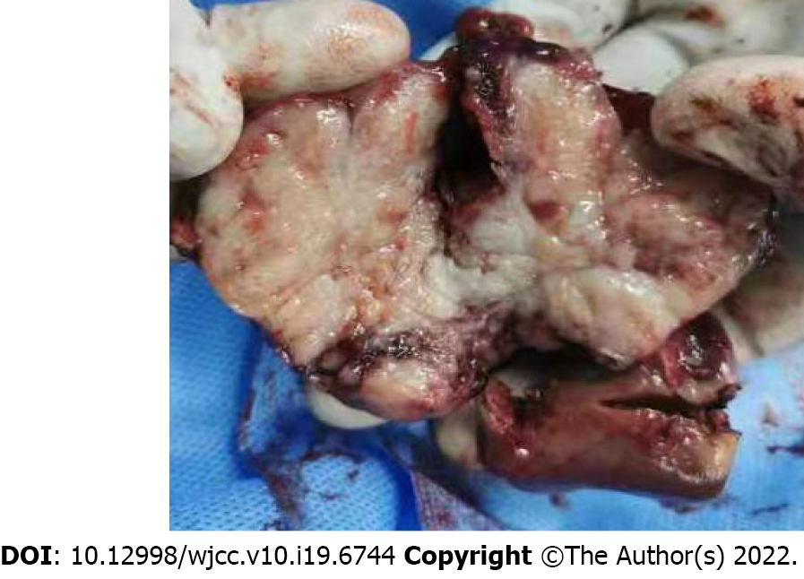
Figure 2 Gross features of the hepatic tumor.
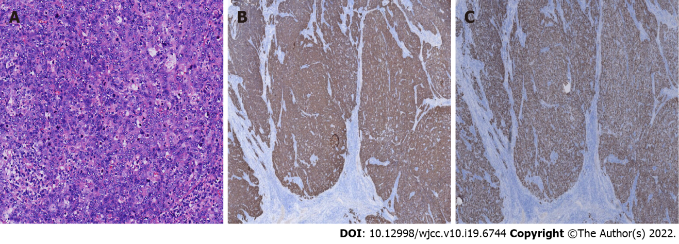
Figure 3 Pathologic characteristicsof the resected liver tumor. A: The tumor was composed of non-keratinized squamous cells with some keratinization (HE x 200); B: Immunohistochemical findings (IHC x 200); C: Squamous cells expressing strong positive P40 staining (IHC x 200).
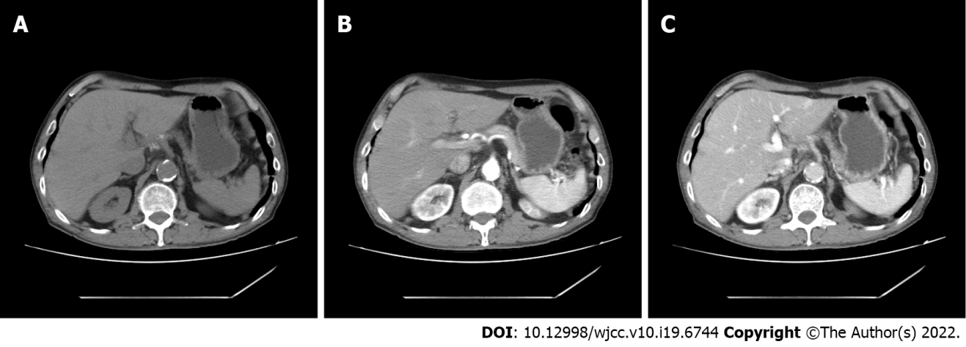
Figure 4 computed tomography showed no tumor recurrence or metastasis at the resection site. A: Postoperative computed tomography (CT) plain scan period; B: Postoperative CT arterial phase; C: Postoperative CT venous phase.

Published by Baishideng Publishing Group Inc
7041 Koll Center Parkway, Suite 160, Pleasanton, CA 94566, USA
Telephone: +1-925-3991568
E-mail: bpgoffice@wjgnet.com
Help Desk: https://www.f6publishing.com/helpdesk
https://www.wjgnet.com

© 2022 Baishideng Publishing Group Inc. All rights reserved.

