Name of Journal: World Journal of Hepatology
Manuscript NO: 80909
Manuscript Type: LETTER TO THE EDITOR

Prognostic role of ring finger and WD repeat domain 3 and immune cell infiltration in hepatocellular carcinoma

Miao YD et al. RFWD3 in HCC

Yan-Dong Miao, Wu-Xia Quan, Jiang-Tao Wang, Jian Gan, Xin Dong, Fang Zhang

Yan-Dong Miao, Fang Zhang, Cancer Center, Yantai Affiliated Hospital of Binzhou Medical University, Yantai 264000, Shandong Province, China

Wu-Xia Quan, Department of Electrocardiogram, Yantai Affiliated Hospital of Binzhou Medical University, Yantai 264100, Shandong Province, China

Jiang-Tao Wang, Department of Thyroid and Breast Surgery, Yantai Affiliated Hospital of Binzhou Medical University, Yantai 264000, Shandong Province, China

Jian Gan, Department of Gastroenterology, Yantai Affiliated Hospital of Binzhou Medical University, Yantai 264000, Shandong Province, China

Xin Dong, Second Department of Oncology, Yantai Affiliated Hospital of Binzhou Medical University, Yantai 264000, Shandong Province, China

Author contributions: Miao YD and Zhang F designed the research; Miao YD wrote the paper; Quan WX and Wang JT performed the data analysis, Gan J and Dong X prepared the tables and figures; Zhang F and Miao YD reviewed the manuscript; Miao YD and Quan WX contributed equally to the article; All authors approved the final manuscript.

Corresponding author: Fang Zhang, MD, Chief Doctor, Professor, Cancer Center, Yantai Affiliated Hospital of Binzhou Medical University, No. 717 Jinbu Street, Muping District, Yantai 264000, Shandong Province, China. zhangfang820127@163.com

Received: October 17, 2022
Revised: October 29, 2022
Accepted: December 23, 2022
Published online: January 27, 2023

Abstract
We have found that the expression of ring finger and WD repeat domain 3 (RFWD3) is significantly higher in unpaired and paired hepatocellular carcinoma (HCC) tissues than in normal tissues. Moreover, this expression has a significant correlation with the infiltration level of 14 immune cell types and when the detected RFWD3 expression levels were grouped as high and low, a prominent difference was revealed for overall survival, disease-specific survival, and progression-free interval. Through statistical analysis (univariate Cox), we were also able to identify RFWD3 as an independent prognostic element for HCC, with RFWD3 having an ability to accurately predict HCC prognosis (area under the curve of 0.863). Finally, we have generated prognostic nomograms for probabilities of 1-, 3- and 5-year overall survival in HCC via integrating the factors of age, pathologic stage, alpha-fetoprotein level, and RFWD3 expression.

Key Words: Hepatocellular carcinoma; Ring finger and WD repeat domain 3; Immune cell infiltration; Bioinformatics

©The Author(s) 2023. Published by Baishideng Publishing Group Inc. All rights reserved.

Citation: Miao YD, Quan WX, Wang JT, Gan J, Dong X, Zhang F. Prognostic role of ring finger and WD repeat domain 3 and immune cell infiltration in hepatocellular carcinoma. World J Hepatol 2023; 15(1): 116-122
URL: https://www.wjgnet.com/1948-5182/full/v15/i1/116.htm
DOI: https://dx.doi.org/10.4254/wjh.v15.i1.116

Core Tip: We have discovered that ring finger and WD repeat domain 3 (RFWD3) expression is remarkably higher in tumor tissues compared to corresponding non-tumor tissues, regardless of hepatocellular carcinoma (HCC) tissue type (unpaired or paired). The RFWD3 expression also showed a significant correlation with the infiltration level of 14 immune cell types and was identified as an independent prognostic element in HCC by univariate Cox regression analysis. Our collective findings suggest that RFWD3 has the ability to accurately predict prognosis of HCC.

TO THE EDITOR
We perused the recently published paper by Liang et al^{[1]} with much interest. The authors reported on their assessments of ring finger and WD repeat domain 3 (RFWD3) expression levels in hepatocellular carcinoma (HCC) patients. Their findings included RFWD3 effects on HCC prognosis, the processes of proliferation, invasion and metastasis, and the underlying mechanisms, specifically regulation via the Wnt/β-catenin signaling pathway. We have a particular appreciation for these authors' novel investigation into the prognostic implication of RFWD3 in HCC as we have also discovered that the expression of RFWD3 is prominently higher in both unpaired and paired HCC tissues from HCC patients than in their corresponding normal tissues (Figure 1A and B).
According to the current literature, cancer cells, endothelial cells, stromal cells, immune cells, and cancer-associated fibroblasts cells all exist in the tumor microenvironment (TME)^{[3,4]}. While the TME is known to play crucial roles in development, invasion and metastasis of HCC, the immune escape of HCC cells has yet to be fully understood and continues to complicate cancer treatment^{[5]}. Due to the ongoing and well-known limitations of chemotherapy in general, immunotherapies are a hot topic of bench and clinical research. This newly emerging cancer therapy exploits immune cells both inside and outside the TME to target and attack cancer cells; its demonstrated advantages are high specificity and low side-effects^{[6]}. The power of this therapeutic method’s potential lies in the fact that different types of immune-related cells serve diverse roles; for HCC, the research into defining and developing those immune cells that inhibit/promote tumor processes has a long way to go^{[7]}.
Upon reading the report that Liang et al^{[1]} found RFWD3 is able to affect the prognosis of HCC, we tested a hypothesis that the expression of RFWD3 may be associated with immune cell infiltration in HCC. Detailed information is shown in Table 1. Following our initial positive data, we systematically explored the correlation between RFWD3 expression and infiltration level of 24 immune cell types, using a single-sample gene set analysis (also known as ssGSEA) algorithm and Spearman coefficient correlation analysis^{[8]}. We found that RFWD3 expression has a remarkable correlation with the infiltration level of 14 immune cell types (Figure 2A). Among them, RFWD3 expression was positively associated with the infiltration level of T helper (Th) cells in general, Th2 cells in particular, T follicular helper (TFH) cells, T central memory (Tcm) cells, activated dendritic cells (DCs), natural killer (NK) CD56^{bright} cells, and eosinophils ( all P < 0.05; Figure 2B-H). There were negative associations with cytotoxic cells, DCs, plasmacytoid DCs (pDCs), neutrophils, T gamma delta (Tgd) cells, T regulatory cells (Tregs), and Th17 cells (all P < 0.05; Figure 2I-O). We hope our findings will encourage further investigations into RFWD3 as an HCC immunotherapy. Detailed information on this aspect is presented in Table 2.
Importantly, we agree with the finding of Liang et al^{[1]} that indicates higher RFWD3 expression is related to worse overall survival (OS) in HCC. We have found that OS, disease-free survival, and progression-free interval were prominently shorter in HCC patient tissues with high RFWD3 expression than in those with low RFWD3 expression (all P < 0.05; Figure 3A-C). Our further statistical analysis via univariate Cox regression identified RFWD3 as an independent prognostic element for HCC (Table 3). Generation of the receiver operating characteristic curve showed that RFWD3 has the ability to accurately predict prognosis in HCC (area under the curve of 0.863). Finally, we generated prognostic nomograms for probabilities of 1-, 3- and 5-year OS in HCC via integrating the factors of age, pathologic stage, alpha-fetoprotein level, and RFWD3 expression; each element was assigned a score according to its contribution to survival (Figure 3E).
Ultimately, our new findings highlight that the research of Liang et al^{[1]} is worthy of attention and that subsequent efforts to build upon it, such as our related discoveries, may promote the next generation of effective and safe therapeutics, such as immunotherapies.

Statistical analysis
R statistical software (version 4.1.2; R Foundation for Statistical Computing, Vienna, Austria; https://www.R-project.org/) was used for all statistical analyses. Wilcoxon rank-sum test was used to perform the differential expression analysis of RFWD3 between HCC samples and corresponding normal samples, with results demonstrated by the “ggplot2” R package^{[10]}. Survival analysis was carried out by log-rank test and univariate Cox regression. The association between RFWD3 expression and immune cell infiltration were performed by Spearman and Pearson analysis. Positive values of correlation coefficient indicate positive correlation, negative values indicate negative correlation.

REFERENCES
1 Liang RP, Zhang XX, Zhao J, Lu QW, Zhu RT, Wang WJ, Li J, Bo K, Zhang CX, Sun YL. RING finger and WD repeat domain 3 regulates proliferation and metastasis through the Wnt/β-catenin signalling pathways in hepatocellular carcinoma. World J Gastroenterol 2022; 28: 3435-3454 [PMID: 36158256 DOI: 10.3748/wjg.v28.i27.3435]
2 Vivian J, Rao AA, Nothaft FA, Ketchum C, Armstrong J, Novak A, Pfeil J, Narkizian J, Deran AD, Musselman-Brown A, Schmidt H, Amstutz P, Craft B, Goldman M, Rosenbloom K, Cline M, O'Connor B, Hanna M, Birger C, Kent WJ, Patterson DA, Joseph AD, Zhu J, Zaranek S, Getz G, Haussler D, Paten B. Toil enables reproducible, open source, big biomedical data analyses. Nat Biotechnol 2017; 35: 314-316 [PMID: 28398314 DOI: 10.1038/nbt.3772]
3 Hanahan D. Hallmarks of Cancer: New Dimensions. Cancer Discov 2022; 12: 31-46 [PMID: 35022204 DOI: 10.1158/2159-8290.CD-21-1059]
4 Hanahan D, Weinberg RA. Hallmarks of cancer: the next generation. Cell 2011; 144: 646-674 [PMID: 21376230 DOI: 10.1016/j.cell.2011.02.013]
5 Wu Q, Zhou L, Lv D, Zhu X, Tang H. Exosome-mediated communication in the tumor microenvironment contributes to hepatocellular carcinoma development and progression. J Hematol Oncol 2019; 12: 53 [PMID: 31142326 DOI: 10.1186/s13045-019-0739-0]
6 Yost KE, Satpathy AT, Wells DK, Qi Y, Wang C, Kageyama R, McNamara KL, Granja JM, Sarin KY, Brown RA, Gupta RK, Curtis C, Bucktrout SL, Davis MM, Chang ALS, Chang HY. Clonal replacement of tumor-specific T cells following PD-1 blockade. Nat Med 2019; 25: 1251-1259 [PMID: 31359002 DOI: 10.1038/s41591-019-0522-3]
7 Hao X, Sun G, Zhang Y, Kong X, Rong D, Song J, Tang W, Wang X. Targeting Immune Cells in the Tumor Microenvironment of HCC: New Opportunities and Challenges. Front Cell Dev Biol 2021; 9: 775462 [PMID: 34869376 DOI: 10.3389/fcell.2021.775462]
8 Hänzelmann S, Castelo R, Guinney J. GSVA: gene set variation analysis for microarray and RNA-seq data. BMC Bioinformatics 2013; 14: 7 [PMID: 23323831 DOI: 10.1186/1471-2105-14-7]
9 Miao Y, Wang J, Li Q, Quan W, Wang Y, Li C, Wu J, Mi D. Prognostic value and immunological role of PDCD1 gene in pan-cancer. Int Immunopharmacol 2020; 89: 107080 [PMID: 33069926 DOI: 10.1016/j.intimp.2020.107080]
10 Walter W, Sánchez-Cabo F, Ricote M. GOplot: an R package for visually combining expression data with functional analysis. Bioinformatics 2015; 31: 2912-2914 [PMID: 25964631 DOI: 10.1093/bioinformatics/btv300]

Footnotes
Conflict-of-interest statement: All the authors report having no relevant conflicts of interest for this article.

Open-Access: This article is an open-access article that was selected by an in-house editor and fully peer-reviewed by external reviewers. It is distributed in accordance with the Creative Commons Attribution NonCommercial (CC BY-NC 4.0) license, which permits others to distribute, remix, adapt, build upon this work non-commercially, and license their derivative works on different terms, provided the original work is properly cited and the use is non-commercial. See: https://creativecommons.org/Licenses/by-nc/4.0/

Provenance and peer review: Unsolicited article; Externally peer reviewed.
Peer-review model: Single blind

Peer-review started: October 17, 2022
First decision: November 15, 2022
Article in press: December 23, 2022

Specialty type: Oncology
Country/Territory of origin: China
Peer-review report’s scientific quality classification
Grade A (Excellent): A
Grade B (Very good): 0
Grade C (Good): 0
Grade D (Fair): D
Grade E (Poor): 0

P-Reviewer: Ding Y, China; Papadopoulos N, Greece S-Editor: Xing YX L-Editor: Filipodia P-Editor: Xing YX

Figure Legends
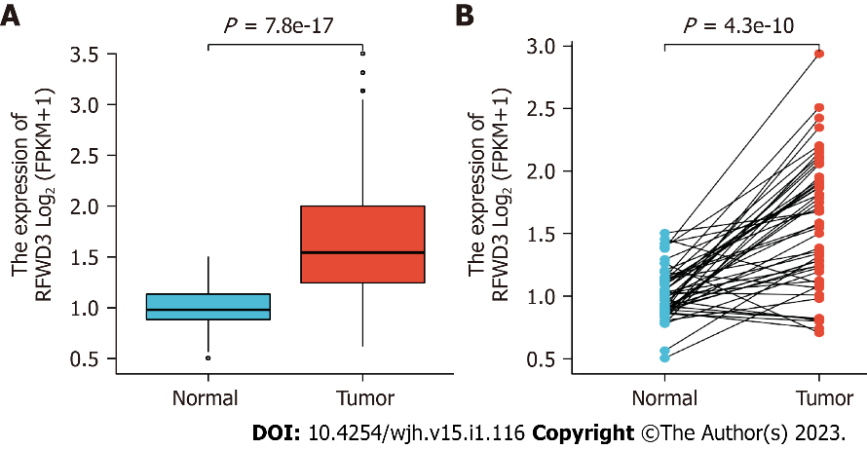
Figure 1 Differential expression levels of ring finger and WD repeat domain 3 in hepatocellular carcinoma and normal tissues. A: Non-paired hepatocellular carcinoma (HCC) and normal samples; B: Paired HCC and normal samples. Data source: mRNA-Seq data from the Genotype-Tissue Expression project (GTEx) of The Cancer Genome Atlas processed through the Toil process in the UCSC Xena database.(https://xenabrowser.net/datapages/)^{[2]}.
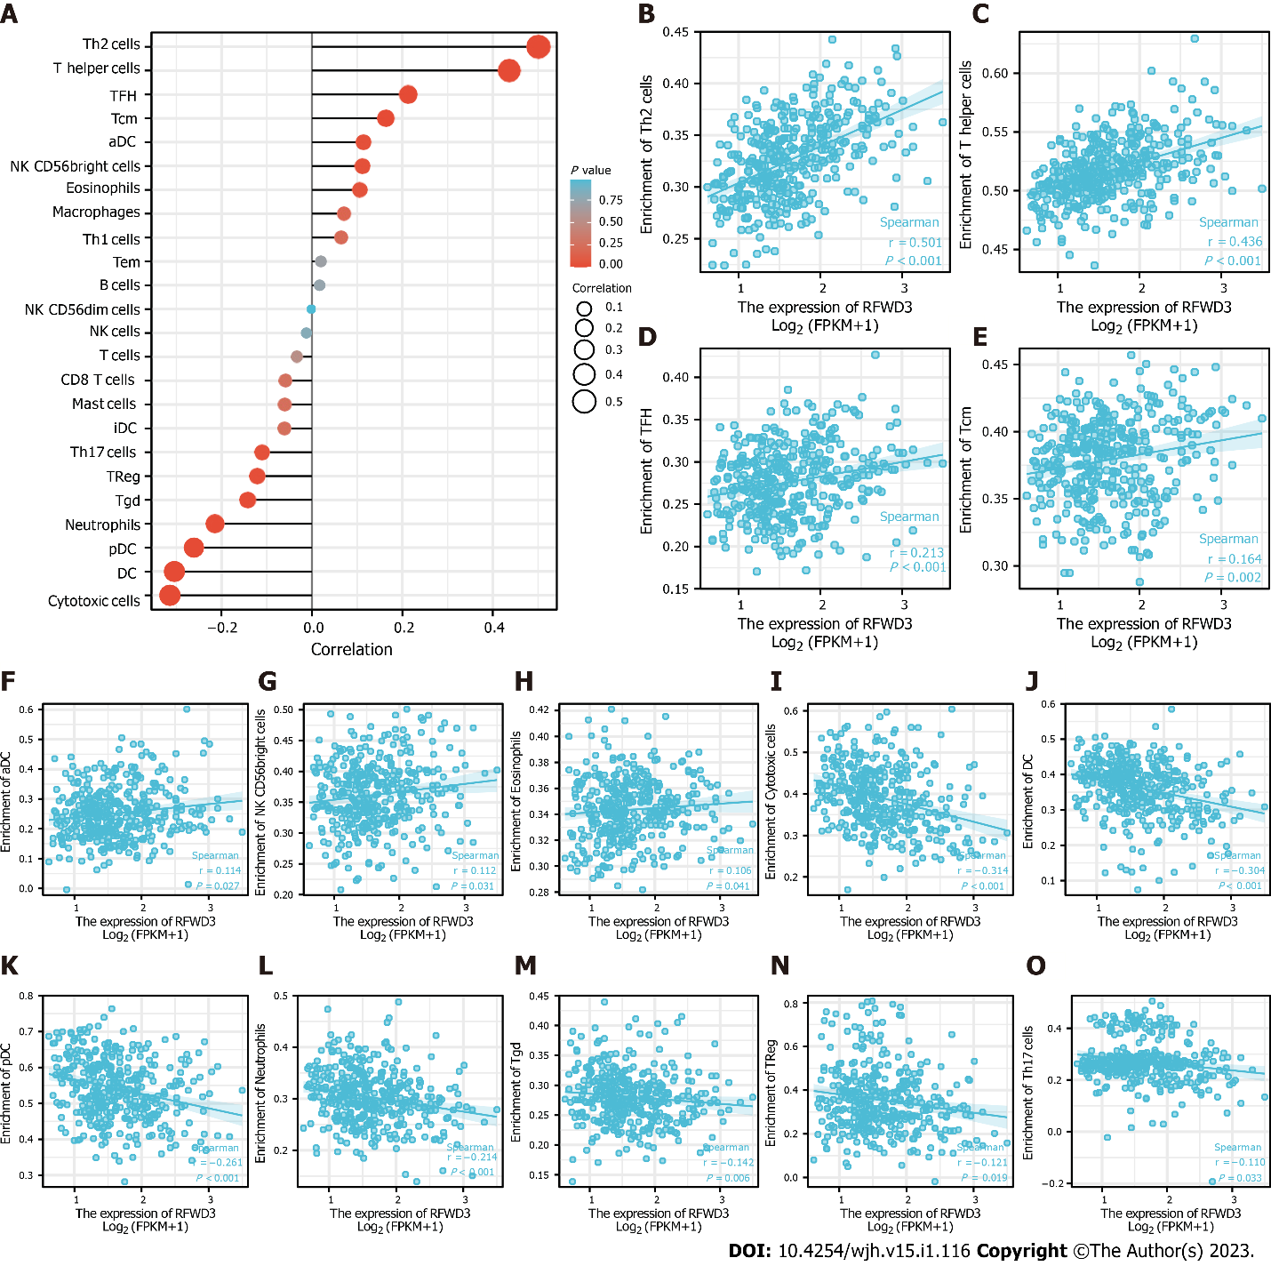
Figure 2 Correlation analysis of ring finger and WD repeat domain 3 expression and immune cell infiltration in hepatocellular carcinoma. A: Lollipop plot manifesting the correlation between ring finger and WD repeat domain 3 (RFWD3) expression and the infiltration level of 24 immune cell types; B-H: The infiltration levels of 7 immune cell types have significant positive correlation with RFWD3 expression; B: T helper (Th)2 cells; C: Th cells; D: T follicular helper (TFH) cells; E: T central memory (Tcm) cells; F: Activated dendritic cells (aDCs); G: Natural killer (NK) CD56^{bright} cells; H: Eosinophils; I-O: The infiltration levels of 7 immune cell types have significant negative correlation with RFWD3 expression; I: Cytotoxic cells; J: Dendritic cells (DCs); K: Plasmacytoid dendritic cells (pDCs); L: Neutrophils; M: T gamma delta (Tgd) cells; N: T regulatory cells (Tregs); O: Th17 cells.

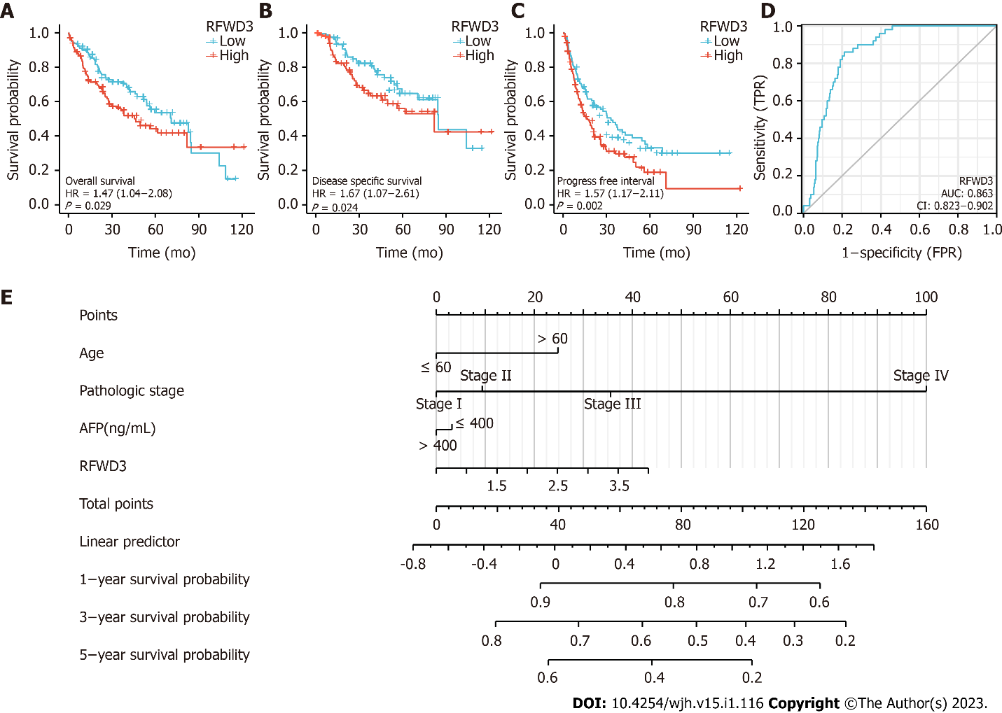
Figure 3 Survival analysis of ring finger and WD repeat domain 3 in hepatocellular carcinoma and the nomogram for prognosis. A-C: Ring finger and WD repeat domain 3 (RFWD3) expression is related to overall survival, disease-specific survival (B) and progression-free interval (C)^{[9]} in the The Cancer Genome Atlas-liver hepatocellular carcinoma (HCC) data; D: Receiver operating characteristic curves for the RFWD3 gene’s prognosis predictive ability. The nomogram can predict 1-, 3- and 5-year overall survival of HCC based on clinicopathological features and the expression of RFWD3.
Table 1 Detailed statistical results of differential expression of ring finger and WD repeat domain 3 in hepatocellular carcinoma and normal tissues
Gene | Group | n | Minimum | Maximum | Median | IQR | Lower quartile | Upper quartile | Mean | SD | SE
RFWD3 | Normal | 50 | 0.504 | 1.504 | 0.98 | 0.251 | 0.883 | 1.133 | 1.013 | 0.208 | 0.029
 | Tumor | 374 | 0.62 | 3.5 | 1.544 | 0.755 | 1.245 | 2 | 1.647 | 0.559 | 0.029
 | Normal | 50 | 0.504 | 1.504 | 0.98 | 0.251 | 0.883 | 1.133 | 1.013 | 0.208 | 0.029
 | Tumor | 50 | 0.707 | 2.939 | 1.577 | 0.716 | 1.204 | 1.92 | 1.578 | 0.521 | 0.074
RFWD3: Ring finger and WD repeat domain 3; IQR: Interquartile range; SD: Standard deviation; SE: Standard error.

Table 2 Detailed information on the statistical correlation between ring finger and WD repeat domain 3 expression and immune cell infiltration
Gene | Immune cell type | Pearson’s correlation coefficient | Pearson’s P value | Spearman’s correlation coefficient | Spearman’s P value
RFWD3 | Th2 cells | 0.499 | < 0.001 | 0.501 | < 0.001
 | Th cells | 0.434 | < 0.001 | 0.436 | < 0.001
 | Cytotoxic cells | -0.304 | < 0.001 | -0.314 | < 0.001
 | DCs | -0.281 | < 0.001 | -0.304 | < 0.001
 | pDCs | -0.261 | < 0.001 | -0.261 | < 0.001
 | Neutrophils | -0.210 | < 0.001 | -0.214 | < 0.001
 | TFH cells | 0.226 | < 0.001 | 0.213 | < 0.001
 | Tcm cells | 0.187 | < 0.001 | 0.164 | 0.002
 | Tgd cells | -0.105 | 0.043 | -0.142 | 0.006
 | Tregs | -0.155 | 0.003 | -0.121 | 0.019
 | aDCs | 0.141 | 0.006 | 0.114 | 0.027
 | NK CD56^{bright} cells | 0.128 | 0.013 | 0.112 | 0.031
 | Th17 cells | -0.170 | < 0.001 | -0.110 | 0.033
 | Eosinophils | 0.077 | 0.135 | 0.106 | 0.041
 | Macrophages | 0.096 | 0.063 | 0.071 | 0.171
 | Th1 cells | 0.090 | 0.081 | 0.064 | 0.214
 | iDCs | -0.034 | 0.507 | -0.061 | 0.241
 | Mast cells | -0.053 | 0.309 | -0.060 | 0.247
 | CD8 T cells | -0.047 | 0.368 | -0.058 | 0.260
 | T cells | -0.013 | 0.796 | -0.033 | 0.522
 | Tem cells | 0.085 | 0.100 | 0.020 | 0.704
 | B cells | 0.033 | 0.525 | 0.017 | 0.744
 | NK cells | 0.035 | 0.494 | -0.012 | 0.810
 | NK CD56^{dim} cells | 0.020 | 0.699 | -0.001 | 0.979
aDCs: Activated dendritic cells; DCs: Dendritic cells; iDCs: Immature dendritic cells; NK: Natural killer; pDCs: Plasmacytoid dendritic cells; RFWD3: Ring finger and WD repeat domain 3; Tcm: T central memory; Tem: T effector memory; TFH: T follicular helper; Tgd: T gamma delta.

Table 3 Univariate Cox regression analysis in hepatocellular carcinoma
Characteristics | Total, n | Univariate analysis
 |  | Hazard ratio (95%CI) | P value
Pathologic stage | 349
I | 173
II | 86 | 1.417 (0.868-2.312) | 0.164
III | 85 | 2.734 (1.792-4.172) | < 0.001
IV | 5 | 5.597 (1.726-18.148) | 0.004
Child-Pugh grade | 240
A | 218
B | 21 | 1.595 (0.757-3.361) | 0.219
C | 1 | 2.138 (0.294-15.544) | 0.453
Fibrosis Ishak score | 214
0 | 75
1/2 | 31 | 0.935 (0.437-2.002) | 0.864
3/4 | 28 | 0.698 (0.288-1.695) | 0.428
5/6 | 80 | 0.737 (0.410-1.325) | 0.308
Histologic grade | 368
G1 | 55
G2 | 178 | 1.162 (0.686-1.969) | 0.576
G3 | 123 | 1.185 (0.683-2.057) | 0.545
G4 | 12 | 1.681 (0.621-4.549) | 0.307
RFWD3 | 373 | 1.557 (1.148-2.110) | 0.004
CI: Confidence interval; RFWD3: Ring finger and WD repeat domain 3.

Published by Baishideng Publishing Group Inc
7041 Koll Center Parkway, Suite 160, Pleasanton, CA 94566, USA
Telephone: +1-925-3991568
E-mail: bpgoffice@wjgnet.com
Help Desk: https://www.f6publishing.com/helpdesk
https://www.wjgnet.com

© 2023 Baishideng Publishing Group Inc. All rights reserved.

