Name of journal: World Journal of Clinical Cases
Manuscript NO: 45773
Manuscript Type: ORIGINAL ARTICLE

Retrospective Study
Analysis of twenty-four patients with Achenbach's syndrome

Ada F et al. Achenbach’s syndrome

Fatih Ada, Ferit Kasimzade

Fatih Ada, Department of Cardiovascular Surgery, Sivas Cumhuriyet University School of Medicine, Sivas 58140, Turkey

Ferit Kasimzade, Department of Cardiovascular Surgery, Turkiye Yuksek Ihtisas Training and Research Hospital, Ankara 06100, Turkey

ORCID number: Fatih Ada (0000-0002-6953-5906); Ferit Kasimzade (0000-0003-3646-3181).

Author contributions: Ada F designed and performed the research and wrote the paper; Kasimzade F provided clinical advice and contributed to the analysis.

Institutional review board statement: This study was reviewed and approved by the Local Ethics Committee of the Sivas Cumhuriyet University.

Informed consent statement: All patients gave informed consent.

Conflict-of-interest statement: The authors declare that they have no conflict-of-interests.

Data sharing statement: No additional data are available.

Open-Access: This article is an open-access article which was selected by an in-house editor and fully peer-reviewed by external reviewers. It is distributed in accordance with the Creative Commons Attribution Non Commercial (CC BY-NC 4.0) license, which permits others to distribute, remix, adapt, build upon this work non-commercially, and license their derivative works on different terms, provided the original work is properly cited and the use is non-commercial. See: http://creativecommons.org/licenses/by-nc/4.0/

Manuscript source: Unsolicited manuscript

Corresponding author: Fatih Ada, PhD, Assistant Professor, Cardiovascular Surgeon, Department of Cardiovascular Surgery, Sivas Cumhuriyet University School of Medicine, Merkez, Sivas 58140, Turkey. drfatihada@gmail.com
Telephone: +90-346-2191010

Received: January 15, 2019
Peer-review started: January 15, 2019
First decision: March 10, 2019
Revised: April 29, 2019
Accepted: May 1, 2019
Article in press: May 1, 2019
Published online: May 26, 2019

Abstract
BACKGROUND
Achenbach’s syndrome is a rare condition and the etiology is unknown. It is most commonly seen in the volar plate of the hand distal interphalangeal joint. Patients diagnosed with Achenbach’s syndrome in cardiovascular surgery clinic were retrospectively compared with the literature.

AIM
To investigate the symptoms, findings, sociodemographic conditions and laboratory data of patients diagnosed with Achenbach’s syndrome.

METHODS
The study is a retrospective review of 24 patients diagnosed with Achenbach’s syndrome at Afyonkarahisar State Hospital between march 2015 and november 2016 and at Sivas Numune Hospital between november 2016 and november 2017 and at Cumhuriyet University Cardiovascular Surgery Department between november 2017 and november 2018. In the study, demographic characteristics of the patients, signs and symptoms of the disease, and laboratory data were analyzed retrospectively.

RESULTS
83.3% of the patients were female and 16.6% were male. The disease was most commonly located in the index finger of the right hand. All of the patients complained of bruising and pain. No pathologic findings were present in the laboratory results. According to these results, it can be concluded that Achenbach syndrome is most commonly seen in the right index finger of middle-aged female patients.

CONCLUSION
Further research is needed to clarify Achenbach’s syndrome, to develop a diagnosis and treatment algorithm. As the awareness of this syndrome increases, large amounts of data will be obtained. According to current knowledge, Achenbach’s syndrome is not among the known causes of mortality or morbidity. However, it is unknown whether it is seen in brain or other vital organs.

Key words: Achenbach’s syndrome; Blue thumb; Digital hematoma; Digital hemorrhage; Hand; Pulse oximeter

© The Author(s) 2019. Published by Baishideng Publishing Group Inc. All rights reserved.

Core tip: The etiology of Achenbach’s syndrome is not clearly known. This disease is often seen on the volar surface of hand fingers. Blue-colored finger and sudden onset pain are the most common symptoms. No morbidity and mortality have been reported in this syndrome. However, there is little awareness of the disease. This study showed that this syndrome is most commonly seen in the index finger of middle-aged female patients. Further studies are needed to explain the Achenbach’s syndrome pathogenesis and to define a diagnostic and therapeutic algorithm.

Citation: Ada F, Kasimzade F. Analysis of 24 patients with Achenbach's syndrome. World J Clin Cases 2019; 7(10): 1103-1110
URL: https://www.wjgnet.com/2307-8960/full/v7/i10/1103.htm
DOI: https://dx.doi.org/10.12998/wjcc.v7.i10.1103

INTRODUCTION
The etiology of Achenbach's syndrome, which is often encountered in the cardiac surgery clinics, yet forgotten during the diagnostic process, is not clearly known. This rare syndrome is frequently neglected in the diagnostic process most probably because the disease does not clearly result in any mortality or morbidity and therefore it is ignored. However, we are convinced that as the studies on this subject increases (such as studies to enlighten if this syndrome is precursor to more serious illnesses or to reveal what happens in the vascular bed), the awareness about the disease will also increase. Achenbach’s syndrome is typically characterized by a digital hematoma and bruising that begins suddenly and painfully in one or several hand fingers, and decreases within hours or days. There are no known risk factors such as trauma, drug use, bleeding disorder, rheumatologic disease associated with the etiology of the syndrome.The disease was named after by German doctor Achenbach as it was first diagnosed by him^{[1]}. We retrospectively analyzed the data of 24 patients with Achenbach's syndrome in our study and compared with the literature.

MATERIALS AND METHODS
The study is a retrospective analysis of 24 patients diagnosed with Achenbach’s syndrome at Afyonkarahisar State Hospital between march 2015-november 2016 and at Sivas Numune Hospital between november 2016-november 2017 and at Sivas Cumhuriyet University Cardiovascular Surgery Department between november 2017-november 2018 with decision of the local ethics committee. Written consent form was obtained from all patients. Patient information was obtained from patient cards and the hospital registry system. The anamnesis of the patients was carefully taken and the physical examinations were made to identify vascular and other pathological diseases. Subsequently, arterial and venous doppler scans of the extremity veins, complete blood counts (to diagnose bleeding disorders), and international normalized ratio (INR), prothrombin time (PT), activated partial thromboplastin time (aPTT) tests were requested. Biochemical parameters were studied. Oxygen saturation was measured at the fingertips of the patients by pulse-oximetry. Patients who did not use anticoagulants or antiaggregants in their history, normal doppler ultrasonographic findings, normal pulse oximeter values, and no laboratory abnormalities were evaluated as Achenbach’s syndrome. Patients were treated with analgesics (if necessary), mucopolysaccharidepolysulphate containing cream or gel, cold applications, and just advised to rest the diseased hand. After 2 wk of treatment, it was observed that the patients did not have any complaints.

RESULTS
In total, 24 patients were studied retrospectively. 83.3% of the patients were female (n = 20) and 16.6% were male (n = 4). The mean age was 47.91 ± 11.72. As a result, it was concluded that this syndrome was seen in middle ages and occurs in females 5 times more than males. None of the patients had received anticoagulation and antiplatelet treatment. The arterial and venous doppler findings showed no pathology. Only 16.6% of the patients were smokers and none of them had a history of alcohol use. The demographic data of the patient are shown in Table 1.
In patients’ laboratory data, the mean number of platelets was 246.95 (PLT × 10³/μL),the mean INR was 1.05, the mean PT was 11.79 min, and the mean aPTT 29.54 min. In none of the patients, the laboratory values were not in the range of values that would explain the table or require further investigation. Unlike other studies, we used a pulse oximeter in the differential diagnosis of arterial ischemia or digital ischemia, and we did not observe oxygenation impairment in the pulse oximetry that would suggest ischemia in any of the patients (Table 2).
When the symptoms and the location of the syndrome are examined, all the patients had pain and bruising in the affected area. The swelling was 54.1% and the paraesthesia was 37.5%. The mean number of episodes was 3.04. When the affected area and finger was considered, the most common regions were right hand (54.1%) and index finger (33.3%) (Table 3). Herein, it can be concluded that the disease is seen at the right hand index fingers of middle-aged females.

DISCUSSION
There are few publications on Achenbach’s syndrome in the literature. However, the only reason for the scarcity of these publications is not the rareness of the disease. Our clinical observations suggest that the disease is more common than generally thought. Although a large proportion of patients referred to cardiac surgery clinics, some of them referred to other departments such as family medicine, dermatology, internal medicine, haematology, rheumatology, plastic surgery and orthopaedics or the patients were directed to these departments from cardiac surgery clinics.
In the absence of a known essential cause, Achenbach’s syndrome is characterized by an acute pain and numbness on the fingers. In addition to these complaints swelling and parasthesia can be observed, as well. In our study, all the patients had complaints of pain and bruising, yet, swelling and paraesthesia were present in some of them. In the literature, two cases were identified in which the locations of the disease were not hand fingers. One of these cases was recurrent subconjunctival hemorrhage in the eye while the other was located in the wrist^{[2,3]}.
Although the etiology of Achenbach’s syndrome is unknown, Singer has hypothesized that in some patients increased capillary resistance and vascular fragility may trigger this disease even in a minimal trauma^{[4]}. It has also been reported that acrocyanosis, gastrointestinal diseases, migraine and biliary diseases may be related to the etiology of the disease^{[5]}. Kämpfen and his colleagues^{[6]} have proposed the etiology of vasospasm through a case in which ergotamine was used due to migraine. It has been suggested that Achenbach's syndrome may be associated with Raynaud’s syndrome and chilblains in the secondary data gathered from Carpentier and friends’ epidemiological study of Raynaud’s syndrome^{[7]}. In the same study, this syndrome was found to be associated with tobacco use, alcohol consumption and estrogen therapy while no relation was observed with body-mass index, education level, marital status, occupation, vibration and trauma. Achenbach’s syndrome is 2-7 times more common in middle-aged women than in men^{[8-10]}. Although the most common location of the disease varies in the sources, it has been observed more frequently in middle and index fingers^{[7]}. Achenbach’s syndrome is generally episodic^{[11,12]}. In our study, the average number of episodes was 3.04, and the most common finger was the index finger (Figure 1 and 2).
Physical examination and anamnesis have a major role in the diagnosis of Achenbach’s syndrome. Laboratory and imaging techniques may be required for differential diagnosis (Table 4). However, in suspected cases, these methods should be used and unnecessary invasive procedures should be avoided^{[6,13]}. Because of the possibility of mistaking the syndrome with many vascular, hematologic, dermatological and rheumatologic diseases, some laboratory and imaging methods might be required (such as complete blood count, coagulation factors, c-reactive protein, blood lipid level and arterial and venous doppler ultrasonography of the concerned extremity)^{[8,11,14]}. In the literature, biopsies were performed for lesions in two cases^{[8,15]}. In one of these cases, the epidermis shows hyperkeratosis, parakeratosis and in the other one, amorphous, eosinophilic amyloid deposition in the stroma and fibrin accumulation were observed. In both cases no pathology was detected in microvascular structures. Capillaroscopy examination was not necessary for diagnosis, but Khaira and his friends performed capillaroscopy in their series including 11 patients and no pathology was detected^{[9]}. Frerix and colleagues showed capillary haemorrhage in one case^{[16]}. Arterial and venous doppler ultrasonography is a good non-invasive choice for evaluating vascular bed^{[17]}. No arterial or venous pathology was found in the doppler ultrasonography in any of the studies performed. On suspicion of arterial micro-embolism invasive imaging methods can be used to investigate the origin of micro-emboli^{[18]}. While in the case reported by Weinberg and colleagues^{[11]}, no pathology was observed in the upper extremity angiography, in the case of Robertson and colleagues, slow flow was observed in the digital arteries^{[19]}. There are studies in which transthoracic echocardiography was used in the diagnosis of arterial embolism, and no cardiogenic embolic source has been found in these studies^{[10,11]}. In our study, oxygen saturation was measured at the diseased fingertip by pulse-oximetry considering the possibility of micro-emboli. No abnormal oxygen saturation, which would suggest ischemia or embolism, was found in any of the patients. Achenbach’s syndrome should be considered in the differential diagnosis of symptoms similar to Raynaud’s syndrome with clinical episodic digital ischemia^{[20]}. The rheumatologic aspect of the syndrome has been further investigated in case reports, but no rheumatologic relationship has been found other than Achenbach’s syndrome associated with rheumatoid arthritis reported by Manappallil et al^{[8,21,22]}.
Nowadays, many patients now refer to hospitals by searching their symptoms from the internet, from written and visual media, and from social media. This situation forces physicians not only to diagnose and treat, but also to help reduce the anxiety caused by incorrect or incomplete information. Patients with Achenbach’s syndrome who refer to the clinics are in urgent expectation thinking that there is a blockage of the blood vessels or a blood clot in the finger. For this reason, the unwarranted concerns of the patients should be eliminated properly. There are many different opinions in the general treatment of the disease. Some of these views suggest that there is no need for treatment because of the benign course of the disease, so that only follow-up is sufficient^{[10,23,24]}. On the other hand, there are publications in which treatment includes sargegrelate hydrochloride, acetylsalicylic acid 81 mg, long-acting diprimadol, heparin, isosorbidedinitrate^{[8,11,19]}. Even if the etiology was unknown, as a bleeding point was definite we did not apply anticoagulant, antiplatelet, vasodilator treatments unless there is another compulsory indication. When necessary, patients were treated with analgesics, or with cream or gel containing mucopolysaccharidepolysulphate; sometimes cold applications were applied or the patient was just advised to rest the diseased hand. After 2 wk of treatment, it was observed that the patients did not have any complaints.
Today we know very little about this syndrome. Further studies on the disease is important for the future because we know that the disease is on the fingers, the palmar surface, the ankle and the eye, but we do not know whether the brain and other vital organs have the same bleeding and hematoma^{[7]}. Due to Achenbach’s syndrome, a probable hemorrhage or hematoma in the brain and other vital organs would be life-threatening, so the disease should be illuminated.
In conclusion, there is no doubt that many new studies will be done as the awareness of Achenbach’s syndrome increases. The etiology and prognosis of the disease is still a mystery. It is worrying not to know whether the syndrome is seen in the brain and vital organs or not. However, it is relieving to know that there is no proven mortality or morbidity of the disease and that the course of the disease is benign.

ArtIcle HIghlIghts
Research background
Achenbach’s syndrome is often characterized by sudden onset of pain and bruising in the fingers of the hand. The etiology and clinical course of this syndrome are not clearly known. In fact, this syndrome is seen commonly in the clinic, but the lack of a known morbidity and mortality led to neglect. In our retrospective study with large population from different centers, detailed data were obtained about the Achenbach’s syndrome.

Research motivation
Achenbach’s syndrome is rarely known but is commonly seen in clinical practice, therefore it should be kept in mind, especially by cardiovascular surgeons. We think that as the awareness of the syndrome increases, it will be revealed that is seen much more than it is thought in the society.

Research objectives
In this study, we aimed to determine the symptoms, laboratory values and clinical characteristics of patients with Achenbach’s syndrome. It was aimed to compare the obtained data with literature.

Research methods
24 patients who were diagnosed with Achenbach’s syndrome in different centers between 2016-2018 were retrospectively evaluated. The sociodemographic data, laboratory values and clinical characteristics of the patients were compared with the literature.

Research results
In this study, patients diagnosed with Achenbach’s syndrome were retrospectively evaluated and 83.3% of the patients were female. This rate was 5 times higher than male patients. There was no pathology in the bleeding profiles of the patients. No pathology was detected in pulse oximetry of bruising finger in any patient. All patient has pain and bruising of their fingers. The most frequently affected side was the upper right extremity and the index finger.

Research conclusions
It was observed that based on obtained datas, it was not characterized by impaired circulation and oxygenation of Achenbach’s syndrome. Therefore, we hypothesized the syndrome was to be a venous disease. Although the most common place of this syndrome is the fingers of the hand, the condition of the brain and other vital organs is unknown. Achenbach’s syndrome needs an algorithm for diagnosis and treatment.

Research perspectives
If patients who have sudden onset bruising finger, Achenbach’s syndrome should be kept in mind. An algorithm should be created in diagnosis and treatment for Achenbach’s syndrome. Other features of the Achenbach’s syndrome should be revealed in a multidisciplinary approach.

REFERENCES
1 Achenbach W. Paroxysmal hematoma of the hand. Medizinische 1958; 52: 2138-2140 [PMID: 13622116]
2 Young B, Okera S. Recurrent subconjunctival haemorrhage in Achenbach's syndrome. Clin Exp Ophthalmol 2018; 46: 965-966 [PMID: 29700952 DOI: 10.1111/ceo.13314]
3 Huikeshoven M, de Priester JA, Engel AF. A case of spontaneous wrist haematoma in Achenbach syndrome. J Hand Surg Eur Vol 2009; 34: 551-552 [PMID: 19675046 DOI: 10.1177/1753193409103731]
4 Sınger R. On the symptoms and diagnosis of finger apoplexy (paroxysmal hematoma of the hand). Wien Klin Wochenschr 1962; 74: 741-743 [PMID: 13977617]
5 Layton AM, Cotterill JA. A case of Achenbach's syndrome. Clin Exp Dermatol 1993; 18: 60-61 [PMID: 8440056 DOI: 10.1111/j.1365-2230.1993.tb00970.x]
6 Kämpfen S, Santa DD, Fusetti C. A painful blue thumb: a case of Achenbach’s syndrome. EJVES Extra 2005; 10: 84-85 [DOI: 10.1016/j.ejvsextra.2005.07.004]
7 Carpentier PH, Maricq HR, Biro C, Jiguet M, Seinturier C. Paroxysmal finger haematoma--a benign acrosyndrome occurring in middle-aged women. Vasa 2016; 45: 57-62 [PMID: 26986711 DOI: 10.1024/0301-1526/a000496]
8 Takeuchi H, Uchida HA, Okuyama Y, Wada J. Acute idiopathic blue fingers: a young man with Achenbach's syndrome. BMJ Case Rep 2016; 2016: 10.1136/bcr-2016-214491 [PMID: 27090544 DOI: 10.1136/bcr-2016-214491]
9 Khaira HS, Rittoo D, Vohra RK, Smith SR. The non-ischaemic blue finger. Ann R Coll Surg Engl 2001; 83: 154-157 [PMID: 11432130]
10 Cowen R, Richards T, Dharmadasa A, Handa A, Perkins JM. The acute blue finger: management and outcome. Ann R Coll Surg Engl 2008; 90: 557-560 [PMID: 18701013 DOI: 10.1308/003588408X318237]
11 Weinberg I, Jaff MR. Spontaneous blue finger syndrome: a benign process. Am J Med 2012; 125: e1-e2 [PMID: 22195537 DOI: 10.1016/j.amjmed.2011.05.007]
12 Yamada T. Achenbach's syndrome in an elderly woman. J Gen Fam Med 2018; 19: 65-66 [PMID: 29600134 DOI: 10.1002/jgf2.158]
13 Kordzadeh A, Caine PL, Jonas A, Rhodes KM, Panayiotopolous YP. Is Achenbach's syndrome a surgical emergency? A systematic review. Eur J Trauma Emerg Surg 2016; 42: 439-443 [PMID: 26669687 DOI: 10.1007/s00068-015-0610-0]
14 Harper CM, Waters PM. Acute idiopathic blue finger: case report. J Hand Surg Am 2013; 38: 1980-1982 [PMID: 24021741 DOI: 10.1016/j.jhsa.2013.07.022]
15 Watchorn RE, Babu S, Lewis F, Calonje E, Taibjee SM. Paroxysmal purple palmar macules with a rare aetiology. Clin Exp Dermatol 2017; 42: 561-563 [PMID: 28543701 DOI: 10.1111/ced.13101]
16 Frerix M, Richter K, Müller-Ladner U, Hermann W. Achenbach's syndrome (paroxysmal finger hematoma) with capillaroscopic evidence of microhemorrhages. Arthritis Rheumatol 2015; 67: 1073 [PMID: 25546651 DOI: 10.1002/art.39003]
17 Sidhu MS, Ahmad Z, Jose RM. A case of non-ischaemic blue finger and toe. Eur J Plast Surg 2015; 38: 165-166 [DOI: 10.1007/s00238-014-1040-7]
18 Gaines PA, Swarbrick MJ, Lopez AJ, Cleveland T, Beard J, Buckenham TM, Belli AM, Kessel D. The endovascular management of blue finger syndrome. Eur J Vasc Endovasc Surg 1999; 17: 106-110 [PMID: 10063403 DOI: 10.1053/ejvs.1998.0704]
19 Robertson A, Liddington MI, Kay SP. Paroxysmal finger haematomas (Achenbach's syndrome) with angiographic abnormalities. J Hand Surg Br 2002; 27: 391-393 [PMID: 12162986 DOI: 10.1054/jhsb.2001.0726]
20 Yetkin U, Gürbüz A. Current Approach To Raynaud’s Phenomenon. Turk Gogus Kalp Dama 2002; 10: 56-62
21 Manappallil RG, Jayaraj J. Blue Finger Syndrome: An Unusual Presentation of Rheumatoid Arthritis. J Clin Diagn Res 2017; 11: OD06-OD07 [PMID: 28658830 DOI: 10.7860/JCDR/2017/25300.9784]
22 Hayta SB, Guner R. A case with acute idiopathic blue finger. CMJ 2017; 39: 635-636 [DOI: 10.7197/223.v39i31705.347465]
23 Yamamoto Y, Yamamoto S. Achenbach's Syndrome. N Engl J Med 2017; 376: e53 [PMID: 28657879 DOI: 10.1056/NEJMicm1610146]
24 Mintz J, Mintz BL, Jaff MR, editors. Atlas of Clinical Vascular Medicine. e-book: John Wiley & Sons, Ltd; 2013: 82-83 [DOI: 10.1002/9781118618189.ch41]

P-Reviewer: Huang Y S-Editor: Dou Y L-Editor: A E-Editor: Wu YXJ
Specialty type: Medicine, Research and Experimental
Country of origin: Turkey
Peer-review report classification
Grade A (Excellent): 0
Grade B (Very good): B
Grade C (Good): 0
Grade D (Fair): 0
Grade E (Poor): 0

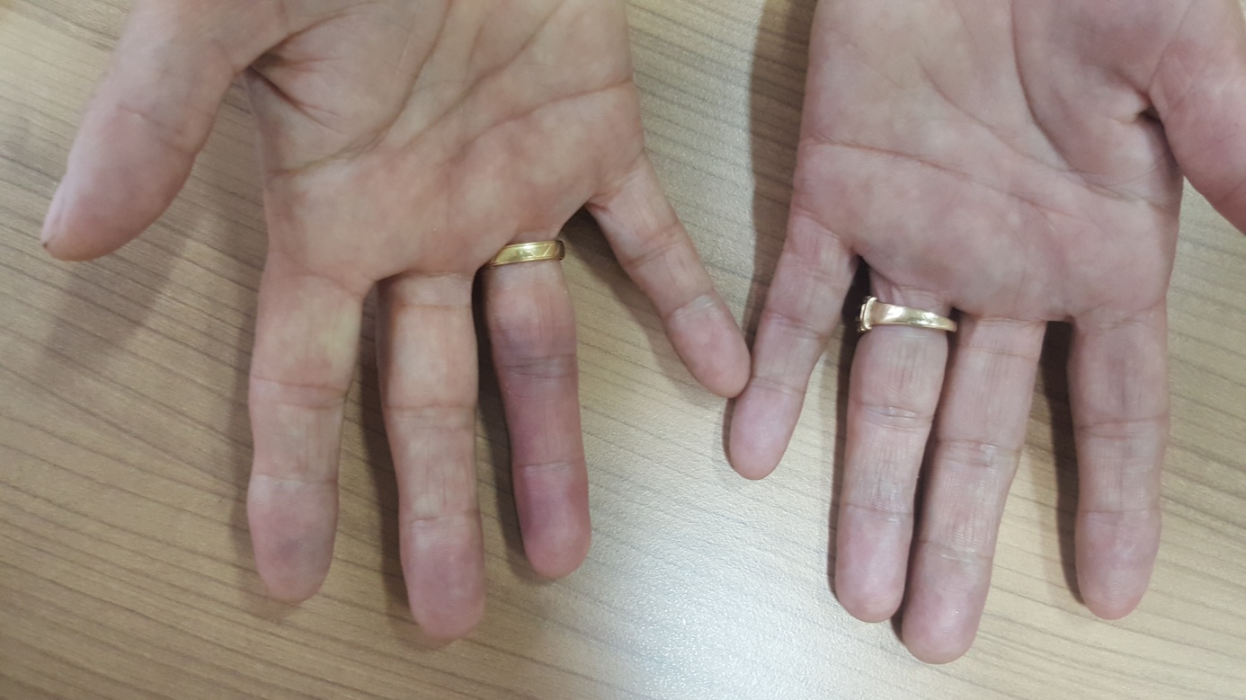
Figure 1 Please note that for the bruising on the right hand ring finger.

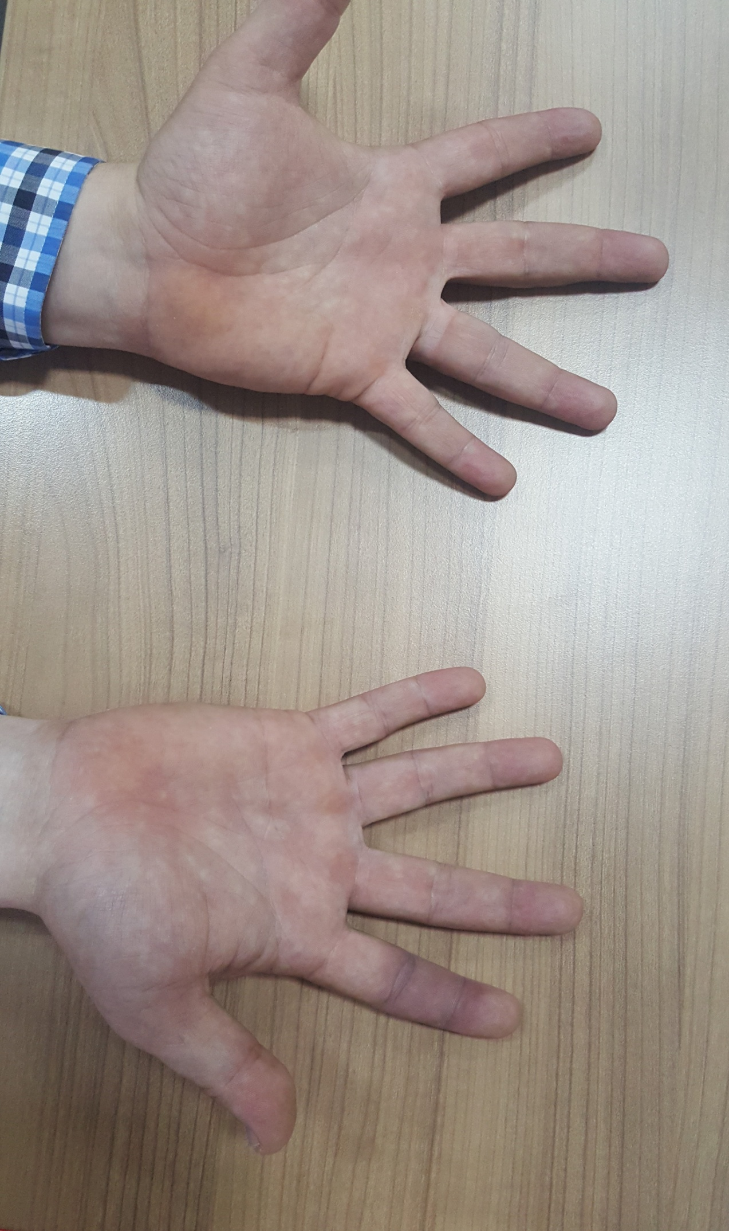
Figure 2 Please note that for the bruising on the right hand index finger.

Table 1 Demographic data of patients
Variable | n or mean + sd | % or min-max
Age | 47.91 ± 11.72 | 21-67
Female sex | 20 | 83.3
Male sex | 4 | 16.6
Family history | 1 | 4.1
Brusing elsewhere | 2 | 8.3
Diabetes | 3 | 12.5
Hypertension | 7 | 29.1
Smoking | 4 | 16.6
Alchol | 0 | -
Antiplatelet use | 0 | -
Anticoagulant use | 0 | -
Pathology in arterial duplex ulrtrasonography | 0 | -
Pathology in venous duplex ultrasonography | 0 | -
min: Minimum; max: Maximum.
Table 2 Laboratory data of patients
Parameters | mean + sd and min-max | Reference range
White blood cell (WBC × 10³/μL) | 7.84 (4.2-13.4) | 4-11
Redblood cell (RBC × 10⁶ /μL) | 5.07 (3.8-6.4) | 4.6-6.2
Hemoglobin(g/dL) | 15.06 (11.4-19.2) | 14-18
Hematocrit (%) | 45.62 (34.2-57) | 42-52
Platelets (PLT × 10³/μL) | 246.95(152-356) | 150-400
International normalized ratio (INR) | 1.05 (0.82-1.18) | 0.8-1.2
Prothrombin time (PT) (s) | 11.79 (10.8-12.8) | 10.7-13.0
Active partial thromboplastin time (aPTT) (s) | 29.54 (24-36) | 22-36.9
C-reactive protein (CRP) (mg/L) | 4.18 (0.8-8.4) | 0-8
Sedimentation (mm/h) | 13.45 (2-24) | 0-24
Low density lipoprotein (LDL) (mg/dL) | 130.83 (48-184) | < 160
Triglycerides (mg/dL) | 150.37 (36-252) | < 203
Pulse oximeter (SpO₂%) | 96.8 (94-100) | 95-100
min: Minimum; max: Maximum.

Table 3 Achenbach’s syndrome symptoms and location features
Symptoms and location | n or mean + sd | % or min-max
Swollen | 13 | 54.1
Pain | 24 | 100
Paraesthesia | 9 | 37.5
Brusing | 24 | 100
Mean epizod count | 3.04 | 1-6
Thumb | 4 | 16.6
Index finger | 8 | 33.3
Middle finger | 7 | 29.1
Ring finger | 3 | 12.5
Little finger | 1 | 4.1
Other (Palmar, wrist, etc.) | 1 | 4.1
Right hand | 13 | 54.1
Left hand | 11 | 45.8
min: Minimum; max: Maximum.

Table 4 Differential diagnosis
Differential diagnosis
Raynaud syndrome or phenomen | Thoracic outlet syndrome
Spontaneus digital venous thrombosis | Trauma
Gardner-Diamond syndrome | Collagen vascular disease
Atherosclerosis | Buerger disease
Takayasu arteritis | Ulnar artery thrombosis
Giant cell arteritis | Radial artery thrombosis
Aneurysmal diseas producing emboli | Microemboli
Vibration-induced injury | Polycythemia
Cold injury | Cryoglobulinemia
Dermatitis artefacta | Sptontaneus rupture of the vincula
Acute limb ischemia | Chilblain’s disease
Acrocyanosis | Acrorygosis

