Name of Journal: World Journal of Clinical Cases
Manuscript NO: 69293
Manuscript Type: CASE REPORT

Extracranial multiorgan metastasis from primary glioblastoma: A case report

Luan XZ et al. Glioblastoma with multiple extracranial metastases

Xing-Zhao Luan, Hao-Run Wang, Wei Xiang, Shen-Jie Li, Haiping He, Li-Gang Chen, Jian-Mei Wang, Jie Zhou

Xing-Zhao Luan, Hao-Run Wang, Wei Xiang, Shen-Jie Li, Haiping He, Li-Gang Chen, Jie Zhou, Department of Neurosurgery, The Affiliated Hospital of Southwest Medical University, Luzhou 646000, Sichuan Province, China

Xing-Zhao Luan, Hao-Run Wang, Wei Xiang, Shen-Jie Li, Haiping He, Li-Gang Chen, Jie Zhou, Sichuan Clinical Research Center for Neurosurgery, Southwest Medical University, Luzhou 646000, Sichuan Province, China

Hao-Run Wang, Wei Xiang, Shen-Jie Li, Haiping He, Li-Gang Chen, Jie Zhou, Academician (Expert) Workstation of Sichuan Province, Southwest Medical University, Luzhou 646000, Sichuan Province, China

Jian-Mei Wang, Department of Pathology, The Affiliated Hospital of Southwest Medical University, Luzhou 646000, Sichuan Province, China

Author contributions: Luan XZ conceptualized and drafted the report; Wang HR was responsible for the imaging curation; Li SJ was responsible for the methodology; Xiang W conceptualized and revised the manuscript; He HP collected patient data; Wang JM conducted and supervised the pathological examinations; Chen LG supervised the study; Zhou J supervised the study, reviewed and edited the manuscript; all authors issued final approval for the version to be submitted.

Supported by Medical Research Fund for Young Scholars of the Sichuan Medical Association, No. Q16076; Natural Science Foundation of Southwest Medical University, No. 2016XNYD217; and Science and Technology Projects of Sichuan Province, No. 2018JY0403.

Corresponding author: Jie Zhou, MD, Associate Chief Physician, Department of Neurosurgery, The Affiliated Hospital of Southwest Medical University, No. 25 Taiping Street, Luzhou 646000, Sichuan Province, China. zj000718@yeah.net

Received: July 8, 2021
Revised: August 31, 2021
Accepted: September 16, 2021
Published online: November 26, 2021

Abstract
BACKGROUND
Glioblastoma has a high degree of malignancy and poor prognosis. It is common to have in situ recurrence and intracranial metastasis, while extracranial metastasis is rare, and extracranial multiorgan metastasis is extremely rare. We report a case of glioblastoma with extracranial multiorgan metastasis, which will strengthen clinicians’ attention to the extracranial metastasis of glioblastoma and its treatment.

CASE SUMMARY
A male patient visited our hospital for treatment of dizziness and headache. Magnetic resonance imaging of the brain revealed a space-occupying lesion in the right temporoparietal occipital region. Chest computed tomography and abdominal ultrasound were normal, and no space-occupying lesions were observed in other organs of the body. The patient underwent surgery and diagnosed with glioblastoma. Postoperative concurrent radiotherapy and chemotherapy were completed. During the follow-up, the tumor was found to have metastasized to the scalp and neck, and a second tumor resection was performed. Postoperative follow-up revealed extracranial metastases to multiple extracranial organs including skull, scalp, ribs, spine, liver and lung. His family members refused further treatment, and requested only symptomatic treatment such as pain relief, and the patient died of systemic multiple organ failure. Survival time from diagnosis to death was 13 mo and from extracranial metastasis to death was 6 mo.

CONCLUSION
Glioblastoma extracranial metastasis is extremely rare, clinicians should always pay attention to its existence. The mechanism of glioblastoma extracranial metastasis is still unclear, and genetic and molecular studies are required.

Key Words: Glioblastoma; Extracranial metastasis; Multiple organ metastasis; Primary glioblastoma; Case report

©The Author(s) 2021. Published by Baishideng Publishing Group Inc. All rights reserved.

Citation: Luan XZ, Wang HR, Xiang W, Li SJ, He H, Chen LG, Wang JM, Zhou J. Extracranial multiorgan metastasis from primary glioblastoma: A case report . World J Clin Cases 2021; 9(33): 10300-10307
URL: https://www.wjgnet.com/2307-8960/full/v9/i33/10300.htm
DOI: https://dx.doi.org/10.12998/wjcc.v9.i33.10300

Core Tip: Glioblastoma is common to have in situ recurrence and intracranial metastasis, while extracranial metastasis is rare, and extracranial multiorgan metastasis is extremely rare. We reported a case of extracranial multiple organ metastasis of glioblastoma, reviewed relevant literature, and discussed the related mechanism and treatment plan. This report may provide more possibilities for the related mechanism and treatment of extracranial metastasis of glioblastoma.
INTRODUCTION
Glioblastoma is the most common primary malignant tumor of the central nervous system (CNS). It often recurs in situ and rarely metastases, especially extracranially. Extracranial multiorgan metastasis is even rarer. We report a case of postoperative glioblastoma with not only extracranial metastasis but also multiorgan metastasis; the relevant literature is subsequently reviewed.

CASE PRESENTATION
Chief complaints
A 47-year-old man presented with dizziness for 1 mo and headache for 1 wk without other discomfort.

History of present illness
The patient developed dizziness without obvious cause 1 mo ago, and was obviously dizzy and uncomfortable when squatting and suddenly standing up. The head distension and pain occurred 1 wk ago, and the symptoms persisted, but there was no relief after rest.

History of past illness
The patient had a history of right elbow injury caused by a car accident 20 years ago.

Personal and family history
Denial of personal and family history.

Physical examination
Physical examination showed no obvious abnormality and blood pressure was 130/80 mmHg.

Laboratory examinations
Blood analysis revealed mild leukocytosis 12.5 × 10⁹/L, with predominant neutrophils (80%) with normal hematocrit and platelet count. Other tests were within the normal range.

Imaging examinations
Magnetic resonance imaging (MRI) of the brain revealed a space-occupying lesion of 62 mm × 40 mm × 43 mm in the right temporoparietal occipital region. T1-weighted and T2-weighted images showed high signal. The contrast-enhanced scan showed irregular annular enhancement, and the cerebral line shifted about 0.8 cm to the left (Figure 1A). Chest computed tomography (CT) and abdominal ultrasound were normal, and no space-occupying lesions were observed in other organs of the body.

Further diagnostic work-up
After admission, the lesion was extensively excised and the ventricle was opened intraoperatively (Figure 1B). The pathological results of the patient suggested that hematoxylin-eosin staining showed a large amount of necrosis and scattered heteromorphic cells, considering high-grade glioblastoma (Figure 1C), glial fibrillary acidic protein (+) (Figure 1D), Ki67 (+20%) (Figure 1E). Furthermore, pathological examination revealed that immune phenotype IDH1 wild type, IDH2 wild type, MGMT unmethylated, and the diagnosis was glioblastoma (World Health Organization grade IV).

FINAL DIAGNOSIS
The patient was diagnosed with glioblastoma (IDH-wild type).

TREATMENT
Postoperative concurrent chemoradiotherapy with the following regimen was administered: Radiotherapy (daily fractions of 2 Gy given 5 d/wk for 6 wk, for a total of 60 Gy) plus continuous daily temozolomide (75 mg/m² body-surface area per day, 7 d/wk from the first to the last day of radiotherapy), followed by six cycles of adjuvant temozolomide (150-200 mg/m² for 5 d during each 28-d cycle, and regular follow-up.

OUTCOME AND FOLLOW-UP
Six months after surgery, the patient had a mass at the site of surgical incision (Figure 2A), and intracranial recurrence and subcutaneous metastasis were considered in the re-examination of enhanced MRI (Figure 2B). Family members required temporary observation and simultaneous radiotherapy and chemotherapy. Nine months postoperatively, the patient was readmitted due to enlargement of the scalp incision and a new neck mass (Figure 2C). After the second admission, the patient underwent maximum lesion resection and scalp mass resection. Pathological examination of the scalp mass revealed glioblastoma, which was confirmed as extracranial metastasis (Figure 2D-F). Ultrasound indicated that the cervical mass was cervical lymph node enlargement, and we performed excision of the mass (Figure 2G). The pathological examination was consistent with glioblastoma metastasis to the cervical lymph nodes (Figure 2H). Follow-up head and chest CT showed metastases in the skull, scalp, ribs, spine, liver and lungs, and the patient died of systemic organ failure (Figure 3A-F). We suggested that the patient complete positron emission tomography/CT examination and further surgical treatment, but the patient and his family members refuse further examination and surgery, and only palliative treatment. Survival time from diagnosis to death was 13 mo and from extracranial metastasis to death was 6 mo.

DISCUSSION
Postoperative recurrence of glioblastoma is common, but metastasis is rare and extracranial multiorgan metastasis is extremely rare^{[1]}.
Weiss^{[2]} proposed the diagnostic criteria for extraencephalic metastasis of malignant tumors in 1955: (1) The histological features of the CNS neoplasm must be demonstrated to be unitary; (2) The initial symptoms must be caused by the tumor in the clinical history; (3) A full autopsy is necessary and there is sufficient evidence to rule out the possibility of other tumors; and (4) The pathomorphology of distant metastases and CNS neoplasm must be consistent, and appropriate degrees of difference can be considered. In view of the histological features of brain glioblastoma and the histological manifestations of scalp and neck lymph nodes, the present case met the diagnostic criteria proposed by Weiss (except autopsy).
To further explore the characteristics of glioblastoma extracranial metastases, we reviewed cases of intracranial tumors with extracranial metastases reported in the past 5 years (Table 1). We found the following features. (1) Glioblastoma is the most common intracranial tumor with extracranial metastasis, although astrocytomas and diffuse glioblastoma have also been reported. (2) The most common site of the disease is the temporal lobe, and the frontal and occipital lobes have also been reported. (3) The most common site of extracranial metastasis is the spinal canal, followed by liver, lungs, lymph nodes and other sites, while extracranial multiorgan metastasis is relatively rare. (4) The average time from diagnosis to death for intracranial tumors was 15.2 mo, and the discovery of extracranial metastases was approximately 4 mo. Our patient had glioblastoma located in the right temporal lobe with extracranial metastases to the skull, scalp, ribs, spine, liver and lungs. The survival time from diagnosis to death was 13 mo, and the survival time from extracranial metastases to death was 6 mo.
The mechanisms of glioblastoma extracranial metastasis are still not well known. Many reports of extracranial glioblastoma metastases show a strong correlation between these lesions and preceding intracranial operation such as aggressive surgical resection, biopsy, and ventriculopleural shunting, in particular, the intraoperative opening of the ventricle. Extracranial metastases have been attributed commonly to tumor cells depositing into the bloodstream or to surgical defects in the dura and skull^{[3]}. However, Anzil^{[4]} found that > 10% of all cases occurred in the absence of prior surgical intervention. He believed that aggressive operations are not prerequisites for extracranial metastasis of glioblastoma, also suggesting that early hematogenous spread may be a mechanism. While intracranial operations are not necessary in the development of extracranial glioblastoma metastases, such operations provide opportunities for vascular invasion and cerebrospinal fluid dissemination of tumor cells, thereby increasing the risk of systemic spread and extracranial tumor metastasis^{[5,6]}. The most common mechanism of glioblastoma metastasis outside the CNS/neuraxis is likely vascular invasion, which indicates the existence of circulating tumor cells in the bloodstream. Therefore, the tumor-free principle becomes especially important during surgery and ensures dura mater integrity. In addition, the fraction of tumor cells in the circulation may provide an opportunity for early detection and genetic analysis of the intracranial glioblastoma^{[7]}. In our patient, the ventricle was opened and the dura was destroyed during the operation. The opening of the ventricular system led to tumor invasion into the ventricular system, coupled with the destruction of the dura and invasion of the epidural blood vessels, leading to the systemic metastasis of multiple organs. However, beyond these factors, is there a deeper genetic connection to extracranial metastasis?
Our case suggests that MGMT is not methylated, and whether extracranial diffusion is affected by MGMT methylation status remains unknown. A significant study by Hegi et al^{[8]} suggested that MGMT promoter methylation is an independent prognostic factor, and adjuvant TMZ can be beneficial in glioblastoma patients treated with methylated MGMT promoter. It has been reported that MGMT status is potentially in contact with extracranial metastasis, and distant metastasis of oligoendrocytes and melanoma in tumors has been reported^{[9,10]}. MGMT promoter methylation is closely associated with distant metastasis, and there is considerable heterogeneity. However, whether MGMT promoter methylation status is associated with poor prognosis in GBM has not been found. MGMT promoter status with glioblastoma extracranial metastasis merits further research.
Currently, the standard initial approach for most primary glioblastomas is maximum safe surgical resection followed by postoperative concurrent radiotherapy and chemotherapy^{[11]}. The same is true of our patient treatment regimens. In the case of extracranial metastases, there is no standard treatment; surgery, radiation and systemic chemotherapy or bevacizumab are all potential options, depending on the patient’s condition^{[11]}. Studies have suggested a possible beneficial pairing between immunotherapy and TMZ therapy, and radiation-driven evolution may have therapeutic implications for recurrent GBM^{[12,13]}. Moreover, Draaisma et al^{[14]} found that MGMT promoter methylation had a prognostic effect in tumor recurrence, and the high-mutated phenotype only occurred in 6%-8% of TMZ-treated IDH WT GBMs. Therefore, for patients with extracranial multiple organ metastasis of glioblastoma, simultaneous radiotherapy and chemotherapy combined with immunotherapy is worth a try, and the study of targeted genes is a direction worthy of profound exploration.

CONCLUSION
Malignant glioblastoma with extracranial multiorgan metastasis is rare, and survival is short. Surgeons should always be alert to its occurrence. At present, surgical treatment and concurrent chemoradiotherapy are still the primary options for glioblastoma, so attention should be paid to achieving tumor-free status during surgery to reduce the possibility of extracranial metastasis. The mechanism of extracranial metastasis of glioblastoma is still not clear, thus genetic and molecular pathology is still worthy of further exploration.

REFERENCES
1 Kalokhe G, Grimm SA, Chandler JP, Helenowski I, Rademaker A, Raizer JJ. Metastatic glioblastoma: case presentations and a review of the literature. J Neurooncol 2012; 107: 21-27 [PMID: 21964740 DOI: 10.1007/s11060-011-0731-1]
2 Mavroudis C, Townsend JJ, Wilson CB. A metastasizing ependymoma of the cauda equina. Case report. J Neurosurg 1977; 47: 771-775 [PMID: 908942 DOI: 10.3171/jns.1977.47.5.0771]
3 Figueroa P, Lupton JR, Remington T, Olding M, Jones RV, Sekhar LN, Sulica VI. Cutaneous metastasis from an intracranial glioblastoma multiforme. J Am Acad Dermatol 2002; 46: 297-300 [PMID: 11807444 DOI: 10.1067/mjd.2002.104966]
4 Anzil AP. Glioblastoma multiforme with extracranial metastases in the absence of previous craniotomy. Case report. J Neurosurg 1970; 33: 88-94 [PMID: 4316740 DOI: 10.3171/jns.1970.33.1.0088]
5 Frank S, Kuhn SA, Brodhun M, Mueller U, Romeike B, Kosmehl H, Regenbrecht CR, Ewald C, Reichart R, Kalff R. Metastatic glioblastoma cells use common pathways via blood and lymphatic vessels. Neurol Neurochir Pol 2009; 43: 183-190 [PMID: 19484696]
6 Thorsen F, Tysnes BB. Brain tumor cell invasion, anatomical and biological considerations. Anticancer Res 1997; 17: 4121-4126 [PMID: 9428345]
7 Adamczyk LA, Williams H, Frankow A, Ellis HP, Haynes HR, Perks C, Holly JM, Kurian KM. Current Understanding of Circulating Tumor Cells - Potential Value in Malignancies of the Central Nervous System. Front Neurol 2015; 6: 174 [PMID: 26322014 DOI: 10.3389/fneur.2015.00174]
8 Hegi ME, Diserens AC, Gorlia T, Hamou MF, de Tribolet N, Weller M, Kros JM, Hainfellner JA, Mason W, Mariani L, Bromberg JE, Hau P, Mirimanoff RO, Cairncross JG, Janzer RC, Stupp R. MGMT gene silencing and benefit from temozolomide in glioblastoma. N Engl J Med 2005; 352: 997-1003 [PMID: 15758010 DOI: 10.1056/NEJMoa043331]
9 Li G, Zhang Z, Zhang J, Jin T, Liang H, Gong L, Cui G, Yang H, He S, Zhang Y, Gao G. Occipital anaplastic oligodendroglioma with multiple organ metastases after a short clinical course: a case report and literature review. Diagn Pathol 2014; 9: 17 [PMID: 24447608 DOI: 10.1186/1746-1596-9-17]
10 Kohonen-Corish MR, Cooper WA, Saab J, Thompson JF, Trent RJ, Millward MJ. Promoter hypermethylation of the O(6)-methylguanine DNA methyltransferase gene and microsatellite instability in metastatic melanoma. J Invest Dermatol 2006; 126: 167-171 [PMID: 16417233 DOI: 10.1038/sj.jid.5700005]
11 Tan AC, Ashley DM, López GY, Malinzak M, Friedman HS, Khasraw M. Management of glioblastoma: State of the art and future directions. CA Cancer J Clin 2020; 70: 299-312 [PMID: 32478924 DOI: 10.3322/caac.21613]
12 Hotchkiss KM, Sampson JH. Temozolomide treatment outcomes and immunotherapy efficacy in brain tumor. J Neurooncol 2021; 151: 55-62 [PMID: 32813186 DOI: 10.1007/s11060-020-03598-2]
13 McAbee JH, Rath BH, Valdez K, Young DL, Wu X, Shankavaram UT, Camphausen K, Tofilon PJ. Radiation Drives the Evolution of Orthotopic Xenografts Initiated from Glioblastoma Stem-like Cells. Cancer Res 2019; 79: 6032-6043 [PMID: 31615806 DOI: 10.1158/0008-5472.CAN-19-2452]
14 Draaisma K, Chatzipli A, Taphoorn M, Kerkhof M, Weyerbrock A, Sanson M, Hoeben A, Lukacova S, Lombardi G, Leenstra S, Hanse M, Fleischeuer R, Watts C, McAbee J, Angelopoulos N, Gorlia T, Golfinopoulos V, Kros JM, Verhaak RGW, Bours V, van den Bent MJ, McDermott U, Robe PA, French PJ. Molecular Evolution of IDH Wild-Type Glioblastomas Treated With Standard of Care Affects Survival and Design of Precision Medicine Trials: A Report From the EORTC 1542 Study. J Clin Oncol 2020; 38: 81-99 [PMID: 31743054 DOI: 10.1200/JCO.19.00367]

Footnotes
Informed consent statement: Informed written consent was obtained from the patient and legal guardian for publication of this report and any accompanying images.

Conflict-of-interest statement: The authors declare that they have no conflicts of interest.

CARE Checklist (2016) statement: The authors have read the CARE Checklist (2016), and the manuscript was prepared and revised according to the CARE Checklist (2016).

Open-Access: This article is an open-access article that was selected by an in-house editor and fully peer-reviewed by external reviewers. It is distributed in accordance with the Creative Commons Attribution NonCommercial (CC BY-NC 4.0) license, which permits others to distribute, remix, adapt, build upon this work non-commercially, and license their derivative works on different terms, provided the original work is properly cited and the use is non-commercial. See: http://creativecommons.org/Licenses/by-nc/4.0/

Provenance and peer review: Unsolicited article; Externally peer reviewed.

Peer-review started: July 8, 2021
First decision: August 18, 2021
Article in press: September 16, 2021

Specialty type: Medicine, research and experimental
Country/Territory of origin: China
Peer-review report’s scientific quality classification
Grade A (Excellent): A
Grade B (Very good): B
Grade C (Good): C
Grade D (Fair): 0
Grade E (Poor): 0

P-Reviewer: Kołat D, Li C S-Editor: Gao CC L-Editor: A P-Editor: Li JH

Figure Legends
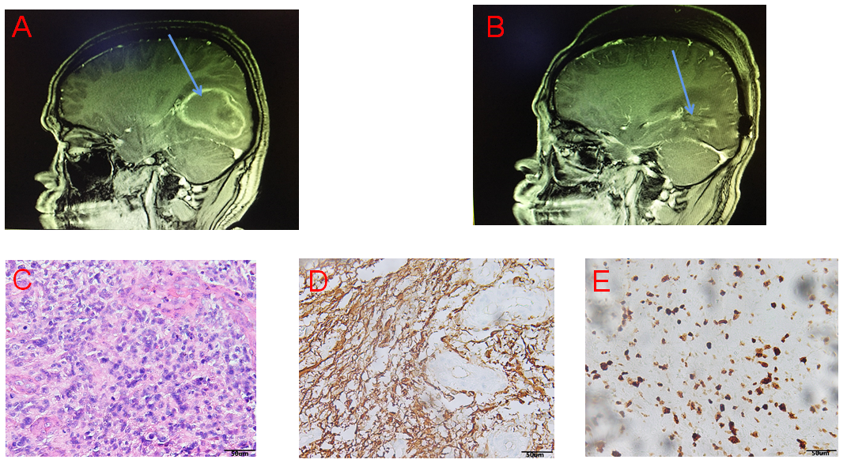
Figure 1 Images and pathology before and after the first operation. A: Preoperative brain contrast-enhanced magnetic resonance imaging (MRI) indicated right temporal lobe lesions and the tumor border is located next to the lateral ventricle; B: Postoperative brain contrast-enhanced MRI indicated complete resection of the tumor; C: Hematoxylin-eosin staining showed a large amount of necrosis and scattered heteromorphic cells, considering high-grade glioblastoma (magnification, × 200); D: Glial fibrillary acidic protein (+) (magnification, × 200); E: Ki67 (+20%) (magnification, × 200).
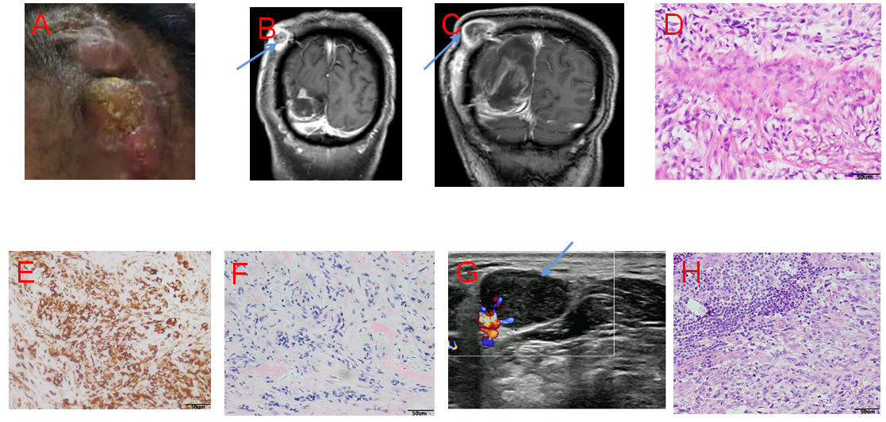
Figure 2 Imaging and pathology before and after the second operation. A: The patient has a lump on the scalp at the first surgical incision in the right temple; B: 6 mo after first surgery, brain contrast-enhanced magnetic resonance imaging (MRI): intracranial recurrence and scalp transfer; C: Brain contrast-enhanced MRI was re-examined 9 mo after first surgery: both the intracranial recurrent tumors and the scalp metastases have grown up; D: Hematoxylin-eosin staining suggested fibrous tissue proliferation and necrosis, and scattered abnormal cells, which was considered as intracranial GBM metastasis (magnification, × 200); E: GFAP (+) (magnification, × 200); F: Vim (+) (magnification, × 200); G: Ultrasonography revealed enlarged lymph nodes in the right neck (2.1 cm × 1.5 cm); H: Pathological examination of enlarged lymph nodes in the right neck was diagnosed as glioblastoma, hematoxylin-eosin staining (magnification, × 200).
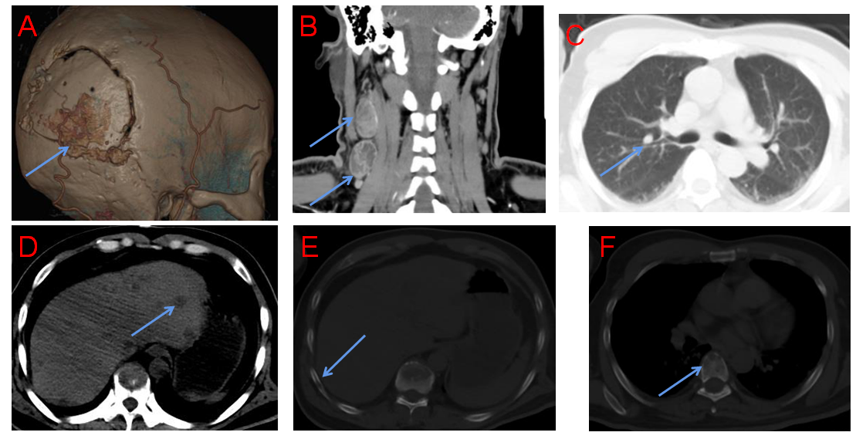
Figure 3 Follow-up after secondary surgery revealed multiple extracranial metastases. A: Three-dimensional reconstruction of the skull suggested that the skull was infiltrated by the tumor; B: Cervical computed tomography (CT) suggested enlargement of cervical lymph nodes; C-F: Chest CT showed multiple nodules in the liver (C) and lungs (D), infiltration in the ribs (E), and infiltration in the spine (F), and all the above lesions are considered for multiple extracranial metastases of intracranial glioblastoma.

Table 1 Review the literature on extracranial metastases of malignant gliomas in the past five years
No. | Ag/sex | Location primary | Location metastasis | Diagnose | Interval | Survival | Adjuvant therapy
1 | 65/M | R occipital lobe | Bones (femur, ilium, sacrum) | GBM | 13 | 11 | Concurrent radiochemotherapy
2 | 20/W | L temporal lobe | Lung, lymph gland | GBM | NS | NS | Chemotherapy (temozolomide)
3 | 75/W | L temporal lobe | Lung, pleura | Diffuse astrocytoma | NS | NS | NS
4 | 48/W | L temporal lobe | Bone, lung, pleura, liver, mesentery | GBM | 13 | 11 | Concurrent radiochemotherapy
5 | 43/W | L frontal lobe | Lung, pleura | GBM | 38 | 2 | Concurrent radiochemotherapy
6 | 49/M | R temporal lobe | Lung, cerebrospinal fluid | GBM | 12 | 10 | Concurrent radiochemotherapy
7 | 56/W | R temporal lobe | Parotid, lymph node, lung | GBM | 14.5 | 11 | Concurrent radiochemotherapy
8 | 32/M | L basal ganglia region | Lymph nodes, bones (ribs, scapula, spine) | GBM | 22 | 3 | Concurrent radiochemotherapy
9 | 41/W | R temporal lobe | Lymphatic, spinal column | GBM | 10 | 1 | Concurrent radiochemotherapy
10 | 43/M | R temporal lobe | Multiple bone metastases | GBM | 3 | 2 | Radiotherapy
11 | 38/W | R temporal lobe | Lymph gland, bones | GBM | 10 | 6 | Concurrent radiochemotherapy
12 | 23/W | L temporal lobe | Lung, multiple bone metastases | Oligoastrocytoma | 36 | 5 | Concurrent radiochemotherapy
13 | 47/M | R temporal lobe | Scalp, lymph gland ribs, spine, liver, lungs | GBM | 13 | 6 | Concurrent radiochemotherapy
Interval: Time from diagnosis of primary to diagnosis of metastasis in months; Survival: Survival after diagnosis of metastasis in months. R: Right; L: Left; M: Male; F: Female; NS: Not stated or not known; GBM: Glioblastoma multiforme.

Published by Baishideng Publishing Group Inc
7041 Koll Center Parkway, Suite 160, Pleasanton, CA 94566, USA
Telephone: +1-925-3991568
E-mail: bpgoffice@wjgnet.com
Help Desk: https://www.f6publishing.com/helpdesk
https://www.wjgnet.com

© 2021 Baishideng Publishing Group Inc. All rights reserved.

