Name of Journal: World Journal of Clinical Cases
Manuscript NO: 78332
Manuscript Type: CASE REPORT

Endoscopic magnetic compression stricturoplasty for congenital esophageal stenosis: A case report

Liu SQ et al. MCS for esophageal stenosis

Shi-Qi Liu, Yi Lv, Rui-Xue Luo

Shi-Qi Liu, Department of Nursing, The Medical College, Xijing University, Xi’an 710123, Shaanxi Province, China

Yi Lv, Department of Hepatobiliary Surgery, The First Affiliated Hospital of Xi’an Jiaotong University, Xi’an 710061, Shaanxi Province, China

Rui-Xue Luo, The Corrosion & Protection Research Lab, Northwest Institute for Nonferrous Metal Research, Xi’an 710016, Shaanxi Province, China

Author contributions: Liu SQ conducted the operation, collected the data, performed data analysis and interpretation, and drafted the manuscript; Lv Y guided the operation and revised the manuscript; Luo RX assisted in magnetic ring processing and revised the contents about magnetic device.

Supported by the National Natural Science Foundation of China, No. 82170676; Natural Science Foundation of Shaanxi Provincial Key Industries Innovation Chain (Cluster) - Social Development Project, No. 2020ZDLSF02-03; and the Special Fund for High-level Talents of Xijing University, No. XJ20B04.

Corresponding author: Yi Lv, MD, Professor, Department of Hepatobiliary Surgery, The First Affiliated Hospital of Xi’an Jiaotong University, No. 277 West Road, Xi’an 710061, Shaanxi Province, China. luyi169@126.com

Received: June 21, 2022
Revised: August 24, 2022
Accepted: October 17, 2022
Published online: November 26, 2022

Abstract
BACKGROUND
Congenital esophageal stenosis (CES) is a rare malformation of the digestive tract. Endoscopic dilation and thoracotomy have been the main treatments for CES. However, there is no well-defined management protocol. Magnetic compression stricturoplasty (MCS) has been used in refractory esophageal stricture in children after esophageal atresia.

CASE SUMMARY
We describe the first case of MCS for CES in one female child patient. The child (aged 3 years and 1 mo) was admitted due to frequent vomiting and choking after eating complementary food since 7 mo old. Esophagography and gastroendoscopy showed that there was stenosis in the lower esophagus, suggesting a diagnosis of CES. The patient did not receive any treatment for esophageal stricture including surgery or endoscopic dilation procedures before MCS. MCS procedure was smoothly conducted without complications. At 24 mo after MCS, durable esophageal patency without dysphagia was achieved.

CONCLUSION
MCS may serve as an alternative and efficient method for patients with CES.

Key Words: Congenital esophageal stenosis; Magnetic compression stricturoplasty; Endoscopy; Case report

©The Author(s) 2022. Published by Baishideng Publishing Group Inc. All rights reserved.

Citation: Liu SQ, Lv Y, Luo RX. Endoscopic magnetic compression stricturoplasty for congenital esophageal stenosis: A case report. World J Clin Cases 2022; 10(33): 12313-12318
URL: https://www.wjgnet.com/2307-8960/full/v10/i33/12313.htm
DOI: https://dx.doi.org/10.12998/wjcc.v10.i33.12313

Core Tip: Magnetic compression stricturoplasty (MCS) is a relatively safe dredge method for patients with postoperative obstruction, stricture, or dehiscence of anastomosis. For the first time, we describe the application of MCS in treating congenital esophageal stenosis (CES) without using endoscopic bougienage and dilation treatment in a child patient. The data on diagnosis, treatment, and long-term follow-up of CES are analyzed. Additionally, key properties of MCS in treating segmental fibromuscular hypertrophy stricture following CES are discussed.

INTRODUCTION
Congenital esophageal stenosis (CES) is a very rare clinical condition^{[1,2]}. Membranous web (MW), segmental fibromuscular hypertrophy (FM), and ectopic tracheobronchial remnants (TBR) are histological subtypes of CES. They each have different treatment strategies^{[3]}. Magnetic compression stricturoplasty (MCS) is a relatively safe dredge method for patients with postoperative obstruction, stricture, or dehiscence of anastomosis. This method has been successfully used for refractory esophageal stenosis and choledochojejunostomy^{[4,5]}. For the first time, we report the use of MCS in treating CES without using endoscopic bougienage and dilation treatment in a female child patient. The data on the diagnosis, treatment, and long-term follow-up of CES are analyzed. Furthermore, key properties of MCS in treating FM stricture following CES are discussed.

CASE PRESENTATION
Chief complaints
A female child aged 3 years and 1 mo presented vomiting and choking for more than 2 years after eating complementary food.

History of present illness
The symptoms started 2 years and 6 mo ago with recurrent difficulty in eating solid food.

History of past illness
The child was born at 38 wk of gestation through vaginal delivery with a birth weight of 3.7 kg. Her Apgar score was 10 at 1 min, 10 at 5 min, and 10 at 10 min. Prenatal ultrasound showed polyhydramnios. On the subsequent 6 mo after birth, she received breast feeding and had normal growth. At 7 mo old, she had frequent vomiting and choking after eating complementary food and could only eat a full flow diet.

Personal and family history
A family history of malignant tumors was denied.

Physical examination
The vital signs were as follows: Body temperature, 36.5 °C; blood pressure, 80/50 mmHg; heart rate, 100 beats per min; and, respiratory rate, 20 breaths per min. Physical examination of the chest and abdomen revealed no abnormalities.

Laboratory examinations
Routine blood and urine test results were normal.

Imaging examinations
Esophagography and gastroendoscopy showed that there was stenosis in the lower esophagus (Figures 1A and 1B), suggesting a diagnosis of CES.

FINAL DIAGNOSIS
The patient was finally diagnosed as having CES.

TREATMENT
Segmental resection or balloon dilatation was recommended for this patient. However, because of the potential complications such as restenosis, these procedures were not performed. Following preoperative evaluation, the patient received an endoscopy-guided MCS of the esophagus. Magnetic rings were prepared with neodymium-iron-boron (Nd-Fe-B) alloy and the titanium nitride film of 10 μm thickness was coated on the rings (Figure 2A). The outer diameter was 11 mm, the height was 6 mm, and the magnetic strength was 3750 Gs.
A transoral approach was used for the placement of magnetic rings. A guide wire was placed through the esophageal stenosis under endoscopic guidance. The end of a gastric tube with a side hole was fixed on the guide wire. The daughter ring was fixed on the gastric tube. The guide wire was retracted through the mouth, so the end of the gastric tube with a side hole was retrograded through the stenosis segment and was retracted through the mouth. The placement of daughter ring was completed with the placement of the gastric tube. Next, another magnetic ring (mother ring) that had opposite polarity to the daughter ring reached the proximal esophageal lumen above the stenotic segment along the gastric tube under endoscopic guidance (Figure 2B). Intraoperative X-ray confirmed that the two magnets naturally attracted together and accurately compressed the proliferation tissue of stenosis (Figure 2C). Gradual MCS was conducted for 13 d to achieve esophageal stricturoplasty adequacy. During MCS, the patient was fed via the gastric tube. The magnets were moved by pulling the tube daily, starting within 1 wk after surgery. The apposition of magnets was confirmed by anteroposterior or lateral chest radiographs. Subsequently, under fluoroscopic guidance, the magnets were removed. On removal, a remarkably increased luminal diameter was observed by esophagogram (Figure 2D). A 9 mm anastomotic stoma was formed without esophageal perforation and other complications. Temporary stent placement and balloon dilatation were not needed after MCS.

OUTCOME AND FOLLOW-UP
Follow-up at 24 mo after MCS showed that there was no sign indicating esophageal stricture. The patient had normal development and was in good health, without dysphagia or reflux. On esophagram, there was no residual stricture.

DISCUSSION
CES is a rare developmental malformation of the digestive tract, often accompanied with multiple organ malformation and even chromosomal abnormality. Traditional treatment methods mainly include endoscopic esophageal dilatation or incision. CES histological diagnosis is difficult because it is difficult to identify TBR and FM characteristics without histological examination. Intraesophageal ultrasonography is helpful to distinguish tracheobronchial heterotopia^{[6,7]}. For CES patients lacking a histological diagnosis, surgery may be suggested if there is persistent dysphagia after dilation for two series^{[2]}. For severe esophageal stenosis, repeated esophageal dilatation^{[2]} or even partial esophagectomy by thoracotomy or thoracoscopic minimally invasive surgery is required for stricturoplasty^{[8]}. However, patients may still have anastomotic re-stricture after surgery. Thus, a more effective method for treating CES in children is needed.
MCS is a cavity organ anastomosis measure based on magnetic compression anastomosis (MCA), which utilizes the magnetic force between magnetic materials to induce ischemic necrosis and shedding of the compressed tissue and the re-healing of the adjacent tissue and mucosa. MCA has been used for minimally invasive cardiac bypass surgery^{[9,10]} and for the treatment of biliary obstruction after liver transplantation^{[5,11-13]}. In recent years, in addition to the application of MCA in gastrointestinal anastomosis^{[14-17]}, rectum atresia, and colorectal stricture in children^{[4,16,18,19]}, more clinical studies have been reported on its application in refractory stricture after esophageal atresia (EA). Zaritzky et al^{[18]} showed that MCA achieved esophageal reanastomosis within 6 d in infants with EA who had primary or secondary anastomotic stenosis. Importantly, we report the first MCS case for CES in one female child.
On the basis of the compatibility of Nd-Fe-B permanent magnet alloy material in vivo and the application of magnetic anastomosis devices in the field of surgery, our team developed a magnetic anastomosis device suitable for the treatment of digestive tract malformations in children. The titanium oxide coating on Nd-Fe-B alloy magnetic rings could resist gastric acid or succus entericus corrosion. In this case, we used the digestive tract endoscopy and gastric fistula respectively to put the magnetic ring into the proximal and distal end of the esophageal stenosis site. The magnet magnetic field force was used for the minimally invasive treatment of CES between. The tissues at the stenotic site were continuously compressed by the magnet rings, causing ischemic necrosis and natural shedding of the compressed tissues and achieving esophageal patency. An ideal anastomosis between the mucosa and mucosa of esophageal wall was achieved. There were no complications such as esophageal perforation or fistula after operation. In particular, the child did not undergo endoscopic dilation or other treatment procedures before or after MCS. The child was followed for 24 mo and received a general diet. There was no dysphagia upon esophagram and clinical examination. Esophageal continuity was achieved after MCS for FM repair without short or long-term complications. MCS for MW has not been reported. Theoretically, MW has a thinner and weaker structure than FM, so it would be easier to treat by MCS. These findings suggest that MCS is a safe, effective, and alternative method for FM and MW type of CES patients. However, the long-term safety of MCS treatment in children is unclear. We are still following this special case to observe the long-term effects of MCS treatment in children.

CONCLUSION
In this case, MCS successfully established the patency of the esophageal stenosis. This report is the first to utilize MCS in CES. It provides a new reliable method for the treatment of CES. Additionally, attempting MCS does not exclude further esophageal dilatation or segmental resection. We believe that MCA may have good application prospects for children with esophageal stenosis diseases.

ACKNOWLEDGEMENTS
The authors would like to thank Dr. Hong-Bin Yang (Department of Digestive Diseases, The Xi’an Children’s Hospital) for performing the endoscopic procedures.

REFERENCES
1 Bluestone CD, Kerry R, Sieber WK. Congenital esophageal stenosis. Laryngoscope 1969; 79: 1095-1103 [PMID: 5786187 DOI: 10.1288/00005537-196906000-00004]
2 Michaud L, Coutenier F, Podevin G, Bonnard A, Becmeur F, Khen-Dunlop N, Auber F, Maurel A, Gelas T, Dassonville M, Borderon C, Dabadie A, Weil D, Piolat C, Breton A, Djeddi D, Morali A, Bastiani F, Lamireau T, Gottrand F. Characteristics and management of congenital esophageal stenosis: findings from a multicenter study. Orphanet J Rare Dis 2013; 8: 186 [PMID: 24289834 DOI: 10.1186/1750-1172-8-186]
3 Takamizawa S, Tsugawa C, Mouri N, Satoh S, Kanegawa K, Nishijima E, Muraji T. Congenital esophageal stenosis: Therapeutic strategy based on etiology. J Pediatr Surg 2002; 37: 197-201 [PMID: 11819198 DOI: 10.1053/jpsu.2002.30254]
4 Woo R, Wong CM, Trimble Z, Puapong D, Koehler S, Miller S, Johnson S. Magnetic Compression Stricturoplasty For Treatment of Refractory Esophageal Strictures in Children: Technique and Lessons Learned. Surg Innov 2017; 24: 432-439 [PMID: 28745145 DOI: 10.1177/1553350617720994]
5 Li Y, Zhang N, Lv Y; Scientific Committee of the Third International Conference of Magnetic Surgery*. Expert consensus on magnetic recanalization technique for biliary anastomotic strictures after liver transplantation. Hepatobiliary Surg Nutr 2021; 10: 401-404 [PMID: 34159175 DOI: 10.21037/hbsn-20-800]
6 Athanasiou T, Ashrafian H, Glenville B, Casula R. Coronary artery bypass with the use of a magnetic distal anastomotic device: surgical technique and preliminary experience. Heart Surg Forum 2004; 7: 356-359 [PMID: 15769704 DOI: 10.1532/hsf98.2004-1024]
7 Morbiducci U, Lemma M, Ponzini R, Boi A, Bondavalli L, Antona C, Montevecchi FM, Redaelli A. Does the Ventrica magnetic vascular positioner (MVP) for coronary artery bypass grafting significantly alter local fluid dynamics? A numeric study. Int J Artif Organs 2007; 30: 628-639 [PMID: 17674340 DOI: 10.1177/039139880703000711]
8 Umemura A, Sasaki A, Nitta H, Takahara T, Hasegawa Y, Wakabayashi G. Magnetic compression anastomosis for the stricture of the choledochocholedochostomy after ABO-incompatible living donor liver transplantation. Clin J Gastroenterol 2014; 7: 361-364 [PMID: 26185888 DOI: 10.1007/s12328-014-0507-1]
9 Ersoz G, Tekin F, Bozkaya H, Parildar M, Turan I, Karasu Z, Ozutemiz O, Tekesin O. Magnetic compression anastomosis for patients with a disconnected bile duct after living-donor related liver transplantation: a pilot study. Endoscopy 2016; 48: 652-656 [PMID: 27258814 DOI: 10.1055/s-0042-105642]
10 Koksal AS, Eminler AT, Parlak E, Gurakar A. Management of biliary anastomotic strictures after liver transplantation. Transplant Rev (Orlando) 2017; 31: 207-217 [PMID: 28427741 DOI: 10.1016/j.trre.2017.03.002]
11 van Hooft JE, Vleggaar FP, Le Moine O, Bizzotto A, Voermans RP, Costamagna G, Devière J, Siersema PD, Fockens P. Endoscopic magnetic gastroenteric anastomosis for palliation of malignant gastric outlet obstruction: a prospective multicenter study. Gastrointest Endosc 2010; 72: 530-535 [PMID: 20656288 DOI: 10.1016/j.gie.2010.05.025]
12 Pichakron KO, Jelin EB, Hirose S, Curran PF, Jamshidi R, Stephenson JT, Fechter R, Strange M, Harrison MR. Magnamosis II: Magnetic compression anastomosis for minimally invasive gastrojejunostomy and jejunojejunostomy. J Am Coll Surg 2011; 212: 42-49 [PMID: 21184956 DOI: 10.1016/j.jamcollsurg.2010.09.031]
13 Dauser B, Winkler T, Loncsar G, Herbst F. Compression anastomosis revisited: prospective audit of short- and medium-term outcomes in 62 rectal anastomoses. World J Surg 2011; 35: 1925-1932 [PMID: 21541799 DOI: 10.1007/s00268-011-1135-2]
14 Machytka E, Bužga M, Zonca P, Lautz DB, Ryou M, Simonson DC, Thompson CC. Partial jejunal diversion using an incisionless magnetic anastomosis system: 1-year interim results in patients with obesity and diabetes. Gastrointest Endosc 2017; 86: 904-912 [PMID: 28716404 DOI: 10.1016/j.gie.2017.07.009]
15 Zaritzky M, Ben R, Zylberg GI, Yampolsky B. Magnetic compression anastomosis as a nonsurgical treatment for esophageal atresia. Pediatr Radiol 2009; 39: 945-949 [PMID: 19506849 DOI: 10.1007/s00247-009-1305-7]
16 Liu SQ, Lv Y, Fang Y, Luo RX, Zhao JR, Luo RG, Li YM, Zhang J, Zhang PF, Guo JZ, Li QH, Han MX. Magnetic compression for anastomosis in treating an infant born with long-gap oesophageal atresia: A case report. Medicine (Baltimore) 2020; 99: e22472 [PMID: 33080683 DOI: 10.1097/MD.0000000000022472]
17 Liu SQ, Li QF, Lv Y, Zhao JR, Luo RX, Zhang PF, Guo JZ, Zhang AP, Li QH. Magnetic compression anastomosis for rectal atresia following necrotizing enterocolitis: A case report. Medicine (Baltimore) 2020; 99: e23613 [PMID: 33327332 DOI: 10.1097/MD.0000000000023613]
18 Zaritzky M, Ben R, Johnston K. Magnetic gastrointestinal anastomosis in pediatric patients. J Pediatr Surg 2014; 49: 1131-1137 [PMID: 24952802 DOI: 10.1016/j.jpedsurg.2013.11.002]
19 Liu S, Lv Y. Constant magnetic field in treating congenital esophageal and anorectal malformation: a review. World J Pediat Surg 2020; 3: e000130 [DOI: 10.1136/wjps-2020-000130]

Footnotes
Informed consent statement: The authors certify that they have obtained the appropriate patient consent form. In the form, the patient’s parents/guardians have given their consent for the images and other clinical information to be reported in the journal. The patient’s parents/guardians understand that the names and initials will not be published and due efforts will be made to conceal their identity, but anonymity cannot be guaranteed.

Conflict-of-interest statement: All the authors report no relevant conflicts of interest for this article.

CARE Checklist (2016) statement: The authors have read the CARE Checklist (2016), and the manuscript was prepared and revised according to the CARE Checklist (2016).

Open-Access: This article is an open-access article that was selected by an in-house editor and fully peer-reviewed by external reviewers. It is distributed in accordance with the Creative Commons Attribution NonCommercial (CC BY-NC 4.0) license, which permits others to distribute, remix, adapt, build upon this work non-commercially, and license their derivative works on different terms, provided the original work is properly cited and the use is non-commercial. See: https://creativecommons.org/Licenses/by-nc/4.0/

Provenance and peer review: Unsolicited article; Externally peer reviewed.
Peer-review model: Single blind

Peer-review started: June 21, 2022
First decision: August 1, 2022
Article in press: October 17, 2022

Specialty type: Medicine, research and experimental
Country/Territory of origin: China
Peer-review report’s scientific quality classification
Grade A (Excellent): A
Grade B (Very good): 0
Grade C (Good): C
Grade D (Fair): 0
Grade E (Poor): 0

P-Reviewer: Asreah RH, Iraq; Kamran M, Pakistan S-Editor: Wang JJ L-Editor: Wang TQ P-Editor: Wang JJ

Figure Legends
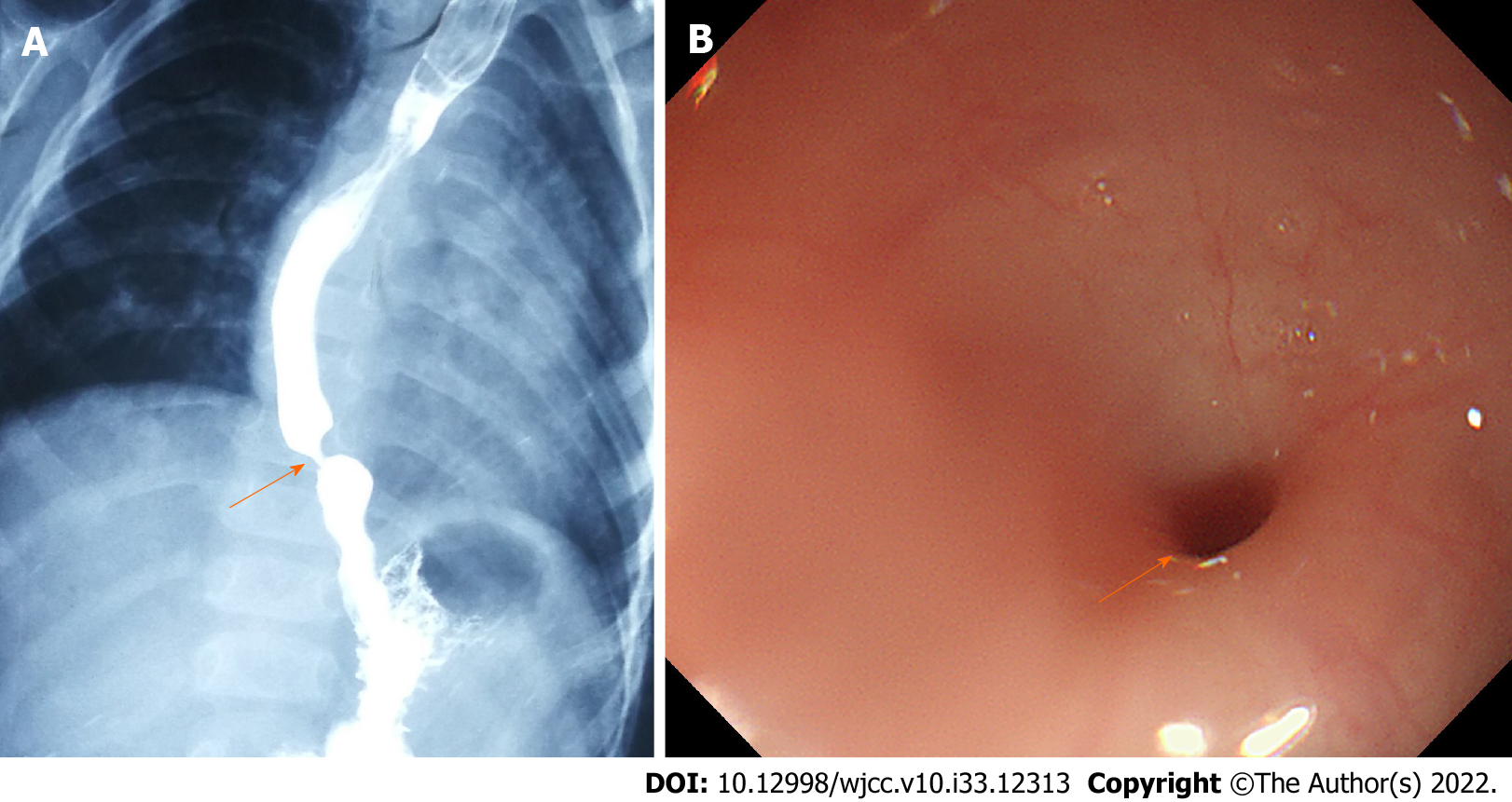
Figure 1 Esophagography and gastroendoscopy of the esophagus. A: Esophagography confirmed that the stenosis was located in the lower esophagus (arrow); B: The congenital stenosis opening in the esophagus with a < 3 mm inner diameter was observed by gastroendoscopy (arrow).

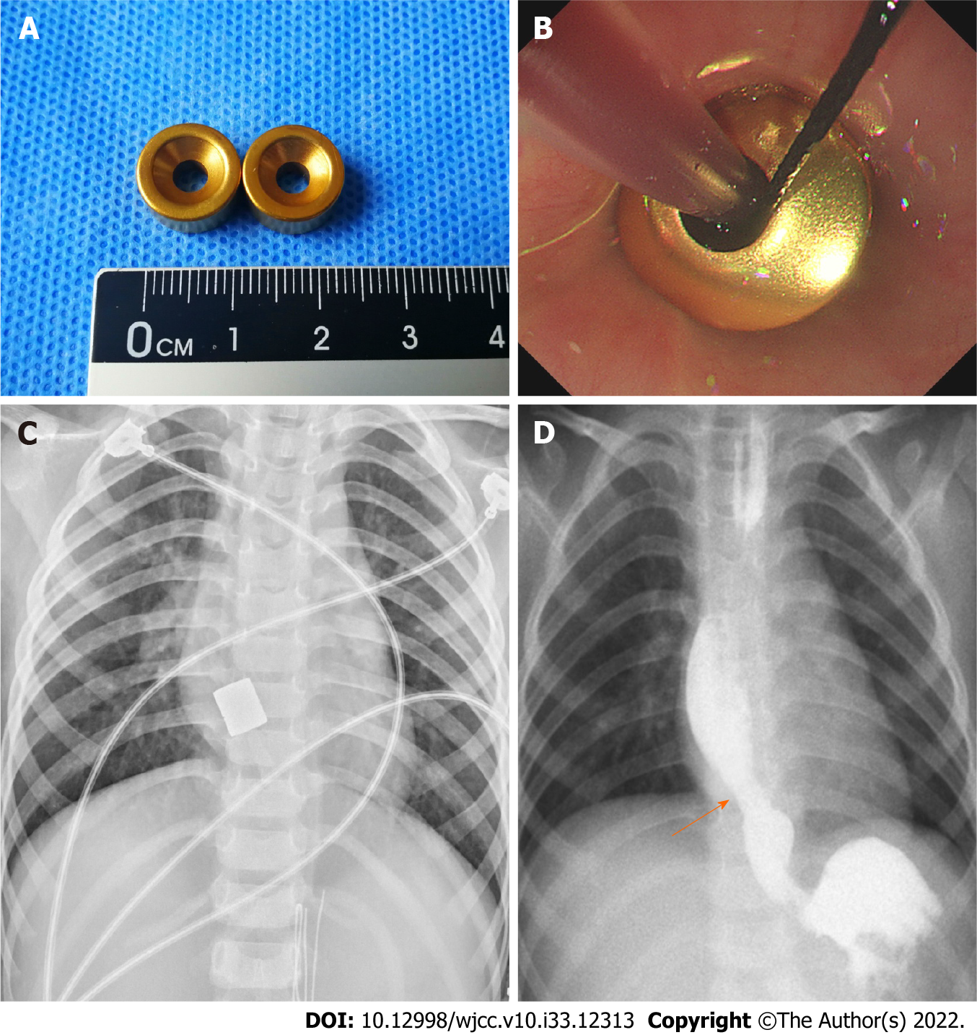
Figure 2 Magnetic compression stricturoplasty. A: Magnets prepared for the operation; B: Magnets were placed under endoscopy and fluoroscopy guidance; C: Intraoperative chest radiograph confirming that the magnets were in good alignment; D: Magnets were removed and radiographic examination of the patient after magnetic compression stricturoplasty showed a patent esophageal lumen with an inner diameter of 8.5 mm at the stenosis site on day 14 (arrow).

Published by Baishideng Publishing Group Inc
7041 Koll Center Parkway, Suite 160, Pleasanton, CA 94566, USA
Telephone: +1-925-3991568
E-mail: bpgoffice@wjgnet.com
Help Desk: https://www.f6publishing.com/helpdesk
https://www.wjgnet.com

© 2022 Baishideng Publishing Group Inc. All rights reserved.

