Name of Journal: World Journal of Gastrointestinal Endoscopy
Manuscript NO: 61287
Manuscript Type: CASE REPORT

Visibility of the bleeding point in acute rectal hemorrhagic ulcer using red dichromatic imaging: A case report

Hirai Y et al. RDI of rectal ulcer bleeding

Yuichiro Hirai, Atsuto Kayashima, Yoshihiro Nakazato, Ai Fujimoto

Yuichiro Hirai, Atsuto Kayashima, Yoshihiro Nakazato, Ai Fujimoto, Department of Gastroenterology, National Hospital Organization Tokyo Medical Center, Tokyo 1520021, Japan

Author contributions: Fujimoto A was involved in conceptualization, revision and final approval; Hirai Y carried out investigation, data curation, writing original draft and editing the figures; Kayashima A was involved in performing the endoscopic hemostasis with the patient's consent; all authors have read and approved the final manuscript.

Corresponding author: Ai Fujimoto, MD, PhD, Staff Physician, Department of Gastroenterology, National Hospital Organization Tokyo Medical Center, 2-5-1 Higashigaoka, Meguro-ku, Tokyo 1528902, Japan. aifujimoto0517@gmail.com

Received: December 18, 2020
Revised: January 14, 2021
Accepted: June 25, 2021
Published online: July 16, 2021

Abstract
BACKGROUND
Red dichromatic imaging (RDI) is a novel image-enhanced endoscopy expected to improve the visibility of the bleeding point. However, it has not been thoroughly investigated.

CASE SUMMARY
A 91-year-old man developed a sudden massive hematochezia and underwent emergent colonoscopy. An ulcer with pulsatile bleeding was found on the lower rectum. Due to massive bleeding, the exact location of the bleeding point was not easy to detect with white light imaging (WLI). Upon switching to RDI, the bleeding point appeared in deeper yellow compared to the surrounding blood. Thus, RDI enabled us for easier recognition of the bleeding point, and hemostasis was achieved successfully. Furthermore, we reviewed endoscopic images and evaluated the color difference between the bleeding point and surrounding blood for WLI and RDI. In our case, the color difference of RDI was greater than that of WLI (9. 75 vs 6. 61), and RDI showed a better distinguished bleeding point from the surrounding blood.

CONCLUSION
RDI may improve visualization of the bleeding point by providing better contrast in color difference relative to surrounding blood.

Key Words: Red dichromatic imaging; Image-enhanced endoscopy; Acute hemorrhagic rectal ulcer; Gastrointestinal hemorrhage; Endoscopic hemostasis; Case report

©The Author(s) 2021. Published by Baishideng Publishing Group Inc. All rights reserved.

Citation: Hirai Y, Kayashima A, Nakazato Y, Fujimoto A. Visibility of the bleeding point in acute rectal hemorrhagic ulcer using red dichromatic imaging: A case report. World J Gastrointest Endosc 2021; 13(7): 233-237
URL: https://www.wjgnet.com/1948-5190/full/v13/i7/233.htm
DOI: https://dx.doi.org/10.4253/wjge.v13.i7.233

Core Tip: Red dichromatic imaging (RDI) is a novel image-enhanced endoscopy presumed to improve the visibility of the bleeding point but has not yet been fully explored. We present a case in which RDI effectively identified the bleeding point in an acute hemorrhagic rectal ulcer lesion with an analysis of color difference compared to white light imaging. RDI may enable easier recognition of the bleeding point by enhancing the color contrast of the bleeding point relative to the surrounding blood.
INTRODUCTION
Endoscopic hemostasis of acute gastrointestinal bleeding is sometimes a challenging task, especially when pulsatile bleeding from the artery impedes clear visibility of the bleeding point. Red dichromatic imaging (RDI) is a new endoscopic technology using three types of wavelength (540 nm, 600 nm and 630 nm) lights^{[1]}. It is integrated as a new function in the latest endoscopic system (EVIS X1, Olympus Co., Tokyo, Japan) from April 2020. An endoscopist can quickly switch from white light imaging (WLI) to RDI, a modality that visualizes blood in yellow, during an endoscopic intervention. Recently, RDI has been found to be effective in the identification of bleeding point in endoscopic hemostasis during endoscopic submucosal dissection or hemorrhage from upper gastrointestinal ulcer^{[2-5]}. In this report, we describe an impressive case in which RDI effectively identified the bleeding point in an acute hemorrhagic rectal ulcer lesion via analysis of the color difference between the bleeding point and surrounding blood.

CASE PRESENTATION
Chief complaints
A 91-year-old man hospitalized with pneumonia was referred to our department due to sudden massive fresh hematochezia on the 13th day of hospitalization.

History of present illness
At admission, a right femoral neck fracture was also found and required bed-rest as a nonoperative treatment.

History of past illness
He had a history of pneumonia and hypertension.

Personal and family history
He had smoked 2 packs-per-day of cigarettes for over 30 years but quit 40 years ago and was a social drinker. His family history was unremarkable.

Physical examination
He presented signs of hypovolemic shock with low blood pressure (BP of 79/38 mmHg) and tachycardia (101 bpm). The vital signs were stabilized after a rapid infusion of 1000 mL of lactated Ringer’s solution. His abdominal examination was normal with no tenderness.

Laboratory examinations
His hemoglobin level dropped from 11.5 to 7.2 g/dL.

Imaging examinations
Contrast computed tomography revealed extravasation in the lower rectum (Figure 1). After computed tomography, we promptly performed an emergent colonoscopy using a prototype endoscope (GIF-Y0058; Olympus Co., Tokyo, Japan) instrumented with RDI mode, and an ulcer accompanied with a pulsatile bleeding was found on the lower rectum.

FINAL DIAGNOSIS
The patient was diagnosed with acute hemorrhagic rectal ulcer, likely caused due to being bed-rest status and constipated.

TREATMENT
Followed by endoscopic observation, we went on to achieve hemostasis. However, massive bleeding with pooled blood hindered observation of the bleeding point with WLI (Figure 2A). Thereby, we switched to RDI, and the bleeding point was clearly identified as it was displayed in deeper yellow compared to the surrounding blood (Figure 2B). The bleeding vessel was coagulated with hemostatic forceps (Coagrasper; Olympus Co., Tokyo, Japan) in soft coagulation current (effect 5, 50 W) using an electrosurgical system (VIO300D; ERBE, Tübingen, Germany), and hemostasis was obtained successfully (Figure 2C).

OUTCOME AND FOLLOW-UP
After the achievement of endoscopic hemostasis, his anemia improved after receiving 4 units of packed red blood cells. No further bleeding was noted for a month until the patient was discharged to another hospital for rehabilitation.

DISCUSSION
When attempting endoscopic hemostasis for active bleeding with acute hemorrhagic rectal ulcer using WLI, we often encounter with pooled blood hindering the detection of bleeding points in a similar shade of red. The patient may even need to be repositioned to facilitate the detection of the bleeding point when the bleeding point is located at the gravity side. RDI may overcome this problem as it can enhance the bleeding point in the presence of pooled blood and eventually facilitate the endoscopic hemostasis. The key mechanism of RDI that enables clear visualization of the bleeding point in the presence of pooled blood is the difference in blood concentration and/or blood volume. The narrow-band light of 600 nm wavelength highlights the difference in blood concentration and/or its volume because of the light absorption features of the hemoglobin. The center and circumference of the bleeding point appears in clear contrast because they contain different amounts of hemoglobin and accordingly absorb and reflect differential levels of 600 nm light^{[6,7]}. This means that more light is reflected from the center and less from the circumference. We speculated that this mechanism produces a larger color difference between the bleeding point and surrounding blood, resulting in easier detection of the bleeding point.
Therefore, we investigated the visibility of the bleeding point by evaluating the color difference between the bleeding point and surrounding blood for WLI and the corresponding RDI images in still pictures of this case. The color difference was evaluated by comparing the color values of regions of interest (ROI) for the bleeding point and surrounding blood using Adobe Photoshop Elements 2020 (Adobe Systems Inc., CA, San Jose, United States). The details for the setting of ROI are shown in Figure 3A. The color values were defined as the median color values in each ROI (24 × 24 pixels) according to the Commission Internationaled’Eclairage L¹a¹b¹ (L¹ = black to white; 0 to + 100, a¹ = green to red; -128 to + 127, b¹ = blue to yellow; -128 to + 127) color space^{[8]}. The color difference was calculated by the following equation: ΔE = √ (ΔL)² + (Δa)² + (Δb)². In the present case, the color difference with WLI and RDI was 6.61 and 9.75, respectively (Figure 3B). Thus, RDI differentiated the bleeding point from surrounding blood better than WLI based on color difference.
This report is the first of its kind to use the color difference as an objective indicator for the investigation of the visibility of bleeding point with RDI. Subsequent to this research, we are now conducting a larger study by comparing the visibility of the bleeding point including the evaluation of the color difference between WLI and RDI for acute gastrointestinal bleeding.

CONCLUSION
Our case of acute hemorrhagic rectal ulcer demonstrated the usefulness of red dichromatic imaging for achieving endoscopic hemostasis by improving the detection of the bleeding point. Red dichromatic imaging may be useful for recognition of the bleeding point by offering good contrast in color difference relative to surrounding blood.

REFERENCES
1 Yahagi N, Fujimoto A, Horii J, Uraoka T, Shimoda M, Takabayashi K, Nisizawa T, Goto O, Ochiai Y, Maehata T, Nakayama A, Kato M, Hosoe N, Naganuma M. Dual red imaging: a novel endoscopic imaging technology visualizing thick blood vessels in the gastrointestinal wall. Endosc Int Open 2019; 7: E1632-E1635 [PMID: 31788544 DOI: 10.1055/a-0749-0075]
2 Tanaka H, Oka S, Tanaka S. Endoscopic hemostasis for spurting duodenal bleeding using dual red imaging. Dig Endosc 2017; 29: 816-817 [PMID: 28758246 DOI: 10.1111/den.12930]
3 Kubosawa Y, Mori H, Fujimoto A. Utility of Dual Red Imaging for Endoscopic Hemostasis of Gastric Ulcer Bleeding. Dig Dis 2020; 38: 352-354 [PMID: 31865356 DOI: 10.1159/000504386]
4 Yorita N, Oka S, Tanaka S, Kotachi T, Nagasaki N, Hata K, Kuroki K, Masuda K, Kurihara M, Kiso M, Boda T, Ito M, Chayama K. Clinical Usefulness of Dual Red Imaging in Gastric Endoscopic Submucosal Dissection: A Pilot Study. Clin Endosc 2020; 53: 54-59 [PMID: 31476844 DOI: 10.5946/ce.2019.065]
5 Maehata T, Fujimoto A, Uraoka T, Kato M, Horii J, Sasaki M, Kiguchi Y, Akimoto T, Nakayama A, Ochiai Y, Goto O, Nishizawa T, Yahagi N. Efficacy of a new image-enhancement technique for achieving hemostasis in endoscopic submucosal dissection. Gastrointest Endosc 2020; 92: 667-674 [PMID: 32497538 DOI: 10.1016/j.gie.2020.05.033]
6 Fujimoto A, Saito Y, Abe S, Hoteya S, Nomura K, Yasuda H, Matsuo Y, Uraoka T, Kuribayashi S, Saito I, Tsuji Y, Maehata T, Ochiai Y, Nishizawa T, Yahagi N. Haemostasis treatment using dual red imaging during endoscopic submucosal dissection: a multicentre, open-label, randomised controlled trial. BMJ Open Gastroenterol 2019; 6: e000275 [PMID: 30997140 DOI: 10.1136/bmjgast-2019-000275]
7 Miyamoto S, Sugiura R, Abiko S, Hatanaka K, Yamamoto Y, Naruse H, Sakamoto N. Red dichromatic imaging helps in detecting exposed blood vessels in gastric ulcer induced by endoscopic submucosal dissection. Endoscopy 2020 [PMID: 33336336 DOI: 10.1055/a-1314-9714]
8 Kuehni RG. Color-tolerance data and the tentative CIE 1976 L a b formula. J Opt Soc Am 1976; 66: 497-500 [PMID: 932844 DOI: 10.1364/josa.66.000497]

Footnotes
Informed consent statement: Informed consent was obtained from the patient’s son.

Conflict-of-interest statement: All the authors declare no conflicts of interest associated with this manuscript. The prototype endoscope (GIF-Y0058) was provided free of charge by Olympus Corporation, Tokyo, Japan.

CARE Checklist (2016) statement: The authors have read the CARE Checklist (2016), and the manuscript was prepared and revised according to the CARE Checklist (2016).

Open-Access: This article is an open-access article that was selected by an in-house editor and fully peer-reviewed by external reviewers. It is distributed in accordance with the Creative Commons Attribution NonCommercial (CC BY-NC 4.0) license, which permits others to distribute, remix, adapt, build upon this work non-commercially, and license their derivative works on different terms, provided the original work is properly cited and the use is non-commercial. See: http://creativecommons.org/Licenses/by-nc/4.0/

Manuscript source: Unsolicited manuscript

Peer-review started: December 18, 2020
First decision: December 31, 2020
Article in press: June 25, 2021

Specialty type: Gastroenterology and hepatology
Country/Territory of origin: Japan
Peer-review report’s scientific quality classification
Grade A (Excellent): 0
Grade B (Very good): 0
Grade C (Good): C
Grade D (Fair): 0
Grade E (Poor): 0

P-Reviewer: Montemurro N S-Editor: Zhang L L-Editor: A P-Editor: Wang LL

Figure Legends
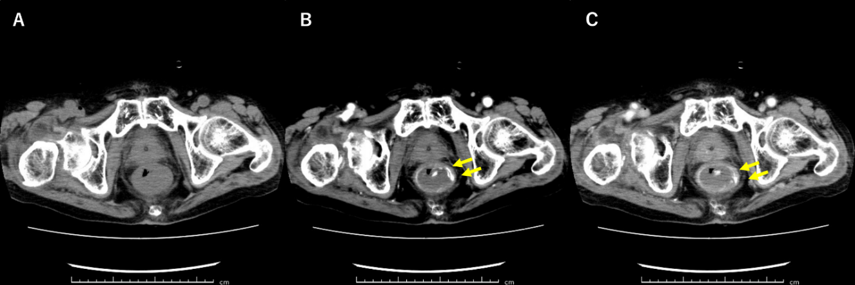
Figure 1 Computed tomography scan images of the pelvis. A: Plain; B: Arterial phase; and C: Delayed phase; Contrast extravasation is observed in the lower rectum on the arterial phase with further pooling of contrast on the delayed phase (orange arrow).

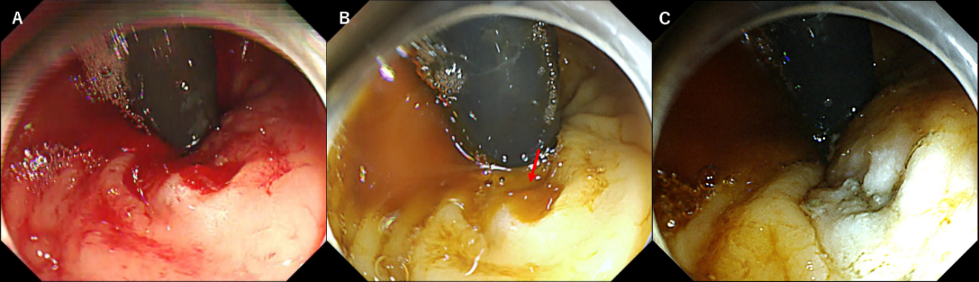Figure 2 Endoscopic images of emergent colonoscopy. A: Massive pulsatile bleeding from the ulcer on the lower rectum hindered the detection of the bleeding point with white light imaging; B: After switching to red dichromatic imaging, the bleeding point was observed as deep yellow (orange arrow) compared to surrounding blood, and that allowed us to recognize it precisely; and C: The bleeding vessel was coagulated, and hemostasis was achieved successfully with red dichromatic imaging.

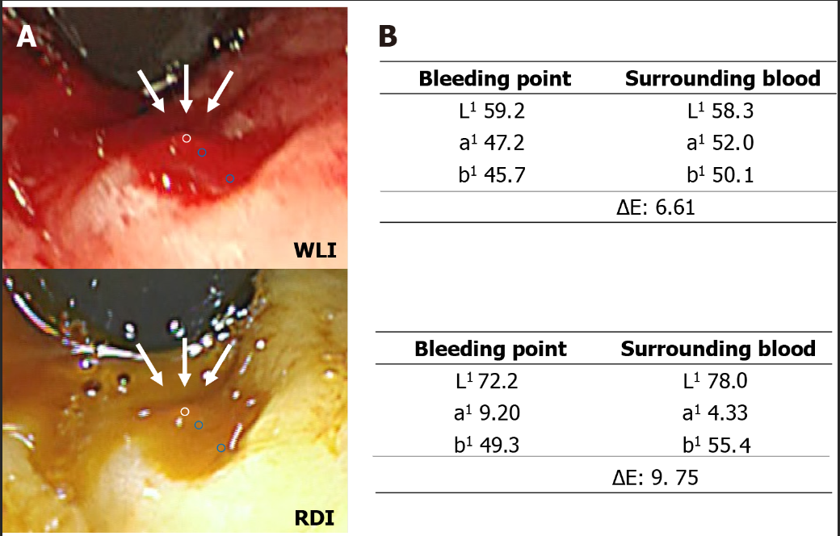
Figure 3 Color values and color differences between bleeding point and surrounding blood. A: The regions of interests (ROIs) were located in the bleeding point and at two selected points in surrounding blood (one was just next to outside of the bleeding point and the other was just inside the surrounding blood), avoiding areas with halation. Each ROI was set approximately in the same region for white light imaging and red dichromatic imaging. The white and blue circles indicate the ROI of the bleeding point (white arrow) and surrounding blood, respectively. The color values were defined as the median color value in each ROI; and B: The ΔE based on color value change between the ROI of the bleeding point and surrounding blood. WLI: White light imaging; RDI: Red dichromatic imaging; ΔE: Color difference.

Published by Baishideng Publishing Group Inc
7041 Koll Center Parkway, Suite 160, Pleasanton, CA 94566, USA
Telephone: +1-925-3991568
E-mail: bpgoffice@wjgnet.com
Help Desk: https://www.f6publishing.com/helpdesk
https://www.wjgnet.com

© 2021 Baishideng Publishing Group Inc. All rights reserved.

